System Design Document (SDD)

SmartLab Automation Suite: End-to-End LIMS Workflow & Data Pipeline Engine

Document Control
Item | Details
Project Title | SmartLab Automation Suite (Unified LIMS Workflow Engine)
Document Version | 2.0.0 (Unified Design Release)
Date | September 2026
Author | Automated Laboratory Solutions Engineering Team
Target Platform | Google Chrome / Chromium Browsers (Manifest V3)
Modules Covered | Module 1: Patient Intake Engine (lab-auto-register)<br>Module 2: Diagnostic Results AutoFill Engine (lab-autofill)
Status | Final Approved

Table of Contents
1. [Architectural Overview](#1-architectural-overview)
- 1.1 High-Level Modular Design
- 1.2 Component Architecture Diagram
- 1.3 Chrome MV3 Messaging & Execution Contexts
2. [Module 1 Technical Design (lab-auto-register)](#2-module-1-technical-design-lab-auto-register)
- 2.1 Storage Data Schema (reg_status)
- 2.2 CSV Parsing & Title Inference Logic
- 2.3 Select2 DOM Event Synthesizer Architecture
- 2.4 Pre-Commit Reload Recovery Engine
3. [Module 2 Technical Design (lab-autofill)](#3-module-2-technical-design-lab-autofill)
- 3.1 Storage Data Schema (savedPdfText, sessionPatientInfo)
- 3.2 Position-Aware Tabular PDF Text Extractor
- 3.3 Multi-Strategy Parameter Matcher & Alias Dictionary
- 3.4 Substring Collision Guarding (isAliasMatch)
- 3.5 Range Validation Engine (checkRange)
- 3.6 Persistent Background Monitor & DOM Mutation Observer
4. [Data Storage Dictionary](#4-data-storage-dictionary)
- 4.1 Storage Keys & Structure
5. [System UML Diagrams & Circuit Flow Placeholders](#5-system-uml-diagrams--circuit-flow-placeholders)
- 5.1 System Component & Storage Architecture Diagram
- 5.2 Pre-Commit Queue Execution Flowchart
- 5.3 Position-Aware PDF Parsing Algorithm Flowchart

1. Architectural Overview

1.1 High-Level Modular Design
The SmartLab Automation Suite is designed around a Modular Dual-Extension Architecture. Rather than forcing all features into a single monolithic extension popup, the platform decouples front-desk patient intake (Module 1) from diagnostic report entry (Module 2).
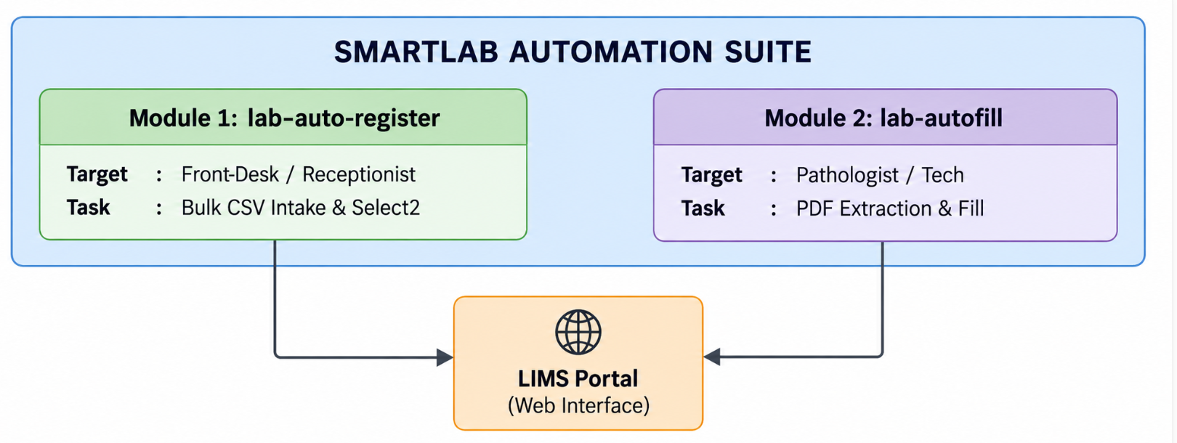

1.2 Component Architecture Diagram
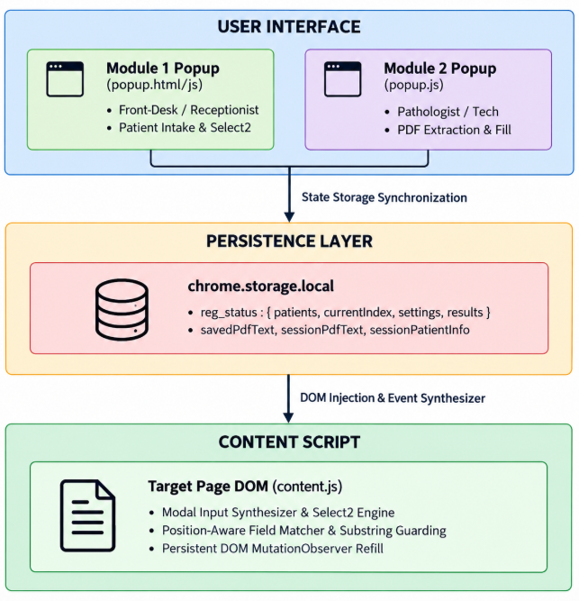

2. Module 1 Technical Design (`lab-auto-register`)

2.1 Storage Data Schema (`reg_status`)
{
"reg_status": {
"patients": [
{
"name": "SAROJANA M",
"age": 60,
"gender": "Female",
"title": "Mrs.",
"status": "done"
}
],
"currentIndex": 1,
"settings": {
"labName": "Glukem Biocare PVT Limit",
"contract": "MRP",
"packageName": "Glukem Health Checkup",
"doctorName": "Employee Health Checkup"
},
"results": [
{
"name": "SAROJANA M",
"success": true,
"code": "PAT10042"
}
],
"isRunning": true
}
}

2.2 Title Inference Rules
let title;
if (gender === 'Male') {
title = 'Mr.';
} else {
title = age >= 20 ? 'Mrs.' : 'Miss';
}

2.3 Select2 DOM Synthesizer Architecture
async function clickSelect2Option(selectEl, targetText) {
let s2container = selectEl.nextElementSibling || selectEl.parentElement?.querySelector('.select2-container');
if (!s2container) {
setNativeSelect(selectEl, targetText);
return;
}
const selection = s2container.querySelector('.select2-selection');
if (selection) {
selection.dispatchEvent(new MouseEvent('mousedown', { bubbles: true }));
}
await sleep(400);
const searchInput = document.querySelector('.select2-search__field');
if (searchInput) {
searchInput.focus();
const searchChars = targetText.substring(0, 4);
for (const char of searchChars) {
searchInput.value += char;
searchInput.dispatchEvent(new Event('input', { bubbles: true }));
searchInput.dispatchEvent(new KeyboardEvent('keyup', { bubbles: true, key: char }));
await sleep(50);
}
await sleep(600);
}
const resultItems = document.querySelectorAll('.select2-results__option');
for (const item of resultItems) {
const itemText = item.textContent.trim().toLowerCase();
if (itemText.includes(targetText.toLowerCase())) {
item.click();
item.dispatchEvent(new MouseEvent('mouseup', { bubbles: true }));
break;
}
}
}

2.4 Pre-Commit Reload Recovery Engine
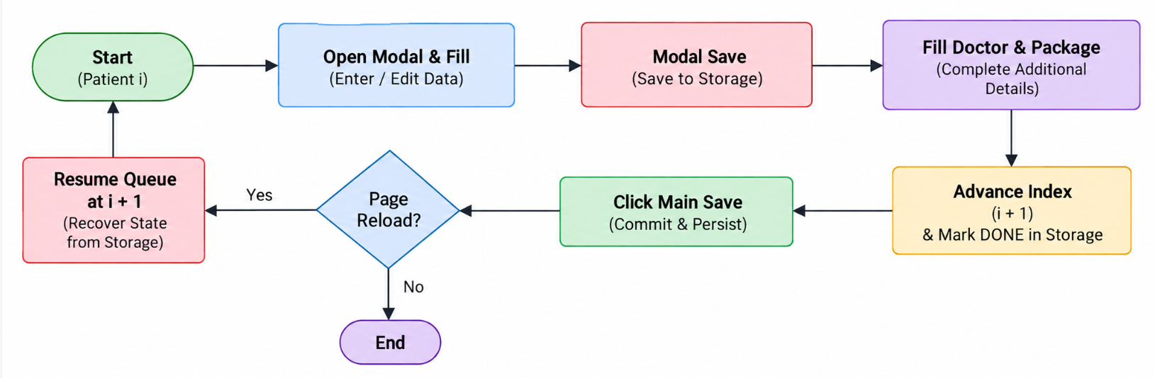

3. Module 2 Technical Design (`lab-autofill`)

3.1 Position-Aware Tabular PDF Extractor
const rows = {};
const yThreshold = 3; // Items within 3 units belong to the same row
for (const item of content.items) {
if (!item.str || item.str.trim() === '') continue;
const y = Math.round(item.transform[5] / yThreshold) * yThreshold;
const x = item.transform[4];
if (!rows[y]) rows[y] = [];
rows[y].push({ x, text: item.str });
}
const sortedYs = Object.keys(rows).map(Number).sort((a, b) => b - a);
for (const y of sortedYs) {
rows[y].sort((a, b) => a.x - b.x); // Sort left-to-right
const line = rows[y].map(item => item.text).join(' ');
fullText += line + '\n';
}

3.2 Substring Collision Guarding (`isAliasMatch`)
function isAliasMatch(cleanLabelLower, alias) {
const index = cleanLabelLower.indexOf(alias);
if (index === -1) return false;
// Prefix Guard: Ensure preceding char is not a letter (e.g. 'v' in 'vldl')
if (index > 0 && /[a-z]/i.test(cleanLabelLower[index - 1])) {
return false;
}
// Suffix Guard: Ensure succeeding char is not a letter (e.g. 's' in 'erythrocytes')
const endIndex = index + alias.length;
if (endIndex < cleanLabelLower.length && /[a-z]/i.test(cleanLabelLower[endIndex])) {
return false;
}
return true;
}

3.3 Medical Range Validation (`checkRange`)
function checkRange(labelLower, num) {
if (isNaN(num)) return null;
const ranges = {
'hemoglobin': [4, 20],
'glucose': [20, 700],
'creatinine': [0.1, 20],
'platelet': [10, 2000]
};
for (const [key, [min, max]] of Object.entries(ranges)) {
if (labelLower.includes(key) && (num < min || num > max)) {
return `${num} is outside expected medical range [${min}–${max}]`;
}
}
return null;
}

4. Data Storage Dictionary
Storage Key | Module | Type | Description
reg_status | Module 1 | Object | Stores current queue state, patient list, currentIndex, settings, and results.
reg_lab | Module 1 | String | Saved default Lab Location setting.
reg_contract | Module 1 | String | Saved default Contract Pricing model.
reg_package | Module 1 | String | Saved default Package profile choice.
reg_doctor | Module 1 | String | Saved default Supervising Doctor name.
savedPdfText | Module 2 | String | Raw tabular extracted text of the active PDF report.
savedPdfName | Module 2 | String | File name of the currently loaded PDF report.
sessionPdfText | Module 2 | String | Background memory PDF text for auto-refill across table re-renders.
sessionPatientInfo | Module 2 | Object | Extracted patient name and barcode list for verifying tab session match.

5. System UML Diagrams & Circuit Flow Placeholders

5.1 System Component Architecture Diagram
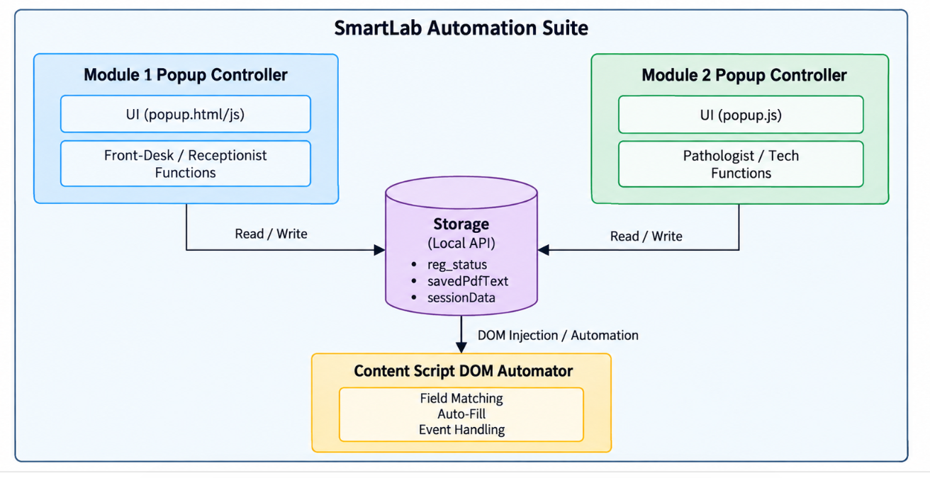

5.2 Pre-Commit Queue Execution Flowchart
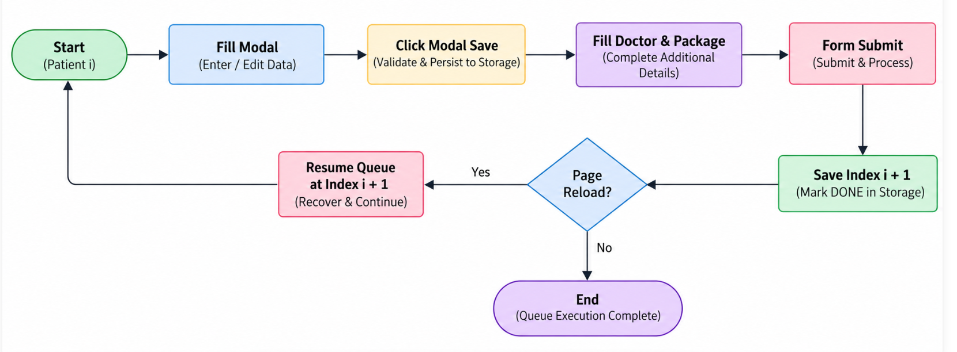

5.3 Position-Aware PDF Parsing Algorithm Flowchart
