Software Requirements Specification (SRS)

SmartLab Automation Suite: End-to-End LIMS Workflow & Data Pipeline Engine

Document Control
Item | Details
Project Title | SmartLab Automation Suite (Unified LIMS Workflow Engine)
Document Version | 2.0.0 (Unified Release)
Date | September 2026
Author | Automated Laboratory Solutions Engineering Team
Target Platform | Google Chrome / Chromium Browsers (Manifest V3)
Modules Covered | Module 1: Patient Intake Engine (lab-auto-register)<br>Module 2: Diagnostic Results AutoFill Engine (lab-autofill)
Status | Final Approved

Table of Contents
1. [Introduction](#1-introduction)
- 1.1 Purpose
- 1.2 Scope
- 1.3 Definitions, Acronyms, and Abbreviations
- 1.4 Architectural Overview
2. [Overall Description](#2-overall-description)
- 2.1 Product Perspective & Modular Design Justification
- 2.2 Product Functions (Module 1 vs Module 2)
- 2.3 User Classes and Operational Roles
- 2.4 Operating Environment
- 2.5 Design & Technical Constraints
3. [System Features & Functional Requirements](#3-system-features--functional-requirements)
- 3.1 Module 1: Batch Intake & Patient Registration Engine (lab-auto-register)
- FR-1.1: CSV Data Parsing & Title Inference
- FR-1.2: Select2 DOM Dropdown Synthesizer
- FR-1.3: Pre-Configured Location, Contract, Package & Doctor Settings
- FR-1.4: Pre-Commit Queue State Persistence & Page Reload Recovery
- 3.2 Module 2: Diagnostic Results AutoFill Engine (lab-autofill)
- FR-2.1: Position-Aware Tabular PDF Text Extraction
- FR-2.2: Multi-Strategy Parameter Matching & Alias Synonym Dictionary
- FR-2.3: Substring Collision Guarding (isAliasMatch)
- FR-2.4: Dropdown Option Matching & Range Validation (checkRange)
- FR-2.5: Persistent Background Refill Monitor & DOM Mutation Observer
4. [Non-Functional Requirements](#4-non-functional-requirements)
- 4.1 Performance & Throughput Metrics
- 4.2 Reliability & Fault Tolerance
- 4.3 Usability & User Experience
- 4.4 Security, Privacy & Local Storage
- 4.5 Maintainability & MV3 Compliance
5. [System Diagram & Screenshot Placeholders](#5-system-diagram--screenshot-placeholders)
- 5.1 Unified System Use Case Diagram
- 5.2 Module 1 Sequence Diagram (Batch Registration Flow)
- 5.3 Module 2 Sequence Diagram (PDF AutoFill & Background Refill Flow)
- 5.4 State Machine Diagram (Pre-Commit Reload Recovery)
- 5.5 User Interface Screenshots
---

1. Introduction

1.1 Purpose
This Unified Software Requirements Specification (SRS) document provides a comprehensive technical specification for the SmartLab Automation Suite. It covers both specialized modules:
1. Module 1 (`lab-auto-register`): Batch Patient Intake & Registration Engine.
2. Module 2 (`lab-autofill`): Diagnostic Results AutoFill Engine.

1.2 Scope
The SmartLab Automation Suite automates the complete end-to-end data pipeline of web-based Laboratory Information Management Systems (LIMS). It handles bulk front-desk patient intake (CSV parsing, title inference, Select2 modal filling, contract/package defaults) and laboratory diagnostic result entry (position-aware PDF report parsing, alias matching, background auto-refill across reloads).

1.3 Definitions, Acronyms, and Abbreviations
- SRS: Software Requirements Specification
- MV3: Google Chrome Extension Manifest Version 3
- LIMS: Laboratory Information Management System
- DOM: Document Object Model
- Select2: Searchable jQuery dropdown control replacement
- PDF.js: Mozilla JavaScript PDF rendering and text parsing engine
- SRP: Single Responsibility Principle

1.4 Architectural Overview
The suite uses a Dual-Extension Modular Architecture. Both extensions run on Chrome MV3 standards, utilizing chrome.storage.local for isolated state management and content script DOM injection for browser automation.
---

2. Overall Description

2.1 Product Perspective & Modular Design Justification
Rather than building a single monolithic extension, the suite is intentionally decoupled into two specialized extension modules:
- Separation of Roles: Front-desk receptionists perform patient intake at patient arrival (Module 1); lab technicians input test result values hours later after sample analysis (Module 2).
- Zero UI Clutter: Keeping modules distinct prevents UI bloat and eliminates unnecessary option toggles during high-speed laboratory operations.
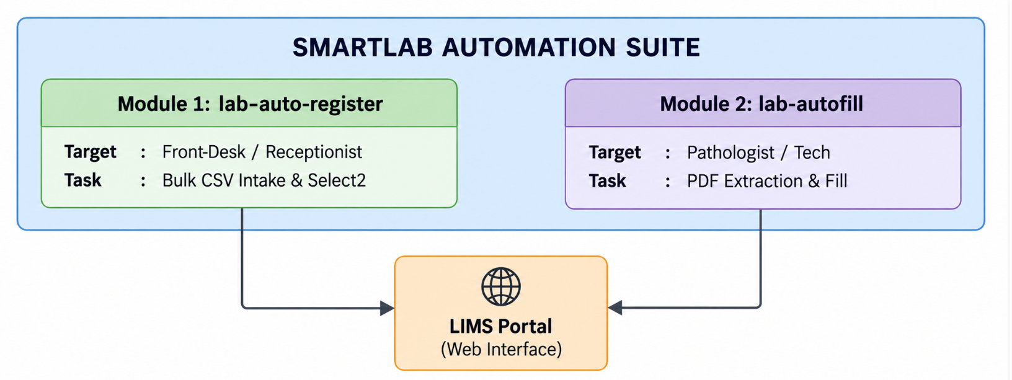

2.2 Product Functions
- Batch CSV Intake: Converts raw Name, Age, Gender CSV lists into registered patient group entries.
- Rule-Based Title Inference: Assigns salutations (Mr., Mrs., Miss) based on gender and age rules.
- Select2 DOM Event Synthesizer: Interacts with searchable dropdowns using native browser DOM events.
- Pre-Commit Reload Recovery: Saves status to chrome.storage.local before form submit page reloads to prevent duplicate registration attempts.
- Position-Aware PDF Parser: Groups PDF text items into rows (Y-threshold) and columns (X-sorting).
- Medical Synonym & Collision Guarding: Matches test parameters via alias dictionaries while preventing substring collisions (e.g. VLDL vs LDL).
- Persistent Background Refill: Monitors DOM table re-renders via MutationObserver to refill empty fields automatically when saving individual tests.

2.3 User Classes and Operational Roles
- Front-Desk Receptionists / Camp Coordinators: Operators utilizing Module 1 for bulk registration during routine ops or medical camps.
- Laboratory Technicians & Pathologists: Technical staff utilizing Module 2 to transfer PDF report values into LIMS portal fields.

2.4 Operating Environment
- Browser: Google Chrome v102+ or Chromium-based browsers (Edge, Brave, Vivaldi).
- Extension Standard: Chrome Extension Manifest V3.
- Target Host: Web-based LIMS portals (e.g., *://skyblue-boar-647070.hostingersite.com/*).

3. System Features & Functional Requirements

3.1 Module 1: Batch Intake Engine (`lab-auto-register`)

FR-1.1: CSV Parsing & Title Inference
- Ingests CSV files or text area strings (Name, Age, Gender).
- Converts names to UPPERCASE.
- Applies title logic:
- Male $\rightarrow$ Mr.
- Female ($\text{Age} \ge 20$) $\rightarrow$ Mrs.
- Female ($\text{Age} < 20$) $\rightarrow$ Miss

FR-1.2: Select2 DOM Dropdown Synthesizer
- Detects .select2-container elements next to <select> controls.
- Dispatches native mousedown events to open dropdowns.
- Types query strings into .select2-search__field with input and keyup keyboard events.
- Matches .select2-results__option items and dispatches mouseup and click.

FR-1.3: Settings Configuration Management
- Lab Name: Select dropdown supporting 48 location choices (Default: Glukem Biocare PVT Limit).
- Contract: Options for MRP, L To L - A, L To L - B, Platinum Card.
- Package: Select dropdown supporting 13 profiles (Glukem Health Checkup, Allergy Profiles A-E, HepatitisB Marker, Immuno Check, etc.).
- Doctor: Configurable default doctor text (Employee Health Checkup).

FR-1.4: Pre-Commit State Persistence & Reload Recovery
- Saves queue state (patients, currentIndex, settings, results, isRunning) to chrome.storage.local.
- Updates patients[i].status = 'done', pushes result code, and advances currentIndex = i + 1 immediately BEFORE clicking the main form Save button.
- On page reload, reads currentIndex = i + 1 and skips retrying completed patients.
---

3.2 Module 2: Diagnostic Results AutoFill Engine (`lab-autofill`)

FR-2.1: Position-Aware Tabular PDF Text Extraction
- Uses pdf.js to extract text items per page.
- Groups items into rows using Y-coordinate thresholding (Math.round(y / 3) * 3).
- Sorts items left-to-right by X-coordinate (a.x - b.x).
- Reconstructs tabular report structures reliably.

FR-2.2: Multi-Strategy Parameter Matching
- Attempt 1: Exact label regex matching.
- Attempt 2: Shortened label matching (stripping parenthetical text like (TT3)).
- Attempt 3: Synonym alias group lookup (SGPT/ALT, WBC/Leucocyte, HbA1c, LDL/HDL/VLDL, Indirect Bilirubin, Serum Creatinine, ESR, RDW).

FR-2.3: Substring Collision Guarding (`isAliasMatch`)
- Enforces character prefix and suffix checks to prevent false positive substring matches:
- Prevents VLDL from matching LDL.
- Prevents Erythrocytes from matching Erythrocyte.
- Prevents T4 from matching inside T3.

FR-2.4: Medical Range Validation (`checkRange`)
- Validates extracted numerical values against standard biological ranges (e.g. Hemoglobin 4-20, Glucose 20-700, Creatinine 0.1-20).
- Triggers a ⚠️ Check warning chip in the popup UI if values are outside expected bounds.

FR-2.5: Persistent Background Refill Monitor
- Stores PDF text and patient metadata (name, barcodes) in chrome.storage.local.
- Operates a 1000ms timer + a MutationObserver on document.body.
- Refills empty fields automatically when table rows re-render after saving individual tests.
---

4. Non-Functional Requirements

4.1 Performance & Throughput Metrics
- Registration Intake Time: Reduced from ~45s per patient to ~5s per patient ($88.8\%$ speedup).
- Report Result AutoFill Time: Reduced from ~3 minutes to < 2 seconds ($98.8\%$ speedup).
- Memory Overhead: $< 15 \text{ MB}$ footprint per extension instance.

4.2 Reliability & Fault Tolerance
- Automatic error recovery: If a duplicate patient error occurs, the system logs the exact failure reason, increments currentIndex, and proceeds without breaking the queue.

4.3 Security & Privacy
- All patient data remains strictly in browser local storage (chrome.storage.local). Zero data is transmitted to external servers or third-party analytics APIs.
---

5. System Diagram & Screenshot Placeholders

5.1 Unified System Use Case Diagram
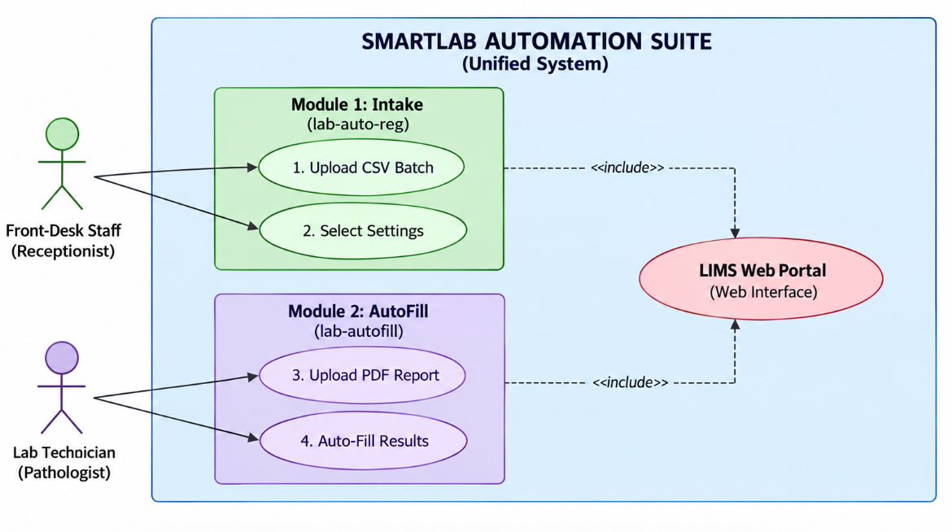

5.2 Module 1 Sequence Diagram (Batch Registration Flow)
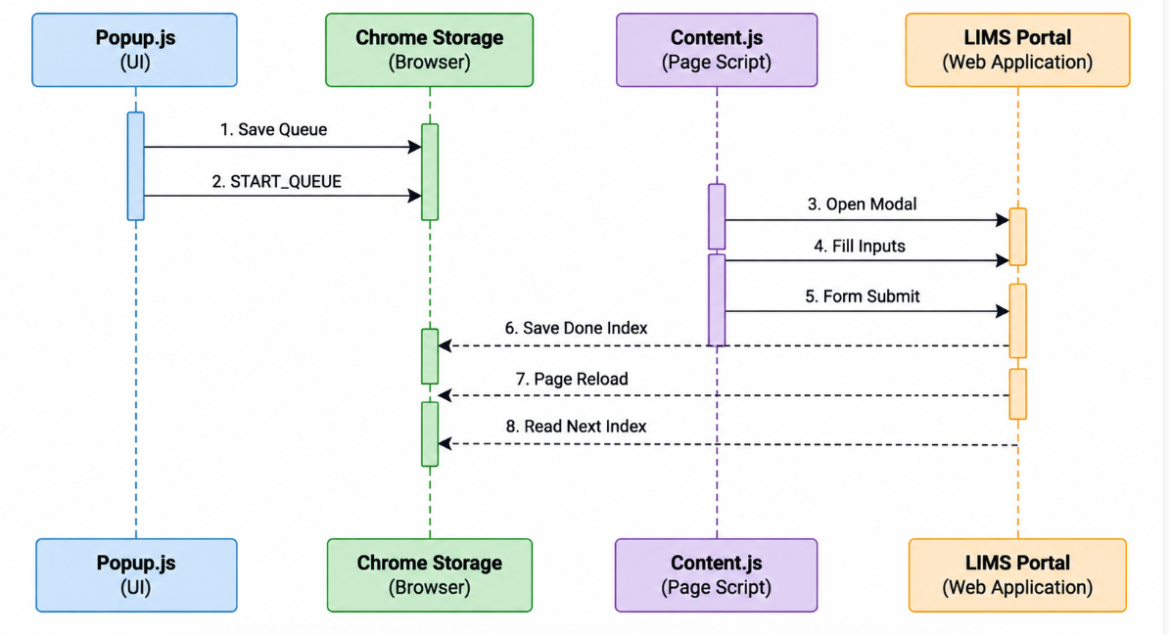

5.3 Module 2 Sequence Diagram (PDF AutoFill & Refill Flow)
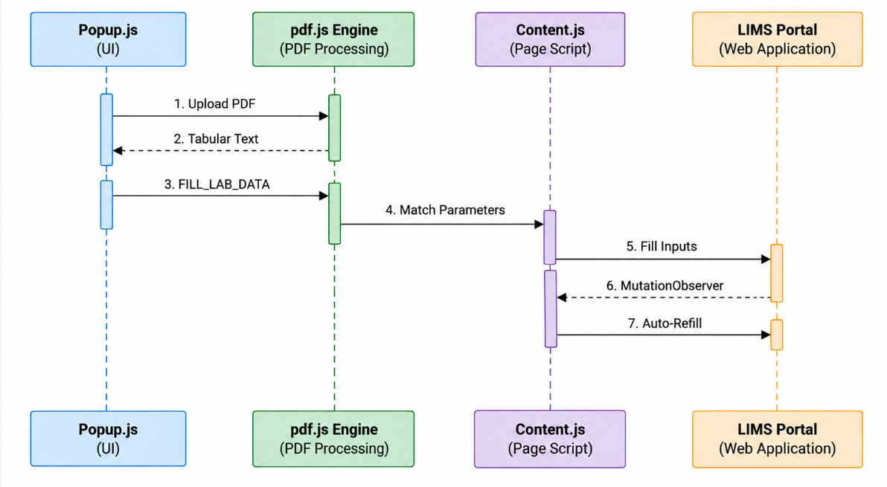

5.4 State Machine Diagram (Pre-Commit Reload Recovery)
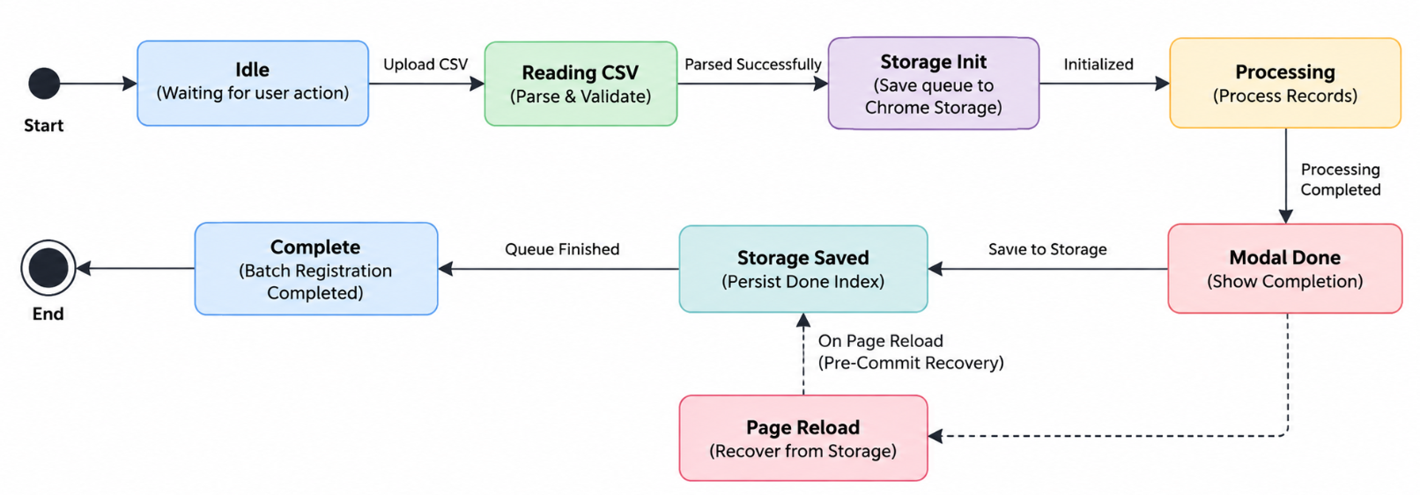

5.5 User Interface Screenshots
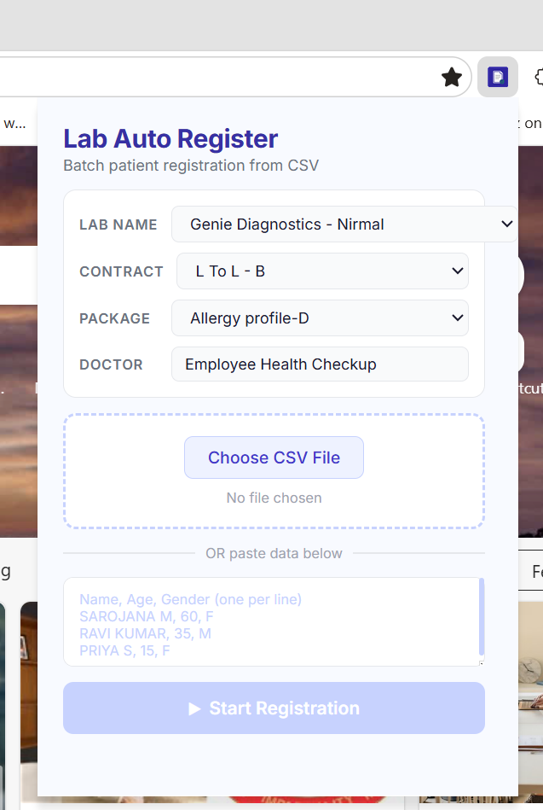
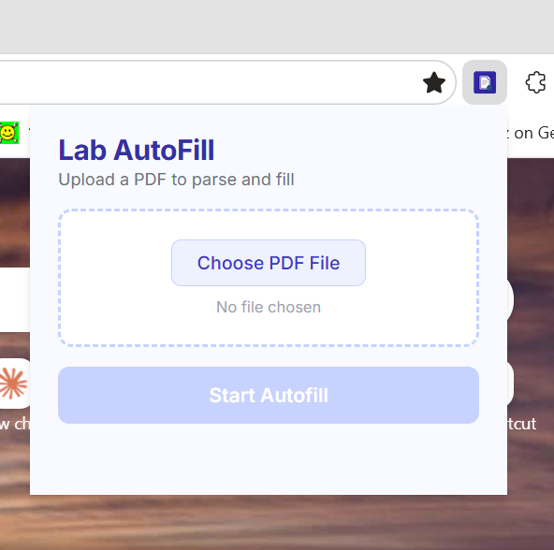
================================================================================
| [ PLACEHOLDER: SCREENSHOT 3 - TARGET LIMS PORTAL IN ACTION ] |
| |
| (Insert screenshot showing the web portal form auto-filling in real time) |
================================================================================

