UNIFIED USER MANUAL & OPERATIONS GUIDE

SmartLab Automation Suite: End-to-End LIMS Workflow & Data Pipeline Engine
---

Document Control
Item | Details
Project Title | SmartLab Automation Suite
Document Type | User Manual & Operations Guide
Document Version | 2.0.0
Date | September 2026
Target Audience | Front-Desk Receptionists, Camp Coordinators, Lab Technicians, Pathologists
Modules Covered | Module 1 (lab-auto-register) & Module 2 (lab-autofill)

---

1. Installation & Initial Setup

1.1 Loading Unpacked Extensions in Chrome / Edge / Brave
1. Download or locate the project directories:
- lab-auto-register (Module 1: Intake)
- lab-autofill (Module 2: AutoFill)
2. Open your web browser and navigate to chrome://extensions/ (or edge://extensions/).
3. Enable Developer mode using the toggle switch in the top right corner.
4. Click Load unpacked.
5. Select the lab-auto-register folder. Repeat for lab-autofill.
6. Pin both extension icons to your browser toolbar for easy access.
---

2. Module 1 User Guide: Batch Patient Intake (`lab-auto-register`)
Target User: Front-Desk Receptionist / Camp Coordinator
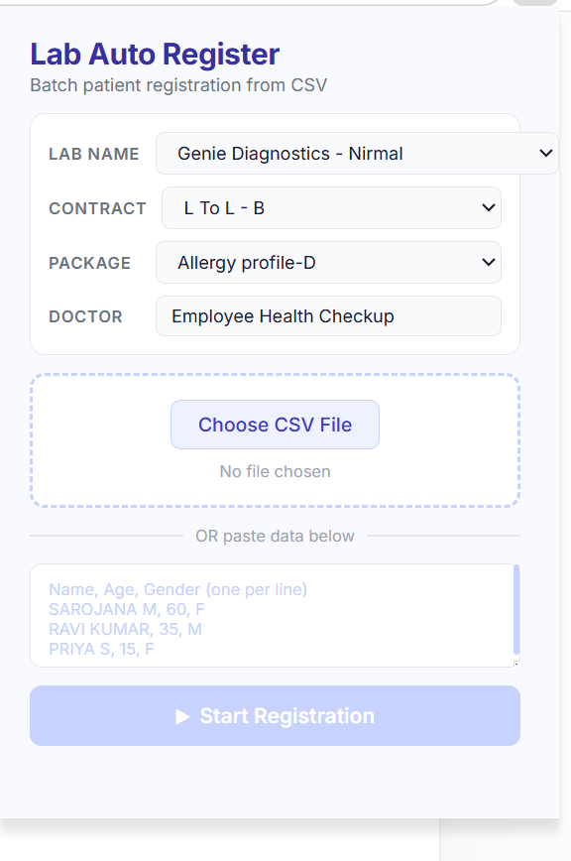

Step-by-Step Registration Instructions:
1. Log into your lab management web portal (/admin/groups/create).
2. Click the Lab Auto Register extension icon in the toolbar.
3. Select your batch presets:
- Lab Name: Choose from 48 diagnostic center locations.
- Contract: Select MRP, L To L - A, L To L - B, or Platinum Card.
- Package: Select your test profile (e.g. *Glukem Health Checkup*, *Allergy Profiles*).
- Doctor: Confirm supervising doctor name.
4. Supply your patient list:
- Click Choose CSV File to upload a .csv / .txt file, OR
- Paste patient rows directly into the text area (Name, Age, Gender).
5. Click ▶ Start Registration.
6. The extension will automatically open the patient modal, fill demographic details (inferring Mr., Mrs., Miss), select options, click Save, and proceed patient-by-patient until completed.

3. Module 2 User Guide: Diagnostic Results AutoFill (`lab-autofill`)
Target User: Lab Technician / Pathologist
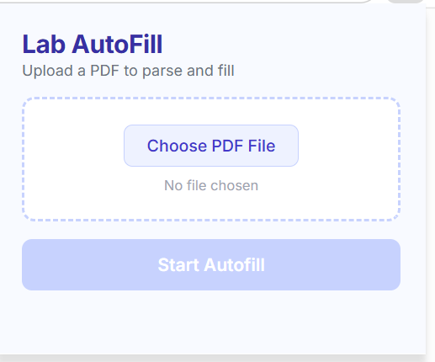

Step-by-Step AutoFill Instructions:
1. Open the patient's test form page on your lab portal.
2. Click the Lab AutoFill extension icon in your toolbar.
3. Upload the patient's PDF report (.pdf). The extension parses and stores the text in memory.
4. Click Start AutoFill.
5. The extension populates input fields and dropdowns automatically across the test table.
6. Review the Results Panel:
- ✅ Filled: Successfully matched parameters.
- ⚠️ Check: Values that appear outside expected biological bounds (double-check these numbers!).
- ❌ Missed: Parameters not found in the PDF.
7. Background Refill Feature: When you save an individual test on the web portal and the table re-renders, the extension automatically refills empty fields in the background—you do not need to re-upload the PDF!

4. Troubleshooting & FAQ
Problem | Cause | Solution
Extension shows "Error: Refresh lab website" | Web tab lost active connection | Refresh the lab web page (F5) and click Start again.
Patient marked with Miss instead of Mrs. | Age listed under 20 years | Verify age field in CSV input.
Parameter yellow warning ⚠️ Check shown | Extracted value outside expected range | Manually double-check the value against the original PDF report.
Modal doesn't open automatically | Portal loaded slowly | Increase page load delay or click "Not Listed" manually once.

