SOFTWARE REQUIREMENTS SPECIFICATION
Explainable Hybrid NLP-Based AI Resume Screening System
Final Year Project (FYP) | Version 1.0 | September 2026

Document Control
Item | Details
Project Type | Final Year Project – Data Science
Document | Software Requirements Specification
Version | 1.0
Primary Users | Recruiter / HR, Administrator
Core Stack | React, FastAPI, Python, PostgreSQL
AI/NLP | TF-IDF, semantic embeddings, hybrid scoring

Contents
1. Introduction
2. Overall Description
3. Scope and Objectives
4. Functional Requirements
5. Non-Functional Requirements
6. Use Cases
7. System Architecture
8. Data Flow Diagrams
9. Database / ERD
10. AI/NLP Methodology
11. UI Requirements
12. Security, Privacy & Fairness
13. Testing & Evaluation
14. Constraints & Assumptions
15. Future Enhancements
16. Acceptance Criteria

1. Introduction

1.1 Purpose
This SRS defines the requirements for a web-based AI Resume Screening System that assists recruiters in comparing candidate resumes with job descriptions using Natural Language Processing, semantic similarity, structured information extraction and explainable hybrid scoring.

1.2 Problem Statement
Manual screening is time-consuming and difficult to scale. Simple keyword matching can also miss semantically related qualifications. The proposed system combines keyword, structured and semantic signals to produce a transparent candidate-job match score.

1.3 Objectives
- Automate initial resume analysis.
- Extract skills, education, experience, projects and certifications.
- Normalize equivalent skill expressions.
- Compare resumes with job descriptions using keyword and semantic methods.
- Generate explainable hybrid scores.
- Rank candidates for recruiter review.
- Evaluate alternative NLP approaches on a documented dataset.
- Investigate potential bias and keep screening focused on job-relevant information.

1.4 Key Terms
Term | Meaning
NLP | Natural Language Processing
ATS | Applicant Tracking System
TF-IDF | Term Frequency–Inverse Document Frequency
Embedding | Numerical representation of text meaning
Semantic Similarity | Meaning-level similarity between texts
Hybrid Score | Combination of multiple matching signals

2. Overall Description

2.1 Product Perspective
The system consists of a React frontend, FastAPI backend, AI/NLP services, resume parsers and PostgreSQL database. The backend exposes authenticated REST APIs to the frontend.

2.2 Users
Role | Permissions
Recruiter/HR | Create jobs, upload resumes, screen, rank, compare, review explanations, export reports.
Administrator | Manage users, skills, system data, model/dataset versions and system statistics.

2.3 Assumptions
- Most resumes are PDF or DOCX.
- Job descriptions contain sufficient requirements.
- A curated skill taxonomy is available.
- Dataset licensing permits the intended use.
- AI results support, rather than replace, human review.

2.4 Constraints
- Scanned resumes may require OCR.
- Public datasets may not represent all industries or populations.
- Semantic models can miss unusual terminology.
- A score is not a guarantee of candidate suitability.

3. Scope and Objectives
In scope: authentication, job management, resume upload/parsing, NLP preprocessing, skill extraction/normalization, semantic matching, hybrid scoring, ranking, explanations, candidate comparison, analytics, reporting, security and model evaluation.
Out of scope for the first release: autonomous hiring/rejection, background checks, payroll and fully automated interviewing.

4. Functional Requirements
ID | Feature | Requirement
FR-01 | Authentication | Register/login and validate credentials.
FR-02 | Authorization | Role-based access to recruiter/admin resources.
FR-03 | Job Management | Create, edit, delete and view jobs.
FR-04 | Resume Upload | Upload PDF/DOCX and validate files.
FR-05 | Batch Processing | Upload multiple resumes for a selected job.
FR-06 | Text Extraction | Extract text from supported resumes.
FR-07 | NLP Processing | Clean and normalize resume/job text.
FR-08 | Information Extraction | Extract skills, education, experience, projects and certifications.
FR-09 | Skill Normalization | Map equivalent skill expressions to normalized concepts.
FR-10 | Keyword Matching | Perform exact/normalized requirement matching.
FR-11 | TF-IDF | Support TF-IDF/cosine similarity baseline.
FR-12 | Semantic Matching | Support embedding-based semantic similarity.
FR-13 | Hybrid Scoring | Combine multiple matching components.
FR-14 | Explainability | Show matched/missing requirements and score explanation.
FR-15 | Ranking | Rank candidates for a selected job.
FR-16 | Search/Filter | Filter by score, skills, experience and education.
FR-17 | Comparison | Compare selected candidates side by side.
FR-18 | Analytics | Display job/candidate/screening statistics.
FR-19 | Reporting | Generate screening reports.
FR-20 | Human Review | Keep recruiter decisions separate from AI score.
FR-21 | Fairness Evaluation | Include documented bias/fairness testing methodology.

5. Non-Functional Requirements
ID | Area | Requirement
NFR-01 | Performance | Process normal resumes within a reasonable time under expected load.
NFR-02 | Security | Secure password hashing, authentication and authorization.
NFR-03 | Privacy | Controlled access, retention and deletion of candidate data.
NFR-04 | Usability | Responsive, simple interface for recruiters.
NFR-05 | Reliability | Handle invalid/corrupt files without crashing.
NFR-06 | Maintainability | Modular frontend, backend, AI and data layers.
NFR-07 | Scalability | Support growth in users, jobs and resumes.
NFR-08 | Explainability | Expose major factors contributing to scores.
NFR-09 | Compatibility | Support modern web browsers.

6. Use Cases
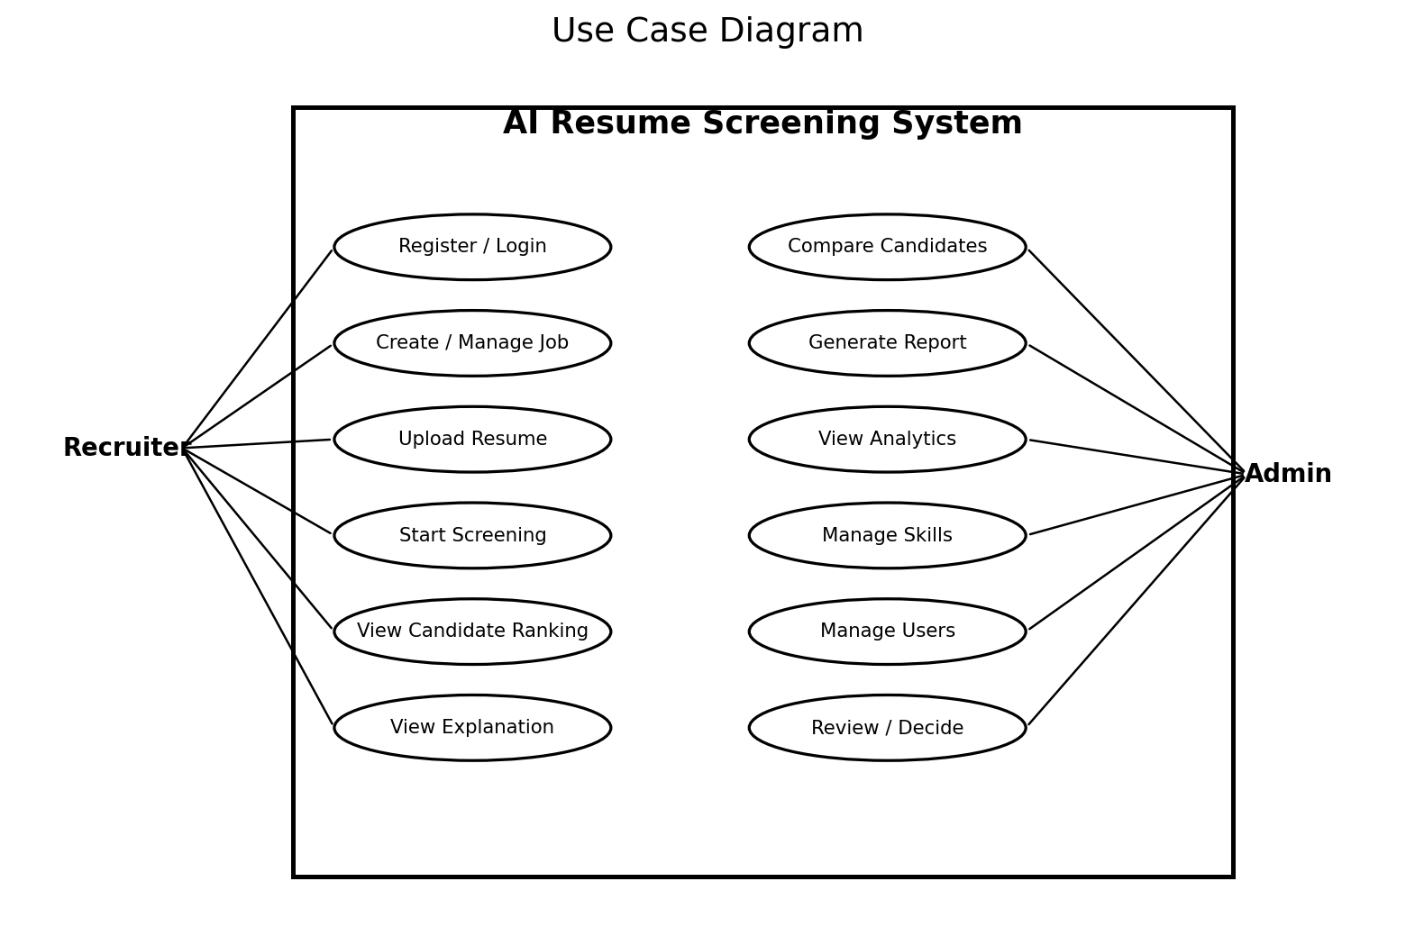
ID | Actor | Use Case | Summary
UC-01 | Recruiter/Admin | Login | Authenticate and open dashboard.
UC-02 | Recruiter | Create Job | Enter and save job requirements.
UC-03 | Recruiter | Upload Resume | Upload one or more supported files.
UC-04 | System/Recruiter | Screen Candidates | Parse, extract, match, score and rank.
UC-05 | Recruiter | Review Candidate | Inspect score, evidence and missing skills.
UC-06 | Recruiter | Compare Candidates | Compare multiple candidates.
UC-07 | Recruiter | Generate Report | Export screening summary.
UC-08 | Admin | Manage Users/Skills | Maintain accounts and skill taxonomy.

6.1 Detailed Use Case: Screen Candidates
Field | Description
Actor | Recruiter
Precondition | Logged in; job exists; resumes uploaded.
Trigger | Recruiter selects Start Screening.
Main Flow | Extract text → preprocess → extract information → keyword match → semantic match → hybrid score → rank → store results.
Alternative | Unsupported/corrupt file → error shown and file flagged/skipped.
Postcondition | Ranked results and explanations are available.

7. System Architecture
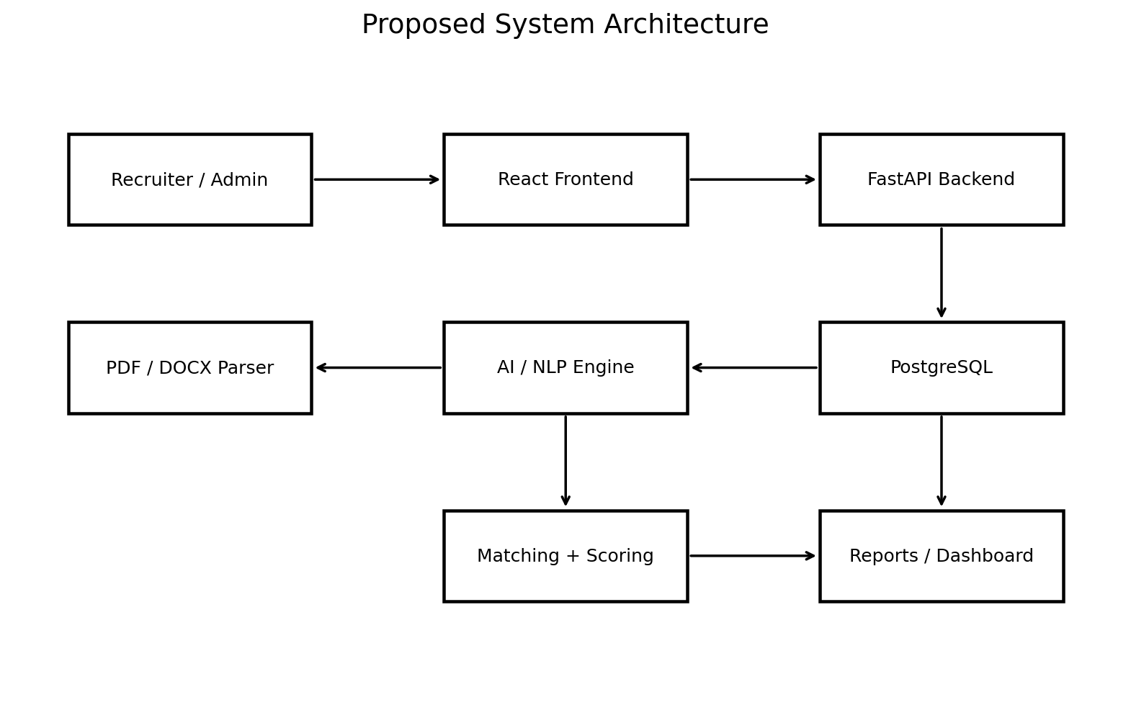
Component | Responsibility
React Frontend | Pages, forms, dashboard, upload, ranking and charts.
FastAPI Backend | Authentication, APIs, validation and business logic.
Resume Parser | PDF/DOCX text extraction.
AI/NLP Engine | Preprocessing and information extraction.
Matching Engine | Keyword, TF-IDF and semantic matching.
Scoring Engine | Hybrid score and explanations.
PostgreSQL | Users, jobs, resumes, skills and results.
Reporting | Downloadable candidate/job reports.

8. Data Flow Diagrams

8.1 Level-1 DFD
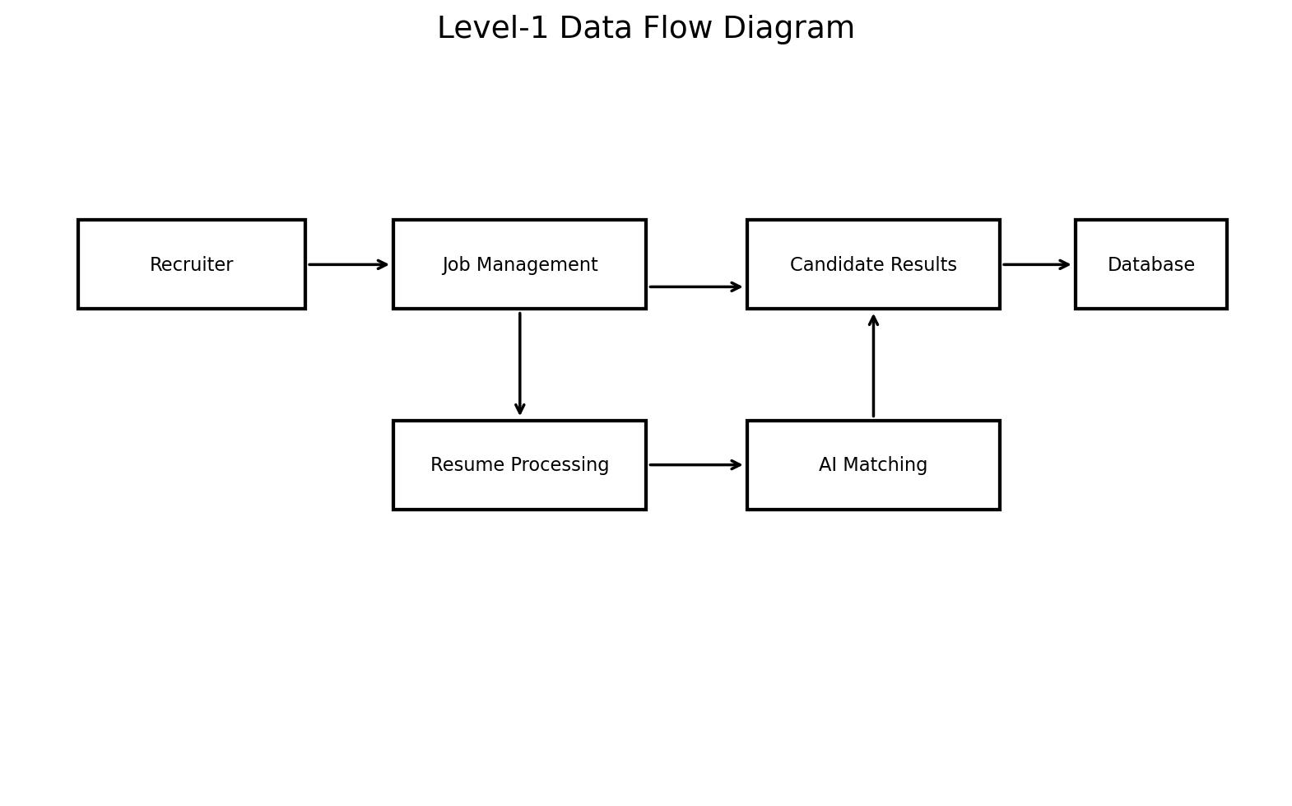

8.2 AI/NLP Screening Flow
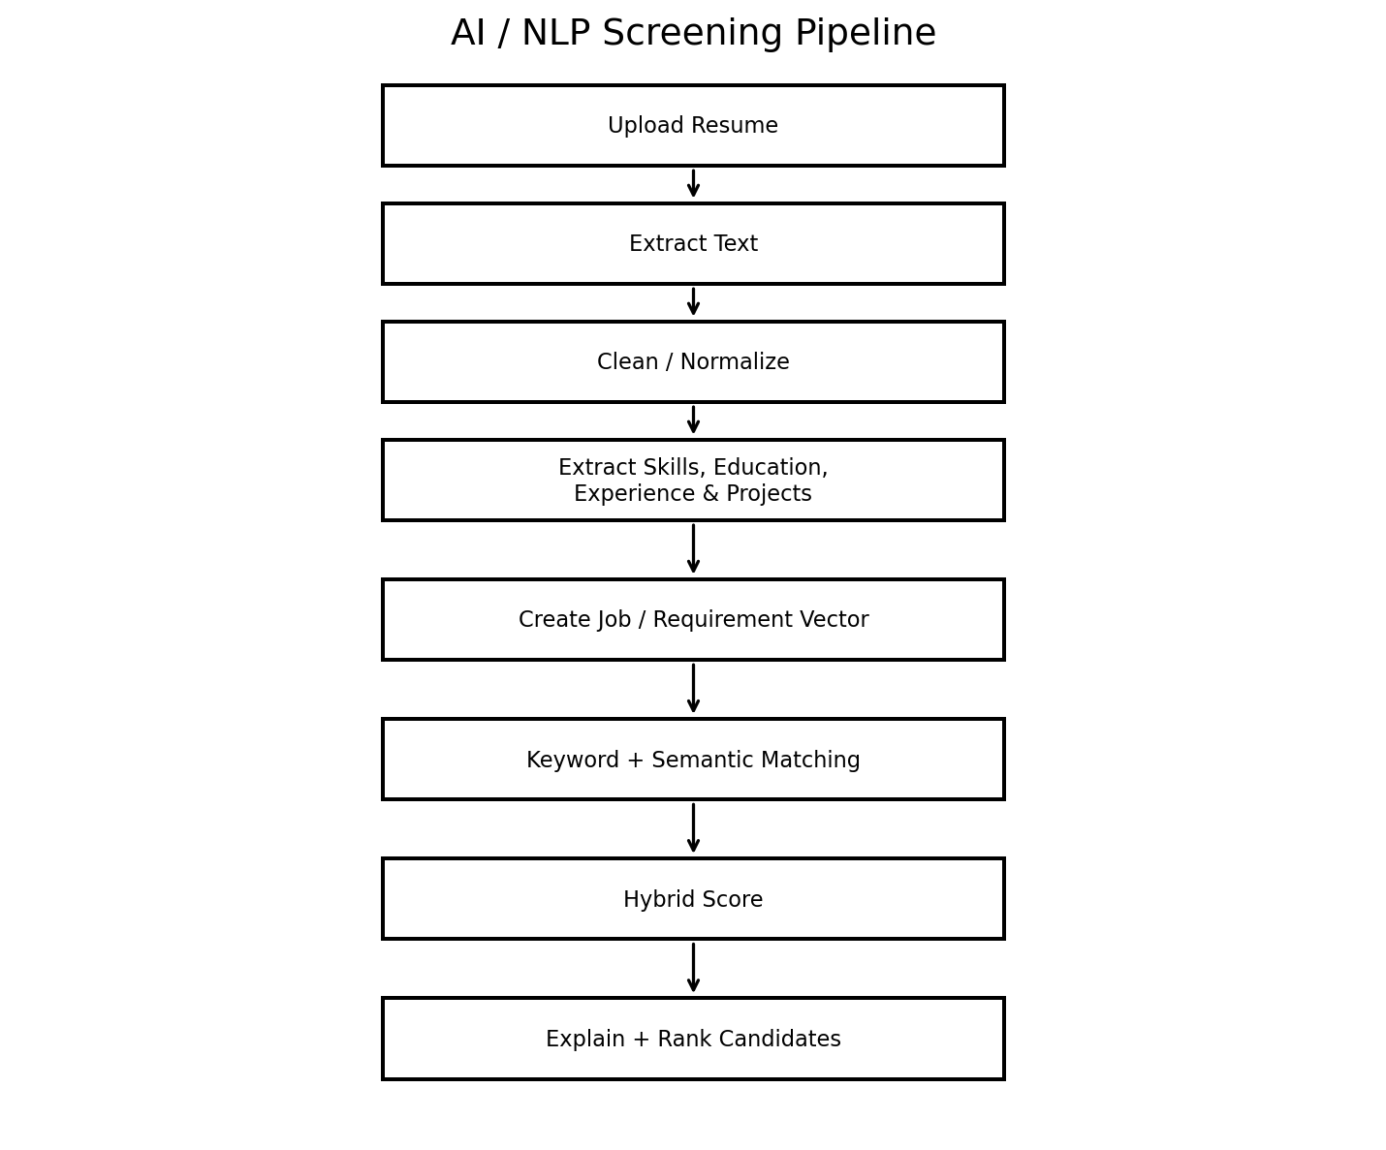

9. Database Design / ERD
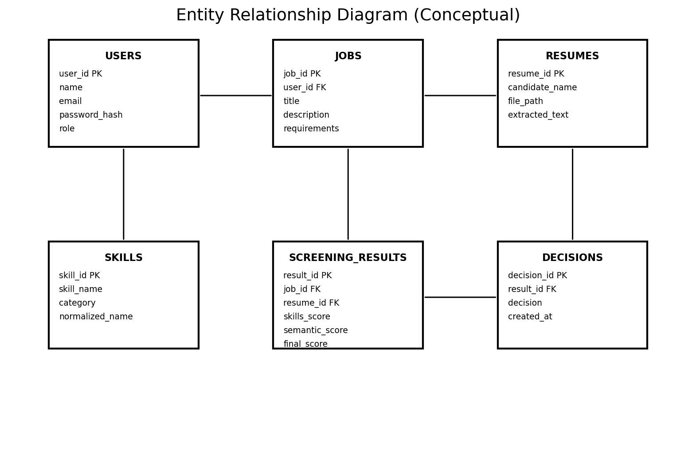
Table | Important Fields
users | user_id, name, email, password_hash, role, created_at
jobs | job_id, user_id, title, description, education, experience, status
resumes | resume_id, candidate_name, file_path, extracted_text, uploaded_at
skills | skill_id, skill_name, category, normalized_name
screening_results | result_id, job_id, resume_id, skills_score, semantic_score, experience_score, education_score, final_score
decisions | decision_id, result_id, decision, created_at
Conceptual relationships: one recruiter can create many jobs; a job can have many candidate resumes; each screening result links one job to one resume; recruiter decisions are associated with screening results.

10. AI / NLP Methodology

10.1 Pipeline

10.2 Proposed Hybrid Score
Initial experimental weighting: Skills 35%, Semantic Similarity 25%, Experience 20%, Education 10%, Projects/Certifications 10%. These are research starting points and must be justified and evaluated using the project's dataset.

10.3 Model Comparison
Approach | Role
Keyword Matching | Simple baseline.
TF-IDF + Cosine Similarity | Classical text-similarity baseline.
Sentence Embeddings | Semantic matching.
Hybrid Approach | Combines structured and semantic signals.

10.4 Evaluation
- Use accuracy/precision/recall/F1 when a labeled classification task is defined.
- Use confusion matrices for classification experiments.
- Use correlation/error metrics for continuous targets when appropriate.
- Record processing time, failure cases and examples of false matches/misses.
All reported performance numbers must come from the final evaluation dataset; example scores in the design are not experimental results.

11. User Interface Requirements
Page | Main Elements
Landing | Introduction, features, login/get started.
Login/Register | Authentication and validation.
Dashboard | Jobs, candidates, statistics.
Create Job | Title, description, skills, education, experience.
Upload | Job selector, file upload, validation and progress.
Ranking | Search, filters, rank and match score.
Candidate Details | Score breakdown, evidence, missing skills and explanation.
Comparison | Side-by-side candidate metrics.
Analytics | Charts for candidates, scores and skills.
Admin | Users, skills, system statistics.

12. Security, Privacy and Fairness
- Never store passwords in plain text.
- Protect authentication tokens/session credentials.
- Validate file type and size; consider content validation.
- Enforce authorization for recruiter-owned resources.
- Minimize sensitive candidate data in logs and analytics.
- Document retention and deletion policies.
- Keep irrelevant personal characteristics out of scoring where practical.
- Present AI output as decision support and retain human review.

13. Testing and Evaluation Plan
Test | Scenario | Expected Result
T01 | Valid login | Dashboard opens.
T02 | Invalid login | Access denied.
T03 | PDF upload | File accepted and parsed.
T04 | DOCX upload | File accepted and parsed.
T05 | Unsupported file | Clear validation error.
T06 | Corrupt/empty resume | Handled without crash.
T07 | Create job | Job stored and displayed.
T08 | Run screening | Scores/rankings generated.
T09 | View explanation | Matched/missing evidence shown.
T10 | Unauthorized access | Request denied.
T11 | Compare candidates | Comparison displayed.
T12 | Generate report | Report generated.

13.1 AI Evaluation Procedure
- Prepare a documented evaluation set with resumes, job descriptions and a labeling/ground-truth procedure.
- Use consistent train/validation/test splits where model training is performed.
- Compare baseline methods with the proposed hybrid method.
- Report metrics, data distribution, errors and limitations.
- Document dataset source, license and preprocessing steps.

14. Constraints and Assumptions
- Dataset licensing and representativeness may limit conclusions.
- Resume formats vary substantially.
- Scanned documents may require OCR.
- NLP models may produce false positives/negatives.
- Timeline and hardware may limit model size and experimentation.

15. Future Enhancements
- OCR for scanned resumes.
- Multilingual processing including Urdu.
- Fine-tuned transformer models.
- Recruiter feedback loop.
- Advanced fairness auditing.
- Cloud deployment.
- Integration with ATS/recruitment platforms.
- Automated interview scheduling.

16. Acceptance Criteria
- Recruiter can authenticate and create a job.
- PDF/DOCX resumes can be uploaded and parsed.
- Relevant candidate information can be extracted.
- Keyword and semantic matching can be executed.
- A documented hybrid score is generated.
- Candidates can be ranked and filtered.
- Each result provides an explanation.
- Recruiter decisions remain separate from AI output.
- Security/authorization tests pass.
- AI experiments are evaluated with documented data and metrics.

Appendix A – Suggested Project Structure
ai-resume-screening/
├── frontend/
│ ├── src/pages/
│ ├── src/components/
│ └── src/services/
├── backend/
│ ├── app/api/
│ ├── app/models/
│ ├── app/schemas/
│ ├── app/services/
│ └── main.py
├── ai_engine/
│ ├── parser.py
│ ├── preprocessing.py
│ ├── skill_extractor.py
│ ├── embeddings.py
│ ├── similarity.py
│ └── scoring.py
├── data/
├── tests/
├── reports/
└── README.md

Appendix B – Development Roadmap
Phase | Deliverable
1 | Requirements, SRS, use cases and diagrams
2 | UI/UX wireframes and React pages
3 | PostgreSQL schema and database APIs
4 | FastAPI backend and authentication
5 | PDF/DOCX parser
6 | NLP preprocessing and skill extraction
7 | TF-IDF and semantic matching
8 | Hybrid scoring and explainability
9 | Frontend-backend-AI integration
10 | Dataset and model evaluation
11 | Testing and security
12 | Deployment, report and presentation

Appendix C – FYP Research Contribution
The academic contribution should focus on experimentally comparing keyword, TF-IDF, semantic and hybrid matching approaches, then evaluating the proposed explainable method on a documented dataset. The web application demonstrates the practical implementation of the research rather than merely reproducing the feature list of an existing commercial recruitment platform.

