**A guide how to add port 9000**

1. Go to windows Defender Firewall

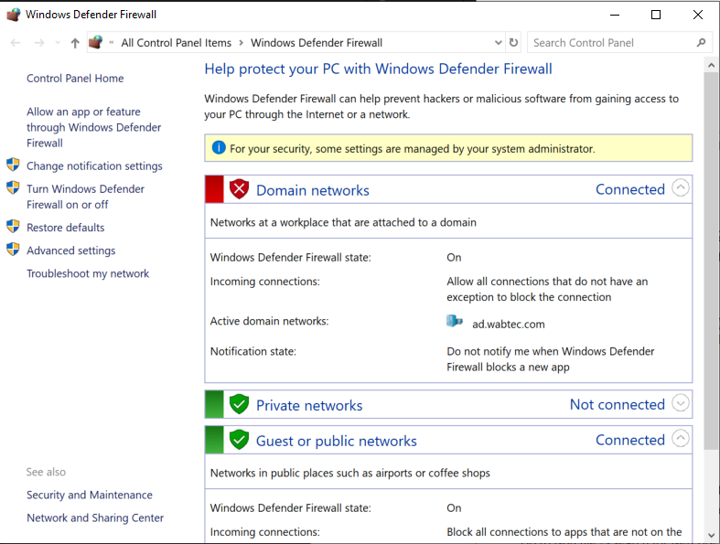

1. Advanced settings

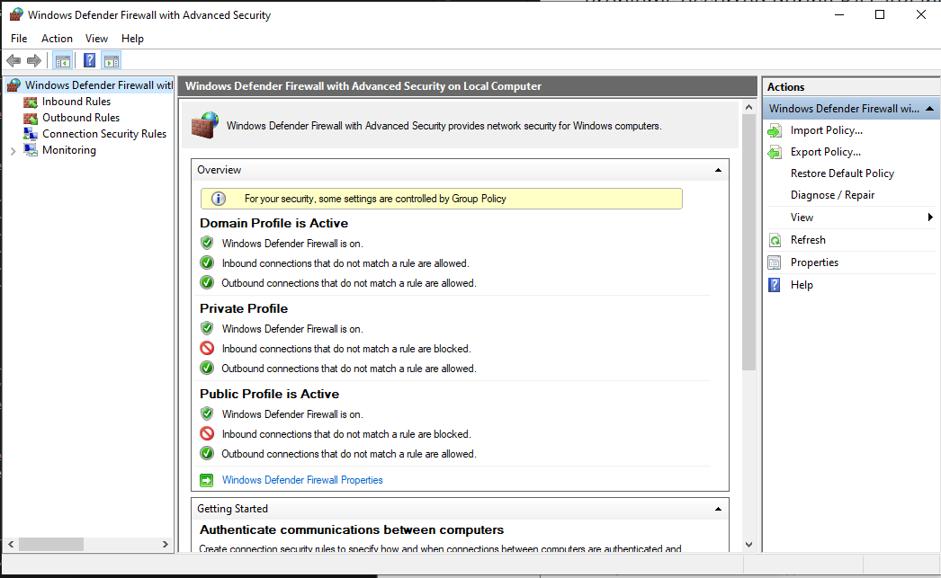

1. Press Inbound Rules

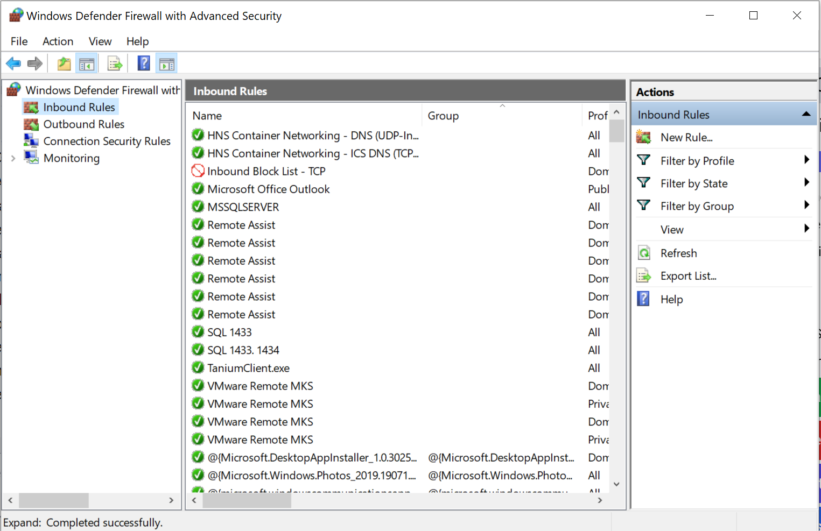

1. New rule... Press Port

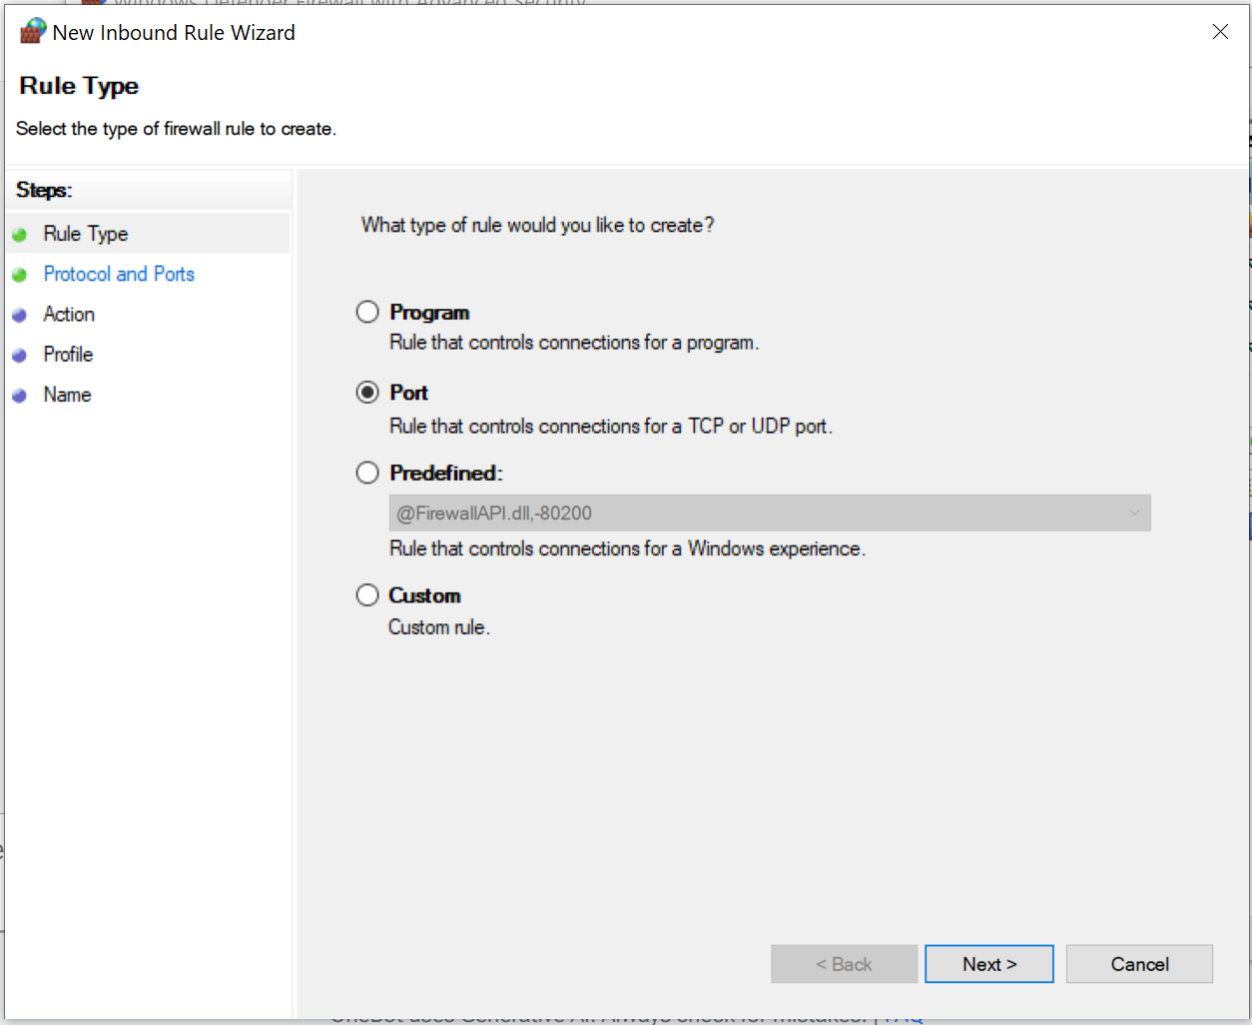

1. TCP and Specific Local Ports: Enter 9000

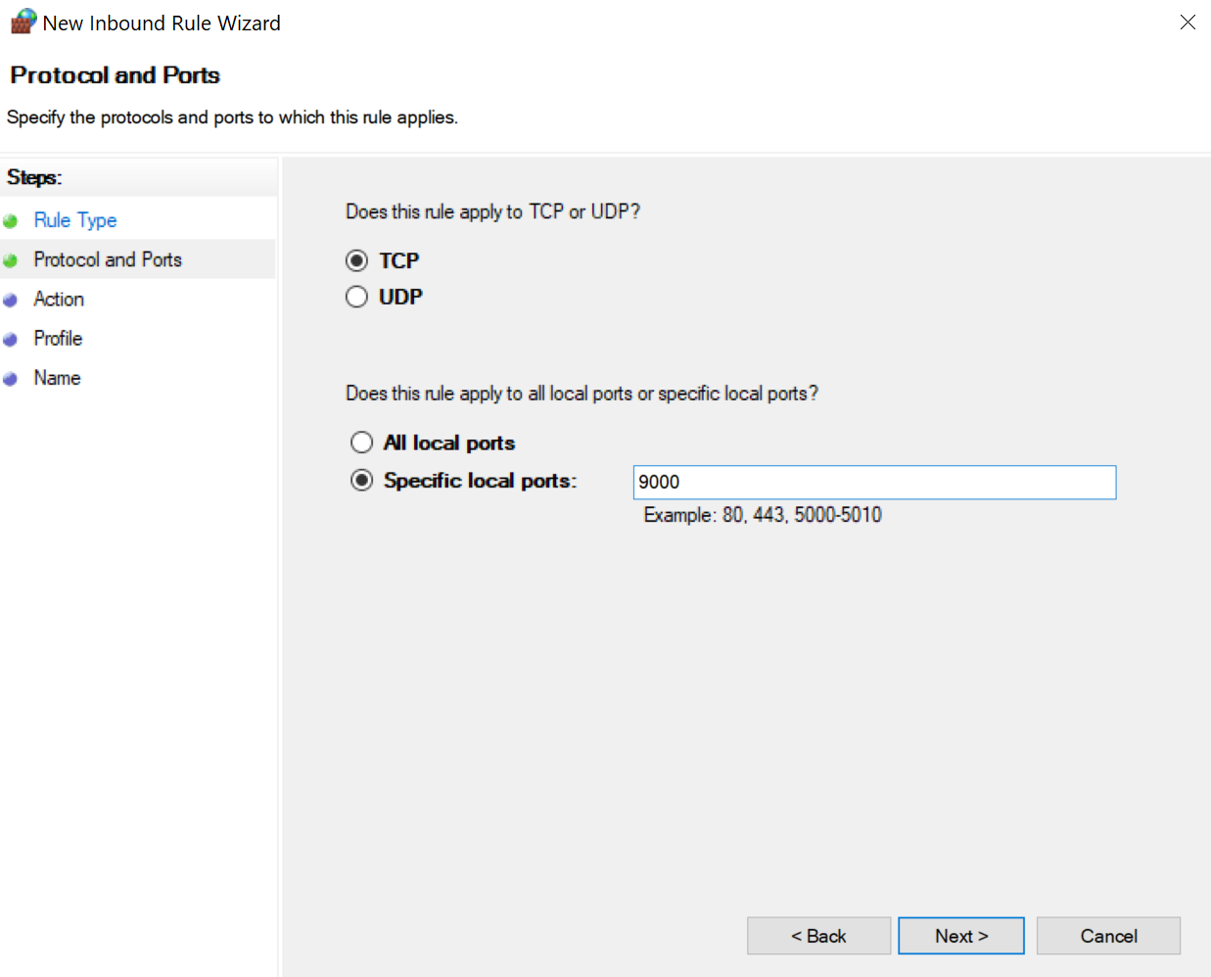

1. Next.

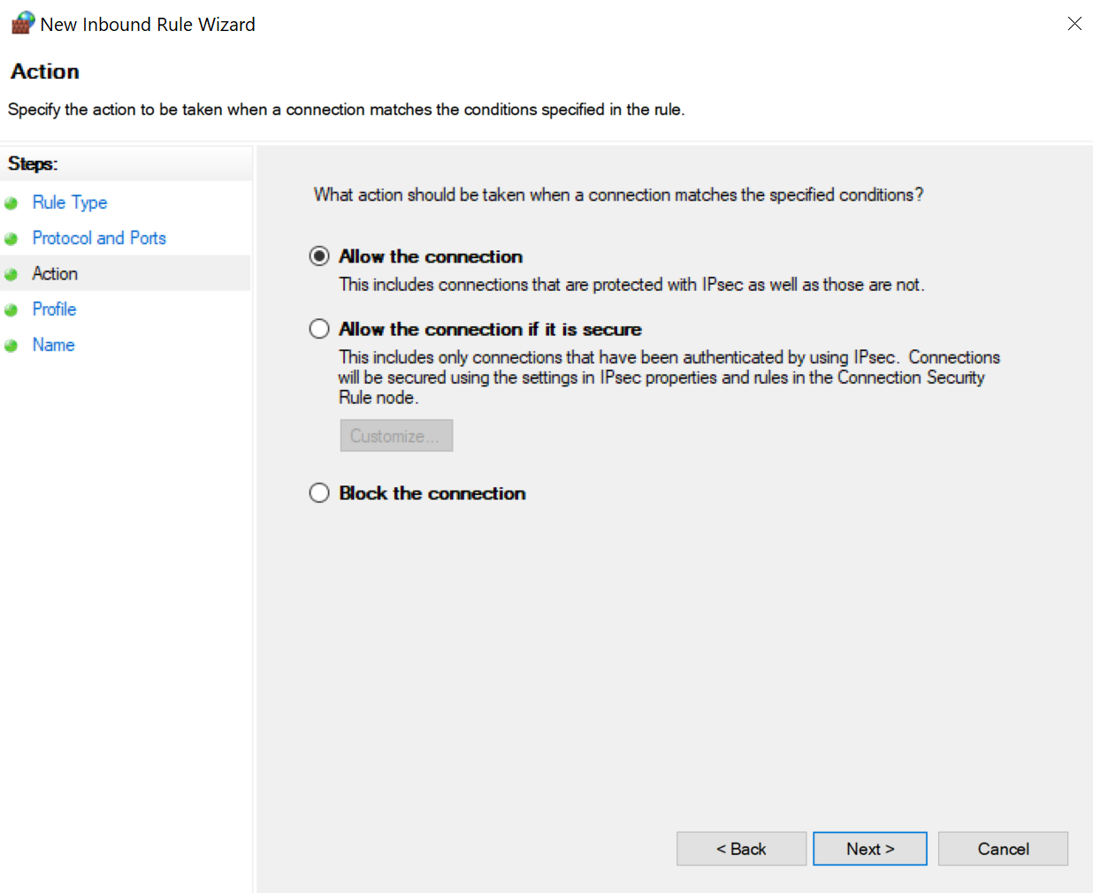

1. Next

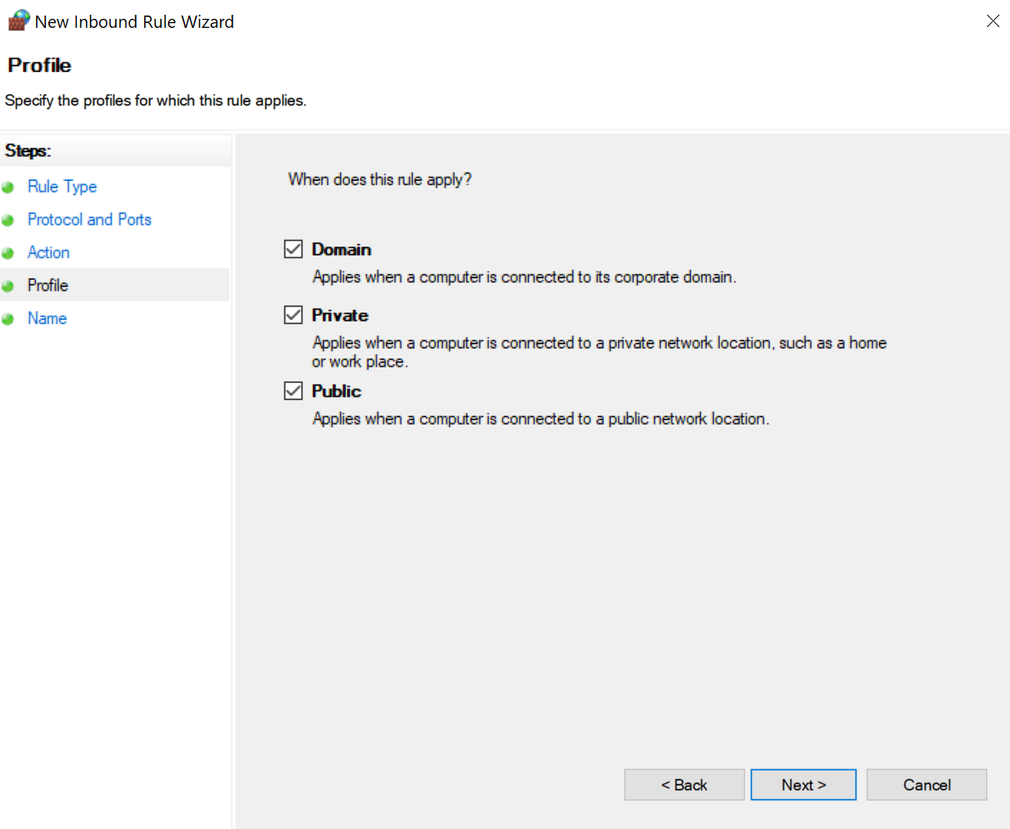

1. Write name for the rule and press Finish

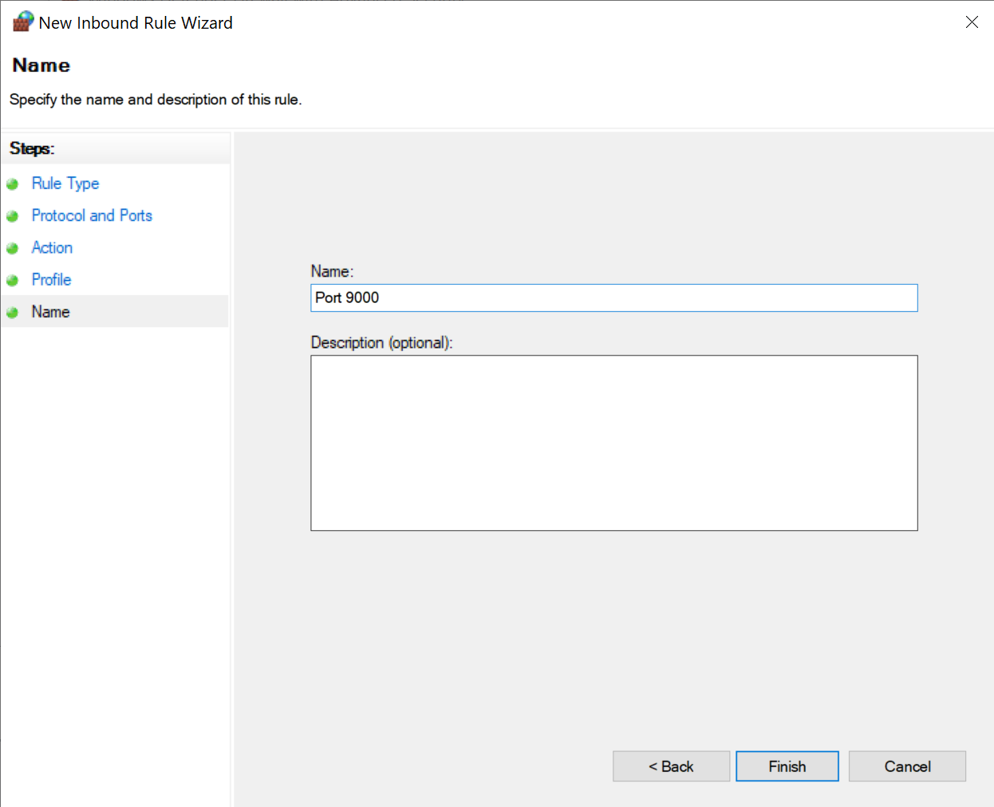

1. Do steps 4 to 8 in the same way, but for Outbound Rules

