**DAILY ONLINE ACTIVITIES SUMMARY**

|  |  |  |  |  |  |  |  |  |
| --- | --- | --- | --- | --- | --- | --- | --- | --- |
| **Date:** | **18/05/2020** | | | | | **Name:** | **NAIPUNYA VINOD NAIK** | |
| **Sem & Sec** | **IV SEM A SEC** | | | | | **USN:** | **4AL18CS050** | |
| **Online Test Summary** | | | | | | | | |
| **Subject** | | **COMPLEX ANALYSIS, PROBABILITY AND STATISTICAL METHODS** | | | | | | |
| **Max. Marks** | | **30** | | **Score** | | | **11** | |
| **Certification Course Summary** | | | | | | | | |
| **Course** | **INTRODUCTION TO HADOOP** | | | | | | | |
| **Certificate Provider** | | | **GREAT LEARNING ACADEMY** | | **Duration** | | | **5.5 HRS** |
| **Coding Challenges** | | | | | | | | |
| **Problem Statement:**  Top of Form  Bottom of Form   |  | | --- | | 1.Using methods charAt() & length() of String class, write a program to print the frequency of each character in a string. “Hello friend”  Output should be -: 1 d: 1 e: 2 f: 1 | | | | | | | | | |
| **Status: COMPLETED** | | | | | | | | |
| **Uploaded the report in Github** | | | | | **YES** | | | |
| **If yes Repository name** | | | | | <https://github.com/naiknaipu/lockdown-coding/blob/master/helo.java> | | | |
| **Uploaded the report in slack** | | | | | **YES** | | | |

Certification Course Details: (Attach the snapshot and briefly write the report for the same)

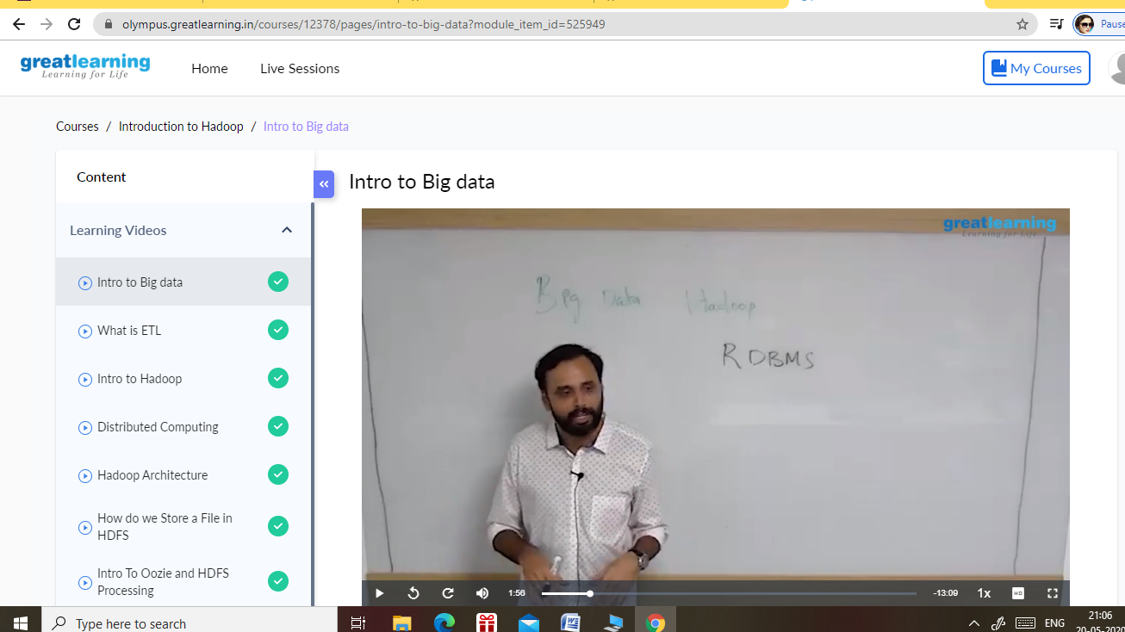

SNAPSHOT OF THE CERTIFICATION COURSE , INTRODUCTION TO HADOOP

TOPICS COVERED OF CERTIFICATION COURSE:-

* INTRO TO BIG DATA
* WHAT IS ETL
* INTRO TO HADOOP
* DISTRIBUTED COMPUTING
* HADOOP ARCHITECTURE
* HOW DO WE STORE A FILE IN HDFS
* INTRO TO OOZIE AND HDFS PROCESSING

Coding Challenges Details: (Attach the snapshot and briefly write the report for the same)

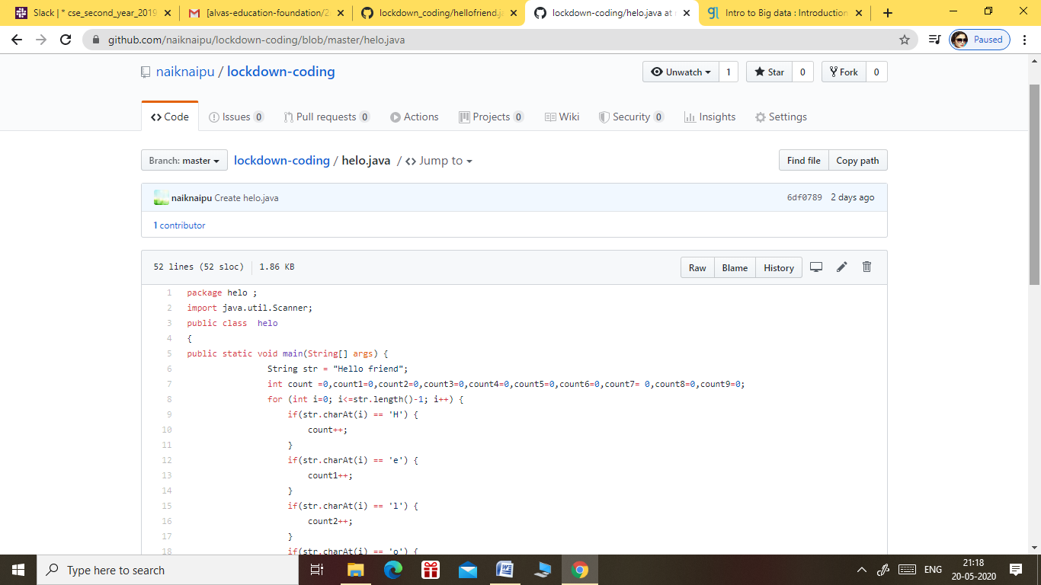

OUTPUT OF THE FOLLOWING CODE:-

