**DAILY ONLINE ACTIVITIES SUMMARY**

|  |  |  |  |  |  |  |  |  |
| --- | --- | --- | --- | --- | --- | --- | --- | --- |
| **Date:** | **23/05/2020** | | | | | **Name:** | **NAIPUNYA VINOD NAIK** | |
| **Sem & Sec** | **IV SEM & A SECTION** | | | | | **USN:** | **4AL18CS050** | |
| **Online Test Summary** | | | | | | | | |
| **Subject** | | **DATA COMMUNICATIONS** | | | | | | |
| **Max. Marks** | | **30** | | **Score** | | | **28** | |
| **Certification Course Summary** | | | | | | | | |
| **Course** | **JAVA PROGRAMMING** | | | | | | | |
| **Certificate Provider** | | | **GREAT LEARNING ACADEMY** | | **Duration** | | | **3.5 HRS** |
| **Coding Challenges** | | | | | | | | |
| **Problem Statement:** [Write a C Program to generate first N Triangular Numbers (Where N is Read from the Key board).](https://github.com/orgs/alvas-education-foundation/teams/2nd-year/discussions/78) | | | | | | | | |
| **Status: EXECUTED** | | | | | | | | |
| **Uploaded the report in Github** | | | | | **YES** | | | |
| **If yes Repository name** | | | | | <https://github.com/naipunya-naik/lockdown-coding/blob/master/C%20CODING/triangle%20generation.c> | | | |
| **Uploaded the report in slack** | | | | | **YES** | | | |

Online Test Details: (Attach the snapshot and briefly write the report for the same)

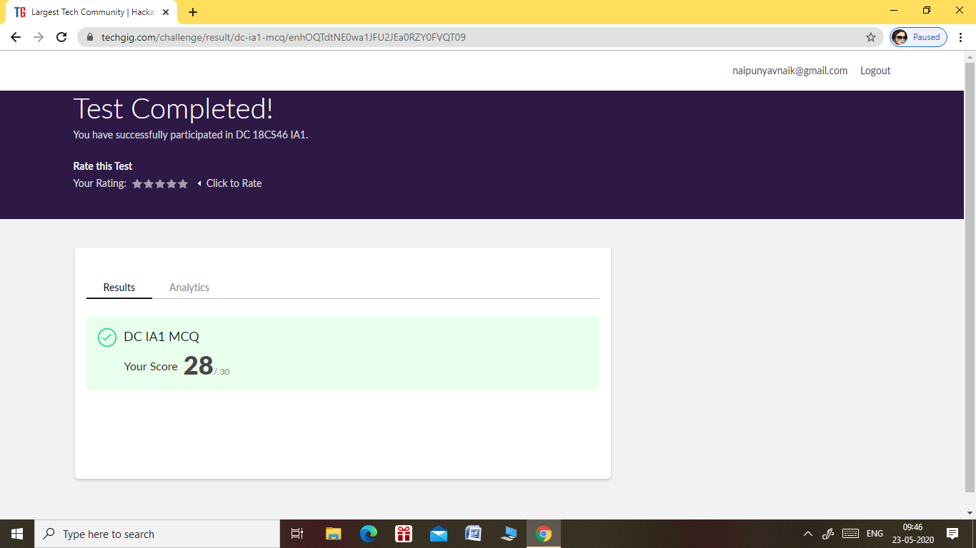

THE 1ST I.A TEST DATA COMMUNICATION WAS CONDUCTED ON 23 MAY 2020.

* SUBJECT NAME:-DATA COMMUNICATION
* SYLLABUS:- MODULE 1& MODULE 2.
* NO. OF QUESTIONS:- 30
* EACH QUESTION CARRIED ONE MARK.
* TOTAL MARKS:- 30
* DURATION:- 40 MIN
* TEST START TIME:- 9.15 AM
* TEST END TIME:- 9.55 AM

Certification Course Details: (Attach the snapshot and briefly write the report for the same)

CERTIFICATION COURSE NAME:- JAVA PROGRAMMING

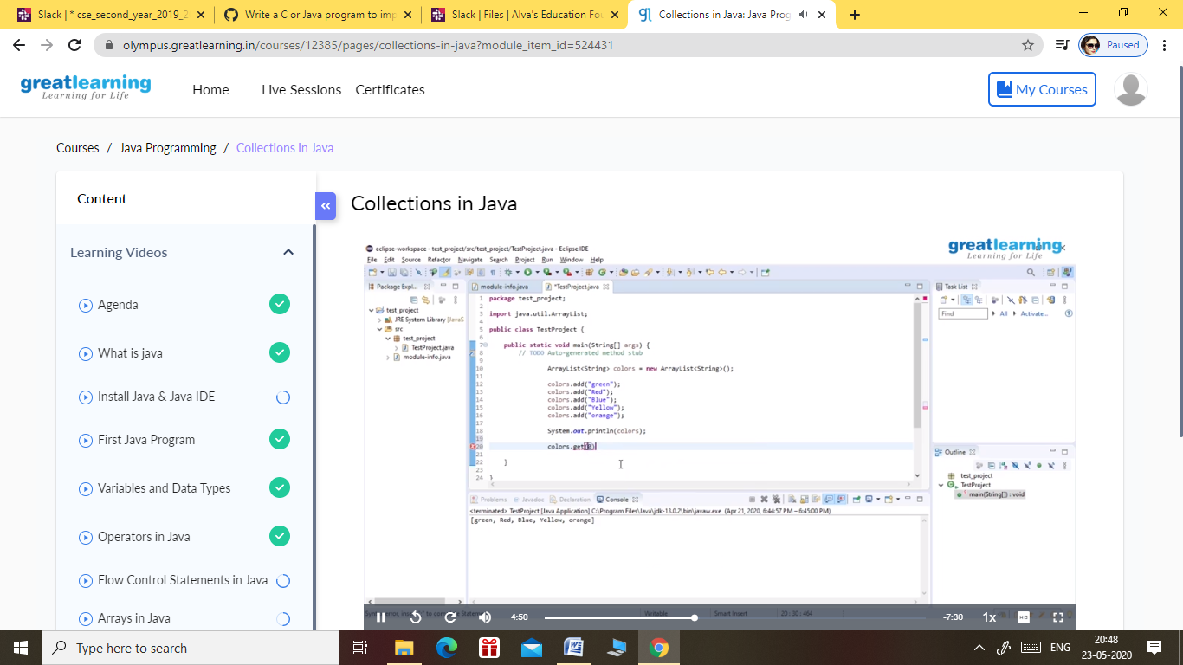

TOPICS COVERED ON 23 MAY 2020:-

* ARRAYS IN JAVA
* FUNCTIONS IN JAVA
* OBJECT ORIENTED PROGRAMMING IN JAVA
* INHERITANCE IN JAVA
* COLLECTIONS IN JAVA

Coding Challenges Details: (Attach the snapshot and briefly write the report for the same)

PROBLEM STATEMENT 1:-

[Write a C Program to generate first N Triangular Numbers (Where N is Read from the Key board).](https://github.com/orgs/alvas-education-foundation/teams/2nd-year/discussions/78)

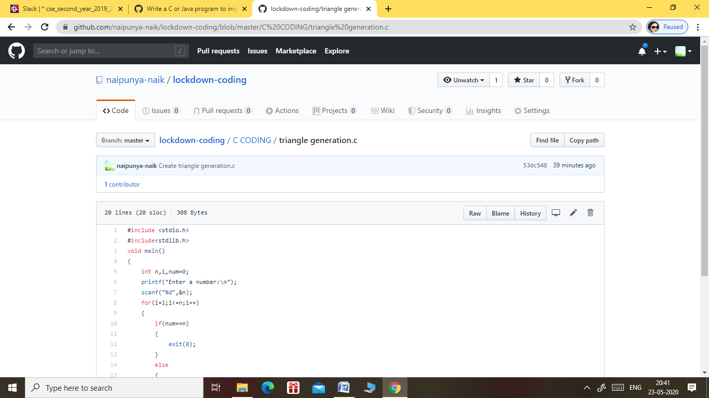

GITHUB REPOSITORY LINK:-

<https://github.com/naipunya-naik/lockdown-coding/blob/master/C%20CODING/triangle%20generation.c>