**DAILY ONLINE ACTIVITIES SUMMARY**

|  |  |  |  |  |  |  |  |  |
| --- | --- | --- | --- | --- | --- | --- | --- | --- |
| **Date:** | **04/06/2020** | | | | | **Name:** | **NAIPUNYA VINOD NAIK** | |
| **Sem & Sec** | **IV SEM & A SECTION** | | | | | **USN:** | **4AL18CS050** | |
| **Online Test Summary** | | | | | | | | |
| **Subject** | | **MICROCONTROLLER & EMBEDDED SYSTEMS** | | | | | | |
| **Max. Marks** | | **20** | | **Score** | | | **16** | |
| **Certification Course Summary** | | | | | | | | |
| **Course** | **INTRODUCTION TO DIGITAL MARKETING** | | | | | | | |
| **Certificate Provider** | | | **GOOGLE** | | **Duration** | | | **40 HRS** |
| **Coding Challenges** | | | | | | | | |
| **Problem Statement:1) write a java program to read three integer values from the keyboard and find the sum of the values. Declare a variable "sum" of type int and store the result in it.**  **2)** [**Write a C++ program to find the missing number in array**](https://github.com/orgs/alvas-education-foundation/teams/2nd-year/discussions/99)**.** | | | | | | | | |
| **Status: EXECUTED** | | | | | | | | |
| **Uploaded the report in Github** | | | | | **YES** | | | |
| **If yes Repository name** | | | | | [**https://github.com/naipunya-naik/lockdown-coding/blob/master/JAVA%20CODING/sum_04-06-2020.java**](https://github.com/naipunya-naik/lockdown-coding/blob/master/JAVA%20CODING/sum_04-06-2020.java)  [**https://github.com/naipunya-naik/lockdown-coding/blob/master/C%2B%2B%20CODING/MissingElements_04-06-2020.cpp**](https://github.com/naipunya-naik/lockdown-coding/blob/master/C%2B%2B%20CODING/MissingElements_04-06-2020.cpp) | | | |
| **Uploaded the report in slack** | | | | | **YES** | | | |

**Online Test Details: (Attach the snapshot and briefly write the report for the same).**

**THE 3RD I.A TEST OF SUBJECT MICROCONTROLLER & EMBEDDED SYSTEMS WAS CONDUCTED ON 04 JUNE 2020.**

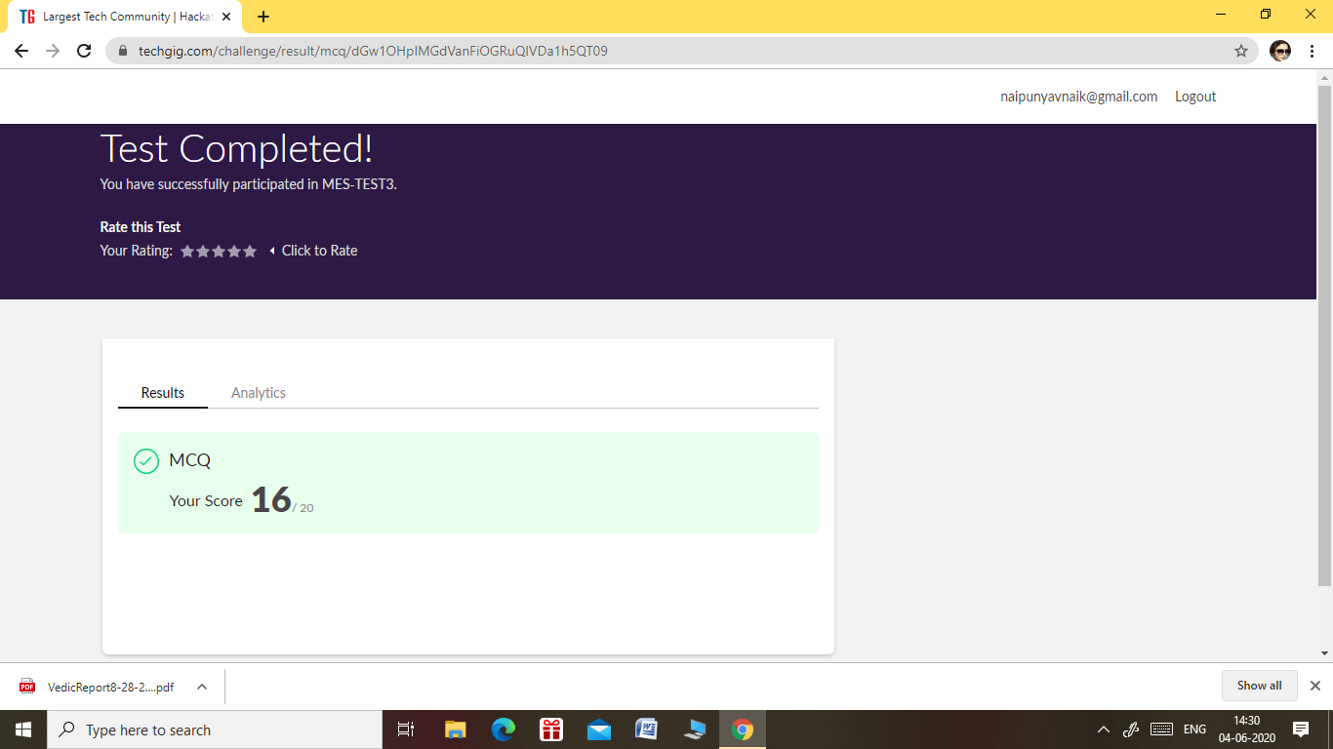

* **SUBJECT :- MICROCONTROLLER AND EMBEDDED SYSTEMS**
* **SYLLABUS:- MODULE 3**
* **START TIME:- 2.00 PM**
* **END TIME:- 2.30 PM**
* **DURATION:- 30 MIN**
* **NO.OF QUESTIONS:- 20**
* **TOTAL MARKS:- 20**
* **EACH QUESTION CARRIED 1MARK**

**Certification Course Details: (Attach the snapshot and briefly write the report for the same).**



* **ON JUNE 01, 2020, I ATTENDED A WEBINAR ON THE TOPIC “OPPORTUNITIES IN IT HARDWARE SECTOR” FROM ACS COLLEGE OF ENGINEERING.**
* **TODAY I RECEIVED THIS E-CERTIFICATE.**

**2) CERTIFICATION COURSE NAME:- INTRODUCTION TO DIGITAL MARKETING**



**TOPICS COVERED ON 04 JUNE 2020:-**

* **THE BENEFITS OF AN ONLINE STRATEGY**
* **TAKING A BUSINESS ONLINE**
* **UNDERSTANDING CUSTOMER BEHAVIOUR**
* **HOW TO STAND OUT FROM THE COMPETITION**
* **USING GOALS TO IMPROVE PERFORMANCE**

**Coding Challenges Details: (Attach the snapshot and briefly write the report for the same)**

**1)** [**Write a C++ program to find the missing number in array**](https://github.com/orgs/alvas-education-foundation/teams/2nd-year/discussions/99)

|  |
| --- |
| **Given an array C of size N-1 and given that there are numbers from 1 to N with one element missing, the missing number is to be found.**  **Input: The first line of input contains an integer T denoting the number of test cases. For each test case first line contains N(size of array). The subsequent line contains N-1 array elements.**  **Output: Print the missing number in array.**  **Constraints: 1 ≤ T ≤ 200 1 ≤ N ≤ 107 1 ≤ C[i] ≤ 107**  **Example: Input: 1 5 1 2 3 5**  **Output:- 4**  **Screenshot (87).png**  **GITHUB REPOSITORY LINK:-**  [**https://github.com/naipunya-naik/lockdown-coding/blob/master/C%2B%2B%20CODING/MissingElements_04-06-2020.cpp**](https://github.com/naipunya-naik/lockdown-coding/blob/master/C%2B%2B%20CODING/MissingElements_04-06-2020.cpp) |

**2) PROBLEM STATEMENT:- Write a java program to read three integer values from the keyboard and find the sum of the values. Declare a variable "sum" of type int and store the result in it.**

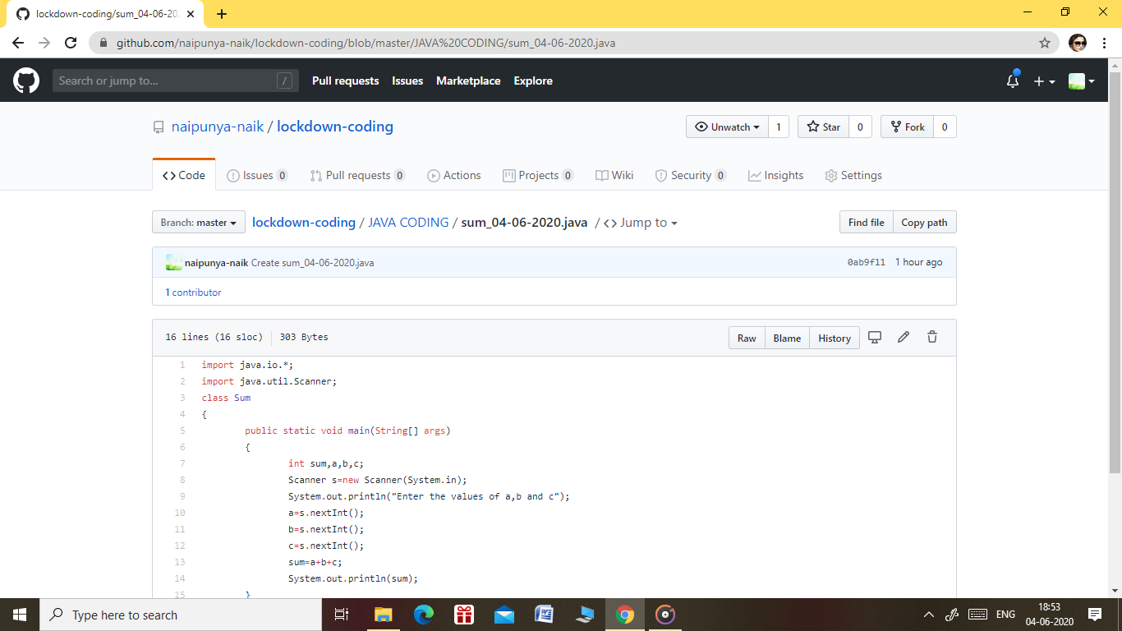

**GITHUB REPOSITORY LINK:-**

[**https://github.com/naipunya-naik/lockdown-coding/blob/master/JAVA%20CODING/sum_04-06-2020.java**](https://github.com/naipunya-naik/lockdown-coding/blob/master/JAVA%20CODING/sum_04-06-2020.java)