**Data Warehouse Assignment 1: Q1. IPL tournament**

Ans: DWH diagram (Star Schema)

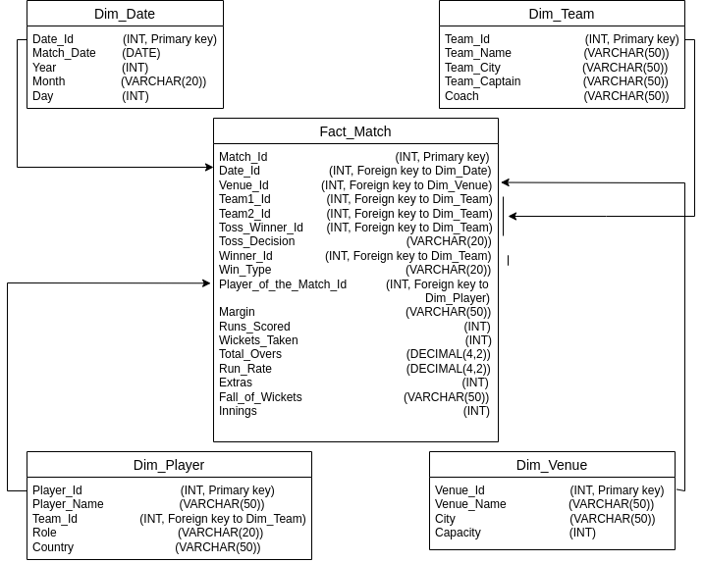

**List of Dimensions and their definition:**

**All the dimensions shall be maintained in SCD-Type1 fashion**

1. **Dim_Date Table:- This table would contain the date of each IPL match**

CREATE TABLE Dim_Date (

Date_Id INT PRIMARY KEY,

Match_Date DATE,

Year INT,

Month VARCHAR(20),

Day INT

);

1. **Dim_Team Table:- This table would contain information about the teams that play in IPL**

CREATE TABLE Dim_Team (

Team_Id INT PRIMARY KEY,

Team_Name VARCHAR(50),

Team_City VARCHAR(50),

Team_Captain VARCHAR(50),

Coach VARCHAR(50)

);

1. **Dim_Player Table:- This table would contain information about the players in IPL**

CREATE TABLE Dim_Player (

Player_Id INT PRIMARY KEY,

Player_Name VARCHAR(50),

Team_Id INT,

Role VARCHAR(20),

Country VARCHAR(50),

FOREIGN KEY (Team_Id) REFERENCES Dim_Team(Team_Id)

);

1. **Dim_Venue Table:- This table would contain information about the venues where IPL matches are played**

CREATE TABLE Dim_Venue (

Venue_Id INT PRIMARY KEY,

Venue_Name VARCHAR(50),

City VARCHAR(50),

Capacity INT

);

1. **Fact_Match Table:- This table would contain information about each IPL match**

CREATE TABLE Fact_Match (

Match_Id INT PRIMARY KEY,

Date_Id INT,

Venue_Id INT,

Team1_Id INT,

Team2_Id INT,

Toss_Winner_Id INT,

Toss_Decision VARCHAR(20),

Winner_Id INT,

Win_Type VARCHAR(20),

Player_of_the_Match_Id INT,

Margin VARCHAR(50),

Runs_Scored INT,

Wickets_Taken INT,

Total_Overs DECIMAL(4,2),

Run_Rate DECIMAL(4,2),

Extras INT,

Fall_of_Wickets VARCHAR(50),

Innings INT,

FOREIGN KEY (Date_Id) REFERENCES Dim_Date(Date_Id),

FOREIGN KEY (Venue_Id) REFERENCES Dim_Venue(Venue_Id),

FOREIGN KEY (Team1_Id) REFERENCES Dim_Team(Team_Id),

FOREIGN KEY (Team2_Id) REFERENCES Dim_Team(Team_Id),

FOREIGN KEY (Toss_Winner_Id) REFERENCES Dim_Team(Team_Id),

FOREIGN KEY (Winner_Id) REFERENCES Dim_Team(Team_Id),

FOREIGN KEY (Player_of_the_Match_Id) REFERENCES Dim_Player(Player_Id)

);

The Fact_Match table would also contain columns for various match statistics such as runs scored, wickets taken, and other performance metrics.

SQL queries to generate insightful business metrics:

1. **Total matches played in each year:**

SELECT year, COUNT(*) AS num_matches

FROM Dim_Date d

JOIN Fact_Match f ON d.Date_Id = f.Date_Id

GROUP BY year;

1. **Total runs scored by each team in each year:**

SELECT year, t.Team_Name, SUM(runs) AS total_runs

FROM Dim_Team t

JOIN Fact_Match f ON t.Team_Id = f.Team1_Id OR t.Team_Id = f.Team2_Id

JOIN (SELECT Match_Id, SUM(runs_scored) AS runs

FROM Fact_Match

GROUP BY Match_Id) fm ON f.Match_Id = fm.Match_Id

JOIN Dim_Date d ON f.Date_Id = d.Date_Id

GROUP BY year, t.Team_Name;

1. **Top 10 players with the highest batting average:**

SELECT p.Player_Name, AVG(batting_average) AS avg_batting_avg

FROM Dim_Player p

JOIN (SELECT Player_Id, SUM(runs_scored) AS total_runs, COUNT(*) AS num_innings,

SUM(CASE WHEN out_type IS NULL THEN 0 ELSE 1 END) AS num_outs,

(SUM(runs_scored) / (CASE WHEN SUM(CASE WHEN out_type IS NULL THEN 0 ELSE 1 END) = 0 THEN 1 ELSE SUM(CASE WHEN out_type IS NULL THEN 0 ELSE 1 END) END)) AS batting_average

FROM Fact_Match

GROUP BY Player_Id) b ON p.Player_Id = b.Player_Id

GROUP BY p.Player_Name

ORDER BY avg_batting_avg DESC

LIMIT 10;

**Q2. Swiggy DWH**

Ans: DWH diagram (Star Schema)

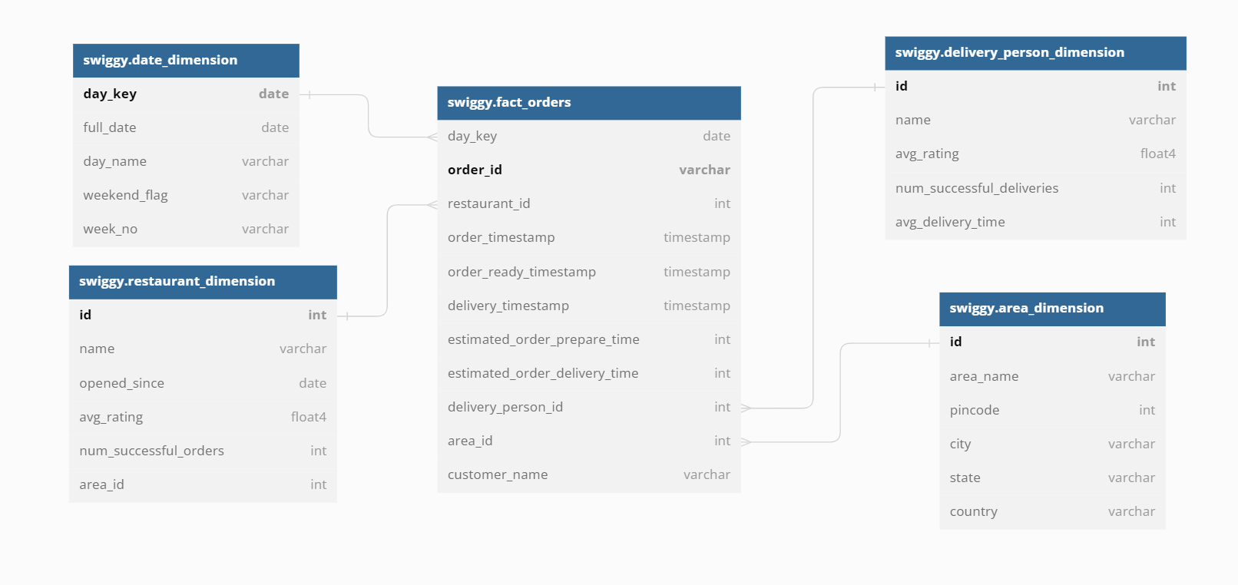

**List of Dimensions and their definition:**

**All the dimensions shall be maintained in SCD-Type1 fashion**

1. **swiggy.restaurant_dimension**

swiggy.restaurant_dimension {

id int [pk]

name varchar

opened_since date

avg_rating float4

num_successful_orders int

area_id int

}

1. **swiggy.area_dimension**

swiggy.area_dimension {

id int [pk]

area_name varchar

pincode int

city varchar

state varchar

country varchar

}

1. **swiggy.delivery_person_dimension**

swiggy.delivery_person_dimension {

id int [pk]

name varchar

avg_rating float4

num_successful_deliveries int

avg_delivery_time int

}

1. **swiggy.date_dimension**

swiggy.date_dimension {

day_key date [pk]

full_date date

day_name varchar

weekend_flag varchar

week_no varchar

}

1. **swiggy.fact_orders**

swiggy.fact_orders {

day_key date [ref: > swiggy.date_dimension.day_key]

order_id varchar [pk]

restaurant_id int [ref: > swiggy.restaurant_dimension.id]

order_timestamp timestamp

order_ready_timestamp timestamp

delivery_timestamp timestamp

estimated_order_prepare_time int

estimated_order_delivery_time int

delivery_person_id int [ref: > swiggy.delivery_person_dimension.id]

area_id int [ref: > swiggy.area_dimension.id]

customer_name varchar

}

SQL queries to generate insightful business metrics:

1. **What is the area wise percentage of orders delivered on time?**

with cte as

(

select a.area_name, a.pincode, count(*) ontime_deliveries from swiggy.area_dim a

inner join

swiggy.fact_orders f

on a.id= f.area_id

where TIMESTAMPADD(MINUTE,estimated_order_delivery_time,order_timestamp) <= order_timestamp

group by a.area_name, a.pincode

),

cte1 as

(

select a.area_name, a.pincode, count(*) total_deliveries from swiggy.area_dim a

inner join

swiggy.fact_orders f

on a.id= f.area_id

group by a.area_name, a.pincode

)

select cte.area_name,cte.pincode, (ontime_deliveries*100/total_deliveries) area_wise_percentage

from cte

inner join cte1

on cte.area_name=cte1.area_name and cte.pincode=cte1.pincode;

**2. What is the area from which most orders are received?**

with cte as

(

select a.area_name, a.pincode, count(*) total_deliveries from swiggy.area_dim a

inner join

swiggy.fact_orders f

on a.id= f.area_id

group by a.area_name, a.pincode

)

Select * from cte

Order by total_deliveries desc limit 1;

3.**Who’s fault was there in a particular area for delayed deliveries (restaurant or delivery person)?**

select a.area_name, a.pincode,

case

when TIMESTAMPADD(MINUTE, estimated_order_prepare_time,order_timestamp) > order_ready_timestamp then ‘Restaurant’s fault’

when TIMESTAMPADD(MINUTE, estimated_order_delivery_time,order_timestamp) > delivery_timestamp then ‘Delivery person’s fault’

end Delay_Reason

from swiggy.fact_orders f

inner join

swiggy.area_dim a

on a.id= f.area_id

where a.area_name=’Kondapur’ and a.pincode=500084

**Q3. Uber DWH**

Ans: **DWH diagram (Star Schema)**

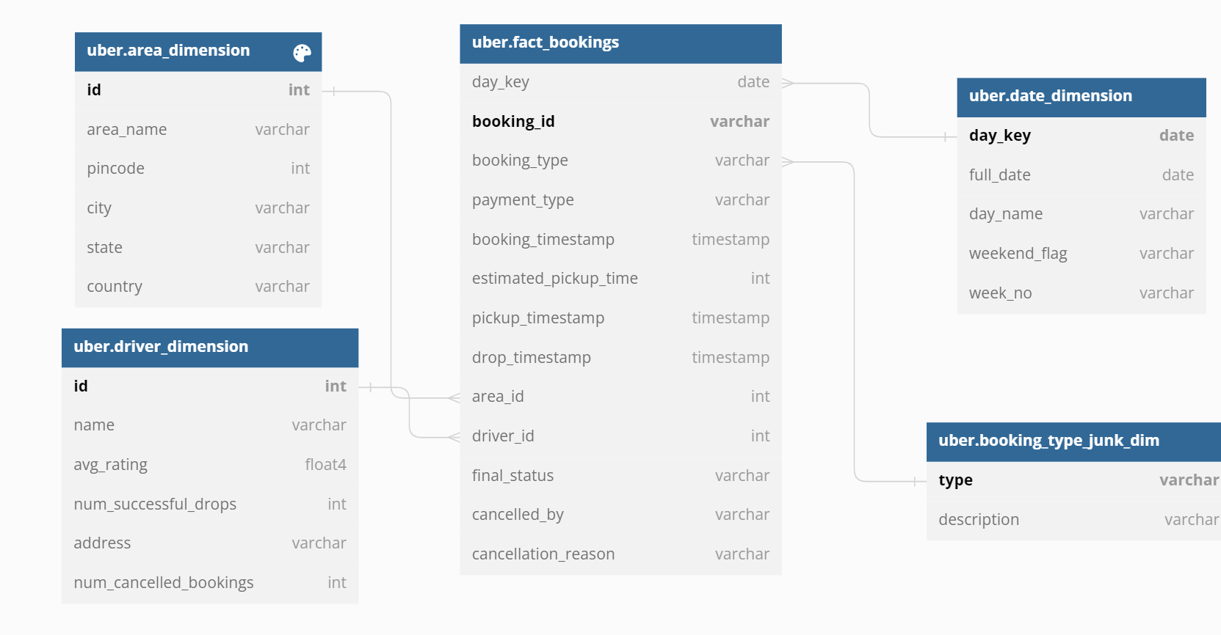

**List of Dimensions and their definition:**

**All the dimensions shall be maintained in SCD-Type1 fashion**

Table uber.area_dimension {

id int [pk]

area_name varchar

pincode int

city varchar

state varchar

country varchar

}

Table uber.driver_dimension {

id int [pk]

name varchar

avg_rating float4

num_successful_drops int

address varchar

num_cancelled_bookings int

}

Table uber.date_dimension {

day_key date [pk]

full_date date

day_name varchar

weekend_flag varchar

week_no varchar

}

**Facts and their definition:**

Table uber.fact_bookings {

day_key date [ref: > uber.date_dimension.day_key]

booking_id varchar [pk]

booking_type varchar

payment_type varchar

booking_timestamp timestamp

estimated_pickup_time int

pickup_timestamp timestamp

drop_timestamp timestamp

area_id int [ref: > uber.area_dimension.id]

driver_id int [ref: > uber.driver_dimension.id]

final_status varchar

cancelled_by varchar

cancellation_reason varchar

}

**Insightful reports:**

1. **What is the area wise count of ride bookings on a particular day?**

select count(*) num_of_rides,f.booking_type , a.area_name, a.city, a.state from

uber.fact_bookings f left join uber.area_dimension a

on f.area_id=a.id

where f.day_key='2022-01-05'

group by f.booking_type , a.area_name, a.city, a.state;

1. **Percentage of rides which have abnormally long pickup time daywise?**

with cte as

(

select f.day_key, count(*) delayed_pickup_num from uber.fact_orders f

inner join

uber.area_dim a

on a.id= f.area_id

where TIMESTAMPADD(MINUTE,estimated_pickup_time,booking_timestamp)

> pickup_timestamp group by f.day_key

),

cte1 as

(

select f.day_key, count(*) total_drops from uber.fact_orders f

inner join

uber.area_dim a

on a.id= f.area_id

where f.final_status='Dropped successfully'

group by f.day_key

)

select cte.day_key, (cte.delayed_pickup_num*100/cte1.total_drops)

day_wise_percentage

from cte

inner join cte1

on cte.day_key=cte1.day_key;

1. **Daywise, Areawise, peak time of the day (in terms of hour of the day)?**

with cte as

(

select f.day_key, hour(f.booking_timestamp) hour_of_booking

a.area_name, a.city, a.state,

count(*) num_of_rides,

from

uber.fact_bookings f

inner join uber.area_dimension a

on f.area_id=a.id

group by f.day_key , hour(f.booking_timestamp), a.area_name, a.city, a.state

order by count(*) desc limit 1

)

select * from cte

**Q4. Dineout Datawarehouse**

Ans: **DWH diagram (Snowflake Schema)**

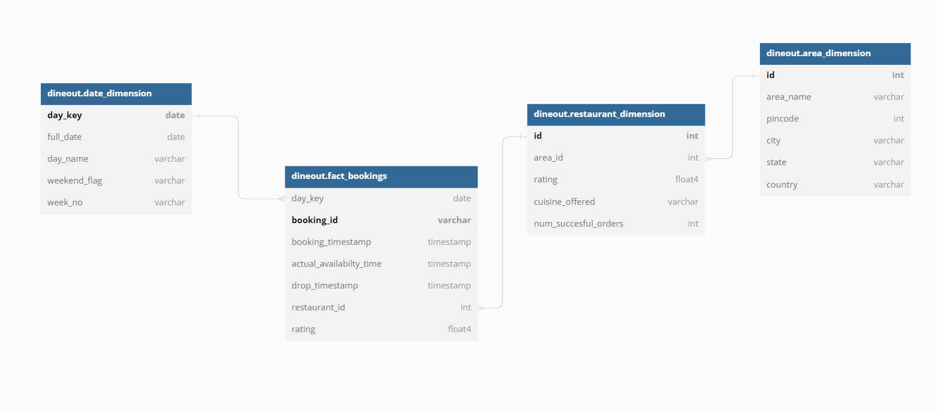

**List of Dimensions and their definition:**

**All the dimensions shall be maintained in SCD-Type1 fashion**

Table dineout.restaurant_dimension {

id int [pk]

area_id int [ref: > dineout.area_dimension.id]

rating float4

cuisine_offered varchar

num_succesful_orders int

}

Table dineout.area_dimension {

id int [pk]

area_name varchar

pincode int

city varchar

state varchar

country varchar

}

Table dineout.date_dimension {

day_key date [pk]

full_date date

day_name varchar

weekend_flag varchar

week_no varchar

}

**Facts and their definition:**

Table dineout.fact_bookings {

day_key date [ref: > dineout.date_dimension.day_key]

booking_id varchar [pk]

booking_timestamp timestamp

est_availability_time timestamp

actual_availabilty_time timestamp

drop_timestamp timestamp

restaurant_id int [ref: > dineout.restaurant_dimension.id]

rating float4

final_status varchar

}

**Insightful reports:**

**1. What is the area wise percentage of tables provided to the customer on time?**

with cte as

(

select a.area_name, a.city,a.state, count(*) ontime_bookings from

dineout.fact_bookings f

inner join

dineout.area_dim a

on a.id= f.area_id

where actual_availabilty_time <= est_availabilty_time

group by a.area_name, a.city,a.state

),

cte1 as

(

select a.area_name, a.city,a.state, count(*) total_bookings from

dineout.fact_bookings f

inner join

dineout.area_dim a

on a.id= f.area_id

where f.final_status='success'

group by a.area_name. a.city,a.state

)

select a.area_name, a.city,a.state, (cte.ontime_bookings

*100/cte1.total_bookings) area_wise_percentage

from cte

inner join cte1

on cte.area_name =cte1. area_name

and cte.city =cte1.city

and cte.state =cte1.state

**2. How many bookings (percentage) were cancelled because of**

**delayed table availabilty, area wise?**

with cte as

(

select a.area_name, a.city,a.state, count(*) late_bookings from

dineout.fact_bookings f

inner join

dineout.area_dim a

on a.id= f.area_id

where actual_availabilty_time > est_availabilty_time

and final_status=’cancelled’

group by a.area_name, a.city,a.state

),

cte1 as

(

select a.area_name, a.city,a.state, count(*) total_bookings from

dineout.fact_bookings f

inner join

dineout.area_dim a

on a.id= f.area_id

group by a.area_name. a.city,a.state

)

select a.area_name, a.city,a.state, (cte.late_bookings

*100/cte1.total_bookings) area_wise_percentage

from cte

inner join cte1

on cte.area_name =cte1. area_name

and cte.city =cte1.city

and cte.state =cte1.state;

**Q5. Covid Vaccination Datawarehouse**

Ans: **DWH diagram (Snowflake Schema)**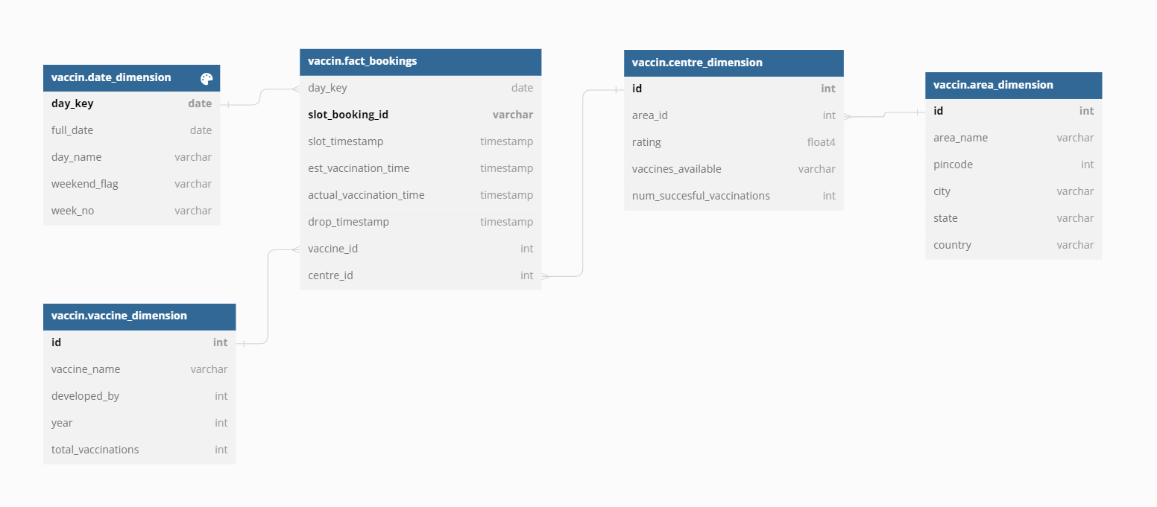

**List of Dimensions and their definition:**

**All the dimensions shall be maintained in SCD-Type1 fashion**

Table vaccin.centre_dimension {

id int [pk]

area_id int [ref: > vaccin.area_dimension.id]

rating float4

vaccines_available varchar

num_succesful_vaccinations int

}

Table vaccin.area_dimension {

id int [pk]

area_name varchar

pincode int

city varchar

state varchar

country varchar

}

Table vaccin.date_dimension {

day_key date [pk]

full_date date

day_name varchar

weekend_flag varchar

week_no varchar

}

Table vaccin.date_dimension {

day_key date [pk]

full_date date

day_name varchar

weekend_flag varchar

week_no varchar

}

**Facts and their definition:**

Table vaccin.fact_vaccinations {

day_key date [ref: > vaccin.date_dimension.day_key]

slot_booking_id varchar [pk]

slot_timestamp timestamp

est_vaccination_time timestamp

actual_vaccination_time timestamp

drop_timestamp timestamp

vaccine_id int [ref: > vaccin.vaccine_dimension.id]

centre_id int [ref: > vaccin.centre_dimension.id]

}

**Insightful reports:**

**1. What is the area wise percentage of vaccinations done on time?**

with cte as

(

select a.area_name, a.city,a.state, count(*) ontime_vaccinations from

vaccin.fact_vaccinations f

inner join

vaccin.centre_dimension c

on c.id= f.centre_id

inner join

vaccin.area_dimension a

on a.id= c.area_id

where actual_vaccination_time <= est_vaccination_time

group by a.area_name, a.city,a.state

),

cte1 as

(

select a.area_name, a.city,a.state, count(*) total_vaccinations from

vaccin.fact_vaccinations f

inner join

vaccin.centre_dimension c

on c.id= f.centre_id

inner join

vaccin.area_dimension a

on a.id= c.area_id

group by a.area_name. a.city,a.state

)

select a.area_name, a.city,a.state, (cte.ontime_vaccinations

*100/cte1.total_vaccinations) area_wise_percentage

from cte

inner join cte1

on cte.area_name =cte1. area_name

and cte.city =cte1.city

and cte.state =cte1.state

**2. What was the peak time of slot bookings, area wise , day wise?**

with cte as

(

select a.area_name, a.city,a.state,f.day_key,f.day_name,hour(f.slot_timestamp) hour,

count(*) over (partition by a.area_name,

a.city,a.state,f.day_key,f.day_name,hour(f.slot_timestamp)) total from

vaccin.fact_vaccinations f

inner join vaccin.date_dimension d

d.day_key=f.day_key

inner join

vaccin.centre_dimension c

on c.id= f.centre_id

inner join

vaccin.area_dimension a

on a.id= c.area_id

),

cte1 as

(

select

cte.area_name, cte.city,cte.state,cte.day_key,cte.day_name,cte.hour

hour,

dense_rank() over(partition by cte.area_name,

cte.city,cte.state,cte.day_key,cte.day_name order by cte.total desc) rnk

from cte

)

select *

from cte1

where rnk=1