Use Case

Revision History
Date | Author | Description of change
16-05-2022 | YESTEAM | Initial Creation

Use Case:
Name pronunciation

Description
Application will generate an audio file using Google cloud API, when text is entered as input.

Primary Actor
User will input text and the outcome of the API is an audio file which will pronounce given text.

Stakeholders and Interests
People with different backgrounds and variety of names sometimes due to the regional/accent differences name will be pronouncing incorrectly. API is created to pronounce the name correctly

Post Conditions

Success end condition
User will enter their name in the given API and then Click on the GO button an audio file will be created as output. User need to play the audio to check whether Name is pronounced correctly or not.

Minimal Guarantee
70% of text will be pronounced correctly

Main Success Scenario

- Click on the local host link http://localhost:8081

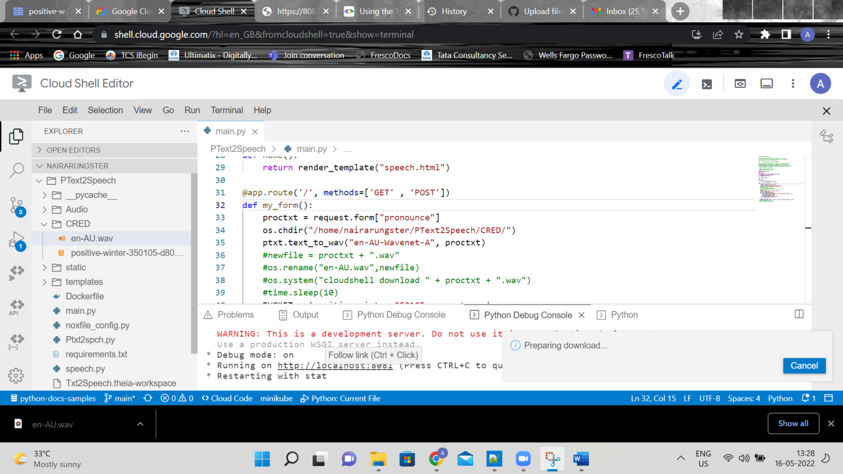
- The below screen will appear , enter the Text and click on the go button then an audio file will be generated.
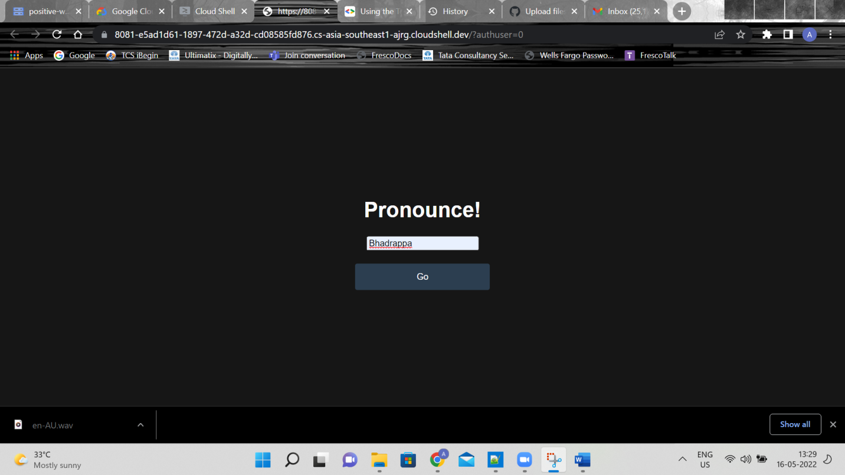
- Play the audio button to listen to the Text pronunciation.
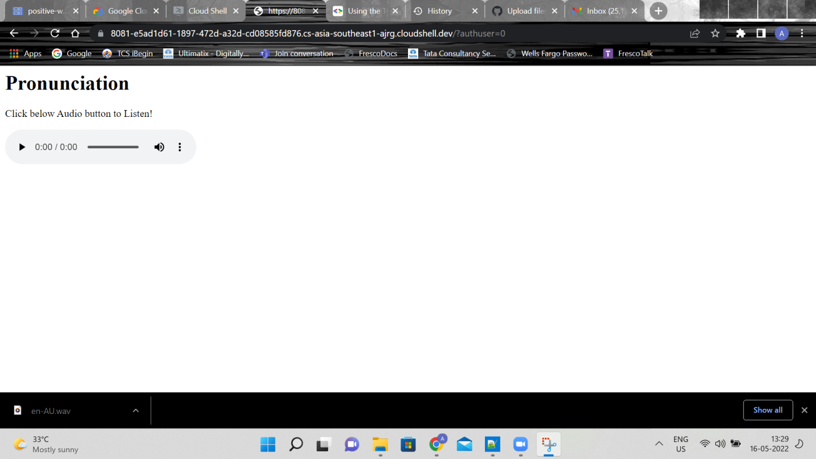
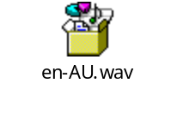

Frequency:
User driven

Assumptions
Australian language is used for Pronunciation

To do

- Non-Standard pronunciation
- Service creation

