Name Pronunciation App

Table of Contents

Overview: 2

Instructions to run the application: 2

## Overview:

Name Pronunciation app will pronounce the text entered by the user. The input for this application is text format and the output will be an audio file which can be played to listen to the pronunciation.

## Instructions to run the application:

1. Click on the local host link <http://localhost:8081>

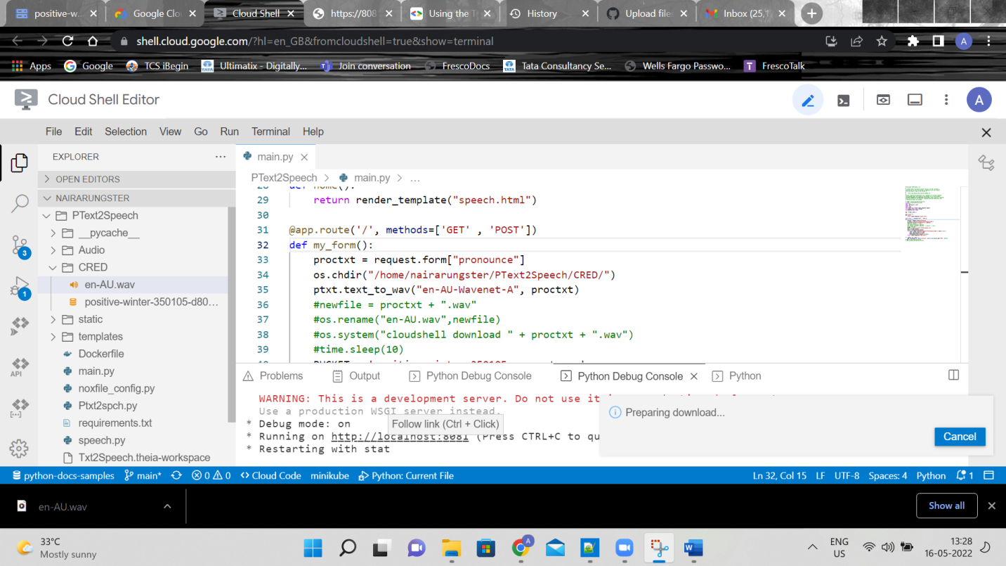

1. The below screen will appear , enter the Text and click on the go button then an audio file will be generated.

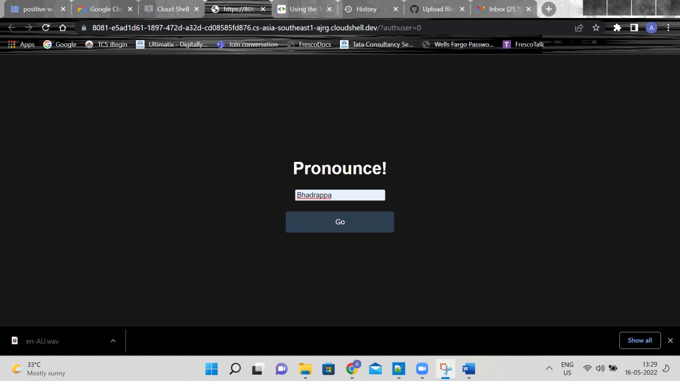

1. Play the audio button to listen to the Text pronunciation.

