# Recorded Steps

This file contains all the steps and information that was recorded to help you describe the recorded steps to others.

Before sharing this file, you should verify the following:

* The steps below accurately describe the recording.
* There is no information below or on any screenshots that you do not want others to see.

Passwords or any other text you typed were not recorded, except for function and shortcut keys that you used.

*There were errors during recording. Some information may be missing.*

You can do the following:

* Review the recorded steps
* Review the recorded steps as a slide show
* Review the additional details

# Steps

Previous Next

**Step 1: (‎16-‎05-‎2022 14:33:57)** User left click on "Cloud Shell (complementary)" in "Welcome – My First Project – Google Cloud Platform - Google Chrome"

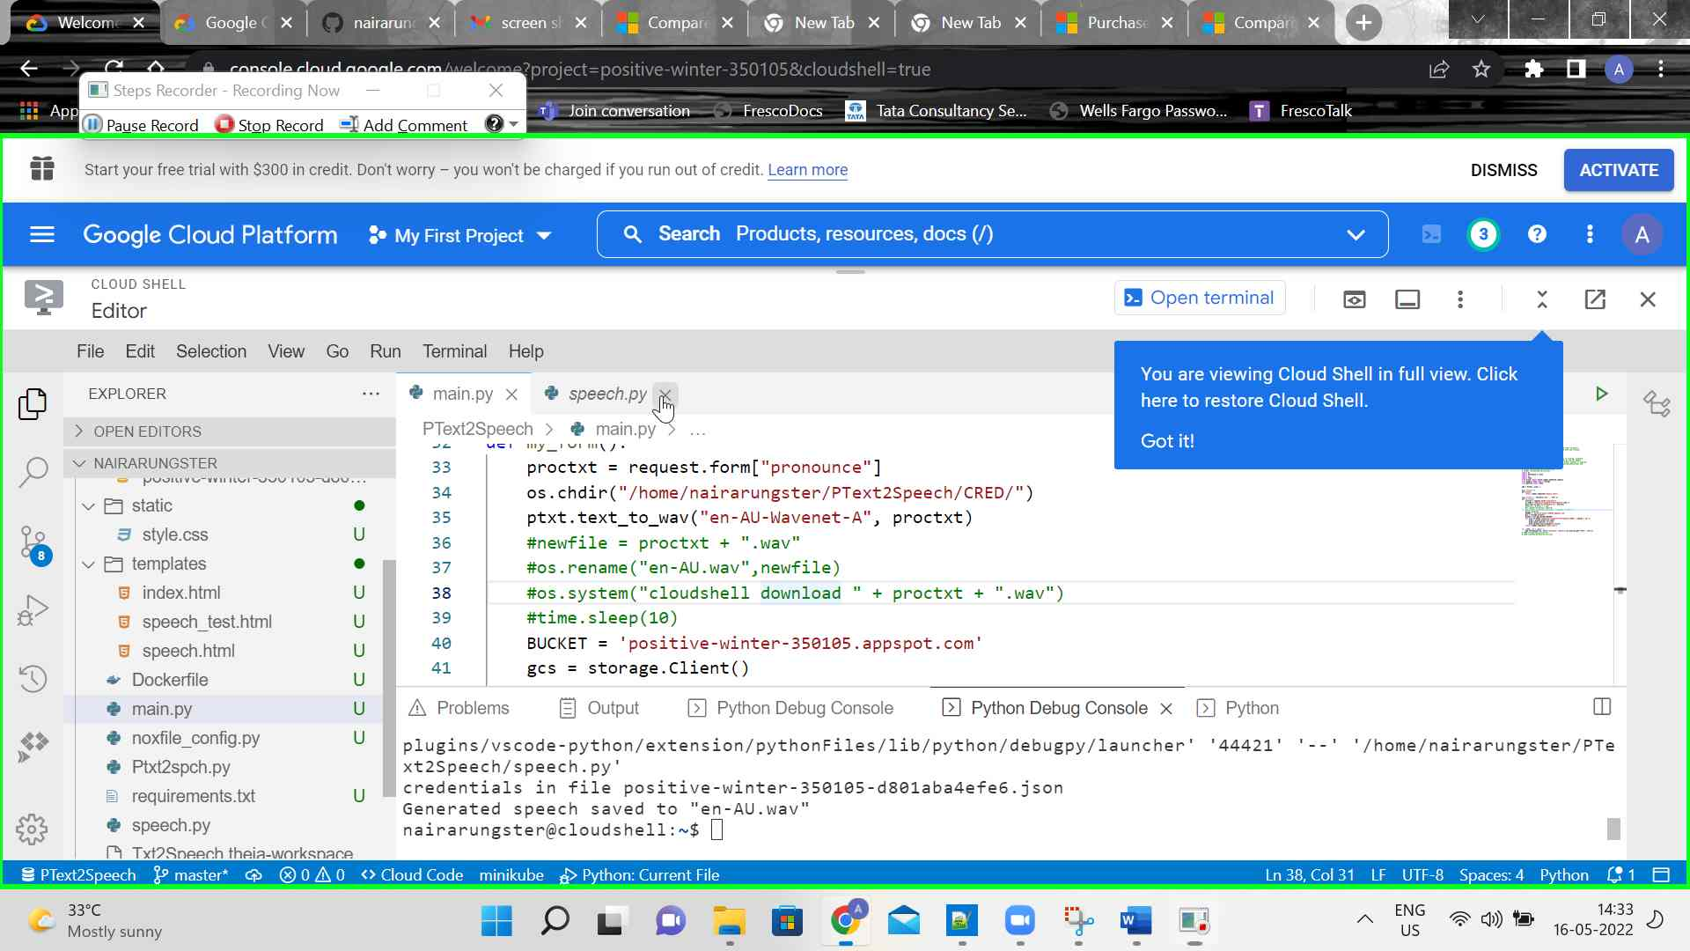Step 1 screenshot.

Previous Next

**Step 2: (‎16-‎05-‎2022 14:34:00)** User left click on "Cloud Shell (complementary)" in "Welcome – My First Project – Google Cloud Platform - Google Chrome"

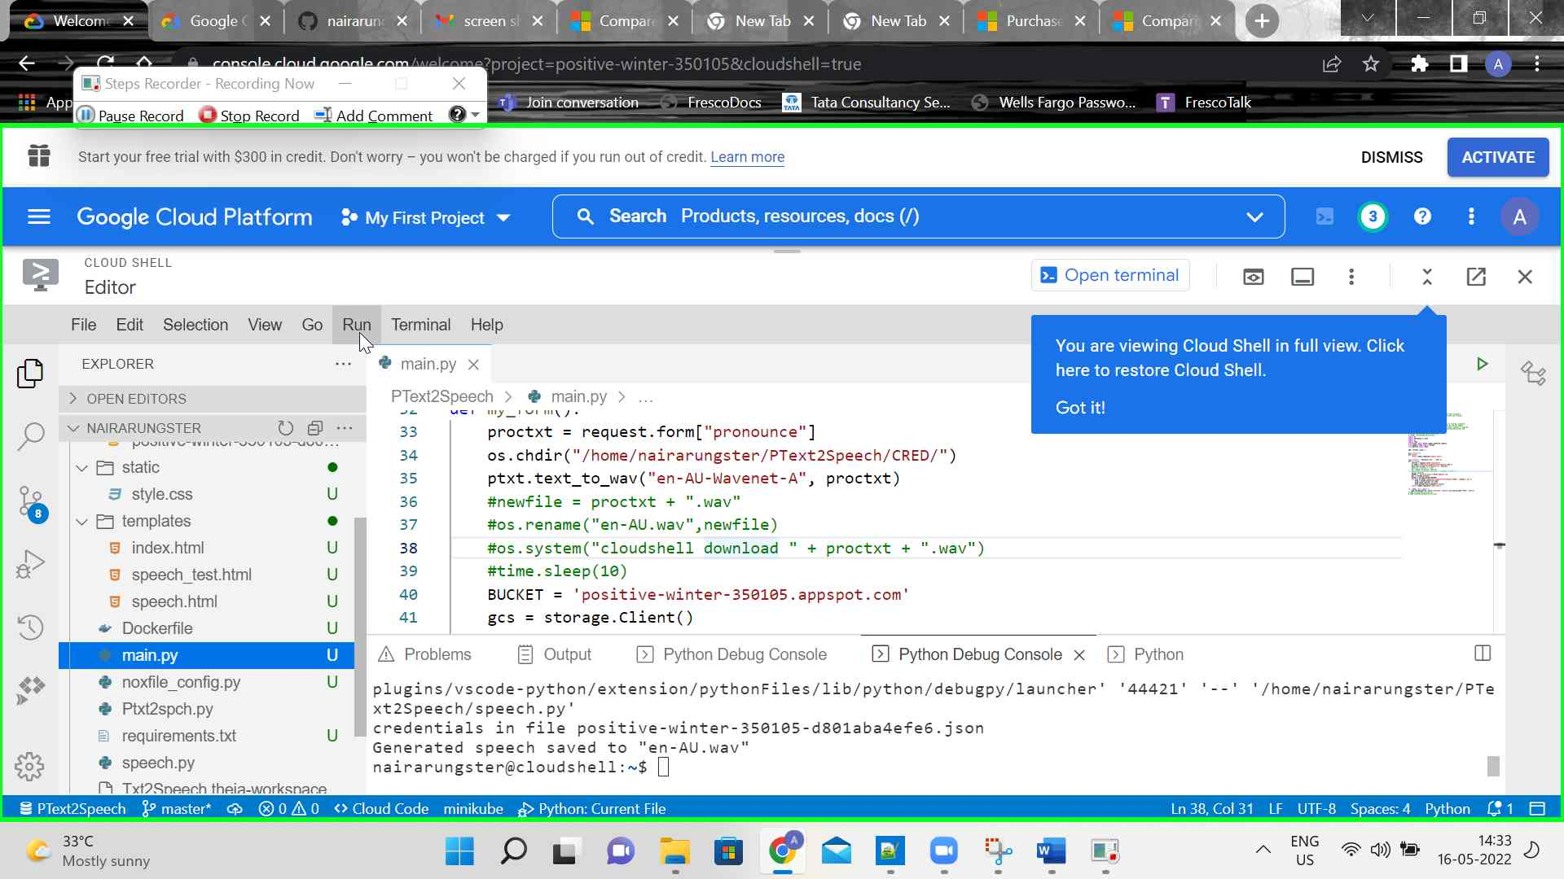Step 2 screenshot.

Previous Next

**Step 3: (‎16-‎05-‎2022 14:34:03)** User left click on "Cloud Shell (complementary)" in "Welcome – My First Project – Google Cloud Platform - Google Chrome"

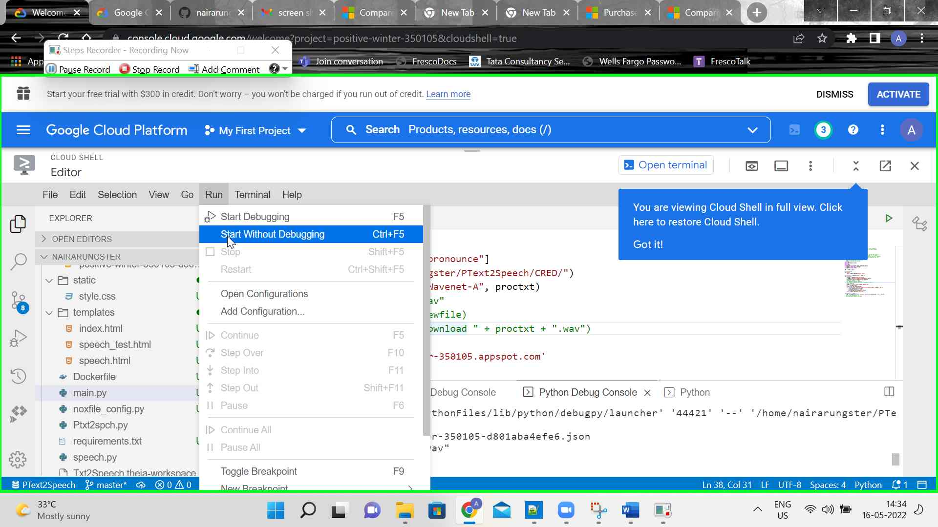Step 3 screenshot.

Previous Next

**Step 4: (‎16-‎05-‎2022 14:34:11)** User mouse wheel up on "Cloud Shell (complementary)" in "Welcome – My First Project – Google Cloud Platform - Google Chrome"

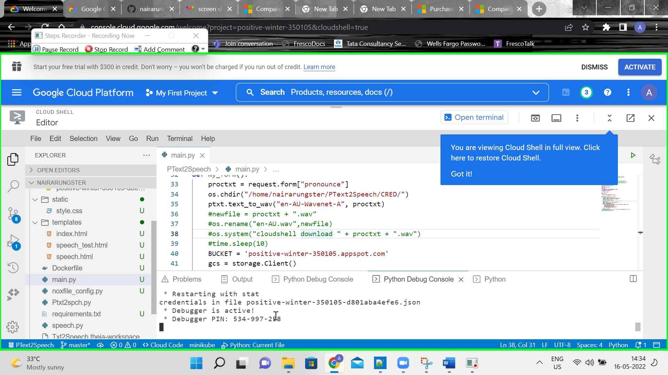Step 4 screenshot.

Previous Next

**Step 5: (‎16-‎05-‎2022 14:34:13)** User mouse wheel down in "Welcome – My First Project – Google Cloud Platform - Google Chrome"

Step 5 screenshot.

Previous Next

**Step 6: (‎16-‎05-‎2022 14:34:14)** User mouse wheel up in "Welcome – My First Project – Google Cloud Platform - Google Chrome"

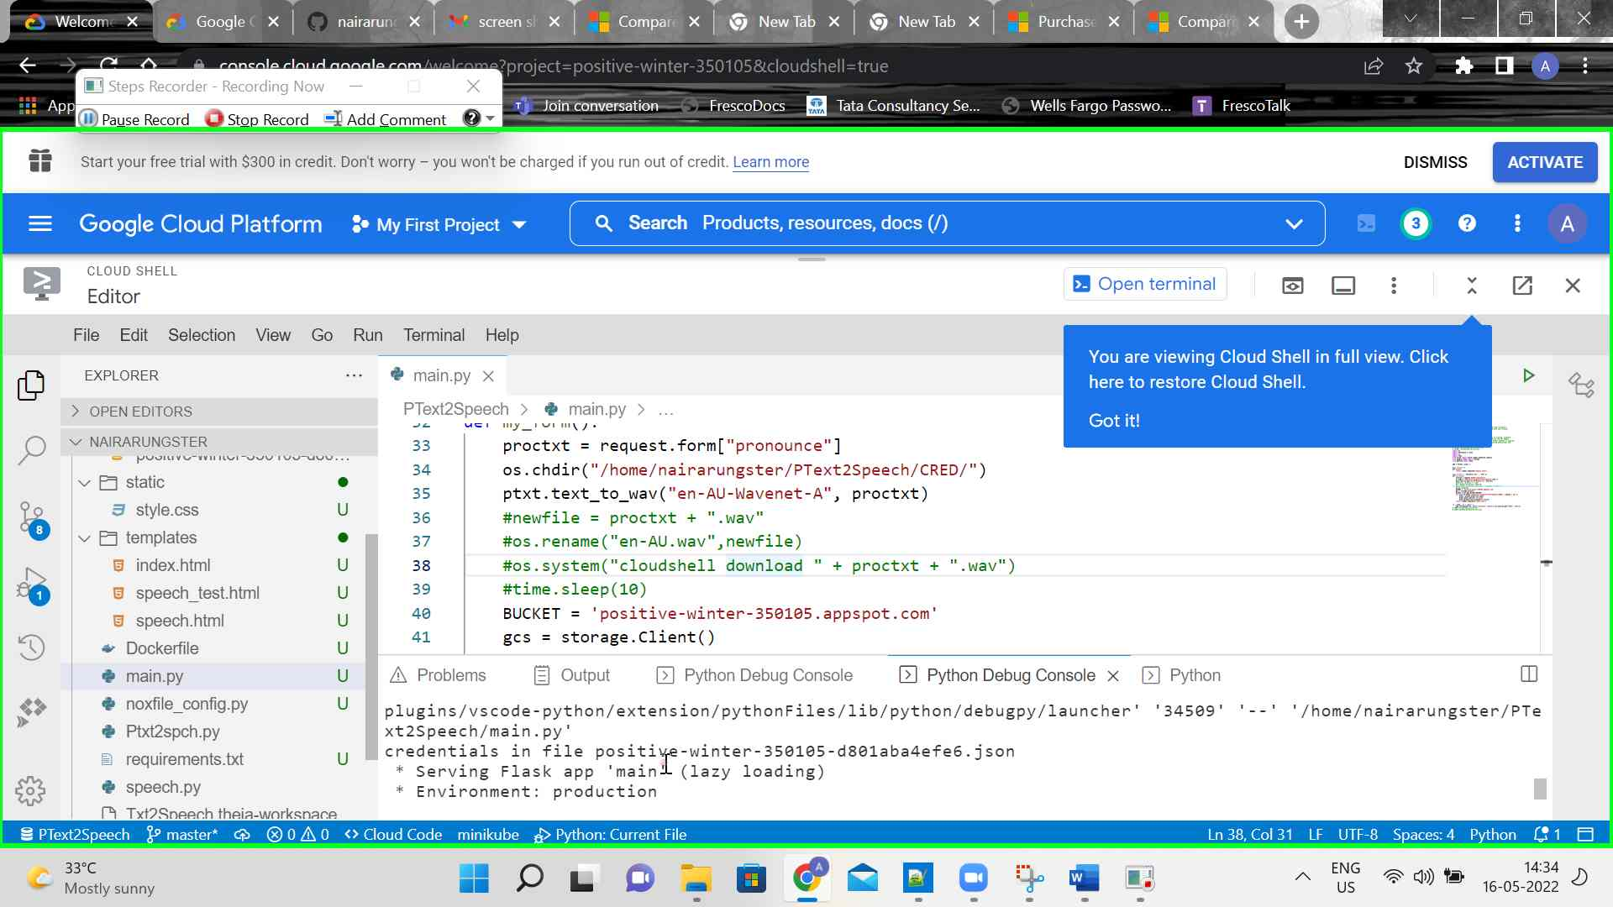Step 6 screenshot.

Previous Next

**Step 7: (‎16-‎05-‎2022 14:34:15)** User mouse wheel down in "Welcome – My First Project – Google Cloud Platform - Google Chrome"

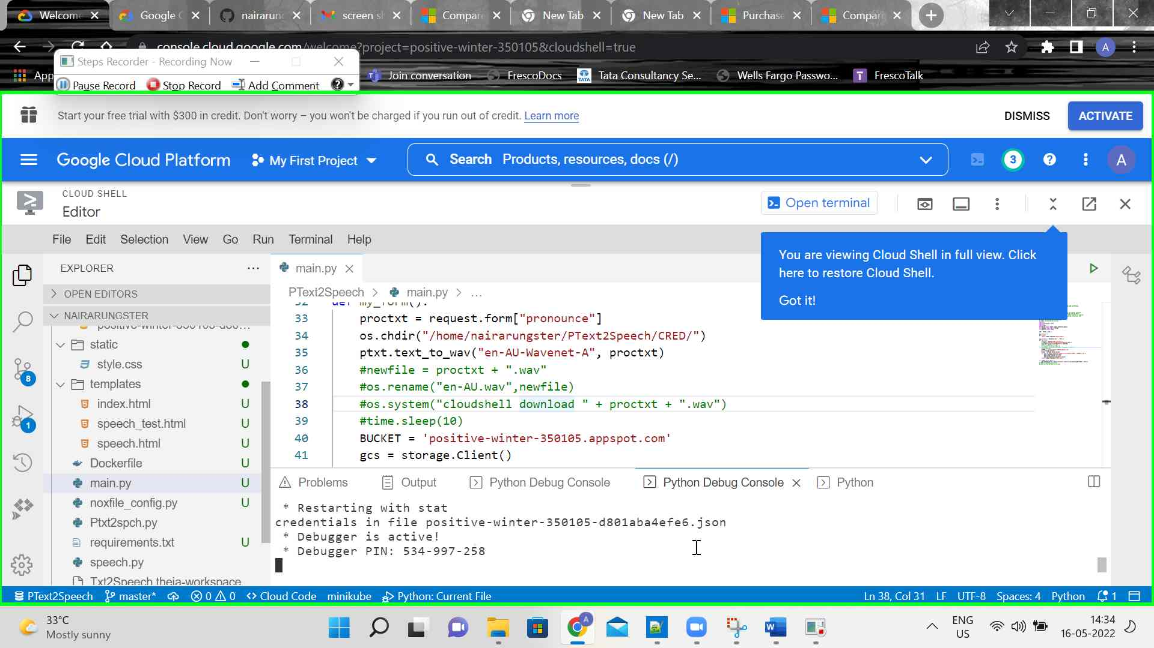Step 7 screenshot.

Previous Next

**Step 8: (‎16-‎05-‎2022 14:34:18)** User mouse drag start in "Welcome – My First Project – Google Cloud Platform - Google Chrome"

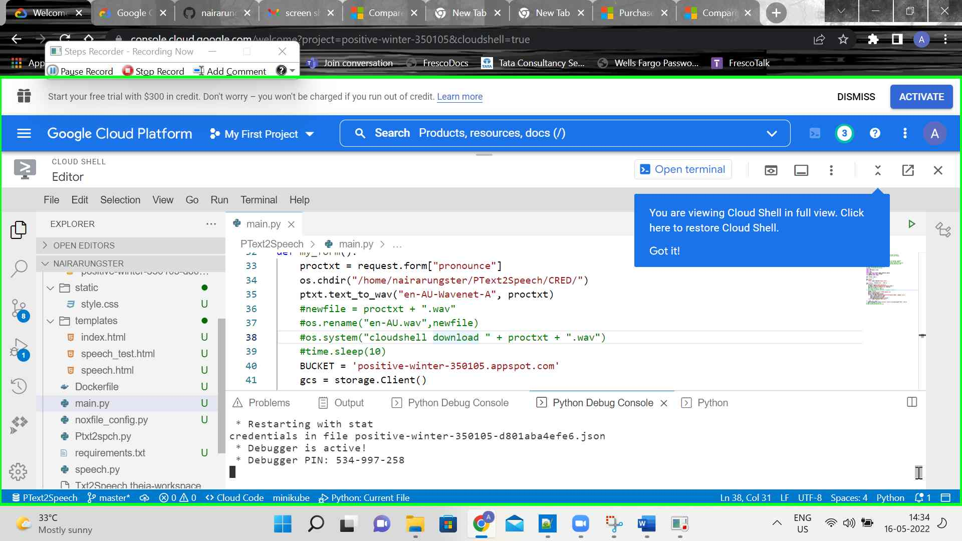Step 8 screenshot.

Previous Next

**Step 9: (‎16-‎05-‎2022 14:34:19)** User mouse drag end in "Welcome – My First Project – Google Cloud Platform - Google Chrome"

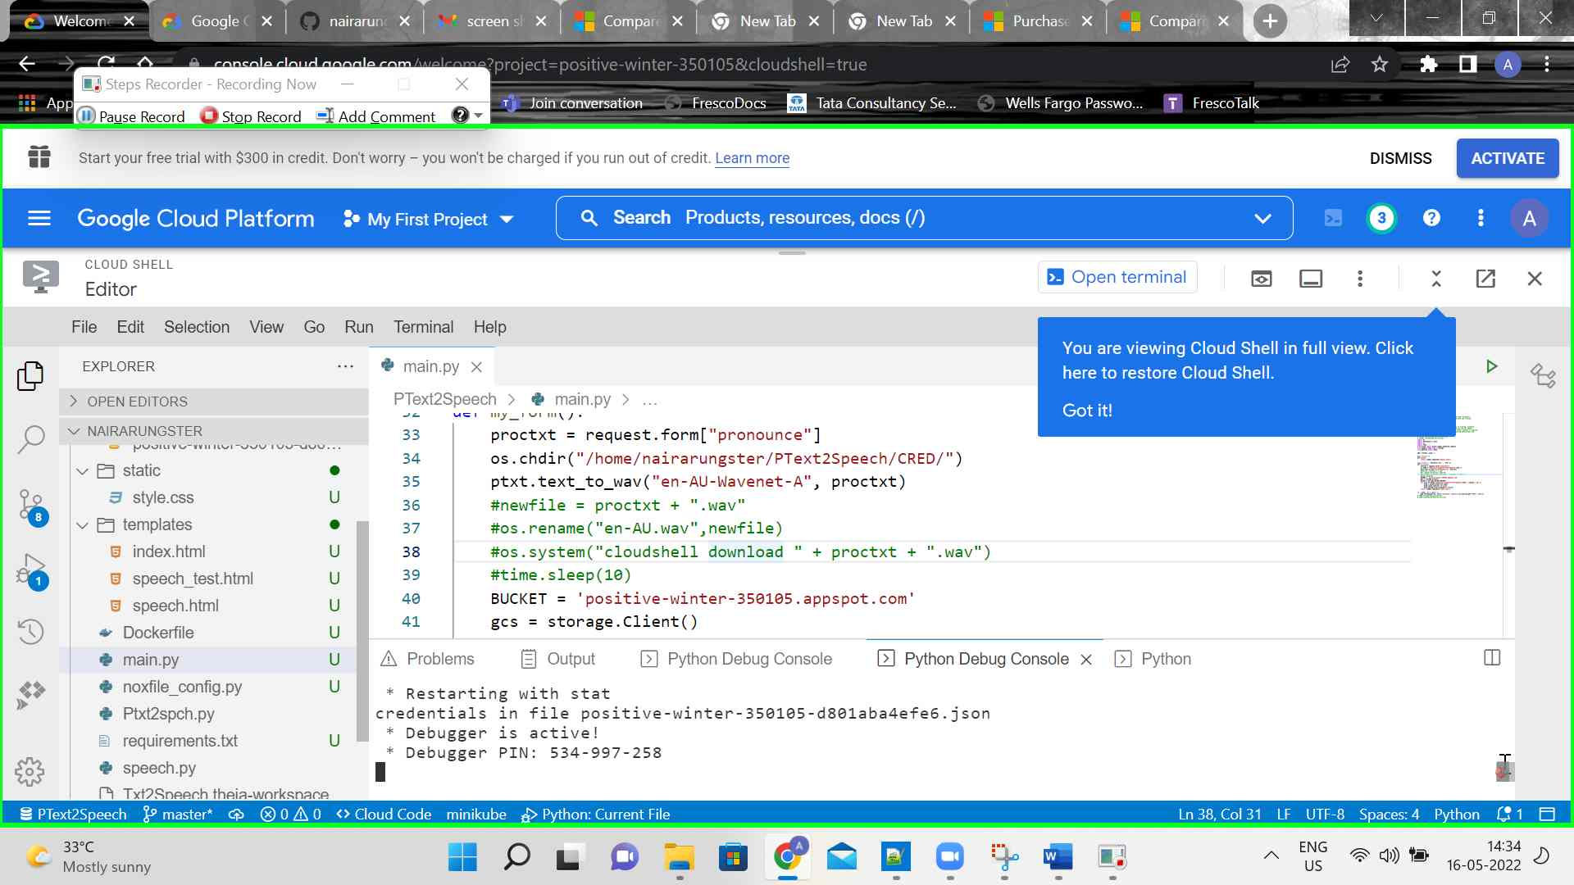Step 9 screenshot.

Previous Next

**Step 10: (‎16-‎05-‎2022 14:34:20)** User mouse drag start in "Welcome – My First Project – Google Cloud Platform - Google Chrome"

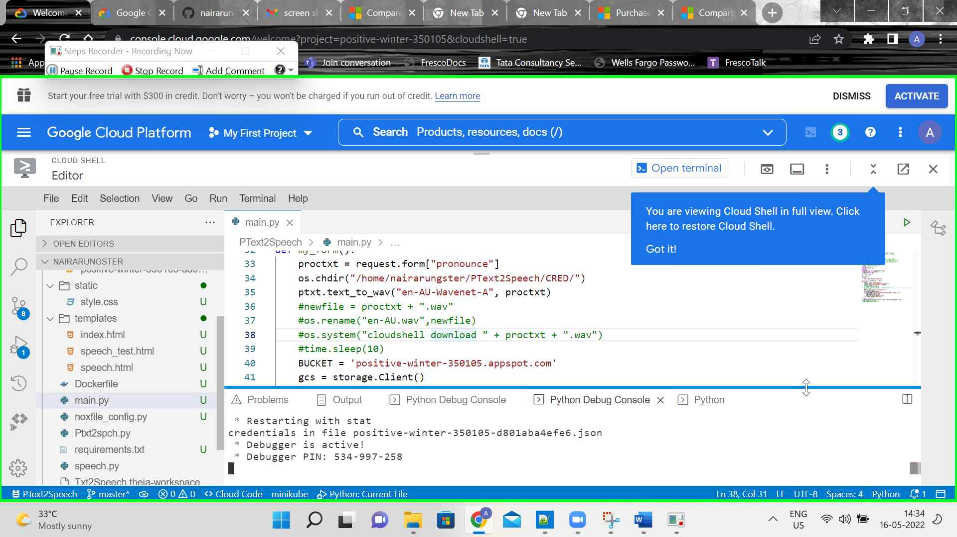Step 10 screenshot.

Previous Next

**Step 11: (‎16-‎05-‎2022 14:34:20)** User mouse drag end on "Cloud Shell (complementary)" in "Welcome – My First Project – Google Cloud Platform - Google Chrome"

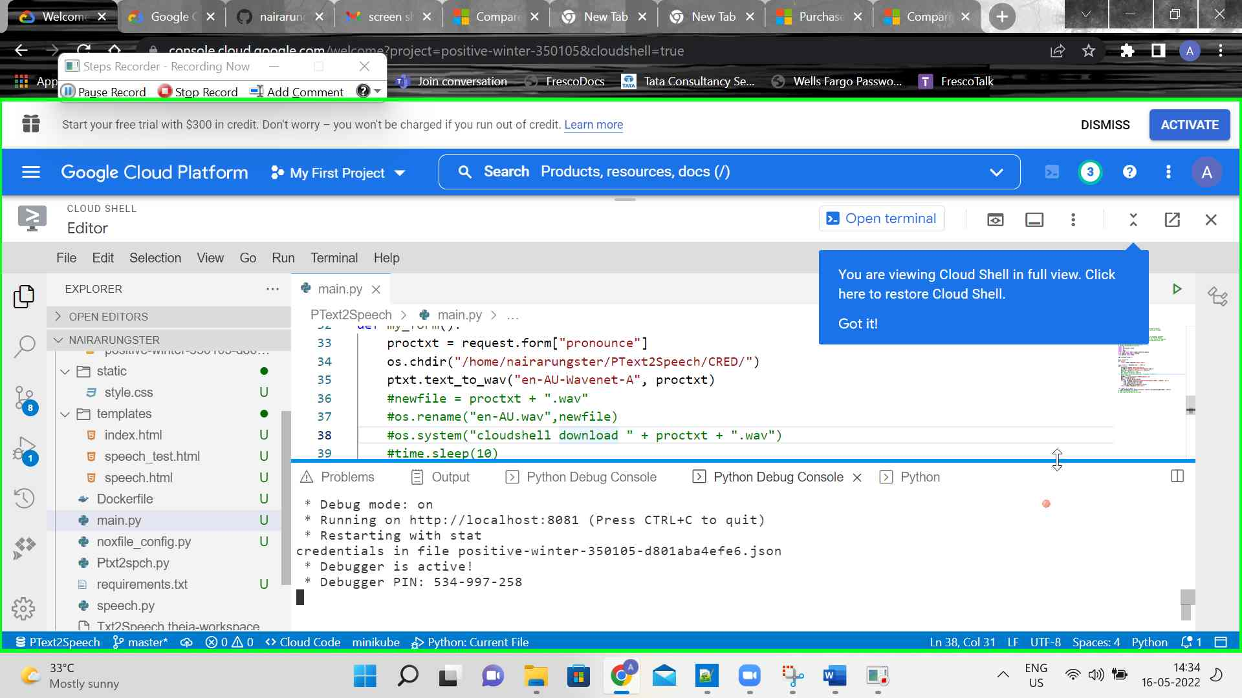Step 11 screenshot.

Previous Next

**Step 12: (‎16-‎05-‎2022 14:34:23)** User keyboard input on "Welcome – My First Project – Google Cloud Platform - Google Chrome - Arun.G (pane)" in "Welcome – My First Project – Google Cloud Platform - Google Chrome" [... Ctrl-Ctrl ...]

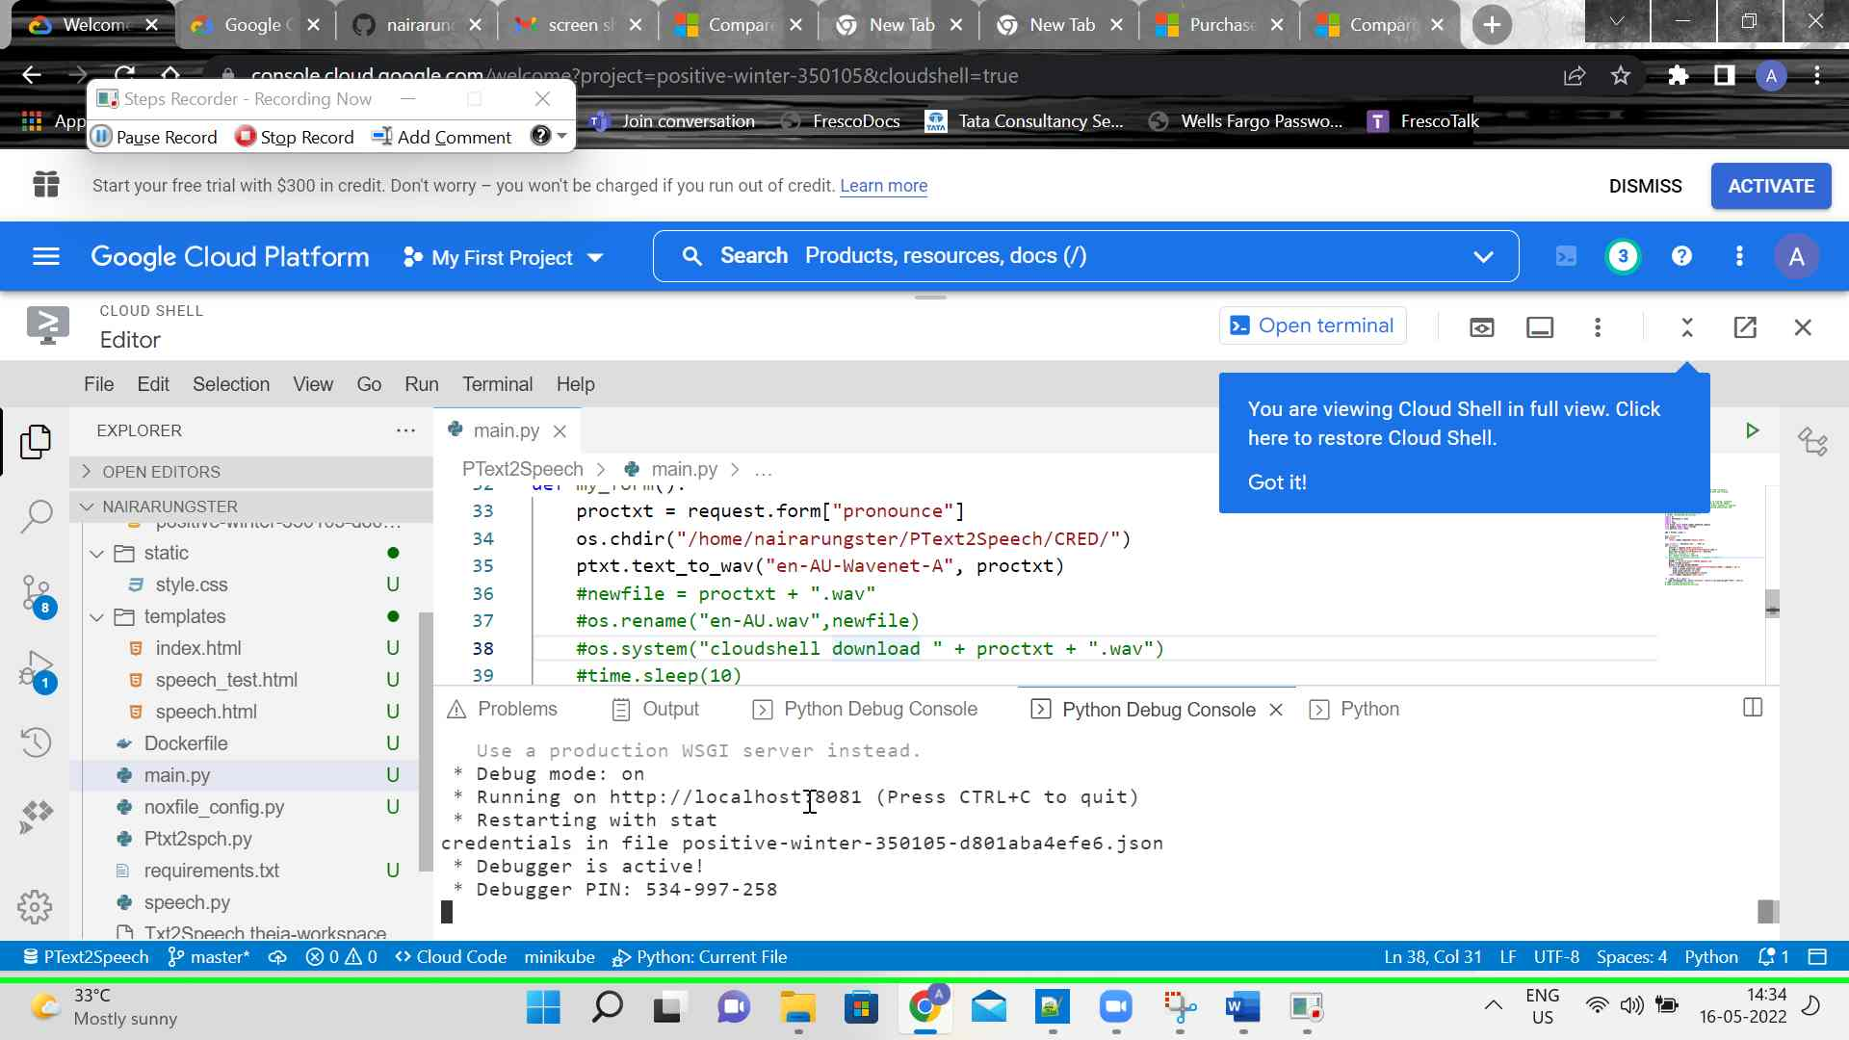Step 12 screenshot.

Previous Next

**Step 13: (‎16-‎05-‎2022 14:34:24)** User left click in "Welcome – My First Project – Google Cloud Platform - Google Chrome"

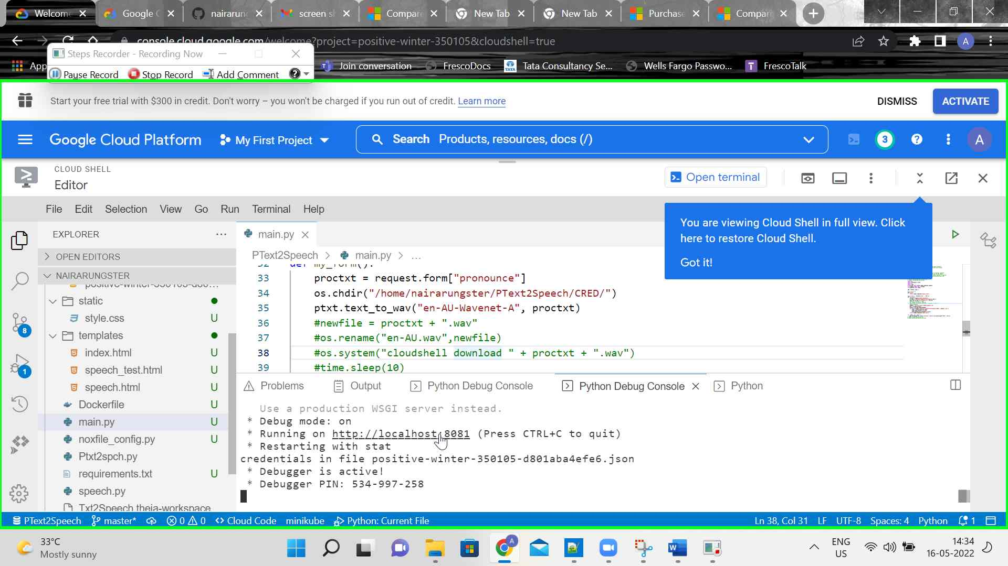Step 13 screenshot.

Previous Next

**Step 14: (‎16-‎05-‎2022 14:34:25)** User keyboard input on "Welcome – My First Project – Google Cloud Platform - Google Chrome - Arun.G (pane)" in "Welcome – My First Project – Google Cloud Platform - Google Chrome" [Ctrl-Ctrl]

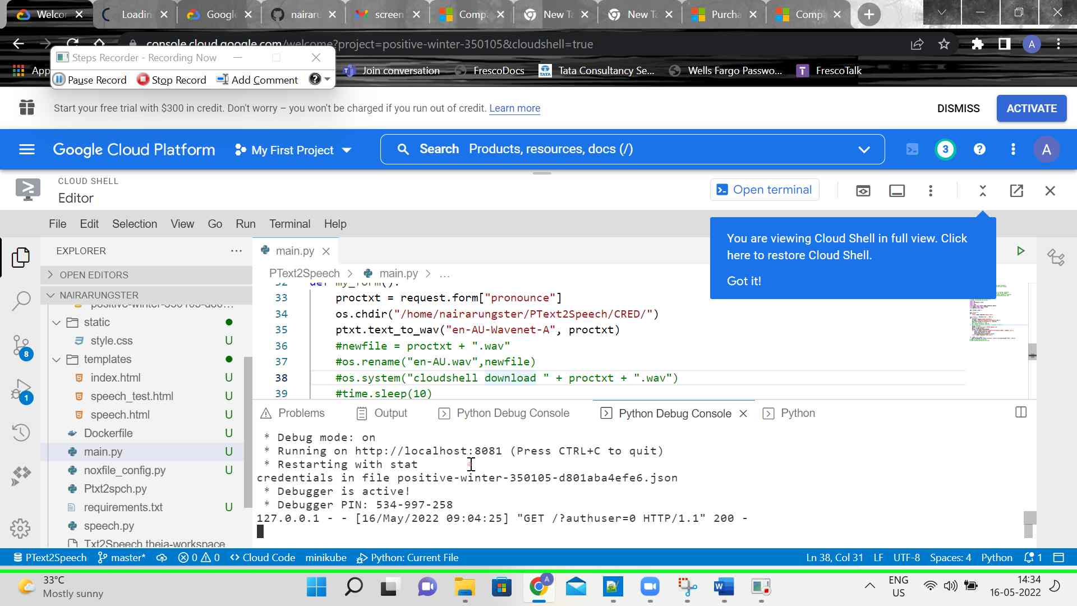Step 14 screenshot.

Previous Next

**Step 15: (‎16-‎05-‎2022 14:34:29)** User left click on "https://8081-e5ad1d61-1897-472d-a32d-cd08585fd876.cs-asia-southeast1-ajrg.cloudshell.dev/?authuser=0 - Google Chrome - Arun.G (pane)" in "https://8081-e5ad1d61-1897-472d-a32d-cd08585fd876.cs-asia-southeast1-ajrg.cloudshell.dev/?authuser=0 - Google Chrome"

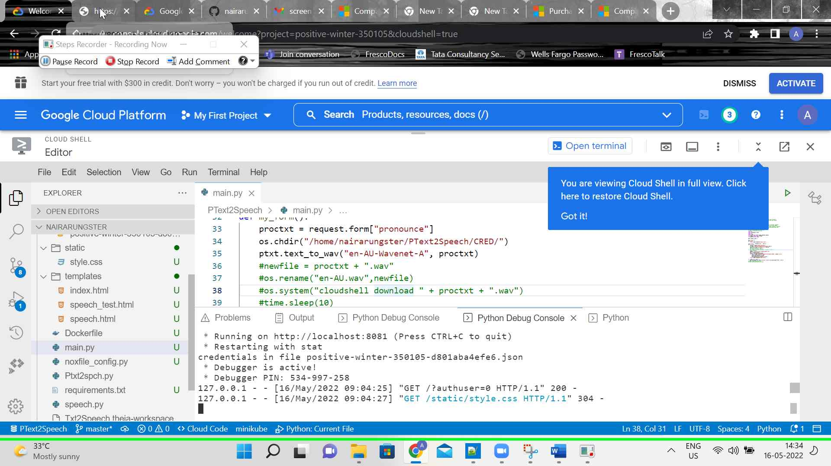Step 15 screenshot.

Previous Next

**Step 16: (‎16-‎05-‎2022 14:34:31)** User left click on "https://8081-e5ad1d61-1897-472d-a32d-cd08585fd876.cs-asia-southeast1-ajrg.cloudshell.dev/?authuser=0 - Google Chrome - Arun.G (pane)" in "https://8081-e5ad1d61-1897-472d-a32d-cd08585fd876.cs-asia-southeast1-ajrg.cloudshell.dev/?authuser=0 - Google Chrome"

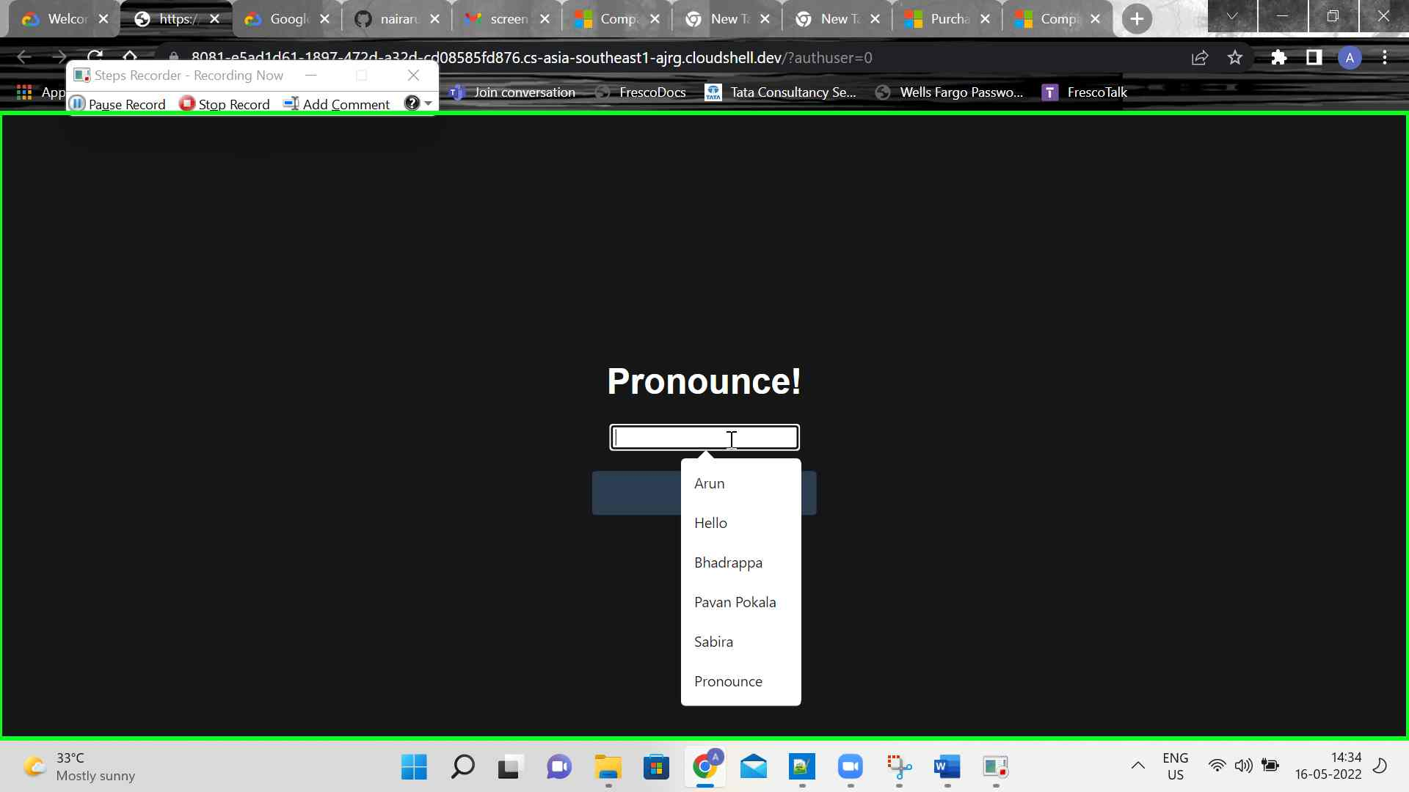Step 16 screenshot.

Previous Next

**Step 17: (‎16-‎05-‎2022 14:34:36)** User left click on "Pronounce (list item)"

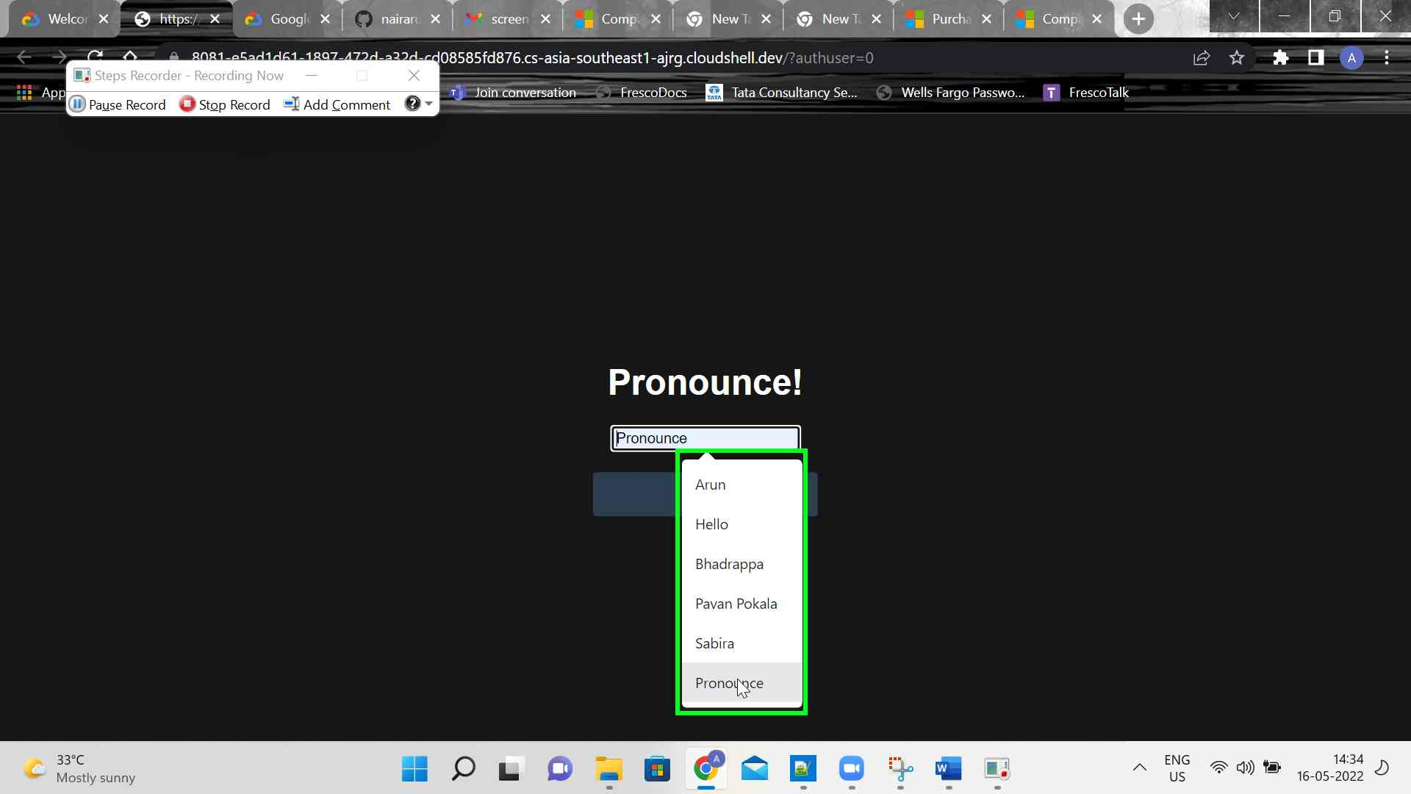Step 17 screenshot.

Previous Next

**Step 18: (‎16-‎05-‎2022 14:34:39)** User mouse drag start on "https://8081-e5ad1d61-1897-472d-a32d-cd08585fd876.cs-asia-southeast1-ajrg.cloudshell.dev/?authuser=0 - Google Chrome - Arun.G (pane)" in "https://8081-e5ad1d61-1897-472d-a32d-cd08585fd876.cs-asia-southeast1-ajrg.cloudshell.dev/?authuser=0 - Google Chrome"

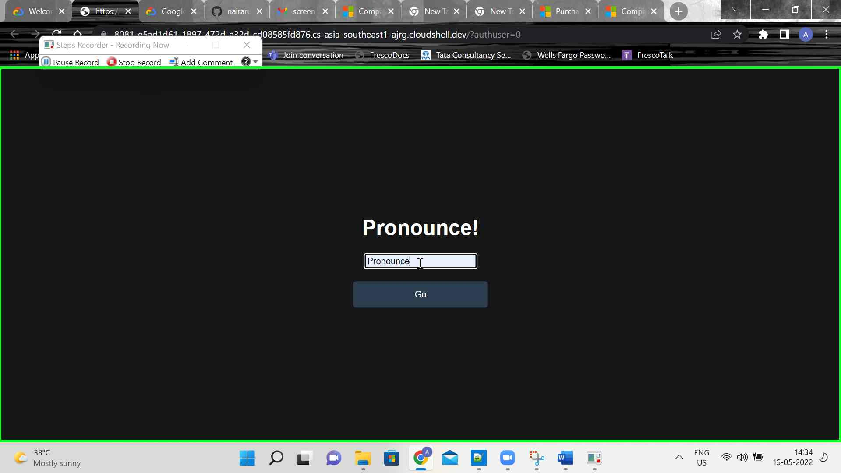Step 18 screenshot.

Previous Next

**Step 19: (‎16-‎05-‎2022 14:34:39)** User mouse drag end on "https://8081-e5ad1d61-1897-472d-a32d-cd08585fd876.cs-asia-southeast1-ajrg.cloudshell.dev/?authuser=0 - Google Chrome - Arun.G (pane)" in "https://8081-e5ad1d61-1897-472d-a32d-cd08585fd876.cs-asia-southeast1-ajrg.cloudshell.dev/?authuser=0 - Google Chrome"

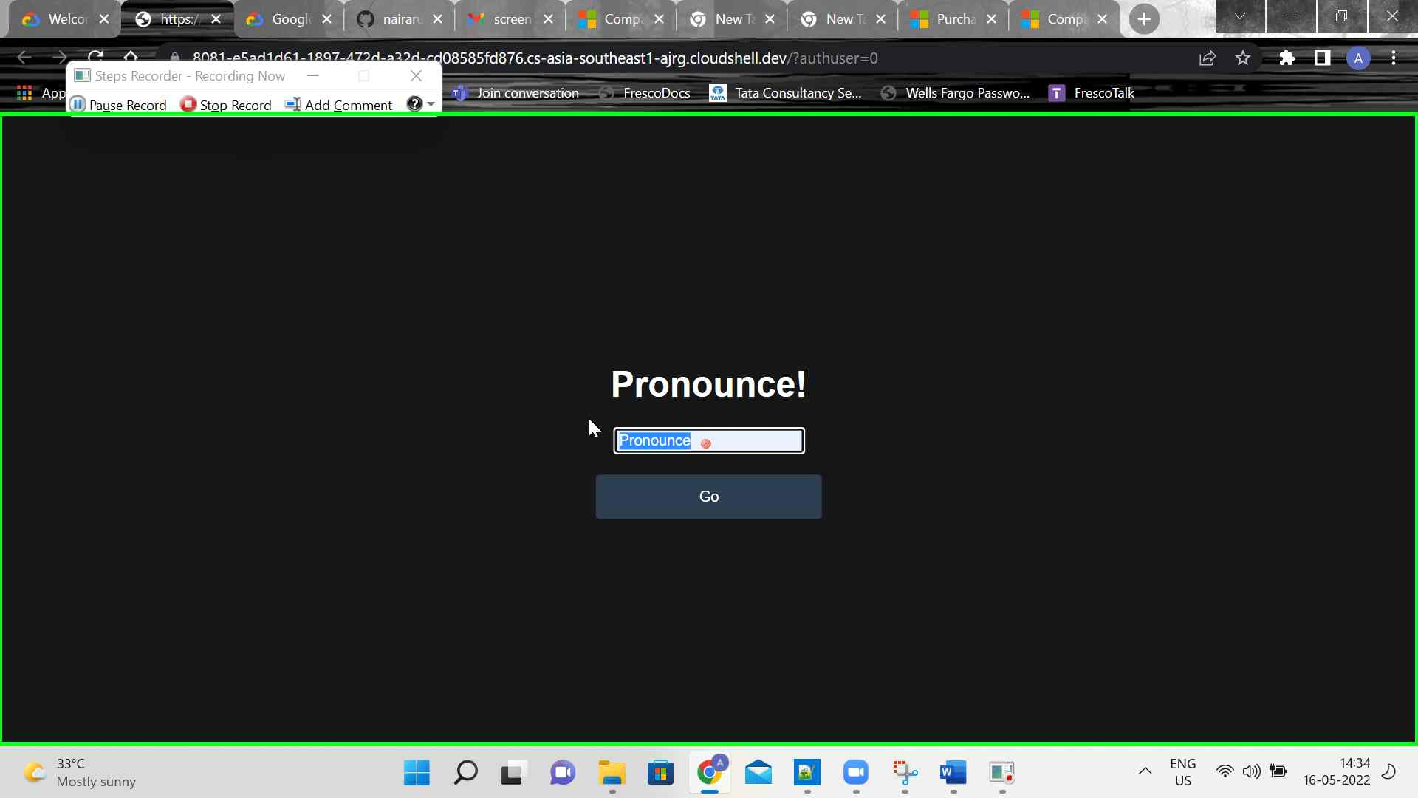Step 19 screenshot.

Previous Next

**Step 20: (‎16-‎05-‎2022 14:34:40)** User keyboard input on "https://8081-e5ad1d61-1897-472d-a32d-cd08585fd876.cs-asia-southeast1-ajrg.cloudshell.dev/?authuser=0 - Google Chrome - Arun.G (pane)" in "https://8081-e5ad1d61-1897-472d-a32d-cd08585fd876.cs-asia-southeast1-ajrg.cloudshell.dev/?authuser=0 - Google Chrome" [Backspace ... Backspace Backspace Backspace Backspace Backspace Backspace Backspace Backspace Backspace ...]

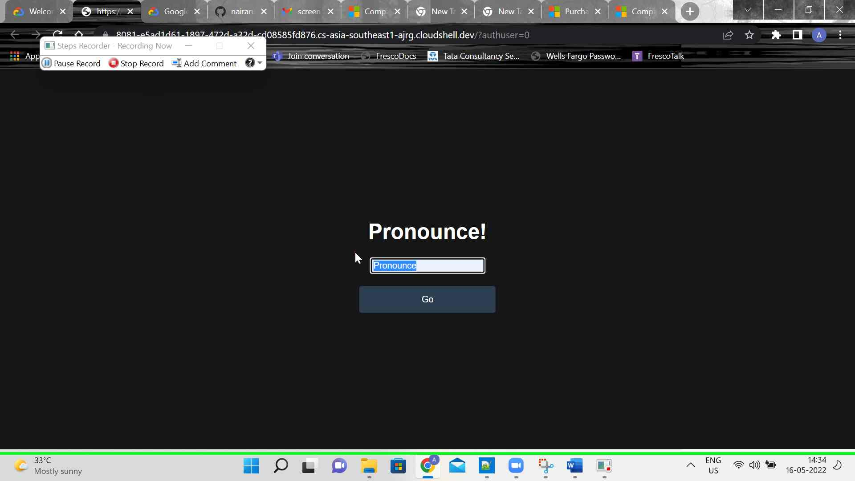Step 20 screenshot.

Previous Next

**Step 21: (‎16-‎05-‎2022 14:34:54)** User left click on "https://8081-e5ad1d61-1897-472d-a32d-cd08585fd876.cs-asia-southeast1-ajrg.cloudshell.dev/?authuser=0 - Google Chrome - Arun.G (pane)" in "https://8081-e5ad1d61-1897-472d-a32d-cd08585fd876.cs-asia-southeast1-ajrg.cloudshell.dev/?authuser=0 - Google Chrome"

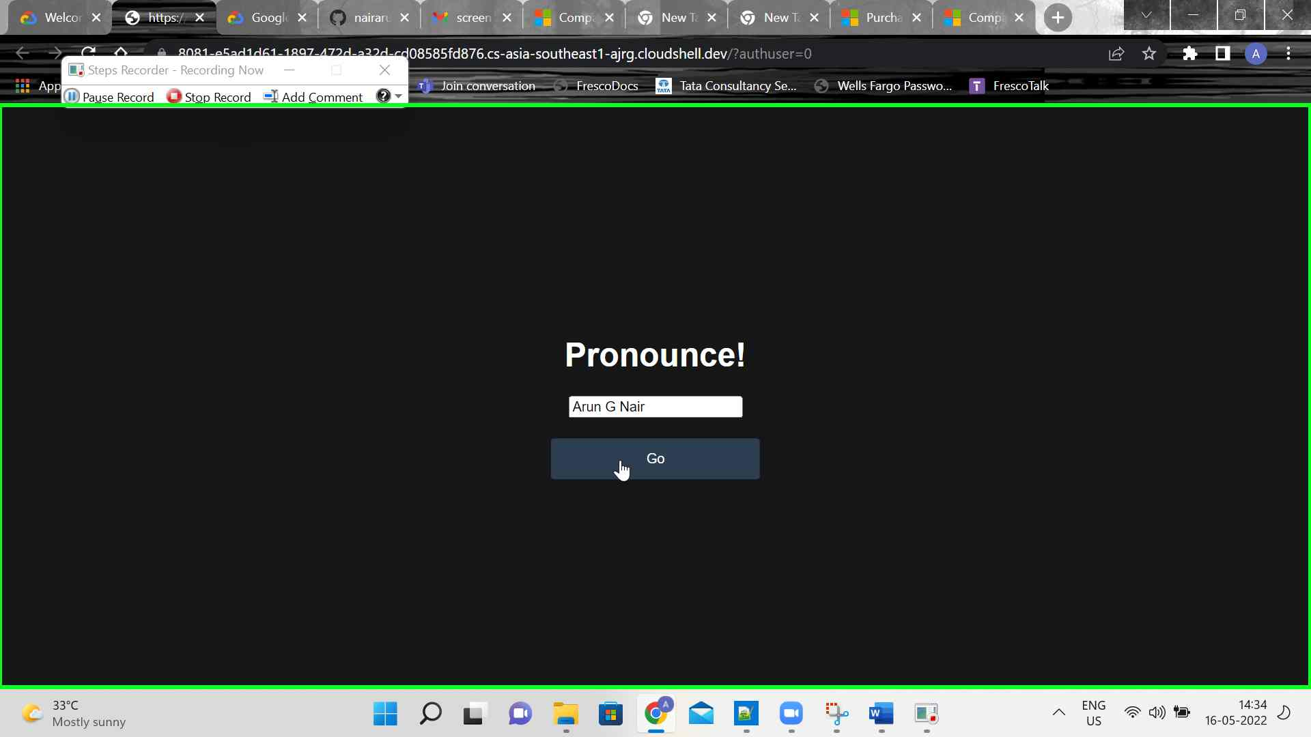Step 21 screenshot.

Previous Next

**Step 22: (‎16-‎05-‎2022 14:35:01)** User left click on "play (button)" in "https://8081-e5ad1d61-1897-472d-a32d-cd08585fd876.cs-asia-southeast1-ajrg.cloudshell.dev/?authuser=0 - Google Chrome"

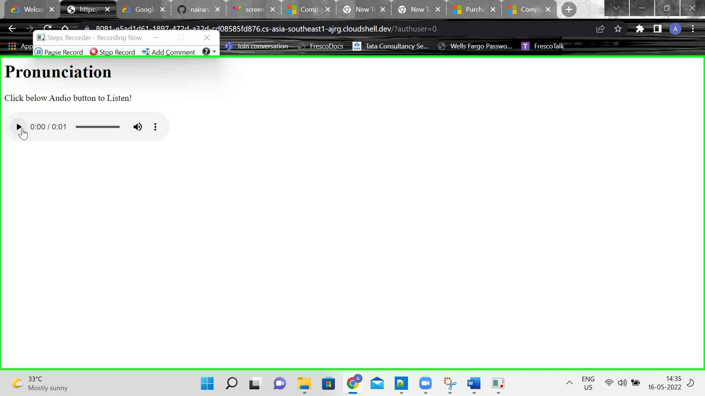Step 22 screenshot.

Previous Next

**Step 23: (‎16-‎05-‎2022 14:35:04)** User left click on "https://8081-e5ad1d61-1897-472d-a32d-cd08585fd876.cs-asia-southeast1-ajrg.cloudshell.dev/?authuser=0 - Audio playing - Google Chrome - Arun.G (pane)" in "https://8081-e5ad1d61-1897-472d-a32d-cd08585fd876.cs-asia-southeast1-ajrg.cloudshell.dev/?authuser=0 - Google Chrome"

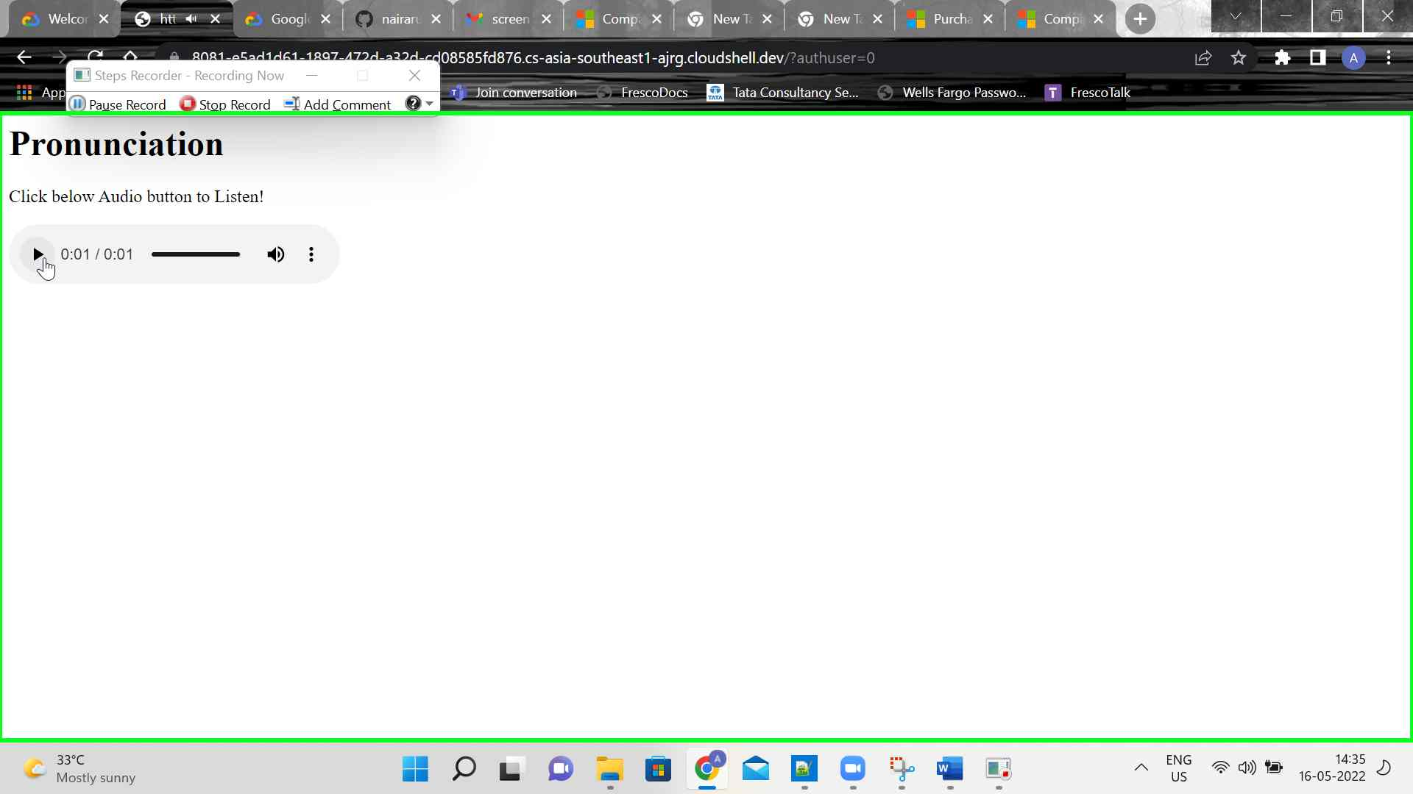Step 23 screenshot.

Return to top of page...

# Additional Details

The following section contains the additional details that were recorded.

These details help accurately identify the programs and UI you used in this recording.

This section may contain text that is internal to programs that only very advanced users or programmers may understand.

Please review these details to ensure that they do not contain any information that you would not like others to see.

Recording Session: ‎16-‎05-‎2022 14:33:54 - 14:35:07  
  
Recorded Steps: 23, Missed Steps: 8, Other Errors: 0  
  
Operating System: 22000.1.amd64fre.co_release.210604-1628 10.0.0.0.2.100  
  
Step 1: User left click on "Cloud Shell (complementary)" in "Welcome – My First Project – Google Cloud Platform - Google Chrome"  
Program: Google Chrome, 101.0.4951.67, Google LLC, CHROME.EXE, CHROME.EXE  
UI Elements: Cloud Shell, Welcome – My First Project – Google Cloud Platform, Chrome_RenderWidgetHostHWND, Welcome – My First Project – Google Cloud Platform - Google Chrome - Arun.G, Chrome_WidgetWin_1  
  
Step 2: User left click on "Cloud Shell (complementary)" in "Welcome – My First Project – Google Cloud Platform - Google Chrome"  
Program: Google Chrome, 101.0.4951.67, Google LLC, CHROME.EXE, CHROME.EXE  
UI Elements: Cloud Shell, Welcome – My First Project – Google Cloud Platform, Chrome_RenderWidgetHostHWND, Welcome – My First Project – Google Cloud Platform - Google Chrome - Arun.G, Chrome_WidgetWin_1  
  
Step 3: User left click on "Cloud Shell (complementary)" in "Welcome – My First Project – Google Cloud Platform - Google Chrome"  
Program: Google Chrome, 101.0.4951.67, Google LLC, CHROME.EXE, CHROME.EXE  
UI Elements: Cloud Shell, Welcome – My First Project – Google Cloud Platform, Chrome_RenderWidgetHostHWND, Welcome – My First Project – Google Cloud Platform - Google Chrome - Arun.G, Chrome_WidgetWin_1  
  
Step 4: User mouse wheel up on "Cloud Shell (complementary)" in "Welcome – My First Project – Google Cloud Platform - Google Chrome"  
Program: Google Chrome, 101.0.4951.67, Google LLC, CHROME.EXE, CHROME.EXE  
UI Elements: Cloud Shell, Welcome – My First Project – Google Cloud Platform, Chrome_RenderWidgetHostHWND, Welcome – My First Project – Google Cloud Platform - Google Chrome - Arun.G, Chrome_WidgetWin_1  
  
Step 5: User mouse wheel down in "Welcome – My First Project – Google Cloud Platform - Google Chrome"  
Program: Google Chrome, 101.0.4951.67, Google LLC, CHROME.EXE, CHROME.EXE  
UI Elements:   
  
Step 6: User mouse wheel up in "Welcome – My First Project – Google Cloud Platform - Google Chrome"  
Program: Google Chrome, 101.0.4951.67, Google LLC, CHROME.EXE, CHROME.EXE  
UI Elements:   
  
Step 7: User mouse wheel down in "Welcome – My First Project – Google Cloud Platform - Google Chrome"  
Program: Google Chrome, 101.0.4951.67, Google LLC, CHROME.EXE, CHROME.EXE  
UI Elements:   
  
Step 8: User mouse drag start in "Welcome – My First Project – Google Cloud Platform - Google Chrome"  
Program: Google Chrome, 101.0.4951.67, Google LLC, CHROME.EXE, CHROME.EXE  
UI Elements:   
  
Step 9: User mouse drag end in "Welcome – My First Project – Google Cloud Platform - Google Chrome"  
Program: Google Chrome, 101.0.4951.67, Google LLC, CHROME.EXE, CHROME.EXE  
UI Elements:   
  
Step 10: User mouse drag start in "Welcome – My First Project – Google Cloud Platform - Google Chrome"  
Program: Google Chrome, 101.0.4951.67, Google LLC, CHROME.EXE, CHROME.EXE  
UI Elements:   
  
Step 11: User mouse drag end on "Cloud Shell (complementary)" in "Welcome – My First Project – Google Cloud Platform - Google Chrome"  
Program: Google Chrome, 101.0.4951.67, Google LLC, CHROME.EXE, CHROME.EXE  
UI Elements: Cloud Shell, Welcome – My First Project – Google Cloud Platform, Chrome_RenderWidgetHostHWND, Welcome – My First Project – Google Cloud Platform - Google Chrome - Arun.G, Chrome_WidgetWin_1  
  
Step 12: User keyboard input on "Welcome – My First Project – Google Cloud Platform - Google Chrome - Arun.G (pane)" in "Welcome – My First Project – Google Cloud Platform - Google Chrome" [... Ctrl-Ctrl ...]  
Program: Google Chrome, 101.0.4951.67, Google LLC, CHROME.EXE, CHROME.EXE  
UI Elements: Welcome – My First Project – Google Cloud Platform - Google Chrome - Arun.G, Chrome_WidgetWin_1  
  
Step 13: User left click in "Welcome – My First Project – Google Cloud Platform - Google Chrome"  
Program: Google Chrome, 101.0.4951.67, Google LLC, CHROME.EXE, CHROME.EXE  
UI Elements:   
  
Step 14: User keyboard input on "Welcome – My First Project – Google Cloud Platform - Google Chrome - Arun.G (pane)" in "Welcome – My First Project – Google Cloud Platform - Google Chrome" [Ctrl-Ctrl]  
Program: Google Chrome, 101.0.4951.67, Google LLC, CHROME.EXE, CHROME.EXE  
UI Elements: Welcome – My First Project – Google Cloud Platform - Google Chrome - Arun.G, Chrome_WidgetWin_1  
  
Step 15: User left click on "https://8081-e5ad1d61-1897-472d-a32d-cd08585fd876.cs-asia-southeast1-ajrg.cloudshell.dev/?authuser=0 - Google Chrome - Arun.G (pane)" in "https://8081-e5ad1d61-1897-472d-a32d-cd08585fd876.cs-asia-southeast1-ajrg.cloudshell.dev/?authuser=0 - Google Chrome"  
Program: Google Chrome, 101.0.4951.67, Google LLC, CHROME.EXE, CHROME.EXE  
UI Elements: https://8081-e5ad1d61-1897-472d-a32d-cd08585fd876.cs-asia-southeast1-ajrg.cloudshell.dev/?authuser=0 - Google Chrome - Arun.G, Chrome_WidgetWin_1  
  
Step 16: User left click on "https://8081-e5ad1d61-1897-472d-a32d-cd08585fd876.cs-asia-southeast1-ajrg.cloudshell.dev/?authuser=0 - Google Chrome - Arun.G (pane)" in "https://8081-e5ad1d61-1897-472d-a32d-cd08585fd876.cs-asia-southeast1-ajrg.cloudshell.dev/?authuser=0 - Google Chrome"  
Program: Google Chrome, 101.0.4951.67, Google LLC, CHROME.EXE, CHROME.EXE  
UI Elements: Chrome_RenderWidgetHostHWND, https://8081-e5ad1d61-1897-472d-a32d-cd08585fd876.cs-asia-southeast1-ajrg.cloudshell.dev/?authuser=0 - Google Chrome - Arun.G, Chrome_WidgetWin_1  
  
Step 17: User left click on "Pronounce (list item)"  
Program: Google Chrome, 101.0.4951.67, Google LLC, CHROME.EXE, CHROME.EXE  
UI Elements: Pronounce, Chrome_WidgetWin_1, https://8081-e5ad1d61-1897-472d-a32d-cd08585fd876.cs-asia-southeast1-ajrg.cloudshell.dev/?authuser=0 - Google Chrome - Arun.G, Chrome_WidgetWin_1  
  
Step 18: User mouse drag start on "https://8081-e5ad1d61-1897-472d-a32d-cd08585fd876.cs-asia-southeast1-ajrg.cloudshell.dev/?authuser=0 - Google Chrome - Arun.G (pane)" in "https://8081-e5ad1d61-1897-472d-a32d-cd08585fd876.cs-asia-southeast1-ajrg.cloudshell.dev/?authuser=0 - Google Chrome"  
Program: Google Chrome, 101.0.4951.67, Google LLC, CHROME.EXE, CHROME.EXE  
UI Elements: Chrome_RenderWidgetHostHWND, https://8081-e5ad1d61-1897-472d-a32d-cd08585fd876.cs-asia-southeast1-ajrg.cloudshell.dev/?authuser=0 - Google Chrome - Arun.G, Chrome_WidgetWin_1  
  
Step 19: User mouse drag end on "https://8081-e5ad1d61-1897-472d-a32d-cd08585fd876.cs-asia-southeast1-ajrg.cloudshell.dev/?authuser=0 - Google Chrome - Arun.G (pane)" in "https://8081-e5ad1d61-1897-472d-a32d-cd08585fd876.cs-asia-southeast1-ajrg.cloudshell.dev/?authuser=0 - Google Chrome"  
Program: Google Chrome, 101.0.4951.67, Google LLC, CHROME.EXE, CHROME.EXE  
UI Elements: Chrome_RenderWidgetHostHWND, https://8081-e5ad1d61-1897-472d-a32d-cd08585fd876.cs-asia-southeast1-ajrg.cloudshell.dev/?authuser=0 - Google Chrome - Arun.G, Chrome_WidgetWin_1  
  
Step 20: User keyboard input on "https://8081-e5ad1d61-1897-472d-a32d-cd08585fd876.cs-asia-southeast1-ajrg.cloudshell.dev/?authuser=0 - Google Chrome - Arun.G (pane)" in "https://8081-e5ad1d61-1897-472d-a32d-cd08585fd876.cs-asia-southeast1-ajrg.cloudshell.dev/?authuser=0 - Google Chrome" [Backspace ... Backspace Backspace Backspace Backspace Backspace Backspace Backspace Backspace Backspace ...]  
Program: Google Chrome, 101.0.4951.67, Google LLC, CHROME.EXE, CHROME.EXE  
UI Elements: https://8081-e5ad1d61-1897-472d-a32d-cd08585fd876.cs-asia-southeast1-ajrg.cloudshell.dev/?authuser=0 - Google Chrome - Arun.G, Chrome_WidgetWin_1  
  
Step 21: User left click on "https://8081-e5ad1d61-1897-472d-a32d-cd08585fd876.cs-asia-southeast1-ajrg.cloudshell.dev/?authuser=0 - Google Chrome - Arun.G (pane)" in "https://8081-e5ad1d61-1897-472d-a32d-cd08585fd876.cs-asia-southeast1-ajrg.cloudshell.dev/?authuser=0 - Google Chrome"  
Program: Google Chrome, 101.0.4951.67, Google LLC, CHROME.EXE, CHROME.EXE  
UI Elements: Chrome_RenderWidgetHostHWND, https://8081-e5ad1d61-1897-472d-a32d-cd08585fd876.cs-asia-southeast1-ajrg.cloudshell.dev/?authuser=0 - Google Chrome - Arun.G, Chrome_WidgetWin_1  
  
Step 22: User left click on "play (button)" in "https://8081-e5ad1d61-1897-472d-a32d-cd08585fd876.cs-asia-southeast1-ajrg.cloudshell.dev/?authuser=0 - Google Chrome"  
Program: Google Chrome, 101.0.4951.67, Google LLC, CHROME.EXE, CHROME.EXE  
UI Elements: play, Chrome_RenderWidgetHostHWND, https://8081-e5ad1d61-1897-472d-a32d-cd08585fd876.cs-asia-southeast1-ajrg.cloudshell.dev/?authuser=0 - Google Chrome - Arun.G, Chrome_WidgetWin_1  
  
Step 23: User left click on "https://8081-e5ad1d61-1897-472d-a32d-cd08585fd876.cs-asia-southeast1-ajrg.cloudshell.dev/?authuser=0 - Audio playing - Google Chrome - Arun.G (pane)" in "https://8081-e5ad1d61-1897-472d-a32d-cd08585fd876.cs-asia-southeast1-ajrg.cloudshell.dev/?authuser=0 - Google Chrome"  
Program: Google Chrome, 101.0.4951.67, Google LLC, CHROME.EXE, CHROME.EXE  
UI Elements: Chrome_RenderWidgetHostHWND, https://8081-e5ad1d61-1897-472d-a32d-cd08585fd876.cs-asia-southeast1-ajrg.cloudshell.dev/?authuser=0 - Audio playing - Google Chrome - Arun.G, Chrome_WidgetWin_1

Return to top of page...