TRIBHUVAN UNIVERSITY

INSTITUTE OF ENGINEERING

THAPATHALI CAMPUS



**Lab Report of Data Structures and Algorithms (CT552)**

**Submitted By** **Submitted To**

Sushovan Shakya Er. Rama Bastola  
THA075BEI046 Department of Electronics  
2020/12/12 and Computer Engineering

**TABLE OF CONTENTS**

1. Lab 1: Stack
   1. Array implementation of Stack
   2. Reverse a list using Stack
   3. Check parenthesis of an expression using stack
   4. Convert Infix to Postfix using Stack
   5. Evaluate Postfix expression
   6. Convert Infix to Prefix using Stack
   7. Evaluate Prefix expression
2. Lab 2: Queue

2.1 Array implementation of Linear Queue

2.2 Implementation of Circular Queue

1. Lab 3: List

3.1 Implementation of Contiguous List using Array

3.2 List Implementation of Queue

1. Lab 4: Linked List

4.1 Implementation of Singly Linked List

4.2 Implementation of Circular Linked List

4.3 Implementation of Doubly Linked List

4.4 Implementation of Priority Queue using Linked List

4.5 Implementation of Stack using Linked List

4.6 Implementation of Queue using Linked List

4.7 Store a polynomial using Linked List, perform addition

and subtraction on two polynomials

1. Lab 5: Recursion

5.1 Recursive program to find Factorial of a given number

5.2 Recursive program to find Nth term of Fibonacci series

5.3 Recursive program to solve Tower of Hanoi

5.4 Recursive program to find Greatest Common Divisor of two numbers

1. Lab 6: Trees

6.1 Create a BST of N integer

6.2 Traverse the BST in In-order, Pre-order and Post-order

6.3 Search the BST for a given element (key) and print

appropriate message

1. Lab 7: Sorting

7.1 Implementation of Insertion Sort Algorithm

7.2 Implementation of Merge Sort Algorithm

**LAB 1  
Stack**

**1.1 WAP for array implementation of stack.**

**Problem Analysis**

Stack works in the principle of LIFO (Last in First Out). There are mainly three methods for working with Stacks.

1. push() : for inserting a data to the top of the stack.
2. pop() : for popping out or deletes a data from the top of the stack.
3. peek() : for traversing the stack items without deleting the contents.

Here, we have to implement stack using arrays, which means we have to insert, delete and traverse the stack data using arrays following LIFO principle.

**Algorithm**

**For pushing data into stack**

Step 1: Initialize variable ‘top’, ‘size’  
Step 2: For checking whether the stack is full  
 if top == size – 1:  
 print “Stack Overflow”  
 Go to step 4  
Step 3: For storing data  
 Initialize variable ‘data’  
 stack[top] = data  
 ++top  
Step 4: Exit

**For popping data from the stack**

Step 1: Check whether the stack is empty (if top == -1)  
Step 2: If it is empty:  
 Print “Stack underflow”  
 Go to step 3  
 Else  
 delete stack[top]  
 --top  
Step 3: Exit

**Source code:**

#include <iostream>

#define MAX 100

using namespace std;

class Stack {

int top;

int _stack_[MAX];

public:

Stack() {

top = -1;

}

bool isEmpty() {

return (top == -1);

}

void push(int data) {

if(top == MAX - 1) {

cout << "Stack Overflow" << endl;

}

else {

_stack_[++top] = data;

cout << data << " pushed into the stack." << endl;

}

}

void pop() {

int pop_value;

if(top < 0) {

cout << "Stack underflow" << endl;

}

else {

pop_value = _stack_[--top];

cout << pop_value << " has been popped." << endl;

}

}

void peek() {

if(top < 0) {

cout << "Stack underflow" << endl;

}

else {

cout << "Top of stack: " << _stack_[top] << endl;

}

}

};

int main() {

Stack stack_obj;

// Pushing values to the stack

for(int i = 0; i < 5; ++i) {

stack_obj.push(i);

}

stack_obj.pop();

stack_obj.peek();

return 0;

}

**Output**

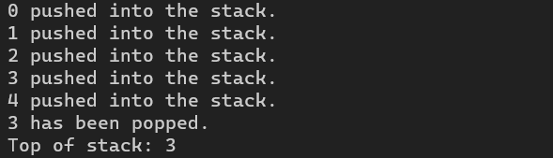

**Conclusion**

Stack data structure was thus implemented using array; however, this is only useful for storing a fixed size of data, and is not memory efficient. Thus, stack can be implemented using array.

**1.2 WAP to reverse list using stack.**

**Problem Analysis**

The problem here is to print the data of the stack in reverse. The stack implemented here is by using array, and since stack is a LIFO data structure, the data is popped from the top of the stack, which is in descending order. Thus, to print the data in reverse, data is shown from index 0, the first index of the stack.

**Algorithm**

Step 1: Check if stack is empty.  
 if top == -1:  
 Go to step 4  
Step 2: Initialize iterator ‘i’ with value 0  
Step 3: while i <= top:

Print stack[i]

Step 4: Stop

**Source Code**

#include <iostream>

#define MAX 100

using namespace std;

class Stack {

int _stack_[MAX];

int top;

public:

Stack() { top = -1; }

bool isEmpty { return (top == -1); }

void push(int data) {

if(top == MAX - 1) {

cout << "Stack overflow" << endl;

}

else {

_stack_[++top] = data;

cout << "Pushed into the stack. " << endl;

}

}

void pop() {

int pop_value;

if(top < 0) {

cout << "Stack underflow" << endl;

}

else {

pop_value = _stack_[--top];

return pop_value;

}

}

void peek() {

if(top < 0) {

cout << "Stack underflow" << endl;

}

else {

return _stack_[top];

}

}

void display() {

cout << "Stack: " << endl;

for(int i = top; i > -1; --i)

{

cout << _stack_[i] << endl;

}

}

void reverse()

{

cout << "Reverse stack: " << endl;

for (int i = 0; i <= top; i++)

{

cout << _stack_[i] << endl;

}

}

}

int main() {

Stack stack_obj;

int rand_int;

for(int i = 0; i <=7; ++i) {

rand_int = rand() / 7;

stack_obj.push(rand_int);

}

stack_obj.display();

stack_obj.reverse();

return 0;

}

**Output**

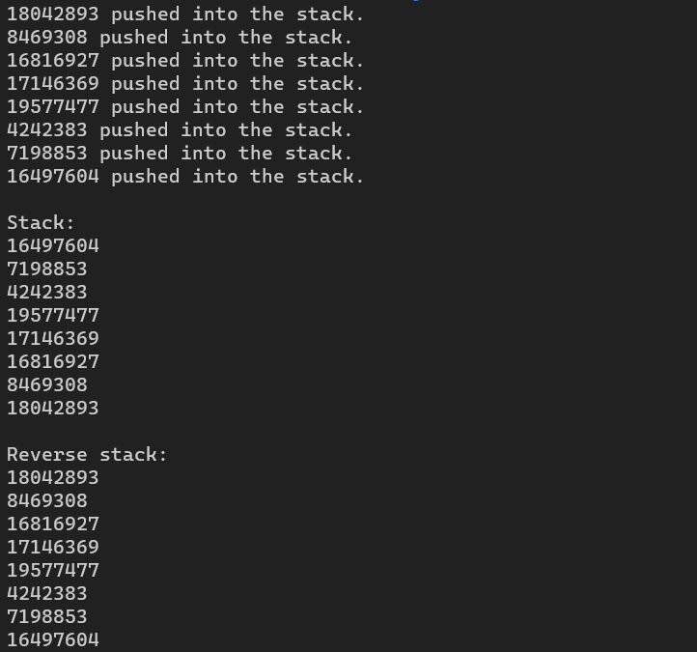

**Conclusion**

Thus, we can use stack, implemented using array, and perform operations like reversing the stack.

**1.3 WAP to check parentheses of algebraic expression using stack.**

**Problem Analysis**

The problem here is to check if an expression has all the parentheses balanced. To check if the expression is balanced, the expression is traversed through. If the current character is a starting bracket, it is pushed into the stack. If the current character is a closing bracket, it is popped from the stack. If the popped character is the matching starting bracket then it is balanced else the expression is not balanced.

**Algorithm**

Step 1: Initialize a character stack  
Step 2: Traverse through the expression.  
 If character = ‘[’ or ‘{’ or ‘(’:  
 Push to the stack.  
 Else if character = ‘[’ or ‘}’ or ‘)’:  
 Pop from the stack  
 [END OF IF]  
Step 3: If popped_char = matching_bracket:  
 Print “Balanced  
 Else   
 Print “Unbalanced”  
Step 4: EXIT

**Source Code**

#include <iostream>

#include <stack>

using namespace std;

bool isBalanced(string exp) {

    stack <char> st;

    char c;

    // Traversing through the Expression

    for(int i=0; i< exp.length(); i++) {

        // Checking the input char

        if(exp[i] == '[' || exp[i] == '{'|| exp[i] == '(') {

            // Push the char in the stack

            st.push(exp[i]);

            continue;

        }

        else {

            continue;

        }

        // If the char is not the opening bracket

        // // it must be closing bracket, so stack is not empty

        // if(st.empty())

        //  return true;

        switch(exp[i]) {

            case ')': {

                c = st.top();

                st.pop();

                if(c == '{' || c == '[')

                    return false;

                break;

            }

            case '}': {

                c = st.top();

                st.pop();

                if(c == '(' || c == '[')

                    return false;

                break;

            }

            case ']': {

                c = st.top();

                st.top();

                if(c == '(' || c == '{')

                    return false;

                break;

            }

        }

    }

    // // check the status of the stack

    // if (st.empty())

        return true;

}

int main() {

    string exp = "([{(2+3))}]";

    // Checking the value return by the function

    if(isBalanced(exp))

        cout << "The expression is balanced" << endl;

    else if(!isBalanced(exp))

        cout << "The expression is not balanced" << endl;

    else

        cout << "I don't know";

    return 0;

}

**Output**



**Conclusion**

In this way, we can use the stack data structure to analyze an algebraic expression and check if it is a balanced expression or not.

**1.4 WAP to convert infix to postfix using stack.**

**Problem Analysis**

To convert infix to postfix, the given expression is first traversed and checked if the current char is an operand or an operator. If the character is an operand, the postfix expression is appended and the char is added. If the char is an opening bracket, it is pushed into the stack and if it is a closing parenthesis, it is popped from the stack. If the char is an operator, it is pushed to the top of the stack following the precedence of the operator.

**Algorithm**

Step 1: Traverse through the expression  
 If top = NULL:  
 Print “Stack is empty”  
Step 2: If character = operand:  
 postfix = operand  
 Else if character = operator:  
 If operator1.precedence > operator2.precedence:  
 push()  
 Else if character = ‘)’:  
 pop()  
Step 3:  
 If char = ‘(’:  
 push()  
 Else if char = ‘)’:  
 While char != ‘(’:  
 pop()  
Step 4: Exit

**Source Code**

#include <iostream>

#include <stack>

#include <string>

// Function to return precedence of operators

int prec(char c)

{

switch (c) {

case '^':

return 3;

case '*':

return 2;

case '/':

return 2;

case '+':

return 1;

case '-':

return 1:

default:

return -1;

}

}

void infixToPostfix(string s)

{

std::stack<char> st;

st.push('N');

int l = s.length();

std::string ns;

for(int i = 0; i < l; i++)

{

// If the scanned character is an operand, add it to output string.

if((s[i] >= 'a' && s[i] <= 'z')||(s[i] >= 'A' && s[i] <= 'Z'))

ns+=s[i];

// If the scanned character is an Ô(Ô, push it to the stack.

else if(s[i] == '(')

st.push('(');

// If the scanned character is an Ô)Õ, pop and to output string from the stack

// until an Ô(Ô is encountered.

else if(s[i] == ')')

{

while(st.top() != 'N' && st.top() != '(')

{

char c = st.top();

st.pop();

ns += c;

}

if(st.top() == '(')

{

char c = st.top();

st.pop();

}

}

//If an operator is scanned

else{

while(st.top() != 'N' && prec(s[i]) <= prec(st.top()))

{

char c = st.top();

st.pop();

ns += c;

}

st.push(s[i]);

}

}

//Pop all the remaining elements from the stack

while(st.top() != 'N')

{

char c = st.top();

st.pop();

ns += c;

}

std::cout << ns << std::endl;

}

//Driver program to test above functions

int main()

{

std::string exp = "a+b*(c^d-e)^(f+g*h)-i";

infixToPostfix(exp);

return 0;

}

**Output**

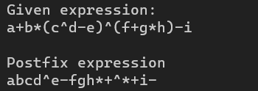

**Conclusion**

In this way, we can apply the stack data structure to convert an infix algebraic expression into postfix expression.

**1.5 WAP to convert infix to prefix using stack.**

**Problem Analysis**

For converting infix to prefix, the infix expression is first converted into a postfix expression, and the obtained postfix expression is reversed to obtain the prefix expression.

**Algorithm**

Step 1: Traverse through the expression  
 If top = NULL:  
 Print “Stack is empty”  
Step 2: If character = operand:  
 postfix = operand  
 Else if character = operator:  
 If operator1.precedence > operator2.precedence:  
 push()  
 Else if character = ‘)’:  
 pop()  
Step 3:  
 If char = ‘(’:  
 push()  
 Else if char = ‘)’:  
 While char != ‘(’:  
 pop()  
Step 4:   
 reverse(postfix.begin(), postfix.end())  
 print result  
Step 5: Exit

**Source Code**

#include <iostream>

#include <stack>

#include <string>

#include <algorithm>

bool isOperator(char c)

{

return (!isalpha(c) && !isdigit(c));

}

int getPriority(char C)

{

if (C == '-' || C == '+')

return 1;

else if (C == '*' || C == '/')

return 2;

else if (C == '^')

return 3;

return 0;

}

std::string infixToPostfix(std::string infix)

{

infix = '(' + infix + ')';

int l = infix.size();

std::stack<char> char_stack;

std::string output;

for (int i = 0; i < l; i++) {

// If the scanned character is an

// operand, add it to output.

if (isalpha(infix[i]) || isdigit(infix[i]))

output += infix[i];

// If the scanned character is an

// ‘(‘, push it to the stack.

else if (infix[i] == '(')

char_stack.push('(');

// If the scanned character is an

// ‘)’, pop and output from the stack

// until an ‘(‘ is encountered.

else if (infix[i] == ')') {

while (char_stack.top() != '(') {

output += char_stack.top();

char_stack.pop();

}

// Remove '(' from the stack

char_stack.pop();

}

// Operator found

else {

if (isOperator(char_stack.top())) {

while (getPriority(infix[i])

<= getPriority(char_stack.top())) {

output += char_stack.top();

char_stack.pop();

}

// Push current Operator on stack

char_stack.push(infix[i]);

}

}

}

return output;

}

std::string infixToPrefix(std::string infix)

{

/* Reverse String

* Replace ( with ) and vice versa

* Get Postfix

* Reverse Postfix * */

int l = infix.size();

// Reverse infix

std::reverse(infix.begin(), infix.end());

// Replace ( with ) and vice versa

for (int i = 0; i < l; i++) {

if (infix[i] == '(') {

infix[i] = ')';

i++;

}

else if (infix[i] == ')') {

infix[i] = '(';

i++;

}

}

std::string prefix = infixToPostfix(infix);

// Reverse postfix

std::reverse(prefix.begin(), prefix.end());

return prefix;

}

// Driver code

int main()

{

std::string s = ("(a-b/c)*(a/k-l)");

std::cout << "Given expression: " << std::endl << s << std::endl << std::endl;

std::cout << "Prefix expression: " << std::endl << infixToPrefix(s) << std::endl;

return 0;

}

**Output**

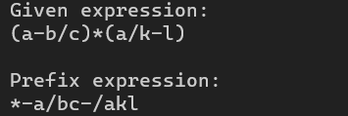

**Conclusion**

Similar to the previous problem, stack can be applied to analyze an algebraic expression and convert an infix expression into prefix expression.

**LAB 2  
Queue**

**2.1 WAP for array implementation of linear queue**

**Problem Analysis**

Queue is a data structure following First In, First Out (FIFO) principle. Here, we use array to implement a linear queue, where we insert, delete and traverse through the data structure. The data is inserted from the rear, a process called enqueue, while the data is retrieved from the first, a process called dequeue.

**Algorithm**

Step 1: Enqueue  
 if rear == MAX – 1:  
 print “Queue overflow”  
Step 2:   
 if front == -1 and rear == -1:  
 front = rear = -1  
 queue[rear] = -1  
 else:  
 rear += 1  
 queue[rear] = data  
 [END IF]  
Step 3: Dequeue  
 if rear = -1:  
 print “Queue Empty”  
 else if front == 0 and rear == 0:  
 delete queue[front]  
 front = rear = -1  
 else:  
 delete queue[front]  
 front += 1  
Step 4: Traversing the queue  
 while index <= rear:  
 print queue[index]  
Step 5: Exit

**Source Code**

#include <iostream>

using namespace std;

int max_size = 100;

class Queue {

int front, rear;

int *queue;

public:

Queue() {

front = 0;

rear = 0;

queue = new int[max_size];

}

bool isEmpty() {

return(front == rear);

}

bool isFull() {

return(rear == max_size - 1);

}

// Enque method

void enque(int data) {

if(isFull()) {

cout << "Overflow" << endl;

return;

}

else{

queue[rear] = data;

++rear;

}

}

// Deque method

void deque() {

int deque_value = 0;

if(isEmpty()) {

cout << "Underflow" << endl;

}

else {

deque_value = queue[front];

for(int i = 0; i < rear - 1; ++i) {

queue[i] = queue[i+1];

}

--rear;

cout << deque_value << " dequed from the queue." << endl;

}

}

// For returning front of the queue

void frontOf() {

if(isEmpty()) {

cout << "Queue empty." << endl;

return;

}

else {

cout << "Front of the queue: " << queue[front] << endl;

}

}

void display() {

if(isEmpty()) {

cout << "Queue empty." << endl;

return;

}

else {

for(int i = front; i < rear; ++i) {

cout << queue[i] << " ";

}

}

}

~Queue() {

delete[] queue;

}

};

int main() {

Queue *queue_obj = new Queue();

for(int i = 0; i < 6; ++i) {

queue_obj->enque(rand() % 7);

}

queue_obj->display();

cout << endl;

queue_obj->deque();

queue_obj->frontOf();

cout << "List after deque: " << endl;

queue_obj->display();

cout << endl;

delete queue_obj;

return 0;

}

**Output**

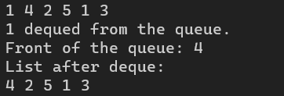

**Conclusion**

Similar to implementing stack, queue data structure can be implemented through the use of arrays. However, this data structure, like stack from array, is not memory efficient, and is only useful for storing fixed size of data.

**2.2 WAP for implementation of Circular Queue**

**Problem Analysis**

For creating a circular queue, the last position of the queue is connected to the first position of the queue, creating a circle of data, hence efficiently managing the memory and implementing a circular queue.

**Algorithm**

Step 1: For insertion  
 if (front == 0 and rear == size – 1) or rear == (front – 1) % (size – 1):  
 print “Queue full”  
Step 2:  
 if front == -1:  
 front = rear = 0  
 queue[rear] = data  
 else:  
 rear += 1  
 queue[rear] = data  
Step 3: For deleting data  
 if front == -1:  
 print “Queue empty”  
Step 4:  
 delete queue[front]  
 queue[front] = -1  
Step 5:  
 if front == rear:  
 front = rear = -1  
 else if front == size – 1:  
 front = 0  
 else:  
 front += 1  
Step 6: Traversing data  
 if rear >= front:  
 while index <= rear:  
 print queue[index]  
Step 7: Exit

**Source Code**

#include <iostream>

using namespace std;

int max_size = 100;

class Queue {

int rear, front;

int *queue;

int size;

public:

Queue(int size) {

front = -1;

rear = -1;

this->size = size;

queue = new int[this->size];

}

bool isEmpty() { return(front == -1); }

void enque(int data) {

// We know that the next element in a circular queue is given by (rear + 1) % size

if(((rear+1) % size) == front) {

cout << "Queue full" << endl;

return;

}

else if (front == -1) {

front = rear = 0;

queue[rear] = data;

}

else {

queue[rear] = data;

rear = (rear + 1) % size;

}

}

void deque() {

int deque_item = 0;

if(isEmpty()) {

cout << "Empty queue" << endl;

}

else if (front == rear) {

deque_item = queue[front];

front = rear = -1;

}

else {

deque_item = queue[front];

front = (front + 1) % size;

}

}

void frontOf() {

if(isEmpty()) {

cout << "Queue empty." << endl;

return;

}

else {

cout << "Front of the queue: " << queue[front] << endl;

}

}

void display() {

if(isEmpty()) {

cout << "Queue empty." << endl;

return;

}

else if(front <= rear) {

for(int i = front; i <= rear; ++i) {

cout << " " << queue[i];

}

}

else {

for(int i = front; i < size; ++i) {

cout << " " << queue[i];

}

for(int i = 0; i <= rear; ++i) {

cout << " " << queue[i];

}

}

cout << endl;

}

~Queue() {

delete[] queue;

}

};

int main() {

Queue *queue_obj = new Queue(max_size);

for(int i = 0; i < 6; ++i) {

queue_obj->enque(rand() % 7);

}

queue_obj->display();

cout << endl;

cout << "List after deque: " << endl;

queue_obj->deque();

queue_obj->frontOf();

queue_obj->display();

cout << endl;

delete queue_obj;

return 0;

}

**Output**

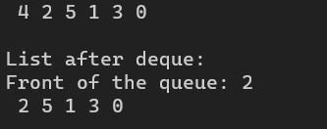

**Conclusion**

In this way, we can implement circular queue data structure through the use of arrays. However, unlike a linear queue, this is more memory efficient, but only can only store a fixed size of data.

**LAB 3**

**List**

**3.1 WAP to create contiguous list using array**

**Problem Analysis**

List is a collection of nodes. A pointer to a node is represented by array index whose value lies between 0 and max-1. Null pointer is represented by -1. There must be separate function to get the available nodes and free the nodes.

**Algorithm**

**For getting a Node**

Step 1. If avail = NULL

Write overflow

Go to step 5

Step 2. Set pointer ptr = avail

Step 3. Set avail = node[avail].next

Step 4. Return ptr

Step 5. Exit

**For freeing a node**

Step 1. Input a pointer ptr

Step 2. Set node[ptr].next = avail

Step 3. Set avail = ptr

Step 4. Stop

**Delete node**

Step 1. Input ptr  
 Step 2. node[ptr].info = 0  
 Step 3. If ptr = null or ptr > size – 1  
 print “Invalid node”  
 Goto step 6  
 Step 4. node[ptr-1].next = node[ptr].next  
 Step 5. Free node ptr  
 Step 6. Exit

**Insert after a pointer**  
 Step 1. Input a value val and pointer ptr  
 Step 2. if ptr = null  
 Write “Invalid insertion”  
 Goto step 7  
 Step 3. newptr = available node  
 Step 4. node[newptr].info = val  
 Step 5. node[newptr].next = node[ptr].next  
 Step 6. node[ptr].next = newptr  
 Step 7. Exit

**Delete after a pointer**  
 Step 1. Input a pointer ptr  
 Step 2. If ptr = null or node[ptr].next = null   
 print “Invalid deletion”  
 Goto step 7  
 Step 3. delptr = node[ptr].next  
 Step 4. delval = node[delptr].info  
 Step 5. node[ptr].next = node[delptr].next  
 Step 6. free node delptr  
 Step 7. Exit

**Source Code**

#include<iostream>

#define max 15

using namespace std;

struct nodetype

{

int info, next;

};

class list

{

struct nodetype node[max];

int avail = 0;

public:

int intialize_availlist()

{

int i;

for (i = 0;i < max - 1;i++)

{

node[i].next = i + 1;

}

node[max - 1].next = -1;

}

int get_node()

{

int p;

if (avail == -1)

{

cout << "Overflow";

}

p = avail;

avail = node[avail].next;

return p;

}

int freenode(int p)

{

node[p].next = avail;

avail = p;

}

void insertnode(int& list1)

{

int val, ptr, curptr, newnode = 1;

while (newnode == 1)

{

if (list1 == -1)

{

ptr = get_node();

list1 = ptr;

cout << "Enter the number: ";

cin >> val;

node[ptr].info = val;

node[ptr].next = -1;

}

else

{

curptr = 0;

while (node[curptr].next != -1)

{

curptr = node[curptr].next;

}

ptr = get_node();

cout << "Enter the Number: ";

cin >> val;

node[curptr].next = ptr;

node[ptr].info = val;

node[ptr].next = -1;

}

cout << "enter 1 for newnode" << endl;

cin >> newnode;

}

}

int displaynode()

{

cout << "**********Displaying The list**********" << endl;

int i;

int ptr = 0;

if (avail == 0)

{

cout << "List Underflow" << endl;

}

while (ptr != -1)

{

cout << "Index: " << ptr << " Value: " << node[ptr].info << " Next: " << node[ptr].next << endl;

ptr = node[ptr].next;

}

}

int deletenode(int& list1)

{

int val, curptr, preptr = -1;

curptr = list1;

while (node[curptr].next != -1)

{

preptr = curptr;

curptr = node[curptr].next;

}

freenode(curptr);

cout << endl;

cout << "The deleted value is: " << node[curptr].info << endl;

if (preptr == -1)

{

list1 = -1;

}

else

{

node[preptr].next = -1;

}

}

int insert_after(int ptr, int val)

{

int newptr;

if (ptr == -1)

{

cout << "Invalid Insertion";

}

else

{

newptr = get_node();

node[newptr].info = val;

node[newptr].next = node[ptr].next;

node[ptr].next = newptr;

cout << "Inserted Node After " << ptr << " Value: " << val << " Index: " << newptr << endl;

}

}

int delete_after(int ptr)

{

int delptr, delval;

if (ptr == -1 || node[ptr].next == -1)

{

cout << "Invalid deletion after given ptr" << endl;

}

else {

delptr = node[ptr].next;

delval = node[delptr].info;

cout << "Deleted Value is " << delval << endl;

node[ptr].next = node[delptr].next;

freenode(delptr);

}

}

};

int main()

{

list l;

l.intialize_availlist();

int ch;

int list1 = -1;

do

{

cout << "1. Insert a new node: " << endl;

cout << "2. Display Nodes: " << endl;

cout << "3. Delete Node" << endl;

cout << "4. Insert After Node" << endl;

cout << "5. Delete After Node" << endl;

cout << "6. Exit" << endl;

cout << " Choose the option: \t";

cin >> ch;

switch (ch)

{

case 1:

l.insertnode(list1);

break;

case 2:

l.displaynode();

break;

case 3:

l.deletenode(list1);

break;

case 4:

{

int ptr, val;

cout << "Enter the node index after which the new node has to be inserted: ";

cin >> ptr;

cout << "Enter the value to be inserted in the new node: ";

cin >> val;

l.insert_after(ptr, val);

break;

}

case 5:

{

int ptr;

cout << "Enter the node index after which the node has to be deleted: ";

cin >> ptr;

l.delete_after(ptr);

break;

}

case 6: break;

default: cout << "invalid input" << endl;

}

} while (ch != 6);

}

**Output**

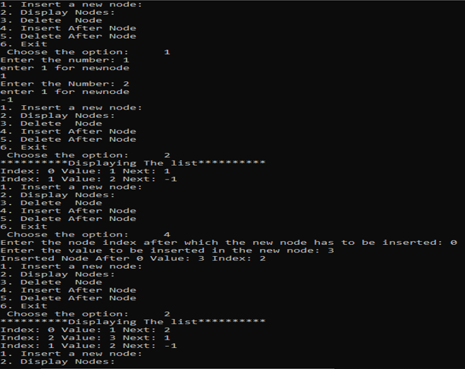

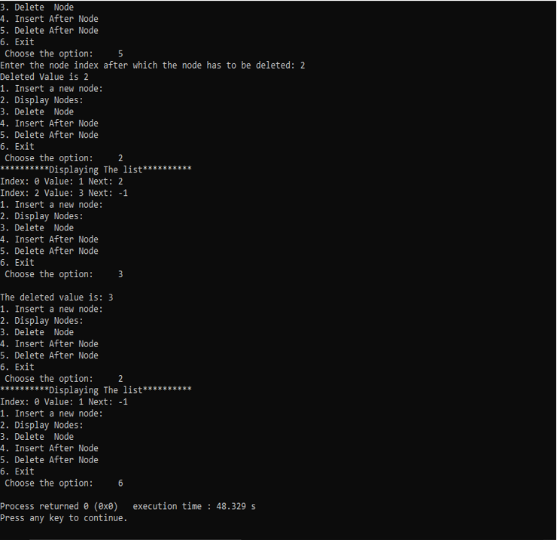

**Conclusion**

Thus, we can implement linked list data structure through the use of array, to store contiguous value. However, this list is not dynamic in nature, and is less memory efficient, since it uses arrays, and can only store a fixed size of data.

**3.2 WAP to implement Queue using List**

**Problem Analysis**

Queue can be implemented by using static list structure. Initially front and rear nodes can be made null. Operations like enqueue and dequeue can be implemented by getting the available node and making the node free as required.

**Algorithm**

**Enqueue a data**

Step 1: Initialize a variable for inputting data  
 Step 2: ptr = available node  
 Step 3: node[ptr].data = val  
 Step 4: node[ptr].next = null  
 Step 5: if rear == null:  
 front = ptr  
 else:  
 node[rear].next = ptr  
**Dequeue a data**

Step 1: if front == null or front > rear:  
 print “Queue underflow”  
 Step 2: del_val = node[front].data  
 Step 3: ptr = front  
 Step 4: front = node[front].next  
 Step 5: if front == null:  
 rear = null  
 Step 6: Free node ptr  
 Step 7: Return del_val  
 Step 8: Exit

**Source Code**

#include<iostream>

using namespace std;

int max_size = 7;

struct nodeType {

int data;

int next;

};

int get_node() {

if(avail == -1) {

return -1;

}

else {

int temp;

temp = avail;

avail = node[avail].next;

return temp;

}

}

void free_node(int n) {

node[n].data = 0;

node[n].next = avail;

avail = n;

}

void display() {

if(avail==0) {

cout<<"List Underflow"<<endl;

}

do {

cout << "Index: " << ptr << " Value: " << node[ptr].info << " Next: "<< node[ptr].next<<endl;

ptr = node[ptr].next;

} while(ptr != -1);

}

class Queue{

private:

int front, rear;

public:

Queue() {

front = -1;

rear = -1;

}

bool isempty(){

return (front == -1);

}

void enqueue() {

int ptr;

ptr = getnode();

cout << "Enter an integer:";

cin >> node[ptr].info;

if(rear == -1)

front = ptr;

else

node[rear].next = ptr;

rear = ptr;

}

int dequeue() {

int del_val, ptr;

if(isempty()) {

cout << "Underflow" << endl;

exit(1);

}

else{

del_val = node[front].info;

ptr = front;

front = node[front].next;

if(front==-1)

rear=-1;

freenode(ptr);

return del_val;

}

}

int getfront(){

return front;

}

};

int main(){

Queue queue_obj;

int option = 1;

int val, pos;

for(int i = 0; i < max;i++){

if(i == max-1){

node[i].next = -1;

}

else{

node[i].next = i+1;

}

}

while(option != 0){

cout << "Menu:" << endl;

cout << "1 .Enqueue" << endl;

cout << "2 .Dequeue" << endl;

cout << "0 .Exit" << endl;

cout << "Enter your choice: ";

cin >> option;

switch(choose){

case 1:

queue_obj.enqueue();

break;

case 2:

val = queue_obj.dequeue();

cout << val << " is dequeued" << endl;

break;

case 0:

break;

}

}

return 0;

}

**Output**

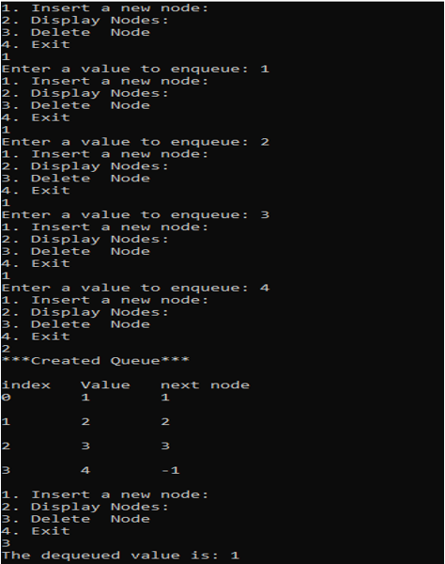

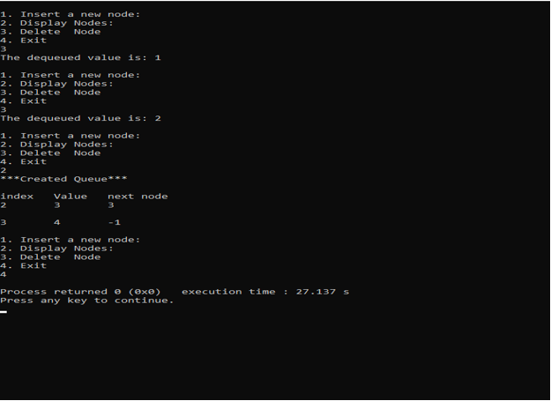

**Conclusion**

Thus, we can use contiguous list implemented through array to implement a queue.

**LAB 4**

**Linked List**

**4.1 WAP to implement singly linked list**

**Problem Analysis**

Here, a struct containing data and a pointer is created, and a class is further created, encapsulating the variables necessary for a linked list. When the first node is created, the node is null, and for further addition of nodes, the pointer points to the newly created node and hence a list is formed.

**Algorithm**

**Creating a node**  
 Step 1: Input data   
 Step 2: Create a node temp  
 Step 3: Set temp->data = data  
 Step 4: if head == null:  
 head = temp  
 tail = temp  
 else:  
 tail->next = temp  
 tail = temp  
 Step 5: temp->next = null  
 Step 6: Exit

**Inserting node at beginning**  
 Step 1: Input data  
 Step 2: Create new node temp  
 Step 3: if temp == null:  
 print “Error in memory allocation”  
 Goto step 7  
 Step 4: temp->data = data  
 Step 5: If head == null:  
 temp->next = null  
 else:  
 temp->next = head  
 Step 6: head = temp  
 Step 7: Exit  
  
**Inserting node at the end**

Step 1: Input data  
Step 2: Create temp  
Step 3: if temp == null:  
 Goto step 7  
Step 4: temp->data = data  
 temp->next = null  
Step 5: if head == null:  
 head = temp  
 else:  
 ptr = head  
 while ptr->next != null:  
 ptr = ptr->next  
Step 6: ptr->next = temp  
Step 7: Exit

**Inserting node after a given node**

Step 1: Input data  
Step 2: Create temp  
Step 3: if temp == null:  
 Goto step 7  
Step 4: temp->data = data  
 temp->next = null   
Step 5: ptr = head, pre_ptr = ptr  
Step 6: while pre_ptr->data != num:  
 pre_ptr = ptr  
 ptr = ptr->next  
Step 7: pre_ptr->next = temp  
Step 8: temp->next = ptr  
Step 9: Exit

**Insert a node after given node**

Step 1: Input data  
Step 2: Create temp  
Step 3: if temp == null:  
 Goto step 7  
Step 4: temp->data = data  
 temp->next = null   
Step 5: ptr = head, pre_ptr = ptr  
Step 6: while pre_ptr->data != num:  
 pre_ptr = ptr  
 ptr = ptr->next  
Step 7: pre_ptr->next = temp  
Step 8: temp->next = ptr  
Step 9: Exit

**Delete first node**

Step 1: if head == null  
 print “Empty list”  
Step 2: set ptr = head  
Step 3: set head = head->next  
Step 4: Delete ptr  
Step 5: Exit

**Delete last node**

Step 1: if head == null:  
 print “Empty list”  
 Step 2: ptr = head  
 Step 3: while ptr->next != null:

pre_ptr = ptr  
 ptr = ptr->next  
 Step 4: pre_ptr->next = null  
 Step 5: Delete ptr  
 Step 6: Exit

**Delete given node**

Step 1: if head == null:

Print “Empty list”  
 Step 2: ptr = head  
 Step 3: while ptr->data != num:  
 pre_ptr = ptr  
 ptr = ptr->next  
 Step 4: temp = ptr  
 Step 5: pre_ptr->next = ptr->next  
 Step 6: Exit

**Source Code**

#include <iostream>

#define null NULL

using namespace std;

struct Node {

int data;

Node *next;

};

class List {

private:

Node* head, *tail;

public:

List() {

head = null;

tail = null;

}

bool isEmpty() { return (head == null); }

void insert(int data) {

Node *temp = new Node;

temp->data = data;

temp->next = null;

if(isEmpty()) {

head = temp;

tail = temp;

}

else {

tail->next = temp;

tail = tail->next;

}

}

void remove() {

Node *temp = head;

if(isEmpty()) {

cerr << "Error, the list is empty" << endl;

}

else {

while(temp->next->next != null)

{

temp = temp->next;

}

temp->next = null;

}

}

void display() {

if(isEmpty()) {

cerr << "Error, the list is empty!" << endl;

}

else {

Node *temp = new Node;

temp = head;

do {

cout << temp->data << " ";

temp = temp->next;

} while (temp->next != null);

}

}

};

int main() {

List *list_obj = new List;

char option, query;

int some_data;

cout << "Enter options below: " << endl;

cout << "1. Insert data on list" << endl;

cout << "2. Remove data from list" << endl;

cout << "3. Display the list" << endl;

cin >> option;

if(option == '1') {

do {

cout << endl << "Enter data: ";

cin >> some_data;

list_obj->insert(some_data);

cout << "Do you want to add more elements? [Y/N] ";

cin >> query;

} while(query != 'N' || query != 'n');

}

else if (option == '2') {

list_obj->remove();

}

else if (option == '3') {

list_obj->display();

}

else {

cerr << "Error, incorrect option" << endl;

}

return 0;

}

**Output**

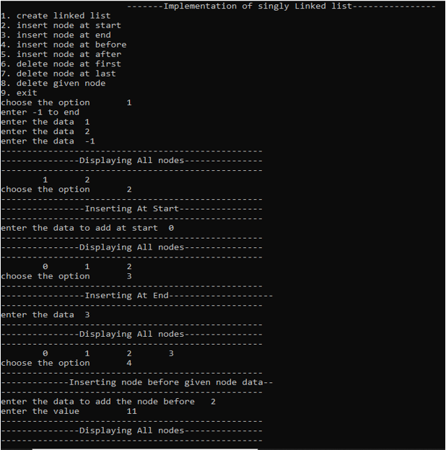

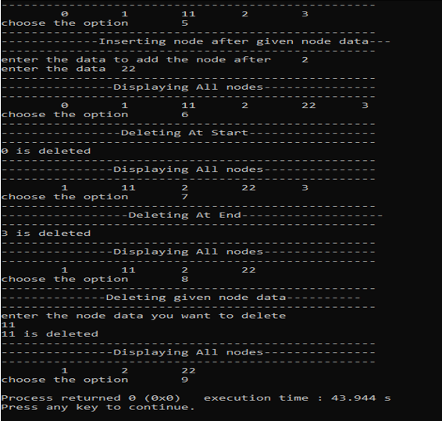

**Conclusion**

Thus, linked list can be implemented through the use of nodes, and the list will be of dynamic nature.

**4.2 WAP to implement Circular Linked List**

**Problem Analysis**

Here we have to create a node . Each node contains a pointer that points to the next node in the list. The last node’s next pointer is pointed to the first node .

**Algorithm**

**Create node**

Step 1: Input data VAL

Step 2: Create a NEW_NODE

Step 3: SET NEW_NODE =>DATA = VAL

Step 4: IF START = NULL

SET START=NEW_NODE

SET END = NEW_NODE

ELSE

END=>NEXT=NEW_NODE

END=NEW_NODE

Step 5: END=>NEXT = START

Step 6: Exit

**Insert node at Beginning**

Step 1: Input data VAL

Step 2: Create a NEW_NODE

Step 3: IF NEW_NODE = NULL

write ERROR IN MEMORY ALLOCATION

Go to Step 7

Step 4: SET NEW_NODE => DATA = VAL

Step 5: SET PTR = START

Step 6: Repeat Step 7

While PTR => NEXT != START

Step 7: SET PTR=PTR=>NEXT

[END OF While LOOP]

Step 8: SET NEW_NODE =>NEXT = START

Step 9: PTR=>NEXT = NEW_NODE

Step 10: SET START = NEW_NODE

Step 11: Exit

**Insert node at End**

Step 1: Input data VAL

Step 2: Create a NEW_NODE

Step 3: IF NEW_NODE = NULL

Step 3.1: write ERROR IN MEMORY ALLOCATION

Step 3.2: Go to Step 9

Step 4: SET NEW_NODE =>DATA = VAL

Step 5: SET NEW_NODE =>NEXT = START

Step 6: SET PTR=START

Step 7: Repeat Step 8

While PTR => NEXT!=START

Step 8: SET PTR = PTR=>NEXT

[END of While Loop]

Step 9: SET PTR=>NEXT = NEW_NODE

Step 10: Exit

**Insert node after a given node**

Step 1: Input data VAL

Step 2: Create a NEW_NODE

Step 3: IF NEW_NODE = NULL

Step 3.1: write ERROR IN MEMORY ALLOCATION

Step 3.2: Go to Step 12

Step 4: SET NEW_NODE => DATA = VAL

Step 5: SET PTR = START

Step 6: SET PREPTR = PTR

Step 7: Repeat Steps 8 and 9 while PREPTR => DATA != NUM

Step 8: SET PREPTR = PTR

Step 9: SET PTR = PTR=>NEXT

[End of while loop]

Step 10: PREPTR=> NEXT = NEW_NODE

Step 11: SET NEW_NODE =>NEXT = PTR

Step 12: Exit

**Insert node before a given node**

Step 1: Input data VAL

Step 2: Create a NEW_NODE

Step 3: IF NEW_NODE = NULL

Step 3.1: write ERROR IN MEMORY ALLOCATION

Step 3.2: Go to Step 12

Step 4: SET NEW_NODE =>DATA = VAL

Step 5: SET PTR = START

Step 6: SET PREPTR = PTR

Step 7: Repeat Steps 8 and 9 while PTR => DATA != NUM

Step 8: SET PREPTR = PTR

Step 9: SET PTR = PTR=>NEXT

[End of while loop]

Step 10: PREPTR=>NEXT = NEW_NODE

Step 11: SET NEW_NODE =>NEXT = PTR

Step 12: Exit

**Delete first node**

Step 1: If START = NULL

Write ‘underflow’

Goto Step 5

[END OF IF]

Step 2: SET PTR = START

Step 3: Repeat Step 4 While PTR => NEXT != START

Step 4: SET PTR=PTR=>NEXT

[END OF While LOOP]

Step 5: SET PTR=>NEXT=START=>NEXT

Step 6: FREE START

Step 7 SET START=PTR=>NEXT

Step 8: Exit

**Delete last node**

Step 1: IF START = NULL

Write ‘Underflow’

Goto Step 8

[END OF IF]

Step 2: SET PTR= START

Step 3: Repeat Steps 4 and 5 While PTR => NEXT ! = NULL

Step 4: SET PREPTR =PTR

Step 5: SET PTR = PTR=>NEXT

[END OF LOOP]

Step 6: SET PREPTR =>NEXT = START

Step 7: FREE PTR

Step 8: Exit

**Delete a given node**

Step 1: IF START = NULL

Write ‘Underflow’

Goto Step 9

[END OF IF]

Step 2: SET PTR= START

Step 3: Repeat Steps 4 and 5 While PTR => DATA!=NUM

Step 4: SET PREPTR =PTR

Step 5: SET PTR = PTR=>NEXT

[END OF LOOP]

Step 6: SET TEMP = PTR

Step 7: SET PREPTR =>NEXT = PTR => NEXT

Step 8: FREE TEMP

Step 9: Exit

**Source Code**

#include <iostream>

#define null NULL

using namespace std;

struct Node {

int data;

Node *next;

};

class List {

private:

Node* head, *tail;

public:

List() {

head = null;

tail = null;

}

bool isEmpty() { return (head == null); }

void insert(int data) {

Node *temp = new Node;

Node *prev = head;

temp->data = data;

temp->next = head;

if(isEmpty()) {

temp->next = temp;

}

else {

do {

prev = prev->next;

} while(prev->next != null);

prev->next = temp;

}

head = temp;

}

void display() {

if(isEmpty()) {

cerr << "Error, the list is empty!" << endl;

}

else {

Node *temp = head;

do {

cout << temp->data << " ";

temp = temp->next;

} while (temp->next != head);

}

}

};

int main() {

List *list_obj = new List;

for(int i = 0; i < 7; ++i) {

list_obj->insert(rand() % 7);

}

list_obj->display();

return 0;

}

**4.3 WAP to implement Doubly Linked List**

**Problem Analysis**

Here we have to create a node. Each node contains a pointer that points to the next node in the list. The last node’s next pointer is pointed to the first node. Since it is doubly linked list or a two-way linked list which is a more complex type of linked list which contains a pointer to the next as well as the previous node in the sequence. The problem here is to linked previous and current node. We have to create such type of linked list where not only forward but also backward traversing is possible.

**Algorithm**

**Inserting at beginning**

Step 1: Input data VAL

Step 2: Create a NEW_NODE

Step 3: IF NEW_NODE = NULL

Step 3.1: write ERROR IN MEMORY ALLOCATION

Step 3.2: Go to Step 9

Step 4: SET NEW_NODE => DATA = VAL

Step 5: SET NEW_NODE =>PREV = NULL

Step 6: SET NEW_NODE => NEXT = START

Step 7: SET START=>PREV = NEW_NODE

Step 8: SET START = NEW_NODE

Step 9: EXIT

**Inserting at End**

Step 1: Input data VAL

Step 2: Create a NEW_NODE

Step 3: IF NEW_NODE = NULL

Step 3.1: write ERROR IN MEMORY ALLOCATION

Step 3.2: Go to Step 11

Step 4: SET NEW_NODE => DATA = VAL

Step 5: SET NEW_NODE =>NEXT = NULL

Step 6: SET PTR = START

Step 7: Repeat Step 8 While PTR=> NEXT != NULL

Step 8: SET PTR = PTR=>NEXT

Step 9: SET PTR => NEXT = NEW_NODE

Step 10: Set NEW_NODE=>PREV = PTR

Step 11: EXIT

**Inserting node after a given node**

Step 1: Input data VAL

Step 2: Create a NEW_NODE

Step 3: IF NEW_NODE = NULL

Step 3.1: write ERROR IN MEMORY ALLOCATION

Step 3.2: Go to Step 12

Step 4: SET NEW_NODE => DATA = VAL

Step 5: SET PTR = START

Step 6: Repeat Step 7 While PTR=>DATA != NUM

Step 7: SET PTR = PTR=>NEXT

[End of while Loop]

Step 8: SET NEW_NODE =.>NEXT = PTR ◊ NEXT

Step 9: SET NEW_NODE=>PREV = PTR

Step 10 : SET PTR=>NEXT=>PREV = NEW_NODE

Step 11: SET PTR=>NEXT = NEW_NODE

Step 12: EXIT

**Inserting node before a given node**

Step 1: Input data VAL

Step 2: Create a NEW_NODE

Step 3: IF NEW_NODE = NULL

Step 3.1: write ERROR IN MEMORY ALLOCATION

Step 3.2: Go to Step 12

Step 4: SET NEW_NODE =>DATA = VAL

Step 5: SET PTR = START

Step 6: Repeat Step 7 While PTR=> DATA != NUM

Step 7: SET PTR = PTR=>NEXT [End of while Loop]

Step 8: SET NEW_NODE =>NEXT = PTR

Step 9: SET NEW_NODE=>PREV = PTR◊PREV

Step 10: SET PTR=>PREV=>NEXT = NEW_NODE

Step 11: SET PTR=>PREV = NEW_NODE

Step 12: EXIT

**Deleting the first node**

Step 1: IF START = NULL

Write “underflow”

Goto step 6

[END OF IF]

Step 2: SET PTR = START

Step 3: SET START=START=>NEXT

Step 4: SET START=>PREV=NULL

Step 5: FREE PTR

Step 6: EXIT

**Deleting the last node**

Step 1: IF START = NULL

Write “underflow”

Goto step 7

[END OF IF]

Step 2: SET PTR = START

Step 3: Repeat Step 4 While PTR=>NEXT!=NULL

Step 4: SET PTR = PTR=>NEXT

[ END OF LOOP ]

Step 5: SET PTR=>PREV=>NEXT=NULL

Step 6: FREE PTR

Step 7: EXIT

**Deleting node after a given node**

Step 1: IF START=NULL

Write “UNDERFLOW”

Goto Step 9

[ END OF IF ]

Step 2: SET PTR= START

Step 3: Repeat Step 4 While PTR=>DATA!=NUM

Step 4: SET PTR=PTR=>NEXT

[END OF LOOP]

Step 5: SET TEMP = PTR=>NEXT

Step 6: SET PTR=>NEXT = TEMP=>NEXT

Step 7: SET TEMP=>NEXT=>PREV=PTR

Step 8: FREE TEMP

Step 9: EXIT

**Deleting node before a given node**

Step 1: IF START=NULL

Write “UNDERFLOW”

Goto Step 9

[ END OF IF ]

Step 2: SET PTR= START

Step 3: Repeat Step 4 While PTR=>DATA!=NUM

Step 4: SET PTR=PTR=>NEXT

[END OF LOOP]

Step 5: SET TEMP = PTR=>PREV

Step 6: SET TEMP=>PREV=>NEXT = PTR

Step 7: SET PTR=>PREV = TEMP =>PREV

Step 8: FREE TEMP

Step 9: EXIT

**Deleting a given node**

Step 1: IF START=NULL

Write “UNDERFLOW”

Goto Step 8

[ END OF IF ]

Step 2: SET PTR= START

Step 3: Repeat Step 4 While PTR=>DATA!=NUM

Step 4: SET PTR=PTR=>NEXT

[END OF LOOP]

Step 5: SET PTR=>PREV=>NEXT=PTR=>NEXT

Step 6: SET PTR=>NEXT=>PREV=PTR=>PREV

Step 7: FREE PTR

Step 8: EXIT

**Source Code**

#include <iostream>

#define null NULL

using namespace std;

struct Node {

int data;

Node *next;

Node *prev;

};

class List {

private:

Node* head;

Node* tail;

public:

List() {

head = null;

tail = null;

}

bool isEmpty() { return (head == null); }

void insert(int data) {

Node *temp = new Node;

temp->data = data;

if(isEmpty()) {

head = temp;

tail = temp;

head->prev = null;

tail->next = null;

}

else {

tail->next = temp;

temp->prev = tail;

tail = temp;

tail->next = null;

}

}

void remove() {

Node *temp = new Node;

temp = head;

head = head->next;

head->next->prev = null;

delete temp;

}

void display() {

Node *temp = head;

if(isEmpty()) {

cerr << "Error, the list is empty!" << endl;

}

else {

do {

cout << temp->data << " ";

temp = temp->next;

} while(temp->next != null);

}

}

};

int main() {

List *list_obj = new List;

char option, query;

int some_data;

cout << "Enter options below: " << endl;

cout << "1. Insert data on list" << endl;

cout << "2. Remove data from list" << endl;

cout << "3. Display the list" << endl;

cin >> option;

if(option == '1') {

do {

cout << endl << "Enter data: ";

cin >> some_data;

list_obj->insert(some_data);

cout << "Do you want to add more elements? [Y/N] ";

cin >> query;

} while(query != 'N' || query != 'n');

}

else if (option == '2') {

list_obj->remove();

}

else if (option == '3') {

list_obj->display();

}

else {

cerr << "Error, incorrect option" << endl;

}

return 0;

}

**Output**

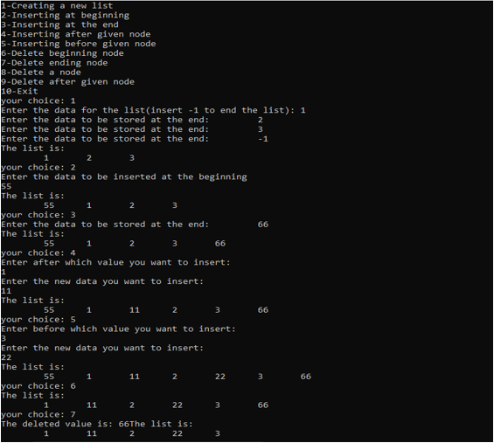

**Conclusion**

Thus, the linked list implemented is a doubly linked list, which can be traversed both ways.

**4.4 WAP to implement priority queue using list**

**Problem Analysis**

The problem here is to implement priority queue using linked list. Where we have to create a queue according to its priority and dequeue as FIFO principle according to its priority order.

**Algorithm**

**Enqueue**

Step 1: Allocate memory for the new node

Step 2: SET NEW_NODE=>DATA=VAL

Step 3: SET NEW_NODE=>NEXT=NULL

Step 4: PTR= START

Step 5: Repeat Step while NEW_NODE=>DATA!=NULL

Step 5.1: IF NEW_NODE=>PRIORITY<START=>PRIORITY

SET NEW_NODE=>START

SET START=NEW_NODE

ELSE

Repeat While PTR=>NEXT!=NULL AND PTR=>NEXT=>PRIORITY<NEW_NODE=>PRIORITY

PTR=PTR=>NEXT

[END OF WHILE LOOP]

SET NEW_NODE=>NEXT=PTR=>NEXT

SET PTR=>NEXT = NEW_NODE

Step 6: EXIT

**Dequeue**

Step 1: SET PTR=START=>NEXT

Step 2: FREE START

Step 3: SET START = PTR

Step 4: EXIT

**Source Code**

#include <iostream>

using namespace std;

#define null NULL

struct Node {

Node *next;

int data;

int priority;

};

// Queue class

class Queue {

Node *head;

public:

Queue() {

head = null;

}

bool isEmpty() { return(front == null); }

void enque(int data, int prior) {

Node *new_node = new Node;

Node *temp = head;

Node *prev = null;

if(isEmpty()) {

new_node->data = data;

new_node->priority = prior;

new_node->next = head;

head = new_node;

}

else {

while(temp->priority < prior){

prev = temp;

if(temp->next == NULL){

break;

}

temp = temp->next;

}

if(temp == NULL){

new_node = new Node;

new_node->next = prev;

new_node->data = data;

temp->priority = prior;

head = temp;

}

else if(temp->priority >= prior){

new_node = new Node;

prev->next = new_node;

new_node->next = temp;

new_node->data = data;

new_node->priority = prior;

}

else{

new_node = new Node;

temp->next = new_node;

new_node->data = data;

new_node->priority = prior;

new_node->next =NULL;

}

}

}

void deque() {

Node *temp = head;

if(isEmpty()) {

cerr << "Error, queue empty" << endl;

}

else {

Node *temp = head;

head = temp->next;

cout << temp->data << " dequed" << endl;

delete temp;

}

}

// Traversing and displaying the queue

void display() {

if(isEmpty()) {

cout << "Queue empty...." << endl;

}

else {

Node *temp = front;

do {

cout << temp->data << " ";

temp = temp->next;

} while(temp->next != null);

cout << endl;

}

}

};

int main() {

Queue *queue_obj = new Queue;

for(int i = 0; i < 6; ++i) {

queue_obj->enque(rand() % 7);

}

cout << "Queue: ";

queue_obj->display();

queue_obj->deque();

cout << "Queue after deque: ";

queue_obj->display();

cout << endl;

delete queue_obj;

return 0;

}

**Output**

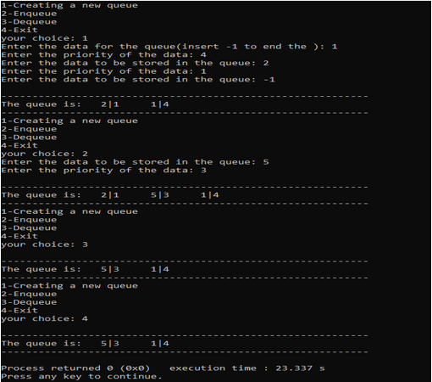  
  
**Conclusion**

Thus, priority queue was implemented through the use of dynamic linked list data structure.

**4.5 WAP to implement Stack using Linked List**

**Problem Analysis**

The problem here is to use linked list to create a stack. Using linked list, we can insert and delete data, so we use it to use it as a stack by implementing LIFO principle. We push data to the linked list and pop data from the linked list.

**Algorithm**

**Push**

Step 1: Allocate memory for the new_node and named it as NEW_NODE

Step 2: SET NEW_NODE=>DATA = VAL

Step 3: IF TOP =NULL

SET NEW_NODE=>NEXT=NULL

SET TOP=NEW_NODE

ELSE

SET NEW_NODE=>NEXT = TOP

SET TOP = NEW_NODE

[ END OF IF ]

Step 4: END

**Pop**

Step 1: IF TOP=NULL

PRINT “UNDERFLOW”

Goto Step 5

[END OF IF ]

Step 2: SET PTR=TOP

Step 3: SET TOP = TOP=>NEXT

Step 4: FREE PTR

Step 5: END

**Source Code:**

#include <iostream>

using namespace std;

#define null NULL

// Struct for storing Node of the linked list

struct Node {

Node *next;

int data;

};

// Stack class

class Stack {

private:

Node *head;

public:

Stack() {

head = null;

}

bool isEmpty() { return(head == null); }

void push(int data) {

Node *temp = new Node;

temp->data = data;

if(!isEmpty()) {

temp->next = head;

}

else {

temp->next = null;

}

head = temp;

}

void pop() {

if(isEmpty()) {

cerr << "Error, stack underflow!" << endl;

}

else {

Node *temp = new Node;

temp = head;

head = head->next;

delete temp;

}

}

void peek() {

cout << head->data << endl;

}

void display() {

Node *temp = new Node;

temp = head;

do {

cout << temp->data << " ";

temp = temp->next;

} while(temp->next != null);

cout << endl;

}

};

int main() {

Stack *stack_obj = new Stack;

for(int i = 0; i < 6; ++i) {

stack_obj->push(rand() % 7);

}

stack_obj->peek();

cout << "StackL ";

stack_obj->display();

stack_obj->pop();

cout << "Stack after popping: ";

stack_obj->display();

cout << endl;

delete stack_obj;

return 0;

}

**Output**

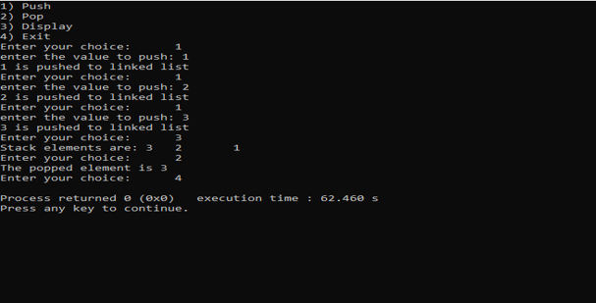

**Conclusion**

Thus, stack was implemented through the use of dynamic linked list, and operations, like push, pop, peek and traversal can be done on the stack.

**4.6 WAP to implement Queue using Linked List**

**Problem Analysis**

The problem here is to implement the principle of FIFO principle to implement queue using linked list data structure. For this, we insert and delete the data from the rear end and the front respectively. We define two node pointers, *front and *rear which points to front end and rear end respectively. To insert data we create a new node and initialize the next pointer of rear to the newly created node and initialize rear end with the new node. For deleting data, we first store the front pointer to a temporary variable and initialize front with the value of next pointer and then delete the temp variable.

**Algorithm**

Enqueue:

Step 1 : Allocate memory for the new node and name it as PTR

Step 2 : SET PTR=>DATA =VAL

Step 3 : IF FRONT = NULL

SET FRONT = REAR=PTR

SET FRONT => NEXT = REAR => NEXT = NULL

ELSE

SET REAR=>NEXT = PTR

SET REAR=PTR

SET REAR=>NEXT = NULL

[END OF IF]

Step 4: END

Dequeue :

Step 1 : IF FRONT = NULL

Write “UNDERFLOW”

Goto Step 5

[END OF IF]

Step 2 : SET PTR = FRONT

Step 3 : SET FRONT = FRONT=>NEXT

Step 4 : FREE PTR

Step 5 : END

**Source Code**

#include <iostream>

using namespace std;

#define null NULL

// Struct for storing Node of the linked list

struct Node {

Node *next;

int data;

};

// Queue class

class Queue {

Node *front, *rear; // Two pointers that point to the front and rear of the Queue

public:

Queue() {

front = null;

rear = null;

}

bool isEmpty() { return(front == null); }

// Method for pushing data into the queue

void enque(int data) {

Node *temp = new Node;

temp->data = data;

if(isEmpty()) {

front = temp;

rear = temp;

}

else {

rear->next = temp;

rear = temp;

}

}

// Method for removing data from front of the queue

void deque() {

if(isEmpty()) {

cout << "Queue empty...." << endl;

}

else {

Node *temp = new Node;

temp = front;

front = front->next;

if(front == null) {

rear = null;

}

delete temp;

}

}

// Returns the front of the queue

void frontof() {

if(isEmpty()) {

cout << "Queue empty...." << endl;

}

else {

cout << "Front of the queue: " << front->data << endl;

}

}

// Traversing and displaying the queue

void display() {

if(isEmpty()) {

cout << "Queue empty...." << endl;

}

else {

Node *temp = front;

do {

cout << temp->data << " ";

temp = temp->next;

} while(temp->next != null);

cout << endl;

}

}

};

int main() {

Queue *queue_obj = new Queue;

for(int i = 0; i < 6; ++i) {

queue_obj->enque(rand() % 7);

}

queue_obj->frontof();

cout << "Queue: ";

queue_obj->display();

queue_obj->deque();

cout << "Queue after deque: ";

queue_obj->display();

cout << endl;

delete queue_obj;

return 0;

}

**Output**

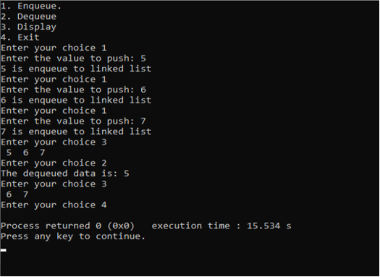

**Conclusion**

Thus, stack was implemented through dynamic linked list, and different operations, like enqueue, dequeue and traversal, was performed in it.

**4.7 WAP to store a polynomial using linked list, and perform addition and subtraction on two polynomials**

**Problem Analysis**

In this program we perform an addition and subtraction of two polynomials by storing a polynomial using linked list.

**Algorithm**

Step 1: Create a structure for coefficient , exponents and next for

new node.

Step 2: Call a function to create a polynomial, add a polynomial,

Subtract a polynomial, and display a polynomial.

Step 3: Scan two polynomials node by node comparing for the

exponents.

Step 4: If the exponents are equal, add/subtract their coefficients.

Step 5: If the exponents are not equal, simply add/subtract a node

in the new list.

**Source Code**

#include<iostream>

#include<cstdlib>

#include<cmath>

using namespace std;

struct node

{

int check;

int info, xp;

node* next;

};

class POLY

{

node* START;

public:

POLY() :START(NULL) {}

void AddExpression(int, int);

POLY operator + (POLY&);

POLY operator - (POLY&);

bool DisplayExpression();

};

void POLY::AddExpression(int num, int x)

{

node* temp = new node;

if (temp == NULL)

cout << "Failed to initialize the memory for new block.\n";

else

{

temp->info = num;

temp->xp = x;

temp->next = NULL;

if (START == NULL)

START = temp;

else

{

node* ptr;

ptr = START;

while (ptr->next != NULL)

ptr = ptr->next;

ptr->next = temp;

}

}

}

POLY POLY::operator+(POLY& second)

{

POLY t;

if (START == NULL)

{

cout << "There is no first polynomial expression.\n";

return t;

}

else if (second.START == NULL)

{

cout << "There is no second polynomial expression.\n";

return t;

}

else

{

int c;

node* p1, * p2;

p1 = START;

while (p1 != NULL)

{

c = 0;

p2 = second.START;

while (p2 != NULL)

{

if (p1->xp == p2->xp)

{

c = 1;

p2->check = 1;

t.AddExpression((p1->info + p2->info), p1->xp);

break;

}

p2 = p2->next;

}

if (c == 0)

t.AddExpression(p1->info, p1->xp);

p1 = p1->next;

}

p2 = second.START;

while (p2 != NULL)

{

if (p2->check != 1)

t.AddExpression(p2->info, p2->xp);

p2 = p2->next;

}

return t;

}

}

POLY POLY::operator-(POLY& second)

{

POLY t;

if (START == NULL)

{

cout << "There is no first polynomial expression.\n";

return t;

}

else if (second.START == NULL)

{

cout << "There is no second polynomial expression.\n";

return t;

}

else

{

int c;

node* p1, * p2;

p1 = START;

while (p1 != NULL)

{

c = 0;

p2 = second.START;

while (p2 != NULL)

{

if (p1->xp == p2->xp)

{

c = 1;

p2->check = 1;

t.AddExpression((p1->info - p2->info), p1->xp);

break;

}

p2 = p2->next;

}

if (c == 0)

t.AddExpression(p1->info, p1->xp);

p1 = p1->next;

}

p2 = second.START;

while (p2 != NULL)

{

if (p2->check != 1)

t.AddExpression(-p2->info, p2->xp);

p2 = p2->next;

}

return t;

}

}

bool POLY::DisplayExpression()

{

if (START == NULL)

{

cout << "No expression\n";

return false;

}

else

{

node* ptr;

ptr = START;

cout << "The expression is :\n";

while (ptr != NULL)

{

if (ptr == START && ptr->info >= 0)

cout << ptr->info << "x^" << ptr->xp << " ";

else if (ptr->info >= 0)

cout << "+" << ptr->info << "x^" << ptr->xp << " ";

else

cout << ptr->info << "x^" << ptr->xp << " ";

ptr = ptr->next;

}

cout << "\n\n";

return true;

}

}

int main()

{

POLY e1, e2, e3;

int choice, info, x, y, z;

char ch;

while (1)

{

cout << "1. Enter the first expression\n2. Enter the second expression\n3. Add first and second expressions\n4. Subtract second expression from first expression\n5. Display first expression\n6. Display second expression\n7. Exit\nEnter your choice : ";

cin >> choice;

switch (choice)

{

case 1:

{

char c = 'y';

while (c == 'y' || c == 'Y')

{

cout << "Enter in the form (coeff,x pow): \t";

cin >> ch >> info >> ch >> x >> ch;

e1.AddExpression(info, x);

cout << "Want to add another term for first expression? y/n\t";

cin >> c;

}

break;

}

case 2:

{

char c = 'y';

while (c == 'y' || c == 'Y')

{

cout << "Enter in the form (coeff,x pow): \t";

cin >> ch >> info >> ch >> x >> ch;

e2.AddExpression(info, x);

cout << "Want to add another term for second expression? y/n\t";

cin >> c;

}

break;

}

case 3:

{

e3 = e1 + e2;

bool b = e3.DisplayExpression();

break;

}

case 4:

{

e3 = e1 - e2;

bool b = e3.DisplayExpression();

break;

}

case 5:

{

bool b = e1.DisplayExpression();

break;

}

case 6:

{

bool b = e2.DisplayExpression();

break;

}

default:exit(0);

}

}

return 0;

}

**Output**

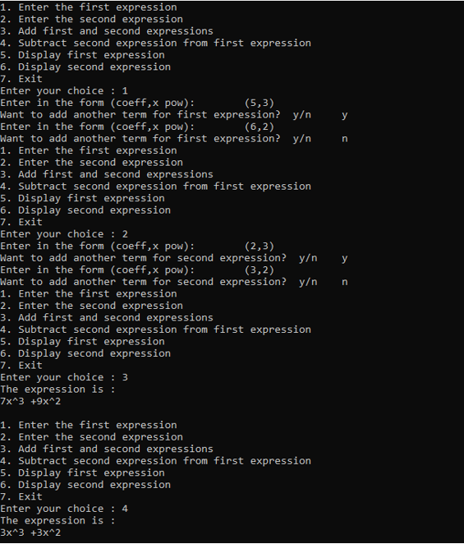

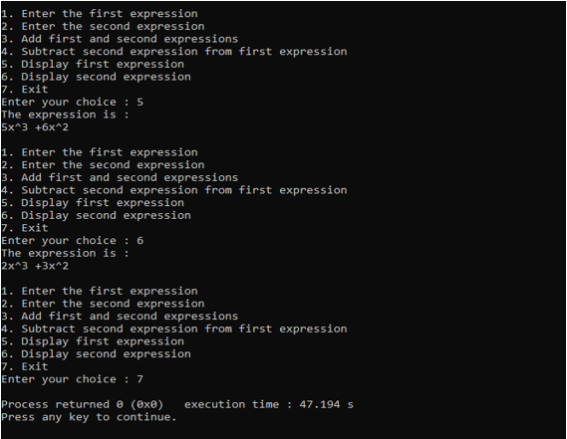

**Conclusion**

Thus, we can apply linked list data structure to analyze polynomial expression and operate on any two polynomial expressions.

**LAB 5  
Recursion**

**5.1 Write a recursive program to find factorial of a number**

**Problem Analysis**

A factorial of a number is a number obtained by multiplying all the preceding numbers, provided it is not less than 1. Factorial is only applied for non-zero positive integers. For finding out the factorial, recursion can be used. A recursive function is a self-calling function; and for finding out factorial, the number is multiplied with a function calling a number less than the given number.

**Algorithm**

Step 1: Create a function returning unsigned int value, taking one parameter.  
Step 2: if num == 0 or num == 1:  
 return 1  
 else:  
 return num * factorial(num – 1)  
Step 3: Stop.

**Source Code**

#include <stdio.h>

unsigned long long int factorial(int n) {

if(n < 0) {

return -1;

}

else {

if(n == 0 || n == 1)

return 1;

else {

return (n * factorial(n - 1));

}

}

}

int main() {

int input_num;

unsigned long int fact;

printf("Enter any number: ");

scanf("%d", &input_num);

fact = factorial(input_num);

printf("Factorial of %d : %llu\n", input_num, fact);

return 0;

}

**Output**

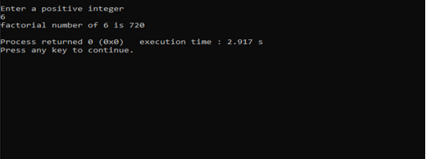

**Conclusion**

Thus, recursion was used to find factorial of a positive non-zero integer.

**5.2 Write a recursive program to find N terms of a Fibonacci series.**

**Problem Analysis**

A Fibonacci series is a series where the next term is a sum of previous two terms. For example, we take two positive integers, 0, 1. The next term is 0+1=1, and thus we have 0, 1, 1. The next term after this is 1+1=2, thus the sequence is 0, 1, 1, 2. Similarly, 1+2=3, 2+3=5, 3+5=8, and so on. This can be implemented through recursion, and the Nth term of the series can be deduced.

**Algorithm**

Step 1: Create a function taking one positive integer parameter.  
Step 2: if num == 1:  
 return 0  
 else if num == 2:  
 return 1  
 else  
 return Fibonacci(num – 2) + Fibonacci (num – 1)  
Step 3: Stop

**Source Code**

#include <stdio.h>

unsigned long long int Fibonacci(int N) {

if(N == 0)

return 0;

else if(N == 1)

return 1;

else

return Fibonacci(N - 1) + Fibonacci(N - 2);

}

int main() {

int input_num;

unsigned long long int fibo;

printf("Enter any number to find nth Fibonacci term: ");

scanf("%d", &input_num);

fibo = Fibonacci(input_num);

printf("Fibonacci term at %d is %llu\n", input_num, fibo);

return 0;

}

**Output**

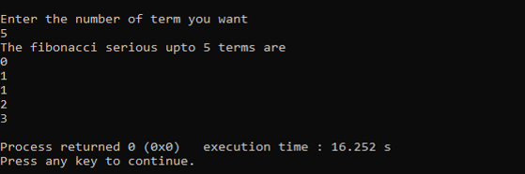

**Conclusion**

Thus, we can deduce the nth term of a Fibonacci series through the use of recursion.

**5.3 Write a recursive program to solve Tower of Hanoi.**

**Problem Analysis**

Tower of Hanoi is a mathematical puzzle where we have three rods and n number of discs. The objective of the puzzle is to move the entire stack to another rod, obeying the following simple rules:

1) Only one disk can be moved at a time.

2) Only a smaller disk can be placed above a bigger disk, the opposite is strictly forbidden.

The problem here is that, we have to solve that puzzle using recursion though we cannot solve it by looping. So, this problem is typically recursion based.

**Algorithm**

Step 1: Create a recursive function having four parameters.  
 void TOH(int n, int source, int dest, int aux)  
Step 2: if n == 1:  
 Move disc 1 from source to dest  
 else  
 TOH(n-1, source, dest, aux)  
 Move n from source to dest  
 TOH(n-1, aux, dest, source)  
Step 3: Exit

**Source Code**

#include <stdio.h>

#include <unistd.h>

void TOH(int N, char source, char dest, char aux) {

if(N < 0) {

printf("Error, invalid disc number");

return;

}

// If it has only one disc

if(N == 1) {

printf("Move disc 1 from %c to %c \n", source, dest);

sleep(1);

}

else {

// Making C auxiliary and B destination

TOH(N - 1, source, aux, dest);

sleep(1);

printf("Move disc %d from %c to %c \n", N, source, dest);

sleep(1);

// make B the source and A an auxiliary position.

TOH(N - 1, aux, dest, source);

}

}

int main() {

int disc_num;

printf("Enter the number of disks: ");

scanf("%d", &disc_num);

TOH(disc_num, '1', '3', '2'); // 1 = source, 2 = auxillary, 3 = destination

return 0;

}

**Output**

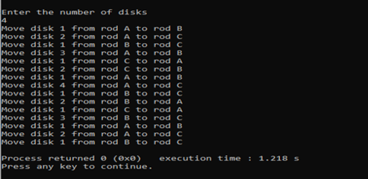 **Conclusion**

Thus, the Tower of Hanoi problem can be solved through the use of recursion.

**5.4 Write a recursive program to find Greatest Common Divisor of two numbers.**

**Problem Analysis**

The greatest common divisor of two numbers is the largest number that divides both the numbers. The GCD of two numbers can be deduced with a recursive function. First of all, whether one of the numbers is 0 is checked; if it is, then the second number is the GCD of the two numbers. The remainder is and the quotient of two numbers after division is calculated. The recursive function is then called and the second number and the remainder is passed as function parameters which will recursively check the conditions until one of them is zero.

**Algorithm**

Step 1: Create a recursive function taking two numbers as parameters.  
 int GCD(int n1, int n2)  
Step 2: if n2 == 0:  
 gcd = n1  
 else:  
 quotient = n1 / n2  
 remainder = n1 % n2  
Step 3: GCD(n2, remainder)  
Step 4: Exit

**Source Code**

#include <stdio.h>

int gcd(int A, int B) {

if(B != 0)

return gcd(B, A % B);

else

return A;

}

int main() {

int in_num_1, in_num_2, hcf;

printf("Enter any two numbers: \n");

scanf("%d %d", &in_num_1, &in_num_2);

hcf = gcd(in_num_1, in_num_2);

printf("GCD of %d and %d is %d\n", in_num_1, in_num_2, hcf);

return 0;

}

**Output**

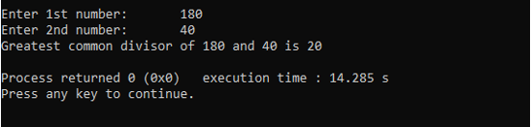

**Conclusion**

Thus, we can find the greatest common divisor of any two positive integers through the use of recursion.

**LAB 6  
Trees**

**6.1 Write a menu driven program for the following operations on Binary Search Tree (BST) of integers**

1. **Create a BST of N integers: 5, 10, 25, 2, 8, 15, 24, 14, 7, 8, 35, 2**
2. **Traverse the BST in in-order, pre-order and post-order.**
3. **Search the BST for a given element (key) and print the appropriate message.**
4. **Exit.**

**Program Analysis**

In this program, we create a binary search tree by inserting a given integer and perform the different operations like traversing in pre-order , in-order and post-order and searching the BST element.

**Algorithm**

Pre-order

Step 1: while tree != null:

tree->data = data  
 preorder(tree->left)  
 preorder(tree->right)  
 [ END OF LOOP ]  
 Step 2: Exit

In-order  
 Step 1: while tree != null  
 inorder(tree->left)  
 tree->data = data  
 inorder(tree->right)  
 [ END OF LOOP ]   
 Step 2: Exit

Post-order:

Step 1: while tree != null  
 postorder(tree->left)  
 postorder(tree->right)  
 tree->data = data  
 [ END OF LOOP ]

Step 2: Exit

**Source Code:**

#include <iostream>

struct Node {

int data;

struct Node *left, *right;

Node() {

data = 0;

left = NULL;

right = NULL;

}

};

class BST {

public:

Node *rootPtr;

BST() {

rootPtr = NULL;

}

/*

Here:

insert() => inserting new data

search() => searching specified data

largest() => finding the largest node

purge() => deleting specified data

display_pre() => pre-order display

display_post() => post-order display

display_in() => in-order display

*/

void insert(Node *rootPtr, int data);

void search(Node *rootPtr, int data);

Node* largest(Node *rootPtr);

void purge(Node *rootPtr, int data);

void display_pre(Node *rootPtr);

void display_post(Node *rootPtr);

void display_in(Node *rootPtr);

};

// For insertion of data

void BST::insert(Node *rootPtr, int data) {

Node *newNode;

if(rootPtr == NULL) {

newNode = new Node;

newNode->data = data;

newNode->left = NULL;

newNode->right = NULL;

}

else {

if(data < rootPtr->data) {

insert(rootPtr->left, data);

}

else {

insert(rootPtr->right, data);

}

}

}

// For searching the element

void BST::search(Node *rootPtr, int data) {

if(rootPtr == NULL || data == rootPtr->data) {

std::cout << "\nData not found!" << std::endl;

}

else {

std::cout << rootPtr->data << " has been found" << std::endl;

}

}

// For finding the largest

Node* BST::largest(Node *rootPtr) {

if(rootPtr->right == NULL) {

return rootPtr;

}

else {

return largest(rootPtr->right);

}

}

// For deleting the specified data

void BST::purge(Node *rootPtr, int data) {

if(rootPtr == NULL) {

std::cout << "Error, value not found" << std::endl;

}

else if(data < rootPtr->data) {

purge(rootPtr->left, data);

}

else if(data > rootPtr->data) {

purge(rootPtr->right, data);

}

else if(rootPtr->left && rootPtr->right) {

Node *newNode = largest(rootPtr->left);

rootPtr->data = newNode->data;

purge(rootPtr->left, newNode->data);

}

else {

Node *newNode = rootPtr;

if(rootPtr->left == NULL && rootPtr->right == NULL) {

rootPtr = NULL;

}

else if(rootPtr->left != NULL) {

rootPtr = rootPtr->left;

}

else {

rootPtr = rootPtr->right;

}

delete newNode;

}

}

// Pre-order display

void BST::display_pre(Node *rootPtr) {

if(rootPtr != NULL) {

std::cout << " -> " << rootPtr->data;

display_pre(rootPtr->left);

display_pre(rootPtr->right);

}

}

// Post-order display

void BST::display_post(Node *rootPtr) {

if(rootPtr != NULL) {

display_post(rootPtr->left);

display_post(rootPtr->right);

std::cout << "->" << rootPtr->data;

}

}

// In-order display

void BST::display_in(Node *rootPtr) {

if(rootPtr != NULL) {

display_in(rootPtr->left);

std::cout << "->" << rootPtr->data;

display_in(rootPtr->right);

}

}

int main() {

BST *tree = new BST;

int some_data, choice = 1;

while (choice != 7) {

std::cout << "Binary Search Tree" << std::endl << std::endl;

std::cout << "1: Insert data " << std::endl;

std::cout << "2: Search data" << std::endl;

std::cout << "3: Delete data" << std::endl;

std::cout << "4: Display pre-order" << std::endl;

std::cout << "5: Display post-order" << std::endl;

std::cout << "6: Display in-order" << std::endl;

std::cout << "7: Exit" << std::endl << std::endl;

std::cin >> choice;

switch(choice) {

case 1:

std::cout << "Enter data to insert: ";

std::cin >> some_data;

tree->insert(tree->rootPtr, some_data);

case 2:

std::cout << "Enter data to search: ";

std::cin >> some_data;

tree->search(tree->rootPtr, some_data);

case 3:

std::cout << "Enter data to delete: ";

std::cin >> some_data;

tree->purge(tree->rootPtr, some_data);

case 4:

std::cout << "Pre-order display" << std::endl;

tree->display_pre(tree->rootPtr);

case 5:

std::cout << "Post-order display" << std::endl;

tree->display_post(tree->rootPtr);

case 6:

std::cout << "In-order display" << std::endl;

tree->display_in(tree->rootPtr);

case 7:

break;

}

}

delete tree;

return 0;

}

**Output**

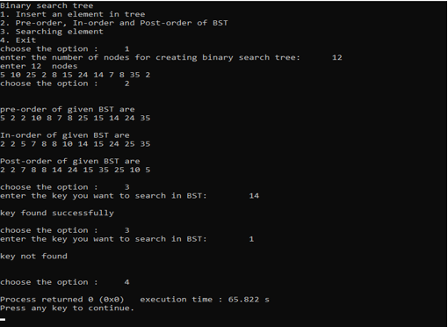

**Conclusion**

In this way a BST of given n integers can be created and traversed in pre-order, in-order and post-order. Search operation can also be implemented in the BST; if the element is in BST, the key is found and the appropriate message is displayed.

**LAB 7  
Sorting**

**7.1 WAP to implement Insertion Sorting Algorithm**

**Problem Analysis**

The problem here is to sort the array values using insertion sorting algorithm. First of all, the array of values to be sorted is divided into two sets. One that stores sorted values and another that contains unsorted values. The sorting algorithm will proceed until there are elements in the unsorted set.

**Algorithm**

INSERTING-SORT (ARR, N)

Step 1: Repeat Steps 2 to 5 for k = 1 to N-1

Step 2: SET TEMP=ARR[K]

Step 3: SET J=K-1

Step 4: Repeat while TEMP <= ARR[J]

SET ARR[J+1] = ARR[J]

SET J = J-1

[END OF INNER LOOP]

Step 5: SET ARR[J+1] = TEMP

[END OF LOOP]

Step 6: EXIT

**Source Code**

#include<iostream>

using namespace std;

int main()

{

int i, j, n, temp, a[30];

cout << "Enter the number of elements:";

cin >> n;

cout << "Enter the elements\t";

for (i = 0;i < n;i++)

{

cin >> a[i];

}

for (i = 1;i <= n - 1;i++)

{

temp = a[i];

j = i - 1;

while ((temp < a[j]) && (j >= 0))

{

a[j + 1] = a[j]; //moves element forward

j = j - 1;

}

a[j + 1] = temp; //insert element in proper place

}

cout << "Sorted list is as follows\n";

for (i = 0;i < n;i++)

{

cout << a[i] << " ";

}

return 0;

}

**Output**

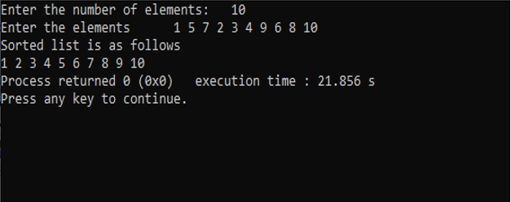

**Conclusion**

Thus, an array can be sorted through the use of insertion sort algorithm.

**7.2 WAP to implement Merge Sorting Algorithm**

**Problem Analysis**

The problem here is to sort the value of array using merge sorting algorithm. If the array is of length 0 or 1, then it is already sorted. Otherwise, divide the unsorted array into two sub-arrays of about half the size. Use merge sort algorithm recursively to sort each sub-array and Merge the two sub-arrays to form a single sorted list.

**Algorithm**

MERGE (ARR, BEG, MID, END)

Step 1: [INITIALIZE] SET I = BEG, J=MID+1, INDEX=0

Step 2: Repeat while (I<=MID) AND (J<=END)

IF ARR[I] < ARR[J]

SET TEMP[INDEX]=ARR[I]

SET I = I+1

ELSE

SET TEMP[INDEX]=ARR[J]

SET J = J+1

[END OF IF]

SET INDEX=INDEX+1

[END OF LOOP]

Step 3: [Copy the remaining elements of right sub-array, if any]

IF I > MID

Repeat while J<=END

SET TEMP[INDEX]=ARR[J]

SET INDEX=INDEX+1, SET J = J+1

[END OF LOOP]

[Copy the remaining elements of left sub-array, if any]

ELSE

Repeat while I<=END

SET TEMP[INDEX]=ARR[I]

SET INDEX=INDEX+1, SET I=I+1

[END OF LOOP]

[END OF IF]

Step 4: [Copy the contents of TEMP back to ARR] SET K=0

Step 5: Repeat while K<INDEX

SET ARR[K]=TEMP[K]

SET K=K+1

[END OF LOOP]

Step 6: END

MERGE_SORT (ARR, BEG, END)

Step 1: IF BEG<END

SET MID = (BEG+END)/2

CALL MERGE_SORT (ARR, BIG, MID)

CALL MERGE_SORT (ARR, MID+1, END)

MERGE (ARR, BEG, MID, END)

[END OF IF]

Step 2: END

**Source Code**

#include<iostream>

using namespace std;

void merge(int A[], int beg, int mid, int end) {

int i = beg;

int j = mid + 1;

int index = beg;

int temp[end + 1], k;

while (i <= mid && j <= end) {

if (A[i] < A[j]) {

temp[index] = A[i];

i++;

}

else {

temp[index] = A[j];

j++;

}

index++;

}

if (i > mid) {

while (j <= end) {

temp[index] = A[j];

index++;

j++;

}

}

else {

while (i <= mid) {

temp[index] = A[i];

index++;

i++;

}

}

k = beg;

while (k < index) {

A[k] = temp[k];

k++;

}

}

void merge_sort(int A[], int beg, int end) {

int mid;

if (beg < end) {

mid = (beg + end) / 2;

merge_sort(A, beg, mid);

merge_sort(A, mid + 1, end);

merge(A, beg, mid, end);

}

}

int main() {

int n;

cout << "Merge Sorting\n";

cout << "Enter no of the array inputs: ";

cin >> n;

int arr[n];

cout << "Enter elements:\t";

for (int i = 0;i < n;i++)

cin >> arr[i];

merge_sort(arr, 0, n - 1);

cout << "The sorted items are: \t";

for (int i = 0;i < n;i++)

cout << arr[i] << " ";

return 0;

}

**Output**

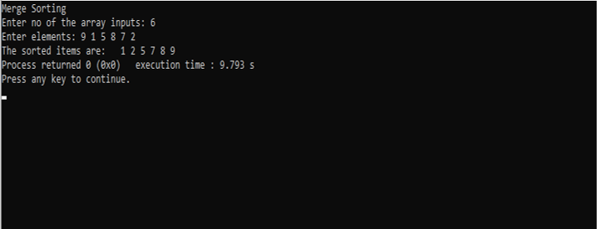

**Conclusion**

Thus, array can be sorted using merge sort algorithm.