ISM 6562 901 Big Data For Business
Midterm Project Part 1: Operational Databases, Data Warehousing, and ETL
Jonathan James, Nairi Keeney, Maaz Ul Hasan Masood, Abdul Mannan Mohammad
2 April 2026

PART 1: ENVIRONMENT SETUP

Task 1.1: Start the Docker Compose Environment

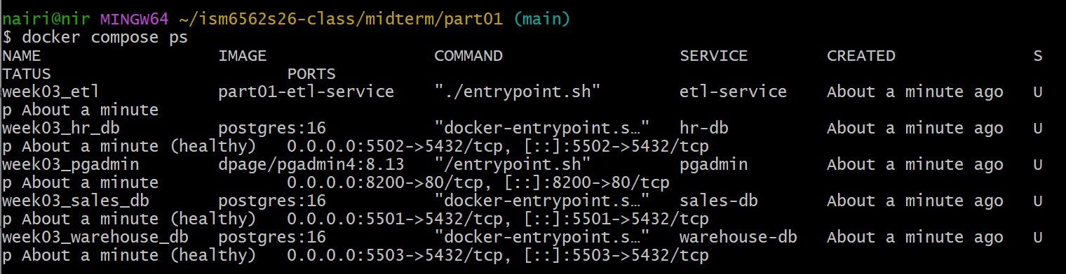

Task 1.2: Connect to Each Database via psql

Sales DB

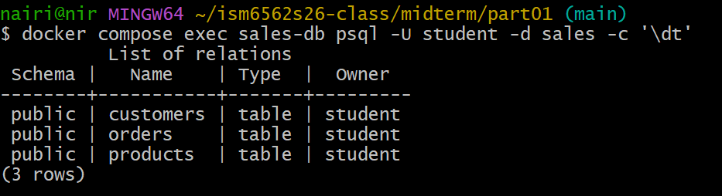

HR DB

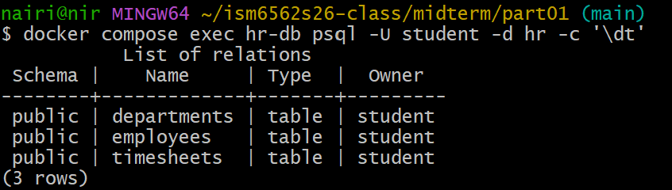

Warehouse DB

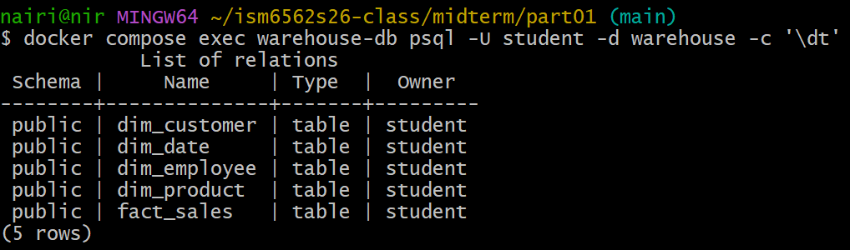

Task 1.3: Register All Three Servers in pgAdmin

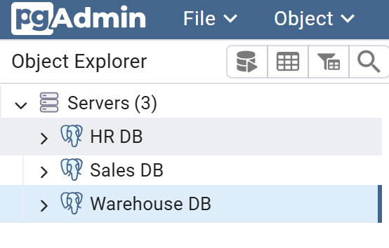

PART 2: EXPLORE OPERATIONAL DATABASES

Task 2.1: Examine the Sales Schema

\d customer output

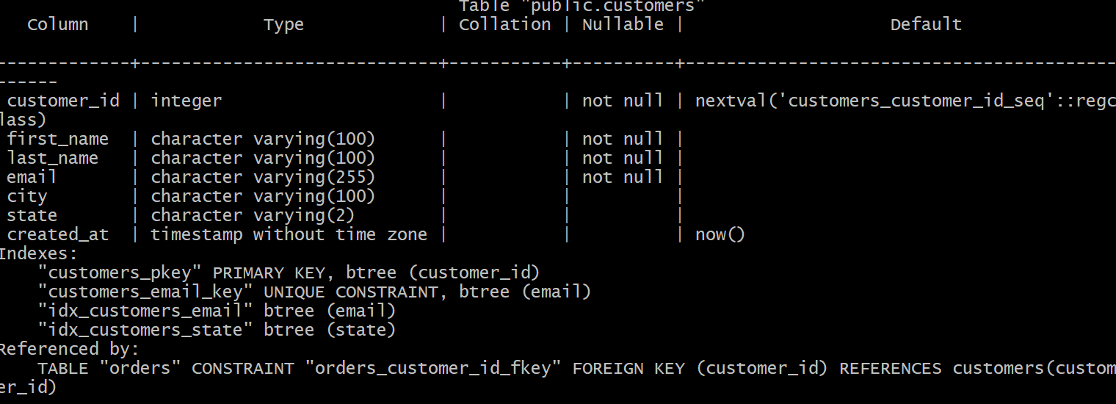

\d products output

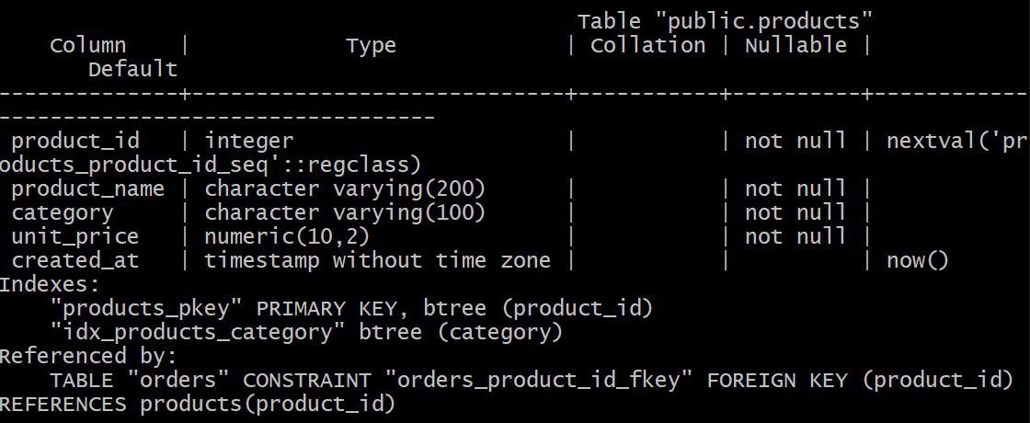

\d orders output

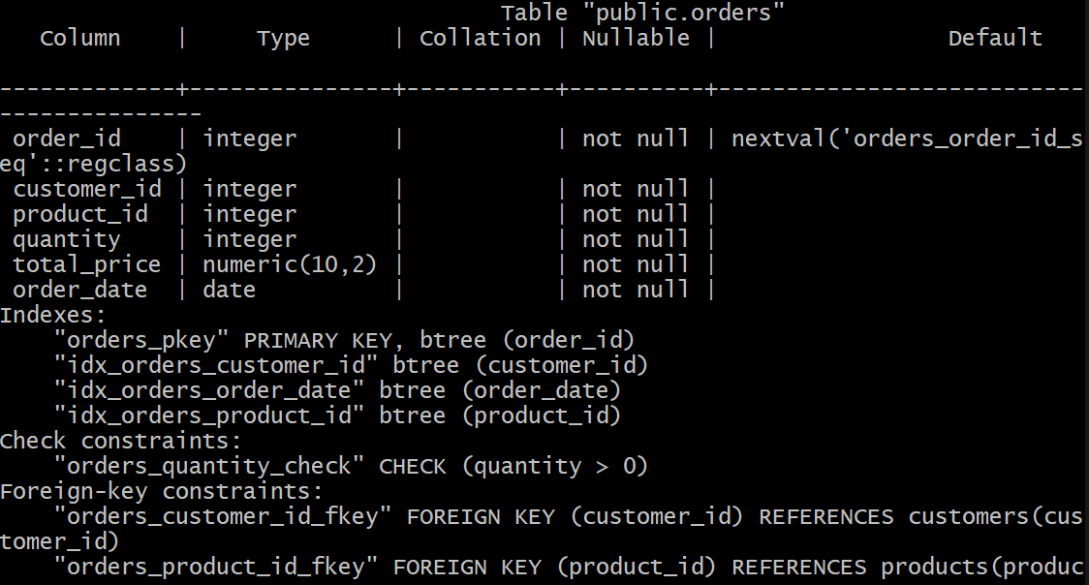

The sales schema demonstrates normalization through the separation of data into three distinct tables, each focused on a single entity. The customers table uses customer_id as its primary key, and will only store customer-specific attributes, such as name, email, city and state. The products table uses product_id as its primary key, and will store any information relating to product details, such as name, category, and unit price.The orders table uses order_id as its primary key and links to the other two tables using the respective foreign keys for both, customer_id will reference customers(customer_id) and product_id will reference products(product_id). Using this design allows for a reduction in redundancy by ensuring customer and product details will only be stored once, in their respective tables, rather than repeating across each order row. If a customer wants to make an update to their email, or a product price changes, the updates will be made to one place.

Task 2.2: Examine the HR Schema

\d departments command

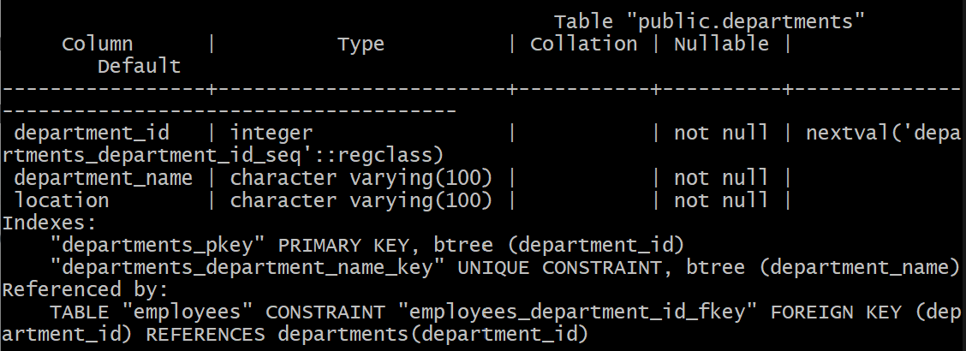

\d employees command

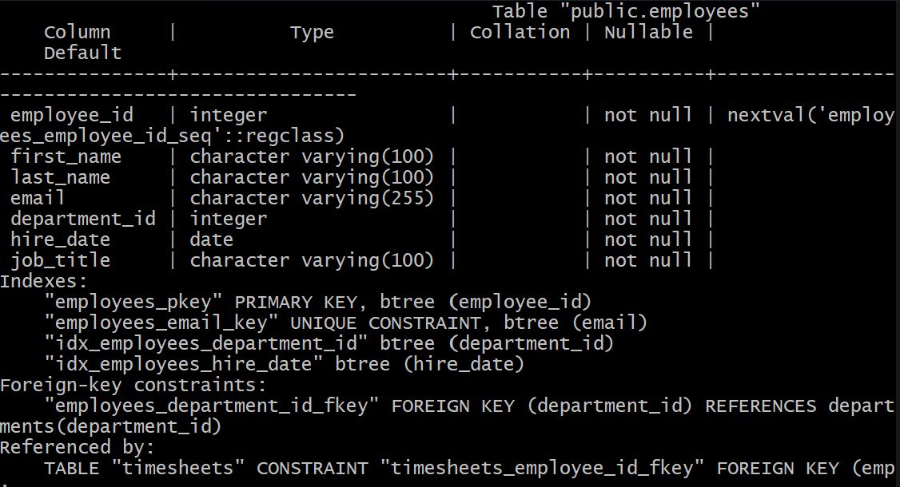

\d timesheets command

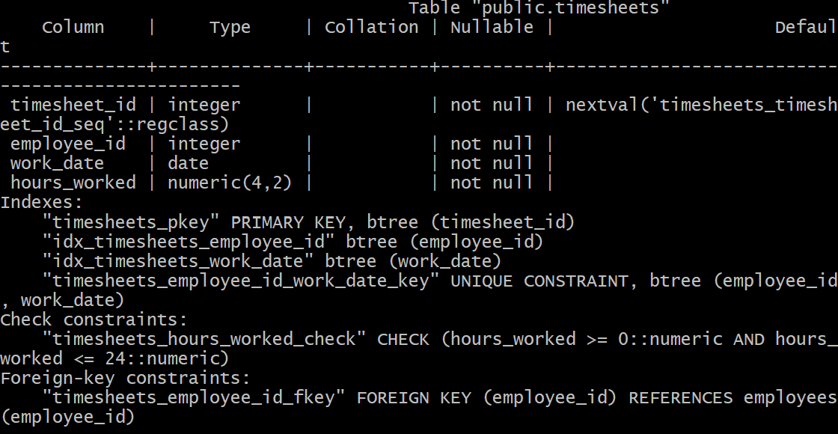

The HR schema consists of three related tables: the departments table, the employees table, and the timesheets table. The departments table uses department_id as its primary key and stores the name and location of each department. The employees table uses employee_id as its primary key and links to the departments table via foreign key on department_id, which creates a many-to-one relationship between employees and department. The timesheets table uses timesheet_id as its primary key and links to the employees table using a foreign key on employee_id, recording the number of hours worked by each employee per day.

The UNIQUE(employee_id, work_date) constraint on timesheets is critical in preventing data quality issues. This constraint ensures that no employee can have more than one timesheet entry for the same date. Without it, duplicate rows could be inserted for the same employee on the same work day, causing an inflation in reported work hours. Since the rule is applied at the database level, it will be applied automatically regardless of the application or process used.

Task 2.3: Run Queries Against the Operational Databases

Sales Database Queries

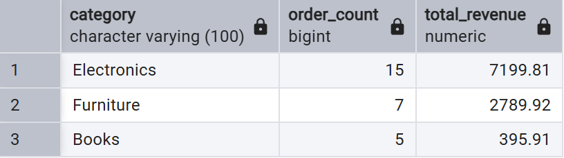

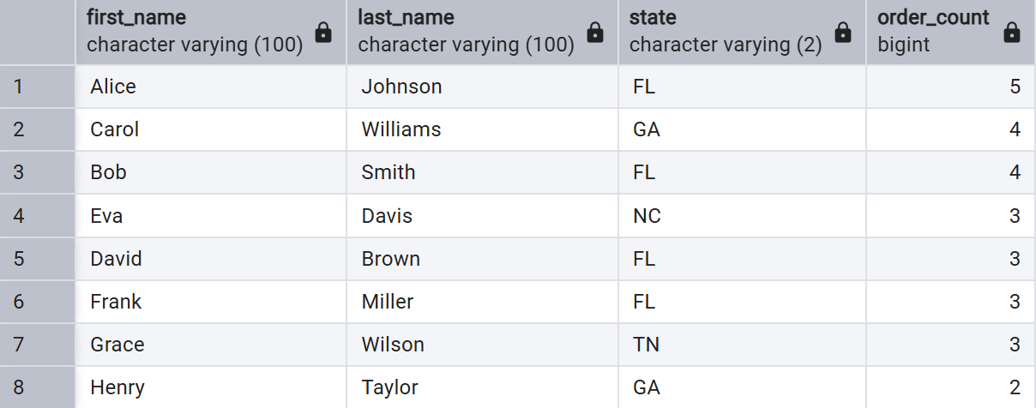

HR Database Queries

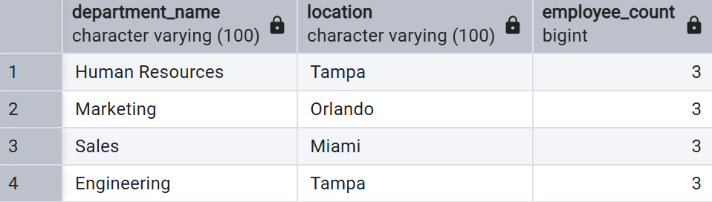

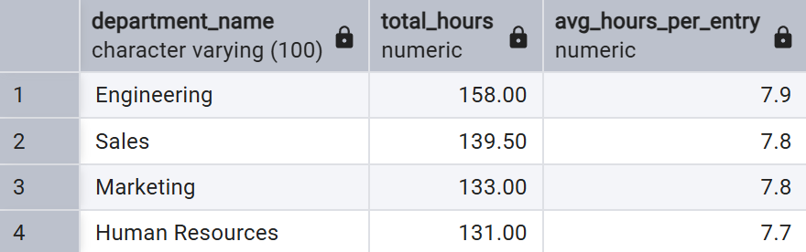

PART 3: DATA WAREHOUSE CONCEPTS

Task 3.1: Examine the Star Schema

\d dim_date output

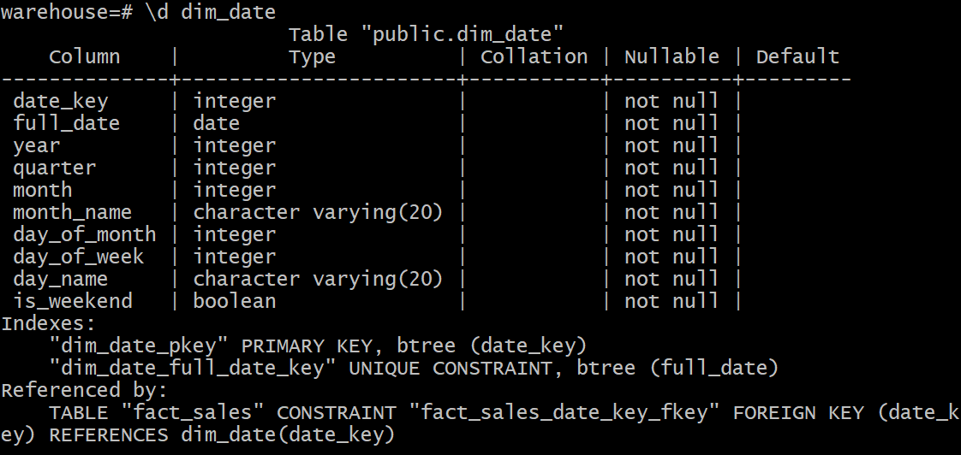

\d dim_customer output

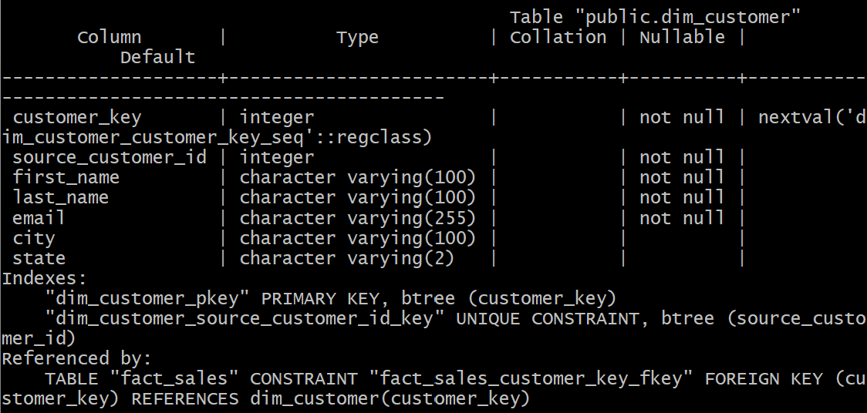

\d dim_product output

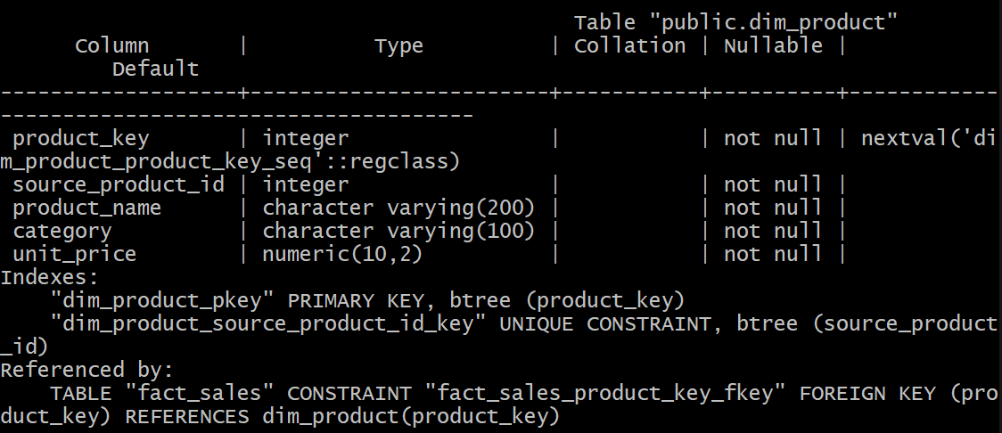

\d dim_employee output

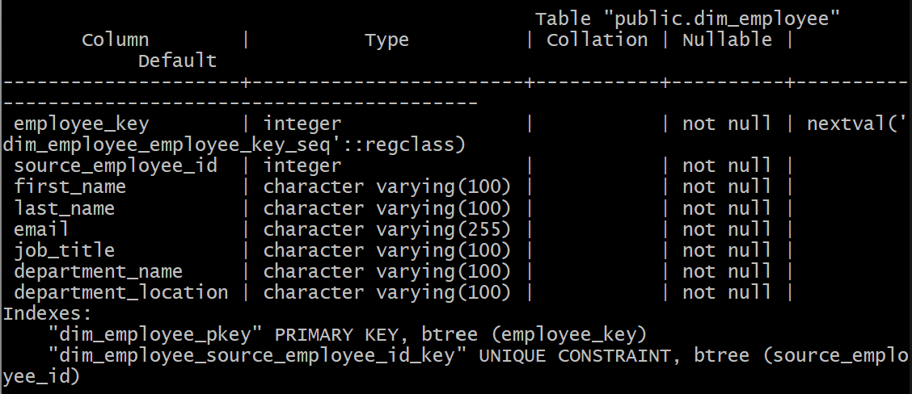

\d fact_sales output

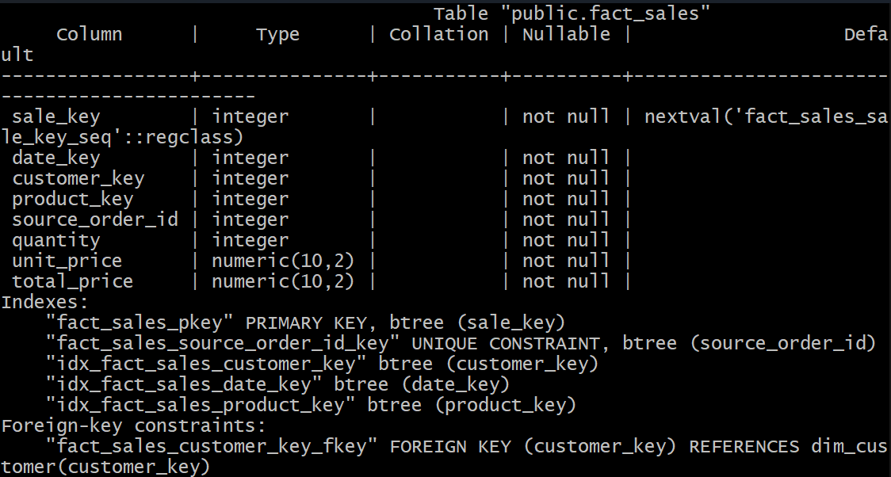

Task 3.2: Compare Operational vs Warehouse Design

When comparing operational databases, such as the sales db and hr db, with the data warehouse, warehouse db, there are clear differences in how customer and product information is stored. In the sales database, customers and products are stored in separate tables and linked to the orders table through foreign keys. This means a JOIN across multiple tables is needed in order to gain a full picture of an order. In the warehouse, all descriptive information about a customer or product is copied into the dimension table itself, meaning fewer JOIN operations are needed when querying data.
Examining the dim_employee table shows the same denormalization approach is used. In the HR operational database, finding an employee’s department_name and department_location would require a JOIN across both the employees and departments tables. In the warehouse, on the other hand, department_name and department_location are stored directly in the dim_employee row, removing the necessity of a JOIN and reducing the time needed to complete a query.
By separating order_date into the dim_date table with columns such as month_name, day_name, quarter, and is_weekend, data can quickly be grouped and filtered without the need for any complex functions.

Task 3.3: Identify Facts vs Dimensions

When examining the warehouse schema, fact tables and dimension tables can be determined based on the type of data each table contains. Fact_sales is the fact table, while dim_date, dim_customer, dim_product, and dim_employee are the dimension tables. Fact_sales contains numeric measurements and includes foreign keys such as date_key, customer_key, and product_key, each connecting outwards to their respective dimension tables. Dimension tables, on the other hand, only contain descriptive attributes and a primary key; they do not contain any foreign keys pointing to other tables.
The grain of the fact_sales table indicates one row per individual sales transaction. Each row represents one order, highlighting what was sold, to whom, at what cost and when.
A business question an analyst could answer by joining fact_sales with two or more dimensions is a question such as “Which product accrues the most revenue per month?” By joining the fact_sales table to dim_product, the product category can be retrieved, and joining to dim_date would allow for results to be grouped by month. The total_price column within fact_sales could then be summed and grouped by category and month, providing a clear revenue breakdown.

PART 4: ETL PIPELINE

Task 4.1: Analyze the ETL Script

During the extraction process, data is pulled from two operational databases. From the sales db, the script runs three SELECT queries in order to retrieve all rows from the customers, products, and orders table. From the hr db, the script will run a single SELECT query to join the employees and departments tables together, allowing for the retrieval of each employee’s details alongside their respective department name and location.
During the transform phase, the script will handle two key operations. First, the generate_dim_date_rows function builds one row per day for any given year by looping through every date and calculating derived attributes such as year, quarter, month, month_name, day_of_week, day_name, and is_weekend. The second operation performed is the denormalization of the employee dimension, which is done during extraction. By joining employees and departments using a SQL query, department_name and department_location are already embedded in each employee row prior to the loading process beginning.
In order to ensure idempotency during the load phase, the script uses INSERT statements with ON CONFLICT clauses. For dim_date, conflicts are skipped entirely using DO NOTHING. For dim_customer, dim_product, and dim_employee, conflicts will trigger a DO UPDATE SET, which will update existing records with the latest values. For fact_sales, conflicts on source_order_id are ignored, thus preventing duplicate orders from being inserted.
A cron schedule of */5**** means the ETL pipeline will run every 5 minutes, every hour, every day. This ensures the warehouse is consistently and automatically kept up to date, without manual intervention.

Task 4.2: Verify ETL Results

Source DB Counts

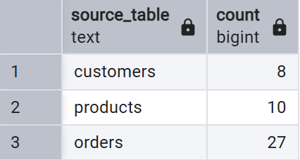

Warehouse DB Counts

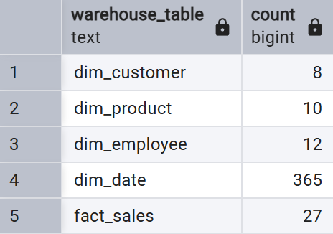

Task 4.3: Test the ETL Pipeline

Step 1: Insert New Order into Sales DB

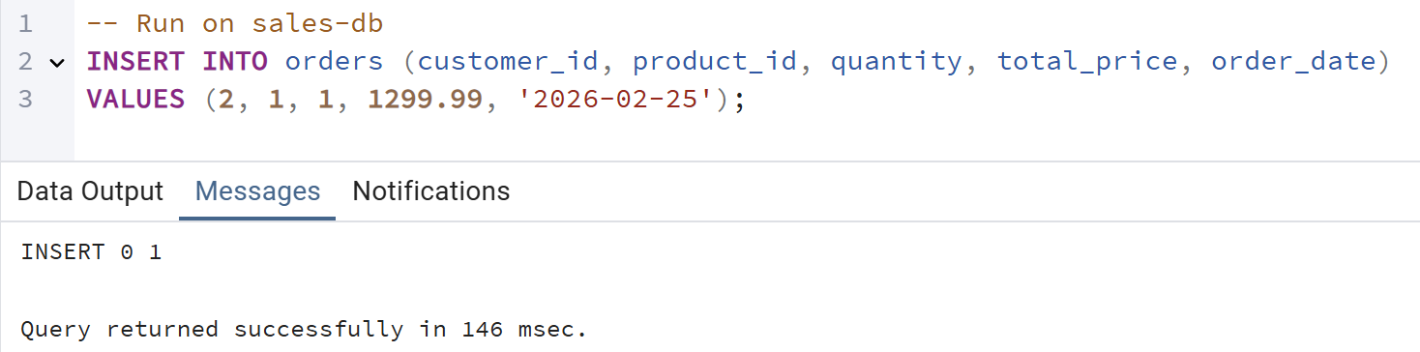

Step 2: Verify New Order Exists in Sales DB

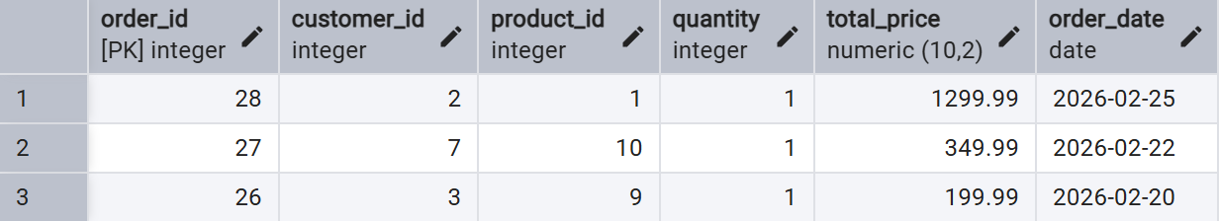

Step 3: Manually Trigger the ETL Pipeline

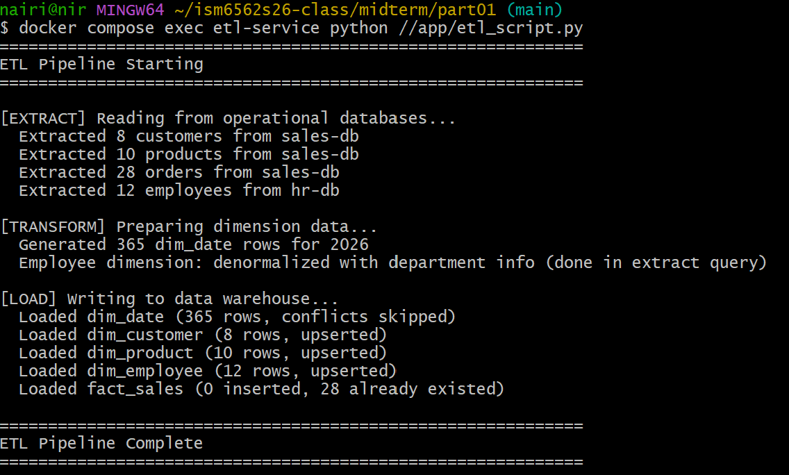

Step 4: Verify the New Order Appears in the Warehouse

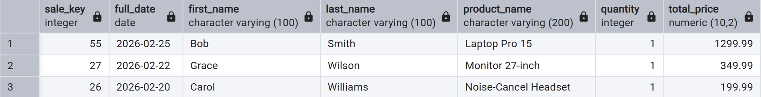

PART 5: ANALYTICAL QUERIES

Task 5.1: Write Analytical Queries

Query 1: Monthly Sales Summary:
SELECT d.month_name, d.year,
COUNT(*) AS total_orders,
SUM(f.total_price) AS total_revenue
FROM fact_sales f
JOIN dim_date d ON f.date_key = d.date_key
GROUP BY d.month, d.month_name, d.year
ORDER BY d.month;

Output:
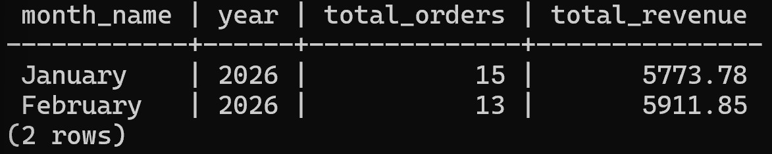

Query 2: Top Customers by Spending:
SELECT c.first_name, c.last_name,
COUNT(*) AS number_of_orders,
SUM(f.total_price) AS total_spent
FROM fact_sales f
JOIN dim_customer c ON f.customer_key = c.customer_key
GROUP BY c.customer_key, c.first_name, c.last_name
ORDER BY total_spent DESC;
Output: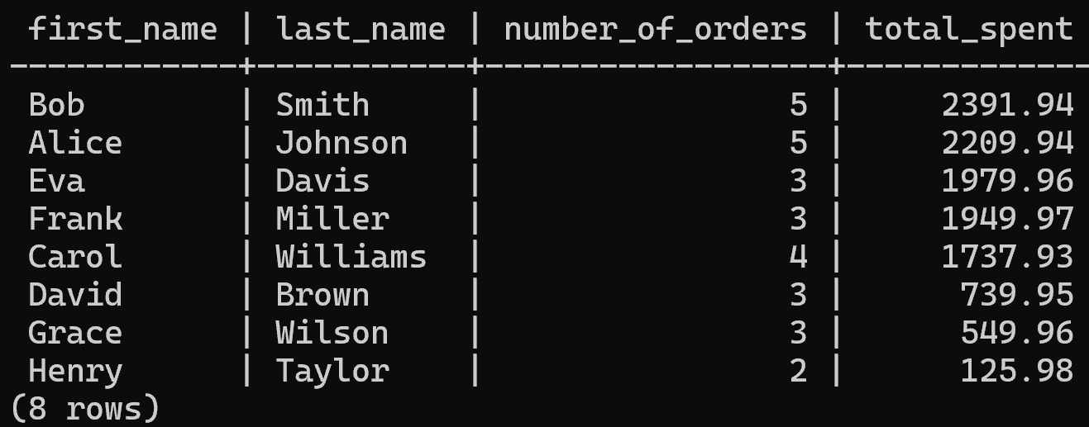

Query 3: Revenue by Product Category and Month
SELECT d.month_name, d.month, p.category,
SUM(f.total_price) AS total_revenue
FROM fact_sales f
JOIN dim_date d ON f.date_key = d.date_key
JOIN dim_product p ON f.product_key = p.product_key
GROUP BY d.month, d.month_name, p.category
ORDER BY d.month, p.category;

Output:
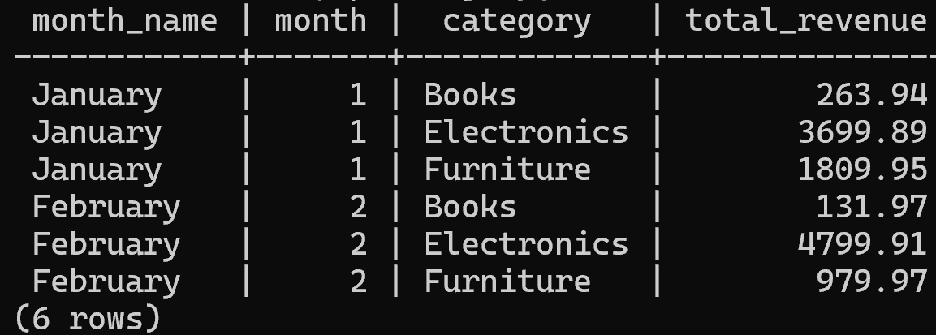

Task 5.2: EXPLAIN ANALYZE Comparison

Sales DB
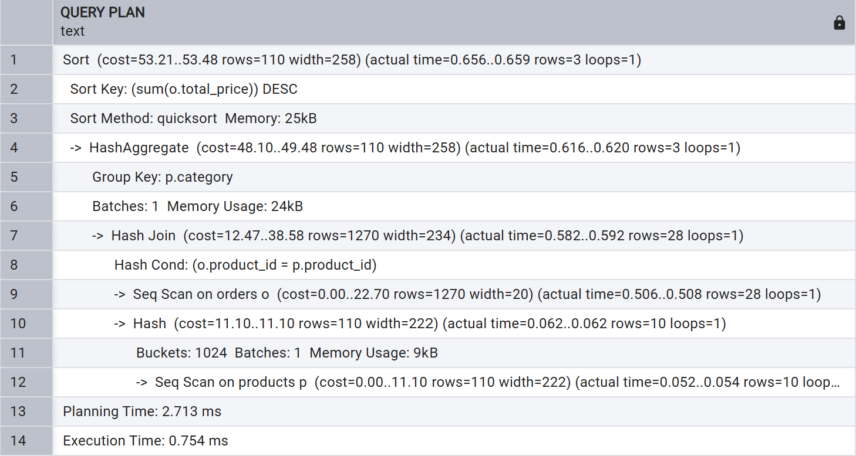

Warehouse DB

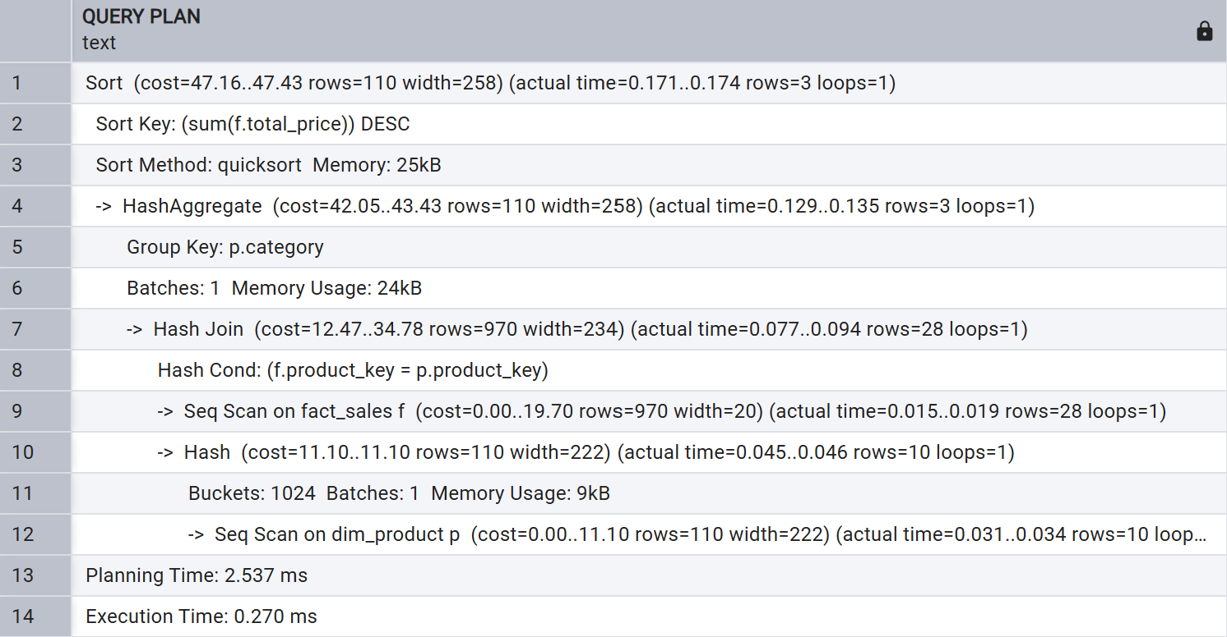

Upon examination, both execution plans use sequential scans and a hash join, due to the size of the dataset; however, there are some clear differences in each execution plan. The sales db query had a planning time of 2.713ms and an execution time of 0.754ms, whereas the warehouse db query had a planning time of 2.537ms and an execution time of 0.270ms. The warehouse db ended up querying much quicker due to fact_sales only containing numeric values and surrogate keys, making each row smaller and quicker to scan. When querying the orders table within an operational database, such as sales db, the rows are filled with more data; and as a result, contain wider rows and slow down the scan.
With a small dataset such as this, the time difference may appear negligible; however, with millions of rows the difference will become significant. The warehouse schema is specifically designed for analytical queries, meaning that aggregations and joins across large quantities of data would perform much faster in comparison to an operational database. This is because operational databases contain wider tables and require joins across multiple tables, which drastically increases both the planning and execution times.

8 Team GitHub Repository

GitHub repo URL: https://github.com/nairikny/ISM6562ArcaneMidterm

