ISM 6562 901 Big Data For Business
Midterm Project Part 3: Operational Databases, Data Warehousing, and ETL
Jonathan James, Nairi Keeney, Maaz Ul Hasan Masood, Abdul Mannan Mohammad
2 April 2026

PART 1: SETUP & CASSANDRA EXPLORATION

Task 1.1: Start the Part 3 Environment
docker compose ps
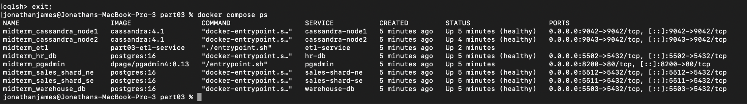

Task 1.2: Explore the Cassandra Cluster
docker compose exec cassandra-node1 nodetool status
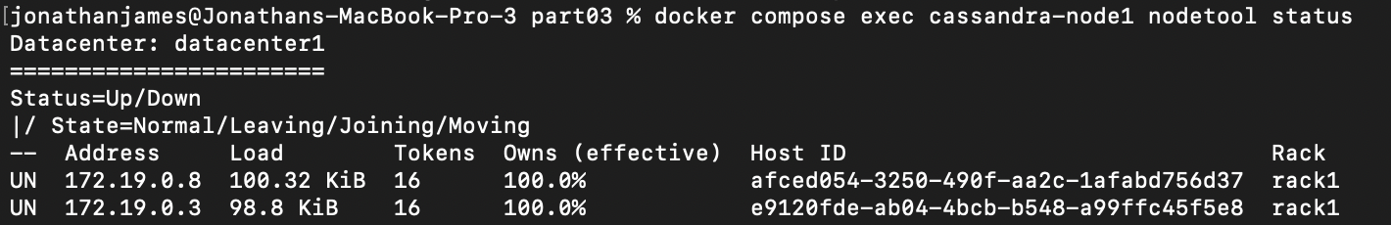

DESCRIBE KEYSPACES;
USE techretail_orders;
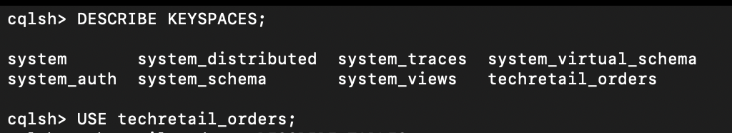

DESCRIBE TABLES;
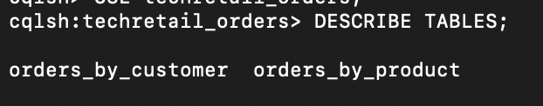

DESCRIBE TABLE orders_by_customer;
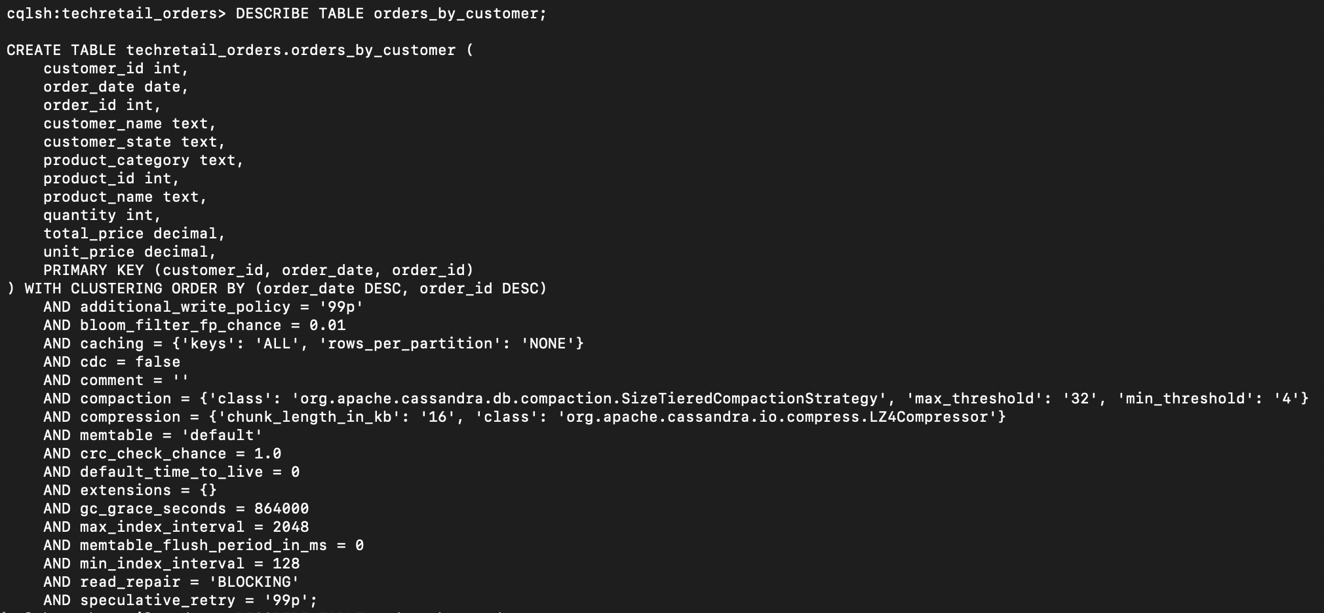

DESCRIBE TABLE orders_by_product;
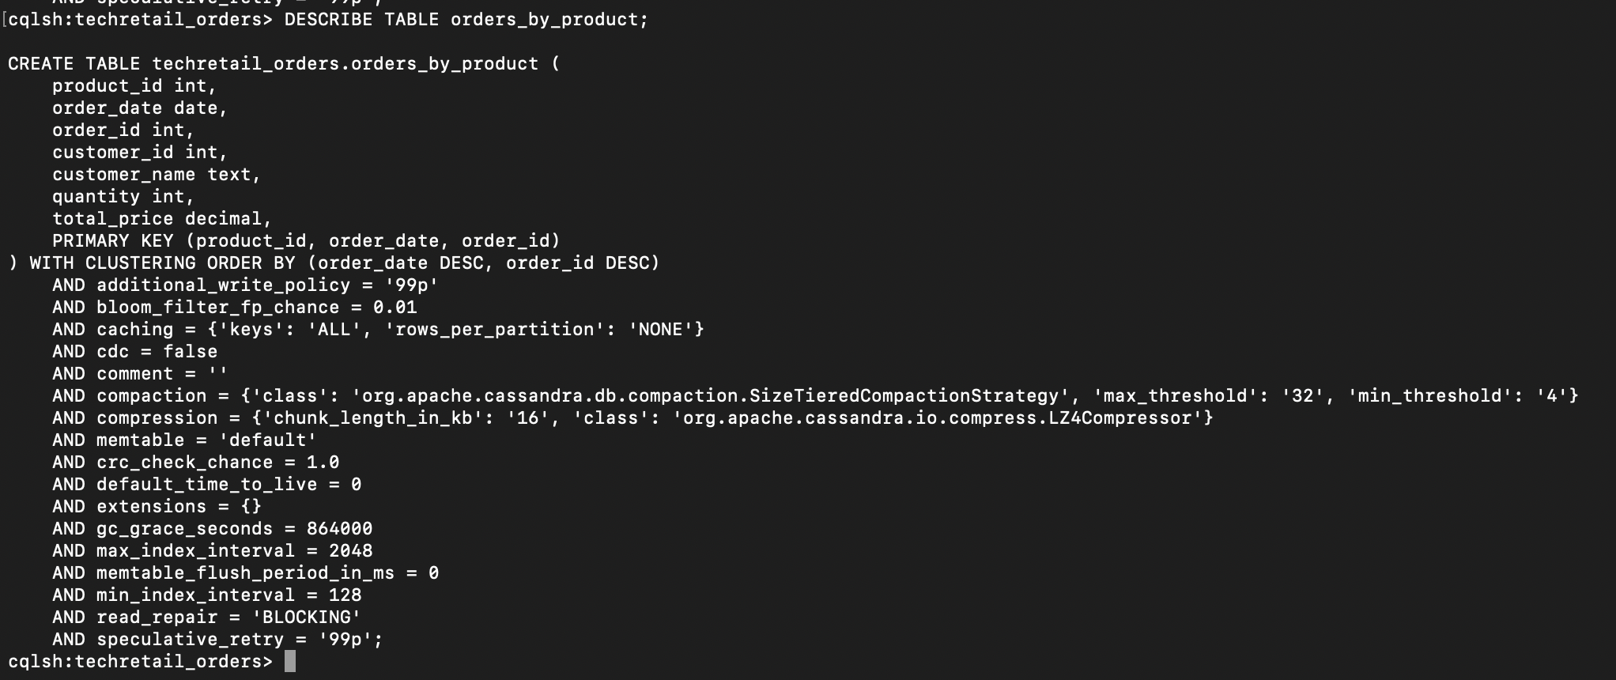

Task 1.3: Compare Cassandra and PostgresSQL Table Design
Why does the Cassandra table include customer_name and customer_state directly in each order row, while PostgreSQL stores this in a separate customers table with a foreign key?
In Cassandra, orders_by_customer stores fields like customer_name and customer_state directly in each order row because Cassandra is designed around the queries the application needs to run, not around minimizing redundancy. Apache Cassandra documentation describes this as query-driven modeling, and because Cassandra does not support joins the way a relational database does, denormalizing data into the same table is the preferred approach. In contrast, PostgreSQL is typically normalized, so customer details live in a separate customers table and the orders table references them with a foreign key. That reduces duplication and keeps updates consistent across related tables.

Why are there TWO Cassandra tables (orders_by_customer and orders_by_product) for what is essentially the same order data?
There are two Cassandra tables because each table is built to support a different query pattern. orders_by_customer is optimized for retrieving all orders for one customer using customer_id as the partition key, while orders_by_product is optimized for retrieving orders for one product using product_id as the partition key. Cassandra best practices often follow a table-per-query pattern, meaning similar data may be duplicated across multiple tables so each query can be answered efficiently from one partition without joins.

PART 2: QUERY-FIRST DESIGN ANALYSIS
Task 2.1: Run Valid Cassandra Queries
-- Query 1: All orders for customer 1 (Alice)
SELECT order_id, order_date, product_name, quantity, total_price
FROM techretail_orders.orders_by_customer
WHERE customer_id = 1;

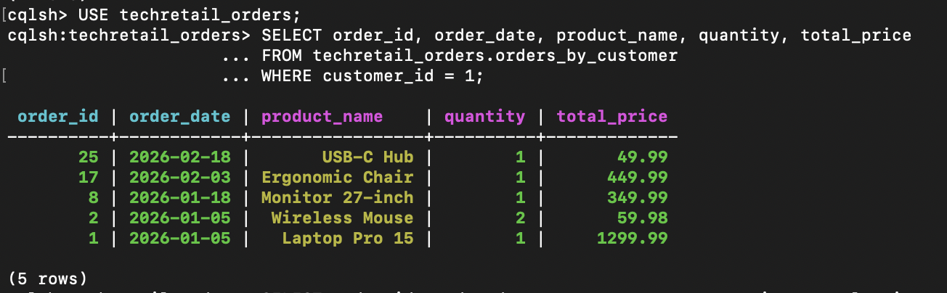
-- Query 2: All orders for product 1 (Laptop Pro 15)
SELECT order_id, order_date, customer_name, quantity, total_price
FROM techretail_orders.orders_by_product
WHERE product_id = 1;

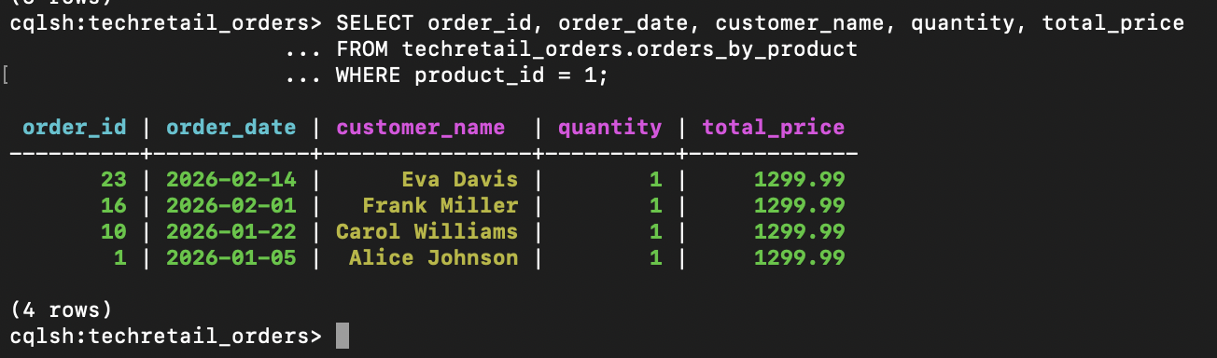

Task 2.2: Attempt an Invalid Query

Written response & ss
SELECT * FROM techretail_orders.orders_by_customer
WHERE product_id = 1;

InvalidRequest: Error from server: code=2200 [Invalid query] message="Cannot execute this query as it might involve data filtering and thus may have unpredictable performance. If you want to execute this query despite the performance unpredictability, use ALLOW FILTERING"

Written Response
Cassandra rejects this query because orders_by_customer is partitioned by customer_id, not by product_id. In Cassandra, the partition key determines how data is distributed across the cluster and how it is retrieved. This means all rows for one customer_id are stored together, making queries by customer efficient. However, when a query searches by product_id on this table, Cassandra cannot directly locate the correct partition. Instead, it would need to scan many partitions and filter rows, which is inefficient and unpredictable. That is why Cassandra blocks the query unless ALLOW FILTERING is used. Query-first design solves this limitation by creating tables around the exact access patterns needed. Instead of forcing one table to support every query, Cassandra uses separate tables, such as orders_by_customer and orders_by_product, so each query can be answered efficiently.

PART 3: WRITE ORDERS TO CASSANDRA

Task 3.1: Insert a New Order into Both Tables
INSERT INTO techretail_orders.orders_by_customer
(customer_id, order_date, order_id, product_id, product_name,
product_category, quantity, unit_price, total_price,
customer_name, customer_state)
VALUES (2, '2026-02-25', 28, 1, 'Laptop Pro 15', 'Electronics',
1, 1299.99, 1299.99, 'Bob Smith', 'FL');

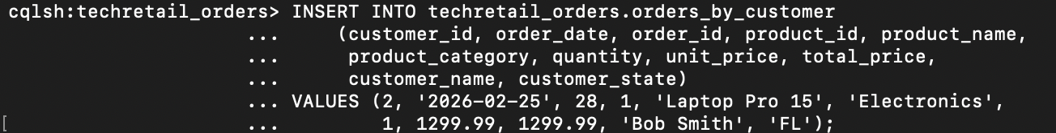

INSERT INTO techretail_orders.orders_by_product
(product_id, order_date, order_id, customer_id, customer_name,
quantity, total_price)
VALUES (1, '2026-02-25', 28, 2, 'Bob Smith', 1, 1299.99);

SELECT * FROM techretail_orders.orders_by_customer
WHERE customer_id = 2 AND order_date = '2026-02-25';
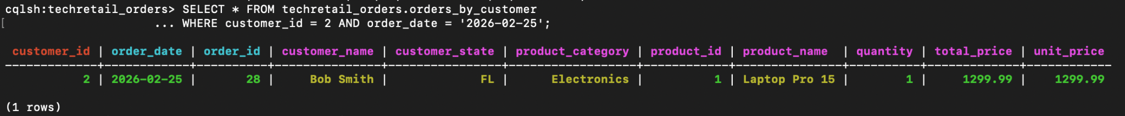

SELECT * FROM techretail_orders.orders_by_product
WHERE product_id = 1 AND order_date = '2026-02-25';
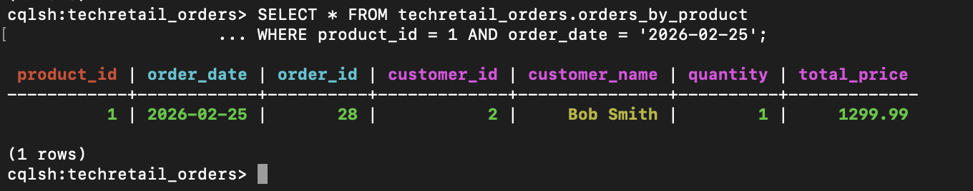

Task 3.2: Dual-Write Consistency Challenge
Written response
If one INSERT succeeds and the other fails, the order data becomes inconsistent. For example, the order may appear in orders_by_customer but not in orders_by_product, which means some queries would return incomplete results. In production, I would handle this by using a logged batch statement in Cassandra to group both inserts together. A logged batch records the batch in Cassandra’s batch log first, so the system can coordinate the writes and reduce the chance of only one table being updated. This is useful in a dual-write design like this one, where the same order must be stored in multiple tables for different query patterns. I would also include retry logic and monitoring, since logged batches improve coordination but do not completely replace careful error handling in distributed systems.

PART 4: UPDATE ETL PIPELINE
Task 4.1: Analyze the Current ETL Script
Written response
To change the ETL from PostgreSQL order extraction to Cassandra, the first update is adding the new import from cassandra.cluster import Cluster at the top of the script. Next, I would create a new function such as extract_orders_from_cassandra() that connects to the Cassandra cluster, reads order data from orders_by_customer, and returns the order records in the same format expected by the ETL pipeline. In run_etl(), the lines that currently extract se_orders and ne_orders from the PostgreSQL shards, and the line orders = se_orders + ne_orders, would need to be replaced with a call to the new Cassandra extraction function. The customer and product extraction from the PostgreSQL shards would stay the same, since those remain reference data. All transform steps and all load steps into the warehouse also remain unchanged.

Task 4.2: Modify the ETL to Extract from Cassandra
Modified ETL code
#!/usr/bin/env python3
"""
ETL Pipeline: Operational Databases -> Data Warehouse
ISM 6562 - Midterm Part 3
This script extracts data from operational databases and loads it into a
data warehouse using a star schema.
This is the Part 2 ETL script (multi-shard extraction working). In Part 3,
you need to modify it to extract ORDERS from Cassandra instead of from the
PostgreSQL shards. Customers and products still come from the PostgreSQL
shards (reference data).
Phases:
1. EXTRACT - Read customers/products from PostgreSQL shards,
orders from PostgreSQL shards (you will change this to Cassandra),
employees from hr-db
2. TRANSFORM - Generate dim_date; denormalize employee + department
3. LOAD - Upsert dimensions and insert facts (idempotent)
"""
import os
import sys
from datetime import date, timedelta
import psycopg2
from psycopg2.extras import execute_values
from cassandra.cluster import Cluster
# ---------------------------------------------------------------------------
# Database connection helpers
# ---------------------------------------------------------------------------
def get_connection(prefix):
"""Create a database connection using environment variables."""
return psycopg2.connect(
host=os.environ[f"{prefix}_DB_HOST"],
port=os.environ[f"{prefix}_DB_PORT"],
dbname=os.environ[f"{prefix}_DB_NAME"],
user=os.environ[f"{prefix}_DB_USER"],
password=os.environ[f"{prefix}_DB_PASSWORD"],
)
# ---------------------------------------------------------------------------
# EXTRACT phase
# ---------------------------------------------------------------------------
def extract_sales_from_shard(conn, shard_name):
"""Extract customers, products, and orders from a single sales shard."""
cur = conn.cursor()
cur.execute("SELECT customer_id, first_name, last_name, email, city, state FROM customers;")
customers = cur.fetchall()
print(f" Extracted {len(customers)} customers from {shard_name}")
cur.execute("SELECT product_id, product_name, category, unit_price FROM products;")
products = cur.fetchall()
print(f" Extracted {len(products)} products from {shard_name}")
cur.execute("""
SELECT order_id, customer_id, product_id, quantity, total_price, order_date
FROM orders;
""")
orders = cur.fetchall()
print(f" Extracted {len(orders)} orders from {shard_name}")
cur.close()
return customers, products, orders
def extract_orders_from_cassandra():
"""Extract orders from Cassandra's orders_by_customer table."""
hosts = os.environ["CASSANDRA_HOSTS"].split(",")
keyspace = os.environ["CASSANDRA_KEYSPACE"]
cluster = Cluster(hosts)
session = cluster.connect(keyspace)
# Query all orders — need to get all customer_ids first
# For simplicity, query with a full table scan (small dataset)
rows = session.execute("SELECT order_id, customer_id, product_id, quantity, total_price, order_date FROM orders_by_customer")
# Deduplicate by order_id (in case of overlapping partitions)
seen = set()
orders = []
for row in rows:
if row.order_id not in seen:
seen.add(row.order_id)
orders.append((row.order_id, row.customer_id, row.product_id,
row.quantity, float(row.total_price), date.fromisoformat(str(row.order_date))))
print(f" Extracted {len(orders)} orders from Cassandra")
cluster.shutdown()
return orders
def extract_hr(conn):
"""Extract employees joined with departments from the HR database."""
cur = conn.cursor()
cur.execute("""
SELECT e.employee_id, e.first_name, e.last_name, e.email,
e.job_title, d.department_name, d.location
FROM employees e
JOIN departments d ON e.department_id = d.department_id;
""")
employees = cur.fetchall()
print(f" Extracted {len(employees)} employees from hr-db")
cur.close()
return employees
# ---------------------------------------------------------------------------
# TRANSFORM phase
# ---------------------------------------------------------------------------
def generate_dim_date_rows(year):
"""Generate one row per day for the given year."""
rows = []
day_names = ["Monday", "Tuesday", "Wednesday", "Thursday",
"Friday", "Saturday", "Sunday"]
month_names = ["January", "February", "March", "April", "May", "June",
"July", "August", "September", "October", "November", "December"]
current = date(year, 1, 1)
end = date(year, 12, 31)
while current <= end:
date_key = int(current.strftime("%Y%m%d"))
rows.append((
date_key,
current,
current.year,
(current.month - 1) // 3 + 1, # quarter
current.month,
month_names[current.month - 1],
current.day,
current.weekday(), # 0=Monday
day_names[current.weekday()],
current.weekday() >= 5, # is_weekend
))
current += timedelta(days=1)
print(f" Generated {len(rows)} dim_date rows for {year}")
return rows
# ---------------------------------------------------------------------------
# LOAD phase
# ---------------------------------------------------------------------------
def load_dim_date(cur, rows):
"""Load date dimension (insert, skip conflicts)."""
execute_values(cur, """
INSERT INTO dim_date (date_key, full_date, year, quarter, month,
month_name, day_of_month, day_of_week, day_name, is_weekend)
VALUES %s
ON CONFLICT (date_key) DO NOTHING;
""", rows)
print(f" Loaded dim_date ({len(rows)} rows, conflicts skipped)")
def load_dim_customer(cur, customers):
"""Load customer dimension (upsert on source_customer_id)."""
rows = [(c[0], c[1], c[2], c[3], c[4], c[5]) for c in customers]
execute_values(cur, """
INSERT INTO dim_customer (source_customer_id, first_name, last_name, email, city, state)
VALUES %s
ON CONFLICT (source_customer_id) DO UPDATE SET
first_name = EXCLUDED.first_name,
last_name = EXCLUDED.last_name,
email = EXCLUDED.email,
city = EXCLUDED.city,
state = EXCLUDED.state;
""", rows)
print(f" Loaded dim_customer ({len(rows)} rows, upserted)")
def load_dim_product(cur, products):
"""Load product dimension (upsert on source_product_id)."""
rows = [(p[0], p[1], p[2], p[3]) for p in products]
execute_values(cur, """
INSERT INTO dim_product (source_product_id, product_name, category, unit_price)
VALUES %s
ON CONFLICT (source_product_id) DO UPDATE SET
product_name = EXCLUDED.product_name,
category = EXCLUDED.category,
unit_price = EXCLUDED.unit_price;
""", rows)
print(f" Loaded dim_product ({len(rows)} rows, upserted)")
def load_dim_employee(cur, employees):
"""Load employee dimension with denormalized department info."""
rows = [(e[0], e[1], e[2], e[3], e[4], e[5], e[6]) for e in employees]
execute_values(cur, """
INSERT INTO dim_employee (source_employee_id, first_name, last_name,
email, job_title, department_name, department_location)
VALUES %s
ON CONFLICT (source_employee_id) DO UPDATE SET
first_name = EXCLUDED.first_name,
last_name = EXCLUDED.last_name,
email = EXCLUDED.email,
job_title = EXCLUDED.job_title,
department_name = EXCLUDED.department_name,
department_location = EXCLUDED.department_location;
""", rows)
print(f" Loaded dim_employee ({len(rows)} rows, upserted)")
def load_fact_sales(cur, orders):
"""Load fact_sales by looking up surrogate keys from dimensions."""
inserted = 0
skipped = 0
for order in orders:
order_id, customer_id, product_id, quantity, total_price, order_date = order
date_key = int(order_date.strftime("%Y%m%d"))
# Look up surrogate keys
cur.execute("SELECT customer_key FROM dim_customer WHERE source_customer_id = %s;",
(customer_id,))
cust_row = cur.fetchone()
cur.execute("SELECT product_key FROM dim_product WHERE source_product_id = %s;",
(product_id,))
prod_row = cur.fetchone()
cur.execute("SELECT unit_price FROM dim_product WHERE source_product_id = %s;",
(product_id,))
price_row = cur.fetchone()
if cust_row and prod_row and price_row:
cur.execute("""
INSERT INTO fact_sales (date_key, customer_key, product_key,
source_order_id, quantity, unit_price, total_price)
VALUES (%s, %s, %s, %s, %s, %s, %s)
ON CONFLICT (source_order_id) DO NOTHING;
""", (date_key, cust_row[0], prod_row[0],
order_id, quantity, price_row[0], total_price))
if cur.rowcount > 0:
inserted += 1
else:
skipped += 1
else:
print(f" WARNING: Could not find dimension keys for order {order_id}")
print(f" Loaded fact_sales ({inserted} inserted, {skipped} already existed)")
# ---------------------------------------------------------------------------
# Main ETL orchestrator
# ---------------------------------------------------------------------------
def run_etl():
"""Execute the full ETL pipeline."""
print("=" * 60)
print("ETL Pipeline Starting")
print("=" * 60)
# --- EXTRACT ---
print("\n[EXTRACT] Reading from operational databases...")
# Extract from SE shard
se_conn = get_connection("SALES_SHARD_SE")
se_customers, se_products, _ = extract_sales_from_shard(se_conn, "sales-shard-se")
se_conn.close()
# Extract from NE shard
ne_conn = get_connection("SALES_SHARD_NE")
ne_customers, ne_products, _ = extract_sales_from_shard(ne_conn, "sales-shard-ne")
ne_conn.close()
# Extract orders from Cassandra
orders = extract_orders_from_cassandra()
# Merge shard results
customers = se_customers + ne_customers
products = se_products # Products are identic
print(f" Merged: {len(customers)} customers, {len(products)} products, {len(orders)} orders")
hr_conn = get_connection("HR")
employees = extract_hr(hr_conn)
hr_conn.close()
# --- TRANSFORM ---
print("\n[TRANSFORM] Preparing dimension data...")
dim_date_rows = generate_dim_date_rows(2026)
print(" Employee dimension: denormalized with department info (done in extract query)")
# --- LOAD ---
print("\n[LOAD] Writing to data warehouse...")
wh_conn = get_connection("WAREHOUSE")
cur = wh_conn.cursor()
load_dim_date(cur, dim_date_rows)
load_dim_customer(cur, customers)
load_dim_product(cur, products)
load_dim_employee(cur, employees)
load_fact_sales(cur, orders)
wh_conn.commit()
cur.close()
wh_conn.close()
print("\n" + "=" * 60)
print("ETL Pipeline Complete")
print("=" * 60)
if __name__ == "__main__":
try:
run_etl()
except Exception as e:
print(f"ETL FAILED: {e}", file=sys.stderr)
sys.exit(1)

Successful Output
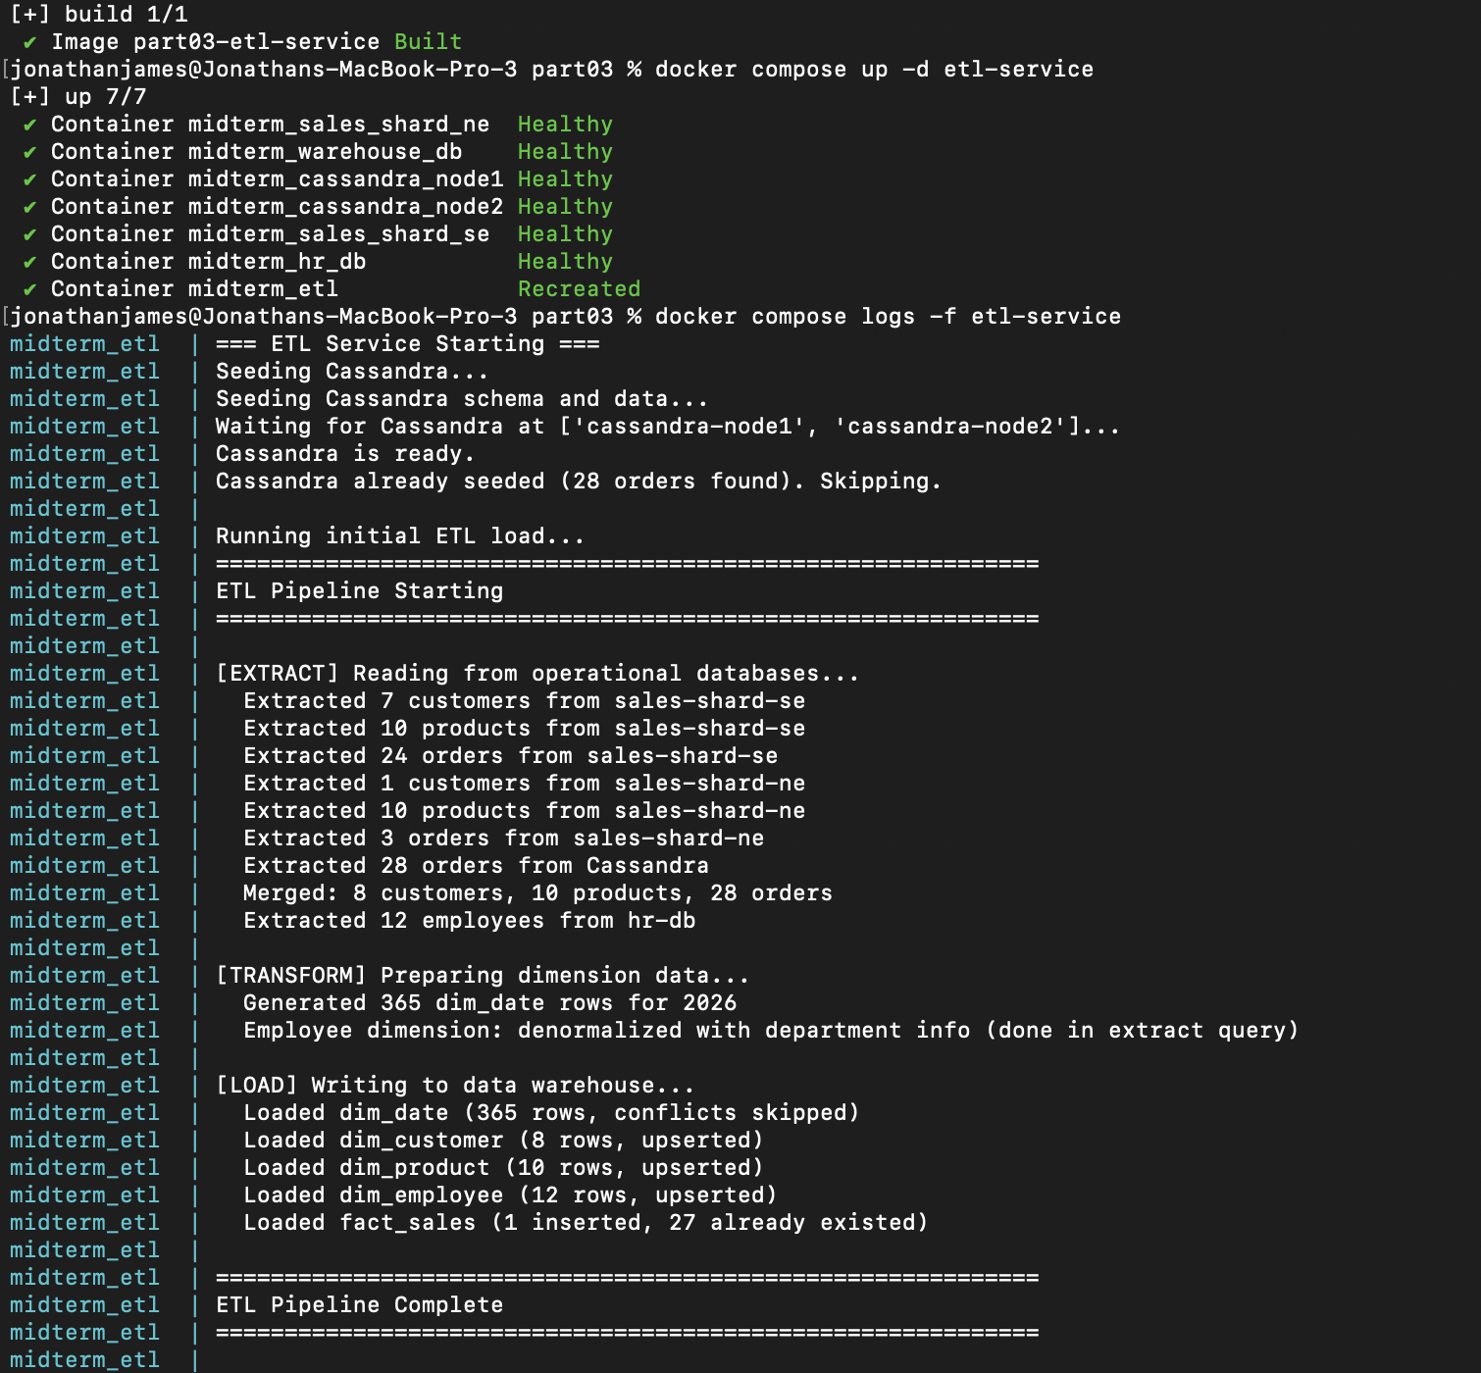
Warehouse verification showing order 28
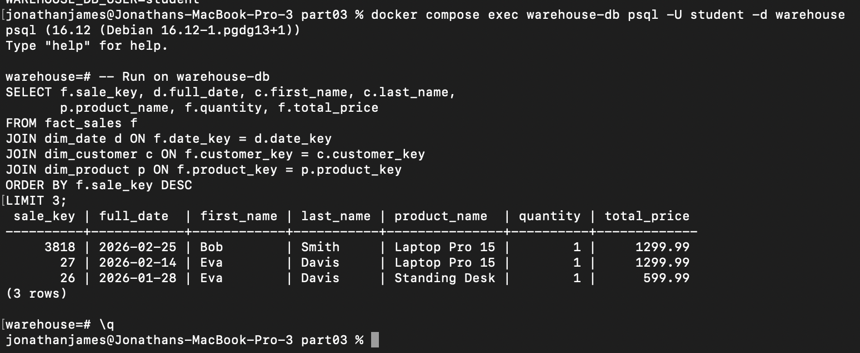

PART 5: POLYGLOT PERSISTENCE REFLECTION

Task 5.1: Compare the Three Database Roles

Table & written response

Aspect | PostgreSQL(shards) | Cassandra(Ingestion) | PostgreSQL  (Warehouse)
Primary Role | Operational transactions and reference data such as customers and products | High-volume order ingestion and fast writes | Analytical reporting and star schema queries
CAP Positioning | CA — prioritizes Consistency and Availability in normal relational operation | AP — prioritizes Availability and Partition tolerance, even if data may be temporarily inconsistent | CA — prioritizes Consistency and Availability for reliable analytical queries
Consistency Model | Strong consistency and ACID transactions | Tunable consistency, often eventual consistency in write-heavy workloads | Strong consistency and ACID transactions
Best for | Updates, inserts, deletes, foreign keys, and reliable transactional data | Massive write throughput, horizontal scaling, and partition-based queries | Joins, aggregations, historical reporting, and business intelligence
Limitation | Harder to scale for extreme write bursts across many nodes | Poor support for joins, ad hoc queries, and normalized relational design | Not ideal for high-velocity ingestion workloads

In this architecture, each database serves a different purpose based on its strengths. The PostgreSQL shards handle operational and reference data such as customers and products. This works well because PostgreSQL supports ACID transactions, strong consistency, foreign keys, and normalized schemas. These features are important for data that must remain accurate and structured during daily business operations.

Cassandra is used for order ingestion because it is designed for high write throughput and horizontal scalability. It can handle burst traffic, such as flash sales or peak ordering periods, much better than a traditional relational database. Its query-first design also allows fast reads for specific access patterns, but it requires denormalization and duplicated data.

The PostgreSQL warehouse serves a different role from both of these systems. It is optimized for analytics, star schema design, joins between fact and dimension tables, and reporting queries. This makes it ideal for business intelligence and trend analysis.

A single database technology would struggle to handle all three roles efficiently. PostgreSQL alone would not scale as well for heavy ingestion spikes, while Cassandra would not support the joins and flexible analytical queries needed in the warehouse. Using multiple databases allows each workload to run on the system best suited for it.

Task 5.2: Argue For or Against Cassandra as a Warehouse

Written response
I would argue against replacing the PostgreSQL warehouse with Cassandra for analytical queries. Cassandra is a strong choice for high-volume ingestion and fast writes, but it is not well suited for the warehouse role in this architecture. A data warehouse depends heavily on star schema queries, which require joins between fact and dimension tables. PostgreSQL supports these joins efficiently, while Cassandra does not support joins in the same relational way. This makes Cassandra a poor fit for analytical workloads that need to combine sales, customer, product, and date data.

Cassandra is also limited for aggregation-heavy queries. In PostgreSQL, GROUP BY queries are natural and efficient for reporting, summaries, and trend analysis. In Cassandra, these types of queries are much more restricted and often require inefficient workarounds such as denormalization, precomputed tables, or ALLOW FILTERING, which is not ideal for analytics. Analytical systems also usually require strong consistency because reports must be accurate and trustworthy for business decisions. PostgreSQL provides stronger transactional guarantees for this purpose, while Cassandra focuses more on availability and scalable writes.

Finally, Cassandra’s query-first design works best when queries are known in advance. Warehouses often support ad hoc analysis, where users may ask new questions at any time. Because of that, Cassandra is not a good replacement for the PostgreSQL warehouse.

