ISM 6562 901 Big Data For Business
Midterm Project Part 2: Operational Databases, Data Warehousing, and ETL
Jonathan James, Nairi Keeney, Maaz Ul Hasan Masood, Abdul Mannan Mohammad
2 April 2026

PART 1: SETUP & EXPLORATION

Task 1.1: Start the Part 2 Environment

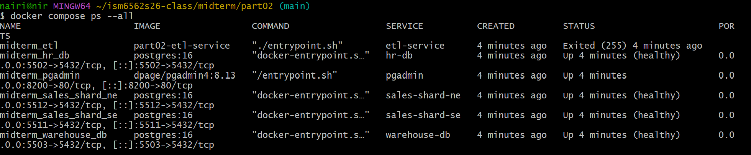

Task 1.2: Count Rows in Each Shard

Southeast Shard

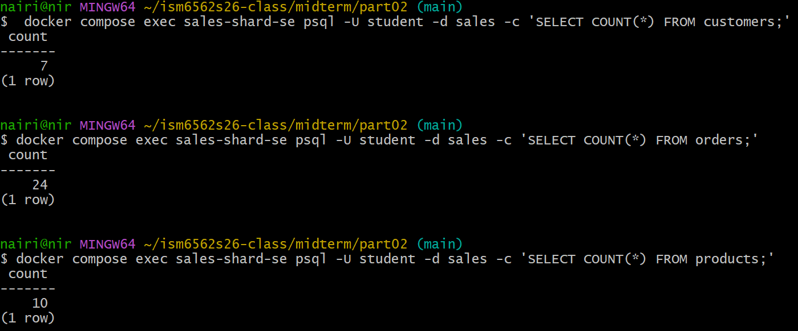

Northeast Shard

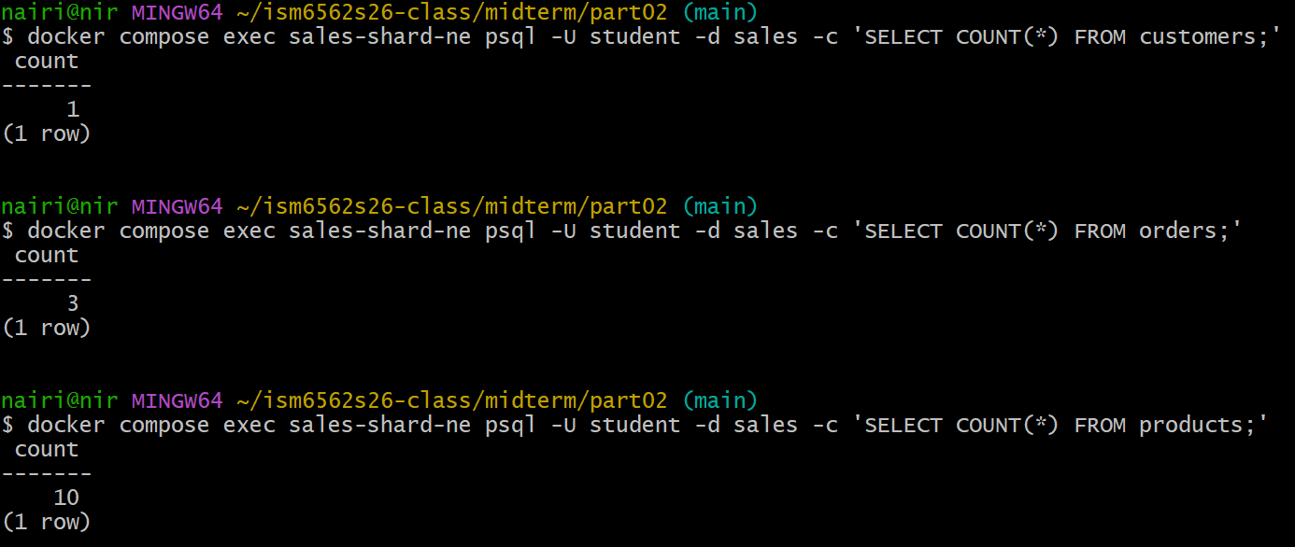

Task 1.3: Analyze Uneven Distribution

The current sharding strategy partitions data by region, leading to a heavily skewed distribution; with the Southeast shard holding 7 customers and 24 orders, while the Northeast shard holds 1 customer and 3 orders. This imbalance creates several problems.
The first problem is the disproportionate query load present. The Southeast shard handles around 85-90% of the reads and writes, leaving the Northeast shard to sit rather idle.Without balanced load distribution, the Southeast shard could end up becoming a bottleneck just like in an unsharded database.
With the present sharding technique also comes the challenge of uneven storage distribution. The Southeast shard consumers a lot more disk and memory, while the Northeast shard sits practically wasted. It is clear that this technique is not optimized for the business problem and as a result, is ill-suited for completing such a task.
A better shard key for this situation would be customer_id with hash_based partitioning. With the implementation of hashing comes the randomized distribution of rows evenly across shards.

PART 2: UPDATE ETL PIPELINE

Task 2.1: Diagnose the ETL Failure

Error log output

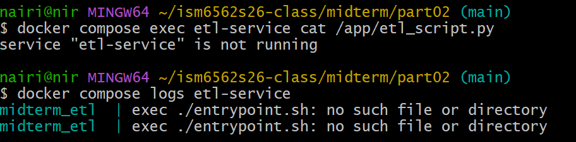

ETL Script Content

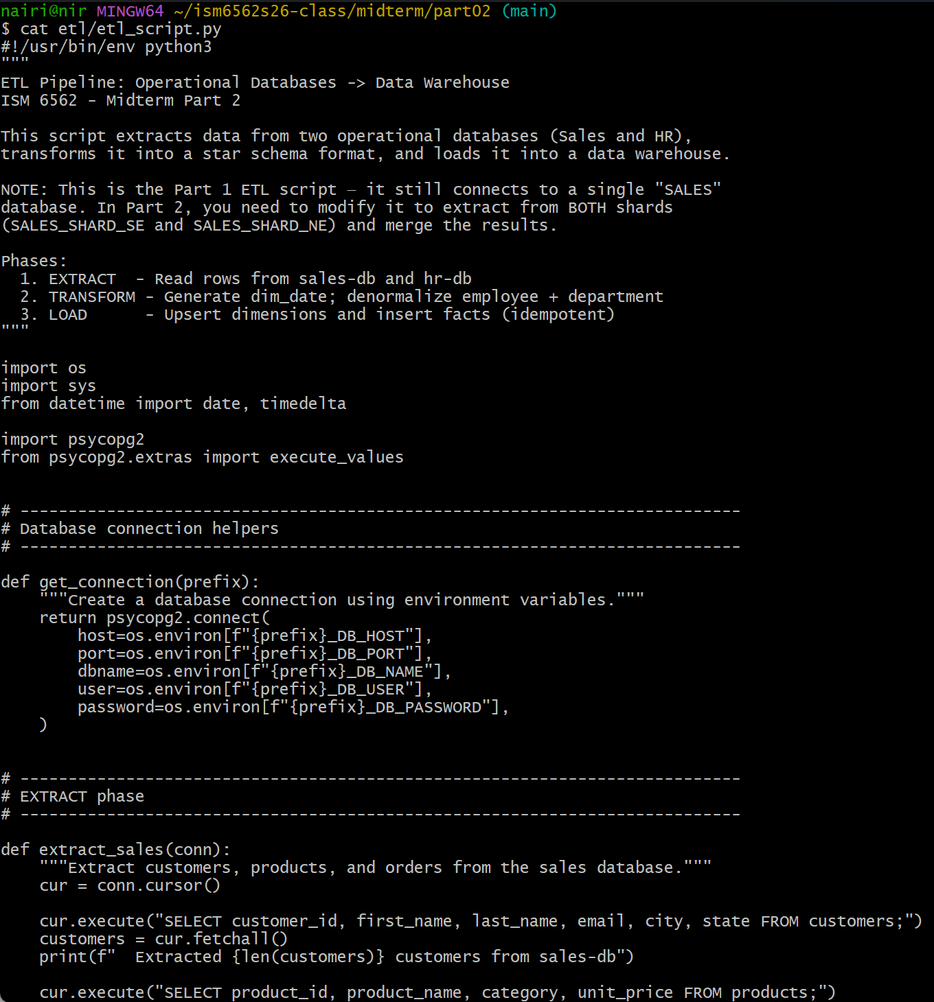
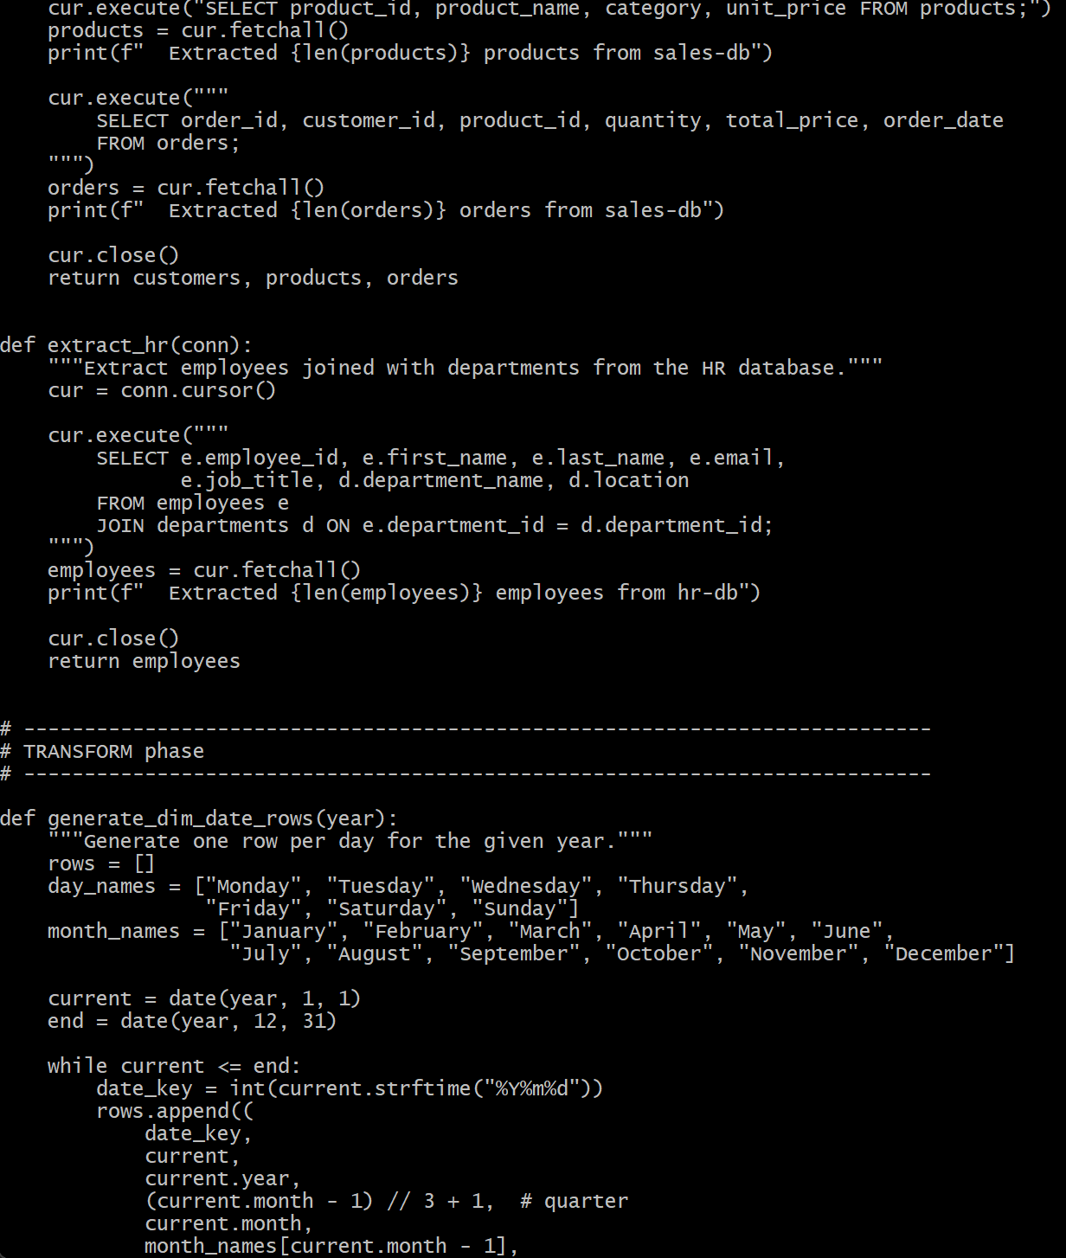
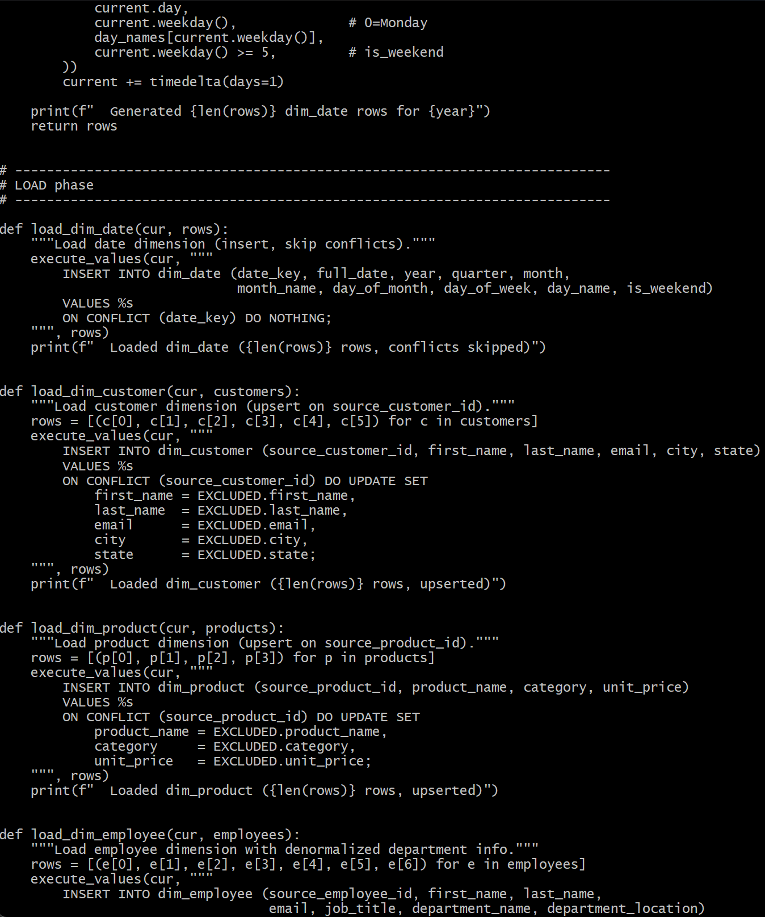
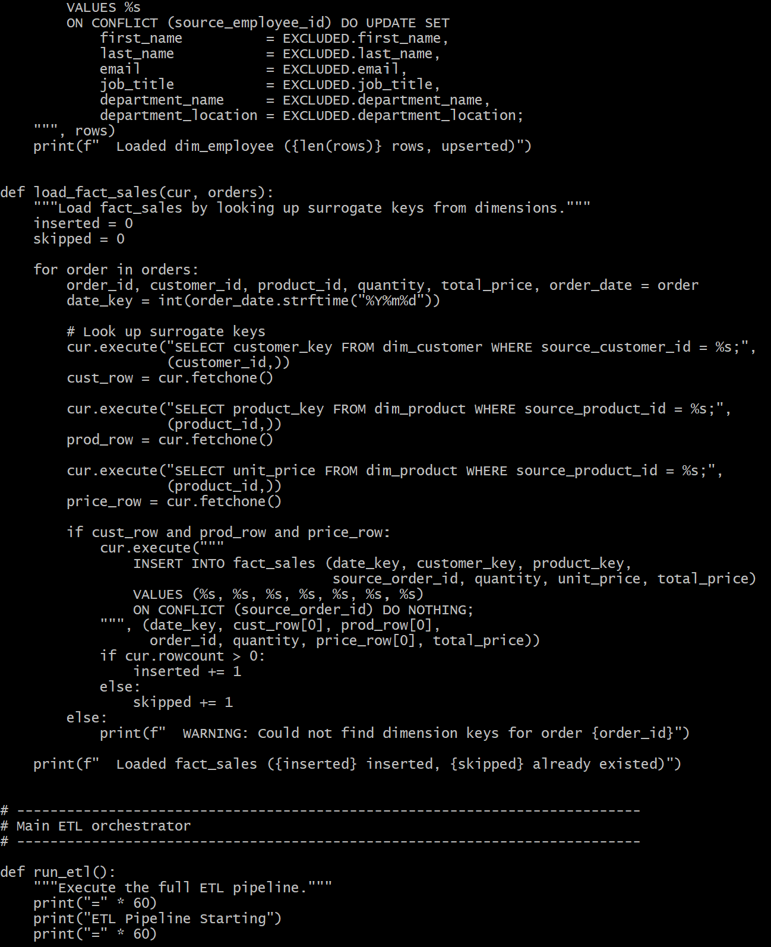
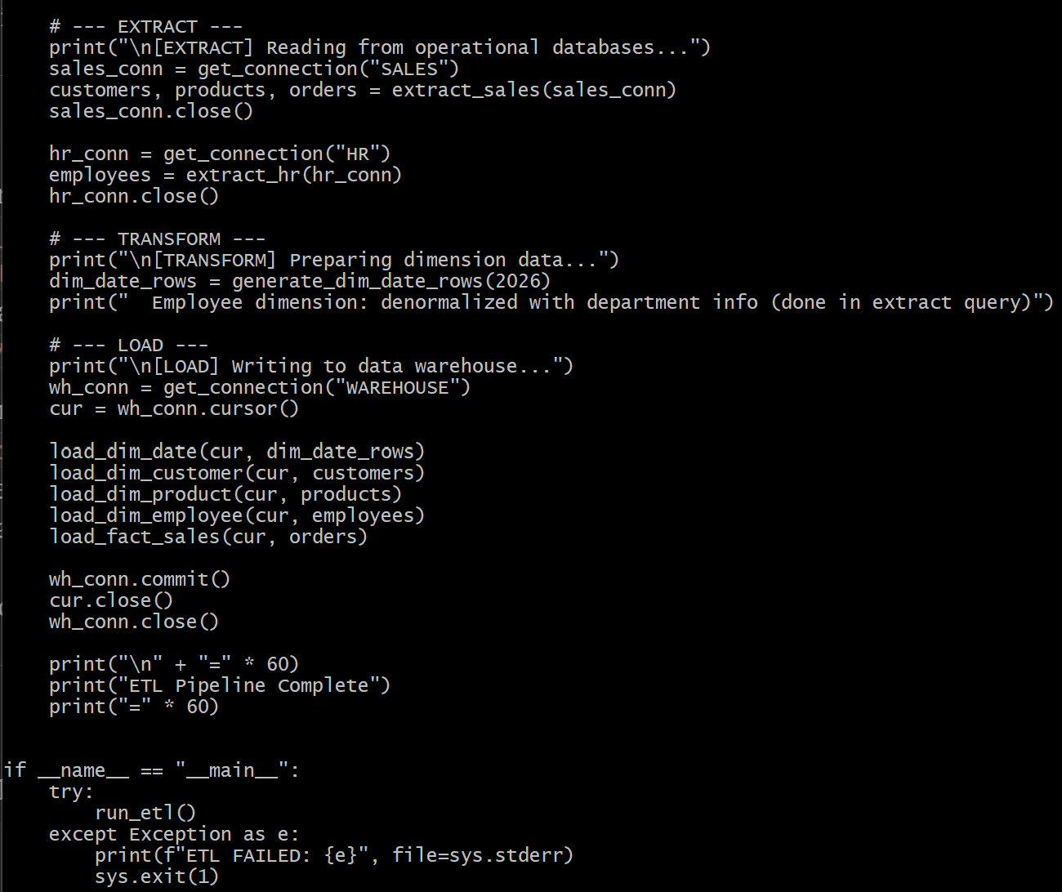

When examining the ETL script, the problem becomes quite clear. In the run_etl() function, get_connection(“SALES”) attempts to read the environment variables SALES_DB_HOST, SALES_DB_PORT, SALES_DB_NAME, SALES_DB_USER, and SALES_DB_PASSWORD, as previously defined in the script. The ETL script was initially defined to handle a single database; however, this database was replaced with two shards, SALES_SHARD_SE_DB_* and SALES_SHARD_NE_DB_*, causing the ETL to be unable to connect.
To fix this, the single get_connection(“SALES”) call must be replaced with the following connection calls: get_connection(“SALES_SHARD_SE”) and get_connection(“SALES_SHARD_NE”). Each shard will be queried independently and with the data split across two shards, the outputs must be combined into a single list. Since customers and orders will vary depending on the shard, the outputs from each shard will be combined; whereas, the products will not change based on shard, so only one copy is necessary to avoid duplicate information. The information collected will then be transformed and loaded as intended.
Task 2.2: Modify the ETL Script

Modified ETL Script

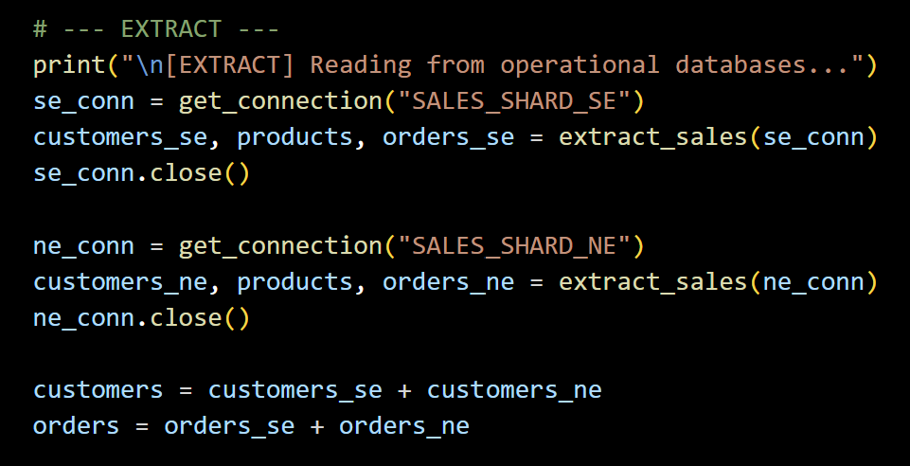

Successful Output

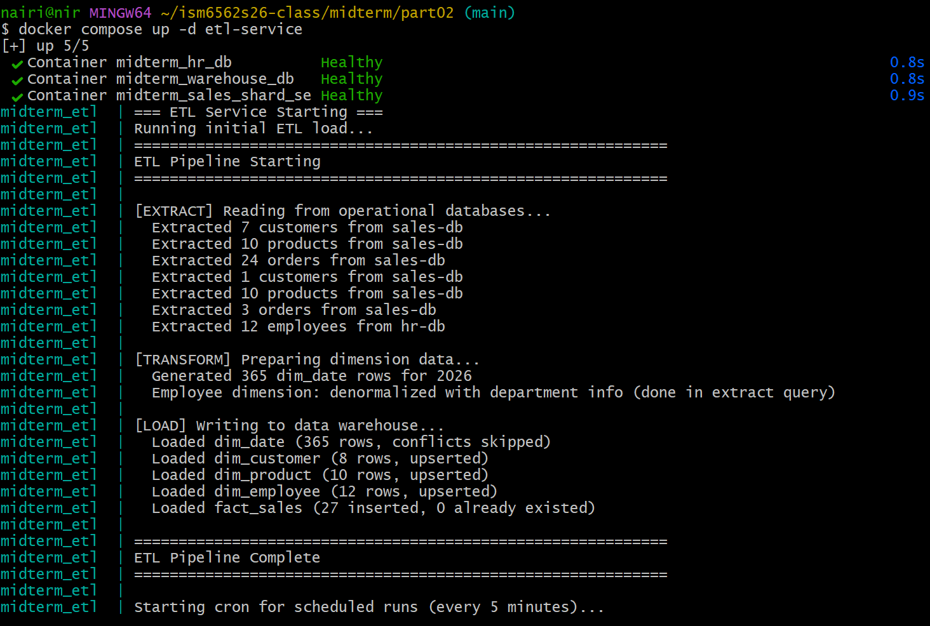
Task 2.3: Verify Warehouse Data

Step 1

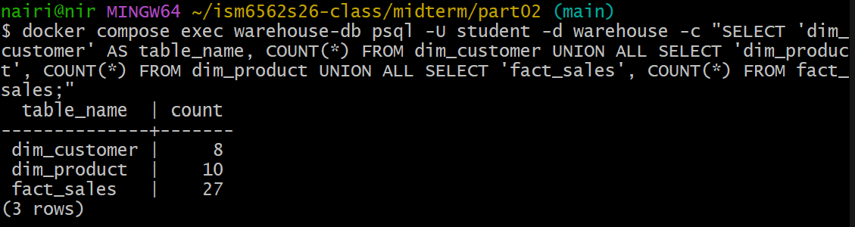

Step 2

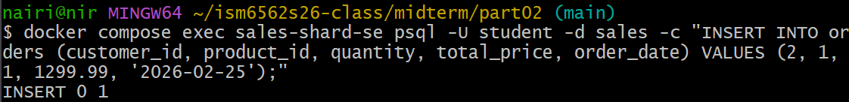

Step 3

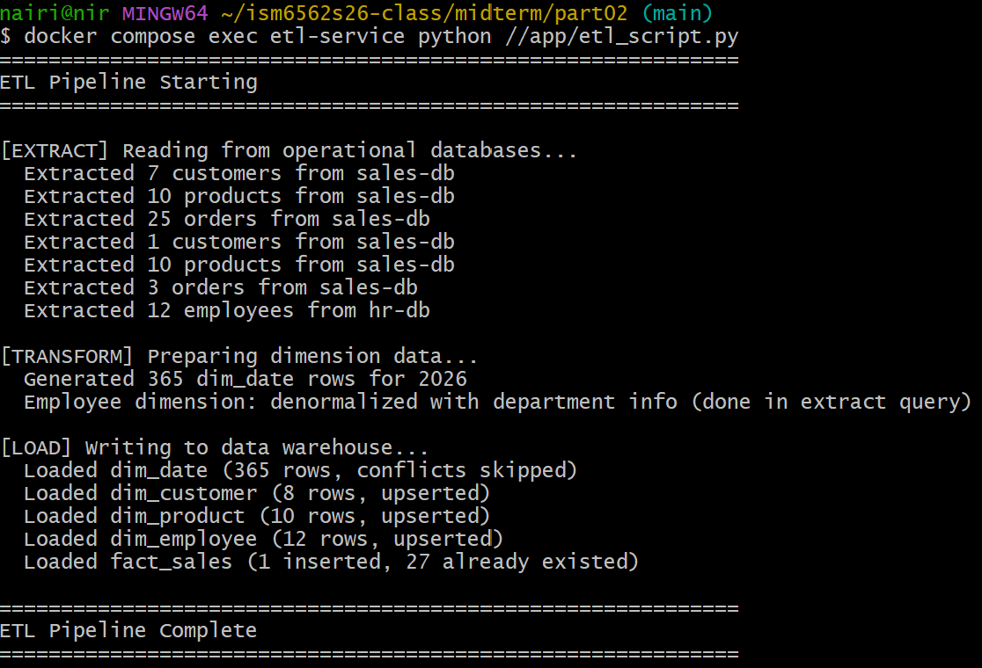
Step 4

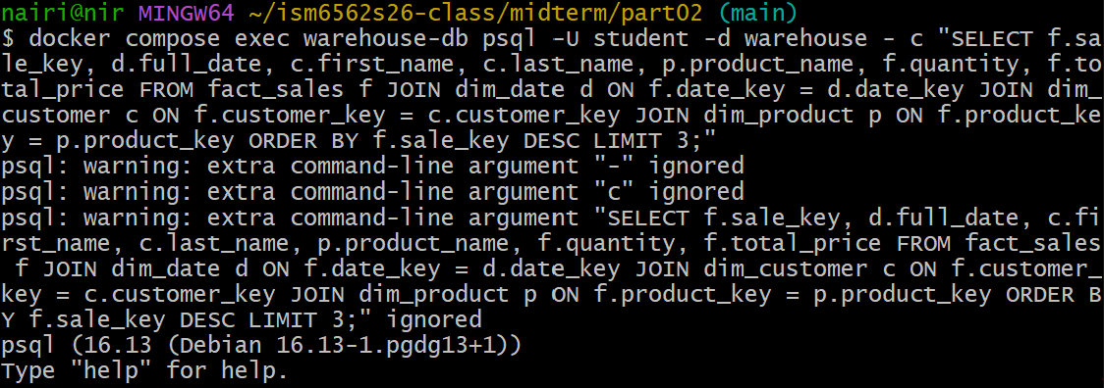

PART 3: CROSS-SHARD CHALLENGES

Task 3.1: Cross-Shard Query Attempt

Southeast Shard

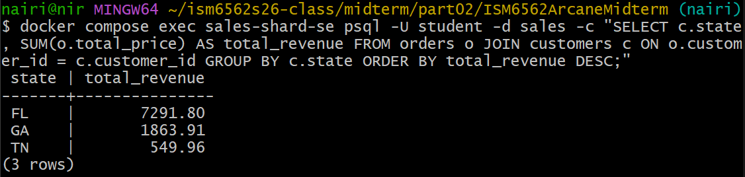

Northeast Shard

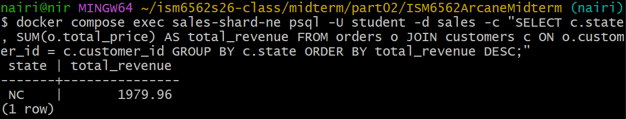

Cross-Shard Limitation

From each of the queries we can see the total revenue amount for each state within each shard; however, there is no way to run a single query that JOINs or aggregates the information across both shards simultaneously. Since both shards operate completely independent of each other, the results of both shards would need to manually be combined at the application level. This highlights the key limitation of a sharded architecture, in that any query requiring data from multiple shards cannot be handled by the database alone, adding significant complexity to the application layer.

Task 3.2: Sharding Trade-off Analysis

Regional sharding can provide meaningful benefits when implemented properly. By storing data close to its user base, query latency is reduced for each region. A sharded architecture also allows for independent scaling, meaning one shard's resources can be upgraded without affecting another. This is particularly beneficial when one shard experiences increased traffic. Another important advantage is fault isolation, meaning if one shard goes down, the remaining shards stay fully operational. Lastly, smaller table sizes within each shard allow queries to run significantly faster compared to a single large database.
Although sharding offers clear benefits, the challenges it introduces cannot be ignored. As demonstrated in Task 3.1, cross-shard queries cannot be performed using standard SQL, meaning results from each shard must be manually combined at the application level, adding complexity and potential for error. The ETL pipeline also becomes more complex, as it must connect to and extract from multiple shards before merging the data. Reference tables must remain identical across all shards, requiring careful attention whenever updates are made. Additionally, the absence of cross-shard foreign keys and transactions means data integrity must be enforced at the application level rather than the database level. Finally, as seen in this assignment, an uneven data distribution indicates a poor choice of shard key, which leads to hot shards and ultimately undermines the core benefits that sharding was intended to provide.

PART 4: EXPLAIN ANALYZE

Task 4.1: Query Plan on the SE Shard

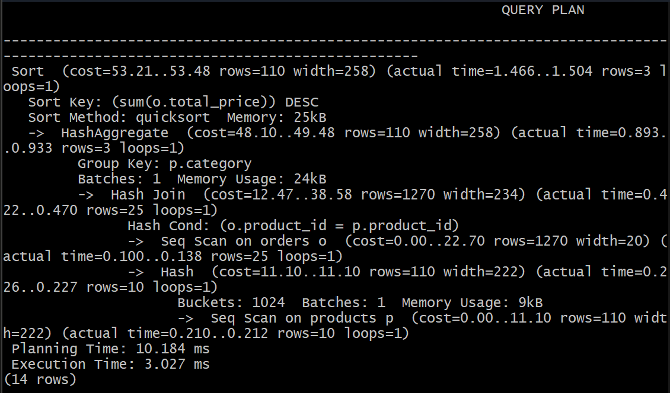

Task 4.2: Query Plan on the Warehouse

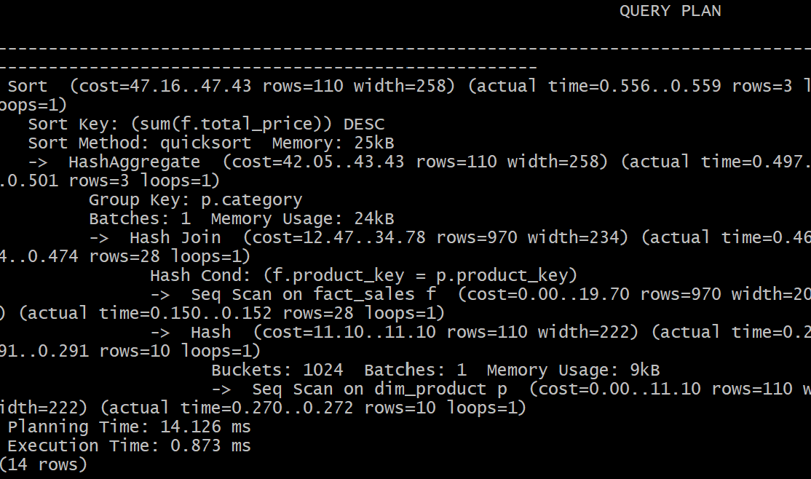

The warehouse query plan is unaffected by operational sharding due to the ETL pipeline consolidating data from both shards into a single star schema prior to any analytical queries being run. Upon queries being performed, all orders have already been extracted and loaded into a single unified table, regardless of which shard they originated from. The warehouse operates completely independently from the operational shards and has no awareness of where the data was sourced from.
This highlights a key benefit of the ETL and data warehouse pattern. Rather than analysts facing the complexity of multiple shards, the ETL layer absorbs all the complexity. Analysts are able to interact with a clean, denormalized schema, allowing any concern for data locality to be disregarded.

