/table

Project Step | Description
Step 1 | Obtain EGFR target gene sequence from NCBI in FASTA format
Step 2 | Open and visualize sequence in SnapGene
Step 3 | Access CHOPCHOP for gRNA design
Step 4 | Run gRNA search and identify PAM sites
Step 5 | Select best guide RNAs based on efficiency and off-target criteria
Step 6 | Export results in Excel and sort required guides
Validation | Validate selected guide RNA using Next Generation Sequencing

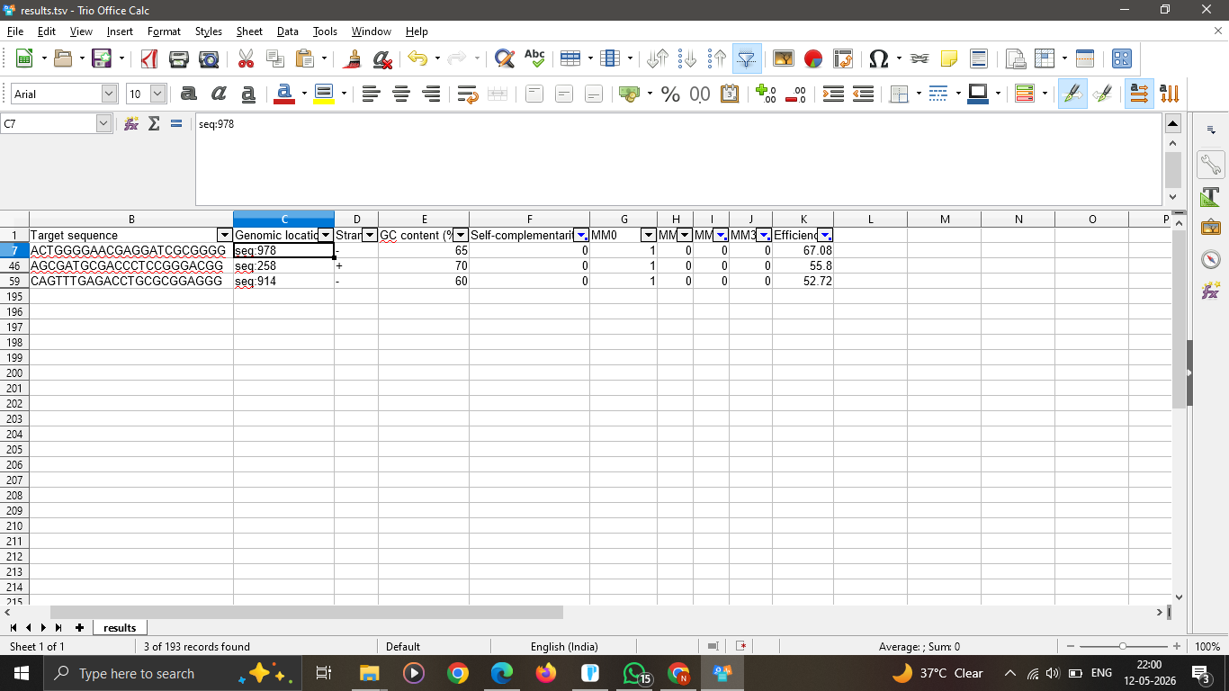
The table in open in excel, it shows the target sequence according to out given criteria.

