Login Page – Bugs & Suggestions Report
Application: Nimbus QA Auth App
URL: https://nimbus-qa-auth-app.onrender.com/
Modules: Login, Sign Up, Forgot Password, Logout
Prepared by: Naishadh (QA Tester)
Date: 13 October 2026
1. Scope of Testing
I tested these four modules:
- Login: page design, email and password fields, Sign Up and Forgot Password links, Log In button and Remember Me.
- Sign Up: Full Name, Email, Password, Confirm Password, Phone Number, Terms and Conditions checkbox, Sign Up button and Login link.
- Forgot Password: email check, reset code check and password reset.
- Logout: logout, going back to the Login page and clearing the session.
Test Result Summary
Total test cases: 158. Passed: 153. Failed: 5. All 5 failed test cases are in the Sign Up module and are listed as bugs below.
2. Bug Log
2.1 Sign Up Module
Bug ID: BUG_SIGNUP_001
Bug Title: Phone Number field accepts letters
Steps:
- Open the Sign Up page.
- Type letters in the Phone Number field, for example ABCDEFGHIJ.
Expected Result: Letters should not be accepted.
Actual Result: Letters were accepted in the Phone Number field.
Severity: Low
Priority: Medium
Status: Fail
Screenshot:
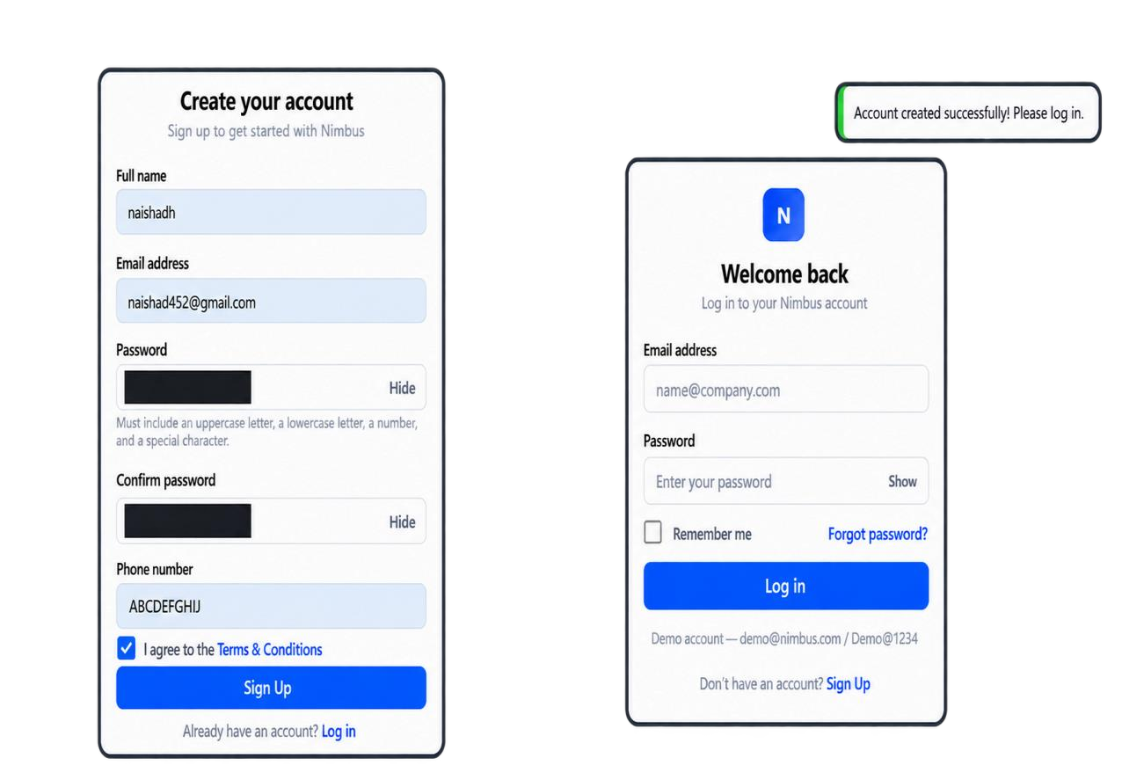
Bug ID: BUG_SIGNUP_002
Bug Title: Password field accepts spaces
Steps:
- Open the Sign Up page.
- Type a password with a space in it, for example Naishad @132.
Expected Result: The password should not accept spaces.
Actual Result: A password with a space was accepted.
Severity: Low
Priority: Medium
Status: Fail
Screenshot:
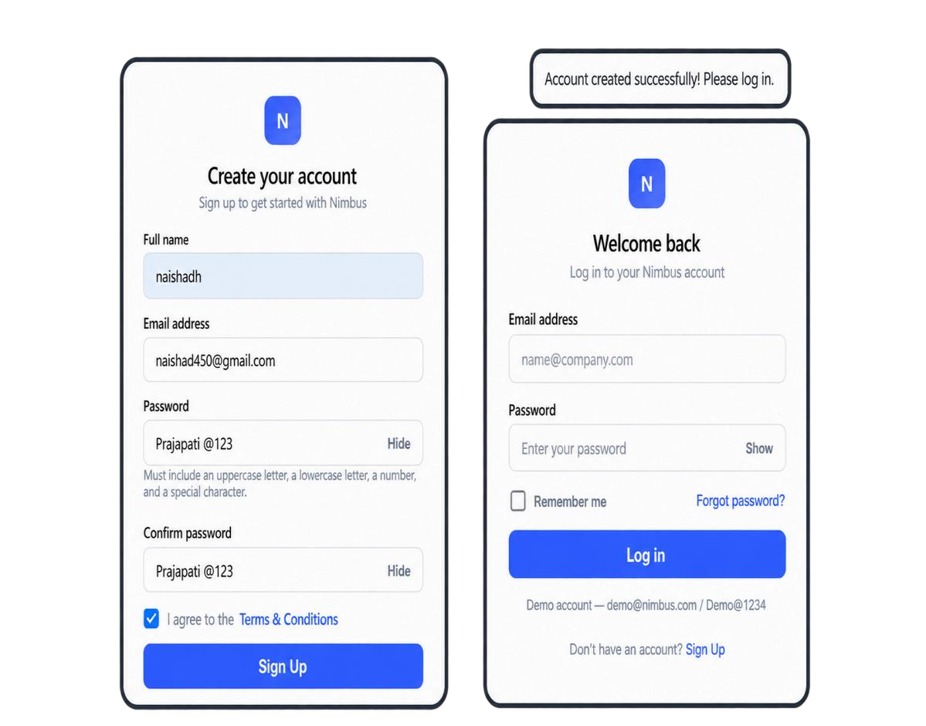
Bug ID: BUG_SIGNUP_003
Bug Title: Terms & Conditions link does not open the page
Steps:
- Open the Sign Up page.
- Click the Terms & Conditions link.
Expected Result: The Terms & Conditions page should open.
Actual Result: The link only shows the path https://nimbus-qa-auth-app.onrender.com/#terms and the page does not open.
Severity: Low
Priority: Medium
Status: Fail
Screenshot:
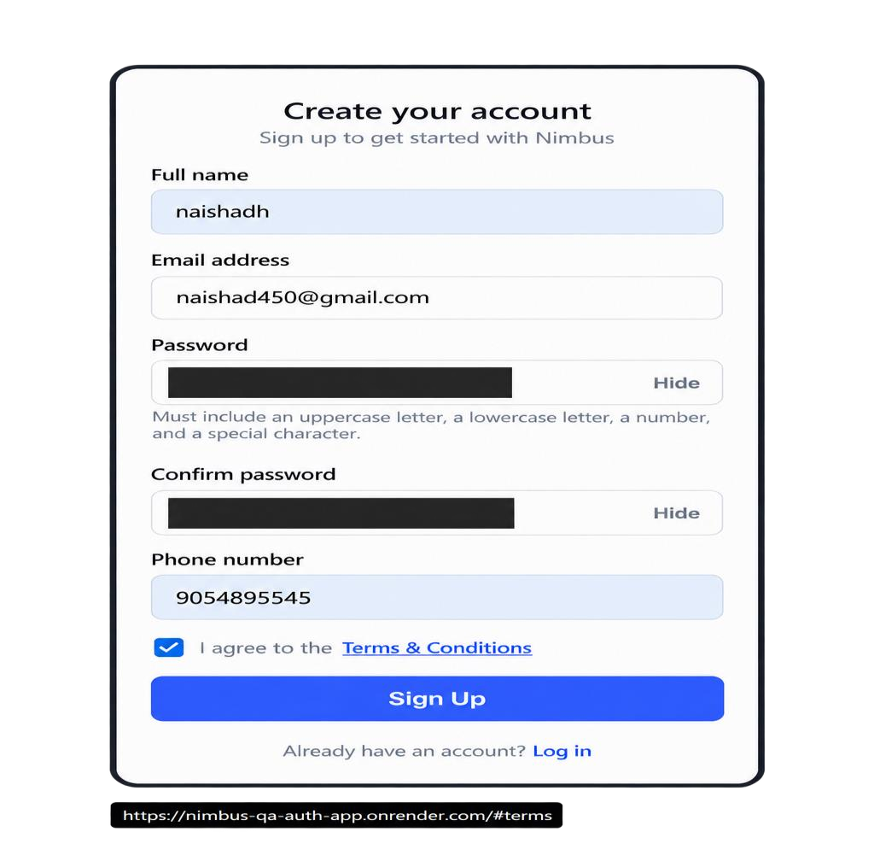
Bug ID: BUG_SIGNUP_004
Bug Title: Sign Up accepts a 9-digit phone number
Steps:
- Open the Sign Up page.
- Fill in the other required details.
- Type a 9-digit number in the Phone Number field, for example 905489555.
- Accept Terms and Conditions and click Sign Up.
Expected Result: Sign Up should be blocked with a message to enter a 10-digit phone number.
Actual Result: The 9-digit phone number was accepted and the account was created successfully.
Severity: Medium
Priority: Medium
Status: Fail
Screenshot:
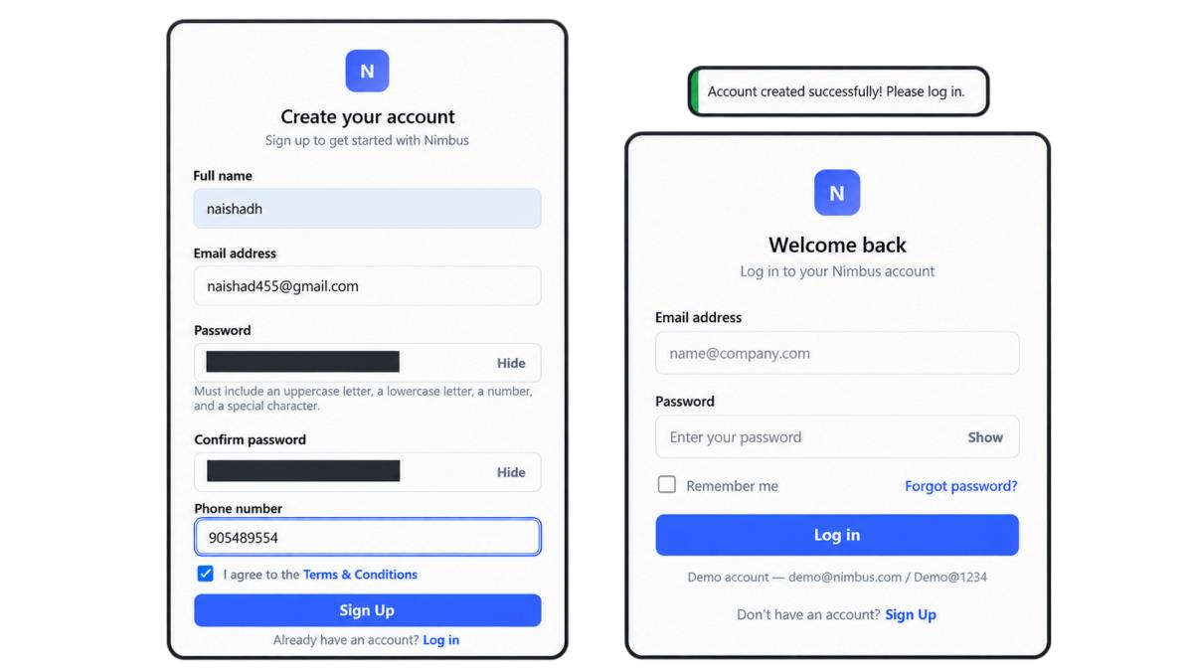
Bug ID: BUG_SIGNUP_005
Bug Title: Sign Up accepts an 11-digit phone number
Steps:
- Open the Sign Up page.
- Fill in the other required details.
- Type an 11-digit number in the Phone Number field, for example 90548955545.
- Accept Terms and Conditions and click Sign Up.
Expected Result: Sign Up should be blocked with a message to enter a 10-digit phone number.
Actual Result: The 11-digit phone number was accepted and the account was created successfully.
Severity: Medium
Priority: Medium
Status: Fail
Screenshot:
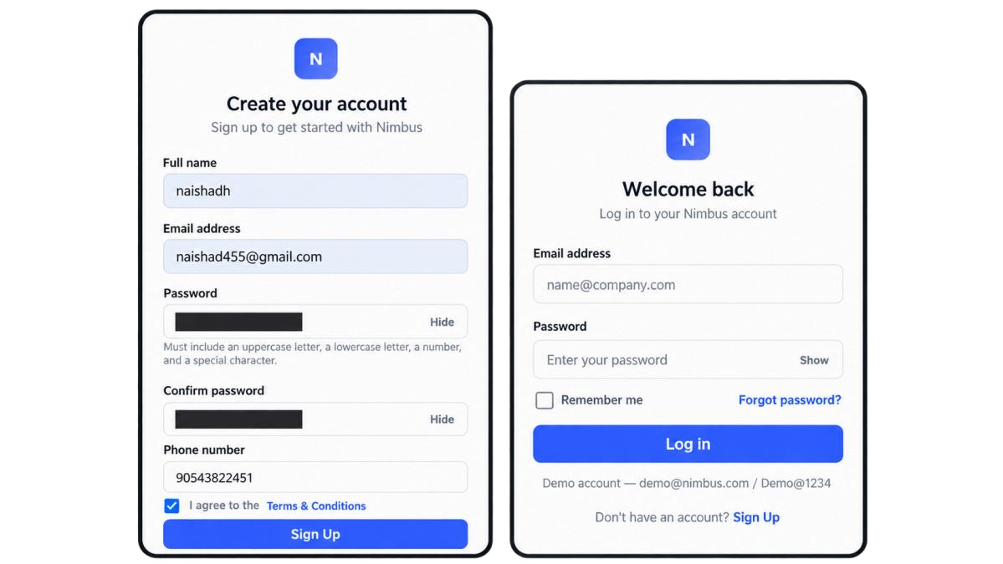
2.2 Login Page Module
No bugs were found during Login module testing.
2.3 Forgot Password Module
No bugs were found during Forgot Password module testing.
2.4 Logout Module
No bugs were found during Logout module testing.

3. Suggestions
These ideas will make the app easier to use. They are improvements, not confirmed bugs.
3.1 Login Module
- Add a short explanation beside Remember Me.
- After a successful Sign Up, show the registered email on the Login page.
3.2 Sign Up Module
- Reduce the extra spacing in the form so there is less scrolling.
- Show the password rules as a checklist and tick each rule when it is met.
- Add a hint under Phone Number, for example “Enter a 10-digit phone number”.
3.3 Forgot Password Module
- Show the same message for registered and unregistered emails, for example “If this email is registered, a reset code has been sent”. This keeps account emails private.
3.4 Logout Module
Show a short message after logout, if the app does not already do this. This needs to be checked.

