Category Intelligence
Retail Product Performance EDA · Team Documentation & Insight Report
Calibo AI Academy · Path 2 · KLU Batch 16 Phase 1 — Mini Use Case 01
Field | Details
Use case | MUC01 — Category Intelligence: Retail Product Performance EDA
Team members | Naishadh Vytla · Nakul Sriraj · Sushmitha · Adi Seshu
Dataset | MUC01_Retail_Sales_Dataset.csv — 107,836 transactions, Jan–Jun 2026
Scope | 12 stores · 6 cities · 5 categories · 25 products
Tools | Python · Jupyter/Colab · Pandas · NumPy · Matplotlib · Seaborn
Deliverables | Notebook (.ipynb) · CBIM Problem Canvas · Insight report · 4 individual contribution reports · Clarity web app (extension)
At a Glance
The five numbers that carry the whole analysis.
Metric | Value | What it tells us
Total revenue analysed | ₹459.8M | 107,836 transactions over six months
Chain revenue trend | ₹84.8M → ₹69.3M | Down ₹15.5M per month from Jan to Jun
Steepest decline | Electronics, −35% | Largest category, ₹16.0M of monthly revenue lost
Strongest growth | Apparel, +34% | Only category with sustained momentum
Discount effect on volume | 2.59 → 2.58 units | No volume gain from 0% to 20% discount
1. Ownership & Contribution
Work was divided equally across the four members. Each member owns analysis sections plus one cross-cutting deliverable, so the load is balanced across both the analysis and the submission artefacts.
Member | Analysis sections owned | Cross-cutting deliverable
Naishadh Vytla | Step 1 — Load, inspect & build the SSOT | SSOT validation + final notebook assembly
Adi Seshu | Step 2 — Category revenue trend over time  Step 3 — Top & bottom products by category | Chart style consistency pass (palette, labelling)
Sushmitha | Step 4 — Discount effectiveness  Step 5 — Day-of-week & monthly patterns | This insight report document
Nakul Sriraj | Step 6 — Category Manager Briefing  Step 7 — Conclusion & 90-day roadmap | End-to-end QA (restart + run all) + checklist
The CBIM Problem Canvas was completed jointly by all four members before any analysis code was written. Each step's markdown cell in the notebook carries its owner's name.

2. CBIM Problem Canvas
Completed together, before touching the data.
Canvas element | Answer
Situation (S) | A regional retail chain runs 12 stores across six Andhra Pradesh cities, selling in five categories (Electronics, Apparel, Grocery, Home & Kitchen, Personal Care). Six months of transaction data (Jan–Jun 2026) exist.
Complication (C) | The Category Manager enters a quarterly supplier review where every supplier argues for shelf space and promotional spend. She has no consolidated, trend-based view of which categories and products have earned their place — so today the loudest supplier wins, not the best-performing one.
Question (Q) | Which categories are growing vs. declining over the six months, which products drive each category, and is the discount ladder actually working — so she can decide where to add investment and which supplier to challenge.
SSOT | One cleaned, validated DataFrame built once from MUC01_Retail_Sales_Dataset.csv. Revenue is verified as units_sold × unit_price × (1 − discount_pct/100) for all 107,836 rows, and every chart, table and figure derives from that same frame — no re-reads, no divergent copies, one definition of every metric.
Success definition | The Category Manager can name, with a figure attached, one category to back and one to challenge — and cite the discount finding — from a single page. Useful means it changes what she says in the room, not merely that it is correct.
Primary stakeholder | The Category Manager. She needs a defensible position (category + rupee figure + action), not a dashboard.
3. Data Quality & the Single Source of Truth
Before any analysis, the dataset was validated once and every downstream figure was derived from that one frame.
Check | Result
Rows / columns | 107,836 × 10
Missing values | None in any column
Duplicate transactions | None — all transaction_id values unique
Revenue formula | units_sold × unit_price × (1 − discount_pct/100) holds for 100% of rows
Date coverage | 2026-01-01 to 2026-06-30, continuous
Discount levels present | 0%, 5%, 10%, 15%, 20% — no 25%+ bracket exists in the data
No cleaning beyond date parsing was required, so every figure in this report can be traced back to the raw transactions without adjustment.

4. Findings
Finding 1 — Electronics is the largest category and the steepest decline
Electronics is ~49% of revenue but has lost a third of its value, from ₹45.7M in January to ₹29.7M in June. Because it is so large, its decline is what pulls chain revenue down (₹84.8M → ₹69.3M).
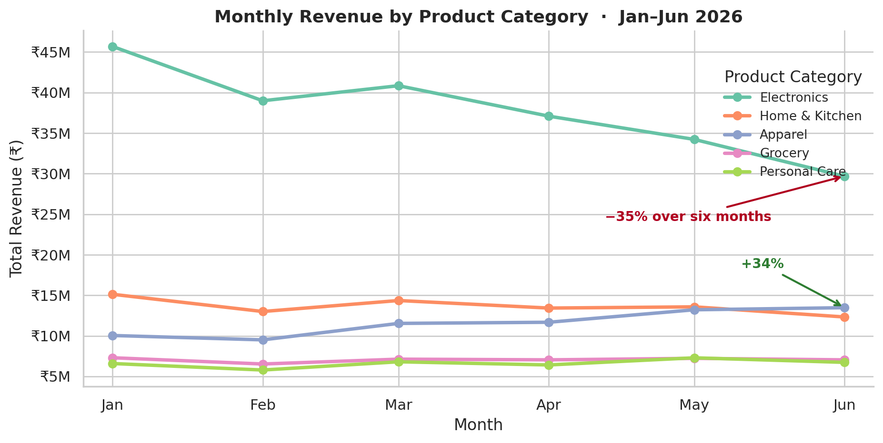
Figure 1 — Monthly revenue by category. Electronics falls steadily while Apparel climbs past Home & Kitchen in June.
Size and momentum point in opposite directions. The category with the most shelf space has the worst trend; the category with the best trend is only the third largest.
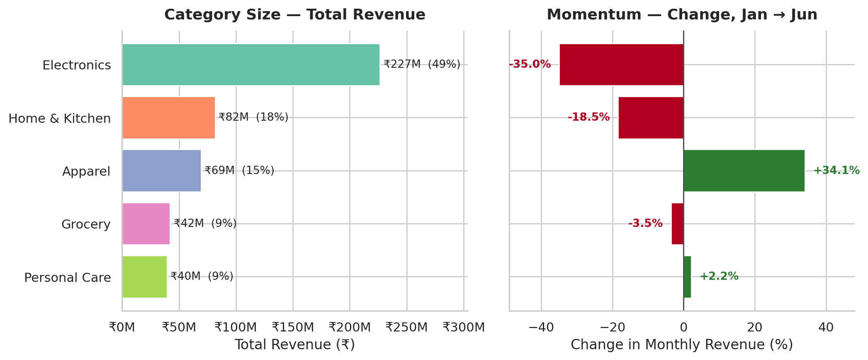
Figure 2 — Category size (left) against six-month momentum (right). Electronics leads on size and trails on growth.
Finding 2 — One category accounts for the entire chain decline
Splitting the ₹15.5M monthly drop by category shows it is not a broad slowdown. Electronics alone lost ₹16.0M of monthly revenue — more than the chain's entire net decline — partly offset by Apparel's ₹3.4M gain.
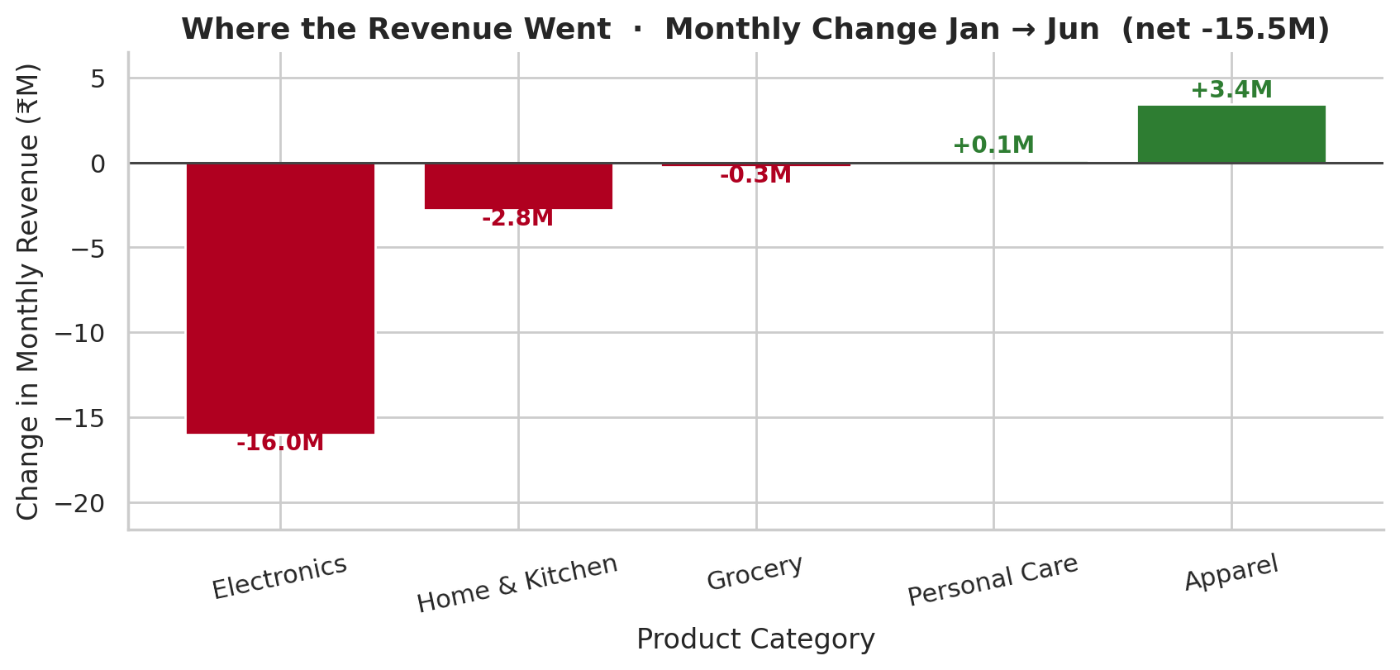
Figure 3 — Contribution to the chain's monthly revenue change. The decline is an Electronics problem, not a chain-wide one.
Category | Jan (₹M) | Jun (₹M) | 6-month total (₹M) | Share | Change
Electronics | 45.7 | 29.7 | 226.5 | 49.3% | −35.0%
Home & Kitchen | 15.1 | 12.3 | 81.8 | 17.8% | −18.5%
Apparel | 10.0 | 13.5 | 69.5 | 15.1% | +34.1%
Grocery | 7.3 | 7.0 | 42.3 | 9.2% | −3.5%
Personal Care | 6.6 | 6.7 | 39.6 | 8.6% | +2.2%
Table 1 — Category performance summary. Ranked by six-month total revenue.
Finding 3 — The discount ladder buys no extra volume
This is the clearest result in the analysis. Average units sold stay flat at about 2.58 across every discount level from 0% to 20%, while average revenue per transaction falls roughly 22%. The discount is being handed back on sales that would have happened anyway.
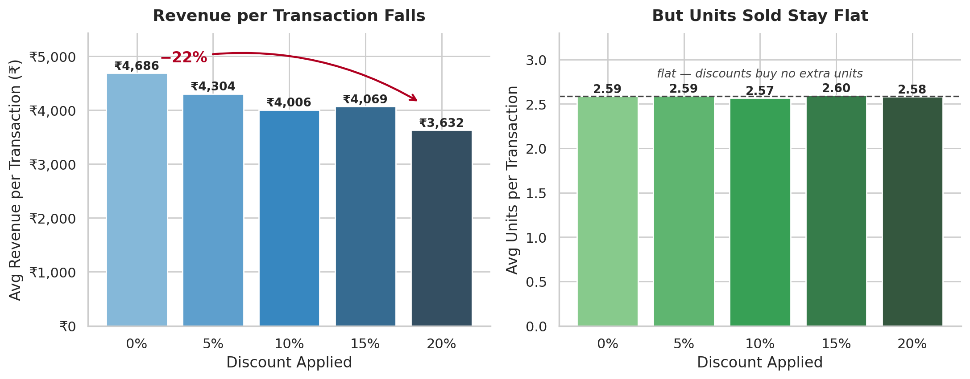
Figure 4 — Revenue per transaction falls as discount deepens (left) while units per transaction do not move (right).
Discount level | Avg revenue / transaction | Avg units / transaction | Transactions | Share of all sales
0% | ₹4,686 | 2.59 | 36,033 | 33.4%
5% | ₹4,304 | 2.59 | 23,922 | 22.2%
10% | ₹4,006 | 2.57 | 23,810 | 22.1%
15% | ₹4,069 | 2.60 | 11,935 | 11.1%
20% | ₹3,632 | 2.58 | 12,136 | 11.3%
Table 2 — Discount effectiveness. Revenue per transaction falls 22% across the ladder; units are unchanged.
Finding 4 — Demand is weekend-driven, so mid-week discounting is misplaced
Saturday earns about 75% more than Monday (₹3.52M vs ₹2.01M per day). Electronics follows the same weekend-skewed shape as the chain rather than behaving differently, so promotional timing can be set chain-wide.
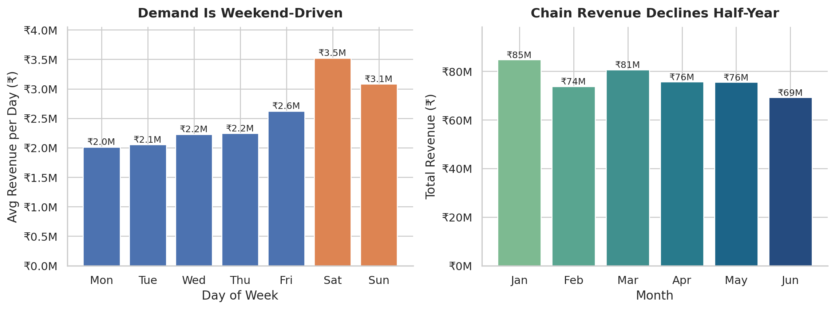
Figure 5 — Average daily revenue by day of week (left) and total revenue by month (right).
Finding 5 — No single product is dragging any category down
Within every category the best and worst product differ by only 6–15% in revenue — there is no dead SKU to cut. This is a negative result worth stating: the actionable signal in this dataset sits at category level, not product level.
Category | Top product | Bottom product | Gap
Electronics | Headphones — ₹47.7M | Smart TV — ₹41.9M | 13.9%
Home & Kitchen | Mixer Grinder — ₹16.9M | Water Bottle — ₹15.8M | 6.8%
Apparel | Saree — ₹14.2M | Kurta — ₹13.6M | 4.0%
Grocery | Rice (5kg) — ₹8.6M | Sugar (1kg) — ₹8.4M | 2.2%
Personal Care | Shampoo — ₹8.2M | Sunscreen — ₹7.6M | 7.7%
Table 3 — Top and bottom product per category by six-month revenue.

5. Recommendation to the Category Manager
Action | Rationale | Figure to cite
Back Apparel with incremental shelf space and promo funding | Only category with sustained momentum; overtook Home & Kitchen by June | +34% (₹10.0M → ₹13.5M)
Challenge the Electronics supplier on trend, not size | Largest category but accounts for the entire chain decline | −35% (₹45.7M → ₹29.7M); −₹16.0M/month
Pull mid-week discounting; concentrate promotions Thu–Sun | Discounts do not move units; demand already peaks at the weekend | 2.59 → 2.58 units; Sat ₹3.52M vs Mon ₹2.01M
Request category-level COGS before finalising | Revenue-only data cannot confirm whether growth is profitable | Not available in current dataset
Limitation
The dataset contains revenue only — no cost or margin data. A growing category could still be low-margin and a declining one highly profitable, so these recommendations rest on top-line performance alone. Category-level COGS, and ideally footfall counts to separate demand shifts from basket-size effects, would be needed to confirm the call on profit.
Section ownership
Naishadh Vytla — SSOT build and data validation (Step 1). Adi Seshu — category revenue trend and product top/bottom analysis (Steps 2–3). Sushmitha — discount effectiveness and time patterns (Steps 4–5), and this report. Nakul Sriraj — Category Manager Briefing and 90-day roadmap (Steps 6–7). Canvas completed jointly.

6. Future Work & Extensions
The analysis answers the supplier-review question it was scoped to, but three lines of work would extend it materially.
Close the margin gap
Every recommendation in this report rests on revenue alone. Ingesting category-level COGS would convert "back Apparel, challenge Electronics" from a top-line call into a profit call, and would settle whether the +34% growth category is actually the most profitable one. Adding footfall or unique-customer counts would separate genuine demand shifts from basket-size effects.
Test the discount finding causally
The flat units-per-transaction result across the discount ladder is a strong observational finding, but it is not a controlled one. A held-out A/B test — discounting one set of stores mid-week and not another — would confirm that withdrawing promotions does not cost volume before the policy is rolled out chain-wide.
Productise the workflow — Clarity
Beyond the assigned scope, Naishadh Vytla built and deployed Clarity, a live web application that generalises this entire workflow to any dataset: upload a CSV, XLSX, JSON or TSV file and it profiles the data, scores its quality against itemised and fully transparent criteria, detects and fixes data-quality issues with preview-and-undo, runs the EDA and correlation analysis automatically, and generates an SSOT-style report in the same format as this document — exportable to HTML or PDF.
Live at https://clarityeda.netlify.app · Accounts are real (email or Google sign-in), each user keeps up to two saved analyses, and all processing runs in the browser so uploaded data never leaves the user’s machine. Built as a single static HTML file with Supabase handling authentication, database and file storage, deployed on Netlify.
The significance for this use case is reproducibility: the SSOT discipline applied manually in Step 1 — validate once, derive everything from one frame — is enforced automatically by the application, so the same analysis can be repeated on next quarter’s data in minutes rather than rebuilt by hand.
7. Individual Reflections
Naishadh Vytla
I owned Step 1 — loading the data, validating it, and building the single source of truth the rest of the notebook runs on, then assembling the final notebook. The part that taught me most was verifying that revenue equalled units × price × (1 − discount) for all 107,836 rows before trusting any chart; it turned the SSOT from an abstract idea into something concrete. Getting the foundation right mattered more than I expected — every figure the team later quoted depends on that one validated frame, so a silent error there would have propagated through all seven steps. From Sushmitha's discount section I learned to check a lever against volume rather than revenue alone — average units barely moving across discount levels is a cleaner argument than anything the revenue numbers show on their own. Beyond the assigned scope I also built and deployed Clarity (clarityeda.netlify.app), a live web app that generalises this workflow to any uploaded dataset — profiling, cleaning, EDA and SSOT report generation — which forced me to turn the manual SSOT discipline into rules a machine could apply consistently.
Adi Seshu
I owned Steps 2 and 3 — the category revenue trend and the top and bottom products within each category — plus the chart consistency pass across the notebook. Plotting the trend was where the analysis became a business story: Electronics being the largest category and the steepest decline at the same time is the finding the whole recommendation rests on. At product level I expected to find one or two weak lines to cut, and found none — the gap between best and worst inside a category was only 4–14%, so the honest answer was that there is no dead SKU. Learning to report that rather than force a recommendation the data did not support was the main lesson. Standardising the palette and axis labels also showed me how much a consistent chart style affects whether a reader trusts the analysis.
Sushmitha
I owned Steps 4 and 5 — the discount effectiveness analysis and the day-of-week and monthly patterns — and drafted this report. Comparing average revenue per transaction against average units sold at each discount level was the turning point: revenue per transaction drops about 22% from 0% to 20% discount while units stay flat at roughly 2.58, which says the discounts are not buying volume at all. Taking a clear position on that, rather than just presenting the chart, was harder than the code. The timing work sharpened it further — Saturday earns about 75% more than Monday, so mid-week discounting spends margin on the days demand is already weakest. From Adi Seshu's product analysis I learned that a clearly stated negative finding is still a finding.
Nakul Sriraj
I owned Steps 6 and 7 — the Category Manager Briefing and the conclusion with its 90-day roadmap — plus the end-to-end QA. Writing the briefing was the hardest part of the assignment, because every sentence had to carry a number and an action rather than an observation. The reframing that made it work was realising Electronics alone lost ₹16.0M of monthly revenue against a chain net decline of ₹15.5M, which turns a vague conversation about a slowdown into a specific, evidence-backed challenge to one supplier. Running restart-and-run-all on sections I had not written also showed me how easily a notebook breaks when cells depend on hidden state, and why the SSOT discipline set up in Step 1 matters for reproducibility.
8. Submission Checklist
Requirement | Status
Notebook runs end-to-end without errors (restart + run all) | Verified — 24 cells, 0 errors, 3 charts
All seven steps present with code and markdown explanation | Complete
Each step's markdown credits the owning team member | Complete
CBIM canvas completed together, all six fields, before analysis | Complete
Every chart titled with business-language axis labels | Complete
Step 4 discount analysis takes a clear position backed by numbers | Complete
Step 6 briefing answers all four points with specific figures | Complete
Findings, recommendation, limitation and ownership documented | Complete
Individual contribution report from each member | Complete
Files named [Batch16]_MUC01_KLU_Notebook.ipynb / _Summary.docx | Completed
Extension — live EDA web app (Naishadh Vytla) | Deployed at clarityeda.netlify.app

