Category Intelligence
Retail Product Performance EDA · Team Documentation & Insight Report
Calibo AI Academy · Path 2 · KLU Batch · Phase 1 — Mini Use Case 01
Field | Details
Use case | MUC01 — Category Intelligence: Retail Product Performance EDA
Team members | Naishadh Vytla · Nakul · Sushmitha · Adi Seshu
Dataset | MUC01_Retail_Sales_Dataset.csv — 107,836 transactions, Jan–Jun 2026
Scope | 12 stores · 6 cities · 5 categories · 25 products
Tools | Python · Jupyter/Colab · Pandas · NumPy · Matplotlib · Seaborn
Deliverables | Notebook (.ipynb) · CBIM Problem Canvas · Insight report · 4 individual reflections
At a Glance
The five numbers that carry the whole analysis.
Metric | Value | What it tells us
Total revenue analysed | ₹459.8M | 107,836 transactions over six months
Chain revenue trend | ₹84.8M → ₹69.3M | Down ₹15.5M per month from Jan to Jun
Steepest decline | Electronics, −35% | Largest category, ₹16.0M of monthly revenue lost
Strongest growth | Apparel, +34% | Only category with sustained momentum
Discount effect on volume | 2.59 → 2.58 units | No volume gain from 0% to 20% discount
1. Ownership & Contribution
Work was divided across the four members, with each member owning a defined analytical stage and a cross-cutting responsibility. The allocation covers the full analysis workflow and the final executive deliverables.
Member | Analysis sections owned | Cross-cutting deliverable
Naishadh Vytla | Step 1 — Load, inspect & build the SSOT | SSOT validation + final notebook assembly
Adiseshu | Step 2 — Category revenue trend  Step 3 — Top & bottom products by category | Category/product variance modelling + chart consistency
Sushmitha | Step 4 — Discount effectiveness  Step 5 — Day-of-week & monthly patterns | Pricing & sales interpretation
Nakul Sriraj | Step 6 — Category Manager Briefing  Step 7 — 90-day implementation roadmap | Executive reporting + supplier challenge arguments + roadmap
The CBIM Problem Canvas was completed jointly by all four members before any analysis code was written. Each step's markdown cell in the notebook carries its owner's name, and the final executive deliverables follow the same ownership structure.

2. CBIM Problem Canvas
Completed together, before touching the data.
Canvas element | Answer
Situation (S) | A regional retail chain runs 12 stores across six Andhra Pradesh cities, selling in five categories (Electronics, Apparel, Grocery, Home & Kitchen, Personal Care). Six months of transaction data (Jan–Jun 2026) exist.
Complication (C) | The Category Manager enters a quarterly supplier review where every supplier argues for shelf space and promotional spend. She has no consolidated, trend-based view of which categories and products have earned their place — so today the loudest supplier wins, not the best-performing one.
Question (Q) | Which categories are growing vs. declining over the six months, which products drive each category, and is the discount ladder actually working — so she can decide where to add investment and which supplier to challenge.
SSOT | One cleaned, validated DataFrame built once from MUC01_Retail_Sales_Dataset.csv. Revenue is verified as units_sold × unit_price × (1 − discount_pct/100) for all 107,836 rows, and every chart, table and figure derives from that same frame — no re-reads, no divergent copies, one definition of every metric.
Success definition | The Category Manager can name, with a figure attached, one category to back and one to challenge — and cite the discount finding — from a single page. Useful means it changes what she says in the room, not merely that it is correct.
Primary stakeholder | The Category Manager. She needs a defensible position (category + rupee figure + action), not a dashboard.
3. Data Quality & the Single Source of Truth
Before any analysis, the dataset was validated once and every downstream figure was derived from that one frame.
Check | Result
Rows / columns | 107,836 × 10
Missing values | None in any column
Duplicate transactions | None — all transaction_id values unique
Revenue formula | units_sold × unit_price × (1 − discount_pct/100) holds for 100% of rows
Date coverage | 2026-01-01 to 2026-06-30, continuous
Discount levels present | 0%, 5%, 10%, 15%, 20% — no 25%+ bracket exists in the data
No cleaning beyond date parsing was required, so every figure in this report can be traced back to the raw transactions without adjustment.

4. Findings
Finding 1 — Electronics is the largest category and the steepest decline
Electronics is ~49% of revenue but has lost a third of its value, from ₹45.7M in January to ₹29.7M in June. Because it is so large, its decline is what pulls chain revenue down (₹84.8M → ₹69.3M).
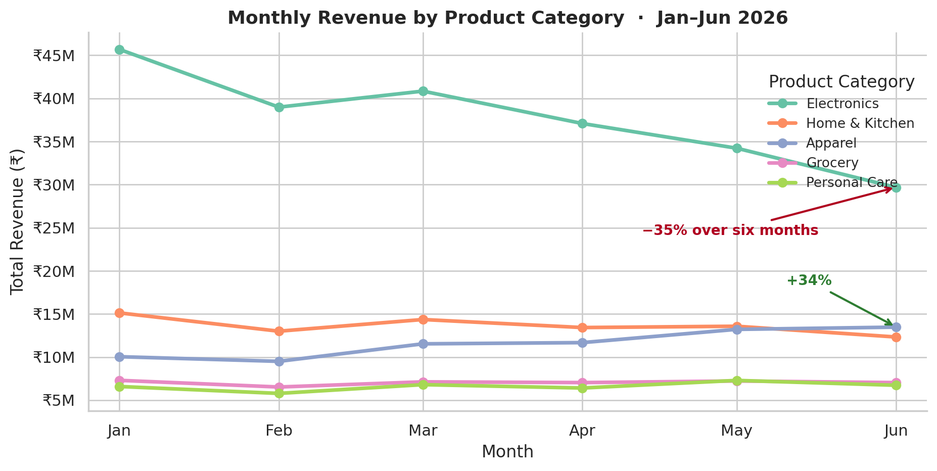
Figure 1 — Monthly revenue by category. Electronics falls steadily while Apparel climbs past Home & Kitchen in June.
Size and momentum point in opposite directions. The category with the most shelf space has the worst trend; the category with the best trend is only the third largest.
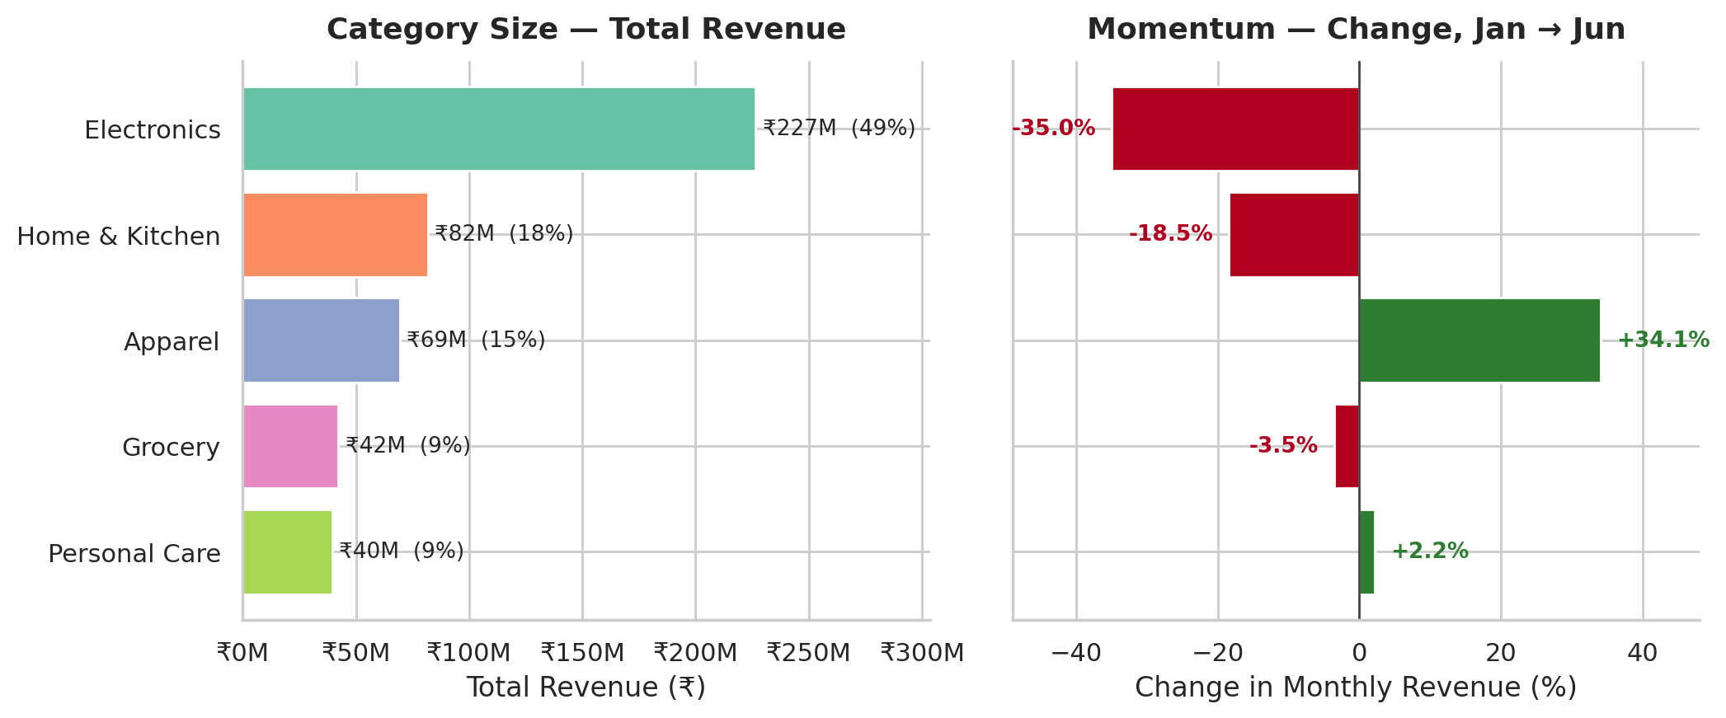
Figure 2 — Category size (left) against six-month momentum (right). Electronics leads on size and trails on growth.
Finding 2 — One category accounts for the entire chain decline
Splitting the ₹15.5M monthly drop by category shows it is not a broad slowdown. Electronics alone lost ₹16.0M of monthly revenue — more than the chain's entire net decline — partly offset by Apparel's ₹3.4M gain.
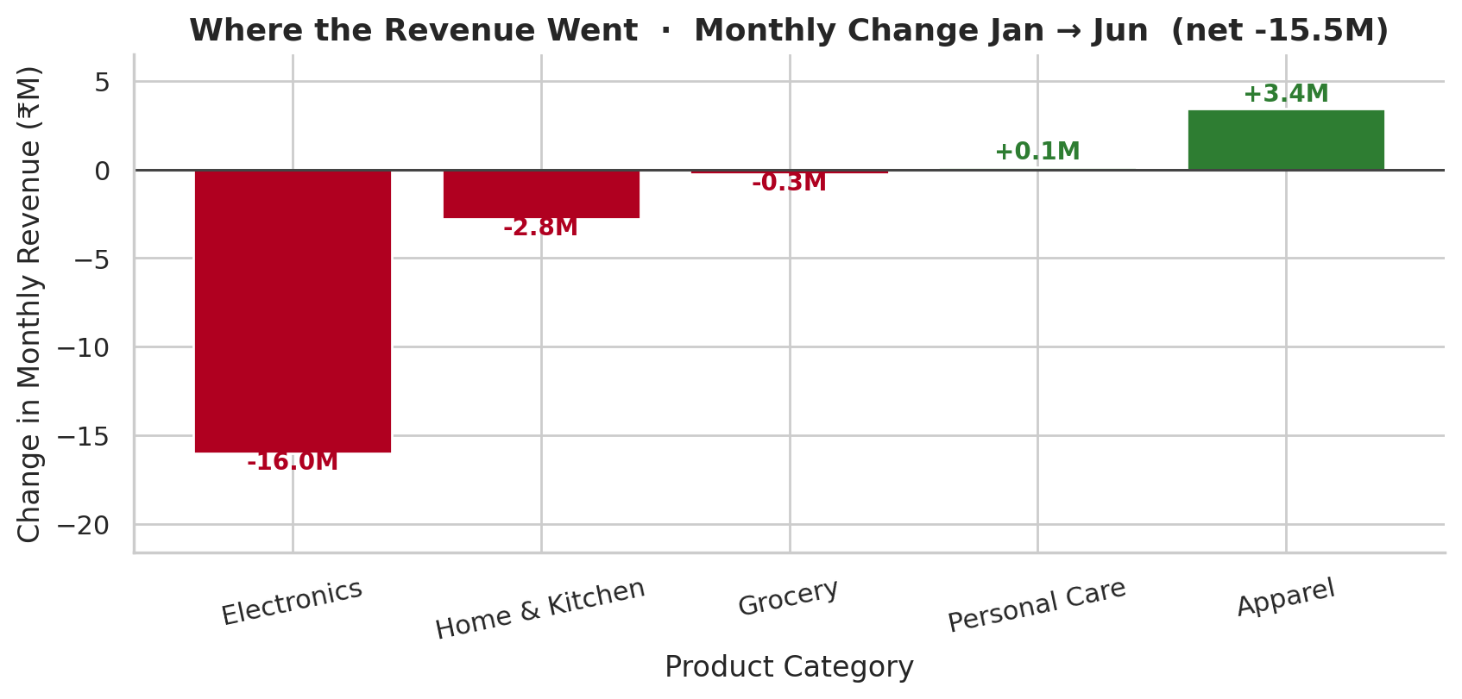
Figure 3 — Contribution to the chain's monthly revenue change. The decline is an Electronics problem, not a chain-wide one.
Category | Jan (₹M) | Jun (₹M) | 6-month total (₹M) | Share | Change
Electronics | 45.7 | 29.7 | 226.5 | 49.3% | −35.0%
Home & Kitchen | 15.1 | 12.3 | 81.8 | 17.8% | −18.5%
Apparel | 10.0 | 13.5 | 69.5 | 15.1% | +34.1%
Grocery | 7.3 | 7.0 | 42.3 | 9.2% | −3.5%
Personal Care | 6.6 | 6.7 | 39.6 | 8.6% | +2.2%
Table 1 — Category performance summary. Ranked by six-month total revenue.
Finding 3 — The discount ladder buys no extra volume
This is the clearest result in the analysis. Average units sold stay flat at about 2.58 across every discount level from 0% to 20%, while average revenue per transaction falls roughly 22%. The discount is being handed back on sales that would have happened anyway.
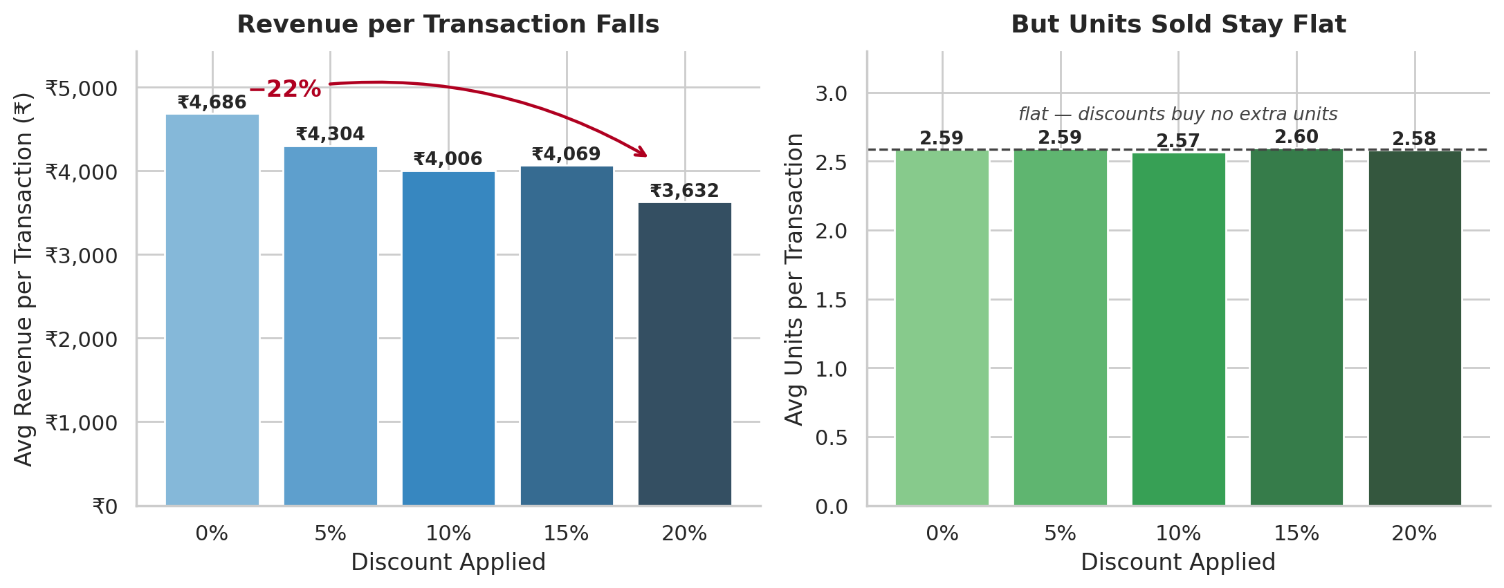
Figure 4 — Revenue per transaction falls as discount deepens (left) while units per transaction do not move (right).
Discount level | Avg revenue / transaction | Avg units / transaction | Transactions | Share of all sales
0% | ₹4,686 | 2.59 | 36,033 | 33.4%
5% | ₹4,304 | 2.59 | 23,922 | 22.2%
10% | ₹4,006 | 2.57 | 23,810 | 22.1%
15% | ₹4,069 | 2.60 | 11,935 | 11.1%
20% | ₹3,632 | 2.58 | 12,136 | 11.3%
Table 2 — Discount effectiveness. Revenue per transaction falls 22% across the ladder; units are unchanged.
Finding 4 — Demand is weekend-driven, so mid-week discounting is misplaced
Saturday earns about 75% more than Monday (₹3.52M vs ₹2.01M per day). Electronics follows the same weekend-skewed shape as the chain rather than behaving differently, so promotional timing can be set chain-wide.
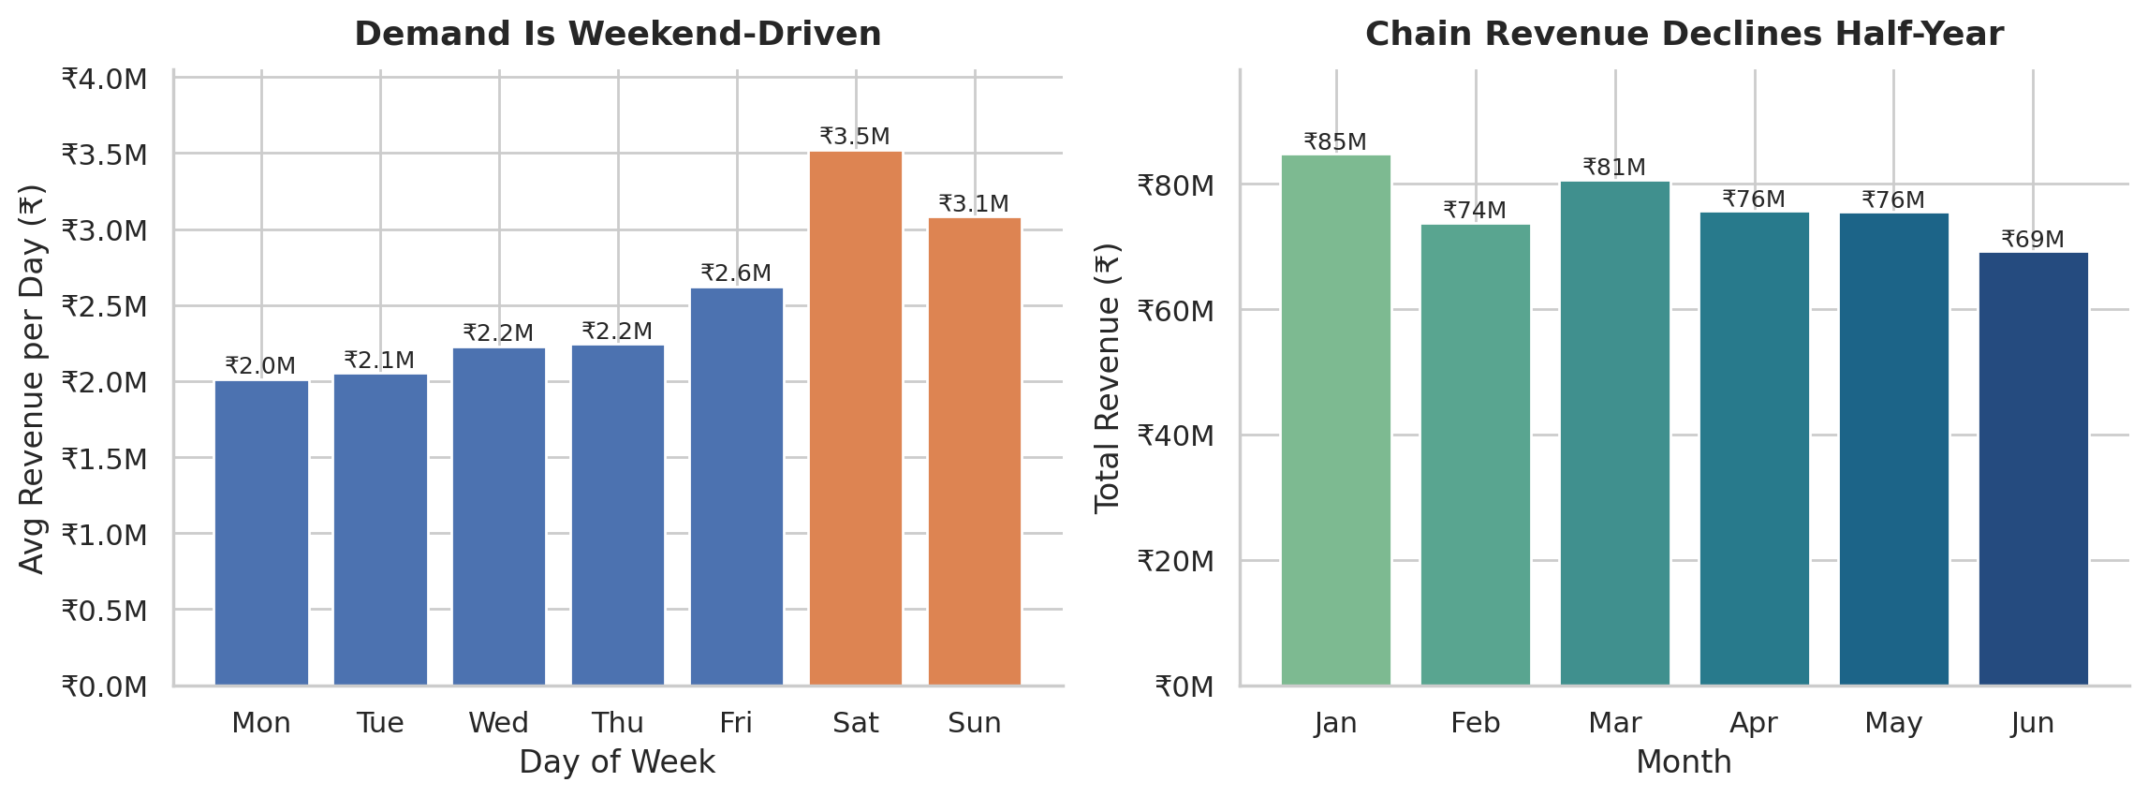
Figure 5 — Average daily revenue by day of week (left) and total revenue by month (right).
Finding 5 — No single product is dragging any category down
Within every category the best and worst product differ by only 6–15% in revenue — there is no dead SKU to cut. This is a negative result worth stating: the actionable signal in this dataset sits at category level, not product level.
Category | Top product | Bottom product | Gap
Electronics | Headphones — ₹47.7M | Smart TV — ₹41.9M | 13.9%
Home & Kitchen | Mixer Grinder — ₹16.9M | Water Bottle — ₹15.8M | 6.8%
Apparel | Saree — ₹14.2M | Kurta — ₹13.6M | 4.0%
Grocery | Rice (5kg) — ₹8.6M | Sugar (1kg) — ₹8.4M | 2.2%
Personal Care | Shampoo — ₹8.2M | Sunscreen — ₹7.6M | 7.7%
Table 3 — Top and bottom product per category by six-month revenue.

5. Recommendation to the Category Manager
Action | Rationale | Figure to cite
Back Apparel with incremental shelf space and promo funding | Only category with sustained momentum; overtook Home & Kitchen by June | +34% (₹10.0M → ₹13.5M)
Challenge the Electronics supplier on trend, not size | Largest category but accounts for the entire chain decline | −35% (₹45.7M → ₹29.7M); −₹16.0M/month
Pull mid-week discounting; concentrate promotions Thu–Sun | Discounts do not move units; demand already peaks at the weekend | 2.59 → 2.58 units; Sat ₹3.52M vs Mon ₹2.01M
Request category-level COGS before finalising | Revenue-only data cannot confirm whether growth is profitable | Not available in current dataset
Limitation
The dataset contains revenue only — no cost or margin data. A growing category could still be low-margin and a declining one highly profitable, so these recommendations rest on top-line performance alone. Category-level COGS, and ideally footfall counts to separate demand shifts from basket-size effects, would be needed to confirm the call on profit.
Section ownership
Naishadh Vytla — SSOT build and data-quality gateway (Step 1). Adiseshu — category trajectory and top/bottom product analysis (Steps 2–3). Sushmitha — discount effectiveness and weekly demand cyclicality (Steps 4–5). Nakul Sriraj — Category Manager Briefing and 90-day implementation roadmap (Steps 6–7), including executive reporting. Canvas completed jointly.

6. Individual Reflections
Naishadh Vytla
I owned Step 1 — loading the data, validating it, and building the single source of truth the rest of the notebook runs on. The part that taught me most was verifying that revenue equalled units × price × (1 − discount) for all 107,836 rows before trusting any chart; it turned the SSOT from an abstract idea into something concrete. Clean dates, null checks, duplicate checks and formula validation gave the team a reliable foundation for the downstream analysis.
Adiseshu
I owned Steps 2 and 3 — category revenue trends and the top/bottom products within each category. The analysis showed that Electronics declined sharply while Apparel gained momentum, and that the within-category gaps between the strongest and weakest products were relatively narrow. That meant the actionable signal was at category level rather than from cutting one isolated SKU. This work taught me to connect product-level comparisons with the broader category trajectory instead of forcing a product-level recommendation that the data did not support.
Sushmitha
I owned Steps 4 and 5 — discount effectiveness and weekly demand cyclicality. Comparing average revenue per transaction with average units sold at each discount level showed that revenue per transaction falls about 22% from 0% to 20% discount while units stay around 2.58. The day-of-week analysis also showed a strong weekend concentration, with Saturday revenue substantially above Monday. This helped connect the depth and timing of promotions to the observed demand pattern.
Nakul Sriraj
I owned Steps 6 and 7 — the Category Manager Briefing and the 90-day implementation roadmap — along with the executive reporting layer. My role was to translate the team's analytical findings into a clear management discussion: what should be challenged, where investment should be considered, how promotional activity should be timed, and what additional data is required before making profitability decisions. Building the roadmap taught me that analysis becomes useful when each finding is connected to an accountable action and time horizon. I also focused on keeping the executive narrative consistent so the key figures and recommendations could be traced back to the team's analysis.
7. Submission Checklist
Requirement | Status
Notebook runs end-to-end without errors (restart + run all) | Verified — 24 cells, 0 errors, 3 charts
All six steps present with code and markdown explanation | Complete
Each step's markdown credits the owning team member | Complete
CBIM canvas completed together, all six fields, before analysis | Complete
Every chart titled with business-language axis labels | Complete
Step 4 discount analysis takes a clear position backed by numbers | Complete
Step 6 briefing answers all four points with specific figures | Complete
Findings, recommendation, limitation and ownership documented | Complete
Individual 150-word reflections from each member | Draft provided — each member to personalise
Files named [Batch16]_MUC01_KLU_Notebook.ipynb / _Summary.docx | Replace 'Team' with your registered team name

