FraudGuard

Business Report
Real-time payment fraud decisions: approve, step-up OTP or block, set by rupee cost · KLU + Path-3 · ML-02 · 31 October 2026
Group 8 · Matrix Mechanics · N. Varshitha · M. Kumara Swamy · V. Naishadh · M. Suman Srinivas
Live app: https://calibofraudguard.netlify.app/ · Code: github.com/naishadhvytla/hackathon01calibo

1. Executive summary
A cost-tuned approve / step-up OTP / block rule cuts expected fraud cost by 78% on unseen data and touches only 0.33% of customers. On the held-out test period it blocks 60 payments, 54 of them fraud. It sends 125 to OTP, approves the remaining 56,561, and lowers expected cost from ₹3,70,000 (no model) to ₹82,675. The organiser's UPI file carries no learnable fraud signal, so the system is proven on the ULB credit-card benchmark, with UPI run through the same pipeline as a negative control.
- The trap: a model that approves everything is 99.87% accurate and catches no fraud. We judge every model by recall, precision, PR-AUC and rupee cost.
- The model: CatBoost with class weights, chosen from 22 supervised candidates by a rule fixed before testing. Test PR-AUC is 0.80 (95% CI 0.71–0.88), against 0.0013 for random ranking.
- Unknown fraud: COPOD, trained with no labels, ranks 59% of test fraud in its top 1% of scores. It is a ready-made watch-list for fraud patterns that have no labels yet.
- Three actions: (1) replace the 0.5 threshold with the cost-based three-band rule; (2) fix UPI data capture before modelling UPI; (3) target card testing and night-time bursts operationally.

2. The datasets
 | ULB Credit Card Fraud (primary) | UPI Transactions 2024 (control)
Source | Worldline and the Machine Learning Group, Université Libre de Bruxelles; published on Kaggle (mlg-ulb/creditcardfraud) | Supplied by the organisers; simulated UPI-style data
Scope | Card payments by European cardholders, September 2013, two days | 250,000 UPI payments, 1 Jan – 30 Dec 2024
Size and fraud | 284,807 rows, 31 columns; 492 frauds (0.172%) | 250,000 rows, 17 columns; 480 frauds (0.192%)
Columns | Time (seconds since first txn), V1–V28 (PCA components), Amount (currency not stated), Class | Transaction type, merchant category, amount (₹), sender/receiver age group, sender state, sender/receiver bank, device, network, status, hour, weekday, weekend, fraud flag
Confidentiality | Original features and cardholder identities withheld; only PCA components released | No names, account numbers, VPAs or phone numbers; banks and states only as categories

3. Data quality and cleaning
Check | Credit card: finding → treatment | UPI: finding → treatment
Missing values | None | None
Duplicates | 1,081 exact duplicates (19 fraud) → dropped, keep first | None
Impossible amounts | No negatives; 1,808 zero amounts (25 fraud) → kept, flagged as card-testing signal | None (₹10 to ₹42,099); log-transformed
Timestamps | Seconds since start → hour of day derived; raw Time dropped | All valid; hour and weekday consistent
Inconsistent categories | None (PCA features) | All 112,445 P2P rows carry a merchant category; amounts identical across types → flagged as simulated
Leakage columns | Only Class excluded | transaction_status (known only after the decision) and transaction id excluded
After cleaning, both files are split by time (first 60% train, next 20% validation, last 20% test) before any resampling or tuning.

4. The accuracy trap
Test period | Accuracy | Recall | Precision | Missed | Blocked genuine | Expected cost
Do-nothing (approve all) | 99.87% | 0% | — | 74 | 0 | ₹3,70,000
Final model, default 0.5 | 99.95% | 75.7% | 86.2% | 18 | 9 | ₹92,700
Final model, cost threshold | 99.93% | 78.4% | 72.5% | 16 | 22 | ₹86,600
Accuracy separates useless from useful by 0.08 points, and ranks the cheaper threshold lower. It is reported only to make this point.

5. Where fraud lives (credit card)
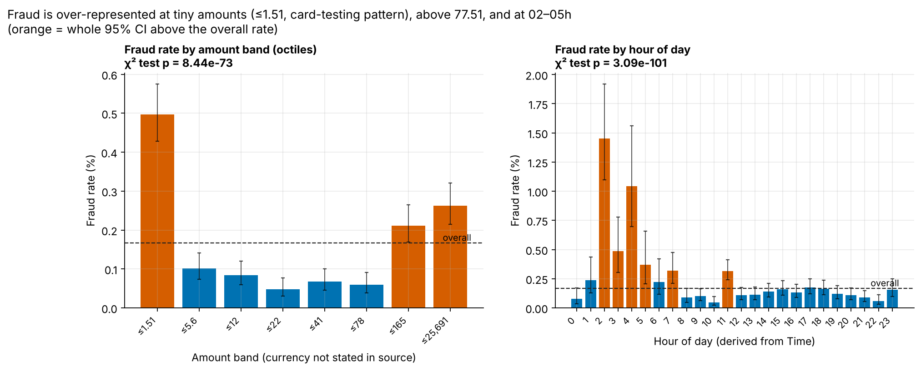
Figure 1. Fraud rate by amount octile and by hour, with Wilson 95% CIs (orange = whole interval above the overall rate).
- Tiny amounts: payments of 1.51 or less (currency not stated) have a 0.50% fraud rate, 3× the 0.17% average, and hold 177 of 473 frauds. Zero-amount authorisations run at 1.38% (8×). This fits card testing.
- Large amounts: above 77.51 the rate rises again (0.21% and 0.26%).
- Night window 01–05h: 5.7% of payments but 23.0% of fraud (rate 0.67% vs 0.14% otherwise).
- Bursts: 43 frauds arrived in a single hour (Figure 2), so fraud comes in campaigns.
- Behaviour signature: a few anonymised components separate fraud strongly (Kolmogorov–Smirnov: V14 0.84, V10 0.80, V12 0.78, V4 0.76).
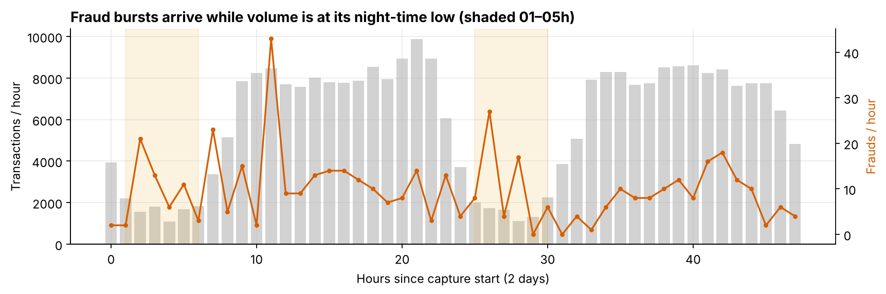
Figure 2. Payments and frauds per hour over the two days; shaded = 01–05h.
UPI: no transaction type, merchant, amount band, hour, device or age group differs from the overall rate once multiple testing is accounted for (Figure 3). These are associations, not causes.
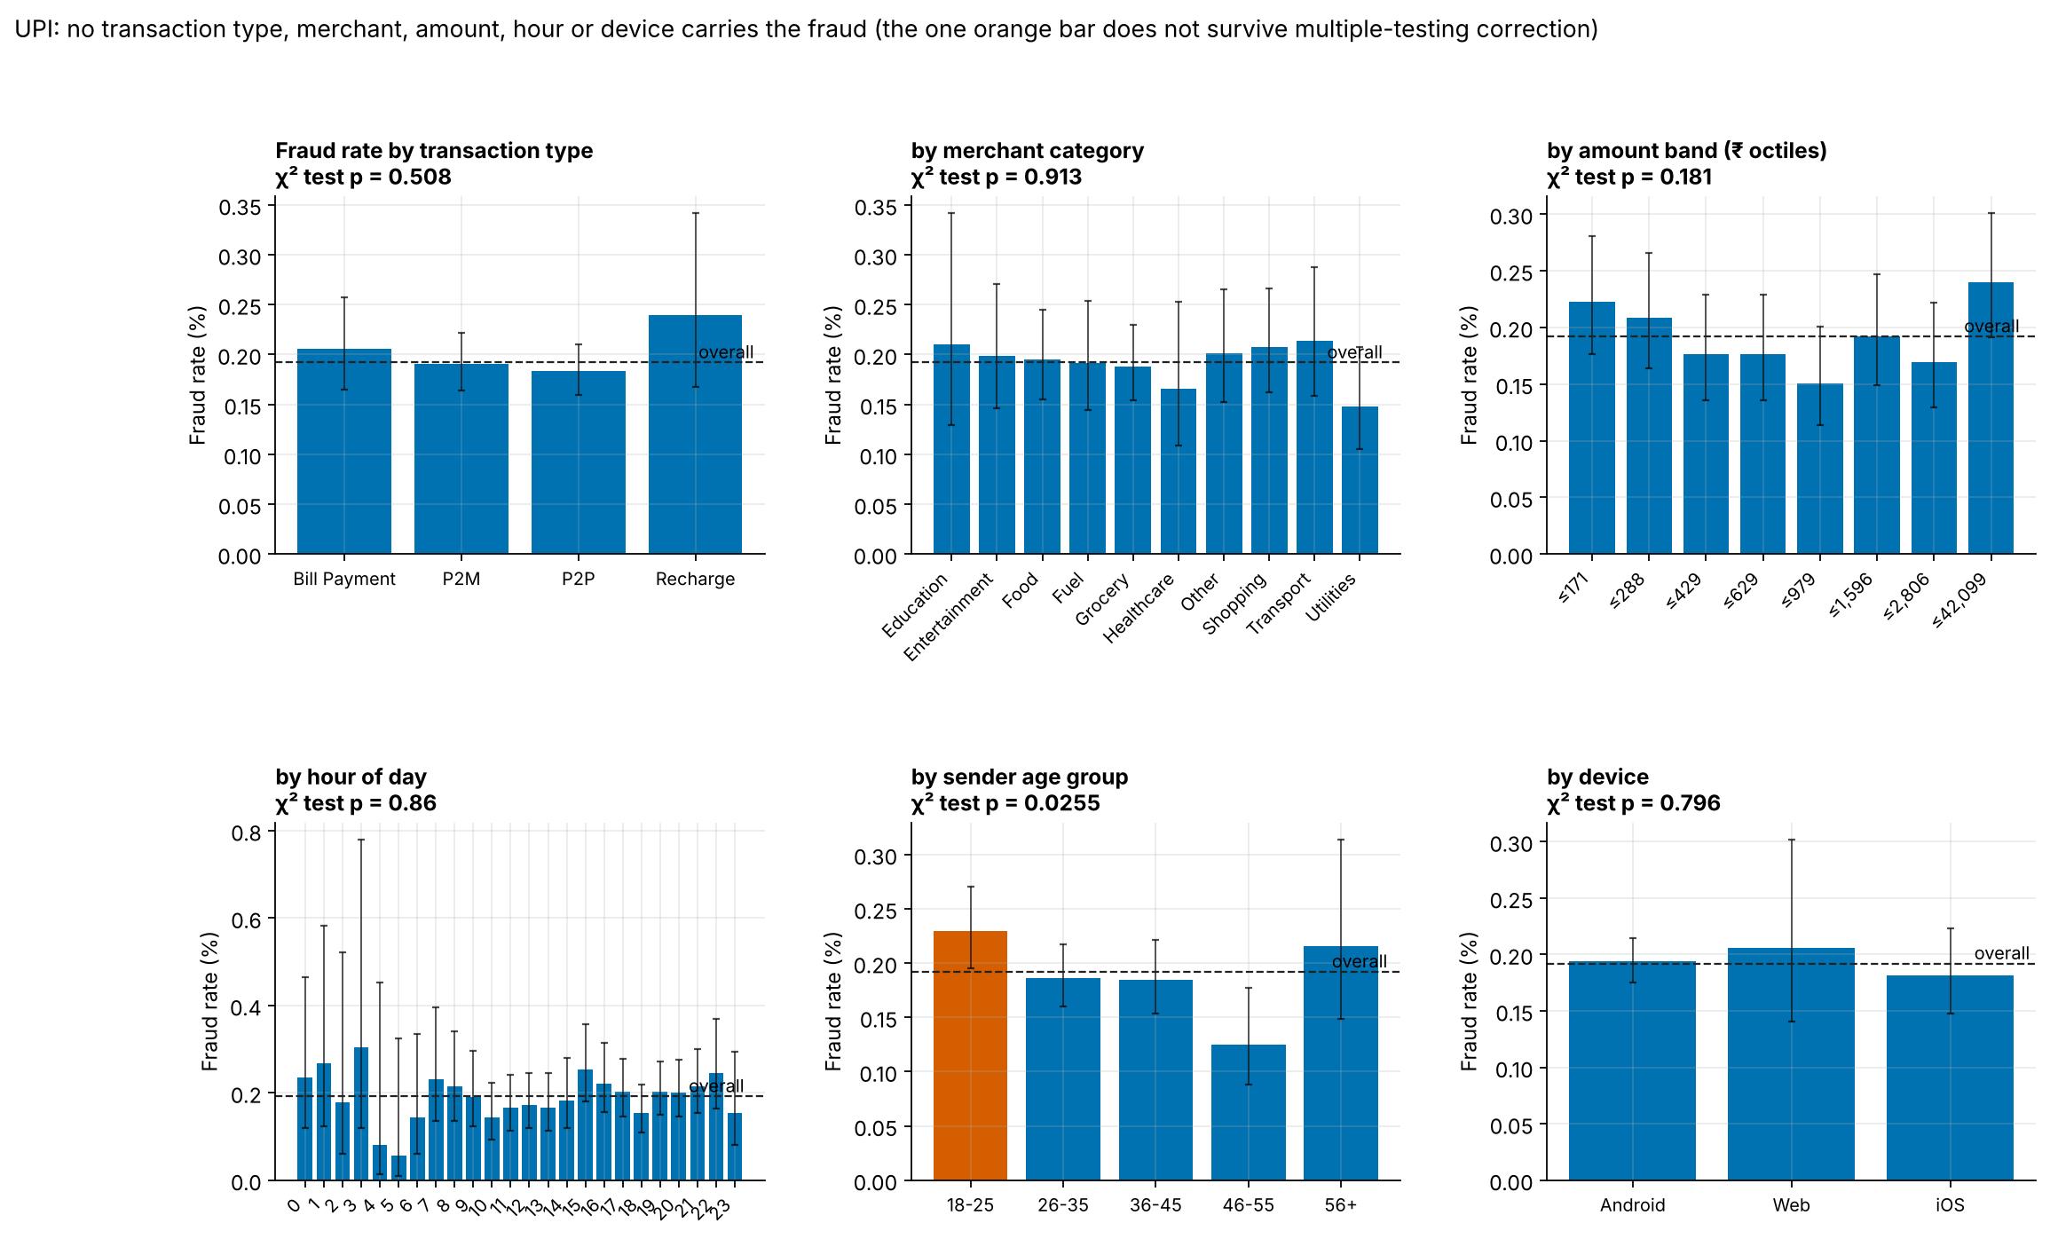
Figure 3. UPI fraud rate by type, merchant, amount, hour, sender age and device, with 95% CIs.

6. What we built
- Supervised: two rule baselines and 22 models (logistic regression, random forest, XGBoost, LightGBM × none / class weights / SMOTE inside the pipeline; CatBoost; Balanced RF; EasyEnsemble; Optuna-tuned LightGBM; focal-loss MLP; FT-Transformer; hybrid; soft-vote ensemble). Detail in the Model Comparison document.
- Label-free: Isolation Forest, ECOD, COPOD, LOF, autoencoder and DBSCAN, trained without labels and evaluated afterwards.
- Decision layer: isotonic calibration, then two thresholds from an exact search minimising expected rupee cost on validation, frozen and scored once on test. Detail in the Cost Analysis document.
- Explanation: exact TreeSHAP; in the web app it runs in the browser for every payment.
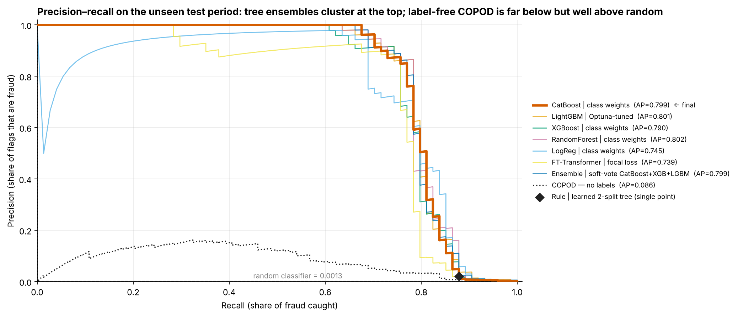
Figure 4. Precision–recall on the test period.

7. The decision rule and its cost
Band | Rule (model score) | Payments | Fraud | Genuine customers | Expected cost
APPROVE | < 9.49e-3 | 56,561 | 14 missed | pass | ₹70,000
STEP-UP OTP | 9.49e-3 – 0.771 | 125 | 6 challenged | 119 challenged | ₹10,875
BLOCK | ≥ 0.771 | 60 | 54 stopped | 6 blocked | ₹1,800
Total ₹82,675 against ₹92,700 at the default 0.5 threshold and ₹3,70,000 with no model (observed counts × assumed costs). Scenario estimate: about ₹50.63 L saved per million payments.
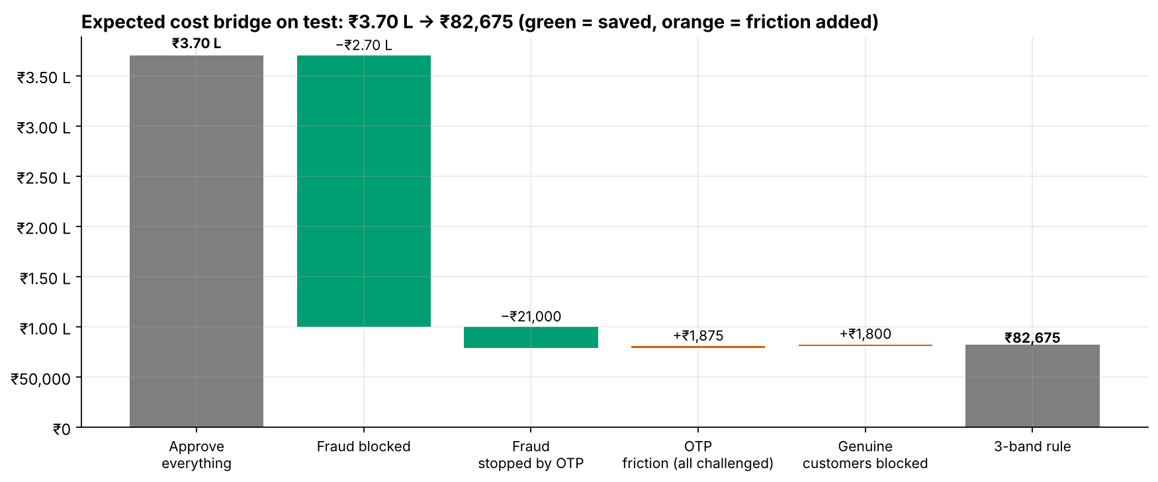
Figure 5. From approve-everything to the three-band rule on test.

8. Why the model flags a payment
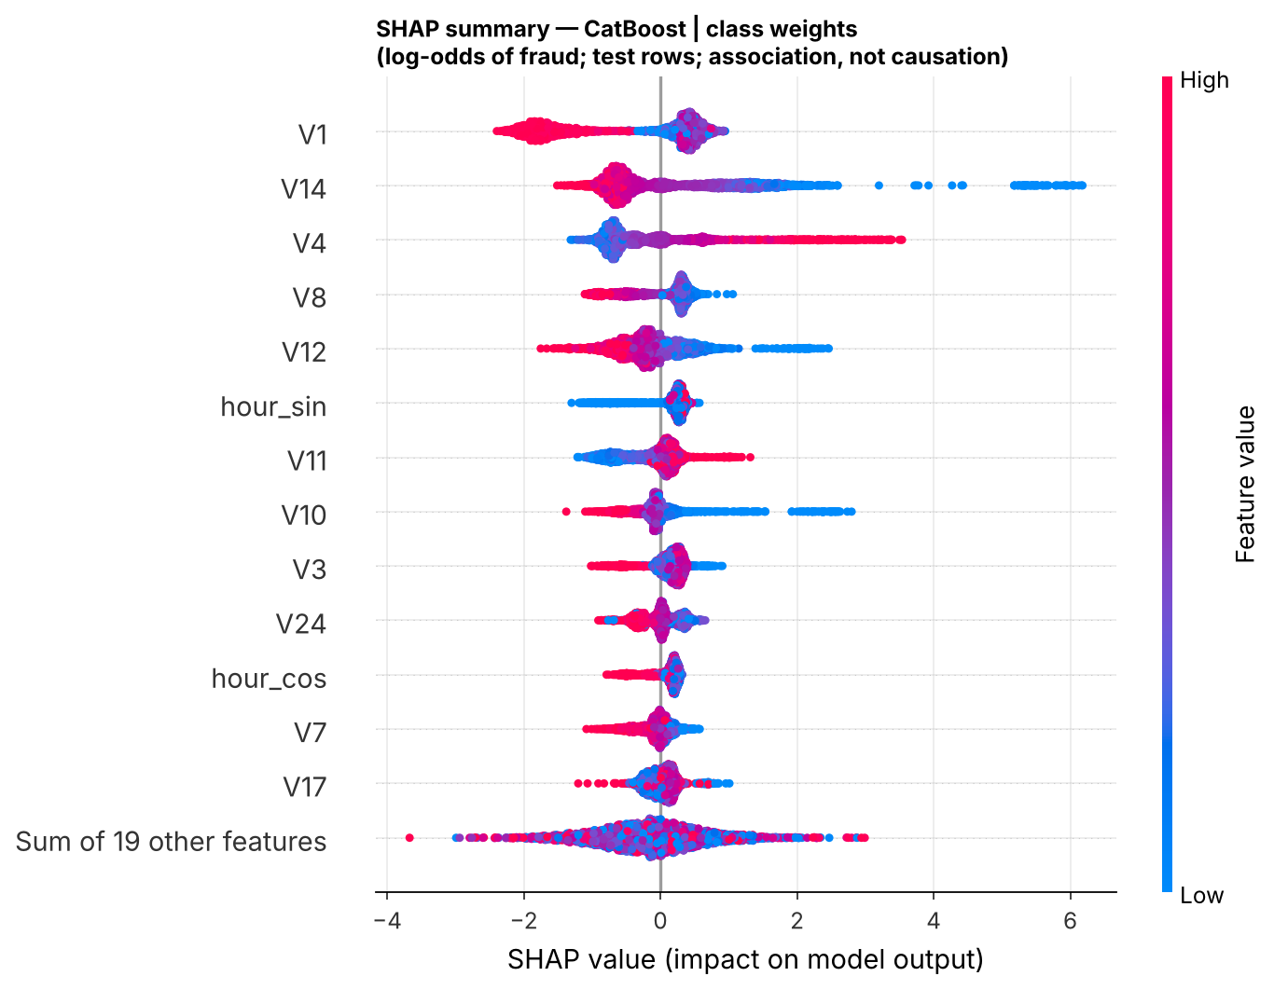
Figure 6. SHAP summary for the final model (log-odds of fraud). Low V14 and high V4 push towards fraud; hour of day ranks 6th.
The model relies on the same components the exploration found (V14, V4, V12, V10, hour of day), so it has learned real behaviour, not an artefact. SHAP shows how the model uses inputs, not what causes fraud.

9. Three findings → three actions
Priority | Finding (observed) | Evidence | Action | Projected impact
1 · this quarter | A cost-tuned three-band rule beats the 0.5 threshold | ₹82,675 vs ₹92,700 on test; blocks are 90% fraud; 81.1% of fraud stopped or challenged | Shadow-run CatBoost for 2–4 weeks, then go live with the two thresholds; re-fit them monthly from the cost curve | ≈ ₹50.63 L per million payments (scenario)
2 · before any UPI model | The UPI data cannot support a fraud model | 22 models at chance (ROC-AUC 0.47–0.54); permutation p = 0.78; no account or device IDs; post-outcome status field | Log sender, receiver and device IDs and dated confirmed-fraud labels; keep post-outcome fields out; run COPOD as a watch-list; hold out a small random slice from blocking | Not estimable until labels carry signal; avoids ₹4,680+ of pure friction per 50,000 payments
3 · next sprint | Fraud clusters in card testing, nights and bursts | ≤ 1.51 amounts: 3× rate, 37% of fraud; zero amounts 8×; 01–05h: 23% of fraud in 5.7% of traffic; 43 frauds in one hour | Velocity limit on micro and zero-amount authorisations per card/device; burst alerts at 3× trailing volume of OTP+block; night staffing; A/B-test first | Faster response to new campaigns; not separately quantified (associations)

10. Special points
- Confidentiality: the card data's real features are hidden behind PCA by the data owner, so reasons are given as V-components. The UPI file holds no personal identifiers. The web app scores in the browser; saved records sit in each user's own Supabase rows, protected by row-level security.
- Compliance for a real rollout: customer consent, purpose limitation and retention under India's Digital Personal Data Protection Act 2023; RBI fraud-reporting and customer-liability rules for blocked or disputed payments; an appeal path for blocked customers.
- Currency: the credit-card source never states the currency of Amount, so amounts are shown in source units and rupee costs are applied per event.
- Official costs: none were published. All rupee figures use stated assumptions and can be recomputed instantly in the notebook or the app's Policy page.
- Feedback loop: blocked fraud is never confirmed, which biases future labels. A small random holdout of unblocked traffic keeps them honest.

11. Limitations
- About two days of 2013 European card data; 57 validation and 74 test frauds, so costs carry wide CIs (reported throughout).
- Anonymised features prevent business-readable reason codes and transaction-type analysis on card data.
- Costs and the 70% OTP stop rate are assumptions; savings are scenario estimates.
- UPI patterns cannot be studied with this file; card patterns may not transfer to UPI.

12. Deliverables
- Notebook (both datasets, seed 42, reproducible from scratch), source library, README, architecture decision records.
- Web app (Netlify + Supabase): Credit Card and UPI modes, live scoring with SHAP, batch CSV scoring, policy lab, evidence pages, sign-in with saved scorings and audit log.
- Model Comparison and Cost Analysis & Risk-Score Rule documents; presentation deck.
- Live app: https://calibofraudguard.netlify.app/ (create an account, confirm the email, sign in; Credit Card and UPI modes).

13. Team and ownership
Member | Problem statements | Sections of this report
N. Varshitha | PS1 Data quality & reliability · PS2 Fraud lens & accuracy trap | §2 Datasets · §3 Cleaning · §4 Accuracy trap
M. Kumara Swamy | PS3 Fraud patterns (EDA) · PS4 Supervised learning | §5 Where fraud lives · §6 What we built
V. Naishadh | PS5 Anomaly detection · PS6 Cost-based threshold | §6 Label-free detectors · §7 Threshold and cost
M. Suman Srinivas | PS7 Risk-score rule · PS8 Selection, explanation & actions | §7 Decision rule · §8 Explanation · §9 Actions
Group 8 · Matrix Mechanics. Each member owns two problem statements end to end in the notebook, the documents and the presentation.

