FraudGuard

Cost Analysis & Risk-Score Rule
From model score to approve / step-up OTP / block, using expected rupee cost · thresholds chosen on validation, frozen, scored once on test · ULB credit card (primary), UPI 2024 (control)
Group 8 · Matrix Mechanics · N. Varshitha · M. Kumara Swamy · V. Naishadh · M. Suman Srinivas
Live app: https://calibofraudguard.netlify.app/ · Code: github.com/naishadhvytla/hackathon01calibo

1. Result
On the unseen test period (56,746 payments, 74 frauds, about 7.7 hours of traffic), the three-band rule stops or challenges 60 of 74 frauds (81.1%). It blocks only 6 genuine customers and challenges 119 with an OTP. Expected cost falls from ₹3,70,000 with no model to ₹82,675 (95% CI ₹51,837–₹1.15 L), a 78% reduction. The default 0.5 threshold costs ₹92,700.
Owners: cost-based threshold (PS6) V. Naishadh · approve / step-up OTP / block rule (PS7) M. Suman Srinivas. The same rule runs live in the web app's Policy page: https://calibofraudguard.netlify.app/

2. The cost model
Expected cost = missed fraud × ₹X + genuine blocked × ₹Y + every OTP challenge × ₹Z + fraud that passes OTP × ₹X.
Assumption | Value | Basis
Missed fraud (₹X) | ₹5,000 | Average loss + chargeback handling + investigation; the organisers published no official figure
Genuine payment blocked (₹Y) | ₹300 | Lost transaction margin, a support call, churn risk
Step-up OTP (₹Z) | ₹15 per challenge | Mostly genuine drop-off: about 5% of challenged customers abandon × ₹300 ≈ ₹15. The SMS itself costs well under ₹1
Fraud stopped by OTP | 70% | Stolen-credential and account-takeover fraud fails OTP; socially engineered victims type the OTP themselves
Cost basis | per event | The credit-card Amount column has no stated currency (the source says only "European cardholders"), so it is never converted to rupees
Official costs. The brief refers to organiser-published ₹ figures, but none were provided. Every number here comes from one config cell in the notebook (CostConfig) and the Policy page of the web app. Entering official values there re-optimises both thresholds on validation and re-scores test, with no retraining. Sections 4 and 7 show how far the answer moves when the costs change.

3. Cost-based threshold (two outcomes: approve or block)
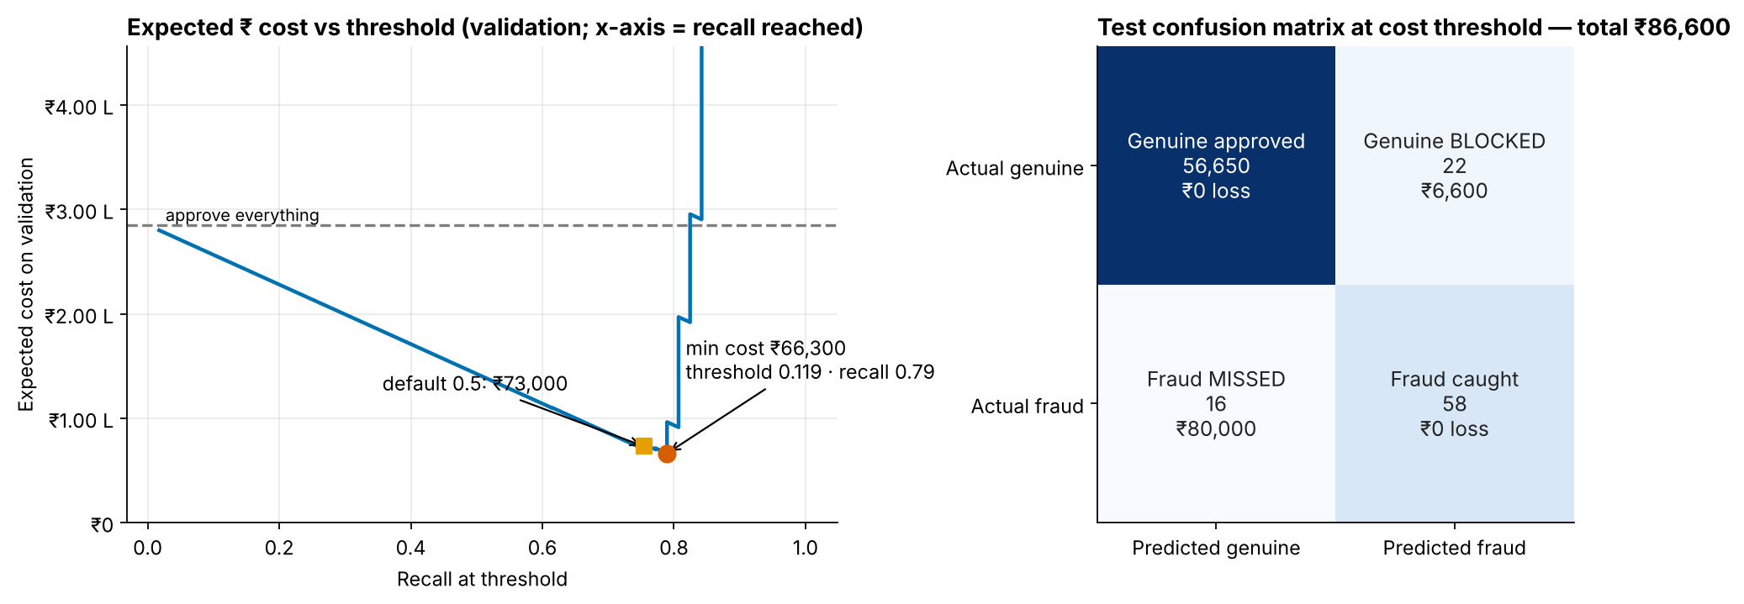
Figure 1. Left: expected cost on validation at every threshold (x = recall reached), with the minimum and the 0.5 default marked. Right: test confusion matrix at the chosen threshold, in rupees.
Policy (test period) | Accuracy | Recall | Precision | Fraud missed | Genuine blocked | Expected cost
Do-nothing (approve all) | 99.87% | 0% | — | 74 | 0 | ₹3,70,000
CatBoost | class weights @ default 0.5 | 99.95% | 75.7% | 86.2% | 18 | 9 | ₹92,700
CatBoost | class weights @ cost threshold 0.119 | 99.93% | 78.4% | 72.5% | 16 | 22 | ₹86,600
Bootstrap 95% CIs on test: recall 67.6%–86.5%, cost ₹54,500–₹1,27,245. The cost-optimal threshold is less accurate than 0.5 but ₹6,100 cheaper. Accuracy cannot rank the two.

4. How the threshold moves with ₹X and ₹Y
₹Y \ ₹X | ₹1,000 | ₹2,500 | ₹5,000 | ₹10,000 | ₹25,000
₹50 | 0.118 · 78% | 0.118 · 78% | 0.118 · 78% | 9.5e-3 · 81% | 1.5e-3 · 87%
₹150 | 0.771 · 73% | 0.118 · 78% | 0.118 · 78% | 0.118 · 78% | 9.5e-3 · 81%
₹300 | 0.771 · 73% | 0.771 · 73% | 0.118 · 78% | 0.118 · 78% | 0.118 · 78%
₹600 | 0.771 · 73% | 0.771 · 73% | 0.771 · 73% | 0.118 · 78% | 0.118 · 78%
₹1200 | 0.771 · 73% | 0.771 · 73% | 0.771 · 73% | 0.771 · 73% | 0.118 · 78%
Each cell: cost-optimal threshold chosen on validation · test recall at that threshold. Base case: row ₹300, column ₹5,000.
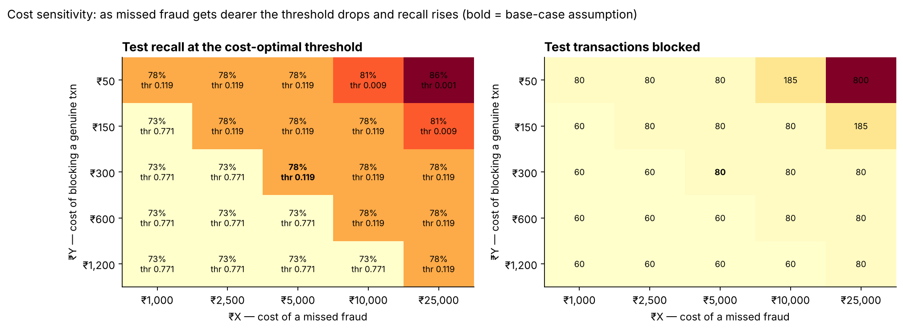
Figure 2. Threshold sensitivity. Across 25 scenarios only four distinct thresholds appear, so the decision is stable across the plausible range.

5. The risk-score rule (three outcomes)
Both thresholds are found by an exact search over every distinct validation score in the top 5%, minimising the full three-outcome cost. The same rule runs in the web app. Result: approve below 9.49e-3; step-up OTP from 9.49e-3 to 0.771; block at 0.771 and above. On the calibrated 0–100 risk score (isotonic regression fitted on validation) that is OTP from 1.0 and block from 88.9. As a theory cross-check, Bayes-optimal cut-offs on a calibrated probability are OTP above 0.43% and block above 15.8%: the same order of decisions.
Band (test) | Payments | Share | Frauds | Share of fraud | Genuine customers | Fraud rate in band | ₹ from fraud | ₹ from genuine | Total ₹
APPROVE | 56,561 | 99.67% | 14 | 18.9% | 0 (56,547 pass) | 0.02% | ₹70,000 | ₹0 | ₹70,000
STEP-UP OTP | 125 | 0.22% | 6 | 8.1% | 119 challenged | 4.80% | ₹9,090 | ₹1,785 | ₹10,875
BLOCK | 60 | 0.11% | 54 | 73.0% | 6 blocked | 90.00% | ₹0 | ₹1,800 | ₹1,800
Test period, thresholds frozen from validation. OTP band: each challenge ₹15; fraud passing OTP (30%) costs ₹5,000.
Band (validation) | Payments | Share | Frauds | Share of fraud | Genuine customers | Fraud rate in band | ₹ from fraud | ₹ from genuine | Total ₹
APPROVE | 56,578 | 99.71% | 11 | 19.3% | 0 (56,567 pass) | 0.02% | ₹55,000 | ₹0 | ₹55,000
STEP-UP OTP | 123 | 0.22% | 3 | 5.3% | 120 challenged | 2.44% | ₹4,545 | ₹1,800 | ₹6,345
BLOCK | 44 | 0.08% | 43 | 75.4% | 1 blocked | 97.73% | ₹0 | ₹300 | ₹300
Validation period, where the thresholds were chosen. Test behaves the same way, which is evidence that the rule generalises.
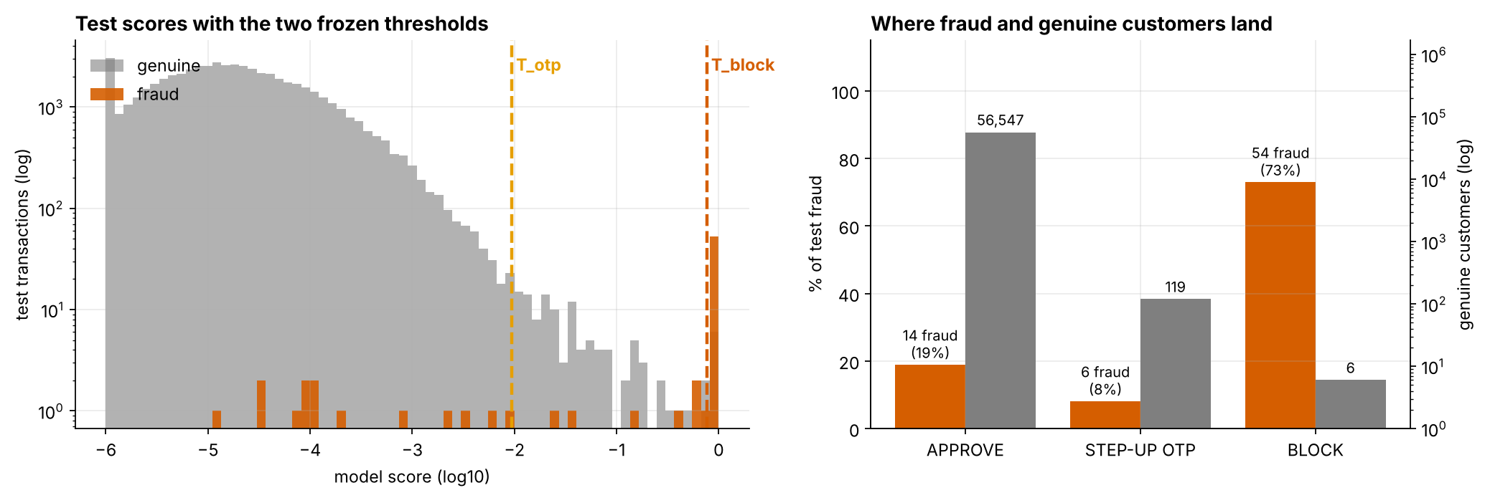
Figure 3. Test scores with the two thresholds (left) and where fraud and genuine customers land (right).

6. Where the money goes
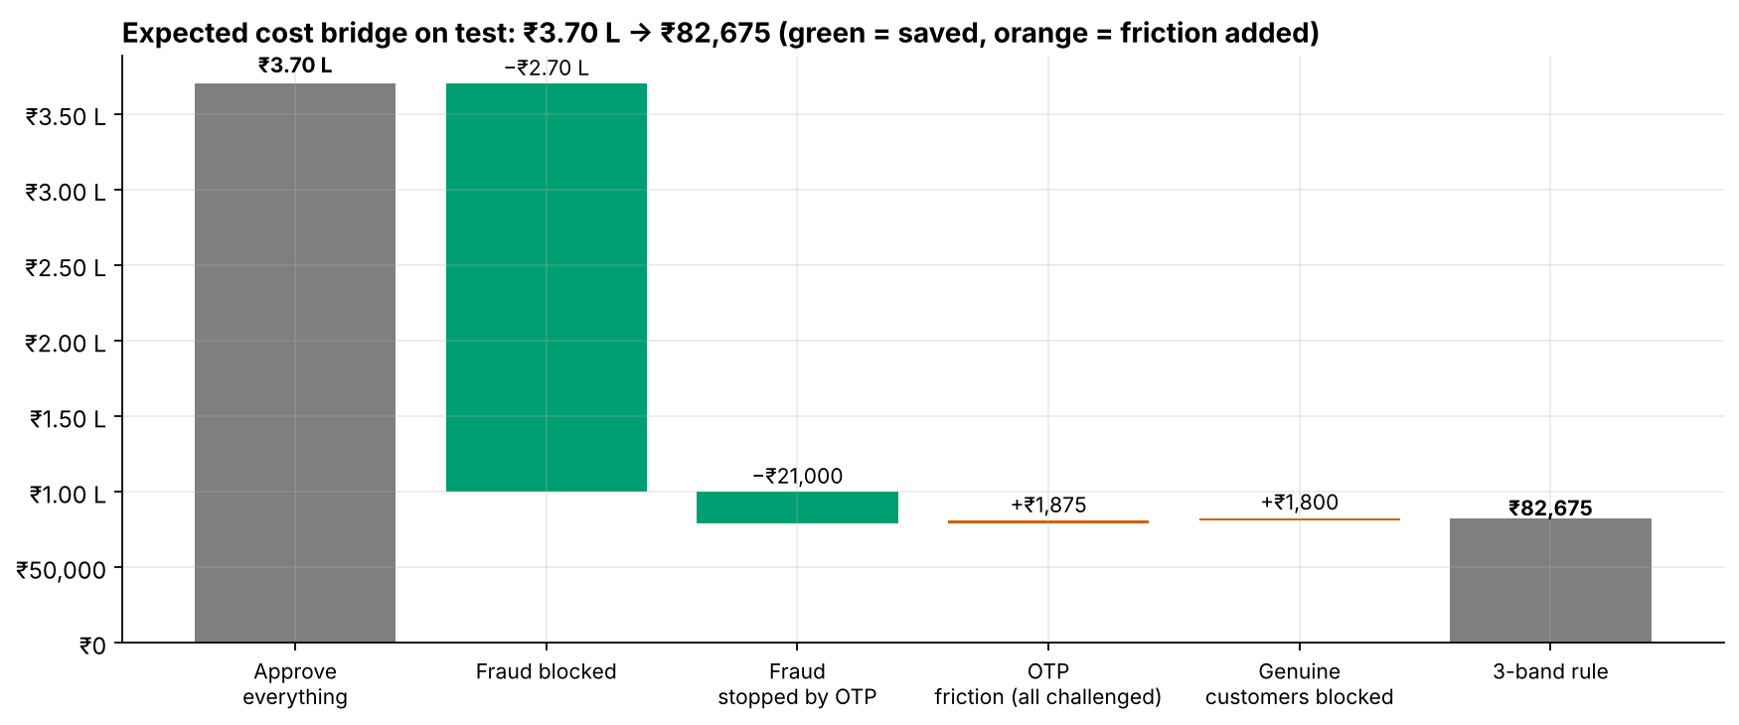
Figure 4. Cost bridge on test. Blocking removes most of the expected loss; OTP removes more; the friction it adds (OTP challenges, 6 blocked customers) is small.
Band | Fraud amount in band | Share of fraud amount | Genuine amount in band
APPROVE | 2,385 | 30.9% | 44,06,959
STEP-UP OTP | 1,250 | 16.2% | 21,733
BLOCK | 4,092 | 53.0% | 25,696
Transaction value by band, in the dataset's own (unstated) currency units, not rupees. Blocked and OTP payments hold 69% of fraudulent value but only 1.1% of genuine value.

7. Stress-testing the OTP assumptions
OTP stops \ ₹Z | ₹5 | ₹10 | ₹15 | ₹30 | ₹50
50% | ₹80,500 · OTP 740 | ₹88,050 · OTP 125 | ₹88,675 · OTP 125 | ₹92,400 · OTP 20 | ₹86,600 · OTP 0
60% | ₹75,500 · OTP 740 | ₹85,050 · OTP 125 | ₹85,675 · OTP 125 | ₹90,400 · OTP 20 | ₹90,800 · OTP 20
70% | ₹70,500 · OTP 740 | ₹74,200 · OTP 740 | ₹82,675 · OTP 125 | ₹84,550 · OTP 125 | ₹88,800 · OTP 20
80% | ₹65,500 · OTP 740 | ₹69,200 · OTP 740 | ₹79,675 · OTP 125 | ₹81,550 · OTP 125 | ₹86,800 · OTP 20
90% | ₹73,115 · OTP 4163 | ₹64,200 · OTP 740 | ₹76,675 · OTP 125 | ₹78,550 · OTP 125 | ₹84,800 · OTP 20
Each cell: test cost of the three-band rule re-optimised on validation · payments sent to OTP. The block band is 60 payments in every cell. The base case (₹15, 70%) is the middle cell.
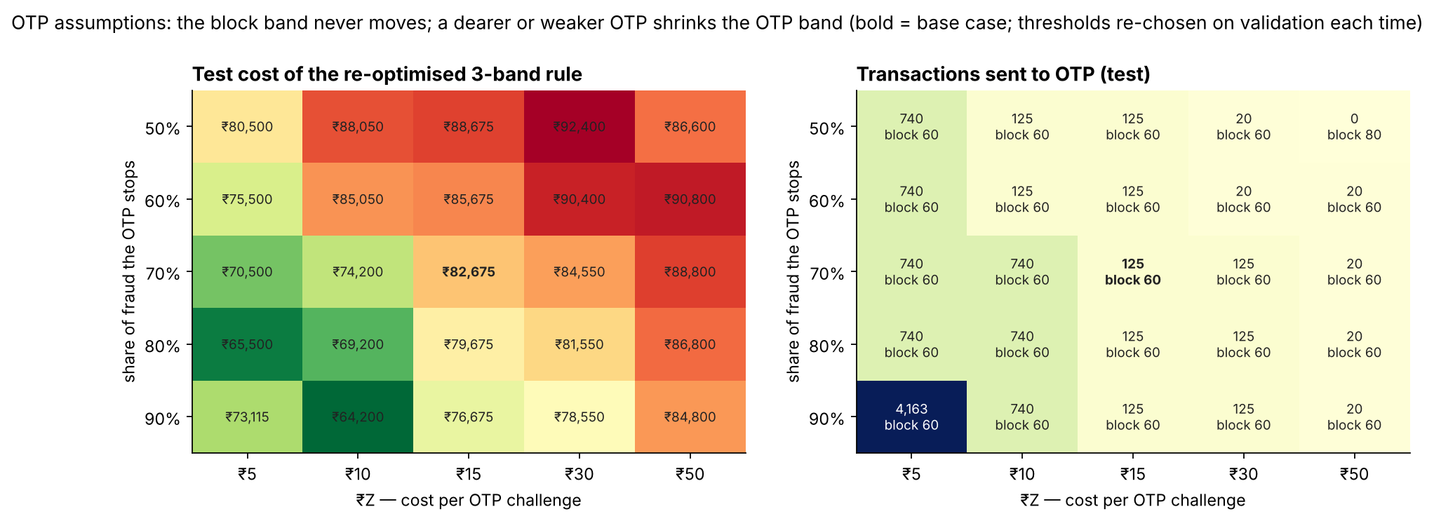
Figure 5. A cheaper or stronger OTP widens the OTP band and lowers cost. A dearer or weaker OTP shrinks it, and at ₹50 with 50% the rule falls back to approve/block. Non-monotone cells reflect validation noise (57 frauds).

8. Observed results vs projected savings
Policy | Observed test cost | Saving vs no model (observed) | Cost per 1M payments (scenario estimate)
Approve everything (no model) | ₹3,70,000 | — | ₹65.20 L
Model @ default 0.5 | ₹92,700 | ₹2,77,300 | ₹16.34 L
Model @ cost threshold | ₹86,600 | ₹2,83,400 | ₹15.26 L
Three-band rule | ₹82,675 | ₹2,87,325 | ₹14.57 L (CI ₹9.13 L–₹20.26 L)
Projected (scenario estimate, not observed): if future traffic looks like the test period and the assumed costs hold, the three-band rule would save about ₹50.63 L per million payments compared with approving everything. The observed columns use held-out counts × assumed costs; the projection additionally assumes the test fraud rate (0.13%) persists.

9. UPI 2024 (negative control)
The same exact search on the UPI validation scores produces thresholds, but on test the resulting three-band rule costs ₹4,84,680 against ₹4,80,000 for approving everything. It challenges 212 genuine customers and blocks 5, and catches no fraud. At the default 0.5 threshold, the validation "winner" would cost ₹76.74 L, because it blocks about 24,700 genuine customers. For UPI the cost-optimal policy is to approve everything until the data carries signal. The web app enforces this in UPI mode.

10. How to use official costs on the day
- Notebook: edit COST = L.CostConfig(X=…, Y=…, Z=…, otp_stop_rate=…) in the setup cell and run all. Cached models are reused, so this takes about 3 minutes.
- Web app: open Policy, enter the four values, and press Re-optimise thresholds. The new thresholds apply to Score and Batch immediately, and the test-period table updates.

