FraudGuard

Model Comparison
All supervised models, imbalance methods, label-free detectors, metrics and the final selection with reasoning · ULB credit card (primary) and UPI 2024 (negative control) · seed 42
Group 8 · Matrix Mechanics · N. Varshitha · M. Kumara Swamy · V. Naishadh · M. Suman Srinivas
Live app: https://calibofraudguard.netlify.app/ · Code: github.com/naishadhvytla/hackathon01calibo

1. The decision in one paragraph
Selected model: CatBoost | class weights. It has the best validation PR-AUC (0.784) and the lowest validation cost (₹66,300) among the shortlisted models. On the untouched test period it reaches PR-AUC 0.799 (95% CI 0.71–0.88), against 0.0013 for a random ranking, and a label-permutation test gives p < 0.002. It scores a transaction in about 0.5 µs and has an exact TreeSHAP explanation.
We compared 22 supervised candidates and 6 label-free detectors. The selection rule was written before test was opened. The top six models overlap within their confidence intervals on test, so the choice rests on cost and operability, not on a clear accuracy gap.
Owners: supervised comparison and imbalance methods (PS4) M. Kumara Swamy · label-free detectors (PS5) V. Naishadh · final selection and explanation (PS8) M. Suman Srinivas.

2. Protocol (how every model was treated)
Split | Rows | Frauds | Fraud rate | Used for
train | 1,70,235 | 342 | 0.201% | fitting every model; Optuna time-series folds; deep-model early stopping (last 15%)
validation | 56,745 | 57 | 0.100% | model selection, calibration, both thresholds
test | 56,746 | 74 | 0.130% | scored once, at the end
Time-ordered split of the de-duplicated credit-card data (283,726 rows). The fraud rate drifts (0.20% → 0.10% → 0.13%), which a random split would hide.
- Imbalance handling stays inside the training pipeline. SMOTE runs inside an imblearn.Pipeline, so synthetic frauds come only from the training fold. Nothing is resampled before the split.
- Metrics: PR-AUC (primary, threshold-free), ROC-AUC (with a caution), and precision, recall, F1 and ₹ cost, each at the model's own validation cost-optimal threshold. Test PR-AUC has a 200-sample stratified bootstrap 95% CI.
- Baselines a fraud team could run without ML: a business rule (night and amount above the 95th percentile) and a learned two-split decision tree (V14 ≤ −1.63, then V10).

3. Full comparison table (credit card)
◆ = selected. Validation columns drove the choice; test columns are reported for transparency. Latency is measured on batch scoring, per transaction, on a 2-core CPU.

Model | Imbalance handling | Val PR-AUC | Test PR-AUC (95% CI) | Test ROC-AUC | Precision* | Recall* | F1* | Val ₹ cost* | Test ₹ cost* | µs / txn
CatBoost | class weights ◆ | class weights (√balanced) | 0.784 | 0.799 (0.71–0.88) | 0.968 | 72.5% | 78.4% | 0.753 | ₹66,300 | ₹86,600 | 0.5
XGBoost | class weights | class weights | 0.783 | 0.790 (0.69–0.87) | 0.976 | 91.7% | 74.3% | 0.821 | ₹70,900 | ₹96,500 | 2.5
Ensemble | soft-vote CatBoost+XGB+LGBM | inherits | 0.781 | 0.799 (0.71–0.88) | 0.983 | 65.2% | 78.4% | 0.712 | ₹69,000 | ₹89,300 | 11.4
LightGBM | Optuna-tuned | tuned scale_pos_weight | 0.777 | 0.801 (0.71–0.88) | 0.984 | 71.6% | 78.4% | 0.748 | ₹67,500 | ₹86,900 | 8.3
XGBoost | none | none | 0.775 | 0.791 (0.70–0.87) | 0.979 | 58.4% | 79.7% | 0.674 | ₹70,200 | ₹87,600 | 2.7
Hybrid | tuned LightGBM + anomaly scores | tuned scale_pos_weight | 0.775 | 0.789 (0.70–0.87) | 0.983 | 70.4% | 77.0% | 0.735 | ₹67,500 | ₹92,200 | 28.1
LightGBM | SMOTE | SMOTE (in-fold) | 0.773 | 0.778 (0.68–0.87) | 0.978 | 53.2% | 78.4% | 0.634 | ₹68,700 | ₹95,300 | 15.0
LightGBM | class weights | class weights (√ratio) | 0.771 | 0.794 (0.70–0.88) | 0.988 | 58.4% | 79.7% | 0.674 | ₹72,600 | ₹87,600 | 15.9
LightGBM | none | none | 0.770 | 0.799 (0.70–0.88) | 0.983 | 88.5% | 73.0% | 0.800 | ₹73,000 | ₹1.02 L | 14.1
RandomForest | none | none | 0.769 | 0.787 (0.70–0.87) | 0.944 | 74.0% | 77.0% | 0.755 | ₹66,900 | ₹91,000 | 5.6
BalancedRF | undersample-bagging | per-tree undersampling | 0.766 | 0.802 (0.71–0.88) | 0.989 | 68.2% | 78.4% | 0.730 | ₹67,800 | ₹88,100 | 5.9
RandomForest | class weights | class weights | 0.766 | 0.802 (0.72–0.88) | 0.940 | 64.4% | 78.4% | 0.707 | ₹67,800 | ₹89,600 | 4.0
RandomForest | SMOTE | SMOTE (in-fold) | 0.764 | 0.813 (0.72–0.88) | 0.970 | 85.9% | 74.3% | 0.797 | ₹70,900 | ₹97,700 | 7.2
XGBoost | SMOTE | SMOTE (in-fold) | 0.763 | 0.779 (0.68–0.87) | 0.976 | 73.1% | 77.0% | 0.750 | ₹69,800 | ₹91,300 | 2.8
LogReg | class weights | class weights | 0.753 | 0.745 (0.66–0.86) | 0.981 | 72.6% | 71.6% | 0.721 | ₹74,900 | ₹1.11 L | 0.2
Deep MLP | focal loss | focal loss | 0.742 | 0.806 (0.72–0.88) | 0.981 | 66.3% | 79.7% | 0.724 | ₹79,900 | ₹84,000 | 0.5
FT-Transformer | focal loss | focal loss | 0.707 | 0.739 (0.64–0.83) | 0.939 | 74.7% | 75.7% | 0.752 | ₹71,900 | ₹95,700 | 57.5
LogReg | SMOTE | SMOTE (in-fold) | 0.705 | 0.741 (0.64–0.83) | 0.978 | 58.9% | 75.7% | 0.663 | ₹69,600 | ₹1.02 L | 0.3
EasyEnsemble | undersample-boosting | per-member undersampling | 0.654 | 0.599 (0.49–0.73) | 0.984 | 49.5% | 73.0% | 0.590 | ₹95,100 | ₹1.17 L | 16.4
LogReg | none | none | 0.608 | 0.694 (0.59–0.79) | 0.975 | 58.1% | 73.0% | 0.647 | ₹83,100 | ₹1.12 L | 0.3
Rule | learned 2-split tree | n/a | 0.150 | 0.176 (0.13–0.22) | 0.959 | 24.4% | 70.3% | 0.362 | ₹1.25 L | ₹1.58 L | —
Rule | night & amount>p95 | n/a | 0.001 | 0.001 (0.00–0.00) | 0.500 | 0.0% | 0.0% | 0.000 | ₹2.85 L | ₹3.70 L | —
* at each model's own cost-optimal threshold chosen on validation (missed fraud ₹5,000, false block ₹300). Sorted by validation PR-AUC.
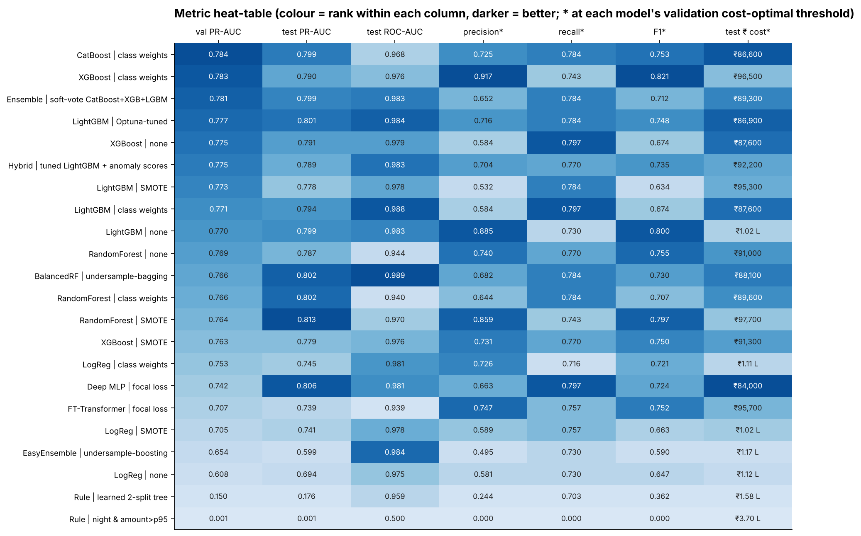
Figure 1. Metric heat-table for all 22 models (colour = rank within each column).

4. Combined views
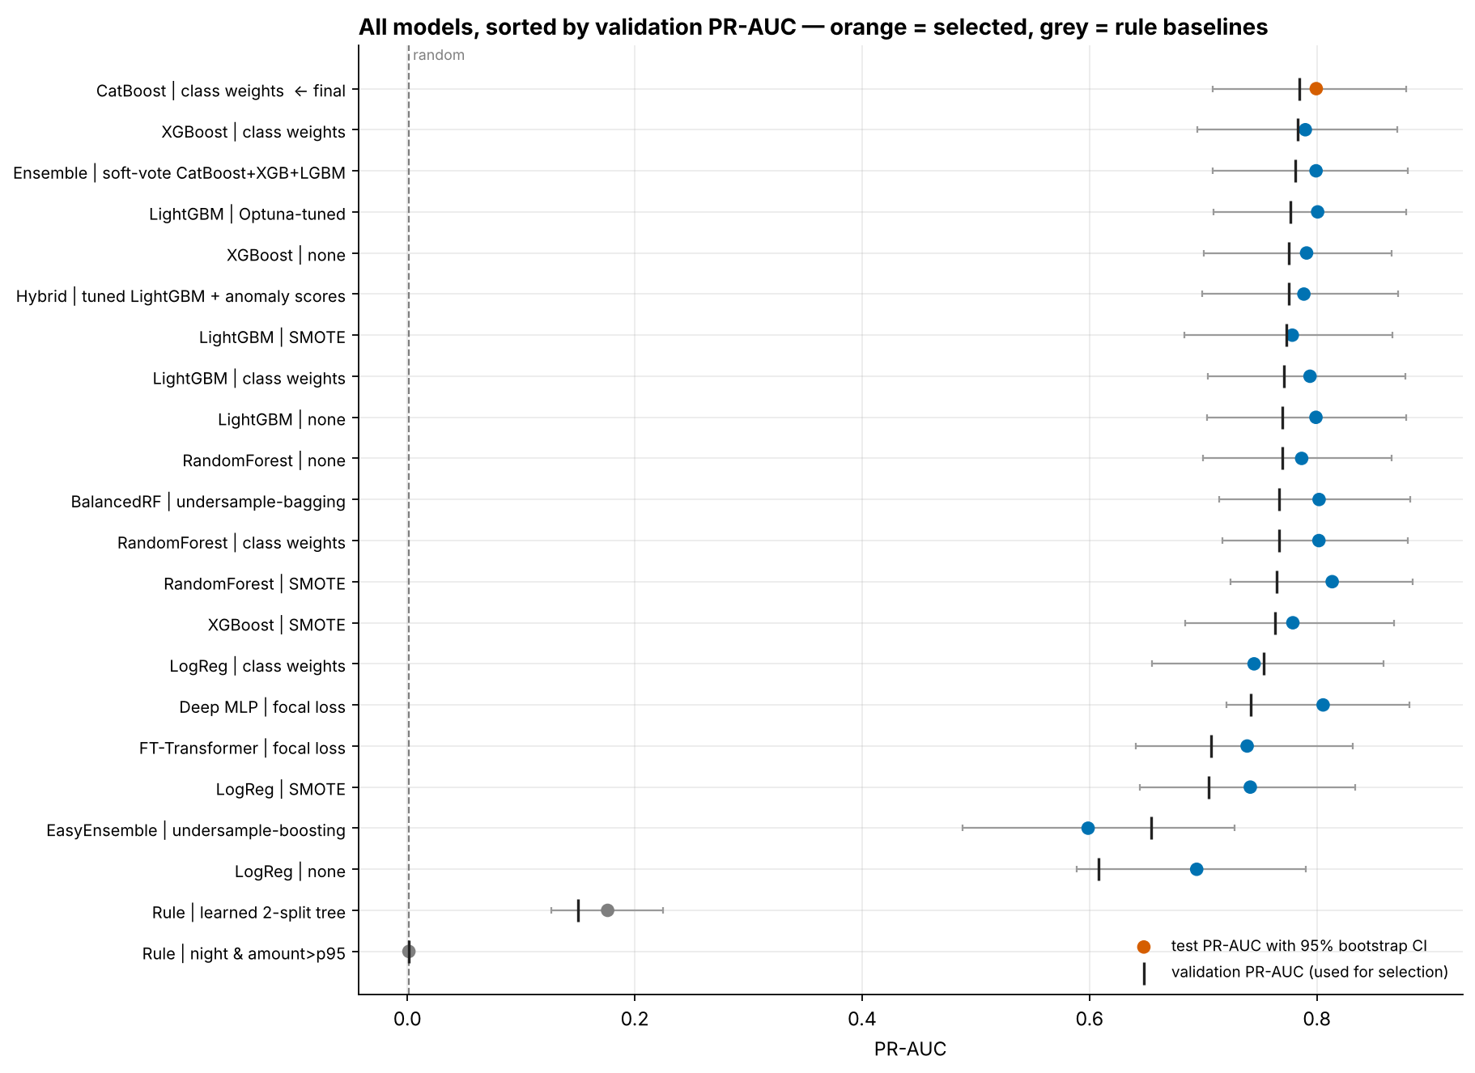
Figure 2. Test PR-AUC with 95% bootstrap CI (dots) and validation PR-AUC (bars) for every model. The gradient-boosted trees and forests overlap; rule baselines sit far left.
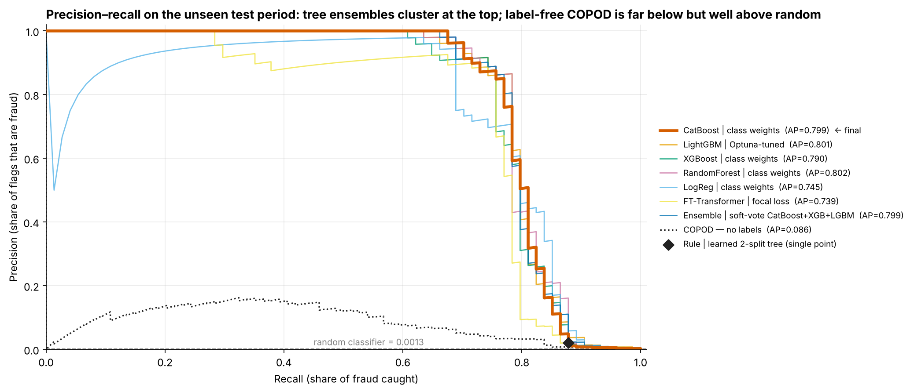
Figure 3. Precision–recall curves on the test period for the main candidates, the best label-free detector and the learned rule.
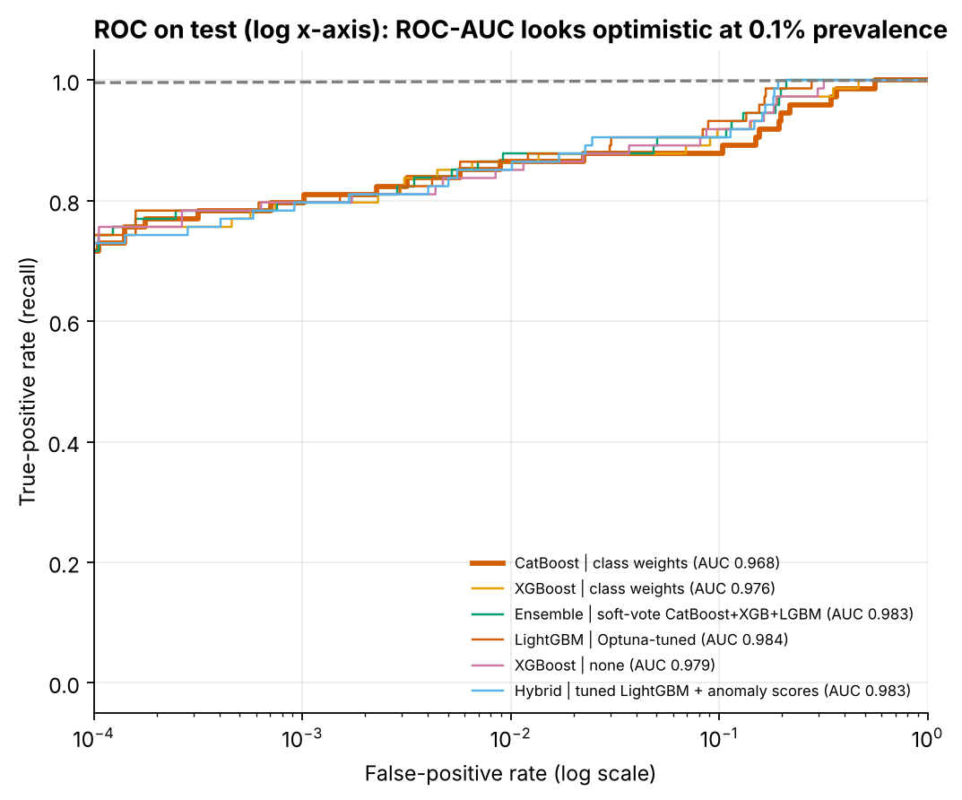
Figure 4. ROC on test with a log x-axis. Every model looks excellent by ROC-AUC (0.94–0.99), which is why PR-AUC and cost drive selection at 0.13% prevalence.

5. Individual views
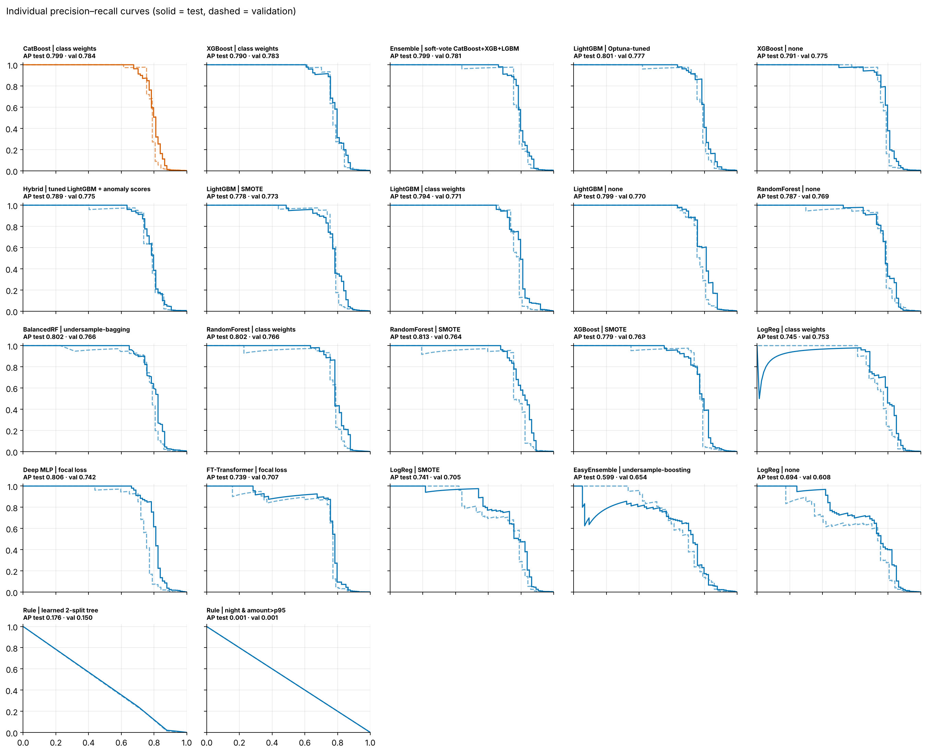
Figure 5. One precision–recall panel per model: solid = test, dashed = validation. Close solid and dashed curves mean the model generalises to the later period.

6. Imbalance methods: class weights vs SMOTE vs none
Family | No handling (val PR-AUC / val ₹) | Class weights | SMOTE in pipeline
Logistic Regression | 0.608 / ₹83,100 | 0.753 / ₹74,900 | 0.705 / ₹69,600
Random Forest | 0.769 / ₹66,900 | 0.766 / ₹67,800 | 0.764 / ₹70,900
XGBoost | 0.775 / ₹70,200 | 0.783 / ₹70,900 | 0.763 / ₹69,800
LightGBM | 0.770 / ₹73,000 | 0.771 / ₹72,600 | 0.773 / ₹68,700
Validation PR-AUC / validation cost at the best threshold. Also tested: Balanced RF and EasyEnsemble (undersampling per tree or member), CatBoost (√-balanced weights), focal loss for the neural models, and a tuned scale_pos_weight in Optuna.
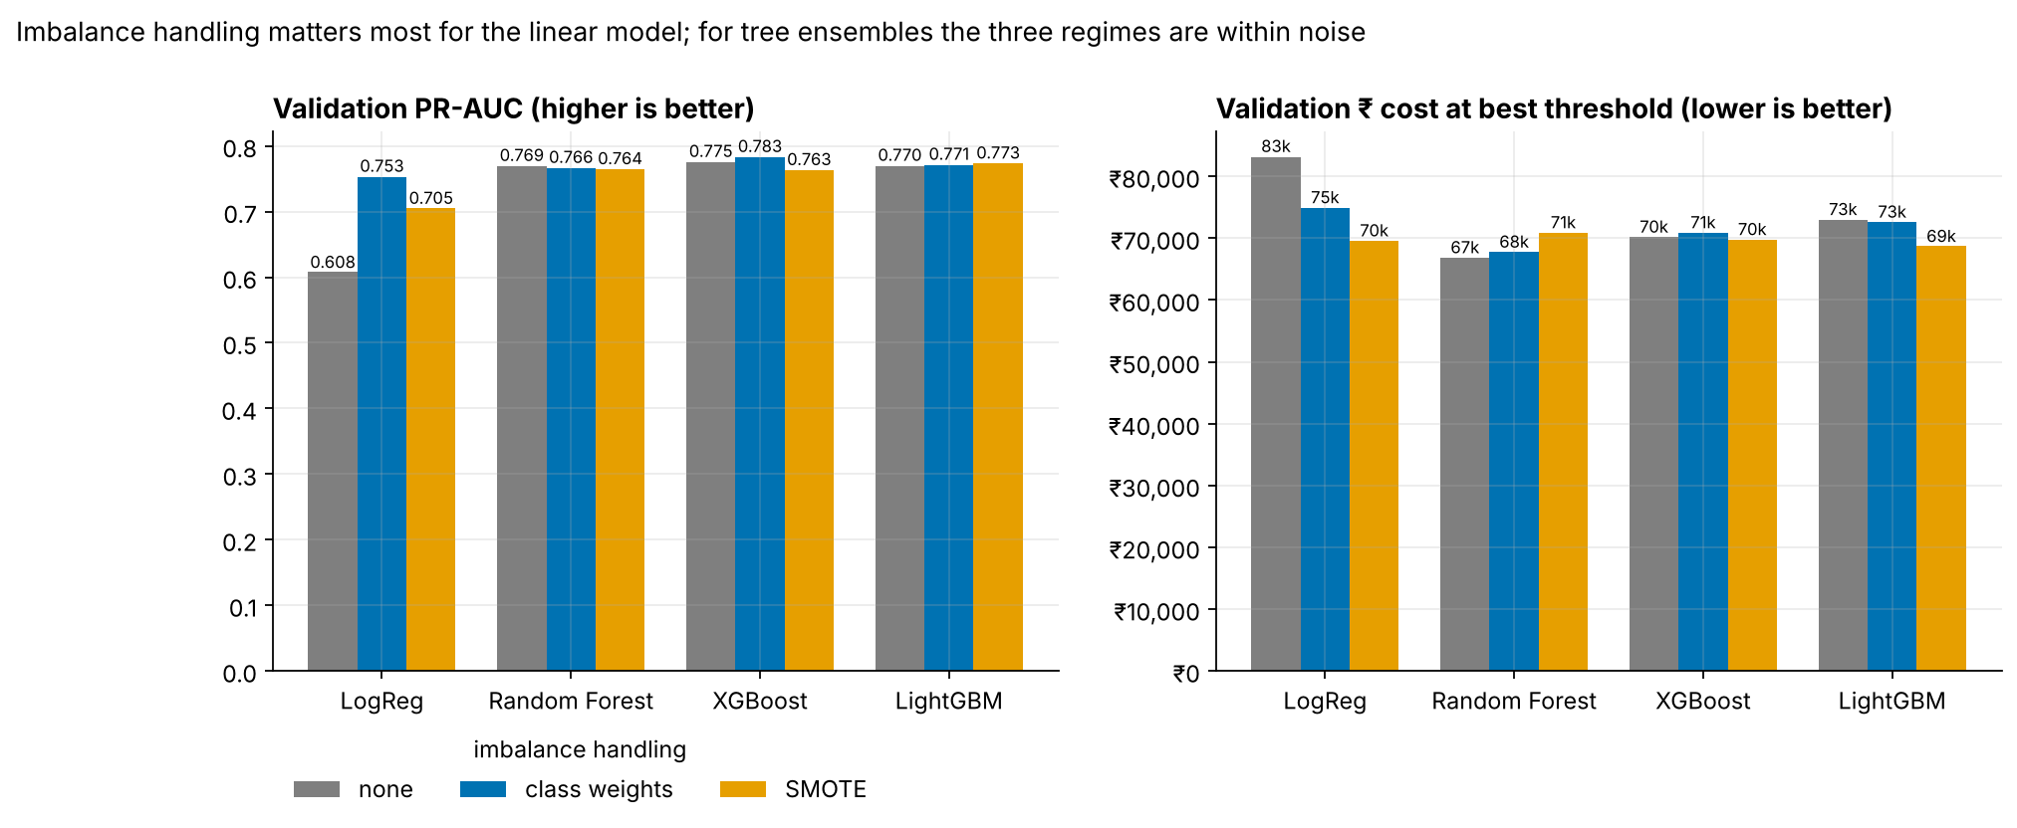
Figure 6. Imbalance handling by model family.
- Logistic regression needs imbalance handling. Class weights lift validation PR-AUC from 0.608 to 0.753; SMOTE reaches 0.705.
- For tree ensembles the three regimes are within noise (±0.02), well inside the ±0.08 bootstrap CI.
- Decision: class weights. No synthetic transactions, no extra training time, and probabilities that stay closer to calibrated.

7. Research models
The FT-Transformer (Gorishniy et al., 2021) and a focal-loss MLP (Lin et al., 2017) were trained with early stopping on the last 15% of train. They reached validation PR-AUC 0.707 and 0.742, below every gradient-boosted tree. This matches the published finding that tree ensembles still lead on mid-sized tabular data (Grinsztajn et al., 2022). Optuna (30 TPE trials on time-series folds inside train) did not beat default LightGBM on validation. The hybrid (tuned LightGBM plus three anomaly scores as features) also added nothing.

8. Label-free anomaly detectors (trained without labels)
Detector | Test PR-AUC | Test ROC-AUC | Fraud in top 0.5% | Fraud in top 1% | Precision in top 1% | Fraud in top 5%
COPOD | 0.086 | 0.946 | 49% | 59% | 7.7% | 84%
ECOD | 0.068 | 0.947 | 41% | 58% | 7.6% | 84%
Isolation Forest | 0.049 | 0.956 | 23% | 53% | 6.9% | 84%
LOF (novelty) | 0.042 | 0.577 | 28% | 30% | 3.9% | 41%
Autoencoder | 0.034 | 0.920 | 24% | 41% | 5.3% | 64%
DBSCAN (10k test sample) | — | — | — | 6/12 in 0.58% flagged | 10.3% | —
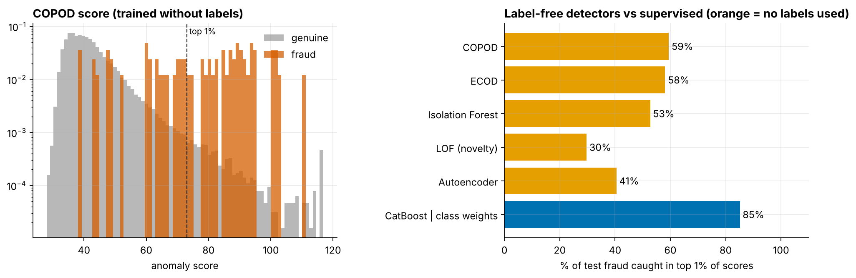
Figure 7. COPOD score distribution (left) and share of test fraud in the top 1% of scores, label-free detectors vs the supervised model (right).
Comparison with supervised: COPOD puts 44 of 74 test frauds in its top 1%, against 63 for CatBoost | class weights. 43 frauds are in both lists; 1 is caught only by the detector. The detector therefore works as a second, label-free watch-list for new fraud patterns, not as the blocking model.

9. Selection rule and reasoning
- Shortlist: every model within 0.01 of the best validation PR-AUC (CatBoost | class weights, LightGBM | Optuna-tuned, Hybrid | tuned LightGBM + anomaly scores, Ensemble | soft-vote CatBoost+XGB+LGBM, XGBoost | none, XGBoost | class weights).
- Lowest validation ₹ cost at its own cost-optimal threshold: CatBoost | class weights (₹66,300).
- Tie-breakers: a single model over an ensemble (latency, exact SHAP), then the fastest.
- Signal check: label-permutation test on validation and test, p < 0.002 for CatBoost | class weights.
Fixed in advance to avoid selection bias: the ensemble's members (one per GBDT library) were chosen before any validation score was seen. An ensemble of the top 3 on validation, judged on that same validation set, would look better than it is.

10. UPI 2024: the same comparison is a negative control
All 22 UPI models score test ROC-AUC 0.47–0.54 and test PR-AUC 0.0018–0.0031, against a base rate of 0.0019. The validation "winner" (EasyEnsemble | undersample-boosting, permutation p = 0.016) falls to p = 0.78 on test, which is what picking the best of 22 models on noise produces. Every anomaly detector catches at most 1 of 96 test frauds in its top 1%. No UPI model is deployable, and approving everything is the cost-optimal policy.
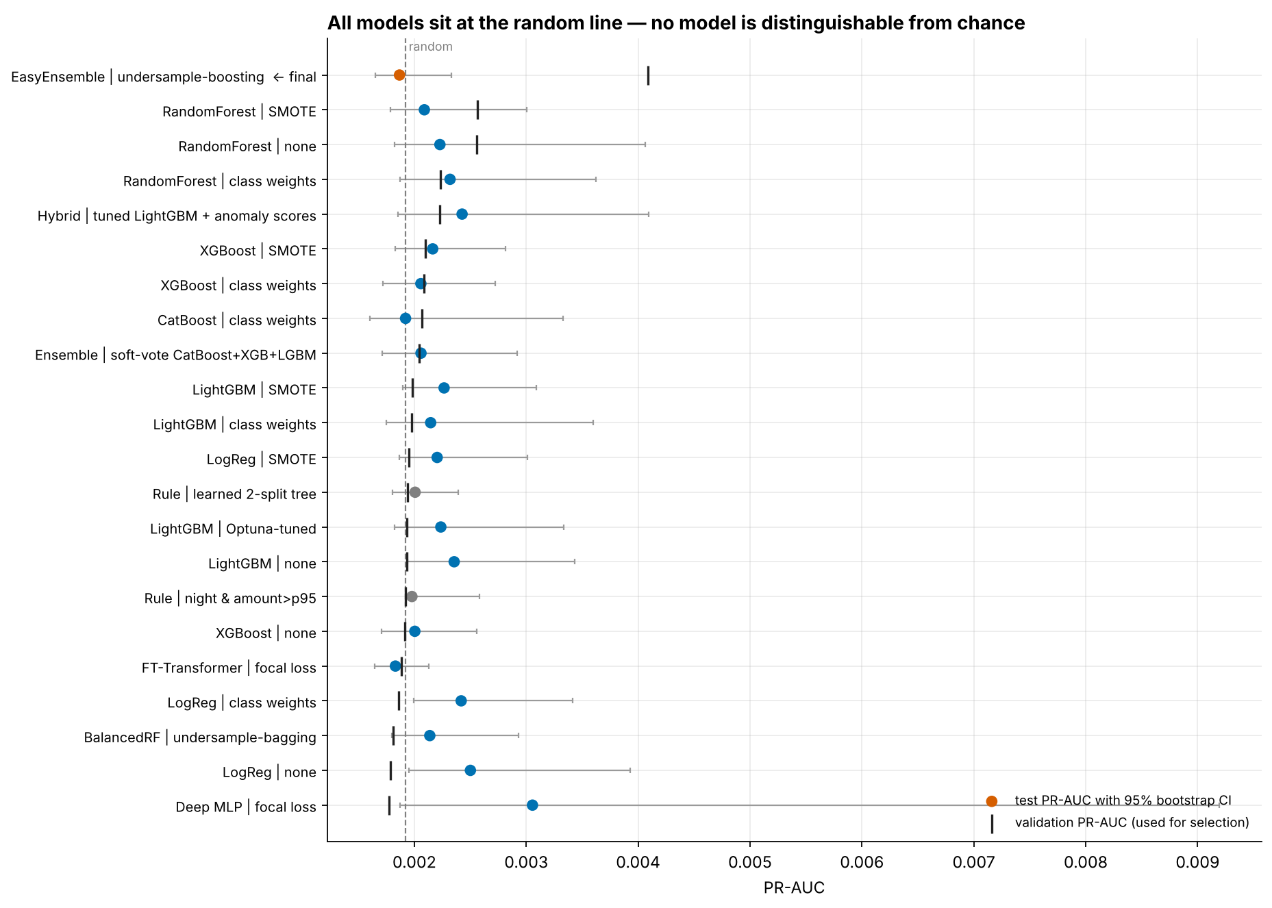
Figure 8. UPI: every model's test PR-AUC sits on the random line.
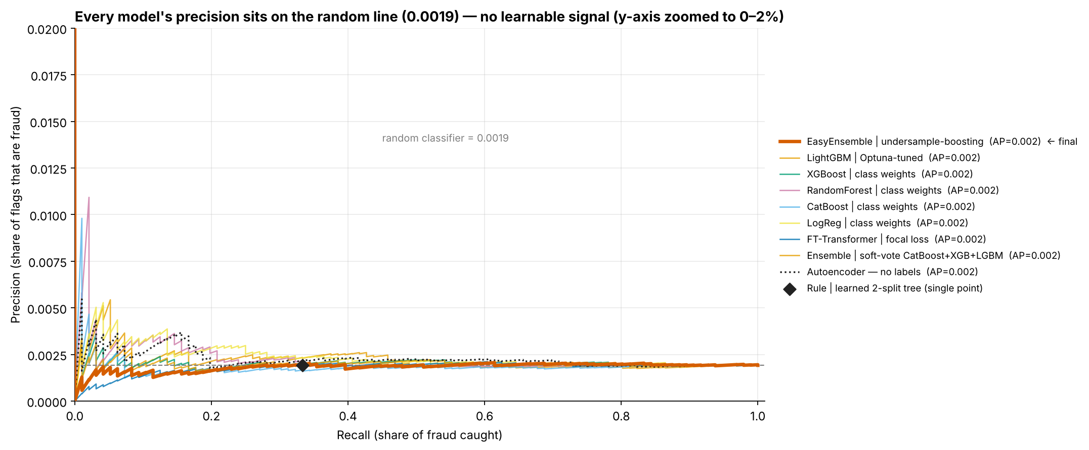
Figure 9. UPI precision–recall curves (y-axis zoomed to 0–2%).
Reproduce with fraudguard_pipeline.ipynb (seed 42). Tables: outputs/tables/{creditcard,upi}/model_comparison.csv and model_pr_auc_ci.csv. A from-scratch rerun reproduces every number in this document exactly.

