**MCA372 – Unix Programming**

**Task for Lab 18 – 03.09.2020**

**iNODE**

Execute the following:

1.Suppose there exist a file name with some special character in it. For example:  “christ*

* Try to remove it normally using rm command, you will not be able to remove it.
* However using the inode number of this file you can remove it.

Ans: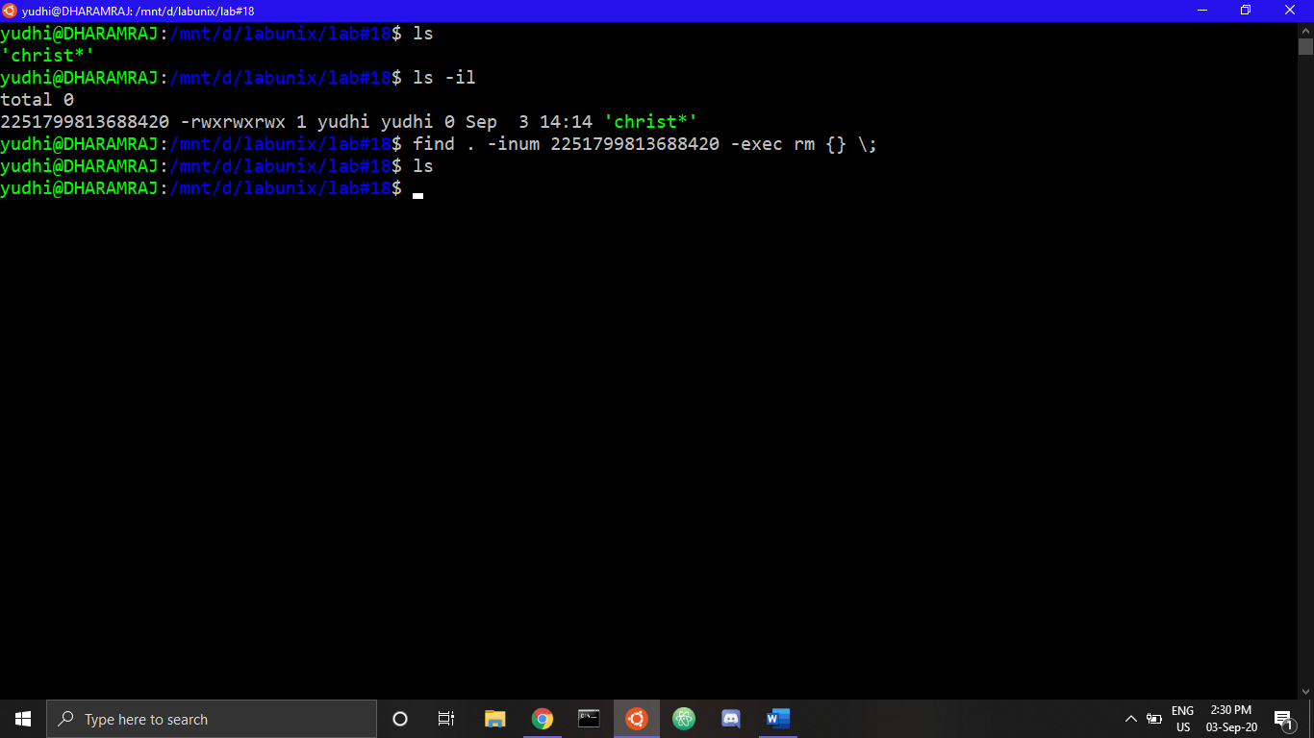

1. Stat command to display different information about file

Ans: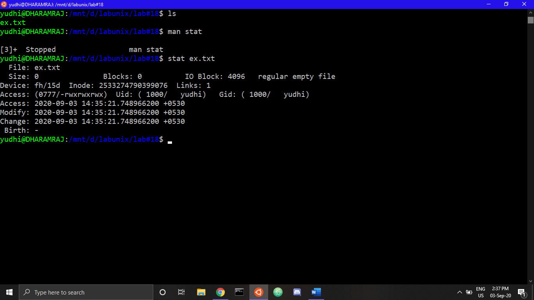

1. Ls -i and Df -I usage

Ans: ls -i is used to show the inode number of the files which are present the current working directory.

The df command is used to show the amount of disk space that is free on file systems. In the examples, df is first called with no arguments. This default action is to display used and free file space in blocks.

Df -l is used to show used and free file space in blocks with the disk or local file systems.

Example:-

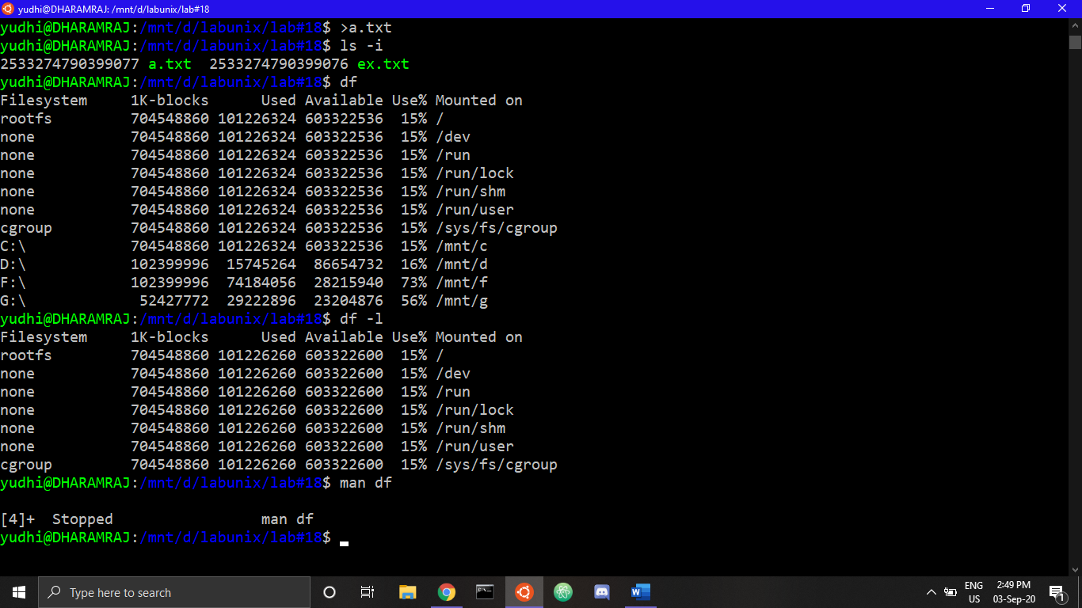

1. Create Soft link,  Hard link for a file and demonstrate inode number

Ans: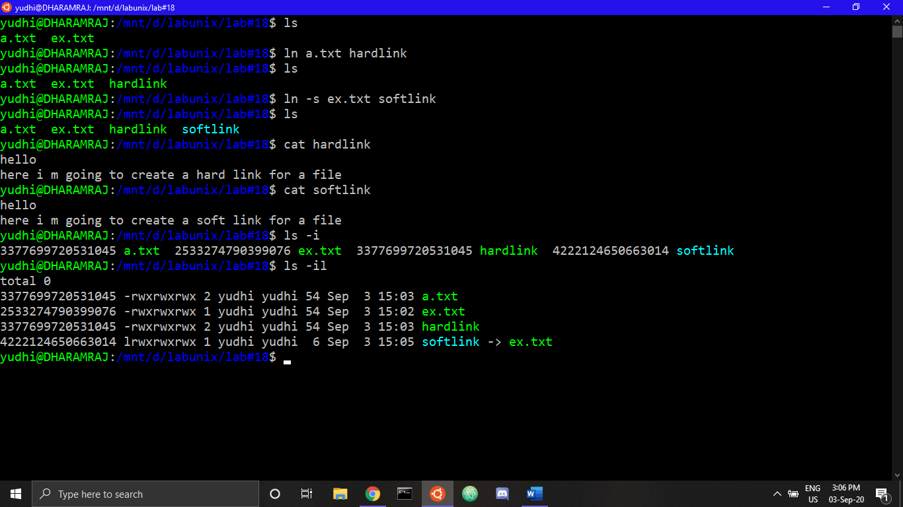

i-node number: An Inode number is a uniquely existing number for all the files in Linux and all Unix type systems. When a file is created on a system, a file name and Inode number is assigned to it.we can see the i-node number of files in the above screenshot in first column.

1. Diffrentiate inode number for a.text and A.txt

Ans:

For both a.text and A.txt , inode number will be different as both are not same file.(example is below)

