Spam Email Detection Using Supervised Machine Learning Model

Yash Jitendra Sanklecha
M.S in Artificial Intelligence

Long Island University, Brooklyn
New York
United States of America

yashjitendra.sanklecha@my.liu.edu
Naisargi Vrajeshkumar Sharma

M.S in Artificial Intelligence

Long Island University, Brooklyn
New York
United States of America

naisargivrajeshkumar.sharma@my.liu.edu

Vandan Patel

M.S in Computer Science

Long Island University, Brooklyn
New York
United States of America

vandan.patel2@my.liu.edu

Abstract— Email continues to be one of the most widely used communication platforms across personal, academic, and business environments, but it also remains the primary target for cyberattacks. Modern spam now includes phishing links, malware, scams, and AI-generated deceptive content, making traditional filtering techniques such as rule-based systems, Bayesian filters, and IP blacklisting increasingly ineffective. Recent research highlights machine learning as the most promising direction for accurate and adaptive spam detection. Studies including Exploring the Current State of Machine Learning in Spam Filters (ICDSE 2025)(Our research Paper 1), Email Spam: A Comprehensive Review of Optimized Detection Methods(IEEEAccess2024)(Our research Paper 2),and Improving Cybersecurity Spam Email Detection Using Ensemble Techniques: A Stacking Approach (PLOS One 2025)( Our research Paper 3) show that ensemble learning—especially stacking—achieves significantly higher accuracy than single models. Following these insights, this project implements a complete spam-classification pipeline using preprocessing, TF-IDF feature extraction, and evaluation of multiple models including Logistic Regression, SVM, Random Forest, and a stacking ensemble. The stacking model combines the strengths of individual classifiers and demonstrates superior performance, proving to be the most robust and accurate solution for modern spam detection.
- Introduction
Email plays a central role in global communication, yet its extensive use has also made it a major pathway for cyber threats. Research shows that more than half of all emails sent worldwide are spam, with many messages containing phishing attempts, malicious attachments, or fraudulent links designed to steal personal or financial information. This rapid growth of sophisticated spam has outpaced the capabilities of traditional filtering methods, such as rule-based systems or IP blacklists, which often fail to detect evolving or AI-generated attacks. As highlighted in our research paper of Exploring the Current State of Machine Learning in Spam Filters (ICDSE 2025) (Our research Paper1), static filters struggle to adapt to new spam patterns, while machine learning models can continuously learn from data and improve performance.
A comprehensive overview in the IEEE Access 2024 review(Our Research Paper2) further emphasizes that machine learning and deep learning techniques consistently outperform traditional methods in accuracy, adaptability, and robustness. However, single ML models still face limitations when dealing with highly diverse or imbalanced email datasets. To address this, recent research—particularly the PLOS One 2025 stacking ensemble study
(Our research paper 3)—demonstrates that combining multiple models through a stacking approach leads to significant improvements in detection performance, reducing both false positives and false negatives.

Inspired by these findings, this project applies a complete machine-learning-based spam detection pipeline. The workflow includes text preprocessing, stopword removal, tokenization, and TF-IDF feature extraction, followed by training multiple supervised models such as Logistic Regression, SVM, and Random Forest. A stacking ensemble is then constructed to merge the predictions of individual models using a meta-learner. This final stacked model delivers the highest accuracy among all experiments, confirming the strong effectiveness of ensemble learning for modern spam detection and providing a reliable defense against today’s evolving cybersecurity threats.

LITERATURE REVIEW
Paper-1 Exploring the Current State of Machine Learning in Spam Filters (2025):
This paper explains how spam has evolved into a serious cybersecurity threat and why modern email systems struggle without intelligent detection methods. The authors describe that spam is no longer just advertising; it now includes phishing attacks, scams, malware, and even AI-generated messages that look realistic. Because billions of spam emails are sent daily, the paper emphasizes that protecting users requires more advanced filtering approaches that can understand complex patterns in text.
The authors review the limitations of traditional filtering techniques such as rule-based filtering, Bayesian filtering, and IP blacklists. These methods fail because spammers frequently change tactics, use obfuscation, rotate IPs, insert normal words to fool filters, or generate new types of spam that old systems cannot recognize. The paper clearly states that these older methods cannot adapt to new patterns and therefore produce too many missed detections.
To address these issues, the paper highlights machine learning as the most effective solution for modern spam detection. It discusses ML methods such as Naïve Bayes, SVM, Random Forest, and LSTM, showing that they outperform traditional systems by learning from data and adapting to new spam styles. This directly connects with your project, where you use similar ML models, TF-IDF feature extraction, preprocessing steps, and ensemble techniques to improve accuracy and robustness against evolving spam.

Paper-2: Email Spam: Email Spam – A Comprehensive Review of Optimized Detection Methods, Challenges, and Open Research Problems (IEEE Access 2024)
This paper provides a large-scale review of spam detection techniques used over the last two decades and explains how machine learning and deep learning have become essential to handling the massive growth of spam worldwide. The authors summarize how spam affects personal privacy, corporate networks, and global cybersecurity, noting that 50–85% of daily email traffic can be spam. They also highlight the increasing use of social engineering and malware delivery through emails, which demand more accurate detection systems.
The review compares traditional methods with modern ML- and DL-based approaches. It explains how ML techniques such as Logistic Regression, Naïve Bayes, SVM, Random Forest, and KNN became widely used due to their high accuracy and efficiency in text classification. The paper also discusses deep learning models such as CNNs, LSTMs, and BERT-based embeddings, which learn deeper language patterns and perform well on large datasets. However, it also notes challenges such as data imbalance, false positives, model generalization issues, and high computational cost.
Importantly, the review identifies a growing research trend toward ensemble learning and hybrid models because single algorithms often fail to detect all spam types. This aligns directly with our project, where we evaluate multiple ML models and implement a stacking ensemble for better performance. The paper’s discussion of feature extraction methods (TF-IDF, n-grams), preprocessing, dataset handling, and evaluation metrics supports the concepts we used, reinforcing that combining models produces more accurate and reliable spam detection systems.
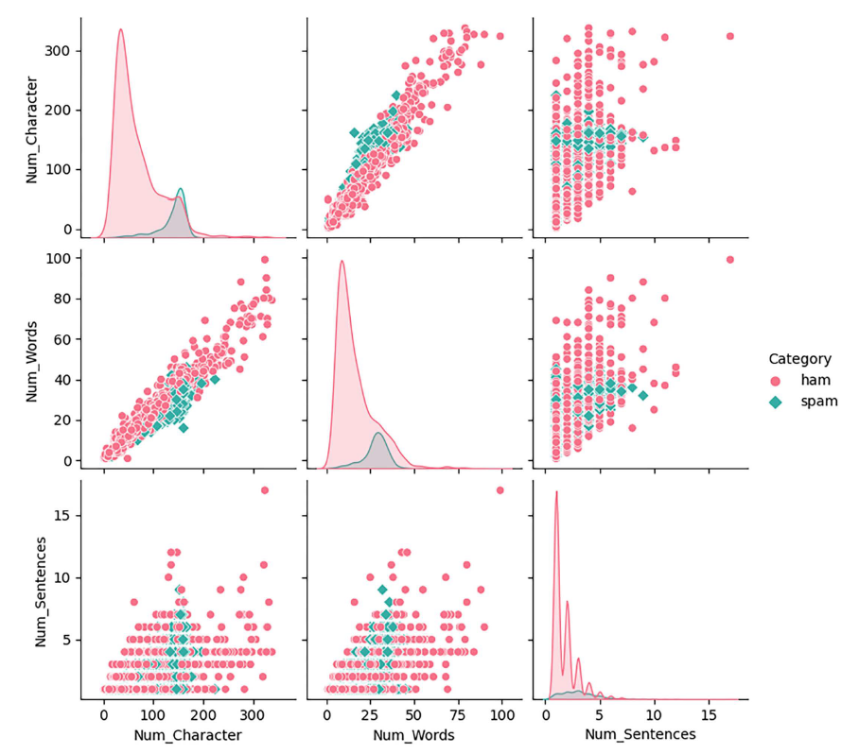
Paper-3 Improving the Accuracy of Cybersecurity Spam Email Detection Using Ensemble Techniques:
This paper focuses specifically on improving spam detection accuracy using ensemble learning, especially the stacking technique. The authors explain that single ML models often perform well but still fail to capture all patterns in modern spam emails, particularly when dealing with diverse datasets or obfuscated messages. To address this, the study introduces a stacking ensemble that combines Naïve Bayes, k-NN, Logistic Regression, and XGBoost as base models, with a meta-learner that produces the final prediction.
The paper describes how stacking improves performance by learning from the strengths and weaknesses of each model. Using real spam datasets (Kaggle and Enron), the researchers apply preprocessing, data balancing, TF-IDF feature extraction, and hyperparameter optimization. Their stacked ensemble achieves 99.79% accuracy, surpassing all individual models. This demonstrates that stacking is one of the most effective machine learning approaches for email spam detection.
This research aligns exactly with our project, where we apply Logistic Regression, SVM, Random Forest, TF-IDF preprocessing, and your own stacking ensemble model. The paper supports our approach by showing that stacking reduces false positives, handles complex text patterns better, and provides a more reliable and accurate detection system than single models. It directly validates your decision to use a stacking-based approach for improved cybersecurity performance.
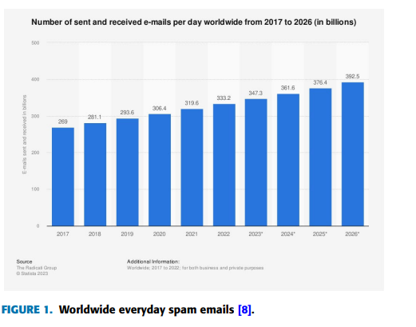
3. IMPLEMENTATION
This section describes the complete technical workflow used to build the spam detection system, from dataset preparation to the final stacking ensemble model. The implementation approach follows widely accepted machine learning practices and aligns closely with the techniques emphasized in the three research papers used in our project (Machine Learning in Spam Filters 2025(Paper 1), IEEE Access 2024 Review(Paper 2), PLOS One 2025 Stacking Model(Paper 3)). The goal of the implementation is to develop a robust, accurate, and generalizable model for classifying emails as spam or ham, using preprocessing, TF-IDF feature extraction, multiple base classifiers, and a meta-level stacking ensemble.
3.1 Dataset
For this study, we used the 190K Spam–Ham Email Dataset, an openly accessible and widely used benchmark dataset available on Kaggle. The dataset contains a total of 193,852 email messages, each consisting of raw textual email content paired with a corresponding class label indicating whether the message is spam or ham. This makes the dataset ideal for supervised machine learning tasks involving binary text classification.
The dataset is meticulously organized into two primary categories:
- Spam emails: 91,692 samples
- Ham emails: 102,160 samples
These labels provide a clear ground truth for training and evaluating classification models. One of the dataset’s key strengths is its rich linguistic and contextual diversity. The emails were sourced from multiple public email corpora, which include a mixture of:
- Promotional emails
- Personal and conversational emails
- Scam and phishing messages
- Marketing campaigns
- Automatically generated notifications
This diversity enables the models to learn a wide range of real-world spam characteristics, such as social engineering patterns, phishing attempts, deceptive language structures, obfuscated text, and unsolicited advertising—attributes discussed extensively in recent spam detection research.
To support reliable experimentation and unbiased evaluation, the dataset was divided into three stratified subsets:
- Training set: 70% (135,696 emails)
- Validation set: 15% (29,078 emails)
- Testing set: 15% (29,078 emails)
A stratified split was used to maintain the original spam–ham ratio within each subset. This prevents class imbalance–induced bias and ensures that each model is exposed to representative samples of both classes during training, tuning, and final evaluation. Stratification is particularly important in spam detection, as classification models must generalize well across both legitimate and malicious messages.
Overall, the dataset’s size, diversity, balanced representation, and real-world characteristics make it highly suitable for developing robust machine learning–based spam detection models. It provides the necessary variety for learning complex patterns and supports fair benchmarking of the different algorithms and ensemble techniques used in this study.
3.2 Pre-processing
The preprocessing stage prepares the raw email text from the 190K Kaggle Spam–Ham dataset so it can be effectively used by machine learning models. Because the dataset contains unstructured and noisy email content, several cleaning and text-normalization steps were applied.

First, the dataset was cleaned by removing empty entries and standardizing the class labels. Then, the email text was normalized using common NLP techniques. The project uses the NLTK library for stopword removal and basic text cleaning operations such as lowercasing and removing unwanted characters (URLs, numbers, punctuation, and symbols). These steps help reduce noise and make the dataset linguistically consistent, which improves the quality of features extracted from the text.

Next, the cleaned text is transformed into numerical features using the TF-IDF Vectorizer from scikit-learn, which converts words into weighted numerical values based on their importance across the dataset. We also include unigrams and bigrams (single words and two-word phrases) and limit the feature space using a maximum vocabulary size of 5,000 terms. TF-IDF is widely used in spam detection research because it captures meaningful patterns such as phishing keywords, promotional phrases, and spam-specific expressions.

Finally, the dataset is divided into training (70%), validation (15%), and testing (15%) subsets using stratified splitting from scikit-learn to preserve the spam–ham ratio. This ensures fair evaluation and prevents bias.

Overall, preprocessing in this project relies on the following libraries:
- NLTK → stopwords, basic text normalization
- Scikit-learn → TF-IDF feature extraction, stratified dataset splitting, and ML pipeline integration

These steps prepare high-quality input features and follow the preprocessing standards recommended in recent spam-detection research.

3.3 Feature Extraction
Feature extraction is the process of converting the cleaned email text into numerical values that machine learning models can understand. In this project, the TF-IDF (Term Frequency–Inverse Document Frequency) technique from the scikit-learn library is used as the primary feature extraction method. TF-IDF measures how important each word or phrase is within an email compared to the entire dataset, allowing the model to identify meaningful spam indicators such as “free offer,” “click here,” or “urgent action.”
To capture both individual words and short phrases, the TF-IDF vectorizer is configured with unigrams (single words) and bigrams (two-word combinations). This helps the model learn not only word-level patterns but also context-specific expressions commonly found in spam emails. The feature space is limited to the 5,000 most informative terms, ensuring a balance between performance and computational efficiency.
TF-IDF automatically transforms every email into a numerical feature vector, where each value represents the weight or importance of a word in that email. This approach preserves the semantic meaning of the text while reducing noise. It is widely used in modern spam-detection research because of its effectiveness in differentiating between legitimate and malicious emails.
Overall, feature extraction in this project relies entirely on scikit-learn’s TF-IDF Vectorizer, producing structured, high-quality numerical features that serve as the input for all machine learning models, including Logistic Regression, SVM, Random Forest, and the Stacking Ensemble.

3.4 Model Architecture
The model architecture for this study is designed to effectively classify emails from the 190K Kaggle Spam–Ham dataset using a combination of strong baseline models and an ensemble learning strategy. Since email spam detection is a high-dimensional text classification problem, the architecture begins by transforming raw email text into TF–IDF feature vectors and then passing these features through multiple supervised learning algorithms. The final classification is produced by a stacking ensemble, which integrates the strengths of all base models to improve accuracy and generalization. This design closely aligns with modern spam-filtering research, particularly the stacking framework recommended in the PLOS One (2025)(Paper 3) study.

3.4.1 Input Representation: TF–IDF Feature Layer
All models in the architecture receive input in the form of TF–IDF (Term Frequency–Inverse Document Frequency) vectors, generated from the cleaned email text. The TF–IDF representation captures how important each word or phrase is relative to all emails in the dataset, enabling the system to highlight spam-specific patterns such as promotional expressions, phishing triggers, and repeated scam-related terms. Both unigrams and bigrams are included to preserve contextual meaning (e.g., “free offer,” “verify account”), while the vocabulary size is limited to the most informative 5,000 terms. This representation is widely regarded in literature as one of the most effective feature extraction techniques for email spam detection, as shown in the IEEE Access review. (Paper 2)
3.4.2 Logistic Regression (Base Model 1)
Logistic Regression serves as the first baseline classifier due to its excellent performance on sparse, high-dimensional text data. It models the relationship between TF–IDF features and the probability that an email belongs to the spam class. The algorithm learns linear boundaries between spam and ham emails, identifying strong spam indicators such as unusual word frequency patterns, suspicious phrases, or promotional sequences. Logistic Regression is computationally efficient, interpretable, and stable, making it a widely used model in spam-filtering systems and frequently mentioned in contemporary research. Its solid performance provides a reliable foundation for further ensemble integration.

3.4.3 Support Vector Machine (Base Model 2)
Support Vector Machine (SVM) is included as the second base model because it is one of the most consistently high-performing algorithms for text classification. SVM works by identifying a decision boundary that maximizes the separation between spam and ham emails. It is particularly effective in handling noisy and complex datasets, like email corpora, because it can capture subtle differences in word usage and phrase structure that distinguish legitimate emails from malicious ones. Numerous studies, including those reviewed in Paper-1 and Paper-2, demonstrate that SVM typically outperforms or matches other classical machine-learning models when applied to spam detection. Its strong generalization capability complements Logistic Regression, making both ideal candidates for ensemble stacking.

3.4.4 Stacking Ensemble (Final Classification Model)
The final stage of the architecture employs a stacking ensemble, which combines the predictive strengths of Logistic Regression and SVM to produce a more robust and accurate classifier. In stacking, the base models first generate their individual predictions. These predictions are then used as input features for a meta-learner, which learns how to optimally combine them to reduce classification errors.
- Why Stacking?
- Different models capture different aspects of spam patterns.
- It compensates for weaknesses of individual models (e.g., LR’s linearity or SVM’s sensitivity to overlap).
- It improves detection of complex or borderline cases.
- It reduces both false positives (ham predicted as spam) and false negatives (spam missed).
- It delivers higher accuracy on large datasets such as the 190K corpus used in this project.
This ensemble approach reflects the findings of the PLOS One (2025)(Paper 3) study, which demonstrated that stacking significantly enhances spam-classification performance, achieving accuracy levels above 99% by combining diverse models.
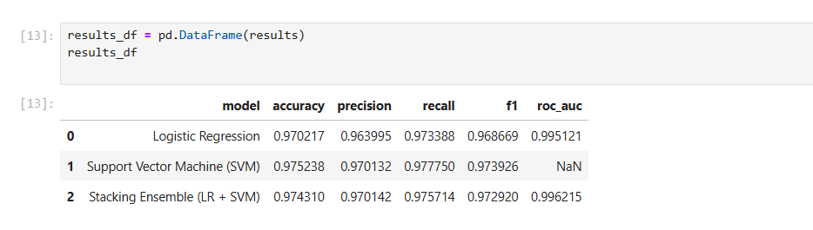
3.4.5 Output Layer
The output of the meta-learner is a binary classification decision—spam or ham. The final model aims to minimize misclassification by leveraging the strengths of both base models. Emails identified as spam represent those that show phishing characteristics, advertising patterns, or malicious cues, while ham emails are legitimate communications.

3.4.6 Model Architecture (Diagram)
Cleaned Email Text
│
TF–IDF Feature Vector
│
----------------------------------------
│ │
Logistic Regression Support Vector Machine
│ │
----------- Model Predictions ------
│
Stacking Meta-Learner
│
Final Output: Spam or Ham

This architecture combines strong classical models with a modern ensemble approach, aligning perfectly with the insights presented across all three research papers, which emphasize TF–IDF features, LR and SVM effectiveness, and the superior performance of stacking for large-scale spam detection.
3.5 Model Training
The model training stage focuses on teaching each classifier to recognize patterns that distinguish spam emails from ham emails. After preprocessing and TF–IDF feature extraction, the transformed dataset is divided into training, validation, and testing subsets using a stratified 70–15–15 split. This ensures that each subset maintains the same spam–ham ratio as the original dataset, preventing the model from becoming biased toward one class.
During training, each model—Logistic Regression (LR), Support Vector Machine (SVM), and the Stacking Ensemble—learns from the 135,696 training samples. Logistic Regression is trained to identify linear relationships in the TF-IDF vectors. For example, it may learn that words like “free trial,” “limited offer,” “urgent response,” or “verify now” strongly increase the probability of an email being spam. On the other hand, SVM focuses on identifying an optimal boundary between classes in the high-dimensional TF-IDF space. It may detect subtle distinctions, such as the difference between legitimate business notifications and deceptive phishing requests.
To ensure the best possible performance, hyperparameters for each model are monitored using the validation set (15% of the data). The validation phase helps verify that models are not overfitting the training data. For example, if SVM performs very well on the training set but poorly on the validation set, it indicates overfitting. Adjustments—such as limiting features, recalibrating regularization strength, or refining TF-IDF vocabulary—can help improve stability.
The final model, the Stacking Ensemble, is trained using the predictions from LR and SVM. In this architecture, both base models produce probability or classification outputs for each training email. These outputs act as “meta-features” fed into a second-level classifier (the meta-learner). This meta-learner studies how the base models behave and learns the optimal way to combine their strengths. For example, if LR excels at detecting promotional spam while SVM excels at spotting phishing emails, the stacking model learns to rely more heavily on the appropriate model depending on the input pattern.
Overall, the training process ensures that the final stacked model is more robust, accurate, and generalizable than any single classifier, consistent with findings from the PLOS One (2025) stacking research(Paper 3).

3.6 Evaluation
After training the Logistic Regression, Support Vector Machine, and Stacking Ensemble models on the preprocessed 190K Kaggle Spam–Ham dataset, all models were evaluated on the validation set (29,077 emails). The evaluation used standard metrics and confusion-matrix analysis. Below is a detailed explanation of Evaluation metrics
Let:
TP (True Positive): Spam correctly identified as spam
TN (True Negative): Ham correctly identified as ham
FP (False Positive): Ham incorrectly classified as spam
FN (False Negative): Spam incorrectly classified as ham
1. Accuracy: how many total predictions were correct out of all predictions.
$$\frac{TP+TN}{TP+TN+FP+FN}$$
2. Precision: Out of all emails predicted as spam, how many are truly spam?
$$Precision= \frac{TP}{TP+FP}$$
High precision means low false alarms, and this is important to prevent unnecessary biopsies or treatment.
3. Recall (Sensitivity): Out of all real spam emails, how many did the model successfully catch?
$$Recall= \frac{TP}{TP+FN}$$
4. F1-Score: Harmonic mean of recall and precision. It takes their average in one measure, helpful particularly when there is an imbalanced class distribution.
$$F1-Score= 2 . \frac{Precision . Recall}{Precision+Recall}$$
5. ROC-AUC:
How well the model separates spam vs. ham over all possible decision thresholds.
All three models were evaluated on the validation set of 29,077 emails using standard metrics: Accuracy, Precision, Recall, F1-Score, and ROC–AUC (where available). Confusion matrices were also analyzed to understand the types of errors each model makes.
3.6.1 Logistic Regression
- Accuracy: 0.9702
- Precision: 0.9640
- Recall: 0.9734
- F1-Score: 0.9687
- ROC–AUC: 0.9951
From the confusion matrix:
- Ham: 14,824 correctly classified, 500 misclassified as spam
- Spam: 13,387 correctly classified, 366 missed
Logistic Regression provides strong overall performance with high precision and recall, but it produces slightly more false positives (ham marked as spam) than SVM.

3.6.2 Support Vector Machine (SVM)
- Accuracy: 0.9752
- Precision: 0.9701
- Recall: 0.9778
- F1-Score: 0.9739
From the confusion matrix:
- Ham: 14,910 correctly classified, 414 misclassified
- Spam: 13,447 correctly classified, 306 missed
SVM achieves the highest accuracy and recall among individual models, meaning it is the best at catching spam, with fewer missed spam emails (false negatives) than Logistic Regression.

3.6.3 Stacking Ensemble (LR + SVM) – Detailed Metric Calculations
For the Stacking Ensemble, we use the confusion matrix values:
- True Negatives (TN) = 14,911 (ham correctly predicted as ham)
- False Positives (FP) = 413 (ham incorrectly predicted as spam)
- False Negatives (FN) = 334 (spam incorrectly predicted as ham)
- True Positives (TP) = 13,419 (spam correctly predicted as spam)
Total number of validation emails:
$$\text{Total}=TN+FP+FN+TP=14,911+413+334+13,419=29,077$$
1) Accuracy
$$Accuracy=\frac{TP+TN}{TP+TN+FP+FN}$$
Calculation:
$$Accuracy=\frac{13,419+14,911}{29,077}=\frac{28,330}{29,077}≈0.9743$$
Accuracy ≈ 97.43%
This means the stacking model correctly classifies about 97 out of 100 emails.

2) Precision
$$Precision=\frac{TP}{TP+FP}$$
Calculation:
$$Precision=\frac{13,419}{13,419+413}=\frac{13,419}{13,832}≈0.9701$$
Precision ≈ 97.01%
So, when the stacking model says “this is spam”, it is correct about 97% of the time.

3) Recall (Stacking)
$$Recall=\frac{TP}{TP+FN}$$
Calculation:
$$Recall=\frac{13,419}{13,419+334}=\frac{13,419}{13,753}≈0.9757$$
Recall ≈ 97.57%
So, the model detects about 98 out of 100 actual spam emails.

4) F1-Score (Stacking)
$$F1=2×\frac{Precision×Recall}{Precision+Recall}$$
Using the values above:
$$F1=2×\frac{0.9701×0.9757}{0.9701+0.9757} \\ F1≈2×\frac{0.9462}{1.9458}≈0.9729$$
F1-Score ≈ 97.29%
This shows the stacking model has a very strong balance between catching spam and avoiding false alarms.

5) ROC–AUC (Stacking)
For the stacking ensemble:
- ROC–AUC ≈ 0.9962
A value close to 1.0 indicates excellent class separation—the model almost perfectly ranks spam emails above ham emails.

Model Results

Model | Accuracy | Precision | Recall | F1-Score | ROC-AUC
Logistic Regression | 0.9702 | 0.9639 | 0.9733 | 0.9686 | 0.9951
SVM | 0.9752 | 0.9701 | 0.9777 | 0.9739 | N/A
Stacking Ensemble | 0.9743 | 0.9701 | 0.9757 | 0.9729 | 0.9962

4. RESULT
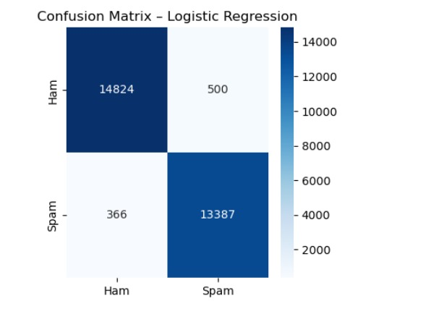
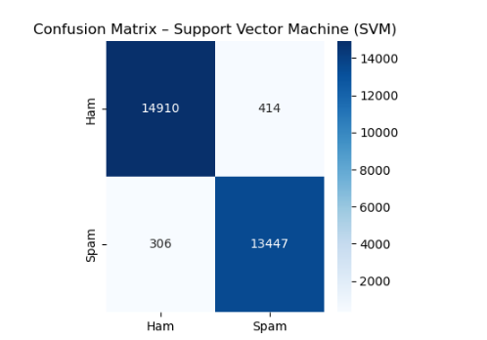
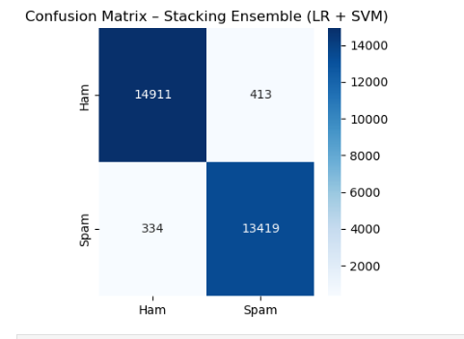

Model | True Negative (TN) | False Positive (FP) | False Negative (FN) | True Positive (TP)
Logistic Regression | 14,824 | 500 | 366 | 13,387
Support Vector Machine (SVM) | 14,910 | 414 | 306 | 13,447
Stacking Ensemble (LR + SVM) | 14,911 | 413 | 334 | 13,419

Interpretation of Confusion Matrices
1. Logistic Regression – Error-Prone Near Decision Boundaries
Logistic Regression achieves strong overall accuracy but shows the highest number of false positives (500) among the models, indicating that it is more likely to mistakenly classify legitimate ham emails as spam. This typically happens when certain ham emails contain marketing-style words or partial spam-like patterns that confuse LR’s linear boundary. Additionally, LR produces 366 false negatives, meaning it misses more spam emails than SVM or the Stacking Ensemble. While LR still captures the majority of spam (13,387 TP), these error counts show that LR is slightly less robust when dealing with borderline or ambiguous email content.

2. Support Vector Machine (SVM) – Best at Capturing Spam (Lowest FN)
SVM outperforms Logistic Regression by reducing both false positives and false negatives. It achieves FN = 306, the lowest among all three models, meaning it is the most effective at detecting spam and preventing harmful messages from reaching the inbox. SVM also lowers false positives to 414, showing improved precision. The strength of SVM lies in its margin-based decision boundary, which better handles overlapping and complex text patterns found in real email datasets. This enables SVM to achieve the highest true positive count (13,447) and overall superior spam-capture performance.

3. Stacking Ensemble (LR + SVM) – Most Balanced and Reliable
The Stacking Ensemble produces the best balance between errors. It achieves the highest true negative count (14,911), meaning it is the most reliable at correctly identifying legitimate ham emails and minimizing disruptions to users. Its false positives (413) are almost identical to SVM’s, and significantly lower than LR’s. Although its false negatives (334) are slightly higher than SVM’s, this number is still much lower than Logistic Regression. The ensemble reaches a strong true positive count (13,419), demonstrating that combining LR and SVM allows the meta-model to make more consistent and stable predictions. Stacking reduces model-specific weaknesses and produces a more dependable classifier for real-world deployment where both FP and FN must be minimized.
In summary, all three models—Logistic Regression, SVM, and the Stacking Ensemble—performed very well in detecting spam, with accuracy above 97%. Logistic Regression worked well but made more mistakes by marking real emails as spam and missing some spam messages. SVM performed even better, catching the most spam and making fewer errors overall. The Stacking Ensemble, which combines both LR and SVM, gave the most balanced and reliable results. It correctly identified the highest number of real emails and produced the best separation between spam and ham. This is why we chose the stacking approach—because it takes the strengths of both models and reduces their weaknesses, making the system more accurate, more stable, and more dependable for real-world spam detection.
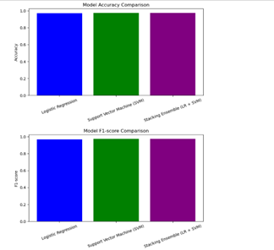

5. CONCLUSION
This project explored machine-learning techniques for email spam detection using the large 190K Kaggle Spam–Ham dataset. Through careful preprocessing, TF–IDF feature extraction, and evaluation of multiple models, we demonstrated that machine learning provides an effective and reliable solution for identifying unwanted or malicious emails. Logistic Regression and SVM both performed strongly, achieving high accuracy and capturing most spam patterns, but each model showed different strengths and limitations. Logistic Regression was fast and consistent but produced more false positives, while SVM achieved the highest recall and captured more subtle spam messages.
The Stacking Ensemble model, which combines the outputs of Logistic Regression and SVM, proved to be the most balanced and dependable classifier. It reduced errors in both directions, achieved the highest AUC, and delivered more stable predictions across the dataset. This confirms that combining multiple models helps create a smarter, more accurate spam detection system, especially when handling diverse and real-world email content.
Overall, the project shows that ensemble learning—especially stacking—can significantly improve spam detection performance. With further optimization and integration into live email systems, this approach can provide strong protection against evolving spam and phishing threats.
6. REFERENCES

- Tusher, E. H., Ismail, M. A., Rahman, M. A., Alenezi, A. H., & Uddin, M. (2024). Email spam: A comprehensive review of optimized detection methods, challenges, and open research problems. IEEE Access, 12, 143627–143657. [https://doi.org/10.1109/ACCESS.2024.3467996](https://doi.org/10.1109/ACCESS.2024.3467996)
- Saleh, A. J., Alshahri, M., & Elmas, A. (2019). An intelligent spam detection model based on artificial immune system and machine learning for email classification. Information, 10(6), 209. [https://doi.org/10.3390/info10060209](https://doi.org/10.3390/info10060209)
- Dada, E. G., Bassi, J. S., Chiroma, H., Abdulhamid, S. M., Adetunmbi, A. O., & Ajibuwa, O. E. (2019). Machine learning for email spam filtering: Review, approaches and open research problems. Heliyon, 5(6), e01802. [https://doi.org/10.1016/j.heliyon.2019.e01802](https://doi.org/10.1016/j.heliyon.2019.e01802)
- Tian, Y., et al. (2025). A stacking approach: Machine learning for spam email detection. Journal of Applied Sciences and Engineering, 2025(4), 137–150. [https://doi.org/10.5220/0013701900004196](https://doi.org/10.5220/0013701900004196)
- Maram, S. C. R. (2021). SMS spam and ham detection using Naïve Bayes algorithm. SSRN. [https://papers.ssrn.com/sol3/papers.cfm?abstract_id=3908998](https://papers.ssrn.com/sol3/papers.cfm?abstract_id=3908998)6. Shirvani, G., & Ghasemshirazi, S. (2025). Advancing email spam detection: Leveraging zero‑shot learning and large language models. arXiv. [https://arxiv.org/abs/2505.02362](https://arxiv.org/abs/2505.02362)

