Assignment-5

22BCA069

GONDALIYA NAITIKBHAI

#include<iostream>

using namespace std;

class A{

public:

int no1;

void display()

{

cout << "The no1 is : " << no1 << endl;

}

};

class B:public A{

public:

int no2;

void display()

{

A::display();

cout << "no2 is : " << no2 << endl;

}

void add()

{

cout << "Add of two no is : " << no1 + no2 << endl;

}

void sub()

{

cout << "sub of two no is : " << no1 - no2 << endl;

}

void mul()

{

cout << "mult of two no is : " << no1 * no2 << endl;

}

void div()

{

cout << "div of two no is : " << no1 / no2 << endl;

}

};

int main()

{

B obj;

obj.no1 = 12;

obj.no2 = 6;

obj.display();

obj.add();

obj.sub();

obj.mul();

obj.div();

return 0;

}

Output:

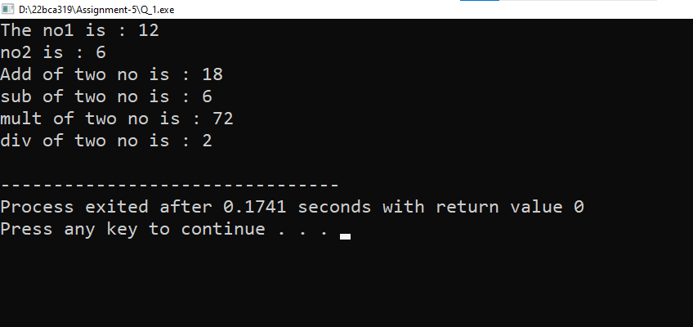

Q-2

#include<iostream>

using namespace std;

class A{

public:

int h,w;

A()

{

cout << "Enter height : ";

cin >> h;

cout << "Enter width : ";

cin >> w;

}

};

class B:public A{

public:

void display()

{

int res = h * w;

cout << "The area of ractanle is : " << res;

}

};

int main()

{

B obj;

obj.display();

return 0;

}

Output:

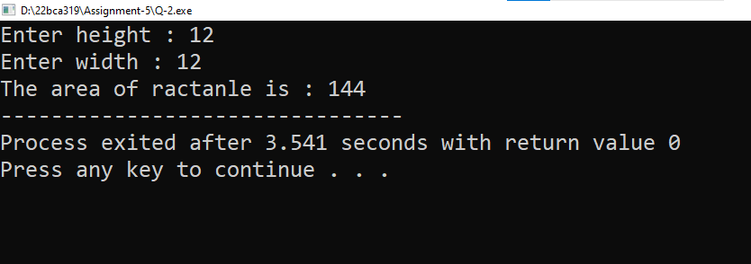

Q-3

#include<iostream>

using namespace std;

class A{

public:

string eid,ename;

void takedata()

{

cout << "Enter employee id : ";

cin >> eid;

cout << "Enter employee name : ";

cin >> ename;

}

};

class B:public A{

public:

string edpt;

int l_no;

void getdata()

{

cout << "Enter Employee Department : ";

cin >> edpt;

cout << "Enter no of leave applied : ";

cin >> l_no;

}

void display();

};

void B::display()

{

cout << "Employee id is : " << eid;

cout << "Employee name is : " << ename;

cout << "Employee department is : " << edpt;

cout << "Employee leave no is : " << l_no;

}

int main()

{

B obj;

obj.takedata();

obj.getdata();

obj.display();

return 0;

}

Output:

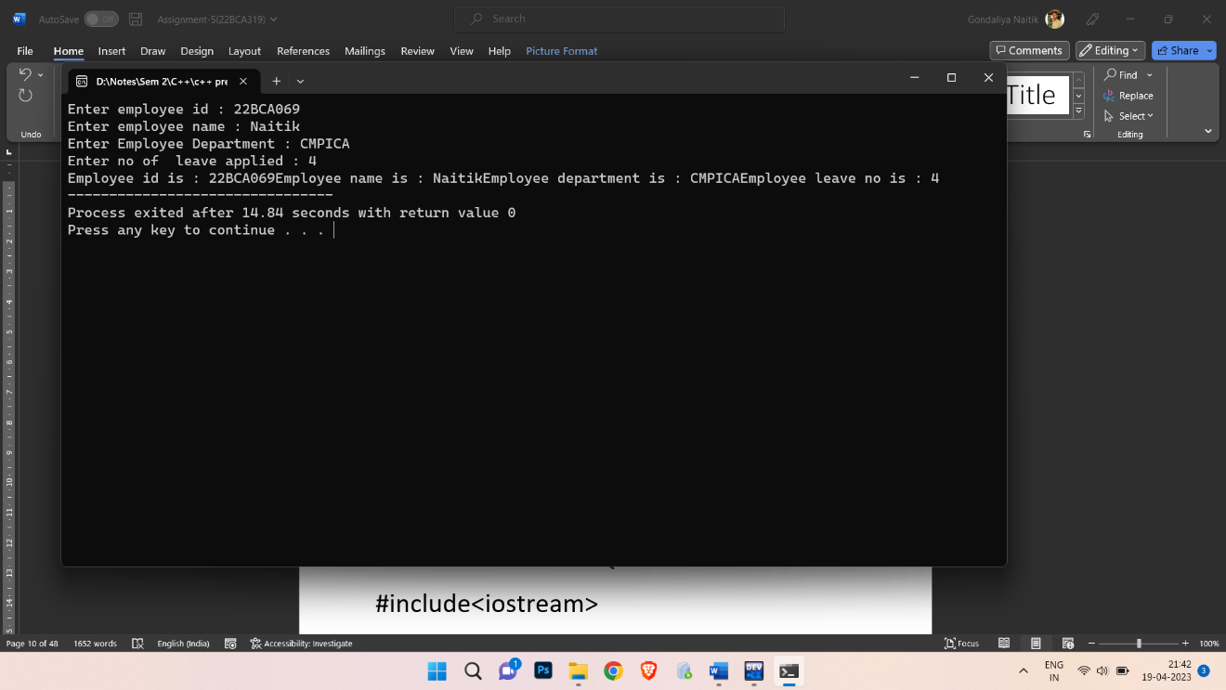

Q-4

#include<iostream>

using namespace std;

class base{

public:

int no1;

void takedata()

{

cout << "Enter Father salary : ";

cin >> no1;

}

};

class base2{

public:

int no2;

void m()

{

cout << "Enter Mother salary : ";

cin >> no2;

}

};

class derive:public base,public base2{

public:

void display()

{

cout << "The total salary of the father and mother is : " << no1 + no2;

}

};

int main()

{

derive obj;

obj.takedata();

obj.m();

obj.display();

return 0;

}

Output:

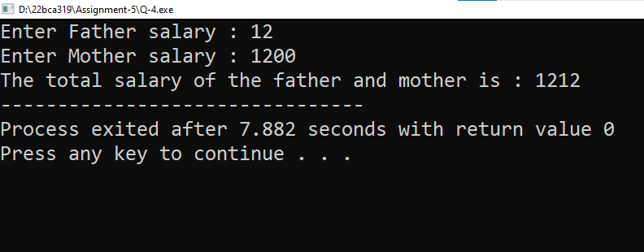

Q-5

#include<iostream>

using namespace std;

class internal{

public:

int oopc,pi,sad,fec,uid;

void takedata()

{

cout << " Enter internal marks of students : \n";

cout << "Enter marks of oopc : ";

cin >> oopc;

cout << "Enter marks of pi : ";

cin >> pi;

cout << "Enter marks of sad : ";

cin >> sad;

cout << "Enter marks of fec : ";

cin >> fec;

cout << "Enter marks of uid : ";

cin >> uid;

}

};

class external{

public:

int e_oopc,e_pi,e_sad,e_fec,e_uid;

void getdata()

{

cout << " Enter External marks of students : \n";

cout << "Enter marks of oopc : ";

cin >> e_oopc;

cout << "Enter marks of pi : ";

cin >> e_pi;

cout << "Enter marks of sad : ";

cin >> e_sad;

cout << "Enter marks of fec : ";

cin >> e_fec;

cout << "Enter marks of uid : ";

cin >> e_uid;

}

};

class Final:public internal,public external{

public:

void total()

{

int total,total2,res;

float per;

total = oopc + pi + sad + fec + uid;

total2 = e_oopc + e_pi + e_sad + e_fec + e_uid;

res = total + total2;

per = float(res) / 5;

cout << "The total marks of student is : " << res << endl;

cout << "The per of student is : " << per << endl;

}

};

int main()

{

Final obj;

obj.takedata();

obj.getdata();

obj.total();

return 0;

}

Output:

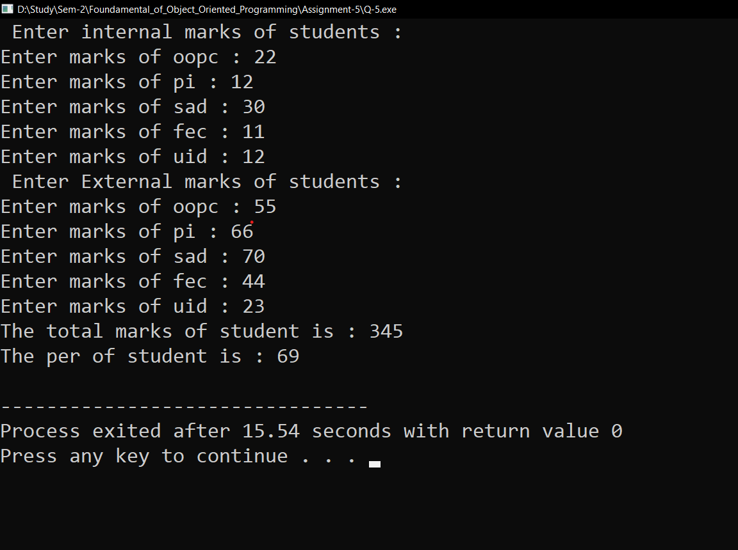

Q-6

#include<iostream>

using namespace std;

class patient{

public:

string pname,d;

void takedata()

{

cout << "Enter patient name : ";

cin >> pname;

cout << "Enter patient Disease : ";

cin >> d;

}

};

class hospital{

public:

string hname,city;

void getdata()

{

cout << "Enter hospital name : ";

cin >> hname;

cout << "Enter city of hospital: ";

cin >> city;

}

};

class Appointment:public patient,public hospital{

public:

string dname,fees;

void display()

{

patient::takedata();

hospital::getdata();

cout << "Enter doctor name : ";

cin >> dname;

cout << "Enter fees of doctor : ";

cin >> fees;

cout << "The doctor name is : " << dname << endl;

cout << "The fees of doctor is : " << fees;

}

};

int main()

{

Appointment obj;

obj.display();

return 0;

}

Output:

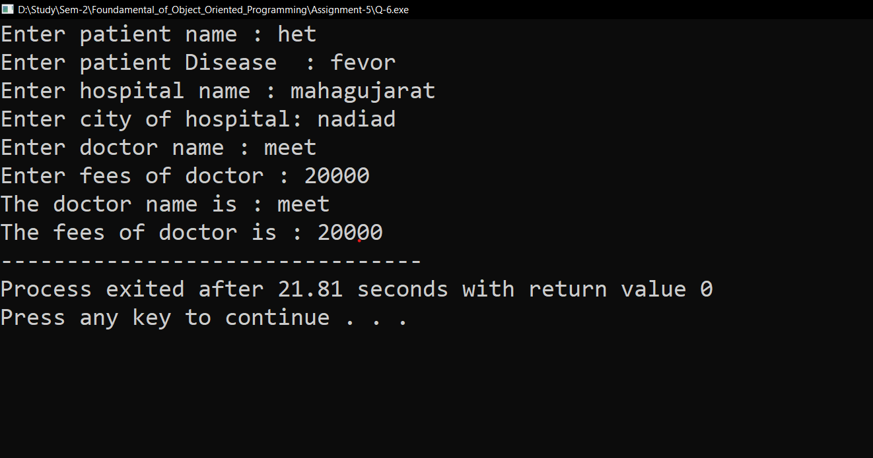

Q-7

#include<iostream>

using namespace std;

class surname{

public:

string sname;

void getdata()

{

cout << "Enter surname of student is : ";

cin >> sname;

}

};

class name:public surname{

public:

string name;

void takedata()

{

cout << "Enter name of student is : ";

cin >> name;

}

};

class fname:public name{

public:

void display()

{

surname::getdata();

name::takedata();

cout << "The surname is : " << sname << endl;

cout << "The name is : " << name << endl;

}

};

int main()

{

fname obj;

obj.display();

return 0;

}

Output:

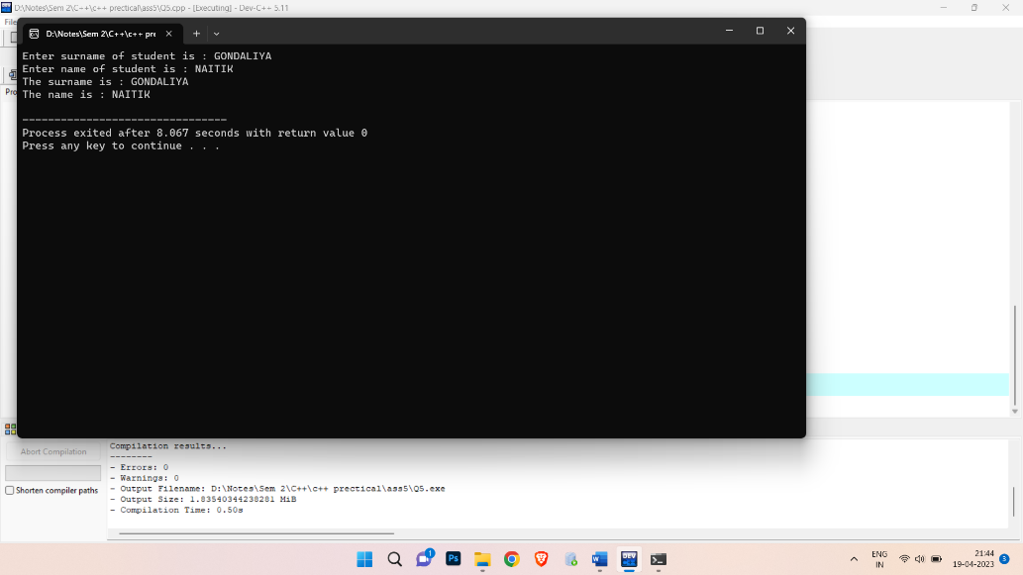

Q-8

#include<iostream>

using namespace std;

class patient{

public:

string pid,pname;

void takedata()

{

cout << "Enter patient id : ";

cin >> pid;

cout << "Enter patient name : ";

cin >> pname;

}

};

class doctor:public patient{

public:

string dname,sp;

void getdata()

{

cout << "Enter doctor name : ";

cin >> dname;

cout << "Enter spacialist : ";

cin >> sp;

}

};

class chemist:public doctor{

public:

string mname;

int q,p;

void take()

{

cout << "Enter medicine name : ";

cin >> mname;

cout << "Enter Quantity : ";

cin >> q;

cout << "Enter price : ";

cin >> p;

}

void display();

};

void chemist::display()

{

cout << "The patient id is : " << pid << endl;

cout << "The patient name is : " << pname << endl;

cout << "The medicine name is : " << mname << endl;

cout << "The Quantity is : " << q << endl;

cout << "The price is : " << p << endl;

}

int main()

{

chemist obj;

obj.takedata();

obj.getdata();

obj.take();

obj.display();

return 0;

}

Output:

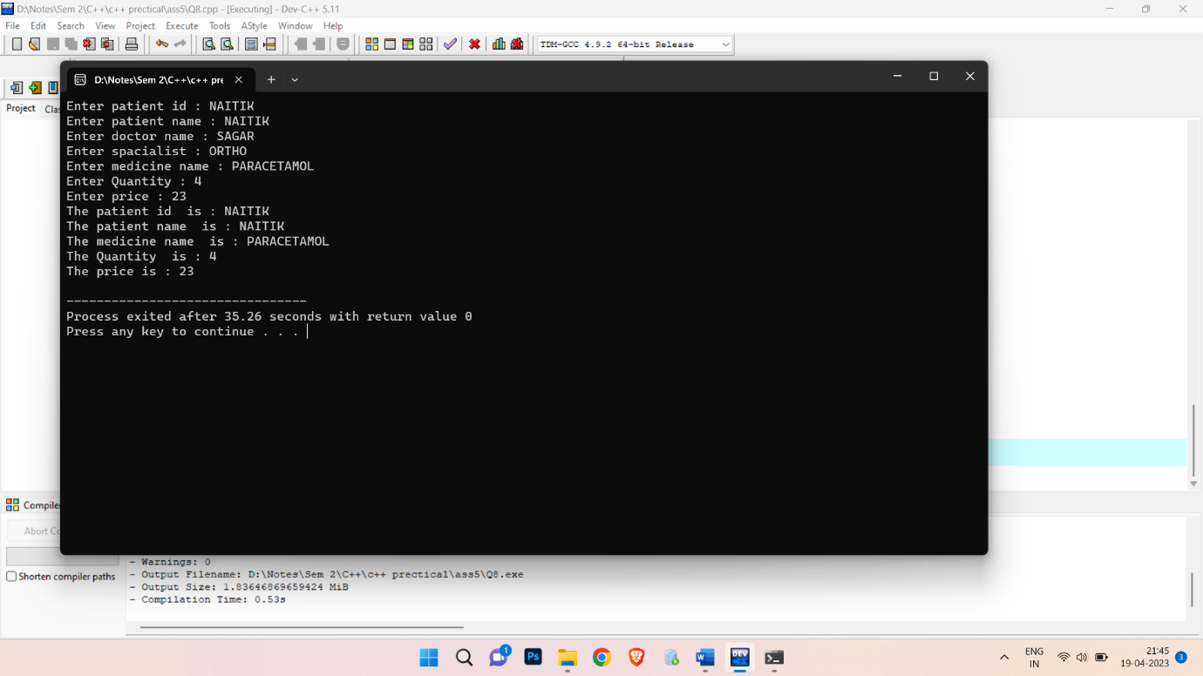

Q-9

#include<iostream>

using namespace std;

class dtl{

public:

string id,name;

string branch,cn;

string dep;

int sal;

void take(){

cout<<"Enter id : ";

cin>>id;

cout<<"Enter Name : ";

cin>>name;

}

void display();

};

class Emp:public dtl{

public:

void take(){

cout<<"Enter department name : ";

cin>>dep;

cout<<"Enter salary : ";

cin>>sal;

}

void print();

};

class student:public dtl{

public:

void take(){

dtl::take();

cout<<"Enter Branch : ";

cin>>branch;

cout<<"Enter Clg Name : ";

cin>>cn;

}

void putdata();

};

void dtl::display(){

cout<<"ID= "<<id;

cout<<"\nName= "<<name;

}

void Emp::print(){

cout<<"\nDepartment name= "<<dep;

cout<<"\nsalary= "<<sal;

}

void student::putdata(){

cout<<"\nBranch= "<<branch;

cout<<"\nClg Name= "<<cn;

}

int main(){

Emp e1;

student s1;

s1.take();

e1.take();

s1.display();

e1.print();

s1.putdata();

}

Output:

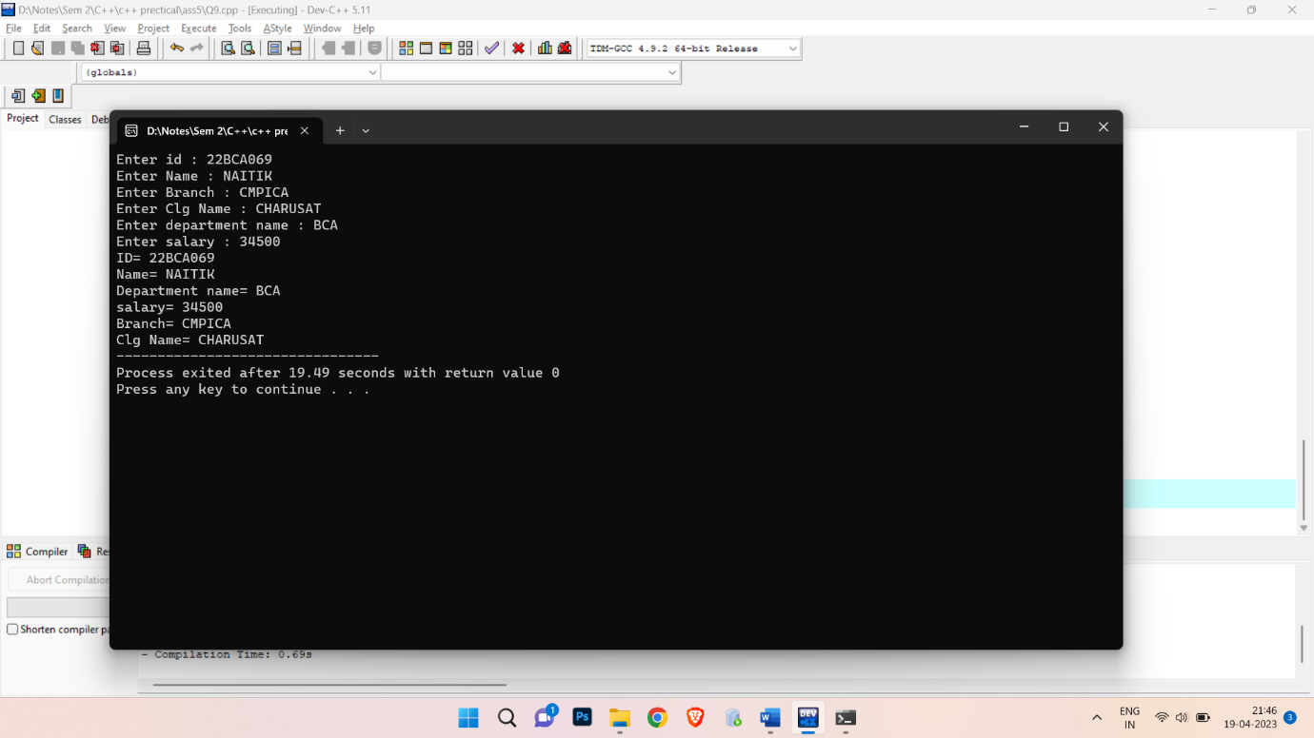

Q-10

#include<iostream>

using namespace std;

class area{

public:

float area;

float l,w,h;

void take1();

void take2();

void take3();

};

void area::take1(){

cout<<"Enter Length,Width";

cin>>l>>w;

}

void area::take2(){

cout<<"\nEnter Length,Width,height";

cin>>l>>w>>h;

}

void area::take3(){

cout<<"\nEnter length";

cin>>l;

}

class rectangle :public area{

public:

void display();

};

void rectangle::display(){

area=l*w;

cout<<"\nArea of rect= "<<area;

}

class cuboid :public area{

public:

void display();

};

void cuboid::display(){

area=(2*((l*w)+(l*h)+(w*h)));

cout<<"\nArea of cuboid= "<<area;

}

class square :public area{

public:

void display();

};

void square::display(){

area=l*l;

cout<<"\nArea of square= "<<area;

}

int main(){

rectangle r1;

cuboid c1;

square s1;

r1.take1();

r1.display();

c1.take2();

c1.display();

s1.take3();

s1.display();

return 0;

}

Output:

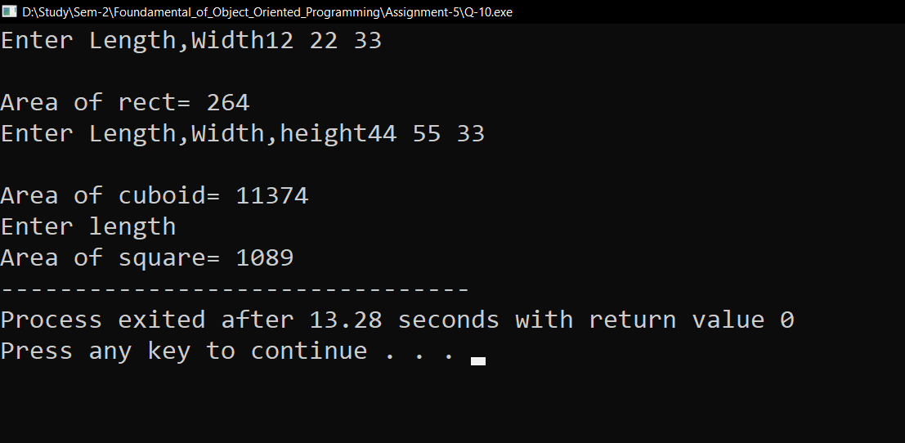

Q-11

#include<iostream>

using namespace std;

class grandfather{

public:

int nh;

void take(){

cout<<"Enter number of house hold : ";

cin>>nh;

}

};

class father :public grandfather{

public:

int ar;

void see(){

grandfather::take();

cout<<"Enter land area hold : ";

cin>>ar;

}

void display(){

cout<<"Houses hold= "<<nh<<endl;

cout<<"Land area= "<<ar<<endl;

}

};

class mother{

public:

int g;

void s(){

cout <<"Enter total gold held by mother : ";

cin>>g;

}

};

class son :public mother{

public:

int c;

void car(){

mother::s();

cout<<"Enter num of cars he have";

cin>>c;

}

void display(){

cout<<"Gold held= "<<g<<endl;

cout<<"total cars= "<<c<<endl;

}

};

int main(){

father f1;

son s1;

f1.see();

s1.car();

cout<<"Final property held by son:"<<endl;

f1.display();

s1.display();

return 0;

}

Output:

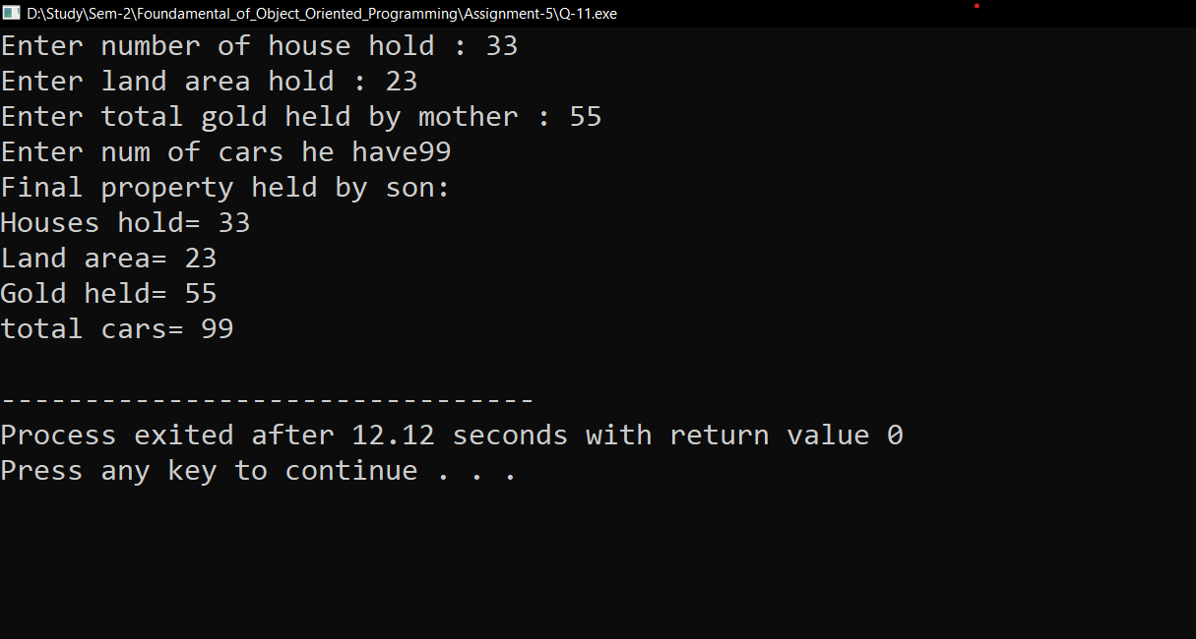

Q-12

#include<iostream>

using namespace std;

class person{

public:

string name;

void getdata()

{

cout << "Enter name : ";

cin >> name;

}

void putdata();

};

class student:virtual public person{

public:

int r_no;

void take()

{

cout << "\nEnter roll_no : ";

cin >> r_no;

}

void print();

};

class teacher:virtual public person{

public:

string dname;

void get()

{

cout << "\nEnter department name : ";

cin >> dname;

}

void put_data();

};

class library:public student,public teacher{

public:

int books;

void get_books(){

cout << "\nEnter no of books : ";

cin >> books;

}

void printdata();

};

void person::putdata()

{

cout << "The name is: " << name << endl;

}

void student::print()

{

cout << "The roll_no is : " << r_no << endl;

}

void teacher::put_data()

{

cout << "The department name is : " << dname << endl;

}

void library::printdata()

{

cout << "The no of books issued is : " << books;

}

int main()

{

library obj;

obj.getdata();

obj.take();

obj.get();

obj.get_books();

obj.putdata();

obj.print();

obj.put_data();

obj.printdata();

return 0;

}

Output:

