- CMOS Battery:

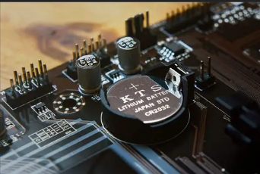
- Definition: A small battery on the motherboard that powers the CMOS chip, which stores BIOS settings and system time.
- Work: Maintains system clock and BIOS settings when the computer is off.
Advantages:
- Keeps system time accurate.
- Retains BIOS settings without power.
Disadvantages:
- Can lose charge and need replacement.
- Failure can cause BIOS settings to reset.

- Primary and Secondary IDE (IDE-1 & IDE-2):

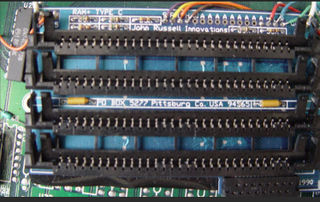
- Definition: IDE interfaces for connecting storage devices. IDE-1 (Primary) and IDE-2 (Secondary) are two channels on the IDE controller.
- Work: Primary channel connects the boot drive; secondary connects additional drives.
Advantages:
- Simple and cost-effective.
- Allows two devices per channel.
Disadvantages:
- Slower than newer interfaces (SATA).
- Limited to two devices per channel.

- AGP Slots & Cards (Accelerated Graphics Port):

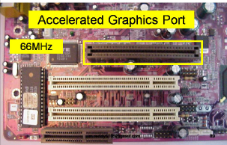
- Definition: A specialized motherboard slot for high-performance graphics cards.
- Work: Provides a faster data path for graphics, improving performance.
Advantages:
- Faster graphics than PCI.
- Optimized for 3D rendering.
Disadvantages:
- Obsolete (replaced by PCIe).
- Limited upgrade options.

- CI Slots & Cards (Common Interface):

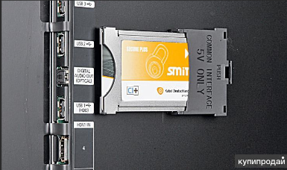
- Definition: A slot for inserting a Conditional Access Module (CAM) to decrypt encrypted content.
- Work: Allows access to subscription-based content (e.g., satellite TV).
Advantages:
- Enables encrypted content access.
- Can switch CAMs for different providers.
Disadvantages:
- Limited to specific devices (set-top boxes, TVs).
- Not widely used in general computing.

