Batch: A3 Roll No.: 1211055
Experiment No. 10
Grade: AA / AB / BB / BC / CC / CD /DD

Signature of the Staff In-charge with date

Title: Intrusion Detection system

Objective: To implement an Intrusion Detection system that can detect 5 different types of attack:

Expected Outcome of Experiment:

CO | Outcome
4 | Install and configure Intrusion Detection System

Books/ Journals/ Websites referred:

http://www.techrepublic.com/article/capture-network-packets-in-java-with-jpcap/

cryptography and network security Behrouz A. Forouzan.

- Problem Definition
The project is about creating an intrusion detection system which would be able to monitor network or system activities for malicious activities or policy violations and produces reports to a management station. Different types of IDS approach the goal of detecting traffic in different ways. There are network based and host based intrusion detection systems.

- Scope
The intrusion detection system would be capable of detecting the following types of attacks:
- Any unreliable transmission
- TCP attack(Signature attack).
- Syn-Flooding attack(Denial of service attack).
- ICMP attack(Anomaly Detection).
- UDP attack.

- Software Architecture
  - System architecture diagram

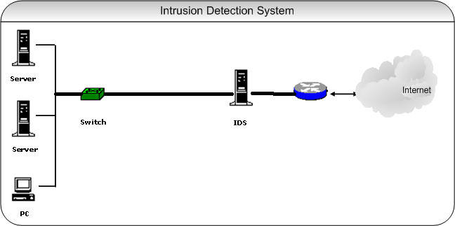

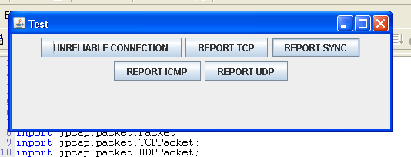

- Requirement Specification

  - Software Requirements
- Java’s JPCAP library
- Java’s AWT and swing libraries.
- An IDE like NetBeans, JCreator,Jframe

  - Hardware Requirements
- Desktop computer or a laptop

  - Functional Requirements
- There are various types of attacks in the network by an attacker.
- The Intrusion Detection system will function as follows:
- The system must be able to capture the unreliable packets and generate a report about the attack.
- The system must be able to check attack by a particular range of IP address or class of address i.e. the signature of the attack and should be able to detect and report it.
- The system must be able to detect the Syn-Flooding attack and specify the attack in the report.
- The system must check the type in ICMP packets and detect the infected packets and report about the same.
- The system must check for the access of private port in case of UDP packets and report about the same.

  - Non –Functional Requirement

Performance Requirements
It is expected that the program to capture minimum of 20 packet in each second. It should detect attack as soon as possible.

Safety Requirements
The intrusion detection system should not alter any system code. It should not change.
Availability-
The availability of the system is easy.

Correctness-
The results of the function are pure and accurate.

Flexibility-
The operation may be flexible and reports can be presented in many ways.

Maintainability-
After the deployment of the system if any error occurs then it can be easily maintained and corrected.

Timelines-
The time limit is very important. It will save much time and provide fast accessing.

- Software Design

  - Use case diagram

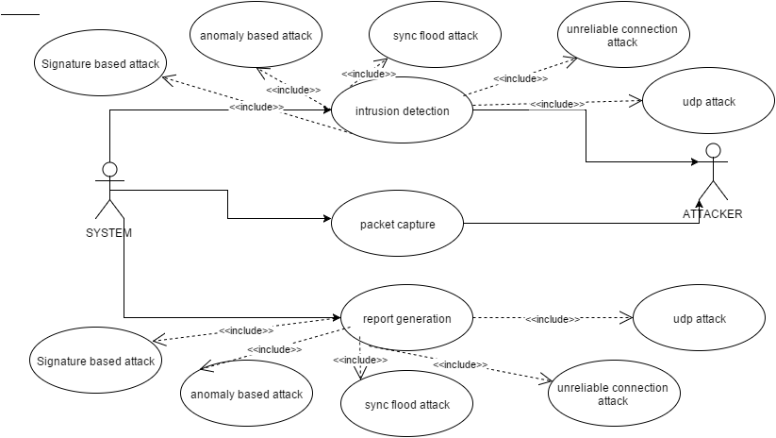

  - Component Diagram

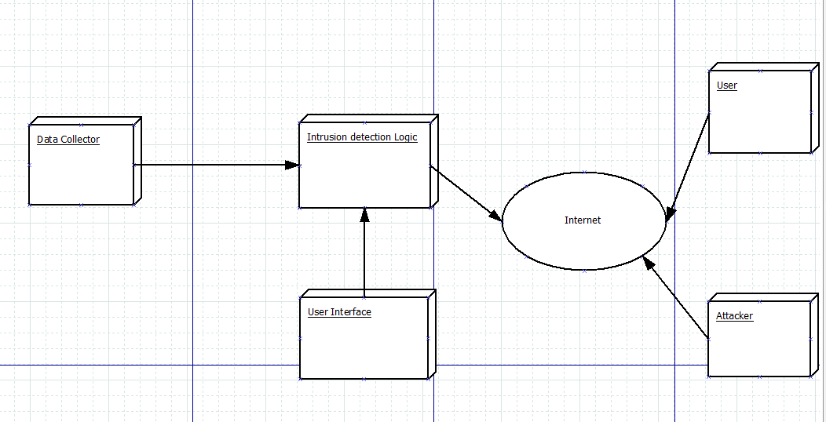

  - Deployment Diagram
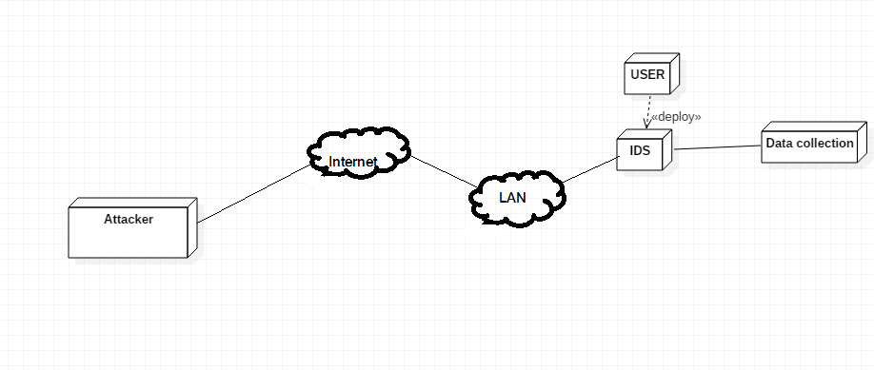

  - Sequence diagram

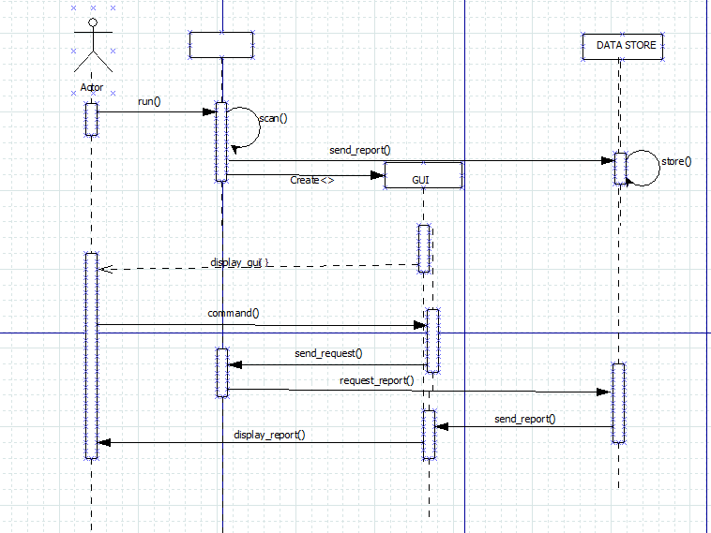

- Implementation Details
  - Screen shots of implementation
- Interface:

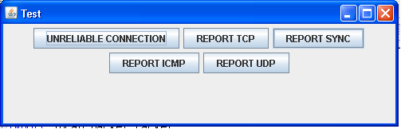

- Packet Capture:

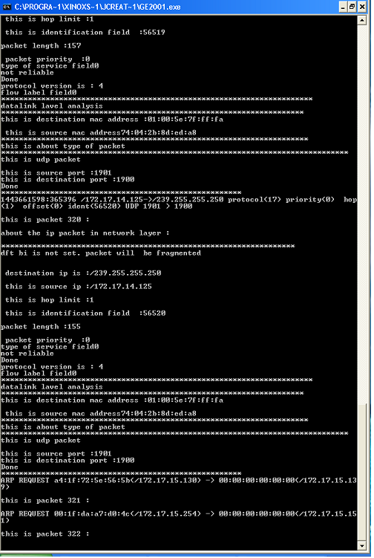

- Unreliable Connection:

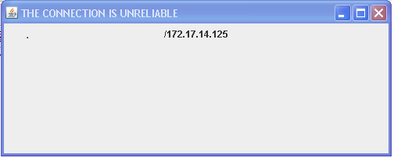

- Signature attack (TCP):

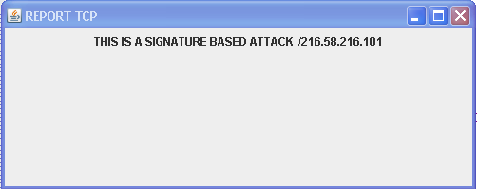

- Syn-Flood attack:

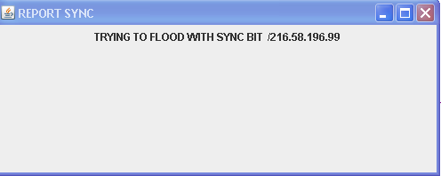

- Anomaly based attack (ICMP):

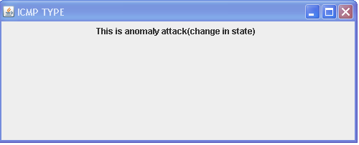

- Access to private port (UDP):

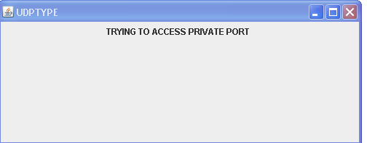

- Conclusion

Thus, the Intrusion Detection System (IDS) detects various types of attacks on the network and makes a general report about all the attacks occurred in the network.

Date: _____________ Signature of faculty in-charge

