Nilesh

[company name]

[Document title]

[Document subtitle]

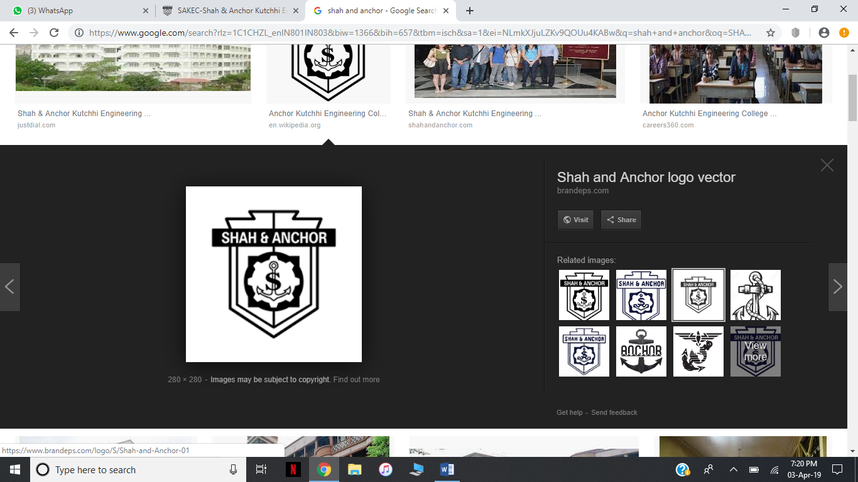

MAHAVIR EDUCATION TRUST’S

SHAH AND ANCHOR KUTCHHI ENGINEERING COLLEGE

**PYTHON LAB PROJECT REPORT**

|  |  |
| --- | --- |
| ROLL NO. | NAME |
| 58. | MIRAJ SHAH |
| 59. | MITESH SHAH |
| 60. | NAIVEDH SHAH |
| 61. | NIYATI SHAH |
| 62. | SAHIL SHAH |

TOPIC – EXAMINATION MANAGEMENT

PROBLEM STATEMENT:

With the advent in technology and with perpetual increase in the strength of the students and the number of departments in educational institution, it becomes chaotic situation for students and staff when an examination is to be conducted .

The Exam management system eases the job in conducting an exam for both teachers as well as students by:

1. Creating a secured account for both teacher and student so that it is easy for them to do their own task.

2. Once teacher logged in

a. They can upload as well as edit the result of the individuals.

b. Teachers can delete the marks of a student only after reverification of the profile by re-entering the password.

c. They can see the result of the whole class

d. A detailed statistics of the class can be obtained where in the top 10 ranks and failed students can be listed separately.

3. Once student logged in

a. After logging in the student can check the number assigned to them and if in case its not generated the student can generate by themselves.

b. He/She can see only his/hers result and not others by entering the seat no.

c. Students can see the upcoming examination time table.

DATABASE SCHEMA:

tstaff(staffid,staffpassword)

desc tstaff;

+---------------+-------------+------+-----+---------+-------+

| Field | Type | Null | Key | Default | Extra |

+---------------+-------------+------+-----+---------+-------+

| staffid | varchar(20) | NO | PRI | NULL | |

| staffpassword | varchar(10) | NO | | NULL | |

+---------------+-------------+------+-----+---------+-------+

tstudent(rollno,seatno,studentpassword,name)

desc tstudent;

+-----------------+-------------+------+-----+---------+-------+

| Field | Type | Null | Key | Default | Extra |

+-----------------+-------------+------+-----+---------+-------+

| rollno | varchar(10) | NO | PRI | NULL | |

| seatno | varchar(10) | YES | | NULL | |

| studentpassword | varchar(10) | NO | | NULL |

| studentname | varchar(20) | NO | | NULL | |

+-----------------+-------------+------+-----+---------+-------+

Subject(subjectno,subjectname)

desc subject;

+-------------+-------------+------+-----+---------+-------+

| Field | Type | Null | Key | Default | Extra |

+-------------+-------------+------+-----+---------+-------+

| subjectno | int(10) | NO | PRI | NULL | |

| subjectname | varchar(20) | NO | | NULL | |

+-------------+-------------+------+-----+---------+-------+

Marks(seatno,subjectno,subjectmarks)

desc Marks;

+--------------+-------------+------+-----+---------+-------+

| Field | Type | Null | Key | Default | Extra |

+--------------+-------------+------+-----+---------+-------+

| seatno | varchar(10) | NO | | NULL | |

| subjectno | int(10) | NO | MUL | NULL | |

| subjectmarks | int(11) | NO | | NULL | |

db=mysql.connector.connect(host="localhost",user="root",passwd="",database="em1")

stmt=db.cursor()

SOURCE CODE:

import random

import tkinter

from tkinter import *

from tkinter import messagebox

import mysql.connector

def timetable():

w101=tkinter.Toplevel(root)

w101.title("SE-EXAM TIME TAABLE")

w101.geometry("1000x525")

pic3 = PhotoImage(file = "C:\\Users\\Nilesh\\Desktop\\sem4\\EXAMINATION MANAGEMENT\\pics\\kjk.png")

w = Label(w101, image=pic3,anchor=CENTER)

w.photo = pic3

w.place(x=300,y=100)

w.pack()

def failedstud():

w100=tkinter.Toplevel(root)

w100.title("SE-5")

w100.geometry("600x400")

db=mysql.connector.connect(host="localhost",user="root",passwd="",database="em1")

stmt=db.cursor()

stmt.execute(" select subject.subjectno,subject.subjectname,marks.seatno, marks.subjectno, marks.subjectmarks,tstudent.studentname from subject,marks,tstudent where marks.subjectno=subject.subjectno and tstudent.seatno=marks.seatno having(subjectmarks)<32 order by marks.seatno;");

rs=stmt.fetchall()

ll=tkinter.Listbox(w100)

i=0

str2=tkinter.StringVar()

str2=""

for fp in rs:

i=i+1

str2+= str(fp[2])+" | "+ fp[5]+" | "+str(fp[1])

ll.insert(tkinter.END,str2+ " | MARKS= "+str(fp[4]))

str2=""

ll.pack(fill=tkinter.BOTH, expand=tkinter.YES)

def closebfs1():

w100.withdraw()

bfs1=tkinter.Button(w100,text ="Go Back",command=closebfs11)

bfs1.pack()

def sresult():

global s0

global s1

global s2

global s3

global s4

global s5

global s6

def showresult():

global s0

global s1

global s2

global s3

global s4

global s5

global s6

db=mysql.connector.connect(host="localhost",user="root",passwd="",database="em1")

stmt=db.cursor()

stmt.execute("select * from marks where seatno='"+esr1.get()+"'")

rs=stmt.fetchall()

i=0

s0=esr1.get()

s1=""

s2=""

s3=""

s4=""

s5=""

s6=""

#if len(rs)==0

for x in rs:

i=i+1

s0=x[0]

if i==1: s1=str(x[2])

elif i==2: s2=str(x[2])

elif i==3: s3=str(x[2])

elif i==4: s4=str(x[2])

elif i==5: s5=str(x[2])

elif i==6: s6=str(x[2])

w9.withdraw()

sresult()

v1=tkinter.StringVar()

v2=tkinter.StringVar()

v3=tkinter.StringVar()

v4=tkinter.StringVar()

v5=tkinter.StringVar()

v6=tkinter.StringVar()

v7=tkinter.StringVar()

v8=tkinter.StringVar()

v1.set(s0)

v2.set(s1)

v3.set(s2)

v4.set(s3)

v5.set(s4)

v6.set(s5)

v7.set(s6)

if len(s0)==0 or len(s1)==0 or len(s2)==0 or len(s2)==0 or len(s3)==0 or len(s4)==0 or len(s5)==0 or len(s6)==0 :

v8.set("")

else:

total=(int(s1)+int(s2)+int(s3)+int(s4)+int(s5)+int(s6))/6.0

v8.set(str(total))

w9=tkinter.Toplevel(root)

w9.title("SEM-IV")

w9.geometry("425x500")

pic3 = PhotoImage(file="C:\\Users\\Nilesh\\Downloads\\225.png")

w = Label(w9, image=pic3,anchor=NW)

w.photo = pic3

w.place(x=100,y=300)

w.pack()

lsr1=tkinter.Label(w9,text="ENTER SEAT NO.")

lsr1.place(x=50,y=25)

esr1=tkinter.Entry(w9, textvariable=v1)

esr1.place(x=160,y=25)

bsr2=tkinter.Button(w9,text ="SHOW",command=showresult)

bsr2.place(x=130,y=72)

lsr2=tkinter.Label(w9,text="AM-IV")

lsr2.place(x=50,y=125)

esr2=tkinter.Entry(w9 ,textvariable=v2)

esr2.place(x=150,y=125)

lsr3=tkinter.Label(w9,text="COA")

lsr3.place(x=50,y=175)

esr3=tkinter.Entry(w9 , textvariable=v3)

esr3.place(x=150,y=175)

lsr4=tkinter.Label(w9,text="PYTHON LAB")

esr4=tkinter.Entry(w9,textvariable=v4)

lsr4.place(x=50,y=225)

esr4.place(x=150,y=225)

lsr5=tkinter.Label(w9,text="OS")

lsr5.place(x=50,y=275)

esr5=tkinter.Entry(w9,textvariable=v5)

esr5.place(x=150,y=275)

lsr6=tkinter.Label(w9,text="AT")

lsr6.place(x=50,y=325)

esr6=tkinter.Entry(w9,textvariable=v6)

esr6.place(x=150,y=325)

lsr7=tkinter.Label(w9,text="CN")

lsr7.place(x=50,y=375)

esr7=tkinter.Entry(w9,textvariable=v7)

esr7.place(x=150,y=375)

lsr8=tkinter.Label(w9,text="PERCENTAGE")

lsr8.place(x=175,y=425)

esr8=tkinter.Entry(w9,textvariable=v8)

esr8.place(x=150,y=450)

def gobackshowresult():

w9.withdraw()

bsr1=tkinter.Button(w9,text ="Go Back",command=gobackshowresult)

bsr1.place(x=360,y=460)

def classresult():

w8=tkinter.Toplevel(root)

w8.title("SE-5 : SEM IV")

w8.geometry("600x400")

db=mysql.connector.connect(host="localhost",user="root",passwd="",database="em1")

stmt=db.cursor()

stmt.execute("Select * from marks order by seatno");

rs=stmt.fetchall()

l=tkinter.Listbox(w8)

i=0

str1=tkinter.StringVar()

str1=""

for x in rs:

i=i+1

if i%6==1:

str1+=x[0]+ " | Maths=" +str(x[2])

if i%6==2:

str1+= " | COA=" +str(x[2])

if i%6==3:

str1+=" | Python Lab=" +str(x[2])

if i%6==4:

str1+= " | OS=" +str(x[2])

if i%6==5:

str1+= " | AT=" +str(x[2])

if i%6==0:

l.insert(tkinter.END,str1+ " | CN=" +str(x[2]))

str1=""

l.pack(fill=tkinter.BOTH, expand=tkinter.YES)

def closebcr1():

w8.withdraw()

bcr1=tkinter.Button(w8,text ="Go Back",command=closebcr1)

bcr1.pack()

def deletemarks():

def msgboxdm():

global username

w7.withdraw()

db=mysql.connector.connect(host="localhost",user="root",passwd="",database="em1")

stmt=db.cursor()

stmt.execute("select * from tstaff where staffid='"+username+"' and staffpassword='"+e9.get()+"'")

rs=stmt.fetchall()

if len(rs)==0:

messagebox.showinfo(title="INVALID",message="Password does not match")

else :

stmt.execute("delete from marks where seatno='"+e8.get()+"'")

db.commit()

messagebox.showinfo(title="DELETED",message="Marks are deleted!")

w7=tkinter.Toplevel(root)

w7.title("SE-5")

w7.geometry("600x200")

pic3 = PhotoImage(file="C:\\Users\\Nilesh\\Downloads\\black-metal-grill-texture-x-textured-473647.png")

w = Label(w7, image=pic3,anchor=CENTER)

w.photo = pic3

w.place(x=300,y=100)

w.pack()

l8=tkinter.Label(w7,text="Enter Seat No.")

l8.place(x=235,y=50)

e8=tkinter.Entry(w7)

e8.place(x=365,y=50)

l9=tkinter.Label(w7,text="Password for verification")

l9.place(x=225,y=100)

e9=tkinter.Entry(w7)

e9.place(x=365,y=100)

bdm1=tkinter.Button(w7,text ="Delete Marks",command=msgboxdm)

bdm1.place(x=255,y=150)

def uploadmarks():

def msgboxum()

db=mysql.connector.connect(host="localhost",user="root",passwd="",database="em1")

stmt=db.cursor()

stmt.execute("delete from marks where seatno='"+e1.get()+"'")

stmt.execute("insert into marks values('"+e1.get()+"',1,"+e2.get()+")")

stmt.execute("insert into marks values('"+e1.get()+"',2,"+e3.get()+")")

stmt.execute("insert into marks values('"+e1.get()+"',3,"+e4.get()+")")

stmt.execute("insert into marks values('"+e1.get()+"',4,"+e5.get()+")")

stmt.execute("insert into marks values('"+e1.get()+"',5,"+e6.get()+")")

stmt.execute("insert into marks values('"+e1.get()+"',6,"+e7.get()+")")

db.commit()

messagebox.showinfo(title="ENTERED",message="Marks are successfully entered!")

w6.withdraw(

w6=tkinter.Toplevel(root)

w6.title("SE-5")

w6.geometry("500x350")

#c1=Canvas(w6, bg="purple2", height=1000, width=800)

l1=tkinter.Label(w6,text="ENTER SEAT NO.")

l1.pack()

e1=tkinter.Entry(w6)

e1.pack()

l2=tkinter.Label(w6,text="AM-IV")

l2.pack()

e2=tkinter.Entry(w6)

e2.pack()

l3=tkinter.Label(w6,text="COA")

l3.pack()

e3=tkinter.Entry(w6)

e3.pack()

l4=tkinter.Label(w6,text="PYTHON LAB")

e4=tkinter.Entry(w6)

l4.pack()

e4.pack()

l5=tkinter.Label(w6,text="OS")

l5.pack()

e5=tkinter.Entry(w6)

e5.pack()

l6=tkinter.Label(w6,text="AT")

l6.pack()

e6=tkinter.Entry(w6)

e6.pack()

l7=tkinter.Label(w6,text="CN")

l7.pack()

e7=tkinter.Entry(w6)

e7.pack()

bum1=tkinter.Button(w6,text ="Enter Marks",command=msgboxum)

bum1.pack()

def closebum2():

w6.withdraw()

bum2=tkinter.Button(w6,text ="Go Back",command=closebum2)

bum2.pack()

def top10():

global p0

global p1

global p2

global p3

global p4

global p5

global p6

global p7

global p8

global p9

def top102():

global p0

global p1

global p2

global p3

global p4

global p5

global p6

global p7

global p8

global p9

db=mysql.connector.connect(host="localhost",user="root",passwd="",database="em1")

stmt=db.cursor()

stmt.execute("select studentname,marks.seatno from tstudent,marks where tstudent.seatno=marks.seatno group by seatno having max(subjectmarks) order by sum(subjectmarks) desc;")

rs=stmt.fetchall()

p0=""

p1=""

p2=""

p3=""

p4=""

p5=""

p6=""

p7=""

p8=""

p9=""

ii=0

for xxx in rs:

ii=ii+1

if ii==1: p0=("1.",xxx[0])

elif ii==2: p1=("2.",xxx[0])

elif ii==3: p2=("3",xxx[0])

elif ii==4: p3=("4.",xxx[0])

elif ii==5: p4=("5.",xxx[0])

elif ii==6: p5=("6.",xxx[0])

elif ii==7: p6=("7.",xxx[0])

elif ii==8: p7=("8.",xxx[0])

elif ii==9: p8=("9.",xxx[0])

elif ii==10:p9=("10.",xxx[0])

w10.withdraw()

top10()

w10=tkinter.Toplevel()

w10.title("SEM 4: TOP 10")

w10.geometry("600x400")

vv1=tkinter.StringVar()

vv2=tkinter.StringVar()

vv3=tkinter.StringVar()

vv4=tkinter.StringVar()

vv5=tkinter.StringVar()

vv6=tkinter.StringVar()

vv7=tkinter.StringVar()

vv8=tkinter.StringVar()

vv9=tkinter.StringVar()

vv10=tkinter.StringVar()

vv1.set(p0)

vv2.set(p1)

vv3.set(p2)

vv4.set(p3)

vv5.set(p4)

vv6.set(p5)

vv7.set(p6)

vv8.set(p7)

vv9.set(p8)

vv10.set(p9)

ett1=tkinter.Entry(w10, textvariable=vv1)

ett1.pack()

ett2=tkinter.Entry(w10, textvariable=vv2)

ett2.pack()

ett3=tkinter.Entry(w10, textvariable=vv3)

ett3.pack()

ett4=tkinter.Entry(w10, textvariable=vv4)

ett4.pack()

ett5=tkinter.Entry(w10, textvariable=vv5)

ett5.pack()

ett6=tkinter.Entry(w10, textvariable=vv6)

ett6.pack()

ett7=tkinter.Entry(w10, textvariable=vv7)

ett7.pack()

ett8=tkinter.Entry(w10, textvariable=vv8)

ett8.pack()

ett9=tkinter.Entry(w10, textvariable=vv9)

ett9.pack()

ett10=tkinter.Entry(w10, textvariable=vv10)

ett10.pack()

btp1=tkinter.Button(w10,text ="Show",command=top102)

btp1.pack()

def closetop():

w10.withdraw()

btp2=tkinter.Button(w10,text ="GO Back",command=closetop)

btp2.pack()

def statistics():

w11=tkinter.Toplevel()

w11.title("SEM 4: ANALYSIS")

w11.geometry("670x200")

pic100 = PhotoImage(file="C:\\Users\\Nilesh\\Downloads\\new-statistics.png")

w = Label(w11, image=pic100,anchor=NW)

w.photo = pic100

w.place(x=100,y=300)

w.pack()

bn3=tkinter.Button(w11,text ="Top 10 students",command=top10)

bn3.place(x=313,y=75)

bn4=tkinter.Button(w11,text ="Failed Students",command=failedstud)

bn4.place(x=313,y=125)

def closestat():

w11.withdraw()

bn2=tkinter.Button(w11,text ="Go Back",command=closestat)

bn2.place(x=323,y=168

def stafflogin():

#root.withdraw()

def staff2():

global username

db=mysql.connector.connect(host="localhost",user="root",passwd="",database="em1")

stmt=db.cursor()

stmt.execute("select * from tstaff where staffid='"+et1.get()+"' and staffpassword='"+et2.get()+"'")

rs=stmt.fetchall()

if len(rs)==0:

print("Invalid login")

messagebox.showinfo(title="INVALID",message="INVALID CREDENTIALS!")

else:

username=et1.get()

w2.withdraw()

w4=tkinter.Toplevel(root)

w4.title("SEM 4")

w4.geometry("400x400")

c=Canvas(w4, bg="light cyan", height=1000, width=800)

c.pack()

c.create_text(125,22,fill="darkblue",font="Times 28 italic bold",text="Welcome,user!",justify=CENTER)

c.update

bt21=tkinter.Button(w4,text ="Upload/Edit Marks",command=uploadmarks) #left

bt21.place(x=160,y=100)

bt31=tkinter.Button(w4,text ="Delete Marks",command=deletemarks) #left

bt31.place(x=166,y=150)

bt24=tkinter.Button(w4,text ="Class Result",command=classresult)

bt24.place(x=167,y=200)

bn1=tkinter.Button(w4,text ="Statistics",command=statistics)

bn1.place(x=172,y=250)

def close25():

global username

username=""

w4.withdraw()

bt25=tkinter.Button(w4,text ="Sign out",command=close25)

bt25.place(x=171,y=300)

w4.mainloop()

w2=tkinter.Toplevel(root)

w2.title("Staff LOGIN")

w2.geometry("600x200")

C = Canvas(w2, bg="lightgoldenrod", height=1000, width=800)

C.pack()

lt2=tkinter.Label(w2,text="Teacher ID")

lt2.place(x=190,y=10)

et1=tkinter.Entry(w2)

et1.place(x=270,y=10)

lt3=tkinter.Label(w2,text="Password",)

lt3.place(x=197,y=50)

et2=tkinter.Entry(w2,show="*")

et2.place(x=270,y=50)

bt2=tkinter.Button(w2,text ="LOGIN",command=staff2 )

bt2.place(x=310,y=70)

def closebt3():

w2.withdraw()

bt3=tkinter.Button(w2,text ="GO BACK",command=closebt3)

bt3.place(x=305,y=100)

w2.mainloop()

def studentlogin():

#root.withdraw()

def student2():

global username

db=mysql.connector.connect(host="localhost",user="root",passwd="",database="em1")

stmt=db.cursor()

stmt.execute("select * from tstudent where rollno='"+es1.get()+"' and studentpassword='"+es2.get()+"'")

rs=stmt.fetchall()

if len(rs)==0:

print("Invalid login")

messagebox.showinfo(title="INVALID",message="INVALID CREDENTIALS!")

else:

username=es1.get()

w3.withdraw()

w5=tkinter.Toplevel(root)

w5.title("SEM IV")

w5.geometry("500x300")

C = Canvas(w5, bg="SteelBlue1", height=1000, width=800

C.pack()

def gen_seatno():

global username

while(True):

randseatno=random.randint(999,1051)

db=mysql.connector.connect(host="localhost",user="root",passwd="",database="em1")

stmt=db.cursor()

stmt.execute("select * from tstudent where seatno='"+str(randseatno)+"'")

#print("select * from tstudent where rollno='"+username+"' and seatno<>''")

rs=stmt.fetchall()

if len(rs)==0:

# update

stmt.execute("update tstudent set seatno='"+str(randseatno)+"' where rollno='"+username+"'")

db.commit()

messagebox.showinfo(title="GENERATED",message="Seat no. generated, please login again!")

w5.withdraw()

break

db=mysql.connector.connect(host="localhost",user="root",passwd="",database="em1")

stmt=db.cursor()

stmt.execute("select * from tstudent where rollno='"+username+"' and seatno<>''")

print("select * from tstudent where rollno='"+username+"' and seatno<>''")

rs=stmt.fetchall()

print(len(rs))

if len(rs)==0:

C.create_text(105,19,fill="darkblue",font="Times 25 italic bold",text="Welcome,user!")

C.update

bs21=tkinter.Button(w5,text =" Generate Exam Seat No.",command=gen_seatno)

bs21.place(x=100,y=50)

es21=tkinter.Entry(w5) #To-Display-SeatNO

es21.place(x=300,y=55)

else:

#bs21=tkinter.Button(w5,text ="Exam Seat No.",command="")

#bs21.pack()

C.create_text(105,19,fill="darkblue",font="Times 25 italic bold",text="Welcome,user!")

C.update

v=tkinter.StringVar()

for xx in rs:

v.set(xx[1])

break

es21=tkinter.Entry(w5,textvariable=v,state='disabled') #To-Display-SeatNO

es21.place(x=375,y=50)

bs24=tkinter.Button(w5,text ="Exam Timetable",command=timetable)

bs24.place(x=200,y=100)

bs25=tkinter.Button(w5,text ="Result",command=sresult)

bs25.place(x=215,y=150)

def closebs26():

w5.withdraw()

bs26=tkinter.Button(w5,text ="Sign out",command=closebs26)

bs26.place(x=400,y=255)

w3=tkinter.Toplevel(root)

w3.title("Student LOGIN")

w3.geometry("600x200")

C = Canvas(w3, bg="lightgoldenrod", height=1000, width=800)

pic2 = PhotoImage(file = "C:\\Users\\Nilesh\\Downloads\\aaa.png")

C.create_image(0,0, image=pic2,anchor=NW)

C.pack()

ls2=tkinter.Label(w3,text=" Student ID:")

ls2.place(x=190,y=10)

es1=tkinter.Entry(w3)

es1.place(x=270,y=10)

ls3=tkinter.Label(w3,text="Password:")

ls3.place(x=197,y=50)

es2=tkinter.Entry(w3,show="*")

es2.place(x=270,y=50)

bs2=tkinter.Button(w3,text ="LOGIN",command=student2)

bs2.place(x=310,y=70)

def closebs2():

w3.withdraw()

bs3=tkinter.Button(w3,text ="GO BACK",command=closebs2)

bs3.place(x=305,y=100)

global s0

global s1

global s2

global s3

global s4

global s5

global s6

global username

username=""

s0=""

s1=""

s2=""

s3=""

s4=""

s5=""

s6="”

global p0

global p1

global p2

global p3

global p4

global p5

global p6

global p7

global p8

global p9

p0=""

p1=""

p2=""

p3=""

p4=""

p5=""

p6=""

p7=""

p8=""

p9=""

root=tkinter.Tk()

root.geometry("600x400")

root.title("SHAH & ANCHOR KUTCHHI ENGINEERING COLLEGE")

C = Canvas(root, bg="blue", height=1000, width=800)

pic1 = PhotoImage(file = "C:\\Users\\Nilesh\\Downloads\\aaa.png")

C.create_image(0,0, image=pic1,anchor=NW)

C.pack()

mb=Menu(root)

about_menu = Menu(mb, tearoff=0)

mb.add_cascade(label="About us",menu=about_menu)

academic_menu = Menu(mb, tearoff=0)

mb.add_cascade(label="Academic",menu=academic_menu)

admission_menu = Menu(mb, tearoff=0)

mb.add_cascade(label="Admission",menu=admission_menu)

placement_menu = Menu(mb, tearoff=0)

mb.add_cascade(label="Placement",menu=placement_menu)

gallery_menu = Menu(mb, tearoff=0)

mb.add_cascade(label="Gallery",menu=gallery_menu)

researchcell_menu = Menu(mb, tearoff=0)

mb.add_cascade(label="Research Cell",menu=researchcell_menu)

login_menu = Menu(mb, tearoff=0)

mb.add_cascade(label="Events",menu=about_menu)

events_menu = Menu(mb, tearoff=0)

mb.add_cascade(label="Contact us",menu=about_menu)

contact_menu = Menu(mb, tearoff=0)

mb.add_cascade(label=" login",menu=login_menu)

login_menu.add_command(label="Teachers login",command=stafflogin)

login_menu.add_separator()

login_menu.add_command(label="Student Login",command=studentlogin)

root.config(menu=mb)

root.mainloop()

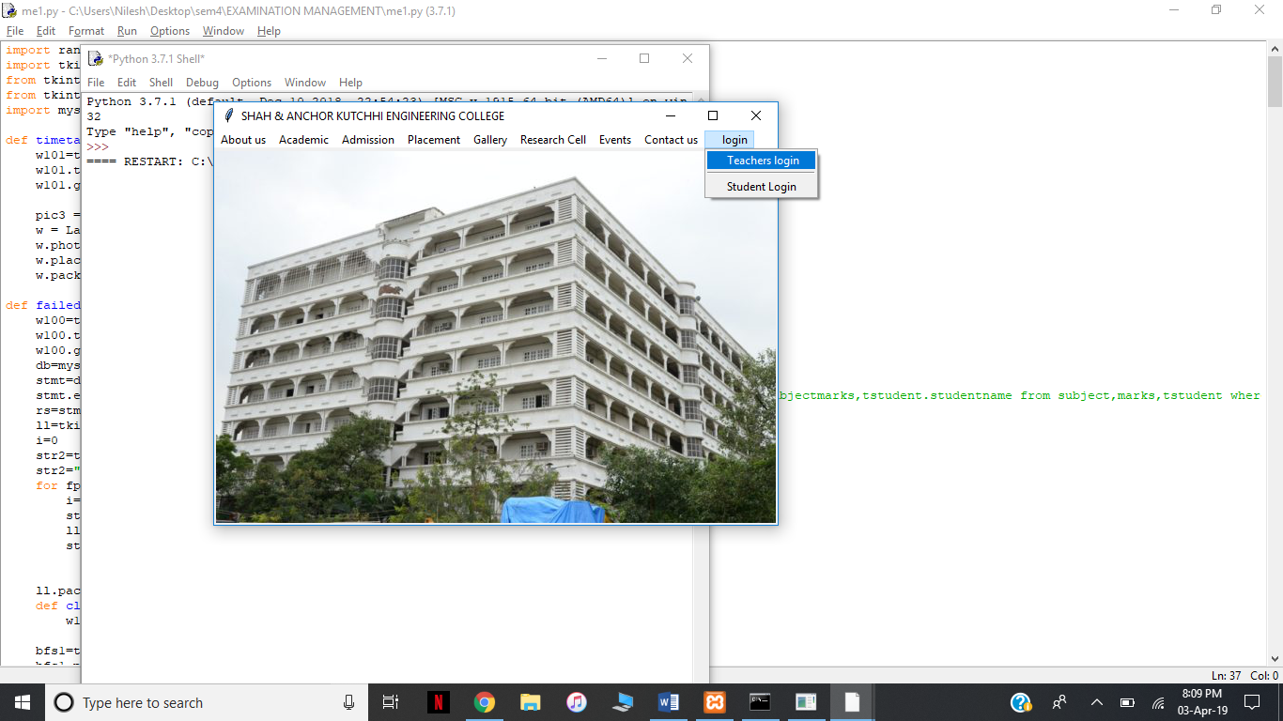**OUTPUT:**





