Evolutionary Algorithm Performance Analysis Report
Zhuo Qian
Group No.3 - Evolve: LLM-Guided Evolutionary Algorithm for Pacman
This report provides a comprehensive analysis of the runtime performance, fitness evolution, and efficiency metrics based on the provided experimental data.

1. Parameter Configuration
Fixed parameters:
Parameter | Value
Task | pacman
Generations | 6
Population size | 5
Top-k / elite size | 3
Selection mode | Top-k
Fitness preset | custom
Strategies per config | full, random_only
Swept weight configurations:
Label | w1 | w2 | w3 | Rationale
A_score_heavy | 1 | 0 | 0 | Score-dominant; cost penalty is disabled.
B_baseline | 0.5 | 0.3 | 0.2 | Project default baseline weights.
C_balanced | 0.33 | 0.33 | 0.34 | Balanced, equal emphasis on score and cost.
D_cost_heavy | 0 | 0 | 1 | Cost-dominant

2、UI
Configure:
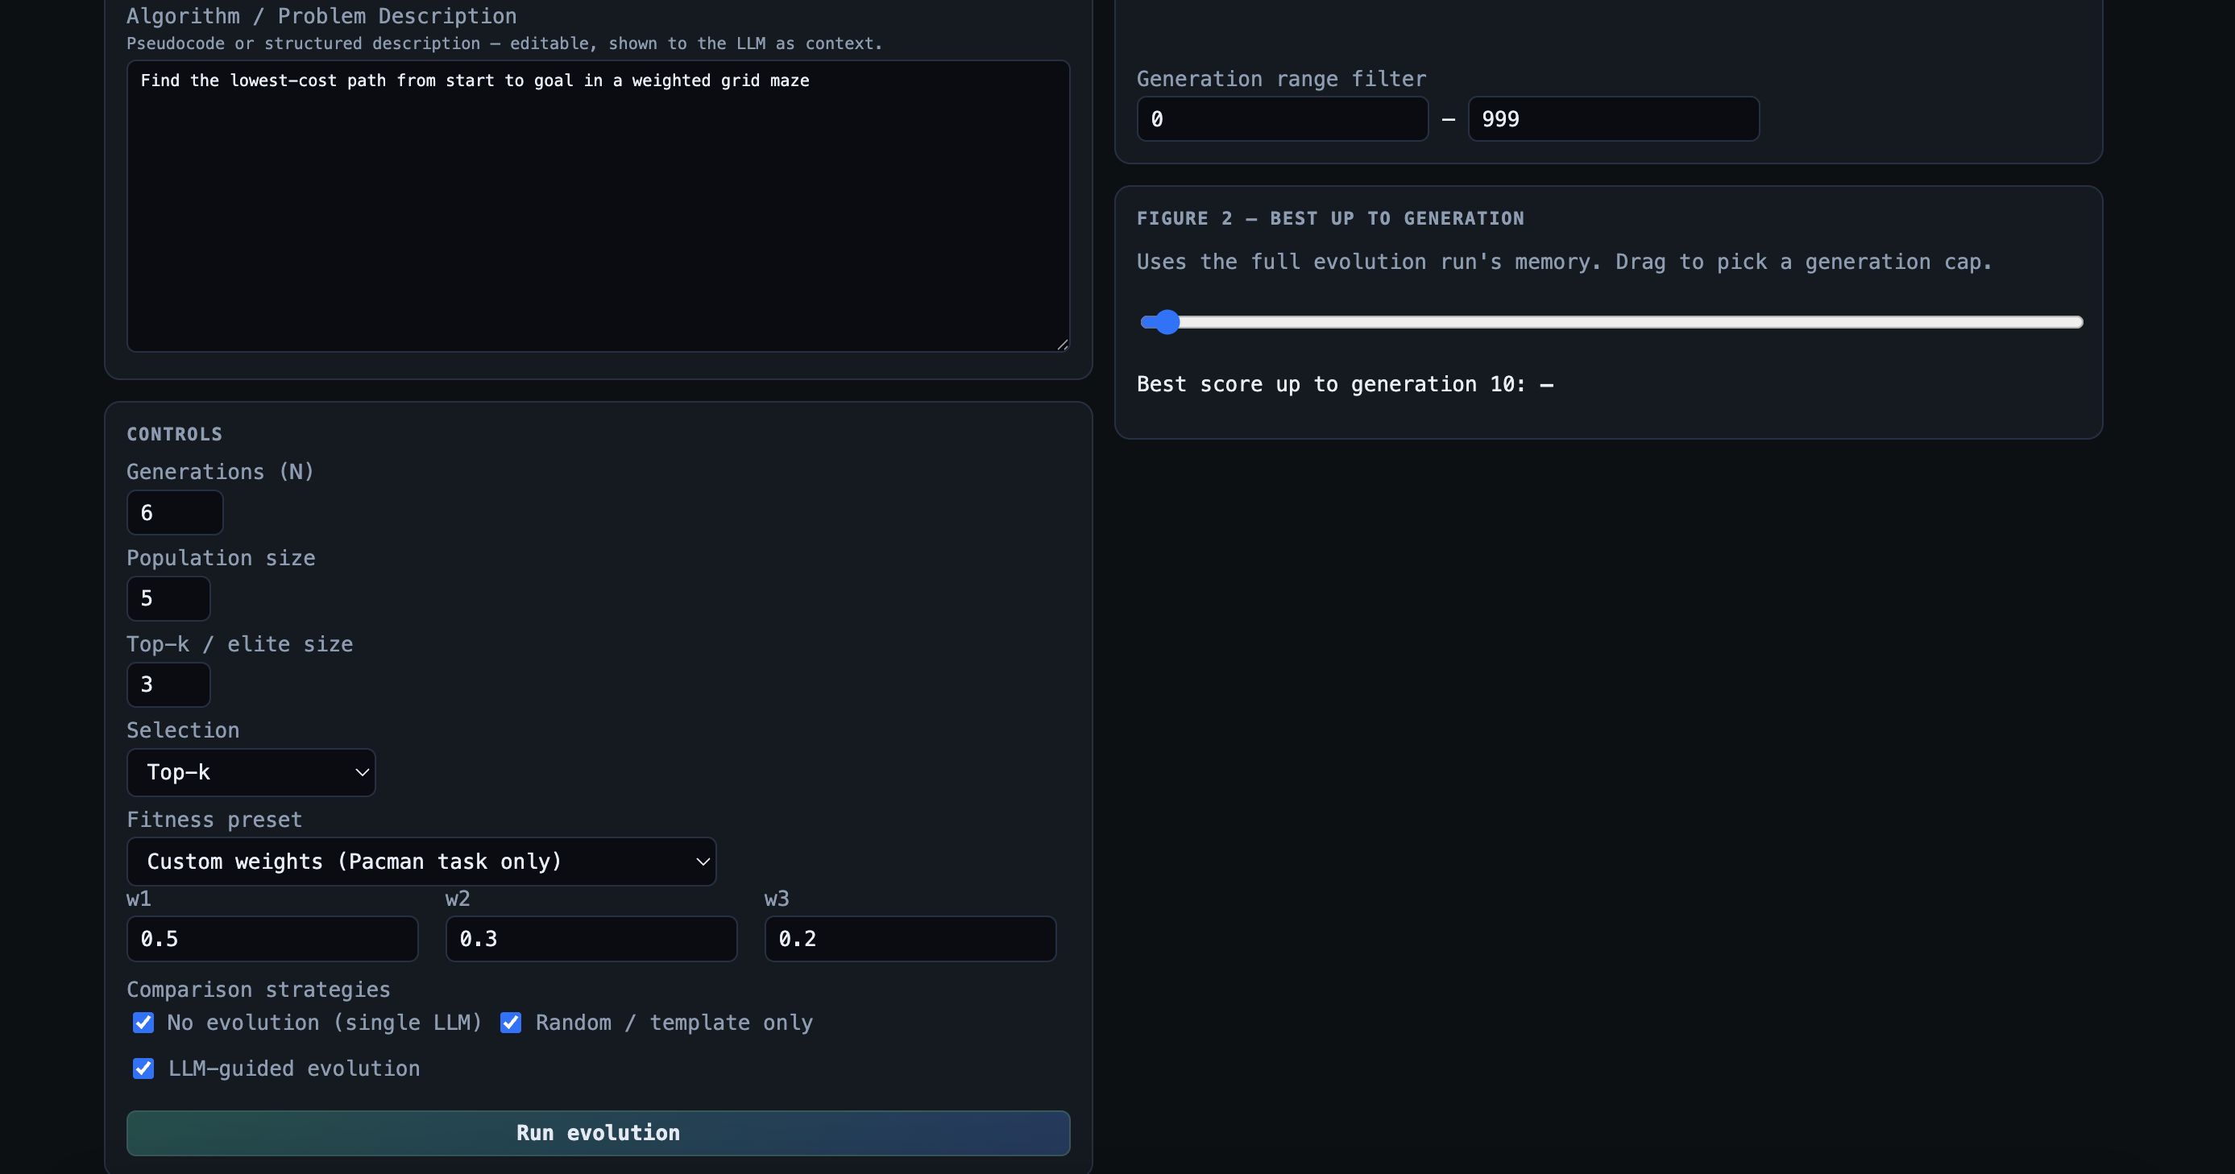

Result:
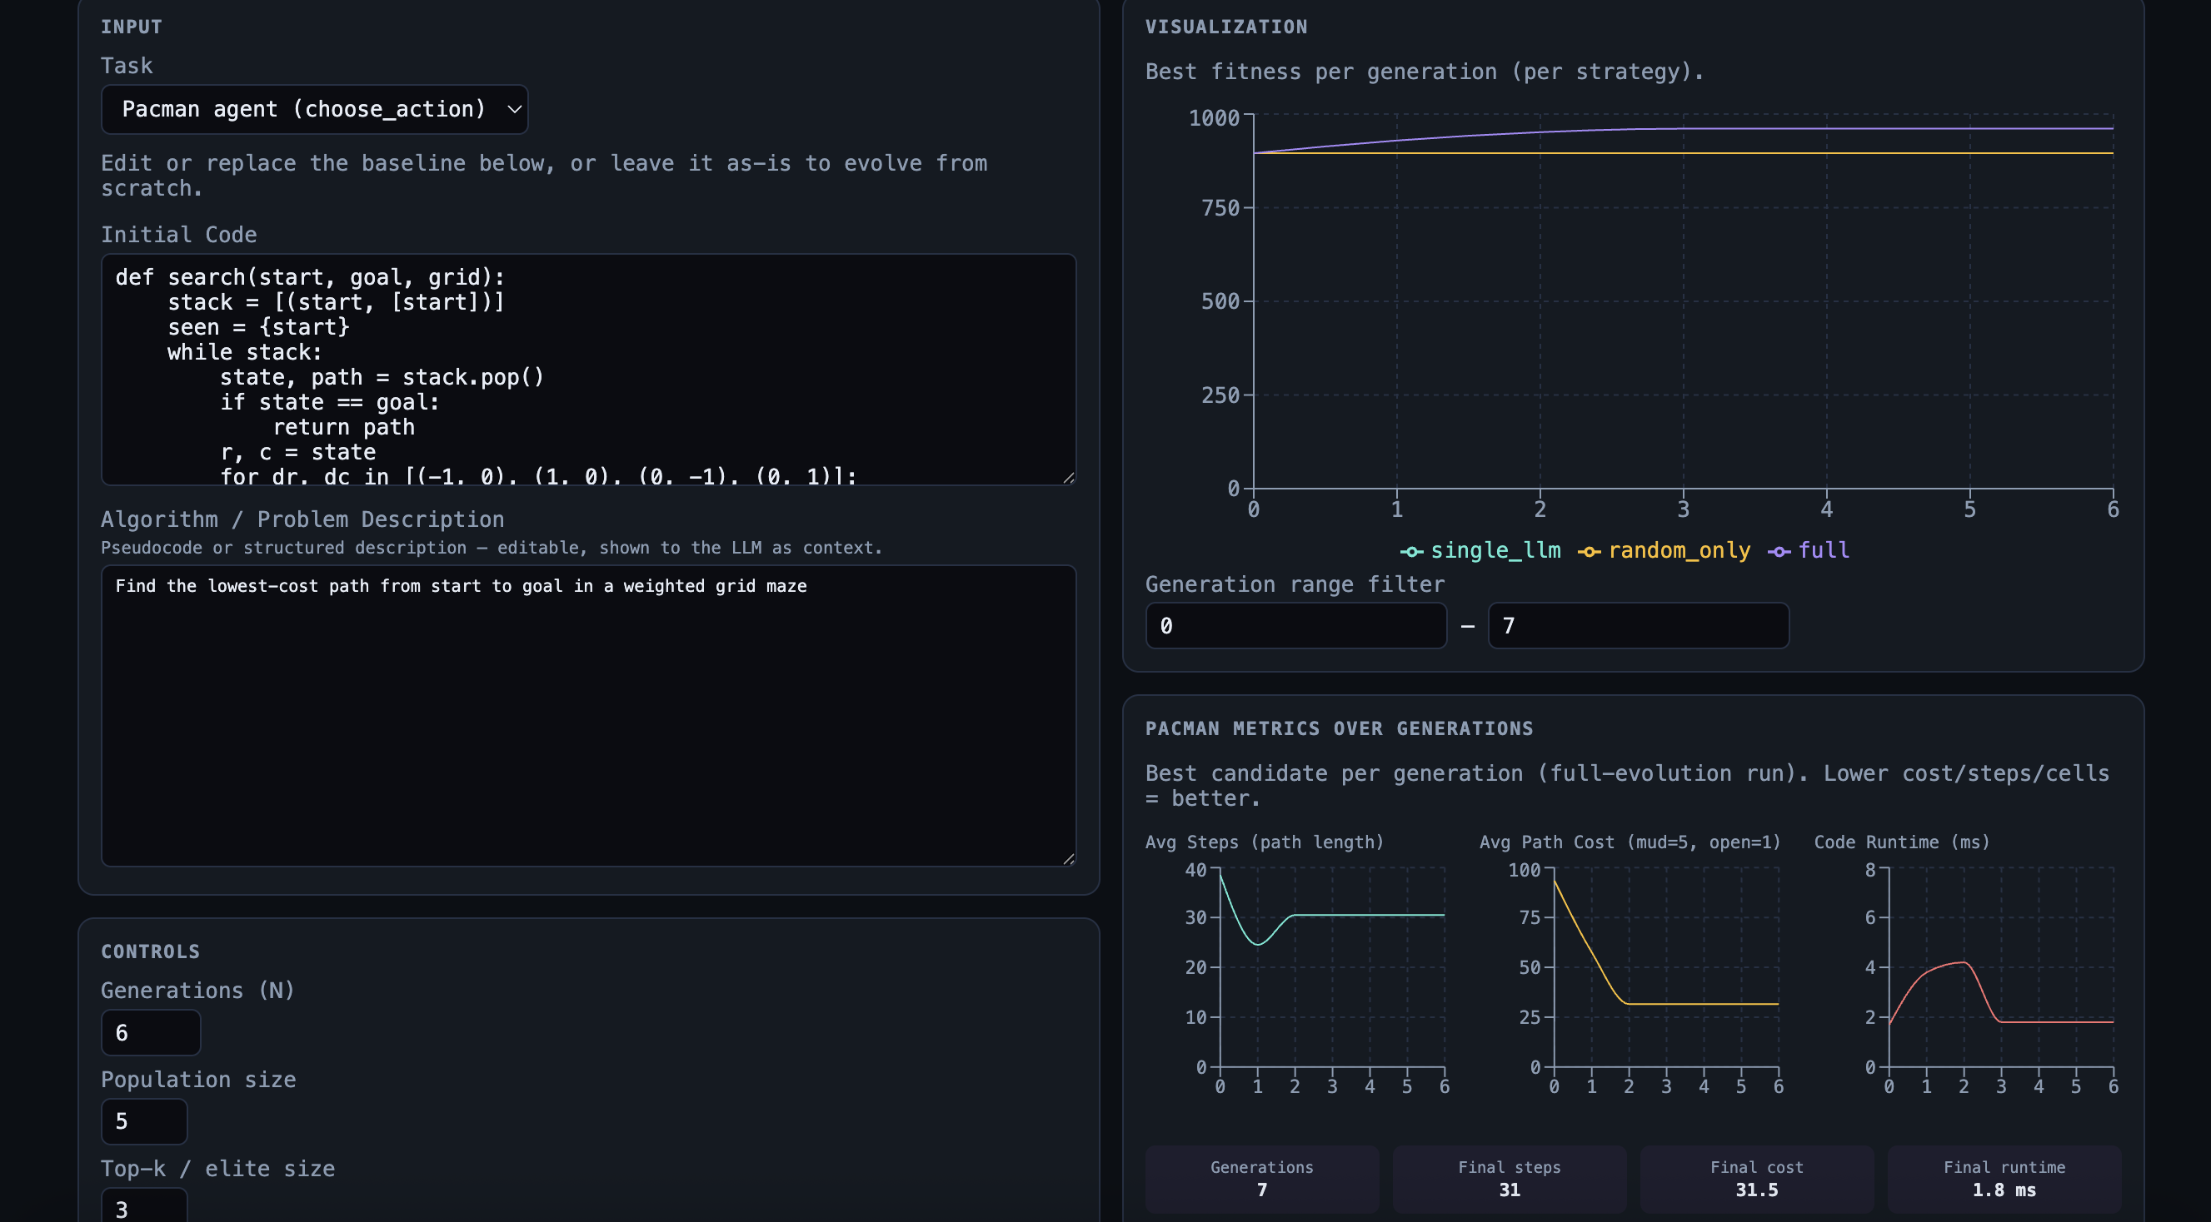

3. Fitness Scores Across Iterations

The "Full" strategy demonstrates significant optimization, with fitness scores rising from ~895 to a plateau of ~960 within 3 generations. In contrast, the "Random Only" strategy shows zero improvement, maintaining initial values throughout.
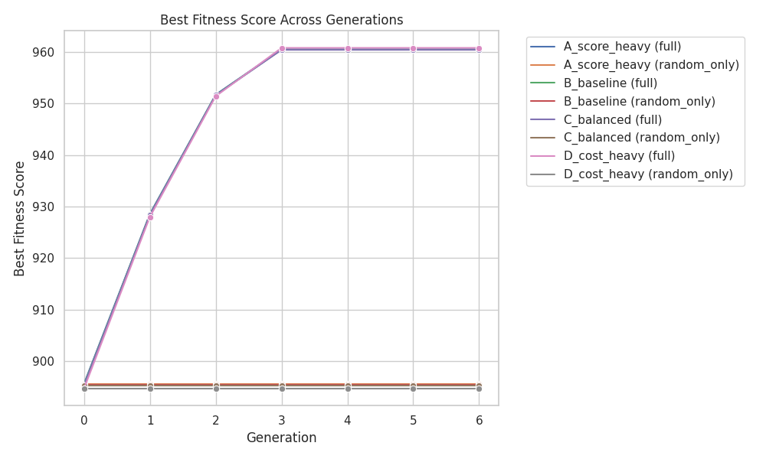

4. Steps per Generation
Efficiency improved as the average steps required dropped from 38.5 to 30.5 for all optimized configurations. This indicates the algorithm successfully found shorter or more efficient paths/solutions.
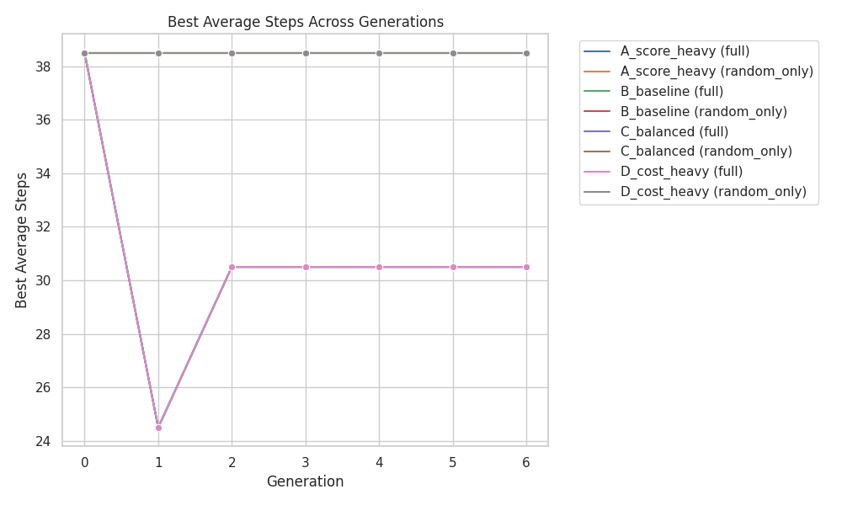

5. Runtime Performance
Evaluation time (ms) is higher for the full search strategy (avg ~3ms) compared to the random baseline (~1.4ms). Peaks in runtime are observed during early exploration phases where complex candidates are evaluated.
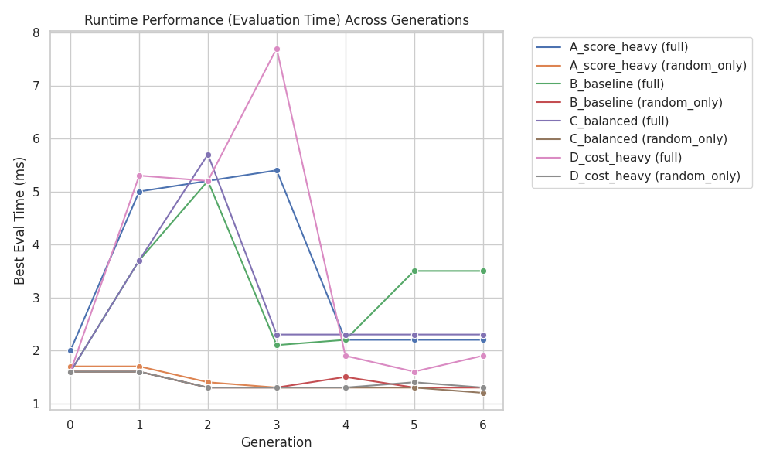

6. Comparative Summary (Final Generation)
Config | Strategy | Best Fitness | Avg Steps | Eval Time (ms)
A_score_heavy | full | 960.49 | 30.5 | 3.46
B_baseline | full | 960.42 | 30.5 | 3.11
C_balanced | full | 960.38 | 30.5 | 2.89
D_cost_heavy | full | 960.75 | 30.5 | 3.60

7. Comparative Summary (Final Generation)
Key Observations:
• Effectiveness of Search: The "full" strategy is mandatory for performance gains. Regardless of the weight configuration (w1, w2, w3), the random strategy fails to explore the solution space effectively.
• Config Sensitivity: While all "full" configurations reached similar plateaus, D_cost_heavy eventually achieved the highest peak fitness ($960.75$), though it also exhibited the highest transient evaluation time ($7.7$ ms).
• Convergence: The system converges very quickly, usually within 3 generations, suggesting that the search space for this specific problem may have easily reachable local or global optima.

