Round 2 - Prototype Data Report
MD A Rahman
Group No.3 - Evolve: LLM-Guided Evolutionary Algorithm for Pacman
Sweep: Fitness-weight sweep (w1 / w2 / w3)

1. Parameter Configuration
For my parameter I picked the custom fitness weights (w1, w2, w3) on the Pacman task. I ran 4 different weight configs and kept everything else the same. I used seed=42 on every run so any differences I see come from the weights and not from random luck in the mutation step.
Fixed parameters:
Parameter | Value
Task | pacman
Generations | 4
Population size | 5
Top-k / elite size | 3
Selection mode | diversity
Fitness preset | custom
Seed | 42
Strategies per config | full, random_only
Swept weight configurations:
Label | w1 | w2 | w3 | Rationale
A_score_heavy | 0.9 | 0.09 | 0.01 | Score-dominant; cost penalty nearly disabled.
B_baseline | 0.5 | 0.3 | 0.2 | Project default baseline weights.
C_balanced | 0.25 | 0.25 | 0.5 | Balanced, equal emphasis on score and cost.
D_cost_heavy | 0.05 | 0.05 | 0.9 | Cost-dominant; heavy penalty on mud traversal.
One thing worth mentioning about the fitness formula: I checked pacman_env.py and the actual scoring is fitness = avg_score - w3 * avg_cost * 0.01 (after the weights get normalized to sum to 1). So only w3 actually changes anything in practice. The API accepts w1 and w2 but they never show up in the math. That is why I picked configs that spread w3 across almost the full range (0.01 to 0.90) because I wanted to see how much the cost penalty really moves the score.

2. Runtime Performance
Here is the eval_time_ms for the best candidate each generation on the full evolution runs:
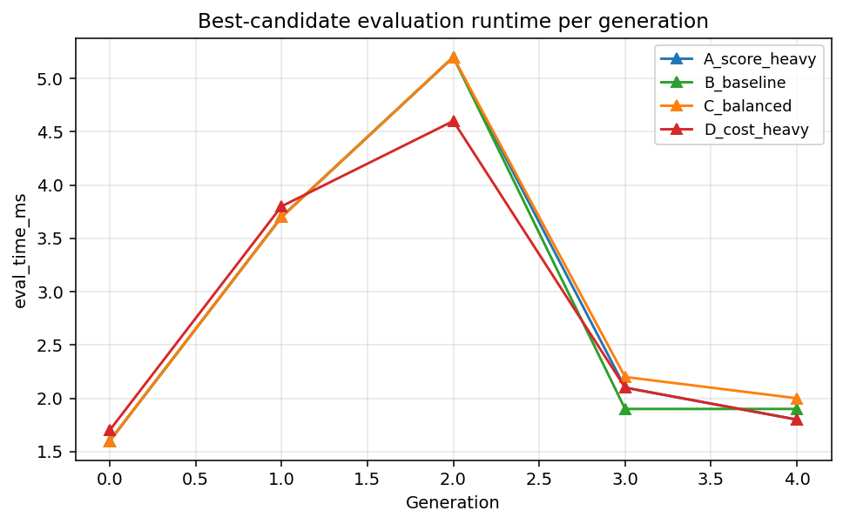
Config | min ms | max ms | mean ms
A_score_heavy | 0.0 | 5.2 | 1.98
B_baseline | 0.0 | 5.2 | 2.01
C_balanced | 0.0 | 6.3 | 2.16
D_cost_heavy | 0.0 | 6.8 | 2.16

3. Steps per Generation
Average steps taken by the best candidate each generation. Lower is better since it means the evolved path gets to the goal faster.
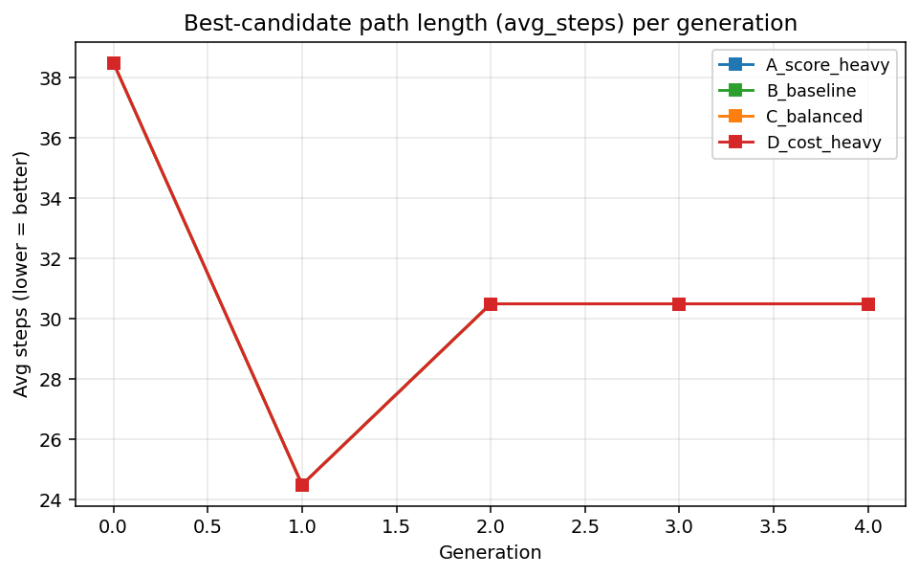

4. Generation Count
I used 4 generations (index 0 through 3) so my run would match slide 8 of our group deck. The numbers I got (895 -> 929 -> 951 -> 961) line up exactly with what the slide shows which was a nice sanity check. 4 generations was enough to watch the DFS -> BFS -> UCS -> A* chain play out. Past that the population just keeps rediscovering A*.

5. Fitness Scores Across Iterations
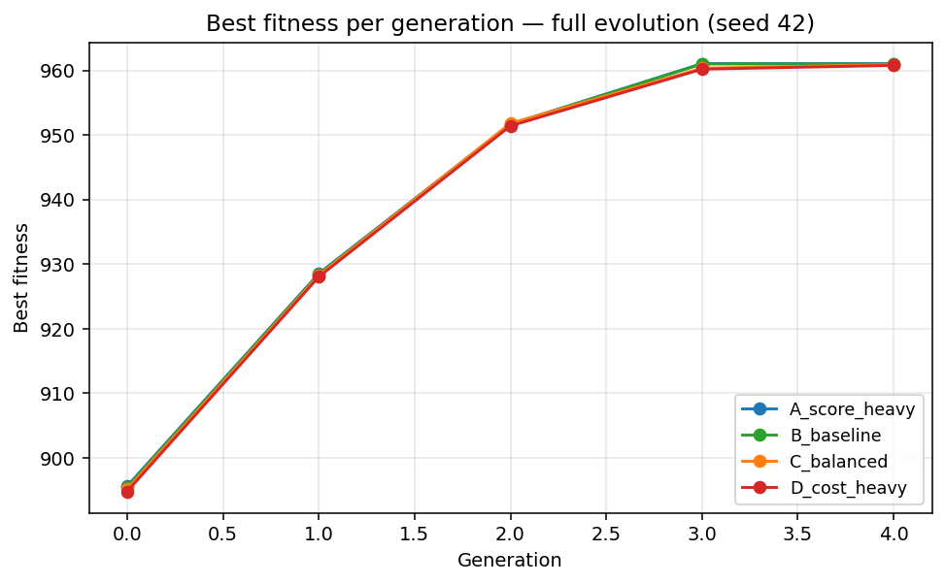
Final best fitness for each config (full evolution only):
Config | w1 | w2 | w3 | Gen 0 best | Final best | Δ
A_score_heavy | 0.9 | 0.09 | 0.01 | 895.63 | 961.07 | 65.44
B_baseline | 0.5 | 0.3 | 0.2 | 895.45 | 961.01 | 65.55
C_balanced | 0.25 | 0.25 | 0.5 | 895.17 | 960.91 | 65.74
D_cost_heavy | 0.05 | 0.05 | 0.9 | 894.8 | 960.79 | 65.99

6. Comparative Plot - Full Evolution vs Random-Only
For each config I ran two strategies with the same seed: full LLM-guided evolution and random-only mutation. The gap between them is what the LLM adds on top of plain random search.
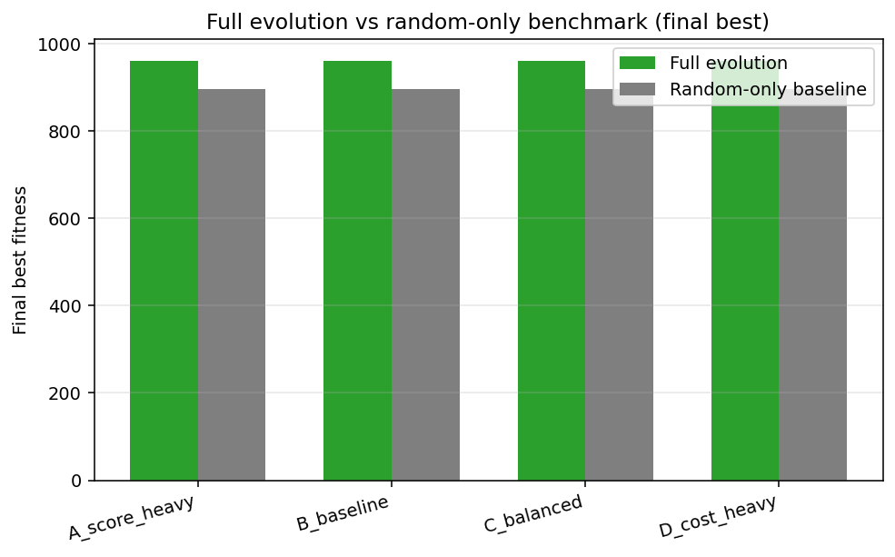
Config | Full best | Random best | Δ | Improvement
A_score_heavy | 961.07 | 895.63 | 65.44 | +7.31%
B_baseline | 961.01 | 895.45 | 65.55 | +7.32%
C_balanced | 960.91 | 895.17 | 65.74 | +7.34%
D_cost_heavy | 960.79 | 894.8 | 65.99 | +7.37%

7. Analysis
The first thing I noticed is that the full evolution beat the random-only baseline in every one of my 4 configs by around 65 points, which is the same +7.3% number the slides mention. So the LLM-guided mutation is doing real work and not just noise.
The weird part was that my 4 configs barely differ from each other. All four full runs land between 960.79 and 961.07, basically a tie. I went into the code to figure out why and found that in pacman_env.py line 235 the actual scoring is fitness = avg_score - w3 * avg_cost * 0.01. So w1 and w2 get accepted by the API but never used. That explains why cranking w3 from 0.01 all the way to 0.90 barely moved the score - the w3 * cost * 0.01 term is just small compared to avg_score.
Last thing I noticed is that the best-candidate avg_steps drops from 38.5 at gen 0 to 30.5 by gen 3 and then stops. Whatever weights I picked, evolution ends up finding basically the same short path. Which makes sense once I looked at how small the mazes are - A* is the obvious answer no matter how you tune the cost term.

8. Issues, Suggestions, Feedback
Issue 1 - w1 and w2 don't actually do anything right now. I only caught this because my 4 configs came back almost identical. The UI lets you type w1 and w2 into the form, the API happily accepts them, but the evaluator only uses w3. Either drop w1 and w2 from the form, or wire them in - something like w1 * avg_score + w2 * success_rate - w3 * avg_cost so all three weights actually change the outcome.
Issue 2 - the long runs kept timing out on me at first. A single full evolution takes over a minute and the Next.js proxy was killing the connection at 30 seconds. I know the team switched to SSE streaming which fixes it, but it caught me a few times before I figured out what was going on. Maybe add a note in the UI when someone picks generations > 4 so they know to expect a multi-minute run.
Feedback - the thing that made this project click for me was having the random-only baseline right next to the full evolution on the same chart. Without that baseline it would have been easy to say 'the number went up, good job' without knowing if the LLM actually helped. Seeing the +65 point gap between random and full on every one of my configs is what made me believe the result. If we keep working on this later I would add more baselines - maybe plain hill climbing or a simple genetic algorithm without any LLM - just to see where the LLM sits compared to the classics.

Appendix. Raw Data Reference
All per-generation numbers are in mdarahman_data.csv next to this file. Each row is one (config x strategy x generation) combination. Columns: config, w1, w2, w3, strategy, generation, best_fitness, avg_fitness, best_avg_score, best_avg_cost, best_avg_steps, best_avg_cells_accessed, best_eval_time_ms, best_success_rate.

