【1】电力曳引式升降机
Electric traction lift
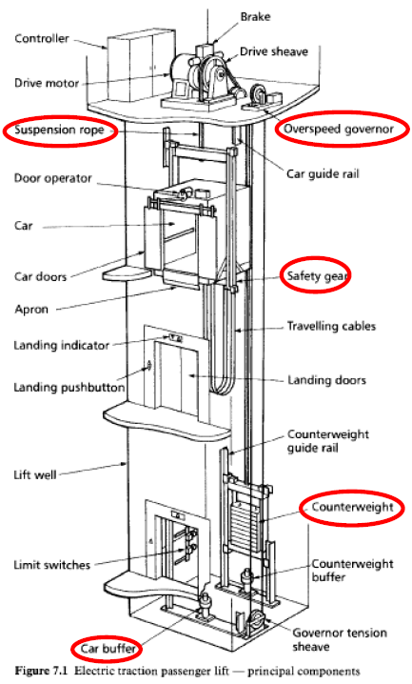
图 1 电力曳引式升降机 / Figure 1 Electric traction lift

电力曳引式：组成部分及功能
Electric traction lift: components and functions
组成部分 / Component | 功能 / Function
Controller  控制器 | 接收召梯指令，协调电动机、制动器及门机，控制运行和停车；平层控制提高停靠楼层的准确度。  Receives calls and coordinates the motor, brake and doors for travel and stopping; levelling control improves stopping accuracy at landings.
Drive motor  驱动电动机 | 提供机械动力转动曳引轮，驱动轿厢升降。  Provides mechanical power to rotate the drive sheave and move the car up or down.
Brake  制动器 | 使轿厢停止并保持静止；弹簧施闸、电力释放，断电自动施闸。因须制动轿厢与对重的总运动质量，制动力须大于相应的无对重系统。  Stops and holds the car; spring-applied and electrically released, so power loss applies it. Braking both car and counterweight requires greater braking capacity than an equivalent hoist without a counterweight.
Drive sheave  曳引轮 | 通过轮槽与悬吊绳的摩擦传递驱动力，使轿厢与对重反向运动。  Transmits driving force through friction between its grooves and the suspension ropes, moving car and counterweight in opposite directions.
Suspension rope  悬吊绳 | 承受并悬吊轿厢与对重，通过曳引轮传递的摩擦力使两者反向运动。  Supports and suspends the car and counterweight; traction from the drive sheave moves them in opposite directions.
Overspeed governor  限速器 | 监测轿厢速度；达到预定超速值时触发停止，并在需要时使安全钳或辅助制动器动作。  Monitors car speed and initiates stopping at a predetermined overspeed; it applies the safety gear or auxiliary brake when necessary.
Door operator  门机 | 驱动轿门，并在停层时联动层门；配合接近传感器，关门时检测到有人进入即重新开门。  Drives car doors and couples to landing doors at stops; a proximity sensor triggers reopening if someone enters during closing.
Car  轿厢 | 承载乘客或货物。  Carries passengers or goods.
Car doors  轿门 | 封闭轿厢入口，保护乘客免于接触井道；运行时保持关闭并防止意外开启。  Close the car entrance to protect passengers from the well; remain closed during travel and are protected against accidental opening.
Apron  护脚板 | 从轿厢门槛下方向下延伸，遮护未平层时露出的间隙，降低人员跌入井道的风险。  Extends below the car sill to guard the gap exposed when the car is not level, reducing the risk of falling into the well.
Landing indicator  层站指示器 | 向候梯乘客显示轿厢所在楼层、运行方向等信息。  Shows waiting passengers the car position, direction or other operating information.
Landing pushbutton  层站按钮 | 向控制器发出所在层站的召梯指令。  Registers a call from the landing with the controller.

电力曳引式：组成部分及功能（续）
Electric traction lift: components and functions (continued)
组成部分 / Component | 功能 / Function
Lift well  井道 | 为轿厢、对重及相关设备提供围护的运行空间，边界为底坑底部、井道壁和井道顶。  Encloses the travel space for the car, counterweight and associated equipment, bounded by the pit bottom, well walls and well roof.
Car guide rail  轿厢导轨 | 引导轿厢垂直运动，限制横向摆动，并为安全钳提供制动面。  Guides the car vertically, restrains lateral movement and provides a braking surface for the safety gear.
Safety gear  安全钳 | 轿厢向下超速或悬吊失效时，机械夹持导轨，使轿厢停止并保持静止。  Mechanically grips the guide rails to stop and hold the car during downward overspeed or suspension failure.
Travelling cables  随行电缆 | 随轿厢移动，连接固定设备与轿厢，传送电力、控制及通信信号。  Move with the car and carry power, control and communication signals between fixed equipment and the car.
Landing doors  层门 | 遮护层站井道口，防止人员跌落或门意外开启；全部层门关闭并锁紧后，联锁才允许正常运行。  Guard well openings against falls and accidental opening; interlocks allow normal travel only with all landing doors closed and locked.
Counterweight guide rail  对重导轨 | 引导对重垂直运动，限制其横向摆动。  Guides the counterweight vertically and restrains lateral movement.
Counterweight  对重 | 平衡轿厢及部分载荷，降低驱动功率并允许采用较小电动机；电动机主要克服不平衡负载和摩擦。  Balances the car and part of its load, reducing drive power and allowing a smaller motor; the motor mainly overcomes load imbalance and friction.
Limit switches  限位开关 | 在行程端部触发停止保护，切断驱动电源，防止超越允许行程或冲入井道顶部。  Initiate stopping and disconnect drive power at travel limits, preventing overtravel, including movement into the overhead.
Car buffer  轿厢缓冲器 | 设于底坑，在轿厢向下越程时吸收能量、缓和冲击；油压式以液体阻尼制动，亦可采用弹簧式。  Absorbs energy and cushions the car during downward overtravel into the pit; oil buffers use fluid braking, while spring buffers are an alternative.
Counterweight buffer  对重缓冲器 | 设于底坑，在对重向下越程时吸收能量、缓和冲击；可采用弹簧式或油压式。  Absorbs energy and cushions the counterweight during downward overtravel into the pit; spring or hydraulic buffers may be used.
Governor tension sheave  限速器张紧轮 | 保持限速器绳环张紧，使其随轿厢运动，确保限速器可靠测速并触发安全钳。  Keeps the governor rope loop taut so it follows car movement, enabling reliable speed detection and tripping of the safety gear.

【2】直顶式液压升降机
Direct-driven cylinder hydraulic lift
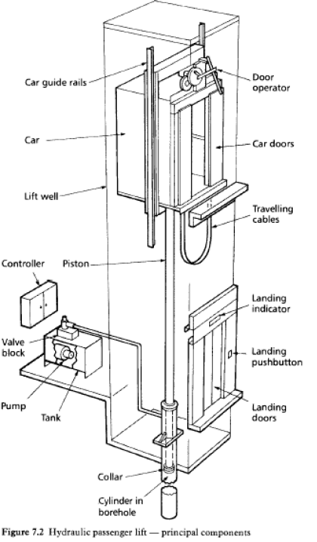
图 2 直顶式液压升降机 / Figure 2 Direct-ram hydraulic lift

直顶式液压：组成部分及功能
Direct-ram hydraulic lift: components and functions
组成部分 / Component | 功能 / Function
Car guide rails  轿厢导轨 | 引导轿厢垂直运动，限制横向摆动。  Guide the car vertically and restrain lateral movement.
Car  轿厢 | 承载乘客或货物，由柱塞直接承托和顶升。  Carries passengers or goods and is supported and raised directly by the piston.
Lift well  井道 | 为轿厢及相关设备提供围护的运行空间，边界为底坑底部、井道壁和井道顶。  Encloses the travel space for the car and associated equipment, bounded by the pit bottom, well walls and well roof.
Controller  控制器 | 接收召梯指令，协调油泵、阀组及门机，控制运行和停车；平层控制提高停靠准确度。  Receives calls and coordinates the pump, valves and doors for travel and stopping; levelling control improves stopping accuracy.
Piston  柱塞 | 受油压推动而伸出，直接顶升轿厢；受控回油时，在轿厢重量作用下回缩下降。  Extends under oil pressure to raise the car directly; retracts under the car weight during controlled oil return for descent.
Valve block  阀组 | 控制油流：上升时进油，停止时封闭油路保持轿厢，下降时调节回油量以控制速度。  Controls oil flow: admits oil for ascent, closes the flow path to hold the car, and meters returning oil to control descent speed.
Pump  油泵 | 由电动机高速驱动，将油箱中的液压油送入油缸，供给顶升轿厢所需的流量和压力。  Driven at high speed by an electric motor, delivers hydraulic oil from the tank to the cylinder to provide the flow and pressure for lifting.
Tank  油箱 | 储存液压油，向油泵供油，并接收轿厢下降时的回油。  Stores hydraulic oil, supplies the pump and receives returning oil during descent.

直顶式液压：组成部分及功能（续）
Direct-ram hydraulic lift: components and functions (continued)
组成部分 / Component | 功能 / Function
Door operator  门机 | 驱动轿门，并在停层时联动层门；配合接近传感器，关门时检测到有人进入即重新开门。  Drives car doors and couples to landing doors at stops; a proximity sensor triggers reopening if someone enters during closing.
Car doors  轿门 | 封闭轿厢入口，保护乘客免于接触井道；运行时保持关闭并防止意外开启。  Close the car entrance to protect passengers from the well; remain closed during travel and are protected against accidental opening.
Travelling cables  随行电缆 | 随轿厢移动，连接固定设备与轿厢，传送电力、控制及通信信号。  Move with the car and carry power, control and communication signals between fixed equipment and the car.
Landing indicator  层站指示器 | 向候梯乘客显示轿厢所在楼层、运行方向等信息。  Shows waiting passengers the car position, direction or other operating information.
Landing pushbutton  层站按钮 | 向控制器发出所在层站的召梯指令。  Registers a call from the landing with the controller.
Landing doors  层门 | 遮护层站井道口，防止人员跌落或门意外开启；全部层门关闭并锁紧后，联锁才允许正常运行。  Guard well openings against falls and accidental opening; interlocks allow normal travel only with all landing doors closed and locked.
Collar  柱塞限位圈 | 设于柱塞下端，限制最大伸出行程，防止柱塞从油缸脱出。  A retaining collar at the piston lower end limits maximum extension and prevents the piston from leaving the cylinder.
Cylinder in borehole  埋地油缸 | 容纳受压油液和柱塞，形成直接顶升机构；向地下延伸，以容纳与轿厢提升高度相应的柱塞行程。  Contains pressurised oil and the piston for direct lifting; extends underground to accommodate piston travel corresponding to the car rise.

