Q4 冷媒性能、设备构造及环境影响
Refrigerant performance, plant construction and environmental impacts
按所绘P–H图的手写标值比较理想单级循环，忽略额外过热、过冷及管路压降；所有结果均为图示近似值。压力统一为bar(abs)，1MPa=10bar。
Compare ideal single-stage cycles using the handwritten P–H readings, without extra superheat, subcooling or line losses. All results are graphical approximations. Pressures use bar(abs); 1MPa = 10bar.
1：压缩机入口；2：出口；3：冷凝器出口；4：节流后。h₄=h₃，点4为h₃垂线与pₑ的交点，不能取pₑ处的饱和液点。
1: compressor inlet; 2: outlet; 3: condenser outlet; 4: after throttling. h₄ = h₃: state 4 is the h₃ vertical’s intersection with pₑ, not the saturated-liquid point at pₑ.
qₑ=h₁−h₄=h₁−h₃；w=h₂−h₁；COP=qₑ/w；s₁=s₂。

【1】冷水机组 / Chiller：5°C / 45°C
Quantity / 量 | R22 | R123 | R134a | R407C
h₁ / kJ/kg | 408.0 | 384.0 | 401.0 | 415.0
h₂ / kJ/kg | 435.0 | 407.0 | 426.0 | 446.0
h₃=h₄ / kJ/kg | 256.0 | 245.0 | 263.0 | 272.0
qₑ / kJ/kg | 152.0 | 139.0 | 138.0 | 143.0
w / kJ/kg | 27.0 | 23.0 | 25.0 | 31.0
COP | 5.63 | 6.04 | 5.52 | 4.61
pₑ / bar(abs) | 6.00 | 0.40 | 3.40 | 5.50
p꜀ / bar(abs) | 17.0 | 1.8 | 12.0 | 19.0
v₁ / m³/kg | 0.04 | 0.38 | 0.06 | 0.043
v₂ / m³/kg | 0.0155 | 0.097 | 0.017 | 0.013
s₁=s₂ / kJ/(kg·K) | 1.75 | 1.67 | 1.73 | 1.77

【2】房间冷却器 / Room cooler：10°C / 60°C
Quantity / 量 | R22 | R123 | R134a | R407C
h₁ / kJ/kg | 408.5 | 386.0 | 404.0 | 417.0
h₂ / kJ/kg | 438.0 | 414.0 | 434.0 | 449.0
h₃=h₄ / kJ/kg | 278.0 | 261.0 | 287.0 | 304.0
qₑ / kJ/kg | 130.5 | 125.0 | 117.0 | 113.0
w / kJ/kg | 29.5 | 28.0 | 30.0 | 32.0
COP | 4.42 | 4.46 | 3.90 | 3.53
pₑ / bar(abs) | 7.00 | 0.51 | 4.10 | 6.40
p꜀ / bar(abs) | 24.1 | 2.8 | 17.0 | 28.0
v₁ / m³/kg | 0.034 | 0.3 | 0.053 | 0.038
v₂ / m³/kg | 0.0108 | 0.058 | 0.014 | 0.0082
s₁=s₂ / kJ/(kg·K) | 1.73 | 1.66 | 1.72 | 1.76

【3】逐项比较及构造影响 / Comparison and construction implications

（1）COP｜制冷性能系数
按图中数据，两工况均为R123＞R22＞R134a＞R407C；房间工况下R123与R22很接近。同制冷量下，COP越高，压缩机耗功及冷凝器散热量越小。由5/45改为10/60工况，温升由40K增至50K，各COP均下降。
For these diagram readings, both cases rank R123 > R22 > R134a > R407C; R123 and R22 are close in the room-cooler case. Higher COP reduces compressor power and condenser heat rejection at equal duty. The 40K-to-50K increase in temperature lift lowers all four COPs.

（2）Refrigeration effect｜单位质量制冷效应
R22两工况均最大，分别为152及130.5kJ/kg。同制冷量下，较大的qₑ使所需质量流量ṁ=Q̇ₑ/qₑ较小。房间工况中，四种冷媒的qₑ均降低、单位质量压缩功w均增加。
R22 has the greatest effect in both cases: 152 and 130.5kJ/kg. At equal cooling duty, larger qₑ reduces mass flow, ṁ = Q̇ₑ/qₑ. In the room-cooler case, all four have lower qₑ and greater specific compressor work w.

（3）Evaporating pressure｜蒸发压力
两工况均为R22＞R407C＞R134a＞R123。R123仅0.40及0.51bar(abs)，低于大气压，容易吸入空气及水分，故须良好密封、排不凝气体装置及水分控制；排气不能代替修漏。
Both cases rank R22 > R407C > R134a > R123. R123 evaporates at only 0.40 and 0.51bar(abs), below atmospheric pressure. It requires good sealing, a purge unit and moisture control to limit inward air/moisture leakage; purging does not replace leak repair.

（4）Condensing pressure｜冷凝压力
两工况均为R407C＞R22＞R134a＞R123。R407C最高，为19及28bar(abs)，其次R22为17及24.1bar(abs)；其管道、阀件和换热器须有相应耐压等级。R123的低运行压力不免除超压保护。
Both cases rank R407C > R22 > R134a > R123. R407C is highest at 19 and 28bar(abs), followed by R22 at 17 and 24.1bar(abs). Their pipes, valves and heat exchangers need corresponding pressure ratings. Low operating pressure does not remove R123’s need for overpressure protection.

（5）Specific volume｜压缩机入口及出口比容
各组均v₂＜v₁。R123的入口及出口比容远大于其余三种；同冷量下应按V̇₁=Q̇ₑv₁/qₑ确定吸气流量，R123需要较大的容积流量及相应流道，适合大流量离心冷水机。R22/R407C较利于紧凑型机组；R134a居间。
Every case has v₂ < v₁. R123 has much larger inlet and outlet volumes. At equal duty, V̇₁ = Q̇ₑv₁/qₑ governs suction volume flow; R123 needs greater flow capacity and suits high-volume centrifugal chillers. R22/R407C favour more compact units, with R134a intermediate.

（6）Entropy｜熵
各图按s₁=s₂确定理想等熵压缩终点。实际绝热压缩会产熵，通常需要更多功，COP较低；不同冷媒的绝对熵值不能直接作为效率排名。R123图示终点接近／略入湿区，实际须保证适当吸气过热以避免湿压缩。
Each plot uses s₁ = s₂ to locate the ideal isentropic outlet. Real adiabatic compression generates entropy, requires more work and lowers COP. Absolute entropy values do not rank different refrigerants’ efficiency. R123’s plotted outlets approach/slightly enter the wet region, so suitable suction superheat is needed to avoid wet compression.

工况及换热器 / Conditions and heat exchangers
R407C按图中饱和汽、液端点，将蒸发标温理解为点1露点、冷凝标温理解为点3泡点；水平段是等压段，相变沿程有温度滑移。
For R407C, the plotted vapour/liquid endpoints are interpreted as the state-1 evaporating dew point and state-3 condensing bubble point. Horizontal processes are isobars; phase change has temperature glide.

【4】安全及环境影响 / Safety and environmental impacts

（7）Corrosion｜腐蚀性
四者均须配用相容的材料及润滑油，并保持系统干燥、洁净；水分、污染及高温分解物可引起腐蚀。R123低压侧较易吸入空气及水分，尤须密封及干燥控制。
All four require compatible materials/lubricant and a dry, clean system. Moisture, contamination and thermal decomposition products can cause corrosion. R123’s sub-atmospheric side especially needs effective sealing and moisture control.

（8）Explosion｜爆炸及爆裂风险
四者均为安全分类1级，即标准试验下无火焰传播，但仍可能因高温、超压造成设备爆裂。所有机组均须有适当耐压、压力切断及泄压保护，较高压力的R22/R407C尤其须关注。
All four are class 1, with no flame propagation in classification tests, but heat/overpressure can still rupture equipment. All systems need suitable pressure ratings, pressure cut-outs and relief protection, particularly the higher-pressure R22/R407C systems.

（9）Toxicity｜毒性
R123为B1，毒性类别高于R22、R134a及R407C的A1。四者均须控制泄漏并通风；R123尤其须注意人员暴露和泄漏检测。高浓度泄漏还可能造成缺氧。
R123 is B1, a higher toxicity class than A1 R22, R134a and R407C. Control leaks and provide ventilation for all four, with particular attention to R123 exposure and detection. High concentrations can also displace oxygen.

（10）Ozone depletion｜臭氧层消耗
R22及R123为含氯HCFC，课件ODP分别为0.05及0.014；R134a及R407C为HFC，ODP为0。R22/R123泄漏会破坏臭氧层，故须控制泄漏并回收冷媒。
Chlorine-containing HCFCs R22 and R123 have course-table ODPs of 0.05 and 0.014. HFCs R134a and R407C have zero ODP. R22/R123 leakage damages the ozone layer, requiring containment and refrigerant recovery.

（11）Global warming｜全球变暖
统一采用IPCC AR4的100年GWP：R22为1810、R123为77、R134a为1430、R407C约1774。四者泄漏均造成直接温室效应，R123较低；较高COP可减少耗电引致的间接排放。
On the same IPCC AR4 100-year basis, GWP is 1810 for R22, 77 for R123, 1430 for R134a and about 1774 for R407C. All cause direct warming when leaked, with R123 lower. Higher COP reduces electricity-related indirect emissions.

应用 / Application
构造应用：大冷水机可采用与大容积流量相配的离心机；R22/R407C较适合紧凑型房间DX机组。R407C须匹配换热器温差及膨胀阀控制；冷水机以水侧换热器供冷，房间机以空气侧盘管供冷。
Plant application: large chillers can use centrifugal compressors matched to high volume flow; R22/R407C favour compact room DX units. R407C glide requires suitable heat-exchanger temperature differences and expansion-valve control. Chillers cool water; room units use air-cooling coils.
资料 / Sources: 本人所绘P–H图；HVAC System II, slides 9–20, 29, 44–45；ASHRAE Handbook—Fundamentals (2025), Ch.29；IPCC AR4 (2007), WGI Table 2.14, pp.212–213（GWP100；R407C按R32/R125/R134a的23/25/52质量分数加权 / mass-weighted）。

附图 1 / Figure 1 — R22（原图 / Original drawing）
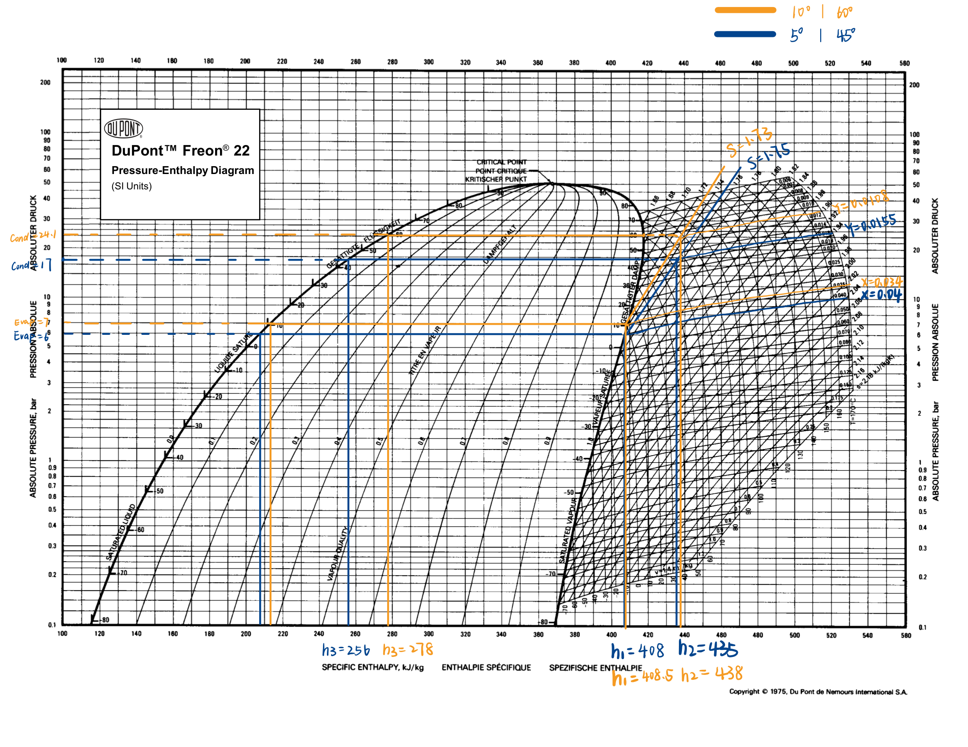
附图 2 / Figure 2 — R407C（原图 / Original drawing）
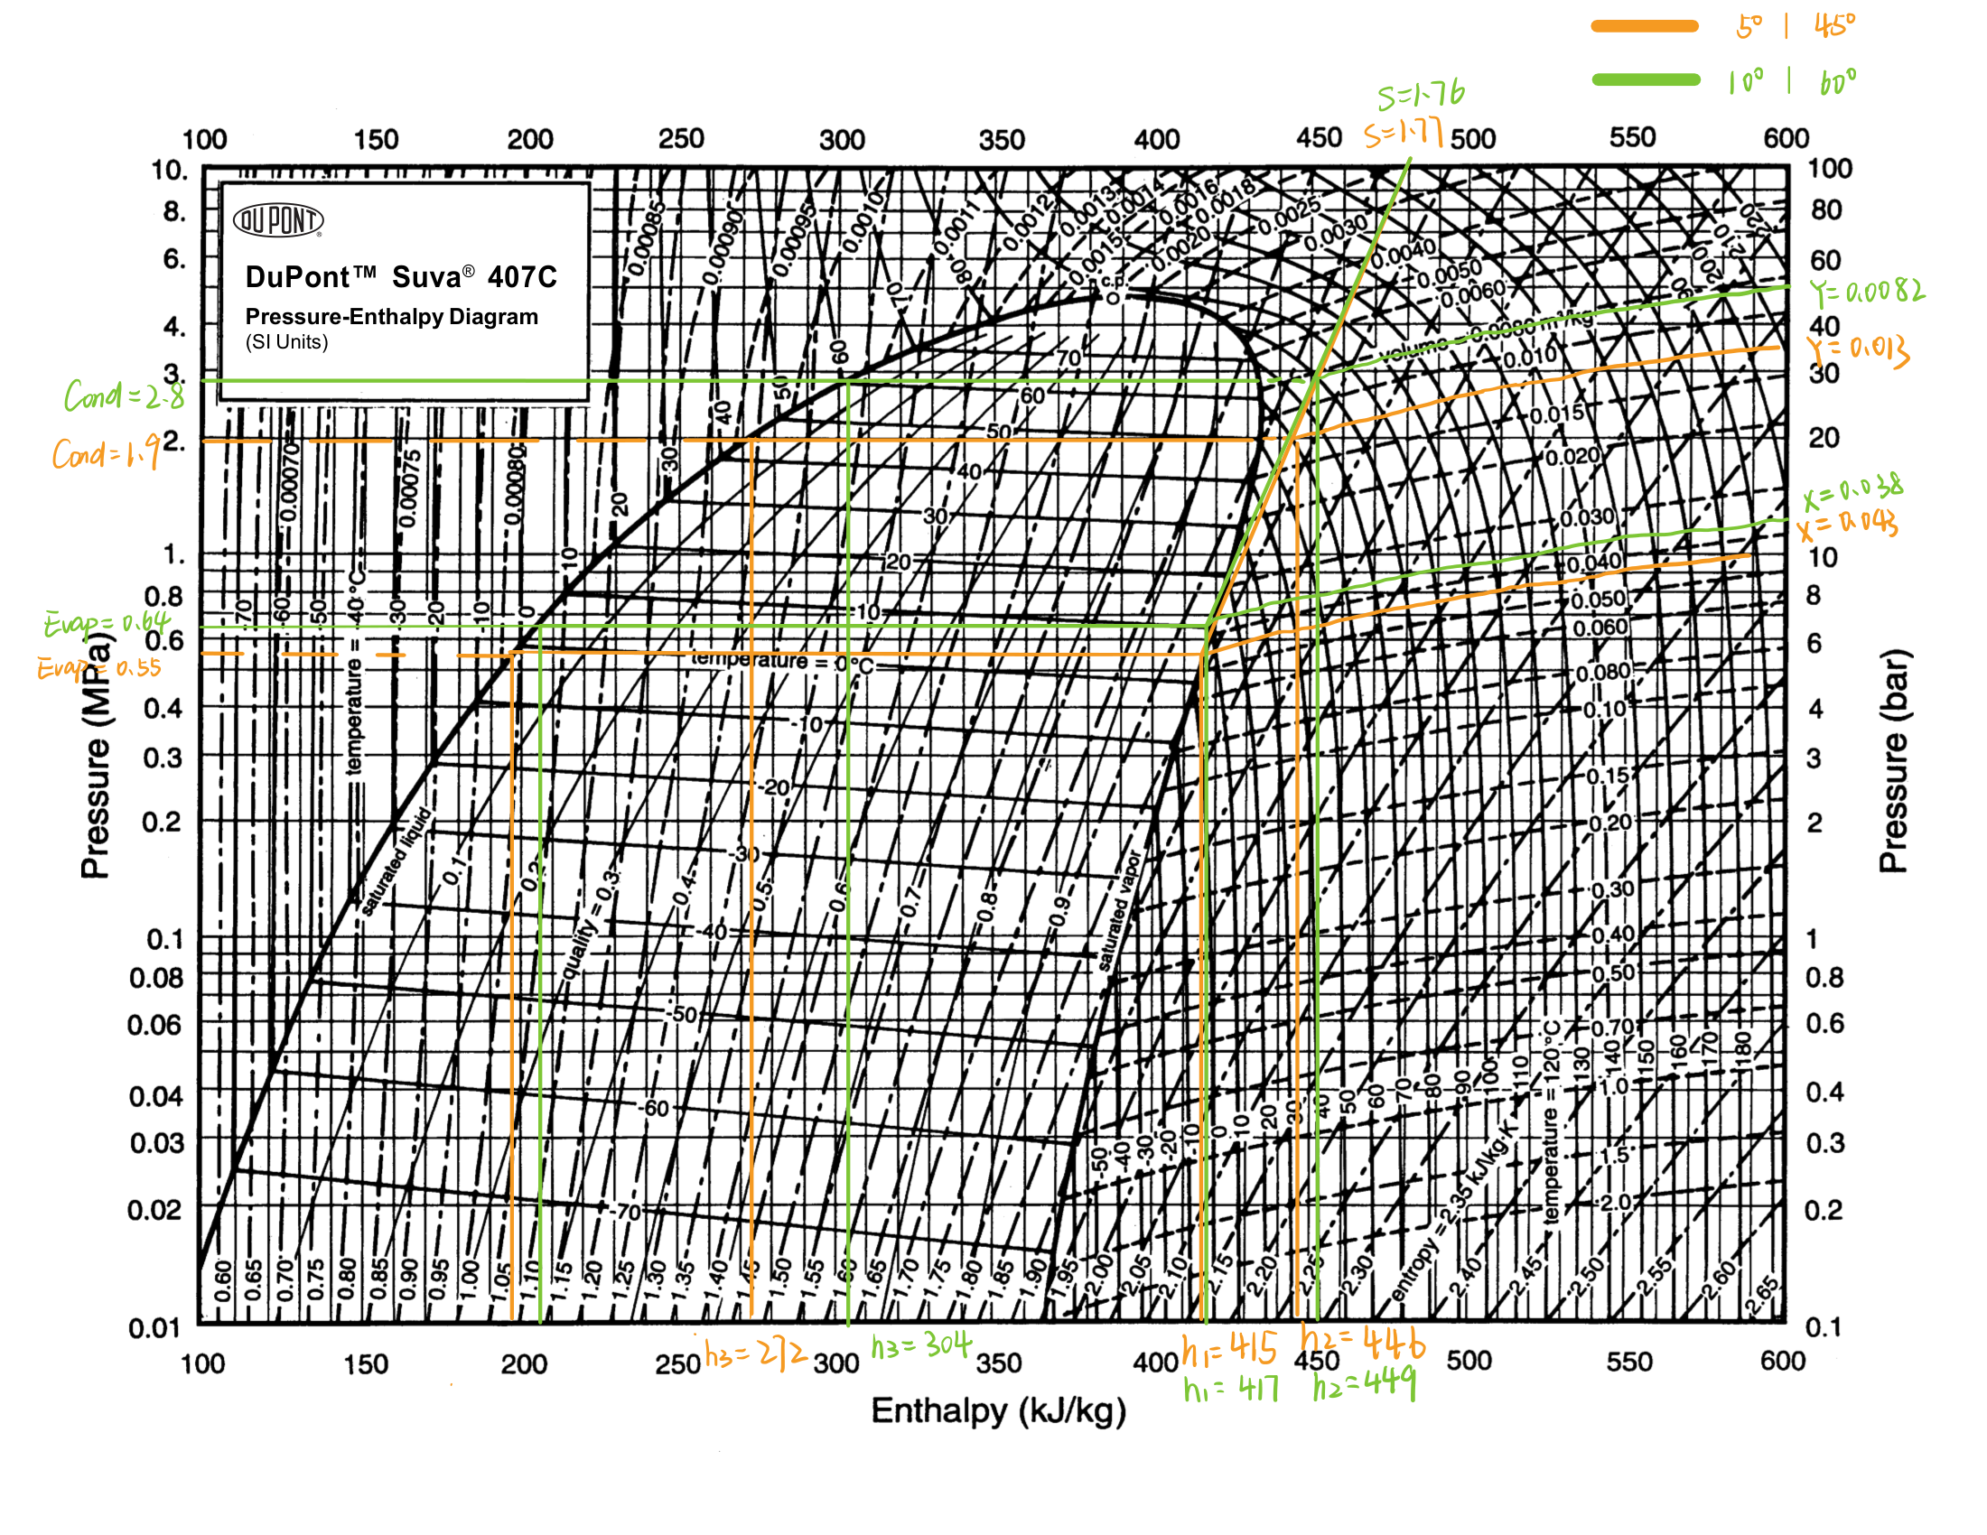
附图 3 / Figure 3 — R134a（原图 / Original drawing）
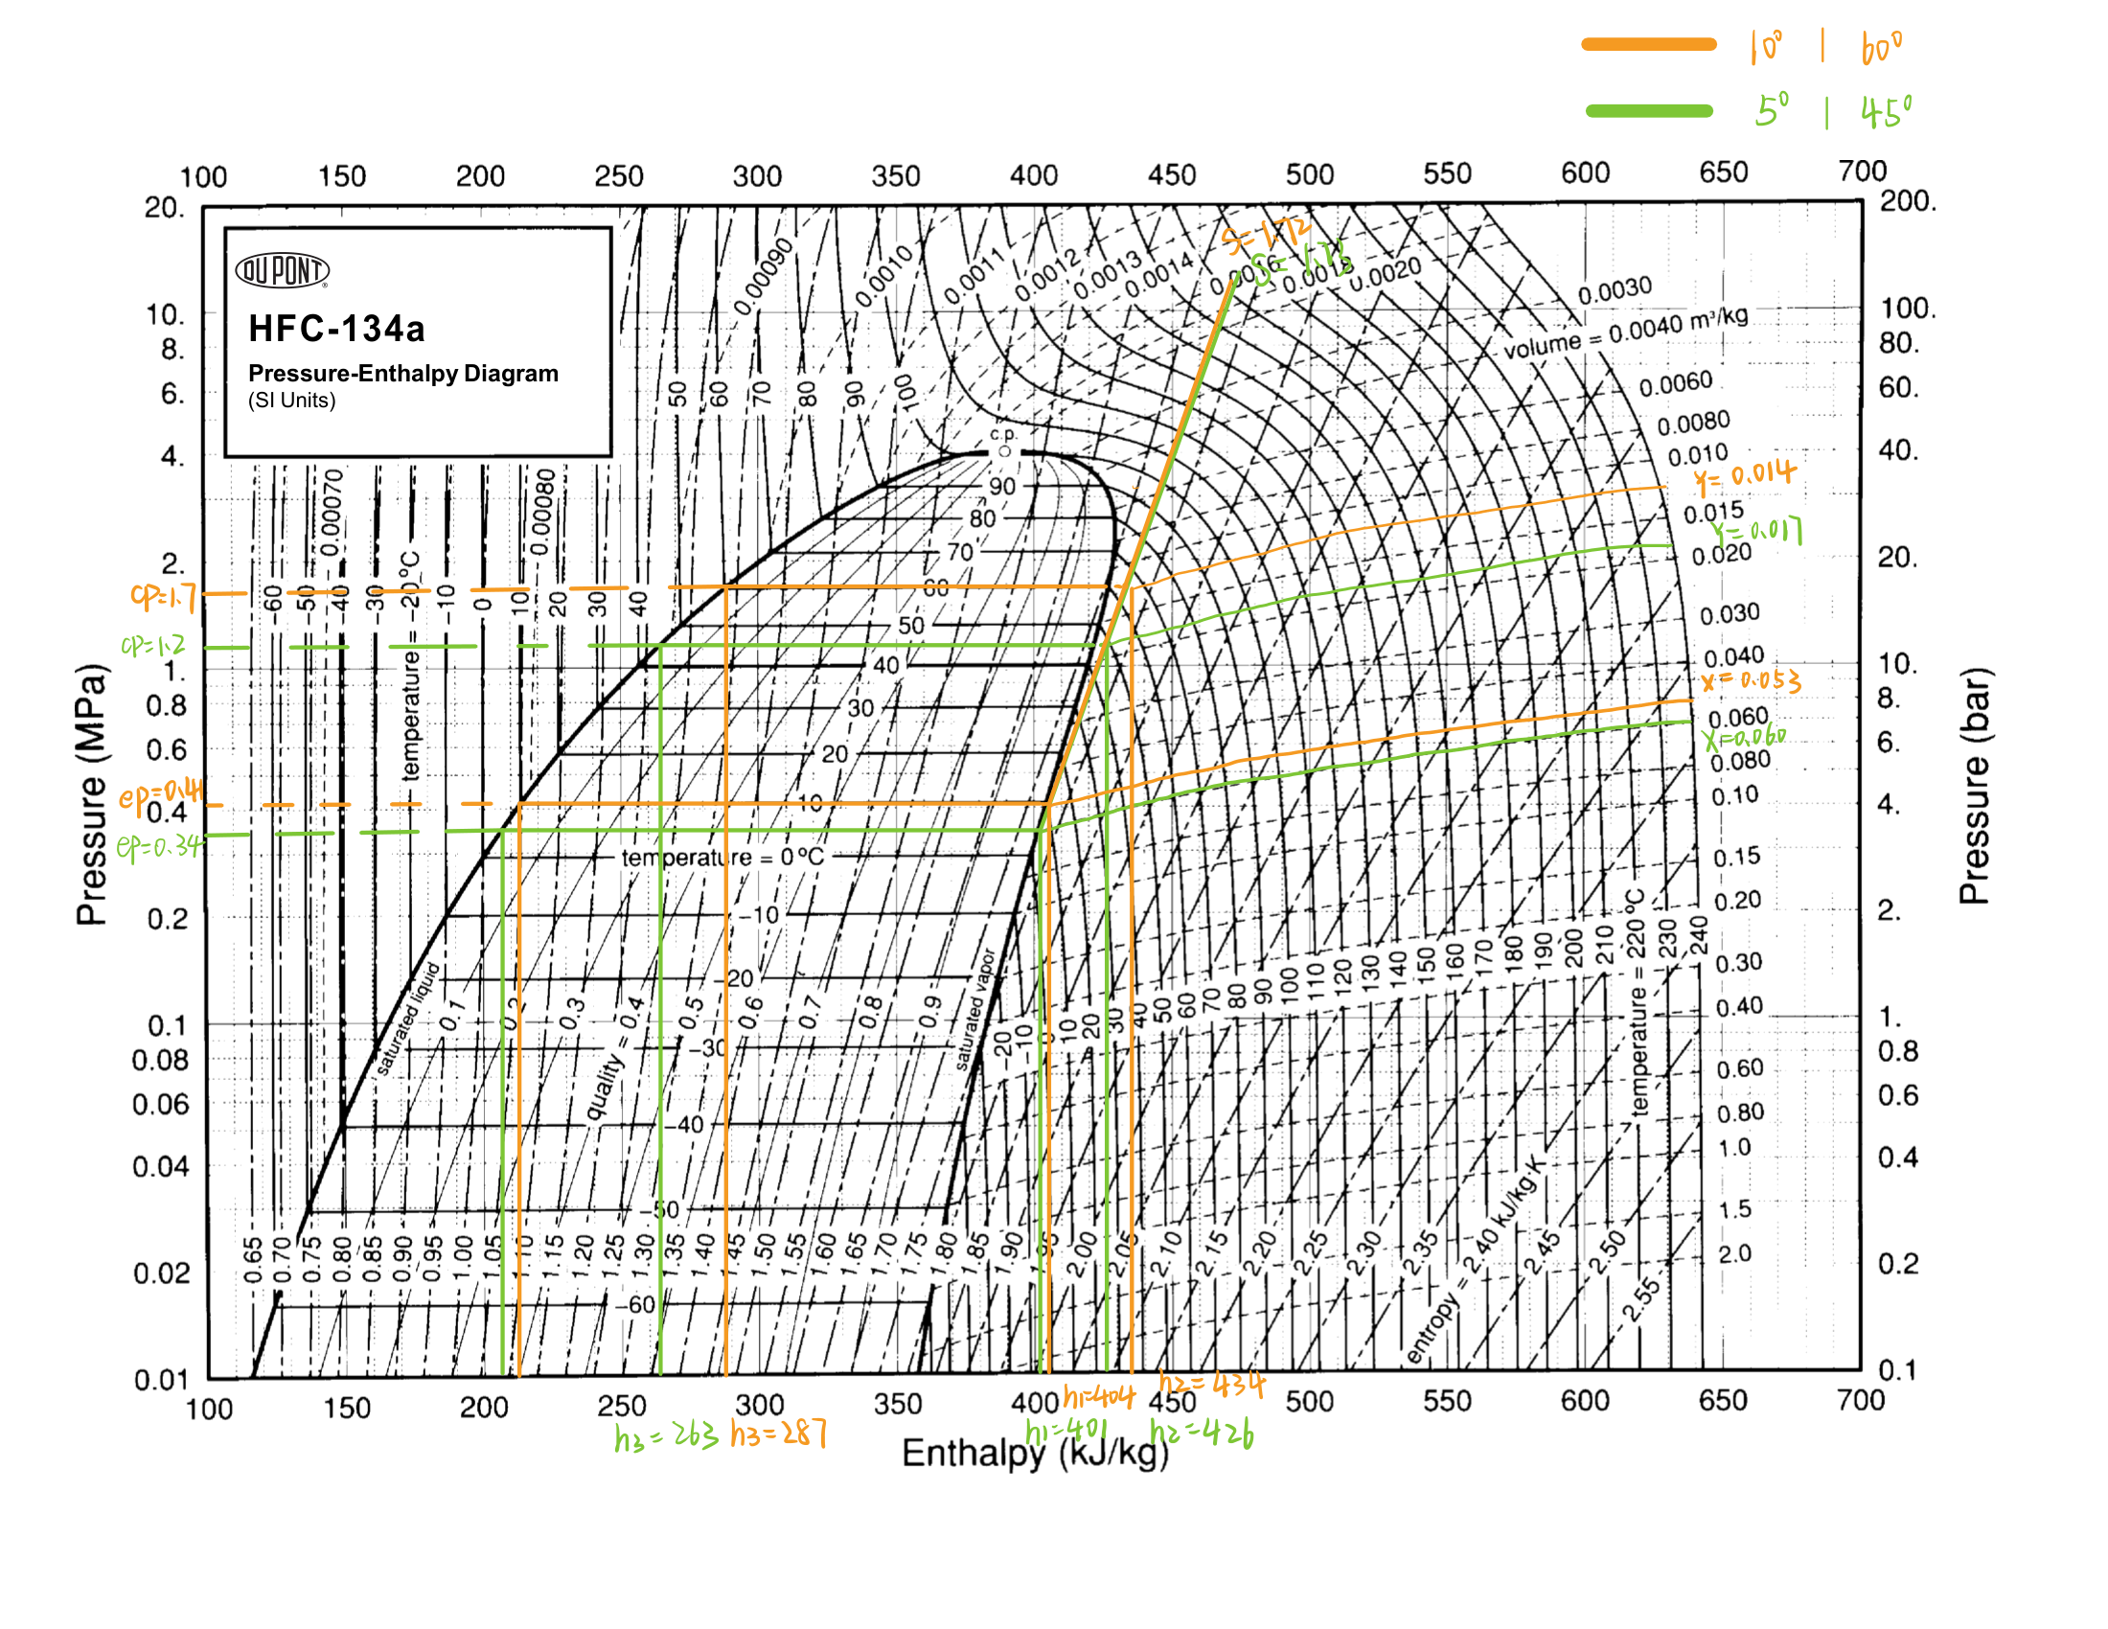
附图 4 / Figure 4 — R123（原图 / Original drawing）


