01｜福利资本主义世界（二）：发展型国家 / World of welfare capitalism (II)
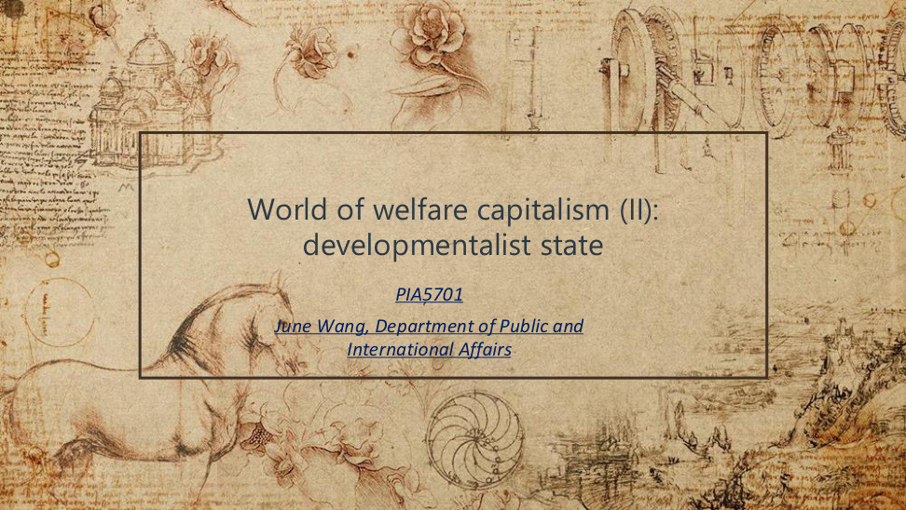
原PPT第1页 / Original slide 1

PPT中英翻译 / PPT translation
PPT English / 英文原文 | 中文翻译 / Chinese translation
World of welfare capitalism (II): developmentalist state | 福利资本主义世界（二）：发展型国家
PIA5701; June Wang, Department of Public and International Affairs | PIA5701；June Wang，公共及国际事务系

本页核心 / Key takeaway
本课主线：国家怎样推动经济赶超，以及增长目标怎样塑造东亚福利安排。
Main thread: how states drive economic catch-up and how growth priorities shape East Asian welfare arrangements.

阅读说明 / Reading guide
红色只标核心理论与关键区别；加粗标次重点。复习按“截图—翻译—本页核心—精要解析”展开。章节过渡页与结束页不额外扩写。
Red marks core theory and key distinctions; bold marks secondary emphasis. Each slide follows the sequence: screenshot, translation, takeaway, essential explanation. Transition and closing slides are kept brief.
材料核对：所附“课堂3总结”听课宝实际主要讨论前课的普遍权利、养老金、劳动市场与教育，仅在相关页作跨课对照。本课发展型国家内容以PPT为主，结合Word整理；不另设附录。
Source check: the supplied “Lesson 3” listening summary mainly concerns the previous lesson’s universal rights, pensions, labour markets and education. Relevant points are used only for cross-lesson comparison. This lesson’s developmental-state content follows the PPT, integrated with the Word notes; there is no appendix.

02｜什么是发展型国家？ / What is a developmentalist state?
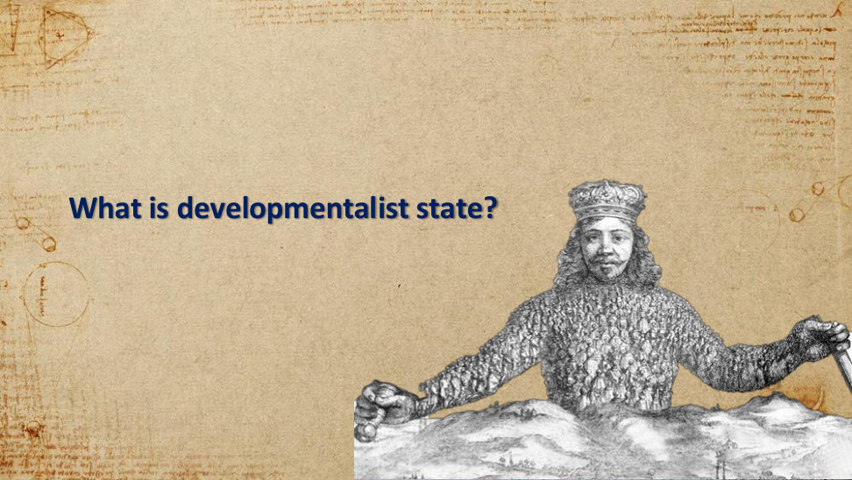
原PPT第2页 / Original slide 2

PPT中英翻译 / PPT translation
PPT English / 英文原文 | 中文翻译 / Chinese translation
What is developmentalist state? | 什么是发展型国家？

本页核心 / Key takeaway
先抓住一个问题：国家是否把经济发展放在优先位置，并有组织地引导产业升级？
Start with one question: does the state prioritise economic development and systematically guide industrial upgrading?

精要解析 / Essential explanation

1. 理解入口 / Starting point
“发展型”指国家的目标与组织能力，不能仅凭经济增长快或政府规模大来判断。
“Developmental” concerns state priorities and organisational capacity; rapid growth or a large government alone is insufficient.

03｜为何关注东亚？ / Why the attention to East Asia?
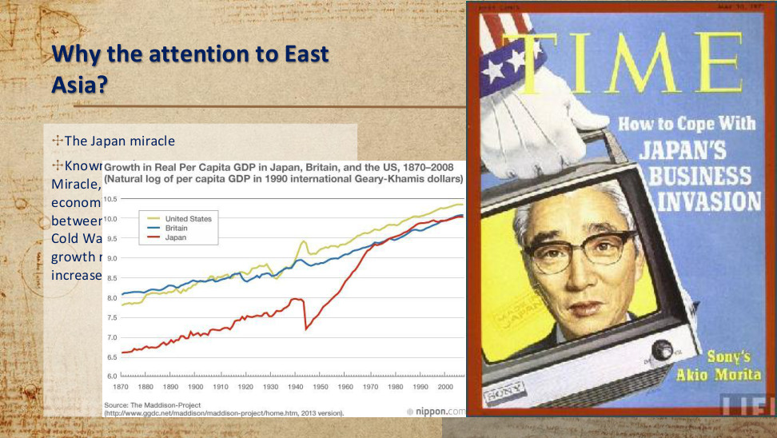
原PPT第3页 / Original slide 3

PPT中英翻译 / PPT translation
PPT English / 英文原文 | 中文翻译 / Chinese translation
Why the attention to East Asia? The Japan miracle. | 为何关注东亚？日本经济奇迹。
Known as the Japanese Economic Miracle, Japan experienced rapid and sustained economic growth from 1945 to 1991, the period between post World War II and the end of the Cold War. As depicted in Figure 1, the real growth rate was positive until 1973 and increased for 20 consecutive years. [PDF text partly covered by the chart.] | 日本在1945—1991年，即二战后至冷战结束期间，经历了快速而持续的经济增长，被称为“日本经济奇迹”。原文续称：实际增长率在1973年前为正，并连续增长20年。【此段部分被图表遮挡；关于“增长率”的表述见下方辨析。】
Chart: Growth in Real Per Capita GDP in Japan, Britain, and the US, 1870–2008 (natural log of per capita GDP in 1990 international Geary–Khamis dollars). United States; Britain; Japan. Source: The Maddison Project, 2013 version. | 图：1870—2008年日本、英国与美国实际人均GDP增长（以1990年国际Geary–Khamis元计量的人均GDP的自然对数）。图例：美国、英国、日本。来源：麦迪森项目，2013年版本。
TIME cover: How to Cope With JAPAN’S BUSINESS INVASION; Sony’s Akio Morita. | 《时代》封面：如何应对日本企业的扩张；索尼的盛田昭夫。

本页核心 / Key takeaway
日本的战后赶超使学者追问：国家干预和制度安排如何促进工业化，而非仅用自由市场解释增长。
Japan’s post-war catch-up prompted scholars to ask how state intervention and institutions promoted industrialisation, beyond a free-market explanation.

精要解析 / Essential explanation

1. 案例用途 / What the case shows
本页提供理论产生的历史背景；之后要解释增长背后的政策机制，而不是只记“日本增长很快”。
This page gives the theory’s historical background; the next step is to explain policy mechanisms behind growth, rather than merely recall rapid Japanese growth.

易错辨析 / Key distinction
图中纵轴是人均GDP的对数水平，并非年度增长率；曲线上升不能证明“增长率连续20年提高”。复习时掌握长期赶超趋势即可。
The chart shows the log level of GDP per capita, not annual growth rates; a rising line does not prove that the growth rate increased for 20 consecutive years. Focus on the long-run catch-up trend.

04｜福利国家体制 / Welfare-state regimes
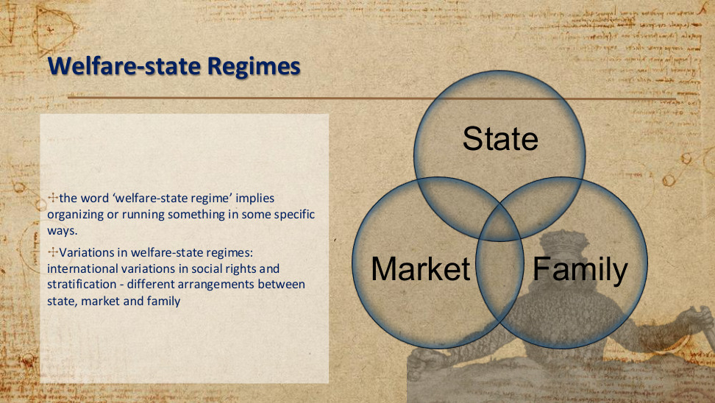
原PPT第4页 / Original slide 4

PPT中英翻译 / PPT translation
PPT English / 英文原文 | 中文翻译 / Chinese translation
The word “welfare-state regime” implies organizing or running something in some specific ways. | “福利国家体制”意味着以特定方式组织和运作福利安排。
Variations in welfare-state regimes: international variations in social rights and stratification — different arrangements between state, market and family. | 福利国家体制的差异：各国社会权利与社会分层不同，体现为国家、市场和家庭之间的不同安排。
Diagram: State — Market — Family. | 图示：国家—市场—家庭，三者相互交叠。

本页核心 / Key takeaway
福利体制看的是国家、市场、家庭如何分担福利责任，以及这种安排如何影响社会权利与分层。
A welfare regime concerns how the state, market and family share welfare responsibilities, and how this shapes social rights and stratification.

精要解析 / Essential explanation

1. 承接前课 / Link to the previous lesson
听课宝强调福利资格可建立在需要审查、职业缴费或公民身份等基础上。这里把视角扩大到“谁负责提供福利、谁更受保护”。
The listening summary contrasts eligibility based on means tests, occupational contributions and citizenship. This page broadens the question to who provides welfare and who receives stronger protection.

易错辨析 / Key distinction
福利体制不能只按社会开支多少分类；还要看资格、覆盖范围与国家—市场—家庭的分工。
Social spending alone cannot classify a welfare regime; eligibility, coverage and the state–market–family division also matter.

05｜发展型国家的起源 / Origins of the developmental state
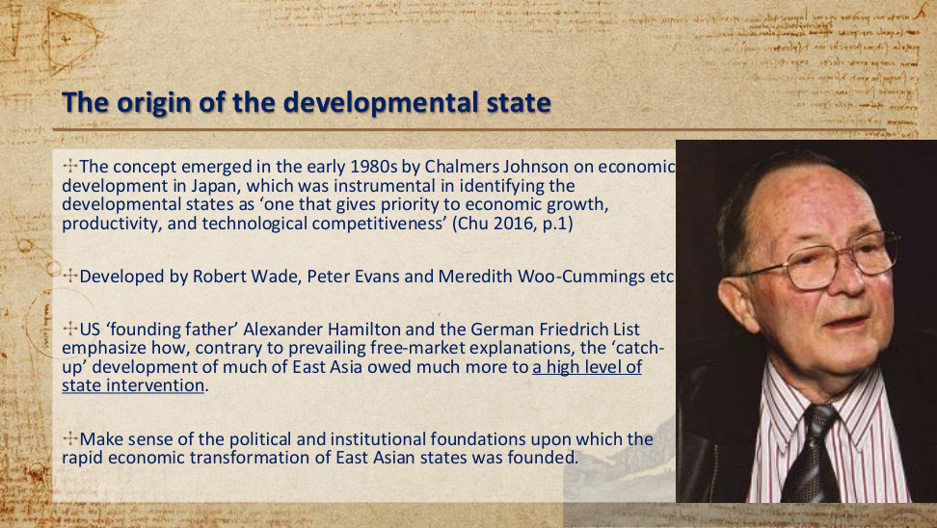
原PPT第5页 / Original slide 5

PPT中英翻译 / PPT translation
PPT English / 英文原文 | 中文翻译 / Chinese translation
The concept emerged in the early 1980s by Chalmers Johnson on economic development in Japan, identifying the developmental state as “one that gives priority to economic growth, productivity, and technological competitiveness” (Chu 2016, p.1). | 查默斯·约翰逊在20世纪80年代初研究日本经济发展时提出这一概念：发展型国家“优先重视经济增长、生产率与技术竞争力”（Chu，2016，第1页）。
Developed by Robert Wade, Peter Evans and Meredith Woo-Cummings etc. | 这一理论随后由罗伯特·韦德、彼得·埃文斯、梅雷迪思·吴—卡明斯等人进一步发展。
US “founding father” Alexander Hamilton and the German Friedrich List emphasize how, contrary to prevailing free-market explanations, the “catch-up” development of much of East Asia owed much more to a high level of state intervention. | 原文将美国建国先贤亚历山大·汉密尔顿、德国的弗里德里希·李斯特与国家干预思路联系起来：与自由市场解释相对，东亚许多经济体的“赶超”发展高度依赖国家干预。【这是思想渊源与后来的东亚研究相结合的概括。】
Make sense of the political and institutional foundations upon which the rapid economic transformation of East Asian states was founded. | 解释东亚国家快速经济转型背后的政治与制度基础。

本页核心 / Key takeaway
发展型国家的定义重点是：优先追求经济增长、生产率与技术竞争力，并通过国家能力推动赶超。
The defining priority is economic growth, productivity and technological competitiveness, pursued through state capacity for catch-up.

精要解析 / Essential explanation

1. 记忆重点 / What to remember
先记“约翰逊—日本—20世纪80年代初”，再理解国家如何选择产业、协调资本与推动升级；其他学者姓名作为理论脉络掌握。
Remember “Johnson—Japan—early 1980s”, then understand how the state selects industries, coordinates capital and promotes upgrading. Other scholars provide the wider theoretical lineage.

易错辨析 / Key distinction
汉密尔顿与李斯特是更早的国家促进发展思想先驱，不是研究战后东亚奇迹的当代学者。
Hamilton and List were earlier intellectual precursors of state-led development, not contemporary researchers of post-war East Asia.

06｜构成与特征：日本案例 / Components and characteristics: Japan
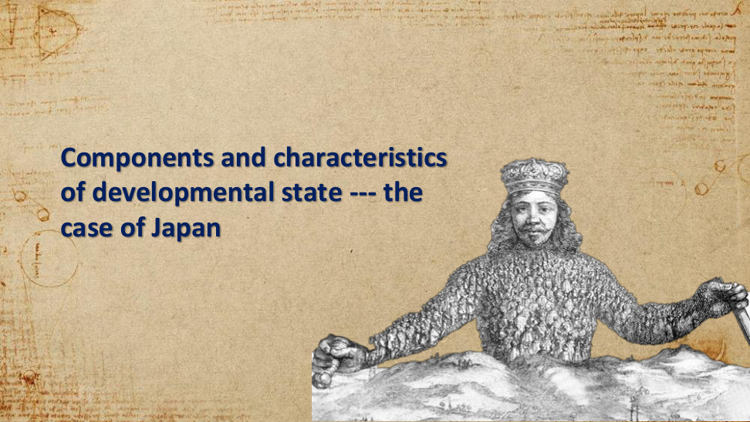
原PPT第6页 / Original slide 6

PPT中英翻译 / PPT translation
PPT English / 英文原文 | 中文翻译 / Chinese translation
Components and characteristics of developmental state — the case of Japan. | 发展型国家的构成与特征——日本案例。

本页核心 / Key takeaway
下面以日本为例，从政策工具、官僚组织与国家—企业关系理解发展型国家。
The following pages use Japan to examine policy tools, bureaucracy and state–business relations.

07｜日本发展型国家 / Japan’s developmental state
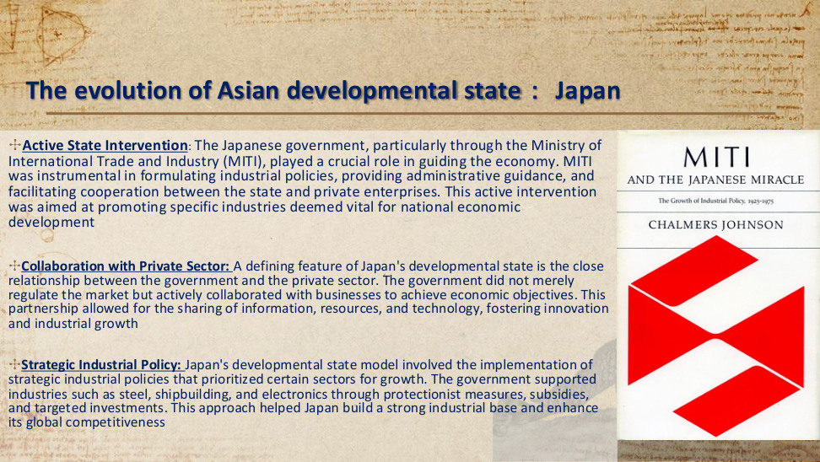
原PPT第7页 / Original slide 7

PPT中英翻译 / PPT translation
PPT English / 英文原文 | 中文翻译 / Chinese translation
Active State Intervention: The Japanese government, particularly through the Ministry of International Trade and Industry (MITI), guided the economy through industrial policies, administrative guidance and cooperation with private enterprises, promoting industries vital for national development. | 积极的国家干预：日本政府尤其通过通商产业省（MITI），运用产业政策、行政指导以及政企合作引导经济，推动被视为国家发展关键的产业。
Collaboration with Private Sector: Close government–business relations meant not merely regulating the market, but actively collaborating to achieve economic objectives. Sharing information, resources and technology fostered innovation and industrial growth. | 与私营部门合作：政府与企业关系紧密，除了规制市场，还主动合作以实现经济目标；双方共享信息、资源与技术，促进创新及产业增长。
Strategic Industrial Policy: Steel, shipbuilding and electronics were supported through protectionist measures, subsidies and targeted investments, building an industrial base and global competitiveness. | 战略性产业政策：政府通过保护措施、补贴与定向投资，支持钢铁、造船和电子等行业，建设产业基础并提高国际竞争力。
Book cover: MITI and the Japanese Miracle; Chalmers Johnson. | 书封：《通产省与日本奇迹》；查默斯·约翰逊。

本页核心 / Key takeaway
日本案例的核心机制是选择性产业政策与政企合作：国家集中资源扶持战略产业，推动升级与竞争力。
Japan’s central mechanisms were selective industrial policy and state–business collaboration: directing resources to strategic industries to promote upgrading and competitiveness.

精要解析 / Essential explanation

1. 把工具连到目标 / Connect tools to goals
行政指导协调企业行动；补贴、保护与定向投资降低重点产业的发展障碍。MITI是执行与协调机构，不是所有企业的所有者。
Administrative guidance coordinates firms; subsidies, protection and targeted investment reduce barriers facing priority industries. MITI was a coordinating institution, not the owner of every firm.

2. 理解合作 / Understand collaboration
政企接触帮助政府了解产业所需的信息和技术；是否有发展效果，还取决于政府能否坚持目标并约束企业，而非只提供优惠。
State–business contact supplies information about industrial and technological needs. Developmental results also depend on the state maintaining its goals and disciplining firms, beyond granting benefits.

08｜发展型国家的六项构成 / Six components
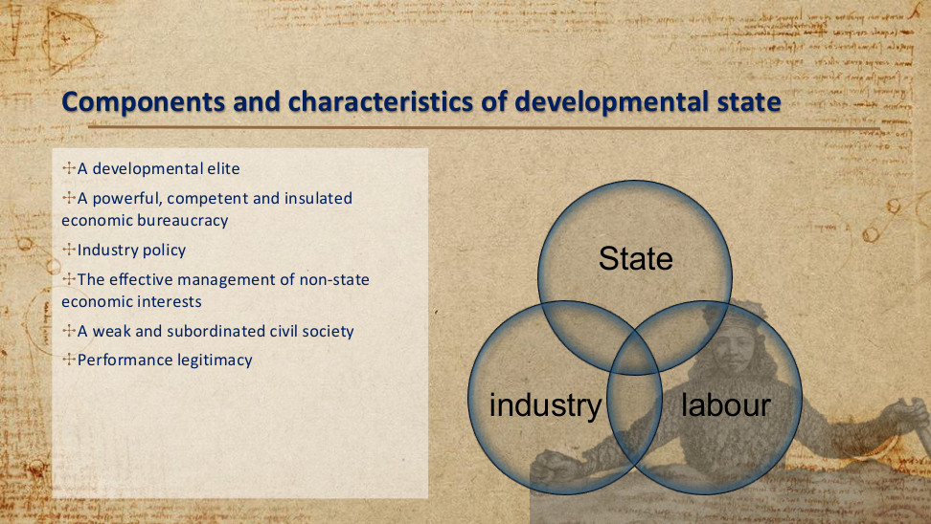
原PPT第8页 / Original slide 8

PPT中英翻译 / PPT translation
PPT English / 英文原文 | 中文翻译 / Chinese translation
A developmental elite. | 发展导向的精英。
A powerful, competent and insulated economic bureaucracy. | 强大、能干且具有相对自主性的经济官僚体系。
Industry policy. | 产业政策。
The effective management of non-state economic interests. | 有效管理非国家经济利益。
A weak and subordinated civil society. | 较弱、处于从属地位的公民社会。
Performance legitimacy. | 绩效合法性。
Diagram: State — industry — labour. | 图示：国家—产业—劳工之间的关系。

本页核心 / Key takeaway
六项构成可串成：发展精英定方向，能干官僚与产业政策组织资源，管理资本及社会关系，再以发展绩效获得支持。
The six components form a chain: developmental elites set priorities; capable bureaucracy and industrial policy organise resources; capital and social relations are managed; development performance sustains support.

精要解析 / Essential explanation

1. 按三组记忆 / Remember three groups
“谁决策”：精英、官僚；“怎样干预”：产业政策、管理非国家利益；“怎样维持”：公民社会的从属地位、绩效合法性。
“Who decides”: elites and bureaucracy. “How intervention works”: industrial policy and management of non-state interests. “How the system is sustained”: subordinated civil society and performance legitimacy.

易错辨析 / Key distinction
本页的国家—产业—劳工图分析发展协调与权力关系；第4页的国家—市场—家庭图分析福利责任，两个三角不能互换。
This state–industry–labour diagram concerns developmental coordination and power; the state–market–family diagram on slide 4 concerns welfare responsibilities. They are not interchangeable.

09｜发展精英：组织与官僚来源 / Developmental elites
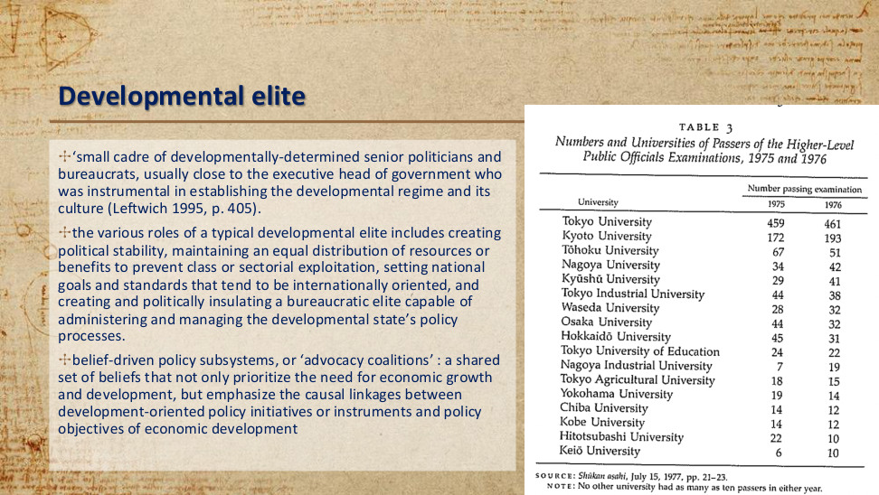
原PPT第9页 / Original slide 9

PPT中英翻译 / PPT translation
PPT English / 英文原文 | 中文翻译 / Chinese translation
A “small cadre of developmentally-determined senior politicians and bureaucrats”, usually close to the executive head, establishes the developmental regime and its culture (Leftwich 1995, p.405). | 一小群坚定追求发展的高级政治人物与官僚，通常接近政府行政首脑，对建立发展型体制及其文化起关键作用（Leftwich，1995，第405页）。
Roles include political stability; equal distribution of resources or benefits to prevent class or sectorial exploitation; internationally oriented national goals and standards; and creating and politically insulating a bureaucratic elite able to manage development policy. | 其作用包括：建立政治稳定；维持资源或利益的均衡分配以防阶级或部门剥削；制定面向国际的国家目标和标准；建立并在政治上保护能管理发展政策的官僚精英。
Belief-driven policy subsystems, or “advocacy coalitions”: shared beliefs prioritise growth and development, and connect development-oriented policy instruments causally to economic-development objectives. | 由信念驱动的政策子系统，即“倡议联盟”：成员共享优先重视经济增长与发展的信念，并相信特定发展政策工具能够因果性地推动发展目标。
Table 3: Numbers and Universities of Passers of the Higher-Level Public Officials Examinations, 1975 and 1976. Source: Shūkan asahi, July 15, 1977, pp.21–23. Note: no other university had as many as ten passers in either year. | 表3：1975、1976年高级公务员考试合格者人数及毕业大学（数字见下表）。来源：《周刊朝日》，1977年7月15日，第21—23页；注：其他大学在这两年中任何一年都没有达到10名合格者。

图表转写：高级公务员考试合格者的毕业大学 / Table: universities of higher-level civil-service examination passers
大学 / University | 1975年人数 / Passers | 1976年人数 / Passers
东京大学 / Tokyo University | 459 | 461
京都大学 / Kyoto University | 172 | 193
东北大学 / Tōhoku University | 67 | 51
名古屋大学 / Nagoya University | 34 | 42
九州大学 / Kyūshū University | 29 | 41
东京工业大学 / Tokyo Industrial University | 44 | 38
早稻田大学 / Waseda University | 28 | 32
大阪大学 / Osaka University | 44 | 32
北海道大学 / Hokkaidō University | 45 | 31
东京教育大学 / Tokyo University of Education | 24 | 22
名古屋工业大学 / Nagoya Industrial University | 7 | 19
东京农业大学 / Tokyo Agricultural University | 18 | 15
横滨大学（原表名）/ Yokohama University | 19 | 14
千叶大学 / Chiba University | 14 | 12
神户大学 / Kobe University | 14 | 12
一桥大学 / Hitotsubashi University | 22 | 10
庆应大学 / Keiō University | 6 | 10

本页核心 / Key takeaway
发展精英不仅提出增长目标，还要建立能执行政策、相对不受利益集团干扰的官僚体系。
Developmental elites must establish a bureaucracy capable of implementing policy and relatively insulated from interest-group interference, as well as setting growth goals.

精要解析 / Essential explanation

1. 图表如何使用 / How to read the table
日本高级公务员考试合格者集中来自少数大学，说明精英招募渠道的集中性；考试合格人数不是在任官员总数，更不能直接证明政策有效。
The concentration of examination passers in a few universities illustrates selective elite recruitment. Passer counts are not the number of serving officials and do not themselves prove policy effectiveness.

易错辨析 / Key distinction
“相对自主”强调避免被特殊利益俘获，仍可与企业沟通。原文的均衡分配是对精英作用的理论描述，不代表所有发展型国家都已实现平等。
“Insulation” means avoiding capture by special interests while retaining communication with firms. The distributional role described in the text does not establish that every developmental state achieved equality.

10｜发展精英：共同信念 / Developmental elites: shared beliefs
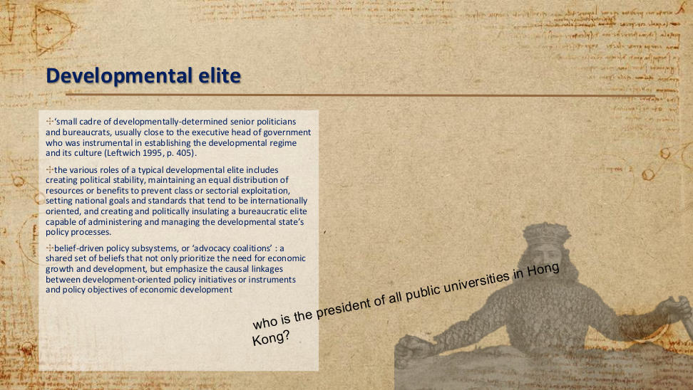
原PPT第10页 / Original slide 10

PPT中英翻译 / PPT translation
PPT English / 英文原文 | 中文翻译 / Chinese translation
A “small cadre of developmentally-determined senior politicians and bureaucrats”, usually close to the executive head, establishes the developmental regime and its culture (Leftwich 1995, p.405). | 一小群坚定追求发展的高级政治人物与官僚，通常接近政府行政首脑，对建立发展型体制及其文化起关键作用（Leftwich，1995，第405页）。
Roles include political stability; equal distribution of resources or benefits to prevent class or sectorial exploitation; internationally oriented national goals and standards; and creating and politically insulating a bureaucratic elite able to manage development policy. | 其作用包括：建立政治稳定；维持资源或利益的均衡分配以防阶级或部门剥削；制定面向国际的国家目标和标准；建立并在政治上保护能管理发展政策的官僚精英。
Belief-driven policy subsystems, or “advocacy coalitions”: shared beliefs prioritise growth and development, and connect development-oriented policy instruments causally to economic-development objectives. | 由信念驱动的政策子系统，即“倡议联盟”：成员共享优先重视经济增长与发展的信念，并相信特定发展政策工具能够因果性地推动发展目标。
Who is the president of all public universities in Hong Kong? [Slide question.] | 谁是香港所有公立大学的“president”？【课件提问；原词对大学治理职位的表述不够精确。】

本页核心 / Key takeaway
本页承接上页，重点转向倡议联盟：共同的发展信念把政策工具与增长目标连接起来。
Building on the previous page, focus on advocacy coalitions: shared developmental beliefs link policy instruments to growth objectives.

精要解析 / Essential explanation

1. 精英为何能协调 / Why coordination is possible
成员不仅都赞成“发展”，还对哪些工具能带来发展形成共识，例如通过产业扶持推动技术升级。这样才可能形成持续、协调的政策行动。
Members agree not only that development is desirable, but also on how instruments can deliver it, such as industrial support promoting technological upgrading. This supports sustained, coordinated action.

易错辨析 / Key distinction
课件的大学治理提问用于引发对政治与精英组织关系的思考，不宜把“校长”与“校监”等职位混为一谈，也无需把某个人名当作理论重点。
The university-governance question prompts reflection on politics and elite organisation. Do not conflate university presidents with chancellors or treat a person’s name as the theoretical focus.

11｜管理非国家经济利益 / Managing non-state economic interests
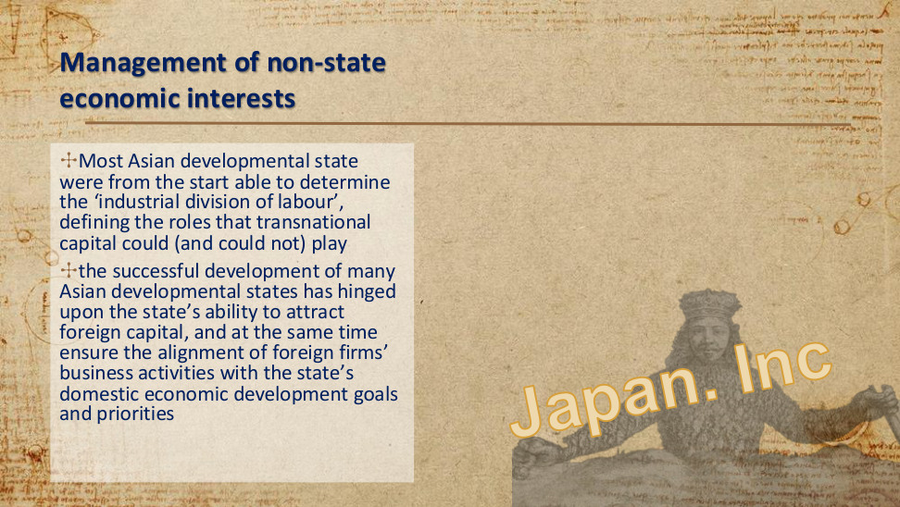
原PPT第11页 / Original slide 11

PPT中英翻译 / PPT translation
PPT English / 英文原文 | 中文翻译 / Chinese translation
Most Asian developmental states were from the start able to determine the “industrial division of labour”, defining the roles that transnational capital could (and could not) play. | 许多亚洲发展型国家从一开始就能决定“产业分工”，规定跨国资本可以及不可以扮演的角色。
Successful development hinged upon the ability to attract foreign capital and, at the same time, align foreign firms’ business activities with domestic economic development goals and priorities. | 成功发展取决于国家既能吸引外资，又能使外国企业的经营活动符合本国经济发展的目标与优先次序。
Japan Inc. | “日本株式会社”（Japan Inc.）：把日本政企协调形象地比作一个整体。

本页核心 / Key takeaway
管理非国家利益的关键是吸引资本，同时让资本服务国家发展目标。
Managing non-state interests means attracting capital while aligning it with national development goals.

精要解析 / Essential explanation

1. 开放与引导可以并存 / Openness and steering can coexist
国家并非只能在“拒绝外资”和“完全放任”中二选一，而可引导外资进入哪些产业、发挥什么作用，争取投资与本国产业发展相互配合。
The state can steer which sectors foreign capital enters and what role it plays, rather than choosing only between exclusion and unrestricted entry. Investment can thus be coordinated with domestic industrial development.

12｜外资目标的例子 / An example of an FDI target
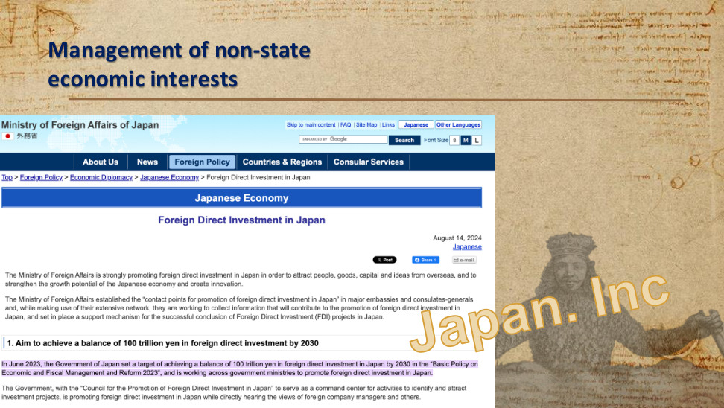
原PPT第12页 / Original slide 12

PPT中英翻译 / PPT translation
PPT English / 英文原文 | 中文翻译 / Chinese translation
Management of non-state economic interests; Japan Inc. | 管理非国家经济利益；“日本株式会社”。
Ministry of Foreign Affairs of Japan — Japanese Economy — Foreign Direct Investment in Japan. August 14, 2024. | 日本外务省—日本经济—对日外国直接投资。网页日期：2024年8月14日。
The Ministry is strongly promoting foreign direct investment in Japan to attract people, goods, capital and ideas from overseas, strengthen growth potential and create innovation. | 外务省积极促进对日外国直接投资，以吸引海外人才、商品、资本与创意，增强经济增长潜力并创造创新。
Contact points in major embassies and consulates-general collect information through overseas networks and support the successful conclusion of FDI projects in Japan. | 在主要使领馆设立促进对日投资的联络点，利用海外网络收集信息，并支持投资项目在日本顺利落地。
Aim to achieve a balance of 100 trillion yen in foreign direct investment by 2030. In June 2023, the Government set this target in the “Basic Policy on Economic and Fiscal Management and Reform 2023” and is working across ministries to promote FDI in Japan. | 目标：到2030年使对日外国直接投资存量达到100万亿日元。日本政府于2023年6月在《经济财政运营与改革基本方针2023》中提出该目标，并通过跨部门协作促进对日投资。
The Council for the Promotion of Foreign Direct Investment in Japan serves as a command centre to identify and attract investment projects, while hearing foreign company managers’ views. | 通过“对日直接投资推进会议”统筹识别和吸引投资项目，并直接听取外国企业管理者等的意见。

本页核心 / Key takeaway
这一网页例子体现：政府可主动设定外资目标，并通过跨部门与海外网络协调招商。
The webpage illustrates how government can set FDI targets and coordinate investment promotion through ministries and overseas networks.

精要解析 / Essential explanation

1. 从例子提炼机制 / Extract the mechanism
接续上页即可：设定目标—组织协调—吸引投资。数字与年份帮助读懂例子，理论重点仍是国家引导资本的能力。
Read it as a sequence: set targets, coordinate institutions, attract investment. Figures and dates explain the example; the theoretical focus remains the capacity to steer capital.

易错辨析 / Key distinction
100万亿日元是2030年的对内FDI存量目标，不是一年流入量，也不是课件已经证明实现的成果。
100 trillion yen is the target stock of inward FDI by 2030, not annual inflows or an outcome already demonstrated by the slide.

13｜绩效合法性 / Performance legitimacy
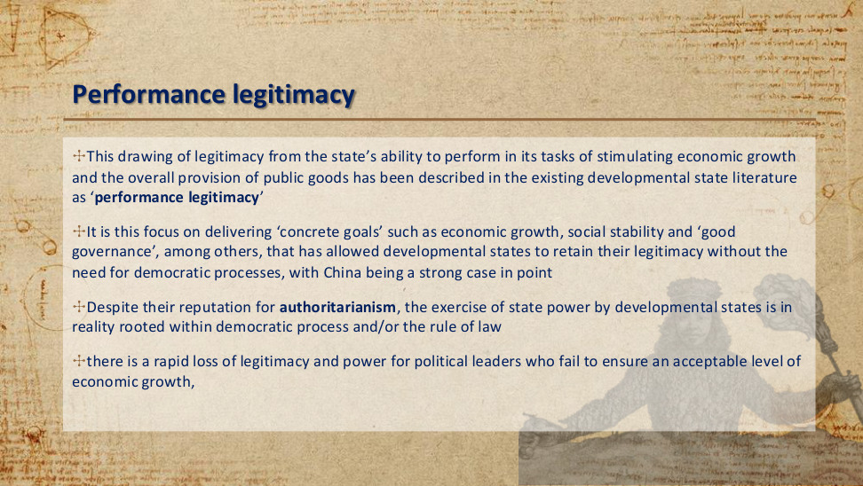
原PPT第13页 / Original slide 13

PPT中英翻译 / PPT translation
PPT English / 英文原文 | 中文翻译 / Chinese translation
Legitimacy drawn from the state’s ability to stimulate economic growth and provide public goods is described as “performance legitimacy”. | 国家凭借促进经济增长和提供公共物品的能力获得支持，被称为“绩效合法性”。
Delivering “concrete goals” such as growth, social stability and “good governance” allows developmental states to retain legitimacy without the need for democratic processes; China is given as an example. | 原文认为，通过实现经济增长、社会稳定和“良好治理”等具体目标，发展型国家可在不依赖民主程序的情况下维持合法性，并以中国为例。
Despite their reputation for authoritarianism, the exercise of state power by developmental states is in reality rooted within democratic process and/or the rule of law. | 原文又指出：尽管发展型国家常有威权形象，其国家权力的行使实际上植根于民主程序和／或法治。
Political leaders who fail to ensure an acceptable level of economic growth rapidly lose legitimacy and power. | 如果政治领导者无法维持可接受的经济增长水平，可能迅速失去合法性与权力。

本页核心 / Key takeaway
绩效合法性是以经济增长、公共物品等治理成果获得政治支持；当绩效下滑，支持基础也可能减弱。
Performance legitimacy derives political support from outcomes such as growth and public goods; declining performance can weaken that support.

精要解析 / Essential explanation

1. 机制要会说明 / Explain the mechanism
发展成果让公众认为政府有能力、能改善生活，因此有助于维持政治支持。
Developmental results can sustain political support by demonstrating governmental competence and improving living conditions.

易错辨析 / Key distinction
本页对民主程序的两句话存在张力。稳妥理解是：绩效是一种合法性来源，可与程序或法治基础并存；发展型国家不必都属于同一种政体。
The slide contains tension in its statements about democracy. Treat performance as one source of legitimacy that may coexist with procedural or rule-of-law foundations; developmental states need not share one political regime.

14｜公民社会 / Civil society
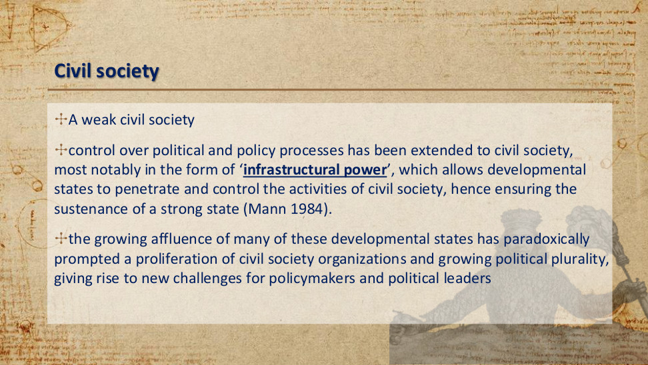
原PPT第14页 / Original slide 14

PPT中英翻译 / PPT translation
PPT English / 英文原文 | 中文翻译 / Chinese translation
A weak civil society. | 较弱的公民社会。
Control over political and policy processes extends to civil society through “infrastructural power”, allowing states to penetrate and control civil-society activities and sustain a strong state (Mann 1984). | 对政治与政策过程的控制延伸至公民社会，尤其通过“基础性权力”进入并影响社会活动，以维持强国家（Mann，1984）。
Growing affluence paradoxically prompts more civil-society organisations and political plurality, creating new challenges for policymakers and leaders. | 但日益富裕也可能促使公民社会组织增加、政治多元化发展，从而对决策者与领导者提出新挑战。

本页核心 / Key takeaway
基础性权力强调国家把政策贯彻到社会的能力；经济发展也可能增强社会组织与多元诉求，改变国家—社会关系。
Infrastructural power concerns the capacity to implement policy throughout society; development may also strengthen social organisations and plural demands, changing state–society relations.

精要解析 / Essential explanation

1. 本页的动态关系 / The dynamic relationship
较弱的社会制衡可扩大国家主导政策的空间，但社会变得富裕后，组织和诉求可能增多，原来的权力关系未必一直稳定。
Weak societal checks can give the state greater room to lead policy, but rising affluence may generate more organisations and demands, so the original power relationship may change.

易错辨析 / Key distinction
“Infrastructural power”不是只指修路建桥，也不能直接等同于强制镇压；此处重点是国家对社会的组织与执行能力。
“Infrastructural power” does not simply mean building roads or bridges, nor is it identical to coercion; the focus is organisational and implementation capacity within society.

15｜建立并引导市场 / Building and shaping markets
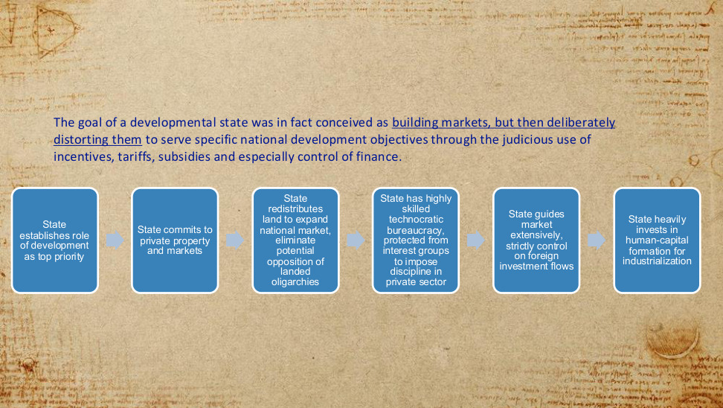
原PPT第15页 / Original slide 15

PPT中英翻译 / PPT translation
PPT English / 英文原文 | 中文翻译 / Chinese translation
The goal of a developmental state was conceived as building markets, but then deliberately distorting them to serve national development objectives through judicious incentives, tariffs, subsidies and especially control of finance. | 发展型国家的目标被理解为先建立市场，再通过审慎运用激励、关税、补贴，尤其是金融控制，有意改变市场配置，使其服务于国家发展目标。
State establishes development as top priority. | 国家把发展确立为首要任务。
State commits to private property and markets. | 国家承认并支持私有财产与市场。
State redistributes land to expand the national market and eliminate potential opposition from landed oligarchies. | 国家重新分配土地，以扩大国内市场，并消除土地寡头可能带来的阻力。
Highly skilled technocratic bureaucracy, protected from interest groups, imposes discipline on the private sector. | 高技能的技术官僚体系受到保护，避免利益集团干扰，并对私营部门施加约束。
State guides markets extensively and strictly controls foreign investment flows. | 国家广泛引导市场，并严格管理外国投资流动。
State invests heavily in human-capital formation for industrialisation. | 国家大量投入人力资本培育，以支持工业化。

本页核心 / Key takeaway
发展型国家承认市场与私有产权，但主动改变激励和资源流向，使市场服务国家发展目标。
The developmental state recognises markets and private property, but actively reshapes incentives and resource allocation to serve national development goals.

精要解析 / Essential explanation

1. 读懂“扭曲” / Understand “distorting”
关税、补贴和金融控制会改变相对价格及投资回报，把资源导向重点产业。“扭曲”在这里描述偏离自由市场配置的机制，并不预先证明政策好或坏。
Tariffs, subsidies and financial controls alter relative prices and investment returns, directing resources to priority industries. “Distorting” describes departure from free-market allocation; it does not establish whether a policy succeeds or fails.

2. 把六步串起来 / Connect the six elements
发展目标提供方向，土地改革扩大市场，官僚体系协调并约束企业，资本引导与人力资本投入支持工业化。土地改革是课件所概括的历史路径，并非所有国家必经的定义条件。
Developmental goals set direction; land reform broadens markets; bureaucracy coordinates and disciplines firms; capital steering and human-capital investment support industrialisation. Land reform is part of the historical model presented, not a defining step every state must follow.

16｜发展型与规制型国家 / Developmental and regulatory states
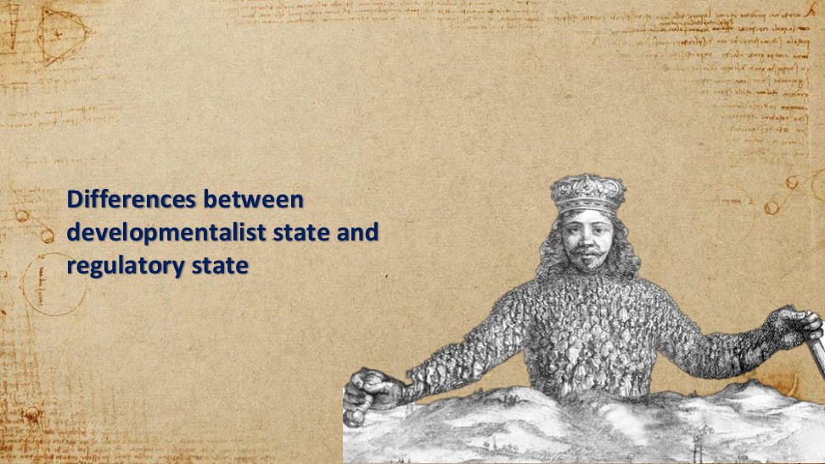
原PPT第16页 / Original slide 16

PPT中英翻译 / PPT translation
PPT English / 英文原文 | 中文翻译 / Chinese translation
Differences between developmentalist state and regulatory state. | 发展型国家与规制型国家的差异。

本页核心 / Key takeaway
接下来按政策目标、干预方式与决策机构比较两种国家角色。
Next compare the two state roles by policy goals, forms of intervention and decision-making institutions.

17｜The developmentalist state vs the regulatory state｜发展型国家与规制型国家
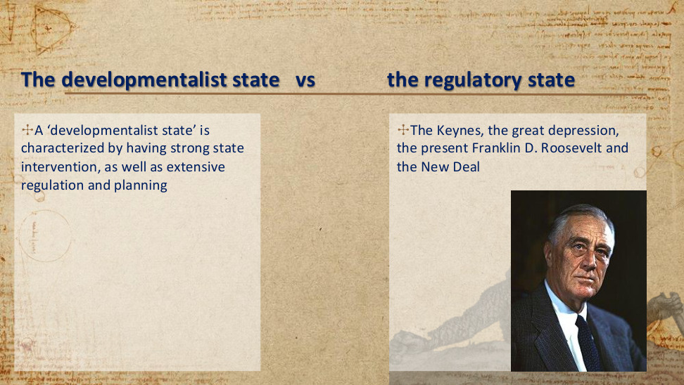
原PPT第17页 / Original slide 17

PPT中英翻译 / PPT translation
PPT English / 英文原文 | 中文翻译 / Chinese translation
A ‘developmentalist state’ is characterized by having strong state intervention, as well as extensive regulation and planning | “发展型国家”的特点是强有力的国家干预，以及广泛的规制与规划。
The Keynes, the great depression, the present Franklin D. Roosevelt and the New Deal | 凯恩斯、大萧条、富兰克林·D.罗斯福总统和新政。（原文 present 应指 President，即“总统”。）

本页核心 / Key takeaway
发展型国家以强力干预、规制和规划推动发展；关键是国家干预的目标与方式。
The developmental state promotes development through strong intervention, regulation and planning; its goals and methods matter.

精要解析 / Essential explanation

1. 干预的目的｜Purpose of intervention
结合前文，发展型国家的干预围绕产业转型与经济追赶。大萧条与新政提示另一类干预背景：应对经济危机、稳定经济活动。
In the earlier slides, developmental intervention concerns industrial transformation and economic catch-up. The Depression and New Deal illustrate another context for intervention: crisis management and economic stabilisation.

易错辨析 / Key distinction
不能由“国家干预”直接推出“社会民主福利国家”，也不能把新政或凯恩斯主义与发展型国家完全画等号。
State intervention alone does not establish a social-democratic welfare regime; neither the New Deal nor Keynesianism is identical to the developmental state.

18｜The Keynes and the Hayek｜凯恩斯与哈耶克

原PPT第18页 / Original slide 18

PPT中英翻译 / PPT translation
PPT English / 英文原文 | 中文翻译 / Chinese translation
Fear the Boom and Bust: Keynes vs. Hayek | 《忧惧繁荣与萧条：凯恩斯对阵哈耶克》
Keynes Vs Hayek | 凯恩斯对阵哈耶克（配图文字）

本页核心 / Key takeaway
本页用凯恩斯与哈耶克的对照，引出国家干预与市场协调的争论。
The Keynes–Hayek comparison introduces the debate over state intervention and market coordination.

精要解析 / Essential explanation

1. 理解分歧｜Understanding the disagreement
作为背景理解：凯恩斯强调需求不足时政府稳定总需求的作用；哈耶克强调价格传递分散知识及干预可能造成的扭曲。本页未提供视频逐字稿，不把延伸解释当作视频原话。
As background, Keynes stresses government support for aggregate demand when demand is deficient; Hayek stresses prices as carriers of dispersed knowledge and possible distortions from intervention. The slide provides no video transcript; this explanation is not a quotation from it.

易错辨析 / Key distinction
这是一组思想比较，不是“凯恩斯＝发展型、哈耶克＝规制型”的一一对应表。
This is a comparison of ideas, not a one-to-one mapping of Keynes to developmental states and Hayek to regulatory states.

19｜The developmentalist state vs the regulatory state｜发展型国家与规制型国家
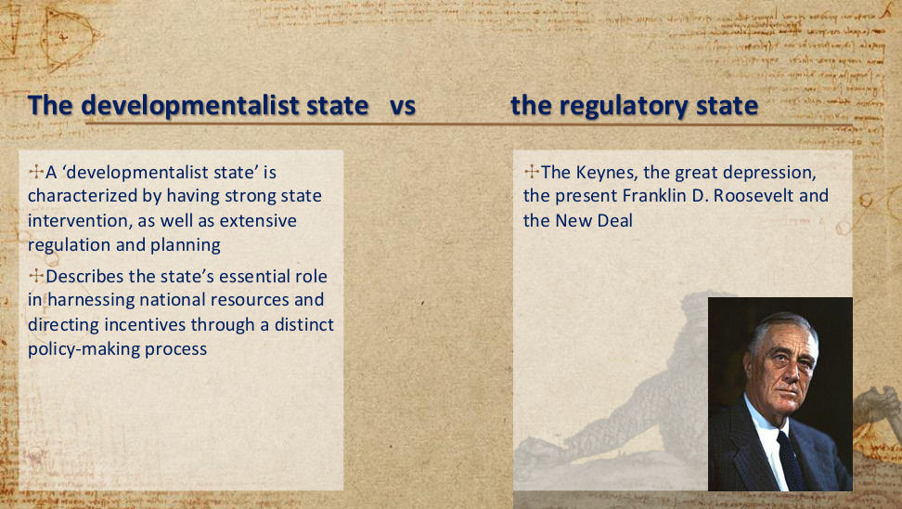
原PPT第19页 / Original slide 19

PPT中英翻译 / PPT translation
PPT English / 英文原文 | 中文翻译 / Chinese translation
A ‘developmentalist state’ is characterized by having strong state intervention, as well as extensive regulation and planning | “发展型国家”的特点是强有力的国家干预，以及广泛的规制与规划。
Describes the state’s essential role in harnessing national resources and directing incentives through a distinct policy-making process | 这一概念强调：国家通过独特的政策制定过程，在统筹国家资源、引导激励方面发挥关键作用。
The Keynes, the great depression, the present Franklin D. Roosevelt and the New Deal | 凯恩斯、大萧条、富兰克林·D.罗斯福总统和新政。（present 应指 President。）

本页核心 / Key takeaway
本页新增重点是资源动员与激励引导：国家把分散资源协调到发展目标上。
The added emphasis is resource mobilisation and incentive direction: the state coordinates dispersed resources towards development goals.

精要解析 / Essential explanation

1. 政策怎样发挥作用｜How policy works
结合总结中的产业政策，信贷、补贴和贸易政策可以改变企业投资的收益与风险，引导私人企业参与产业升级；国家不必拥有全部企业。
As the summary explains, credit, subsidies and trade policies can alter the returns and risks of investment and steer private firms towards industrial upgrading; the state need not own every firm.

20｜The developmentalist state vs the regulatory state｜发展型国家与规制型国家
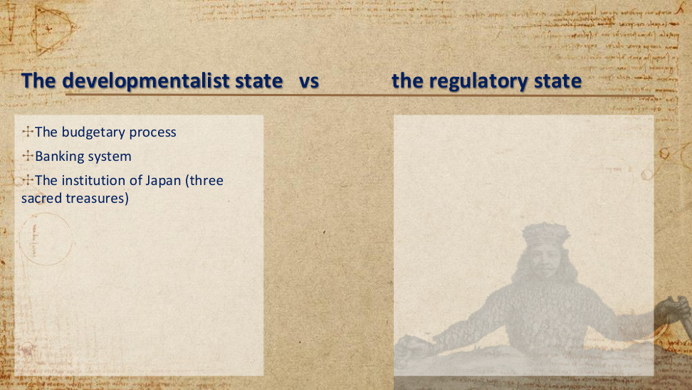
原PPT第20页 / Original slide 20

PPT中英翻译 / PPT translation
PPT English / 英文原文 | 中文翻译 / Chinese translation
The budgetary process | 预算过程
Banking system | 银行体系
The institution of Japan (three sacred treasures) | 日本的制度（“三大瑰宝”）

本页核心 / Key takeaway
本页转向制度工具：财政、金融与企业制度如何共同支撑发展战略。
The slide turns to institutional tools: how fiscal, financial and enterprise institutions jointly support development strategy.

精要解析 / Essential explanation

1. 三个观察入口｜Three entry points
预算决定公共资源投向；银行体系影响企业能否获得资金；企业制度影响就业关系与福利安排。“三大瑰宝”的具体内容在第25页展开。
Budgets direct public resources; banking shapes firms’ access to finance; enterprise institutions shape employment and welfare. The three Japanese employment institutions are specified on page 25.

21｜the developmental orientation vs the regulatory orientation｜发展导向与规制导向
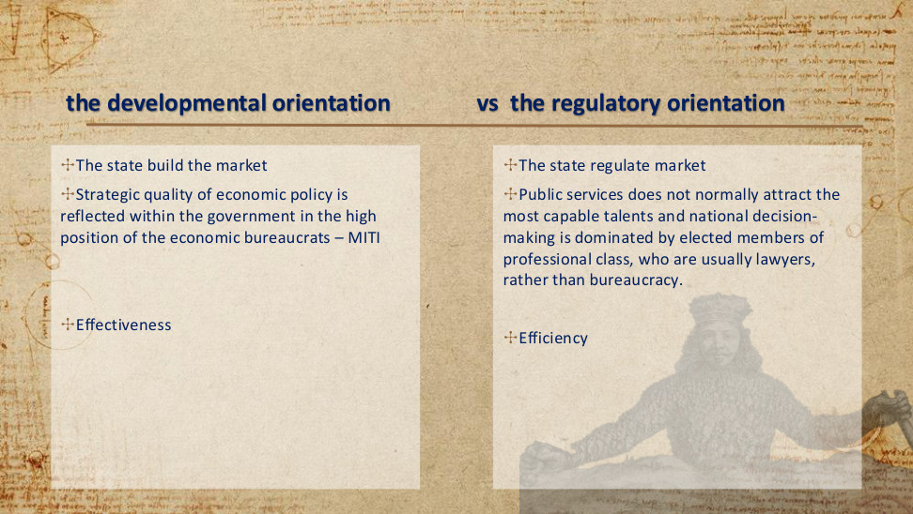
原PPT第21页 / Original slide 21

PPT中英翻译 / PPT translation
PPT English / 英文原文 | 中文翻译 / Chinese translation
The state build the market | 【发展导向】国家构建市场。
Strategic quality of economic policy is reflected within the government in the high position of the economic bureaucrats – MITI | 【发展导向】经济政策的战略性，在政府内部体现为经济官僚的高地位——例如通商产业省（MITI，简称通产省）。
Effectiveness | 【发展导向】有效性／效果：能否实现政策目标。
The state regulate market | 【规制导向】国家规制市场。
Public services does not normally attract the most capable talents and national decision-making is dominated by elected members of professional class, who are usually lawyers, rather than bureaucracy. | 【规制导向，PPT的概括】公共部门通常不吸引最顶尖的人才；国家决策由专业阶层中的民选成员主导——这些人通常有律师背景，而非由官僚体系主导。
Efficiency | 【规制导向】效率：资源投入与产出的关系。

本页核心 / Key takeaway
发展导向侧重构建市场和实现战略目标；规制导向侧重市场规则与效率。
The developmental orientation stresses market building and strategic goal attainment; the regulatory orientation stresses market rules and efficiency.

精要解析 / Essential explanation

1. 效果与效率｜Effectiveness and efficiency
“效果好”是实现了既定目标，例如产业升级；“效率高”是以较少投入取得产出。两者可以同时提高，也可能出现取舍。
Effectiveness means attaining a goal, such as industrial upgrading; efficiency concerns output relative to inputs. They can improve together or involve a trade-off.

2. 官僚为何重要｜Why bureaucracy matters
MITI体现专业经济官僚在战略制定和协调中的地位。PPT比较的是两种理想类型，不宜把“律师主导、公共部门缺乏人才”当作所有规制型国家的事实。
MITI illustrates the strategic and coordinating role of expert economic officials. These are ideal types; claims about lawyers or public-sector recruitment should not be treated as universal facts about regulatory states.

22｜the developmental orientation vs the regulatory orientation｜发展导向与规制导向
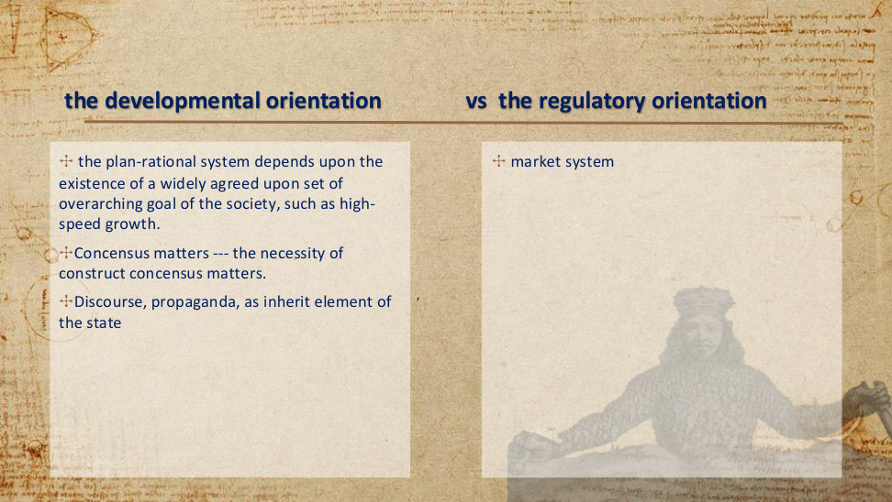
原PPT第22页 / Original slide 22

PPT中英翻译 / PPT translation
PPT English / 英文原文 | 中文翻译 / Chinese translation
the plan-rational system depends upon the existence of a widely agreed upon set of overarching goal of the society, such as high-speed growth. | 【发展导向】计划理性体系依赖社会对一组总体目标形成广泛共识，例如高速增长。
Concensus matters --- the necessity of construct concensus matters. | 【发展导向】共识很重要——建构共识的必要性很重要。（原文拼写与语法有误。）
Discourse, propaganda, as inherit element of the state | 【发展导向】话语、宣传是国家的内在组成要素。（inherit 按语境应为 inherent。）
market system | 【规制导向】市场体系。

本页核心 / Key takeaway
计划理性要求围绕共同发展目标协调政策，而共识需要主动建构。
Plan rationality coordinates policy around shared development goals, and that consensus must be actively constructed.

精要解析 / Essential explanation

1. 共识如何支持政策｜How consensus supports policy
若政府、企业与社会普遍认可增长目标，长期投资和政策协调更容易持续；国家通过政策话语与宣传说明目标、争取支持。形成共识不等于消除所有利益冲突。
Shared acceptance of growth goals can sustain long-term investment and policy coordination. Policy discourse and propaganda explain goals and seek support; consensus does not eliminate every conflict of interest.

易错辨析 / Key distinction
计划理性不等于全面计划经济；发展型国家仍可以使用市场、私营企业和价格机制。
Plan rationality does not mean a fully planned economy; developmental states may still use markets, private firms and prices.

23｜the developmental orientation vs the regulatory orientation｜发展导向与规制导向
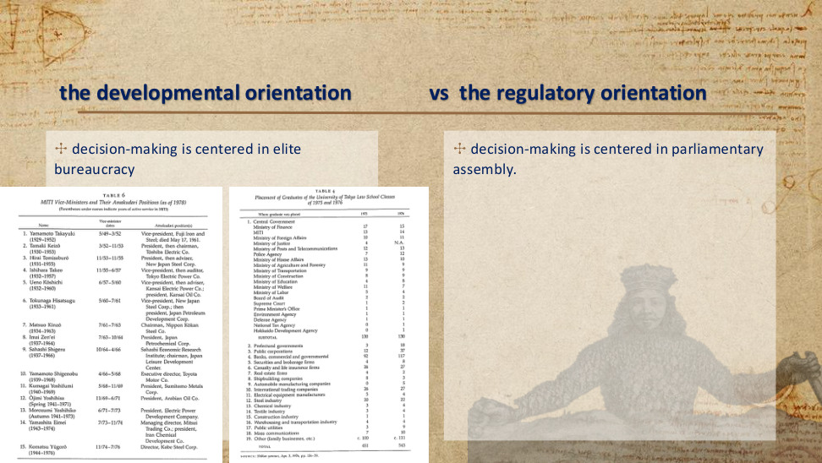
原PPT第23页 / Original slide 23

PPT中英翻译 / PPT translation
PPT English / 英文原文 | 中文翻译 / Chinese translation
decision-making is centered in elite bureaucracy | 【发展导向】决策以精英官僚体系为中心。
decision-making is centered in parliamentary assembly. | 【规制导向】决策以议会为中心。
(Parentheses under names indicate years of active service in MITI) | （姓名下方括号内表示在通产省任职的年份。）
SOURCE: Shūkan yomiuri, Apr. 3, 1976, pp. 156–59. | 右表来源：《周刊读卖》，1976年4月3日，第156–159页。

TABLE 6. MITI Vice-Ministers and Their Amakudari Positions (as of 1978)｜表6：通产省事务次官及其“天下り”去向（截至1978年）
Name (MITI service)｜姓名（通产省任职期） | Vice-minister dates｜事务次官任期（月/年） | Amakudari position(s)｜离任后职位
Yamamoto Takayuki (1929–1952) | 5/49–3/52 | Vice-president, Fuji Iron and Steel; died May 17, 1961.｜富士钢铁副总裁；1961年5月17日逝世。
Tamaki Keizō (1930–1953) | 3/52–11/53 | President, then chairman, Toshiba Electric Co.｜东芝电气总裁，后任董事长。
Hirai Tomisaburō (1931–1955) | 11/53–11/55 | President, then adviser, New Japan Steel Corp.｜新日本制铁总裁，后任顾问。
Ishihara Takeo (1932–1957) | 11/55–6/57 | Vice-president, then auditor, Tokyo Electric Power Co.｜东京电力副总裁，后任监察役。
Ueno Kōshichi (1932–1960) | 6/57–5/60 | Vice-president, then adviser, Kansai Electric Power Co.; president, Kansai Oil Co.｜关西电力副总裁、后任顾问；关西石油总裁。
Tokunaga Hisatsugu (1933–1961) | 5/60–7/61 | Vice-president, New Japan Steel Corp.; then president, Japan Petroleum Development Corp.｜新日本制铁副总裁；后任日本石油开发公司总裁。
Matsuo Kinzō (1934–1963) | 7/61–7/63 | Chairman, Nippon Kōkan Steel Co.｜日本钢管董事长。
Imai Zen’ei (1937–1964) | 7/63–10/64 | President, Japan Petrochemical Corp.｜日本石油化学公司总裁。
Sahashi Shigeru (1937–1966) | 10/64–4/66 | Sahashi Economic Research Institute; chairman, Japan Leisure Development Center.｜佐桥经济研究所；日本休闲开发中心董事长。
Yamamoto Shigenobu (1939–1968) | 4/66–5/68 | Executive director, Toyota Motor Co.｜丰田汽车执行董事。
Kumagai Yoshifumi (1940–1969) | 5/68–11/69 | President, Sumitomo Metals Corp.｜住友金属总裁。
Ōjimi Yoshihisa (Spring 1941–1971｜1941年春–1971年) | 11/69–6/71 | President, Arabian Oil Co.｜阿拉伯石油公司总裁。
Morozumi Yoshihiko (Autumn 1941–1973｜1941年秋–1973年) | 6/71–7/73 | President, Electric Power Development Company.｜电源开发公司总裁。
Yamashita Eimei (1943–1974) | 7/73–11/74 | Managing director, Mitsui Trading Co.; president, Iran Chemical Development Co.｜三井贸易常务董事；伊朗化学开发公司总裁。
Komatsu Yūgorō (1944–1976) | 11/74–7/76 | Director, Kobe Steel Corp.｜神户制钢董事。

TABLE 4. Placement of Graduates of the University of Tokyo Law School Classes of 1975 and 1976｜表4：东京大学法学部1975、1976届毕业生的就业去向
Where graduate was placed｜就业去向 | 1975 | 1976
1. Central Government｜1.中央政府
Ministry of Finance｜大藏省 | 17 | 15
MITI｜通商产业省 | 13 | 14
Ministry of Foreign Affairs｜外务省 | 10 | 11
Ministry of Justice｜法务省 | 4 | N.A.（无可用数据）
Ministry of Posts and Telecommunications｜邮政省 | 12 | 13
Police Agency｜警察厅 | 7 | 12
Ministry of Home Affairs｜自治省 | 13 | 10
Ministry of Agriculture and Forestry｜农林省 | 11 | 9
Ministry of Transportation｜运输省 | 9 | 9
Ministry of Construction｜建设省 | 8 | 9
Ministry of Education｜文部省 | 4 | 8
Ministry of Welfare｜厚生省 | 11 | 7
Ministry of Labor｜劳动省 | 5 | 4
Board of Audit｜会计检查院 | 2 | 2
Supreme Court｜最高裁判所 | 1 | 2
Prime Minister’s Office｜总理府 | 1 | 1
Environment Agency｜环境厅 | 1 | 1
Defense Agency｜防卫厅 | 1 | 1
National Tax Agency｜国税厅 | 0 | 1
Hokkaido Development Agency｜北海道开发厅 | 0 | 1
SUBTOTAL｜小计 | 130 | 130
2. Prefectural governments｜2.都道府县政府 | 3 | 18
3. Public corporations｜3.公共企业 | 12 | 37
4. Banks, commercial and governmental｜4.商业银行及政府银行 | 92 | 117
5. Securities and brokerage firms｜5.证券与经纪公司 | 4 | 8
6. Casualty and life insurance firms｜6.财产及人寿保险公司 | 26 | 27
7. Real estate firms｜7.房地产公司 | 4 | 2
8. Shipbuilding companies｜8.造船公司 | 8 | 3
9. Automobile manufacturing companies｜9.汽车制造公司 | 0 | 5
10. International trading companies｜10.国际贸易公司 | 26 | 27
11. Electrical equipment manufacturers｜11.电气设备制造商 | 5 | 4
12. Steel industry｜12.钢铁业 | 20 | 22
13. Chemical industry｜13.化工业 | 3 | 4
14. Textile industry｜14.纺织业 | 3 | 4
15. Construction industry｜15.建筑业 | 1 | 1
16. Warehousing and transportation industry｜16.仓储与运输业 | 4 | 4
17. Public utilities｜17.公用事业 | 3 | 9
18. Mass communications｜18.大众传播业 | 7 | 10
19. Other (family businesses, etc.)｜19.其他（家族企业等） | c. 100（约100） | c. 111（约111）
TOTAL｜合计 | 451 | 543

本页核心 / Key takeaway
两种导向的区别之一，是政策决策中心：精英官僚体系或议会。
One distinction is the centre of policy decision-making: elite bureaucracy or parliament.

精要解析 / Essential explanation

1. 两张表说明什么｜What the tables illustrate
左表展示通产省高级官员离任后进入企业的“天下り”（amakudari）联系；右表展示东京大学法学毕业生的职业去向。它们帮助理解精英招募与政商网络，不能单独证明政策一定有效。
The left table traces MITI officials’ post-retirement corporate positions (amakudari); the right shows employment destinations of University of Tokyo law graduates. They illustrate elite recruitment and state–business networks, not proof that policy necessarily succeeds.

易错辨析 / Key distinction
官僚居于核心不等于没有议会或选举；这里比较的是主要决策重心。
A central bureaucracy does not imply the absence of a parliament or elections; the comparison concerns the main decision-making locus.

24｜Welfare of East Asia｜东亚的福利
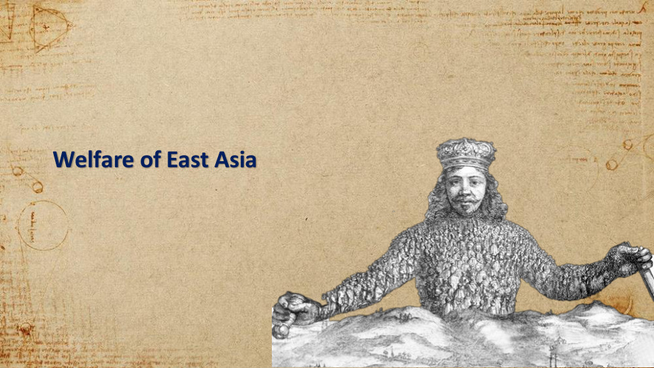
原PPT第24页 / Original slide 24

PPT中英翻译 / PPT translation
PPT English / 英文原文 | 中文翻译 / Chinese translation

本页核心 / Key takeaway
从经济发展转向福利问题：观察国家、市场、企业与家庭怎样分担保障责任。
The focus shifts from economic development to welfare: how the state, market, enterprises and households share responsibility.

精要解析 / Essential explanation

1. 阅读后续页面｜Reading the following slides
这是章节过渡页。后续要结合福利结果、就业机会、支出来源与具体制度，理解东亚福利；不要只看政府支出一项指标。
This is a section transition. The following slides combine welfare outcomes, employment, spending sources and institutions; public spending alone is insufficient.

25｜The developmentalist state vs the regulatory state｜发展型国家与规制型国家
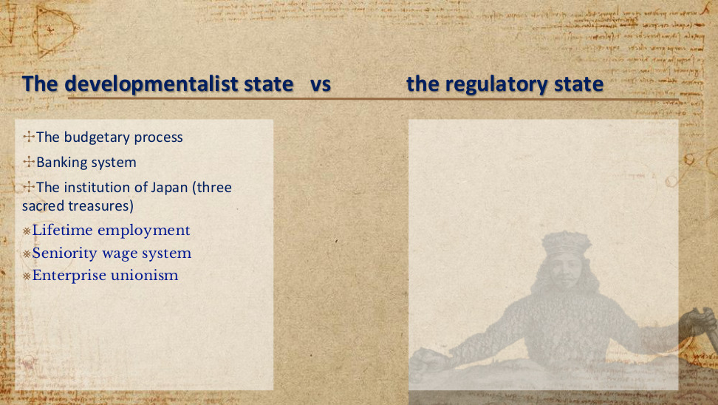
原PPT第25页 / Original slide 25

PPT中英翻译 / PPT translation
PPT English / 英文原文 | 中文翻译 / Chinese translation
The budgetary process | 预算过程
Banking system | 银行体系
The institution of Japan (three sacred treasures) | 日本的制度（“三大瑰宝”）
Lifetime employment | 终身雇佣
Seniority wage system | 年功工资制（工资与资历、工龄等相联系）
Enterprise unionism | 企业工会主义／以企业为单位组织工会

本页核心 / Key takeaway
日本的“三大瑰宝”是终身雇佣、年功工资、企业工会，使就业关系承载部分保障功能。
Japan’s three employment institutions—lifetime employment, seniority wages and enterprise unionism—make employment a channel of welfare protection.

精要解析 / Essential explanation

1. 企业为何能承载福利｜Why firms can provide protection
长期雇佣提供收入稳定，年功工资将收入与长期服务联系起来，企业工会在企业内部协商劳动条件。保障因而与企业成员身份紧密相连。
Long-term employment stabilises earnings, seniority pay links income to continuing service, and enterprise unions negotiate within firms. Protection is therefore closely tied to company membership.

易错辨析 / Key distinction
这些制度主要描述特定历史阶段大型企业的核心正式雇员，不能理解为所有日本劳动者都享有终身保障；企业工会也不等于行业工会。
These institutions mainly describe core regular employees in large firms during a particular historical period, not lifelong protection for every Japanese worker; enterprise unions are not industry-wide unions.

26｜Welfare of East Asia｜东亚的福利
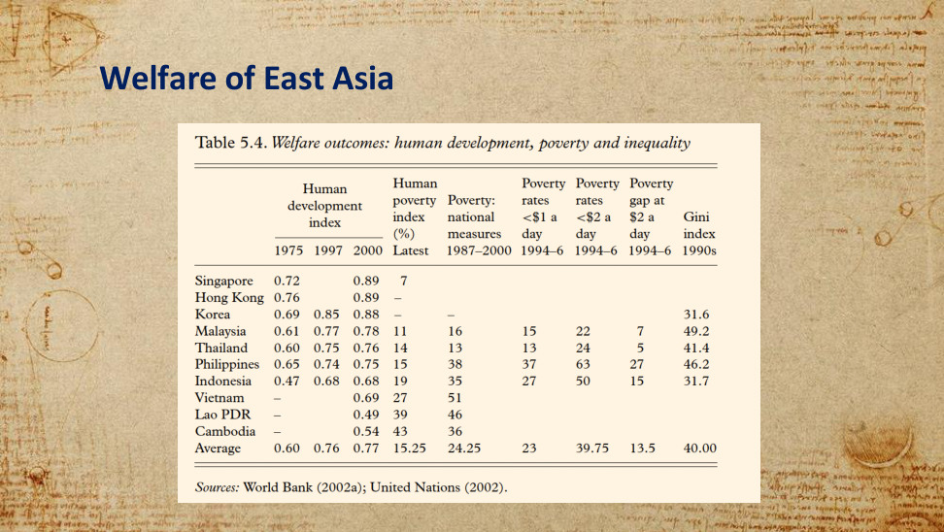
原PPT第26页 / Original slide 26

PPT中英翻译 / PPT translation
PPT English / 英文原文 | 中文翻译 / Chinese translation
Sources: World Bank (2002a); United Nations (2002). | 来源：世界银行（2002a）；联合国（2002）。

Table 5.4. Welfare outcomes: human development, poverty and inequality｜表5.4：福利结果——人类发展、贫困与不平等
Economy｜经济体 | HDI 1975｜人类发展指数1975 | HDI 1997｜人类发展指数1997 | HDI 2000｜人类发展指数2000 | Human poverty index (%) Latest｜人类贫困指数（%），最新 | Poverty: national measures 1987–2000｜本国标准贫困指标1987–2000 | Poverty rates <$1 a day 1994–6｜每日低于1美元贫困率1994–96 | Poverty rates <$2 a day 1994–6｜每日低于2美元贫困率1994–96 | Poverty gap at $2 a day 1994–6｜每日2美元标准贫困缺口1994–96 | Gini index 1990s｜基尼指数1990年代
Singapore｜新加坡 | 0.72 |  | 0.89 | 7
Hong Kong｜香港 | 0.76 |  | 0.89 | –
Korea｜韩国 | 0.69 | 0.85 | 0.88 | – | – |  |  |  | 31.6
Malaysia｜马来西亚 | 0.61 | 0.77 | 0.78 | 11 | 16 | 15 | 22 | 7 | 49.2
Thailand｜泰国 | 0.60 | 0.75 | 0.76 | 14 | 13 | 13 | 24 | 5 | 41.4
Philippines｜菲律宾 | 0.65 | 0.74 | 0.75 | 15 | 38 | 37 | 63 | 27 | 46.2
Indonesia｜印度尼西亚 | 0.47 | 0.68 | 0.68 | 19 | 35 | 27 | 50 | 15 | 31.7
Vietnam｜越南 | – |  | 0.69 | 27 | 51
Lao PDR｜老挝 | – |  | 0.49 | 39 | 46
Cambodia｜柬埔寨 | – |  | 0.54 | 43 | 36
Average｜平均 | 0.60 | 0.76 | 0.77 | 15.25 | 24.25 | 23 | 39.75 | 13.5 | 40.00

本页核心 / Key takeaway
福利结果具有多个维度：人类发展、贫困与不平等必须分别观察。
Welfare outcomes are multidimensional: human development, poverty and inequality must be examined separately.

精要解析 / Essential explanation

1. 怎样读指标｜Reading the indicators
人类发展指数（HDI）综合反映健康、教育与生活水平，数值越高通常越好；人类贫困指数（HPI）越低表示匮乏越少。贫困率、贫困缺口与基尼指数分别关注贫困人数、贫困深度与收入分配，不能相互替代。
The HDI combines health, education and living standards; higher values generally indicate better outcomes. A lower Human Poverty Index indicates less deprivation. Poverty rates, poverty gaps and the Gini index address poverty incidence, its depth and income distribution respectively, and are not interchangeable.

2. 从结果回到制度｜Linking outcomes to institutions
表内不少经济体的人类发展水平提高，但贫困和收入不平等仍存在。经济增长可能改善福利，却不自动保证所有群体受益或实现平等。
Human development improved in several economies, while poverty and inequality remained. Growth may improve welfare but does not automatically benefit every group or ensure equality.

易错辨析 / Key distinction
各列年份不同，属于历史资料；空白或破折号不能当作零。表中的每日1美元／2美元是当时统计口径，不是今天可直接套用的贫困线。
Columns refer to different historical years; blanks and dashes are not zeros. The $1/$2-a-day thresholds are those used in the source and should not be applied directly as today’s poverty lines.

27｜Welfare of East Asia｜东亚的福利
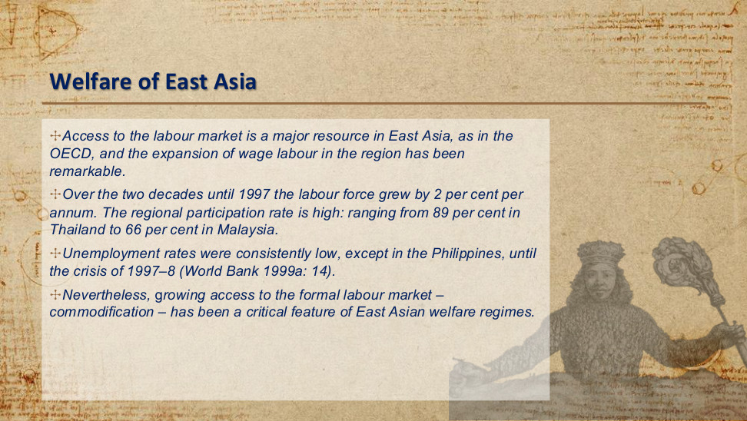
原PPT第27页 / Original slide 27

PPT中英翻译 / PPT translation
PPT English / 英文原文 | 中文翻译 / Chinese translation
Access to the labour market is a major resource in East Asia, as in the OECD, and the expansion of wage labour in the region has been remarkable. | 与经合组织（OECD）地区一样，进入劳动力市场是东亚获得生活资源的重要途径；该地区工资劳动的扩展十分显著。
Over the two decades until 1997 the labour force grew by 2 per cent per annum. The regional participation rate is high: ranging from 89 per cent in Thailand to 66 per cent in Malaysia. | 截至1997年的此前二十年，劳动力规模每年增长2%。地区劳动力参与率较高：从泰国的89%到马来西亚的66%不等。
Unemployment rates were consistently low, except in the Philippines, until the crisis of 1997–8 (World Bank 1999a: 14). | 在1997—1998年危机之前，除菲律宾外，失业率一直较低（世界银行1999a：14）。
Nevertheless, growing access to the formal labour market – commodification – has been a critical feature of East Asian welfare regimes. | 尽管如此，进入正规劳动力市场的机会扩大——即商品化——一直是东亚福利体制的重要特征。

本页核心 / Key takeaway
东亚福利的重要渠道是获得有薪就业；这种保障依赖出售劳动力，属于商品化。
Access to paid work is a major welfare channel in East Asia; protection that depends on selling labour reflects commodification.

精要解析 / Essential explanation

1. 增长怎样转化为生活保障｜How growth supports livelihoods
就业扩张通过工资收入改善生活，并可连接企业福利；但一旦失业、退出劳动市场或只从事非正规工作，保障可能减弱。
Employment expansion improves living standards through earnings and may provide access to enterprise benefits. Protection can weaken with unemployment, labour-market exit or informal work.

2. 把三个统计量分清｜Distinguishing three statistics
劳动力规模增长率是人数的变化；参与率指劳动年龄人口中进入劳动力市场的比例；失业率指劳动力中失业者的比例。原PPT未交代89%／66%的具体年龄与性别口径。
Labour-force growth measures changes in numbers; participation measures entry into the labour force relative to the relevant population; unemployment measures the unemployed within the labour force. The slide does not specify the age or sex coverage behind 89%/66%.

易错辨析 / Key distinction
商品化＝依靠市场就业获得生活资源；去商品化＝即使暂不出售劳动力，也能凭社会权利维持基本生活。高就业率本身不等于高去商品化。
Commodification means relying on market employment for a livelihood; decommodification means maintaining a basic livelihood through social rights even without selling labour. High employment is not itself high decommodification.

28｜Welfare of East Asia｜东亚的福利
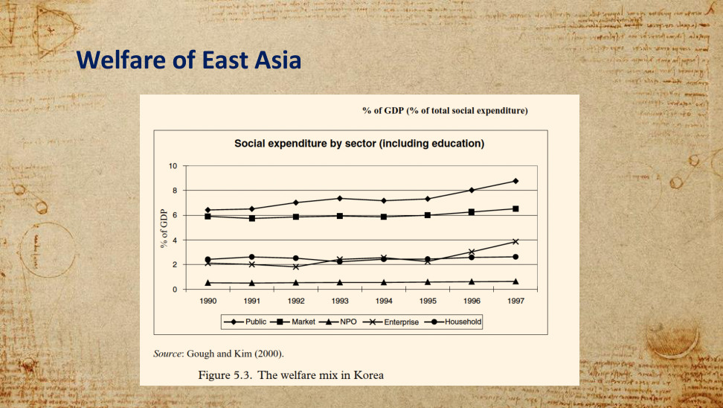
原PPT第28页 / Original slide 28

PPT中英翻译 / PPT translation
PPT English / 英文原文 | 中文翻译 / Chinese translation
% of GDP (% of total social expenditure) | 占GDP的百分比（占社会总支出的百分比）〔原图上方文字；纵轴实际标示为占GDP百分比〕
Social expenditure by sector (including education) | 按部门划分的社会支出（含教育）
% of GDP | 占GDP的百分比（纵轴）
1990, 1991, 1992, 1993, 1994, 1995, 1996, 1997 | 1990—1997年（横轴）
Public; Market; NPO; Enterprise; Household | 公共部门；市场；非营利组织（NPO）；企业；家庭
Source: Gough and Kim (2000). | 来源：Gough与Kim（2000）。
Figure 5.3. The welfare mix in Korea | 图5.3：韩国的福利混合

本页核心 / Key takeaway
韩国的福利混合显示：公共部门、市场、企业、家庭与非营利组织共同承担社会支出。
Korea’s welfare mix shows social spending shared by the public sector, market, enterprises, households and nonprofit organisations.

精要解析 / Essential explanation

1. 读出主要结构｜Reading the main pattern
1990—1997年，图中公共部门与市场支出较高；企业、家庭也持续承担支出，非营利部门较小。公共支出上升，并不表示其他主体退出。
From 1990 to 1997, public and market spending are the largest series shown; enterprises and households also contribute continuously, while the nonprofit sector is smaller. Rising public spending does not mean other actors withdraw.

易错辨析 / Key distinction
图中是各部门支出占GDP的比重，不是各部门占总福利支出的份额；这里依据线条读趋势，不把估读值写成精确统计。
The y-axis reports each sector’s expenditure as a share of GDP, not its share of total welfare spending. Read the trends without treating visually estimated values as exact statistics.

29｜Welfare of East Asia｜东亚的福利
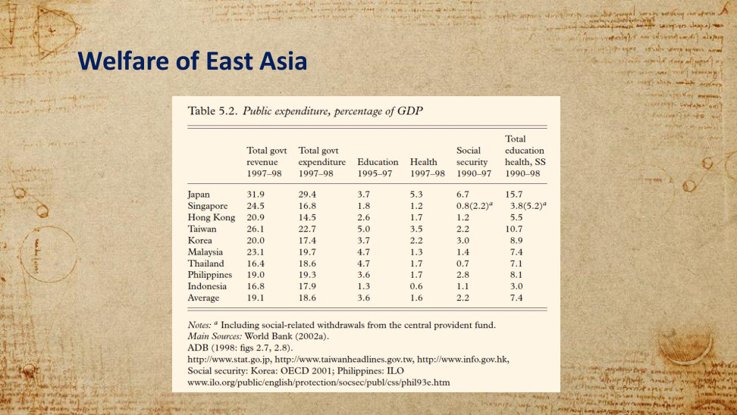
原PPT第29页 / Original slide 29

PPT中英翻译 / PPT translation
PPT English / 英文原文 | 中文翻译 / Chinese translation
Notes: a Including social-related withdrawals from the central provident fund. | 注a：包括从中央公积金提取的社会福利相关款项。
Main Sources: World Bank (2002a). ADB (1998: figs 2.7, 2.8). | 主要来源：世界银行（2002a）；亚洲开发银行（1998：图2.7、2.8）。
http://www.stat.go.jp, http://www.taiwanheadlines.gov.tw, http://www.info.gov.hk, | 其他来源网址：http://www.stat.go.jp；http://www.taiwanheadlines.gov.tw；http://www.info.gov.hk。
Social security: Korea: OECD 2001; Philippines: ILO | 社会保障数据：韩国——OECD（2001）；菲律宾——国际劳工组织（ILO）。
www.ilo.org/public/english/protection/socsec/publ/css/phil93e.htm | 原表所列网址：www.ilo.org/public/english/protection/socsec/publ/css/phil93e.htm。

Table 5.2. Public expenditure, percentage of GDP｜表5.2：公共支出，占GDP百分比
Economy｜经济体 | Total govt revenue 1997–98｜政府总收入1997–98 | Total govt expenditure 1997–98｜政府总支出1997–98 | Education 1995–97｜教育1995–97 | Health 1997–98｜医疗卫生1997–98 | Social security 1990–97｜社会保障1990–97 | Total education health, SS 1990–98｜教育、医疗、社会保障合计1990–98
Japan｜日本 | 31.9 | 29.4 | 3.7 | 5.3 | 6.7 | 15.7
Singapore｜新加坡 | 24.5 | 16.8 | 1.8 | 1.2 | 0.8 (2.2)ᵃ | 3.8 (5.2)ᵃ
Hong Kong｜香港 | 20.9 | 14.5 | 2.6 | 1.7 | 1.2 | 5.5
Taiwan｜台湾 | 26.1 | 22.7 | 5.0 | 3.5 | 2.2 | 10.7
Korea｜韩国 | 20.0 | 17.4 | 3.7 | 2.2 | 3.0 | 8.9
Malaysia｜马来西亚 | 23.1 | 19.7 | 4.7 | 1.3 | 1.4 | 7.4
Thailand｜泰国 | 16.4 | 18.6 | 4.7 | 1.7 | 0.7 | 7.1
Philippines｜菲律宾 | 19.0 | 19.3 | 3.6 | 1.7 | 2.8 | 8.1
Indonesia｜印度尼西亚 | 16.8 | 17.9 | 1.3 | 0.6 | 1.1 | 3.0
Average｜平均（按原表保留） | 19.1 | 18.6 | 3.6 | 1.6 | 2.2 | 7.4

本页核心 / Key takeaway
判断福利投入，要区分政府总支出与教育、医疗、社会保障等具体支出。
Assessing welfare effort requires distinguishing total government expenditure from spending on education, health and social security.

精要解析 / Essential explanation

1. 表格如何支持比较｜How the table supports comparison
各经济体的支出结构与水平不同；日本的社会保障及三项合计明显高于表内多数其他经济体。低公共福利支出不能直接推出“完全没有福利”，还需联系上一页的市场、企业和家庭。
Spending levels and composition differ. Japan’s social security and combined spending exceed those of most other economies shown. Low public welfare spending does not mean an absence of welfare; the market, enterprise and household channels on the previous slide also matter.

易错辨析 / Key distinction
单位均为占GDP百分比，各列年份不同。新加坡括号值按注a纳入公积金相关提取；不能把括号内外当作两个年份。
All values are percentages of GDP and column years differ. Singapore’s bracketed values include the provident-fund withdrawals in note a; they are not observations for a second year.

30｜Welfare of East Asia｜东亚的福利
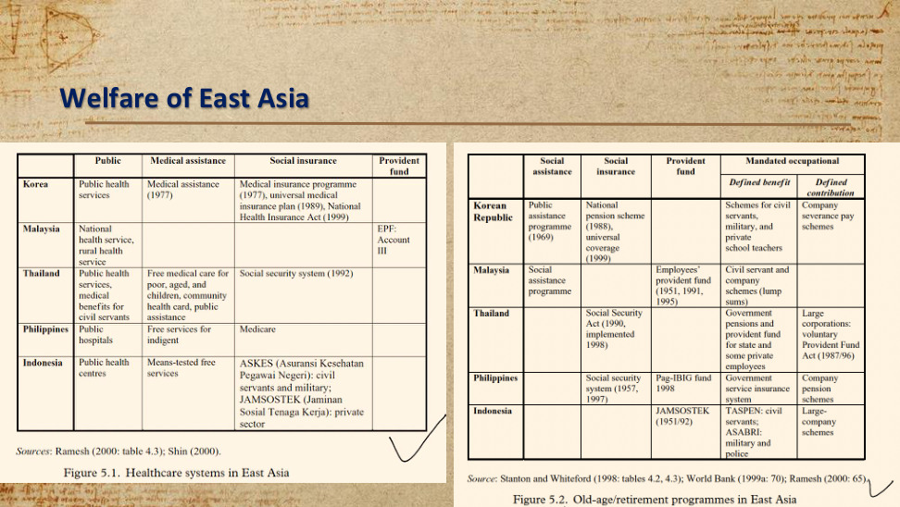
原PPT第30页 / Original slide 30

PPT中英翻译 / PPT translation
PPT English / 英文原文 | 中文翻译 / Chinese translation
Sources: Ramesh (2000: table 4.3); Shin (2000). | 医疗表来源：Ramesh（2000：表4.3）；Shin（2000）。
Source: Stanton and Whiteford (1998: tables 4.2, 4.3); World Bank (1999a: 70); Ramesh (2000: 65). | 养老表来源：Stanton与Whiteford（1998：表4.2、4.3）；世界银行（1999a：70）；Ramesh（2000：65）。

Figure 5.1. Healthcare systems in East Asia｜图5.1：东亚医疗制度
Economy｜经济体 | Public｜公共服务 | Medical assistance｜医疗救助 | Social insurance｜社会保险 | Provident fund｜公积金
Korea｜韩国 | Public health services｜公共卫生服务 | Medical assistance (1977)｜医疗救助（1977） | Medical insurance programme (1977), universal medical insurance plan (1989), National Health Insurance Act (1999)｜医疗保险项目（1977）、全民医疗保险计划（1989）、《国民健康保险法》（1999）
Malaysia｜马来西亚 | National health service, rural health service｜国家卫生服务、农村卫生服务 |  |  | EPF: Account III｜雇员公积金：第三账户
Thailand｜泰国 | Public health services, medical benefits for civil servants｜公共卫生服务、公务员医疗福利 | Free medical care for poor, aged, and children, community health card, public assistance｜为贫困者、老年人及儿童提供免费医疗；社区健康卡；公共救助 | Social security system (1992)｜社会保障制度（1992）
Philippines｜菲律宾 | Public hospitals｜公立医院 | Free services for indigent｜为贫困者提供免费服务 | Medicare｜Medicare医疗保险
Indonesia｜印度尼西亚 | Public health centres｜公共卫生中心 | Means-tested free services｜经过经济状况审查的免费服务 | ASKES (Asuransi Kesehatan Pegawai Negeri): civil servants and military; JAMSOSTEK (Jaminan Sosial Tenaga Kerja): private sector｜ASKES（公务员健康保险）：公务员及军人；JAMSOSTEK（劳动者社会保障）：私营部门

Figure 5.2. Old-age/retirement programmes in East Asia｜图5.2：东亚老年／退休保障计划
Economy｜经济体 | Social assistance｜社会救助 | Social insurance｜社会保险 | Provident fund｜公积金 | Mandated occupational: Defined benefit｜强制性职业计划：确定给付（DB） | Mandated occupational: Defined contribution｜强制性职业计划：确定缴费（DC）
Korean Republic｜韩国 | Public assistance programme (1969)｜公共救助计划（1969） | National pension scheme (1988), universal coverage (1999)｜国民年金计划（1988）、全民覆盖（1999，按原表表述） |  | Schemes for civil servants, military, and private school teachers｜公务员、军人和私立学校教师计划 | Company severance pay schemes｜企业离职补偿计划
Malaysia｜马来西亚 | Social assistance programme｜社会救助计划 |  | Employees’ provident fund (1951, 1991, 1995)｜雇员公积金（1951、1991、1995） | Civil servant and company schemes (lump sums)｜公务员及企业计划（一次性支付）
Thailand｜泰国 |  | Social Security Act (1990, implemented 1998)｜《社会保障法》（1990，1998年实施） |  | Government pensions and provident fund for state and some private employees｜政府养老金，以及面向国家部门和部分私营部门雇员的公积金 | Large corporations: voluntary Provident Fund Act (1987/96)｜大型企业：自愿性安排，《公积金法》（1987/96，按原表）
Philippines｜菲律宾 |  | Social security system (1957, 1997)｜社会保障制度（1957、1997） | Pag-IBIG fund 1998｜Pag-IBIG基金（1998） | Government service insurance system｜政府雇员保险制度 | Company pension schemes｜企业养老金计划
Indonesia｜印度尼西亚 |  |  | JAMSOSTEK (1951/92)｜JAMSOSTEK劳动者社会保障（1951/92，按原表） | TASPEN: civil servants; ASABRI: military and police｜TASPEN：公务员；ASABRI：军人及警察 | Large-company schemes｜大型企业计划

本页核心 / Key takeaway
东亚医疗与养老由多种制度并存提供，保障资格往往与职业、缴费或经济困难有关。
East Asian healthcare and retirement combine multiple schemes, with eligibility often linked to occupation, contributions or financial need.

精要解析 / Essential explanation

1. 按制度而非只按国家比较｜Compare schemes, not only countries
社会救助主要针对需要帮助者；社会保险通常以参保和缴费为基础；公积金强调积累；职业计划由特定就业关系连接。一个国家可以同时使用多种安排。
Social assistance mainly targets need; social insurance generally rests on membership and contributions; provident funds emphasise accumulation; occupational schemes are linked to particular employment relationships. These arrangements can coexist within one country.

2. 表中的两类职业养老金｜Two occupational pension designs
确定给付（DB）预先规定待遇计算规则；确定缴费（DC）预先规定缴费规则，最终待遇取决于积累等因素。不要把计划名称等同于实际全民覆盖。
Defined benefit (DB) specifies the benefit formula; defined contribution (DC) specifies contributions, with eventual benefits depending on accumulation and related factors. A scheme’s existence does not establish effective universal coverage.

易错辨析 / Key distinction
这是约1990年代至2000年前后的历史制度图，不能作为各国现行制度说明；空格表示原表未列项目，不等于该国完全没有相关保障。
These tables describe historical arrangements around the 1990s–2000 period, not current systems. Blank cells mean no scheme is listed in the original, not necessarily a complete absence of protection.

31｜社区、公民社会与非政府组织 vs 家庭—家户｜Community, civil society and NGOs vs Family – household
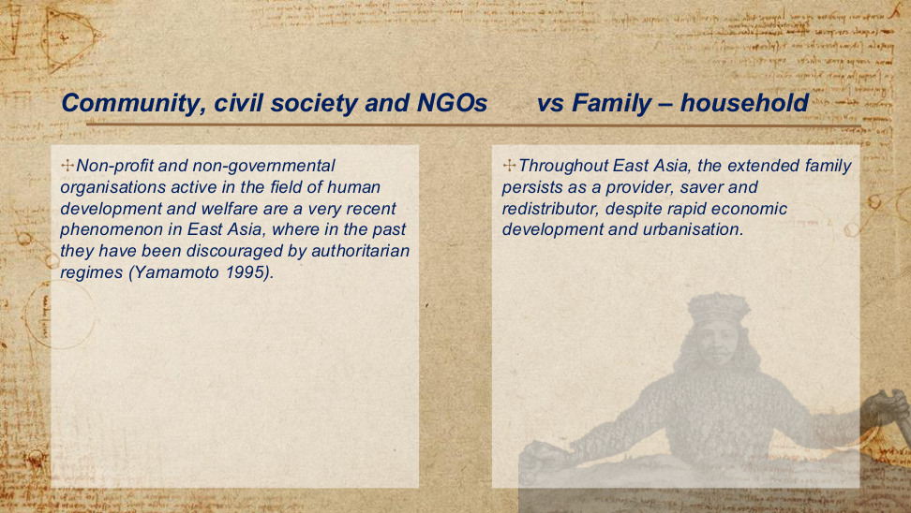
原PPT第31页 / Original slide 31

PPT中英翻译 / PPT translation
PPT English / 英文原文 | 中文翻译 / Chinese translation
Non-profit and non-governmental organisations active in the field of human development and welfare are a very recent phenomenon in East Asia, where in the past they have been discouraged by authoritarian regimes (Yamamoto 1995). | 在人类发展与福利领域活跃的非营利组织和非政府组织，在东亚是较晚近才出现的现象；过去，威权政权曾抑制这些组织的发展（Yamamoto，1995）。
Throughout East Asia, the extended family persists as a provider, saver and redistributor, despite rapid economic development and urbanisation. | 尽管经历了快速经济发展与城市化，扩展家庭在整个东亚仍持续承担供给、储蓄和再分配的角色。

本页核心 / Key takeaway
东亚福利不能只看政府与市场；扩展家庭持续承担福利供给、储蓄与再分配，而公民社会组织的发展受到历史条件影响。
East Asian welfare depends on the extended family for provision, saving and redistribution, while the development of civil society organisations reflects historical conditions.

精要解析 / Essential explanation

1. 家庭的三重角色｜Three family roles
“供给”指照护与生活支持，“储蓄”指为家庭需要积累资源，“再分配”指在家庭成员与代际之间转移资源。
Provision means care and material support; saving accumulates resources for household needs; redistribution transfers resources among family members and generations.

2. 组织发展与国家关系｜Organisations and the state
本页把NGO发展较晚与过去的威权限制联系起来。复习时同时观察国家是否容许社会组织成长，以及家庭承担多少福利责任。
The slide links the late development of NGOs to past authoritarian restrictions. Consider both the space allowed for civic organisations and the welfare responsibilities carried by families.

32｜生产主义福利资本主义：第四种体制的提议｜A fourth welfare regime of productivism welfare capitalism
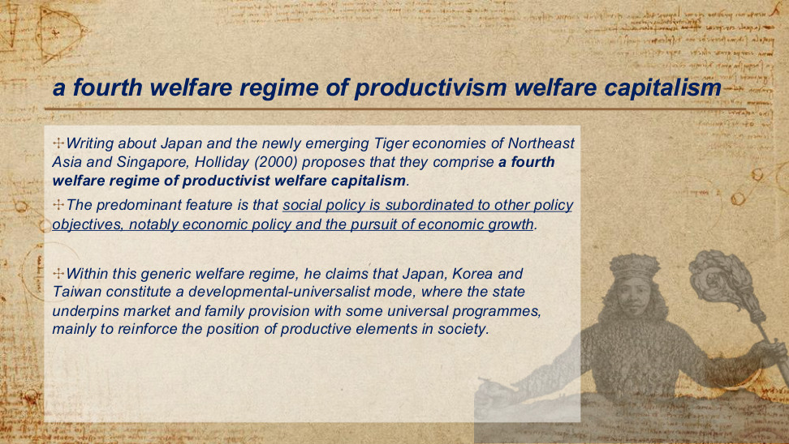
原PPT第32页 / Original slide 32

PPT中英翻译 / PPT translation
PPT English / 英文原文 | 中文翻译 / Chinese translation
Writing about Japan and the newly emerging Tiger economies of Northeast Asia and Singapore, Holliday (2000) proposes that they comprise a fourth welfare regime of productivist welfare capitalism. | Holliday（2000）讨论日本、东北亚新兴“亚洲虎”经济体及新加坡时，提出它们构成第四种福利体制，即生产主义福利资本主义。
The predominant feature is that social policy is subordinated to other policy objectives, notably economic policy and the pursuit of economic growth. | 其最突出特征是社会政策从属于其他政策目标，尤其是经济政策和经济增长的追求。
Within this generic welfare regime, he claims that Japan, Korea and Taiwan constitute a developmental-universalist mode, where the state underpins market and family provision with some universal programmes, mainly to reinforce the position of productive elements in society. | 在这一总体福利体制内，他认为日本、韩国和中国台湾构成发展—普遍主义模式：国家通过部分普遍性项目支持市场与家庭供给，主要目的是强化社会中生产性群体的地位。

本页核心 / Key takeaway
Holliday提出生产主义福利资本主义：社会政策从属于经济增长；部分普遍性福利项目也可服务于生产性群体。
Holliday proposes productivist welfare capitalism: social policy is subordinated to economic growth, and some universal programmes also support productive groups.

精要解析 / Essential explanation

1. 判断标准：政策目标｜Identify the policy goal
识别生产主义要问“福利为什么投入”：如果主要为了增强生产能力与推动增长，即使存在公共或普遍性项目，也符合这一分析逻辑。
Ask why welfare resources are allocated. Public or universal programmes can fit a productivist logic when their main purpose is to strengthen productive capacity and growth.

2. 发展—普遍主义｜Developmental-universalist mode
“普遍主义”说明部分项目的覆盖方式；“发展”说明这些项目所服务的增长目标。不能只凭“普遍”二字把它等同于社会民主福利体制。
Universalism describes the coverage of some programmes; developmentalism describes the growth goal they serve. Universal coverage alone does not establish a social democratic welfare regime.

易错辨析 / Key distinction
“第四种体制”是Holliday对既有分类的扩展提议，并非Esping-Andersen原始“三个世界”本来就有的第四类。
The fourth regime is Holliday’s proposed extension of existing classifications; it is not a fourth category in Esping-Andersen’s original three worlds.

33｜生产主义福利的市场与企业支柱｜A fourth welfare regime of productivism welfare capitalism
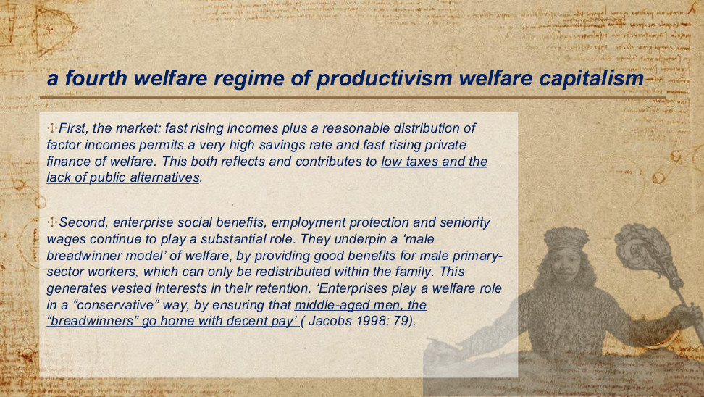
原PPT第33页 / Original slide 33

PPT中英翻译 / PPT translation
PPT English / 英文原文 | 中文翻译 / Chinese translation
First, the market: fast rising incomes plus a reasonable distribution of factor incomes permits a very high savings rate and fast rising private finance of welfare. This both reflects and contributes to low taxes and the lack of public alternatives. | 第一，市场：收入快速增长，加上较为合理的要素收入分配，使高储蓄率和迅速增加的私人福利融资成为可能。这既反映了低税收与公共替代方案的不足，也进一步促成了这种格局。
Second, enterprise social benefits, employment protection and seniority wages continue to play a substantial role. | 第二，企业社会福利、就业保护与年功工资仍发挥重要作用。
They underpin a ‘male breadwinner model’ of welfare, by providing good benefits for male primary-sector workers, which can only be redistributed within the family. This generates vested interests in their retention. | 它们通过向核心就业部门的男性劳动者提供较好福利，支撑“男性养家者模式”；这些福利只能通过家庭内部再分配给其他成员。这使受益者形成保留这些安排的既得利益。
‘Enterprises play a welfare role in a “conservative” way, by ensuring that middle-aged men, the “breadwinners” go home with decent pay’ (Jacobs 1998: 79). | “企业以一种‘保守’方式发挥福利作用：确保作为‘养家者’的中年男性能够带着体面的薪酬回家”（Jacobs，1998：79）。

本页核心 / Key takeaway
市场融资与企业福利共同支撑男性养家者模式：核心男性雇员先获得收入与福利，再通过家庭分配给其他成员。
Market finance and enterprise welfare support a male breadwinner model: core male employees receive income and benefits, then share them within the family.

精要解析 / Essential explanation

1. 私人融资的循环｜Private-finance feedback
收入增长与高储蓄提高家庭自付福利的能力；私人融资、低税收与有限公共替代方案相互强化，不能只看公共开支判断整个福利供给。
Rising incomes and high savings support private welfare finance. Private finance, low taxes and limited public alternatives reinforce one another, so public spending alone misses part of welfare provision.

2. 企业福利的分配后果｜Distribution through employment
福利与稳定就业、工龄和养家者身份相联系，因此不同就业位置的保障并不相同；依赖者往往通过与雇员的家庭关系间接受益。
Benefits are linked to secure employment, seniority and breadwinner status, producing unequal protection across employment positions. Dependants often benefit indirectly through their family relationship with the employee.

易错辨析 / Key distinction
这里的primary-sector workers指核心／主要劳动力市场中的雇员，不是农业等“第一产业劳动者”。
Here, primary-sector workers means employees in the core or primary labour-market sector, not workers in primary industries such as agriculture.

34｜生产主义福利的家庭支柱｜A fourth welfare regime of productivism welfare capitalism
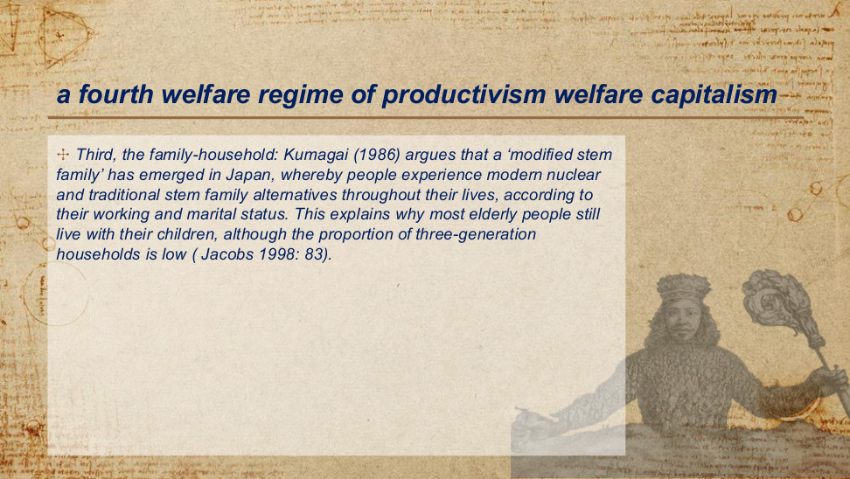
原PPT第34页 / Original slide 34

PPT中英翻译 / PPT translation
PPT English / 英文原文 | 中文翻译 / Chinese translation
Third, the family-household: Kumagai (1986) argues that a ‘modified stem family’ has emerged in Japan, whereby people experience modern nuclear and traditional stem family alternatives throughout their lives, according to their working and marital status. | 第三，家庭—家户：Kumagai（1986）认为，日本出现了“改良型主干家庭”；人们会随着就业和婚姻状况，在一生中经历现代核心家庭与传统主干家庭等不同安排。
This explains why most elderly people still live with their children, although the proportion of three-generation households is low (Jacobs 1998: 83). | 这解释了为什么尽管三代同堂家户所占比例较低，多数老年人仍与子女同住（Jacobs，1998：83）。

本页核心 / Key takeaway
改良型主干家庭强调家庭安排随生命周期变化：核心家庭与代际同住并存，现代化不必然消除家庭福利责任。
The modified stem family describes changing arrangements across the life course: nuclear households and intergenerational co-residence coexist, preserving family welfare responsibilities.

精要解析 / Essential explanation

1. 动态理解家庭结构｜A life-course approach
不要把家庭只看作固定的一种结构。结婚、就业及晚年需要变化，可能使同一个人先后处在不同的居住与照护安排中。
Do not treat family structure as fixed. Changes in marriage, employment and later-life needs can place the same person in different living and care arrangements over time.

2. 两个比例可以并存｜Two compatible observations
“老人同子女住”不等于“三代同堂”：只有老人及成年子女的两代家户，也属于代际同住。因此两个统计描述并不矛盾。
Older people living with children need not form three-generation households. A household containing an older parent and adult child has two generations, so the two observations are compatible.

35｜文化解释：儒家福利国家｜Explanations: the cultural perspective
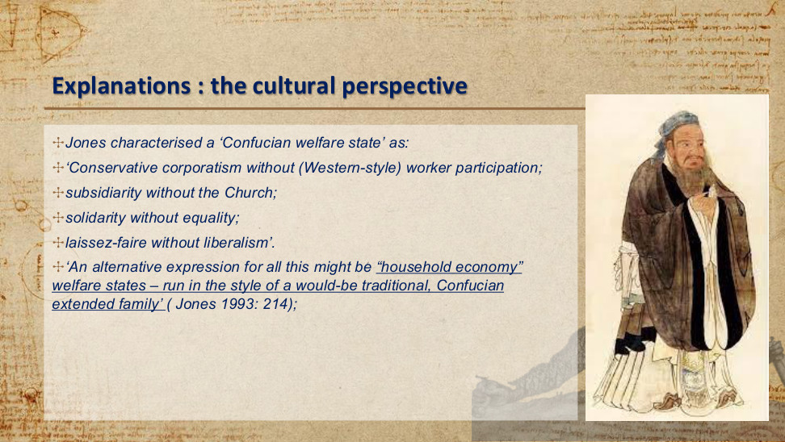
原PPT第35页 / Original slide 35

PPT中英翻译 / PPT translation
PPT English / 英文原文 | 中文翻译 / Chinese translation
Jones characterised a ‘Confucian welfare state’ as: | Jones将“儒家福利国家”概括为：
‘Conservative corporatism without (Western-style) worker participation; | “保守法团主义，但没有西方式的工人参与；
subsidiarity without the Church; | 辅助性原则，但没有教会；
solidarity without equality; | 团结互助，但没有平等；
laissez-faire without liberalism’. | 自由放任，但没有自由主义。”
‘An alternative expression for all this might be “household economy” welfare states – run in the style of a would-be traditional, Confucian extended family’ (Jones 1993: 214). | “另一种说法或许是‘家户经济’福利国家——以一种仿效传统儒家扩展家庭的方式运作”（Jones，1993：214）。

本页核心 / Key takeaway
Jones以儒家福利国家概括一种家户经济式安排：家庭责任与团结可以突出，但不必伴随平等、自由主义或西式工人参与。
Jones’s Confucian welfare state describes a household-economy arrangement in which family responsibility and solidarity need not entail equality, liberalism or Western-style worker participation.

精要解析 / Essential explanation

1. 抓住四个“without”｜Understand the four “withouts”
重点是相似制度词语可有不同组合：有团结不代表追求平等，有市场放任也不代表完整的自由主义价值体系。
Similar institutional terms can appear in different combinations: solidarity does not necessarily imply equality, and laissez-faire does not necessarily imply a full liberal value system.

2. 解释视角的边界｜Limits of the explanation
这是用文化与家庭关系解释福利的一种视角。不能将其当作所有东亚社会不变的本质；后页还会用国家制度与增长战略解释同一现象。
This is one cultural explanation of welfare and family relations, not an unchanging essence of all East Asian societies. Later slides explain the pattern through state institutions and growth strategies.

36｜文化解释：儒家价值的作用｜Explanations: the cultural perspective
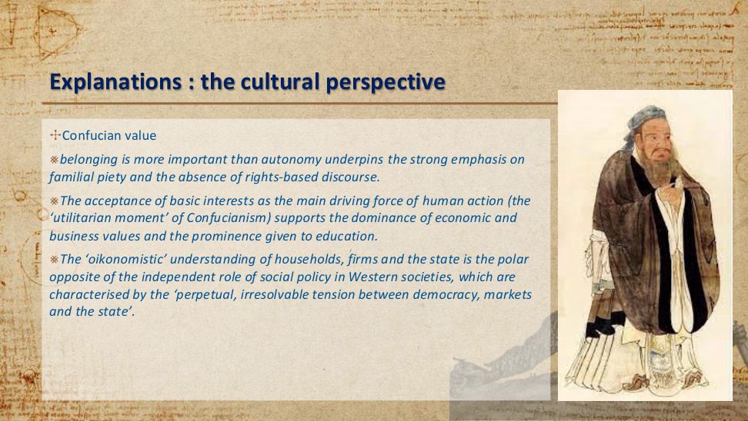
原PPT第36页 / Original slide 36

PPT中英翻译 / PPT translation
PPT English / 英文原文 | 中文翻译 / Chinese translation
Confucian value | 儒家价值观
belonging is more important than autonomy underpins the strong emphasis on familial piety and the absence of rights-based discourse. | 归属比自主更重要的观念，支撑了对家庭孝道的强调，以及以权利为基础的话语的缺位。
The acceptance of basic interests as the main driving force of human action (the ‘utilitarian moment’ of Confucianism) supports the dominance of economic and business values and the prominence given to education. | 将基本利益视为人类行动主要驱动力的观念（儒家思想的“功利性面向”），支持了经济与商业价值的主导地位，以及对教育的高度重视。
The ‘oikonomistic’ understanding of households, firms and the state is the polar opposite of the independent role of social policy in Western societies, which are characterised by the ‘perpetual, irresolvable tension between democracy, markets and the state’. | 对家户、企业和国家的“家户经济本位”理解，与西方社会中社会政策的独立角色形成鲜明对照；后者被描述为存在“民主、市场与国家之间永久且无法消解的张力”。

本页核心 / Key takeaway
文化视角把归属优先于自主与孝道、家庭责任联系起来，并用家户经济本位解释教育及经济目标为何受到重视。
The cultural perspective links belonging over autonomy to filial duty and family responsibility, and uses household-oriented reasoning to explain the priority of education and economic goals.

精要解析 / Essential explanation

1. 责任与权利话语｜Duties and rights discourse
本页的对照是：福利可被理解为家庭成员的相互责任，也可被理解为个人能够提出的权利要求。文化解释侧重前一种语言。
The contrast is between welfare understood as mutual family duties and welfare understood as individual rights claims. This cultural explanation emphasises the former language.

2. oikonomistic的含义｜Meaning of oikonomistic
这里指用家户经营的逻辑理解家庭、企业和国家，强调共同经济目标；不要只把它译为泛泛的“经济学的”。
Here, oikonomistic means understanding households, firms and the state through household-management logic and shared economic goals; it is more specific than simply “economic”.

37｜政治经济学解释：发展型国家与社会政策｜Explanations: the political economic perspective
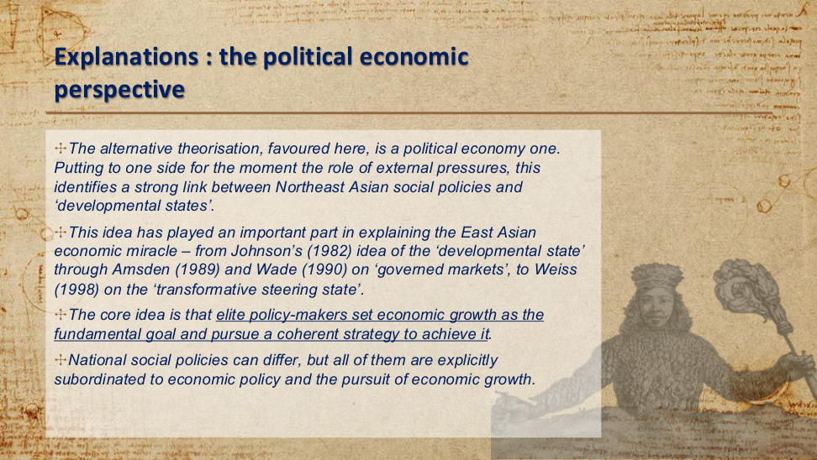
原PPT第37页 / Original slide 37

PPT中英翻译 / PPT translation
PPT English / 英文原文 | 中文翻译 / Chinese translation
The alternative theorisation, favoured here, is a political economy one. Putting to one side for the moment the role of external pressures, this identifies a strong link between Northeast Asian social policies and ‘developmental states’. | 本处更倾向于另一种理论解释，即政治经济学视角。暂且搁置外部压力的作用，这一视角指出东北亚社会政策与“发展型国家”之间存在紧密联系。
This idea has played an important part in explaining the East Asian economic miracle – from Johnson’s (1982) idea of the ‘developmental state’ through Amsden (1989) and Wade (1990) on ‘governed markets’, to Weiss (1998) on the ‘transformative steering state’. | 这一思路在解释东亚经济奇迹中发挥了重要作用：从Johnson（1982）的“发展型国家”，到Amsden（1989）和Wade（1990）有关“受治理的市场”的论述，再到Weiss（1998）的“转型引导型国家”。
The core idea is that elite policy-makers set economic growth as the fundamental goal and pursue a coherent strategy to achieve it. | 核心观点是：精英决策者将经济增长设为根本目标，并通过一套连贯战略实现这一目标。
National social policies can differ, but all of them are explicitly subordinated to economic policy and the pursuit of economic growth. | 各国社会政策可以不同，但都明确从属于经济政策和经济增长目标。

本页核心 / Key takeaway
本课更倾向政治经济学解释：精英通过连贯的发展战略追求增长，社会政策的地位由发展型国家的增长目标塑造。
The course favours a political economy explanation: elites pursue coherent development strategies, and social policy is shaped by the developmental state’s growth goals.

精要解析 / Essential explanation

1. 与文化解释比较｜Compare the explanations
文化视角重在价值、归属与家庭；政治经济学视角重在谁制定目标、国家怎样组织增长，以及社会政策如何服务发展战略。
The cultural perspective stresses values, belonging and family; political economy asks who sets goals, how the state organises growth and how social policy serves development strategy.

2. 共同逻辑与国家差异｜Shared logic and variation
共同点是增长目标的优先地位，而不是各国福利项目完全一致。论述时可先指出共同目标，再比较具体工具与供给安排。
The shared feature is the priority of growth, not identical welfare programmes. An answer can identify the common goal before comparing specific policy tools and provision arrangements.

38｜政治经济学解释：生产主义的四项特征｜Explanations: the political economic perspective
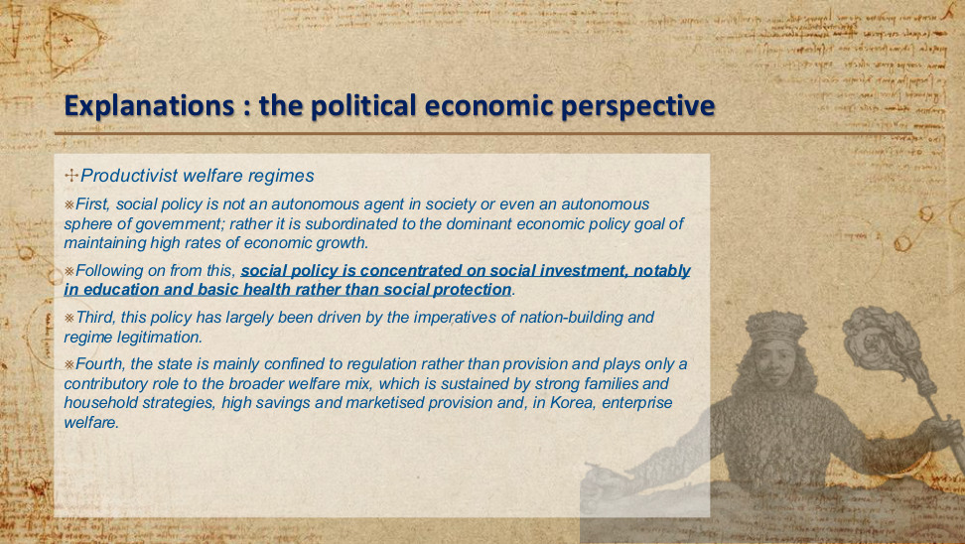
原PPT第38页 / Original slide 38

PPT中英翻译 / PPT translation
PPT English / 英文原文 | 中文翻译 / Chinese translation
Productivist welfare regimes | 生产主义福利体制
First, social policy is not an autonomous agent in society or even an autonomous sphere of government; rather it is subordinated to the dominant economic policy goal of maintaining high rates of economic growth. | 第一，社会政策并非社会中的自主力量，甚至不是政府中自主的政策领域；相反，它从属于维持高速经济增长这一占主导地位的经济政策目标。
Following on from this, social policy is concentrated on social investment, notably in education and basic health rather than social protection. | 由此，社会政策集中于社会投资，尤其是教育和基础医疗，而相较之下较少侧重社会保护。
Third, this policy has largely been driven by the imperatives of nation-building and regime legitimation. | 第三，这类政策主要受到国家建设与政权合法化需求的驱动。
Fourth, the state is mainly confined to regulation rather than provision and plays only a contributory role to the broader welfare mix, which is sustained by strong families and household strategies, high savings and marketised provision and, in Korea, enterprise welfare. | 第四，国家主要承担监管而非直接供给，在更广泛的福利混合体系中只发挥部分支持作用；这一体系由强有力的家庭及家户策略、高储蓄、市场化供给，以及韩国的企业福利共同支撑。

本页核心 / Key takeaway
生产主义把福利作为增长工具：社会投资优先于社会保护，并通过国家、家庭、市场和企业共同维持福利供给。
Productivism uses welfare to support growth, prioritising social investment over social protection within a mix of state, family, market and enterprise roles.

精要解析 / Essential explanation

1. 资源投向：教育与基础医疗｜Resource priorities
本页的重点不是“没有福利”，而是有限资源优先投入教育与基础医疗等生产能力建设；社会保护并非同等优先的政策目标。
The point is the allocation of welfare resources: education and basic health receive priority as productive investments, while social protection has a lower policy priority.

2. 政治目的与供给方式｜Political purposes and provision
国家建设与政权合法化解释“为什么投入”；家庭、储蓄、市场和企业的组合解释“由谁提供”。两者是不同的分析维度。
Nation-building and regime legitimation explain why welfare is supported; families, savings, markets and enterprises explain how it is provided. These are distinct analytical dimensions.

易错辨析 / Key distinction
此处“偏重监管”指国家在福利供给中的角色，仍可与国家在产业政策中的积极干预并存。
The regulatory emphasis here concerns the state’s welfare-provision role; it can coexist with active state intervention in industrial policy.

39｜发展型国家理念的区域化扩散｜The spreading of developmental state ideas as regionalization
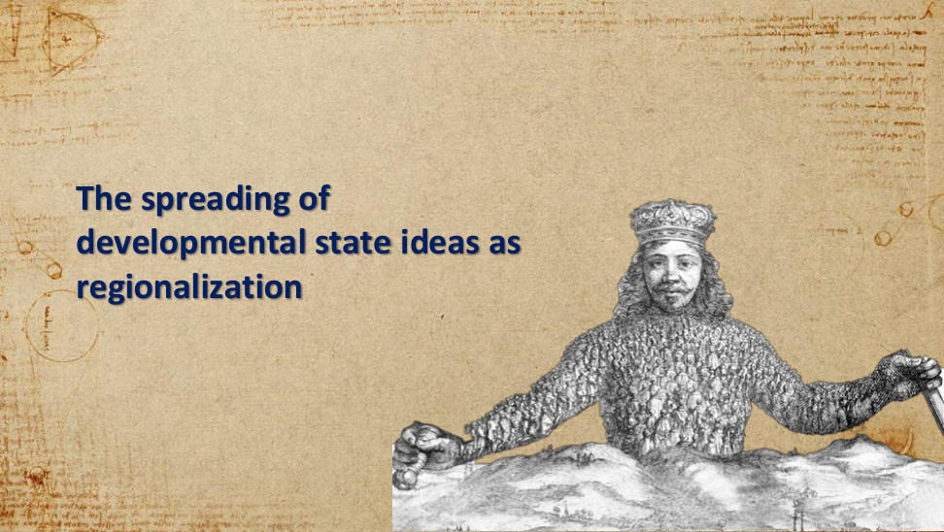
原PPT第39页 / Original slide 39

PPT中英翻译 / PPT translation
PPT English / 英文原文 | 中文翻译 / Chinese translation
The spreading of developmental state ideas as regionalization | 发展型国家理念的传播：作为区域化的过程。

本页核心 / Key takeaway
这是章节转场页：分析层次由一国的发展战略转向区域化，接下来关注东亚产业如何跨经济体扩散与升级。
This transition shifts the analysis from national development strategies to regionalization, introducing industrial diffusion and upgrading across East Asian economies.

40｜雁行模式｜The flying geese model
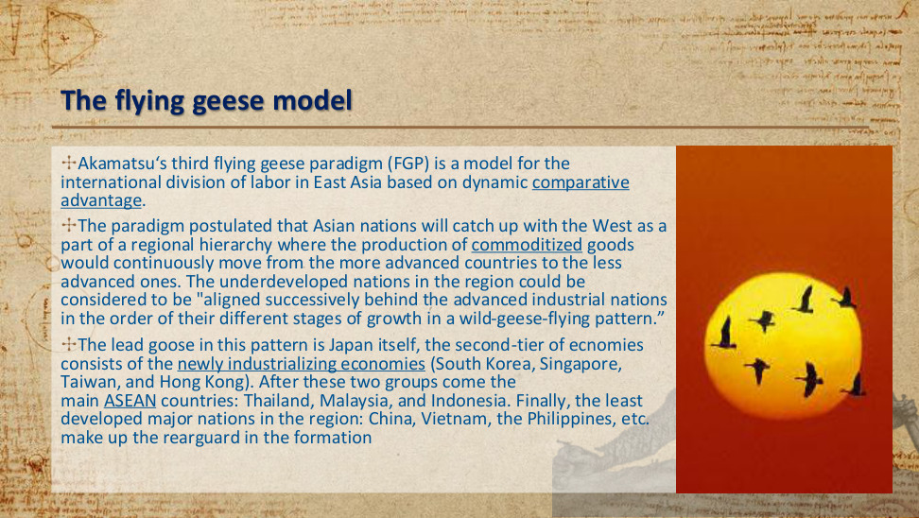
原PPT第40页 / Original slide 40

PPT中英翻译 / PPT translation
PPT English / 英文原文 | 中文翻译 / Chinese translation
Akamatsu‘s third flying geese paradigm (FGP) is a model for the international division of labor in East Asia based on dynamic comparative advantage. | 赤松要的第三种雁行范式（FGP），是一个以动态比较优势为基础、解释东亚国际分工的模型。
The paradigm postulated that Asian nations will catch up with the West as a part of a regional hierarchy where the production of commoditized goods would continuously move from the more advanced countries to the less advanced ones. | 这一范式设想，亚洲各国将在一个区域层级体系中追赶西方；标准化商品的生产会持续从较先进国家转向发展程度较低的国家。
The underdeveloped nations in the region could be considered to be "aligned successively behind the advanced industrial nations in the order of their different stages of growth in a wild-geese-flying pattern.” | 区域内发展程度较低的国家可被理解为：“按照各自不同的增长阶段，以雁行飞行的方式，依次排列在先进工业国家之后。”
The lead goose in this pattern is Japan itself, the second-tier of ecnomies consists of the newly industrializing economies (South Korea, Singapore, Taiwan, and Hong Kong). | 在这一模式中，日本是领头雁；第二梯队由新兴工业化经济体构成，即韩国、新加坡、中国台湾和中国香港。
After these two groups come the main ASEAN countries: Thailand, Malaysia, and Indonesia. Finally, the least developed major nations in the region: China, Vietnam, the Philippines, etc. make up the rearguard in the formation | 这两组之后是主要东盟国家：泰国、马来西亚和印度尼西亚。最后，按该模型的历史描述，区域内发展程度较低的主要国家，如中国、越南、菲律宾等，构成雁阵的后队。

本页核心 / Key takeaway
雁行模式以动态比较优势解释区域分工：较成熟产业向后发经济体转移，形成先后追赶的产业发展序列。
The flying geese model uses dynamic comparative advantage to explain regional divisions of labour, with mature production relocating to later-developing economies in a catching-up sequence.

精要解析 / Essential explanation

1. 机制：优势会变化｜Changing advantages
“动态”表示比较优势会随发展而变化，因此某项生产活动的区位并非永久固定；产业可以从先行者转移给后发者。
Dynamic means comparative advantages change with development. The location of a production activity is therefore not permanently fixed, allowing industry to move from leaders to followers.

2. 记住历史模型的顺序｜Remember the historical sequence
本页顺序为日本→新兴工业化经济体→列举的东盟国家→后发经济体。重点是产业分工与追赶机制，而非死记为永久国家等级。
The slide presents Japan, then NIEs, the listed ASEAN countries and later developers. Focus on industrial division and catching-up mechanisms rather than treating the sequence as a permanent national hierarchy.

易错辨析 / Key distinction
中国等处于“后队”是模型的历史性描述，不能直接作为当代经济实力或技术水平排名。
The rearguard position assigned to China and others is a historical description in the model, not a current ranking of economic strength or technological capacity.

41｜雁行模式的两个分析方向｜Two variants
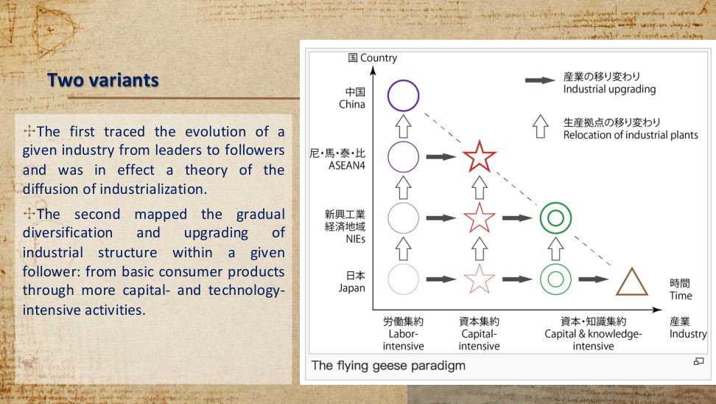
原PPT第41页 / Original slide 41

PPT中英翻译 / PPT translation
PPT English / 英文原文 | 中文翻译 / Chinese translation
The first traced the evolution of a given industry from leaders to followers and was in effect a theory of the diffusion of industrialization. | 第一种追踪某一产业从领先者向追随者的演进，实际上是一种工业化扩散理论。
The second mapped the gradual diversification and upgrading of industrial structure within a given follower: from basic consumer products through more capital- and technology-intensive activities. | 第二种描绘某一追随者内部产业结构逐步多样化和升级的过程：从基本消费品，走向资本与技术更密集的活动。
The flying geese paradigm | 雁行范式（图题）。
Country; Japan; NIEs; ASEAN4; China | 纵轴：国家／经济体；日本；新兴工业化经济体；东盟四国；中国。图上“尼·馬·泰·比”分别指印尼、马来西亚、泰国和菲律宾。
Industry; Time | 横向标签：产业；时间。
Labor-intensive; Capital-intensive; Capital & knowledge-intensive | 劳动密集型；资本密集型；资本与知识密集型。
Industrial upgrading; Relocation of industrial plants | 实心右箭头：产业升级；空心上箭头：工业生产据点转移。

本页核心 / Key takeaway
雁行模式有两条分析线：跨经济体的产业扩散，以及同一经济体内部的产业升级；读图时要区分箭头所指的过程。
The flying geese model distinguishes industrial diffusion across economies from industrial upgrading within an economy; the diagram’s arrows represent these different processes.

精要解析 / Essential explanation

1. 纵向看同一产业｜Read vertically: one industry
空心上箭头表示同类生产从日本等先行经济体向后发经济体转移。比较对象是不同经济体，追踪的是同一类产业。
The upward hollow arrows show similar production relocating from leaders such as Japan to later developers. The comparison is across economies while the industry type remains the same.

2. 横向看同一经济体｜Read horizontally: one economy
实心右箭头表示一个经济体由劳动密集型走向更资本、技术与知识密集的活动。比较对象是一国内部不同时期的产业结构。
The solid rightward arrows show an economy moving from labour-intensive production towards more capital-, technology- and knowledge-intensive activities. The comparison is its industrial structure over time.

易错辨析 / Key distinction
本图ASEAN4包含菲律宾；第40页正文只列三个东盟国家并把菲律宾列入后队。两处示意分组口径不同，应保留原页，不强行合并成固定排名。
This diagram’s ASEAN4 includes the Philippines, whereas page 40 lists three ASEAN countries and places the Philippines in the rearguard. Preserve the differing illustrative groupings rather than forcing a fixed ranking.

42｜亚洲发展型国家的演变：韩国｜The evolution of Asian developmental state: Korea
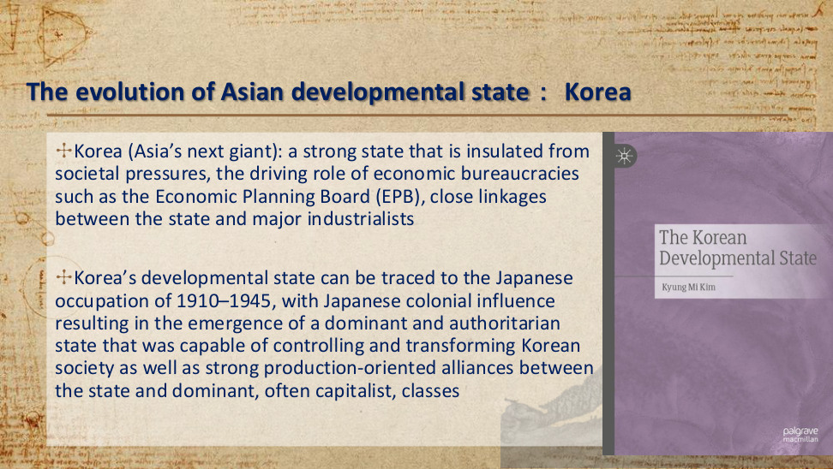
原PPT第42页 / Original slide 42

PPT中英翻译 / PPT translation
PPT English / 英文原文 | 中文翻译 / Chinese translation
Korea (Asia’s next giant): a strong state that is insulated from societal pressures, the driving role of economic bureaucracies such as the Economic Planning Board (EPB), close linkages between the state and major industrialists | 韩国（“亚洲的下一个巨人”）：一个能够相对隔离社会压力的强国家；经济企划厅（EPB）等经济官僚机构发挥推动作用；国家与主要工业企业家之间保持紧密联系。
Korea’s developmental state can be traced to the Japanese occupation of 1910–1945, with Japanese colonial influence resulting in the emergence of a dominant and authoritarian state that was capable of controlling and transforming Korean society as well as strong production-oriented alliances between the state and dominant, often capitalist, classes | 韩国发展型国家的渊源可追溯至1910—1945年的日本占领时期。日本殖民影响促成了一个具有支配性、威权性的国家，它能够控制和改造韩国社会；同时，国家与占主导地位、通常为资本家组成的阶级之间形成了强有力的生产导向联盟。

本页核心 / Key takeaway
韩国案例把强经济官僚与国家—工业资本联盟结合起来：国家保持政策自主性，同时借助企业关系推动生产转型。
The Korean case combines strong economic bureaucracies with state–industrial capital alliances: the state maintains policy autonomy while using business links to drive productive transformation.

精要解析 / Essential explanation

1. 机构与关系一起看｜Institutions and relationships
EPB体现制定和推动经济战略的官僚能力；与主要工业家的紧密联系体现执行战略所需的国家—企业协作。两者共同构成案例逻辑。
The EPB represents bureaucratic capacity to formulate and drive economic strategy; close industrialist links represent state–business coordination for implementation. Together they explain the case.

2. 历史渊源的作用｜Historical origins
本页将强国家及生产导向联盟追溯到殖民时期，是在说明制度如何形成；不能把历史起点简单当成后来经济成功的唯一原因。
The slide traces the strong state and production-oriented alliances to the colonial period to explain institutional formation. This historical origin should not be treated as the sole cause of later economic success.

易错辨析 / Key distinction
“隔离社会压力”不等于国家与企业完全断开联系；本页恰好同时强调政策自主性与紧密的产业联系。
Insulation from societal pressures does not mean severing all business links; the slide explicitly combines policy autonomy with close industrial connections.

43｜韩国：出口导向工业化与民族主义｜Korea: Export-oriented industrialization and nationalist ideology
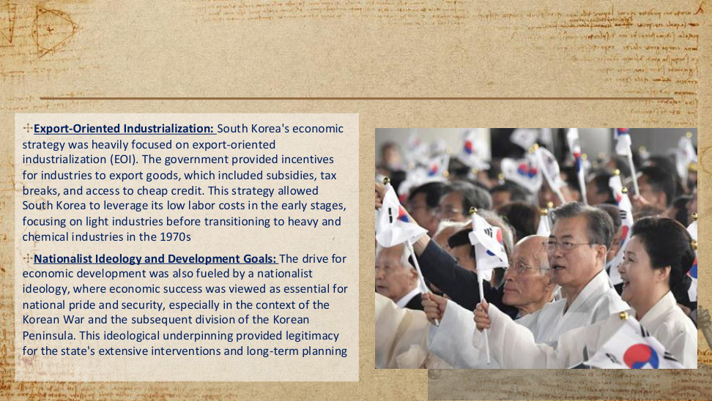
原PPT第43页 / Original slide 43

PPT中英翻译 / PPT translation
PPT English / 英文原文 | 中文翻译 / Chinese translation
Export-Oriented Industrialization: South Korea's economic strategy was heavily focused on export-oriented industrialization (EOI). | 出口导向工业化：韩国的经济战略高度侧重出口导向工业化（EOI）。
The government provided incentives for industries to export goods, which included subsidies, tax breaks, and access to cheap credit. | 政府通过补贴、税收减免和廉价信贷等方式，激励产业出口商品。
This strategy allowed South Korea to leverage its low labor costs in the early stages, focusing on light industries before transitioning to heavy and chemical industries in the 1970s | 这一战略使韩国在早期利用较低的劳动力成本，先侧重轻工业，再于20世纪70年代转向重工业和化学工业。
Nationalist Ideology and Development Goals: The drive for economic development was also fueled by a nationalist ideology, where economic success was viewed as essential for national pride and security, especially in the context of the Korean War and the subsequent division of the Korean Peninsula. | 民族主义意识形态与发展目标：民族主义也推动了经济发展。在朝鲜战争及其后朝鲜半岛分裂的背景下，经济成功尤其被视为民族自豪感和国家安全的必要条件。
This ideological underpinning provided legitimacy for the state's extensive interventions and long-term planning | 这一意识形态基础，为国家的广泛干预与长期规划提供了合法性。

本页核心 / Key takeaway
韩国通过出口导向工业化组织产业追赶，并把经济发展与民族自豪感、国家安全联系起来，为国家干预提供合法性。
Korea organised industrial catching-up through export-oriented industrialization and linked development to national pride and security, legitimising state intervention.

精要解析 / Essential explanation

1. 政策链条｜Policy chain
补贴、税收减免、廉价信贷→鼓励出口→先利用低劳动力成本发展轻工业→20世纪70年代转向重化工业。把工具与产业阶段连起来记忆。
Subsidies, tax breaks and cheap credit encouraged exports; early light industries used low labour costs before the shift towards heavy and chemical industries in the 1970s. Connect tools to industrial stages.

2. 增长与合法性的联系｜Growth and legitimacy
经济成功被赋予民族尊严与安全意义，使长期规划和广泛干预获得支持。论述时既解释经济工具，也说明国家为何能够推动这些工具。
Economic success acquired significance for national pride and security, supporting long-term planning and extensive intervention. Explain both the economic tools and the political grounds for using them.

易错辨析 / Key distinction
出口导向并不自动等于国家少干预；本页的出口增长恰恰受到补贴、税收和信贷政策的积极支持。另：原文时序不严谨，半岛分裂始于1945年，早于1950年开始的朝鲜战争。
Export orientation does not automatically mean limited state intervention; the slide’s export strategy is actively supported by subsidies, tax and credit policies. Also, the slide’s chronology is imprecise: partition began in 1945, before the Korean War began in 1950.

44｜发展型国家的演变与扩展｜Evolution of developmental state
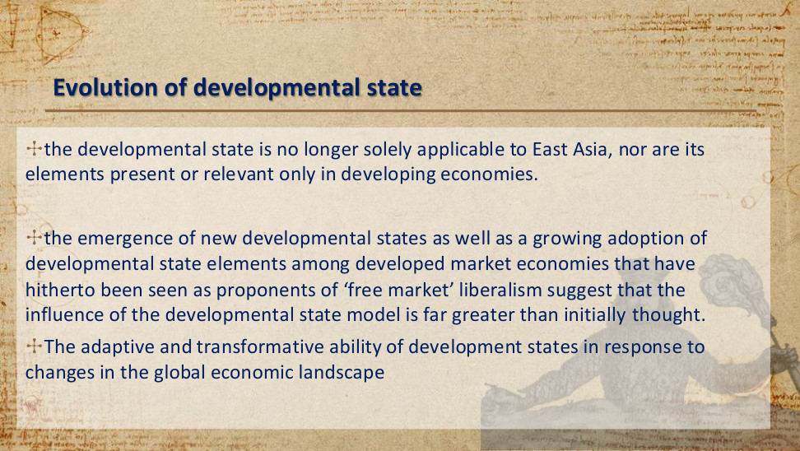
原PPT第44页 / Original slide 44

PPT中英翻译 / PPT translation
PPT English / 英文原文 | 中文翻译 / Chinese translation
the developmental state is no longer solely applicable to East Asia, nor are its elements present or relevant only in developing economies. | 发展型国家已不再仅适用于东亚，其构成要素也并非只存在于发展中经济体或仅对它们有意义。
the emergence of new developmental states as well as a growing adoption of developmental state elements among developed market economies that have hitherto been seen as proponents of ‘free market’ liberalism suggest that the influence of the developmental state model is far greater than initially thought. | 新的发展型国家出现，以及过去被视为“自由市场”自由主义支持者的发达市场经济体越来越多地采用发展型国家要素，表明这一模式的影响远大于最初的估计。
The adaptive and transformative ability of development states in response to changes in the global economic landscape | 发展型国家能够适应全球经济格局的变化，并进行转型。

本页核心 / Key takeaway
发展型国家具有适应与转型能力：其政策要素可以跨地区、跨发展阶段被采用，分析不应局限于早期东亚案例。
The developmental state has adaptive and transformative capacity: its policy elements can spread across regions and development levels beyond the early East Asian cases.

精要解析 / Essential explanation

1. 区分模式与要素｜Model versus policy elements
采用某项产业政策工具，不等于完整复制早期东亚制度。分析时要看该经济体实际采用了哪些要素，以及这些要素怎样组合。
Adopting an industrial-policy tool does not necessarily reproduce the complete early East Asian system. Identify the elements actually adopted and how they are combined.

2. 答题的适用范围｜Scope of application
不要只按地区或收入水平判断是否存在发展型国家特征；应回到国家目标、官僚能力、产业引导与国家—企业关系等课程概念。
Do not identify developmental features solely by geography or income level. Return to course concepts such as state goals, bureaucratic capacity, industrial guidance and state–business relationships.

45｜结束页｜Thanks!

原PPT第45页 / Original slide 45

PPT中英翻译 / PPT translation
PPT English / 英文原文 | 中文翻译 / Chinese translation
Thanks! | 谢谢！
Any questions? | 有什么问题吗？
You can find me at june.wang@cityu.edu.hk | 可通过june.wang@cityu.edu.hk联系我。

本页核心 / Key takeaway
本页是课程结束与联系方式页，没有新增理论知识点。
This closing slide provides contact information and introduces no new theoretical content.

