01｜私人住房与住房所有权 / Private housing and ownership

原PPT第1页 / Original slide 1 · 简读 / Brief

PPT中英翻译 / PPT translation
PPT English / 英文原文与图示 | 中文翻译 / Chinese translation
T5: Private Housing and Ownership | 第五讲：私人住房与住房所有权。
PIA5701: Comparative and International Housing and Urban Policy | PIA5701：比较与国际住房及城市政策。
June Wang, Department of Public and International Affairs, City University of Hong Kong | June Wang，香港城市大学公共及国际事务系。
Word cloud: homeownership; mortgage; property; housing; residence; ownership; estate; investment; credit; purchase; building. | 词云主要术语：住房自有、按揭、财产、住房、住所、所有权、地产、投资、信贷、购买、建造。

本页核心 / Key takeaway
本课分析住房自有如何连接福利、家庭资产、市场风险和国家政策。
This lesson connects homeownership with welfare, household assets, market risks and public policy.

阅读说明 / Reading guide
核心理论和辨析标红，次重点加粗；非重点与重复页浓缩。全篇中英对照，无附录。
Red marks core theory and distinctions; bold marks secondary points. Brief or repetitive pages retain essentials. All review content is bilingual; no appendix.
听课宝偏重美荷公共住房回顾，用于相关对照；本讲新增内容以本课PPT结合Word整理。
The listening summary reviews public housing. Relevant comparisons are integrated; new ownership, affordability and crisis content follows this PPT and the Word notes.

02｜本课路线 / Agenda
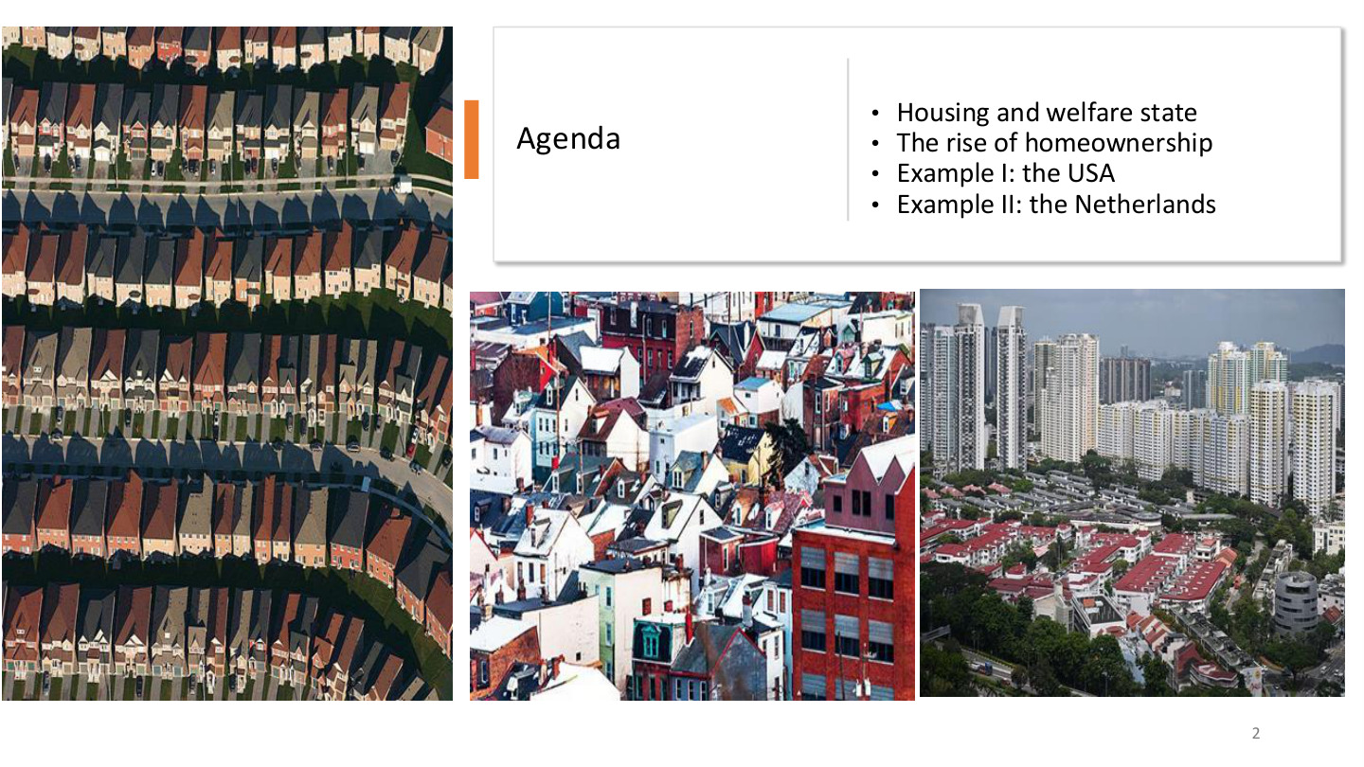
原PPT第2页 / Original slide 2 · 简读 / Brief

PPT中英翻译 / PPT translation
PPT English / 英文原文与图示 | 中文翻译 / Chinese translation
Housing and welfare state; The rise of homeownership; Example I: the USA; Example II: the Netherlands. | 住房与福利国家；住房自有的兴起；案例一：美国；案例二：荷兰。

本页核心 / Key takeaway
按“理论→自有住房与可负担性→美国→荷兰”的顺序复习。
Study theory, homeownership and affordability, then the US and Dutch cases.

03｜住房与福利国家 / Housing and the welfare state

原PPT第3页 / Original slide 3 · 简读 / Brief

PPT中英翻译 / PPT translation
PPT English / 英文原文与图示 | 中文翻译 / Chinese translation
I. Housing and welfare state | 第一部分：住房与福利国家。

本页核心 / Key takeaway
先问：住房保障主要依靠国家制度，还是家庭资产与市场？
Start by asking whether housing security relies mainly on public institutions or on household assets and markets.

04｜住房与去商品化 / Housing and decommodification
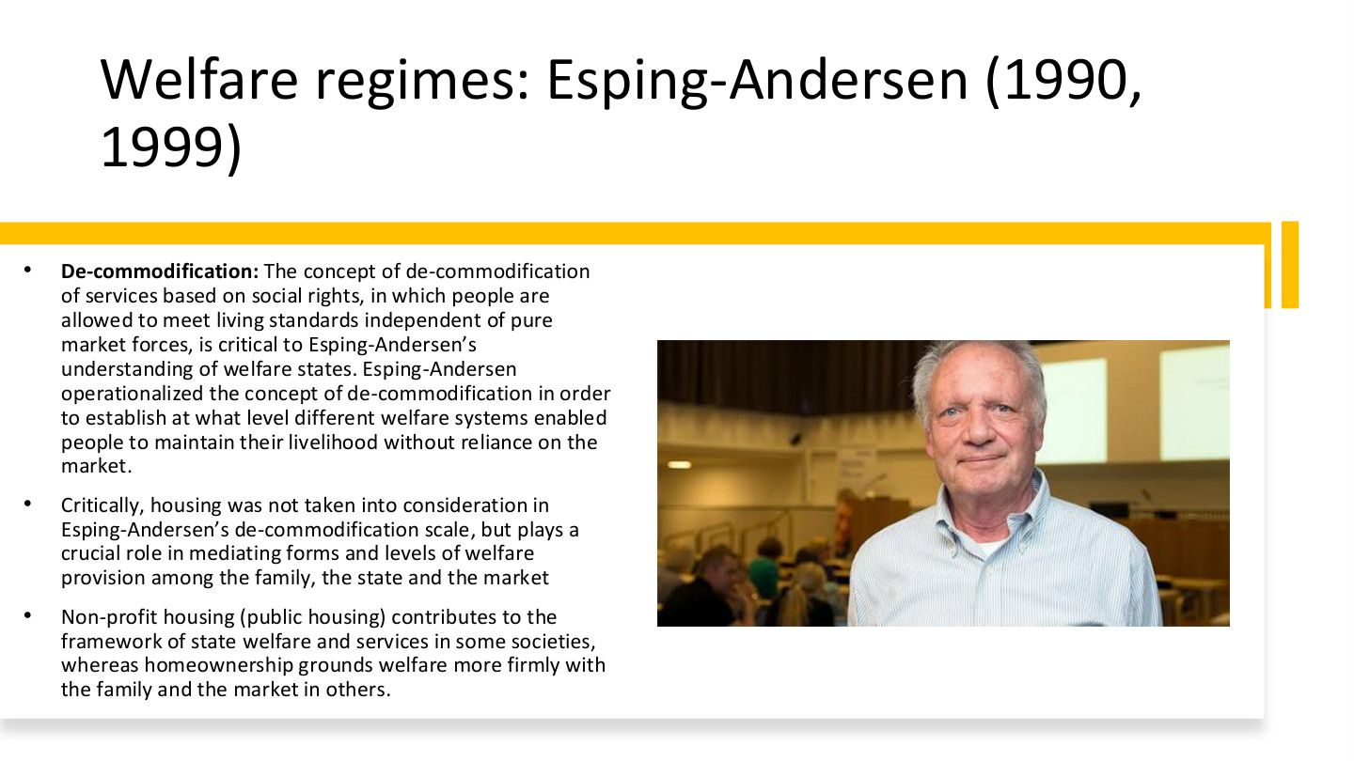
原PPT第4页 / Original slide 4 · 重点 / Focus

PPT中英翻译 / PPT translation
PPT English / 英文原文与图示 | 中文翻译 / Chinese translation
Welfare regimes: Esping-Andersen (1990, 1999) | 福利体制：Esping-Andersen（1990、1999）。
De-commodification: The concept of de-commodification of services based on social rights, in which people are allowed to meet living standards independent of pure market forces, is critical to Esping-Andersen’s understanding of welfare states. Esping-Andersen operationalized the concept of de-commodification in order to establish at what level different welfare systems enabled people to maintain their livelihood without reliance on the market. | 去商品化以社会权利为基础，使人们不完全依靠纯粹市场力量维持生活水平，是Esping-Andersen理解福利国家的关键。他将概念操作化，以比较不同福利制度在多大程度上使个人能够不依赖市场维持生计。
Critically, housing was not taken into consideration in Esping-Andersen’s de-commodification scale, but plays a crucial role in mediating forms and levels of welfare provision among the family, the state and the market. | 关键是，住房未被纳入其去商品化量表，却在家庭、国家和市场之间调节福利供给的形式与程度。
Non-profit housing (public housing) contributes to the framework of state welfare and services in some societies, whereas homeownership grounds welfare more firmly with the family and the market in others. | 一些社会的非营利住房（课件括注公共住房）构成国家福利服务的一部分；另一些社会的住房自有，则把福利更紧密地建立在家庭与市场上。

本页核心 / Key takeaway
原始去商品化量表没有纳入住房，但住房仍决定国家、市场和家庭怎样分担保障。
Housing was omitted from the original decommodification scale, yet it shapes how state, market and family share welfare responsibilities.

精要解析 / Essential explanation

1. 概念与指标分开 / Concept versus measure
去商品化是减少生计对市场依赖的概念；量表是具体测量工具。未纳入量表不等于住房与福利无关，这正是本课引入住房研究的理由。
Decommodification is a concept; a scale is its measurement instrument. Omission from the scale does not make housing irrelevant to welfare, motivating the housing perspective developed in this lesson.

2. 公屋与自有住房的渠道 / Different channels of security
非营利租赁可以通过公共规则提供保障，自有住房则可能以家庭持有资产支持生活。资产保障与社会权利保障的机制不同，而有按揭的房主仍须持续付款。
Nonprofit renting can provide security through public rules; ownership can support households through assets. Asset-based and rights-based security work differently, and mortgaged owners still face continuing payments.

3. 承接听课宝 / Link to the listening summary
听课宝回顾住房券、住房协会和资金流向。本课进一步问：支持租赁与支持买房，分别把哪些责任、资产和风险交给国家、机构及家庭？
The listening summary reviews vouchers, associations and funding flows. This lesson extends the comparison by asking how rental and purchase support allocate responsibilities, assets and risks among public institutions and households.

易错辨析 / Key distinction
非营利住房与政府直接持有住房不完全等同；住房所有权本身也不能证明已经充分去商品化。
Nonprofit housing is not identical to direct government ownership, and owning a home alone does not establish high decommodification.

05｜Kemeny：住房连接福利与社会结构 / Housing, welfare and social structure
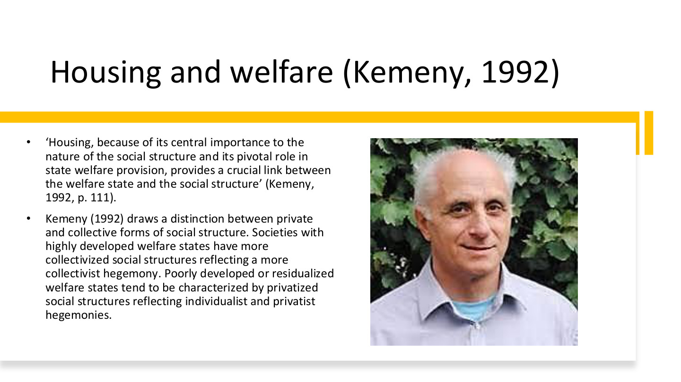
原PPT第5页 / Original slide 5 · 重点 / Focus

PPT中英翻译 / PPT translation
PPT English / 英文原文与图示 | 中文翻译 / Chinese translation
“Housing, because of its central importance to the nature of the social structure and its pivotal role in state welfare provision, provides a crucial link between the welfare state and the social structure” (Kemeny, 1992, p.111). | Kemeny认为，住房因其对社会结构的重要性及在国家福利供给中的关键作用，成为福利国家与社会结构之间的重要连接（1992，第111页）。
Kemeny (1992) draws a distinction between private and collective forms of social structure. Societies with highly developed welfare states have more collectivized social structures reflecting a more collectivist hegemony. Poorly developed or residualized welfare states tend to be characterized by privatized social structures reflecting individualist and privatist hegemonies. | Kemeny区分私人化与集体化社会结构：高度发展的福利国家倾向较集体化的结构及集体主义主导；较弱或剩余化福利国家倾向私人化结构，以及个人主义、私有主义主导。

本页核心 / Key takeaway
Kemeny的核心命题是住房把福利制度与社会结构连接起来，而不只是提供居住空间。
Kemeny’s central thesis is that housing links welfare institutions to social structure, beyond supplying shelter.

精要解析 / Essential explanation

1. 集体主义 / Collectivism
collectivism强调共同承担与集体安排，住房上更容易支持社会租赁等制度。这里描述一种社会和政策取向，不是说所有财产都必须国有。
Collectivism stresses shared responsibility and collective arrangements, supporting options such as social renting. It describes an institutional orientation rather than requiring national ownership of all property.

2. 私有主义 / Privatism
privatism强调私人家庭、产权和自我保障。家庭通过购房积累资产，并把住房安全更多联系到收入、贷款和市场表现；它不等于政府完全没有住房政策。
Privatism emphasises private households, property and self-provision. Security becomes connected to earnings, credit and asset markets, without implying that government housing policy disappears.

3. 与Esping-Andersen的关系 / Relation to Esping-Andersen
前者提供福利体制和去商品化视角，Kemeny突出住房及其社会结构作用。比较时要说明各自解释什么，而不是把两位学者的概念合并为同一个量表。
Esping-Andersen supplies welfare-regime and decommodification perspectives; Kemeny emphasises housing and social structure. Identify their different contributions rather than merging them into one measurement scale.

06｜意识形态、住房形式与反馈 / Ideology, tenure and feedback
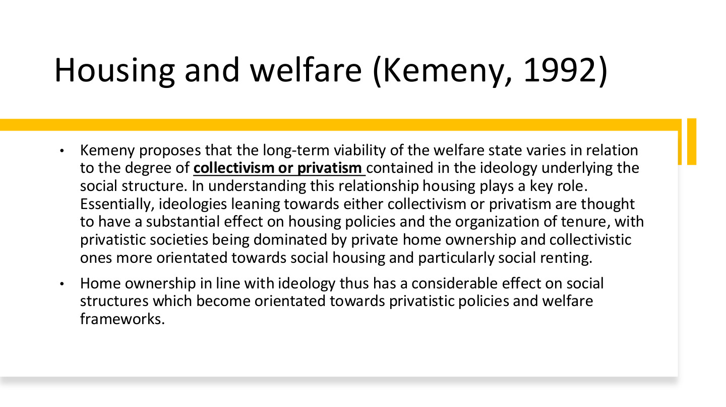
原PPT第6页 / Original slide 6 · 重点 / Focus

PPT中英翻译 / PPT translation
PPT English / 英文原文与图示 | 中文翻译 / Chinese translation
Kemeny proposes that the long-term viability of the welfare state varies in relation to the degree of collectivism or privatism contained in the ideology underlying the social structure. In understanding this relationship housing plays a key role. Essentially, ideologies leaning towards either collectivism or privatism are thought to have a substantial effect on housing policies and the organization of tenure, with privatistic societies being dominated by private home ownership and collectivistic ones more orientated towards social housing and particularly social renting. | Kemeny提出，福利国家的长期持续性与社会结构背后的集体主义或私有主义程度有关。住房政策与占有形式受到意识形态影响：私有主义社会更偏私人自住，集体主义社会更偏社会住房，尤其是社会租赁。
Home ownership in line with ideology thus has a considerable effect on social structures which become orientated towards privatistic policies and welfare frameworks. | 与意识形态相联系的住房自有，也会反过来影响社会结构，使其更偏向私人化政策与福利框架。

本页核心 / Key takeaway
掌握双向关系：意识形态塑造住房制度，住房制度又反馈到社会结构与福利偏好。
Understand the feedback: ideology shapes housing institutions, which in turn shape social structure and welfare preferences.

精要解析 / Essential explanation

1. 先有制度选择 / Institutional choices
社会如何理解责任，会影响国家优先支持买房、非营利租赁还是其他供给。tenure指住房占有和使用形式，包括自住、私人租赁与社会租赁。
Ideas about responsibility influence support for ownership, nonprofit renting and other provision. Tenure means arrangements for occupying and using housing, including ownership, private renting and social renting.

2. 再看制度的反馈 / Institutional feedback
不同住房位置形成不同利益与保障需求：依靠资产者更关心价格和贷款，依靠租赁保障者更关心租金和供给。制度可能因此改变集体政策的支持基础。
Different housing positions create different interests and security needs: asset holders may focus on prices and credit, tenants on rents and provision. Institutions can thereby alter the support base for collective policies.

3. 理论命题的限度 / Limits of the thesis
这是解释制度联系的理论，不是“买房的人一定反对福利”的个人行为定律。国家历史、政策设计和阶层差异仍会影响实际结果。
This is a theory of institutional relationships, not a law that every owner opposes welfare. Historical conditions, policy design and class differences still shape actual outcomes.

07｜二元与整合租赁体系 / Dualist and integrated rental systems
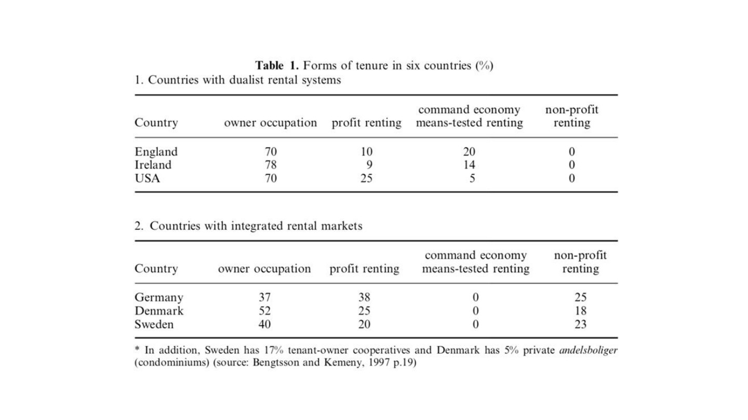
原PPT第7页 / Original slide 7 · 理解 / Understand

PPT中英翻译 / PPT translation
PPT English / 英文原文与图示 | 中文翻译 / Chinese translation
Table 1. Forms of tenure in six countries (%). 1. Countries with dualist rental systems. 2. Countries with integrated rental markets. | 表1：六国住房占有形式（%）。第一组：二元租赁体系；第二组：整合型租赁市场。
Country; owner occupation; profit renting; command economy means-tested renting; non-profit renting. | 列：国家、自住、营利租赁、行政分配／经济状况审查型租赁（原表术语）、非营利租赁。
In addition, Sweden has 17% tenant-owner cooperatives and Denmark has 5% private andelsboliger (condominiums). Source: Bengtsson and Kemeny, 1997, p.19. | 此外，瑞典有17%的租户所有合作住房，丹麦有5%的andelsboliger合作／共管式住房（按原表括注）。来源：Bengtsson与Kemeny，1997，第19页。

原表转写 / Original table transcribed
国家／组别 / Country/system | 自住 / Owner occupation | 营利租赁 / Profit renting | 经审查租赁 / Means-tested renting | 非营利租赁 / Nonprofit renting
England 英格兰｜二元 Dualist | 70 | 10 | 20 | 0
Ireland 爱尔兰｜二元 Dualist | 78 | 9 | 14 | 0
USA 美国｜二元 Dualist | 70 | 25 | 5 | 0
Germany 德国｜整合 Integrated | 37 | 38 | 0 | 25
Denmark 丹麦｜整合 Integrated | 52 | 25 | 0 | 18
Sweden 瑞典｜整合 Integrated | 40 | 20 | 0 | 23

本页核心 / Key takeaway
看市场租赁与非营利／受助租赁是否分隔，而不只比较自有率高低。
Examine separation between market renting and nonprofit or assisted renting, rather than ownership rates alone.

精要解析 / Essential explanation

1. 二元体系与整合体系 / The two arrangements
二元体系中，经审查的公共支持较独立于一般租赁市场；整合体系中，非营利租赁可面向更广市场发挥作用。两者差别在租赁部门怎样组织，不是一个只有两类房屋。
In dualist systems, means-tested assistance is separated from general renting; in integrated systems, nonprofit renting can operate more broadly. The distinction concerns rental-sector organisation, not merely the number of tenure categories.

2. 怎样读数字 / Reading the figures
瑞典、丹麦须连同脚注的合作住房理解；部分合计受四舍五入影响。原表年代较早，德国37%与第10页42%不能当作同年同口径数据直接比较。
Include the cooperative categories in the Swedish and Danish footnote and allow for rounding. This historical table’s German 37% and slide 10’s 42% are not presented as one same-year dataset.

08｜自由主义与私人住房自有 / Liberal regimes and ownership
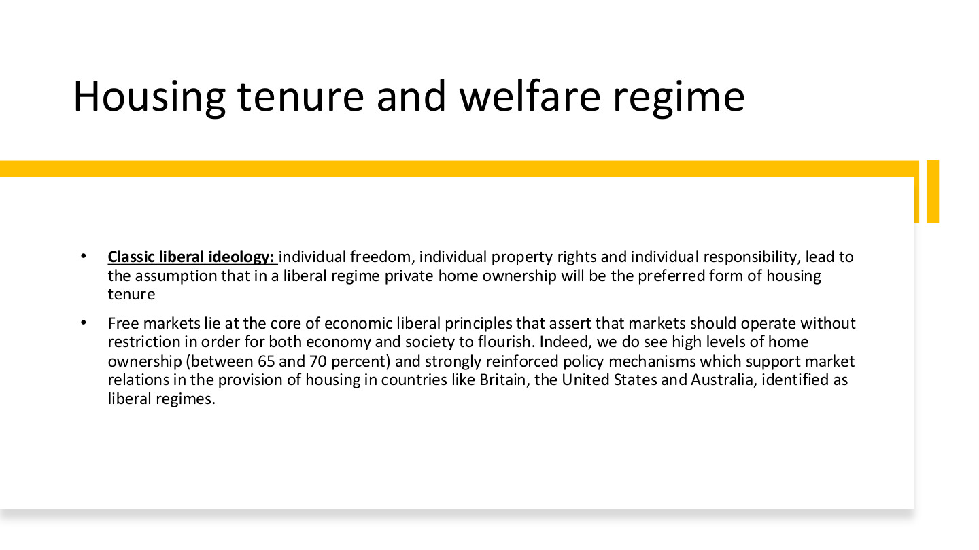
原PPT第8页 / Original slide 8 · 重点 / Focus

PPT中英翻译 / PPT translation
PPT English / 英文原文与图示 | 中文翻译 / Chinese translation
Classic liberal ideology: individual freedom, individual property rights and individual responsibility, lead to the assumption that in a liberal regime private home ownership will be the preferred form of housing tenure. | 古典自由主义强调个人自由、私人产权和个人责任，因此理论上预期自由主义体制偏好私人住房自有。
Free markets lie at the core of economic liberal principles that assert that markets should operate without restriction in order for both economy and society to flourish. Indeed, we do see high levels of home ownership (between 65 and 70 percent) and strongly reinforced policy mechanisms which support market relations in the provision of housing in countries like Britain, the United States and Australia, identified as liberal regimes. | 自由市场是经济自由主义的核心，认为市场应较少受限以促进经济和社会发展。课件以英国、美国、澳大利亚为例，列出约65%—70%的住房自有率，以及支持住房市场关系的政策机制。

本页核心 / Key takeaway
自由主义的解释链是个人自由、产权与责任→偏好私人自有→政策支持市场关系。
The liberal logic links individual liberty, property and responsibility to ownership preferences and market-supporting policies.

精要解析 / Essential explanation

1. 国家怎样支持市场 / How the state supports markets
偏好市场不等于国家不作为。政府可通过贷款制度、税收和购房支持促进私人自有；后面的美国历史正好说明市场住房如何被公共政策塑造。
Preference for markets does not imply state inactivity. Lending institutions, taxation and purchase assistance can promote ownership, as the later US history demonstrates.

2. 65%—70%怎样使用 / Using the percentage
这是课件的历史性案例概括，不是判定自由主义的统一门槛。其他体制也可能有高自有率，必须同时看制度和责任如何安排。
This is a historical illustration, not a classification threshold. Other regimes can also have high ownership; examine institutions and responsibilities alongside the rate.

3. 住房产权与风险 / Ownership and risk
自住家庭可积累资产，但按揭、维护和收入中断风险仍由具体制度决定。评价私人自有时，要把获得住房和持续保有住房分开。
Ownership can accumulate assets, while mortgage, maintenance and income-loss risks depend on institutions. Distinguish gaining access to ownership from being able to retain the home.

09｜社会民主主义：去商品化不只一种产权 / Social democracy and tenure
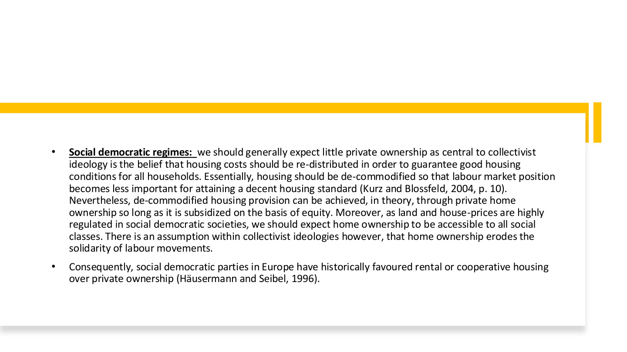
原PPT第9页 / Original slide 9 · 重点 / Focus

PPT中英翻译 / PPT translation
PPT English / 英文原文与图示 | 中文翻译 / Chinese translation
Social democratic regimes: we should generally expect little private ownership as central to collectivist ideology is the belief that housing costs should be re-distributed in order to guarantee good housing conditions for all households. Essentially, housing should be de-commodified so that labour market position becomes less important for attaining a decent housing standard (Kurz and Blossfeld, 2004, p.10). | 社会民主体制重视集体分担和重新分配住房成本，以保证所有家庭有良好居住条件，因此一般预期较少依赖私人自有。住房应去商品化，使劳动市场地位较少决定能否获得体面住所。
Nevertheless, de-commodified housing provision can be achieved, in theory, through private home ownership so long as it is subsidized on the basis of equity. Moreover, as land and house-prices are highly regulated in social democratic societies, we should expect home ownership to be accessible to all social classes. | 但理论上，只要依公平原则提供补贴，私人自有也可能实现去商品化。土地与房价受到较强监管时，各阶层也可能更容易进入自有住房。
There is an assumption within collectivist ideologies however, that home ownership erodes the solidarity of labour movements. Consequently, social democratic parties in Europe have historically favoured rental or cooperative housing over private ownership (Häusermann and Seibel, 1996). | 集体主义理论中也有一种观点，认为住房自有可能削弱劳工运动的团结，因此欧洲社会民主党历史上通常较偏好租赁或合作住房。

本页核心 / Key takeaway
去商品化不等于必须由国家持有产权；关键是住房取得与持续居住是否较少受市场位置支配。
Decommodification does not require state ownership of every home; the issue is how far access and security depend on market position.

精要解析 / Essential explanation

1. 重分配的目标 / The aim of redistribution
住房成本若被共同分担，低收入或就业不稳定者也可能获得良好住房。政策目标是减弱劳动市场地位对居住标准的影响，不是仅追求某一种产权比例。
Shared housing costs can support households with low or unstable earnings. The aim is to weaken the effect of labour-market position on housing standards, rather than achieve one tenure percentage.

2. equity的两种含义 / Two meanings of equity
本页on the basis of equity中的equity指公平，不是住房净值。第28页home equity才指房产价值扣除未还按揭；同一个英文词需按语境判断。
Here equity means fairness, not housing wealth. Home equity on slide 28 means property value minus outstanding mortgage debt; interpret the word in context.

3. 理论预期与经验区分 / Theory and experience
课件一方面讨论集体主义对租赁的偏好，另一方面承认公平补贴的私人自有也可能提供保障。答题应同时保留这两层，避免把社会民主简化为禁止买房。
The slide discusses a preference for renting but also allows ownership supported on equitable terms. Retain both points rather than reducing social democracy to a prohibition on home purchase.

10｜法团主义体制的多样性 / Variation in corporatist regimes
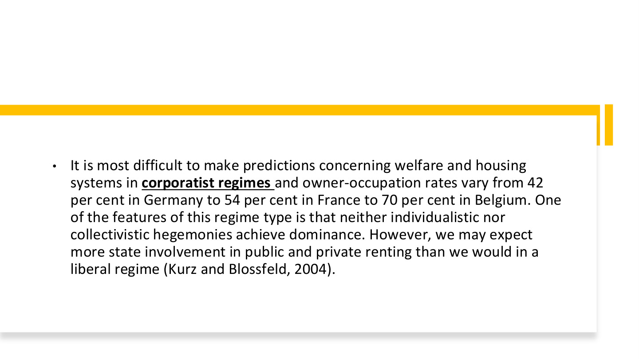
原PPT第10页 / Original slide 10 · 理解 / Understand

PPT中英翻译 / PPT translation
PPT English / 英文原文与图示 | 中文翻译 / Chinese translation
It is most difficult to make predictions concerning welfare and housing systems in corporatist regimes and owner-occupation rates vary from 42 per cent in Germany to 54 per cent in France to 70 per cent in Belgium. One of the features of this regime type is that neither individualistic nor collectivistic hegemonies achieve dominance. However, we may expect more state involvement in public and private renting than we would in a liberal regime (Kurz and Blossfeld, 2004). | 法团主义体制的福利与住房较难一概预测；课件举例德国自有率42%、法国54%、比利时70%。个人主义与集体主义都未完全占主导；相较自由主义，预期国家对公共和私人租赁的介入更多。

本页核心 / Key takeaway
法团主义内部差异说明：福利类型不能机械推出一个固定住房自有率。
Variation within corporatism shows that a welfare-regime label cannot mechanically predict one ownership rate.

精要解析 / Essential explanation

1. 为什么预测较难 / Why prediction is difficult
两种取向都没有绝对支配地位，住房制度可能出现不同组合。分析时应补充国家历史和租赁监管，不能只根据一个体制名称猜比例。
Neither orientation fully dominates, allowing different institutional combinations. Add historical context and rental regulation rather than guessing a percentage from the regime label alone.

2. 数字的用途 / What the figures illustrate
42%、54%、70%用于展示差异，不是今天的即时数据。核心比较仍是国家如何介入公共与私人租赁，以及家庭通过什么渠道获得保障。
The 42%, 54% and 70% figures illustrate variation, not current estimates. The substantive comparison concerns state involvement in renting and households’ routes to housing security.

11｜住房自有的兴起 / The rise of homeownership

原PPT第11页 / Original slide 11 · 简读 / Brief

PPT中英翻译 / PPT translation
PPT English / 英文原文与图示 | 中文翻译 / Chinese translation
II. The rise of homeownership | 第二部分：住房自有的兴起。

本页核心 / Key takeaway
接下来把自有住房连接到市场化福利、家庭资产及住房可负担性。
Next connect ownership with market-oriented welfare, household assets and affordability.

12｜欧洲住房占有形式 / European tenure patterns
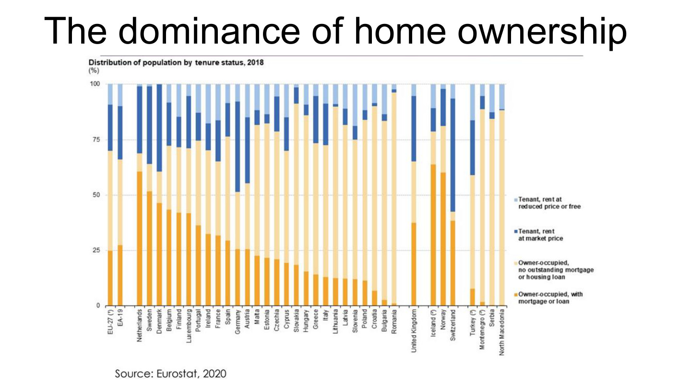
原PPT第12页 / Original slide 12 · 简读 / Brief

PPT中英翻译 / PPT translation
PPT English / 英文原文与图示 | 中文翻译 / Chinese translation
The dominance of home ownership. Distribution of population by tenure status, 2018 (%). Source: Eurostat, 2020. | 住房自有的主导地位。图：2018年按住房占有形式划分的人口构成（%）。来源：Eurostat，2020。
Tenant, rent at reduced price or free; Tenant, rent at market price; Owner-occupied, no outstanding mortgage or housing loan; Owner-occupied, with mortgage or loan. | 图例：低租金或免租租客；市场租金租客；无未偿按揭或住房贷款的自住；仍有按揭或贷款的自住。
EU-27; EA-19; Netherlands; Sweden; Denmark; Belgium; Finland; Luxembourg; Portugal; Ireland; France; Spain; Germany; Austria. | 欧盟27国、欧元区19国、荷兰、瑞典、丹麦、比利时、芬兰、卢森堡、葡萄牙、爱尔兰、法国、西班牙、德国、奥地利。
Malta; Estonia; Czechia; Cyprus; Slovakia; Hungary; Greece; Italy; Lithuania; Latvia; Slovenia; Poland; Croatia; Bulgaria; Romania. | 马耳他、爱沙尼亚、捷克、塞浦路斯、斯洛伐克、匈牙利、希腊、意大利、立陶宛、拉脱维亚、斯洛文尼亚、波兰、克罗地亚、保加利亚、罗马尼亚。
United Kingdom; Iceland; Norway; Switzerland; Turkey; Montenegro; Serbia; North Macedonia. | 英国、冰岛、挪威、瑞士、土耳其、黑山、塞尔维亚、北马其顿。原图个别名称带脚注符号，未展示其说明。

本页核心 / Key takeaway
只抓住自住仍须分有债与无债；本图统计居住人口，不等于每个人都在法律上持有房产。
Remember ownership includes both mortgaged and debt-free occupation; the chart describes residents, not individual legal ownership of property.

精要解析 / Essential explanation

1. 读图精华 / Essential reading
不同国家的自住总份额和债务结构差异很大。较高自有率不自动意味着住房负担轻，也不够单独判断福利体制；不必逐根柱子背数值。
Countries differ in both ownership shares and debt structures. High ownership does not automatically mean low burdens or identify a welfare regime; detailed bar values are secondary.

13｜住房自有与福利新自由主义化 / Neoliberalisation of welfare
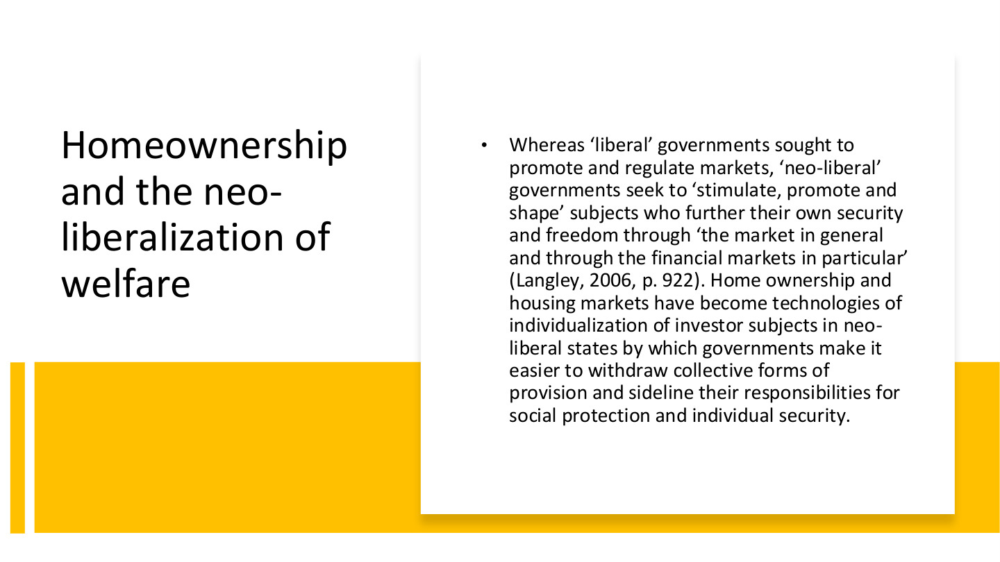
原PPT第13页 / Original slide 13 · 重点 / Focus

PPT中英翻译 / PPT translation
PPT English / 英文原文与图示 | 中文翻译 / Chinese translation
Whereas “liberal” governments sought to promote and regulate markets, “neo-liberal” governments seek to “stimulate, promote and shape” subjects who further their own security and freedom through “the market in general and through the financial markets in particular” (Langley, 2006, p.922). | 自由主义政府试图促进和监管市场；新自由主义政府进一步“激发、推动和塑造”通过市场、尤其金融市场追求自身安全与自由的主体（Langley，2006，第922页）。
Home ownership and housing markets have become technologies of individualization of investor subjects in neo-liberal states by which governments make it easier to withdraw collective forms of provision and sideline their responsibilities for social protection and individual security. | 住房自有和住房市场成为塑造个体化投资者主体的治理工具，使政府更容易缩减集体供给，并把社会保护和个人安全责任推向个人。

本页核心 / Key takeaway
新自由主义化不仅涉及市场交易，还涉及把个人塑造成通过住房和金融市场自我保障的投资者。
Neoliberalisation also involves shaping individuals as investors who seek security through housing and financial markets.

精要解析 / Essential explanation

1. 主体怎样被塑造 / How subjects are shaped
个人被鼓励把买房、借贷、资产升值看作安全来源。住房由生活需要进一步成为投资与自我保障工具，政策因此也改变人们怎样理解责任。
People are encouraged to see purchase, borrowing and appreciation as sources of security. Housing becomes an investment and self-provision instrument as well as a need, changing understandings of responsibility.

2. 责任与风险怎样转移 / How responsibilities and risks shift
当保障更依赖家庭资产，收入下降、还贷和房价波动会直接影响家庭生活。国家并非一定消失，而可能由集体供给转向建立市场、引导投资和管理风险。
Asset-dependent security exposes households to income loss, repayments and price changes. The state need not disappear; its role can shift from collective provision towards market-making, investment promotion and risk management.

3. 怎样连接案例 / Applying it to cases
美国的住房梦想、宣传与住房金融，可用于观察投资者主体怎样形成。解释时写出“政策工具→个人行为与责任→保障后果”，不要只用市场化作为标签。
The US dream, campaigns and housing finance illustrate investor-subject formation. Explain instruments, behavioural or responsibility changes, and welfare consequences rather than using marketisation only as a label.

14｜再商品化与公民身份 / Recommodification and citizenship
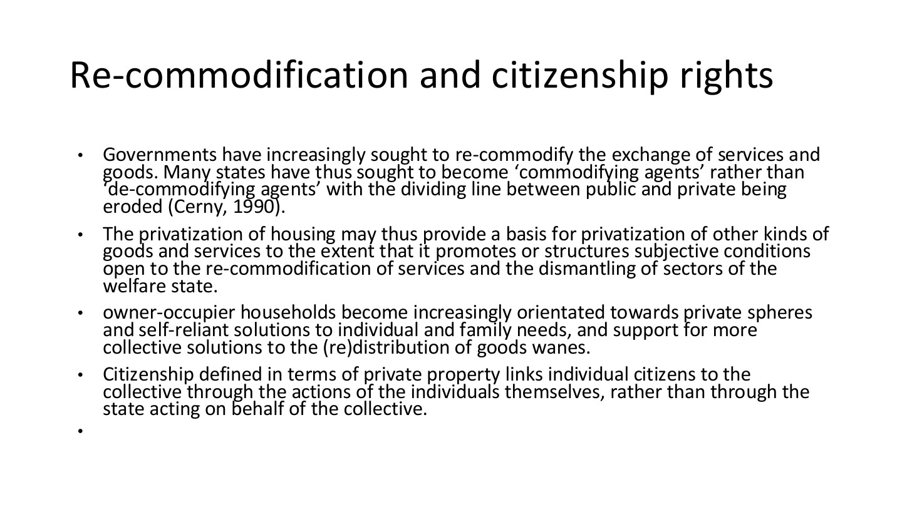
原PPT第14页 / Original slide 14 · 重点 / Focus

PPT中英翻译 / PPT translation
PPT English / 英文原文与图示 | 中文翻译 / Chinese translation
Governments have increasingly sought to re-commodify the exchange of services and goods. Many states have thus sought to become “commodifying agents” rather than “de-commodifying agents”, with the dividing line between public and private being eroded (Cerny, 1990). | 政府越来越多地推动服务和商品再商品化，由“去商品化行动者”转向“商品化推动者”，公私边界随之变化。
The privatization of housing may thus provide a basis for privatization of other kinds of goods and services to the extent that it promotes or structures subjective conditions open to the re-commodification of services and the dismantling of sectors of the welfare state. | 住房私有化若改变人们对私人解决方案的接受程度，也可能为其他商品和服务私有化、服务再商品化及福利部门收缩提供基础。
Owner-occupier households become increasingly orientated towards private spheres and self-reliant solutions to individual and family needs, and support for more collective solutions to the (re)distribution of goods wanes. | 自住家庭可能更倾向私人领域和家庭自助方案，而对集体分配与再分配的支持减弱。
Citizenship defined in terms of private property links individual citizens to the collective through the actions of the individuals themselves, rather than through the state acting on behalf of the collective. | 以私人财产界定公民形象时，个人与集体的联系更多通过个人自身行动实现，而不是由国家代表集体提供保障。

本页核心 / Key takeaway
再商品化是把保障重新更多地系于市场交换和家庭自助；国家也可能主动推动这一过程。
Recommodification reconnects security to market exchange and household self-provision, and can be actively promoted by the state.

精要解析 / Essential explanation

1. 与去商品化相对照 / Contrast with decommodification
去商品化减少维持生活所需的市场依赖；再商品化则把更多需要交由购买、贷款和资产收益解决。区别在保障机制，不只在产权名称。
Decommodification reduces market dependence; recommodification channels needs through purchasing, credit and asset returns. The distinction concerns protection mechanisms, not property labels alone.

2. 为何影响集体支持 / Why collective support may change
若家庭更依靠自有资产解决需要，可能更支持有利于资产收益的政策。这是课件讨论的制度反馈机制，不意味着每位房主都持同一政治立场。
When assets become a household’s solution to need, policies supporting asset returns may gain support. This is an institutional feedback argument, not a claim that every owner shares identical political views.

3. citizenship应怎样理解 / Interpreting citizenship
此处分析政策话语中的公民形象：有产权、负责任、能自助的人。它不是在宣称无房者在法律上不具公民身份；政治理念与法定资格要分开。
The passage analyses an image of the property-owning, responsible, self-reliant citizen. It does not claim that nonowners legally lack citizenship; distinguish political ideals from legal status.

15｜住房阶层 / Housing class
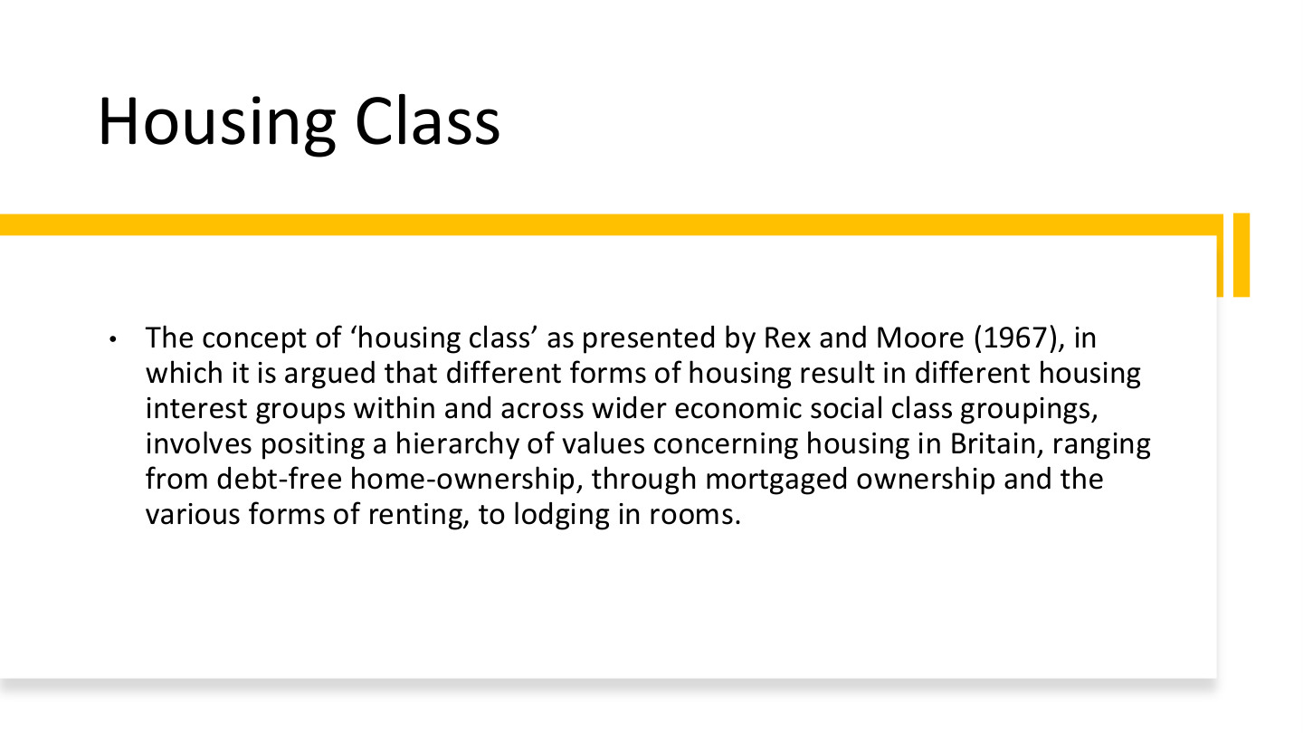
原PPT第15页 / Original slide 15 · 重点 / Focus

PPT中英翻译 / PPT translation
PPT English / 英文原文与图示 | 中文翻译 / Chinese translation
The concept of “housing class” as presented by Rex and Moore (1967), in which it is argued that different forms of housing result in different housing interest groups within and across wider economic social class groupings, involves positing a hierarchy of values concerning housing in Britain, ranging from debt-free home-ownership, through mortgaged ownership and the various forms of renting, to lodging in rooms. | Rex与Moore（1967）的“住房阶层”概念认为，不同住房形式会在更广泛的经济社会阶层内部及其之间形成住房利益群体。英国住房的价值等级被排列为：无债自住、按揭自住、各种租赁形式，再到租住单间。

本页核心 / Key takeaway
住房阶层强调不同住房位置带来不同利益、成本和保障，不能把所有房主或租客视为完全相同。
Housing class concerns different interests, costs and security attached to housing positions, rather than treating all owners or tenants as identical.

精要解析 / Essential explanation

1. 无债与按揭为何不同 / Debt-free versus mortgaged ownership
两者都有产权，但按揭住户仍有持续还款责任和收入风险。名义产权相同不等于负担与安全相同，这也连接到后面的住房金融危机。
Both hold property, but mortgaged households face repayments and income risks. The same ownership label does not imply equal burdens or security, linking housing class to the later financial crisis.

2. 与经济阶层怎样交叉 / Interaction with economic class
收入相似的家庭，可能因是否有房、负债或租赁条件而处境不同。住房阶层因此补充而非直接取代一般阶层分析，帮助识别住房制度中的利益分化。
Households with similar incomes can occupy different positions because of assets, debt and rental conditions. Housing class supplements broader class analysis by identifying interests created through housing institutions.

3. 等级应怎样理解 / Interpreting the hierarchy
课件列的是特定英国背景下的住房价值和利益层级，不是所有国家、所有时期都固定适用的优劣榜。比较时应进一步看实际居住质量与制度保障。
The hierarchy refers to housing values and interests in a particular British context, not a universal ranking for every society. Compare actual housing conditions and institutional security.

16｜住房历程与人生事件 / Housing careers and life events
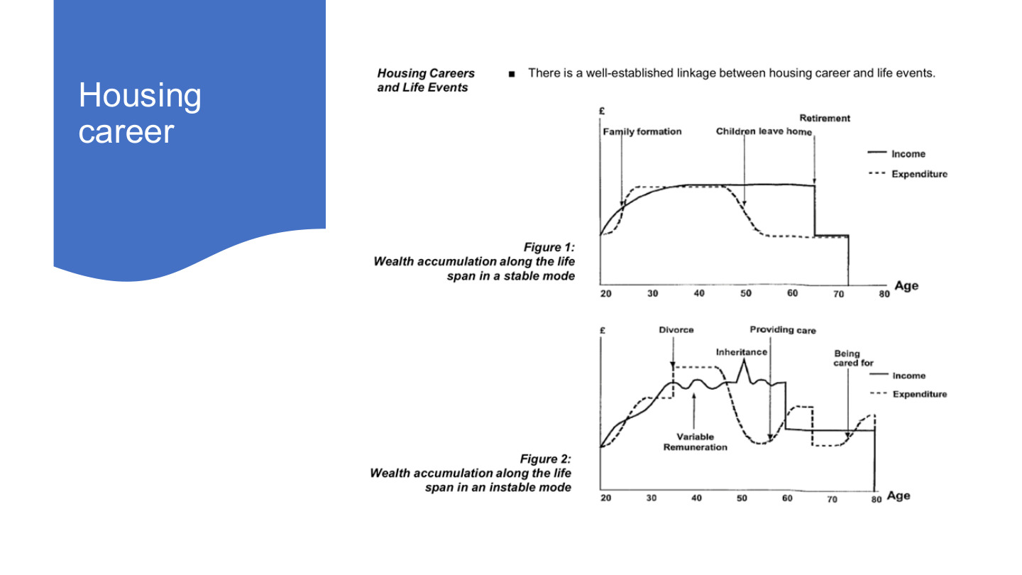
原PPT第16页 / Original slide 16 · 理解 / Understand

PPT中英翻译 / PPT translation
PPT English / 英文原文与图示 | 中文翻译 / Chinese translation
Housing career. Housing Careers and Life Events. There is a well-established linkage between housing career and life events. | 住房历程。住房历程与人生事件之间存在明确联系；career在此不是“职业”。
Figure 1: Wealth accumulation along the life span in a stable mode. Family formation; Children leave home; Retirement. | 图1：稳定模式下的终身财富积累。事件：家庭形成、子女离家、退休。
Figure 2: Wealth accumulation along the life span in an instable mode. Divorce; Variable Remuneration; Inheritance; Providing care; Being cared for. | 图2：不稳定模式下的终身财富积累。事件：离婚、收入报酬波动、继承遗产、提供照护、接受照护。
Axes and legend: £; Age (20–80); Income (solid); Expenditure (dashed). | 坐标与图例：英镑、年龄（20—80岁）；实线为收入，虚线为支出。

本页核心 / Key takeaway
住房历程随人生事件改变；实际收入与支出未必沿平稳生命周期变化。
Housing careers change with life events; actual income and expenditure need not follow a smooth life-cycle path.

精要解析 / Essential explanation

1. 先读清坐标 / Identify the plotted quantities
虽然图题讨论财富积累，实际两条线分别是收入和支出，并非房价或住房净值。收支差影响可积累资源，不能把收入曲线的高度直接当作资产总额。
Although the figures discuss accumulation, their lines plot income and expenditure, not prices or home equity. The income–expenditure gap affects resources available to accumulate, so line height is not total wealth.

2. 为什么影响住房选择 / Effects on housing choices
离婚、照护或收入波动会改变家庭资源及空间需要，可能影响借贷、搬家和保有住房。模型用于解释可能的联系，不要求每个人都结婚、生育或按相同路径生活。
Divorce, care and variable earnings change resources and space needs, affecting borrowing, moving and retention. The model explains possible relationships rather than prescribing marriage, children or one identical life path.

17｜什么是住房可负担性？ / Housing affordability
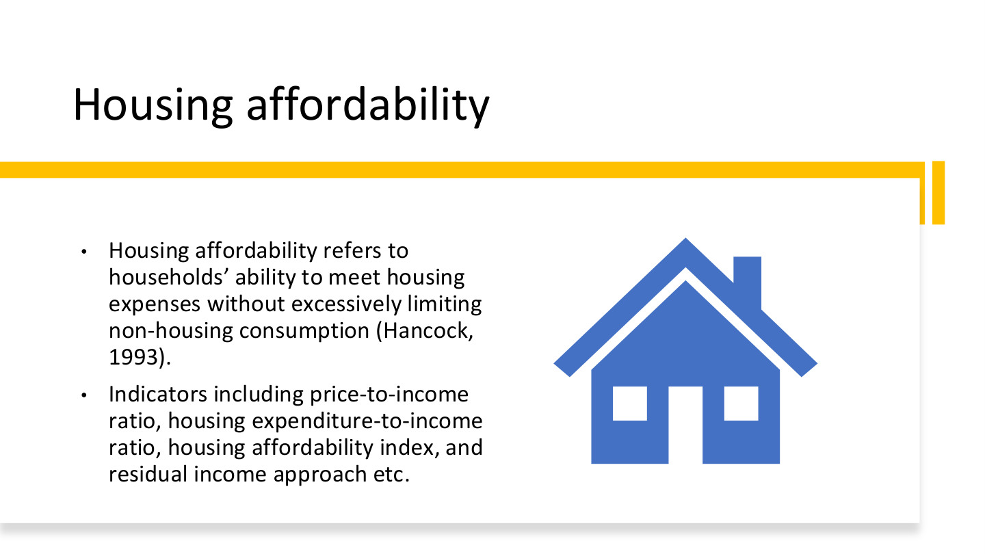
原PPT第17页 / Original slide 17 · 重点 / Focus

PPT中英翻译 / PPT translation
PPT English / 英文原文与图示 | 中文翻译 / Chinese translation
Housing affordability refers to households’ ability to meet housing expenses without excessively limiting non-housing consumption (Hancock, 1993). | 住房可负担性指家庭能够支付住房费用，同时不至于过度压缩非住房消费（Hancock，1993）。
Indicators including price-to-income ratio, housing expenditure-to-income ratio, housing affordability index, and residual income approach etc. | 指标包括房价收入比、住房支出收入比、住房可负担性指数和剩余收入法等。

本页核心 / Key takeaway
付得出住房费还不够，还要能维持必要的非住房生活，这是可负担性的核心。
Paying for housing is insufficient if essential non-housing consumption is squeezed; affordability concerns both.

精要解析 / Essential explanation

1. 住房费用之外还有什么 / Beyond housing expenditure
食品、交通、医疗和照护等必要支出不能被忽略。相同住房支出比例的家庭，剩余生活能力可能不同，因此不能把单一比例当作完整答案。
Food, transport, health and care costs still matter. Households with the same housing-cost ratio can have different remaining living resources, so one percentage cannot fully assess affordability.

2. 价格与持续支付 / Price versus continuing payments
房价收入比观察购买价格相对收入；月供或租金收入比观察持续现金流。购房门槛、还款压力和租赁负担相关，但并不是同一个问题。
Price-to-income compares the purchase price with income; payment or rent ratios assess continuing cash flow. Entry barriers, repayment pressure and rental burdens are related but distinct.

3. 先选问题再选指标 / Match measures to questions
比较城市入市难度、家庭月度负担或基本生活是否受挤压，需要不同信息。第18页的重点是知道各指标测什么、遗漏什么，而不只背英文名称。
Comparing purchase barriers, monthly burdens or pressure on necessities requires different information. Slide 18 asks what each measure captures and omits, beyond remembering its English name.

18｜四种可负担性指标 / Four affordability measures
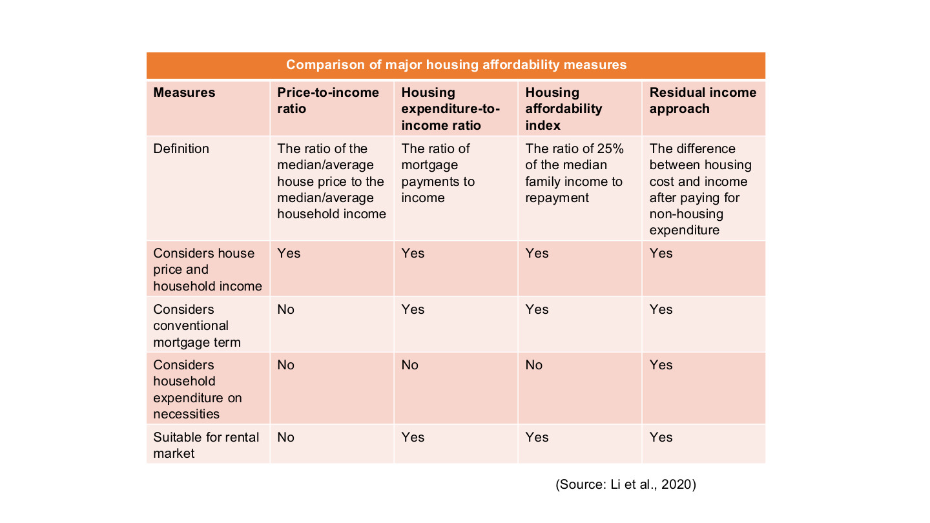
原PPT第18页 / Original slide 18 · 重点 / Focus

PPT中英翻译 / PPT translation
PPT English / 英文原文与图示 | 中文翻译 / Chinese translation
Comparison of major housing affordability measures. Source: Li et al., 2020. | 主要住房可负担性指标比较。来源：Li等，2020。
Price-to-income ratio: The ratio of the median/average house price to the median/average household income. | 房价收入比：住房价格中位数／平均数，与家庭收入中位数／平均数之比。
Housing expenditure-to-income ratio: The ratio of mortgage payments to income. | 住房支出收入比：按揭还款与收入之比。用于租赁时需把支出项改为租金等住房支出。
Housing affordability index: The ratio of 25% of the median family income to repayment. | 住房可负担性指数：家庭收入中位数的25%，与还款额之比。
Residual income approach: The difference between housing cost and income after paying for non-housing expenditure. | 剩余收入法：比较住房成本与扣除非住房支出后的可用收入。原表未明确差额方向，理解时以支付基本生活后的收支是否足够为准。
Comparison criteria: considers house price and household income; considers conventional mortgage term; considers household expenditure on necessities; suitable for rental market. | 比较维度：是否考虑房价及家庭收入；常规按揭条件；家庭必要支出；是否适用于租赁。原表Yes／No完整转写见下表。

原表Yes／No转写 / Original yes/no comparison
维度 / Criterion | 房价收入比 / Price-to-income | 支出收入比 / Cost-to-income | 可负担性指数 / HAI | 剩余收入法 / Residual
房价与家庭收入 / Price and income | Yes 是 | Yes 是 | Yes 是 | Yes 是
常规按揭条件 / Mortgage terms | No 否 | Yes 是 | Yes 是 | Yes 是
必要消费支出 / Necessities | No 否 | No 否 | No 否 | Yes 是
适用于租赁 / Suitable for renting | No 否 | Yes 是 | Yes 是 | Yes 是

本页核心 / Key takeaway
四类指标分别看购买价格、持续支付、标准还款能力、必要消费后的余量；它们的方向和单位不同。
The measures concern purchase prices, continuing payments, benchmark repayment capacity, and resources after necessities; their directions and units differ.

精要解析 / Essential explanation

1. 1. 房价收入比 / Price-to-income
房价÷家庭年收入：假设房价300,000，家庭年收入60,000，则比值为5。它不计日常消费、利率和具体还款安排，不能理解成不吃不喝之外也保证“五年买到房”。
P/annual Y: a price of 300,000 and annual income of 60,000 give 5. It excludes living costs and financing terms, so it does not establish that a household can actually buy the dwelling in five years.

2. 2. 住房支出收入比 / Housing-cost ratio
住房支出÷同一时期收入：月住房支出1,500、月收入5,000，比值为30%。分子是月供或租金等支出，不是整套房价；30%也不是对所有家庭都适用的充分保障标准。
H/Y for the same period: monthly housing costs of 1,500 and income of 5,000 give 30%. Use payments or rent, not the full price; 30% is not a sufficient universal test for every household.

3. 3. 可负担性指数 / Affordability index
本页公式为0.25×收入中位数÷还款。设月家庭收入中位数5,000、月供1,500演示，结果约0.833，或指数化为83.3；比值低于1（或指数低于100），表示未达到这项25%基准，数值越高通常越可负担。
The slide uses 0.25 × median income / repayment. With monthly median income 5,000 and repayment 1,500, this is about 0.833, or 83.3 when scaled by 100. Below 1 in ratio form (or 100 on the index scale) means the 25% benchmark is not met; higher generally indicates greater affordability.

4. 4. 剩余收入法 / Residual-income approach
判断Y−H−N是否≥0，N为必要非住房开支。同一家庭若N=2,800，余额为5,000−1,500−2,800=700。它把基本生活需要纳入评估，说明比例相同的家庭仍可能有不同处境。
Check whether Y − H − N is nonnegative, with N representing necessary non-housing costs. If N is 2,800, the example leaves 700. This incorporates basic needs and distinguishes households with otherwise identical housing-cost ratios.

易错辨析 / Key distinction
HAI本页公式通常越高越好，房价收入比或住房支出比通常越高负担越重；表中“可用于租赁”需要相应调整支付项，不能照搬按揭定义。
The slide’s HAI generally improves as it rises; higher price or cost ratios generally indicate heavier burdens. Applying payment-based measures to renting requires adapting their payment term.

19｜住房生命周期 / Housing life cycle
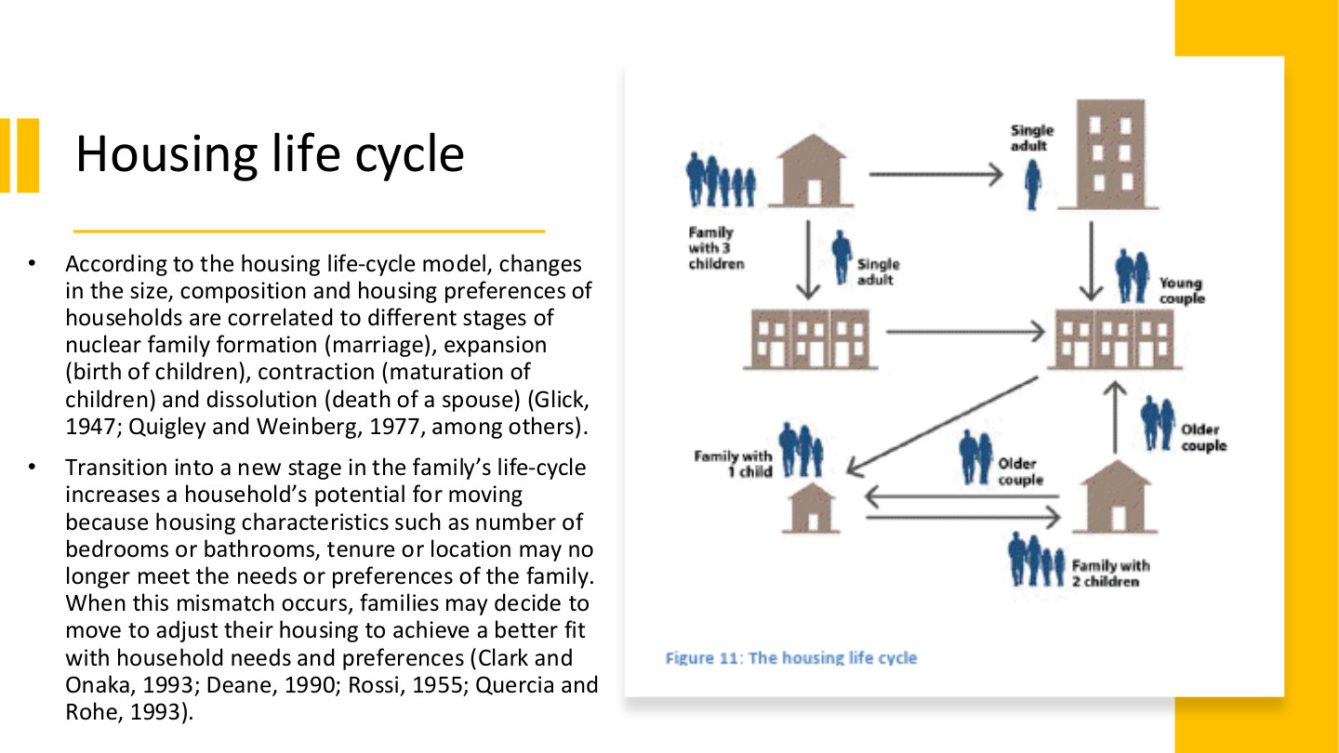
原PPT第19页 / Original slide 19 · 重点 / Focus

PPT中英翻译 / PPT translation
PPT English / 英文原文与图示 | 中文翻译 / Chinese translation
According to the housing life-cycle model, changes in the size, composition and housing preferences of households are correlated to different stages of nuclear family formation (marriage), expansion (birth of children), contraction (maturation of children) and dissolution (death of a spouse) (Glick, 1947; Quigley and Weinberg, 1977, among others). | 住房生命周期模型将家庭规模、结构与偏好变化，联系到核心家庭的形成（结婚）、扩张（子女出生）、收缩（子女成长）及解体（配偶死亡）等阶段。
Transition into a new stage in the family’s life-cycle increases a household’s potential for moving because housing characteristics such as number of bedrooms or bathrooms, tenure or location may no longer meet the needs or preferences of the family. When this mismatch occurs, families may decide to move to adjust their housing to achieve a better fit with household needs and preferences (Clark and Onaka, 1993; Deane, 1990; Rossi, 1955; Quercia and Rohe, 1993). | 进入新阶段后，卧室、卫生间数量、住房占有形式或区位可能不再符合需要，从而提高搬迁的可能性；家庭可通过搬家使住房与需要重新匹配。
Figure 11: The housing life cycle. Single adult; Young couple; Family with 1 child; Family with 2 children; Family with 3 children; Older couple. | 图11：住房生命周期。标签：单身成人、年轻伴侣、一个孩子的家庭、两个孩子的家庭、三个孩子的家庭、年长伴侣。箭头表示家庭与居住安排的变化。

本页核心 / Key takeaway
核心机制是家庭需要变化→现有住房不匹配→搬迁或调整住房，不是年龄本身自动决定买房。
The mechanism is changing household needs, a housing mismatch, then moving or adjustment, rather than age automatically determining purchase.

精要解析 / Essential explanation

1. 四阶段怎样记 / Remembering the stages
形成、扩张、收缩、解体描述家庭结构变化；例如孩子出生增加空间需要，子女长大后需要可能再次改变。把阶段和具体住房需求连起来，而非只背年龄。
Formation, expansion, contraction and dissolution describe household changes. A birth can increase space needs; later changes can alter them again. Connect stages with housing requirements rather than fixed ages.

2. 搬迁的直接原因 / The proximate reason to move
不匹配可来自面积、设施、tenure或区位，不只来自房屋太小。通勤、照护或支付能力改变，也会影响家庭如何选择适合的住所。
Mismatch can concern space, amenities, tenure or location, beyond an undersized dwelling. Commuting, care and affordability also shape appropriate choices.

3. 潜在需要与实际行动 / Need versus action
原文说搬迁可能性增加，并非一定能搬。收入、贷款、房源和交易成本会约束行动；模型也不要求每个家庭经历完全相同的生命周期。
The slide predicts greater moving potential, not guaranteed mobility. Income, credit, supply and transaction costs constrain action, and not every household follows the same life course.

20｜美国案例 / The United States

原PPT第20页 / Original slide 20 · 简读 / Brief

PPT中英翻译 / PPT translation
PPT English / 英文原文与图示 | 中文翻译 / Chinese translation
III. The United States | 第三部分：美国。

本页核心 / Key takeaway
美国案例把住房梦想、国家推动和住房金融风险连接起来。
The US case links the ownership dream, state promotion and financial risks.

21｜美国住房自有梦想 / The American ownership dream
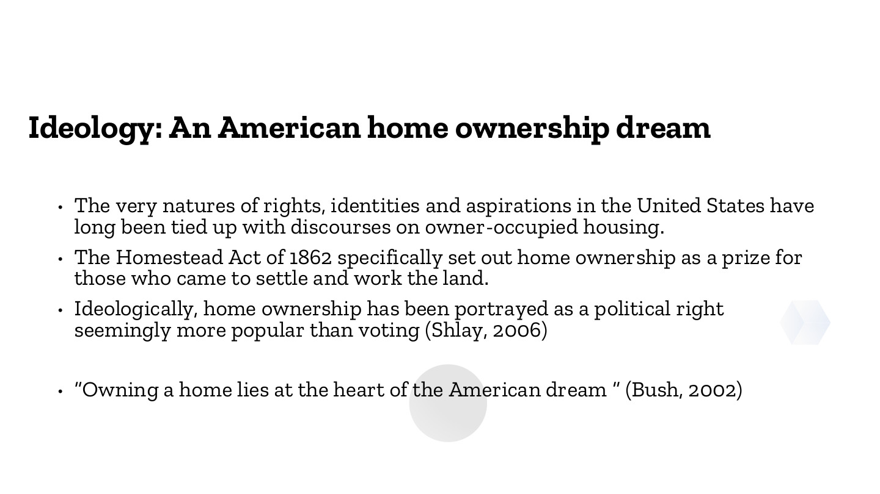
原PPT第21页 / Original slide 21 · 重点 / Focus

PPT中英翻译 / PPT translation
PPT English / 英文原文与图示 | 中文翻译 / Chinese translation
The very natures of rights, identities and aspirations in the United States have long been tied up with discourses on owner-occupied housing. | 美国关于权利、身份和愿望的理解，长期与自住住房的话语联系在一起。
The Homestead Act of 1862 specifically set out home ownership as a prize for those who came to settle and work the land. | 1862年《宅地法》把土地／住房所有权设为对定居并耕作土地者的奖励。
Ideologically, home ownership has been portrayed as a political right seemingly more popular than voting (Shlay, 2006). | 在意识形态中，住房自有被描绘为一种政治权利，甚至似乎比投票更受欢迎（Shlay，2006）。
“Owning a home lies at the heart of the American dream” (Bush, 2002). | “拥有住房处于美国梦的核心”（布什，2002）。

本页核心 / Key takeaway
住房自有不仅是消费选择，还被建构为权利、身份、自立和成功的象征。
Homeownership is framed as a symbol of rights, identity, self-reliance and success, beyond a consumer choice.

精要解析 / Essential explanation

1. 意识形态有什么作用 / What ideology does
把拥有住房视为理想生活，有助于为购房支持政策争取认同。偏好可以被历史制度和公共话语塑造，不必把高自有率当作自然、不变的个人选择。
Presenting ownership as the ideal life helps legitimise purchase-support policies. Preferences can be shaped by institutions and public discourse, rather than being timeless or purely individual choices.

2. 历史政策与价值相连 / Connecting policy and values
宅地法例子说明国家会把财产权与定居、劳动等行为联系起来。后面的宣传和贷款制度则提供不同工具，将“理想”转化成政策方向。
The Homestead example links property with settlement and work. Later campaigns and lending institutions provide other instruments that translate ideals into policy priorities.

3. 权利话语与实际可及性 / Rhetoric and access
把住房自有称为政治权利，并不自动保证每个人买得起或保得住房。分析要继续看信贷、收入、价格与排除条件，不能把宣传用语当作实际结果。
Calling ownership a political right does not guarantee affordability or retention. Examine credit, income, prices and exclusion rather than treating rhetoric as an achieved outcome.

22｜美国梦的官方表述 / An official ownership proclamation
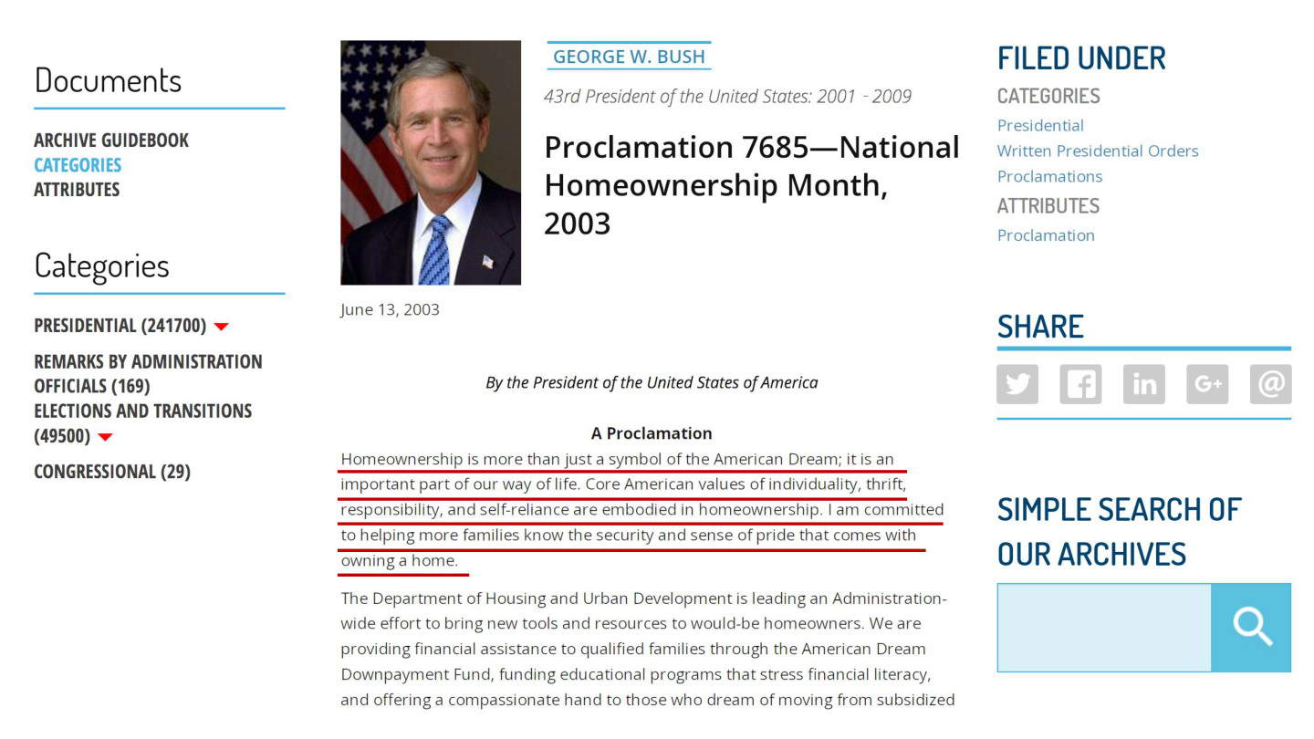
原PPT第22页 / Original slide 22 · 简读 / Brief

PPT中英翻译 / PPT translation
PPT English / 英文原文与图示 | 中文翻译 / Chinese translation
George W. Bush, 43rd President of the United States: 2001–2009. Proclamation 7685—National Homeownership Month, 2003. June 13, 2003. | 乔治·W.布什，美国第43任总统（2001—2009）。第7685号公告——2003年全国家庭住房自有月，日期为2003年6月13日。
By the President of the United States of America. A Proclamation. | 美利坚合众国总统公告。
Homeownership is more than just a symbol of the American Dream; it is an important part of our way of life. Core American values of individuality, thrift, responsibility, and self-reliance are embodied in homeownership. I am committed to helping more families know the security and sense of pride that comes with owning a home. | 住房自有不仅是美国梦的象征，也是生活方式的重要组成部分；个人性、节俭、责任和自立等价值体现在其中。总统承诺帮助更多家庭体验拥有住房所带来的安全感与自豪感。
The Department of Housing and Urban Development is leading an Administration-wide effort to bring new tools and resources to would-be homeowners. We are providing financial assistance to qualified families through the American Dream Downpayment Fund, funding educational programs that stress financial literacy, and offering a compassionate hand to those who dream of moving from subsidized… [image cuts off]. | HUD牵头向潜在购房者提供工具和资源，包括通过美国梦首付基金向合资格家庭提供资助、支持金融素养教育，以及帮助希望从补贴住房迁出的家庭……【截图下文截断，不补写。】
Site navigation: Documents; Archive Guidebook; Categories; Attributes; Presidential; Remarks by Administration Officials; Elections and Transitions; Congressional; Filed Under; Share; Simple Search of Our Archives. | 网页导航：文件、档案指南、类别、属性、总统文件、政府官员讲话、选举与过渡、国会文件、归档、分享、档案检索。

本页核心 / Key takeaway
红线引文把住房自有与节俭、责任、自立和安全感联系起来，是第21页的具体话语例证。
The underlined passage links ownership with thrift, responsibility, self-reliance and security, illustrating slide 21’s discourse.

精要解析 / Essential explanation

1. 只抓这项用途 / Focus on its purpose
本页证明政府怎样公开宣传住房自有，不直接证明这些政策已经使所有家庭更安全。公告原文、价值主张和实际政策效果是不同层次，无需背网页导航。
The document illustrates official promotion, not proof of improved security for every family. Distinguish the proclamation, its values and programme outcomes; navigation labels are not study priorities.

23｜住房自有的历史政治背景 / Historical political context
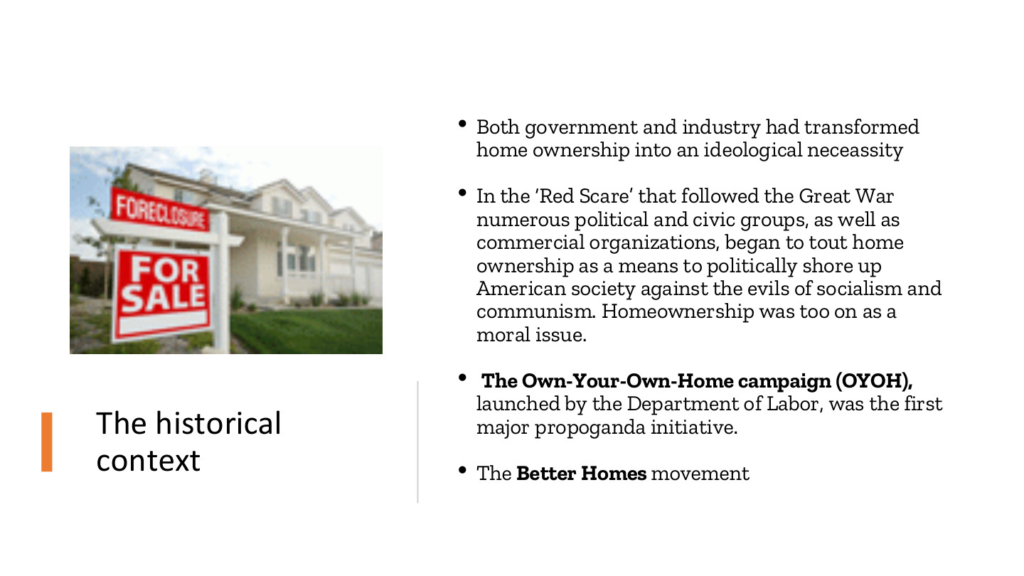
原PPT第23页 / Original slide 23 · 理解 / Understand

PPT中英翻译 / PPT translation
PPT English / 英文原文与图示 | 中文翻译 / Chinese translation
Both government and industry had transformed home ownership into an ideological neceassity. | 政府与行业共同把住房自有塑造成意识形态上的必要追求（原文neceassity为拼写错误）。
In the “Red Scare” that followed the Great War numerous political and civic groups, as well as commercial organizations, began to tout home ownership as a means to politically shore up American society against the evils of socialism and communism. Homeownership was too on as a moral issue. | 一战后的“红色恐慌”时期，政治、公民和商业组织把住房自有宣传为抵御社会主义与共产主义、巩固美国社会的方式，并将其道德化。【末句原文有排印问题，按语境翻译。】
The Own-Your-Own-Home campaign (OYOH), launched by the Department of Labor, was the first major propoganda initiative. The Better Homes movement. | 劳工部推动“拥有自己的家”（OYOH）大型宣传活动；另有“更美好住宅”运动。

本页核心 / Key takeaway
本页说明住房自有也通过政治宣传和道德叙事被推动，不能只用市场偏好解释。
Ownership was also promoted through political campaigns and moral narratives, beyond market preferences.

精要解析 / Essential explanation

1. 政府与行业怎样协作 / Government–industry cooperation
房地产行业有推动交易和建设的利益，政府把产权与社会稳定联系起来。双方可以使用不同理由支持同一方向，这说明住房政策同时具有政治与经济基础。
Property interests can favour transactions and construction while government links ownership with stability. Different motivations can support the same policy direction, giving housing promotion political as well as economic foundations.

2. 与前页如何衔接 / Connection to preceding pages
第21—22页呈现价值主张，本页补充其历史动员背景；后两页再看具体宣传。话语能塑造愿望，但不等于直接提供购房资金。
Slides 21–22 present values, while this page adds historical mobilisation. The next pages show campaigns. Discourse can shape aspirations without directly financing purchase.

24｜OYOH宣传运动 / Own-Your-Own-Home
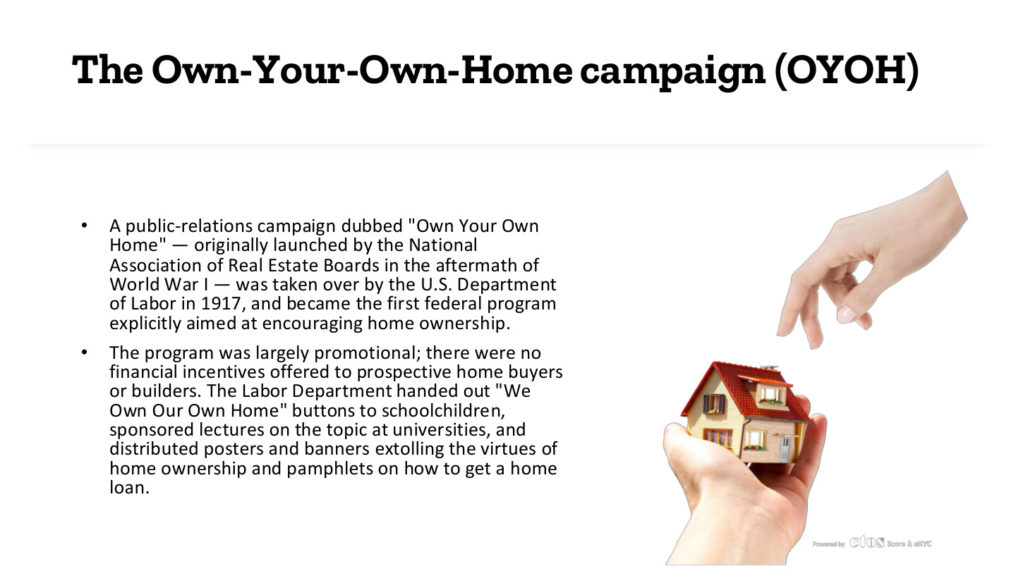
原PPT第24页 / Original slide 24 · 理解 / Understand

PPT中英翻译 / PPT translation
PPT English / 英文原文与图示 | 中文翻译 / Chinese translation
A public-relations campaign dubbed “Own Your Own Home” — originally launched by the National Association of Real Estate Boards in the aftermath of World War I — was taken over by the U.S. Department of Labor in 1917, and became the first federal program explicitly aimed at encouraging home ownership. | 原文称，“拥有自己的家”公关运动由全国房地产委员会协会在一战后发起，1917年由美国劳工部接手，成为第一个明确鼓励住房自有的联邦项目。【两项时序有张力，见辨析。】
The program was largely promotional; there were no financial incentives offered to prospective home buyers or builders. The Labor Department handed out “We Own Our Own Home” buttons to schoolchildren, sponsored lectures on the topic at universities, and distributed posters and banners extolling the virtues of home ownership and pamphlets on how to get a home loan. | 项目主要用于宣传，没有向潜在买家或建造者提供直接财政激励。劳工部向学生发放“我们拥有自己的家”徽章，资助大学讲座，分发赞扬住房自有的海报、横幅及介绍如何获得房贷的手册。

本页核心 / Key takeaway
OYOH主要是宣传与认知动员，并非直接购房补贴。
OYOH principally involved promotion and mobilisation rather than direct purchase subsidies.

精要解析 / Essential explanation

1. 用了什么工具 / Its instruments
徽章、讲座和宣传材料把住房自有变成值得追求的生活方式；贷款信息则连接愿望与金融渠道。这些都属于政策工具，不一定表现为现金转移。
Badges, lectures and publicity normalise ownership, while loan information connects aspiration with finance. These are policy instruments even without cash transfers.

2. 怎样判断效果 / Assessing effects
激励愿望与改善支付能力必须分开。没有直接财政补贴意味着项目不直接解决首付或月供问题；不能只因宣传广泛就推断所有潜在买家更负担得起。
Encouraging aspirations differs from improving ability to pay. Without direct financial aid the campaign does not directly resolve deposits or repayments; widespread publicity alone cannot establish improved affordability.

易错辨析 / Key distinction
原文同时写“一战后发起”和“1917年接手”，时序不一致；保留原文供对照，核心记宣传机制，不把这条起始年当作已核实定论。
The slide combines a post-war launch with a 1917 takeover, an inconsistent sequence. Retain it for comparison and focus on the promotional mechanism rather than treating the start date as settled.

25｜Better Homes与家庭角色 / Better Homes and household roles
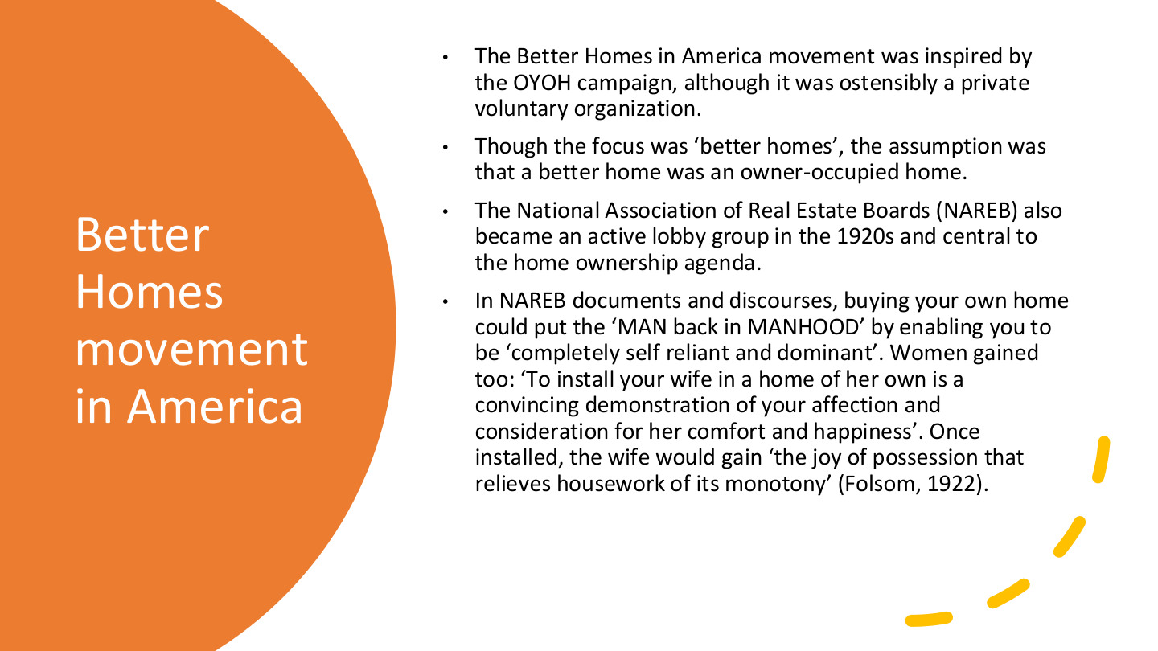
原PPT第25页 / Original slide 25 · 理解 / Understand

PPT中英翻译 / PPT translation
PPT English / 英文原文与图示 | 中文翻译 / Chinese translation
The Better Homes in America movement was inspired by the OYOH campaign, although it was ostensibly a private voluntary organization. | 美国“更美好住宅”运动受OYOH启发，形式上是民间志愿组织。
Though the focus was “better homes”, the assumption was that a better home was an owner-occupied home. | 虽然强调“更好的住宅”，其预设却是更好的家就是自有住房。
The National Association of Real Estate Boards (NAREB) also became an active lobby group in the 1920s and central to the home ownership agenda. | 全国房地产委员会协会（NAREB）在20世纪20年代成为活跃游说组织，在住房自有议程中居于重要位置。
In NAREB documents and discourses, buying your own home could put the “MAN back in MANHOOD” by enabling you to be “completely self reliant and dominant”. Women gained too: “To install your wife in a home of her own is a convincing demonstration of your affection and consideration for her comfort and happiness”. Once installed, the wife would gain “the joy of possession that relieves housework of its monotony” (Folsom, 1922). | NAREB历史宣传把买房描述为恢复男子气概、实现“完全自立与主导”的方式；又称给妻子一个自己的家能表达关爱，并让“拥有的喜悦缓解家务单调”（Folsom，1922）。这段引语呈现当时男性供养者与家庭主妇的角色想象。

本页核心 / Key takeaway
本页抓住“更好的家＝自有住房”的价值预设，以及财产如何被连接到家庭和性别角色。
Focus on the assumption that a better home means an owner-occupied home and its links to household and gender roles.

精要解析 / Essential explanation

1. 不是中性的品质比较 / Beyond a neutral quality comparison
“更好”被赋予产权含义，租赁即使质量良好也可能不被视为理想。价值评价先于住房实际品质，帮助解释为什么所有权能获得较强政治吸引力。
“Better” is given a tenure meaning, potentially excluding good-quality rentals from the ideal. The value judgement precedes actual dwelling quality, helping explain ownership’s political appeal.

2. 家庭形象怎样服务政策 / How household images support policy
宣传把男性自立、妻子幸福和家庭安定与产权捆绑，使购房不只是经济决定。分析时识别这些角色怎样动员支持，并把它与第13页“主体塑造”联系起来。
Publicity links male self-reliance, a wife’s happiness and household stability with property. Identify how these roles mobilise support and connect them to subject formation on slide 13.

26｜美国住房自有政策时间线 / US policy timeline
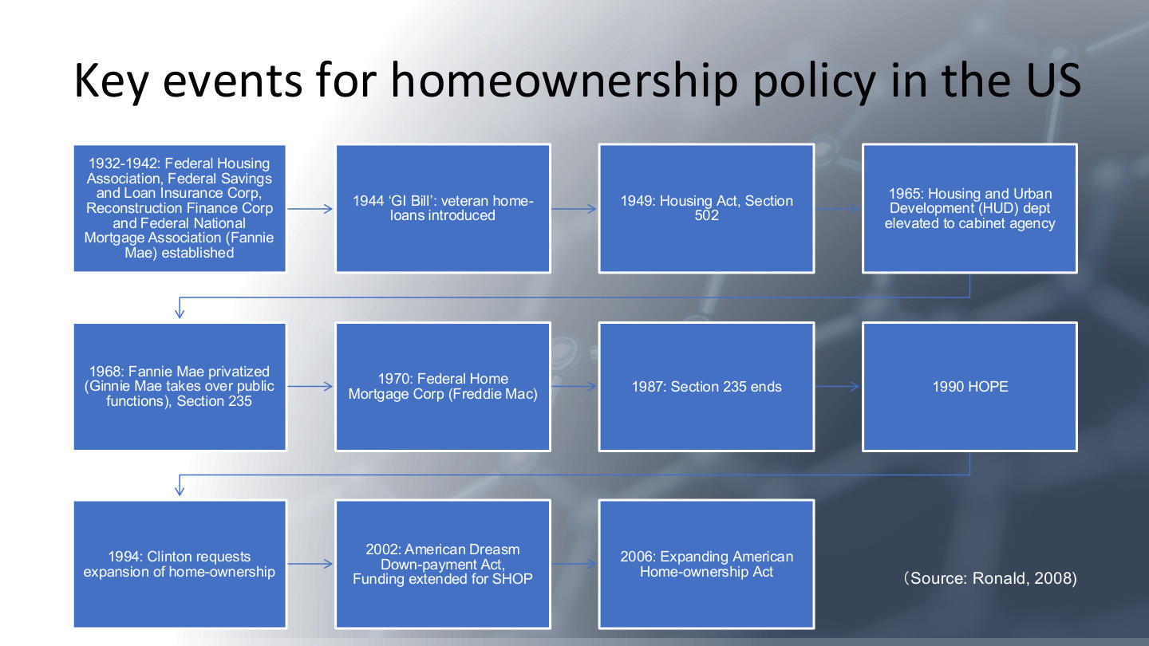
原PPT第26页 / Original slide 26 · 理解 / Understand

PPT中英翻译 / PPT translation
PPT English / 英文原文与图示 | 中文翻译 / Chinese translation
1932–1942: Federal Housing Association, Federal Savings and Loan Insurance Corp, Reconstruction Finance Corp and Federal National Mortgage Association (Fannie Mae) established. | 1932—1942年：原表列联邦住房机构、联邦储蓄贷款保险公司、复兴金融公司及房利美（Fannie Mae）等机构设立；FHA名称辨析见下方。
1944 “GI Bill”: veteran home-loans introduced. 1949: Housing Act, Section 502. | 1944年《退伍军人权利法案》引入退伍军人住房贷款；1949年《住房法》第502条。
1965: Housing and Urban Development (HUD) dept elevated to cabinet agency. | 1965年：住房与城市发展部（HUD）升为内阁级机构。
1968: Fannie Mae privatized (Ginnie Mae takes over public functions), Section 235. | 1968年：房利美私有化，吉利美（Ginnie Mae）接手公共职能；列入第235条。
1970: Federal Home Mortgage Corp (Freddie Mac). 1987: Section 235 ends. | 1970年：设立房地美（Freddie Mac；规范名称为Federal Home Loan Mortgage Corporation）；1987年第235条项目结束。
1990 HOPE. 1994: Clinton requests expansion of home-ownership. | 1990年HOPE；1994年克林顿提出扩大住房自有。
2002: American Dreasm Down-payment Act, Funding extended for SHOP. 2006: Expanding American Home-ownership Act. | 原表2002年列《美国梦首付法案》及SHOP资金延续；2006年列《扩大美国住房自有法案》。【保留原表年份，不将提案与生效状态混同。】
Source: Ronald, 2008. | 来源：Ronald，2008。

本页核心 / Key takeaway
不必逐年扩写；主线是国家从宣传延伸到住房金融机构、贷款和购房支持。
Focus on state promotion extending into financial institutions, lending and purchase support, rather than expanding every date.

精要解析 / Essential explanation

1. 国家与市场的关系 / State and market
机构建设、保险及贷款渠道说明私人自有并非只靠自由市场自发形成。国家可以通过金融制度推动私人产权，与本课“再商品化行动者”的视角相连。
Institutions, insurance and lending show that ownership is not simply a spontaneous market outcome. The state can promote private property through financial institutions, linking this history to recommodification.

2. 怎样使用这条时间线 / How to use the timeline
按“宣传—金融支持—扩大进入”整理政策路径，选择少数工具解释机制即可。1990年HOPE不能直接等同前课1993年启动的HOPE VI更新计划。
Organise the trajectory as promotion, financial support and expanded access, explaining selected instruments. The 1990 HOPE entry is not identical to the HOPE VI redevelopment programme launched in 1993 in the previous lecture.

易错辨析 / Key distinction
原表Federal Housing Association通常应为Federal Housing Administration；个别年份还混有倡议／立法状态，勿把整表当成逐项已核实的生效年表。
Federal Housing Association should normally read Federal Housing Administration. Some entries also require distinguishing proposals from enacted measures; the table is not a fully verified enactment chronology.

27｜美国自有率的长期上升 / Long-run US ownership growth
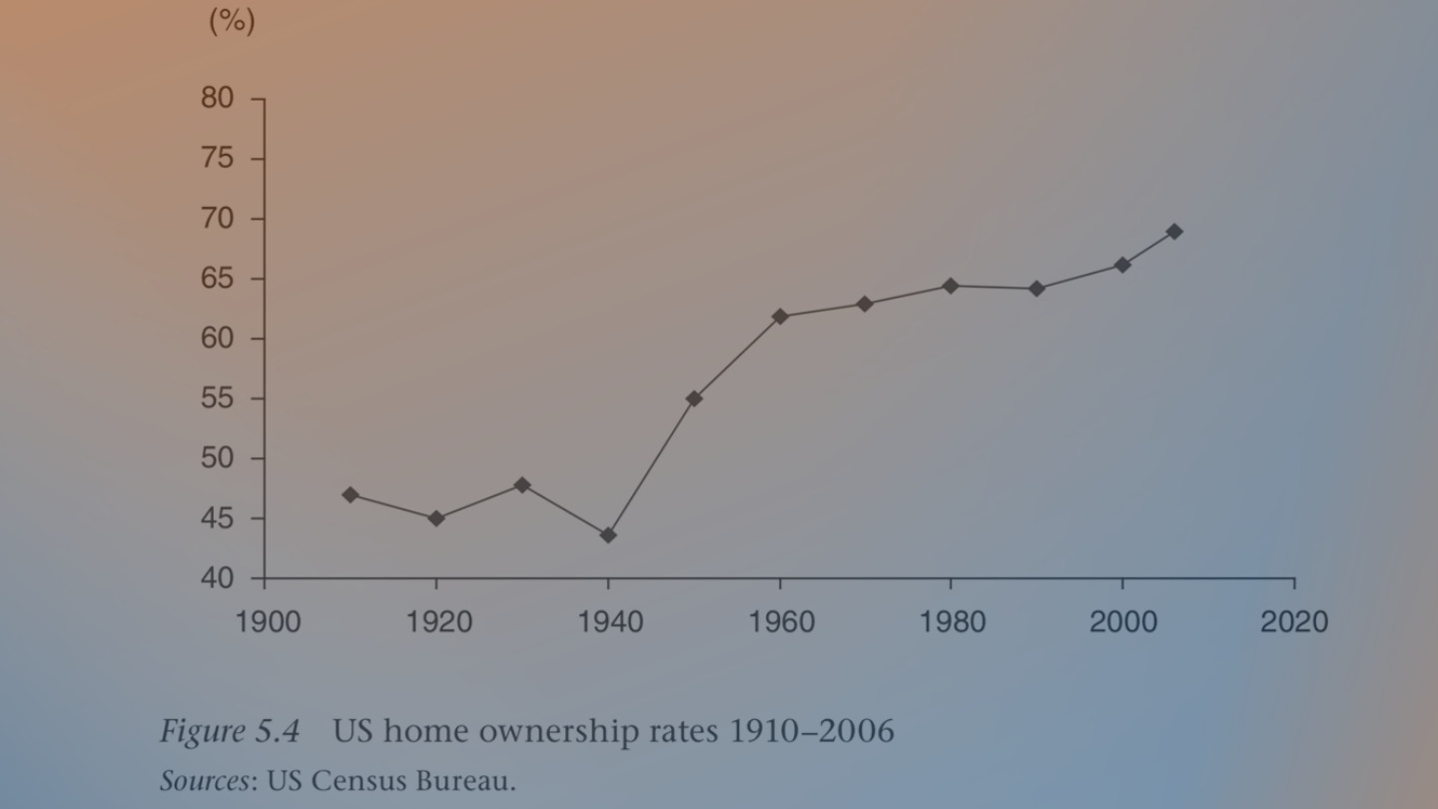
原PPT第27页 / Original slide 27 · 简读 / Brief

PPT中英翻译 / PPT translation
PPT English / 英文原文与图示 | 中文翻译 / Chinese translation
Figure 5.4. US home ownership rates 1910–2006. Sources: US Census Bureau. | 图5.4：1910—2006年美国住房自有率。来源：美国人口普查局。
Vertical axis: % (40–80); horizontal axis: year (ticks from 1900 to 2020). | 纵轴：百分比（40%—80%）；横轴：年份，刻度从1900到2020。刻度范围不同于数据覆盖期。

本页核心 / Key takeaway
只记趋势：早期有起伏，二战后自有率明显上升，并非从起点持续直线上升。
Remember early fluctuations followed by marked post-war growth, rather than an uninterrupted straight rise.

精要解析 / Essential explanation

1. 本页的作用 / Purpose of the figure
它为前页的制度史提供结果背景；单条趋势不能证明某项法律单独造成了上升。具体转折和小数无需逐点记忆，后面还会看到危机后的逆转。
The trend supplies context for the institutional history but cannot isolate one law’s effect. Detailed points are secondary; later slides show the post-crisis reversal.

28｜2008年危机的根源 / Roots of the 2008 crisis
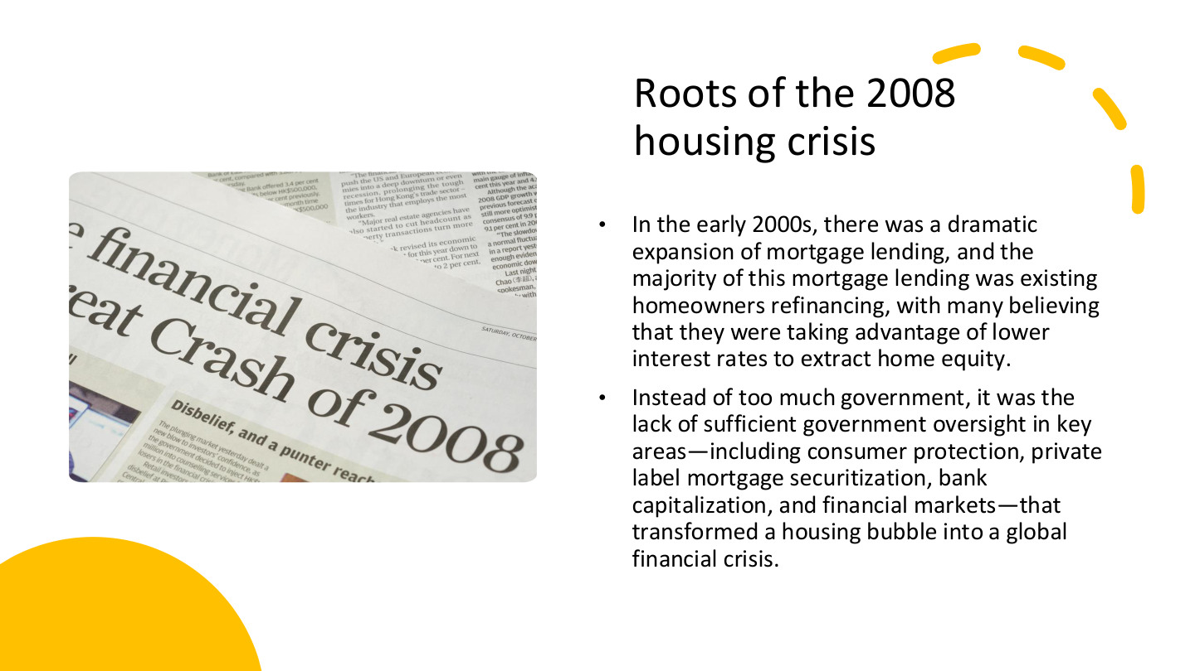
原PPT第28页 / Original slide 28 · 重点 / Focus

PPT中英翻译 / PPT translation
PPT English / 英文原文与图示 | 中文翻译 / Chinese translation
In the early 2000s, there was a dramatic expansion of mortgage lending, and the majority of this mortgage lending was existing homeowners refinancing, with many believing that they were taking advantage of lower interest rates to extract home equity. | 2000年代初按揭贷款大幅扩张，其中大量、按课件说法占多数的活动是现有房主再融资；许多人认为可利用低利率提取住房净值。
Instead of too much government, it was the lack of sufficient government oversight in key areas—including consumer protection, private label mortgage securitization, bank capitalization, and financial markets—that transformed a housing bubble into a global financial crisis. | 本页认为，问题不在于笼统的“政府太多”，而在消费者保护、私人标签按揭证券化、银行资本及金融市场等关键领域监管不足，使住房泡沫演变为全球金融危机。

本页核心 / Key takeaway
把再融资、住房净值提取、风险传递与监管不足串起来，不能把危机只归结为更多人买房。
Connect refinancing, equity extraction, risk transmission and insufficient oversight, rather than explaining the crisis merely as more people buying homes.

精要解析 / Essential explanation

1. home equity怎样算 / Defining home equity
住房净值＝房屋市场价值−未还按揭。例如价值300,000、贷款余额200,000，净值为100,000；这是资产负债差额，不是家庭每月收入。
Home equity equals market value minus outstanding mortgage debt. A home worth 300,000 with debt of 200,000 has equity of 100,000; this is a balance-sheet amount, not monthly income.

2. 再融资为什么能提取现金 / Cash-out refinancing
再融资是以新贷款替换旧贷款；若增加借款，可把部分住房净值转成现金。提取现金本身不创造净财富，还款义务仍在，房价下跌或收入下降可能放大压力。
Refinancing replaces an existing loan; a larger new loan can convert equity into cash. Cash extraction does not itself create net wealth; repayment remains and falling prices or earnings can intensify pressure.

3. 风险怎样向外扩散 / Risk transmission
私人标签证券化把按揭现金流打包为金融产品，使住房风险进入更广金融网络。银行资本是抵御损失的缓冲；若风险识别、消费者保护与资本约束不足，冲击可能相互放大。
Private-label securitisation packages mortgage cash flows into financial products, connecting housing risks to broader finance. Bank capital buffers losses; weak risk assessment, consumer protection and capital constraints can amplify shocks.

4. 国家角色要具体分析 / Specify the state’s role
本页提出的是关键监管缺口，不是任何政府干预都有效。分析时写清哪个环节缺保护、风险由谁承担，再与前文家庭资产化保障联系起来。
The slide identifies regulatory gaps, not a claim that every intervention works. Specify the unprotected stage and risk-bearer, then connect this to the earlier shift towards asset-dependent household security.

29｜金融危机与住房自有逆转 / Crisis and ownership reversal
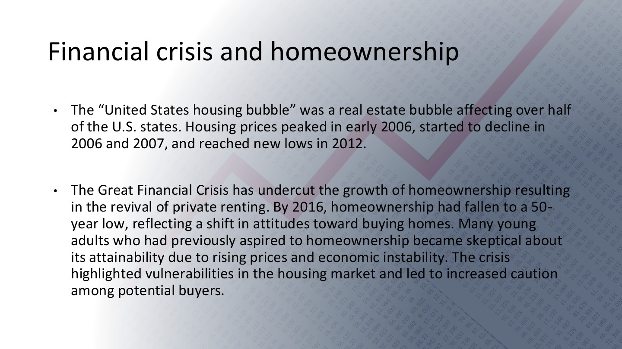
原PPT第29页 / Original slide 29 · 重点 / Focus

PPT中英翻译 / PPT translation
PPT English / 英文原文与图示 | 中文翻译 / Chinese translation
The “United States housing bubble” was a real estate bubble affecting over half of the U.S. states. Housing prices peaked in early 2006, started to decline in 2006 and 2007, and reached new lows in 2012. | 美国住房泡沫影响超过一半的州；课件称房价在2006年初达到高点，2006—2007年开始下降，2012年降至新低。
The Great Financial Crisis has undercut the growth of homeownership resulting in the revival of private renting. By 2016, homeownership had fallen to a 50-year low, reflecting a shift in attitudes toward buying homes. Many young adults who had previously aspired to homeownership became skeptical about its attainability due to rising prices and economic instability. The crisis highlighted vulnerabilities in the housing market and led to increased caution among potential buyers. | 全球金融危机削弱住房自有扩张，并伴随私人租赁复兴。课件称2016年自有率降至约50年低点；房价与经济不稳定使部分年轻人怀疑购房目标能否实现，潜在买家也更谨慎。

本页核心 / Key takeaway
危机显示住房自有扩张可以逆转，家庭也可能重新依靠租赁；资产化保障并非单向增长。
The crisis shows that ownership expansion can reverse and households can return to renting; asset-based security does not grow in one direction indefinitely.

精要解析 / Essential explanation

1. 房价与自有率不同 / Prices and ownership rates differ
房价反映资产价格，自有率反映住户的占有形式。价格下降不自动保证更多家庭能买房，因为收入、信贷可得性和风险预期也会同时变化。
Prices measure asset values; ownership rates measure household tenure. Lower prices do not automatically enable more households to buy, because incomes, credit access and expectations also change.

2. 私人租赁为何重要 / Why private renting matters
当进入或保有自住更困难，租赁成为替代渠道。评价危机后的保障，需要同时观察租金、租赁稳定性和支持制度，而不是只看房价从高点下降多少。
Renting becomes an alternative when entering or retaining ownership is harder. Assess post-crisis protection through rents, tenancy security and support as well as falling purchase prices.

3. 把机制与时间线结合 / Combine mechanisms and chronology
用第28页的借贷与监管机制解释脆弱性，用本页记录价格、自有率和住房选择的变化；不要把所有变化都压成“2008年同一天发生”。
Use slide 28 to explain financial vulnerability and this page to trace prices, ownership and choices. These changes occur over different periods rather than at one moment in 2008.

30｜美国自有率：红圈拐点 / The circled ownership turning point
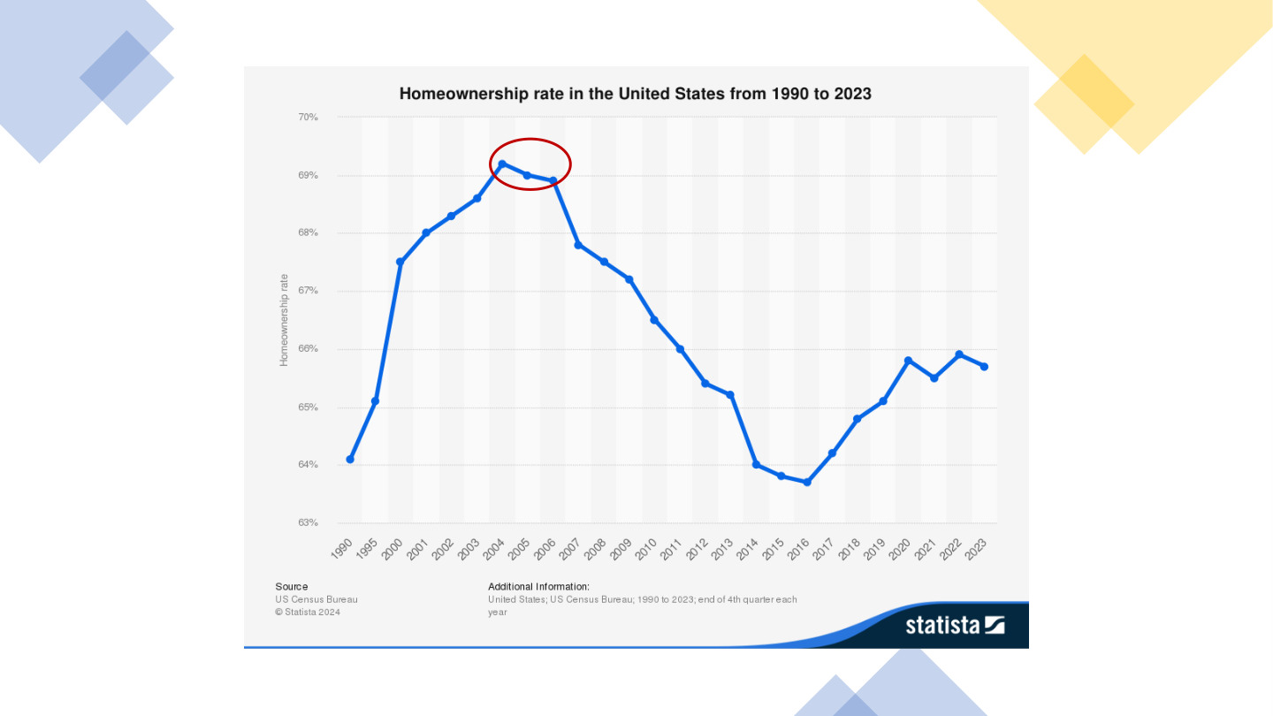
原PPT第30页 / Original slide 30 · 理解 / Understand

PPT中英翻译 / PPT translation
PPT English / 英文原文与图示 | 中文翻译 / Chinese translation
Homeownership rate in the United States from 1990 to 2023. | 1990—2023年美国住房自有率。
Vertical axis: Homeownership rate (63%–70%). Source: US Census Bureau; Statista 2024. Additional information: end of 4th quarter each year. | 纵轴：住房自有率（约63%—70%）。来源：美国人口普查局、Statista 2024。附注：各年第四季度末。
The original red ellipse highlights the high point around 2004–2006. | 原图红圈突出2004—2006年前后的高位与转折。

本页核心 / Key takeaway
重点读2004年前后高位→长期下滑→2016年前后低位→部分回升，而不是逐年背小数。
Read the high around 2004, prolonged decline, a low around 2016 and partial recovery, rather than memorising each decimal.

精要解析 / Essential explanation

1. 别把两个高点混同 / Distinguish the two peaks
本图自有率高点不等于第29页房价高点。前者约在2004年前后，后者课件记为2006年初；两个指标的转折可以不同。
The ownership-rate peak is not the price peak on slide 29. This chart peaks around 2004, while the text dates prices to early 2006; the two series can turn at different times.

2. 回升说明到哪一步 / Interpreting recovery
后期有所回升，但截至原图2023年仍未回到早期高位；它不直接说明家庭债务或可负担性已经恢复。引用时保留截止年份。
The later recovery remains below the early high through 2023. It does not establish that debt burdens or affordability recovered; retain the chart’s end date when discussing the trend.

31｜美国住户与住房援助 / US households and assistance
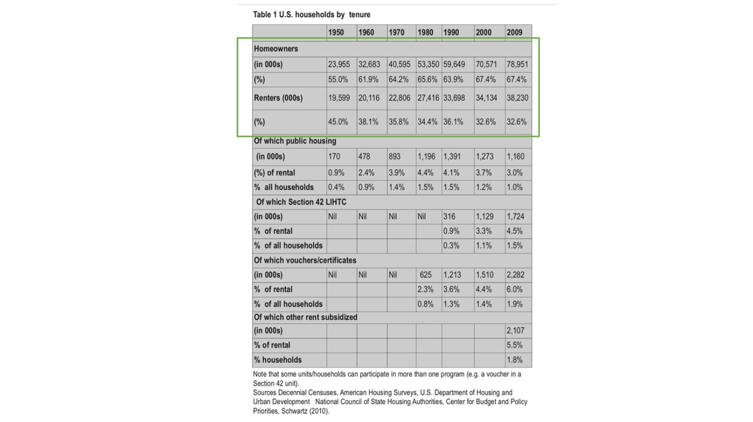
原PPT第31页 / Original slide 31 · 理解 / Understand

PPT中英翻译 / PPT translation
PPT English / 英文原文与图示 | 中文翻译 / Chinese translation
Table 1. U.S. households by tenure. Years: 1950, 1960, 1970, 1980, 1990, 2000, 2009. | 表1：美国按住房占有形式划分的住户，年份为1950—2009所列年份。绿色框突出自住与租赁的总体构成。
Homeowners; Renters; Of which public housing; Section 42 LIHTC; vouchers/certificates; other rent subsidized. Counts in 000s; % of rental; % of all households. | 项目：自住户、租户；租户中公屋、第42条LIHTC、住房券／证书及其他租金补贴。数量为千户；百分比分别以租户或全部住户为分母。
Some units/households can participate in more than one program (e.g. a voucher in a Section 42 unit). | 部分住房／家庭可同时参与多项计划，例如在LIHTC住房中使用住房券。
Sources: Decennial Censuses; American Housing Surveys; HUD; National Council of State Housing Authorities; Center for Budget and Policy Priorities; Schwartz (2010). | 来源：十年人口普查、美国住房调查、HUD、州住房机构全国委员会、CBPP及Schwartz（2010）。
In the transcribed assistance table, each cell reads: count in 000s / % of rental / % of all households. Nil means none as printed; — preserves an original blank. | 下方援助表每格依次为：千户／占租户比例／占全部住户比例。Nil保留原表“无”，—表示原空白，不擅自填成零。

总体住户：数量为千户 / Overall households: thousands
年份 / Year | 自住户 / Owners | 自有率 / Owner % | 租户 / Renters | 租户比例 / Renter %
1950 | 23,955 | 55.0% | 19,599 | 45.0%
1960 | 32,683 | 61.9% | 20,116 | 38.1%
1970 | 40,595 | 64.2% | 22,806 | 35.8%
1980 | 53,350 | 65.6% | 27,416 | 34.4%
1990 | 59,649 | 63.9% | 33,698 | 36.1%
2000 | 70,571 | 67.4% | 34,134 | 32.6%
2009 | 78,951 | 67.4% | 38,230 | 32.6%

援助项目：千户／租户%／全部住户% / Assistance: thousands / renter % / all-household %
年份 / Year | 公屋 / Public housing | LIHTC Section 42 | 券／证书 / Vouchers | 其他补贴 / Other
1950 | 170 / 0.9% / 0.4% | Nil / — / — | Nil / — / — | — / — / —
1960 | 478 / 2.4% / 0.9% | Nil / — / — | Nil / — / — | — / — / —
1970 | 893 / 3.9% / 1.4% | Nil / — / — | Nil / — / — | — / — / —
1980 | 1,196 / 4.4% / 1.5% | Nil / — / — | 625 / 2.3% / 0.8% | — / — / —
1990 | 1,391 / 4.1% / 1.5% | 316 / 0.9% / 0.3% | 1,213 / 3.6% / 1.3% | — / — / —
2000 | 1,273 / 3.7% / 1.2% | 1,129 / 3.3% / 1.1% | 1,510 / 4.4% / 1.4% | — / — / —
2009 | 1,160 / 3.0% / 1.0% | 1,724 / 4.5% / 1.5% | 2,282 / 6.0% / 1.9% | 2,107 / 5.5% / 1.8%

本页核心 / Key takeaway
看清自有率、占租户比例与占全部住户比例三个分母；援助类别还可能重叠。
Distinguish ownership rates, shares of renters and shares of all households; assistance categories may also overlap.

精要解析 / Essential explanation

1. 分母怎样改变结论 / How denominators change interpretation
2009年公屋为租户的3.0%，却为全部住户的1.0%。同一数量可以对应不同百分比；不能把这两个数字当成互相矛盾，也不能与其他年份的0.8%直接混用。
In 2009 public housing accounts for 3.0% of renters but 1.0% of all households. One count can produce different percentages; these are not contradictory, nor interchangeable with a 0.8% figure from another year.

2. 为什么不能直接相加 / Why categories cannot simply be added
原表明确同一家庭可同时使用券和LIHTC房源。项目覆盖不一定互斥，将援助行相加可能重复计数；自有与租赁总体构成才是上方绿色框的主要信息。
The source explicitly permits vouchers in LIHTC units. Programme coverage is not necessarily exclusive, so summing assistance rows can double-count households; the green box focuses on the overall owner–renter split.

32｜美国住房成本负担 / US housing cost burdens
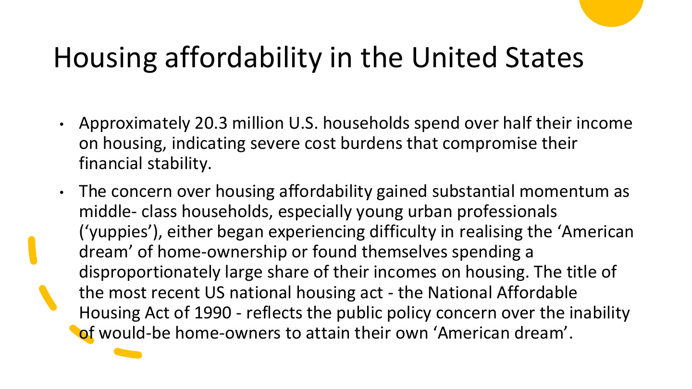
原PPT第32页 / Original slide 32 · 重点 / Focus

PPT中英翻译 / PPT translation
PPT English / 英文原文与图示 | 中文翻译 / Chinese translation
Approximately 20.3 million U.S. households spend over half their income on housing, indicating severe cost burdens that compromise their financial stability. | 课件称，约2,030万美国家庭把超过一半收入用于住房，面临影响财务稳定的严重成本负担。
The concern over housing affordability gained substantial momentum as middle-class households, especially young urban professionals (“yuppies”), either began experiencing difficulty in realising the “American dream” of home-ownership or found themselves spending a disproportionately large share of their incomes on housing. | 当中产家庭、尤其年轻城市专业人士（yuppies）难以实现购房梦想，或把过多收入用于住房时，可负担性问题受到更广泛关注。
The title of the most recent US national housing act—the National Affordable Housing Act of 1990—reflects the public policy concern over the inability of would-be home-owners to attain their own “American dream”. | 原文以1990年《国家可负担住房法》的名称，说明政策对潜在购房者无法实现美国梦的关注。“most recent”为原文历史表述，不作为当前最新法律的判断。

本页核心 / Key takeaway
购房梦想与实际住房负担之间存在落差；本页用支出超过收入一半描述严重成本负担。
The ownership dream can diverge from actual affordability; this slide uses housing costs above half of income to describe severe burdens.

精要解析 / Essential explanation

1. 50%是什么指标 / What the 50% figure measures
这里是住房支出÷收入超过50%，不是房价收入比，也不是一套房值年收入的一半。2,030万的单位是家庭／住户，不是人口。
This concerns housing expenditure exceeding 50% of income, not the house-price ratio or a dwelling worth half of annual income. The 20.3 million figure counts households, not people.

2. 为什么不仅是贫困议题 / Beyond poverty alone
中等收入者也可能因房价、租金或还款而承受压力。可负担性取决于成本与资源的关系，不能只按收入阶层推断；同时也不能忽视低收入家庭的必要消费受挤压。
Middle-income households can face pressure from prices, rents or repayments. Affordability depends on costs relative to resources, not class labels alone; necessary consumption among lower-income households also matters.

3. 怎样连接前面的指标 / Link to earlier measures
用第17—18页的方法检查比例、支付条件与剩余生活资源。原页未注明2,030万的统计年份，作为课程历史材料使用，不把它当作今天的即时总数。
Apply slides 17–18 to payment ratios, terms and resources left for necessities. The slide does not date the 20.3 million statistic; treat it as historical course evidence, not a current estimate.

33｜房价收入比图怎样读？ / Reading the price–income chart
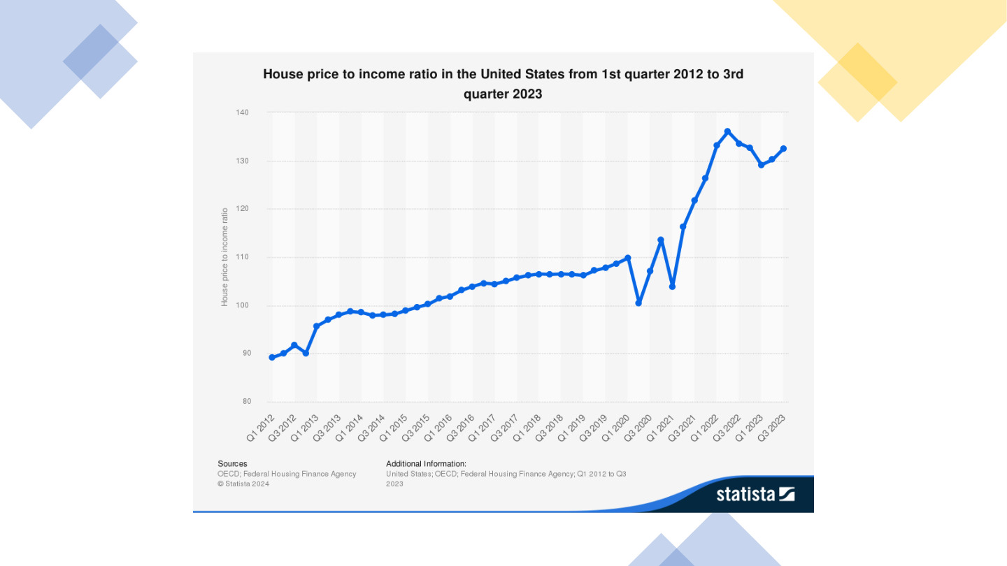
原PPT第33页 / Original slide 33 · 理解 / Understand

PPT中英翻译 / PPT translation
PPT English / 英文原文与图示 | 中文翻译 / Chinese translation
House price to income ratio in the United States from 1st quarter 2012 to 3rd quarter 2023. | 美国2012年第一季度至2023年第三季度的房价收入比序列。
Vertical axis: House price to income ratio, approximately 80–140; horizontal axis: quarters from Q1 2012 to Q3 2023. | 纵轴约80—140，标为房价收入比；横轴为2012Q1—2023Q3的季度。数值应按指数化序列理解，截图未明确基期。
Sources: OECD; Federal Housing Finance Agency. © Statista 2024. | 来源：OECD、美国联邦住房金融局；Statista 2024。

本页核心 / Key takeaway
图中房价相对收入总体上升，后期有明显波动；指数值不能直接读成年收入倍数。
The chart shows an overall rise in prices relative to incomes, with later fluctuations; indexed values are not literal multiples of annual income.

精要解析 / Essential explanation

1. 指数与原始比值不同 / Index versus level
图上130不等于房价为年收入130倍。指数用于比较相对变化；原截图未明确基期，不自行补出基年，也不把它与第18页例子的比值5直接比较。
A chart value of 130 does not mean a price of 130 times annual income. An index compares relative change; the base year is not stated in the screenshot, so do not invent it or compare directly with the ratio of 5 on slide 18.

2. 本页只需记趋势 / Retain the main trend
后段快速上升后有所回落、再波动，并非始终直线上涨。该图不包含利率和必要生活支出，不能独自给出每个家庭实际可负担性的结论。
The later sharp increase is followed by a pullback and further fluctuation, not a continuous straight rise. The chart omits financing costs and necessities, so it cannot establish affordability for each household.

34｜荷兰案例 / The Netherlands

原PPT第34页 / Original slide 34 · 简读 / Brief

PPT中英翻译 / PPT translation
PPT English / 英文原文与图示 | 中文翻译 / Chinese translation
IV. The Netherlands | 第四部分：荷兰。

本页核心 / Key takeaway
观察社会租赁传统下，国家怎样支持住房自有，以及住房结构和成本如何变化。
Examine ownership promotion, changing tenure and costs within a society with a strong social-rental tradition.

35｜荷兰红框：自有不等于无债 / The highlighted Dutch debt structure
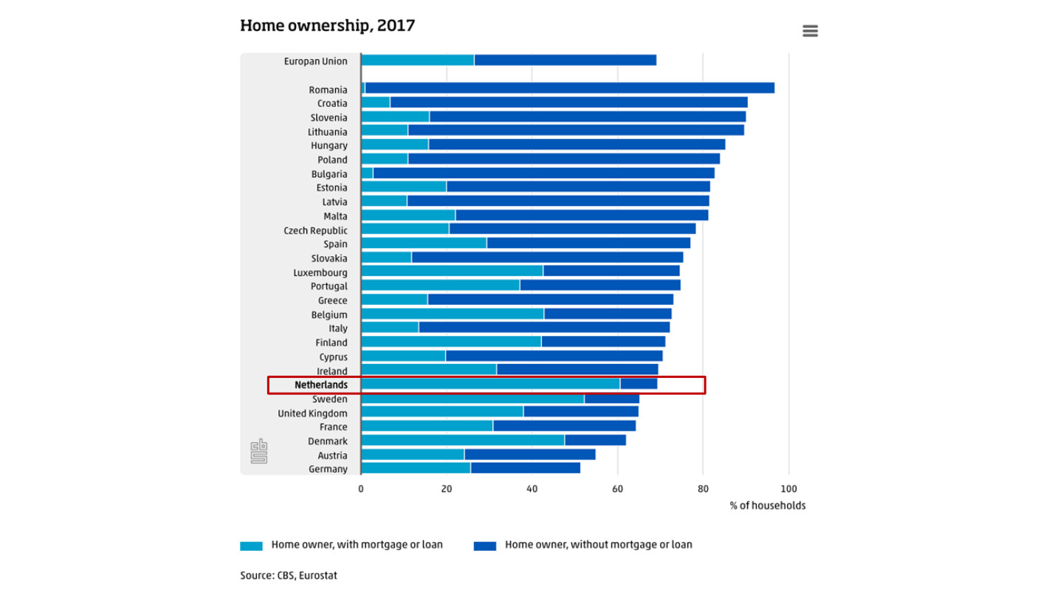
原PPT第35页 / Original slide 35 · 理解 / Understand

PPT中英翻译 / PPT translation
PPT English / 英文原文与图示 | 中文翻译 / Chinese translation
Home ownership, 2017. Horizontal axis: % of households. Source: CBS, Eurostat. | 2017年住房自有。横轴为住户百分比；来源：CBS、Eurostat。
Home owner, with mortgage or loan; Home owner, without mortgage or loan. | 图例：有按揭／贷款的房主；无按揭／贷款的房主。原图红框标出荷兰。
European Union; Romania; Croatia; Slovenia; Lithuania; Hungary; Poland; Bulgaria; Estonia; Latvia; Malta; Czech Republic; Spain; Slovakia; Luxembourg. | 欧盟、罗马尼亚、克罗地亚、斯洛文尼亚、立陶宛、匈牙利、波兰、保加利亚、爱沙尼亚、拉脱维亚、马耳他、捷克、西班牙、斯洛伐克、卢森堡。
Portugal; Greece; Belgium; Italy; Finland; Cyprus; Ireland; Netherlands; Sweden; United Kingdom; France; Denmark; Austria; Germany. | 葡萄牙、希腊、比利时、意大利、芬兰、塞浦路斯、爱尔兰、荷兰、瑞典、英国、法国、丹麦、奥地利、德国。

本页核心 / Key takeaway
荷兰红框强调相当一部分自住家庭仍有按揭，不能把较高自有率理解为已经没有住房支付压力。
The highlighted Dutch bar shows substantial mortgage-backed ownership, so ownership does not mean an absence of payment pressure.

精要解析 / Essential explanation

1. 先看总长，再看内部 / Total share and internal composition
总长表示自有住房住户比例，两种颜色再区分有债与无债。相同自有率可能对应很不同的债务结构；原图无逐段数值，不编造精确比例。
Bar length gives ownership’s share; colours distinguish mortgaged and debt-free positions. Equal ownership rates can conceal different debt structures; do not invent precise segment values absent from the chart.

2. 与后面荷兰数据连接 / Connect to subsequent Dutch evidence
本图是2017年住户口径，第38页是1981—2010年住房存量结构。年份和分母不同，适合相互补充，不宜直接把差值解释成同一指标的变化。
This is a 2017 household measure; slide 38 presents housing stock in 1981–2010. Different dates and denominators make them complementary, not one directly comparable series.

36｜荷兰购房支持 / Dutch homeownership schemes
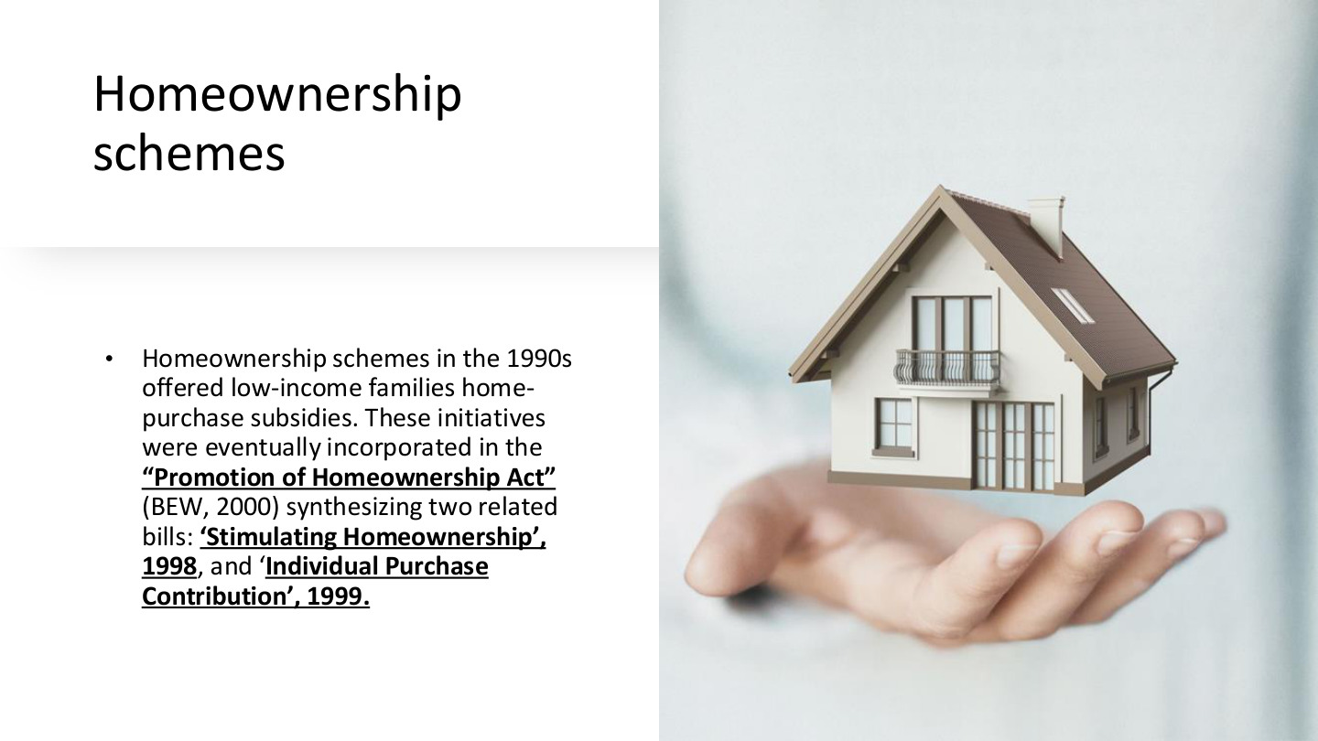
原PPT第36页 / Original slide 36 · 重点 / Focus

PPT中英翻译 / PPT translation
PPT English / 英文原文与图示 | 中文翻译 / Chinese translation
Homeownership schemes in the 1990s offered low-income families home-purchase subsidies. These initiatives were eventually incorporated in the “Promotion of Homeownership Act” (BEW, 2000) synthesizing two related bills: “Stimulating Homeownership”, 1998, and “Individual Purchase Contribution”, 1999. | 20世纪90年代的计划向低收入家庭提供购房补贴，后整合进2000年《促进住房所有权法》（BEW）；课件列出1998年“促进住房自有”和1999年“个人购房补助”两项相关法案。

本页核心 / Key takeaway
荷兰案例说明公共支持也可以用来促进私人住房自有，并不只表现为社会租赁供给。
The Dutch case shows that public support can promote private homeownership, alongside social-rental provision.

精要解析 / Essential explanation

1. 补贴改变什么 / What purchase support changes
购房补贴主要帮助家庭跨越购买门槛，不等于政府长期替代全部还款和维护责任。进入自有住房与持续负担得起是两个问题。
Purchase subsidies help households cross entry barriers; they do not necessarily replace continuing repayments and upkeep. Access to ownership and sustainable affordability are distinct questions.

2. 与听课宝怎样对照 / Comparison with the listening summary
听课宝强调住房协会、租金补贴与资金流向；本页把视角转向购买端。比较要问支持的是租赁支付、非营利供给，还是家庭取得私人资产，而不只看有无补贴。
The listening summary emphasises associations, rent support and funding flows. This page turns to purchases: distinguish support for rent, nonprofit supply and acquisition of household assets rather than subsidies alone.

3. 政策目标与结果分开 / Goals and outcomes
促进自有是政策方向，但成本还受供给、信贷和价格影响。补助可能提高购买能力，却不能单凭设立计划就证明所有目标家庭更可负担；第37页继续看成本。
Ownership promotion is an objective; supply, credit and prices still shape costs. Assistance can increase buying power without proving affordability for every target household; slide 37 examines costs.

37｜荷兰住房成本与价格 / Dutch costs and prices
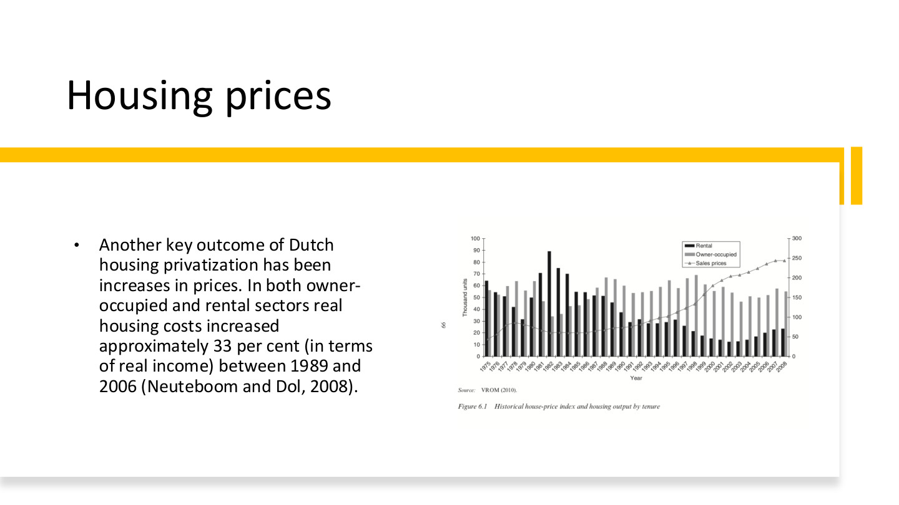
原PPT第37页 / Original slide 37 · 重点 / Focus

PPT中英翻译 / PPT translation
PPT English / 英文原文与图示 | 中文翻译 / Chinese translation
Another key outcome of Dutch housing privatization has been increases in prices. In both owner-occupied and rental sectors real housing costs increased approximately 33 per cent (in terms of real income) between 1989 and 2006 (Neuteboom and Dol, 2008). | 课件把价格上升列为荷兰住房私有化的重要结果，并称1989—2006年自住和租赁部门实际住房成本约增加33%（原文以实际收入表述；Neuteboom与Dol，2008）。
Figure 6.1. Historical house-price index and housing output by tenure. Rental; Owner-occupied; Sales prices. | 图6.1：历史房价指数与按占有形式划分的住房产出。图例：租赁、业主自住、出售价格。
Left axis: Thousand units. Right axis: price-index scale. Horizontal axis: Year, 1975–2008. Source: VROM (2010). | 左轴：千套；右轴：价格指数刻度；横轴：1975—2008年。来源：VROM，2010。

本页核心 / Key takeaway
自有住房扩张不自动等于成本下降；课件同时报告租赁与自住的实际住房成本上升。
Expansion of ownership does not automatically reduce costs; the lecture reports rising real costs in both rented and owner-occupied sectors.

精要解析 / Essential explanation

1. 33%是什么变化 / What increased by 33%?
实际住房成本上升约33%，不是负担率增加33个百分点，也不能直接改写成所有住宅售价上涨33%。成本、房价、收入比例是不同量。
A 33% rise in real housing costs is not a 33-percentage-point increase in a burden ratio, nor a claim about every sale price. Costs, prices and income shares are different quantities.

2. 双轴图怎样读 / Reading the two axes
柱子表示不同住房产出、单位为千套，线条表示销售价格指数。两类量不能直接按同一纵轴比较；建设量变化与价格变化需分别读。
Bars measure housing output in thousands; the line is a sale-price index. They must not be read against one shared vertical scale; interpret quantities and prices separately.

3. 怎样评价私有化 / Evaluating privatisation
把政策方向与成本结果联系起来，同时保留供给、信贷和收入等可能影响。图表的共同变化并不单独证明私有化是唯一原因，也不能只依据房主人数评价福利改善。
Connect policy direction with costs while considering supply, credit and income. Co-movement alone does not establish privatisation as the sole cause, and owner counts alone do not establish welfare gains.

38｜荷兰住房结构：1981—2010 / Dutch tenure structure, 1981–2010
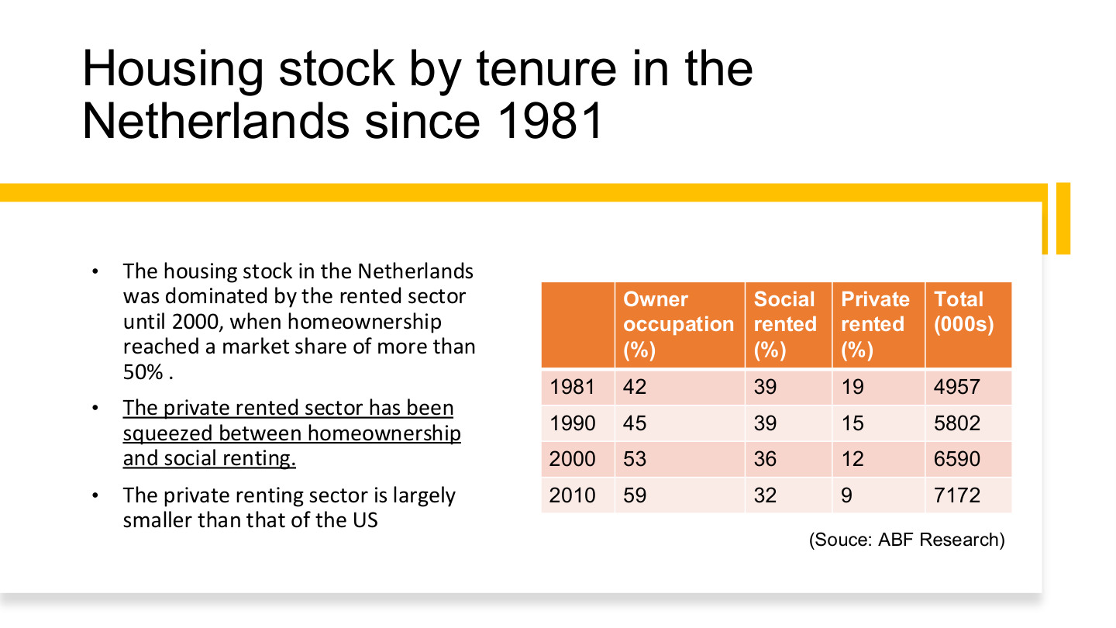
原PPT第38页 / Original slide 38 · 重点 / Focus

PPT中英翻译 / PPT translation
PPT English / 英文原文与图示 | 中文翻译 / Chinese translation
The housing stock in the Netherlands was dominated by the rented sector until 2000, when homeownership reached a market share of more than 50%. | 荷兰住房存量原以租赁为主，到2000年前后自有住房份额超过50%。
The private rented sector has been squeezed between homeownership and social renting. The private renting sector is largely smaller than that of the US. | 私人租赁部门在自有住房与社会租赁之间受到挤压，其相对规模明显小于美国。
Owner occupation (%); Social rented (%); Private rented (%); Total (000s). Source: ABF Research. | 表列自住、社会租赁和私人租赁的百分比，总存量以千套计。来源：ABF Research。

原表完整转写 / Full transcription
年份 / Year | 自住 / Owner % | 社会租赁 / Social % | 私人租赁 / Private % | 总存量：千套 / Total: 000s
1981 | 42 | 39 | 19 | 4,957
1990 | 45 | 39 | 15 | 5,802
2000 | 53 | 36 | 12 | 6,590
2010 | 59 | 32 | 9 | 7,172

本页核心 / Key takeaway
记住自住42%→59%，社会租赁39%→32%，私人租赁19%→9%的结构变化，年份为1981—2010。
From 1981 to 2010, ownership rises from 42% to 59%, social renting falls from 39% to 32%, and private renting from 19% to 9%.

精要解析 / Essential explanation

1. 不是整个租赁部门都消失 / Renting remains important
私人租赁下降不等于社会租赁同步消失；2010年后者仍占32%。要把私人租赁与社会租赁分开，才能解释荷兰与美国的差别。
Declining private renting does not mean social renting disappears; the latter still accounts for 32% in 2010. Separate private from social renting when explaining differences from the US.

2. 比例与数量分开 / Shares versus quantities
总存量从4,957千套增至7,172千套。份额下降不必等于绝对套数下降，因为分母也增长；表内少数年份合计99%或101%，按原表保留四舍五入。
Total stock rises from 4,957 to 7,172 thousand. A falling share need not mean fewer dwellings, because the denominator grows. Preserve the original 99% or 101% totals caused by rounding.

3. 放回整课理解 / Place the evidence in the lesson
荷兰的购房支持和自有率增长，与社会租赁传统同时存在。比较福利体制时，应解释两种机制怎样重新组合，而不是因为自有超过一半就宣布整个国家成为自由主义体制。
Ownership promotion and growth coexist with a social-rental tradition. Explain the changing combination rather than reclassifying the entire welfare regime merely because ownership exceeds half of stock.

39｜荷兰长期结构图 / Long-run Dutch tenure chart
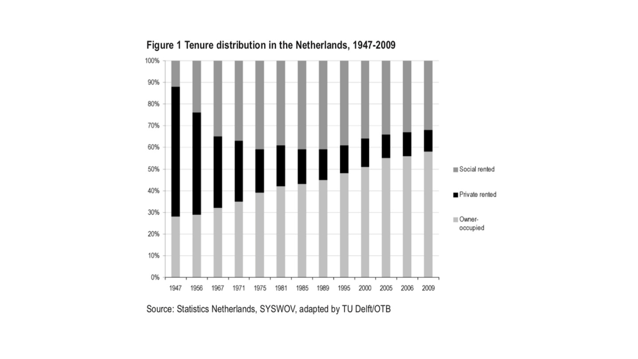
原PPT第39页 / Original slide 39 · 简读 / Brief

PPT中英翻译 / PPT translation
PPT English / 英文原文与图示 | 中文翻译 / Chinese translation
Figure 1. Tenure distribution in the Netherlands, 1947–2009. | 图1：1947—2009年荷兰住房占有形式分布。
Social rented; Private rented; Owner-occupied. Vertical axis: 0–100%. Years: 1947, 1956, 1967, 1971, 1975, 1981, 1985, 1989, 1995, 2000, 2005, 2006, 2009. | 图例：社会租赁、私人租赁、业主自住。纵轴0%—100%；横轴为1947—2009所列年份。
Source: Statistics Netherlands, SYSWOV, adapted by TU Delft/OTB. | 来源：荷兰统计局、SYSWOV，由代尔夫特理工大学／OTB改编。

本页核心 / Key takeaway
本页是第38页的长期图示补充：自住扩张、私人租赁收缩，社会租赁经历先扩张后回落。
This extends slide 38 historically: ownership expands, private renting contracts, and social renting first grows then declines.

精要解析 / Essential explanation

1. 精华即可 / Keep the essential reading
按三种色块看结构变化，不需逐根柱子估算精确比例。它补充历史过程；核心数值已在第38页表格中整理，避免重复背两套数据。
Read the three segments as structural change without inventing exact bar values. This adds historical context; the key figures are already organised on slide 38, so avoid memorising a second dataset.

40｜结束页 / Questions?

原PPT第40页 / Original slide 40 · 简读 / Brief

PPT中英翻译 / PPT translation
PPT English / 英文原文与图示 | 中文翻译 / Chinese translation
Questions? June Wang; June.wang@cityu.edu.hk | 有什么问题吗？June Wang；联系邮箱：June.wang@cityu.edu.hk。

本页核心 / Key takeaway
结束页，无新增理论。
Closing slide; no new theory.

