Q1 · 1 电力曳引式升降机 / Electric traction lift
驱动电动机带动曳引轮，通过与悬吊绳的摩擦，使轿厢和对重反向移动。下图采用典型的 1:1 无齿轮曳引布置。
The Drive motor rotates the Drive sheave. Friction with the Suspension rope moves the Car and Counterweight in opposite directions. The schematic shows a typical 1:1 gearless traction arrangement.
主要部件 / Major components | 运行功能 / Operational functions
驱动电动机  Drive motor | 提供转动曳引轮的动力。  Supplies power to rotate the Drive sheave.
曳引轮  Drive sheave | 通过与悬吊绳的摩擦传递驱动力。  Transfers driving force by friction with the Suspension rope.
悬吊绳  Suspension rope | 悬吊轿厢和对重，使两者反向移动。  Suspends the Car and Counterweight, which move in opposite directions.
轿厢  Car | 承载乘客或货物。  Carries passengers or goods.
对重  Counterweight | 平衡轿厢及部分载荷，减小电动机需克服的不平衡负载。  Balances the Car and part of its load, reducing the unbalanced load on the Drive motor.
轿厢导轨；对重导轨  Car guide rail; Counterweight guide rail | 分别引导轿厢和对重垂直运行，限制横向移动。  Guide the Car and Counterweight respectively and restrain lateral movement.
制动器  Brake | 采用弹簧施闸、电力释放；使驱动系统停止并保持静止。  Is spring-applied and electrically released; stops and holds the drive system.
控制器  Controller | 接收召梯指令，协调驱动、制动、停车、平层和开关门。  Receives calls and coordinates drive, braking, stopping, levelling and door operation.
门机；轿门；层门  Door operator; Car doors; Landing doors | 门机驱动轿门，并在层站联动层门；门关闭轿厢及层站入口。层门联锁确保其关闭锁紧后才可正常运行。  The Door operator drives the Car doors and couples to the Landing doors at a landing. The doors guard both entrances; landing-door interlocks require closure and locking before normal travel.
限速器；限速器张紧轮  Overspeed governor; Governor tension sheave | 限速器检测速度，超速时触发安全停止，必要时使安全钳动作；限速器张紧轮维持限速器绳路张紧。  The Overspeed governor detects overspeed, initiates stopping and applies the Safety gear if necessary. The Governor tension sheave keeps its rope loop tensioned.
安全钳  Safety gear | 发生向下超速或悬吊失效时，夹紧轿厢导轨，使轿厢停止并保持静止。  Grips the Car guide rail to stop and hold the Car during downward overspeed or suspension failure.
限位开关  Limit switches | 在行程端部触发停止保护，防止超越允许行程。  Initiate stopping protection at the ends of permitted travel.
轿厢缓冲器；对重缓冲器  Car buffer; Counterweight buffer | 分别在轿厢或对重发生底部越程时吸收冲击能量。  Absorb impact energy during bottom overtravel of the Car or Counterweight respectively.

运行简述 / Brief operation
层门关闭锁紧并满足安全条件后，控制器协调制动器释放与驱动电动机运行。轿厢到站减速、平层并停止，制动器保持静止后开门；发生超速时，限速器触发安全停止，必要时使安全钳动作。
With the Landing doors closed and locked and safety conditions satisfied, the Controller coordinates Brake release and Drive motor operation. The Car slows, levels and stops; the Brake holds it before the doors open. Overspeed triggers the Overspeed governor and, when necessary, the Safety gear.
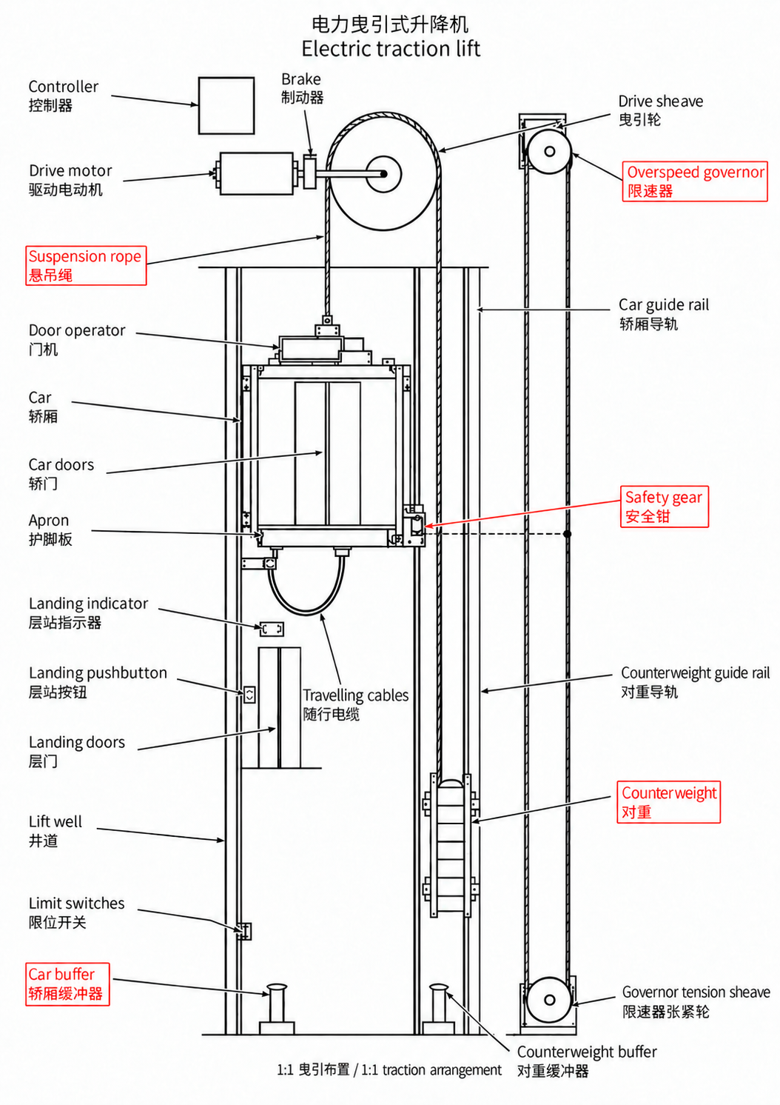

2 直顶式液压升降机 / Direct-driven cylinder hydraulic lift
油泵将液压油经阀组送入埋地油缸，推动柱塞伸出并直接顶升轿厢。下图为埋地油缸布置，柱塞与轿厢之间没有悬吊绳传动。
The Pump supplies oil through the Valve block to the Cylinder in borehole, extending the Piston to raise the Car directly. The schematic shows an in-ground cylinder arrangement with direct support of the Car.
主要部件 / Major components | 运行功能 / Operational functions
油箱  Tank | 储存液压油，向油泵供油，并接收下降时的回油。  Stores hydraulic oil, supplies the Pump and receives returning oil during descent.
油泵  Pump | 由电动机驱动，将油箱中的油送入埋地油缸，产生顶升所需油流。  Is electrically driven and delivers oil from the Tank to the Cylinder in borehole to raise the Car.
阀组  Valve block | 控制进油、保压及回油，实现上升、停止和受控下降。  Controls oil admission, holding and return for ascent, stopping and controlled descent.
埋地油缸  Cylinder in borehole | 容纳受压液压油；向地下延伸，为柱塞回缩提供所需空间。  Contains pressurised oil and extends below ground to accommodate Piston retraction.
柱塞  Piston | 受油压作用伸出，直接顶升轿厢；回油时受轿厢重量作用而回缩。  Extends under oil pressure to raise the Car directly; retracts under Car weight as oil returns.
轿厢  Car | 承载乘客或货物，由柱塞直接承托。  Carries passengers or goods and is directly supported by the Piston.
轿厢导轨  Car guide rails | 引导轿厢垂直运行，限制横向移动。  Guide the Car vertically and restrain lateral movement.
控制器  Controller | 接收召梯指令，协调油泵、阀组、停车、平层和开关门。  Receives calls and coordinates the Pump, Valve block, stopping, levelling and door operation.
门机；轿门；层门  Door operator; Car doors; Landing doors | 门机驱动轿门，并在层站联动层门；门关闭轿厢及层站入口。层门联锁确保其关闭锁紧后才可正常运行。  The Door operator drives the Car doors and couples to the Landing doors at a landing. The doors guard both entrances; landing-door interlocks require closure and locking before normal travel.

运行简述 / Brief operation
上升：控制器启动油泵，油进入埋地油缸，使柱塞伸出。停止：油泵停止供油，阀组封住油液，使轿厢保持位置。下降：阀组允许油受控流回油箱，轿厢重量使柱塞回缩；平层后关闭回油通路，再开门。
Ascent: the Controller starts the Pump and oil extends the Piston. Holding: the Pump stops supplying oil and the Valve block retains oil to hold the Car. Descent: the Valve block meters oil back to the Tank and Car weight retracts the Piston. At the landing, return flow closes before the doors open.


