3. Economic Efficiency — Theoretical Analysis
  - Member C | UK 2024 National Insurance Reductions

3.1 Tax incentives and work decisions
Labour taxation reduces the reward workers retain from employment. The UK employee main National Insurance contributions (NICs) rate fell from 12% to 10% on 6 January 2024 and to 8% on 6 April (HMRC, 2024a). Holding income tax at 20%, each additional pound within the main NICs band leaves 68p, 70p and 72p respectively (Figure C1). Thus the combined cuts increase marginal take-home pay by approximately 5.9%, while the March announcement alone increases it by 2.9%. These are calculated changes in financial incentives, not estimated increases in hours worked.
The distinction between average and marginal taxation matters. An employee already earning above the £50,270 upper earnings limit receives relief on the lower band, but the NICs rate on additional earnings remains 2% (HMRC, 2024c). That income gain therefore need not improve the marginal reward from working longer. The policy changes only part of the wider tax–benefit schedule.
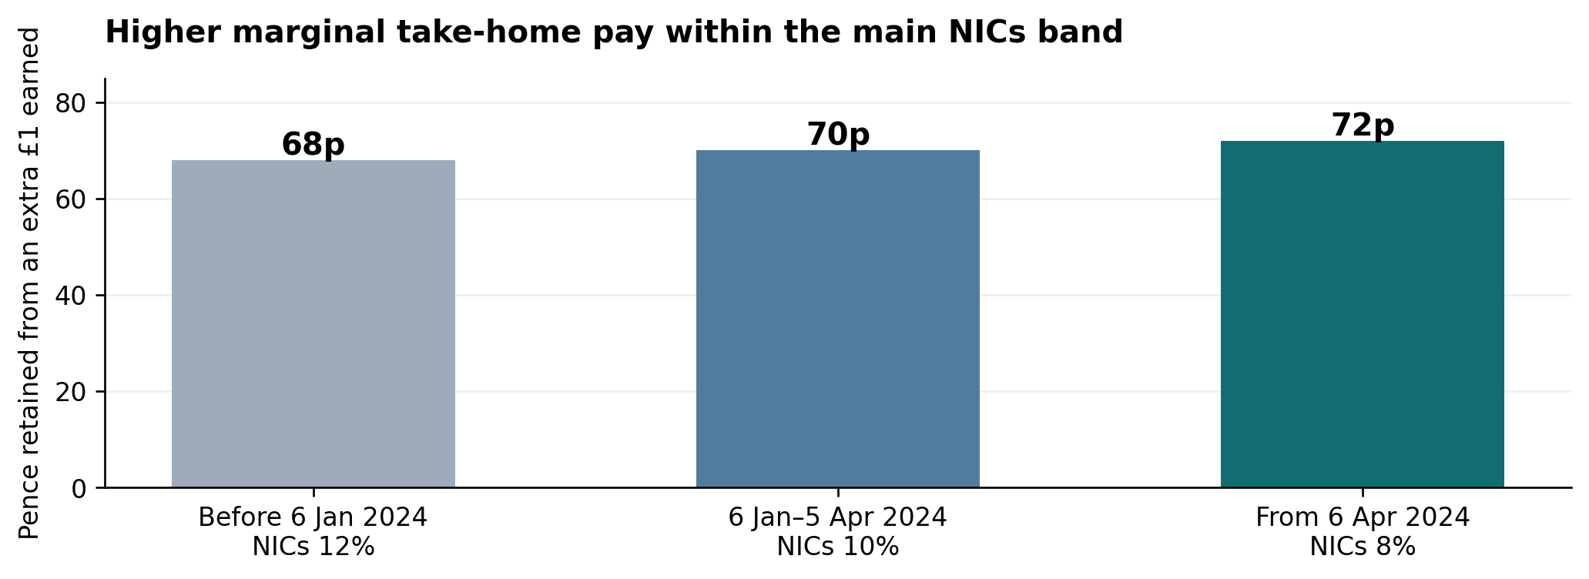
Figure C1. Marginal take-home pay under the employee NICs main rates.
Source: Author’s calculations from HMRC (2024a–c): 100p × (1 − 20% income tax − NICs rate). Assumes a standard working-age employee in England, Wales or Northern Ireland, fixed gross wages and additional earnings entirely within the main NICs band. Excludes benefit withdrawal, student loans and other deductions. This is a statutory calculation, not a measured behavioural effect or the full employer–employee tax wedge.

3.2 Substitution, income and participation effects
In the labour–leisure model, a higher net wage makes leisure relatively more expensive, generating a substitution effect towards work. If leisure is a normal good, greater disposable income also generates an income effect towards leisure. Figure C2 separates these opposing movements: E0 to Ec is the compensated substitution effect; Ec to E1 is the income effect. Their relative strengths determine the net hours response (Meghir and Phillips, 2010). The illustrated net increase in work is one possible outcome, not a general prediction.
Labour supply also has two margins: participation in employment (extensive) and hours conditional on employment (intensive). The OBR models these separately using group-specific elasticities and acknowledges uncertainty about their contemporary relevance. Its framework also assumes that labour demand accommodates additional supply over time (OBR, 2024a, paragraphs 4–15). Caring commitments, benefit withdrawal and fixed working hours can therefore prevent improved financial incentives from translating into an immediate, uniform employment response.
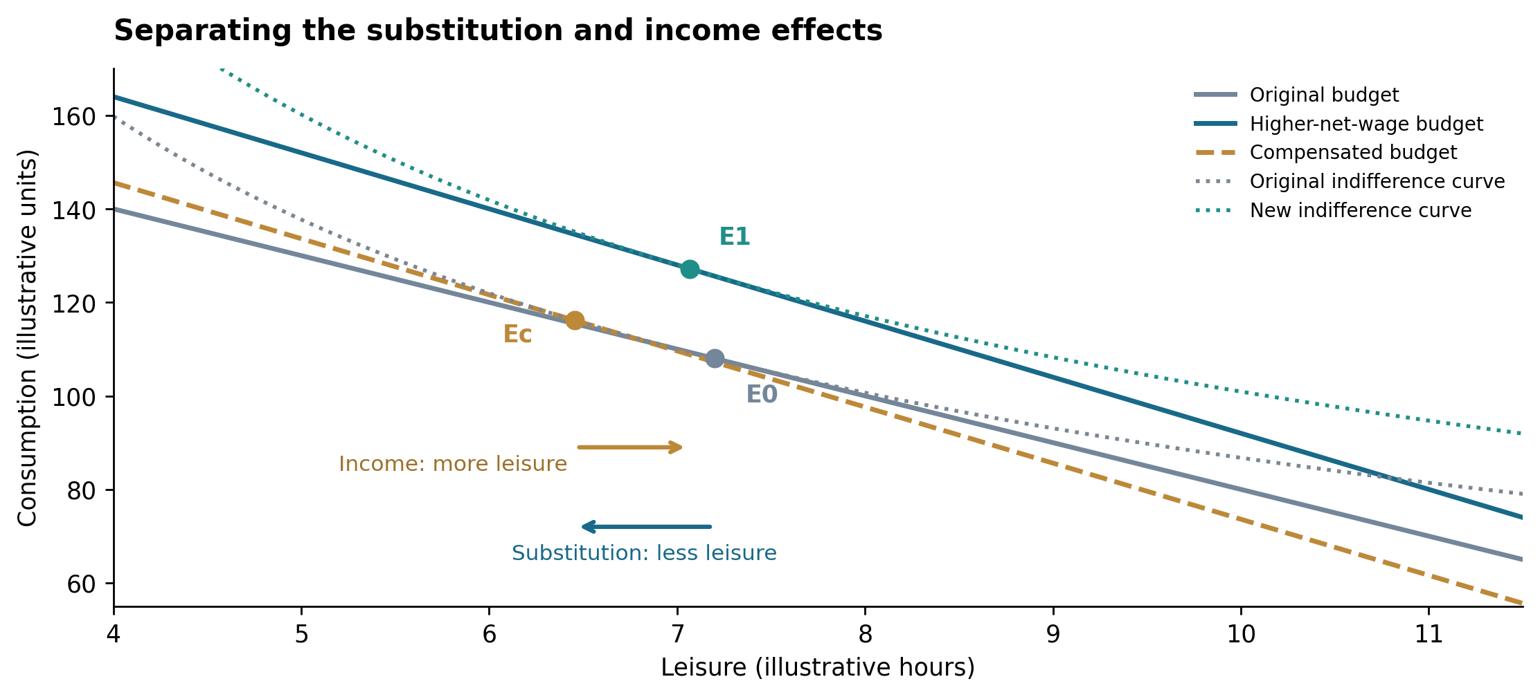
Figure C2. A consistent Hicksian decomposition of a higher net wage.
Source: Author’s theoretical illustration based on Meghir and Phillips (2010). Illustration uses U = C^0.6 L^0.4, a 16-hour time endowment, non-labour income of 20 units, and net wages of 10 and 12 units. The compensated budget is tangent to the original indifference curve at Ec. All values and choices are hypothetical. This smooth-budget example is not the kinked UK NICs schedule or an estimate of actual preferences.

3.3 Laffer curve and the fiscal limit
The Laffer curve concerns a different question: whether behavioural responses recover lost revenue. With R = tB(t), a lower tax rate raises receipts only if expansion of the taxable base more than offsets the mechanical loss. Figure C3 depicts this possibility without locating the UK on either side of the revenue maximum. A theoretical curve cannot establish that the 2024 NICs reductions were self-financing (Hemming and Kay, 1980).
The contemporary forecast provides a useful check. The OBR projected an additional 98,000 full-time equivalents of labour supply from the March measures and estimated that dynamic behavioural effects would offset approximately 20% of their static fiscal cost (OBR, 2024b, paragraphs 3.9–3.10). FTEs measure aggregate hours, not necessarily new jobs; both figures were forecasts, not observed outcomes. Partial cost recovery supports distinguishing plausible efficiency gains from fiscal affordability. Overall, the reform had a credible incentive rationale, but neither universally longer hours nor full revenue recovery follows from theory.
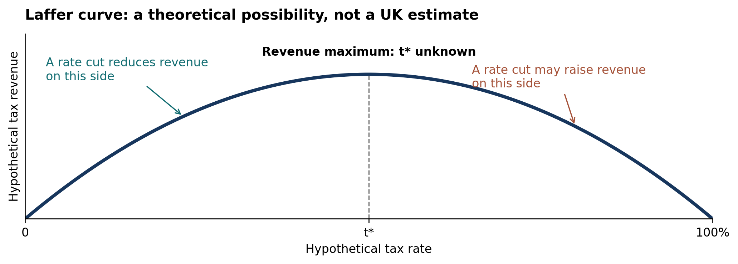
Figure C3. The Laffer curve: a possibility rather than an estimated UK optimum.
Source: Author’s stylised illustration of R = tB(t), informed by Hemming and Kay (1980). The inverted-U shape and location of t* are assumed for exposition; neither is estimated from UK NICs data. A revenue-maximising rate is also not necessarily a welfare-maximising rate. The case-specific 20% cost-offset estimate is from OBR (2024b), not from this diagram.

References
Author–date references. Original source links and locators are provided for checking; forecasts retain their original policy and time horizon.
HM Revenue & Customs [HMRC] (2024a). Reduction to the main rates of primary Class 1 and Class 4 National Insurance contributions. 7 March.
Open original source
Locators: Background to the measure; Detailed proposal; Exchequer impact. The costings are forecasts, not realised revenue outcomes.
HM Revenue & Customs [HMRC] (2024b). Annex A: rates and allowances. Spring Budget 2024: overview of tax legislation and rates. 6 March.
Open original source
Locators: Income Tax rates; Employee’s (primary) Class 1 contribution rates; NICs rates. Figure C1 uses the historical rates, not current-year rates.
HM Revenue & Customs [HMRC] (2024c). Rates and thresholds for employers 2024 to 2025.
Open original source
Locators: Class 1 National Insurance thresholds (annual upper earnings limit £50,270); employee contribution rates (8% / 2%).
Office for Budget Responsibility [OBR] (2024a). The labour supply effects of the Autumn 2023 National Insurance Contributions cut. 8 February.
Open original source
Locators: paragraphs 4–8 (mechanisms); 9–10 (elasticity uncertainty); 11–15 (model and demand assumption). This methodological note evaluates the November announcement; it is not the March forecast.
Meghir, C. and Phillips, D. (2010). “Labour supply and taxes.” In Dimensions of Tax Design: The Mirrlees Review. Oxford University Press.
Open original source
Locator: labour-supply mechanisms, income and substitution effects and the interpretation of empirical responses.
Hemming, R. and Kay, J. A. (1980). “The Laffer curve.” Fiscal Studies, 1(2), pp. 83–90. DOI: 10.1111/j.1475-5890.1980.tb00554.x.
Open original source
Used for the conceptual revenue argument, not an estimate of UK NICs in 2024.
Office for Budget Responsibility [OBR] (2024b). Economic and fiscal outlook – March 2024. CP 1027. 6 March.
Open original source
Locators: paragraphs 3.7–3.10, especially 3.9 (98,000 FTE) and 3.10 (approximately 20% static-cost offset); Box 3.2. Contemporary forecasts only.

