3. Economic Efficiency — Theoretical Analysis
  - Member C | UK 2024 National Insurance Reductions

3.1 Tax incentives and work decisions
Marginal income tax and payroll taxes jointly determine the reward from additional earnings; a NICs reduction should therefore be evaluated through their combined marginal burden. The UK employee main NICs rate fell from 12% to 10% on 6 January 2024 and to 8% on 6 April (HMRC, 2024). With income tax held at 20%, an extra pound within the main NICs band leaves 68p, 70p and 72p respectively (Figure C1). The combined cuts increase marginal take-home pay by approximately 5.9%; the March cut alone increases it by 2.9%. These are incentive calculations, not employment estimates.
Above the £50,270 upper earnings limit, the employee NICs rate remained 2% (OBR, 2024). A worker already above that limit gains relief on the lower band without a lower NICs rate on additional earnings. Lower average taxation therefore need not mean stronger marginal incentives.
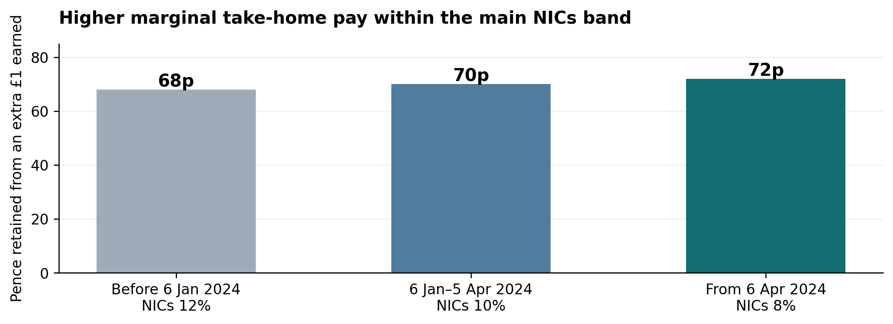
Figure C1. Marginal take-home pay under the employee NICs main rates.
Source: Author’s calculations from HMRC (2024), applying the distinction between marginal income tax and payroll taxes: 100p × (1 − 20% income tax − NICs rate). Assumes a standard working-age employee in England, Wales or Northern Ireland, fixed gross wages and additional earnings entirely within the main NICs band. Excludes benefit withdrawal, student loans and other deductions. This is a statutory calculation, not a measured behavioural effect or the full employer–employee tax wedge.

3.2 Substitution, income and participation effects
Indifference curves and budget constraints explain how workers allocate time between employment and leisure. A higher net wage raises the opportunity cost of leisure, creating a substitution effect towards work. If leisure is normal, higher disposable income creates an opposing income effect. Figure C2 separates the compensated movement E0→Ec from the income movement Ec→E1. Its net increase in work is illustrative; theory alone does not determine the overall hours response (Meghir and Phillips, 2010).
Participation (the extensive margin) must also be distinguished from hours conditional on employment (the intensive margin). Labour-supply elasticity is central to assessing the efficiency effects of taxation. Labour-supply models use group-specific behavioural assumptions whose uncertainty affects estimated responses (Meghir and Phillips, 2010). Fixed hours, caring commitments and benefit withdrawal may constrain responses. The expected efficiency gain consequently depends on who can adjust behaviour, rather than on an assumption that all recipients work longer.
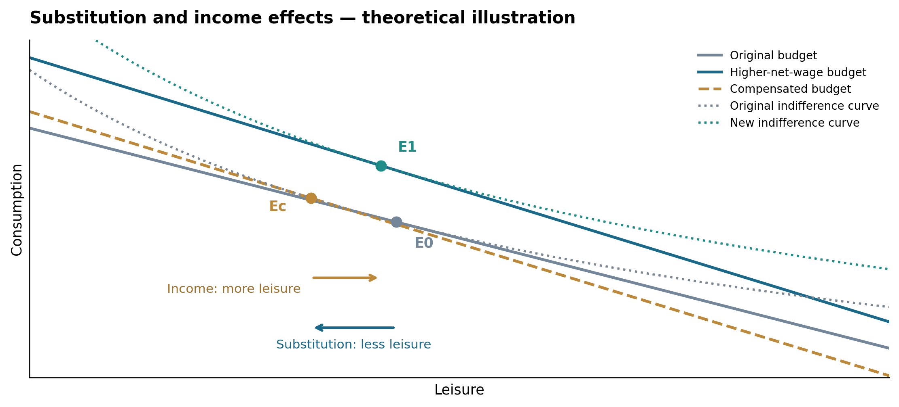
Figure C2. Substitution and income effects: theoretical illustration, not UK empirical data.
Source: Author’s illustration based on Meghir and Phillips (2010). E0→Ec shows the substitution effect; Ec→E1 shows the income effect.

3.3 Laffer curve and the fiscal limit
Revenue maximisation and optimal taxation are distinct objectives. With R = tB(t), reducing tax rates can expand the taxable base by strengthening work incentives. Figure C3 illustrates how this behavioural response influences revenue, while the optimal tax rate also reflects wider welfare objectives (Hemming and Kay, 1980). The OBR projected that the March NICs reductions would increase labour supply by 98,000 full-time equivalents and recover approximately 20% of their static fiscal cost through dynamic behavioural effects (OBR, 2024). These projections support the policy’s incentive rationale and indicate that additional economic activity can partly offset the initial revenue loss.
The overall efficiency assessment balances these incentive gains against the opportunity cost of forgone revenue. Sustainable financing helps preserve resources for public services and investment, allowing improvements in work incentives to contribute to wider social welfare. The NICs reductions therefore offer a credible approach to reducing distortions in labour taxation, with their overall benefits depending on the strength of behavioural responses and the government’s financing choices.
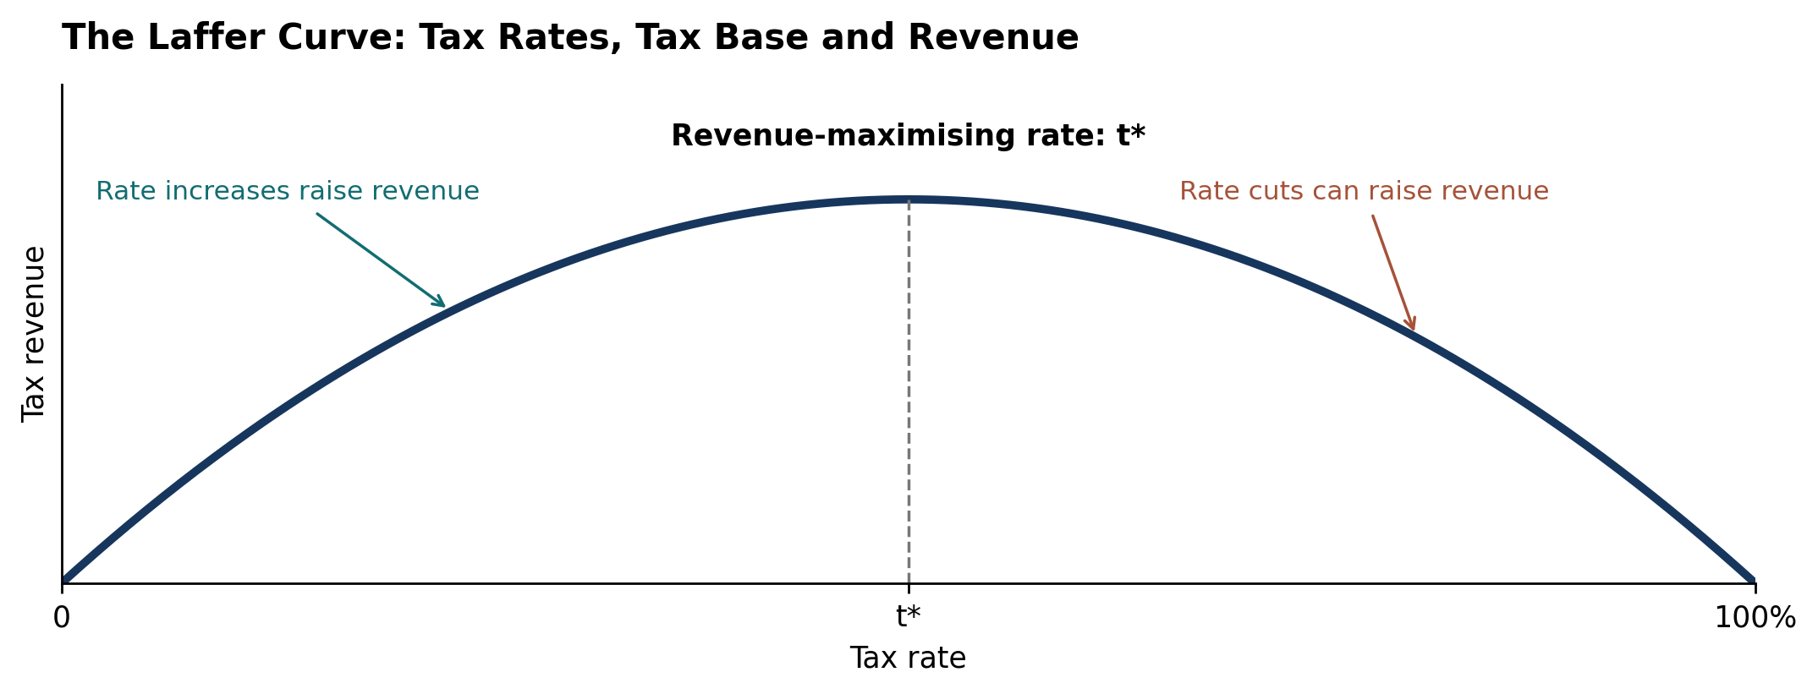
Figure C3. The Laffer curve: tax rates, the taxable base and revenue.
Source: Author’s theoretical illustration based on Hemming and Kay (1980). The curve shows how tax rates and behavioural changes in the taxable base jointly determine revenue; t* marks the revenue-maximising rate.

References
Hemming, R. and Kay, J.A. (1980) ‘The Laffer curve’, Fiscal Studies, 1(2), pp. 83–90. Available at: https://doi.org/10.1111/j.1475-5890.1980.tb00554.x (Accessed: 26 October 2026).
HM Revenue & Customs (2024) Reduction to the main rates of primary Class 1 and Class 4 National Insurance contributions. 7 March. Available at: https://www.gov.uk/government/publications/changes-to-national-insurance-contributions-from-6-april-2024/reduction-to-the-main-rates-of-primary-class-1-and-class-4-national-insurance-contributions (Accessed: 26 October 2026).
Meghir, C. and Phillips, D. (2010) ‘Labour supply and taxes’, in Mirrlees, J. et al. (eds.) Dimensions of Tax Design: The Mirrlees Review. Oxford: Oxford University Press, pp. 202–274. Available at: https://ifs.org.uk/books/labour-supply-and-taxes-0 (Accessed: 26 October 2026).
Office for Budget Responsibility (2024) Economic and fiscal outlook – March 2024. CP 1027. 6 March. Available at: https://obr.uk/efo/economic-and-fiscal-outlook-march-2024/ (Accessed: 26 October 2026).

