Q1

1 电力曳引式升降机 / Electric traction lift
典型电力曳引式升降机由驱动电动机带动曳引轮，通过曳引轮与悬吊绳之间的摩擦传递驱动力，使轿厢与对重反向移动。对重平衡轿厢及部分载荷重量，因此驱动电动机主要克服不平衡负载和摩擦。以下以有齿轮式布置说明。
A typical electric traction lift uses a drive motor to turn a drive sheave. Friction between the drive sheave and suspension rope moves the car and counterweight in opposite directions. The counterweight balances the car and part of its load, so the drive motor mainly overcomes the unbalanced load and friction. The arrangement described here is geared.
主要部件 / Major component | 功能 | Operational function
驱动电动机  Drive motor | 提供升降机运行的动力。 | Supplies power to operate the lift.
齿轮箱  Gear box | 降低驱动电动机转速，并把转矩传递至曳引轮。 | Reduces drive motor speed and transmits torque to the drive sheave.
曳引轮  Drive sheave | 通过与悬吊绳之间的摩擦传递驱动力。 | Transmits driving force through friction with the suspension rope.
悬吊绳  Suspension rope | 连接并悬吊轿厢和对重，使两者反向移动。 | Connects and suspends the car and counterweight so that they move in opposite directions.
轿厢  Car | 承载乘客或货物。 | Carries passengers or goods.
对重  Counterweight | 平衡轿厢及部分载荷重量，减少驱动电动机需要克服的不平衡负载。 | Balances the car and part of its load, reducing the unbalanced load that the drive motor must overcome.
轿厢导轨  Car guide rail | 引导轿厢沿垂直路径运行，并供安全钳作用。 | Guides the car vertically and provides the surface on which the safety gear acts.
对重导轨  Counterweight guide rail | 引导对重沿垂直路径运行。 | Guides the counterweight vertically.
制动器  Brake | 停止并保持驱动系统。采用弹簧施闸、电力释放的安排。 | Stops and holds the drive system. It is spring-applied and electrically released.
控制器  Controller | 协调运行方向、速度、减速、平层、停车及开关门。 | Coordinates direction, speed, deceleration, levelling, stopping and door operation.
门机  Door operator | 驱动轿门开启和关闭。 | Opens and closes the car doors.

1.1 主要部件及功能（续） / Major components (continued)
主要部件 / Major component | 功能 | Operational function
轿门  Car doors | 关闭轿厢入口，保障运行期间的乘客安全。 | Close the car entrance to protect passengers during travel.
层门  Landing doors | 关闭各楼层通向井道的入口。 | Close the well entrance at each landing.
层门联锁  Landing door interlock | 层门未正确关闭并锁紧时，阻止升降机正常运行。 | Prevents normal travel unless the landing doors are properly closed and locked.
层门接近传感器  Landing door proximity sensor | 关门期间检测到乘客进入时，使门重新打开。 | Causes closing doors to reopen when a person enters.
限速器  Overspeed governor | 达到预定超速值时触发安全停止，并在需要时使安全钳动作。 | Initiates safety stopping at a predetermined overspeed and applies the safety gear when necessary.
安全钳  Safety gear | 向下超速或悬吊失效等情况下，作用于轿厢导轨，停止并保持轿厢。 | Acts on the car guide rail to stop and hold the car during downward overspeed or suspension failure.
限速器张紧轮  Governor tension sheave | 使限速器的绳路保持张紧。 | Maintains tension in the overspeed governor rope loop.
限位开关  Limit switches | 在行程端部提供停止保护，防止超过允许行程。 | Provide stopping protection at the ends of travel to prevent overtravel.
轿厢缓冲器  Car buffer | 在轿厢底部越程时吸收冲击能量。 | Absorbs impact energy during bottom overtravel of the car.
对重缓冲器  Counterweight buffer | 在对重底部越程时吸收冲击能量。 | Absorbs impact energy during bottom overtravel of the counterweight.
随行电缆  Travelling cables | 在固定设备与移动轿厢之间传送电源及控制信号。 | Carry power and control signals between fixed equipment and the moving car.

1.2 运作过程 / Operation
层门关闭并锁紧后，控制器协调制动器释放和驱动电动机运行。驱动电动机经齿轮箱带动曳引轮，悬吊绳使轿厢与对重反向移动。接近目标楼层时减速和平层，停车后由制动器保持静止，再开门。限速器和安全钳共同提供超速及悬吊失效情况下的安全保护。
Once the landing doors are closed and locked, the controller coordinates brake release and drive motor operation. The drive motor turns the drive sheave through the gear box, and the suspension rope moves the car and counterweight in opposite directions. The car slows and levels at the destination, the brake holds it stationary, and the doors open. The overspeed governor and safety gear provide protection during overspeed or suspension failure.

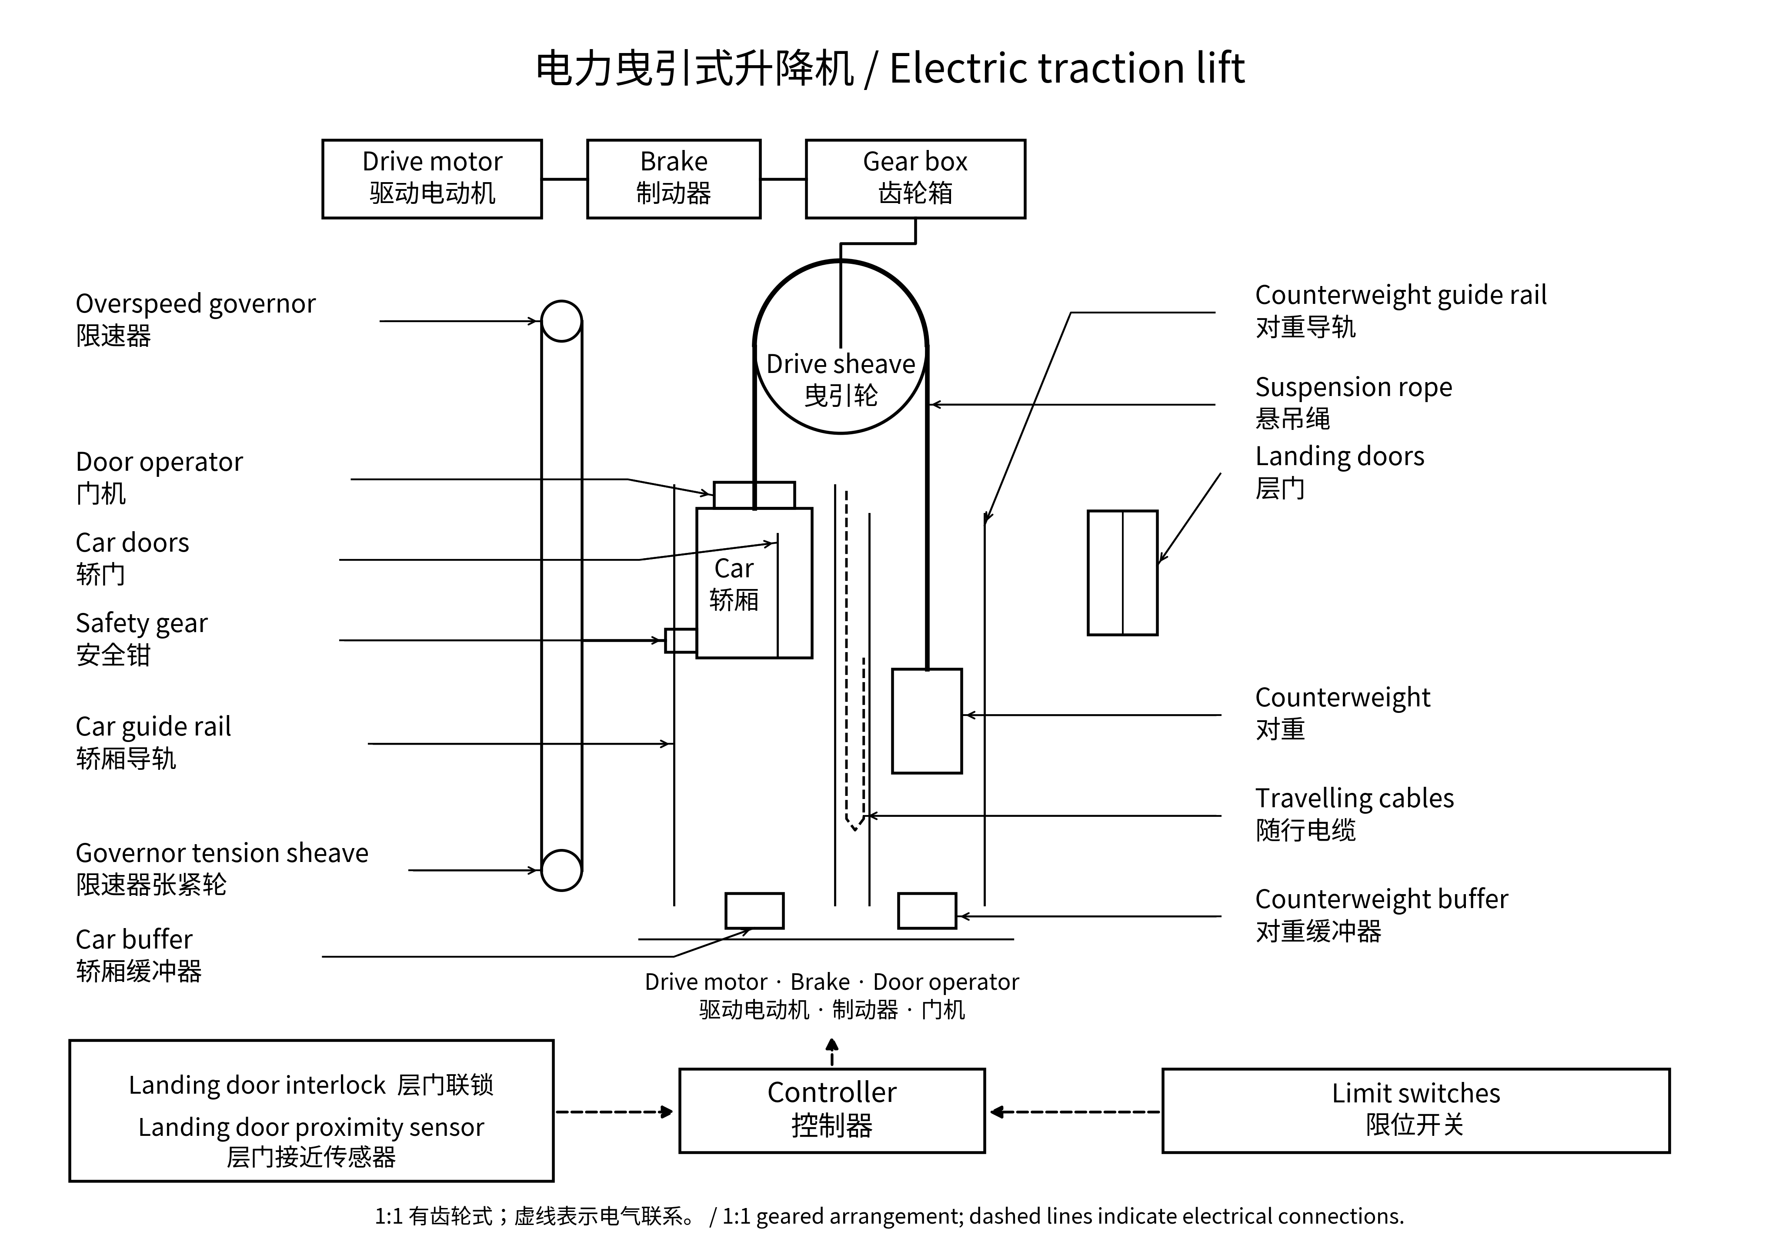

2 直顶式液压升降机 / Direct-driven cylinder hydraulic lift
直顶式液压升降机利用电动机驱动油泵，把液压油由油箱送入油缸。油压使柱塞伸出，直接顶升轿厢。下降时，阀组让油受控流回油箱，轿厢重量使柱塞缩回。此结构的柱塞直接承托轿厢。
A direct-driven cylinder hydraulic lift uses a motor-driven pump to deliver oil from the tank into the cylinder. Oil pressure extends the plunger, directly raising the car. During descent, the valve block permits controlled oil return to the tank, and the weight of the car retracts the plunger. The plunger directly supports the car in this arrangement.
主要部件 / Major component | 功能 | Operational function
轿厢  Car | 承载乘客或货物，并由柱塞直接承托。 | Carries passengers or goods and is directly supported by the plunger.
柱塞  Plunger | 在油压作用下伸出，直接顶升轿厢；回缩时轿厢下降。 | Extends under oil pressure to raise the car directly; its retraction allows descent.
油缸  Cylinder | 容纳受压液压油，与柱塞共同形成顶升机构。 | Contains pressurised oil and forms the lifting actuator with the plunger.
油箱  Tank | 储存液压油，向油泵供油并接收下降回油。 | Stores oil, supplies the pump and receives returning oil during descent.
油位计  Oil level gauge | 显示油箱中的油位。 | Indicates the oil level in the tank.
电动机  Motor | 通过机械轴驱动油泵。 | Drives the pump through a mechanical shaft.
油泵  Pump | 将油箱内的油送往油缸，提供顶升所需油流。 | Delivers oil from the tank towards the cylinder to raise the car.
阀组  Valve block | 控制进油、保压及受控回油，从而实现上升、停止和下降。 | Controls oil admission, holding and controlled return for ascent, stopping and descent.
闸阀  Gate valve | 隔离油缸油路，供检修使用；正常运行时保持开启。 | Isolates the cylinder oil line for maintenance and remains open during normal operation.
控制器  Controller | 协调电动机、阀组、停车、平层和开关门。 | Coordinates the motor, valve block, stopping, levelling and door operation.
轿厢导轨  Car guide rail | 引导轿厢沿垂直路径运行。 | Guides the car vertically.

2.1 主要部件及功能（续） / Major components (continued)
主要部件 / Major component | 功能 | Operational function
导靴  Guide shoe | 配合轿厢导轨引导轿厢，并限制横向移动。 | Runs along the car guide rail to guide the car and restrain lateral movement.
门机  Door operator | 驱动轿门开启和关闭。 | Opens and closes the car doors.
轿门  Car doors | 关闭轿厢入口。 | Close the car entrance.
层门  Landing doors | 关闭各楼层通向井道的入口。 | Close the well entrance at each landing.
层门联锁  Landing door interlock | 层门未正确关闭并锁紧时，阻止正常运行。 | Prevents normal travel unless the landing doors are properly closed and locked.
层门接近传感器  Landing door proximity sensor | 关门期间检测到乘客进入时，使门重新打开。 | Causes closing doors to reopen when a person enters.
楼层停止及限位开关  Floor stop and limit switch | 控制楼层停车并限制轿厢行程。 | Controls landing stops and limits car travel.
低速平层开关凸轮  Creepage and leveling switch cam | 触发相关开关，使系统进行低速平层。 | Actuates the associated switches for low-speed levelling.
弹簧缓冲器  Buffer spring | 在轿厢底部越程时吸收冲击能量。 | Absorbs impact energy during bottom overtravel of the car.
随行电缆  Travelling cables | 在固定设备与移动轿厢之间传送电源及控制信号。 | Carry power and control signals between fixed equipment and the moving car.

2.2 运作过程 / Operation
上升时，电动机驱动油泵，液压油经阀组和闸阀进入油缸，使柱塞伸出并直接顶升轿厢。停止时，阀组保持油缸内的油液。下降时，阀组控制油液回流油箱的速度，使柱塞及轿厢受控下降。正常运行时闸阀保持开启。
During ascent, the motor drives the pump, and oil enters the cylinder through the valve block and gate valve, extending the plunger and directly raising the car. During holding, the valve block retains oil in the cylinder. During descent, it controls the rate of return to the tank so that the plunger and car descend in a controlled manner. The gate valve remains open during normal operation.

