【1】电力曳引式升降机
Electric traction lift
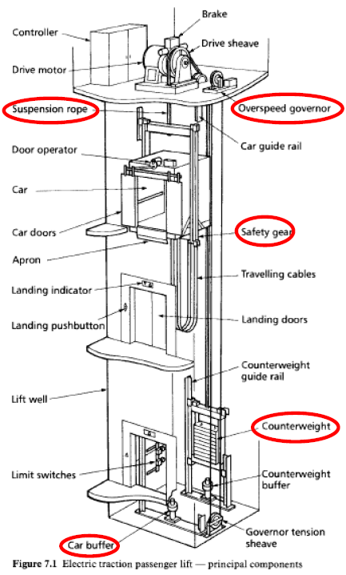
图 1 电力曳引式升降机 / Figure 1 Electric traction lift

电力曳引式：组成部分及功能
Electric traction lift: components and functions
整体运行逻辑：收到召梯信号且门关闭锁紧后，电动机启动、制动器释放，曳引轮经悬吊绳带动轿厢与对重反向运动。接近目标楼层时减速、平层、停车并施闸，保持轿厢静止，再开启轿门及层门。
Overall operation: With doors closed and locked, the motor starts and the brake releases. The drive sheave and ropes move the car and counterweight in opposite directions. Near the destination, the car slows, levels and stops; the brake holds it before the car and landing doors open.
组成部分 / Component | 功能 / Function
Controller  控制器 | 接收召梯指令，协调电动机、制动器及门机，控制运行和停车；平层控制提高停靠楼层的准确度。  Receives calls and coordinates the motor, brake and doors for travel and stopping; levelling control improves stopping accuracy at landings.
Drive motor  驱动电动机 | 提供机械动力转动曳引轮，驱动轿厢升降。  Provides mechanical power to rotate the drive sheave and move the car up or down.
Brake  制动器 | 使轿厢停止并保持静止；弹簧施闸、电力释放，断电自动施闸。因须制动轿厢与对重的总运动质量，制动力须大于相应的无对重系统。  Stops and holds the car; spring-applied and electrically released, so power loss applies it. Braking both car and counterweight requires greater braking capacity than an equivalent hoist without a counterweight.
Drive sheave  曳引轮 | 通过轮槽与悬吊绳的摩擦传递驱动力，使轿厢与对重反向运动。  Transmits driving force through friction between its grooves and the suspension ropes, moving car and counterweight in opposite directions.
Suspension rope  悬吊绳 | 承受并悬吊轿厢与对重，通过曳引轮传递的摩擦力使两者反向运动。  Supports and suspends the car and counterweight; traction from the drive sheave moves them in opposite directions.
Overspeed governor  限速器 | 监测轿厢速度；达到预定超速值时触发停止，并在需要时使安全钳或辅助制动器动作。  Monitors car speed and initiates stopping at a predetermined overspeed; it applies the safety gear or auxiliary brake when necessary.
Door operator  门机 | 驱动轿门，并在停层时联动层门；配合接近传感器，关门时检测到有人进入即重新开门。  Drives car doors and couples to landing doors at stops; a proximity sensor triggers reopening if someone enters during closing.
Car  轿厢 | 承载乘客或货物。  Carries passengers or goods.
Car doors  轿门 | 封闭轿厢入口，保护乘客免于接触井道；运行时保持关闭并防止意外开启。  Close the car entrance to protect passengers from the well; remain closed during travel and are protected against accidental opening.
Apron  护脚板 | 从轿厢门槛下方向下延伸，遮护未平层时露出的间隙，降低人员跌入井道的风险。  Extends below the car sill to guard the gap exposed when the car is not level, reducing the risk of falling into the well.
Landing indicator  层站指示器 | 向候梯乘客显示轿厢所在楼层、运行方向等信息。  Shows waiting passengers the car position, direction or other operating information.
Landing pushbutton  层站按钮 | 向控制器发出所在层站的召梯指令。  Registers a call from the landing with the controller.

电力曳引式：组成部分及功能（续）
Electric traction lift: components and functions (continued)
组成部分 / Component | 功能 / Function
Lift well  井道 | 为轿厢、对重及相关设备提供围护的运行空间，边界为底坑底部、井道壁和井道顶。  Encloses the travel space for the car, counterweight and associated equipment, bounded by the pit bottom, well walls and well roof.
Car guide rail  轿厢导轨 | 引导轿厢垂直运动，限制横向摆动，并为安全钳提供制动面。  Guides the car vertically, restrains lateral movement and provides a braking surface for the safety gear.
Safety gear  安全钳 | 轿厢向下超速或悬吊失效时，机械夹持导轨，使轿厢停止并保持静止。  Mechanically grips the guide rails to stop and hold the car during downward overspeed or suspension failure.
Travelling cables  随行电缆 | 随轿厢移动，连接固定设备与轿厢，传送电力、控制及通信信号。  Move with the car and carry power, control and communication signals between fixed equipment and the car.
Landing doors  层门 | 遮护层站井道口，防止人员跌落或门意外开启；全部层门关闭并锁紧后，联锁才允许正常运行。  Guard well openings against falls and accidental opening; interlocks allow normal travel only with all landing doors closed and locked.
Counterweight guide rail  对重导轨 | 引导对重垂直运动，限制其横向摆动。  Guides the counterweight vertically and restrains lateral movement.
Counterweight  对重 | 平衡轿厢及部分载荷，降低驱动功率并允许采用较小电动机；电动机主要克服不平衡负载和摩擦。  Balances the car and part of its load, reducing drive power and allowing a smaller motor; the motor mainly overcomes load imbalance and friction.
Limit switches  限位开关 | 在行程端部触发停止保护，切断驱动电源，防止超越允许行程或冲入井道顶部。  Initiate stopping and disconnect drive power at travel limits, preventing overtravel, including movement into the overhead.
Car buffer  轿厢缓冲器 | 设于底坑，在轿厢向下越程时吸收能量、缓和冲击；油压式以液体阻尼制动，亦可采用弹簧式。  Absorbs energy and cushions the car during downward overtravel into the pit; oil buffers use fluid braking, while spring buffers are an alternative.
Counterweight buffer  对重缓冲器 | 设于底坑，在对重向下越程时吸收能量、缓和冲击；可采用弹簧式或油压式。  Absorbs energy and cushions the counterweight during downward overtravel into the pit; spring or hydraulic buffers may be used.
Governor tension sheave  限速器张紧轮 | 保持限速器绳环张紧，使其随轿厢运动，确保限速器可靠测速并触发安全钳。  Keeps the governor rope loop taut so it follows car movement, enabling reliable speed detection and tripping of the safety gear.

【2】直顶式液压升降机
Direct-driven cylinder hydraulic lift
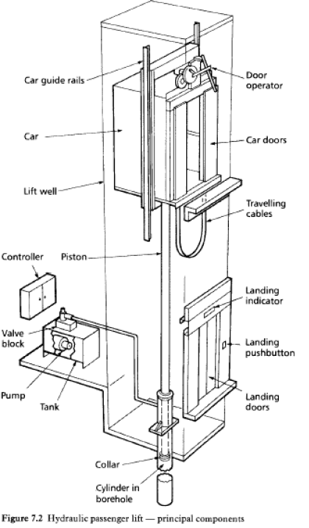
图 2 直顶式液压升降机 / Figure 2 Direct-ram hydraulic lift

直顶式液压：组成部分及功能
Direct-ram hydraulic lift: components and functions
整体运行逻辑：门关闭锁紧后，上升时油泵将油送入油缸，柱塞伸出直接顶升轿厢；下降时油泵通常不运行，阀组调节回油量，使轿厢靠重力下降。到站平层后停止油流、保持轿厢静止，再开启轿门及层门。
Overall operation: With doors closed and locked, the pump supplies oil to the cylinder, extending the piston to raise the car directly. During descent, the pump is normally off; the valve meters oil back to the tank as gravity lowers the car. After levelling, oil flow stops to hold the car before the doors open.
组成部分 / Component | 功能 / Function
Car guide rails  轿厢导轨 | 引导轿厢垂直运动，限制横向摆动。  Guide the car vertically and restrain lateral movement.
Car  轿厢 | 承载乘客或货物，由柱塞直接承托和顶升。  Carries passengers or goods and is supported and raised directly by the piston.
Lift well  井道 | 为轿厢及相关设备提供围护的运行空间，边界为底坑底部、井道壁和井道顶。  Encloses the travel space for the car and associated equipment, bounded by the pit bottom, well walls and well roof.
Controller  控制器 | 接收召梯指令，协调油泵、阀组及门机，控制运行和停车；平层控制提高停靠准确度。  Receives calls and coordinates the pump, valves and doors for travel and stopping; levelling control improves stopping accuracy.
Piston  柱塞 | 受油压推动而伸出，直接顶升轿厢；受控回油时，在轿厢重量作用下回缩下降。  Extends under oil pressure to raise the car directly; retracts under the car weight during controlled oil return for descent.
Valve block  阀组 | 控制油流：上升时进油，停止时封闭油路保持轿厢，下降时调节回油量以控制速度。  Controls oil flow: admits oil for ascent, closes the flow path to hold the car, and meters returning oil to control descent speed.
Pump  油泵 | 由电动机高速驱动，将油箱中的液压油送入油缸，供给顶升轿厢所需的流量和压力。  Driven at high speed by an electric motor, delivers hydraulic oil from the tank to the cylinder to provide the flow and pressure for lifting.
Tank  油箱 | 储存液压油，向油泵供油，并接收轿厢下降时的回油。  Stores hydraulic oil, supplies the pump and receives returning oil during descent.

直顶式液压：组成部分及功能（续）
Direct-ram hydraulic lift: components and functions (continued)
组成部分 / Component | 功能 / Function
Door operator  门机 | 驱动轿门，并在停层时联动层门；配合接近传感器，关门时检测到有人进入即重新开门。  Drives car doors and couples to landing doors at stops; a proximity sensor triggers reopening if someone enters during closing.
Car doors  轿门 | 封闭轿厢入口，保护乘客免于接触井道；运行时保持关闭并防止意外开启。  Close the car entrance to protect passengers from the well; remain closed during travel and are protected against accidental opening.
Travelling cables  随行电缆 | 随轿厢移动，连接固定设备与轿厢，传送电力、控制及通信信号。  Move with the car and carry power, control and communication signals between fixed equipment and the car.
Landing indicator  层站指示器 | 向候梯乘客显示轿厢所在楼层、运行方向等信息。  Shows waiting passengers the car position, direction or other operating information.
Landing pushbutton  层站按钮 | 向控制器发出所在层站的召梯指令。  Registers a call from the landing with the controller.
Landing doors  层门 | 遮护层站井道口，防止人员跌落或门意外开启；全部层门关闭并锁紧后，联锁才允许正常运行。  Guard well openings against falls and accidental opening; interlocks allow normal travel only with all landing doors closed and locked.
Collar  柱塞限位圈 | 设于柱塞下端，限制最大伸出行程，防止柱塞从油缸脱出。  A retaining collar at the piston lower end limits maximum extension and prevents the piston from leaving the cylinder.
Cylinder in borehole  埋地油缸 | 容纳受压油液和柱塞，形成直接顶升机构；向地下延伸，以容纳与轿厢提升高度相应的柱塞行程。  Contains pressurised oil and the piston for direct lifting; extends underground to accommodate piston travel corresponding to the car rise.

