Economic Efficiency: Tax Incentives, Labour Supply and the Laffer Curve
  - Member C’s section · UK 2024 National Insurance reductions

Work incentives and their limits
Reducing National Insurance contributions (NICs) can improve economic efficiency by increasing the reward to employment. The extensive margin concerns whether to work; the intensive margin concerns hours supplied by existing workers. A higher net wage encourages substitution from leisure towards work, but higher disposable income can also finance more leisure. The net hours response therefore requires empirical evidence, rather than following automatically from a tax cut (Adam et al., 2011; OBR, 2024, paragraphs 4–8).
The UK policy illustrates this mechanism. The employee main rate fell from 12% to 10% on 6 January 2024 and to 8% on 6 April (HMRC, 2024a). Holding the basic income tax rate at 20%, an additional pound within the main NICs band leaves 68p, 70p and 72p respectively (Figure C1). The combined cuts raise marginal take-home pay by approximately 5.9%, calculated as (72−68)/68; the March announcement alone raises it by approximately 2.9%, or (72−70)/70. These percentages measure financial incentives, not predicted increases in labour supply.
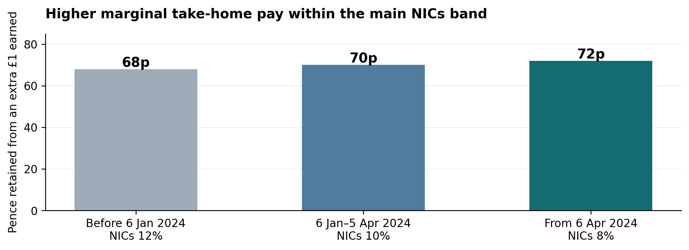
Figure C1. Marginal take-home pay under the three employee NICs main rates.
Source: Author’s calculation, 100p × (1 − 20% income tax − NICs rate), using HMRC (2024a, 2024b). Assumptions: standard-rate working-age employee; earnings remain within the main NICs band; England, Wales or Northern Ireland; no benefit withdrawal, student-loan repayment or other deductions; gross wage fixed. This is a statutory calculation, not observed behaviour or the full employer–employee tax wedge.
The response also depends on where earnings lie. Above the £50,270 annual upper earnings limit, the employee NICs rate remained 2% (HMRC, 2024c). A worker already above that limit gains relief on the lower band but receives no reduction in the NICs rate on the next pound earned. For that worker, an income gain need not produce a positive substitution effect. Moreover, benefit withdrawal, childcare costs and fixed working hours can limit how much a financial incentive changes behaviour.

Behavioural evidence and the revenue constraint
This distinction is supported by the OBR’s modelling methodology. Its February 2024 note separates participation from hours responses, uses group-specific elasticities, and acknowledges uncertainty about whether older estimates represent the contemporary labour market. It also assumes additional labour supply is accommodated by labour demand over time (OBR, 2024, paragraphs 8–15). Consequently, a lower tax rate provides a credible mechanism for greater labour supply, but neither an immediate employment increase nor a uniform response across workers is guaranteed.
The Laffer curve adds a separate revenue question. Revenue can be written as R = tB(t), where t is the tax rate and B(t) the responsive taxable base. A rate reduction increases receipts only if the resulting base expansion more than offsets the mechanical revenue loss. Figure C2 depicts that theoretical possibility; it does not identify the UK’s position or estimate a revenue-maximising rate. A positive labour-supply response alone cannot establish self-financing.
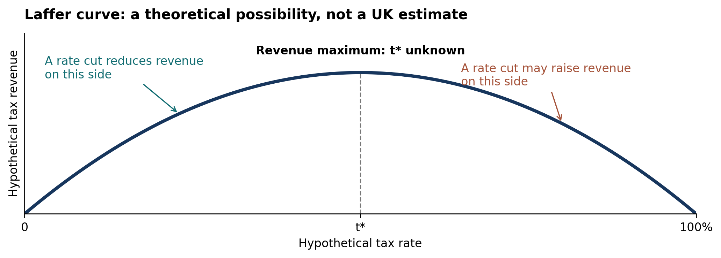
Figure C2. A stylised Laffer curve: why incentive effects do not establish self-financing.
Source: Author’s theoretical illustration of R = tB(t). Curve shape and horizontal placement of t* are arbitrary; no UK observations, tax-rate calibration or estimated optimum are plotted. The diagram illustrates the revenue condition discussed in the text and is not empirical evidence. Actual policy-cost evidence is from HMRC (2024a).
Indeed, the published March costings show negative Exchequer effects throughout 2024–25 to 2028–29 (HMRC, 2024a, “Exchequer impact”). The defensible conclusion is that the NICs reductions plausibly improved work incentives, while the magnitude of behavioural gains and the remaining fiscal cost require separate assessment. Member D’s evidence section can evaluate those forecasts without treating theoretical mechanisms as realised outcomes.

References
Author–date references. Sources checked 26 October 2026. Figures are embedded in the article; captions identify calculation assumptions and evidence limits.
Adam, S., Besley, T., Blundell, R., Bond, S., Chote, R., Gammie, M., Johnson, P., Mirrlees, J., Myles, G. and Poterba, J. M. (2011). “The taxation of labour earnings.” Tax by Design, chapter 3. Institute for Fiscal Studies / Oxford University Press.
Open original source
Locator: opening framework; participation and hours decisions; income and substitution effects.
HM Revenue & Customs [HMRC] (2024a). Reduction to the main rates of primary Class 1 and Class 4 National Insurance contributions. 7 March.
Open original source
Locators: Background to the measure; Detailed proposal; Exchequer impact. The costings are forecasts, not realised revenue outcomes.
HM Revenue & Customs [HMRC] (2024b). Annex A: rates and allowances. Spring Budget 2024: overview of tax legislation and rates. 6 March.
Open original source
Locators: Income Tax rates; Employee’s (primary) Class 1 contribution rates; NICs rates. Figure C1 uses the historical rates, not current-year rates.
HM Revenue & Customs [HMRC] (2024c). Rates and thresholds for employers 2024 to 2025.
Open original source
Locators: Class 1 National Insurance thresholds (annual upper earnings limit £50,270); employee contribution rates (8% / 2%).
Office for Budget Responsibility [OBR] (2024). The labour supply effects of the Autumn 2023 National Insurance Contributions cut. 8 February.
Open original source
Locators: paragraphs 4–8 (mechanisms); 9–10 (elasticity uncertainty); 11–15 (model and demand assumption). This methodological note evaluates the November announcement; it is not the March forecast.

Evidence distinction
Figure C1 is reproducible arithmetic based on official statutory parameters. The OBR paper provides the documented behavioural framework and its limitations. Figure C2 is a theoretical schematic. HMRC’s policy costings provide the case-specific evidence against assuming that the reductions eliminate their own fiscal cost. No estimated labour-supply outcomes are fabricated.

