Q1 升降机系统
Lift Systems
  - 中英双语答案与课件定位
Bilingual answer with lecture references

题目 / Question
描述典型电力曳引式升降机及直顶式液压升降机的主要部件，附示意图，并简要解释各部件的运作功能。
Describe the major components of a typical electric traction lift and a direct-driven cylinder hydraulic lift with schematic diagrams, and briefly explain the operational functions of the components.
出处 / Source: 0 PIA5704 Course Outline 2026_27.pdf, PDF p. 2, Question 1.

资料与页码说明 / Source and page conventions
主要依据：Lecture1+Vertical+Transportation+System+I_2026.pdf，以下简称 L1。页码均为 PDF 阅读器页码，封面计第 1 页。
Main source: Lecture1+Vertical+Transportation+System+I_2026.pdf, abbreviated as L1. All references use PDF page numbers, counting the cover as page 1.
“图示释义”表示课件只在结构图中标出该部件，其功能说明是依据图示关系整理，并非课件逐字原文。液压阀组的停止及下降逻辑属于此类解释，课件没有给出详细液压回路。
“Diagram-based explanation” means that the component is labelled in a lecture diagram and its function is explained from that arrangement, rather than quoted from the slide. Hydraulic holding and descent are explained on this basis; the lecture does not provide a detailed valve circuit.
本题的直顶式液压升降机对应 L1 第 31–33 页的 direct-ram driven type。第 34 页的 roped type 是另一种结构。
The direct-driven cylinder lift in this question corresponds to the direct-ram driven type on L1 pp. 31–33. The roped type on p. 34 is a different arrangement.

最有用的课件位置 / Key slide locations
部件 / Component | 中文功能 | Operational function | PPT 出处 / Source
曳引式 / Traction | 完整部件图；部件及安全装置；驱动系统。 | Complete component diagrams; component and safety definitions; drive arrangements. | L1 pp. 10, 15–30, 35 左图
液压式 / Hydraulic | 液压类型、直顶原理、完整部件图。 | Hydraulic types, direct-ram principle and complete component diagrams. | L1 pp. 6, 31–33, 35 右图

1 电力曳引式升降机 / Electric traction lift

1.1 基本原理 / Operating principle
电动机驱动曳引轮，通过曳引轮与悬吊钢丝绳之间的摩擦传递动力，使轿厢与对重沿导轨反向移动。对重平衡部分重量，因此电动机主要克服不平衡负载及摩擦。
A motor rotates the traction sheave. Friction between the sheave and suspension ropes moves the car and counterweight in opposite directions along their guide rails. The counterweight balances part of the load, so the motor mainly overcomes the unbalanced load and friction.
出处 / Source: L1 p. 10 “Electric Elevators”; p. 25 “Counterweight system”; pp. 26–30 “Traction System”; p. 35 left diagram.
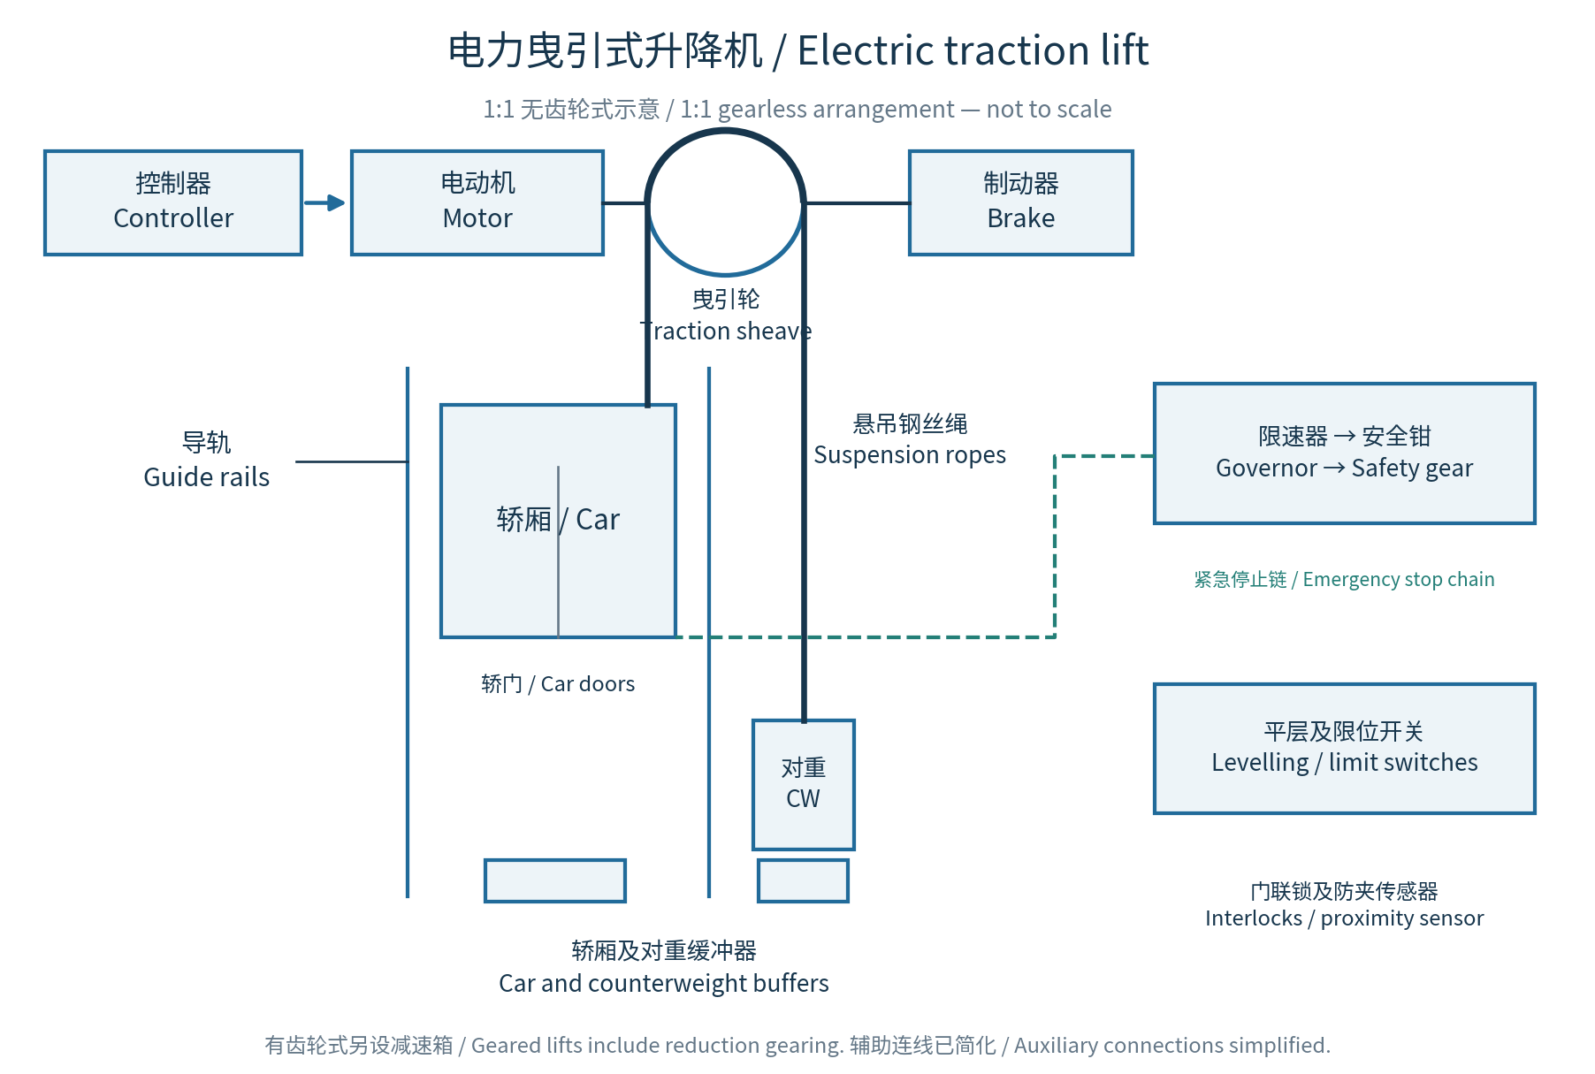
图 1 / Figure 1. 依据 L1 第 10、16–26、35 页重绘的简化结构图；非按比例。
Simplified schematic redrawn from L1 pp. 10, 16–26 and 35; not to scale.

1.2 主要部件及功能 / Major components (1/2)
部件 / Component | 中文功能 | Operational function | PPT 出处 / Source
1 轿厢及轿架  Car and car sling | 轿厢承载乘客或货物；轿架承托轿厢，并与悬吊及导向部件连接。 | The car carries passengers or goods. The car sling supports the car and connects it to the suspension and guiding components. | L1 pp. 10, 35  结构图／图示释义
2 驱动电动机  Drive motor | 提供升降动力。无齿轮式直接驱动曳引轮；有齿轮式通过减速装置驱动。 | The motor supplies driving power. It drives the sheave directly in a gearless lift or through reduction gearing in a geared lift. | L1 p. 10 “Drive”;  pp. 26, 29
3 曳引轮及减速装置  Traction sheave and reduction gearing | 曳引轮通过与钢丝绳的摩擦传递牵引力。有齿轮式的减速装置降低电动机输出转速。 | The sheave transmits driving force to the ropes through friction. In a geared lift, the reduction unit reduces motor speed before driving the sheave. | L1 pp. 26, 29–30  传力过程结合图示
4 悬吊钢丝绳  Suspension / hoisting ropes | 悬吊轿厢和对重，并传递曳引轮的驱动力。 | The ropes suspend the car and counterweight and transmit the driving force from the traction sheave. | L1 p. 15 “Suspension Ropes”; pp. 10, 35 图示
5 对重  Counterweight | 平衡轿厢及部分载荷重量，减少驱动功率，使电动机主要克服不平衡负载和摩擦。 | The counterweight balances the car and part of its load, reducing the power needed to overcome the unbalanced load and friction. | L1 p. 16 “Counterweight”; p. 25 “Counterweight system”
6 导轨及导靴／滚轮  Guide rails and shoes / rollers | 引导轿厢和对重沿规定垂直路径运行，并限制横向移动。 | They guide the car and counterweight along their vertical paths and restrain lateral movement. | L1 p. 16 “Guides”;  pp. 10–11, 35 图示
7 制动器  Brake | 使驱动系统停止并保持静止。课件介绍弹簧施闸、电力释放的结构；有齿轮式通常装在电动机与减速装置之间。 | The brake stops and holds the drive system. It is spring-applied and electrically released. In a geared lift, it normally sits between the motor and reduction unit. | L1 pp. 26, 28–29
出处 / Source: L1: “Electric Elevators”, “Suspension Ropes”, “Components”, “Counterweight system” and “Traction System”.

1.2 主要部件及功能 / Major components (2/2)
部件 / Component | 中文功能 | Operational function | PPT 出处 / Source
8 控制器及传感器  Controller and transducers | 协调运行方向、速度、停车和门的操作；位置及速度传感器提供反馈。 | The controller coordinates direction, speed, stopping and door operation. Position and speed transducers provide feedback. | L1 pp. 10, 35  结构图／图示释义
9 门及门安全装置  Doors and door safety devices | 门机负责开关门。层门联锁确保门未正确关闭并锁紧时不能运行；关门期间若有人进入，接近传感器使门重开。 | The operator opens and closes the doors. Interlocks prevent travel unless landing doors are closed and locked. A proximity sensor reopens closing doors when someone enters. | L1 pp. 17–18 “Landing door interlock”; p. 19; p. 35 图示
10 限速器、绳及张紧轮  Governor, rope and tension sheave | 限速器在达到预定超速值时触发停止，并在需要时使安全钳或辅助制动器动作。绳及张紧轮构成相关机械布置。 | At a predetermined overspeed, the governor initiates stopping and applies the safety gear or auxiliary brake when necessary. Its rope and tension sheave form the associated arrangement. | L1 p. 20 “Overspeed Governor”; p. 35 图示
11 安全钳  Safety gear | 在向下超速或悬吊失效等情况下，作用于导轨，使轿厢停止并保持静止。 | The safety gear acts on the guide rails to stop and hold the car during downward overspeed or suspension failure. | L1 p. 21 “Safety Gear”; p. 24 “Safety Devices”
12 平层及限位装置  Levelling and limit devices | 平层装置提高停靠楼层的准确度；限位或终端停止开关防止轿厢越过允许行程。 | Levelling improves stopping accuracy at landings. Limit or terminal stopping switches prevent travel beyond the permitted limits. | L1 p. 19 “Leveling”; pp. 24, 35
13 缓冲器  Car and counterweight buffers | 在行程底部发生越程冲击时吸收能量。油压缓冲器通过流体阻尼产生制动作用。 | Buffers absorb impact energy at the lower end of travel. Oil buffers provide braking through fluid resistance. | L1 p. 20 “Oil Buffer”; pp. 24, 35

辅助部件 / Auxiliary components
随行电缆连接固定设备与移动轿厢，传送电源及控制信号。补偿绳及补偿轮用于补偿轿厢位置改变时的悬吊绳重量不平衡，并非所有简化配置均需画出。
Travelling cables carry power and control signals between fixed equipment and the moving car. Compensation ropes and sheaves compensate for changes in suspension-rope weight balance as the car changes position; they need not appear in every simplified arrangement.
出处 / Source: L1 pp. 10–11, 35: travelling cables; pp. 10–11: compensation ropes and sheave. Diagram-based explanations / 图示释义。

1.3 运行过程 / Traction operating sequence
收到指令后，控制系统在门已关闭、联锁条件满足时释放制动器，并控制电动机驱动曳引轮。钢丝绳带动轿厢与对重反向移动。接近目标楼层时，系统减速和平层；停车后由制动器保持静止，再开门。
After a travel command, the controller releases the brake and operates the motor once the doors are closed and interlock conditions are satisfied. The sheave moves the ropes, causing opposite travel of the car and counterweight. Near the destination, the system slows and levels the car. The brake holds the stopped car before the doors open.
出处 / Source: Synthesis of L1 pp. 17–19, 25–29 and 35 / 综合课件部件功能整理。

制动器与安全钳的区别 / Brake versus safety gear
制动器作用于驱动系统，用于停止及保持。安全钳则是在向下超速或悬吊失效等异常情况下，作用于导轨的机械安全装置。两者应分开解释。
The brake acts on the drive system to stop and hold it. The safety gear is a mechanical device that acts on the guide rails during conditions such as downward overspeed or suspension failure. Their functions should be explained separately.
出处 / Source: L1 pp. 21, 24, 26 and 29.

有齿轮与无齿轮 / Geared and gearless drives
有齿轮式由高速电动机通过蜗杆及齿轮减速装置驱动曳引轮；无齿轮式由低速电动机直接连接曳引轮。减速箱应注明为有齿轮式所需的部件。
A geared lift uses a high-speed motor with a worm-and-gear reduction unit to drive the sheave. In a gearless lift, a low-speed motor is directly connected to the sheave. A gearbox should therefore be identified as a component of the geared arrangement.
出处 / Source: L1 pp. 26–29; drive illustrations on pp. 14 and 30.

2 直顶式液压升降机 / Direct-ram hydraulic lift

2.1 基本原理 / Operating principle
油泵将液压油送入油缸，油压使柱塞伸出，直接顶升轿厢。课件所示的典型埋地式油缸向地下延伸，以容纳柱塞所需的行程。
The pump delivers oil into a cylinder. Oil pressure extends the plunger, which directly raises the car. In the conventional in-ground arrangement illustrated, the cylinder extends below ground to accommodate the required plunger travel.
出处 / Source: L1 p. 32 “Hydraulic Elevators — Direct-ram driven type”; pp. 33 and 35 right diagram.
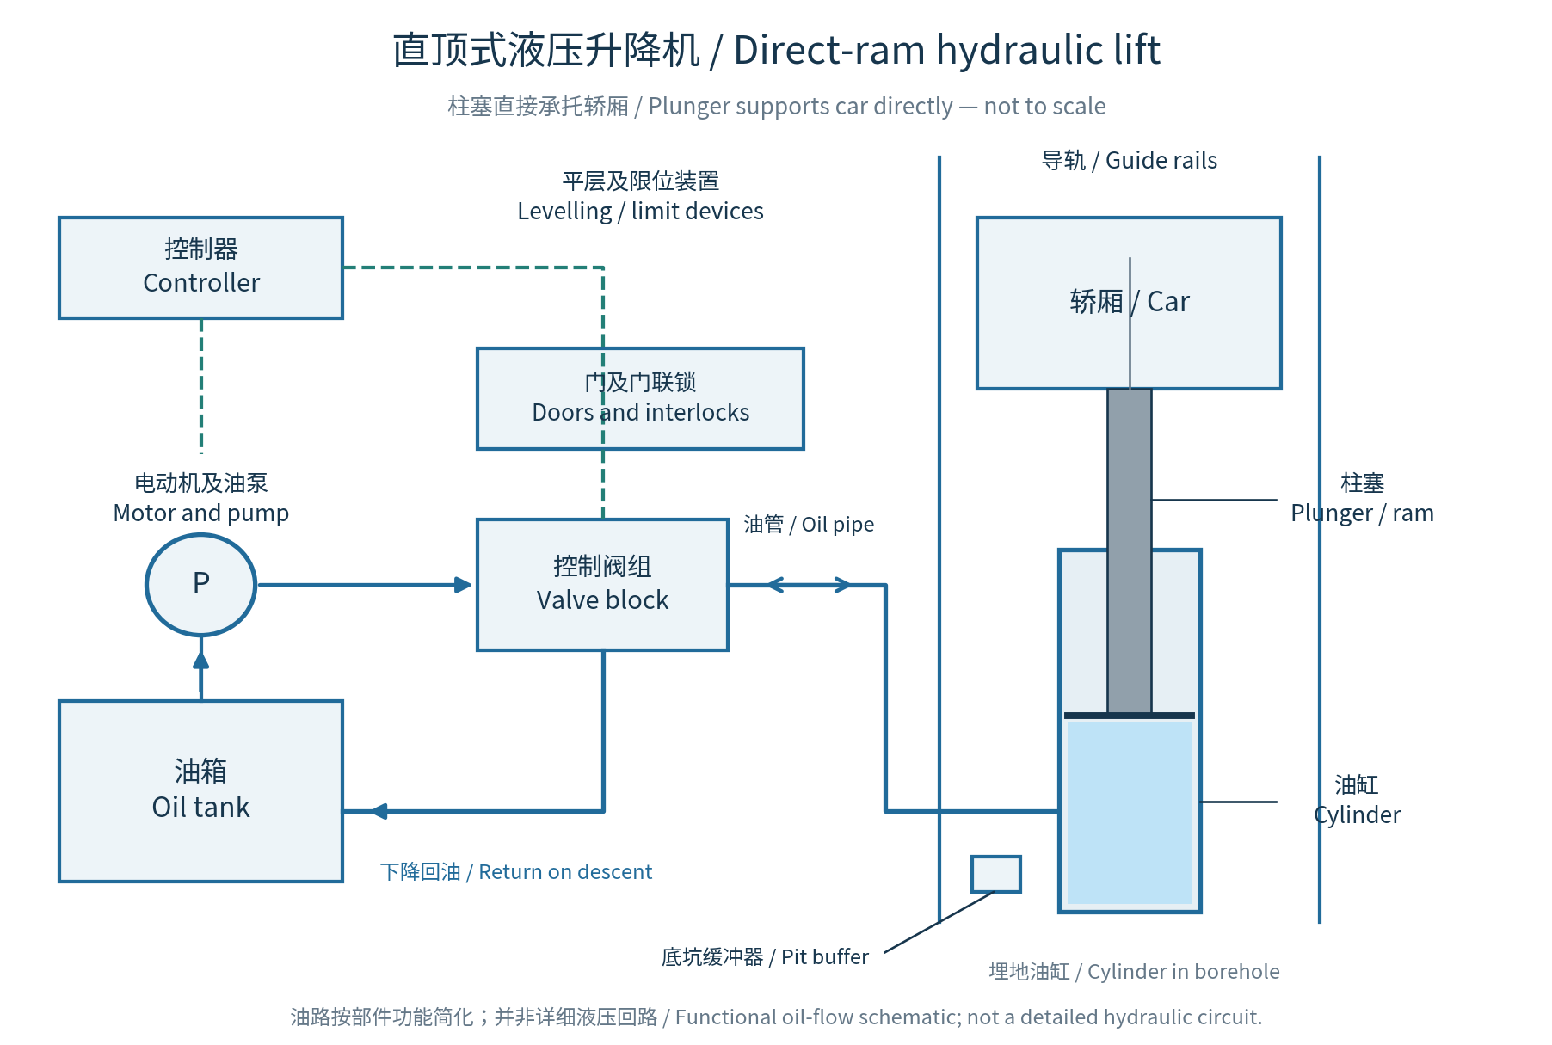
图 2 / Figure 2. 依据 L1 第 6、32–33、35 页重绘。油路按功能简化；非详细阀组回路，非按比例。
Redrawn from L1 pp. 6, 32–33 and 35. Functional oil-flow schematic, not a detailed valve circuit; not to scale.

2.2 主要部件及功能 / Major components (1/2)
部件 / Component | 中文功能 | Operational function | PPT 出处 / Source
1 轿厢及承托结构  Car and support | 承载乘客或货物，底部由柱塞直接承托。 | The car carries passengers or goods and is supported directly by the plunger beneath it. | L1 pp. 32–33;  p. 35 右图
2 柱塞／顶杆  Plunger / ram | 把液压作用转化为垂直机械运动；伸出时顶升轿厢，缩回时轿厢下降。 | The plunger converts hydraulic action into vertical movement. Its extension raises the car, and its retraction allows descent. | L1 p. 32 正文;  p. 33 “Plunger”
3 油缸  Hydraulic cylinder | 容纳受压液压油，与柱塞构成顶升机构。典型埋地式油缸向地下延伸，以容纳所需行程。 | The cylinder contains pressurised oil and forms the actuator with the plunger. In the in-ground arrangement, it extends below ground to accommodate travel. | L1 p. 32; p. 33 “Cylinder”; p. 35 “Cylinder in borehole”
4 液压油  Hydraulic oil | 作为工作介质，把油泵提供的压力传递至柱塞。 | Hydraulic oil is the working fluid that transmits pump pressure to the plunger. | L1 p. 32 正文
5 油箱及油位计  Tank and level gauge | 油箱储油，向油泵供油并接收回油；油位计用于检查油量。 | The tank stores oil, supplies the pump and receives returning oil. The gauge indicates the oil level. | L1 p. 33 “Tank”, “Oil level gauge”; p. 35  图示释义
6 电动机及油泵  Motor and pump | 电动机驱动油泵，向系统输送液压油，提供顶升所需的压力及流量。 | The motor drives the pump, which supplies the oil pressure and flow needed to raise the car. | L1 p. 32 正文;  p. 33 “Motor”, “Pump”; p. 35
出处 / Source: L1 pp. 6, 32–33 and 35. 图示中部件的功能解释参见首页说明 / See the opening note on diagram-based explanations.

2.2 主要部件及功能 / Major components (2/2)
部件 / Component | 中文功能 | Operational function | PPT 出处 / Source
7 控制阀组及油管  Valve block and pipework | 油管连接动力装置和油缸；阀组控制进油、保压及回油，从而控制上升、停止和下降。 | Pipework connects the power unit to the cylinder. The valves control oil admission, holding and return for ascent, stopping and descent. | L1 p. 32 “Valve”; p. 35 “Valve block”及油管  功能属图示释义
8 控制器  Controller | 接收运行指令，协调油泵、阀组、停车及门的操作。 | The controller receives travel commands and coordinates pump, valve, stopping and door operations. | L1 pp. 33, 35  结构图／图示释义
9 导轨、导靴及支架  Rails, shoes and brackets | 引导轿厢垂直移动并限制横向偏移；支架固定导轨。 | Rails and shoes guide the car vertically and restrain lateral movement. Brackets secure the rails. | L1 p. 33 “Rail”, “Guide shoe”, “Rail bracket”; p. 35
10 门、门机及联锁  Doors, operator and interlocks | 控制乘客出入。门未正确关闭并锁紧时，联锁阻止正常运行。 | Doors control passenger access. Interlocks prevent normal travel unless the doors are properly closed and locked. | L1 p. 33 “Car gate”, “Car gate switch”; p. 35; 原理见 pp. 17–18
11 平层及限位装置  Levelling and limit devices | 平层装置使轿厢准确停靠楼层；限位装置防止超出规定行程。 | Levelling devices provide accurate landing alignment. Limit devices prevent travel beyond the permitted range. | L1 p. 33 开关及凸轮标注; 原理见 pp. 19, 24
12 底坑缓冲器  Pit buffers | 在轿厢底部发生越程冲击时吸收能量。 | Pit buffers absorb impact energy if the car overruns at the bottom of travel. | L1 p. 33 “Buffer spring”; p. 6 “Car buffer”; 功能见 pp. 20, 24
控制阀组在第 35 页只以 “Valve block” 标出。上表说明的是整体功能，不把课件未展开的具体阀件型号或详细动作时序当作原文。
The valve block is labelled on p. 35 without an internal circuit. The table explains its overall function; specific internal valve types and detailed sequences are not presented as slide text.

2.3 运行过程 / Hydraulic operating sequence

上升 / Ascent
控制器启动电动机和油泵。油进入油缸，推动柱塞伸出并直接顶升轿厢。
The controller starts the motor and pump. Oil enters the cylinder, extending the plunger and directly raising the car.

停止 / Holding
停止供油，并由阀组保持油缸内的油液，使柱塞和轿厢保持在所需位置。
Oil delivery stops, and the valve arrangement retains oil in the cylinder to hold the plunger and car at the required position.

下降 / Descent
阀组允许油缸内的油受控流回油箱；轿厢重量使柱塞缩回，轿厢随之下降。
The valve arrangement permits controlled oil return to the tank. The weight of the car retracts the plunger, allowing the car to descend.
出处 / Source: L1 p. 32 rising principle; pp. 33 and 35 component connections. Holding and descent are diagram-based functional explanations / 停止及下降为图示功能解释。

直顶结构的关键 / Essential feature of direct drive
应画出柱塞直接承托轿厢。本题采用的典型结构由油缸和柱塞传递顶升力，不需要用曳引轮、悬吊绳和对重来传递该顶升动力。
The diagram should show the plunger supporting the car directly. In the typical arrangement selected here, lifting force is transmitted through the cylinder and plunger, without a traction sheave, suspension ropes or counterweight.
出处 / Source: L1 pp. 31–33 and 35 right diagram; distinguish from the roped hydraulic arrangement on p. 34.

3 课件出处索引 / Lecture reference index
以下索引便于回到原课件核对术语、图示及功能。所有页码均指 PDF 页码。
This index locates the terminology, diagrams and functions in the uploaded lecture. All page numbers refer to PDF pages.
内容 / Topic | 文件或章节 / File or section | 位置 / Location
题目 / Assignment question | 0 PIA5704 Course Outline 2026_27.pdf | p. 2, Question 1
核心课件 / Main lecture | Lecture1+Vertical+Transportation+System+I_2026.pdf | Abbreviation: L1
液压类型 / Hydraulic types | Types of Hydraulic Lifts | L1 p. 6
曳引完整部件图 / Traction component diagram | Electric Elevators | L1 p. 10
曳引绳及部件定义 / Ropes and component definitions | Suspension Ropes; Components; Definitions | L1 pp. 15–23
安全装置及对重 / Safety devices and counterweight | Safety Devices; Counterweight system | L1 pp. 24–25
驱动系统 / Drive systems | Traction System: gearless and geared types | L1 pp. 26–30
直顶液压原理与部件 / Direct-ram principle and components | Hydraulic Elevators: Direct-ram driven type | L1 pp. 31–33
绳索式液压对照 / Roped hydraulic arrangement | Hydraulic Elevators: Roped type | L1 p. 34
两类完整结构图 / Complete diagrams of both types | Comparison of Traction vs Hydraulic Lift | L1 p. 35

参考文献 / References
Leung, G. H. T. (2026). Vertical Transportation Systems (Part 1) [Lecture slides]. PIA5704, City University of Hong Kong. Uploaded file: Lecture1+Vertical+Transportation+System+I_2026.pdf.
City University of Hong Kong. (2026–2027). PIA5704 Building Services Systems and Maintenance for Housing Managers: Course Outline. Uploaded file: 0 PIA5704 Course Outline 2026_27.pdf.
本答案依据用户上传课件整理；图 1、图 2 为根据课件重绘的简化示意图。
This answer is based on the uploaded course materials. Figures 1 and 2 are simplified schematics redrawn from the lecture.

