01｜福利资本主义世界（二）：发展型国家 / World of welfare capitalism (II)
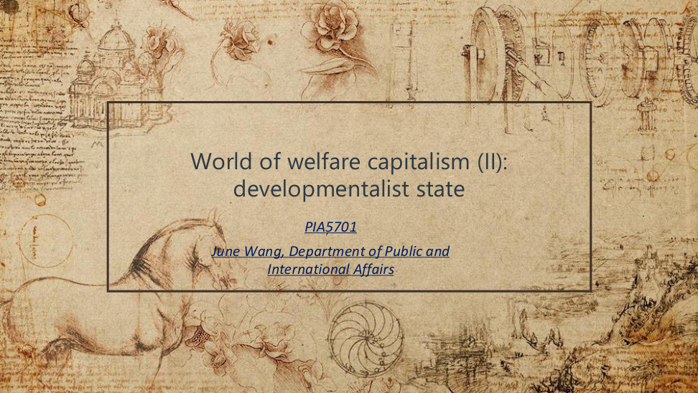
原PPT第1页 / Original slide 1

PPT中英翻译 / PPT translation
PPT English / 英文原文 | 中文翻译 / Chinese translation
World of welfare capitalism (II): developmentalist state | 福利资本主义世界（二）：发展型国家
PIA5701; June Wang, Department of Public and International Affairs | PIA5701；June Wang，公共及国际事务系

本页核心 / Key takeaway
本课主线：国家怎样推动经济赶超，以及增长目标怎样塑造东亚福利安排。
Main thread: how states drive economic catch-up and how growth priorities shape East Asian welfare arrangements.

阅读说明 / Reading guide
红色只标核心理论与关键区别；加粗标次重点。复习按“截图—翻译—本页核心—精要解析”展开。章节过渡页与结束页不额外扩写。
Red marks core theory and key distinctions; bold marks secondary emphasis. Each slide follows the sequence: screenshot, translation, takeaway, essential explanation. Transition and closing slides are kept brief.
材料核对：所附“课堂3总结”听课宝实际主要讨论前课的普遍权利、养老金、劳动市场与教育，仅在相关页作跨课对照。本课发展型国家内容以PPT为主，结合Word整理；不另设附录。
Source check: the supplied “Lesson 3” listening summary mainly concerns the previous lesson’s universal rights, pensions, labour markets and education. Relevant points are used only for cross-lesson comparison. This lesson’s developmental-state content follows the PPT, integrated with the Word notes; there is no appendix.

02｜什么是发展型国家？ / What is a developmentalist state?

原PPT第2页 / Original slide 2

PPT中英翻译 / PPT translation
PPT English / 英文原文 | 中文翻译 / Chinese translation
What is developmentalist state? | 什么是发展型国家？

本页核心 / Key takeaway
先抓住一个问题：国家是否把经济发展放在优先位置，并有组织地引导产业升级？
Start with one question: does the state prioritise economic development and systematically guide industrial upgrading?

精要解析 / Essential explanation

1. 理解入口 / Starting point
“发展型”首先指国家的发展目标与组织能力。判断时要看政府是否能设定产业方向、协调资本和执行政策，而不只是看经济增长速度或政府规模。
“Developmental” concerns state priorities and organisational capacity. Ask whether government can set industrial directions, coordinate capital and implement policy, rather than judging only growth rates or government size.

2. 本课的两个问题 / Two questions for this lesson
先解释国家如何推动工业化，再解释福利怎样服务这一过程。前者关注国家—企业关系，后者关注就业、教育、家庭及福利供给，两个层次需要联系起来。
First explain how the state promotes industrialisation, then how welfare supports that process. The first concerns state–business relations; the second concerns employment, education, families and welfare provision. Connect these two levels.

03｜为何关注东亚？ / Why the attention to East Asia?
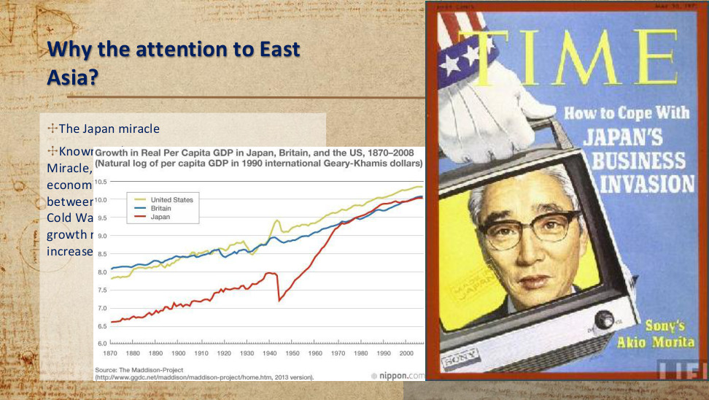
原PPT第3页 / Original slide 3

PPT中英翻译 / PPT translation
PPT English / 英文原文 | 中文翻译 / Chinese translation
Why the attention to East Asia? The Japan miracle. | 为何关注东亚？日本经济奇迹。
Known as the Japanese Economic Miracle, Japan experienced rapid and sustained economic growth from 1945 to 1991, the period between post World War II and the end of the Cold War. As depicted in Figure 1, the real growth rate was positive until 1973 and increased for 20 consecutive years. [PDF text partly covered by the chart.] | 日本在1945—1991年，即二战后至冷战结束期间，经历了快速而持续的经济增长，被称为“日本经济奇迹”。原文续称：实际增长率在1973年前为正，并连续增长20年。【此段部分被图表遮挡；关于“增长率”的表述见下方辨析。】
Chart: Growth in Real Per Capita GDP in Japan, Britain, and the US, 1870–2008 (natural log of per capita GDP in 1990 international Geary–Khamis dollars). United States; Britain; Japan. Source: The Maddison Project, 2013 version. | 图：1870—2008年日本、英国与美国实际人均GDP增长（以1990年国际Geary–Khamis元计量的人均GDP的自然对数）。图例：美国、英国、日本。来源：麦迪森项目，2013年版本。
TIME cover: How to Cope With JAPAN’S BUSINESS INVASION; Sony’s Akio Morita. | 《时代》封面：如何应对日本企业的扩张；索尼的盛田昭夫。

本页核心 / Key takeaway
日本的战后赶超使学者追问：国家干预和制度安排如何促进工业化，而非仅用自由市场解释增长。
Japan’s post-war catch-up prompted scholars to ask how state intervention and institutions promoted industrialisation, beyond a free-market explanation.

精要解析 / Essential explanation

1. 为什么成为研究对象 / Why it attracted research
日本的长期赶超说明，后发经济体可以在较短时间内改变产业与收入水平。研究者因而需要解释：这种转型背后有什么政治组织、政策工具和制度条件。
Japan’s long-run catch-up showed that later developers could transform industry and incomes within a relatively short period. Researchers therefore asked which political organisations, policy tools and institutional conditions supported the transformation.

2. 从现象走向解释 / From an outcome to an explanation
“增长很快”是要解释的结果；产业政策、官僚能力与政企协调才是后面要分析的机制。复习时把结果与原因分开，避免用“成功所以是发展型”循环解释。
Rapid growth is the outcome to be explained; industrial policy, bureaucratic capacity and state–business coordination are proposed mechanisms. Separate outcomes from causes rather than defining a developmental state solely by success.

3. 怎样使用这张图 / How to use the chart
可观察日本人均GDP的战后追赶及其与英美的相对距离；图表不能单独识别哪项政策造成增长。需要把趋势与后续日本制度案例结合，而非从曲线直接推出因果。
Use the chart to observe Japan’s post-war catch-up and its distance from Britain and the US. The trend alone cannot identify which policies caused growth; connect it to the institutional evidence in later slides.

易错辨析 / Key distinction
图中纵轴是人均GDP的对数水平，并非年度增长率；曲线上升不能证明“增长率连续20年提高”。复习时掌握长期赶超趋势即可。
The chart shows the log level of GDP per capita, not annual growth rates; a rising line does not prove that the growth rate increased for 20 consecutive years. Focus on the long-run catch-up trend.

04｜福利国家体制 / Welfare-state regimes
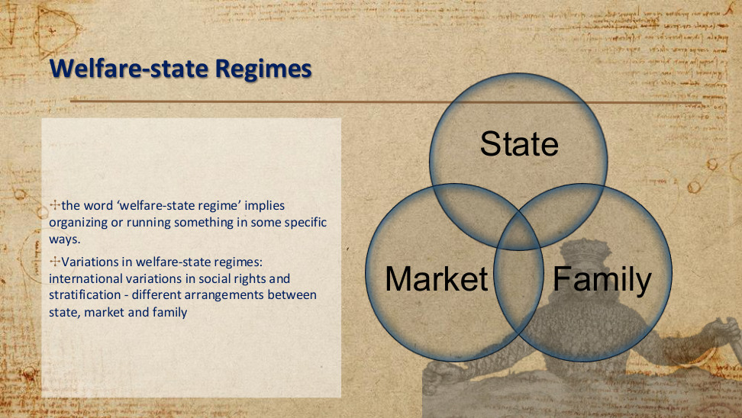
原PPT第4页 / Original slide 4

PPT中英翻译 / PPT translation
PPT English / 英文原文 | 中文翻译 / Chinese translation
The word “welfare-state regime” implies organizing or running something in some specific ways. | “福利国家体制”意味着以特定方式组织和运作福利安排。
Variations in welfare-state regimes: international variations in social rights and stratification — different arrangements between state, market and family. | 福利国家体制的差异：各国社会权利与社会分层不同，体现为国家、市场和家庭之间的不同安排。
Diagram: State — Market — Family. | 图示：国家—市场—家庭，三者相互交叠。

本页核心 / Key takeaway
福利体制看的是国家、市场、家庭如何分担福利责任，以及这种安排如何影响社会权利与分层。
A welfare regime concerns how the state, market and family share welfare responsibilities, and how this shapes social rights and stratification.

精要解析 / Essential explanation

1. 谁承担责任 / Who carries responsibility
国家可通过税收和公共项目提供保障，市场通过就业与购买能力分配资源，家庭通过照护和内部转移支持成员。三者通常同时存在，差别在责任比重和相互关系。
The state provides protection through taxation and public programmes; markets distribute resources through employment and purchasing power; families supply care and transfers. All three usually coexist, with different responsibilities and relationships.

2. 谁有资格获得福利 / Who qualifies for welfare
承接听课宝的前课对照：需要审查看经济困难，职业缴费看就业与贡献，公民权利看共同成员资格。同样是养老金，不同资格规则会保护不同群体。
As a cross-lesson link to the listening summary, means tests assess financial need, contribution rules assess employment and payments, and citizenship-based rights concern membership. Different pension eligibility rules protect different groups.

3. 为什么会影响分层 / How stratification is affected
如果福利紧系稳定职业，核心雇员及家属可能较有优势；如果依赖购买能力，收入差异就会影响保障。分析体制时，要追问制度如何维持或减小群体差距。
When welfare depends on stable employment, core workers and their families may be advantaged; when it depends on purchasing power, income differences shape protection. Ask how institutions maintain or reduce group inequalities.

易错辨析 / Key distinction
福利体制不能只按社会开支多少分类；还要看资格、覆盖范围与国家—市场—家庭的分工。
Social spending alone cannot classify a welfare regime; eligibility, coverage and the state–market–family division also matter.

05｜发展型国家的起源 / Origins of the developmental state
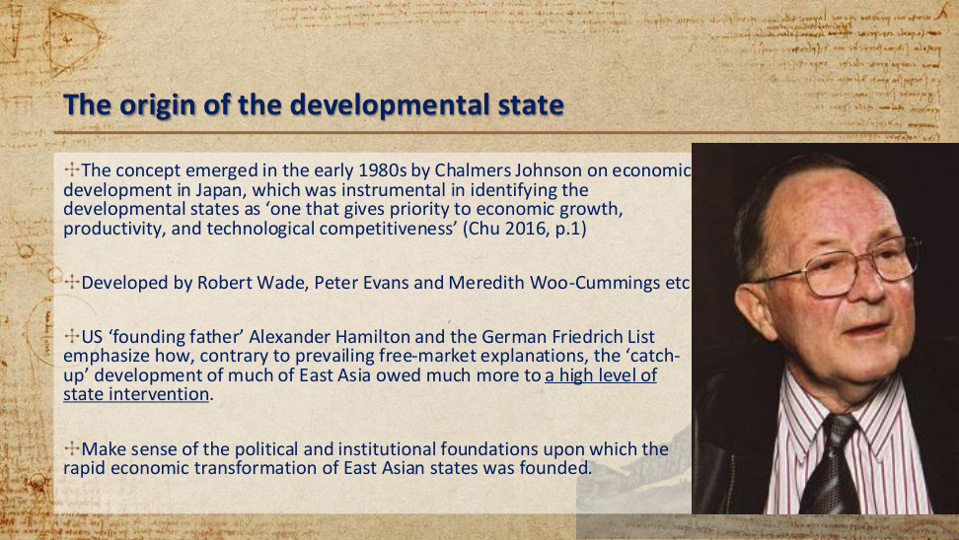
原PPT第5页 / Original slide 5

PPT中英翻译 / PPT translation
PPT English / 英文原文 | 中文翻译 / Chinese translation
The concept emerged in the early 1980s by Chalmers Johnson on economic development in Japan, identifying the developmental state as “one that gives priority to economic growth, productivity, and technological competitiveness” (Chu 2016, p.1). | 查默斯·约翰逊在20世纪80年代初研究日本经济发展时提出这一概念：发展型国家“优先重视经济增长、生产率与技术竞争力”（Chu，2016，第1页）。
Developed by Robert Wade, Peter Evans and Meredith Woo-Cummings etc. | 这一理论随后由罗伯特·韦德、彼得·埃文斯、梅雷迪思·吴—卡明斯等人进一步发展。
US “founding father” Alexander Hamilton and the German Friedrich List emphasize how, contrary to prevailing free-market explanations, the “catch-up” development of much of East Asia owed much more to a high level of state intervention. | 原文将美国建国先贤亚历山大·汉密尔顿、德国的弗里德里希·李斯特与国家干预思路联系起来：与自由市场解释相对，东亚许多经济体的“赶超”发展高度依赖国家干预。【这是思想渊源与后来的东亚研究相结合的概括。】
Make sense of the political and institutional foundations upon which the rapid economic transformation of East Asian states was founded. | 解释东亚国家快速经济转型背后的政治与制度基础。

本页核心 / Key takeaway
发展型国家的定义重点是：优先追求经济增长、生产率与技术竞争力，并通过国家能力推动赶超。
The defining priority is economic growth, productivity and technological competitiveness, pursued through state capacity for catch-up.

精要解析 / Essential explanation

1. 人物与理论问题 / Scholar and theoretical question
先记“约翰逊—日本—20世纪80年代初”。他的重要性在于把经济赶超与国家的政治、制度能力联系起来；其他学者姓名用于理解理论发展，不必取代机制分析。
Remember “Johnson—Japan—early 1980s”. His significance is connecting economic catch-up with political and institutional state capacity. Other scholars extend the theory; memorising names should not replace explaining mechanisms.

2. 三个目标怎样联系 / How the three priorities connect
经济增长关注产出扩张，生产率关注单位投入能产生多少产出，技术竞争力关注技术与产业优势。追赶不只是增加生产数量，还包括提升生产方式与产业能力。
Growth concerns expanding output; productivity concerns output per unit of input; technological competitiveness concerns technological and industrial advantage. Catch-up involves improving production methods and capabilities, as well as increasing production volumes.

3. 国家为什么进入解释 / Why the state matters
自由市场解释重视价格和私人企业；发展型国家理论进一步观察政府怎样选择重点产业、协调投资并建设执行机构。它解释的是有组织的转型能力，不是“政府干预越多越好”。
Alongside prices and private firms, developmental-state theory examines how government selects industries, coordinates investment and builds implementing institutions. The issue is organised transformative capacity, rather than assuming that more intervention always produces better outcomes.

易错辨析 / Key distinction
汉密尔顿与李斯特是更早的国家促进发展思想先驱，不是研究战后东亚奇迹的当代学者。
Hamilton and List were earlier intellectual precursors of state-led development, not contemporary researchers of post-war East Asia.

06｜构成与特征：日本案例 / Components and characteristics: Japan
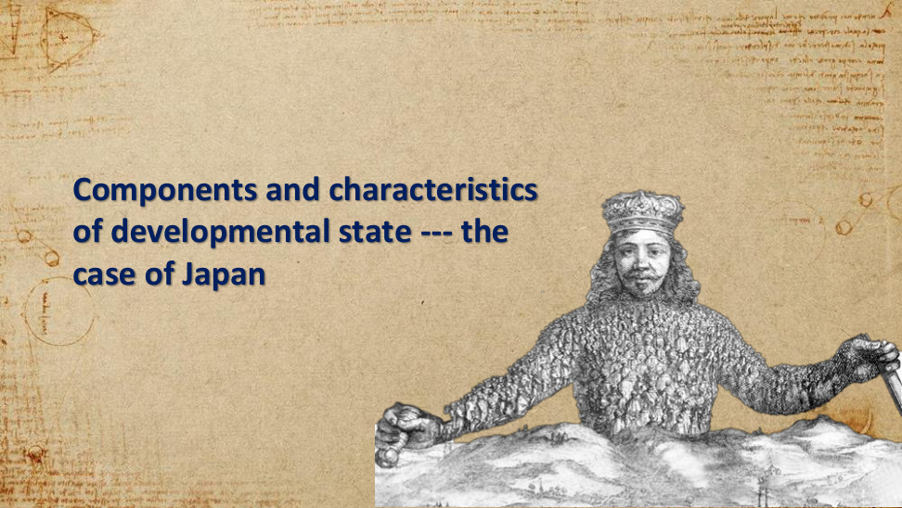
原PPT第6页 / Original slide 6

PPT中英翻译 / PPT translation
PPT English / 英文原文 | 中文翻译 / Chinese translation
Components and characteristics of developmental state — the case of Japan. | 发展型国家的构成与特征——日本案例。

本页核心 / Key takeaway
下面以日本为例，从政策工具、官僚组织与国家—企业关系理解发展型国家。
The following pages use Japan to examine policy tools, bureaucracy and state–business relations.

07｜日本发展型国家 / Japan’s developmental state
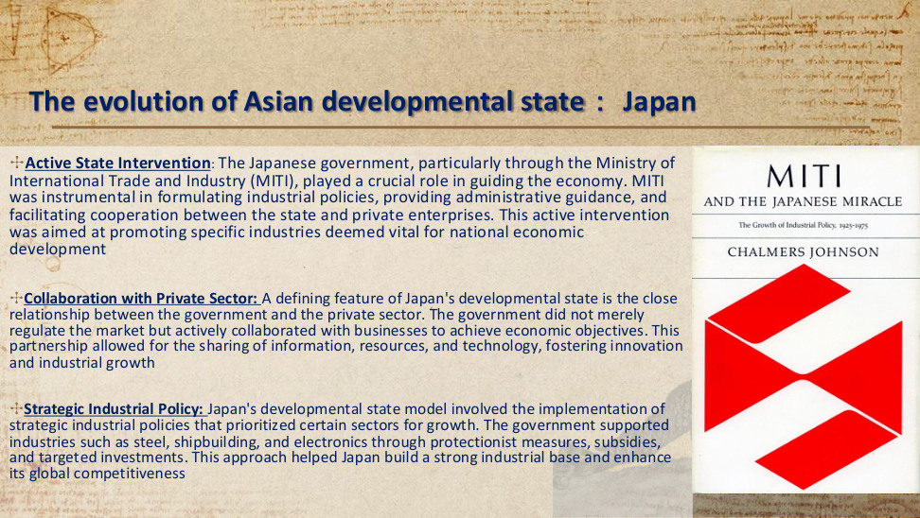
原PPT第7页 / Original slide 7

PPT中英翻译 / PPT translation
PPT English / 英文原文 | 中文翻译 / Chinese translation
Active State Intervention: The Japanese government, particularly through the Ministry of International Trade and Industry (MITI), guided the economy through industrial policies, administrative guidance and cooperation with private enterprises, promoting industries vital for national development. | 积极的国家干预：日本政府尤其通过通商产业省（MITI），运用产业政策、行政指导以及政企合作引导经济，推动被视为国家发展关键的产业。
Collaboration with Private Sector: Close government–business relations meant not merely regulating the market, but actively collaborating to achieve economic objectives. Sharing information, resources and technology fostered innovation and industrial growth. | 与私营部门合作：政府与企业关系紧密，除了规制市场，还主动合作以实现经济目标；双方共享信息、资源与技术，促进创新及产业增长。
Strategic Industrial Policy: Steel, shipbuilding and electronics were supported through protectionist measures, subsidies and targeted investments, building an industrial base and global competitiveness. | 战略性产业政策：政府通过保护措施、补贴与定向投资，支持钢铁、造船和电子等行业，建设产业基础并提高国际竞争力。
Book cover: MITI and the Japanese Miracle; Chalmers Johnson. | 书封：《通产省与日本奇迹》；查默斯·约翰逊。

本页核心 / Key takeaway
日本案例的核心机制是选择性产业政策与政企合作：国家集中资源扶持战略产业，推动升级与竞争力。
Japan’s central mechanisms were selective industrial policy and state–business collaboration: directing resources to strategic industries to promote upgrading and competitiveness.

精要解析 / Essential explanation

1. MITI的协调作用 / MITI’s coordinating role
通产省把国家发展方向转成产业政策与行政指导，并连接不同企业所需的信息、资源和技术。它体现的是制定和组织政策的能力，不要求政府直接拥有所有生产企业。
MITI translated national priorities into industrial policy and administrative guidance, connecting information, resources and technology across firms. This represents policy-making and coordinating capacity without requiring state ownership of every producer.

2. 选择性支持怎样起作用 / How selective support works
保护措施、补贴与定向投资改变重点行业的成本和预期回报，使企业更愿意投入产业建设与技术学习。关键是“选哪些行业、用什么工具、服务什么目标”，而不是只列补贴名称。
Protection, subsidies and targeted investment alter costs and expected returns, encouraging investment and technological learning in priority industries. Explain which industries are selected, which tools are used and which goals they serve.

3. 合作为何还需要约束 / Why collaboration needs discipline
政府需要企业信息来了解产业，但密切接触也可能使政策偏向个别企业利益。因此，政企合作要与官僚相对自主性结合，才能围绕发展目标而非单纯优惠分配运作。
Government needs business information to understand industry, but close contact can also favour particular firms. Collaboration must therefore coexist with bureaucratic autonomy so that policy serves development goals rather than merely distributing privileges.

08｜发展型国家的六项构成 / Six components
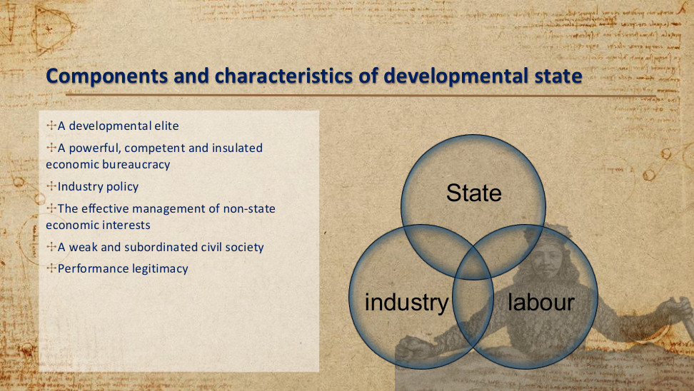
原PPT第8页 / Original slide 8

PPT中英翻译 / PPT translation
PPT English / 英文原文 | 中文翻译 / Chinese translation
A developmental elite. | 发展导向的精英。
A powerful, competent and insulated economic bureaucracy. | 强大、能干且具有相对自主性的经济官僚体系。
Industry policy. | 产业政策。
The effective management of non-state economic interests. | 有效管理非国家经济利益。
A weak and subordinated civil society. | 较弱、处于从属地位的公民社会。
Performance legitimacy. | 绩效合法性。
Diagram: State — industry — labour. | 图示：国家—产业—劳工之间的关系。

本页核心 / Key takeaway
六项构成可串成：发展精英定方向，能干官僚与产业政策组织资源，管理资本及社会关系，再以发展绩效获得支持。
The six components form a chain: developmental elites set priorities; capable bureaucracy and industrial policy organise resources; capital and social relations are managed; development performance sustains support.

精要解析 / Essential explanation

1. 按三组记忆 / Remember three groups
“谁决策”：发展精英与经济官僚；“怎样行动”：产业政策与非国家利益管理；“怎样维持”：国家—社会关系与绩效合法性。这样能把六项特征整理成组织、工具和支持基础。
Group the components into decision-makers (elites and bureaucracy), instruments (industrial policy and management of non-state interests), and support (state–society relations and performance legitimacy). This organises the six features into a coherent structure.

2. 能干与自主要同时具备 / Capacity and autonomy together
能干指有专业知识及执行政策的组织能力；相对自主指不轻易被利益集团俘获。只有专业人才却无法坚持国家目标，或只有权力却缺乏执行能力，都不等于课件的官僚条件。
Capacity means expertise and implementation ability; relative autonomy means resistance to capture by special interests. Expertise without independence, or authority without implementation ability, does not meet the bureaucratic conditions described in the slide.

3. 各要素如何连接 / How the components connect
精英确立目标，官僚运用产业政策并协调企业，发展成果再提供政治支持。这条联系帮助解释为什么特征不能孤立背诵；具体国家仍可能以不同方式组合这些要素。
Elites set goals, bureaucrats deploy industrial policy and coordinate firms, and developmental results provide political support. This links the components rather than treating them as an isolated list; their precise combination varies across countries.

易错辨析 / Key distinction
本页的国家—产业—劳工图分析发展协调与权力关系；第4页的国家—市场—家庭图分析福利责任，两个三角不能互换。
This state–industry–labour diagram concerns developmental coordination and power; the state–market–family diagram on slide 4 concerns welfare responsibilities. They are not interchangeable.

09｜发展精英：组织与官僚来源 / Developmental elites
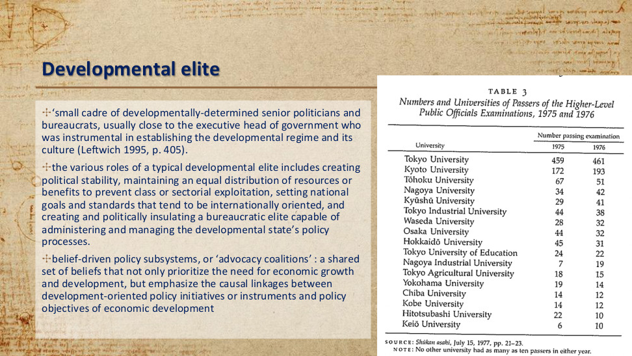
原PPT第9页 / Original slide 9

PPT中英翻译 / PPT translation
PPT English / 英文原文 | 中文翻译 / Chinese translation
A “small cadre of developmentally-determined senior politicians and bureaucrats”, usually close to the executive head, establishes the developmental regime and its culture (Leftwich 1995, p.405). | 一小群坚定追求发展的高级政治人物与官僚，通常接近政府行政首脑，对建立发展型体制及其文化起关键作用（Leftwich，1995，第405页）。
Roles include political stability; equal distribution of resources or benefits to prevent class or sectorial exploitation; internationally oriented national goals and standards; and creating and politically insulating a bureaucratic elite able to manage development policy. | 其作用包括：建立政治稳定；维持资源或利益的均衡分配以防阶级或部门剥削；制定面向国际的国家目标和标准；建立并在政治上保护能管理发展政策的官僚精英。
Belief-driven policy subsystems, or “advocacy coalitions”: shared beliefs prioritise growth and development, and connect development-oriented policy instruments causally to economic-development objectives. | 由信念驱动的政策子系统，即“倡议联盟”：成员共享优先重视经济增长与发展的信念，并相信特定发展政策工具能够因果性地推动发展目标。
Table 3: Numbers and Universities of Passers of the Higher-Level Public Officials Examinations, 1975 and 1976. Source: Shūkan asahi, July 15, 1977, pp.21–23. Note: no other university had as many as ten passers in either year. | 表3：1975、1976年高级公务员考试合格者人数及毕业大学（数字见下表）。来源：《周刊朝日》，1977年7月15日，第21—23页；注：其他大学在这两年中任何一年都没有达到10名合格者。

图表转写：高级公务员考试合格者的毕业大学 / Table: universities of higher-level civil-service examination passers
大学 / University | 1975年人数 / Passers | 1976年人数 / Passers
东京大学 / Tokyo University | 459 | 461
京都大学 / Kyoto University | 172 | 193
东北大学 / Tōhoku University | 67 | 51
名古屋大学 / Nagoya University | 34 | 42
九州大学 / Kyūshū University | 29 | 41
东京工业大学 / Tokyo Industrial University | 44 | 38
早稻田大学 / Waseda University | 28 | 32
大阪大学 / Osaka University | 44 | 32
北海道大学 / Hokkaidō University | 45 | 31
东京教育大学 / Tokyo University of Education | 24 | 22
名古屋工业大学 / Nagoya Industrial University | 7 | 19
东京农业大学 / Tokyo Agricultural University | 18 | 15
横滨大学（原表名）/ Yokohama University | 19 | 14
千叶大学 / Chiba University | 14 | 12
神户大学 / Kobe University | 14 | 12
一桥大学 / Hitotsubashi University | 22 | 10
庆应大学 / Keiō University | 6 | 10

本页核心 / Key takeaway
发展精英不仅提出增长目标，还要建立能执行政策、相对不受利益集团干扰的官僚体系。
Developmental elites must establish a bureaucracy capable of implementing policy and relatively insulated from interest-group interference, as well as setting growth goals.

精要解析 / Essential explanation

1. 精英与官僚怎样分工 / Elite and bureaucratic roles
发展精英主要提供政治方向、稳定与保护；经济官僚把方向变成政策设计和执行。两者接近行政首脑，使长期发展目标有机会跨越个别部门利益，但不保证每项决策都成功。
Developmental elites provide direction, stability and political protection; economic bureaucrats translate priorities into design and implementation. Proximity to the executive can sustain goals across sectoral interests, without guaranteeing the success of every decision.

2. “隔离”不等于不接触 / Insulation is not isolation
官僚需要了解企业情况，才能设计可执行政策；同时又要避免企业把公共资源变成自身特权。记住“获取信息”和“保持判断自主”可以并存，这是理解国家能力的关键。
Officials need business information to design workable policy while preventing firms from turning public resources into private privileges. Access to information can coexist with independent judgement; this is central to understanding state capacity.

3. 表格提供什么证据 / What the table establishes
考试合格者集中于少数大学，说明高级官僚的精英招募渠道较集中。表格没有直接测量政策水平，因此不能把名校出身自动当作官僚能干或产业政策有效的证明。
The concentration of examination passers in a few universities indicates selective elite recruitment. The table does not directly measure policy quality, so university background alone cannot establish bureaucratic competence or industrial-policy effectiveness.

易错辨析 / Key distinction
原文中的均衡分配是对发展精英作用的理论描述，并不证明所有发展型国家都已实现社会平等。
The distributional role described in the text is a theoretical account of developmental elites, not evidence that every developmental state achieved social equality.

10｜发展精英：共同信念 / Developmental elites: shared beliefs
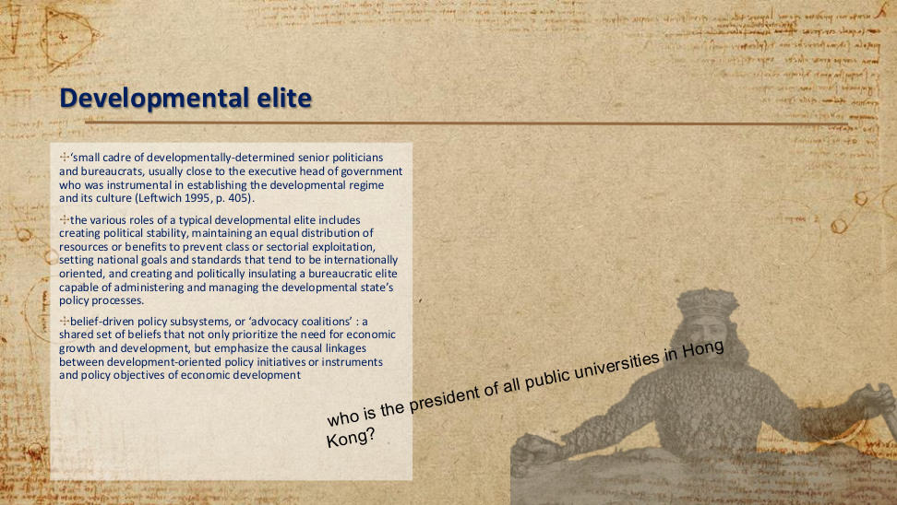
原PPT第10页 / Original slide 10

PPT中英翻译 / PPT translation
PPT English / 英文原文 | 中文翻译 / Chinese translation
A “small cadre of developmentally-determined senior politicians and bureaucrats”, usually close to the executive head, establishes the developmental regime and its culture (Leftwich 1995, p.405). | 一小群坚定追求发展的高级政治人物与官僚，通常接近政府行政首脑，对建立发展型体制及其文化起关键作用（Leftwich，1995，第405页）。
Roles include political stability; equal distribution of resources or benefits to prevent class or sectorial exploitation; internationally oriented national goals and standards; and creating and politically insulating a bureaucratic elite able to manage development policy. | 其作用包括：建立政治稳定；维持资源或利益的均衡分配以防阶级或部门剥削；制定面向国际的国家目标和标准；建立并在政治上保护能管理发展政策的官僚精英。
Belief-driven policy subsystems, or “advocacy coalitions”: shared beliefs prioritise growth and development, and connect development-oriented policy instruments causally to economic-development objectives. | 由信念驱动的政策子系统，即“倡议联盟”：成员共享优先重视经济增长与发展的信念，并相信特定发展政策工具能够因果性地推动发展目标。
Who is the president of all public universities in Hong Kong? [Slide question.] | 谁是香港所有公立大学的“president”？【课件提问；原词对大学治理职位的表述不够精确。】

本页核心 / Key takeaway
本页承接上页，重点转向倡议联盟：共同的发展信念把政策工具与增长目标连接起来。
Building on the previous page, focus on advocacy coalitions: shared developmental beliefs link policy instruments to growth objectives.

精要解析 / Essential explanation

1. 共同信念包含什么 / What shared beliefs include
倡议联盟不仅共同认同增长目标，也共同相信某些工具能促成发展。前者回答“要什么”，后者回答“怎样达到”，两者结合才有助于协调持续的政策行动。
Advocacy coalitions share both a commitment to growth and beliefs about how policy tools produce development. One concerns the goal; the other concerns the causal route. Together they can support sustained policy coordination.

2. 把信念写成因果链 / Express the causal link
例如设想“定向信贷降低融资约束→企业增加设备与技术投入→生产能力提升”。这只是帮助理解的例子；分析联盟时，要说明成员认同哪条工具—目标联系，而非只说他们关系密切。
For illustration, targeted credit may ease financing constraints, support equipment and technology investment, and build productive capacity. Explain which tool–goal relationship coalition members believe in, rather than saying only that they have close relationships.

易错辨析 / Key distinction
课件的大学治理提问用于引发对政治与精英组织关系的思考，不宜把“校长”与“校监”等职位混为一谈，也无需把某个人名当作理论重点。
The university-governance question prompts reflection on politics and elite organisation. Do not conflate university presidents with chancellors or treat a person’s name as the theoretical focus.

11｜管理非国家经济利益 / Managing non-state economic interests
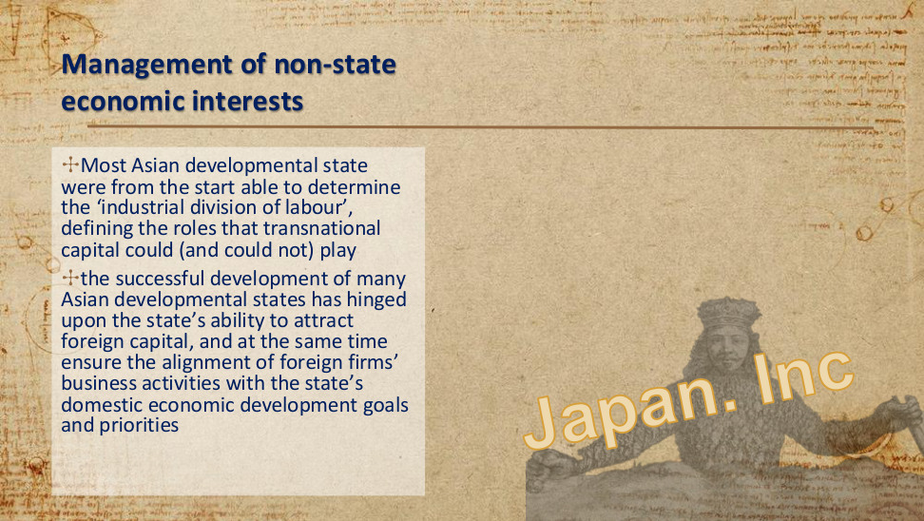
原PPT第11页 / Original slide 11

PPT中英翻译 / PPT translation
PPT English / 英文原文 | 中文翻译 / Chinese translation
Most Asian developmental states were from the start able to determine the “industrial division of labour”, defining the roles that transnational capital could (and could not) play. | 许多亚洲发展型国家从一开始就能决定“产业分工”，规定跨国资本可以及不可以扮演的角色。
Successful development hinged upon the ability to attract foreign capital and, at the same time, align foreign firms’ business activities with domestic economic development goals and priorities. | 成功发展取决于国家既能吸引外资，又能使外国企业的经营活动符合本国经济发展的目标与优先次序。
Japan Inc. | “日本株式会社”（Japan Inc.）：把日本政企协调形象地比作一个整体。

本页核心 / Key takeaway
管理非国家利益的关键是吸引资本，同时让资本服务国家发展目标。
Managing non-state interests means attracting capital while aligning it with national development goals.

精要解析 / Essential explanation

1. 管理的是资本的角色 / Managing capital’s role
“产业分工”强调跨国资本进入后做什么、与哪些国内产业活动相配合。管理非国家利益不是取消私营部门，而是规定资本参与发展的方向和边界。
The industrial division of labour concerns what transnational capital does and how it connects with domestic industry. Managing non-state interests does not abolish private firms; it sets directions and boundaries for their developmental role.

2. 吸引与引导是两项能力 / Attracting and steering are distinct
能吸引投资不等于能实现本国发展目标。还要观察投资是否进入优先产业、是否符合政策方向；这解释了国家为什么既要与企业合作，也要保有协调和约束能力。
Attracting investment does not by itself achieve domestic development goals. Examine whether investment enters priority activities and fits policy directions; this explains the need for both business cooperation and coordinating or disciplinary capacity.

3. 怎样识别政策逻辑 / How to identify the policy logic
读案例时依次找“国家目标—资本角色—协调方式”。如果只写外资规模扩大，仍没有解释发展型国家机制；需要说明这种投资怎样与本国产业发展相连接。
Read a case through national goals, the role assigned to capital and coordination mechanisms. An increase in FDI alone does not explain developmental-state mechanisms; show how that investment connects with domestic industrial development.

12｜外资目标的例子 / An example of an FDI target
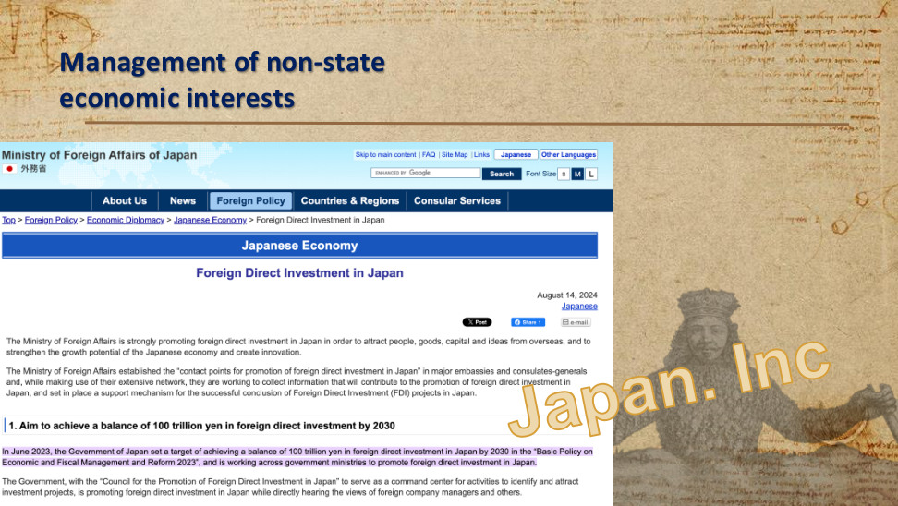
原PPT第12页 / Original slide 12

PPT中英翻译 / PPT translation
PPT English / 英文原文 | 中文翻译 / Chinese translation
Management of non-state economic interests; Japan Inc. | 管理非国家经济利益；“日本株式会社”。
Ministry of Foreign Affairs of Japan — Japanese Economy — Foreign Direct Investment in Japan. August 14, 2024. | 日本外务省—日本经济—对日外国直接投资。网页日期：2024年8月14日。
The Ministry is strongly promoting foreign direct investment in Japan to attract people, goods, capital and ideas from overseas, strengthen growth potential and create innovation. | 外务省积极促进对日外国直接投资，以吸引海外人才、商品、资本与创意，增强经济增长潜力并创造创新。
Contact points in major embassies and consulates-general collect information through overseas networks and support the successful conclusion of FDI projects in Japan. | 在主要使领馆设立促进对日投资的联络点，利用海外网络收集信息，并支持投资项目在日本顺利落地。
Aim to achieve a balance of 100 trillion yen in foreign direct investment by 2030. In June 2023, the Government set this target in the “Basic Policy on Economic and Fiscal Management and Reform 2023” and is working across ministries to promote FDI in Japan. | 目标：到2030年使对日外国直接投资存量达到100万亿日元。日本政府于2023年6月在《经济财政运营与改革基本方针2023》中提出该目标，并通过跨部门协作促进对日投资。
The Council for the Promotion of Foreign Direct Investment in Japan serves as a command centre to identify and attract investment projects, while hearing foreign company managers’ views. | 通过“对日直接投资推进会议”统筹识别和吸引投资项目，并直接听取外国企业管理者等的意见。

本页核心 / Key takeaway
这一网页例子体现：政府可主动设定外资目标，并通过跨部门与海外网络协调招商。
The webpage illustrates how government can set FDI targets and coordinate investment promotion through ministries and overseas networks.

精要解析 / Essential explanation

1. 网页体现的组织链条 / The organisational chain
本页把抽象能力变成具体安排：政府设存量目标，跨部门机构协调项目，海外使领馆网络收集信息与联系投资者。重点是国家怎样组织招商，而非只记投资数字。
The webpage makes organisational capacity concrete: government sets a stock target, cross-ministry bodies coordinate projects, and overseas missions collect information and contact investors. Focus on how investment promotion is organised, beyond the headline figure.

2. 目标与结果分开看 / Separate targets from results
2030年100万亿日元说明政府希望达到的投资规模；要判断成效，还需另有实际投资及产业结果数据。本页可证明存在目标和协调机制，不能单凭网页证明目标已经实现。
The 2030 target states the desired investment scale. Assessing success requires evidence on realised investment and industrial outcomes. The webpage demonstrates a target and coordination mechanisms, not achievement of the target itself.

易错辨析 / Key distinction
100万亿日元是2030年的对内FDI存量目标，不是一年流入量。
100 trillion yen is the target stock of inward FDI by 2030, not annual inflows.

13｜绩效合法性 / Performance legitimacy
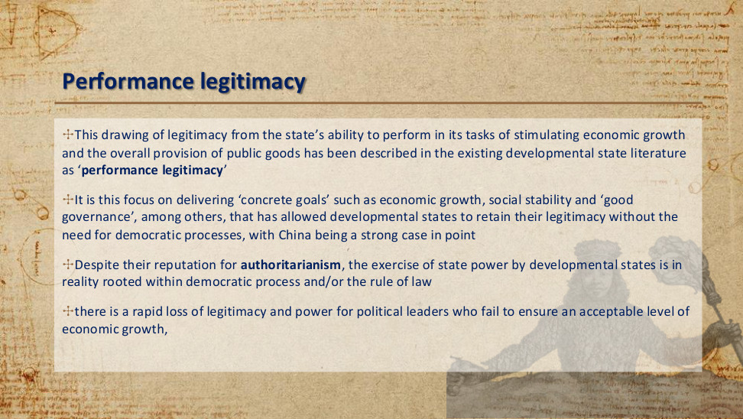
原PPT第13页 / Original slide 13

PPT中英翻译 / PPT translation
PPT English / 英文原文 | 中文翻译 / Chinese translation
Legitimacy drawn from the state’s ability to stimulate economic growth and provide public goods is described as “performance legitimacy”. | 国家凭借促进经济增长和提供公共物品的能力获得支持，被称为“绩效合法性”。
Delivering “concrete goals” such as growth, social stability and “good governance” allows developmental states to retain legitimacy without the need for democratic processes; China is given as an example. | 原文认为，通过实现经济增长、社会稳定和“良好治理”等具体目标，发展型国家可在不依赖民主程序的情况下维持合法性，并以中国为例。
Despite their reputation for authoritarianism, the exercise of state power by developmental states is in reality rooted within democratic process and/or the rule of law. | 原文又指出：尽管发展型国家常有威权形象，其国家权力的行使实际上植根于民主程序和／或法治。
Political leaders who fail to ensure an acceptable level of economic growth rapidly lose legitimacy and power. | 如果政治领导者无法维持可接受的经济增长水平，可能迅速失去合法性与权力。

本页核心 / Key takeaway
绩效合法性是以经济增长、公共物品等治理成果获得政治支持；当绩效下滑，支持基础也可能减弱。
Performance legitimacy derives political support from outcomes such as growth and public goods; declining performance can weaken that support.

精要解析 / Essential explanation

1. 为什么成果能带来支持 / Why results generate support
公众若把生活改善、经济机会和公共服务归因于政府能力，便可能支持执政者。绩效合法性关注这种“成果→支持”的政治联系，并不只是说经济数据变好。
When people attribute improved living conditions, opportunities and public services to governmental competence, they may support political leaders. Performance legitimacy concerns this results-to-support relationship, rather than economic indicators alone.

2. 增长与公共物品分开理解 / Growth and public goods differ
本页同时提到经济增长、社会稳定与公共物品。增长属于经济结果，公共物品涉及共同服务和条件；分析绩效时应写明实际改善了什么，而不能用一个GDP数字替代全部治理表现。
The slide mentions growth, stability and public goods. Growth is an economic outcome; public goods concern shared services and conditions. Specify what improved rather than using GDP alone as a measure of every aspect of governance.

3. 为什么增长失速会有压力 / Why slowdowns create pressure
若政府主要以持续发展证明自身能力，增长低于预期就会削弱这一理由。这里说明的是政治支持的脆弱点；是否失去权力仍受其他合法性来源和制度条件影响。
If government relies heavily on sustained development to demonstrate competence, disappointing growth weakens that justification. This identifies a source of political vulnerability; other legitimacy bases and institutional conditions also affect whether leaders lose power.

易错辨析 / Key distinction
本页对民主程序的两句话存在张力。稳妥理解是：绩效是一种合法性来源，可与程序或法治基础并存；发展型国家不必都属于同一种政体。
The slide contains tension in its statements about democracy. Treat performance as one source of legitimacy that may coexist with procedural or rule-of-law foundations; developmental states need not share one political regime.

14｜公民社会 / Civil society
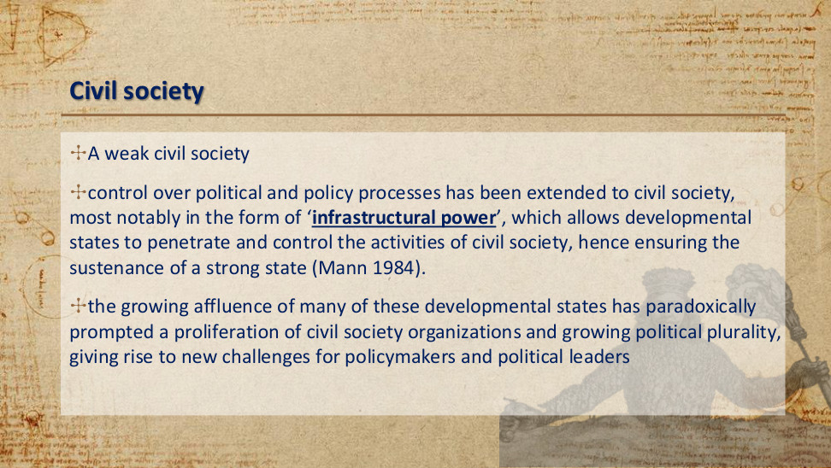
原PPT第14页 / Original slide 14

PPT中英翻译 / PPT translation
PPT English / 英文原文 | 中文翻译 / Chinese translation
A weak civil society. | 较弱的公民社会。
Control over political and policy processes extends to civil society through “infrastructural power”, allowing states to penetrate and control civil-society activities and sustain a strong state (Mann 1984). | 对政治与政策过程的控制延伸至公民社会，尤其通过“基础性权力”进入并影响社会活动，以维持强国家（Mann，1984）。
Growing affluence paradoxically prompts more civil-society organisations and political plurality, creating new challenges for policymakers and leaders. | 但日益富裕也可能促使公民社会组织增加、政治多元化发展，从而对决策者与领导者提出新挑战。

本页核心 / Key takeaway
基础性权力强调国家把政策贯彻到社会的能力；经济发展也可能增强社会组织与多元诉求，改变国家—社会关系。
Infrastructural power concerns the capacity to implement policy throughout society; development may also strengthen social organisations and plural demands, changing state–society relations.

精要解析 / Essential explanation

1. 公民社会指什么 / What civil society means
公民社会包括政府之外的社会组织与公共参与空间，不能简单等同于私营企业或家庭。较弱意味着这些主体对政策的独立影响相对有限，是国家—社会权力关系的一种描述。
Civil society includes social organisations and spaces for public participation beyond government. It is not simply private business or family life. Weakness refers to limited independent influence on policy and describes a state–society power relationship.

2. 基础性权力怎样体现 / How infrastructural power works
国家借助行政组织、社会联系与政策执行网络，使决定能在社会中得到落实。本页强调这种能力可扩大国家对社会活动的影响，概念重点是政策到达和实施。
Administrative organisation, social connections and implementation networks enable state decisions to operate throughout society. This capacity can extend state influence over social activity; the concept concerns policy reach and implementation.

3. 发展为何带来新的关系 / Why development changes relations
富裕可能增加组织资源与社会诉求，促使公民社会组织和政治多元化成长。因此，经济成功虽可支持国家，也可能产生要求更多参与的新群体，原有安排需要调整。
Affluence can expand organisational resources and social demands, encouraging civil organisations and political plurality. Economic success may therefore support the state while also creating groups seeking greater participation, requiring existing arrangements to adapt.

易错辨析 / Key distinction
“Infrastructural power”不是只指修路建桥，也不能直接等同于强制镇压；此处重点是国家对社会的组织与执行能力。
“Infrastructural power” does not simply mean building roads or bridges, nor is it identical to coercion; the focus is organisational and implementation capacity within society.

15｜建立并引导市场 / Building and shaping markets
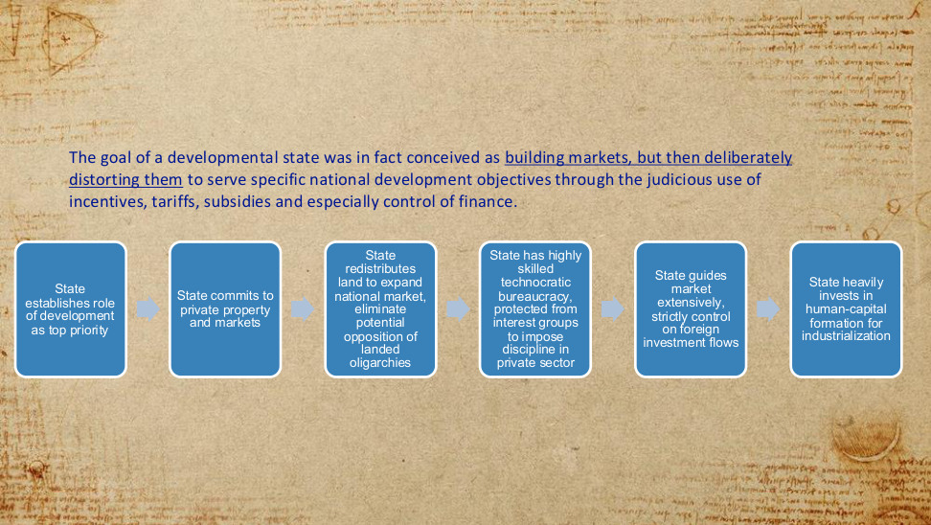
原PPT第15页 / Original slide 15

PPT中英翻译 / PPT translation
PPT English / 英文原文 | 中文翻译 / Chinese translation
The goal of a developmental state was conceived as building markets, but then deliberately distorting them to serve national development objectives through judicious incentives, tariffs, subsidies and especially control of finance. | 发展型国家的目标被理解为先建立市场，再通过审慎运用激励、关税、补贴，尤其是金融控制，有意改变市场配置，使其服务于国家发展目标。
State establishes development as top priority. | 国家把发展确立为首要任务。
State commits to private property and markets. | 国家承认并支持私有财产与市场。
State redistributes land to expand the national market and eliminate potential opposition from landed oligarchies. | 国家重新分配土地，以扩大国内市场，并消除土地寡头可能带来的阻力。
Highly skilled technocratic bureaucracy, protected from interest groups, imposes discipline on the private sector. | 高技能的技术官僚体系受到保护，避免利益集团干扰，并对私营部门施加约束。
State guides markets extensively and strictly controls foreign investment flows. | 国家广泛引导市场，并严格管理外国投资流动。
State invests heavily in human-capital formation for industrialisation. | 国家大量投入人力资本培育，以支持工业化。

本页核心 / Key takeaway
发展型国家承认市场与私有产权，但主动改变激励和资源流向，使市场服务国家发展目标。
The developmental state recognises markets and private property, but actively reshapes incentives and resource allocation to serve national development goals.

精要解析 / Essential explanation

1. 改变市场激励的含义 / What reshaping incentives means
关税、补贴和金融控制会改变相对价格与投资回报，把资源引向重点产业。“扭曲”在这里是配置机制的描述；政策是否有效，还要看它是否真正推动了预定发展目标。
Tariffs, subsidies and financial controls alter relative prices and investment returns to direct resources towards priority industries. “Distortion” describes an allocation mechanism; effectiveness depends on whether the intended development goals are actually achieved.

2. 土地与官僚的不同作用 / Different roles of land and bureaucracy
土地再分配旨在扩大国内市场并削弱土地寡头的阻力；技术官僚则负责协调和约束企业。一个改变发展所面对的社会经济条件，一个提供持续执行政策的组织能力。
Land redistribution aims to expand domestic markets and weaken landed opposition; technocratic bureaucracy coordinates and disciplines firms. One reshapes socioeconomic conditions, while the other supplies organisational capacity for sustained policy implementation.

3. 金融为何特别突出 / Why finance is emphasised
产业升级往往需要先投入、后回报。通过影响信贷及资金去向，国家可改变哪些项目得到支持，把发展目标与企业投资决策连接起来；这比抽象地说“政府干预”更具体。
Industrial upgrading often requires investment before returns arrive. By influencing credit and capital allocation, the state can affect which projects receive support, connecting developmental goals to business investment decisions. This specifies how intervention works.

4. 人力资本怎样连接福利 / How human capital links to welfare
工业化不仅需要设备，也需要具备知识与技能的劳动力。因此教育等投入可同时是社会政策和发展工具；到第38页，要继续比较“提高生产能力”与“保障生活风险”的不同优先顺序。
Industrialisation requires skilled workers as well as equipment. Education can therefore serve both social-policy and developmental purposes. Slide 38 extends this link by comparing the priority given to productive capacity with protection against livelihood risks.

16｜发展型与规制型国家 / Developmental and regulatory states
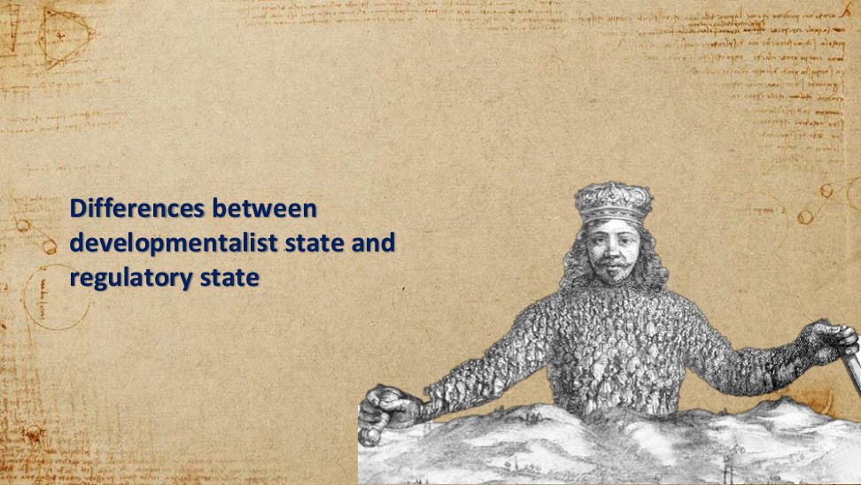
原PPT第16页 / Original slide 16

PPT中英翻译 / PPT translation
PPT English / 英文原文 | 中文翻译 / Chinese translation
Differences between developmentalist state and regulatory state. | 发展型国家与规制型国家的差异。

本页核心 / Key takeaway
接下来按政策目标、干预方式与决策机构比较两种国家角色。
Next compare the two state roles by policy goals, forms of intervention and decision-making institutions.

17｜The developmentalist state vs the regulatory state｜发展型国家与规制型国家
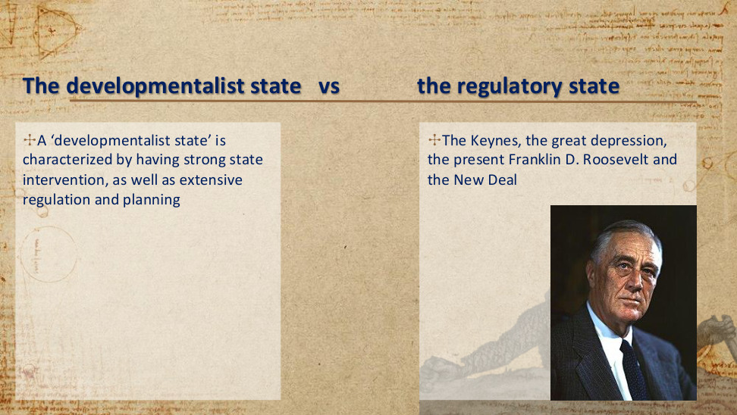
原PPT第17页 / Original slide 17

PPT中英翻译 / PPT translation
PPT English / 英文原文 | 中文翻译 / Chinese translation
A ‘developmentalist state’ is characterized by having strong state intervention, as well as extensive regulation and planning | “发展型国家”的特点是强有力的国家干预，以及广泛的规制与规划。
The Keynes, the great depression, the present Franklin D. Roosevelt and the New Deal | 凯恩斯、大萧条、富兰克林·D.罗斯福总统和新政。（原文 present 应指 President，即“总统”。）

本页核心 / Key takeaway
发展型国家以强力干预、规制和规划推动发展；关键是国家干预的目标与方式。
The developmental state promotes development through strong intervention, regulation and planning; its goals and methods matter.

精要解析 / Essential explanation

1. 先问干预目标｜Identify the goal
同样是国家介入，目标可以不同：稳定经济、扶持产业或改善分配。这里的“发展型”主要围绕工业化与赶超，判断时先看政策要解决什么问题。
State intervention can pursue stabilisation, industrial support or redistribution. Here, developmental intervention primarily concerns industrialisation and catch-up. Start by identifying the problem that a policy seeks to solve.

2. 再看怎样实施｜Identify the method
广泛规制与规划意味着国家不只制定一般规则，还会选择重点方向、协调投资并影响企业行为。前文MITI的产业政策，就是这一角色的日本例子。
Extensive regulation and planning involve more than setting general rules: the state selects priorities, coordinates investment and influences firms. MITI’s industrial policy in the earlier slides illustrates this role in Japan.

3. 新政为何在此出现｜Why the New Deal appears here
大萧条与罗斯福新政提醒我们，国家介入也可能为了应对危机、恢复经济活动。它们提供理解干预的背景，不能据此认为所有强干预都属于同一种国家模式。
The Depression and Roosevelt’s New Deal show that intervention may address crises and revive economic activity. They provide background for understanding intervention, rather than establishing that every interventionist state follows one model.

易错辨析 / Key distinction
国家干预不自动等于社会民主福利国家；还要看政策是否以社会权利、普遍保障和分配平等为目标。
State intervention does not automatically establish a social-democratic welfare regime; examine whether policy prioritises social rights, universal protection and distributive equality.

18｜The Keynes and the Hayek｜凯恩斯与哈耶克

原PPT第18页 / Original slide 18

PPT中英翻译 / PPT translation
PPT English / 英文原文 | 中文翻译 / Chinese translation
Fear the Boom and Bust: Keynes vs. Hayek | 《忧惧繁荣与萧条：凯恩斯对阵哈耶克》
Keynes Vs Hayek | 凯恩斯对阵哈耶克（配图文字）

本页核心 / Key takeaway
本页用凯恩斯与哈耶克的对照，引出国家干预与市场协调的争论。
The Keynes–Hayek comparison introduces the debate over state intervention and market coordination.

精要解析 / Essential explanation

1. 凯恩斯：总需求问题｜Keynes: aggregate demand
作为背景，凯恩斯关注需求不足导致产出和就业低迷的情况：私人支出不能充分支撑经济时，政府可通过支出等政策稳定总需求。关注的是宏观经济运行。
As background, Keynes examines how deficient demand can depress output and employment. When private spending is insufficient, government expenditure and related policies can support aggregate demand. The focus is macroeconomic stabilisation.

2. 哈耶克：知识与价格｜Hayek: knowledge and prices
哈耶克强调，市场价格能传递分散在个人与企业手中的知识。政策干预若改变这些信号，可能使资源配置出现问题；这提示我们考察国家掌握信息的能力。
Hayek emphasises how market prices convey knowledge dispersed among individuals and firms. Intervention that alters these signals may create allocation problems, drawing attention to the information available to the state.

3. 怎样联系发展型国家｜Link to developmental states
本课据此提出国家与市场如何协调的问题，但产业赶超不等于稳定总需求。发展型国家还需解释选择哪些产业、由谁协调，以及怎样引导企业投资。
This comparison introduces state–market coordination, but industrial catch-up differs from stabilising aggregate demand. Developmental-state analysis also asks which industries are selected, who coordinates policy and how firms’ investment is steered.

易错辨析 / Key distinction
不能机械记成“凯恩斯＝发展型、哈耶克＝规制型”。本页没有视频逐字稿，以上是理解思想背景的概括，不是视频原话。
Do not equate Keynes with developmental states or Hayek with regulatory states. The slide supplies no video transcript; these points summarise the intellectual background rather than quote the video.

19｜The developmentalist state vs the regulatory state｜发展型国家与规制型国家
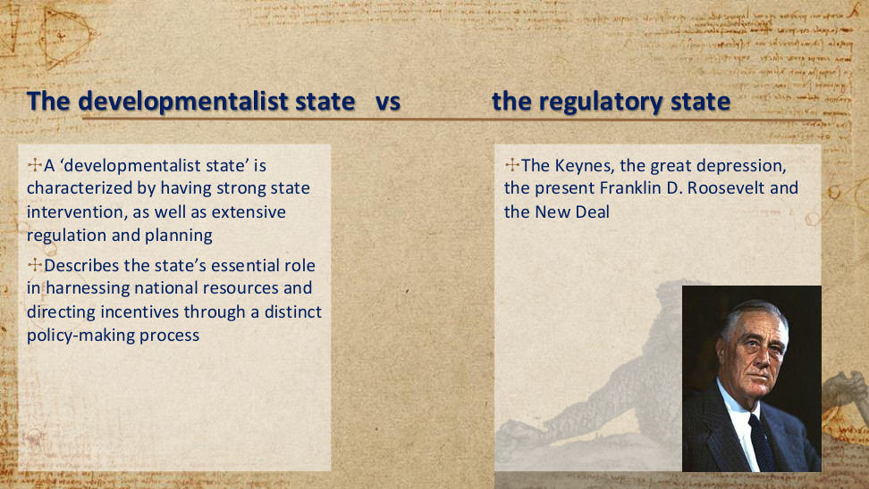
原PPT第19页 / Original slide 19

PPT中英翻译 / PPT translation
PPT English / 英文原文 | 中文翻译 / Chinese translation
A ‘developmentalist state’ is characterized by having strong state intervention, as well as extensive regulation and planning | “发展型国家”的特点是强有力的国家干预，以及广泛的规制与规划。
Describes the state’s essential role in harnessing national resources and directing incentives through a distinct policy-making process | 这一概念强调：国家通过独特的政策制定过程，在统筹国家资源、引导激励方面发挥关键作用。
The Keynes, the great depression, the present Franklin D. Roosevelt and the New Deal | 凯恩斯、大萧条、富兰克林·D.罗斯福总统和新政。（present 应指 President。）

本页核心 / Key takeaway
本页新增重点是资源动员与激励引导：国家把分散资源协调到发展目标上。
The added emphasis is resource mobilisation and incentive direction: the state coordinates dispersed resources towards development goals.

精要解析 / Essential explanation

1. 激励怎样改变选择｜How incentives change choices
信贷、补贴和贸易政策可以改变投资的收益与风险，使企业更愿意进入重点产业。国家因此能通过私人企业推动升级，不必直接拥有全部生产资料。
Credit, subsidies and trade policies can alter investment returns and risks, encouraging firms to enter priority industries. The state can therefore promote upgrading through private enterprises without owning all productive assets.

2. 资源动员需要协调｜Mobilisation requires coordination
单项优惠不等于完整发展战略；资金、技术、人才与产业目标需要配合。理解本页时，要说明政策过程怎样把分散资源连接起来，而不只罗列工具名称。
An isolated incentive is not a complete development strategy: finance, technology and skills must fit industrial goals. Explain how the policy process connects dispersed resources, rather than merely listing policy instruments.

20｜The developmentalist state vs the regulatory state｜发展型国家与规制型国家
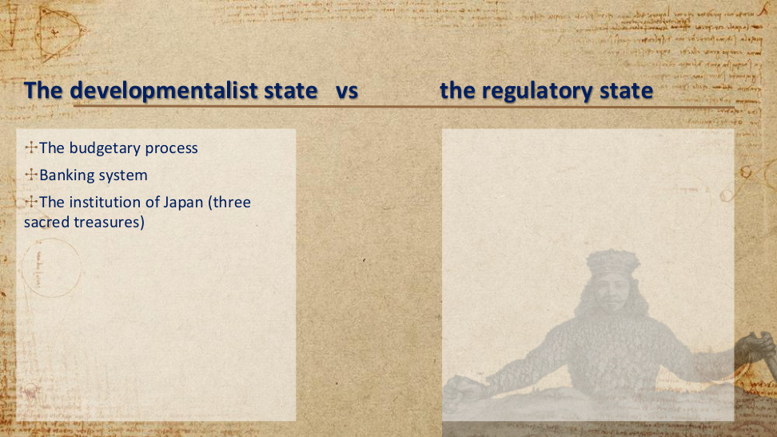
原PPT第20页 / Original slide 20

PPT中英翻译 / PPT translation
PPT English / 英文原文 | 中文翻译 / Chinese translation
The budgetary process | 预算过程
Banking system | 银行体系
The institution of Japan (three sacred treasures) | 日本的制度（“三大瑰宝”）

本页核心 / Key takeaway
本页转向制度工具：财政、金融与企业制度如何共同支撑发展战略。
The slide turns to institutional tools: how fiscal, financial and enterprise institutions jointly support development strategy.

精要解析 / Essential explanation

1. 预算：公共资源往哪里去｜Budget: directing public resources
预算把发展目标转化为实际投入，例如人力资本或产业所需配套。观察预算过程，要问哪些项目获优先支持，而不只是政府总共花了多少钱。
Budgeting translates development goals into resource commitments, such as human capital or support needed by industry. Ask which programmes receive priority, rather than examining only the total amount spent by government.

2. 银行：企业怎样获得资金｜Banking: access to finance
银行体系关系到企业能否承担长期投资。结合前文金融引导理解：改变资金可得性与成本，可以影响企业投向哪些产业；这不等于所有银行都必须国有。
Banking affects firms’ capacity to undertake long-term investment. Financial steering can influence industrial investment through the availability and cost of funding; this does not require every bank to be state-owned.

3. 企业制度：连接增长与福利｜Enterprise institutions: growth and welfare
企业制度把生产组织与劳动者生活联系起来：就业是否稳定、工资怎样增长、劳动条件怎样协商，都会影响保障。日本“三大瑰宝”的具体内容见第25页。
Enterprise institutions link production to workers’ livelihoods through employment stability, wage progression and negotiation of working conditions. Japan’s three employment institutions are specified on slide 25 and help explain this connection.

21｜the developmental orientation vs the regulatory orientation｜发展导向与规制导向
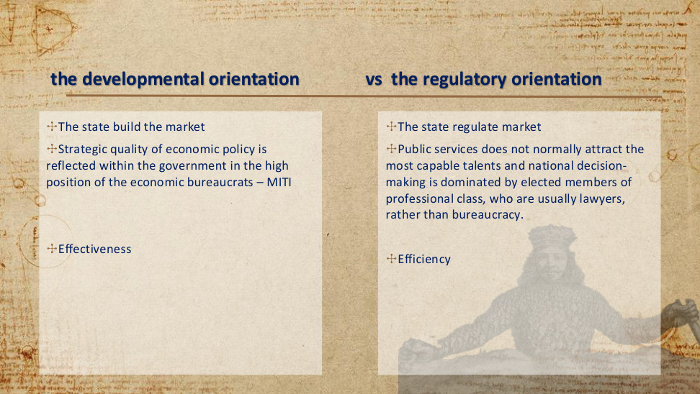
原PPT第21页 / Original slide 21

PPT中英翻译 / PPT translation
PPT English / 英文原文 | 中文翻译 / Chinese translation
The state build the market | 【发展导向】国家构建市场。
Strategic quality of economic policy is reflected within the government in the high position of the economic bureaucrats – MITI | 【发展导向】经济政策的战略性，在政府内部体现为经济官僚的高地位——例如通商产业省（MITI，简称通产省）。
Effectiveness | 【发展导向】有效性／效果：能否实现政策目标。
The state regulate market | 【规制导向】国家规制市场。
Public services does not normally attract the most capable talents and national decision-making is dominated by elected members of professional class, who are usually lawyers, rather than bureaucracy. | 【规制导向，PPT的概括】公共部门通常不吸引最顶尖的人才；国家决策由专业阶层中的民选成员主导——这些人通常有律师背景，而非由官僚体系主导。
Efficiency | 【规制导向】效率：资源投入与产出的关系。

本页核心 / Key takeaway
发展导向侧重构建市场和实现战略目标；规制导向侧重市场规则与效率。
The developmental orientation stresses market building and strategic goal attainment; the regulatory orientation stresses market rules and efficiency.

精要解析 / Essential explanation

1. 构建市场与规制市场｜Building and regulating markets
构建市场强调改变产业发展的条件，例如协调新产业所需资源；规制市场强调既有市场怎样有序运作。两者可以在现实政策中并存，课件突出的是国家角色的重心。
Market building changes conditions for industrial development, such as coordinating resources for new industries. Market regulation concerns orderly market operation. Both may coexist in practice; the slide contrasts the main emphasis of state roles.

2. 效果与效率｜Effectiveness and efficiency
效果看“目标有没有达到”，效率看“投入怎样转化为产出”。某项产业扶持即使促进升级，也要另看资源成本；不能用目标达成直接证明资源使用最有效率。
Effectiveness asks whether a goal is achieved; efficiency concerns output relative to inputs. Industrial support may promote upgrading, but its resource costs require separate assessment. Goal attainment alone does not prove efficient resource use.

3. 经济官僚的作用｜The role of economic bureaucracy
MITI的地位体现政府对专业知识、战略制定与跨部门协调的重视。官僚能力是把发展目标转为行动的组织条件，不能仅凭一个部门存在就推定国家能力强。
MITI’s position reflects the value placed on expertise, strategy and coordination. Bureaucratic capacity helps translate developmental goals into action, but the existence of a ministry alone does not establish strong state capacity.

4. 比较时保留现实差异｜Allow for real-world variation
课件的官僚与民选专业阶层对照，是帮助理解决策风格的理想类型。实际国家可能兼有两种机制，不能把“律师主导、公共部门缺乏人才”当作普遍事实。
The contrast between bureaucracy and elected professionals is an ideal-type comparison of decision-making styles. Actual states may combine both mechanisms; claims about lawyers or weak public-sector recruitment should not be treated as universal facts.

22｜the developmental orientation vs the regulatory orientation｜发展导向与规制导向
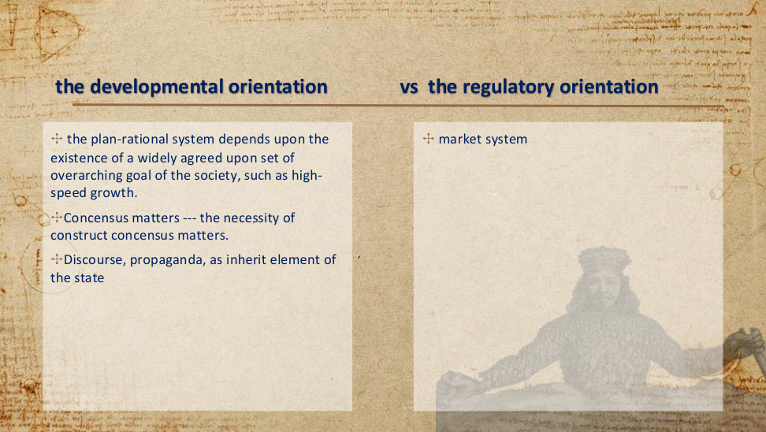
原PPT第22页 / Original slide 22

PPT中英翻译 / PPT translation
PPT English / 英文原文 | 中文翻译 / Chinese translation
the plan-rational system depends upon the existence of a widely agreed upon set of overarching goal of the society, such as high-speed growth. | 【发展导向】计划理性体系依赖社会对一组总体目标形成广泛共识，例如高速增长。
Concensus matters --- the necessity of construct concensus matters. | 【发展导向】共识很重要——建构共识的必要性很重要。（原文拼写与语法有误。）
Discourse, propaganda, as inherit element of the state | 【发展导向】话语、宣传是国家的内在组成要素。（inherit 按语境应为 inherent。）
market system | 【规制导向】市场体系。

本页核心 / Key takeaway
计划理性要求围绕共同发展目标协调政策，而共识需要主动建构。
Plan rationality coordinates policy around shared development goals, and that consensus must be actively constructed.

精要解析 / Essential explanation

1. 共同目标怎样协调政策｜How shared goals coordinate policy
当高速增长成为共同认可的目标，财政、金融和教育等政策就能围绕它安排优先次序。计划理性强调政策之间的连贯性，而不是每项政策各自行动。
When rapid growth becomes a shared goal, fiscal, financial and education policies can align their priorities with it. Plan rationality stresses coherence among policies rather than separate action by each policy area.

2. 共识为何需要建构｜Why consensus must be constructed
长期发展可能要求眼前投入或利益调整，并非所有群体天然同意。国家需要说明未来收益、协调分歧并争取支持；“共同目标”是组织政治行动的条件。
Long-term development may require immediate investment or adjustments in interests, so agreement cannot be assumed. The state explains future benefits, coordinates disagreements and seeks support; shared goals enable organised political action.

3. 话语与宣传的作用｜The role of discourse and propaganda
政策话语把增长描述为共同任务，有助于说明牺牲和投入的理由。但宣传本身不能代替执行能力，也不意味着社会不存在利益冲突或不同的发展主张。
Policy discourse presents growth as a shared task and explains the reasons for investment or sacrifice. Propaganda cannot substitute for implementation capacity, nor does it remove conflicting interests or alternative visions of development.

易错辨析 / Key distinction
计划理性不等于全面计划经济；发展型国家仍可以使用市场、私营企业和价格机制。
Plan rationality does not mean a fully planned economy; developmental states may still use markets, private firms and prices.

23｜the developmental orientation vs the regulatory orientation｜发展导向与规制导向
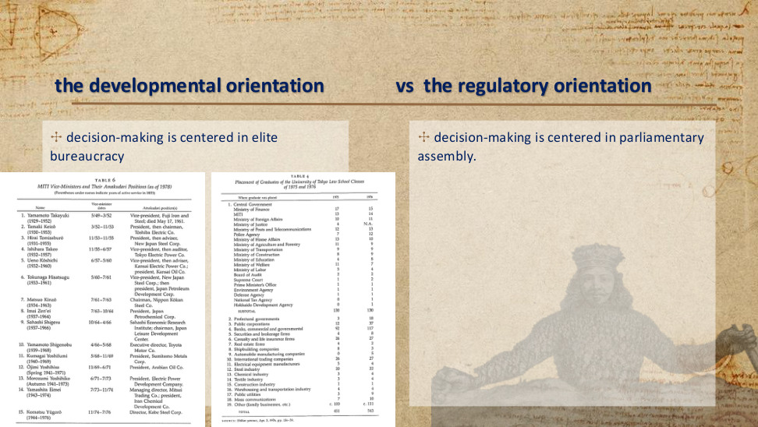
原PPT第23页 / Original slide 23

PPT中英翻译 / PPT translation
PPT English / 英文原文 | 中文翻译 / Chinese translation
decision-making is centered in elite bureaucracy | 【发展导向】决策以精英官僚体系为中心。
decision-making is centered in parliamentary assembly. | 【规制导向】决策以议会为中心。
(Parentheses under names indicate years of active service in MITI) | （姓名下方括号内表示在通产省任职的年份。）
SOURCE: Shūkan yomiuri, Apr. 3, 1976, pp. 156–59. | 右表来源：《周刊读卖》，1976年4月3日，第156–159页。

TABLE 6. MITI Vice-Ministers and Their Amakudari Positions (as of 1978)｜表6：通产省事务次官及其“天下り”去向（截至1978年）
Name (MITI service)｜姓名（通产省任职期） | Vice-minister dates｜事务次官任期（月/年） | Amakudari position(s)｜离任后职位
Yamamoto Takayuki (1929–1952) | 5/49–3/52 | Vice-president, Fuji Iron and Steel; died May 17, 1961.｜富士钢铁副总裁；1961年5月17日逝世。
Tamaki Keizō (1930–1953) | 3/52–11/53 | President, then chairman, Toshiba Electric Co.｜东芝电气总裁，后任董事长。
Hirai Tomisaburō (1931–1955) | 11/53–11/55 | President, then adviser, New Japan Steel Corp.｜新日本制铁总裁，后任顾问。
Ishihara Takeo (1932–1957) | 11/55–6/57 | Vice-president, then auditor, Tokyo Electric Power Co.｜东京电力副总裁，后任监察役。
Ueno Kōshichi (1932–1960) | 6/57–5/60 | Vice-president, then adviser, Kansai Electric Power Co.; president, Kansai Oil Co.｜关西电力副总裁、后任顾问；关西石油总裁。
Tokunaga Hisatsugu (1933–1961) | 5/60–7/61 | Vice-president, New Japan Steel Corp.; then president, Japan Petroleum Development Corp.｜新日本制铁副总裁；后任日本石油开发公司总裁。
Matsuo Kinzō (1934–1963) | 7/61–7/63 | Chairman, Nippon Kōkan Steel Co.｜日本钢管董事长。
Imai Zen’ei (1937–1964) | 7/63–10/64 | President, Japan Petrochemical Corp.｜日本石油化学公司总裁。
Sahashi Shigeru (1937–1966) | 10/64–4/66 | Sahashi Economic Research Institute; chairman, Japan Leisure Development Center.｜佐桥经济研究所；日本休闲开发中心董事长。
Yamamoto Shigenobu (1939–1968) | 4/66–5/68 | Executive director, Toyota Motor Co.｜丰田汽车执行董事。
Kumagai Yoshifumi (1940–1969) | 5/68–11/69 | President, Sumitomo Metals Corp.｜住友金属总裁。
Ōjimi Yoshihisa (Spring 1941–1971｜1941年春–1971年) | 11/69–6/71 | President, Arabian Oil Co.｜阿拉伯石油公司总裁。
Morozumi Yoshihiko (Autumn 1941–1973｜1941年秋–1973年) | 6/71–7/73 | President, Electric Power Development Company.｜电源开发公司总裁。
Yamashita Eimei (1943–1974) | 7/73–11/74 | Managing director, Mitsui Trading Co.; president, Iran Chemical Development Co.｜三井贸易常务董事；伊朗化学开发公司总裁。
Komatsu Yūgorō (1944–1976) | 11/74–7/76 | Director, Kobe Steel Corp.｜神户制钢董事。

TABLE 4. Placement of Graduates of the University of Tokyo Law School Classes of 1975 and 1976｜表4：东京大学法学部1975、1976届毕业生的就业去向
Where graduate was placed｜就业去向 | 1975 | 1976
1. Central Government｜1.中央政府
Ministry of Finance｜大藏省 | 17 | 15
MITI｜通商产业省 | 13 | 14
Ministry of Foreign Affairs｜外务省 | 10 | 11
Ministry of Justice｜法务省 | 4 | N.A.（无可用数据）
Ministry of Posts and Telecommunications｜邮政省 | 12 | 13
Police Agency｜警察厅 | 7 | 12
Ministry of Home Affairs｜自治省 | 13 | 10
Ministry of Agriculture and Forestry｜农林省 | 11 | 9
Ministry of Transportation｜运输省 | 9 | 9
Ministry of Construction｜建设省 | 8 | 9
Ministry of Education｜文部省 | 4 | 8
Ministry of Welfare｜厚生省 | 11 | 7
Ministry of Labor｜劳动省 | 5 | 4
Board of Audit｜会计检查院 | 2 | 2
Supreme Court｜最高裁判所 | 1 | 2
Prime Minister’s Office｜总理府 | 1 | 1
Environment Agency｜环境厅 | 1 | 1
Defense Agency｜防卫厅 | 1 | 1
National Tax Agency｜国税厅 | 0 | 1
Hokkaido Development Agency｜北海道开发厅 | 0 | 1
SUBTOTAL｜小计 | 130 | 130
2. Prefectural governments｜2.都道府县政府 | 3 | 18
3. Public corporations｜3.公共企业 | 12 | 37
4. Banks, commercial and governmental｜4.商业银行及政府银行 | 92 | 117
5. Securities and brokerage firms｜5.证券与经纪公司 | 4 | 8
6. Casualty and life insurance firms｜6.财产及人寿保险公司 | 26 | 27
7. Real estate firms｜7.房地产公司 | 4 | 2
8. Shipbuilding companies｜8.造船公司 | 8 | 3
9. Automobile manufacturing companies｜9.汽车制造公司 | 0 | 5
10. International trading companies｜10.国际贸易公司 | 26 | 27
11. Electrical equipment manufacturers｜11.电气设备制造商 | 5 | 4
12. Steel industry｜12.钢铁业 | 20 | 22
13. Chemical industry｜13.化工业 | 3 | 4
14. Textile industry｜14.纺织业 | 3 | 4
15. Construction industry｜15.建筑业 | 1 | 1
16. Warehousing and transportation industry｜16.仓储与运输业 | 4 | 4
17. Public utilities｜17.公用事业 | 3 | 9
18. Mass communications｜18.大众传播业 | 7 | 10
19. Other (family businesses, etc.)｜19.其他（家族企业等） | c. 100（约100） | c. 111（约111）
TOTAL｜合计 | 451 | 543

本页核心 / Key takeaway
两种导向的区别之一，是政策决策中心：精英官僚体系或议会。
One distinction is the centre of policy decision-making: elite bureaucracy or parliament.

精要解析 / Essential explanation

1. 决策中心决定什么｜What the decision-making centre shapes
精英官僚居于中心，意味着专业行政机构在议程、方案与协调中权重较大；议会居于中心，则更突出民选代表的决策作用。比较对象是主导机制而非机构有无。
A bureaucratic centre gives expert administrative bodies greater weight in agendas, policy design and coordination. A parliamentary centre emphasises elected representatives. The contrast concerns the dominant mechanism, not whether either institution exists.

2. 两张表说明什么｜What the tables illustrate
左表展示通产省高级官员离任后的企业职位，右表展示东京大学法学毕业生去向。它们分别说明政商联系与精英招募，无需逐个背姓名，也不能单独证明政策有效。
The left table traces MITI officials’ later corporate positions; the right shows destinations of Tokyo law graduates. They illustrate state–business links and elite recruitment. Individual names need not be memorised, and the tables do not prove policy effectiveness.

3. 联系与自主性的张力｜Connections and autonomy
政商网络可传递信息、便利协调，也可能带来偏袒或利益俘获。联系前文“相对自主的官僚体系”：发展协调既需要接触企业，也需要保持公共目标和约束能力。
State–business networks can transmit information and facilitate coordination, but may also permit favouritism or capture. Relate this to bureaucratic insulation: developmental coordination needs business contact alongside public goals and the ability to discipline firms.

易错辨析 / Key distinction
官僚居于核心不等于没有议会或选举；这里比较的是主要决策重心。
A central bureaucracy does not imply the absence of a parliament or elections; the comparison concerns the main decision-making locus.

24｜Welfare of East Asia｜东亚的福利

原PPT第24页 / Original slide 24

PPT中英翻译 / PPT translation
PPT English / 英文原文 | 中文翻译 / Chinese translation

本页核心 / Key takeaway
从经济发展转向福利问题：观察国家、市场、企业与家庭怎样分担保障责任。
The focus shifts from economic development to welfare: how the state, market, enterprises and households share responsibility.

精要解析 / Essential explanation

1. 阅读后续页面｜Reading the following slides
这是章节过渡页。后续要结合福利结果、就业机会、支出来源与具体制度，理解东亚福利；不要只看政府支出一项指标。
This is a section transition. The following slides combine welfare outcomes, employment, spending sources and institutions; public spending alone is insufficient.

25｜The developmentalist state vs the regulatory state｜发展型国家与规制型国家
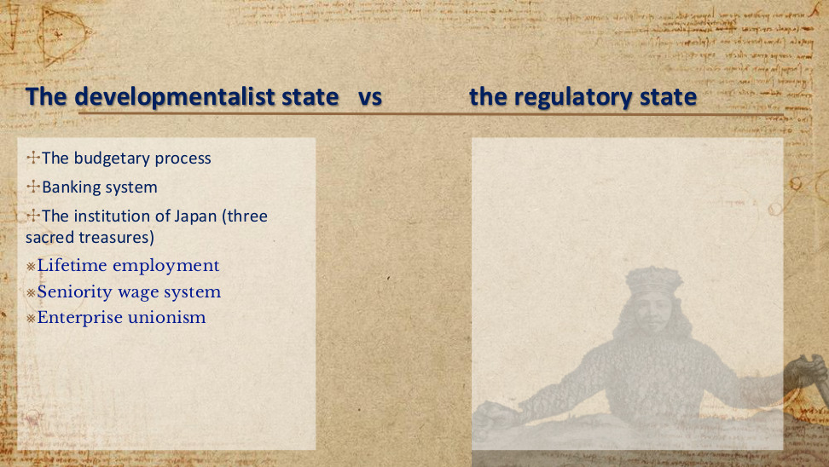
原PPT第25页 / Original slide 25

PPT中英翻译 / PPT translation
PPT English / 英文原文 | 中文翻译 / Chinese translation
The budgetary process | 预算过程
Banking system | 银行体系
The institution of Japan (three sacred treasures) | 日本的制度（“三大瑰宝”）
Lifetime employment | 终身雇佣
Seniority wage system | 年功工资制（工资与资历、工龄等相联系）
Enterprise unionism | 企业工会主义／以企业为单位组织工会

本页核心 / Key takeaway
日本的“三大瑰宝”是终身雇佣、年功工资、企业工会，使就业关系承载部分保障功能。
Japan’s three employment institutions—lifetime employment, seniority wages and enterprise unionism—make employment a channel of welfare protection.

精要解析 / Essential explanation

1. 终身雇佣：稳定关系｜Lifetime employment: stable relationships
长期雇佣使劳动者对持续收入更有预期，也有利于企业培养内部技能。这里的保障主要通过稳定的企业成员身份实现，并不是人人自动获得的国家福利权利。
Long-term employment makes continuing income more predictable and supports the development of firm-specific skills. Protection operates through stable company membership rather than an automatic state welfare entitlement available to everyone.

2. 年功工资：收入随服务累积｜Seniority wages: progression with service
年功工资把收入增长同长期服务联系起来，可支持核心雇员的家庭生活。与此同时，保障依赖持续留在相应就业关系中，离职或未进入核心岗位者未必同样受益。
Seniority wages link income progression to continuing service and can support core employees’ families. The arrangement depends on sustained employment, however; leavers and workers outside core positions may not receive comparable benefits.

3. 企业工会：协商范围在企业内｜Enterprise unions: firm-level negotiation
企业工会主要在本企业内部协商工资和劳动条件，使保障与企业经营相联系。三项制度合起来解释企业如何承载福利，也帮助理解后来男性养家者模式的选择性保护。
Enterprise unions negotiate pay and working conditions mainly within individual firms, linking protection to company circumstances. Together, the three institutions explain firm-based welfare and the selective protection discussed later through the male breadwinner model.

易错辨析 / Key distinction
这些制度主要描述特定历史阶段大型企业的核心正式雇员，不能理解为所有日本劳动者都享有终身保障；企业工会也不等于行业工会。
These institutions mainly describe core regular employees in large firms during a particular historical period, not lifelong protection for every Japanese worker; enterprise unions are not industry-wide unions.

26｜Welfare of East Asia｜东亚的福利
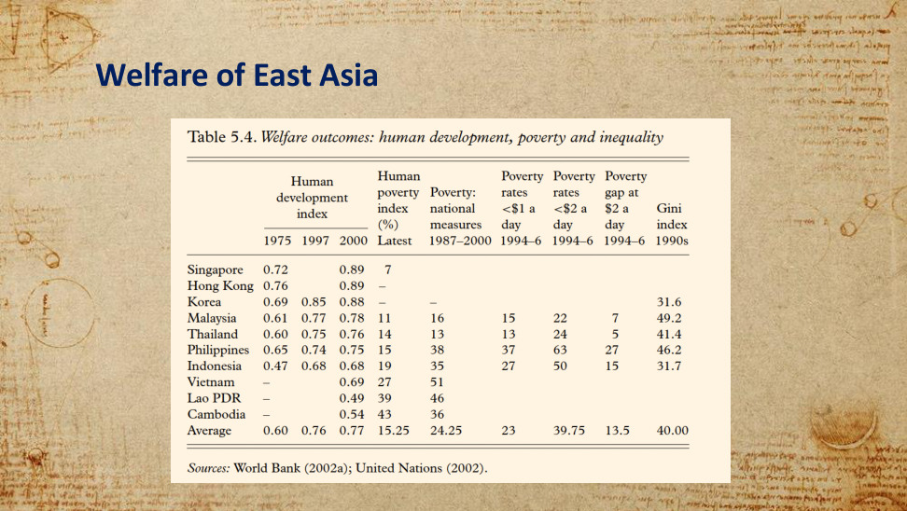
原PPT第26页 / Original slide 26

PPT中英翻译 / PPT translation
PPT English / 英文原文 | 中文翻译 / Chinese translation
Sources: World Bank (2002a); United Nations (2002). | 来源：世界银行（2002a）；联合国（2002）。

Table 5.4. Welfare outcomes: human development, poverty and inequality｜表5.4：福利结果——人类发展、贫困与不平等
Economy｜经济体 | HDI 1975｜人类发展指数1975 | HDI 1997｜人类发展指数1997 | HDI 2000｜人类发展指数2000 | Human poverty index (%) Latest｜人类贫困指数（%），最新 | Poverty: national measures 1987–2000｜本国标准贫困指标1987–2000 | Poverty rates <$1 a day 1994–6｜每日低于1美元贫困率1994–96 | Poverty rates <$2 a day 1994–6｜每日低于2美元贫困率1994–96 | Poverty gap at $2 a day 1994–6｜每日2美元标准贫困缺口1994–96 | Gini index 1990s｜基尼指数1990年代
Singapore｜新加坡 | 0.72 |  | 0.89 | 7
Hong Kong｜香港 | 0.76 |  | 0.89 | –
Korea｜韩国 | 0.69 | 0.85 | 0.88 | – | – |  |  |  | 31.6
Malaysia｜马来西亚 | 0.61 | 0.77 | 0.78 | 11 | 16 | 15 | 22 | 7 | 49.2
Thailand｜泰国 | 0.60 | 0.75 | 0.76 | 14 | 13 | 13 | 24 | 5 | 41.4
Philippines｜菲律宾 | 0.65 | 0.74 | 0.75 | 15 | 38 | 37 | 63 | 27 | 46.2
Indonesia｜印度尼西亚 | 0.47 | 0.68 | 0.68 | 19 | 35 | 27 | 50 | 15 | 31.7
Vietnam｜越南 | – |  | 0.69 | 27 | 51
Lao PDR｜老挝 | – |  | 0.49 | 39 | 46
Cambodia｜柬埔寨 | – |  | 0.54 | 43 | 36
Average｜平均 | 0.60 | 0.76 | 0.77 | 15.25 | 24.25 | 23 | 39.75 | 13.5 | 40.00

本页核心 / Key takeaway
福利结果具有多个维度：人类发展、贫困与不平等必须分别观察。
Welfare outcomes are multidimensional: human development, poverty and inequality must be examined separately.

精要解析 / Essential explanation

1. 人类发展：不只收入｜Human development: beyond income
人类发展指数（HDI）综合健康、教育与生活水平，数值越高通常越好；人类贫困指数（HPI）关注基本能力的匮乏，数值越低越好。两者都比单看收入更宽。
The HDI combines health, education and living standards, with higher values generally better. The HPI concerns deprivation in basic capabilities, with lower values better. Both extend assessment beyond income alone.

2. 贫困与不平等分别问什么｜Poverty and inequality ask different questions
贫困率看多少人低于贫困线，贫困缺口看他们距贫困线有多远，基尼指数看整体收入分配。贫困减少与分配更平等可能同时发生，但不能用一个指标代替另一个。
The poverty rate measures how many fall below a threshold; the poverty gap measures their shortfall; the Gini index describes income distribution. Falling poverty and greater equality may coincide, but these indicators cannot substitute for one another.

3. 从结果回到制度｜Link outcomes to institutions
表内人类发展改善与贫困、不平等可以并存。比较东亚福利时，可先说明哪项结果改善，再问就业、家庭、企业和公共制度怎样分担保障，避免把增长直接等同于全民受益。
Improving human development can coexist with poverty and inequality. Identify which outcome improved, then examine how employment, families, firms and public programmes provide protection. Growth alone does not establish that every group benefits.

易错辨析 / Key distinction
各列年份不同，属于历史资料；空白或破折号不能当作零。表中的每日1美元／2美元是当时统计口径，不是今天可直接套用的贫困线。
Columns refer to different historical years; blanks and dashes are not zeros. The $1/$2-a-day thresholds are those used in the source and should not be applied directly as today’s poverty lines.

27｜Welfare of East Asia｜东亚的福利
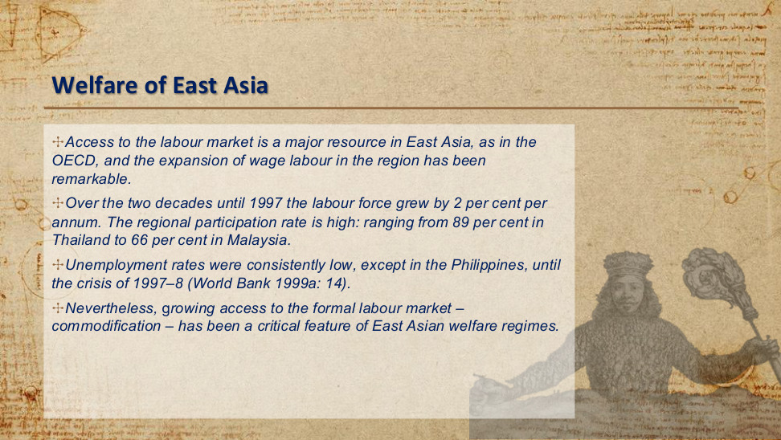
原PPT第27页 / Original slide 27

PPT中英翻译 / PPT translation
PPT English / 英文原文 | 中文翻译 / Chinese translation
Access to the labour market is a major resource in East Asia, as in the OECD, and the expansion of wage labour in the region has been remarkable. | 与经合组织（OECD）地区一样，进入劳动力市场是东亚获得生活资源的重要途径；该地区工资劳动的扩展十分显著。
Over the two decades until 1997 the labour force grew by 2 per cent per annum. The regional participation rate is high: ranging from 89 per cent in Thailand to 66 per cent in Malaysia. | 截至1997年的此前二十年，劳动力规模每年增长2%。地区劳动力参与率较高：从泰国的89%到马来西亚的66%不等。
Unemployment rates were consistently low, except in the Philippines, until the crisis of 1997–8 (World Bank 1999a: 14). | 在1997—1998年危机之前，除菲律宾外，失业率一直较低（世界银行1999a：14）。
Nevertheless, growing access to the formal labour market – commodification – has been a critical feature of East Asian welfare regimes. | 尽管如此，进入正规劳动力市场的机会扩大——即商品化——一直是东亚福利体制的重要特征。

本页核心 / Key takeaway
东亚福利的重要渠道是获得有薪就业；这种保障依赖出售劳动力，属于商品化。
Access to paid work is a major welfare channel in East Asia; protection that depends on selling labour reflects commodification.

精要解析 / Essential explanation

1. 工资就业怎样支持生活｜How wage employment supports livelihoods
有薪就业把经济增长转化为家庭收入，并可能连接企业福利。因此劳动市场是重要保障渠道；但收入取决于能否进入并持续留在有保障的岗位中，而不只是经济总体增长。
Paid employment converts growth into household income and may provide access to enterprise benefits. Labour-market protection therefore depends on entering and remaining in protected jobs, rather than on aggregate economic growth alone.

2. 把三个统计量分清｜Distinguish the three statistics
劳动力规模增长指人数变化，参与率看相关人口中进入劳动力市场的比例，失业率看劳动力中的失业者。三者回答不同问题；原图未交代89%／66%的年龄与性别口径。
Labour-force growth measures changes in numbers; participation relates the labour force to a relevant population; unemployment counts unemployed people within the labour force. They answer different questions, and the slide leaves the age and sex coverage unspecified.

3. 危机暴露哪种依赖｜What a crisis exposes
如果生活保障依赖工资与企业成员身份，失业或非正规就业会削弱这种保障。1997—1998年危机这一时间界线，提醒我们不能把此前低失业率视作长期不变的制度保证。
When protection depends on wages and company membership, unemployment or informal work can weaken it. The 1997–98 crisis marks a reminder that earlier low unemployment was not a permanent institutional guarantee.

4. 听课宝对照：就业与退出｜Listening-summary link: work and exit
听课宝前课内容强调，劳动市场制度还包括退休退出与失业补偿。用它对照本页：就业机会说明在职收入来源，退出后的保障则需另查养老金和社会权利，不能互相替代。
The previous-lesson listening summary includes retirement and unemployment compensation within labour-market institutions. Employment opportunities explain earnings while working; protection after exit requires separate examination of pensions and social rights. Neither can replace the other.

易错辨析 / Key distinction
商品化＝依靠市场就业获得生活资源；去商品化＝即使暂不出售劳动力，也能凭社会权利维持基本生活。高就业率本身不等于高去商品化。
Commodification means relying on market employment for a livelihood; decommodification means maintaining a basic livelihood through social rights even without selling labour. High employment is not itself high decommodification.

28｜Welfare of East Asia｜东亚的福利
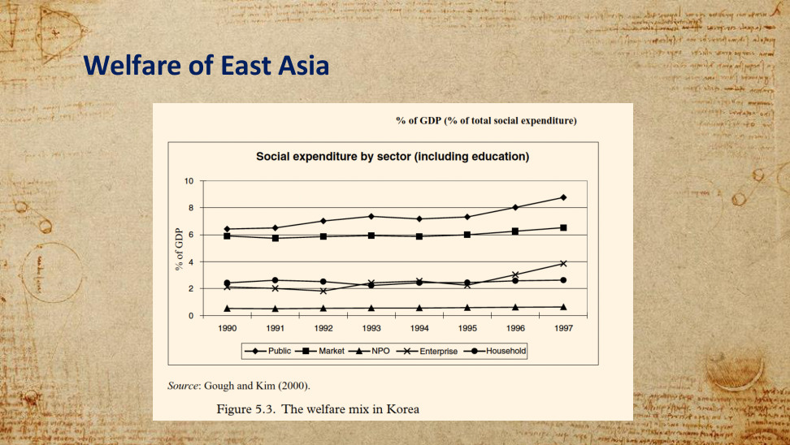
原PPT第28页 / Original slide 28

PPT中英翻译 / PPT translation
PPT English / 英文原文 | 中文翻译 / Chinese translation
% of GDP (% of total social expenditure) | 占GDP的百分比（占社会总支出的百分比）〔原图上方文字；纵轴实际标示为占GDP百分比〕
Social expenditure by sector (including education) | 按部门划分的社会支出（含教育）
% of GDP | 占GDP的百分比（纵轴）
1990, 1991, 1992, 1993, 1994, 1995, 1996, 1997 | 1990—1997年（横轴）
Public; Market; NPO; Enterprise; Household | 公共部门；市场；非营利组织（NPO）；企业；家庭
Source: Gough and Kim (2000). | 来源：Gough与Kim（2000）。
Figure 5.3. The welfare mix in Korea | 图5.3：韩国的福利混合

本页核心 / Key takeaway
韩国的福利混合显示：公共部门、市场、企业、家庭与非营利组织共同承担社会支出。
Korea’s welfare mix shows social spending shared by the public sector, market, enterprises, households and nonprofit organisations.

精要解析 / Essential explanation

1. 先读出主要结构｜Read the main structure
1990—1997年公共部门始终是图中最高的一条，市场为第二大系列；企业与家庭持续承担支出，非营利部门较小。因此本图同时展示国家参与和福利来源多元。
From 1990 to 1997, public spending is the highest series and market spending the second largest. Enterprises and households contribute continuously, while nonprofits are smaller. The chart shows both state participation and diverse welfare sources.

2. 福利混合为什么重要｜Why the welfare mix matters
只看公共支出，会漏掉家庭自付、企业福利及市场化供给。不同渠道也可能保护不同群体：稳定雇员、非就业者和依赖家庭照护者的保障来源未必相同。
Public spending alone misses household payments, enterprise benefits and market provision. These channels may protect different groups: secure employees, non-employed people and those relying on family care need not share the same sources of protection.

3. 趋势能说明到哪一步｜What trends can establish
公共支出上升并不表示其他主体退出，也不能仅凭曲线判断福利是否公平或充分。图表回答“谁支出、占GDP多少”，覆盖资格与受益分配仍要结合制度资料。
Rising public spending does not mean other actors withdraw, nor does a trend establish fairness or adequacy. The chart identifies spending sources and GDP shares; eligibility and the distribution of benefits require institutional evidence.

易错辨析 / Key distinction
图中是各部门支出占GDP的比重，不是各部门占总福利支出的份额；这里依据线条读趋势，不把估读值写成精确统计。
The y-axis reports each sector’s expenditure as a share of GDP, not its share of total welfare spending. Read the trends without treating visually estimated values as exact statistics.

29｜Welfare of East Asia｜东亚的福利
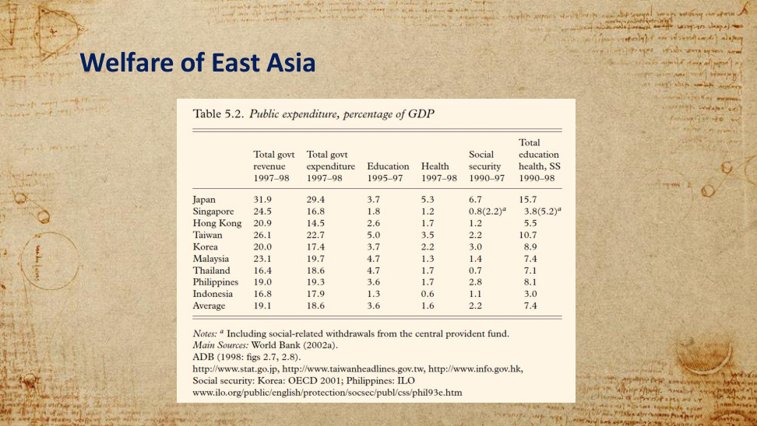
原PPT第29页 / Original slide 29

PPT中英翻译 / PPT translation
PPT English / 英文原文 | 中文翻译 / Chinese translation
Notes: a Including social-related withdrawals from the central provident fund. | 注a：包括从中央公积金提取的社会福利相关款项。
Main Sources: World Bank (2002a). ADB (1998: figs 2.7, 2.8). | 主要来源：世界银行（2002a）；亚洲开发银行（1998：图2.7、2.8）。
http://www.stat.go.jp, http://www.taiwanheadlines.gov.tw, http://www.info.gov.hk, | 其他来源网址：http://www.stat.go.jp；http://www.taiwanheadlines.gov.tw；http://www.info.gov.hk。
Social security: Korea: OECD 2001; Philippines: ILO | 社会保障数据：韩国——OECD（2001）；菲律宾——国际劳工组织（ILO）。
www.ilo.org/public/english/protection/socsec/publ/css/phil93e.htm | 原表所列网址：www.ilo.org/public/english/protection/socsec/publ/css/phil93e.htm。

Table 5.2. Public expenditure, percentage of GDP｜表5.2：公共支出，占GDP百分比
Economy｜经济体 | Total govt revenue 1997–98｜政府总收入1997–98 | Total govt expenditure 1997–98｜政府总支出1997–98 | Education 1995–97｜教育1995–97 | Health 1997–98｜医疗卫生1997–98 | Social security 1990–97｜社会保障1990–97 | Total education health, SS 1990–98｜教育、医疗、社会保障合计1990–98
Japan｜日本 | 31.9 | 29.4 | 3.7 | 5.3 | 6.7 | 15.7
Singapore｜新加坡 | 24.5 | 16.8 | 1.8 | 1.2 | 0.8 (2.2)ᵃ | 3.8 (5.2)ᵃ
Hong Kong｜香港 | 20.9 | 14.5 | 2.6 | 1.7 | 1.2 | 5.5
Taiwan｜台湾 | 26.1 | 22.7 | 5.0 | 3.5 | 2.2 | 10.7
Korea｜韩国 | 20.0 | 17.4 | 3.7 | 2.2 | 3.0 | 8.9
Malaysia｜马来西亚 | 23.1 | 19.7 | 4.7 | 1.3 | 1.4 | 7.4
Thailand｜泰国 | 16.4 | 18.6 | 4.7 | 1.7 | 0.7 | 7.1
Philippines｜菲律宾 | 19.0 | 19.3 | 3.6 | 1.7 | 2.8 | 8.1
Indonesia｜印度尼西亚 | 16.8 | 17.9 | 1.3 | 0.6 | 1.1 | 3.0
Average｜平均（按原表保留） | 19.1 | 18.6 | 3.6 | 1.6 | 2.2 | 7.4

本页核心 / Key takeaway
判断福利投入，要区分政府总支出与教育、医疗、社会保障等具体支出。
Assessing welfare effort requires distinguishing total government expenditure from spending on education, health and social security.

精要解析 / Essential explanation

1. 总支出不等于福利支出｜Total spending is not welfare spending
政府总支出还包括许多非福利项目；教育、医疗和社会保障则展示具体投入方向。复习时先看列标题与年份，再比较支出结构，避免把“大政府”直接等同于高福利。
Total government expenditure includes many non-welfare items, whereas education, health and social security show particular priorities. Check column headings and years before comparing composition; a large government does not automatically imply extensive welfare provision.

2. 怎样比较表内经济体｜Compare the economies shown
日本的社会保障及三项合计高于表内多数其他经济体，说明东亚内部存在差异。解释低公共投入时，还需联系第28页的家庭、企业与市场渠道，不能直接断言“没有福利”。
Japan’s social-security and combined spending exceed those of most other economies shown, indicating variation within East Asia. Lower public spending must also be read alongside household, enterprise and market channels, rather than taken as an absence of welfare.

3. 联系后文生产主义｜Link to later productivism
教育与基础医疗可被理解为培育劳动能力的投入，社会保障更直接关联风险保护。但仅凭花钱多少不能确定政策动机，还要看目标、受益对象和资格条件，后文将进一步解释。
Education and basic health may build productive capabilities, while social security more directly addresses risks. Spending amounts alone cannot establish policy motives; examine goals, beneficiaries and eligibility, which the later productivist analysis develops.

易错辨析 / Key distinction
单位均为占GDP百分比，各列年份不同。新加坡括号值按注a纳入公积金相关提取；不能把括号内外当作两个年份。
All values are percentages of GDP and column years differ. Singapore’s bracketed values include the provident-fund withdrawals in note a; they are not observations for a second year.

30｜Welfare of East Asia｜东亚的福利
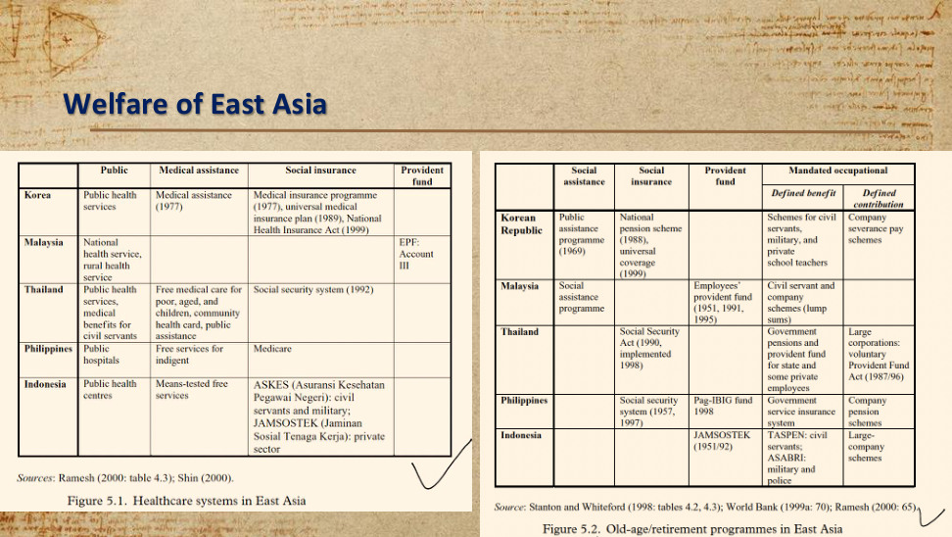
原PPT第30页 / Original slide 30

PPT中英翻译 / PPT translation
PPT English / 英文原文 | 中文翻译 / Chinese translation
Sources: Ramesh (2000: table 4.3); Shin (2000). | 医疗表来源：Ramesh（2000：表4.3）；Shin（2000）。
Source: Stanton and Whiteford (1998: tables 4.2, 4.3); World Bank (1999a: 70); Ramesh (2000: 65). | 养老表来源：Stanton与Whiteford（1998：表4.2、4.3）；世界银行（1999a：70）；Ramesh（2000：65）。

Figure 5.1. Healthcare systems in East Asia｜图5.1：东亚医疗制度
Economy｜经济体 | Public｜公共服务 | Medical assistance｜医疗救助 | Social insurance｜社会保险 | Provident fund｜公积金
Korea｜韩国 | Public health services｜公共卫生服务 | Medical assistance (1977)｜医疗救助（1977） | Medical insurance programme (1977), universal medical insurance plan (1989), National Health Insurance Act (1999)｜医疗保险项目（1977）、全民医疗保险计划（1989）、《国民健康保险法》（1999）
Malaysia｜马来西亚 | National health service, rural health service｜国家卫生服务、农村卫生服务 |  |  | EPF: Account III｜雇员公积金：第三账户
Thailand｜泰国 | Public health services, medical benefits for civil servants｜公共卫生服务、公务员医疗福利 | Free medical care for poor, aged, and children, community health card, public assistance｜为贫困者、老年人及儿童提供免费医疗；社区健康卡；公共救助 | Social security system (1992)｜社会保障制度（1992）
Philippines｜菲律宾 | Public hospitals｜公立医院 | Free services for indigent｜为贫困者提供免费服务 | Medicare｜Medicare医疗保险
Indonesia｜印度尼西亚 | Public health centres｜公共卫生中心 | Means-tested free services｜经过经济状况审查的免费服务 | ASKES (Asuransi Kesehatan Pegawai Negeri): civil servants and military; JAMSOSTEK (Jaminan Sosial Tenaga Kerja): private sector｜ASKES（公务员健康保险）：公务员及军人；JAMSOSTEK（劳动者社会保障）：私营部门

Figure 5.2. Old-age/retirement programmes in East Asia｜图5.2：东亚老年／退休保障计划
Economy｜经济体 | Social assistance｜社会救助 | Social insurance｜社会保险 | Provident fund｜公积金 | Mandated occupational: Defined benefit｜强制性职业计划：确定给付（DB） | Mandated occupational: Defined contribution｜强制性职业计划：确定缴费（DC）
Korean Republic｜韩国 | Public assistance programme (1969)｜公共救助计划（1969） | National pension scheme (1988), universal coverage (1999)｜国民年金计划（1988）、全民覆盖（1999，按原表表述） |  | Schemes for civil servants, military, and private school teachers｜公务员、军人和私立学校教师计划 | Company severance pay schemes｜企业离职补偿计划
Malaysia｜马来西亚 | Social assistance programme｜社会救助计划 |  | Employees’ provident fund (1951, 1991, 1995)｜雇员公积金（1951、1991、1995） | Civil servant and company schemes (lump sums)｜公务员及企业计划（一次性支付）
Thailand｜泰国 |  | Social Security Act (1990, implemented 1998)｜《社会保障法》（1990，1998年实施） |  | Government pensions and provident fund for state and some private employees｜政府养老金，以及面向国家部门和部分私营部门雇员的公积金 | Large corporations: voluntary Provident Fund Act (1987/96)｜大型企业：自愿性安排，《公积金法》（1987/96，按原表）
Philippines｜菲律宾 |  | Social security system (1957, 1997)｜社会保障制度（1957、1997） | Pag-IBIG fund 1998｜Pag-IBIG基金（1998） | Government service insurance system｜政府雇员保险制度 | Company pension schemes｜企业养老金计划
Indonesia｜印度尼西亚 |  |  | JAMSOSTEK (1951/92)｜JAMSOSTEK劳动者社会保障（1951/92，按原表） | TASPEN: civil servants; ASABRI: military and police｜TASPEN：公务员；ASABRI：军人及警察 | Large-company schemes｜大型企业计划

本页核心 / Key takeaway
东亚医疗与养老由多种制度并存提供，保障资格往往与职业、缴费或经济困难有关。
East Asian healthcare and retirement combine multiple schemes, with eligibility often linked to occupation, contributions or financial need.

精要解析 / Essential explanation

1. 先分清制度资格｜Distinguish eligibility rules
社会救助主要针对需要帮助者，社会保险通常联系参保与缴费，职业计划依托特定就业关系。一个经济体可同时存在多种安排，因此不能给整张表只贴一种资格标签。
Social assistance mainly targets need, social insurance generally links protection to membership and contributions, and occupational schemes depend on particular jobs. These arrangements can coexist, so one eligibility label cannot describe the whole table.

2. 公积金与保险怎样区别｜Provident funds and insurance
公积金突出按规定积累账户资金，待遇联系积累及提取规则；社会保险通常按共同制度规则分担风险。两者都可能有强制缴费，但“强制参加”并不说明给付方式相同。
Provident funds emphasise account accumulation and withdrawal rules, while social insurance generally shares risks under common programme rules. Both may require contributions, but compulsory participation does not make their benefit arrangements identical.

3. DB与DC分别确定什么｜What DB and DC define
确定给付（DB）预先规定待遇计算规则；确定缴费（DC）预先规定缴费规则，最终待遇取决于积累等因素。要分清事先确定的是给付公式，还是缴费安排，不能仅凭名称判断保障水平。
Defined benefit specifies a benefit formula; defined contribution specifies contribution rules, with eventual benefits depending on accumulation and related factors. Identify what is predetermined; the label alone does not establish the level of protection.

4. 听课宝对照：怎样比较养老金｜Listening-summary link: comparing pensions
听课宝前课内容提醒：除了有没有养老金，还要看国家角色、职业绑定及公私部门差异。套到本表，应问谁有资格、怎样取得待遇，以及哪些群体仍可能处在制度之外。
The previous-lesson listening summary asks about state involvement, occupational links and public–private differences, beyond whether pensions exist. Apply this by checking who qualifies, how benefits are obtained and which groups may remain outside protection.

易错辨析 / Key distinction
这是约1990年代至2000年前后的历史制度图，不能作为各国现行制度说明；空格表示原表未列项目，不等于该国完全没有相关保障。
These tables describe historical arrangements around the 1990s–2000 period, not current systems. Blank cells mean no scheme is listed in the original, not necessarily a complete absence of protection.

31｜社区、公民社会与非政府组织 vs 家庭—家户｜Community, civil society and NGOs vs Family – household
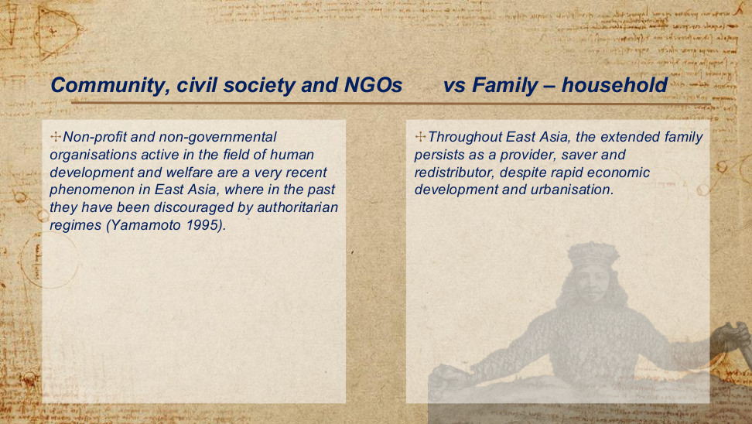
原PPT第31页 / Original slide 31

PPT中英翻译 / PPT translation
PPT English / 英文原文 | 中文翻译 / Chinese translation
Non-profit and non-governmental organisations active in the field of human development and welfare are a very recent phenomenon in East Asia, where in the past they have been discouraged by authoritarian regimes (Yamamoto 1995). | 在人类发展与福利领域活跃的非营利组织和非政府组织，在东亚是较晚近才出现的现象；过去，威权政权曾抑制这些组织的发展（Yamamoto，1995）。
Throughout East Asia, the extended family persists as a provider, saver and redistributor, despite rapid economic development and urbanisation. | 尽管经历了快速经济发展与城市化，扩展家庭在整个东亚仍持续承担供给、储蓄和再分配的角色。

本页核心 / Key takeaway
东亚福利不能只看政府与市场；扩展家庭持续承担福利供给、储蓄与再分配，而公民社会组织的发展受到历史条件影响。
East Asian welfare depends on the extended family for provision, saving and redistribution, while the development of civil society organisations reflects historical conditions.

精要解析 / Essential explanation

1. 家庭的三重功能｜Three family functions
“供给”包括照护与生活支持；“储蓄”是为家庭需要积累资源；“再分配”是在成员和代际之间转移资源。因此，家庭福利不只表现为直接发钱，也包括住房、照护与共同生活。
Provision includes care and material support; saving accumulates resources for household needs; redistribution transfers resources between members and generations. Family welfare therefore includes housing, care and shared living arrangements, as well as cash transfers.

2. NGO为何发展较晚｜Why NGOs developed later
课件把福利领域NGO发展较晚与过去的威权限制联系起来：国家允许多大的组织空间，会影响社会能否独立提供服务和表达需求。这是制度与历史解释，不能简单归因于家庭文化。
The slide links the late growth of welfare NGOs to past authoritarian restrictions. The organisational space allowed by the state affects independent service provision and the expression of needs. This is an institutional and historical explanation, not simply a family-cultural one.

3. 家庭与社会组织不可互换｜Families and civic organisations differ
家庭主要通过亲属关系分担风险，NGO则可面向家庭之外的对象提供服务。两者都属于非国家供给，但覆盖对象和资源来源不同；家庭责任重，并不自动说明社会组织也很强。
Families mainly share risks through kinship, whereas NGOs can serve people beyond the family. Both are non-state providers, but their beneficiaries and resources differ. Heavy family responsibility does not automatically imply a strong civic welfare sector.

32｜生产主义福利资本主义：第四种体制的提议｜A fourth welfare regime of productivism welfare capitalism
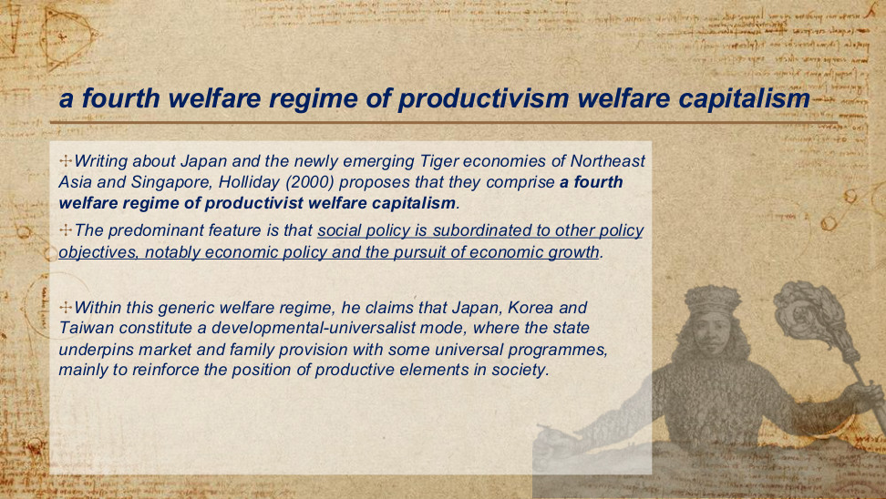
原PPT第32页 / Original slide 32

PPT中英翻译 / PPT translation
PPT English / 英文原文 | 中文翻译 / Chinese translation
Writing about Japan and the newly emerging Tiger economies of Northeast Asia and Singapore, Holliday (2000) proposes that they comprise a fourth welfare regime of productivist welfare capitalism. | Holliday（2000）讨论日本、东北亚新兴“亚洲虎”经济体及新加坡时，提出它们构成第四种福利体制，即生产主义福利资本主义。
The predominant feature is that social policy is subordinated to other policy objectives, notably economic policy and the pursuit of economic growth. | 其最突出特征是社会政策从属于其他政策目标，尤其是经济政策和经济增长的追求。
Within this generic welfare regime, he claims that Japan, Korea and Taiwan constitute a developmental-universalist mode, where the state underpins market and family provision with some universal programmes, mainly to reinforce the position of productive elements in society. | 在这一总体福利体制内，他认为日本、韩国和中国台湾构成发展—普遍主义模式：国家通过部分普遍性项目支持市场与家庭供给，主要目的是强化社会中生产性群体的地位。

本页核心 / Key takeaway
Holliday提出生产主义福利资本主义：社会政策从属于经济增长；部分普遍性福利项目也可服务于生产性群体。
Holliday proposes productivist welfare capitalism: social policy is subordinated to economic growth, and some universal programmes also support productive groups.

精要解析 / Essential explanation

1. 判断标准是政策目的｜Identify the policy purpose
识别生产主义先问“福利投入主要为了什么”。教育、医疗或收入保障若优先服务生产能力与增长，就体现生产主义逻辑；不能只凭公共项目多或政府开支高来判断体制。
Identify productivism by asking what welfare investment primarily seeks to achieve. Education, health or income protection can follow a productivist logic when productive capacity and growth take priority. Programme numbers or spending levels alone do not classify the regime.

2. 发展—普遍主义怎样组合｜How developmental universalism combines goals and coverage
“普遍主义”描述部分项目的覆盖方式，“发展”描述其增长目的。国家并非完全替代市场和家庭，而是用部分普遍性项目支撑它们，并强化生产性群体的地位。
Universalism describes the coverage of some programmes; developmentalism describes their growth purpose. The state supports market and family provision through selected universal programmes rather than replacing them completely, while strengthening productive groups.

3. 与听课宝的跨课对照｜Cross-lesson comparison with the listening summary
听课宝强调普遍权利以成员资格为基础。本页则进一步区分“谁有资格”与“政策优先追求什么”：普遍覆盖与增长导向可以并存，不能把普遍性直接等同于社会民主的平等目标。
The listening summary stresses membership-based universal rights. This slide adds a distinction between who qualifies and what policy prioritises: universal coverage can coexist with growth-oriented aims, so universality alone does not establish a social-democratic equality goal.

4. 放回整课的位置｜Place it within the lesson
前半课解释国家怎样推动增长，本页解释增长战略怎样塑造福利。把两者连起来：产业政策需要劳动力和社会支持，福利安排因而可能成为发展战略的一部分，而非独立追求平等的领域。
The first half explains how states promote growth; this page explains how growth strategies shape welfare. Industrial policy needs labour and social support, so welfare arrangements can become part of development strategy rather than an autonomous sphere pursuing equality.

易错辨析 / Key distinction
“第四种体制”是Holliday对既有分类的扩展提议，并非Esping-Andersen原始“三个世界”本来就有的第四类。
The fourth regime is Holliday’s proposed extension of existing classifications; it is not a fourth category in Esping-Andersen’s original three worlds.

33｜生产主义福利的市场与企业支柱｜A fourth welfare regime of productivism welfare capitalism
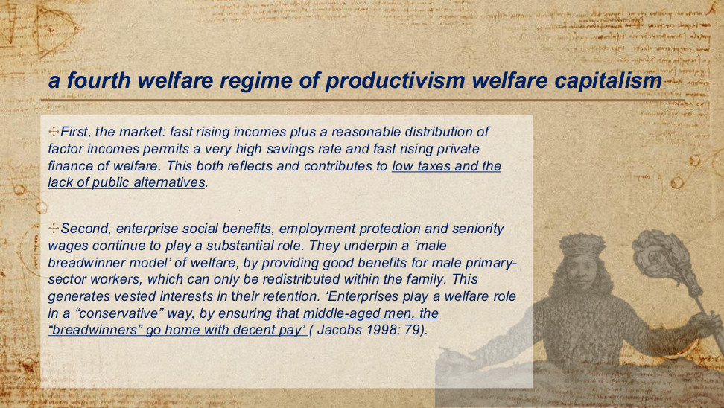
原PPT第33页 / Original slide 33

PPT中英翻译 / PPT translation
PPT English / 英文原文 | 中文翻译 / Chinese translation
First, the market: fast rising incomes plus a reasonable distribution of factor incomes permits a very high savings rate and fast rising private finance of welfare. This both reflects and contributes to low taxes and the lack of public alternatives. | 第一，市场：收入快速增长，加上较为合理的要素收入分配，使高储蓄率和迅速增加的私人福利融资成为可能。这既反映了低税收与公共替代方案的不足，也进一步促成了这种格局。
Second, enterprise social benefits, employment protection and seniority wages continue to play a substantial role. | 第二，企业社会福利、就业保护与年功工资仍发挥重要作用。
They underpin a ‘male breadwinner model’ of welfare, by providing good benefits for male primary-sector workers, which can only be redistributed within the family. This generates vested interests in their retention. | 它们通过向核心就业部门的男性劳动者提供较好福利，支撑“男性养家者模式”；这些福利只能通过家庭内部再分配给其他成员。这使受益者形成保留这些安排的既得利益。
‘Enterprises play a welfare role in a “conservative” way, by ensuring that middle-aged men, the “breadwinners” go home with decent pay’ (Jacobs 1998: 79). | “企业以一种‘保守’方式发挥福利作用：确保作为‘养家者’的中年男性能够带着体面的薪酬回家”（Jacobs，1998：79）。

本页核心 / Key takeaway
市场融资与企业福利共同支撑男性养家者模式：核心男性雇员先获得收入与福利，再通过家庭分配给其他成员。
Market finance and enterprise welfare support a male breadwinner model: core male employees receive income and benefits, then share them within the family.

精要解析 / Essential explanation

1. 市场支柱：私人融资的循环｜Market pillar: private-finance feedback
收入增长与较合理的要素收入分配，使高储蓄和家庭自付福利成为可能；低税收与有限公共替代方案又强化私人融资。这里讲的是相互支持的制度组合，不是“储蓄高就不需要福利”。
Rising incomes and a reasonable distribution of factor incomes support high savings and private welfare finance. Low taxes and limited public alternatives reinforce this arrangement. The argument concerns an institutional feedback loop, not the claim that high savings remove welfare needs.

2. 企业支柱：就业怎样提供保障｜Enterprise pillar: protection through employment
就业保护提高收入稳定性，年功工资把收入与工龄联系起来，企业福利再提供额外支持。因而，企业通过稳定工资与就业关系发挥福利作用，而不只是通过政府式的现金补助。
Employment protection stabilises earnings, seniority wages link pay to length of service, and enterprise benefits add support. Firms therefore perform a welfare role through secure employment and wages, not only through cash benefits resembling government transfers.

3. 家庭再分配及其边界｜Family redistribution and its limits
核心男性雇员先取得较好收入与福利，其他成员通过家庭关系间接受益。这说明保障具有选择性：处于不稳定就业或核心部门之外的人，未必能获得相同的企业保障。
Core male employees receive stronger earnings and benefits, while other members benefit indirectly through family ties. Protection is therefore selective: workers in insecure jobs or outside the core sector may not obtain comparable enterprise protection.

4. 既得利益为何影响改革｜Why vested interests matter
课件指出受益群体会希望保留既有安排。对稳定就业者而言，企业福利是实际保障，因此即使制度存在覆盖缺口，改革也可能遇到阻力；分析时要同时看受益者与未被充分覆盖者。
The slide notes that beneficiaries have interests in preserving existing arrangements. Enterprise welfare gives secure workers real protection, so reform can face resistance even where coverage gaps exist. Examine both the beneficiaries and those who remain insufficiently protected.

易错辨析 / Key distinction
这里的primary-sector workers指核心／主要劳动力市场中的雇员，不是农业等“第一产业劳动者”。
Here, primary-sector workers means employees in the core or primary labour-market sector, not workers in primary industries such as agriculture.

34｜生产主义福利的家庭支柱｜A fourth welfare regime of productivism welfare capitalism
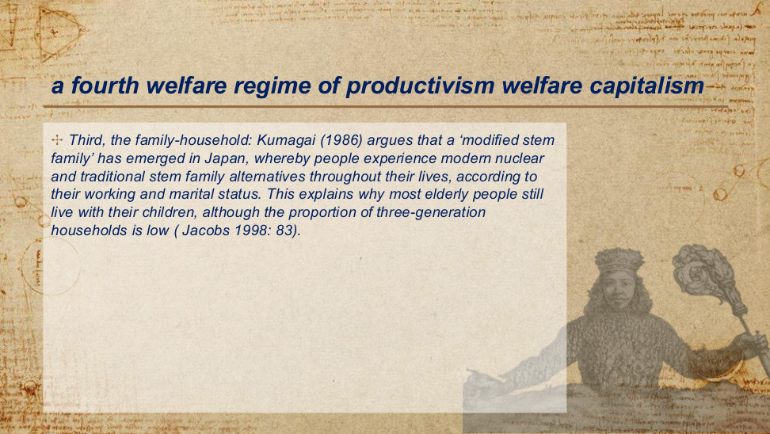
原PPT第34页 / Original slide 34

PPT中英翻译 / PPT translation
PPT English / 英文原文 | 中文翻译 / Chinese translation
Third, the family-household: Kumagai (1986) argues that a ‘modified stem family’ has emerged in Japan, whereby people experience modern nuclear and traditional stem family alternatives throughout their lives, according to their working and marital status. | 第三，家庭—家户：Kumagai（1986）认为，日本出现了“改良型主干家庭”；人们会随着就业和婚姻状况，在一生中经历现代核心家庭与传统主干家庭等不同安排。
This explains why most elderly people still live with their children, although the proportion of three-generation households is low (Jacobs 1998: 83). | 这解释了为什么尽管三代同堂家户所占比例较低，多数老年人仍与子女同住（Jacobs，1998：83）。

本页核心 / Key takeaway
改良型主干家庭强调家庭安排随生命周期变化：核心家庭与代际同住并存，现代化不必然消除家庭福利责任。
The modified stem family describes changing arrangements across the life course: nuclear households and intergenerational co-residence coexist, preserving family welfare responsibilities.

精要解析 / Essential explanation

1. 主干家庭与核心家庭｜Stem and nuclear family arrangements
核心家庭以夫妻及其子女为中心；主干家庭通常延续父母与一支已婚子女家庭的代际联系。“改良型”强调现代就业和婚姻变化下，传统代际联系可以用新的居住方式继续维持。
A nuclear family centres on a couple and their children; a stem family usually maintains an intergenerational link between parents and one married child’s family. The modified form allows those ties to persist through changing residence, employment and marriage arrangements.

2. 按生命周期理解变化｜Read the pattern across the life course
同一个人可能在结婚或就业时独立居住，又在晚年或照护需要增加时与子女同住。重点不是家庭结构永远不变，而是家庭关系能随需要重新组织，并继续承担福利责任。
A person may live independently after marriage or for work, then live with children when later-life care needs rise. The point is not an unchanged household structure, but family ties that can be reorganised to sustain welfare responsibilities.

3. 为何两个比例不矛盾｜Why the two observations are compatible
“老人与子女同住”不必包含孙辈：只有老人和成年子女，就是两代家户。因此，三代同堂比例较低仍可与较高的老人—子女同住并存，不能把这两种统计口径当作同一个指标。
Older people living with children need not include grandchildren: an older parent and an adult child form a two-generation household. A low three-generation share can therefore coexist with substantial parent–child co-residence; these measures have different denominators and definitions.

35｜文化解释：儒家福利国家｜Explanations: the cultural perspective
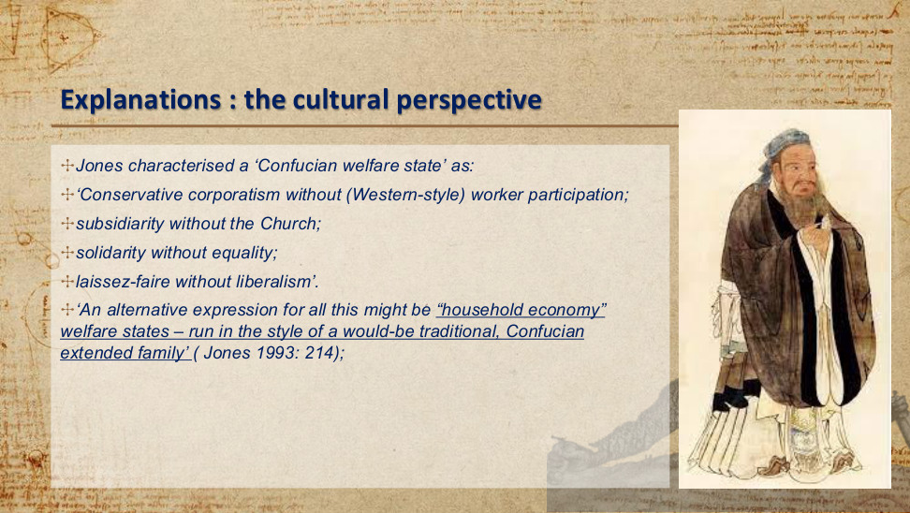
原PPT第35页 / Original slide 35

PPT中英翻译 / PPT translation
PPT English / 英文原文 | 中文翻译 / Chinese translation
Jones characterised a ‘Confucian welfare state’ as: | Jones将“儒家福利国家”概括为：
‘Conservative corporatism without (Western-style) worker participation; | “保守法团主义，但没有西方式的工人参与；
subsidiarity without the Church; | 辅助性原则，但没有教会；
solidarity without equality; | 团结互助，但没有平等；
laissez-faire without liberalism’. | 自由放任，但没有自由主义。”
‘An alternative expression for all this might be “household economy” welfare states – run in the style of a would-be traditional, Confucian extended family’ (Jones 1993: 214). | “另一种说法或许是‘家户经济’福利国家——以一种仿效传统儒家扩展家庭的方式运作”（Jones，1993：214）。

本页核心 / Key takeaway
Jones以儒家福利国家概括一种家户经济式安排：家庭责任与团结可以突出，但不必伴随平等、自由主义或西式工人参与。
Jones’s Confucian welfare state describes a household-economy arrangement in which family responsibility and solidarity need not entail equality, liberalism or Western-style worker participation.

精要解析 / Essential explanation

1. 先理解前两个“without”｜Understand the first two “withouts”
法团主义强调有组织群体与国家的协调，并不自动保证工人参与决策；辅助性原则强调由较接近个人的单位先承担责任，也不一定要由教会支撑。Jones强调相似原则可有不同制度基础。
Corporatism concerns coordination between organised groups and the state, without automatically guaranteeing worker participation. Subsidiarity places responsibility first with units closer to individuals and need not rest on churches. Jones highlights different institutional foundations beneath similar principles.

2. 团结、平等与自由主义须分开｜Separate solidarity, equality and liberalism
家庭可以相互支持，同时保留辈分、性别与身份差异，所以“团结”不必等于平等。市场活动较自由，也不自动代表个人自主与政治自由主义都很强；这是后两个“without”的含义。
Families can offer mutual support while retaining generational, gender and status hierarchies, so solidarity need not mean equality. Relatively free market activity also does not establish strong individual autonomy or political liberalism. These distinctions explain the final two “withouts”.

3. 文化解释的用途与边界｜Uses and limits of the cultural explanation
把国家比作扩展家庭，有助于理解责任、秩序和家户互助为何受到重视。但这是Jones的解释视角，不是所有东亚社会不变的本质；后面的政治经济学解释会进一步追问制度和增长战略。
The extended-family analogy helps explain the emphasis on responsibility, order and household support. It is Jones’s explanatory perspective, not an unchanging essence of all East Asian societies. The political economy account then investigates institutions and growth strategies.

36｜文化解释：儒家价值的作用｜Explanations: the cultural perspective
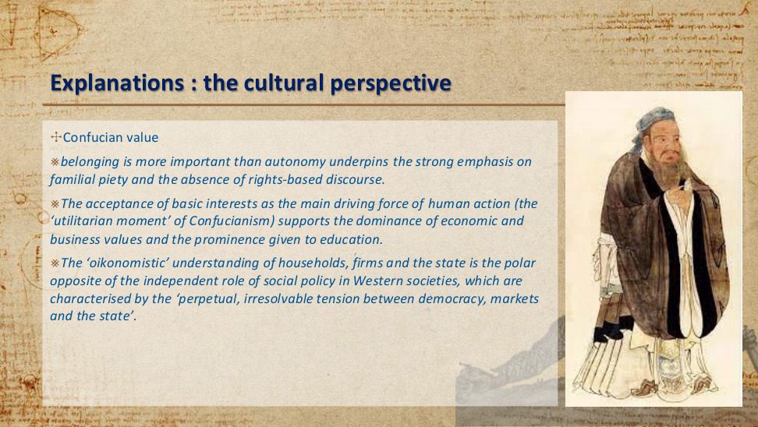
原PPT第36页 / Original slide 36

PPT中英翻译 / PPT translation
PPT English / 英文原文 | 中文翻译 / Chinese translation
Confucian value | 儒家价值观
belonging is more important than autonomy underpins the strong emphasis on familial piety and the absence of rights-based discourse. | 归属比自主更重要的观念，支撑了对家庭孝道的强调，以及以权利为基础的话语的缺位。
The acceptance of basic interests as the main driving force of human action (the ‘utilitarian moment’ of Confucianism) supports the dominance of economic and business values and the prominence given to education. | 将基本利益视为人类行动主要驱动力的观念（儒家思想的“功利性面向”），支持了经济与商业价值的主导地位，以及对教育的高度重视。
The ‘oikonomistic’ understanding of households, firms and the state is the polar opposite of the independent role of social policy in Western societies, which are characterised by the ‘perpetual, irresolvable tension between democracy, markets and the state’. | 对家户、企业和国家的“家户经济本位”理解，与西方社会中社会政策的独立角色形成鲜明对照；后者被描述为存在“民主、市场与国家之间永久且无法消解的张力”。

本页核心 / Key takeaway
文化视角把归属优先于自主与孝道、家庭责任联系起来，并用家户经济本位解释教育及经济目标为何受到重视。
The cultural perspective links belonging over autonomy to filial duty and family responsibility, and uses household-oriented reasoning to explain the priority of education and economic goals.

精要解析 / Essential explanation

1. 家庭责任与个人权利｜Family duties and individual rights
本页把归属与孝道联系起来：福利需求较容易被表述为家庭成员应承担的责任，而非个人向国家提出的独立权利。这是在解释一种话语倾向，不代表现实中不存在权利主张。
This perspective links belonging and filial duty: welfare needs are more readily expressed as family responsibilities than as independent individual claims against the state. It describes a discursive tendency, not the absence of all rights claims in actual societies.

2. 为何突出教育与经济价值｜Why education and economic values matter
按这一文化解释，教育既提升个人机会，也服务家庭改善生活与共同经济目标，因此受到重视。但教育投入本身不能证明儒家文化是唯一原因；下一页还会从国家发展战略解释资源投向。
Within this cultural account, education advances personal opportunities, household wellbeing and shared economic aims, which helps explain its prominence. Educational investment does not establish culture as the sole cause; the next page examines resource priorities through state development strategy.

3. oikonomistic的准确含义｜The meaning of oikonomistic
这里指用家户经营逻辑理解家庭、企业和国家，强调成员围绕共同经济目标协作。与之对照，社会政策作为较独立领域，可以提出不完全服从经济增长的保障或平等要求。
Oikonomistic refers to household-management reasoning applied to families, firms and the state, with members cooperating around shared economic aims. By contrast, a more autonomous social-policy sphere can advance protection or equality goals that do not simply follow economic growth.

37｜政治经济学解释：发展型国家与社会政策｜Explanations: the political economic perspective
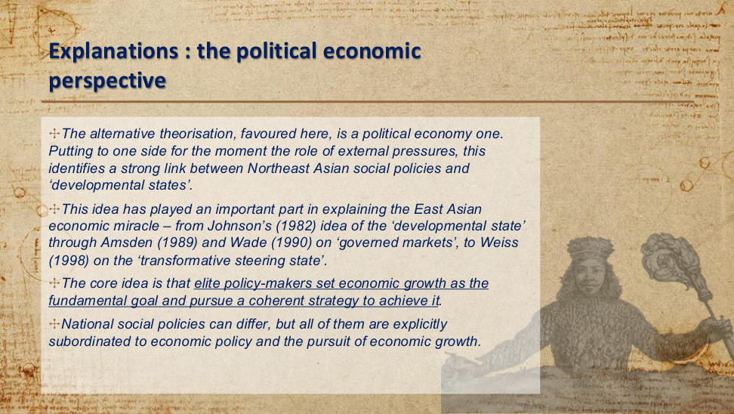
原PPT第37页 / Original slide 37

PPT中英翻译 / PPT translation
PPT English / 英文原文 | 中文翻译 / Chinese translation
The alternative theorisation, favoured here, is a political economy one. Putting to one side for the moment the role of external pressures, this identifies a strong link between Northeast Asian social policies and ‘developmental states’. | 本处更倾向于另一种理论解释，即政治经济学视角。暂且搁置外部压力的作用，这一视角指出东北亚社会政策与“发展型国家”之间存在紧密联系。
This idea has played an important part in explaining the East Asian economic miracle – from Johnson’s (1982) idea of the ‘developmental state’ through Amsden (1989) and Wade (1990) on ‘governed markets’, to Weiss (1998) on the ‘transformative steering state’. | 这一思路在解释东亚经济奇迹中发挥了重要作用：从Johnson（1982）的“发展型国家”，到Amsden（1989）和Wade（1990）有关“受治理的市场”的论述，再到Weiss（1998）的“转型引导型国家”。
The core idea is that elite policy-makers set economic growth as the fundamental goal and pursue a coherent strategy to achieve it. | 核心观点是：精英决策者将经济增长设为根本目标，并通过一套连贯战略实现这一目标。
National social policies can differ, but all of them are explicitly subordinated to economic policy and the pursuit of economic growth. | 各国社会政策可以不同，但都明确从属于经济政策和经济增长目标。

本页核心 / Key takeaway
本课更倾向政治经济学解释：精英通过连贯的发展战略追求增长，社会政策的地位由发展型国家的增长目标塑造。
The course favours a political economy explanation: elites pursue coherent development strategies, and social policy is shaped by the developmental state’s growth goals.

精要解析 / Essential explanation

1. 机制：目标怎样变成制度｜How goals become institutions
精英把增长设为根本目标后，还需通过官僚协调、产业政策和资源配置持续落实。政治经济学解释因此关注可观察的决策者、机构与工具，而不只用共同价值观解释政策结果。
Once elites prioritise growth, bureaucracy, industrial policy and resource allocation must translate that priority into sustained action. Political economy therefore examines identifiable decision-makers, institutions and instruments rather than explaining outcomes through shared values alone.

2. 与文化解释的真正区别｜The distinction from cultural explanation
文化视角问“为什么家庭责任和教育受到重视”；政治经济学问“谁把增长置于首位、怎样组织政策”。两种视角的解释起点不同，课件在这里更倾向后者，但不必据此断言文化毫无作用。
Culture asks why family responsibility and education are valued; political economy asks who prioritises growth and how policy is organised. Their explanatory starting points differ. The slide favours political economy here without requiring the claim that culture has no role.

3. 共同目标不等于政策完全相同｜Shared aims allow different programmes
各国可以采用不同的医疗、教育或养老金安排，仍共享增长优先的逻辑。比较时先找目标与资源配置的共同点，再解释覆盖范围和供给方式的差异，避免把东亚当作单一制度。
Countries may use different health, education or pension arrangements while sharing a growth-first logic. Compare common priorities and resource allocation, then explain differences in coverage and provision. East Asia should not be treated as a single uniform system.

4. 结合听课宝：区分资格与目标｜Listening-summary bridge: eligibility and goals
听课宝重视福利资格、待遇和国家角色；本页补上政策目标。作比较时，例如教育支出既可能支持机会平等，也可能服务产业技能，需要结合对象和资源投向，判断哪一种目标更优先。
The listening summary emphasises eligibility, benefits and state roles; this slide adds policy goals. Educational spending, for example, may promote equal opportunity or industrial skills. Examine beneficiaries and resource allocation to assess which purpose takes priority.

38｜政治经济学解释：生产主义的四项特征｜Explanations: the political economic perspective
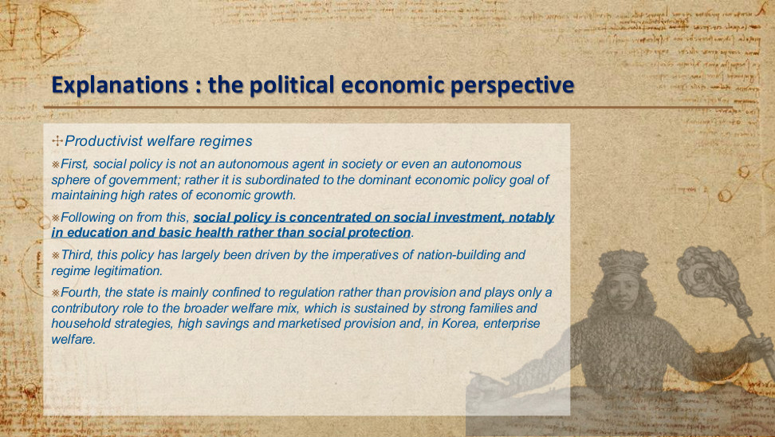
原PPT第38页 / Original slide 38

PPT中英翻译 / PPT translation
PPT English / 英文原文 | 中文翻译 / Chinese translation
Productivist welfare regimes | 生产主义福利体制
First, social policy is not an autonomous agent in society or even an autonomous sphere of government; rather it is subordinated to the dominant economic policy goal of maintaining high rates of economic growth. | 第一，社会政策并非社会中的自主力量，甚至不是政府中自主的政策领域；相反，它从属于维持高速经济增长这一占主导地位的经济政策目标。
Following on from this, social policy is concentrated on social investment, notably in education and basic health rather than social protection. | 由此，社会政策集中于社会投资，尤其是教育和基础医疗，而相较之下较少侧重社会保护。
Third, this policy has largely been driven by the imperatives of nation-building and regime legitimation. | 第三，这类政策主要受到国家建设与政权合法化需求的驱动。
Fourth, the state is mainly confined to regulation rather than provision and plays only a contributory role to the broader welfare mix, which is sustained by strong families and household strategies, high savings and marketised provision and, in Korea, enterprise welfare. | 第四，国家主要承担监管而非直接供给，在更广泛的福利混合体系中只发挥部分支持作用；这一体系由强有力的家庭及家户策略、高储蓄、市场化供给，以及韩国的企业福利共同支撑。

本页核心 / Key takeaway
生产主义把福利作为增长工具：社会投资优先于社会保护，并通过国家、家庭、市场和企业共同维持福利供给。
Productivism uses welfare to support growth, prioritising social investment over social protection within a mix of state, family, market and enterprise roles.

精要解析 / Essential explanation

1. 从属关系：福利的独立性较弱｜Subordination limits social-policy autonomy
社会政策并非独立设定最终目标，而要配合维持高增长。这一框架下，当保障目标与发展目标发生取舍时，分析重点是增长如何影响政策选择；不是说政府完全不关心社会问题。
Social policy does not set its final priorities autonomously; it is organised around sustaining growth. Where protection and development goals involve trade-offs, examine how growth shapes the choice. This does not mean that government has no concern for social problems.

2. 资源投向：投资与保护的区别｜Resource priorities: investment and protection
教育和基础医疗可提升未来劳动力能力，属于社会投资；养老金、失业保障等更直接应对收入中断风险。这里说的是前者优先，不是后者完全不存在；同一项目也可能同时具有两类作用。
Education and basic health can build future workforce capabilities, making them social investments. Pensions and unemployment protection respond more directly to interrupted earnings. The claim concerns relative priority, not the absence of protection; one programme can also serve both functions.

3. 政治动力：国家建设与合法性｜Political drivers: nation-building and legitimacy
福利投入还可整合社会、支持国家建设，并展示政府改善生活的能力。这样既帮助发展战略获得支持，也连接到前文绩效合法性；不宜把福利只解释成技术性的支出安排。
Welfare investment can integrate society, support nation-building and demonstrate the government’s capacity to improve lives. It thereby supports development strategy and connects to performance legitimacy. Welfare is thus more than a purely technical spending arrangement.

4. 供给组合：国家仍有作用｜The welfare mix still includes the state
国家可制定规则、支持项目，而家庭、储蓄、市场与企业承担较多直接供给。听课宝的国家角色分析在此仍适用：要分开看谁制定规则、谁出钱、谁提供服务，而非只问有没有政府。
The state can establish rules and support programmes while families, savings, markets and enterprises provide substantial welfare directly. Applying the listening summary’s concern with state roles, distinguish rule-setting, financing and service delivery rather than asking only whether government is present.

易错辨析 / Key distinction
此处“偏重监管”指国家在福利供给中的角色，仍可与国家在产业政策中的积极干预并存。
The regulatory emphasis here concerns the state’s welfare-provision role; it can coexist with active state intervention in industrial policy.

39｜发展型国家理念的区域化扩散｜The spreading of developmental state ideas as regionalization
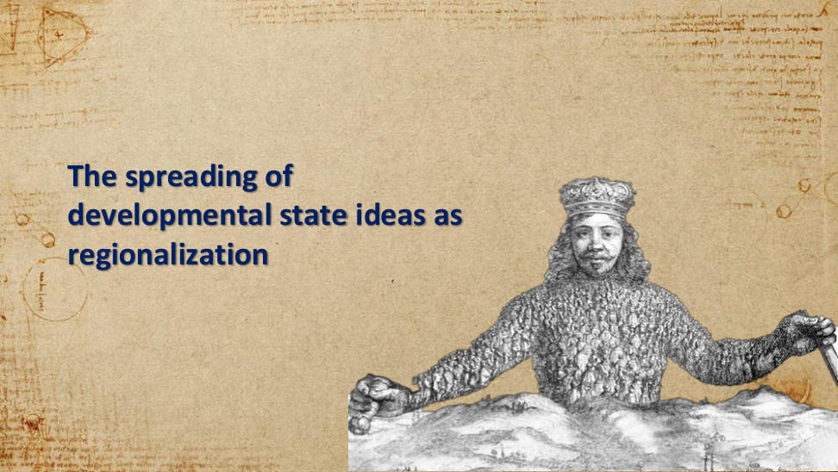
原PPT第39页 / Original slide 39

PPT中英翻译 / PPT translation
PPT English / 英文原文 | 中文翻译 / Chinese translation
The spreading of developmental state ideas as regionalization | 发展型国家理念的传播：作为区域化的过程。

本页核心 / Key takeaway
这是章节转场页：分析层次由一国的发展战略转向区域化，接下来关注东亚产业如何跨经济体扩散与升级。
This transition shifts the analysis from national development strategies to regionalization, introducing industrial diffusion and upgrading across East Asian economies.

40｜雁行模式｜The flying geese model
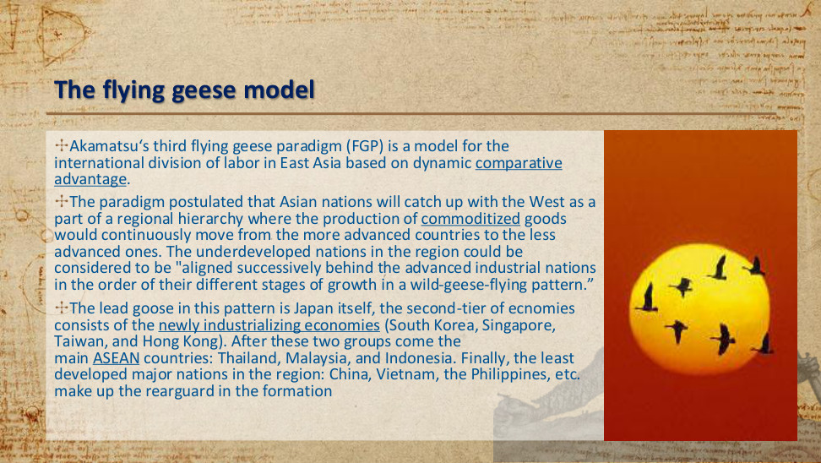
原PPT第40页 / Original slide 40

PPT中英翻译 / PPT translation
PPT English / 英文原文 | 中文翻译 / Chinese translation
Akamatsu‘s third flying geese paradigm (FGP) is a model for the international division of labor in East Asia based on dynamic comparative advantage. | 赤松要的第三种雁行范式（FGP），是一个以动态比较优势为基础、解释东亚国际分工的模型。
The paradigm postulated that Asian nations will catch up with the West as a part of a regional hierarchy where the production of commoditized goods would continuously move from the more advanced countries to the less advanced ones. | 这一范式设想，亚洲各国将在一个区域层级体系中追赶西方；标准化商品的生产会持续从较先进国家转向发展程度较低的国家。
The underdeveloped nations in the region could be considered to be "aligned successively behind the advanced industrial nations in the order of their different stages of growth in a wild-geese-flying pattern.” | 区域内发展程度较低的国家可被理解为：“按照各自不同的增长阶段，以雁行飞行的方式，依次排列在先进工业国家之后。”
The lead goose in this pattern is Japan itself, the second-tier of ecnomies consists of the newly industrializing economies (South Korea, Singapore, Taiwan, and Hong Kong). | 在这一模式中，日本是领头雁；第二梯队由新兴工业化经济体构成，即韩国、新加坡、中国台湾和中国香港。
After these two groups come the main ASEAN countries: Thailand, Malaysia, and Indonesia. Finally, the least developed major nations in the region: China, Vietnam, the Philippines, etc. make up the rearguard in the formation | 这两组之后是主要东盟国家：泰国、马来西亚和印度尼西亚。最后，按该模型的历史描述，区域内发展程度较低的主要国家，如中国、越南、菲律宾等，构成雁阵的后队。

本页核心 / Key takeaway
雁行模式以动态比较优势解释区域分工：较成熟产业向后发经济体转移，形成先后追赶的产业发展序列。
The flying geese model uses dynamic comparative advantage to explain regional divisions of labour, with mature production relocating to later-developing economies in a catching-up sequence.

精要解析 / Essential explanation

1. 动态优势为何产生转移｜Why changing advantages encourage relocation
“动态”表示比较优势会随工资、技能与技术能力的发展而变化。成熟生产可能移向成本或条件更合适的后发经济体，先行者再寻找新产业，因此区位和国家位置不是永久固定的。
Dynamic advantage changes as wages, skills and technological capabilities develop. Mature production may relocate to later developers with more suitable costs or conditions while leaders enter new industries. Industrial locations and national positions are therefore not permanently fixed.

2. 转移与追赶之间的机制｜How relocation can support catching-up
产业转移为后发经济体提供进入制造业、扩大出口和积累能力的机会，但“有产业进入”不等于自动完成追赶；仍要看本国能否吸收技术、培养人才，并进一步升级。
Relocation gives later developers opportunities to enter manufacturing, expand exports and build capabilities. Incoming production does not automatically ensure catching-up: learning, skills formation and subsequent upgrading remain necessary. The model describes an opportunity and mechanism, not a guaranteed outcome.

3. 历史雁阵怎样记忆｜Remember the historical formation
课件按日本、新兴工业化经济体、东南亚等后发经济体描绘先后次序。复习重点是国际分工随发展阶段变化；具体队列属于历史示意，不能直接替代今天的经济实力或技术排名。
The slide depicts Japan, the NIEs and later developers in Southeast Asia and beyond as a historical sequence. Remember changing international divisions of labour across development stages; the illustrative formation is not a substitute for current economic or technological rankings.

41｜雁行模式的两个分析方向｜Two variants
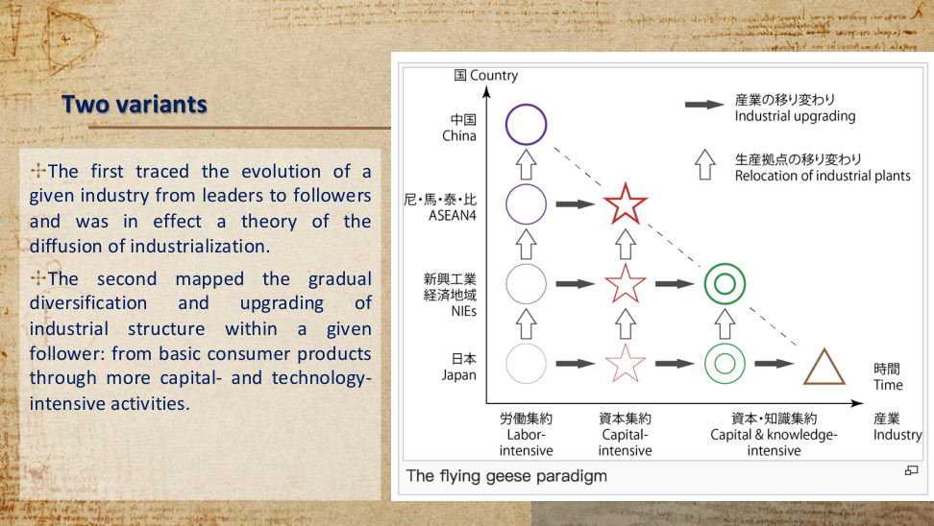
原PPT第41页 / Original slide 41

PPT中英翻译 / PPT translation
PPT English / 英文原文 | 中文翻译 / Chinese translation
The first traced the evolution of a given industry from leaders to followers and was in effect a theory of the diffusion of industrialization. | 第一种追踪某一产业从领先者向追随者的演进，实际上是一种工业化扩散理论。
The second mapped the gradual diversification and upgrading of industrial structure within a given follower: from basic consumer products through more capital- and technology-intensive activities. | 第二种描绘某一追随者内部产业结构逐步多样化和升级的过程：从基本消费品，走向资本与技术更密集的活动。
The flying geese paradigm | 雁行范式（图题）。
Country; Japan; NIEs; ASEAN4; China | 纵轴：国家／经济体；日本；新兴工业化经济体；东盟四国；中国。图上“尼·馬·泰·比”分别指印尼、马来西亚、泰国和菲律宾。
Industry; Time | 横向标签：产业；时间。
Labor-intensive; Capital-intensive; Capital & knowledge-intensive | 劳动密集型；资本密集型；资本与知识密集型。
Industrial upgrading; Relocation of industrial plants | 实心右箭头：产业升级；空心上箭头：工业生产据点转移。

本页核心 / Key takeaway
雁行模式有两条分析线：跨经济体的产业扩散，以及同一经济体内部的产业升级；读图时要区分箭头所指的过程。
The flying geese model distinguishes industrial diffusion across economies from industrial upgrading within an economy; the diagram’s arrows represent these different processes.

精要解析 / Essential explanation

1. 纵向追踪同一产业｜Track one industry across economies
空心上箭头表示同类生产从日本等先行经济体移向后发经济体。比较对象是不同经济体，但追踪的产业类型相同；这是“工业化怎样扩散”的问题，而非本国产业结构变化。
The upward hollow arrows show similar production relocating from leaders such as Japan to later developers. The economies differ while the industry type remains the same. This asks how industrialisation diffuses, rather than how one country changes its industrial structure.

2. 横向追踪一个经济体｜Track one economy over time
实心右箭头表示同一经济体由劳动密集型走向资本、技术与知识更密集的活动。这里地点大体不变、产业组合改变，关注的是经济体自身的产业结构怎样提高复杂程度。
The solid rightward arrows show one economy moving from labour-intensive activities towards more capital-, technology- and knowledge-intensive production. The economy stays the same while its industry mix changes; the question concerns increasing structural complexity within it.

3. 两个过程可以相互衔接｜How the two processes connect
先行经济体把较成熟生产移出，同时发展新产业；后发经济体承接生产后，也可能再向更高层次升级。雁行模式因此同时包含跨境分工和国内转型，不只是工厂不断搬家。
A leader can relocate mature production while developing new industries; a follower receiving production can later upgrade in turn. The flying geese model therefore combines cross-border divisions of labour with domestic transformation, rather than merely describing repeated factory relocation.

4. 读图时先确定比较对象｜Identify the unit of comparison
先问是在比较“同一产业、不同经济体”，还是“同一经济体、不同时期的产业”。图中星形等符号代表产业类别，不是老师手写重点；判断考试知识重点仍要回到这两个理论过程。
First ask whether the comparison concerns one industry across economies or one economy’s industries over time. Stars and other symbols encode industry categories; they are not handwritten teacher emphasis. The theoretical focus remains the distinction between the two processes.

易错辨析 / Key distinction
本图ASEAN4包含菲律宾；第40页正文只列三个东盟国家并把菲律宾列入后队。两处示意分组口径不同，应保留原页，不强行合并成固定排名。
This diagram’s ASEAN4 includes the Philippines, whereas page 40 lists three ASEAN countries and places the Philippines in the rearguard. Preserve the differing illustrative groupings rather than forcing a fixed ranking.

42｜亚洲发展型国家的演变：韩国｜The evolution of Asian developmental state: Korea
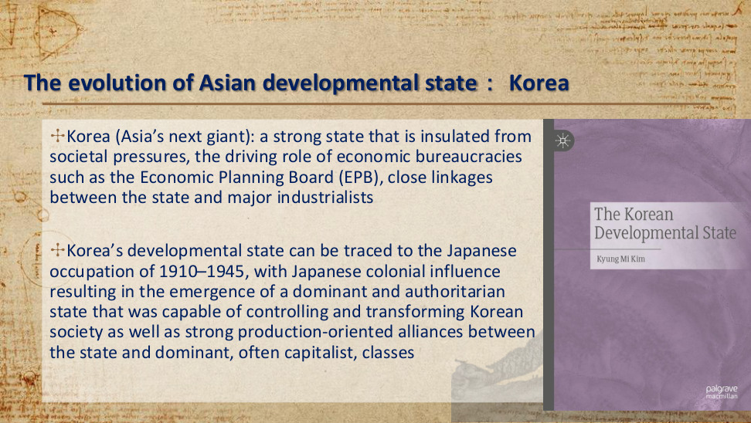
原PPT第42页 / Original slide 42

PPT中英翻译 / PPT translation
PPT English / 英文原文 | 中文翻译 / Chinese translation
Korea (Asia’s next giant): a strong state that is insulated from societal pressures, the driving role of economic bureaucracies such as the Economic Planning Board (EPB), close linkages between the state and major industrialists | 韩国（“亚洲的下一个巨人”）：一个能够相对隔离社会压力的强国家；经济企划厅（EPB）等经济官僚机构发挥推动作用；国家与主要工业企业家之间保持紧密联系。
Korea’s developmental state can be traced to the Japanese occupation of 1910–1945, with Japanese colonial influence resulting in the emergence of a dominant and authoritarian state that was capable of controlling and transforming Korean society as well as strong production-oriented alliances between the state and dominant, often capitalist, classes | 韩国发展型国家的渊源可追溯至1910—1945年的日本占领时期。日本殖民影响促成了一个具有支配性、威权性的国家，它能够控制和改造韩国社会；同时，国家与占主导地位、通常为资本家组成的阶级之间形成了强有力的生产导向联盟。

本页核心 / Key takeaway
韩国案例把强经济官僚与国家—工业资本联盟结合起来：国家保持政策自主性，同时借助企业关系推动生产转型。
The Korean case combines strong economic bureaucracies with state–industrial capital alliances: the state maintains policy autonomy while using business links to drive productive transformation.

精要解析 / Essential explanation

1. EPB体现什么国家能力｜What the EPB illustrates
经济企划厅（EPB）体现经济官僚制定战略、协调资源和推进政策的能力。与前文日本MITI对照，重点是专业机构怎样组织发展，而不是把机构名称或政府规模当成成功的充分条件。
The Economic Planning Board illustrates bureaucratic capacity to formulate strategy, coordinate resources and drive implementation. Compare it with Japan’s MITI: the issue is how specialised institutions organise development, not whether an agency name or government size guarantees success.

2. 自主性与企业联系为何并存｜Why autonomy and business links coexist
国家需要相对不受特殊利益左右，才能坚持发展目标；又需要主要工业家的信息和投资来执行战略。因此，相对自主与紧密政企联系不是简单对立，关键在能否合作而不被俘获。
Relative autonomy helps the state maintain developmental priorities, while industrialists supply information and investment needed for implementation. Autonomy and close business links are therefore compatible; the issue is whether cooperation can support strategy without policy being captured.

3. 怎样处理殖民历史解释｜How to interpret the historical account
课件把强国家和生产导向联盟的渊源追溯到殖民时期，是在说明制度形成的历史条件。它既不能证明殖民统治具有正当性，也不能把这一背景当作韩国后来经济成功的唯一原因。
The slide traces strong-state institutions and production-oriented alliances to the colonial period as historical conditions of institutional formation. This neither justifies colonial rule nor establishes it as the sole cause of Korea’s later economic success.

43｜韩国：出口导向工业化与民族主义｜Korea: Export-oriented industrialization and nationalist ideology
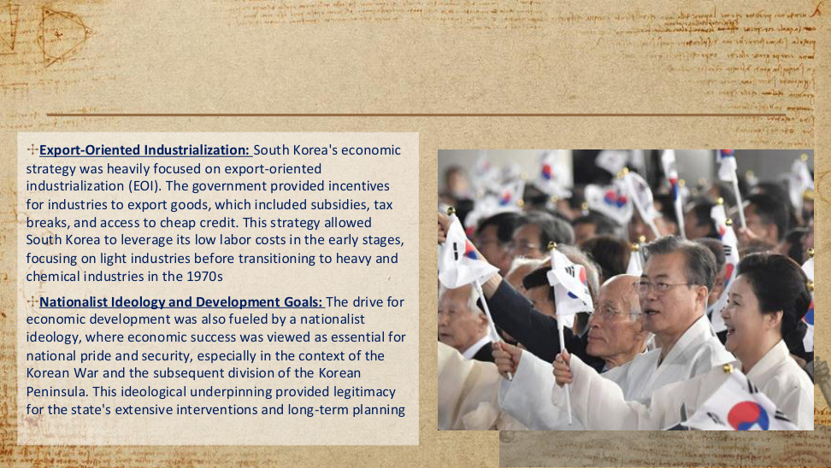
原PPT第43页 / Original slide 43

PPT中英翻译 / PPT translation
PPT English / 英文原文 | 中文翻译 / Chinese translation
Export-Oriented Industrialization: South Korea's economic strategy was heavily focused on export-oriented industrialization (EOI). | 出口导向工业化：韩国的经济战略高度侧重出口导向工业化（EOI）。
The government provided incentives for industries to export goods, which included subsidies, tax breaks, and access to cheap credit. | 政府通过补贴、税收减免和廉价信贷等方式，激励产业出口商品。
This strategy allowed South Korea to leverage its low labor costs in the early stages, focusing on light industries before transitioning to heavy and chemical industries in the 1970s | 这一战略使韩国在早期利用较低的劳动力成本，先侧重轻工业，再于20世纪70年代转向重工业和化学工业。
Nationalist Ideology and Development Goals: The drive for economic development was also fueled by a nationalist ideology, where economic success was viewed as essential for national pride and security, especially in the context of the Korean War and the subsequent division of the Korean Peninsula. | 民族主义意识形态与发展目标：民族主义也推动了经济发展。在朝鲜战争及其后朝鲜半岛分裂的背景下，经济成功尤其被视为民族自豪感和国家安全的必要条件。
This ideological underpinning provided legitimacy for the state's extensive interventions and long-term planning | 这一意识形态基础，为国家的广泛干预与长期规划提供了合法性。

本页核心 / Key takeaway
韩国通过出口导向工业化组织产业追赶，并把经济发展与民族自豪感、国家安全联系起来，为国家干预提供合法性。
Korea organised industrial catching-up through export-oriented industrialization and linked development to national pride and security, legitimising state intervention.

精要解析 / Essential explanation

1. 政策工具怎样推动出口｜How the instruments promote exports
补贴、税收减免与廉价信贷，可降低企业融资或经营成本，提高出口生产的吸引力。因此这里的出口导向包含国家积极塑造激励，不能只把它理解为企业自由参与国际贸易。
Subsidies, tax breaks and cheap credit can reduce financing or operating costs and make export production more attractive. Export orientation here involves the state actively shaping incentives, rather than merely leaving firms free to participate in international trade.

2. 阶段变化体现产业升级｜The sequence shows industrial upgrading
早期利用较低劳动力成本发展轻工业，20世纪70年代转向重化工业。这里既有“向海外销售”的市场方向，也有“生产什么”的产业升级方向；两者要分开理解，再联系起来。
Early light industry used relatively low labour costs before the shift towards heavy and chemical industries in the 1970s. Distinguish the market direction—selling abroad—from the structural direction—changing what is produced—before connecting them.

3. 民族主义怎样支持干预｜How nationalism supports intervention
当经济成功被联系到民族尊严与国家安全，发展就超出企业利润，成为国家共同目标。这有助于解释长期规划和广泛干预为何能争取支持，也把韩国案例连接到共识建构与合法性。
When economic success is linked to national pride and security, development becomes a shared national goal beyond corporate profit. This helps explain support for long-term planning and extensive intervention, connecting the Korean case to consensus-building and legitimacy.

易错辨析 / Key distinction
原文时序不严谨：半岛分裂始于1945年，早于1950年开始的朝鲜战争。
The slide’s chronology is imprecise: partition began in 1945, before the Korean War began in 1950.

44｜发展型国家的演变与扩展｜Evolution of developmental state
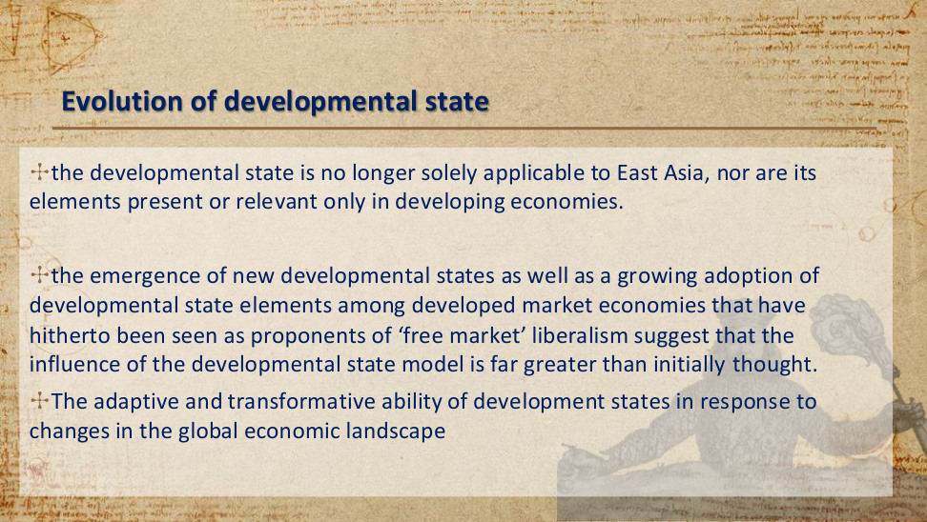
原PPT第44页 / Original slide 44

PPT中英翻译 / PPT translation
PPT English / 英文原文 | 中文翻译 / Chinese translation
the developmental state is no longer solely applicable to East Asia, nor are its elements present or relevant only in developing economies. | 发展型国家已不再仅适用于东亚，其构成要素也并非只存在于发展中经济体或仅对它们有意义。
the emergence of new developmental states as well as a growing adoption of developmental state elements among developed market economies that have hitherto been seen as proponents of ‘free market’ liberalism suggest that the influence of the developmental state model is far greater than initially thought. | 新的发展型国家出现，以及过去被视为“自由市场”自由主义支持者的发达市场经济体越来越多地采用发展型国家要素，表明这一模式的影响远大于最初的估计。
The adaptive and transformative ability of development states in response to changes in the global economic landscape | 发展型国家能够适应全球经济格局的变化，并进行转型。

本页核心 / Key takeaway
发展型国家具有适应与转型能力：其政策要素可以跨地区、跨发展阶段被采用，分析不应局限于早期东亚案例。
The developmental state has adaptive and transformative capacity: its policy elements can spread across regions and development levels beyond the early East Asian cases.

精要解析 / Essential explanation

1. 完整模式与政策要素须区分｜Distinguish the model from its elements
一个发达市场经济体采用产业补贴或战略投资，并不等于完整复制早期东亚制度。要进一步看增长目标、专业官僚与政企协调等要素怎样组合，不能只凭一个工具就完成分类。
Industrial subsidies or strategic investment in a developed market economy do not reproduce the complete early East Asian system. Examine how growth goals, expert bureaucracy and state–business coordination combine; adopting one instrument is insufficient to classify the whole state.

2. 适应意味着工具与组织会变化｜Adaptation changes tools and organisation
全球竞争和产业条件变化后，国家可能调整扶持对象、政策工具及协调方式。复习时保留“国家组织发展”的核心问题，同时允许具体制度随时代变化，不把历史日本案例当作唯一模板。
Changing global competition and industrial conditions may lead states to revise targeted sectors, policy instruments and coordination methods. Retain the core question of how states organise development while allowing institutional variation over time; historical Japan is not the only template.

3. 怎样判断适用范围｜How to assess the scope of the concept
不要只按东亚或西方、发达或发展中来判断。可依次看国家优先什么、是否有执行能力、如何引导投资，以及能否协调又约束企业，从具体机制识别发展型特征。
Do not classify states solely as Eastern or Western, developed or developing. Examine their priorities, implementation capacity, investment guidance and ability to coordinate and discipline firms. Identify developmental features through these mechanisms rather than geography alone.

45｜结束页｜Thanks!

原PPT第45页 / Original slide 45

PPT中英翻译 / PPT translation
PPT English / 英文原文 | 中文翻译 / Chinese translation
Thanks! | 谢谢！
Any questions? | 有什么问题吗？
You can find me at june.wang@cityu.edu.hk | 可通过june.wang@cityu.edu.hk联系我。

本页核心 / Key takeaway
本页是课程结束与联系方式页，没有新增理论知识点。
This closing slide provides contact information and introduces no new theoretical content.

