Q1

1 电力曳引式升降机 / Electric traction lift
电力曳引式升降机由驱动电动机带动曳引轮，利用曳引轮与悬吊绳之间的摩擦传递驱动力。悬吊绳连接轿厢和对重，使两者沿各自导轨反向移动。对重平衡轿厢及部分载荷重量，从而减少不平衡负载及所需驱动功率。
An electric traction lift uses a Drive motor to rotate a Drive sheave. Friction between the Drive sheave and Suspension rope transmits the driving force. The Suspension rope connects the Car and Counterweight so that they move in opposite directions along their guide rails. The Counterweight balances the Car and part of its load, reducing the unbalanced load and driving power required.
部件 / Component | 功能 | Operational function
控制器  Controller | 接收层站按钮指令，协调驱动电动机、制动器、停车、平层和门机。 | Receives calls from the Landing pushbutton and coordinates the Drive motor, Brake, stopping, levelling and Door operator.
驱动电动机  Drive motor | 提供转动曳引轮的机械动力。 | Provides mechanical power to rotate the Drive sheave.
制动器  Brake | 使驱动系统停止并保持静止；采用弹簧施闸、电力释放的安排。 | Stops and holds the drive system; it is spring-applied and electrically released.
曳引轮  Drive sheave | 通过与悬吊绳之间的摩擦传递驱动力。 | Transmits driving force through friction with the Suspension rope.
悬吊绳  Suspension rope | 悬吊轿厢和对重，使两者沿各自导轨反向移动。 | Suspends the Car and Counterweight and moves them in opposite directions along their respective guide rails.
限速器  Overspeed governor | 检测运行速度；达到预定超速值时触发安全停止，并在需要时使安全钳动作。 | Monitors speed and initiates safety stopping at a predetermined overspeed, applying the Safety gear when necessary.
门机  Door operator | 驱动轿门开启和关闭。 | Opens and closes the Car doors.
轿厢  Car | 承载乘客或货物。 | Carries passengers or goods.
轿门  Car doors | 关闭轿厢入口；正常运行时保持关闭。 | Close the Car entrance and remain closed during normal travel.
护脚板  Apron | 向下遮护轿厢入口下方的间隙，降低人员跌入井道的风险。 | Extends below the Car entrance to guard the gap beneath it and reduce the risk of falling into the Lift well.
层站指示器  Landing indicator | 向候梯乘客显示楼层或运行方向等信息。 | Displays information such as floor position or direction to waiting passengers.
层站按钮  Landing pushbutton | 向控制器发出召梯指令。 | Registers a landing call with the Controller.

1.1 主要部件及功能（续） / Major components (continued)
部件 / Component | 功能 | Operational function
井道  Lift well | 围护轿厢、对重及相关设备的运行空间。 | Encloses the travel space of the Car, Counterweight and associated equipment.
轿厢导轨  Car guide rail | 引导轿厢垂直运行，并供安全钳作用。 | Guides the Car vertically and provides the surface on which the Safety gear acts.
安全钳  Safety gear | 在向下超速或悬吊失效等情况下，作用于轿厢导轨，使轿厢停止并保持静止。 | Acts on the Car guide rail to stop and hold the Car during downward overspeed or suspension failure.
随行电缆  Travelling cables | 连接固定设备和移动轿厢，传送电源及控制信号。 | Carry power and control signals between fixed equipment and the moving Car.
层门  Landing doors | 关闭各楼层的井道入口；其联锁防止门未关闭锁紧时正常运行。 | Close the Lift well entrance at each landing; their interlocks prevent normal travel unless they are closed and locked.
对重导轨  Counterweight guide rail | 引导对重沿垂直路径运行，限制横向移动。 | Guides the Counterweight vertically and restrains lateral movement.
对重  Counterweight | 平衡轿厢及部分载荷重量，减少驱动电动机需要克服的不平衡负载。 | Balances the Car and part of its load, reducing the unbalanced load that the Drive motor must overcome.
限位开关  Limit switches | 在行程端部触发停止保护，防止轿厢超越允许行程。 | Initiate stopping protection at the ends of travel to prevent the Car from exceeding the permitted limits.
轿厢缓冲器  Car buffer | 安装于底坑，在轿厢底部越程时吸收冲击能量。 | Absorbs impact energy in the pit during bottom overtravel of the Car.
对重缓冲器  Counterweight buffer | 安装于底坑，在对重底部越程时吸收冲击能量。 | Absorbs impact energy in the pit during bottom overtravel of the Counterweight.
限速器张紧轮  Governor tension sheave | 位于限速器绳路下部，保持绳路张紧，以维持限速器与轿厢运动的联系。 | Maintains tension in the lower part of the governor rope loop so that the Overspeed governor remains linked to Car movement.

1.2 运作过程 / Operation
乘客按下层站按钮后，控制器登记召梯。层门关闭并锁紧且安全条件满足后，控制器协调制动器释放和驱动电动机运行，带动曳引轮和悬吊绳，使轿厢移动。接近目标楼层时减速和平层，停车后制动器保持静止，再打开轿门和层门。限速器在达到预定超速值时触发安全停止，并在需要时使安全钳作用于轿厢导轨。
The Landing pushbutton registers a call with the Controller. Once the Landing doors are closed and locked and safety conditions are satisfied, the Controller coordinates Brake release and Drive motor operation. The Drive sheave moves the Suspension rope and Car. The Car slows and levels at the destination; the Brake holds it stationary before the doors open. At a predetermined overspeed, the Overspeed governor initiates safety stopping and applies the Safety gear to the Car guide rail when necessary.

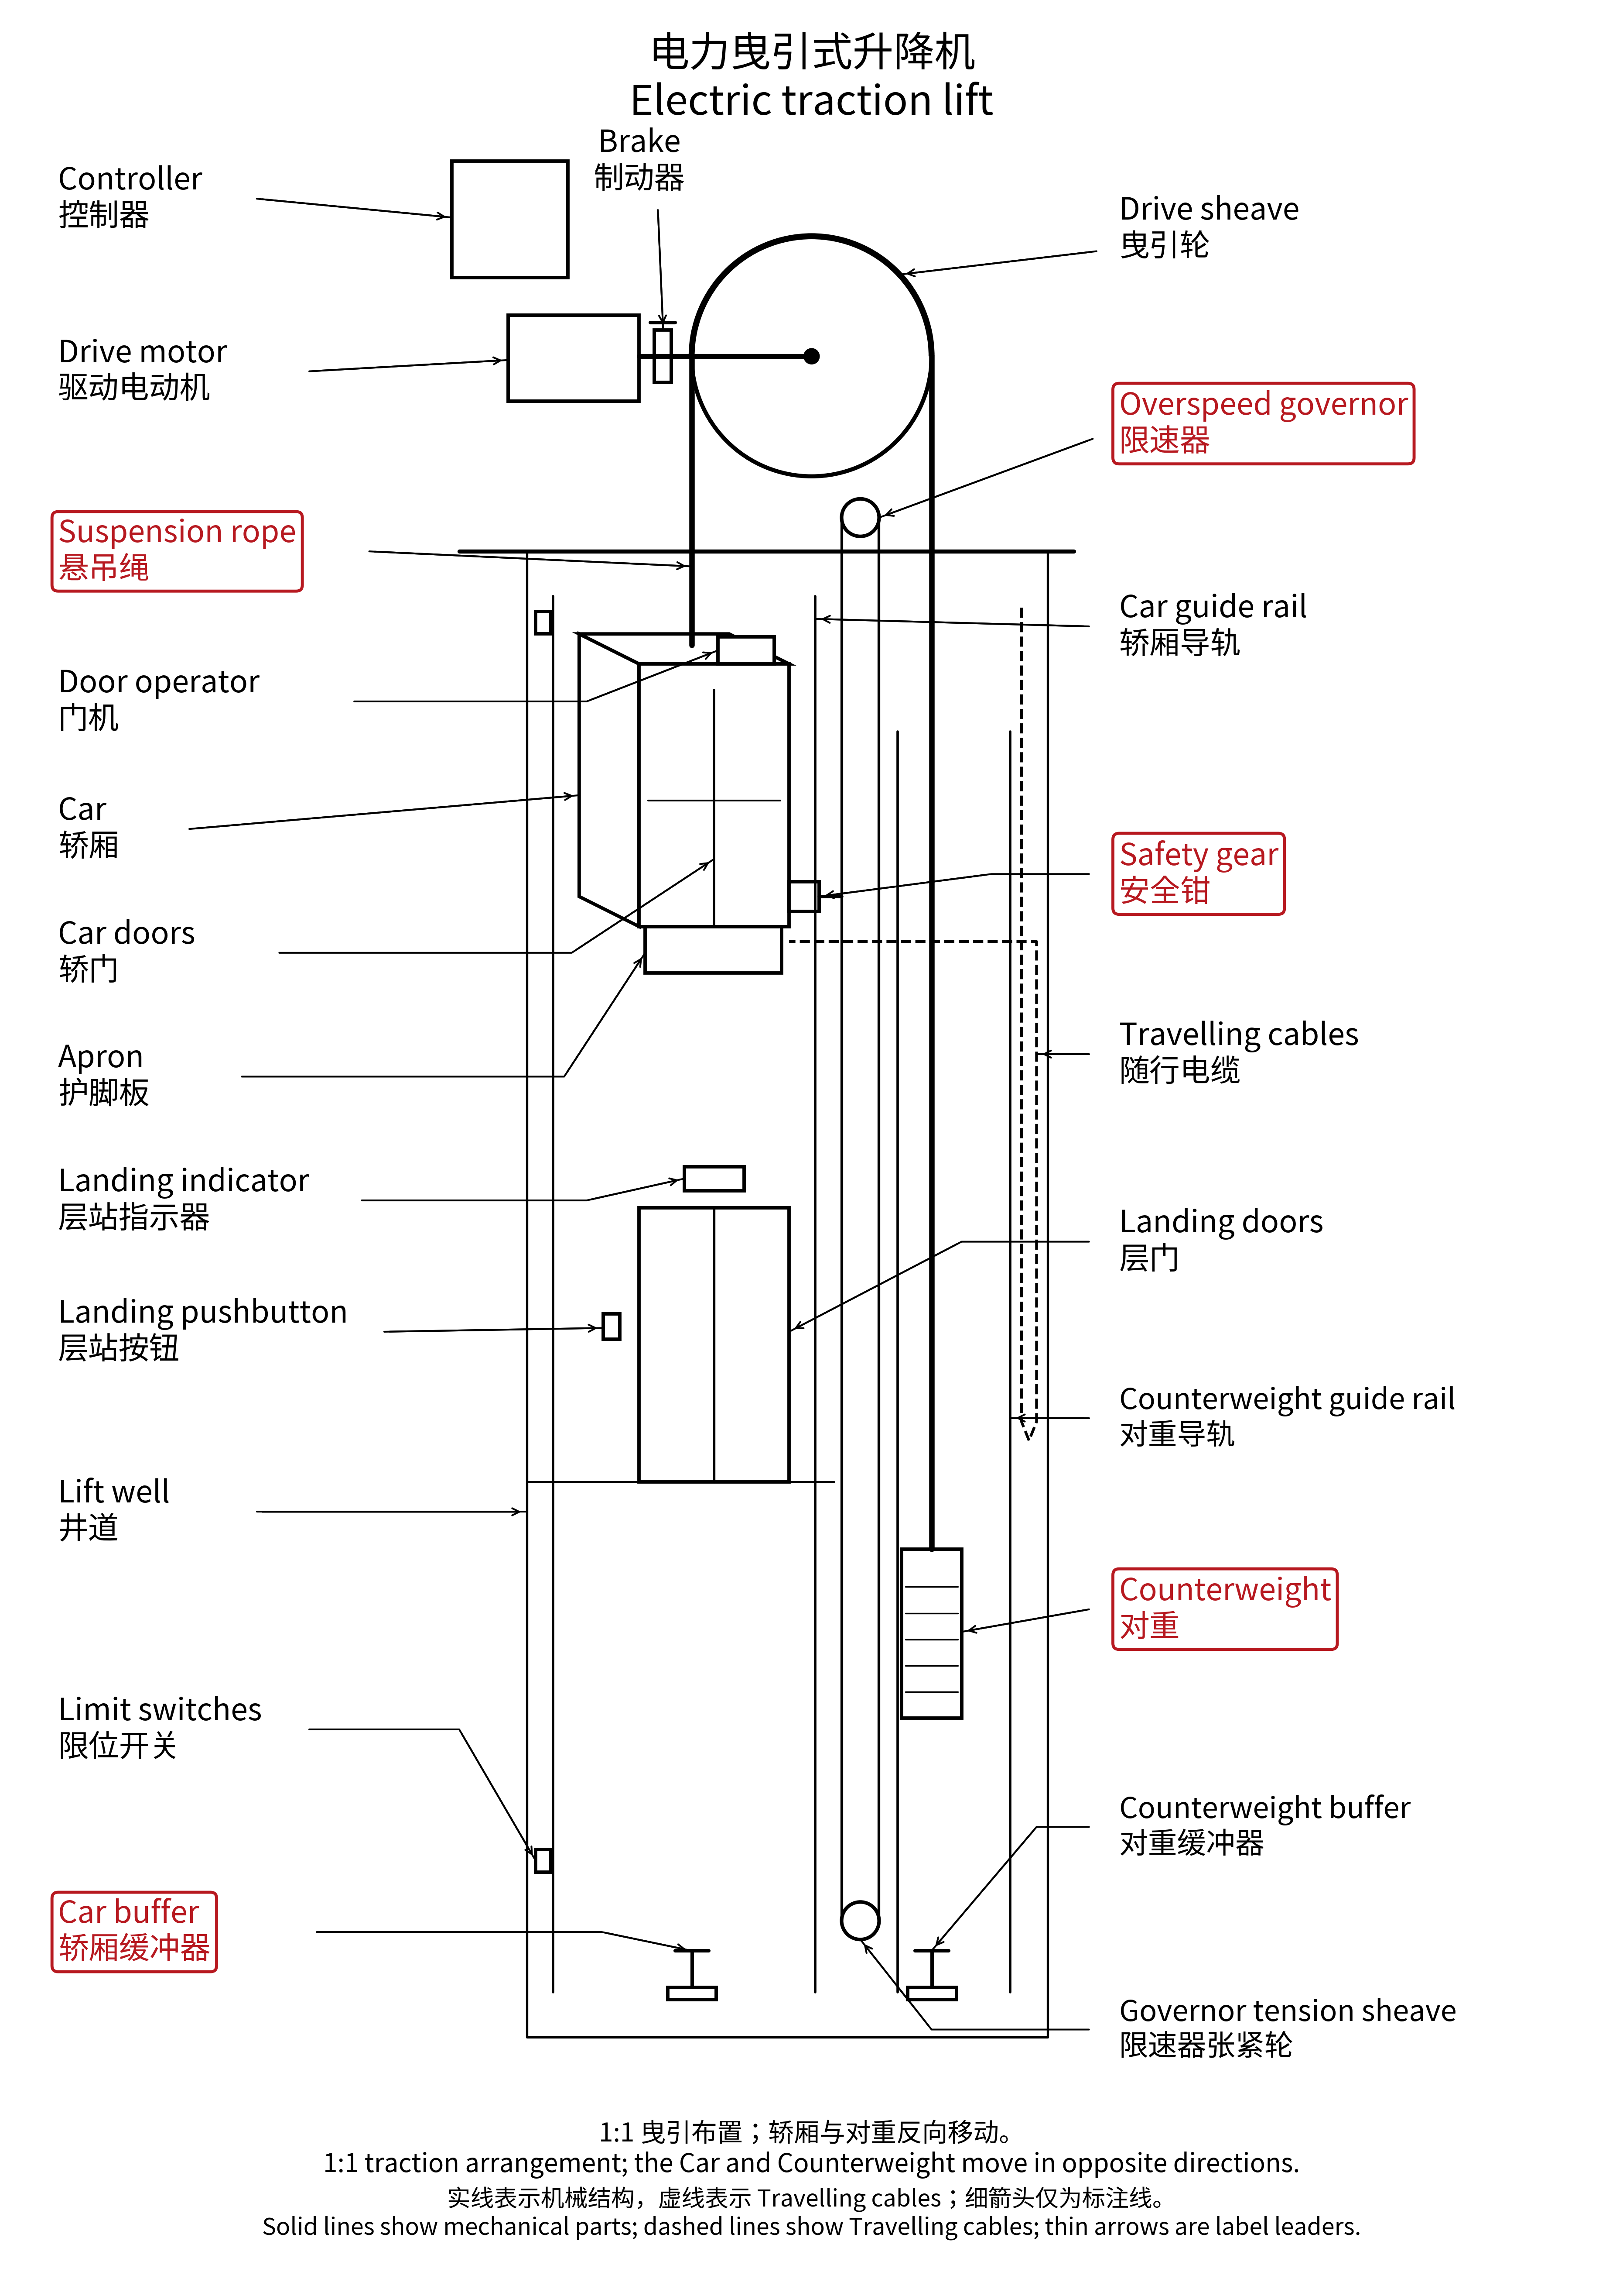

2 直顶式液压升降机 / Direct-driven cylinder hydraulic lift
直顶式液压升降机由电动机驱动油泵，将液压油由油箱经阀组送入埋地油缸。油压推动柱塞伸出，直接顶升轿厢。下降时，阀组让油受控流回油箱，轿厢重量使柱塞回缩。埋地油缸向地下延伸，以容纳所需行程。
A direct-driven cylinder hydraulic lift uses an electrically driven Pump to deliver oil from the Tank through the Valve block into the Cylinder in borehole. Oil pressure extends the Piston and directly raises the Car. During descent, the Valve block permits controlled oil return to the Tank, and the weight of the Car retracts the Piston. The Cylinder in borehole extends below ground to accommodate the required travel.
部件 / Component | 功能 | Operational function
轿厢导轨  Car guide rails | 引导轿厢垂直运行，并限制横向移动。 | Guide the Car vertically and restrain lateral movement.
轿厢  Car | 承载乘客或货物，并由柱塞直接承托。 | Carries passengers or goods and is directly supported by the Piston.
井道  Lift well | 围护轿厢及相关设备的运行空间。 | Encloses the travel space of the Car and associated equipment.
控制器  Controller | 接收层站按钮指令，协调油泵、阀组、停车、平层和门机。 | Receives calls from the Landing pushbutton and coordinates the Pump, Valve block, stopping, levelling and Door operator.
柱塞  Piston | 在油压作用下伸出，直接顶升轿厢；回缩时轿厢下降。 | Extends under oil pressure to raise the Car directly; its retraction allows the Car to descend.
阀组  Valve block | 控制进油、保压及受控回油，从而实现上升、停止和下降。 | Controls oil admission, holding and controlled return for ascent, stopping and descent.
油泵  Pump | 由电动机驱动，将油箱中的液压油送往埋地油缸，提供顶升所需的油流。 | Is driven by an electric motor and delivers oil from the Tank to the Cylinder in borehole to raise the Car.
油箱  Tank | 储存液压油，向油泵供油，并接收下降时的回油。 | Stores oil, supplies the Pump and receives returning oil during descent.

2.1 主要部件及功能（续） / Major components (continued)
部件 / Component | 功能 | Operational function
门机  Door operator | 驱动轿门开启和关闭。 | Opens and closes the Car doors.
轿门  Car doors | 关闭轿厢入口；正常运行时保持关闭。 | Close the Car entrance and remain closed during normal travel.
随行电缆  Travelling cables | 连接固定设备和移动轿厢，传送电源及控制信号。 | Carry power and control signals between fixed equipment and the moving Car.
层站指示器  Landing indicator | 显示楼层或运行方向等信息。 | Displays information such as floor position or direction.
层站按钮  Landing pushbutton | 向控制器发出召梯指令。 | Registers a landing call with the Controller.
层门  Landing doors | 关闭各楼层的井道入口；其联锁防止门未关闭锁紧时正常运行。 | Close the Lift well entrance at each landing; their interlocks prevent normal travel unless they are closed and locked.
密封套  Collar | 在埋地油缸入口处引导柱塞，并配合密封组件限制油液泄漏。 | Guides the Piston at the cylinder entrance and works with the sealing arrangement to limit oil leakage.
埋地油缸  Cylinder in borehole | 容纳受压液压油，与柱塞形成直接顶升机构；埋地部分容纳所需行程。 | Contains pressurised oil and forms the direct lifting actuator with the Piston; its buried length accommodates the required travel.

2.2 运作过程 / Operation
上升：控制器启动油泵，油经阀组进入埋地油缸，使柱塞伸出并直接顶升轿厢。停止：油泵停止供油，阀组保持油缸内的油液，使轿厢停留在所需位置。下降：阀组控制回油速度，使柱塞和轿厢受控下降。平层后停止回油，轿厢保持静止，再开门。
Ascent: the Controller operates the Pump, and oil passes through the Valve block into the Cylinder in borehole, extending the Piston and raising the Car directly. Holding: the Pump stops delivering oil, and the Valve block retains oil to hold the Car at the required position. Descent: the Valve block controls the return flow so that the Piston and Car descend in a controlled manner. After levelling, return flow stops and the Car remains stationary before the doors open.

