01｜产业政策与平台经济 / Industrial policies and the platform economy
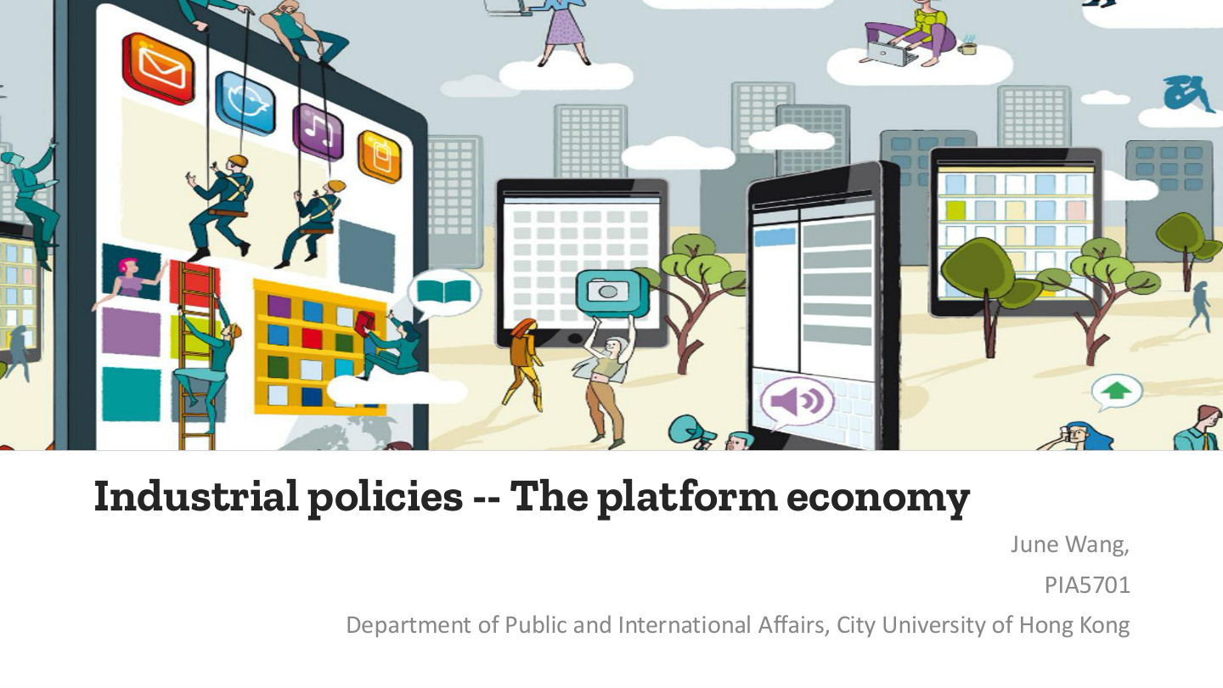
原PPT第1页 / Original slide 1 · 简读 / Brief

PPT中英翻译 / PPT translation
PPT English / 英文原文与图示 | 中文翻译 / Chinese translation
Industrial policies -- The platform economy | 产业政策——平台经济。
June Wang; PIA5701; Department of Public and International Affairs, City University of Hong Kong | June Wang；PIA5701；香港城市大学公共及国际事务系。

本页核心 / Key takeaway
本课既看平台怎样组织生产与创业，也看平台怎样组织人的劳动和收益分配。
This lesson examines how platforms organise production and entrepreneurship, as well as labour and the distribution of returns.

阅读说明 / Reading guide
核心理论和辨析标红，次重点加粗；非重点与重复页浓缩。全篇中英对照，无附录。
Red marks core theory and distinctions; bold marks secondary points. Brief or repetitive pages retain essentials. All review content is bilingual; no appendix.
按原PPT的41页顺序，结合本次上传的Word总结，将相关解释整合于各页；表格中的历史规则和价格按课件呈现。
The 41 original slides determine the order. The supplied Word summary is integrated at corresponding pages; historical rules and prices follow the slides.

02｜三条复习线索 / Agenda
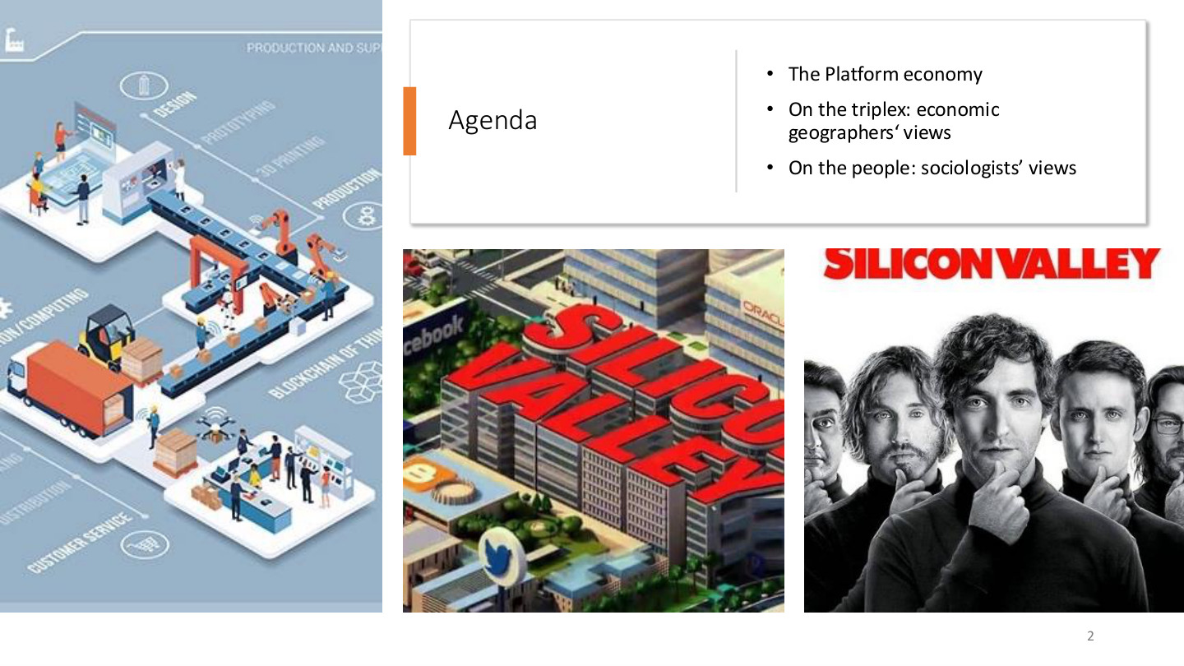
原PPT第2页 / Original slide 2 · 简读 / Brief

PPT中英翻译 / PPT translation
PPT English / 英文原文与图示 | 中文翻译 / Chinese translation
The Platform economy | 平台经济。
On the triplex: economic geographers’ views | 关于“triplex”：经济地理学视角。此处先作空间与创业支持环境这一板块的名称理解，勿直接当作后文三螺旋的定义。
On the people: sociologists’ views | 关于人：社会学视角。

本页核心 / Key takeaway
按“平台的生产组织→创业的空间与网络→数字劳动和算法控制”串联全课。
Connect the lecture through production organisation, entrepreneurial spaces and networks, then digital labour and algorithmic control.

精要解析 / Essential explanation

1. 一条贯穿问题 / A connecting question
平台提高连接和协调能力之后，谁获得机会、谁控制规则、谁承担风险？同一平台可以同时创造创业机会，又使劳动受到新的评价与管理。
As platforms improve connection and coordination, ask who gains opportunities, who controls rules and who bears risks. Entrepreneurial opportunities and new forms of labour evaluation can coexist.

03｜第一部分：平台经济 / Part I: Platform economy
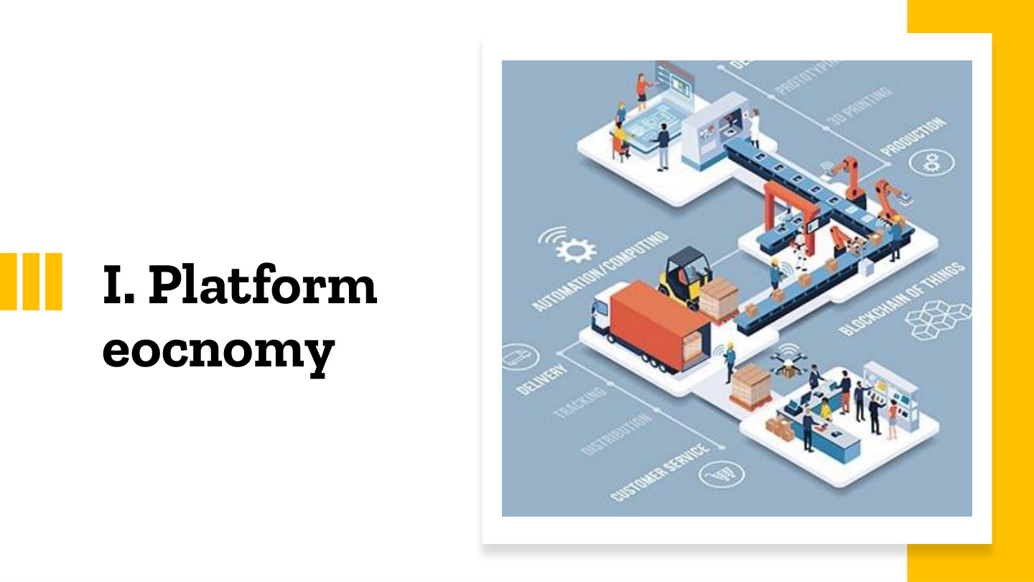
原PPT第3页 / Original slide 3 · 简读 / Brief

PPT中英翻译 / PPT translation
PPT English / 英文原文与图示 | 中文翻译 / Chinese translation
I. Platform eocnomy [slide spelling] | 第一部分：平台经济（economy在原页有拼写错误）。

本页核心 / Key takeaway
先理解平台改变交易和生产组织的方式，再进入其空间及劳动影响。
First understand how platforms change transactions and production organisation, then examine their spatial and labour implications.

04｜工业4.0 / Industry 4.0
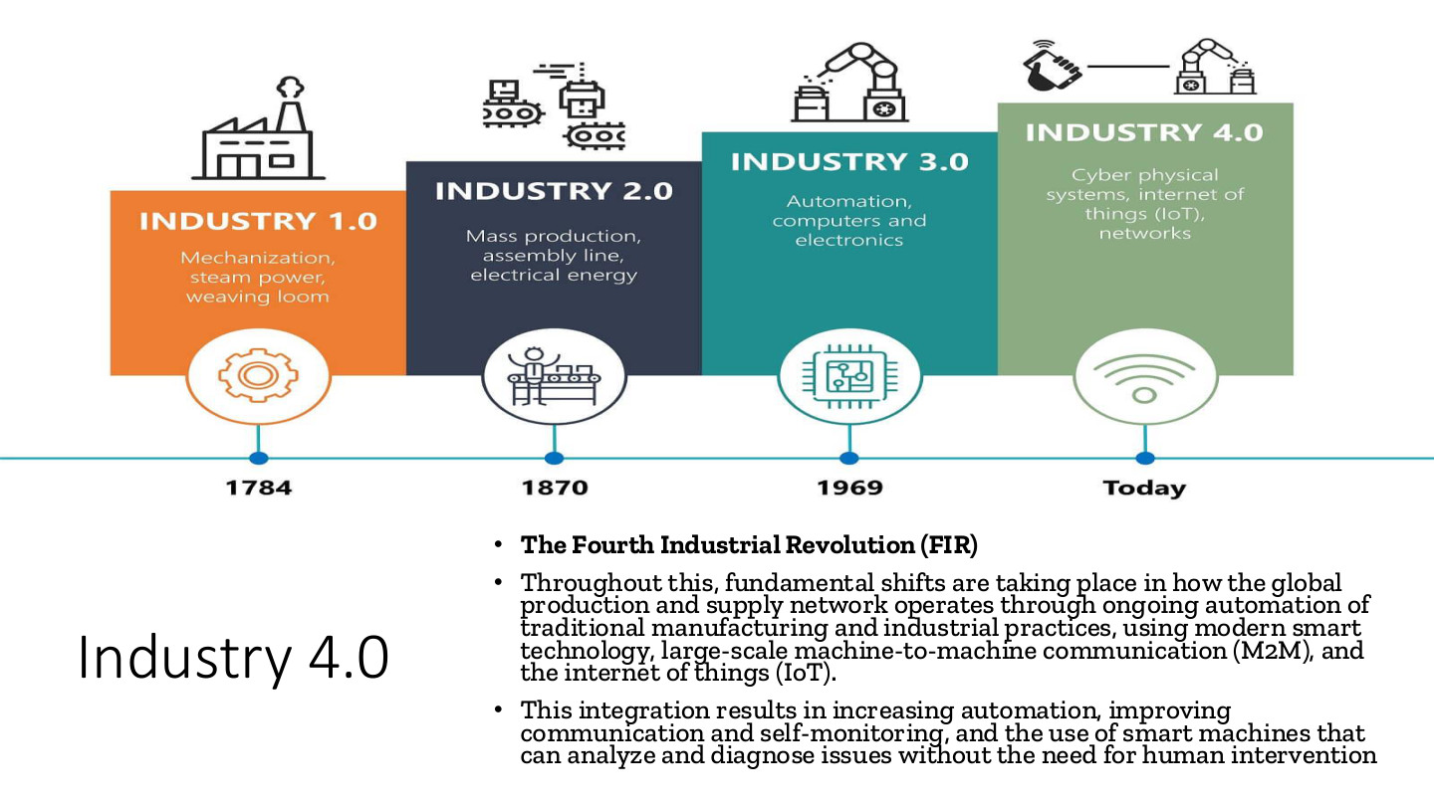
原PPT第4页 / Original slide 4 · 重点 / Focus

PPT中英翻译 / PPT translation
PPT English / 英文原文与图示 | 中文翻译 / Chinese translation
Industry 4.0; The Fourth Industrial Revolution (FIR) | 工业4.0；第四次工业革命（FIR）。
Throughout this, fundamental shifts are taking place in how the global production and supply network operates through ongoing automation of traditional manufacturing and industrial practices, using modern smart technology, large-scale machine-to-machine communication (M2M), and the internet of things (IoT). | 借助现代智能技术、大规模机器间通信（M2M）和物联网（IoT），传统制造及工业实践持续自动化，全球生产与供应网络的运作发生根本变化。
This integration results in increasing automation, improving communication and self-monitoring, and the use of smart machines that can analyze and diagnose issues without the need for human intervention. | 这种整合提高自动化、通信和自我监测水平，使智能机器可在不需要人为介入的情况下分析、诊断某些问题。
Industry 1.0: mechanization, steam power, weaving loom (1784). Industry 2.0: mass production, assembly line, electrical energy (1870). | 图示工业1.0：机械化、蒸汽动力、织机（1784）；工业2.0：大规模生产、流水线、电能（1870）。
Industry 3.0: automation, computers and electronics (1969). Industry 4.0: cyber physical systems, Internet of Things (IoT), networks (Today). | 工业3.0：自动化、计算机与电子技术（1969）；工业4.0：信息物理系统、物联网与网络（Today指制图时当代）。图中年份为阶段性示意。

本页核心 / Key takeaway
工业4.0的重点是智能技术、M2M与IoT整合生产及供应网络，不只是工厂装上电脑。
Industry 4.0 centres on integrating production and supply networks through smart technology, M2M and IoT, beyond simply installing computers.

精要解析 / Essential explanation

1. 三个术语 / Three terms
M2M强调机器之间交换信息；IoT强调设备通过网络连接并收集、交换数据；信息物理系统把数字监测、计算与实体生产连接起来。它们共同支持自动协调。
M2M concerns communication between machines; IoT connects devices to collect and exchange data; cyber-physical systems connect digital monitoring and computation with physical production. Together they support automated coordination.

2. 从单机到网络 / From machines to networks
与只看单台设备效率不同，本页强调信息在生产、供应和监测环节之间流动。例如机器状态可反馈到维护和排程，改变整个生产网络的运作。
The emphasis extends beyond the efficiency of individual machines to information flows across production, supply and monitoring. Machine-status data can inform maintenance and scheduling across the network.

3. 与本课主题的连接 / Connection to the lecture
智能互联为平台协调分散参与者提供技术条件。工业4.0是生产技术与系统转型，平台经济是组织和商业模式问题；二者相连，却不是同一概念。
Smart connectivity enables platforms to coordinate dispersed participants. Industry 4.0 concerns production technologies and systems; the platform economy concerns organisation and business models. The concepts are related but distinct.

05｜经济学视角：价值链重组 / Economists’ views
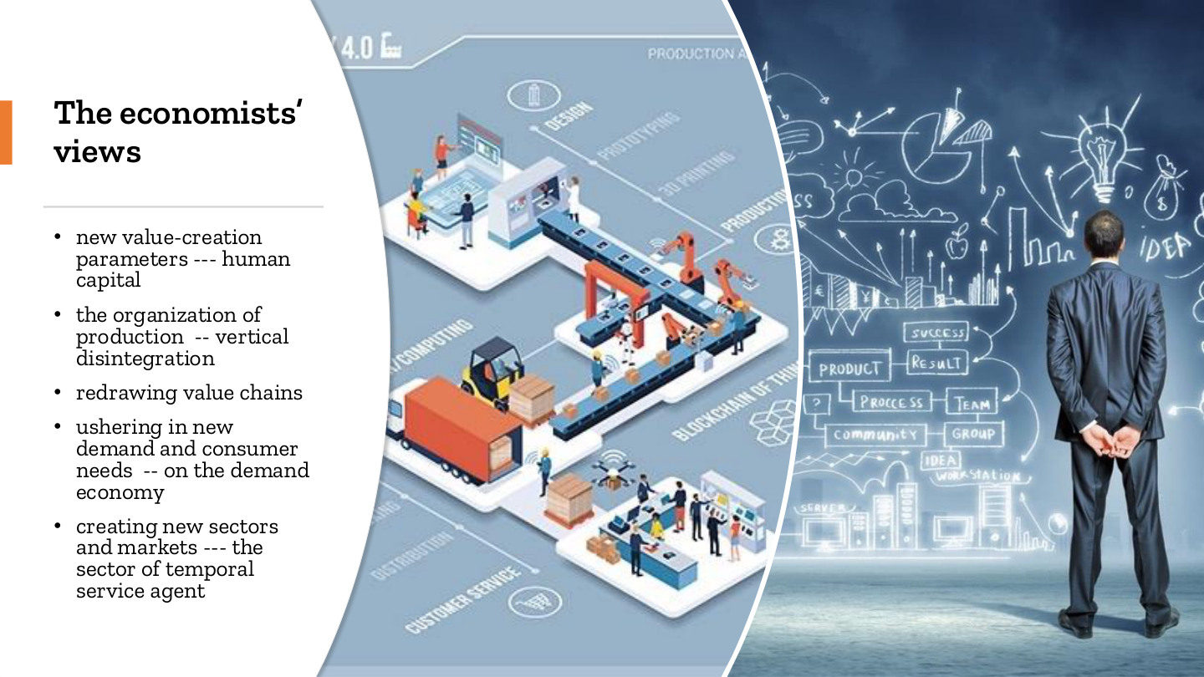
原PPT第5页 / Original slide 5 · 重点 / Focus

PPT中英翻译 / PPT translation
PPT English / 英文原文与图示 | 中文翻译 / Chinese translation
New value-creation parameters --- human capital | 新的价值创造要素——人力资本。
The organization of production -- vertical disintegration | 生产组织——垂直分解。
Redrawing value chains | 重构价值链。
Ushering in new demand and consumer needs -- on the demand economy | 带来新需求与消费需要——结合语境理解为按需经济（通常写作on-demand economy）。
Creating new sectors and markets --- the sector of temporal service agent | 创造新部门与市场——临时性服务中介领域（temporal service agent为原页用语，并非此处单独定义的标准理论名称）。

本页核心 / Key takeaway
平台通过拆分并重新连接价值链，把人力资本、消费者需求和按需服务组织起来。
Platforms organise human capital, consumer demand and on-demand services by splitting and reconnecting value chains.

精要解析 / Essential explanation

1. 垂直分解 / Vertical disintegration
原本由一家企业内部完成的环节，可以交给不同企业或个体完成，再由网络协调。分解的是生产任务和组织边界，并不等于生产流程不再需要协调。
Activities previously performed inside one firm can be distributed among firms or individuals and coordinated through networks. Production tasks and organisational boundaries are split, while coordination remains necessary.

2. 人力资本 / Human capital
指个人的知识、技能、经验和能力。平台使这些能力更容易与需求对接，但能否取得收入，还取决于市场需求、平台准入及分配规则。
Human capital comprises knowledge, skills, experience and capabilities. Platforms can connect these capabilities with demand, but earnings also depend on demand, access and allocation rules.

3. 按需经济 / On-demand economy
消费者提出即时或特定需求，平台匹配服务供给，例如出行或配送。新的消费便利与新的用工安排同时出现，为后文讨论劳动控制埋下线索。
Platforms match service providers to immediate or specific requests, such as transport or delivery. Consumer convenience develops alongside new work arrangements, leading to the later discussion of labour control.

易错辨析 / Key distinction
vertical disintegration译为垂直分解；与把更多环节收归同一企业的vertical integration（垂直整合）方向相反。
Vertical disintegration moves in the opposite direction from vertical integration, which brings more stages under one firm.

06｜群体型资本主义 / Crowd-based capitalism
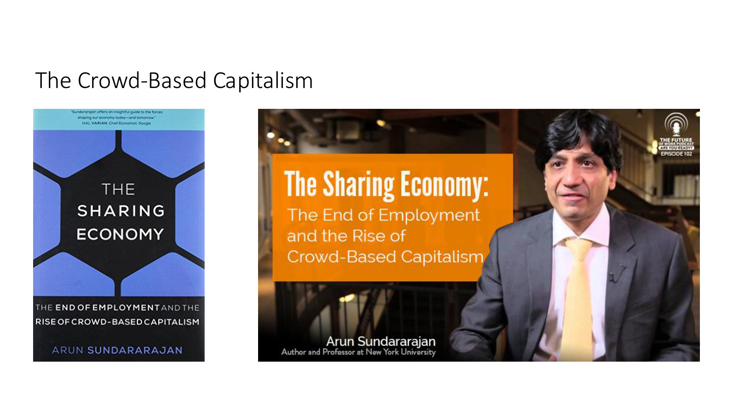
原PPT第6页 / Original slide 6 · 理解 / Understand

PPT中英翻译 / PPT translation
PPT English / 英文原文与图示 | 中文翻译 / Chinese translation
The Crowd-Based Capitalism | 群体型资本主义／基于大众参与的资本主义。
The Sharing Economy: The End of Employment and the Rise of Crowd-Based Capitalism | 《共享经济：雇佣的终结与群体型资本主义的兴起》（书名）。
Arun Sundararajan; Author and Professor at New York University | Arun Sundararajan，作者、纽约大学教授。

本页核心 / Key takeaway
分散的大量参与者通过数字网络提供资源和服务，使生产不必都在传统企业内部完成。
Large numbers of dispersed participants provide resources and services through digital networks, extending production beyond conventional firms.

精要解析 / Essential explanation

1. 抓住组织变化 / Focus on organisation
书名引出的是生产和雇佣关系的变化。平台连接个人资源、技能与需求，传统“公司拥有全部资源、雇员内部生产”的边界可能变得模糊。
The book introduces changes in production and employment. Platforms connect individual resources and skills with demand, potentially blurring the conventional boundary between firm-owned resources and internal employee production.

2. 共享的限度 / Limits of “sharing”
“共享经济”不一定是无偿分享。有偿服务、商业盈利和平台收费也可存在；书名中的“雇佣的终结”也不应背成所有雇佣已经消失的事实判断。
The sharing economy need not involve free sharing: paid services, commercial profit and platform fees may coexist. The subtitle does not establish that all employment has disappeared.

07｜市场与层级 / Markets and hierarchies
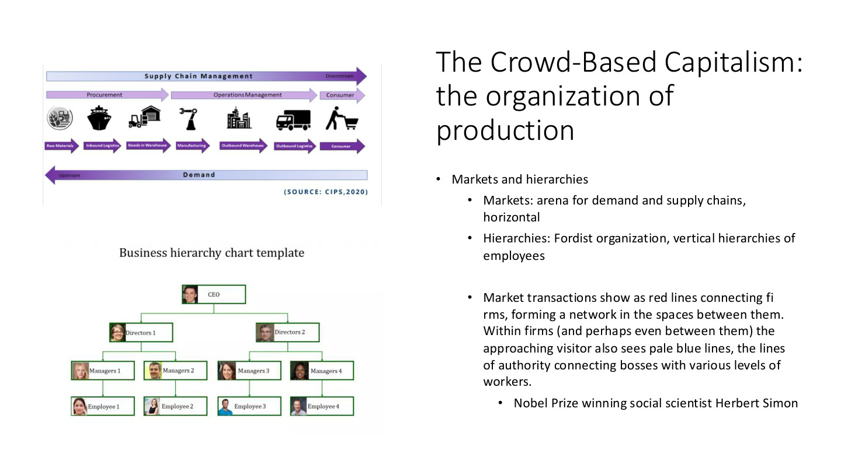
原PPT第7页 / Original slide 7 · 重点 / Focus

PPT中英翻译 / PPT translation
PPT English / 英文原文与图示 | 中文翻译 / Chinese translation
The Crowd-Based Capitalism: the organization of production; Markets and hierarchies | 群体型资本主义：生产组织；市场与层级。
Markets: arena for demand and supply chains, horizontal | 市场：连接供需链的场域，强调横向关系。
Hierarchies: Fordist organization, vertical hierarchies of employees | 层级：福特主义组织，以雇员的纵向等级关系为特征。
Market transactions show as red lines connecting firms, forming a network in the spaces between them. Within firms (and perhaps even between them) the approaching visitor also sees pale blue lines, the lines of authority connecting bosses with various levels of workers. | 引文用红线比喻连接企业的市场交易网络，用浅蓝线比喻企业内部（也可能跨企业）连接老板与各层劳动者的权威关系。
Nobel Prize winning social scientist Herbert Simon | 诺贝尔奖得主、社会科学家Herbert Simon（赫伯特·西蒙）。
Supply chain management: procurement; operations management; consumer. Raw materials → inbound logistics → goods in warehouse → manufacturing → outbound warehouse → outbound logistics → consumer. Demand; upstream/downstream. | 图示供应链管理：采购、运营管理、消费者；原材料→入库物流→仓储货物→制造→出库仓储→外运物流→消费者；需求及上游／下游。
Business hierarchy chart template: CEO → Directors → Managers → Employees | 企业层级示意：首席执行官→董事／部门主管→经理→员工。

本页核心 / Key takeaway
市场以交易协调独立主体，层级以权威协调内部劳动；平台让两类关系重新组合。
Markets coordinate independent actors through transactions; hierarchies coordinate internal work through authority. Platforms can recombine these relations.

精要解析 / Essential explanation

1. 福特主义 / Fordist organisation
课件以纵向雇员体系说明层级：岗位、命令与监督沿组织图传递。这里的重点是权威如何协调劳动，不只是是否采用流水线。
The vertical employee structure illustrates hierarchy: positions, instructions and supervision follow the organisational chart. The focus is coordination through authority, rather than assembly lines alone.

2. 平台为什么值得研究 / Why platforms matter
平台可以让独立服务者与顾客交易，又通过准入、派单和评分影响行为。因此市场化的交易形式可以与集中化的规则控制并存，后文算法管理正解释这一点。
Platforms enable provider-customer transactions while shaping behaviour through access, allocation and ratings. Thus market-based transactions can coexist with centralised rule control, developed later through algorithmic management.

3. 英文答题抓手 / Exam phrasing
比较时分别写协调机制和关系位置：market＝transactions between actors；hierarchy＝authority within an organisation。用这两项解释区别，比只背“横向／纵向”更清楚。
Compare both mechanism and location: markets use transactions between actors; hierarchies use authority within organisations. This explains the distinction more clearly than memorising horizontal versus vertical alone.

易错辨析 / Key distinction
horizontal描述连接形式，不保证参与者权力平等；平台中的个体也未必在实际工作中完全自主。
Horizontal connections do not guarantee equal power, and platform participants need not be fully autonomous in practice.

08｜能否复制硅谷？ / Can another Silicon Valley be planned?

原PPT第8页 / Original slide 8 · 简读 / Brief

PPT中英翻译 / PPT translation
PPT English / 英文原文与图示 | 中文翻译 / Chinese translation
The triplex; Plan another silicon valley? | “triplex”板块：能否规划另一个硅谷？
Startup incubator; Asia’s innovation incubator | 图片文字：创业孵化器；亚洲创新孵化器。

本页核心 / Key takeaway
本页提出问题：建设孵化空间，是否就能形成成功的创业生态系统？
This slide asks whether building incubation spaces is sufficient to create a successful entrepreneurial ecosystem.

精要解析 / Essential explanation

1. 承上启下 / The transition
图中的建筑和孵化器是可见载体。接下来要补上知识交流、人才、制度和社群联系，才能解释为什么相似空间不一定产生相似创业结果。
Buildings and incubators are visible facilities. The following slides add knowledge exchange, talent, institutions and community ties to explain why similar spaces can produce different entrepreneurial outcomes.

09｜知识集群的历史脉络 / Historical evolution of knowledge clusters

原PPT第9页 / Original slide 9 · 理解 / Understand

PPT中英翻译 / PPT translation
PPT English / 英文原文与图示 | 中文翻译 / Chinese translation
The historical evolvement of knowledge clusters | 知识集群的历史演变。
The landscape of the startup economy resembles a number of concepts that have long been explored by economic geographers and urban sociologists—such as knowledge clusters and innovation complex (Zukin 2020; Castells 2000; Scott 1997; Marshall 1920). | 初创经济的空间景观，与经济地理学家和城市社会学家长期研究的知识集群、创新综合体等概念相似（Zukin 2020；Castells 2000；Scott 1997；Marshall 1920）。

本页核心 / Key takeaway
数字创业有新的技术条件，却延续了相关活动在特定地点集聚并相互联系的历史逻辑。
Digital entrepreneurship uses new technologies while continuing the logic of related activities clustering and connecting in particular places.

精要解析 / Essential explanation

1. 为什么回看旧理论 / Why earlier theories matter
研究平台创业不能只看软件。集群理论解释企业为何接近彼此，后面再加入数字连接、跨国网络和商业模式创新，理解新旧组织形式的联系。
Software alone cannot explain platform entrepreneurship. Cluster theories explain proximity; digital connections, transnational networks and business-model innovation then show how newer arrangements build on earlier forms.

2. 空间问题 / The spatial question
cluster强调相互联系的集聚。地理靠近可增加见面与合作机会，但是否真正交换知识，还要看行业关系、制度和社群互动。
A cluster involves concentration and interconnections. Proximity can create opportunities to meet and cooperate, but knowledge exchange also depends on industrial relations, institutions and community interaction.

10｜图例：中国汽车产业分布 / China’s automotive clusters
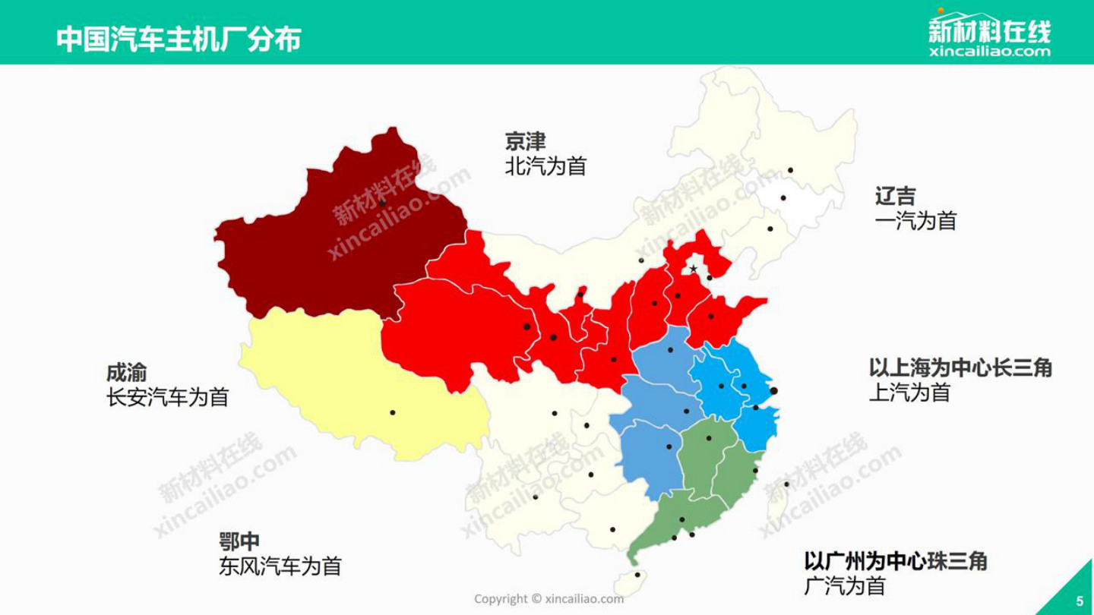
原PPT第10页 / Original slide 10 · 简读 / Brief

PPT中英翻译 / PPT translation
PPT English / 英文原文与图示 | 中文翻译 / Chinese translation
Distribution of automobile manufacturers in China [English rendering of the Chinese map] | 原图标题：中国汽车主机厂分布。
Beijing–Tianjin: BAIC; Liaoning–Jilin: FAW | 京津：北汽为首；辽吉：一汽为首。
Chengdu–Chongqing: Changan; central Hubei: Dongfeng | 成渝：长安汽车为首；鄂中：东风汽车为首。
Yangtze River Delta centred on Shanghai: SAIC; Pearl River Delta centred on Guangzhou: GAC | 以上海为中心的长三角：上汽为首；以广州为中心的珠三角：广汽为首。
Source shown: xincailiao.com; the star near Beijing is a map symbol, not an exam-priority mark. | 图中来源：新材料在线。北京附近的五角星是地图符号，不是教师标出的考试重点。

本页核心 / Key takeaway
汽车产业的区域分布帮助理解产业集聚；本页重点是空间格局，不是背所有厂名。
The regional distribution of automobile manufacturers illustrates industrial clustering; focus on the spatial pattern rather than memorising every manufacturer.

精要解析 / Essential explanation

1. 图示能说明什么 / What the map shows
龙头企业与相关产业活动集中在若干区域，为下一页产业集群提供直观例子。地图本身未测量知识溢出或效率，不能仅凭颜色断定哪个集群最成功。
Leading firms and related activities concentrate in several regions, illustrating clusters. The map does not measure knowledge spillovers or efficiency, so its colours cannot identify the most successful cluster.

11｜马歇尔与米兰时尚集群 / Marshall and the Milan fashion cluster
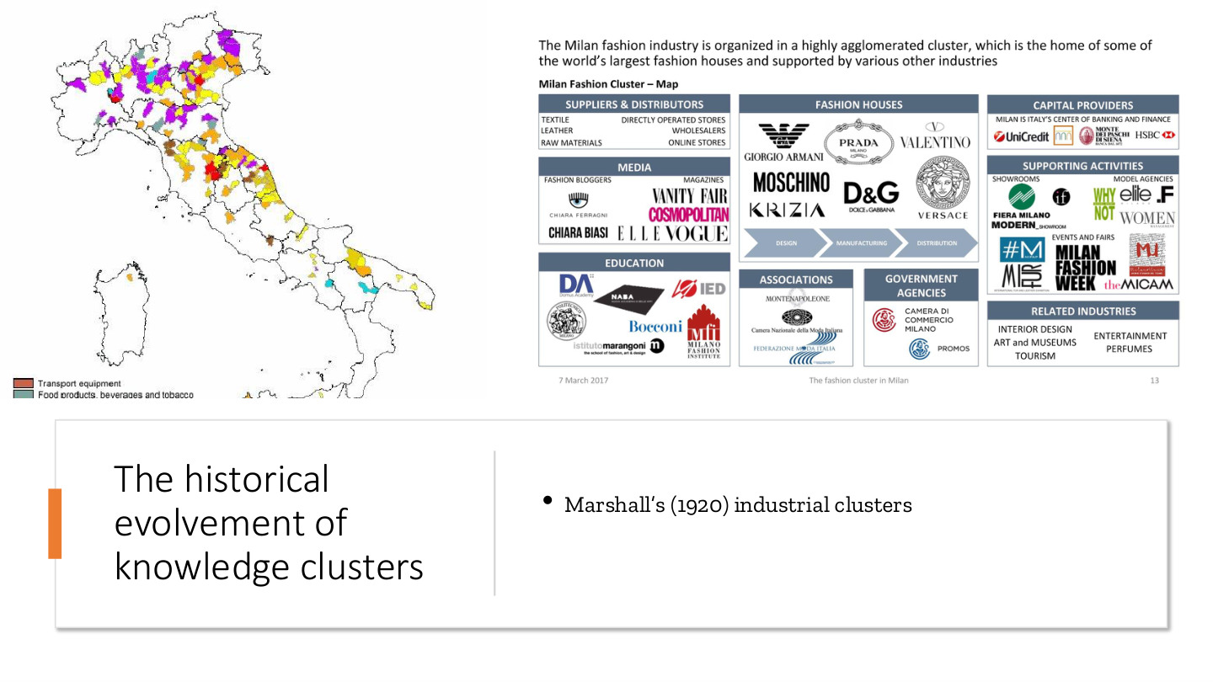
原PPT第11页 / Original slide 11 · 重点 / Focus

PPT中英翻译 / PPT translation
PPT English / 英文原文与图示 | 中文翻译 / Chinese translation
The historical evolvement of knowledge clusters; Marshall’s (1920) industrial clusters | 知识集群的历史演变；马歇尔（1920）的产业集群。
The Milan fashion industry is organized in a highly agglomerated cluster, which is the home of some of the world’s largest fashion houses and supported by various other industries. | 米兰时尚业形成高度集聚的产业集群，汇集世界大型时装企业，并获得多种其他产业支持。
Milan Fashion Cluster – Map: suppliers & distributors; textile, leather, raw materials; directly operated stores, wholesalers, online stores | 米兰时尚集群关系图：供应商与分销商；纺织、皮革、原材料；直营店、批发商、网店。
Fashion houses: design → manufacturing → distribution. Media: fashion bloggers; magazines. Education; associations; government agencies; capital providers. | 时装企业：设计→制造→分销；媒体：时尚博主、杂志；教育、协会、政府机构、资本提供者。
Supporting activities: showrooms, model agencies, events and fairs. Related industries: interior design, art and museums, tourism, entertainment, perfumes. | 支持活动：展厅、模特经纪、活动与展会；相关产业：室内设计、艺术及博物馆、旅游、娱乐、香水。
Italy map legend visible: transport equipment; food products, beverages and tobacco | 意大利分布图可见图例：运输设备；食品、饮料和烟草。

本页核心 / Key takeaway
产业集群的价值来自企业、供应商和支持机构的地方联系，不是许多同类企业简单挤在一起。
Industrial clusters derive value from local connections among firms, suppliers and supporting institutions, beyond the concentration of similar firms.

精要解析 / Essential explanation

1. 米兰例子怎么用 / Using Milan as an example
设计与时装品牌连接原料、生产、销售，也连接学校、媒体、金融和展会。产业链与支持网络共同存在，解释了集群为何能持续运作。
Design and fashion brands connect to materials, manufacturing and sales, alongside education, media, finance and events. Production links and support networks coexist, helping sustain the cluster.

2. 集聚的机制 / Mechanisms of clustering
作为对马歇尔集群的理解补充，可从共享专业供应、人才和知识交流入手：企业更容易找到所需伙伴与技能，也更容易接触行业信息。
To interpret Marshallian clustering, consider shared specialised supply, labour and knowledge exchange: firms can more easily find partners and skills and encounter industry information.

3. 从制造到创新 / From production to innovation
本页说明集群不只属于传统工厂。时尚产品同样依赖设计、文化与传播，因而自然连接下一页隐性知识及后面的认知—文化经济。
Clusters are not confined to conventional factories. Fashion also depends on design, culture and communication, linking this example to tacit knowledge and the cognitive-cultural economy.

12｜隐性知识与地方氛围 / Tacit knowledge and local atmosphere

原PPT第12页 / Original slide 12 · 重点 / Focus

PPT中英翻译 / PPT translation
PPT English / 英文原文与图示 | 中文翻译 / Chinese translation
The tacit knowledge | 隐性知识。
Beneficial effects of place-based “atmosphere”, which nurtures idea exchanges. | 地方性“氛围”的有益影响：它培育思想与创意的交流。
The Milan Fashion Cluster; Industry Clusters and Firm Competitiveness; Stockholm School of Economics | 图片报告：《米兰时尚集群》；产业集群与企业竞争力；斯德哥尔摩经济学院。
Milan City Fashion Week; fashion-show calendar; runway image | 图片：米兰城市时装周、时装展示日程和走秀。日程主要列品牌、日期与时段，用于呈现密集互动场景。

本页核心 / Key takeaway
隐性知识难以完全编码为文字或规则，常通过实践、观察和面对面交流传递。
Tacit knowledge is difficult to codify fully into words or rules and is often transmitted through practice, observation and face-to-face interaction.

精要解析 / Essential explanation

1. 知识是什么 / What the knowledge consists of
例如判断面料质感、把握设计风格或处理合作中的细节，可能需要示范和经验。与可写入手册的编码化知识相比，光拿到文件不一定就能掌握。
Judging fabrics, sensing a design style or handling collaboration may require demonstration and experience. Unlike codified knowledge recorded in manuals, receiving a document may not be enough to acquire the capability.

2. 为什么地方重要 / Why place matters
时装周、展厅和日常交往把相关人士反复带到一起，重复互动有助于形成共同理解并交换经验。“氛围”指这种社会与产业环境，而不是天气或装修风格。
Fashion weeks, showrooms and everyday encounters bring people together repeatedly. Repeated interaction supports shared understanding and experience exchange. Atmosphere refers to this social-industrial environment, not weather or decoration.

3. 政策含义 / Policy implication
可见空间需要配合持续活动和行业联系。建一栋孵化楼不等于获得隐性知识；关键是空间能否支持实际学习、交流与合作。
Physical space needs ongoing activities and industrial ties. An incubation building does not itself supply tacit knowledge; it must support actual learning, exchange and collaboration.

易错辨析 / Key distinction
tacit不是“秘密且不能传播”；它是难以完全言明和标准化，仍可通过共同实践学习。
Tacit does not mean secret or impossible to transmit; it means difficult to articulate and standardise fully, while remaining learnable through practice.

13｜Scott与Florida：文化、人才与城市 / Culture, talent and cities
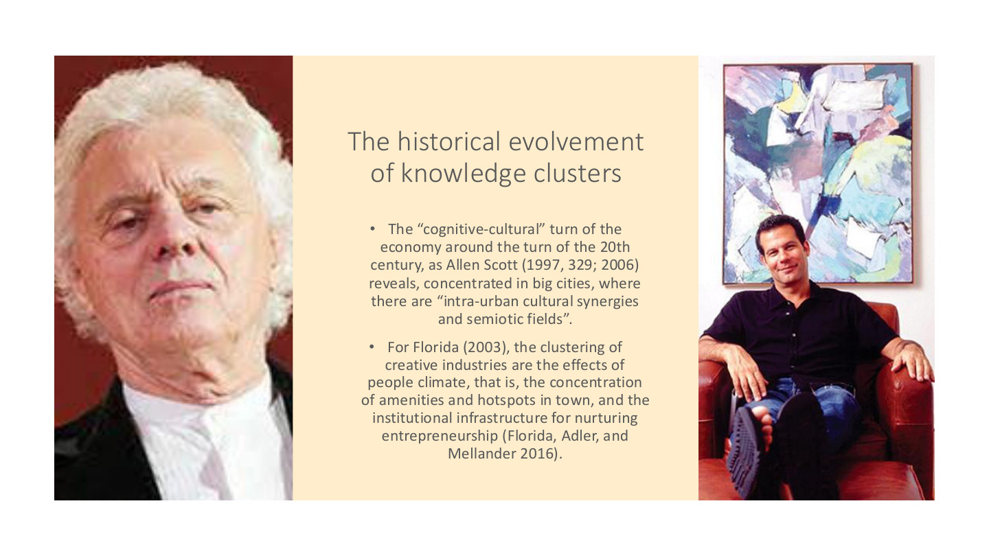
原PPT第13页 / Original slide 13 · 重点 / Focus

PPT中英翻译 / PPT translation
PPT English / 英文原文与图示 | 中文翻译 / Chinese translation
The historical evolvement of knowledge clusters | 知识集群的历史演变。
The “cognitive-cultural” turn of the economy around the turn of the 20th century, as Allen Scott (1997, 329; 2006) reveals, concentrated in big cities, where there are “intra-urban cultural synergies and semiotic fields”. | Allen Scott指出，经济的“认知—文化”转向集中于大城市，那里存在“城市内部文化协同和符号意义场域”。原句时间写作“20世纪之交”，与此处当代经济转型语境可能不一致，不将其作为需背诵的确定年代。
For Florida (2003), the clustering of creative industries are the effects of people climate, that is, the concentration of amenities and hotspots in town, and the institutional infrastructure for nurturing entrepreneurship (Florida, Adler, and Mellander 2016). | Florida认为，创意产业集聚受到“人才／人的环境”影响，包括城市便利设施、活跃场所以及培育创业的制度基础设施。

本页核心 / Key takeaway
Scott强调文化与符号协同，Florida强调吸引人才并支持创业的城市环境；两者补充了企业成本之外的集聚解释。
Scott stresses cultural and symbolic synergies; Florida stresses urban conditions that attract people and support entrepreneurship, extending explanations beyond firm costs.

精要解析 / Essential explanation

1. Scott的关注点 / Scott’s emphasis
认知—文化经济重视知识、创意和符号价值。设计、媒体等活动可能从城市文化、专业互动和共同意义中受益，不只是靠近原料。
The cognitive-cultural economy emphasises knowledge, creativity and symbolic value. Design and media activities may benefit from urban culture, professional interaction and shared meanings, beyond proximity to materials.

2. Florida的关注点 / Florida’s emphasis
people climate不是气候舒适，而是适合人才生活、交流和创业的环境。便利设施与活跃场所要和制度支持一起理解，不能简化成多开咖啡店。
People climate is not climatic comfort; it means conditions supporting people’s lives, interaction and entrepreneurship. Amenities and lively places must be considered with institutional support, rather than reduced to more cafes.

3. 比较答题 / Comparing the perspectives
可用“企业网络—知识交流—文化与人才环境”组织答案：马歇尔提供集群基础，本页突出文化和人才的作用。它们是不同解释角度，不必视为互相排斥。
Organise an answer around firm networks, knowledge exchange, and cultural and talent environments. Marshall provides a cluster foundation; this slide adds culture and people. These are different, potentially complementary perspectives.

14｜创业基础设施与复制硅谷 / Startup infrastructure
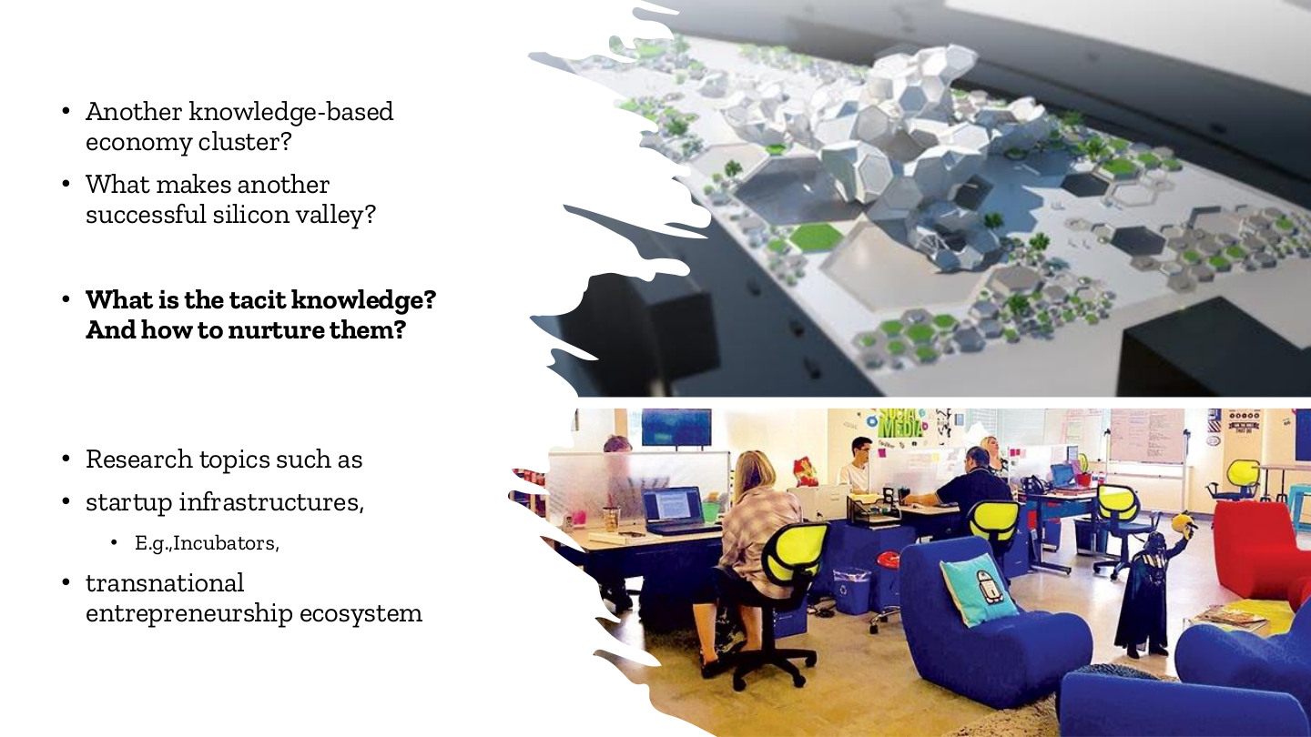
原PPT第14页 / Original slide 14 · 重点 / Focus

PPT中英翻译 / PPT translation
PPT English / 英文原文与图示 | 中文翻译 / Chinese translation
Another knowledge-based economy cluster? What makes another successful silicon valley? | 另一个知识经济集群？什么使另一个硅谷成功？
What is the tacit knowledge? And how to nurture them? [bold on slide] | 什么是隐性知识？如何培育它？（原页加粗。）
Research topics such as startup infrastructures; e.g., incubators; transnational entrepreneurship ecosystem | 研究主题包括创业基础设施，例如孵化器，以及跨国创业生态系统。

本页核心 / Key takeaway
复制硅谷不能只复制建筑；要解释空间怎样连接隐性知识、创业资源与关系网络。
Replicating Silicon Valley requires more than buildings: explain how spaces connect tacit knowledge, entrepreneurial resources and networks.

精要解析 / Essential explanation

1. 孵化器的作用 / The role of incubators
孵化器可以提供办公、指导和接触伙伴的机会。真正的支持来自资源与互动能否被持续组织起来，而不是“孵化器”这个名称本身。
Incubators can offer workspace, guidance and contact with partners. Support depends on sustaining resources and interaction, rather than applying the incubator label.

2. 承接本课总结 / Link to the supplied summary
Word总结强调不能仅凭建成空间复制硅谷。本页可用“硬件空间＋知识交流＋制度和社会联系”概括，后续页面分别展开这些条件。
The supplied notes emphasise that constructed space alone cannot replicate Silicon Valley. Use physical space, knowledge exchange, and institutional and social ties as a framework developed in the following slides.

3. 答题怎么具体 / Making an answer concrete
如果问如何培育创业生态，可从学习机会、导师／同伴联系和跨地资源连接举例。说明这些安排如何促进机会发现，避免只罗列园区、补贴和建筑。
For a question on nurturing ecosystems, discuss learning, mentoring or peer ties, and connections to resources elsewhere. Explain how they support opportunity discovery rather than merely listing parks, subsidies and buildings.

15｜创业生态系统与商业模式创新 / Entrepreneurial ecosystems
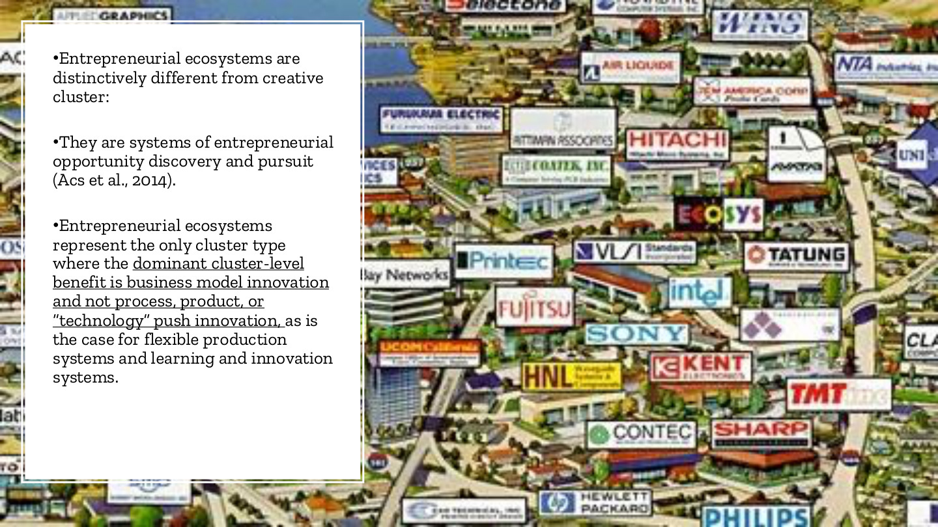
原PPT第15页 / Original slide 15 · 重点 / Focus

PPT中英翻译 / PPT translation
PPT English / 英文原文与图示 | 中文翻译 / Chinese translation
Entrepreneurial ecosystems are distinctively different from creative cluster. | 创业生态系统与创意集群有明显区别。
They are systems of entrepreneurial opportunity discovery and pursuit (Acs et al., 2014). | 它们是发现并追求／实现创业机会的系统。
Entrepreneurial ecosystems represent the only cluster type where the dominant cluster-level benefit is business model innovation and not process, product, or “technology” push innovation, as is the case for flexible production systems and learning and innovation systems. | 按本页比较，创业生态系统是以商业模式创新作为集群层面主导收益的类型；区别于以流程、产品或技术推动型创新为重点的柔性生产体系及学习与创新体系。这里保留的是该分类框架的论点。
Image: a dense landscape of interconnected technology firms and brands | 配图：密集分布的科技企业及品牌，呈现创业活动所处的产业环境。

本页核心 / Key takeaway
创业生态系统围绕机会发现与实现运作，本页尤其强调商业模式创新这一集群层面的收益。
Entrepreneurial ecosystems support opportunity discovery and pursuit, with this slide highlighting business-model innovation as a cluster-level benefit.

精要解析 / Essential explanation

1. 商业模式改变什么 / What business models change
它回答向谁提供什么价值、如何组织交易、如何取得收入。例如技术未必全新，但把分散供给与需求匹配起来并形成收费方式，仍可能改变商业模式。
A business model specifies customers, value offered, transaction organisation and revenue. Matching dispersed supply and demand through a revenue mechanism can change the model even without a wholly new technology.

2. 与产品和流程创新比较 / Distinguishing innovation types
新功能偏向产品创新，更高效的生产方法偏向流程创新；商业模式创新改变价值创造、传递与获取的安排。现实中几者可以并存，分类是帮助识别重点。
New features suggest product innovation; improved production methods suggest process innovation. Business-model innovation changes arrangements for creating, delivering and capturing value. The forms can coexist in practice.

3. 为什么称生态系统 / Why an ecosystem
机会实现依赖资金、技能、制度与关系，而不是单个创业者独自完成。资源互补及持续互动使创业想法有机会转成可运行的业务。
Pursuing opportunities depends on finance, capabilities, institutions and relationships, beyond individual effort. Complementary resources and ongoing interaction help turn ideas into viable businesses.

易错辨析 / Key distinction
本页强调的是“主导收益”，不表示创业生态系统没有技术创新，也不表示创意集群绝不产生商业模式创新。
The claim concerns the dominant benefit; it does not imply an absence of technological innovation in ecosystems or business-model innovation in creative clusters.

16｜创业加速器与同伴互动 / Accelerators and peer interaction
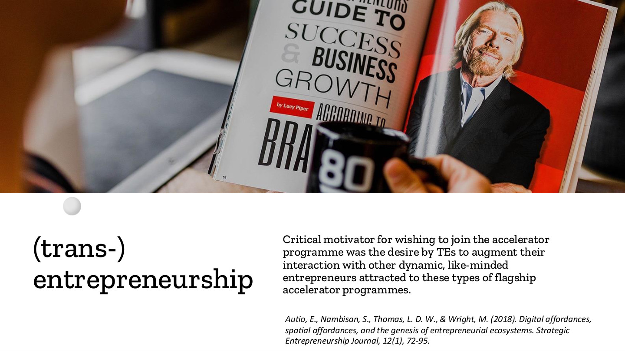
原PPT第16页 / Original slide 16 · 理解 / Understand

PPT中英翻译 / PPT translation
PPT English / 英文原文与图示 | 中文翻译 / Chinese translation
(trans-) entrepreneurship | （跨国）创业。
Critical motivator for wishing to join the accelerator programme was the desire by TEs to augment their interaction with other dynamic, like-minded entrepreneurs attracted to these types of flagship accelerator programmes. | 跨国创业者（TEs）希望参与加速器计划的重要动机，是增加与其他活跃、志同道合创业者的互动；这些创业者也被旗舰加速器计划吸引。
Autio, Nambisan, Thomas & Wright (2018), Digital affordances, spatial affordances, and the genesis of entrepreneurial ecosystems, Strategic Entrepreneurship Journal, 12(1), 72–95. | 文献：Autio等（2018），《数字可供性、空间可供性与创业生态系统的形成》，Strategic Entrepreneurship Journal，12(1)，72—95。

本页核心 / Key takeaway
加速器的价值不只在场地或课程，还在与其他创业者形成密集互动。
Accelerators offer more than facilities or teaching: they enable intensive interaction with other entrepreneurs.

精要解析 / Essential explanation

1. 互动提供什么 / What interaction provides
同伴可交换经验、发现合作、反馈商业想法。接触合适的人是参与项目的动机，连接前文隐性知识及后文社会资本。
Peers can exchange experience, identify collaborations and give feedback on business ideas. Access to relevant people motivates participation and connects tacit knowledge to social capital.

2. 空间与数字条件 / Spatial and digital conditions
加速器把人聚在一起，数字工具又能维持跨地联系。二者共同支持机会探索；不能因为使用线上工具，就认为实体场所已失去作用。
Accelerators bring people together, while digital tools maintain connections across places. Both support opportunity exploration; online communication does not by itself remove the value of physical settings.

17｜“独行鹰”与创业主体 / Lone eagles and entrepreneurial selves
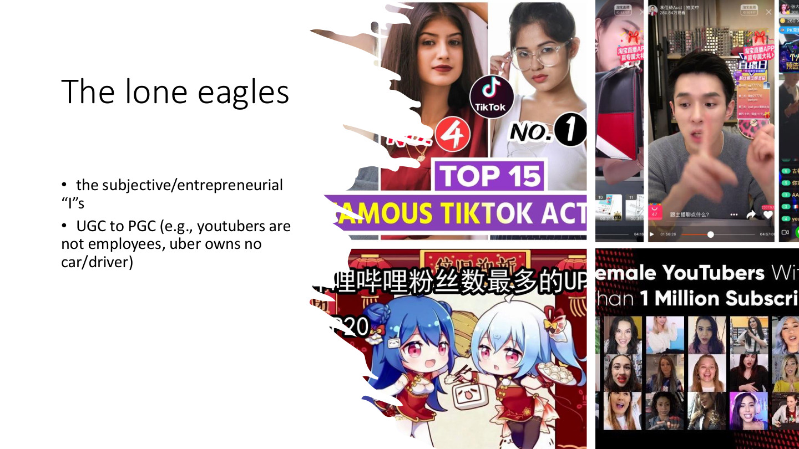
原PPT第17页 / Original slide 17 · 理解 / Understand

PPT中英翻译 / PPT translation
PPT English / 英文原文与图示 | 中文翻译 / Chinese translation
The lone eagles | “独行鹰”：以独立、个体化姿态工作的创业者／创作者形象。
The subjective/entrepreneurial “I”s | 具有主体性／创业性的一个个“我”。
UGC to PGC (e.g., youtubers are not employees, uber owns no car/driver) | 从用户生成内容（UGC）到专业生产内容（PGC）。原页以YouTube创作者非传统雇员、Uber不拥有车辆／司机作简化例子，突出平台与参与者关系；具体雇佣分类和资产安排须按情境判断。
Images: TikTok, YouTube and Bilibili creators | 配图：TikTok、YouTube及哔哩哔哩创作者。

本页核心 / Key takeaway
个人可成为内容或服务的生产主体，但创业式自主不等于摆脱平台依赖。
Individuals can produce content or services, but entrepreneurial autonomy does not eliminate platform dependence.

精要解析 / Essential explanation

1. UGC与PGC / UGC and PGC
UGC强调用户贡献内容，PGC强调更专业化的内容生产。专业程度与是否为平台雇员是两条不同维度；PGC不自动意味着平台直接雇佣。
UGC highlights user contributions; PGC highlights professionalised production. Professionalisation and employment status are separate dimensions; PGC does not automatically mean direct platform employment.

2. 独立与依赖 / Independence and dependence
创作者可以自行安排部分内容和时间，却仍依赖流量、变现接口与规则。用这一张力连接后文：个体承担创业风险，平台可能继续掌握分配和评价条件。
Creators may choose content and schedules while depending on visibility, monetisation systems and rules. This tension connects individual entrepreneurial risk with platform influence over allocation and evaluation.

易错辨析 / Key distinction
不要把“lone”理解成完全没有网络支持，也不要把所有司机或创作者的劳动法律地位一概而论。
Do not read “lone” as having no supporting networks, or generalise one legal employment status to all drivers or creators.

18｜跨国创业的网络联系 / Transnational entrepreneurship
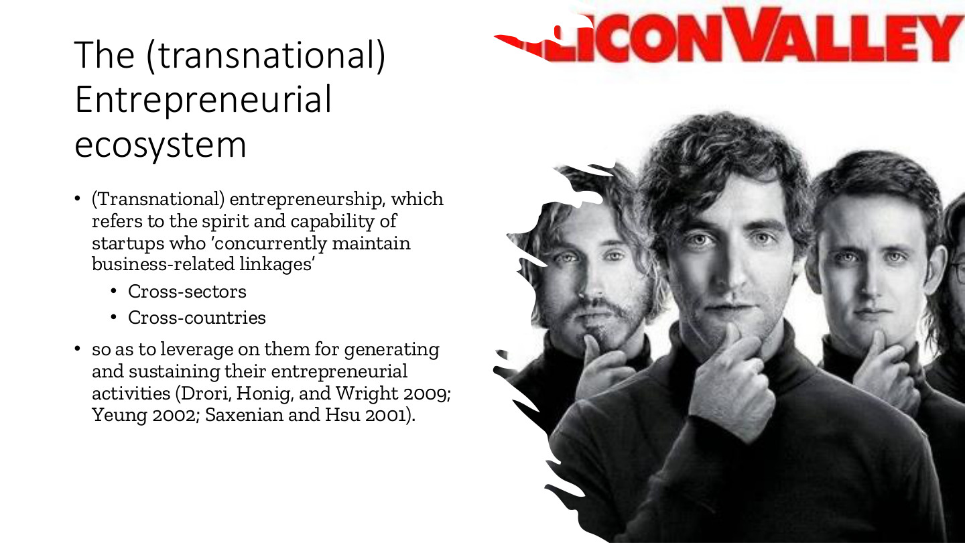
原PPT第18页 / Original slide 18 · 重点 / Focus

PPT中英翻译 / PPT translation
PPT English / 英文原文与图示 | 中文翻译 / Chinese translation
The (transnational) Entrepreneurial ecosystem | （跨国）创业生态系统。
(Transnational) entrepreneurship, which refers to the spirit and capability of startups who “concurrently maintain business-related linkages” | （跨国）创业涉及初创企业／创业者同时维持与业务相关联系的精神与能力。
Cross-sectors; Cross-countries; so as to leverage on them for generating and sustaining their entrepreneurial activities | 跨部门／行业、跨国家的联系，被用于产生并持续开展创业活动。
Drori, Honig & Wright 2009; Yeung 2002; Saxenian & Hsu 2001 | 引用：Drori、Honig与Wright（2009）；Yeung（2002）；Saxenian与Hsu（2001）。

本页核心 / Key takeaway
跨国创业关键在同时维持并利用跨境商业联系，把不同地点的资源用于持续创业。
Transnational entrepreneurship centres on simultaneously maintaining and using cross-border business ties to sustain entrepreneurial activity.

精要解析 / Essential explanation

1. 跨境联系的作用 / What cross-border ties do
例如一地提供研发与人才，另一地连接生产、投资或客户。联系必须能够支持实际业务，而不只是个人曾出国或具有海外身份。
One location may offer research and talent, another production, investment or customers. The connections must support business activity, rather than merely reflect travel or overseas identity.

2. 与本地集群的关系 / Relation to local clusters
跨国联系与本地集聚可以互补：创业者在本地获取信任和日常支持，同时通过外部联系获得其他资源。数字连接不要求所有合作方住在同一城市。
Transnational ties and local clustering can complement each other: local settings support trust and everyday interaction, while external connections bring additional resources. Not all partners must occupy the same city.

3. 概念边界 / Conceptual boundary
原页同时列cross-sectors与cross-countries。跨行业说明资源组合的广度；只有跨行业而没有跨境联系，不能单独证明是跨国创业。
The slide lists both cross-sector and cross-country ties. Cross-sector links show resource diversity; cross-sector activity alone does not establish transnational entrepreneurship.

19｜集聚、失败与三螺旋 / Clustering, failure and the triple helix
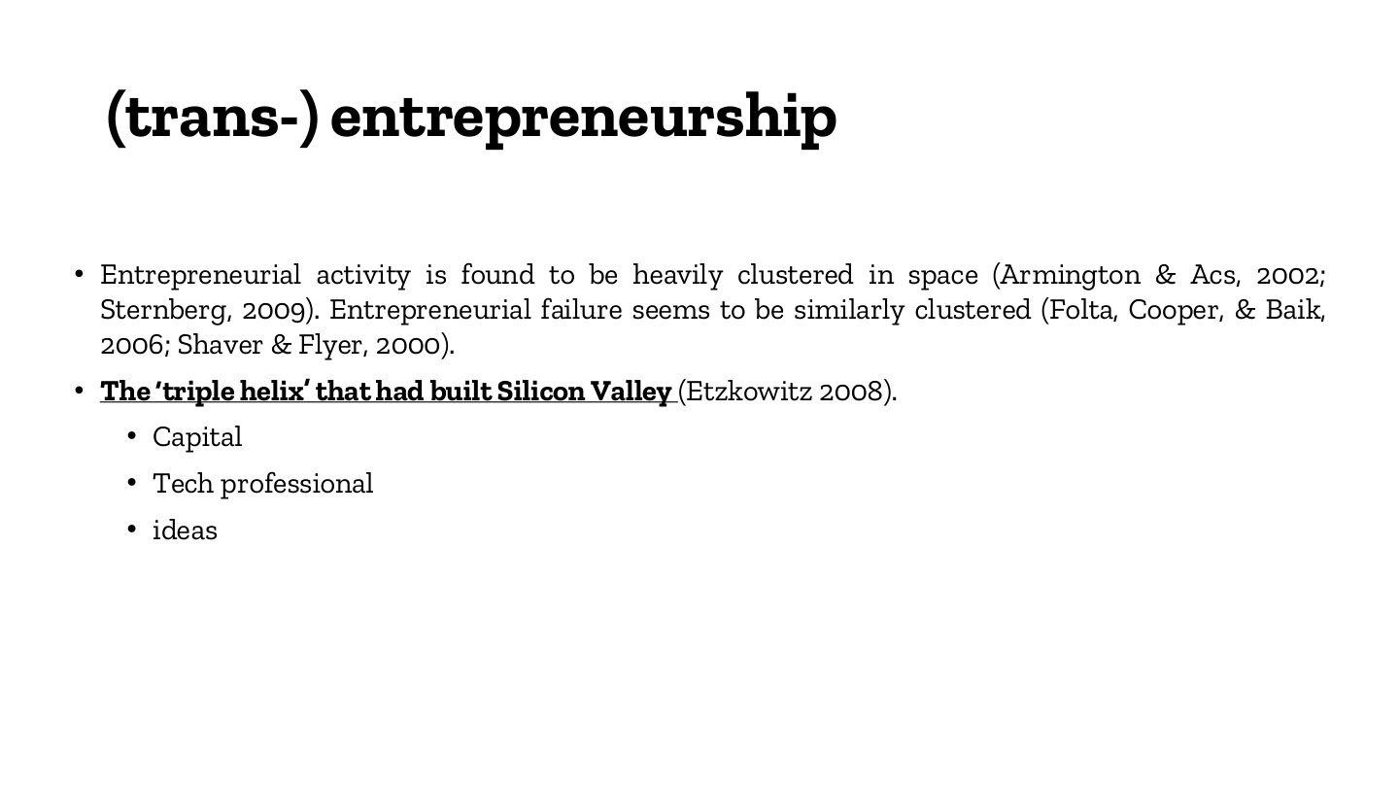
原PPT第19页 / Original slide 19 · 重点 / Focus

PPT中英翻译 / PPT translation
PPT English / 英文原文与图示 | 中文翻译 / Chinese translation
Entrepreneurial activity is found to be heavily clustered in space (Armington & Acs, 2002; Sternberg, 2009). Entrepreneurial failure seems to be similarly clustered (Folta, Cooper & Baik, 2006; Shaver & Flyer, 2000). | 创业活动高度空间集聚；创业失败似乎也呈现类似集聚。
The “triple helix” that had built Silicon Valley (Etzkowitz 2008). [underlined on slide] | 塑造硅谷的“三螺旋”（Etzkowitz 2008；原页划线强调）。
Capital; Tech professional; ideas | 资本；技术专业人才；创意。注意：这是原页列出的资源，不能直接替代三螺旋的标准主体名称。

本页核心 / Key takeaway
集聚并不保证成功；三螺旋通常指大学—产业—政府的互动，共同支持知识与创业发展。
Clustering does not guarantee success. The triple helix conventionally concerns university–industry–government interaction supporting knowledge and entrepreneurship.

精要解析 / Essential explanation

1. 两组“三”要分开 / Distinguish the two triads
资本、技术人才、创意回答“需要哪些资源”；大学、产业、政府回答“哪些制度主体相互协作”。资源可以在主体之间流动，但两组概念不能互换。
Capital, technical professionals and ideas identify resources; universities, industry and government identify interacting institutional actors. Resources flow among actors, but the two triads are not interchangeable.

2. 为什么连失败也集聚 / Why failure can cluster too
高密度创业地区也会出现竞争与失败。成功和失败都集中提示我们研究当地的竞争、资源与关系，而不能把位于集群内直接等同于成功原因。
Dense entrepreneurial locations also contain competition and failures. The concentration of both outcomes encourages analysis of local resources and relationships rather than treating location within a cluster as a guarantee of success.

3. 政策视角 / Policy perspective
大学提供研究和人才，产业连接应用与市场，政府参与制度与公共支持。协作的具体安排才是解释重点，不能只把三类机构放在同一张园区地图上。
Universities contribute research and talent, industry links application and markets, and government participates through institutions and public support. Explain actual collaboration, rather than merely locating three kinds of organisation on one map.

20｜制度网络与人力资本 / Institutional networks and human capital
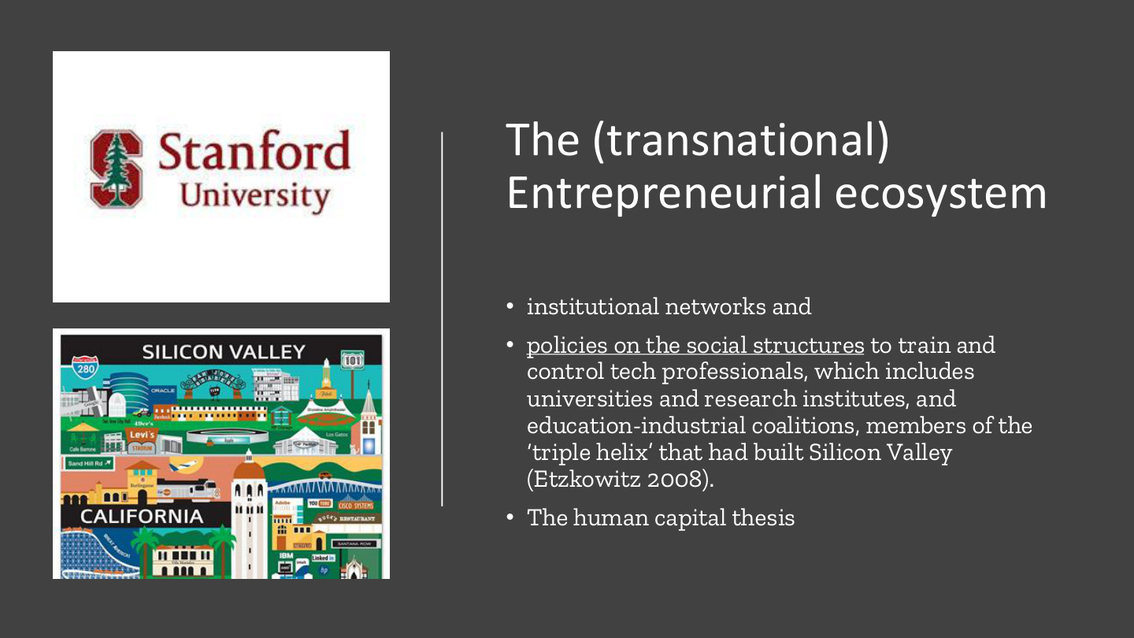
原PPT第20页 / Original slide 20 · 重点 / Focus

PPT中英翻译 / PPT translation
PPT English / 英文原文与图示 | 中文翻译 / Chinese translation
The (transnational) Entrepreneurial ecosystem; institutional networks | （跨国）创业生态系统；制度网络。
Policies on the social structures to train and control tech professionals, which includes universities and research institutes, and education-industrial coalitions, members of the “triple helix” that had built Silicon Valley (Etzkowitz 2008). | 关于培养和规制／组织技术专业人才的社会结构之政策，包括大学、研究机构及教育—产业联盟；这些组织属于支持硅谷三螺旋互动的网络。
The human capital thesis | 人力资本论点。
Images: Stanford University; Silicon Valley, California | 配图：斯坦福大学；加利福尼亚硅谷。

本页核心 / Key takeaway
人才能力的形成需要大学、研究机构与产业等制度网络，不只是靠个体天赋。
Human capabilities develop through institutional networks including universities, research bodies and industry, beyond individual talent alone.

精要解析 / Essential explanation

1. 人力资本如何形成 / How human capital develops
教育、研究训练与产业实践培养知识和技能。教育—产业联系有助于把学习与实际问题、就业或创业机会连接起来。
Education, research training and industrial practice develop knowledge and skills. Education–industry links connect learning with practical problems, employment and entrepreneurship.

2. 制度也是组织力量 / Institutions also organise
原文同时写train与control，提示制度不仅培育人才，也规定资格、角色和发展路径。政策影响谁能进入网络、怎样获得资源，因此生态系统不能只用人才数量解释。
The terms train and control suggest that institutions develop people while structuring qualifications, roles and pathways. Policy shapes access to networks and resources, so talent counts alone cannot explain an ecosystem.

3. 与下一页区分 / Distinction from the next slide
本页主要看正式组织和培养安排，下一页看社群信任、同行交往及社会资本。两者相互支持，但有学历或技术能力，不代表已经拥有关键关系资源。
This slide emphasises formal organisations and training; the next examines community ties and social capital. They reinforce each other, but qualifications or technical skills do not automatically provide crucial relationships.

21｜社群网络与社会资本 / Community networks and social capital
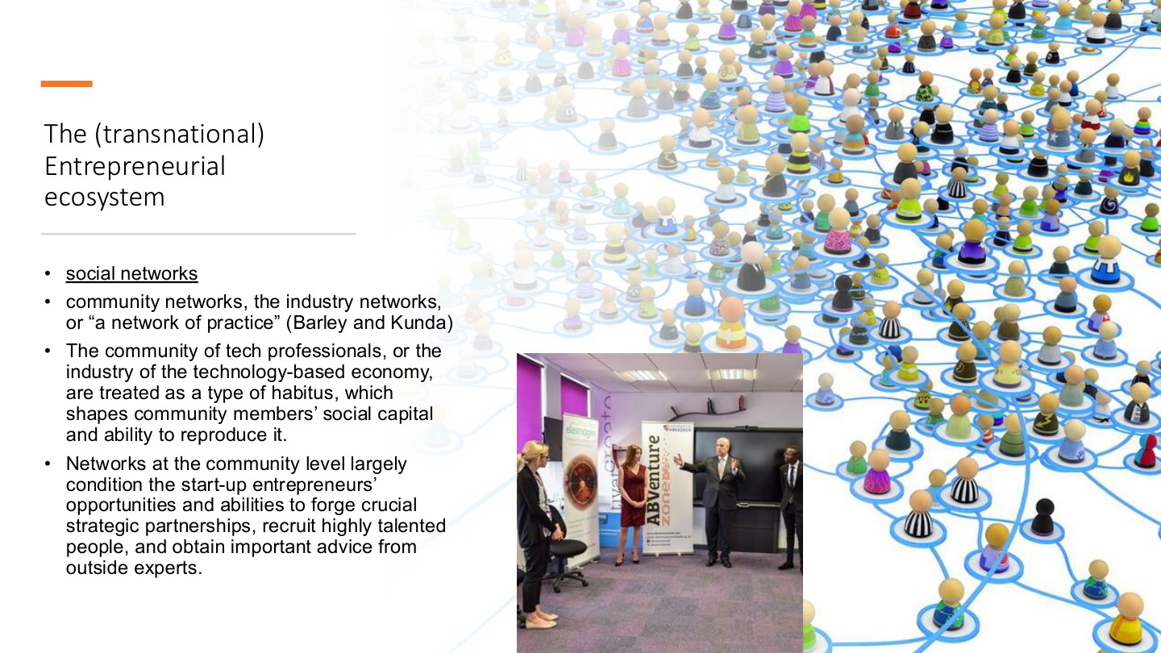
原PPT第21页 / Original slide 21 · 重点 / Focus

PPT中英翻译 / PPT translation
PPT English / 英文原文与图示 | 中文翻译 / Chinese translation
Social networks [underlined on slide] | 社会网络（原页划线）。
Community networks, the industry networks, or “a network of practice” (Barley and Kunda) | 社群网络、产业网络，或“实践网络”（Barley与Kunda）。
The community of tech professionals, or the industry of the technology-based economy, are treated as a type of habitus, which shapes community members’ social capital and ability to reproduce it. | 课件把技术专业人士社群／技术经济行业理解为塑造成员惯习的环境，影响其社会资本及持续再生产关系资源的能力。
Networks at the community level largely condition the start-up entrepreneurs’ opportunities and abilities to forge crucial strategic partnerships, recruit highly talented people, and obtain important advice from outside experts. | 社群层面的网络，在很大程度上影响初创企业建立重要战略伙伴关系、招募优秀人才及取得外部专家建议的机会和能力。

本页核心 / Key takeaway
社会资本是通过关系网络可获得的资源，影响创业者能接触谁、合作什么及获得何种支持。
Social capital consists of resources accessible through relationships, shaping whom entrepreneurs can reach and what partnerships and support they can obtain.

精要解析 / Essential explanation

1. 与人力资本比较 / Compare with human capital
人力资本偏向“我有什么知识和能力”，社会资本偏向“我能通过关系获得什么支持”。技术能力强的人，仍可能缺少投资者、客户或可信合作者的联系。
Human capital concerns what a person knows and can do; social capital concerns support accessible through relationships. Strong skills can coexist with limited access to investors, customers or trusted collaborators.

2. 实践网络与惯习 / Practice networks and habitus
共同工作与反复交往会形成判断方式、行业习惯和信任。这些共享的实践影响成员识别机会与建立合作的能力，不是只看社交平台好友数量。
Shared work and repeated interaction develop judgement, professional habits and trust. These practices shape members’ ability to recognise opportunities and collaborate, beyond counting online contacts.

3. 三个具体结果 / Three concrete outcomes
答题可直接落到合作伙伴、人才招聘、专家建议。先说明网络提供接触和信任，再解释这些联系如何解决初创企业的资源缺口。
Use partnerships, recruitment and expert advice as concrete outcomes. Explain how contact and trust help new ventures overcome resource gaps.

易错辨析 / Key distinction
habitus译为“惯习”，不是“栖息地”；network是关系结构，social capital是经由关系可利用的资源。
Habitus means socially formed dispositions, not a habitat. A network is a structure of relationships; social capital concerns resources accessed through those relationships.

22｜共享办公空间 / Coworking spaces
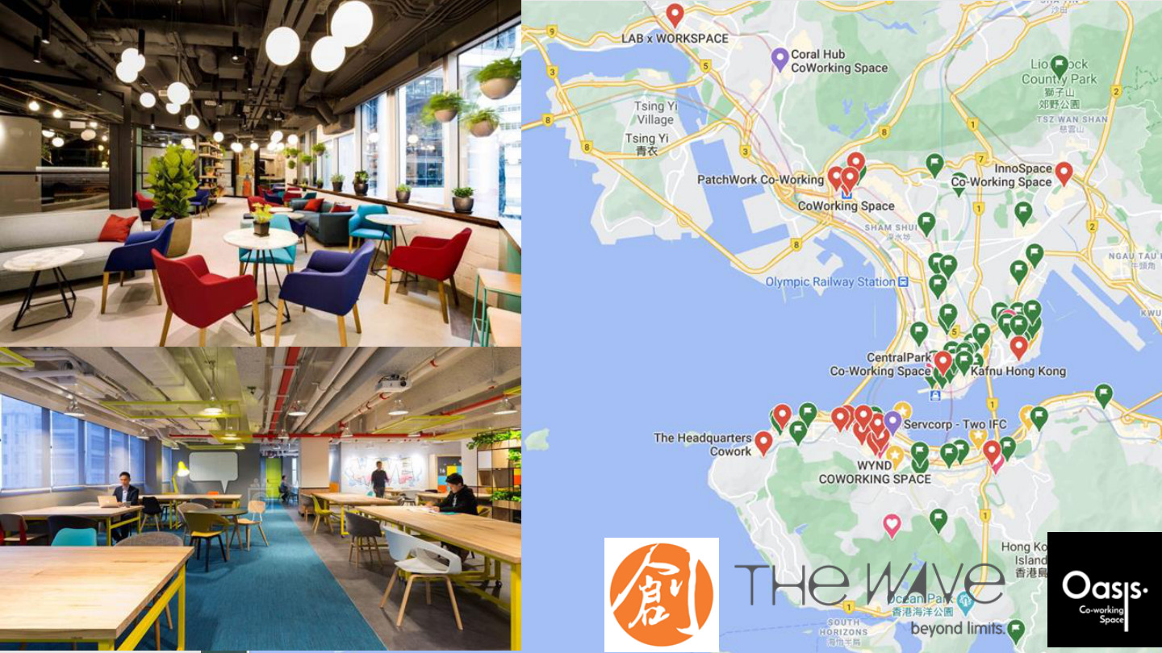
原PPT第22页 / Original slide 22 · 简读 / Brief

PPT中英翻译 / PPT translation
PPT English / 英文原文与图示 | 中文翻译 / Chinese translation
Image-only slide: coworking interiors and a map of workspaces in Hong Kong | 原页以图片为主：共享办公空间内部，以及香港工作空间分布地图。
Visible brands include The Wave and Ooosh; map pins show locations | 可见品牌包括The Wave、Ooosh；地图标记表示地点分布。

本页核心 / Key takeaway
把本页看作网络的空间载体：共享办公可创造相遇机会，但不自动产生合作。
Read this as a spatial setting for networks: coworking can enable encounters without automatically producing collaboration.

精要解析 / Essential explanation

1. 图示精华 / Essential interpretation
共同办公与真正形成社群不同。是否有持续交流、互补技能和信任，才决定场所能否把地理接近转成有效资源联系；无需背地址或品牌。
Sharing an office differs from forming a community. Ongoing interaction, complementary capabilities and trust determine whether proximity becomes useful resource connections; addresses and brands are secondary.

23｜生产的新空间性 / The new spatiality of production
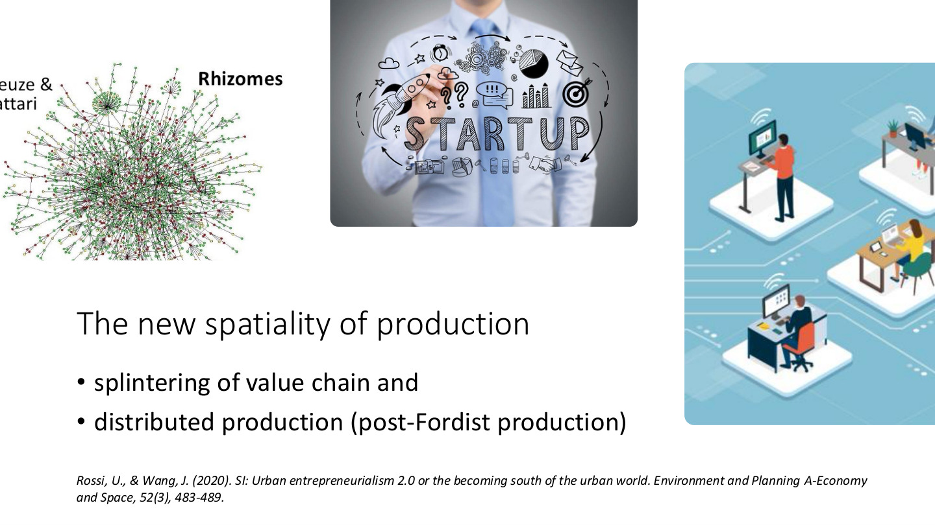
原PPT第23页 / Original slide 23 · 重点 / Focus

PPT中英翻译 / PPT translation
PPT English / 英文原文与图示 | 中文翻译 / Chinese translation
The new spatiality of production | 生产的新空间性／空间组织。
Splintering of value chain; distributed production (post-Fordist production) | 价值链拆分；分散化生产（后福特主义生产）。
Rhizomes; startup; digitally connected dispersed workspaces | 配图：根茎式网络、初创企业，以及数字连接的分散工作空间。根茎图在此辅助呈现网络关系。
Rossi & Wang (2020), Urban entrepreneurialism 2.0 or the becoming south of the urban world, Environment and Planning A: Economy and Space, 52(3), 483–489. | 参考：Rossi与Wang（2020），《城市创业主义2.0，或城市世界的“南方化”》，Environment and Planning A: Economy and Space，52(3)，483—489。

本页核心 / Key takeaway
价值链拆分后，生产可由不同地点的参与者协同完成，形成后福特主义的分散网络。
After value chains are split, participants in different places can coordinate production, forming distributed post-Fordist networks.

精要解析 / Essential explanation

1. 与前面怎样连接 / Connection to earlier slides
第5页讲组织边界的垂直分解，本页讲其空间后果：设计、服务、生产等环节可以分布在不同地点，数字工具把它们重新接起来。
Slide 5 concerns vertical disintegration across organisational boundaries; this slide concerns its spatial consequences. Design, services and production can be distributed and reconnected digitally.

2. 分散与集聚能并存 / Distribution and clustering coexist
生产任务分散，不代表所有集聚消失。研发、资本或交流活动仍可能集中于节点城市，形成“某些活动集聚、跨地任务协作”的组合。
Distributed tasks do not eliminate all clustering. Research, finance or interaction may remain concentrated in urban nodes while tasks are coordinated across locations.

3. 后福特主义的用法 / Using post-Fordism
在本页语境中，抓住从相对集中、纵向组织转向更灵活的网络化生产。它描述组织变化，不表示所有工厂或内部层级已经被替代。
Here, focus on movement from relatively concentrated vertical organisation towards flexible networked production. This describes organisational change, not the disappearance of all factories or internal hierarchies.

24｜社会—技术基础设施 / Socio-technical infrastructure
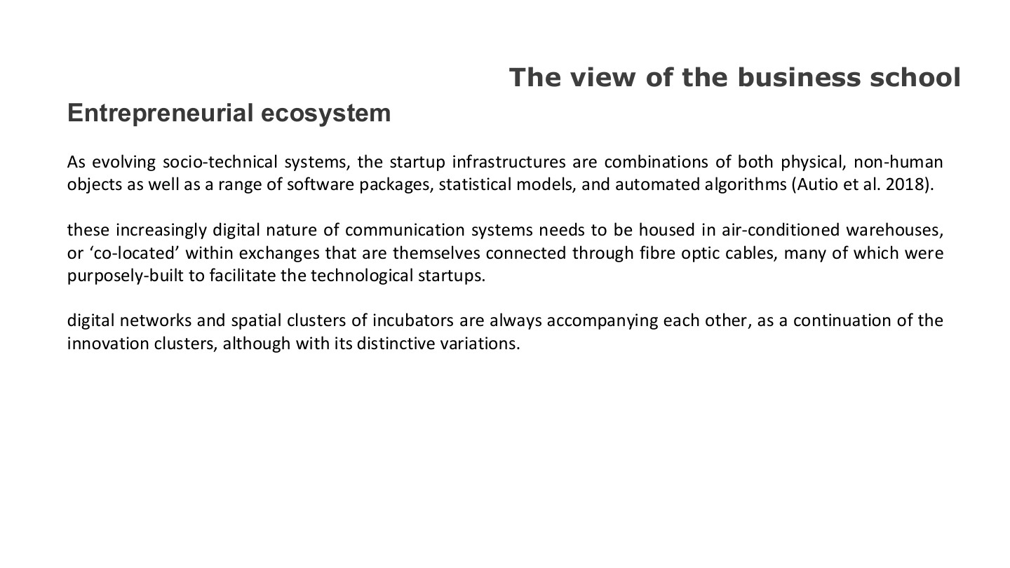
原PPT第24页 / Original slide 24 · 重点 / Focus

PPT中英翻译 / PPT translation
PPT English / 英文原文与图示 | 中文翻译 / Chinese translation
Entrepreneurial ecosystem; The view of the business school | 创业生态系统；商学院的视角。
As evolving socio-technical systems, the startup infrastructures are combinations of both physical, non-human objects as well as a range of software packages, statistical models, and automated algorithms (Autio et al. 2018). | 作为不断演变的社会—技术系统，创业基础设施结合实体的非人类物件、软件包、统计模型及自动化算法。
These increasingly digital communication systems need to be housed in air-conditioned warehouses, or “co-located” within exchanges that are themselves connected through fibre optic cables, many purposely built to facilitate technological startups. [grammar regularised] | 这些越来越数字化的通信系统，仍须置于设有空调的仓库／机房，或托管在通过光纤互连的交换设施中，其中不少是专为科技初创企业建立的。
Digital networks and spatial clusters of incubators are always accompanying each other, as a continuation of innovation clusters, although with distinctive variations. | 课件强调数字网络与孵化器的空间集群相伴发展：它们延续创新集群，同时具有不同变化。

本页核心 / Key takeaway
数字网络依赖实体设施，也依赖社会组织；“线上”创业仍有物理与地方基础。
Digital networks depend on physical infrastructure and social organisation; online entrepreneurship retains material and local foundations.

精要解析 / Essential explanation

1. 社会—技术是什么 / What socio-technical means
软件、算法、服务器和光纤，与使用者、机构和协作规则共同构成系统。技术不是孤立工具，其作用取决于如何被部署和组织。
Software, algorithms, servers and fibre interact with users, institutions and coordination rules. Technology is not an isolated tool; its effects depend on deployment and organisation.

2. “云端”仍需落地 / The cloud remains grounded
数据传输和运算需要设备、供电、散热与连接。通信数字化不等于生产没有空间条件，这解释了网络和实体创新节点为何可以相伴出现。
Data transmission and computation require equipment, power, cooling and connectivity. Digital communication does not remove spatial conditions, helping explain the coexistence of networks and physical innovation nodes.

3. 本板块的整合 / Bringing the section together
创业生态系统可按技术设施、制度培养、社群关系三方面理解。支持政策若只提供场地，便可能遗漏知识交流和实际资源连接；这回应第8页复制硅谷的问题。
Read the ecosystem through technical infrastructure, institutional development and community relationships. Space-only policies may miss knowledge exchange and resource connections, returning to the Silicon Valley question on slide 8.

25｜转向劳动者与用户 / On the people

原PPT第25页 / Original slide 25 · 简读 / Brief

PPT中英翻译 / PPT translation
PPT English / 英文原文与图示 | 中文翻译 / Chinese translation
On the people | 关于人／转向人的视角。
Images: urban crowds and a delivery worker | 配图：城市人群与配送劳动者。

本页核心 / Key takeaway
从“创业如何发生”转向“谁参与价值生产，以及他们如何被组织和管理”。
The focus shifts from how entrepreneurship happens to who produces value and how their activity is organised and managed.

26｜Web 2.0、DIY与主体性 / Web 2.0, DIY and subjectivity
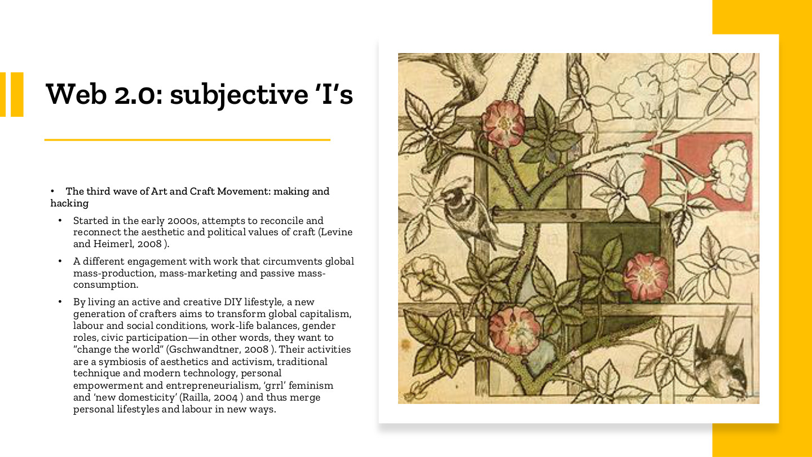
原PPT第26页 / Original slide 26 · 重点 / Focus

PPT中英翻译 / PPT translation
PPT English / 英文原文与图示 | 中文翻译 / Chinese translation
Web 2.0: subjective “I”s; The third wave of Art and Craft Movement: making and hacking | Web 2.0：具有主体性的“我”；第三波工艺运动：制作与创造性技术探索。
Started in the early 2000s, attempts to reconcile and reconnect the aesthetic and political values of craft (Levine and Heimerl, 2008). | 始于21世纪初，尝试调和并重新连接手工艺的审美价值与政治价值。
A different engagement with work that circumvents global mass-production, mass-marketing and passive mass-consumption. | 一种不同的工作参与方式，尝试绕开全球大规模生产、大众营销及被动的大众消费。
By living an active and creative DIY lifestyle, a new generation of crafters aims to transform global capitalism, labour and social conditions, work-life balances, gender roles, civic participation—in other words, they want to “change the world” (Gschwandtner, 2008). | 新一代手工艺者希望通过积极、创造性的DIY生活，改变全球资本主义、劳动与社会状况、工作生活平衡、性别角色和公民参与，即“改变世界”。
Their activities are a symbiosis of aesthetics and activism, traditional technique and modern technology, personal empowerment and entrepreneurialism, “grrl” feminism and “new domesticity” (Railla, 2004), thus merging personal lifestyles and labour in new ways. | 其活动结合审美与行动主义、传统技艺与现代科技、个人赋权与创业精神、“grrl”女性主义与“新家庭生活”观念，以新方式交织个人生活和劳动。

本页核心 / Key takeaway
Web 2.0下的人不仅接收内容，也以创作、制作和互动参与生产，并把生活方式与劳动联系起来。
People in Web 2.0 participate in production through creating, making and interacting, linking lifestyles with labour rather than only receiving content.

精要解析 / Essential explanation

1. 主体性强调什么 / What subjectivity highlights
“I”强调个人主动表达、创造和塑造生活，而不是这里的数学变量。DIY既可是一种兴趣，也可连接创业、社会表达和工作方式。
The “I” highlights active expression, creation and shaping one’s life, rather than a mathematical variable. DIY can connect hobbies with entrepreneurship, social expression and ways of working.

2. 为什么有政治意义 / Why politics enters
手工艺者试图改变消费和劳动关系，而不只是制作好看的物品。审美选择与如何生产、如何生活的价值判断相连，这正是本页把制作与行动主义并列的原因。
Crafters seek to change consumption and labour relations, beyond producing attractive objects. Aesthetic choices connect with values about production and everyday life, explaining the pairing of making and activism.

3. 连接后文的张力 / The tension developed later
个体获得表达和创业机会的同时，平台可能商业化其内容、互动和数据。保留这两层，才能理解为何“参与和赋权”与“数字劳动剥削”会在同一课出现。
Individuals gain expressive and entrepreneurial opportunities while platforms may commercialise content, interaction and data. Both sides explain why participation and empowerment coexist with the later critique of digital labour.

27｜黑客文化：创造性探索 / Hacker culture
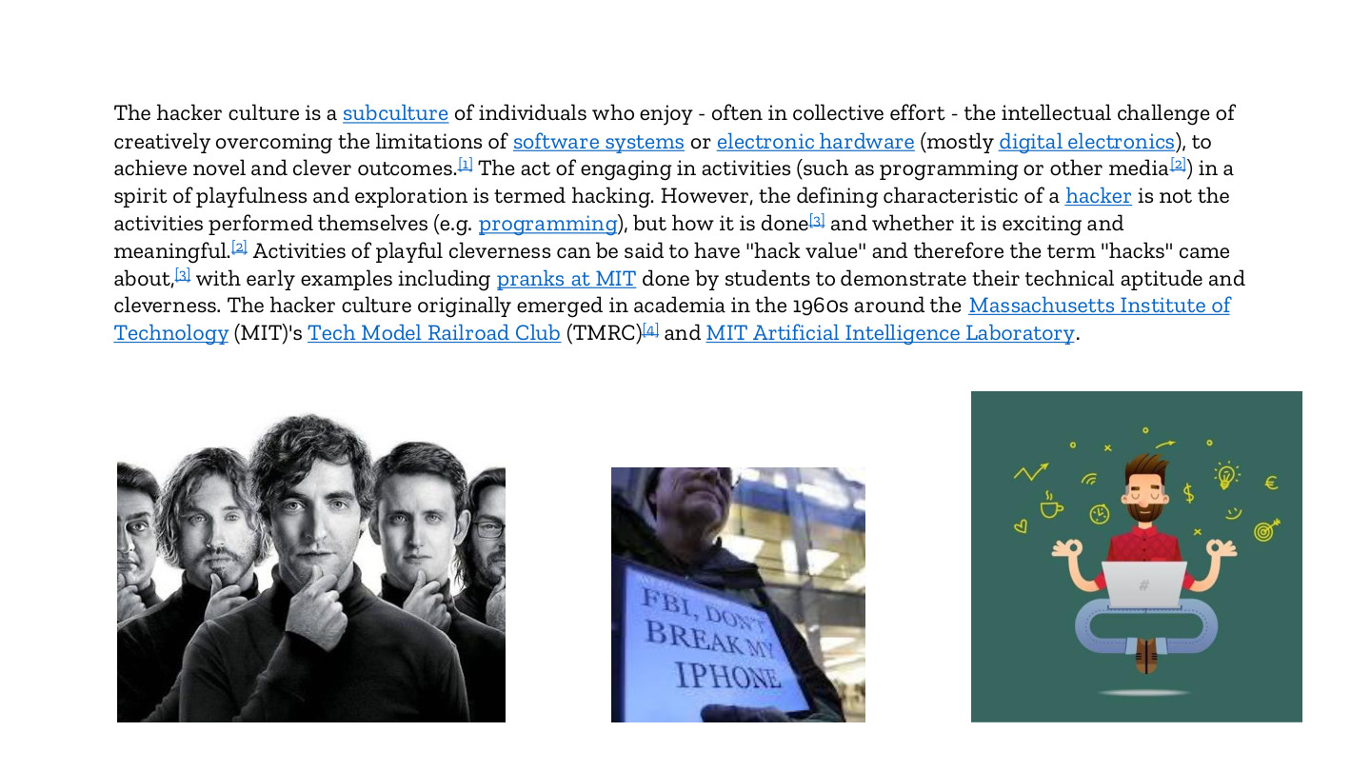
原PPT第27页 / Original slide 27 · 理解 / Understand

PPT中英翻译 / PPT translation
PPT English / 英文原文与图示 | 中文翻译 / Chinese translation
The hacker culture is a subculture of individuals who enjoy—often in collective effort—the intellectual challenge of creatively overcoming the limitations of software systems or electronic hardware, to achieve novel and clever outcomes. | 黑客文化是一种亚文化，参与者享受以创造性方式克服软件或电子硬件限制的智力挑战，且常通过集体努力取得新颖、巧妙的成果。
The act of engaging in activities such as programming or other media in a spirit of playfulness and exploration is termed hacking. | 以玩心和探索精神开展编程或其他媒介活动，被称为hacking。
The defining characteristic of a hacker is not the activities performed themselves, but how it is done and whether it is exciting and meaningful. | 黑客的定义性特征，不在所做活动的种类，而在开展活动的方式，以及是否有趣、有意义。
Activities of playful cleverness can have “hack value”; early examples include MIT student pranks demonstrating technical aptitude and cleverness. | 带有玩心的巧思具有“hack value”（巧妙探索的价值）；早期例子包括麻省理工学生展示技术能力和机智的恶作剧。
The hacker culture originally emerged in academia in the 1960s around MIT’s Tech Model Railroad Club and MIT Artificial Intelligence Laboratory. | 黑客文化于20世纪60年代在学术环境中兴起，与麻省理工技术模型铁路俱乐部及人工智能实验室有关。
Image caption: “FBI, stop breaking my phone” | 配图标语：“FBI，停止破解／破坏我的手机”。

本页核心 / Key takeaway
本页hacking指带有玩心、探索性与创造性的技术实践，不能直接译为网络犯罪。
Here hacking means playful, exploratory and creative technical practice, rather than automatically implying cybercrime.

精要解析 / Essential explanation

1. 怎样识别这类文化 / How to recognise it
关键是对技术限制提出问题、尝试改造并从过程中获得意义。合作、分享与动手试验可成为学习和创造知识的途径，与前文实践网络相呼应。
The emphasis is questioning technical limits, experimenting and finding meaning in the process. Collaboration, sharing and hands-on experimentation can produce learning and knowledge, linking back to practice networks.

2. 在本课的位置 / Its role in this lecture
这说明用户和创作者可以主动生产技术与文化价值。下一阶段再问：这些创造活动进入商业平台后，价值和控制权由谁掌握？
Users and creators can actively produce technical and cultural value. The subsequent slides ask who captures that value and controls activity when it enters commercial platforms.

28｜创业文化口号 / Entrepreneurial culture slogans

原PPT第28页 / Original slide 28 · 简读 / Brief

PPT中英翻译 / PPT translation
PPT English / 英文原文与图示 | 中文翻译 / Chinese translation
05. We get to the bottom of things | 05. 我们追根究底。
06. We simplify | 06. 我们化繁为简。
07. We think big | 07. 我们胸怀大目标。
08. We build trust | 08. 我们建立信任。
09. We never say “it’s not my job” | 09. 我们从不说“这不是我的工作”。
10. We are frugal | 10. 我们节俭。
11. We embrace change | 11. 我们拥抱变化。
12. We celebrate difference | 12. 我们赞赏差异与多样性。

本页核心 / Key takeaway
这些口号展示主动、灵活、合作的创业文化，不必把每句话背成独立理论。
These slogans present an active, flexible and collaborative entrepreneurial culture; each need not be memorised as a separate theory.

精要解析 / Essential explanation

1. 一句连接 / A concise connection
主动承担责任和认同组织价值，可能使个人更投入工作。此页是文化表达的例子，后面则考察具体的平台所有权、数据和劳动控制。
Taking initiative and identifying with organisational values can encourage involvement. This is an illustration of cultural messaging; later slides analyse ownership, data and labour control more directly.

29｜受众商品 / Audience commodity
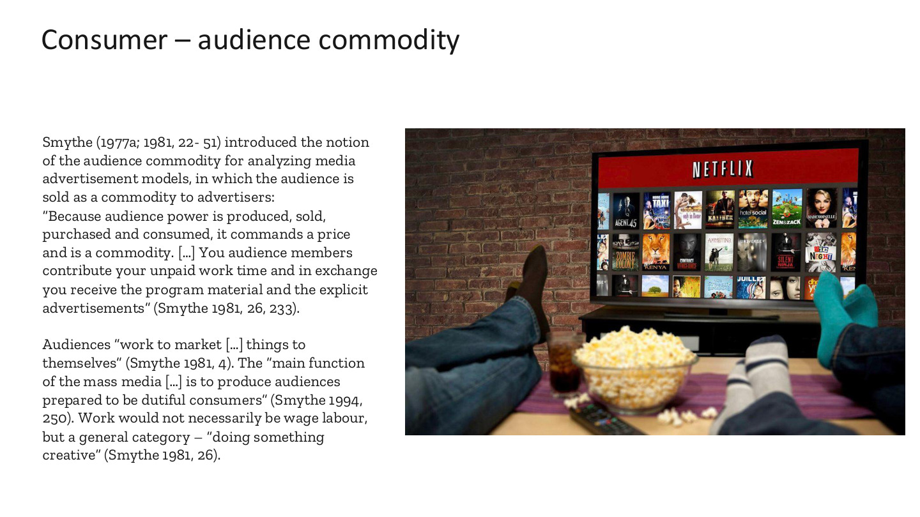
原PPT第29页 / Original slide 29 · 重点 / Focus

PPT中英翻译 / PPT translation
PPT English / 英文原文与图示 | 中文翻译 / Chinese translation
Consumer – audience commodity | 消费者——受众商品。
Smythe (1977a; 1981, 22–51) introduced the notion of the audience commodity for analyzing media advertisement models, in which the audience is sold as a commodity to advertisers. | Smythe提出“受众商品”概念分析媒介广告模式：受众作为商品被出售给广告商。
“Because audience power is produced, sold, purchased and consumed, it commands a price and is a commodity.” | “因为受众力量被生产、出售、购买和消费，所以它具有价格，是一种商品。”
“You audience members contribute your unpaid work time and in exchange you receive the program material and the explicit advertisements” (Smythe 1981, 26, 233). | “受众贡献无偿劳动时间，作为交换，获得节目内容和明确呈现的广告。”
Audiences “work to market […] things to themselves” (Smythe 1981, 4). The “main function of the mass media […] is to produce audiences prepared to be dutiful consumers” (Smythe 1994, 250). | 受众“努力把商品推销给自己”。在这一批判视角中，大众传媒的主要功能是生产准备成为顺从消费者的受众。
Work would not necessarily be wage labour, but a general category—“doing something creative” (Smythe 1981, 26). | 这里的劳动不一定是工资劳动，而是更广义的创造性活动。
Image: viewing screen content; Netflix shown | 配图：观看屏幕内容，出现Netflix标识。配图本身不证明该公司全部收入都来自广告。

本页核心 / Key takeaway
Smythe认为广告媒介把受众的注意力与参与能力商品化，并出售给广告商。
Smythe argues that advertising media commodify audience attention and participation and sell access to advertisers.

精要解析 / Essential explanation

1. 谁在向谁出售什么 / Who sells what to whom
媒介吸引并维持观众，广告商付费接触这些潜在消费者。观众既是内容的接收者，也成为广告商业模式的价值来源；这就是“商品”分析的关键。
Media attract and retain audiences; advertisers pay to reach potential consumers. Audiences receive content while supplying value to the advertising model, which is central to the commodity analysis.

2. 为什么叫无偿劳动 / Why unpaid work
按该理论，观看和学习消费信息也参与商业价值形成，虽然没有工资。理论中的广义劳动与法律／统计上的就业不是同一分类，答题时应保留作者的分析语境。
In this theory, watching and learning consumption messages contribute to commercial value without wages. This broad analytical idea of labour differs from legal or statistical employment classifications.

3. 与平台的连接 / Connection to platforms
传统媒介强调观看和广告接触；数字平台还记录互动、偏好和内容生产。下一页将这种贡献扩展到产消者及用户数据，但不能说所有互联网收入都是广告收入。
Traditional media emphasise viewing and advertising exposure; digital platforms also record interaction, preferences and content creation. The next slide extends this to prosumers and data, without implying that all Internet revenue comes from advertising.

30｜产消者与资本积累 / Prosumers and accumulation
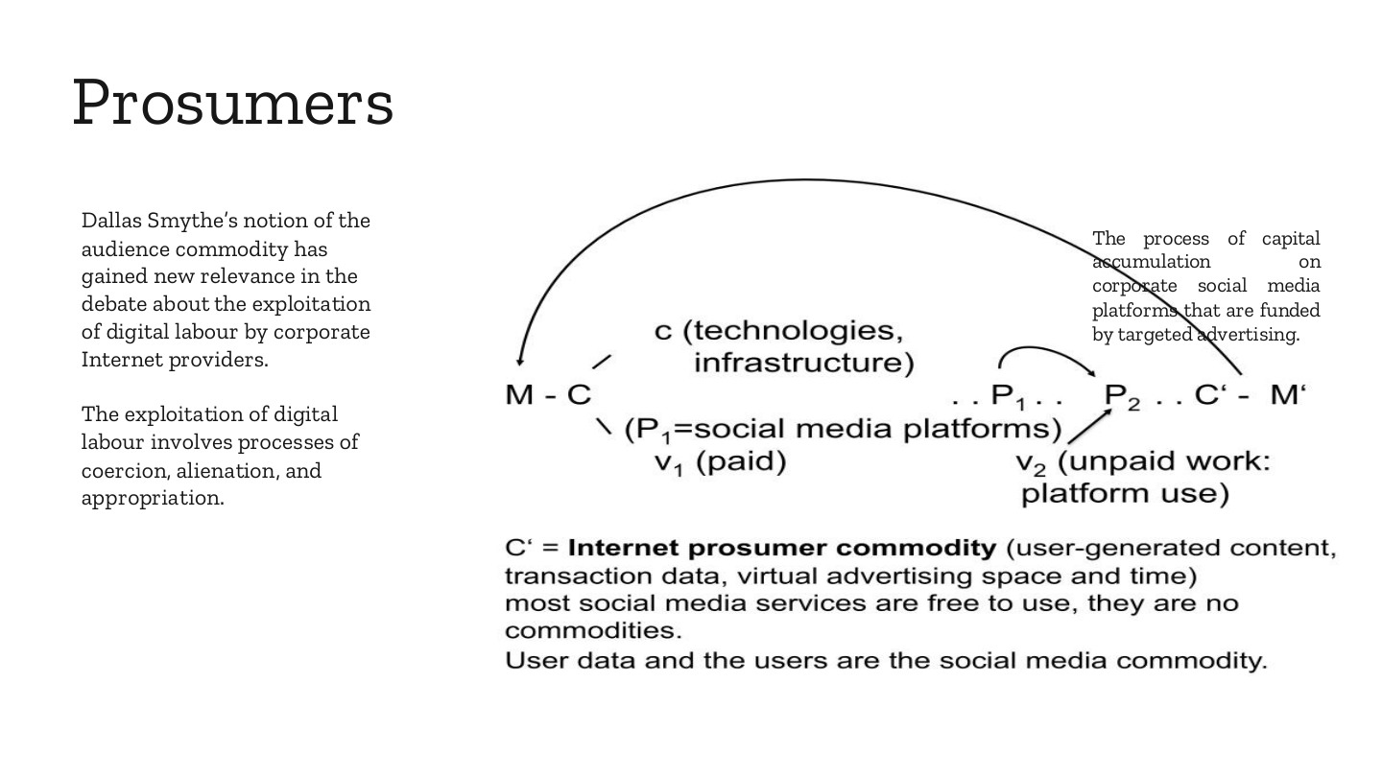
原PPT第30页 / Original slide 30 · 重点 / Focus

PPT中英翻译 / PPT translation
PPT English / 英文原文与图示 | 中文翻译 / Chinese translation
Prosumers | 产消者，即同时参与生产与消费的人。
Dallas Smythe’s notion of the audience commodity has gained new relevance in the debate about the exploitation of digital labour by corporate Internet providers. | 在讨论商业互联网企业对数字劳动的剥削时，Smythe的受众商品概念重新具有解释意义。
The exploitation of digital labour involves processes of coercion, alienation, and appropriation. | 数字劳动剥削涉及强制、异化和占有等过程。
The process of capital accumulation on corporate social media platforms that are funded by targeted advertising. | 图示：以定向广告资助的商业社交媒体平台之资本积累过程。
Diagram: M–C … P₁ … P₂ … C′–M′; c (technologies, infrastructure); v₁ (paid); v₂ (unpaid work: platform use) | 图中符号：M–C … P₁ … P₂ … C′–M′；c为技术和基础设施投入；v₁为有偿劳动；v₂为平台使用这种无偿劳动。M为投入货币，C为购入的生产要素，M′为回流并增殖的货币。
P₁ = social media platforms; C′ = Internet prosumer commodity (user-generated content, transaction data, virtual advertising space and time) | P₁关联社交媒体平台的生产／建立，P₂纳入用户使用；C′为互联网产消者商品，包括用户生成内容、交易数据、虚拟广告空间和时间。
Most social media services are free to use, they are no commodities. User data and the users are the social media commodity. [wording on slide] | 原页认为：多数社交媒体服务免费使用，因此关注的商品是用户数据及用户本身。此处是在解释广告型模式如何商业化参与，不能推广为所有服务都免费或免费服务没有价值。

本页核心 / Key takeaway
产消者既消费平台，也贡献内容、数据和互动；平台可将这些贡献转成广告与资本积累的资源。
Prosumers consume platforms while contributing content, data and interaction, which platforms can commercialise through advertising and accumulation.

精要解析 / Essential explanation

1. 流程图抓住什么 / What to learn from the diagram
平台先投入技术、设施与有偿工作，再吸纳用户活动。用户使用不是流程外的被动消费，而进入价值形成过程；最后通过商业化获得货币回报。
Platforms invest in technology, infrastructure and paid work, then incorporate user activity. Usage enters value production rather than remaining passive consumption outside the process, followed by commercialisation and monetary returns.

2. 三种剥削过程 / Three processes of exploitation
强制关注维持关系所产生的参与压力；异化关注生产贡献与控制／收益的分离；占有关注平台如何获取并商业化这些成果。下一页具体解释前两项。
Coercion concerns pressure to participate for social connection; alienation concerns separation from control and returns; appropriation concerns the platform’s capture and commercial use of contributions. The next slide develops the first two.

3. 一个简短例子 / A short example
用户观看、发帖、点赞，获得沟通和娱乐；平台据此组织内容与广告。用户确实得到使用价值，但获得便利不自动消除对数据、控制权和收益分配的争议。
Users watch, post and like content, gaining communication and entertainment while platforms organise content and advertising. Receiving benefits does not automatically resolve questions about data, control and the distribution of returns.

易错辨析 / Key distinction
prosumer比普通consumer多了生产贡献；但并非每位产消者都有工资、雇员身份或同等收益。
A prosumer contributes to production as well as consumption; this does not imply wages, employee status or equal returns for every participant.

31｜强制、异化与付费模式 / Coercion and alienation
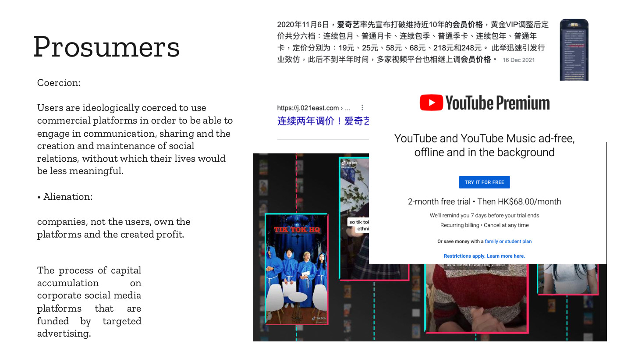
原PPT第31页 / Original slide 31 · 重点 / Focus

PPT中英翻译 / PPT translation
PPT English / 英文原文与图示 | 中文翻译 / Chinese translation
Prosumers; Coercion | 产消者；强制。
Users are ideologically coerced to use commercial platforms in order to be able to engage in communication, sharing and the creation and maintenance of social relations, without which their lives would be less meaningful. | 在该理论视角中，用户为了沟通、分享及建立和维持社会关系，受到使用商业平台的意识形态压力；失去这些活动可能削弱生活意义。
Alienation: companies, not the users, own the platforms and the created profit. | 异化：平台及其产生的利润归公司所有，用户并不因此拥有平台和利润。
The process of capital accumulation on corporate social media platforms that are funded by targeted advertising. | 以定向广告资助的商业社交媒体平台上的资本积累过程。
Image text: On 6 November 2020, iQIYI changed its VIP pricing into six plans: continuous monthly, monthly card, continuous quarterly, quarterly card, continuous annual and annual card; prices shown: RMB19, 25, 58, 68, 218, 248. Other platforms followed. Screenshot dated 16 Dec 2021. | 截图文字：2020年11月6日爱奇艺调整VIP价格，连续包月、普通月卡、连续包季、普通季卡、连续包年、普通年卡分别19、25、58、68、218、248元，随后其他平台跟进；截图标示2021年12月16日。
YouTube Premium: YouTube and YouTube Music ad-free, offline and in the background; 2-month free trial, then HK$68.00/month; reminder 7 days before trial ends; recurring billing, cancel any time; family/student plans; restrictions apply. | YouTube Premium广告图：YouTube与YouTube Music免广告、离线及后台播放；两个月免费试用，之后每月68港元；试用结束前七天提醒；循环计费、可随时取消；另有家庭／学生计划，附限制条件。价格均为截图历史信息。

本页核心 / Key takeaway
社交参与压力可以与平台的私有控制并存；看似自愿的使用，仍可被放进权力关系中分析。
Pressure to participate socially can coexist with private platform control, allowing apparently voluntary use to be analysed through power relations.

精要解析 / Essential explanation

1. 强制不只指暴力 / Coercion beyond force
在这里，离开平台可能意味着失去联系、可见度或参与机会。退出的社会成本使选择受到约束，但课件并不是说每个用户都被法律强迫注册。
Leaving can mean losing relationships, visibility or participation. The social cost of exit constrains choice, without implying that every user is legally forced to register.

2. 异化的重点 / The focus of alienation
用户贡献内容和互动，却未必决定规则、数据处理或利润分配。贡献与控制分离才是这里的重点，不应把异化仅译成孤独或情绪疏离。
Users contribute content and interaction without necessarily controlling rules, data use or profits. Separation of contribution from control is the focus, rather than loneliness alone.

3. 广告与订阅可并存 / Advertising and subscriptions can coexist
右侧价格图提示平台也可售卖会员服务。答题要区分免费使用的广告型模式与付费订阅；同一平台可能组合二者，不能套用“用户永不付钱”。
The price images show that platforms can also sell memberships. Distinguish advertising-funded access from paid subscriptions; a platform can combine them, so users need not always access services free of charge.

32｜平台资本主义：数据与控制 / Platform capitalism
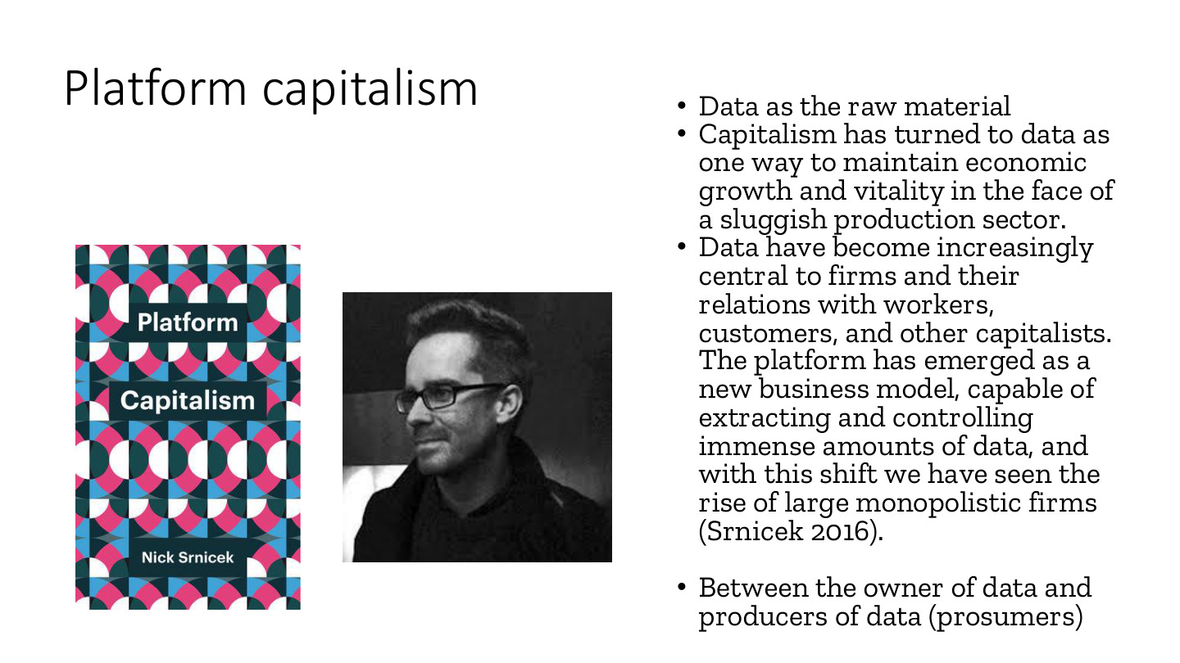
原PPT第32页 / Original slide 32 · 重点 / Focus

PPT中英翻译 / PPT translation
PPT English / 英文原文与图示 | 中文翻译 / Chinese translation
Platform capitalism; Data as the raw material | 平台资本主义；数据作为原材料。
Capitalism has turned to data as one way to maintain economic growth and vitality in the face of a sluggish production sector. | 面对生产部门增长乏力，资本主义转向数据，将其作为维持增长和活力的一条路径。
Data have become increasingly central to firms and their relations with workers, customers, and other capitalists. | 数据日益成为企业及其与劳动者、消费者和其他资本主体关系的核心。
The platform has emerged as a new business model, capable of extracting and controlling immense amounts of data, and with this shift we have seen the rise of large monopolistic firms (Srnicek 2016). | 平台成为能提取并控制海量数据的新商业模式；Srnicek把这一变化与大型垄断性企业的兴起联系起来。
Between the owner of data and producers of data (prosumers) | 数据拥有／控制者与数据生产者（产消者）之间的关系。
Book: Platform Capitalism, Nick Srnicek | 书籍：Nick Srnicek，《平台资本主义》。

本页核心 / Key takeaway
Srnicek强调平台通过提取和控制数据组织商业活动，并关注数据控制与企业集中化之间的联系。
Srnicek highlights platforms’ extraction and control of data to organise business, linking data control to corporate concentration.

精要解析 / Essential explanation

1. 为什么叫原材料 / Why call data raw material
数据是可被收集、处理和用于预测、匹配及广告的投入。原始记录需要组织和分析才转成商业用途，不是产生任何数据就必然盈利。
Data are inputs collected and processed for prediction, matching and advertising. Raw records require organisation and analysis to become commercially useful, rather than generating profit automatically.

2. 生产者与控制者 / Producers and controllers
用户和劳动者留下内容、交易与行为记录；平台掌握接口、分析和使用条件。谁生成数据与谁能支配数据不同，由此产生所有权、收益和议价问题。
Users and workers generate content, transactions and behavioural records; platforms control interfaces, analysis and conditions of use. Generating data differs from controlling it, raising questions of ownership, returns and bargaining power.

3. 与前面比较 / Comparison with earlier slides
经济学视角关注连接效率和新市场；平台资本主义视角进一步追问数据由谁控制、积累的收益归谁。两者研究同一现象的不同层次，不必只选其中一个。
The economic perspective highlights coordination and markets; platform capitalism asks who controls data and captures accumulation. These analyse different aspects of the same phenomenon.

易错辨析 / Key distinction
不是所有平台都已形成垄断，也不是所有数据都同样有价值；应表述为本理论关注的集中化趋势与控制机制。
Not every platform is a monopoly and not all data have equal value; frame the argument as a concern with concentration tendencies and mechanisms of control.

33｜非物质劳动与持续更新 / Immaterial labour
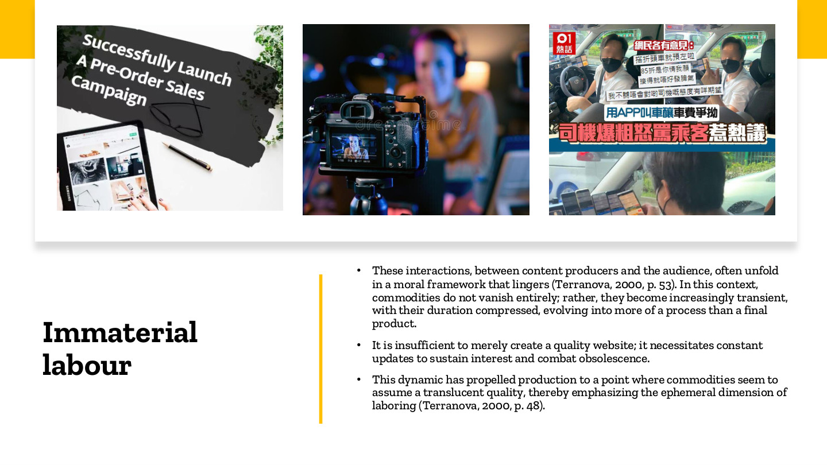
原PPT第33页 / Original slide 33 · 重点 / Focus

PPT中英翻译 / PPT translation
PPT English / 英文原文与图示 | 中文翻译 / Chinese translation
Immaterial labour | 非物质劳动。
These interactions, between content producers and the audience, often unfold in a moral framework that lingers (Terranova, 2000, p.53). In this context, commodities do not vanish entirely; rather, they become increasingly transient, with their duration compressed, evolving into more of a process than a final product. | 内容生产者与受众的互动常处于持续的道德／关系框架中。在这种情境下，商品并未消失，而是更短暂、持续时间被压缩，越来越像一个过程，而非一次完成的最终产品。
It is insufficient to merely create a quality website; it necessitates constant updates to sustain interest and combat obsolescence. | 仅建立优质网站并不足够，还须不断更新以维持兴趣、应对过时。
This dynamic has propelled production to a point where commodities seem to assume a translucent quality, thereby emphasizing the ephemeral dimension of laboring (Terranova, 2000, p.48). | 这一变化使商品仿佛变得“半透明”，突出劳动成果的短暂性与持续劳动的需求。此处为理论性比喻，不是说劳动没有实际结果。
Images: “Successfully Launch a Pre-order Sales Campaign”; livestreaming and content creation | 图片：成功推出预售活动；直播与内容创作场景。

本页核心 / Key takeaway
内容、沟通与关系需要持续维护和更新，价值生产不止发生在一个“成品”完成的时刻。
Content, communication and relationships require ongoing maintenance and updating, so value production extends beyond the completion of a single product.

精要解析 / Essential explanation

1. 非物质指什么 / What immaterial means
产出可以是信息、文化内容、互动或关系，而非一件耐用实物。非物质不等于没有劳动、身体或设备；它强调成果形态与价值形成方式。
Outputs may include information, cultural content, interaction or relationships rather than durable objects. Immaterial does not mean no work, bodies or equipment; it concerns outputs and value creation.

2. 为什么必须持续 / Why continuous work matters
网站和创作者需要新内容、回复和维护来留住受众。注意力会流失，劳动因此表现为持续过程，而不是上传一次后永远获得同等关注。
Websites and creators require new material, responses and maintenance to retain audiences. Attention can fade, making labour an ongoing process, rather than securing permanent interest through one upload.

3. 与产消者连接 / Link to prosumers
专业创作者和普通用户都可能贡献互动，但报酬安排不同。应关注谁持续投入时间、谁控制可见度与变现，而不把所有线上活动视为同一种劳动关系。
Professional creators and ordinary users may both contribute interaction under different payment arrangements. Examine time invested and control over visibility and monetisation rather than assuming one labour relationship for all online activity.

34｜算法管理 / Algorithmic management
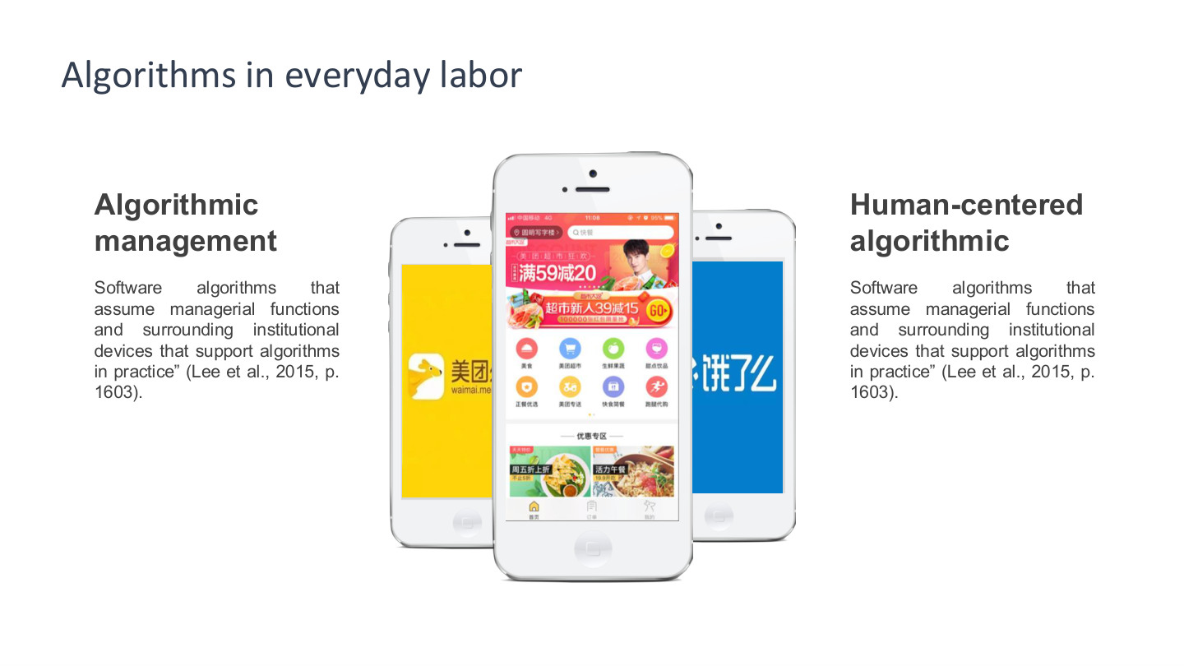
原PPT第34页 / Original slide 34 · 重点 / Focus

PPT中英翻译 / PPT translation
PPT English / 英文原文与图示 | 中文翻译 / Chinese translation
Algorithms in everyday labor; Algorithmic management; Human-centered algorithmic | 日常劳动中的算法；算法管理；以人为中心的算法（原页右侧小标题未写完整）。
“Software algorithms that assume managerial functions and surrounding institutional devices that support algorithms in practice” (Lee et al., 2015, p.1603). | “承担管理职能的软件算法，以及在实践中支持算法运作的周边制度装置。”
The same definition is repeated under the two subheadings. Images: delivery-service apps. | 原页在左右小标题下重复同一定义，不能据此认定两种概念已经作了完整比较。配图为配送平台应用。

本页核心 / Key takeaway
算法管理是软件算法与配套制度共同承担管理职能，包括分单、监测、评价与奖惩。
Algorithmic management uses software algorithms and supporting institutions to perform managerial functions, including allocation, monitoring, evaluation and rewards or penalties.

精要解析 / Essential explanation

1. 算法怎样变成管理 / How algorithms become management
当系统决定任务给谁、何时完成、表现如何以及有何后果时，它就超出普通计算工具。评价结果与收入、机会和处罚相连，才能具体说明管理作用。
A system becomes managerial when it determines allocation, deadlines, performance and consequences. Linking evaluations to income, opportunities and penalties makes the managerial role concrete.

2. 为什么还要制度 / Why institutions matter
平台设定指标、处理申诉并执行奖惩，顾客评价和劳动合同也会影响算法效果。软件并非脱离公司规则而自行治理，技术和制度共同运作。
Platforms set metrics, handle appeals and enforce consequences, while customer ratings and contractual arrangements also matter. Software operates through organisational rules, bringing technology and institutions together.

3. 本课三个机制 / Three mechanisms in this lecture
结合第35—39页，可按准时制的时间纪律、顾客评价与情绪劳动、游戏化等级奖惩复习。这是依据各页内容的归纳，不把补贴或互助另加成第四种正式分类。
Read slides 35–39 through just-in-time discipline, customer evaluation and emotional labour, and gamified rankings and rewards. This summarises their content; subsidies and peer support are not added as separate formal modes.

易错辨析 / Key distinction
算法管理不等于中立排程，也不等于彻底没有人类管理者；重点是管理权如何经由系统和规则执行。
Algorithmic management is more than neutral scheduling and does not require the complete absence of human managers; examine how managerial power operates through systems and rules.

35｜准时制与时间压力 / Just-in-time service
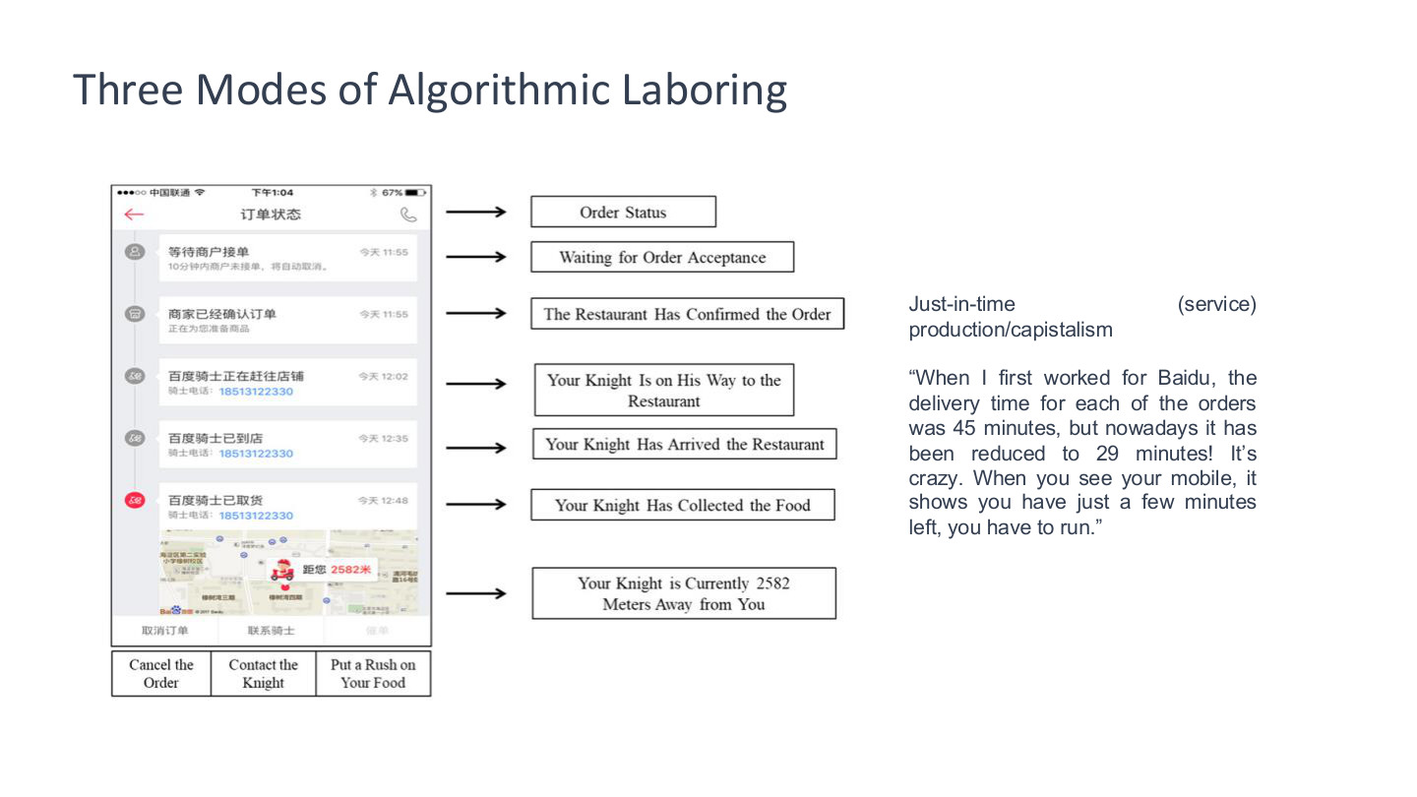
原PPT第35页 / Original slide 35 · 重点 / Focus

PPT中英翻译 / PPT translation
PPT English / 英文原文与图示 | 中文翻译 / Chinese translation
Three Modes of Algorithmic Laboring; Just-in-time (service) production/capistalism [slide spelling] | 算法劳动的三种模式；准时制（服务）生产／资本主义（capitalism原页有拼写错误）。
Order Status → Waiting for Order Acceptance → The Restaurant Has Confirmed the Order | 订单状态→等待接单→商家已确认订单。
Your Knight Is on His Way to the Restaurant → Has Arrived the Restaurant → Has Collected the Food → Is Currently 2582 Meters Away from You | 骑手正在赶往商家→已到店→已取餐→目前距你2582米（Knight在此是“骑手”，不是字面上的骑士）。
Cancel the Order; Contact the Knight; Put a Rush on Your Food | 取消订单；联系骑手；催单。
“When I first worked for Baidu, the delivery time for each of the orders was 45 minutes, but nowadays it has been reduced to 29 minutes! It’s crazy. When you see your mobile, it shows you have just a few minutes left, you have to run.” | “我刚为百度工作时，每单配送时间是45分钟，现在却缩短到29分钟！太疯狂了。看手机只剩几分钟，就得跑起来。”这是课件中的受访者引语。

本页核心 / Key takeaway
实时追踪和倒计时把服务效率目标转成骑手的时间纪律，并可能压缩处理意外的余地。
Real-time tracking and countdowns translate service-efficiency targets into time discipline for riders, potentially reducing room for unexpected delays.

精要解析 / Essential explanation

1. 数字界面怎样控制劳动 / How interfaces shape labour
系统把接单、到店、取餐、送达拆成可见环节。顾客与平台可以持续观察进度，劳动者需要按系统时间证明完成任务，这比普通导航更接近过程管理。
The system makes acceptance, arrival, collection and delivery visible. Continuous progress tracking means workers must demonstrate completion against system time, extending beyond navigation into process management.

2. 45到29分钟如何使用 / Using the 45-to-29 example
引语说明受访骑手感受到的时限收紧，不是所有平台、所有年份的统一标准。外卖是多方协作，餐厅备餐、交通和电梯都可能影响任务完成。
The quotation illustrates one rider’s experience of tighter deadlines, not a universal standard across platforms and years. Delivery depends on several actors, with preparation, traffic and lifts affecting completion.

3. 效率与风险 / Efficiency and risk
可把因果链写成更紧的期限→更高时间压力→赶路与协调行为。这解释管理后果；不能仅凭一段引语直接计算平台整体事故率。
Use the chain tighter deadlines → greater time pressure → rushing and coordination behaviours. This explains a management mechanism without inferring platform-wide accident rates from one quotation.

36｜补贴与行为激励 / Subsidies and incentives
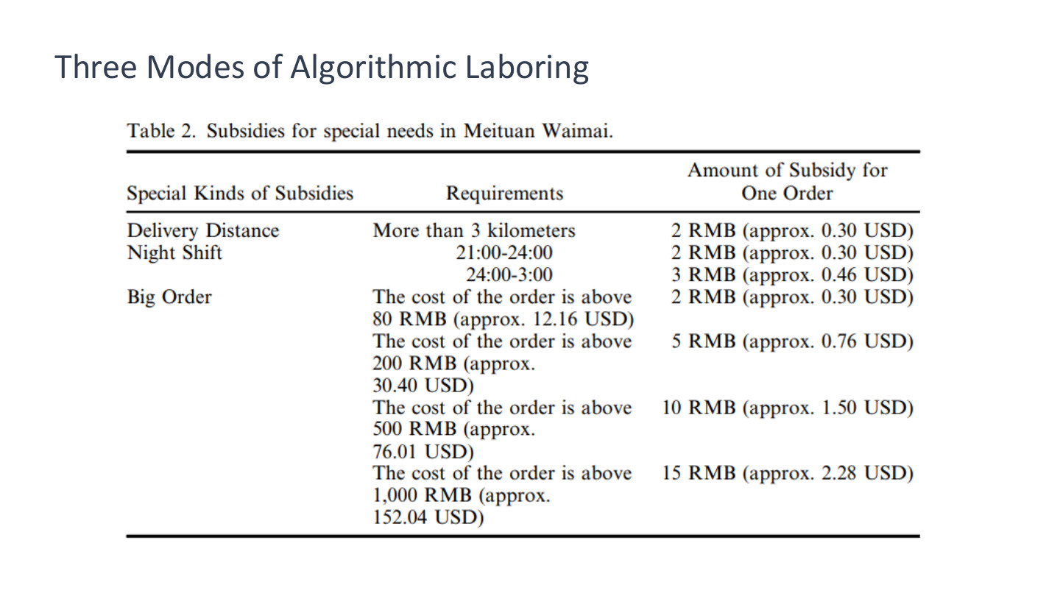
原PPT第36页 / Original slide 36 · 理解 / Understand

PPT中英翻译 / PPT translation
PPT English / 英文原文与图示 | 中文翻译 / Chinese translation
Three Modes of Algorithmic Laboring; Table 2. Subsidies for special needs in Meituan Waimai | 算法劳动的三种模式；表2：美团外卖特殊需求补贴。
Special Kinds of Subsidies; Requirements; Amount of Subsidy for One Order | 列名：补贴类型；条件；每单补贴金额。完整数据见下表；美元为课件原有约数。

原表中英对照 / Bilingual transcription
类型 / Type | 条件 / Requirement | 每单补贴 / Subsidy per order
距离 / Distance | 超过3公里 / More than 3 km | 2元 / RMB2 (≈ US$0.30)
夜班 / Night shift | 21:00–24:00 | 2元 / RMB2 (≈ US$0.30)
夜班 / Night shift | 24:00–3:00 | 3元 / RMB3 (≈ US$0.46)
大单 / Big order | 订单金额>80元 / Order value > RMB80 (≈ US$12.16) | 2元 / RMB2 (≈ US$0.30)
大单 / Big order | 订单金额>200元 / Order value > RMB200 (≈ US$30.40) | 5元 / RMB5 (≈ US$0.76)
大单 / Big order | 订单金额>500元 / Order value > RMB500 (≈ US$76.01) | 10元 / RMB10 (≈ US$1.50)
大单 / Big order | 订单金额>1,000元 / Order value > RMB1,000 (≈ US$152.04) | 15元 / RMB15 (≈ US$2.28)

本页核心 / Key takeaway
补贴把特定任务条件与收入挂钩，是引导配送选择和劳动投入的一种管理方式。
Subsidies connect task conditions with income, helping steer delivery choices and work effort.

精要解析 / Essential explanation

1. 不只是处罚 / More than punishment
距离、夜班和大单补贴提高部分任务的收入吸引力。奖酬同样能组织劳动，平台无需每次直接下命令，也可通过收入结构影响接单。
Distance, night-shift and large-order subsidies make selected tasks more attractive. Rewards also organise work: income structures can influence acceptance without a direct instruction for every task.

2. 读表方法 / How to read the table
区分订单金额与骑手每单补贴：例如订单超过500元，对应表列补贴10元，不是骑手收入500元。原图未交代各类是否叠加，不自行把它们相加。
Distinguish order value from the rider’s subsidy: an order above RMB500 corresponds to RMB10 subsidy, not RMB500 of rider income. The slide does not specify stacking rules, so do not add categories automatically.

易错辨析 / Key distinction
本表为课堂案例规则，不是已经核验的现行美团全国标准；24:00—3:00按跨午夜时段理解。
The table presents classroom case rules, not verified current national Meituan standards. Read 24:00–3:00 as a period crossing midnight.

37｜顾客如上级与情绪劳动 / Consumer-superiors
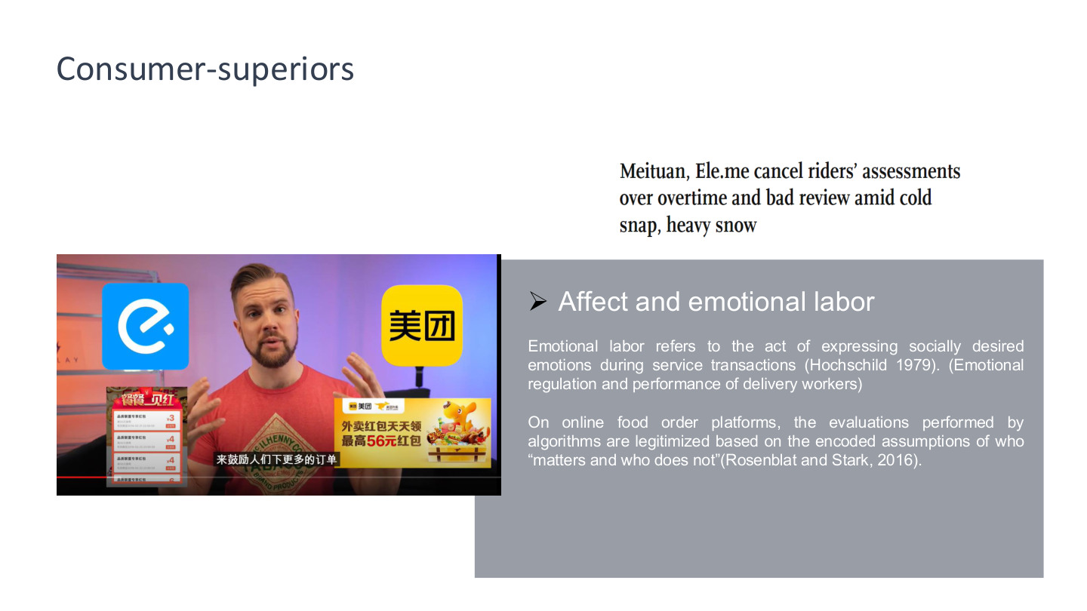
原PPT第37页 / Original slide 37 · 重点 / Focus

PPT中英翻译 / PPT translation
PPT English / 英文原文与图示 | 中文翻译 / Chinese translation
Consumer-superiors | 顾客成为类似上级的评价者。
Affect and emotional labor | 情感与情绪劳动。
Emotional labor refers to the act of expressing socially desired emotions during service transactions (Hochschild 1979). (Emotional regulation and performance of delivery workers) | 情绪劳动指在服务交易中表现社会期望的情绪，包括配送员的情绪调节与情绪表现。
On online food order platforms, the evaluations performed by algorithms are legitimized based on the encoded assumptions of who “matters and who does not” (Rosenblat and Stark, 2016). | 在在线外卖平台中，算法评价的正当性建立在编码进系统的假设上：谁“重要”、谁“不重要”。
Meituan, Ele.me cancel riders’ assessments over overtime and bad review amid cold snap, heavy snow | 新闻标题：寒潮与大雪期间，美团、饿了么取消／暂停针对骑手超时与差评的相关考核。
Video image: “to encourage people to place more orders”; takeaway coupons | 视频图片：外卖优惠券，以及“来鼓励人们下更多的订单”的字幕。

本页核心 / Key takeaway
顾客评价经平台规则变成劳动管理力量，骑手不仅送餐，也需进行情绪调节和服务表现。
Customer evaluations become managerial through platform rules, requiring riders to regulate emotions and perform service as well as deliver food.

精要解析 / Essential explanation

1. 情绪劳动是什么 / What emotional labour involves
例如遇到催单仍需礼貌回应，控制焦虑和不满以维持服务表现。管理对象包括情绪表达，而不仅是体力和速度；这不同于简单说工作让人有情绪。
A rider may need to respond politely while containing anxiety or frustration. Management extends to emotional expression, beyond physical effort and speed, rather than merely causing feelings at work.

2. 顾客为何像上级 / Why customers resemble superiors
顾客可评分、投诉和催单；当这些输入影响奖惩，顾客意见便进入绩效控制。实际管理来自顾客输入与平台规则的结合，不是说顾客在法律上直接雇佣骑手。
Ratings, complaints and requests can affect consequences through platform systems. Control arises from customer input combined with platform rules, not from customers legally employing riders.

3. 规则包含价值判断 / Rules contain priorities
算法如何处理大雪、超时与差评，反映系统优先考虑谁的处境。新闻中的临时调整说明规则可以改变，不应把所有评价结果看成不可更改的客观事实。
How systems treat snow, delays and complaints reflects whose circumstances count. Temporary rule changes in the headline show that evaluations are adjustable rather than immutable objective facts.

38｜游戏化 / Gamification
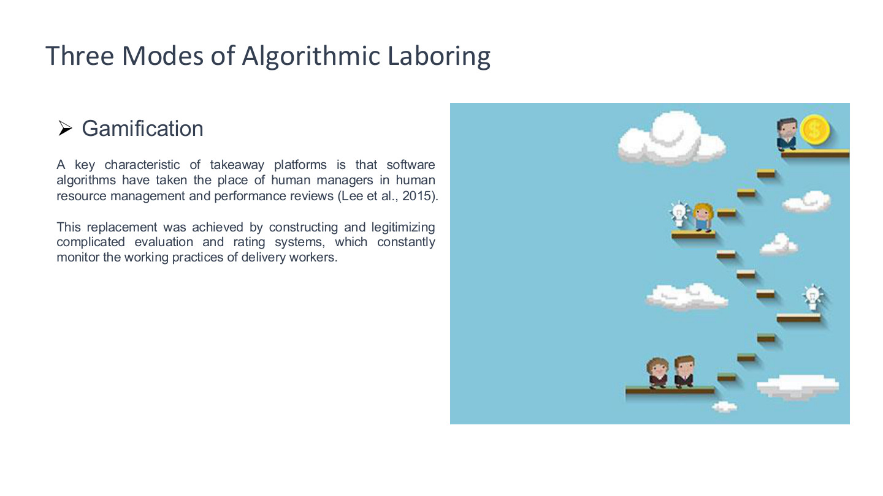
原PPT第38页 / Original slide 38 · 重点 / Focus

PPT中英翻译 / PPT translation
PPT English / 英文原文与图示 | 中文翻译 / Chinese translation
Three Modes of Algorithmic Laboring; Gamification | 算法劳动的三种模式；游戏化。
A key characteristic of takeaway platforms is that software algorithms have taken the place of human managers in human resource management and performance reviews (Lee et al., 2015). | 课件强调外卖平台用软件算法承担部分人力资源管理与绩效考核职能，替代相应的人类管理操作。
This replacement was achieved by constructing and legitimizing complicated evaluation and rating systems, which constantly monitor the working practices of delivery workers. | 这种替代通过建立并使复杂的评价、评分体系获得正当性来实现，系统持续监测配送员的工作实践。
Image: characters climbing a game-like path towards rewards | 配图：角色沿游戏式路径逐级上升并获得奖励。

本页核心 / Key takeaway
游戏化把积分、等级和奖惩嵌入劳动过程，让工作表现成为可比较、可追踪的持续竞赛。
Gamification embeds points, levels, rewards and penalties into work, making performance continuously comparable and trackable.

精要解析 / Essential explanation

1. 机制怎样运作 / How the mechanism works
完成任务可积累分数、获得等级与奖励。将收入前景与升级目标连接，可推动骑手持续投入，管理因此部分表现为追求目标的自我驱动。
Tasks produce points, levels and rewards. Connecting earnings prospects to advancement targets can encourage continued effort, making managerial control partly operate through self-driven pursuit of targets.

2. 为何不只是好玩 / Why it is more than fun
工作游戏化的后果可能涉及真实收入、机会与处罚。游戏形式包裹的是绩效管理，不能因为出现奖励图标，就忽略劳动关系和平台控制。
Work gamification can affect real income, opportunities and penalties. Game-like presentation carries performance management, so reward icons do not remove labour relations or platform control.

3. 连接下一页 / Link to the next slide
本页给出概念，下一页用骑手七级制度说明等级怎样具体连接每单补贴。复习时先会解释机制，再用一组数据举例即可。
This slide provides the concept; the next links seven rider levels to per-order subsidies. Learn the mechanism first, then use a small number of figures to illustrate it.

39｜被计算的劳动者 / The calculated worker
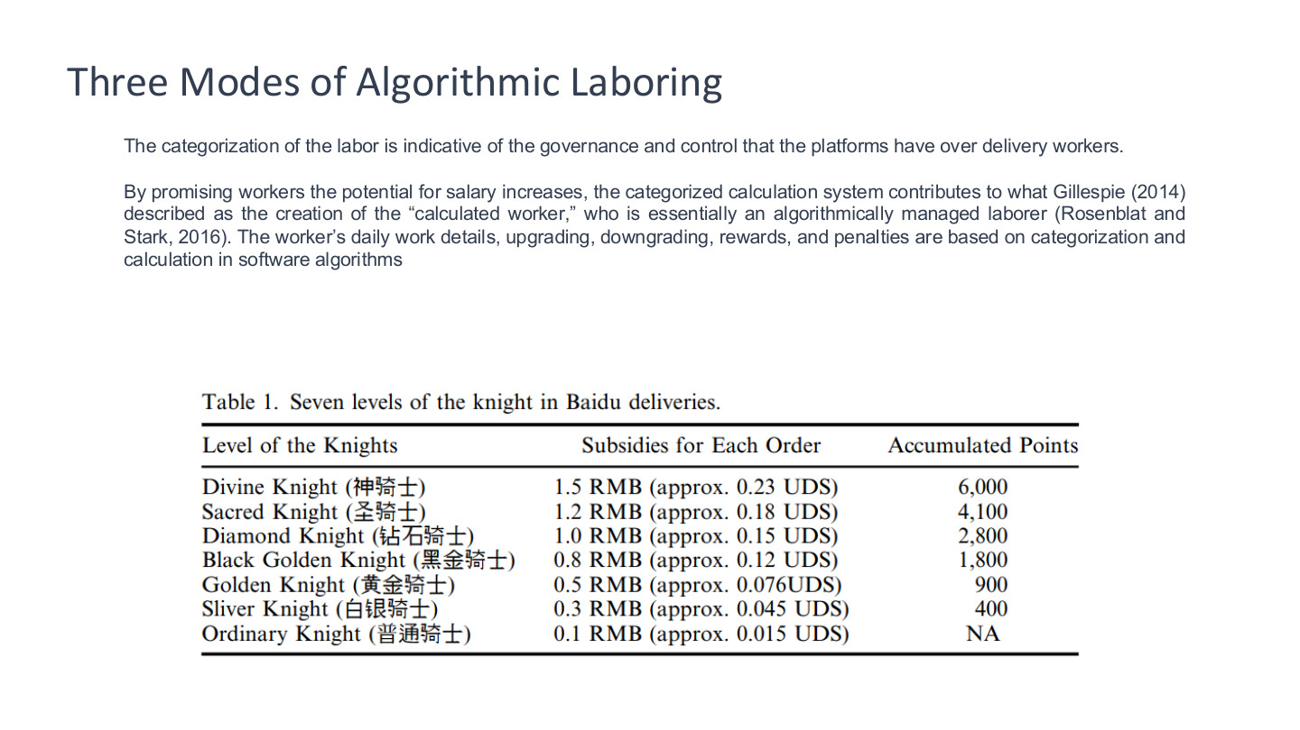
原PPT第39页 / Original slide 39 · 重点 / Focus

PPT中英翻译 / PPT translation
PPT English / 英文原文与图示 | 中文翻译 / Chinese translation
The categorization of the labor is indicative of the governance and control that the platforms have over delivery workers. | 劳动的分类体现平台对配送员的治理和控制。
By promising workers the potential for salary increases, the categorized calculation system contributes to the creation of the “calculated worker” (Gillespie 2014), an algorithmically managed laborer (Rosenblat and Stark 2016). | 分类计算系统以增加收入的可能性吸引劳动者，塑造“被计算的劳动者”，即受到算法管理的劳动者。
The worker’s daily work details, upgrading, downgrading, rewards, and penalties are based on categorization and calculation in software algorithms. | 劳动者日常工作细节、升级、降级、奖励和处罚，都被纳入软件算法的分类与计算。
Table 1. Seven levels of the knight in Baidu deliveries; Level; Subsidies for Each Order; Accumulated Points | 表1：百度配送骑手七个等级；列为等级、每单补贴、累计积分。美元约数按原图保留，原图UDS为USD的拼写错误。

七级骑手制度：原表对照 / Seven-level system
等级 / Level | 每单补贴 / Subsidy per order | 累计积分 / Points
神骑士 / Divine Knight | 1.5元 / RMB1.5 (≈ US$0.23) | 6,000
圣骑士 / Sacred Knight | 1.2元 / RMB1.2 (≈ US$0.18) | 4,100
钻石骑士 / Diamond Knight | 1.0元 / RMB1.0 (≈ US$0.15) | 2,800
黑金骑士 / Black Golden Knight | 0.8元 / RMB0.8 (≈ US$0.12) | 1,800
黄金骑士 / Golden Knight | 0.5元 / RMB0.5 (≈ US$0.076) | 900
白银骑士 / Silver Knight | 0.3元 / RMB0.3 (≈ US$0.045) | 400
普通骑士 / Ordinary Knight | 0.1元 / RMB0.1 (≈ US$0.015) | NA（原图未列 / not specified）

本页核心 / Key takeaway
“被计算的劳动者”指工作、等级与报酬被平台量化分类并持续管理的人。
The calculated worker is a worker whose activity, rank and pay are quantified, classified and continuously managed by the platform.

精要解析 / Essential explanation

1. 表格如何证明游戏化 / How the table illustrates gamification
从普通骑士到神骑士，积分与每单补贴相连。可见的升级路径使骑手有动力积累任务，平台则通过统一指标组织不同劳动者。
From ordinary to divine knight, points connect to per-order subsidies. A visible advancement path motivates task accumulation while common metrics organise different workers.

2. 用一组数字理解 / Understand through one comparison
普通骑士表列每单补贴0.1元，神骑士需6000积分、每单补贴1.5元。等级影响边际收入激励；这些是补贴而非总配送费，不能直接当作全部工资。
The table gives RMB0.1 per order for ordinary knights and RMB1.5 at 6,000 points for divine knights. Rank changes per-task incentives; these subsidies are not total delivery pay or complete wages.

3. 比较三个机制 / Compare the three mechanisms
准时制侧重何时完成，情绪劳动侧重如何面对顾客，游戏化侧重怎样积累等级和奖励。它们可同时作用于同一骑手，而非互斥的三类工作。
Just-in-time discipline concerns when work is completed, emotional labour how customers are treated, and gamification how rank and rewards are accumulated. The mechanisms can operate together on one rider.

易错辨析 / Key distinction
calculated不是“精明算计的性格”；这里指被算法衡量与管理。累计积分也不是货币，不能把6000积分写成6000元。
Calculated does not describe a scheming personality; it refers to algorithmic measurement and management. Points are not currency: 6,000 points do not mean RMB6,000.

40｜时间压力下的同伴互助 / Peer coordination under time pressure
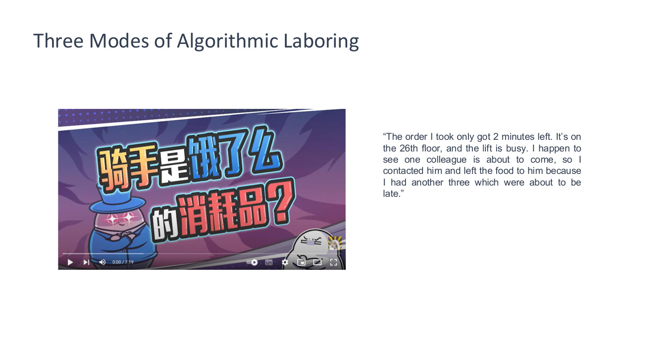
原PPT第40页 / Original slide 40 · 理解 / Understand

PPT中英翻译 / PPT translation
PPT English / 英文原文与图示 | 中文翻译 / Chinese translation
Three Modes of Algorithmic Laboring | 算法劳动的三种模式。
“The order I took only got 2 minutes left. It’s on the 26th floor, and the lift is busy. I happen to see one colleague is about to come, so I contacted him and left the food to him because I had another three which were about to be late.” | “这单只剩2分钟，在26楼，电梯又忙。我看到一个同事快来了，就联系他、把餐交给他，因为我还有另外三单快超时。”
Video caption: “Riders are Ele.me’s expendables?” [English rendering] | 视频画面标题：“骑手是饿了么的消耗品？”（疑问式表达）。

本页核心 / Key takeaway
骑手通过同伴协调来应对算法时限与现实障碍，说明劳动过程仍离不开人的判断和关系。
Riders use peer coordination to cope with algorithmic deadlines and practical obstacles, showing the continuing role of human judgement and relationships.

精要解析 / Essential explanation

1. 案例的因果链 / The causal chain
电梯忙、楼层高与多单临期叠加，骑手借助同事完成配送。系统目标与现场条件之间的缺口，需要劳动者额外协调，不能只看软件上的预计时间。
A busy lift, a high floor and multiple deadlines combine; the rider relies on a colleague. The gap between system targets and practical conditions requires coordination beyond the estimated time on screen.

2. 能动性与约束 / Agency and constraint
互助显示劳动者并非完全被动，但有应对办法不代表时间压力已经消失。它也不等于正式平台规则允许所有转交行为；此页是具体受访案例。
Peer support shows worker agency, but coping strategies do not remove time pressure. The example also does not establish that all handovers are officially permitted.

41｜结束与自检 / Questions and self-check

原PPT第41页 / Original slide 41 · 简读 / Brief

PPT中英翻译 / PPT translation
PPT English / 英文原文与图示 | 中文翻译 / Chinese translation
Questions? June Wang; June.wang@cityu.edu.hk | 有问题吗？June Wang；June.wang@cityu.edu.hk。

本页核心 / Key takeaway
自检能否连起来解释：平台怎样协调生产、创业为何仍需要地方网络、数字活动怎样变成可管理的劳动。
Check whether you can connect platform coordination, the continuing role of local entrepreneurial networks, and the conversion of digital activity into managed labour.

