01｜公共住房供给 / Public housing provision
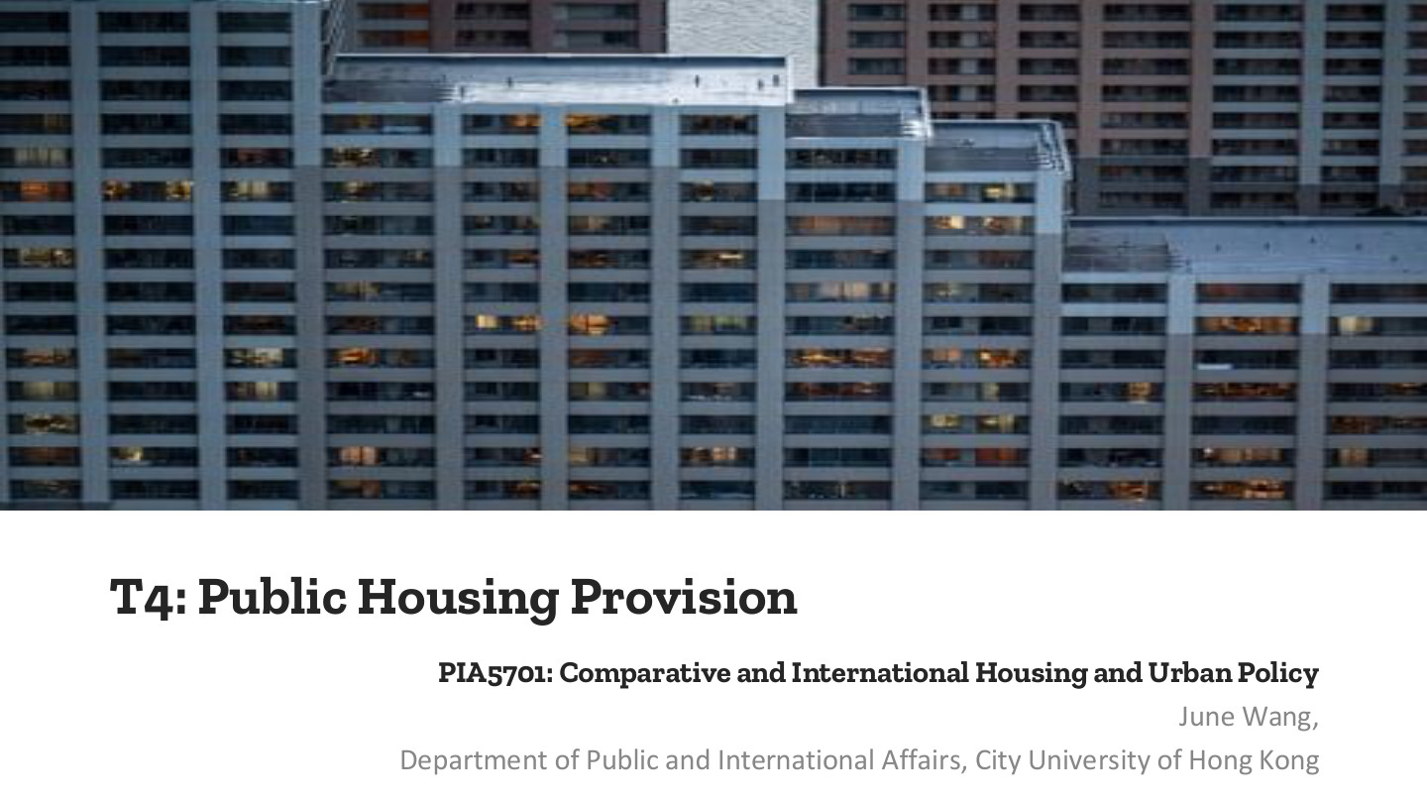
原PPT第1页 / Original slide 1 · 简读 / Brief

PPT中英翻译 / PPT translation
PPT English / 英文原文与图示 | 中文翻译 / Chinese translation
T4: Public Housing Provision | 第四讲：公共住房供给
PIA5701: Comparative and International Housing and Urban Policy | PIA5701：比较与国际住房及城市政策
June Wang, Department of Public and International Affairs, City University of Hong Kong | June Wang，香港城市大学公共及国际事务系

本页核心 / Key takeaway
本课通过美国与荷兰，比较公共住房的权利定位、供给方式及社会后果。
This lesson compares public housing in the US and the Netherlands through rights, provision and social outcomes.

阅读说明 / Reading guide
红色标核心定义、机制和关键区别；黑色加粗标次重点。重点页展开，简读页与重复内容只留精华；所有复习内容中英对照，不设附录。
Red marks key definitions, mechanisms and distinctions; black bold marks secondary emphasis. Focus pages receive fuller treatment, while brief and repetitive pages retain essentials. All review content is bilingual, with no appendix.
材料核对：听课宝主要讨论发展型国家与香港贫困政策，仅把相关政策分析方法用于跨课对照；本课住房制度以PPT为主，结合Word并辨别概括过强之处。
Source check: the listening summary mainly addresses developmental states and Hong Kong poverty policy. Relevant analytical methods are used for cross-lesson links; housing institutions follow the PPT, integrated with the Word notes and qualified where needed.

02｜本课路线 / Agenda
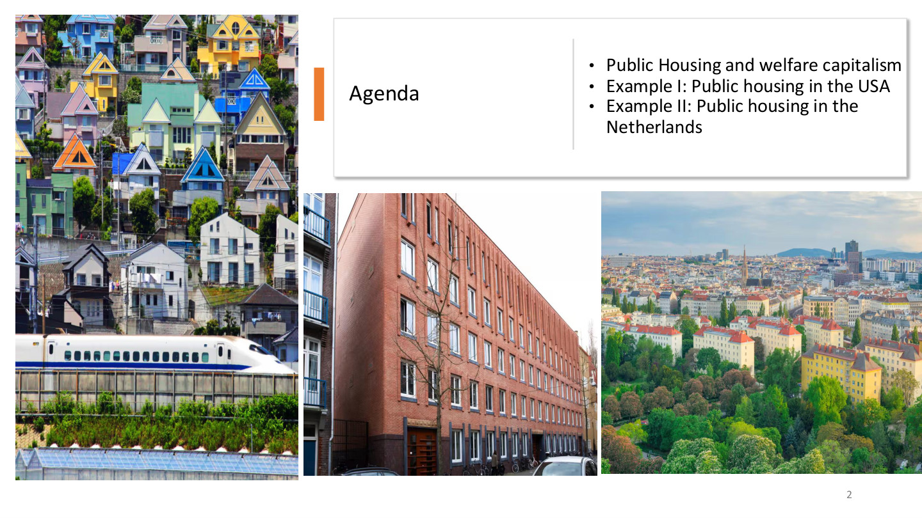
原PPT第2页 / Original slide 2 · 简读 / Brief

PPT中英翻译 / PPT translation
PPT English / 英文原文与图示 | 中文翻译 / Chinese translation
Public Housing and welfare capitalism | 公共住房与福利资本主义
Example I: Public housing in the USA | 案例一：美国公共住房
Example II: Public housing in the Netherlands | 案例二：荷兰公共住房

本页核心 / Key takeaway
按“福利理论→美国→荷兰→两国比较”学习；每个案例都问谁受益、谁供给、谁付钱。
Follow welfare theory, the US, the Netherlands and comparison; ask who benefits, who provides housing and who pays.

03｜公共住房与福利资本主义 / Public housing and welfare capitalism
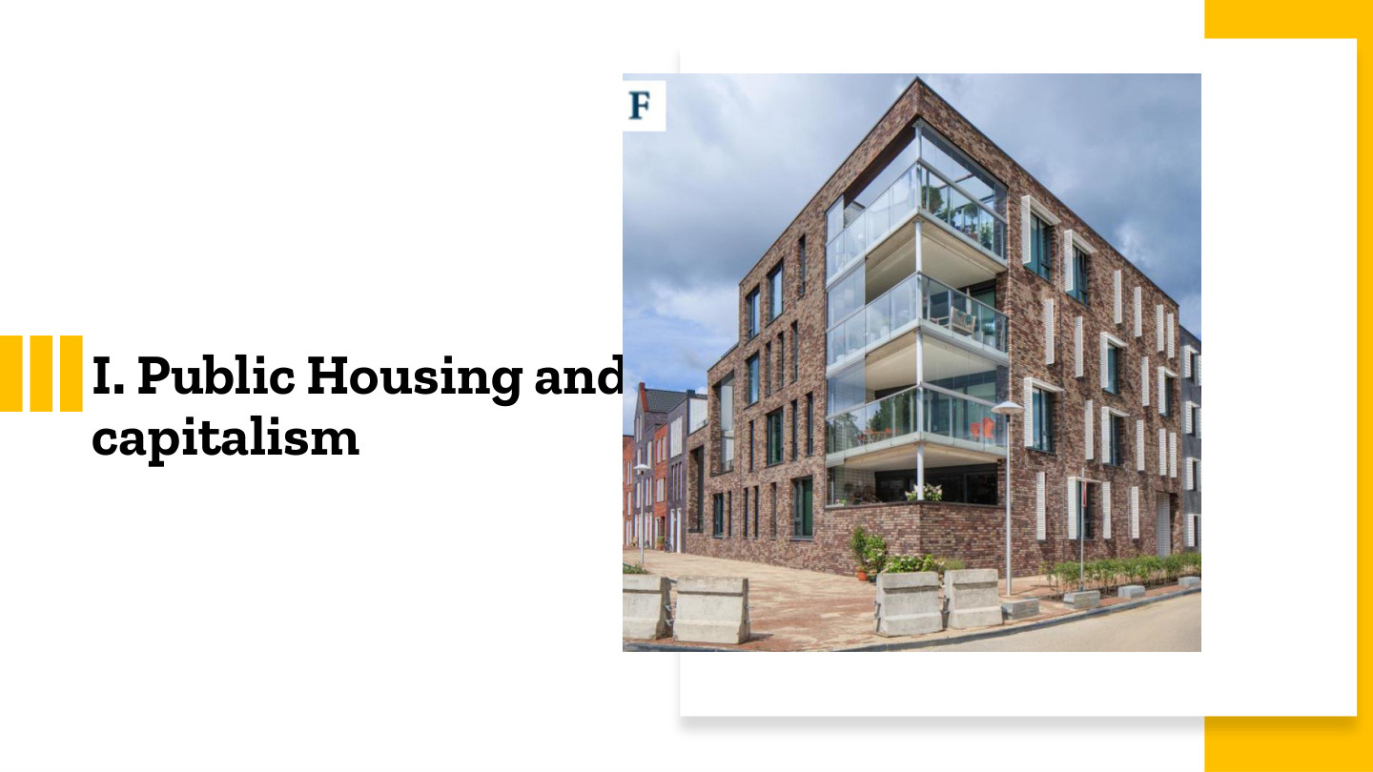
原PPT第3页 / Original slide 3 · 简读 / Brief

PPT中英翻译 / PPT translation
PPT English / 英文原文与图示 | 中文翻译 / Chinese translation
I. Public Housing and welfare capitalism | 第一部分：公共住房与福利资本主义

本页核心 / Key takeaway
本节把住房放回福利体制中，重点看居住保障与市场依赖的关系。
This section locates housing within welfare regimes, focusing on housing security and dependence on markets.

04｜重新界定福利国家 / A re-specification of the welfare state
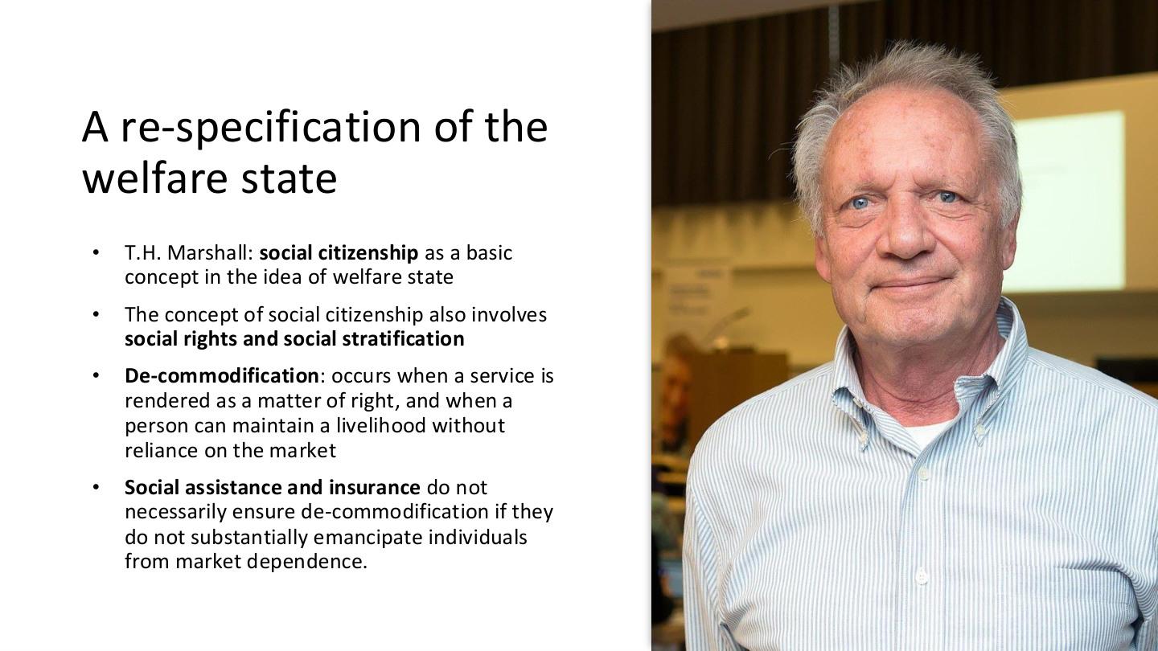
原PPT第4页 / Original slide 4 · 重点 / Focus

PPT中英翻译 / PPT translation
PPT English / 英文原文与图示 | 中文翻译 / Chinese translation
T.H. Marshall: social citizenship as a basic concept in the idea of welfare state | T.H.马歇尔：社会公民权是福利国家理念的基本概念。
The concept of social citizenship also involves social rights and social stratification | 社会公民权概念也涉及社会权利与社会分层。
De-commodification: occurs when a service is rendered as a matter of right, and when a person can maintain a livelihood without reliance on the market | 去商品化：服务作为一项权利提供，而且个人能够不依赖市场维持生计。
Social assistance and insurance do not necessarily ensure de-commodification if they do not substantially emancipate individuals from market dependence. | 如果社会救助和社会保险没有实质性减轻个人对市场的依赖，它们就不一定能确保去商品化。

本页核心 / Key takeaway
去商品化看保障是否实质减轻市场依赖，不能只看政府有没有福利项目。
Decommodification concerns a substantive reduction in market dependence, rather than the mere existence of welfare programmes.

精要解析 / Essential explanation

1. 社会公民权 / Social citizenship
社会公民权把基本保障视为社会成员可主张的权利。社会分层则追问这些权利怎样分配：是共同覆盖，还是按收入、职业或身份产生不同保护。
Social citizenship treats basic protection as a claim of membership. Stratification asks how rights are distributed: through shared coverage or differentiated protection by income, occupation or status.

2. 应用到住房 / Applying the concept to housing
住房方面要问：收入减少或失业时，家庭能否维持可负担、稳定的住所。补贴存在不等于保障充分，还要看资格、补贴水平、可选房源及居住持续性。
For housing, ask whether a household can retain an affordable, stable home after income loss. The existence of a subsidy does not establish adequate protection; eligibility, benefit levels, available homes and security also matter.

3. 与听课宝对照 / Link to the listening summary
听课宝强调不能只看开支多少，还要看政策为谁、服务什么目标。这里将这一方法用于住房：保障居住权、支持劳动力或维持市场运行，可能对应不同制度逻辑。
The listening summary stresses beneficiaries and policy purposes rather than spending alone. Apply that method to housing: securing housing rights, supporting labour or sustaining markets can reflect different institutional logics.

易错辨析 / Key distinction
去商品化是程度问题；公共供给、现金补贴、市场交易的存在都不能单独决定其高低。
Decommodification is a matter of degree; public provision, cash support or market transactions alone cannot determine its level.

05｜福利体制的三种原则 / Three welfare principles
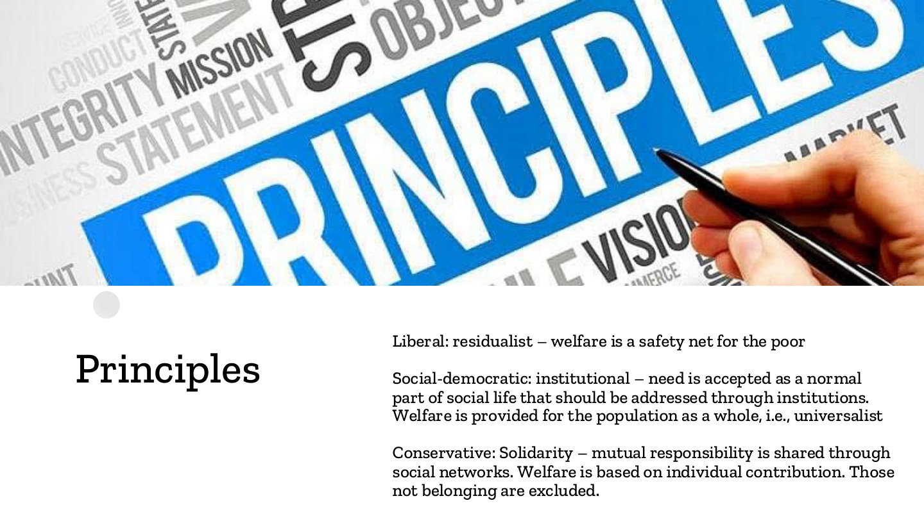
原PPT第5页 / Original slide 5 · 重点 / Focus

PPT中英翻译 / PPT translation
PPT English / 英文原文与图示 | 中文翻译 / Chinese translation
Liberal: residualist – welfare is a safety net for the poor | 自由主义：剩余型——福利是穷人的安全网。
Social-democratic: institutional – need is accepted as a normal part of social life that should be addressed through institutions. Welfare is provided for the population as a whole, i.e., universalist | 社会民主主义：制度型——需要被视为社会生活的正常组成部分，应由制度应对；福利面向全体人口，即普遍主义。
Conservative: Solidarity – mutual responsibility is shared through social networks. Welfare is based on individual contribution. Those not belonging are excluded. | 保守主义：团结——社会网络分担相互责任；福利基于个人贡献，不属于相应网络者可能被排除。

本页核心 / Key takeaway
三组关键词：剩余型安全网、制度型普遍保障、贡献与网络团结。
Remember a residual safety net, institutional universal provision, and contribution-based network solidarity.

精要解析 / Essential explanation

1. 剩余型 / Residualism
市场和家庭先承担生活保障，公共福利主要接住无法自行解决困难的人。套到住房，就是市场之外的低收入安全网，而不是把公共住房作为所有人的常规选择。
Markets and families carry primary responsibilities, while public welfare supports those unable to cope. In housing this implies a low-income safety net alongside the market, rather than a routine public option for everyone.

2. 制度型 / Institutionalism
需要被视为普遍、正常现象，因此由持续的公共制度回应。覆盖全体的理念不等于人人领取相同金额；实际项目仍需说明服务内容、融资与分配规则。
Need is treated as normal and addressed by durable institutions. Universal coverage does not require identical benefits for everyone; actual programmes still specify services, financing and allocation rules.

3. 团结与边界 / Solidarity and boundaries
网络内部的互助可以很强，但成员身份和缴费贡献也划出边界。分析时同时看内部保障与圈外人的处境，避免把“团结”直接理解成人人平等。
Mutual support can be strong within a network, while membership and contributions define its boundaries. Examine both insiders’ protection and outsiders’ position rather than equating solidarity with equality.

06｜住房为何是“摇晃的支柱”？ / The wobbly pillar
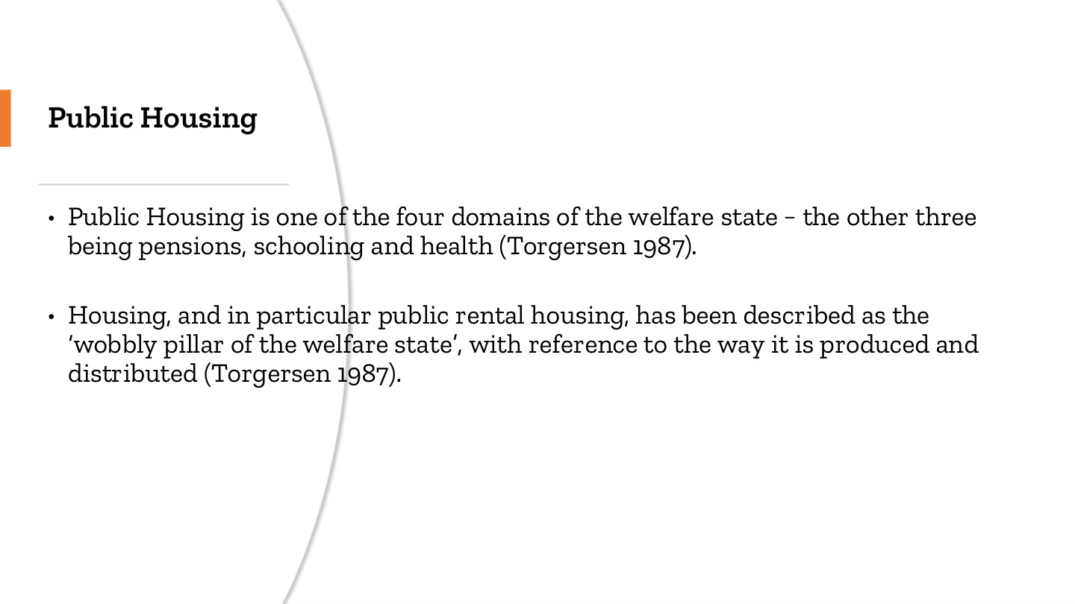
原PPT第6页 / Original slide 6 · 重点 / Focus

PPT中英翻译 / PPT translation
PPT English / 英文原文与图示 | 中文翻译 / Chinese translation
Public Housing is one of the four domains of the welfare state − the other three being pensions, schooling and health (Torgersen 1987). | 公共住房是福利国家四个领域之一；另外三个是养老金、教育和医疗（Torgersen，1987）。
Housing, and in particular public rental housing, has been described as the ‘wobbly pillar of the welfare state’, with reference to the way it is produced and distributed (Torgersen 1987). | 住房，特别是公共租赁住房，因其生产和分配方式，被称为“福利国家摇晃的支柱”（Torgersen，1987）。

本页核心 / Key takeaway
“摇晃”指住房的生产、资产与分配逻辑使其福利地位较不稳定，不是说建筑质量差。
The pillar is “wobbly” because housing production, assets and allocation make its welfare role less stable, not because buildings are physically unsound.

精要解析 / Essential explanation

1. 生产方式有何特殊 / What is distinctive about production?
住房需要土地、建造资金与长期维护，不能像现金待遇一样只靠确定发放规则。供给数量、区位及存量能否保留，会直接影响保障是否兑现。
Housing requires land, construction finance and long-term maintenance, beyond rules for paying cash benefits. Supply, location and retention of existing homes directly shape whether protection can be delivered.

2. 生活需要与资产并存 / A need and an asset
住房既提供居住服务，又可以成为私人资产和投资对象。可负担保障与资产收益之间可能存在张力，因此国家既可能援助租客，也可能以税收优惠支持业主。
Housing supplies shelter while also functioning as a private asset and investment. Affordability and asset returns can pull in different directions, so governments may support tenants and subsidise owners through different instruments.

3. 怎样用于比较 / Using the concept in comparison
不要只问有没有公屋；还要看谁建造和持有住房、谁能入住、租金怎样确定，以及住户能否长期留下。这些问题将贯穿美国和荷兰案例。
Go beyond whether public housing exists: ask who builds and owns it, who enters, how rents are set and whether residents can remain. These questions structure the US–Netherlands comparison.

07｜自由主义与社会民主住房体制 / Liberal and social-democratic housing
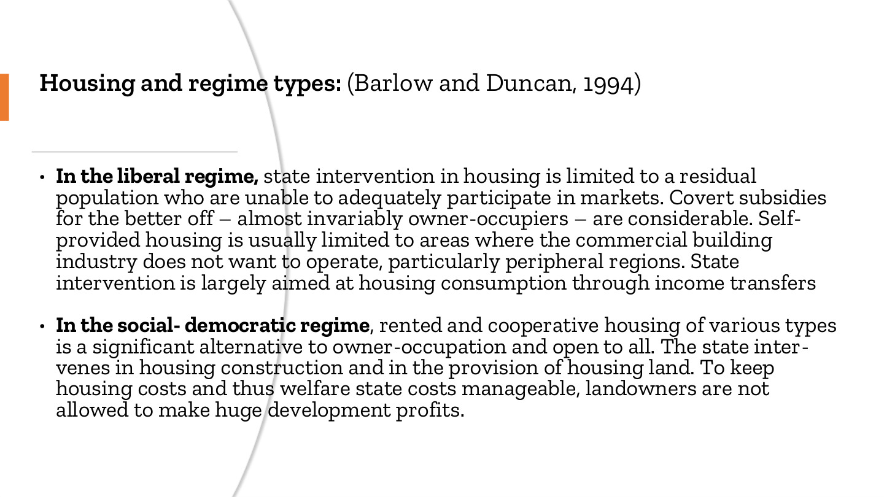
原PPT第7页 / Original slide 7 · 重点 / Focus

PPT中英翻译 / PPT translation
PPT English / 英文原文与图示 | 中文翻译 / Chinese translation
Housing and regime types: (Barlow and Duncan, 1994) | 住房与体制类型（Barlow与Duncan，1994）。
In the liberal regime, state intervention in housing is limited to a residual population who are unable to adequately participate in markets. Covert subsidies for the better off – almost invariably owner-occupiers – are considerable. Self-provided housing is usually limited to areas where the commercial building industry does not want to operate, particularly peripheral regions. State intervention is largely aimed at housing consumption through income transfers. | 自由主义体制下，国家住房干预主要面向无法充分参与市场的剩余群体。给予较富裕者——几乎总是自住业主——的隐性补贴却相当可观。自助供房通常局限于商业建筑业不愿经营的地区，尤其是外围地区。国家主要通过收入转移干预住房消费。
In the social-democratic regime, rented and cooperative housing of various types is a significant alternative to owner-occupation and open to all. The state intervenes in housing construction and in the provision of housing land. To keep housing costs and thus welfare state costs manageable, landowners are not allowed to make huge development profits. | 社会民主体制下，各类租赁住房与合作住房是自住住房的重要替代，并向所有人开放。国家介入住房建设和住房土地供给；为控制住房及福利国家的成本，限制土地所有者获取巨额开发利润。

本页核心 / Key takeaway
核心对照是面向剩余群体的消费补贴，与广泛开放的多种住房选择及供给干预。
Contrast consumption support for residual groups with broad housing alternatives and intervention in supply.

精要解析 / Essential explanation

1. 自由主义不等于没有补贴 / Liberalism does not mean no subsidies
安全网可能较窄，同时业主通过税收等渠道得到隐性支持。分析国家作用时，应把显性公屋开支与隐性业主支持一起考虑，不能只看政府直接建多少房。
A narrow safety net can coexist with indirect support for owners. Examine both visible public-housing spending and less visible owner subsidies rather than judging the state’s role solely by direct construction.

2. 消费端与供给端 / Consumption and supply
收入转移主要提高家庭支付住房的能力；建设和土地政策则改变住房如何生产。给家庭补钱与增加可负担房源是不同机制，效果取决于市场供给和制度约束。
Income transfers support households’ ability to pay; construction and land policies shape production. Supporting purchasing power and adding affordable homes are distinct mechanisms, whose effects depend on supply conditions and institutional rules.

3. 住房选择的地位 / Status of housing alternatives
如果租赁和合作住房也被视为正常选择，社会住房较不容易只与失败或贫困挂钩。这一原则为后面比较污名与社会融合提供了理解入口。
When rental and cooperative housing are normal alternatives, social housing is less readily associated only with failure or poverty. This principle helps explain the later comparison of stigma and integration.

易错辨析 / Key distinction
这是住房体制的理想类型；不能仅凭住房制度就把一个国家所有福利政策归入同一类型。
These are housing-regime ideal types; housing alone cannot classify every welfare policy of a country.

08｜组合主义住房体制 / Corporatist housing
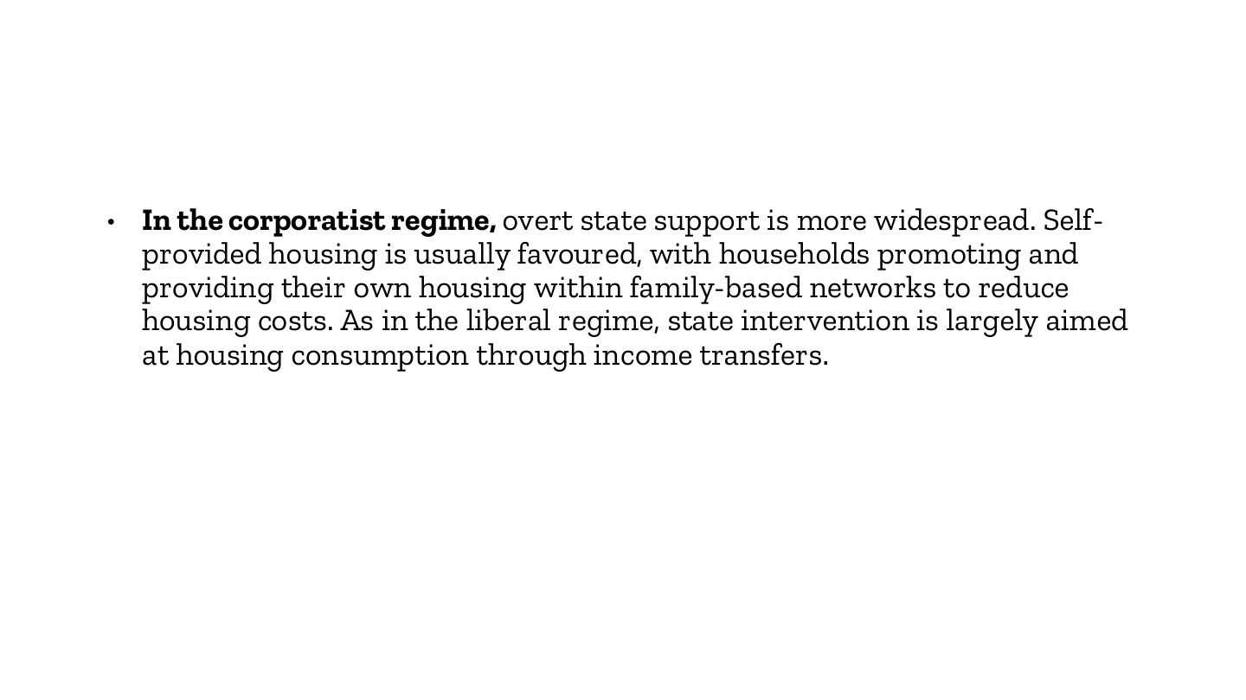
原PPT第8页 / Original slide 8 · 理解 / Understand

PPT中英翻译 / PPT translation
PPT English / 英文原文与图示 | 中文翻译 / Chinese translation
In the corporatist regime, overt state support is more widespread. Self-provided housing is usually favoured, with households promoting and providing their own housing within family-based networks to reduce housing costs. As in the liberal regime, state intervention is largely aimed at housing consumption through income transfers. | 组合主义体制中，显性的国家支持更广泛；通常偏好自助供房，家庭在亲属网络内推动并提供自己的住房，以降低成本。与自由主义类似，国家主要通过收入转移干预住房消费。

本页核心 / Key takeaway
组合主义突出家庭网络的自助供房与显性国家支持；国家和家庭可以共同承担保障。
Corporatist housing emphasises family-based self-provision alongside overt state support; family and state responsibilities can coexist.

精要解析 / Essential explanation

1. 家庭怎样降低成本 / How families reduce costs
家庭网络可通过资金、劳动或住房资源互助，减少成员独立进入市场的压力。“自助供房”不是指国家独自建造，也不只指个人靠工资购买现成商品房。
Family networks can share finance, labour or housing resources, reducing pressure on individual members. Self-provision is neither government-only construction nor simply buying a completed dwelling through wages.

2. 与自由主义怎样区分 / Distinguishing it from liberalism
两者都可能使用收入转移，差别不能只从工具名称判断。还要看家庭责任、国家支持方式与成员边界，这也呼应听课宝按政策对象和目标比较体制的方法。
Both can use income transfers, so the instrument’s name is insufficient. Compare family responsibilities, forms of state support and membership boundaries, consistent with the listening summary’s attention to beneficiaries and purposes.

09｜本课比较框架 / The comparison framework
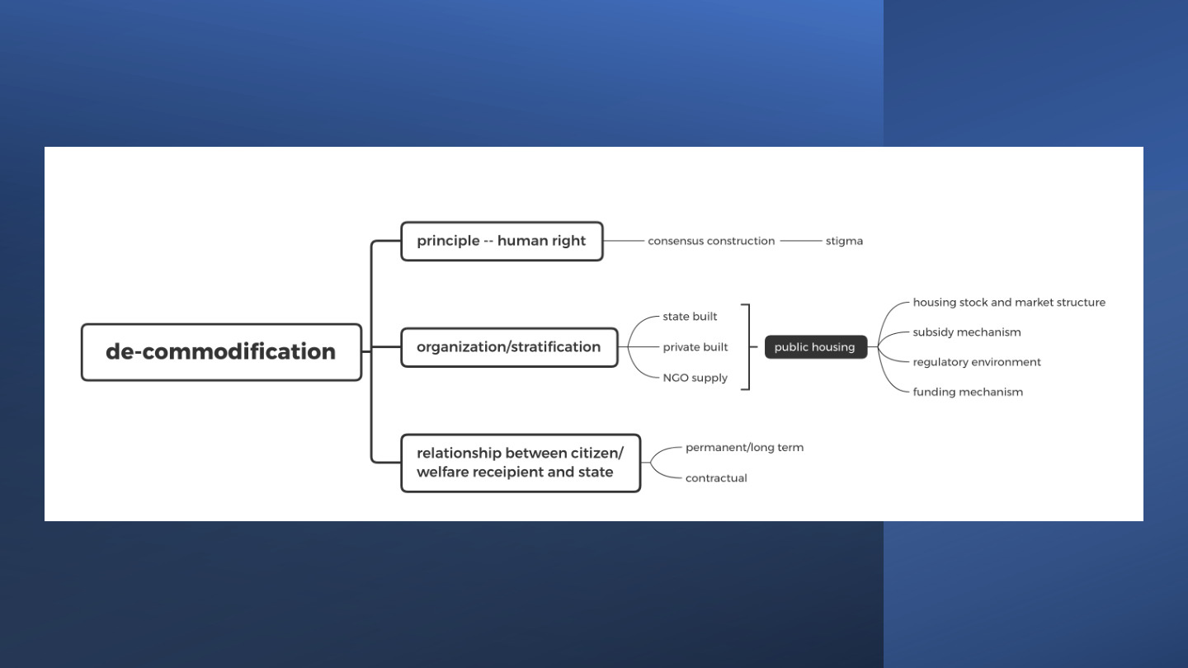
原PPT第9页 / Original slide 9 · 重点 / Focus

PPT中英翻译 / PPT translation
PPT English / 英文原文与图示 | 中文翻译 / Chinese translation
De-commodification | 去商品化。
Principle — human right → consensus construction → stigma | 原则——人权→共识建构→污名。
Organization/stratification: state built; private built; NGO supply → public housing | 组织／分层：国家建造、私人建造、非政府组织供给→公共住房。
Housing stock and market structure; subsidy mechanism; regulatory environment; funding mechanism | 住房存量与市场结构；补贴机制；监管环境；融资机制。
Relationship between citizen/welfare recipient and state: permanent/long term; contractual | 公民／福利接受者与国家的关系：永久／长期；契约型。

本页核心 / Key takeaway
本课用原则、组织／分层、国家—住户关系三条线分析住房去商品化。
Housing decommodification is examined through principles, organisation/stratification, and state–resident relations.

精要解析 / Essential explanation

1. 原则如何产生后果 / From principles to consequences
先看住房被视为社会权利还是剩余安全网，再观察这种理解怎样影响公共支持与污名。原则不只是口号，也会影响谁被认为“值得”获得保障。
Start with housing as a right or residual safety net, then examine effects on public support and stigma. Principles influence who is regarded as deserving of protection, rather than merely supplying slogans.

2. 组织和资金分开看 / Separate organisation from finance
谁建房、谁持有、谁出资和谁监管并非同一个问题。政府出钱可以由私人房东供房，非营利协会持有住房也可以受到严格公共监管。
Builder, owner, funder and regulator are distinct roles. Public funding can support private rental provision, while nonprofit ownership can coexist with extensive public regulation.

3. 住户关系与居住稳定 / Resident relations and security
契约说明租金、维修与终止条件怎样规定；权利定位说明国家承担多大保障责任。两者可能并存，因此还要具体判断保障范围和居住稳定性。
Contracts specify rents, maintenance and termination, while rights define public responsibilities. They can coexist, so examine the actual coverage and security of housing rather than treating them as exclusive categories.

10｜美国案例 / The United States

原PPT第10页 / Original slide 10 · 简读 / Brief

PPT中英翻译 / PPT translation
PPT English / 英文原文与图示 | 中文翻译 / Chinese translation
III. The United States | 第三部分：美国。

本页核心 / Key takeaway
美国案例重点追踪剩余安全网怎样通过公屋、住房券和混合融资运行。
Trace how a residual safety net operates through public housing, vouchers and mixed finance in the US.

11｜美国的基本原则 / US fundamental principle
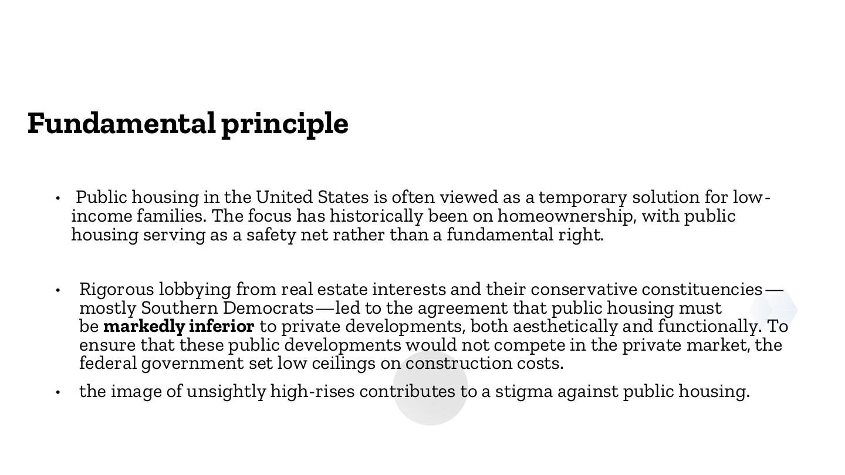
原PPT第11页 / Original slide 11 · 重点 / Focus

PPT中英翻译 / PPT translation
PPT English / 英文原文与图示 | 中文翻译 / Chinese translation
Public housing in the United States is often viewed as a temporary solution for low-income families. The focus has historically been on homeownership, with public housing serving as a safety net rather than a fundamental right. | 美国公共住房常被视为低收入家庭的临时解决办法。历史政策优先鼓励自有住房，公共住房作为安全网，而不是一项基本权利。
Rigorous lobbying from real estate interests and their conservative constituencies—mostly Southern Democrats—led to the agreement that public housing must be markedly inferior to private developments, both aesthetically and functionally. To ensure that these public developments would not compete in the private market, the federal government set low ceilings on construction costs. | 房地产利益集团及其保守支持者——主要是当时的南方民主党人——强力游说，形成了公共住房在外观和功能上须明显逊于私人项目的安排。联邦政府设定较低建设成本上限，以避免公共项目与私人市场竞争。
The image of unsightly high-rises contributes to a stigma against public housing. | 外观欠佳的高层住宅形象助长了对公共住房的污名。

本页核心 / Key takeaway
美国的历史定位是以自有住房为优先、公共住房作低收入安全网，并通过避免市场竞争限制其品质。
Historically, the US prioritised homeownership with public housing as a low-income safety net, while limiting quality to avoid competition with private development.

精要解析 / Essential explanation

1. 制度定位 / Institutional position
“临时解决”描述公共住房在政策中的地位，不等于每份租约都只有短期。安全网目标意味着公共支持集中于市场无法充分保障的人，而不是普遍提供同等住房选择。
“Temporary solution” describes the policy role, not necessarily a short fixed tenancy for every resident. A safety-net aim targets people inadequately served by markets rather than offering everyone an equivalent public alternative.

2. 政治如何影响品质 / How politics shapes quality
成本上限和避免竞争把房地产利益转化为设计约束。较低品质不是贫困居民自然造成的结果，还与制度选择有关；这条因果链有助于解释污名如何形成。
Cost ceilings and noncompetition rules translate property interests into design constraints. Lower quality is not an inevitable result of poor residents; institutional choices matter and can contribute to stigma.

3. 与后页连接 / Link to later pages
把“安全网定位→受限供给与品质→污名和隔离”连起来看。后面的券计划和更新政策改变工具，但仍须追问低收入家庭的选择与居住稳定是否改善。
Connect safety-net positioning, constrained supply and quality, and stigma or segregation. Later vouchers and redevelopment alter instruments, but their effects on low-income choice and security still require examination.

12｜美国制度的历史起点 / Historical origins
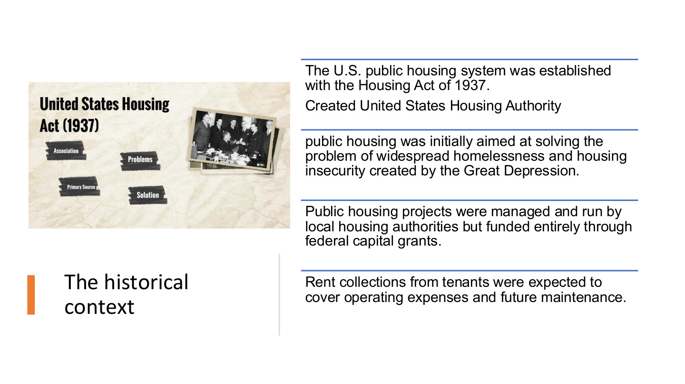
原PPT第12页 / Original slide 12 · 简读 / Brief

PPT中英翻译 / PPT translation
PPT English / 英文原文与图示 | 中文翻译 / Chinese translation
The U.S. public housing system was established with the Housing Act of 1937. Created United States Housing Authority. | 美国公共住房制度由1937年《住房法》建立，并设立美国住房管理局（USHA）。
Public housing was initially aimed at solving the problem of widespread homelessness and housing insecurity created by the Great Depression. | 最初旨在应对大萧条造成的广泛无家可归和住房不稳定。
Public housing projects were managed and run by local housing authorities but funded entirely through federal capital grants. | 住房项目由地方住房管理机构运营，当时建设资本由联邦资本拨款提供。
Rent collections from tenants were expected to cover operating expenses and future maintenance. | 预期以租客租金支付日常运营和未来维护成本。

本页核心 / Key takeaway
记住1937年立法、联邦资本拨款、地方运营、租金维护的历史分工。
Remember the historical arrangement: 1937 legislation, federal capital grants, local management and rents for upkeep.

精要解析 / Essential explanation

1. 资金用途分开 / Separate capital and operating finance
联邦资本拨款对应建设，租金对应运营维护。低收入住户支付能力有限时，维护资金可能面临压力；“联邦出资”并不意味着所有支出都由联邦长期全额承担。
Federal capital grants funded construction, while rents were expected to fund operations and maintenance. Limited tenant incomes can strain upkeep; federal funding does not mean every expense is permanently and fully paid centrally.

13｜美国三类主要项目 / Three major US programmes
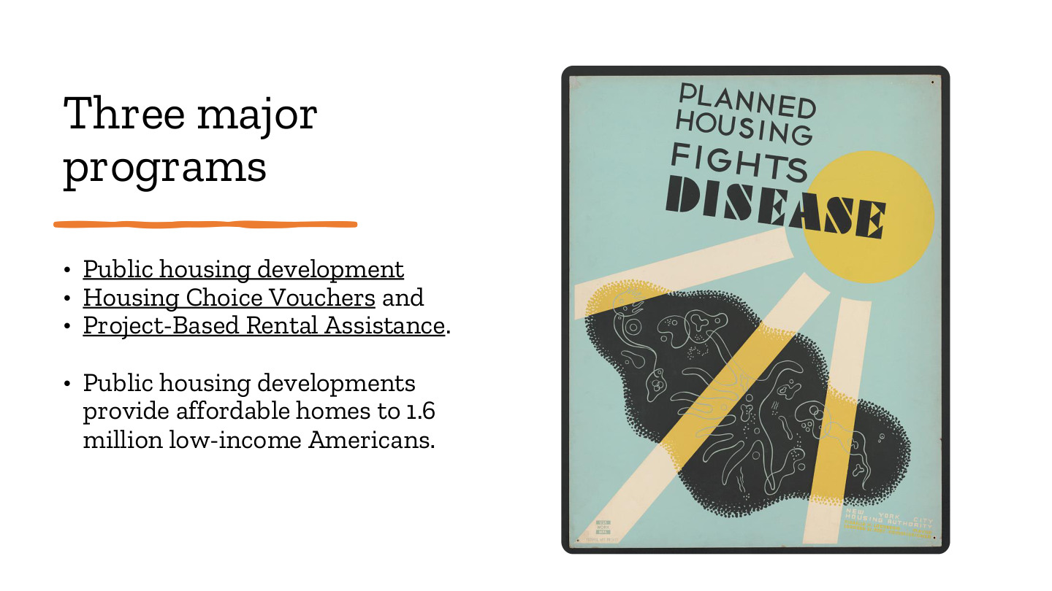
原PPT第13页 / Original slide 13 · 理解 / Understand

PPT中英翻译 / PPT translation
PPT English / 英文原文与图示 | 中文翻译 / Chinese translation
Public housing development; Housing Choice Vouchers; Project-Based Rental Assistance. | 公共住房项目；住房选择券；项目挂钩租赁援助。
Public housing developments provide affordable homes to 1.6 million low-income Americans. | 公共住房项目为约160万低收入美国人提供可负担住房。
Poster: Planned Housing Fights Disease | 海报：有规划的住房有助于抗击疾病。

本页核心 / Key takeaway
先分清直接供房、住户住房券、项目挂钩援助三种渠道；160万指人口，不是住房套数。
Distinguish direct housing provision, household vouchers and project-based assistance; 1.6 million refers to people, not dwellings.

精要解析 / Essential explanation

1. 援助跟着谁 / What is assistance attached to?
住房券主要支持符合条件的家庭寻找私人出租房；项目挂钩援助附着于特定项目或房源。两者都可提供租赁支持，但住户搬家时补贴如何持续并不相同。
Vouchers support eligible households seeking private rentals, while project-based assistance is attached to particular projects or units. Both support renting, but continuity of support when a resident moves differs.

2. 避免概念混用 / Keep categories distinct
本课有时用公共住房概括住房援助，但狭义公共住房项目不是整个援助体系。分析时应写明正在讨论哪类项目，否则会把房源存量与领取补贴的人数混在一起。
The lecture sometimes uses public housing broadly, but public-housing developments are only one part of assistance. Name the programme under discussion to avoid mixing housing-stock figures with assisted populations.

14｜美国公共住房资格 / Who is eligible?
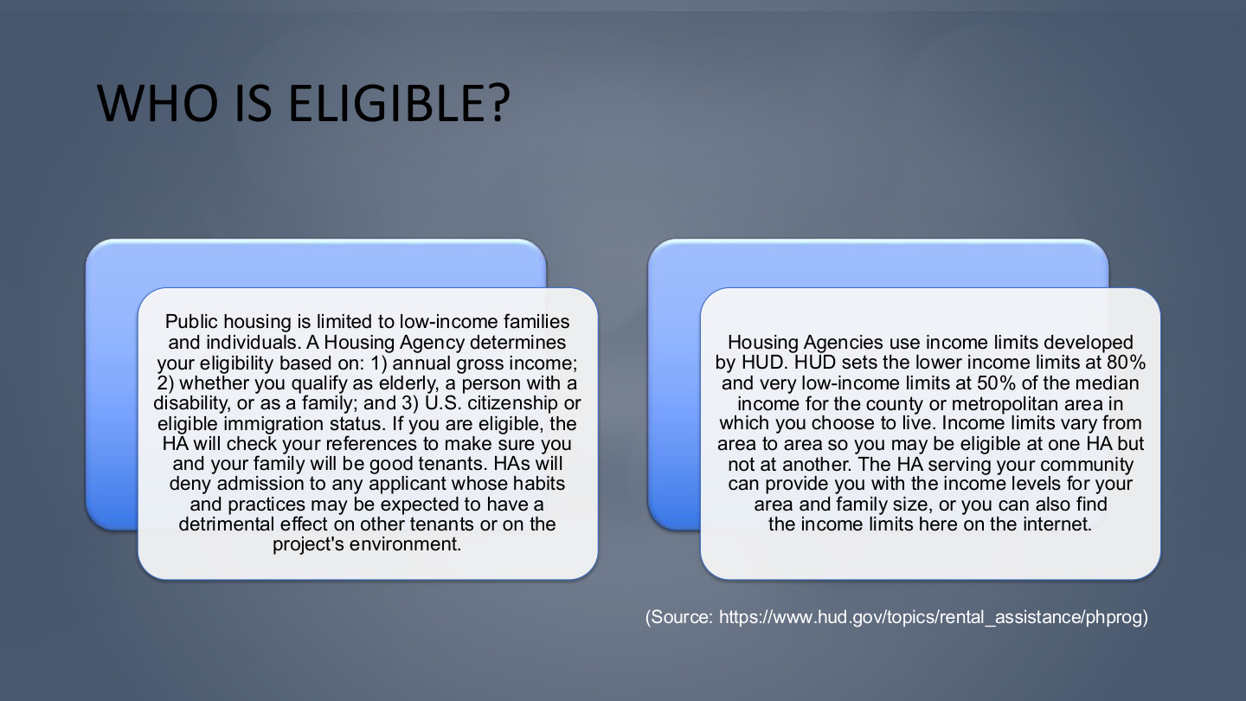
原PPT第14页 / Original slide 14 · 重点 / Focus

PPT中英翻译 / PPT translation
PPT English / 英文原文与图示 | 中文翻译 / Chinese translation
Public housing is limited to low-income families and individuals. A Housing Agency determines your eligibility based on: 1) annual gross income; 2) whether you qualify as elderly, a person with a disability, or as a family; and 3) U.S. citizenship or eligible immigration status. | 公共住房面向低收入家庭和个人。住房机构根据以下条件判断资格：①年度税前总收入；②是否属于老人、残障者或家庭等类别；③美国公民身份或符合条件的移民身份。
If you are eligible, the HA will check your references to make sure you and your family will be good tenants. HAs will deny admission to any applicant whose habits and practices may be expected to have a detrimental effect on other tenants or on the project’s environment. | 初步符合资格后，住房机构还会核查相关资料，判断申请人及家属能否履行租客责任；如其行为可能对其他租客或项目环境造成不利影响，机构可拒绝接纳。
Housing Agencies use income limits developed by HUD. HUD sets the lower income limits at 80% and very low-income limits at 50% of the median income for the county or metropolitan area in which you choose to live. | 住房机构采用HUD制定的收入线：低收入线为所选县或都市区收入中位数的80%，非常低收入线为50%。
Income limits vary from area to area so you may be eligible at one HA but not at another. The HA serving your community can provide you with the income levels for your area and family size, or you can also find the income limits here on the internet. | 收入线因地区而异，因此可能符合一个住房机构的要求，却不符合另一个的要求；当地住房机构可提供对应地区和家庭规模的收入标准，也可上网查询。
Source: HUD, Public Housing Program | 来源：美国住房与城市发展部（HUD）公共住房项目资料。

本页核心 / Key takeaway
美国公共住房通过收入、家庭／个人类别、身份及租客审查筛选对象，具有明确的资格边界。
US public housing selects recipients through income, household categories, status and tenant screening, creating explicit eligibility boundaries.

精要解析 / Essential explanation

1. 收入线怎样理解 / Reading income limits
80%和50%的参照是当地收入中位数，并非全国固定金额。家庭规模也会影响适用标准；不能只拿某个城市的一条收入线判断所有申请人。
The 80% and 50% limits reference local median income, not a single national cash threshold. Household size also matters, so one city’s limit cannot determine eligibility for everyone.

2. 资格不等于已经获房 / Eligibility is not allocation
符合收入条件只是申请筛选的一部分，还存在身份、住户类别及行为资料审查。取得资格与实际获得住房之间也有区别，供给和轮候会影响最终进入。
Meeting an income limit is only one part of screening, alongside status, household categories and tenant checks. Eligibility also differs from receiving a unit, which depends on supply and waiting processes.

3. 筛选怎样塑造对象 / How screening shapes recipients
听课宝讨论指标怎样改变政策对象；本页提供住房中的具体应用。分析时把“哪些人有资格”和“哪些人实际受益”分开，才看得出排除与覆盖。
The listening summary considers how criteria shape policy populations. Apply that insight here by separating who qualifies from who actually benefits, making inclusion and exclusion visible.

易错辨析 / Key distinction
本页是公共住房资格；第19页住房券的50%与75%／30%规则属于另一项目，不要合并为同一条门槛。
This page concerns public-housing eligibility; the 50% and 75%/30% voucher rules on slide 19 belong to a different programme.

15｜公共住房住户画像 / Public-housing recipients
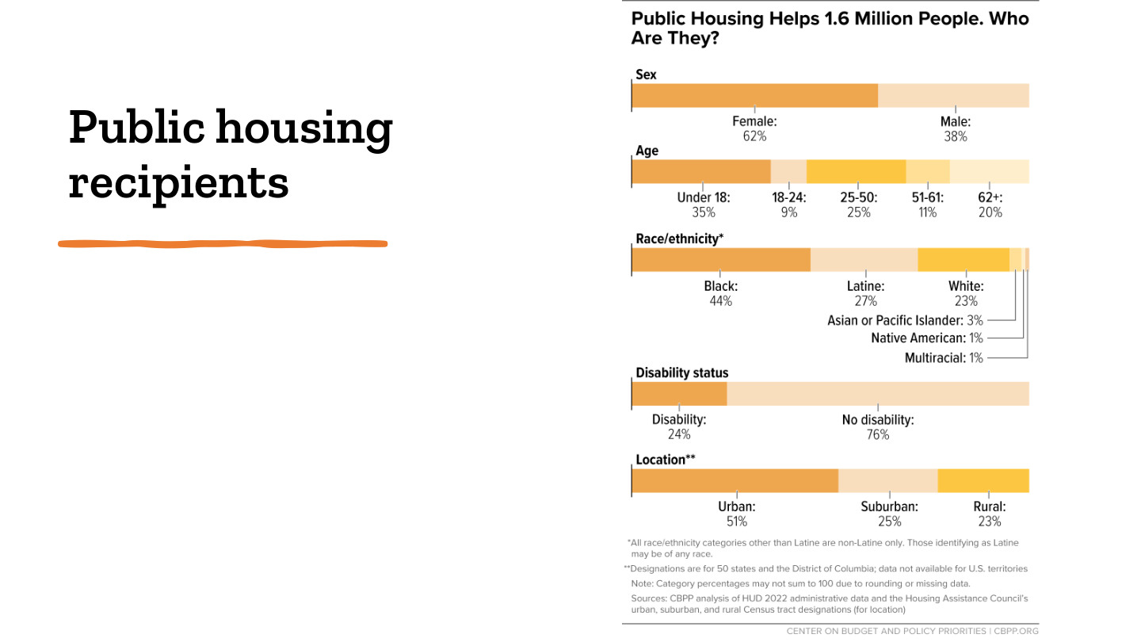
原PPT第15页 / Original slide 15 · 简读 / Brief

PPT中英翻译 / PPT translation
PPT English / 英文原文与图示 | 中文翻译 / Chinese translation
Public Housing Helps 1.6 Million People. Who Are They? | 公共住房帮助160万人，他们是谁？
Sex: Female 62%; Male 38%. | 性别：女性62%，男性38%。
Age: Under 18, 35%; 18–24, 9%; 25–50, 25%; 51–61, 11%; 62+, 20%. | 年龄：18岁以下35%；18—24岁9%；25—50岁25%；51—61岁11%；62岁及以上20%。
Race/ethnicity*: Black 44%; Latine 27%; White 23%; Asian or Pacific Islander 3%; Native American 1%; Multiracial 1%. | 族裔／种族*：黑人44%；拉丁裔27%；白人23%；亚裔或太平洋岛民3%；美洲原住民1%；多种族1%。
Disability status: Disability 24%; No disability 76%. | 残障状况：有残障24%；无残障76%。
Location**: Urban 51%; Suburban 25%; Rural 23%. | 地点**：城市51%；郊区25%；乡村23%。
*All race/ethnicity categories other than Latine are non-Latine only. Those identifying as Latine may be of any race. | *除拉丁裔外，其他种族／族裔类别只统计非拉丁裔；自认拉丁裔者可属于任何种族。
**Designations are for 50 states and the District of Columbia; data not available for U.S. territories. Note: category percentages may not sum to 100 due to rounding or missing data. | **地域分类适用于美国50州与哥伦比亚特区，不含缺乏数据的美国属地。各项比例可能因四舍五入或缺失数据而不合计为100%。
Sources: CBPP analysis of HUD 2022 administrative data and the Housing Assistance Council’s urban, suburban, and rural Census tract designations (for location). | 来源：CBPP对HUD 2022年行政数据的分析；地点分类采用住房援助委员会的城市、郊区及乡村普查区划分。

本页核心 / Key takeaway
记住住户具有多样性：儿童、老人、女性与残障者都占重要部分；不必逐个背比例。
Remember the diverse resident population, including children, older people, women and disabled people; detailed percentages are secondary.

精要解析 / Essential explanation

1. 这张图能说明什么 / What this chart establishes
它描述公共住房住户的构成，不是各群体获得公屋的概率，也不能单独解释谁更贫困。分母是受助居民人口，且数据是2022年历史快照。
The chart describes residents, not each group’s probability of receiving public housing, and cannot independently establish who is poorer. Its denominator is the assisted population and its data are a 2022 snapshot.

16｜住房存量与市场结构 / Housing stock and market structure
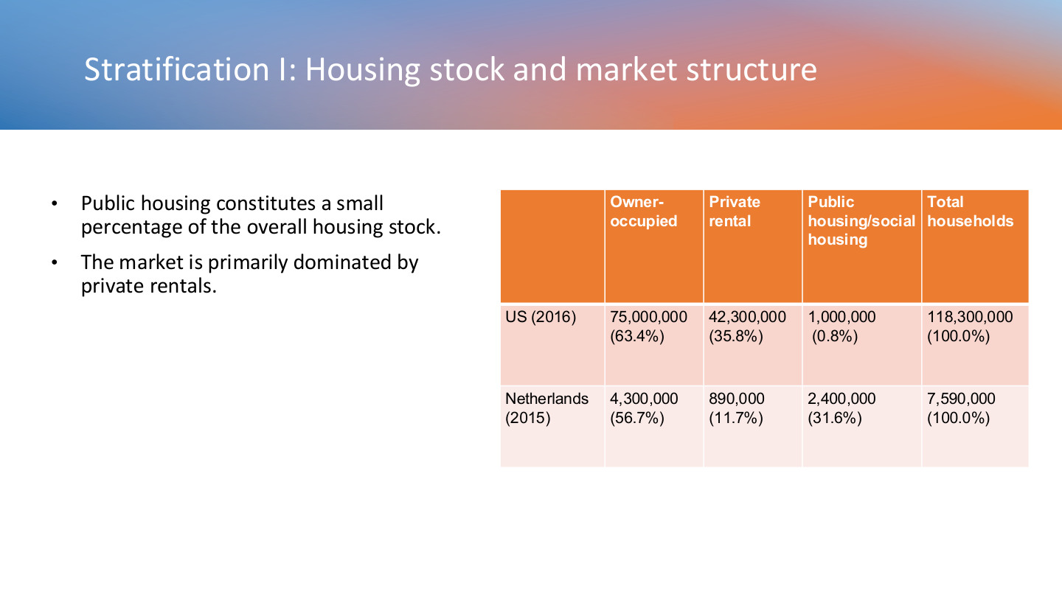
原PPT第16页 / Original slide 16 · 重点 / Focus

PPT中英翻译 / PPT translation
PPT English / 英文原文与图示 | 中文翻译 / Chinese translation
Public housing constitutes a small percentage of the overall housing stock. | 公共住房只占整体住房存量的一小部分。
The market is primarily dominated by private rentals. | 原文：该市场主要由私人租赁主导。【应结合下表区分租赁市场与全部住房。】

原表中英转写 / Bilingual transcription of the table
地区 / Area | 自住 / Owner-occupied | 私人租赁 / Private rental | 公屋／社会住房 / Public/social housing | 总住户 / Total households
US 美国 (2016) | 75,000,000 (63.4%) | 42,300,000 (35.8%) | 1,000,000 (0.8%) | 118,300,000 (100.0%)
Netherlands 荷兰 (2015) | 4,300,000 (56.7%) | 890,000 (11.7%) | 2,400,000 (31.6%) | 7,590,000 (100.0%)

本页核心 / Key takeaway
按课件历史数据，美国公屋占0.8%，荷兰社会住房占31.6%；比较的是供给结构，而非两国贫困率。
In the historical table, US public housing accounts for 0.8% and Dutch social housing for 31.6%; these compare provision structures, not poverty rates.

精要解析 / Essential explanation

1. 先看分母 / Identify the denominator
美国2016年自住占63.4%，因此不能说全部住房以私人租赁为主。私人租赁主导的是其租赁部分；这正是把租赁市场和总体住房存量分开的必要性。
US owner-occupation is 63.4% in 2016, so private renting does not dominate all housing. Private renting dominates its rental sector; separate rental-market composition from the overall housing stock.

2. 大存量意味着什么 / What a large social stock means
荷兰更大的社会租赁存量，为公共目标提供较广的制度基础。它本身不证明荷兰贫困人口更多，也不等于所有房屋都由政府部门直接持有。
A larger Dutch social-rental stock provides a broader institutional base for housing goals. It does not itself show more poverty or imply direct government ownership of every dwelling.

3. 单位与时间 / Units and timing
表中数量是住户／住房存量统计，前页160万是人数；美国为2016年，荷兰为2015年。复习时记住结构差异，引用数字时附上年份与单位。
The table concerns households or housing stock, whereas 1.6 million on earlier slides refers to people. The US figures are for 2016 and Dutch figures for 2015; retain dates and units when quoting numbers.

17｜住房券：以货币支持替代直接供房 / Vouchers instead of housing stock
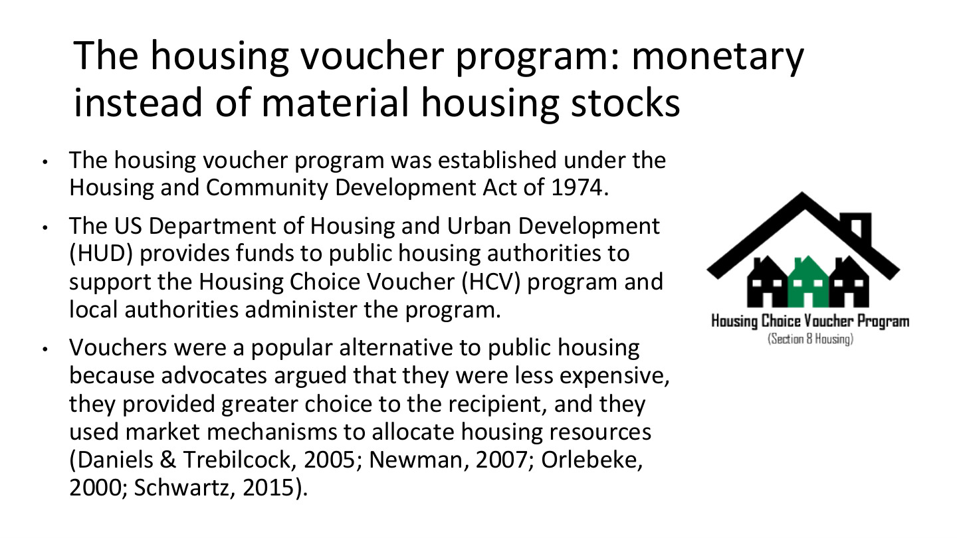
原PPT第17页 / Original slide 17 · 理解 / Understand

PPT中英翻译 / PPT translation
PPT English / 英文原文与图示 | 中文翻译 / Chinese translation
The housing voucher program was established under the Housing and Community Development Act of 1974. | 住房券项目的立法起点被追溯至1974年《住房与社区发展法》。
The US Department of Housing and Urban Development (HUD) provides funds to public housing authorities to support the Housing Choice Voucher (HCV) program and local authorities administer the program. | 美国住房与城市发展部（HUD）向公共住房机构拨款，支持住房选择券（HCV）项目，由地方机构执行。
Vouchers were a popular alternative to public housing because advocates argued that they were less expensive, they provided greater choice to the recipient, and they used market mechanisms to allocate housing resources (Daniels & Trebilcock, 2005; Newman, 2007; Orlebeke, 2000; Schwartz, 2015). | 支持者认为住房券成本较低、可给予接受者更多选择，并利用市场机制配置住房资源，因此它成为直接公共住房的热门替代方案（相关文献见原页）。
Housing Choice Voucher Program — Housing with choice. | 住房选择券项目——具有选择空间的住房。

本页核心 / Key takeaway
住房券用需求端租金援助帮助家庭进入私人租赁市场，由HUD出资、地方机构执行。
Vouchers use demand-side rental assistance to support access to private rentals, with HUD funding and local administration.

精要解析 / Essential explanation

1. 工具改变了什么 / What the instrument changes
直接公屋主要提供特定房源；住房券主要提高符合条件家庭的支付能力。资金补助不自动增加可租房源，因此其效果还受私人市场供给和房东参与影响。
Public housing supplies designated units, while vouchers support eligible households’ ability to pay. Financial assistance does not automatically add available homes, so outcomes also depend on private supply and landlord participation.

2. 支持理由与实际效果 / Arguments and outcomes
成本较低、选择更多是倡导者提出的理由，不能当作每个地区都已实现的效果。后页的轮候与房东限制，正好用于检验这些主张。
Lower costs and greater choice are advocates’ arguments, not established outcomes in every locality. Waiting lists and landlord constraints on subsequent slides help assess those claims.

18｜住房券怎样运行？ / How vouchers operate
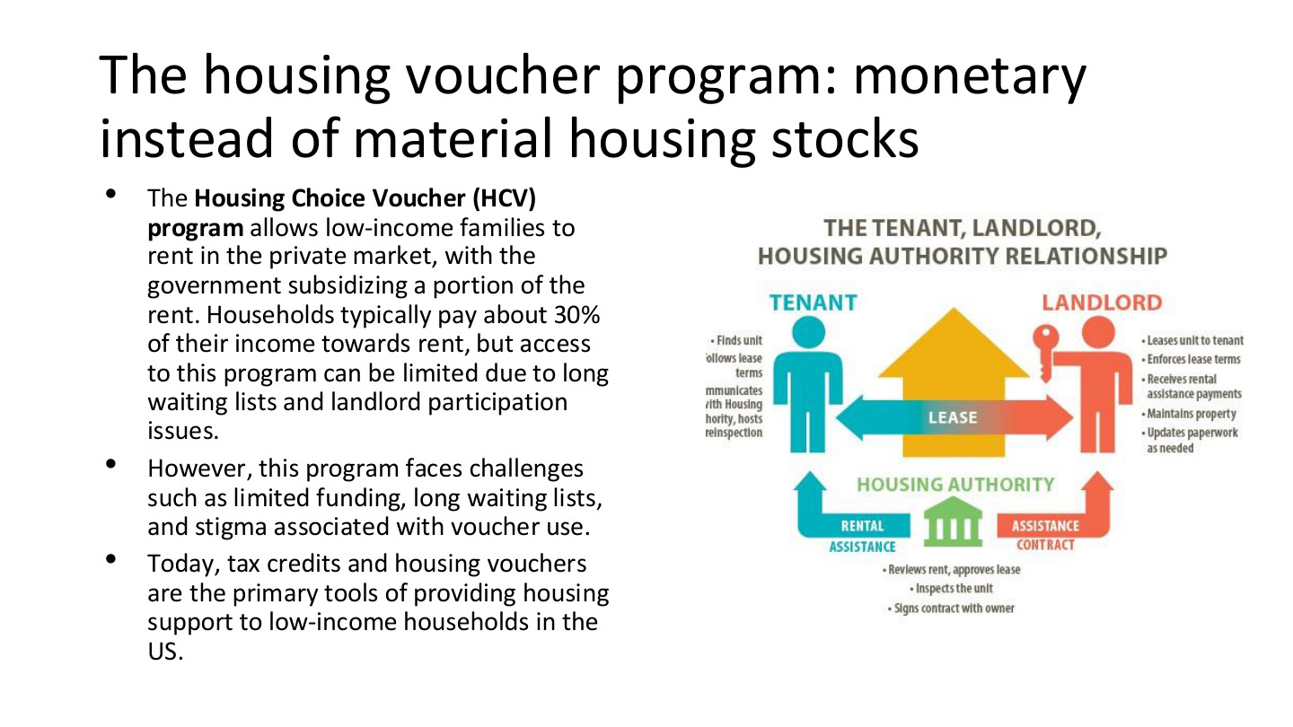
原PPT第18页 / Original slide 18 · 重点 / Focus

PPT中英翻译 / PPT translation
PPT English / 英文原文与图示 | 中文翻译 / Chinese translation
The Housing Choice Voucher (HCV) program allows low-income families to rent in the private market, with the government subsidizing a portion of the rent. Households typically pay about 30% of their income towards rent, but access to this program can be limited due to long waiting lists and landlord participation issues. | 住房选择券使低收入家庭在私人市场租房，由政府补贴部分租金。家庭通常以约30%的收入支付租金，但长期轮候和房东参与不足可能限制获得援助。
However, this program faces challenges such as limited funding, long waiting lists, and stigma associated with voucher use. | 项目面临资金有限、轮候时间长，以及使用住房券所伴随的污名等挑战。
Today, tax credits and housing vouchers are the primary tools of providing housing support to low-income households in the US. | 按课件概括，税收抵免与住房券是美国支持低收入住户的主要工具。
The tenant, landlord, housing authority relationship: Tenant; Landlord; Housing Authority; Lease; Rental Assistance; Assistance Contract. | 图示：租户—房东—住房机构关系。标签：租户；房东；住房机构；租约；租金援助；援助合同。
Tenant: finds unit; follows lease terms; communicates with Housing Authority; hosts reinspection. | 租户：寻找房源、遵守租约、与住房机构沟通，并配合复查。
Landlord: leases unit to tenant; enforces lease terms; receives rental assistance payments; maintains property; updates paperwork as needed. | 房东：出租住房、执行租约、接受租金援助付款、维护物业，并按需要更新文件。
Housing Authority: reviews rent, approves lease; inspects the unit; signs contract with owner. | 住房机构：审查租金并批准租约，检查房屋，与业主签订合同。

本页核心 / Key takeaway
住房券补贴租金，不是政府直接分配一套房；选择能否兑现，取决于房源、房东与项目资金。
A voucher subsidises rent rather than directly allocating a government unit; effective choice depends on housing supply, landlords and programme funding.

精要解析 / Essential explanation

1. 三方分工 / Three-party roles
租户寻找住房并履行租约，房东提供和维护住房，住房机构管理资格、租金与补贴合同。国家通过资助和规制参与供给，即使具体房屋由私人持有。
Tenants seek units and meet lease obligations; landlords supply and maintain them; housing authorities manage eligibility, rents and assistance contracts. Public finance and regulation operate alongside private property ownership.

2. 30%意味着什么 / Interpreting the 30% figure
约30%是住户承担租金的概括，不是政府补贴租金30%，也不能推成所有家庭固定支付同一金额。具体支付规则还取决于项目计算和所选住房。
About 30% summarises the household’s rent contribution, not a government subsidy of 30% of rent or a fixed cash payment for everyone. Actual payments depend on programme calculations and the selected home.

3. 名义选择与实际选择 / Formal and effective choice
即使拿到券，若可负担房源少或房东不参与，可选择范围仍很有限。分析住房券时，把政策承诺的选择与住户真正能租到的住房分开。
Even with a voucher, scarce affordable units or unwilling landlords can limit options. Distinguish the programme’s promise of choice from the homes recipients can actually rent.

19｜住房券资格与定向分配 / Voucher eligibility and targeting
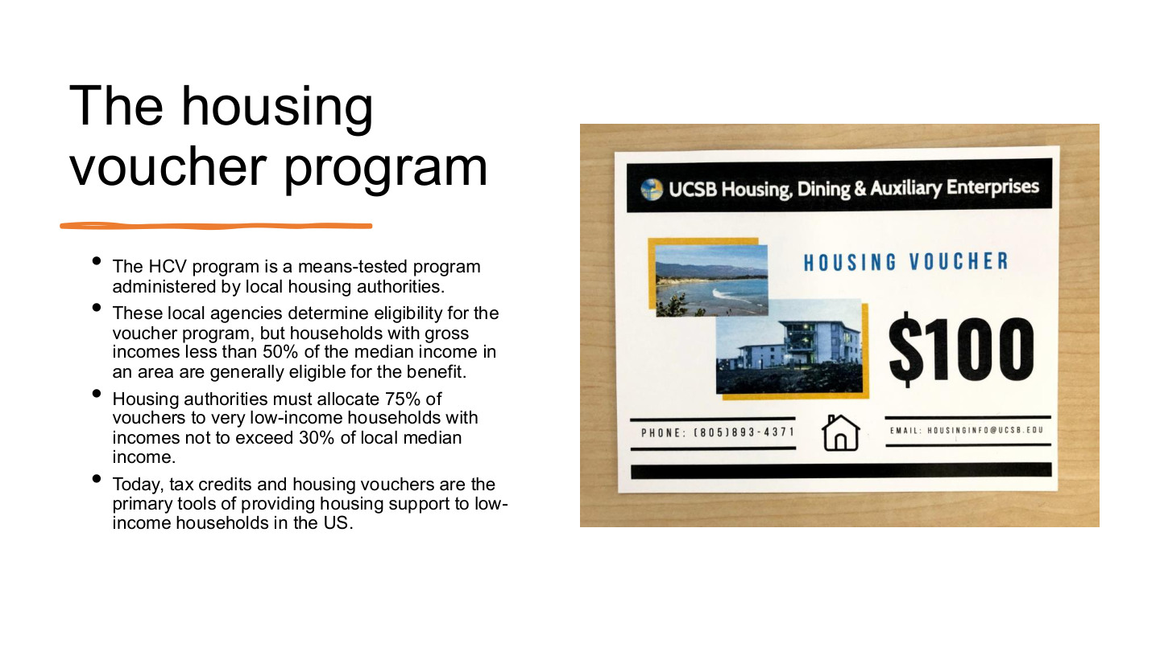
原PPT第19页 / Original slide 19 · 重点 / Focus

PPT中英翻译 / PPT translation
PPT English / 英文原文与图示 | 中文翻译 / Chinese translation
The HCV program is a means-tested program administered by local housing authorities. | HCV是由地方住房机构管理、经过经济状况审查的项目。
These local agencies determine eligibility for the voucher program, but households with gross incomes less than 50% of the median income in an area are generally eligible for the benefit. | 地方机构确定资格；一般而言，税前总收入低于当地收入中位数50%的住户符合收入条件。
Housing authorities must allocate 75% of vouchers to very low-income households with incomes not to exceed 30% of local median income. | 原文规定，75%的住房券须分配给收入不超过当地收入中位数30%的家庭；此处very low-income的术语使用见下方辨析。
Today, tax credits and housing vouchers are the primary tools of providing housing support to low-income households in the US. | 课件再次概括：税收抵免和住房券是美国低收入住房支持的主要工具。
Illustration: Housing Voucher — $100 (UCSB Housing, Dining & Auxiliary Enterprises). | 插图：标有100美元的住房券示意图（UCSB住房、餐饮及辅助服务部门）。这不是HCV统一补贴金额。

本页核心 / Key takeaway
分清50%的一般收入资格与75%券优先给≤30%收入群体：一项筛资格，一项规定分配比例。
Distinguish the general 50% income limit from targeting 75% of vouchers to households at or below 30%: eligibility and allocation are different rules.

精要解析 / Essential explanation

1. 三个数字怎样记 / Remembering the three numbers
50%和30%的分母都是当地收入中位数；75%的分母是分配的住房券／新受助家庭。75%不是每户租金补贴比例，也不是收入门槛。
The 50% and 30% figures reference local median income, while 75% concerns voucher allocation or newly assisted households. 75% is not each household’s rent subsidy rate or an income threshold.

2. 为什么还要定向分配 / Why targeting matters
一般资格范围内可能有很多家庭；优先比例进一步把援助集中给收入更低者。它回应有限资源怎样分配，也说明“符合资格”与“获助优先次序”不是同一问题。
Many households can fall within general eligibility. A priority share concentrates assistance on those with lower incomes, showing how scarce resources are allocated and distinguishing eligibility from priority.

3. 术语与口径 / Terminology and definitions
通常very low-income对应50%，而≤30%群体常称extremely low-income。原页混用了称谓；复习时以明确的百分比和规则功能区分，并保留地区与家庭规模口径。
Very low-income commonly refers to the 50% limit, while the group at or below 30% is commonly termed extremely low-income. The slide mixes the labels; distinguish the explicit thresholds and functions, alongside locality and household size.

20｜HAP合同与居住稳定 / HAP contracts and housing security
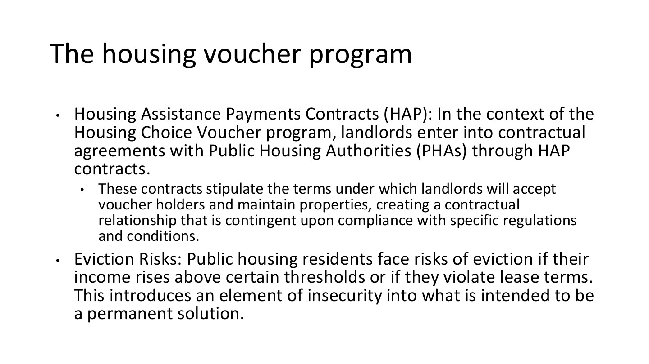
原PPT第20页 / Original slide 20 · 重点 / Focus

PPT中英翻译 / PPT translation
PPT English / 英文原文与图示 | 中文翻译 / Chinese translation
Housing Assistance Payments Contracts (HAP): In the context of the Housing Choice Voucher program, landlords enter into contractual agreements with Public Housing Authorities (PHAs) through HAP contracts. | 住房援助付款合同（HAP）：在HCV项目中，房东通过HAP合同与公共住房机构（PHA）建立契约安排。
These contracts stipulate the terms under which landlords will accept voucher holders and maintain properties, creating a contractual relationship that is contingent upon compliance with specific regulations and conditions. | 合同规定房东接纳券持有人和维护房屋的条件；这种契约关系以遵守具体规则与条件为前提。
Eviction Risks: Public housing residents face risks of eviction if their income rises above certain thresholds or if they violate lease terms. This introduces an element of insecurity into what is intended to be a permanent solution. | 原文：住户收入超过某些门槛或违反租约时，会面临驱逐风险；这给原本旨在长期解决住房问题的安排带来不稳定性。【该概括须结合下方辨析理解。】

本页核心 / Key takeaway
记住租户—房东的租约与住房机构—房东的HAP合同是两种关系；援助具有规则和条件。
Distinguish the tenant–landlord lease from the housing authority–landlord HAP contract; assistance operates through rules and conditions.

精要解析 / Essential explanation

1. 两份关系怎样连接 / How the relationships connect
租约规定住户的居住与付款责任；HAP规定机构对房东的援助付款安排。三方协作并不意味着租客、房东和国家都只签同一份合同。
The lease governs the resident’s occupation and obligations; HAP governs assistance payments between authority and landlord. Three-party cooperation does not mean all parties sign a single identical contract.

2. 合同也是公共规制工具 / Contracts as public regulation
住房虽然由私人房东提供，但补贴附带维护、合规和项目要求。私人供房不等于政府完全退出；国家可通过资金和合同影响房东行为。
Private landlords supply the dwelling, but assistance carries maintenance and compliance requirements. Private provision does not mean complete state withdrawal; public finance and contracts can shape landlord behaviour.

3. 怎样判断稳定性 / Assessing security
应分别问补贴能否持续、租约能否维持，以及失去一套住房后是否还有替代保障。只有看到这些具体条件，才能把契约安排与去商品化程度连接起来。
Ask separately whether assistance continues, the lease is sustained and alternative protection exists after losing a unit. These concrete conditions connect contractual arrangements to decommodification.

易错辨析 / Key distinction
收入增加可能改变补贴或资格，不等于自动、立即被房东驱逐；公共住房与HCV的具体规则也不能混同。
Rising income can alter assistance or eligibility; it does not itself mean automatic immediate eviction by a landlord. Public-housing and HCV rules must also be distinguished.

21｜混合融资模式 / Mixed finance
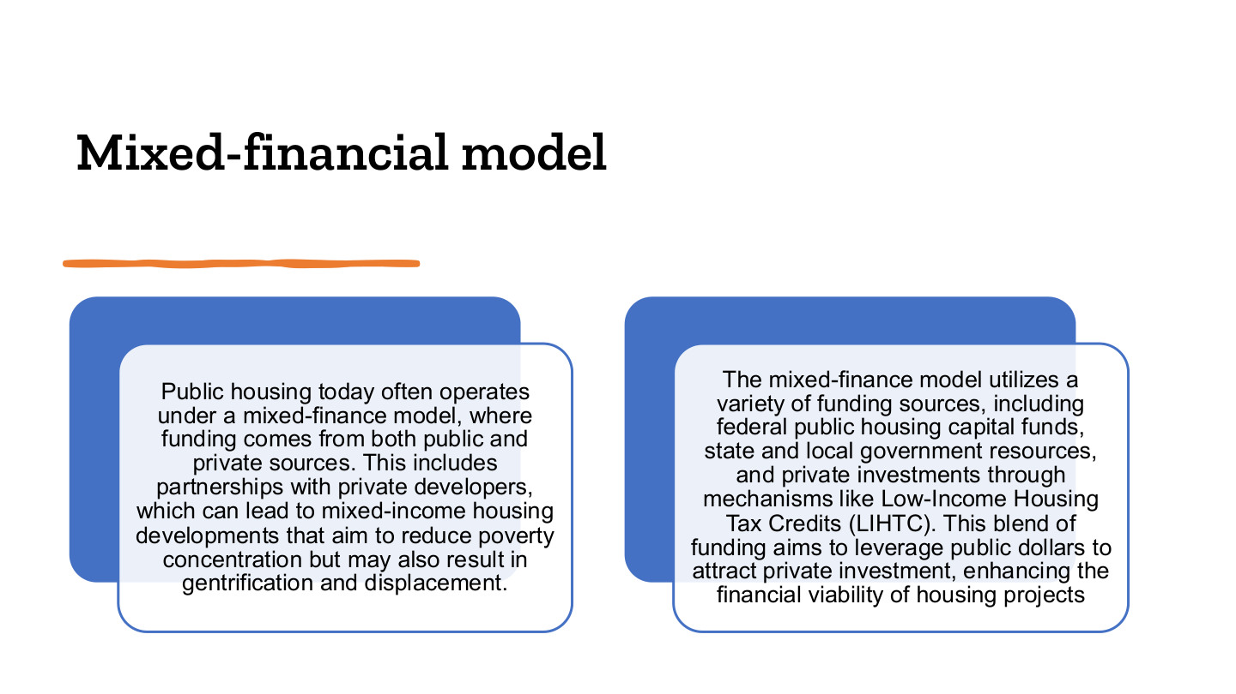
原PPT第21页 / Original slide 21 · 重点 / Focus

PPT中英翻译 / PPT translation
PPT English / 英文原文与图示 | 中文翻译 / Chinese translation
Public housing today often operates under a mixed-finance model, where funding comes from both public and private sources. This includes partnerships with private developers, which can lead to mixed-income housing developments that aim to reduce poverty concentration but may also result in gentrification and displacement. | 当代公共住房常采用公私资金共同参与的混合融资模式，包括与私人开发商合作，建设旨在降低贫困集中的混合收入社区，但也可能带来绅士化与居民迁离。
The mixed-finance model utilizes a variety of funding sources, including federal public housing capital funds, state and local government resources, and private investments through mechanisms like Low-Income Housing Tax Credits (LIHTC). This blend of funding aims to leverage public dollars to attract private investment, enhancing the financial viability of housing projects. | 混合融资使用联邦公共住房资本资金、州及地方资源，以及通过低收入住房税收抵免（LIHTC）等机制吸引的私人投资；目的是以公共资金撬动私人投入，提高项目的财务可行性。

本页核心 / Key takeaway
混合融资用公共资源撬动私人资本；项目财务可行与原居民居住保障是两个需要分别检验的结果。
Mixed finance uses public resources to leverage private capital; financial viability and existing residents’ security are distinct outcomes to assess.

精要解析 / Essential explanation

1. 资金为什么要混合 / Why combine finance?
建设和更新需要大量资本，公共投入可与私人贷款、股权等拼合，使项目能够落地。但不同资金有不同回报要求，社会目标必须在具体安排中落实。
Construction and redevelopment require substantial capital. Public resources can combine with loans and equity to make projects viable, but different funders expect different returns, so social goals require explicit institutional arrangements.

2. 收入混合不等于居民回归 / Mixed income does not ensure return
引入市场价住房可能改变社区的收入构成。社区平均收入提高，不证明原住户处境改善；还需看可负担单位是否保留、资格怎样改变，以及原住户能否返回。
Adding market-rate units can alter a neighbourhood’s income profile. Higher average income does not prove improvement for original residents; examine retained affordable units, eligibility and residents’ ability to return.

3. 两个社会后果 / Two possible social consequences
绅士化指地区的社会经济升级及人口结构变化；迁离指具体住户被迫或难以继续居住。两者相关，但分析时应分别写清地区变化与人的去向。
Gentrification concerns socioeconomic upgrading and population change; displacement concerns residents being forced or unable to remain. They are related, but distinguish neighbourhood change from the fate of particular households.

22｜混合融资的资金工具 / Mixed-finance resources
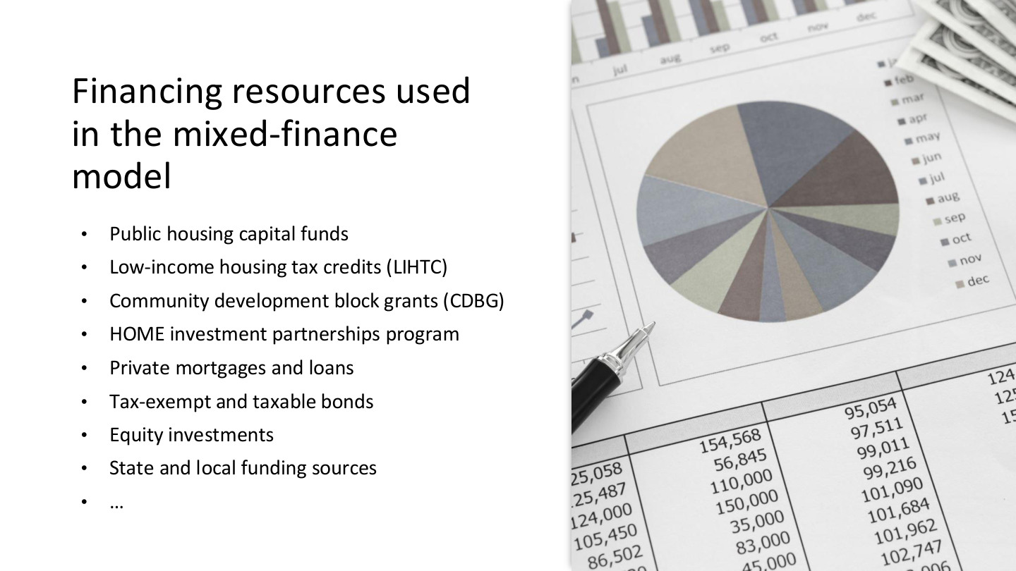
原PPT第22页 / Original slide 22 · 理解 / Understand

PPT中英翻译 / PPT translation
PPT English / 英文原文与图示 | 中文翻译 / Chinese translation
Public housing capital funds | 公共住房资本资金。
Low-income housing tax credits (LIHTC) | 低收入住房税收抵免（LIHTC）。
Community development block grants (CDBG) | 社区发展整笔拨款（CDBG）。
HOME investment partnerships program | HOME投资伙伴计划。
Private mortgages and loans | 私人抵押融资和贷款。
Tax-exempt and taxable bonds | 免税及应税债券。
Equity investments; State and local funding sources; … | 股权投资；州与地方资金；等等。

本页核心 / Key takeaway
抓住公共拨款、税收激励、债务、股权四类来源即可，不必逐项扩展金融细节。
Group the sources into public grants, tax incentives, debt and equity, without expanding every financial instrument.

精要解析 / Essential explanation

1. LIHTC属于哪一端 / Which side does LIHTC support?
LIHTC通过税收抵免吸引资金投入可负担住房项目，主要支持开发和供给；HCV则支持住户租赁支付。Word把两者一起归为需求端，复习时应更正这一分类。
LIHTC uses tax credits to attract investment into affordable housing projects, primarily supporting development and supply; HCV supports rental payments. Correct the Word summary’s grouping of both as demand-side instruments.

2. 钱有不同性质 / Different forms of finance
拨款一般不要求按贷款方式偿还；债务有还本付息安排；股权投资涉及投资回报。这里要理解资金组合怎样支持建设，而不是把所有来源都当成直接发给租户的福利。
Grants differ from repayable debt, while equity involves investment returns. Understand how financing supports construction rather than treating every source as a cash benefit paid directly to tenants.

23｜公私合作 / Public–private partnership
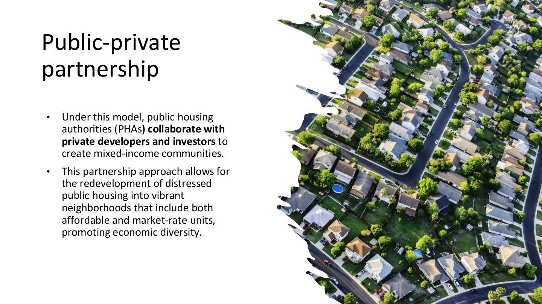
原PPT第23页 / Original slide 23 · 理解 / Understand

PPT中英翻译 / PPT translation
PPT English / 英文原文与图示 | 中文翻译 / Chinese translation
Under this model, public housing authorities (PHAs) collaborate with private developers and investors to create mixed-income communities. | 公共住房机构（PHA）与私人开发商及投资者合作，建设混合收入社区。
This partnership approach allows for the redevelopment of distressed public housing into vibrant neighborhoods that include both affordable and market-rate units, promoting economic diversity. | 合作使衰败公共住房能够更新为同时包含可负担和市场价住房的社区，以促进收入和经济构成的多样性。

本页核心 / Key takeaway
PPP强调公共住房机构与私人开发、投资主体合作；“谁合作”与“资金怎样组合”相关但不相同。
PPP emphasises cooperation between housing authorities and private developers or investors; partners and financing structures are related but distinct.

精要解析 / Essential explanation

1. 与混合融资的关系 / Relation to mixed finance
混合融资回答资金来自哪里，PPP回答由哪些主体协作。一个项目可以同时具有两种特点，但不能把“有私人资金”当作所有公共责任都已转给私人。
Mixed finance concerns funding sources; PPP concerns cooperating actors. A project can have both characteristics, without private investment necessarily transferring every public responsibility to private actors.

2. 评价合作的重点 / Evaluating the partnership
看可负担房源、分配规则与住户回归，而不只看项目外观或投资规模。将本页作为第21页的组织补充即可，避免重复背同一套优缺点。
Examine affordable units, allocation rules and residents’ return, alongside appearance and investment volumes. Treat this as the organisational counterpart to slide 21 rather than a separate list of identical advantages and risks.

24｜美国监管的碎片化 / Fragmented regulation
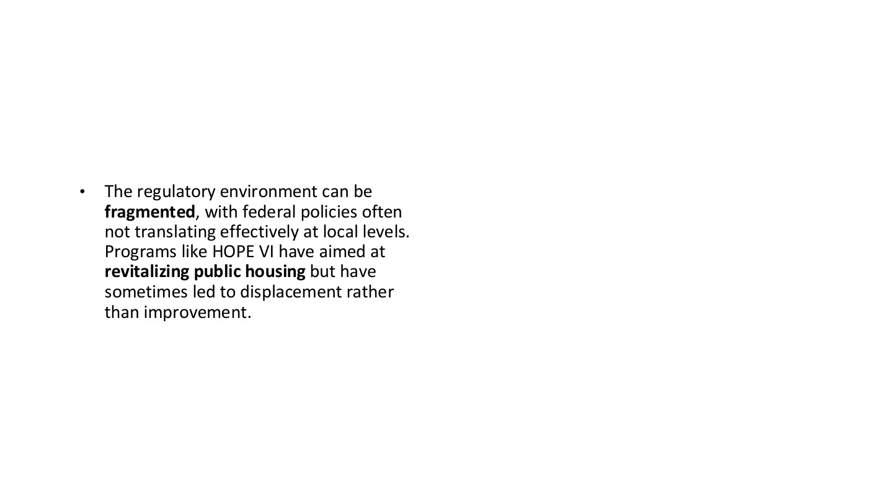
原PPT第24页 / Original slide 24 · 理解 / Understand

PPT中英翻译 / PPT translation
PPT English / 英文原文与图示 | 中文翻译 / Chinese translation
The regulatory environment can be fragmented, with federal policies often not translating effectively at local levels. Programs like HOPE VI have aimed at revitalizing public housing but have sometimes led to displacement rather than improvement. | 监管环境可能碎片化，联邦政策未必在地方有效落实。HOPE VI等项目试图振兴公共住房，但有时造成居民迁离，而非改善其处境。

本页核心 / Key takeaway
碎片化指跨层级政策与执行衔接存在问题，不等于完全没有监管。
Fragmentation concerns problems linking policy and implementation across levels, not an absence of regulation.

精要解析 / Essential explanation

1. 为什么地方执行重要 / Why local implementation matters
联邦制定框架和提供资金，地方机构负责执行及许多具体选择。目标到结果之间需要跨机构协调，因此同一个政策名称在不同地区可能产生不同体验。
Federal frameworks and finance interact with local administration and practical decisions. Coordination across institutions is necessary, so a programme bearing the same name can produce different local experiences.

2. 振兴了谁的生活 / Whose lives are improved?
更新可改善建筑，却让部分原住户失去进入新住房的机会。评价结果须追踪原居民，不能只把新建成的社区与原来的衰败建筑相比。
Redevelopment can improve buildings while excluding some former residents. Evaluation must follow original residents, rather than comparing only a new neighbourhood with its distressed physical predecessor.

25｜HOPE VI更新计划 / HOPE VI redevelopment
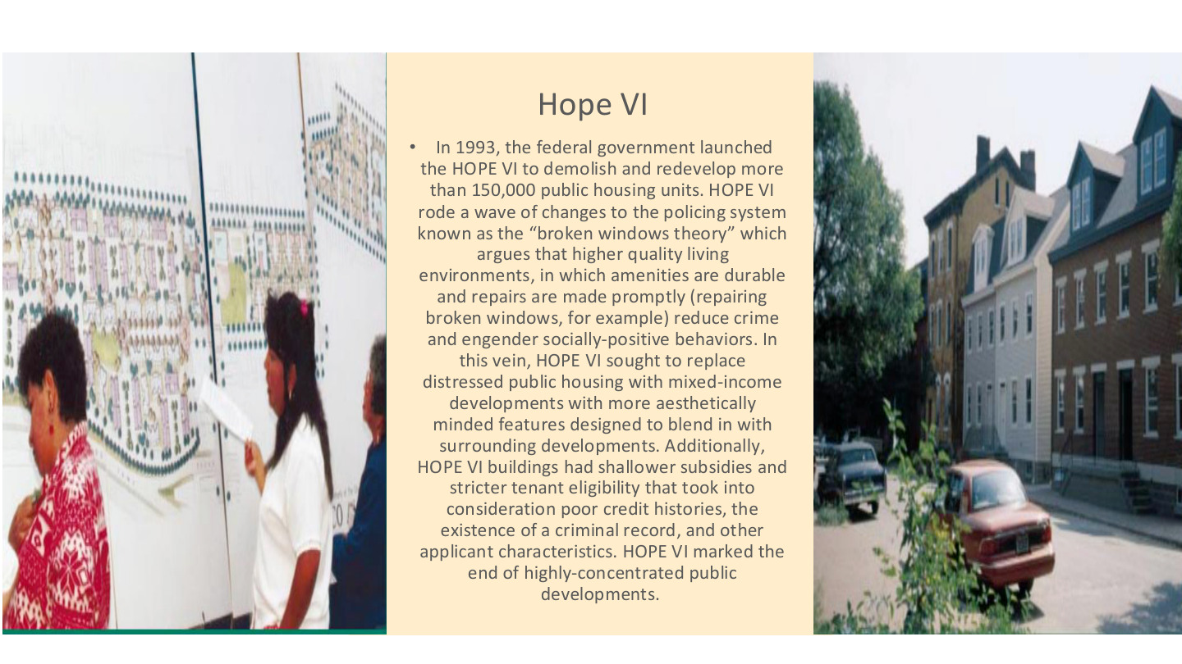
原PPT第25页 / Original slide 25 · 重点 / Focus

PPT中英翻译 / PPT translation
PPT English / 英文原文与图示 | 中文翻译 / Chinese translation
In 1993, the federal government launched the HOPE VI to demolish and redevelop more than 150,000 public housing units. | 1993年联邦政府启动HOPE VI；课件以拆除和更新超过15万套公共住房来概括其规模。
HOPE VI rode a wave of changes to the policing system known as the “broken windows theory” which argues that higher quality living environments, in which amenities are durable and repairs are made promptly (repairing broken windows, for example) reduce crime and engender socially-positive behaviors. | 该计划与“破窗理论”影响下的治理变化相联系。该理论认为，更优质的居住环境、耐用设施和及时维修（例如修复破窗）能够减少犯罪并促进积极社会行为。
In this vein, HOPE VI sought to replace distressed public housing with mixed-income developments with more aesthetically minded features designed to blend in with surrounding developments. | 因此，HOPE VI试图以外观更讲究、融入周边街区的混合收入项目，替代衰败公共住房。
Additionally, HOPE VI buildings had shallower subsidies and stricter tenant eligibility that took into consideration poor credit histories, the existence of a criminal record, and other applicant characteristics. | 同时，新项目补贴深度较浅，租客资格更严格，审查不良信用、犯罪记录及其他申请者特征。
HOPE VI marked the end of highly-concentrated public developments. | 原文把HOPE VI描述为高度集中式公共住房开发时代终结的标志。

本页核心 / Key takeaway
HOPE VI的关键张力：物理环境改善不等于原居民住房保障改善，更新可能同时提高进入门槛。
The central tension is that physical improvement does not establish better housing security for original residents; redevelopment can also raise entry barriers.

精要解析 / Essential explanation

1. 政策的因果设想 / The proposed causal chain
课件把“改善环境→改善行为和安全”作为项目论证之一。应把它理解为政策的因果设想，而不是已经证明所有物理改造都会减少犯罪的定律。
The slide presents better environments leading to improved behaviour and safety as one justification. Treat it as a proposed policy mechanism, not a demonstrated law that every physical intervention reduces crime.

2. 供给结构怎样变化 / How the housing mix changes
混合收入建设引入不同价位房源，试图打散贫困集中。拆掉多少套不等于建回同量、同样可负担的住房；需要另看重建单位的价格与用途。
Mixed-income construction introduces different price levels to reduce concentrated poverty. Units demolished are not equivalent to equally numerous, equally affordable replacements; examine replacement prices and uses separately.

3. 住户筛选为何关键 / Why screening matters
较浅补贴和更严格的信用、犯罪记录等审查，可能使部分原住户无法进入新项目。环境品质与低收入可进入性因此可能向不同方向变化。
Shallower subsidies and stricter credit or criminal-record screening can prevent some former residents from entering rebuilt projects. Physical quality and low-income accessibility may therefore move in different directions.

4. 怎样评价成效 / Assessing outcomes
同时看建筑维护、可负担单位、原居民回归与迁离后的居住处境。评价对象应是住房和居民两者，不能只依据新社区平均收入或外观作结论。
Assess maintenance, affordable units, residents’ return and conditions after relocation. Evaluate both dwellings and people, rather than judging success only by neighbourhood appearance or average income.

26｜被驱逐：住房为何是基础 / Evicted
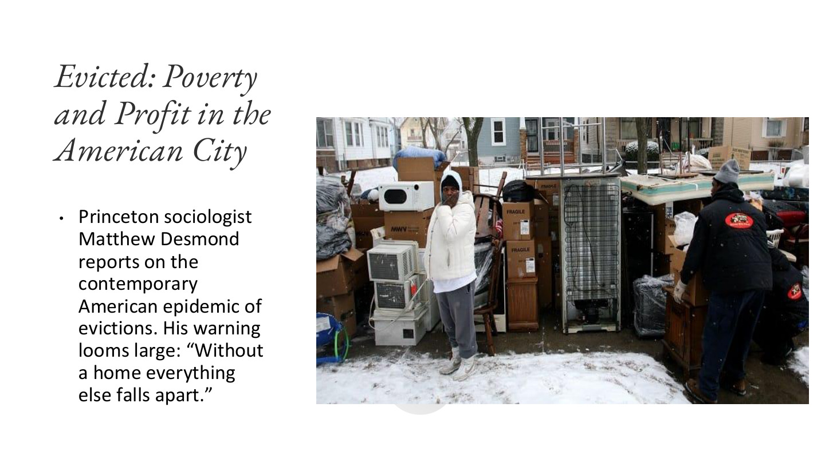
原PPT第26页 / Original slide 26 · 简读 / Brief

PPT中英翻译 / PPT translation
PPT English / 英文原文与图示 | 中文翻译 / Chinese translation
Evicted: Poverty and Profit in the American City | 《被驱逐：美国城市的贫困与利润》。
Princeton sociologist Matthew Desmond reports on the contemporary American epidemic of evictions. His warning looms large: “Without a home everything else falls apart.” | 普林斯顿社会学家马修·德斯蒙德研究美国广泛发生的驱逐现象，并警告：“没有住所，其他一切都会分崩离析。”

本页核心 / Key takeaway
本页只抓一句：住房不稳定会连带影响其他生活领域，住房政策不能只统计建筑数量。
Remember one point: housing insecurity disrupts other areas of life, so housing policy must examine more than building counts.

精要解析 / Essential explanation

1. 与本课连接 / Link to the lesson
稳定住所关系到就业、上学和家庭生活能否持续。这一案例补充第25页：即使更新了住房，也要追问被迁离者后续能否维持稳定生活，不必扩展整本书内容。
A stable home supports continuity in work, schooling and family life. The case extends slide 25 by asking whether displaced residents can maintain stable lives; a full summary of the book is unnecessary here.

27｜美国公共住房污名 / US public-housing stigma
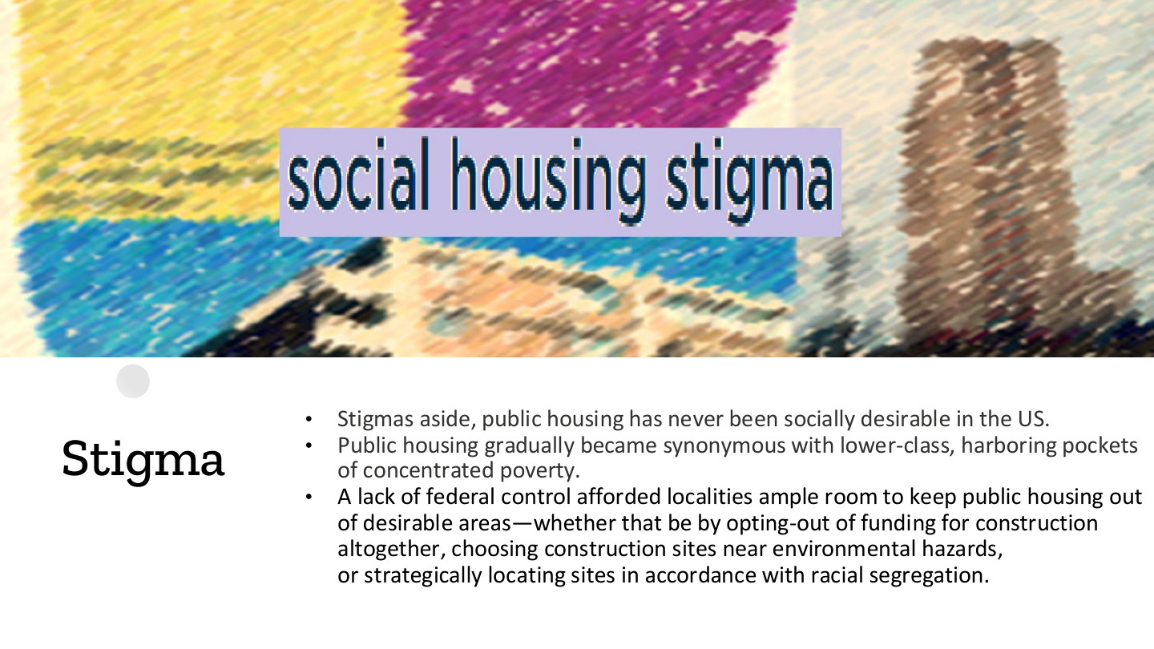
原PPT第27页 / Original slide 27 · 重点 / Focus

PPT中英翻译 / PPT translation
PPT English / 英文原文与图示 | 中文翻译 / Chinese translation
Stigmas aside, public housing has never been socially desirable in the US. | 即便撇开污名，美国公共住房也从未成为社会上普遍向往的住房选择（原文概括）。
Public housing gradually became synonymous with lower-class, harboring pockets of concentrated poverty. | 公共住房逐渐与底层身份和集中贫困地区联系起来。
A lack of federal control afforded localities ample room to keep public housing out of desirable areas—whether that be by opting-out of funding for construction altogether, choosing construction sites near environmental hazards, or strategically locating sites in accordance with racial segregation. | 联邦控制不足，给地方较大空间将公共住房排除在理想区位之外，例如拒绝建设资金、把项目放在环境风险附近，或按种族隔离格局选择区位。

本页核心 / Key takeaway
污名不只是个人偏见；安全网定位、住房品质、区位与隔离共同塑造社会评价。
Stigma is more than individual prejudice: safety-net positioning, quality, location and segregation shape social perceptions.

精要解析 / Essential explanation

1. 空间安排怎样产生分层 / How location stratifies
若公共住房远离优质资源或位于不利环境，住户获得教育、就业和其他服务的条件可能受限。住房分层因此不仅是房屋大小，还涉及区位与机会。
Exclusion from desirable locations or exposure to hazards can constrain access to education, employment and services. Housing stratification concerns location and opportunity as well as dwelling size.

2. 污名怎样被强化 / How stigma is reinforced
集中贫困和较低品质容易被归因于住户本身，掩盖背后的政策选择。制度造成的不利条件可能被误读为居民特征，继而削弱公众支持并限制改善空间。
Concentrated poverty and poor conditions can be attributed to residents while institutional choices disappear from view. Institutional disadvantages may be misread as residents’ traits, weakening support and limiting improvement.

3. 比较时看哪些机制 / What to compare
与荷兰对照时，观察供给是否常态化、建筑标准是否接近私人住房，以及受益者是否广泛。这样能解释污名差异，而不只是评价两国公众态度。
Compare normalisation of provision, standards relative to private housing and breadth of beneficiaries with the Dutch case. These mechanisms explain stigma more effectively than descriptions of national attitudes alone.

28｜荷兰案例 / The Netherlands

原PPT第28页 / Original slide 28 · 简读 / Brief

PPT中英翻译 / PPT translation
PPT English / 英文原文与图示 | 中文翻译 / Chinese translation
IV. The Netherlands | 第四部分：荷兰。
Everyone Deserves Affordable Homes. | 每个人都应享有可负担的住所。

本页核心 / Key takeaway
转向荷兰：重点看社会权利理念、非营利住房协会与受监管的租赁体系。
The Dutch case centres on social rights, nonprofit housing associations and a regulated rental system.

29｜荷兰的住房责任 / Dutch housing responsibility
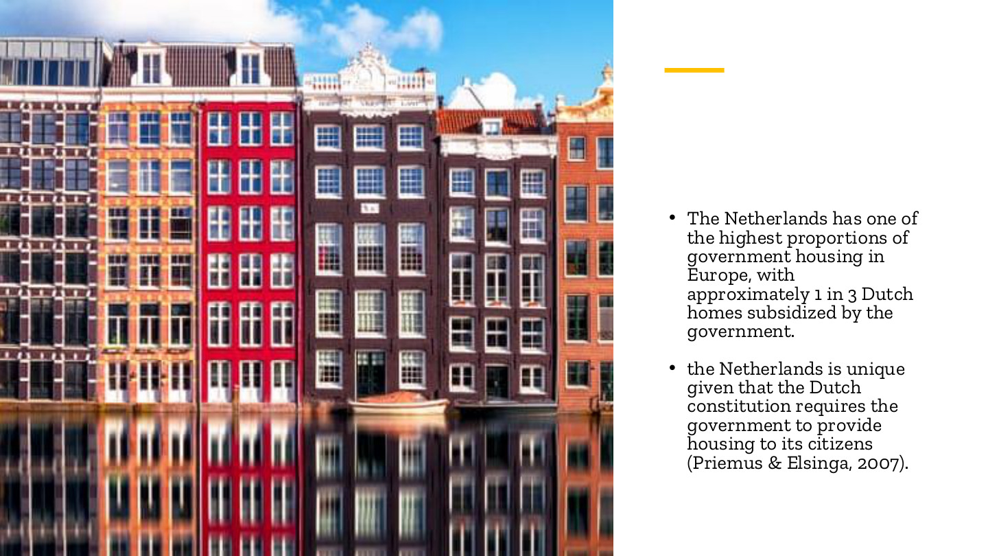
原PPT第29页 / Original slide 29 · 理解 / Understand

PPT中英翻译 / PPT translation
PPT English / 英文原文与图示 | 中文翻译 / Chinese translation
The Netherlands has one of the highest proportions of government housing in Europe, with approximately 1 in 3 Dutch homes subsidized by the government. | 荷兰是欧洲政府支持住房占比较高的国家之一；课件称约三分之一住宅得到政府支持。
The Netherlands is unique given that the Dutch constitution requires the government to provide housing to its citizens (Priemus & Elsinga, 2007). | 课件强调荷兰宪法赋予政府保障公民住房的责任（Priemus与Elsinga，2007）。

本页核心 / Key takeaway
荷兰强调公共部门对充足住房的责任；公共支持不必表现为政府部门直接拥有每套房屋。
The Dutch approach stresses public responsibility for adequate housing; support need not take the form of direct government ownership of every unit.

精要解析 / Essential explanation

1. “政府住房”怎样理解 / Interpreting government housing
本页用语较宽，后面会显示主要供给者是受监管的民间非营利住房协会。受到公共支持与属于政府所有是两回事，不能只按government housing逐字理解产权。
The slide uses broad terminology; later pages identify regulated private nonprofit associations as major providers. Public support and government ownership are distinct, so do not infer legal ownership from the phrase government housing.

2. 公共责任的边界 / Limits of the claim
保障住房的公共职责不等于每位公民都能无条件获得一套免费公房。实际入住仍有分配和收入规则；应把基本理念与具体可主张的待遇区分开。
Public responsibility does not imply an unconditional free government unit for every citizen. Allocation and income rules still apply; distinguish the guiding principle from specific enforceable benefits.

30｜荷兰的基本原则 / Dutch fundamental principle
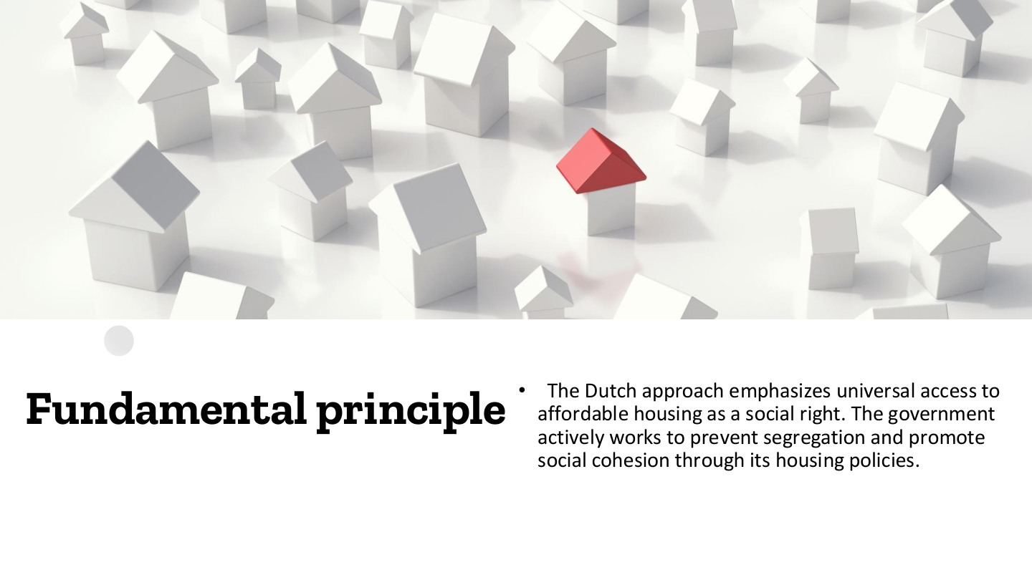
原PPT第30页 / Original slide 30 · 重点 / Focus

PPT中英翻译 / PPT translation
PPT English / 英文原文与图示 | 中文翻译 / Chinese translation
The Dutch approach emphasizes universal access to affordable housing as a social right. The government actively works to prevent segregation and promote social cohesion through its housing policies. | 荷兰模式强调把普遍获得可负担住房作为一项社会权利，并通过住房政策积极防止隔离、促进社会凝聚。

本页核心 / Key takeaway
荷兰的原则是把可负担住房作为社会权利，并追求融合；这与美国历史上的剩余安全网形成对照。
The Dutch principle treats affordable housing as a social right and promotes integration, contrasting with the historical US residual safety net.

精要解析 / Essential explanation

1. 权利定位为何重要 / Why the rights framing matters
当住房是正常社会需要，公共支持较容易获得广泛正当性，受助者也不必只被视为市场失败者。这为较广供给和较低污名提供制度基础。
When housing is a normal social need, broad public support gains legitimacy and recipients need not be viewed only as market failures. This supports broader provision and can reduce stigma.

2. 融合不是只看外观 / Integration is more than appearance
防止隔离既涉及建筑标准，也涉及区位、服务和受益群体能否共同生活。要看进入机会与社会空间后果，不能只从房屋看起来相似推断已经实现平等。
Preventing segregation involves standards, location, services and opportunities for different groups to coexist. Examine access and spatial outcomes, rather than inferring equality solely from similar-looking buildings.

3. 与收入门槛如何并存 / How income limits can coexist
普遍获得可负担住房是原则，特定社会住房项目仍可优先面向低收入者。第31页说明操作规则；两者之间的张力需要分析，而不是简单宣布荷兰完全没有资格审查。
Universal access to affordable housing is a principle, while particular programmes can prioritise lower-income groups. Slide 31 supplies allocation rules; analyse the tension rather than assuming an absence of screening.

31｜点数租金与收入资格 / Rent points and income eligibility
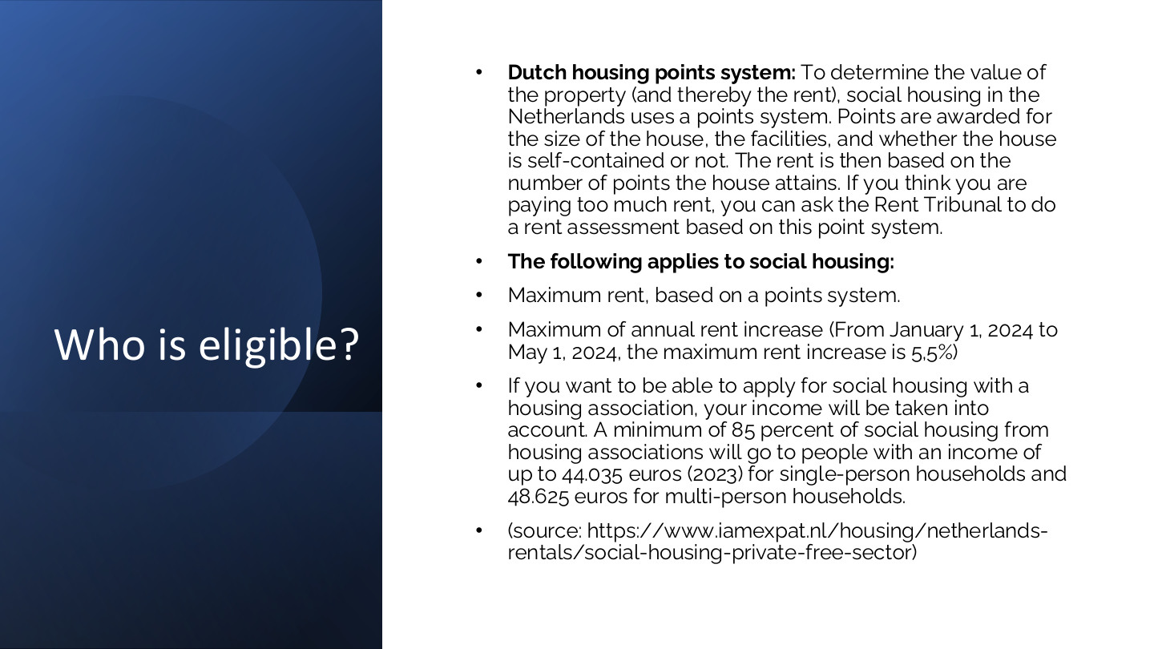
原PPT第31页 / Original slide 31 · 重点 / Focus

PPT中英翻译 / PPT translation
PPT English / 英文原文与图示 | 中文翻译 / Chinese translation
Dutch housing points system: To determine the value of the property (and thereby the rent), social housing in the Netherlands uses a points system. Points are awarded for the size of the house, the facilities, and whether the house is self-contained or not. The rent is then based on the number of points the house attains. If you think you are paying too much rent, you can ask the Rent Tribunal to do a rent assessment based on this point system. | 荷兰住房点数制度：根据住房面积、设施及是否为独立成套住房等因素评分，并据此评定租金；认为租金过高的租客，可向租金裁判机构申请按点数制度评估。
The following applies to social housing: Maximum rent, based on a points system. | 原文列出的社会住房规则：根据点数制度设置最高租金。
Maximum of annual rent increase (From January 1, 2024 to May 1, 2024, the maximum rent increase is 5,5%). | 设置年度租金涨幅上限；原页列出2024年1月1日至5月1日期间5.5%的数字。【适用类别须辨别，见下方。】
If you want to be able to apply for social housing with a housing association, your income will be taken into account. A minimum of 85 percent of social housing from housing associations will go to people with an income of up to 44.035 euros (2023) for single-person households and 48.625 euros for multi-person households. | 申请住房协会的社会住房需考虑收入。按原页2023年口径，至少85%的相关住房分配给年收入不超过44,035欧元的单人家庭，或48,625欧元的多人家庭。
Source: iamexpat.nl, Social housing vs. private housing (free sector). | 来源：IamExpat关于社会住房与私人自由租赁部门的介绍。

本页核心 / Key takeaway
分开记：点数制度评定住房及租金，收入规则筛选住户资格；二者不是同一种评分。
Distinguish points for dwelling quality and rents from income rules for household eligibility; these are separate assessments.

精要解析 / Essential explanation

1. 点数制度管什么 / What the points system regulates
面积、设施与成套性属于房屋属性，用来约束租金。房子分数高不等于租户收入高；租金评估与租户资格不能互相替代。
Size, amenities and self-containment are dwelling attributes used in rent regulation. A higher dwelling score does not mean a higher tenant income; rent assessment and household eligibility cannot substitute for one another.

2. 收入规则管什么 / What income rules regulate
85%是分配给符合收入条件群体的最低比例，不是租金补贴率，也不是住户必须支付85%的收入。单人和多人家庭有不同金额门槛，应连同年份一起记。
85% is a minimum allocation share for the specified income groups, not a subsidy rate or a required income contribution. Single-person and larger households have different thresholds; retain the reference year.

3. 把理念与操作连接 / Connect principle and operation
荷兰的社会权利理念通过具体租金、分配及申诉规则落实。是否更可负担，要看这些规则怎样运行，而不能只依据“普遍权利”这一表述。
Social-rights principles operate through rent, allocation and review procedures. Affordability depends on how these rules work, rather than the universal-rights language alone.

易错辨析 / Key distinction
本页混合2023、2024资料，且5.5%未清楚区分适用租赁类别；不把它作为所有社会住房统一上限或现行规定背诵。
This page mixes 2023 and 2024 material and does not clearly distinguish the rental category for 5.5%; do not memorise it as a universal social-rent cap or current rule.

32｜荷兰住房结构的历史变化 / Historical tenure trends
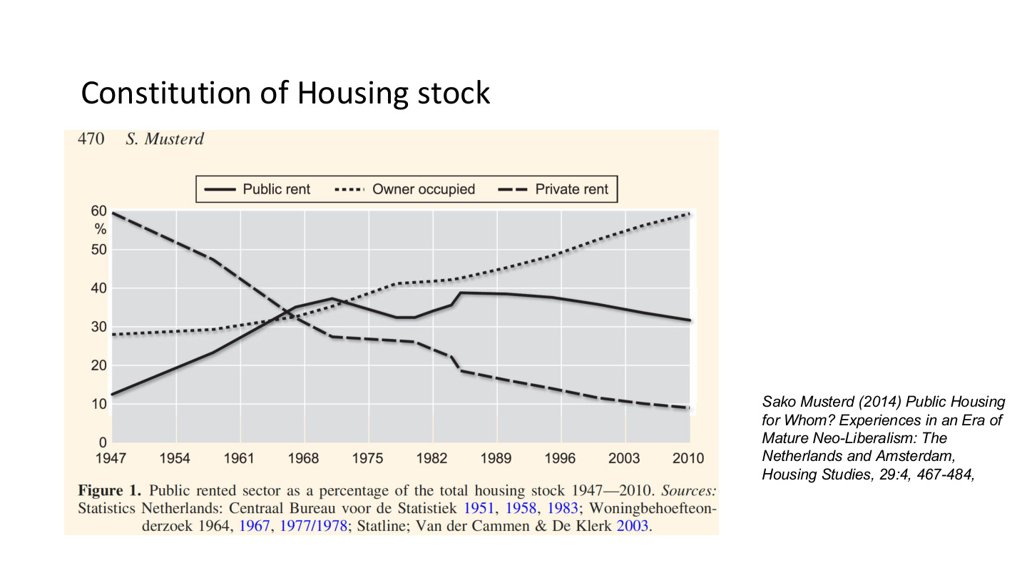
原PPT第32页 / Original slide 32 · 简读 / Brief

PPT中英翻译 / PPT translation
PPT English / 英文原文与图示 | 中文翻译 / Chinese translation
Constitution of Housing stock | 住房存量构成。此处constitution意为“构成”，不是“宪法”。
Figure 1. Public rented sector as a percentage of the total housing stock 1947–2010. | 图1：1947—2010年公共租赁部门占总住房存量的比重；图中同时显示自住与私人租赁。
Public rent (solid); Owner occupied (dotted); Private rent (dashed). Vertical axis: %. Horizontal axis: 1947, 1954, 1961, 1968, 1975, 1982, 1989, 1996, 2003, 2010. | 图例：实线为公共租赁，点线为自住，虚线为私人租赁。纵轴为百分比，横轴为所列历史年份。
Sako Musterd (2014), Public Housing for Whom? Experiences in an Era of Mature Neo-Liberalism: The Netherlands and Amsterdam, Housing Studies, 29:4, 467–484. Chart sources include Statistics Netherlands, housing surveys and other historical series. | 来源：Musterd（2014），《公共住房为谁？成熟新自由主义时期的荷兰与阿姆斯特丹经验》，Housing Studies 29(4)，467—484页；图表综合荷兰统计及历史住房调查。

本页核心 / Key takeaway
只抓趋势：公租先扩张后回落，自住总体上升，私人租赁长期下降。
Focus on the trend: public renting first expanded then declined, owner-occupation rose, and private renting fell over time.

精要解析 / Essential explanation

1. 趋势怎样理解 / Interpreting the trend
公租不是从1947年起一直减少；先增长、后来下降的阶段性变化很重要。后面的新自由主义转向可用于理解后期变化，但不能单凭这张图证明某一政策的因果效果。
Public renting did not decline throughout the entire period; expansion preceded later contraction. The neoliberal turn helps interpret later changes, but this chart alone cannot establish the effect of a particular policy.

33｜存量、覆盖与收入定向 / Stock, coverage and targeting
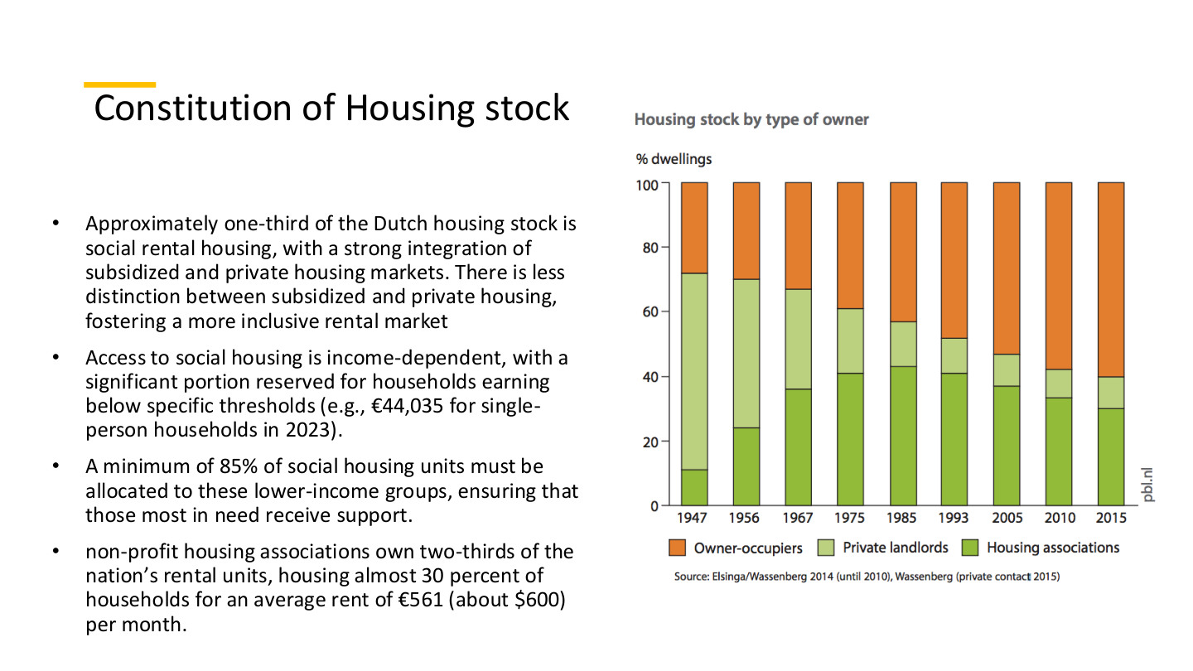
原PPT第33页 / Original slide 33 · 理解 / Understand

PPT中英翻译 / PPT translation
PPT English / 英文原文与图示 | 中文翻译 / Chinese translation
Approximately one-third of the Dutch housing stock is social rental housing, with a strong integration of subsidized and private housing markets. There is less distinction between subsidized and private housing, fostering a more inclusive rental market. | 荷兰约三分之一住房是社会租赁住房；补贴住房与私人市场联系较强，两者区隔较小，有助于形成更具包容性的租赁市场。
Access to social housing is income-dependent, with a significant portion reserved for households earning below specific thresholds (e.g., €44,035 for single-person households in 2023). | 社会住房资格取决于收入，大部分保留给收入低于规定门槛的家庭，如2023年单人家庭44,035欧元的门槛。
A minimum of 85% of social housing units must be allocated to these lower-income groups, ensuring that those most in need receive support. | 至少85%的相关社会住房分配给这些较低收入群体，以支持更有需要者。
Non-profit housing associations own two-thirds of the nation’s rental units, housing almost 30 percent of households for an average rent of €561 (about $600) per month. | 原文称：非营利住房协会拥有全国约三分之二出租住房，为近30%的家庭提供住房，平均月租561欧元（约600美元）。
Chart: Housing stock by type of owner; % dwellings. Owner-occupiers; Private landlords; Housing associations. Years: 1947, 1956, 1967, 1975, 1985, 1993, 2005, 2010, 2015. Source: Elsinga/Wassenberg 2014 (until 2010), Wassenberg (private contact 2015). | 图：按所有者类型划分的住房存量，单位为住宅百分比。图例：自住业主、私人房东、住房协会。年份为1947—2015所列年份。来源：Elsinga／Wassenberg（2014，至2010年）及Wassenberg的2015年资料。

本页核心 / Key takeaway
核心是较大的社会租赁存量与收入定向分配并存；覆盖较广不等于完全没有资格边界。
A large social-rental stock coexists with income-targeted allocation; broad provision does not remove eligibility boundaries.

精要解析 / Essential explanation

1. 这一页比前页多什么 / What this page adds
前页看历史走势，本页补充谁持有住房、谁能进入。存量规模、持有主体、受益资格是三个维度；把它们分开，才能理解荷兰为何兼具广泛供给与收入筛选。
Slide 32 shows trends; this page adds ownership and entry rules. Stock size, provider ownership and recipient eligibility are distinct dimensions, explaining how broad provision can coexist with targeting.

2. 数字不要强行统一 / Do not force figures into one snapshot
本页三分之二、第34页75%的租赁份额，以及总存量约30%—32%，来自不同资料口径。保留原页数字并注明历史性，重点记协会是核心供给者，不把所有比例当同年同分母。
The two-thirds rental share here, 75% on slide 34 and roughly 30–32% of all housing come from differing source contexts. Preserve their historical scope and remember the associations’ central role rather than combining them as one same-year dataset.

34｜住房协会是什么？ / Housing associations
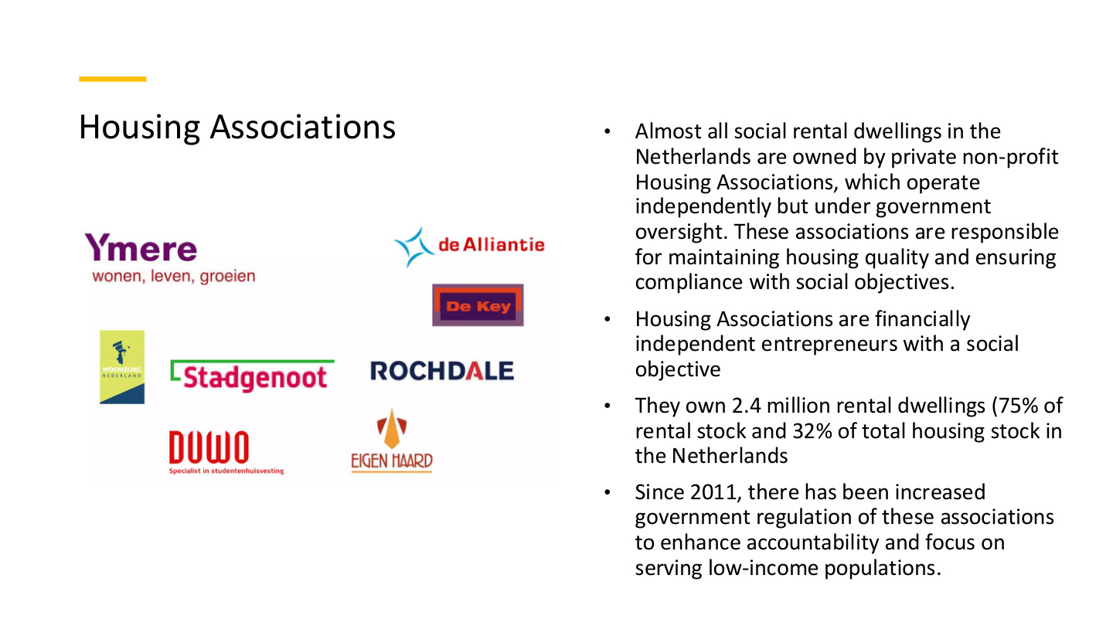
原PPT第34页 / Original slide 34 · 重点 / Focus

PPT中英翻译 / PPT translation
PPT English / 英文原文与图示 | 中文翻译 / Chinese translation
Almost all social rental dwellings in the Netherlands are owned by private non-profit Housing Associations, which operate independently but under government oversight. These associations are responsible for maintaining housing quality and ensuring compliance with social objectives. | 荷兰几乎所有社会租赁住房都由民间非营利住房协会持有。协会独立运作，但接受政府监督，负责住房质量并落实社会目标。
Housing Associations are financially independent entrepreneurs with a social objective. | 住房协会是在财务上独立、具有社会目标的经营主体。
They own 2.4 million rental dwellings (75% of rental stock and 32% of total housing stock in the Netherlands). | 按原页数据，协会持有240万套出租住宅，占租赁存量75%、总住房存量32%。
Since 2011, there has been increased government regulation of these associations to enhance accountability and focus on serving low-income populations. | 课件称，自2011年以来政府加强监管，以提高问责并使协会聚焦低收入群体。
Association logos include Ymere, de Alliantie, de Key, Stadgenoot, Rochdale, DUWO and Eigen Haard. | 图中列举Ymere、de Alliantie、de Key、Stadgenoot、Rochdale、DUWO、Eigen Haard等协会标志。

本页核心 / Key takeaway
住房协会是独立经营、受公共监管的非营利供给者，同时承担社会任务与财务责任。
Housing associations are independent nonprofit providers under public oversight, combining social obligations with financial responsibilities.

精要解析 / Essential explanation

1. 三种身份分开 / Separate three organisational identities
协会不是政府部门，也不是单纯逐利开发商。非营利意味着以社会任务为组织目的；财务独立意味着仍须筹资、维护存量并管理收支，而不是可以忽略成本。
Associations are neither government departments nor purely profit-maximising developers. A social mission defines their purpose, while financial independence requires fundraising, upkeep and management of revenues and costs.

2. 为什么有规模就重要 / Why ownership scale matters
持有大量住房使协会能持续影响租赁供给、质量与可负担性。其作用不只是发放一次性补贴，而是通过保有和管理资产，长期参与住房保障。
Large holdings let associations influence rental supply, quality and affordability over time. Their contribution involves owning and managing assets, rather than merely distributing one-off subsidies.

3. 自主性与问责 / Autonomy and accountability
独立经营可能提高管理灵活性，但也需要公共监督确保社会目标。后面的历史与危机说明：财务独立不等于不受监管，自主与问责始终需要协调。
Operating autonomy can increase flexibility, while oversight protects social objectives. The subsequent history and crises show that financial independence does not imply freedom from regulation; autonomy and accountability must be coordinated.

35｜协会的历史位置 / Associations between public, social and private
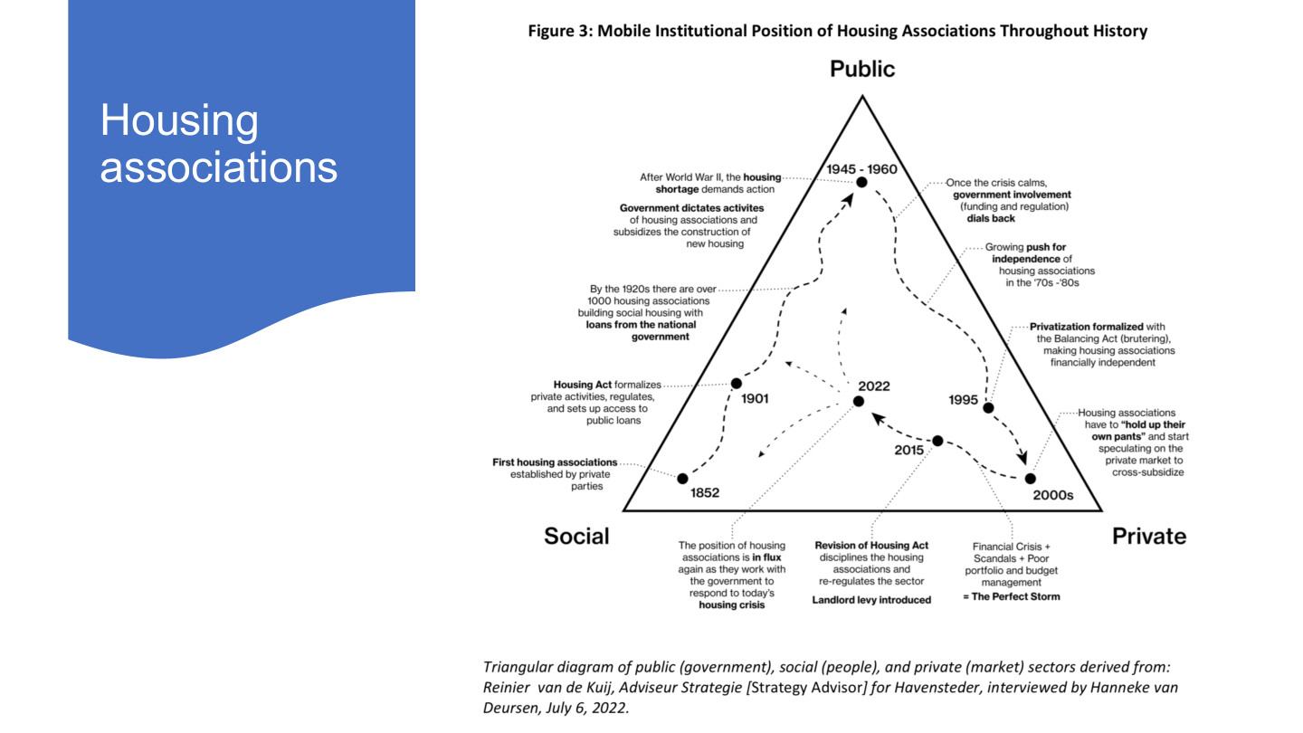
原PPT第35页 / Original slide 35 · 理解 / Understand

PPT中英翻译 / PPT translation
PPT English / 英文原文与图示 | 中文翻译 / Chinese translation
Figure 3: Mobile Institutional Position of Housing Associations Throughout History. Public; Social; Private. | 图3：住房协会在历史中的制度位置变化。三角：公共（政府）、社会（民众）、私人（市场）。
1852: First housing associations established by private parties. | 1852年：民间主体建立最早的住房协会。
1901: Housing Act formalizes private activities, regulates, and sets up access to public loans. | 1901年：《住房法》把民间活动制度化，实施监管，并提供获得公共贷款的渠道。
By the 1920s there are over 1000 housing associations building social housing with loans from the national government. | 到20世纪20年代，超过1000家协会以中央政府贷款建设社会住房。
1945–1960: After World War II, the housing shortage demands action. Government dictates activities of housing associations and subsidizes construction of new housing. | 1945—1960年：战后住房短缺要求采取行动，政府规定协会活动并补贴新住房建设。
Once the crisis calms, government involvement (funding and regulation) dials back. Growing push for independence of housing associations in the ’70s–’80s. | 短缺缓和后，政府在资金和监管上的参与减少；70—80年代要求协会独立的推动增强。
1995: Privatization formalized with the Balancing Act (brutering), making housing associations financially independent. | 1995年：“平衡法案／财务结算”（brutering）使协会财务独立；图中将其概括为私有化的制度化。
2000s: Housing associations have to “hold up their own pants” and start speculating on the private market to cross-subsidize. | 21世纪初：协会需要“自力更生”，转向私人市场活动，谋求交叉补贴。
Financial Crisis + Scandals + Poor portfolio and budget management = The Perfect Storm. | 金融危机、丑闻以及不良资产组合和预算管理叠加，形成“完美风暴”。
2015: Revision of Housing Act disciplines the housing associations and re-regulates the sector. Landlord levy introduced. | 2015年附近标注：《住房法》修订约束协会并重新加强监管；图中另列房东税的引入。
2022: The position of housing associations is in flux again as they work with the government to respond to today’s housing crisis. | 2022年：协会与政府合作应对住房危机，制度位置再度变化。
Triangular diagram derived from Reinier van de Kuij, Strategy Advisor for Havensteder, interviewed by Hanneke van Deursen, July 6, 2022. | 三角图源于对Havensteder战略顾问Reinier van de Kuij的访谈，由Hanneke van Deursen于2022年7月6日进行。

本页核心 / Key takeaway
协会的位置在政府支持、社会使命与市场融资之间移动，不是一次性从国家永久退出到市场。
Associations move between public support, social mission and market finance, rather than permanently shifting from state to market in one step.

精要解析 / Essential explanation

1. 只记主线 / Remember the main sequence
民间起源→战后政府支持扩张→1995年前后财务独立→市场经营与危机→再监管。把阶段与国家—协会关系联系起来即可，不必背图上每一句话。
Remember private origins, post-war public expansion, financial independence around 1995, market exposure and crisis, then renewed regulation. Connect stages to state–association relations rather than memorising every annotation.

2. 财务独立改变了什么 / What financial independence changes
独立后更需要用经营收入和融资维持社会任务，因此更受市场风险影响。“私有化”在此不等于协会全部变成营利公司；图讲的是资金、任务和监管关系的变化。
Independence increases reliance on operating income and finance, exposing social provision to market risks. Privatisation here does not mean every association became a for-profit company; the diagram tracks funding, missions and oversight.

36｜社会租赁资金流 / Financing the social-rental sector
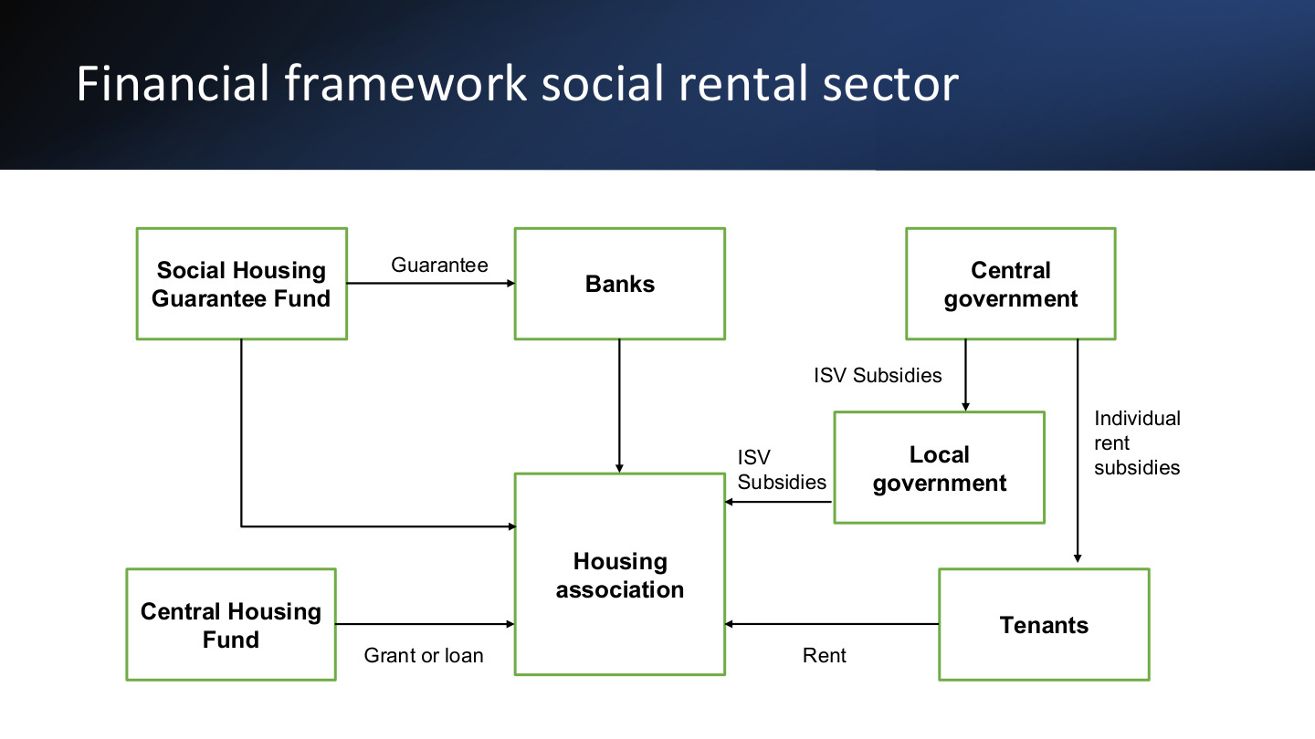
原PPT第36页 / Original slide 36 · 重点 / Focus

PPT中英翻译 / PPT translation
PPT English / 英文原文与图示 | 中文翻译 / Chinese translation
Financial framework social rental sector | 社会租赁部门的金融框架。
Social Housing Guarantee Fund → Banks: Guarantee. | 社会住房担保基金→银行：担保。
Banks → Housing association. Social Housing Guarantee Fund → Housing association. | 图中银行与担保基金分别连接住房协会；银行为融资来源，担保支持融资安排。
Central Housing Fund → Housing association: Grant or loan. | 中央住房基金→住房协会：拨款或贷款。
Central government → Local government → Housing association: ISV Subsidies. | 中央政府→地方政府→住房协会：ISV城市更新补贴。
Central government → Tenants: Individual rent subsidies. | 中央政府→租客：个人租金补贴。
Tenants → Housing association: Rent. | 租客→住房协会：租金。

本页核心 / Key takeaway
资金分两条线：支持协会融资和建设，以及补贴住户支付租金；担保、贷款、拨款与租金不能混为一谈。
Separate support for provider finance and development from support for tenants’ rent payments; guarantees, loans, grants and rent are different mechanisms.

精要解析 / Essential explanation

1. 担保与直接拨款 / Guarantees versus grants
担保帮助降低贷款方承担的风险，并非把同等现金直接交给租客。银行贷款仍是融资关系；图中的公共支持可以通过担保发挥作用。
A guarantee supports lending by limiting lender risk; it is not an equivalent cash grant to tenants. Bank lending remains a financing relationship, while public support can operate through risk-sharing arrangements.

2. 租金怎样形成循环 / The rent-payment circuit
住户获得个人补贴后仍向协会交租，协会以租金支持运营和财务安排。因此支付者、最终收款者与服务提供者可能不是同一个主体。
Tenants receiving personal assistance still pay rent to associations, supporting operations and financial commitments. The assisted recipient, eventual payee and housing provider can therefore be different actors.

3. 看懂混合制度 / Understanding the combined system
这张图同时包含公共资金、银行与非营利机构，并不是纯政府或纯市场模式。资金流比“有没有国家”更能说明制度怎样运作，也为美荷比较提供具体依据。
The diagram combines public finance, banks and nonprofit providers rather than a purely state or market model. Tracing financial flows explains more than asking whether the state is present, providing concrete evidence for comparison.

37｜租金监管与房东类型 / Regulation and landlord types
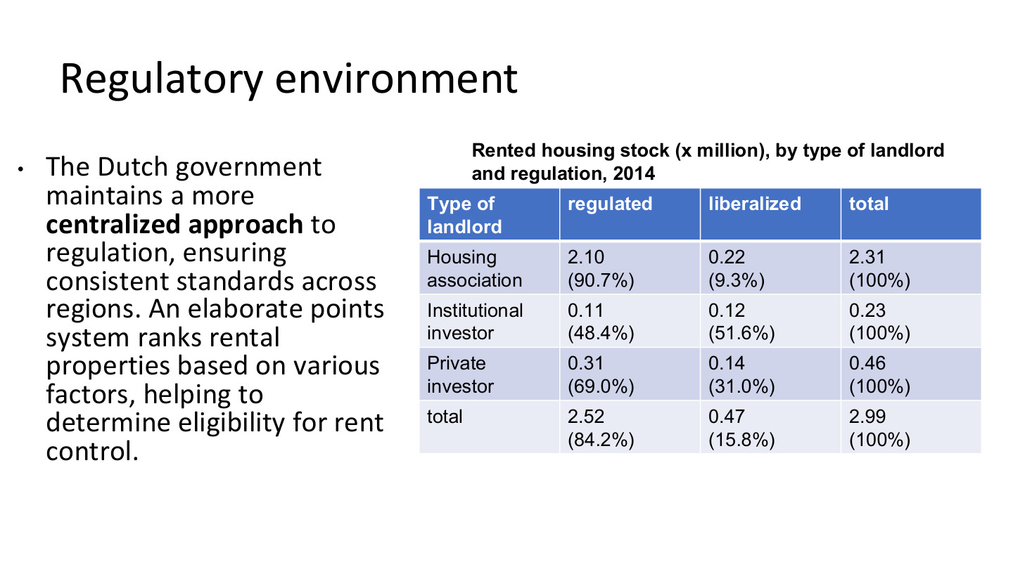
原PPT第37页 / Original slide 37 · 理解 / Understand

PPT中英翻译 / PPT translation
PPT English / 英文原文与图示 | 中文翻译 / Chinese translation
The Dutch government maintains a more centralized approach to regulation, ensuring consistent standards across regions. An elaborate points system ranks rental properties based on various factors, helping to determine eligibility for rent control. | 荷兰监管较为集中，强调跨地区一致标准；点数体系根据多项房屋属性评分，用于判断住房是否属于租金管制范围。
Rented housing stock (× million), by type of landlord and regulation, 2014. | 表：2014年按房东类别与租金监管状态划分的租赁住房存量，单位为百万套。
Regulated; liberalized; total. | 受租金监管；自由化／非管制；合计。

原表转写 / Original table transcribed
房东 / Landlord | 受监管 / Regulated | 自由化 / Liberalized | 合计 / Total
住房协会 / Housing association | 2.10 (90.7%) | 0.22 (9.3%) | 2.31 (100%)
机构投资者 / Institutional investor | 0.11 (48.4%) | 0.12 (51.6%) | 0.23 (100%)
私人投资者 / Private investor | 0.31 (69.0%) | 0.14 (31.0%) | 0.46 (100%)
合计 / Total | 2.52 (84.2%) | 0.47 (15.8%) | 2.99 (100%)

本页核心 / Key takeaway
房东是谁与住房是否受租金监管是两个维度；私人房东的住房也可能受监管。
Landlord identity and whether rents are regulated are separate dimensions; private landlords can also own regulated homes.

精要解析 / Essential explanation

1. 怎样读这张表 / Reading the table
住房协会一行约90.7%受监管，但机构投资者和私人投资者也有受监管房源。不能把受监管住房直接等同于政府产权；国家可通过规则影响不同产权主体。
About 90.7% of association dwellings are regulated, while institutional and private investors also hold regulated units. Rent regulation does not imply government ownership; public rules can apply across ownership types.

2. 数据在什么范围内有效 / Scope of the figures
表中数字是2014年的百万套及行内百分比。分类合计会受四舍五入影响；重点理解监管覆盖和房东构成，不必把每个小数当成现行存量。
Values are 2014 counts in millions with within-row percentages. Rounding affects totals; focus on regulatory coverage and landlord composition rather than memorising each decimal as a current figure.

38｜协会、租客与绩效协议 / Contracts and performance agreements
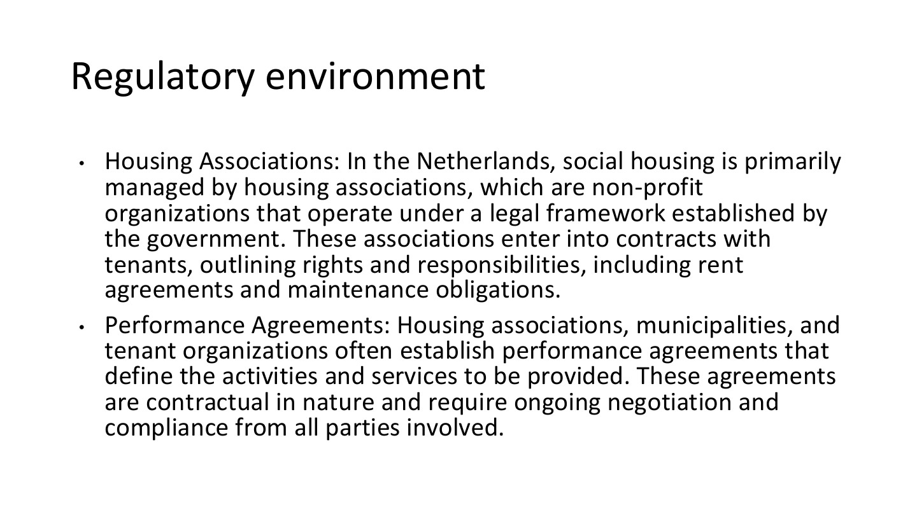
原PPT第38页 / Original slide 38 · 重点 / Focus

PPT中英翻译 / PPT translation
PPT English / 英文原文与图示 | 中文翻译 / Chinese translation
Housing Associations: In the Netherlands, social housing is primarily managed by housing associations, which are non-profit organizations that operate under a legal framework established by the government. These associations enter into contracts with tenants, outlining rights and responsibilities, including rent agreements and maintenance obligations. | 荷兰社会住房主要由住房协会管理；这些非营利组织在政府法律框架下运作，与租客签订合同，规定租金、维修等权利和责任。
Performance Agreements: Housing associations, municipalities, and tenant organizations often establish performance agreements that define the activities and services to be provided. These agreements are contractual in nature and require ongoing negotiation and compliance from all parties involved. | 住房协会、市政当局和租客组织常建立绩效协议，规定应提供的活动与服务。这些协议具有契约性质，需要各方持续协商并履行要求。

本页核心 / Key takeaway
区分协会—租客的租约与协会—市政当局—租客组织的绩效协议；两者协调不同层次的责任。
Distinguish association–tenant leases from performance agreements among associations, municipalities and tenant organisations; they coordinate different responsibilities.

精要解析 / Essential explanation

1. 租约处理个体关系 / Leases govern individual relationships
租约明确某个住户与协会之间的租金、使用和维修责任。具有社会权利理念的住房体系仍然需要合同，不代表住户入住后就没有任何义务。
A lease defines rent, use and maintenance responsibilities between a resident and association. A rights-oriented housing system still needs contracts and does not remove residents’ obligations.

2. 绩效协议处理公共任务 / Performance agreements govern public tasks
绩效协议把供给者、地方政府与租客代表放到同一协商机制中。租客组织参与公共任务的协商，与每个住户单独签租约并不是同一回事。
Performance agreements bring providers, municipalities and tenant representatives into a shared process. Tenant organisations participate in negotiating public tasks, which differs from each household signing an individual lease.

3. 与美国怎么比较 / Comparing with the US
两国都有合同，因此不能用“美国契约、荷兰无条件永久”简单二分。更应比较公共任务、租客参与、监管一致性与实际居住保障。
Both countries use contracts, so avoid contrasting a contractual US with an unconditional permanent Dutch system. Compare public obligations, tenant participation, regulatory consistency and actual housing security.

39｜住房津贴 / Housing allowance
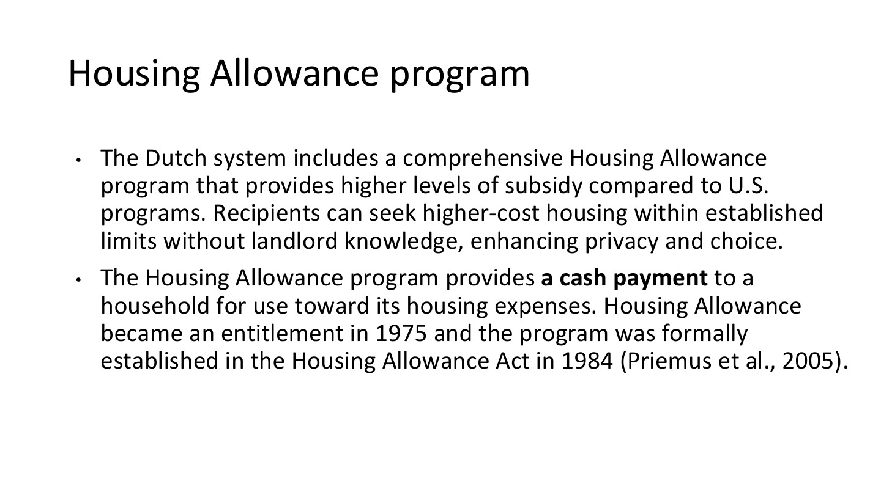
原PPT第39页 / Original slide 39 · 重点 / Focus

PPT中英翻译 / PPT translation
PPT English / 英文原文与图示 | 中文翻译 / Chinese translation
The Dutch system includes a comprehensive Housing Allowance program that provides higher levels of subsidy compared to U.S. programs. Recipients can seek higher-cost housing within established limits without landlord knowledge, enhancing privacy and choice. | 荷兰有较全面的住房津贴项目；课件认为其补贴力度高于所比较的美国项目。接受者可在规定范围内选择租金较高的住房，而房东无需知悉津贴情况，从而增加隐私和选择空间。
The Housing Allowance program provides a cash payment to a household for use toward its housing expenses. Housing Allowance became an entitlement in 1975 and the program was formally established in the Housing Allowance Act in 1984 (Priemus et al., 2005). | 住房津贴以现金形式支付给住户，用于住房支出。课件记载其于1975年成为权利性待遇，并在1984年《住房津贴法》中正式确立（Priemus等，2005）。

本页核心 / Key takeaway
荷兰住房津贴是支付给住户、用于住房费用的现金支持；它与协会持有和运营住房可以同时存在。
Dutch housing allowance is cash support to households for housing expenses, coexisting with association ownership and management of dwellings.

精要解析 / Essential explanation

1. 津贴与供房分开 / Separate allowances from provision
协会提供和维护房屋，津贴帮助住户负担租金。同一体系可同时包含供给支持和需求支持；有现金补贴不意味着社会住房存量已经消失。
Associations supply and maintain homes while allowances support rental affordability. Supply-side and demand-side support can coexist; cash assistance does not imply that social housing stock has disappeared.

2. 与HCV的操作差别 / Operational contrast with HCV
本页突出对住户的现金支付及隐私；美国HCV则涉及PHA与房东的援助合同。比较时看谁领款、房东是否必须参与项目，以及住户实际可选择的房源。
This slide emphasises household cash payments and privacy, while US HCV involves an authority–landlord assistance contract. Compare payment recipients, required landlord participation and the homes recipients can actually choose.

3. “权利”不等于无限补贴 / Entitlement is not unlimited aid
权利性待遇仍可设收入、资产和租金条件。课件“荷兰补贴更高”是比较性概括，不能推出每个荷兰家庭都比每个美国家庭领取更多。
Entitlements can retain income, wealth and rent conditions. The slide’s higher-subsidy comparison does not mean every Dutch household receives more than every US household.

40｜津贴条件与自付部分 / Allowance conditions and own contribution
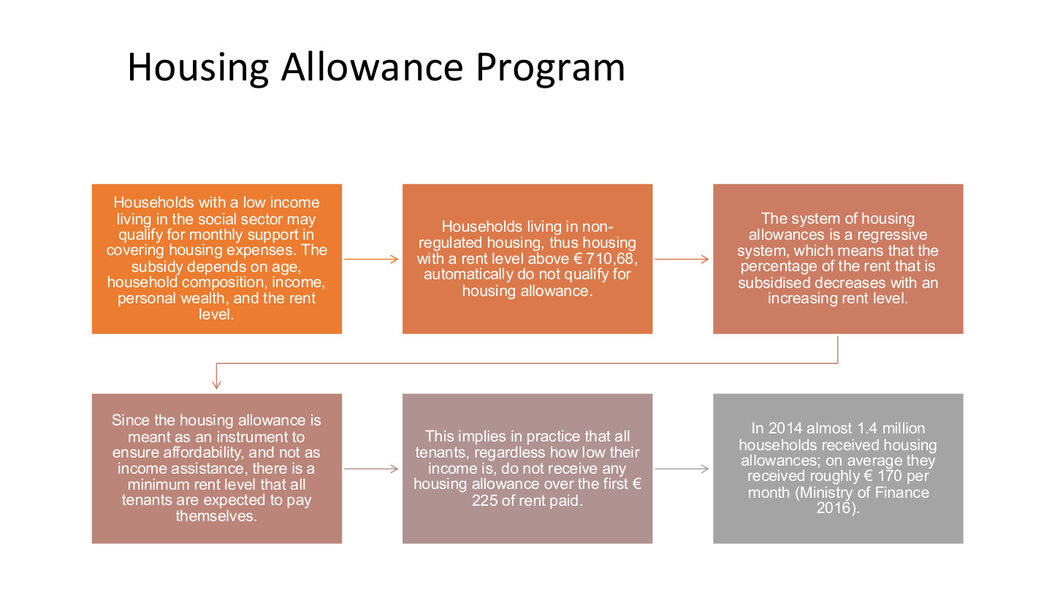
原PPT第40页 / Original slide 40 · 重点 / Focus

PPT中英翻译 / PPT translation
PPT English / 英文原文与图示 | 中文翻译 / Chinese translation
Households with a low income living in the social sector may qualify for monthly support in covering housing expenses. The subsidy depends on age, household composition, income, personal wealth, and the rent level. | 社会租赁部门的低收入住户可能获得每月住房支持；金额取决于年龄、家庭构成、收入、个人资产与租金水平。
Households living in non-regulated housing, thus housing with a rent level above €710,68, automatically do not qualify for housing allowance. | 按原页所述历史口径，居于非管制、租金高于710.68欧元住房的家庭不符合津贴资格。
The system of housing allowances is a regressive system, which means that the percentage of the rent that is subsidised decreases with an increasing rent level. | 课件把该津贴称为“递减型／累退型”：租金越高，租金中获得补贴的比例越低。
Since the housing allowance is meant as an instrument to ensure affordability, and not as income assistance, there is a minimum rent level that all tenants are expected to pay themselves. | 由于津贴旨在保障住房可负担性，而非一般收入救助，所有租客都需自付一部分最低租金。
This implies in practice that all tenants, regardless how low their income is, do not receive any housing allowance over the first €225 of rent paid. | 按原页的历史例子，无论收入多低，租金的最初225欧元部分不获津贴。
In 2014 almost 1.4 million households received housing allowances; on average they received roughly €170 per month (Ministry of Finance 2016). | 2014年近140万户领取住房津贴，平均每月约170欧元（财政部，2016）。

本页核心 / Key takeaway
津贴不是支付全部租金：存在资格条件、自付部分，且补贴比例可随租金上升而下降。
Allowances do not pay all rent: eligibility, an own contribution and declining subsidy shares at higher rents limit support.

精要解析 / Essential explanation

1. 多个条件共同作用 / Several conditions operate together
资格与金额由收入之外的家庭结构、资产和租金等共同决定。这也呼应听课宝的分析方法：指标不仅计算待遇，还决定政策实际保护谁。
Eligibility and payment reflect household structure, wealth and rent as well as income. This echoes the listening summary’s method: criteria shape who is protected as well as how benefits are calculated.

2. regressive在这里指什么 / Meaning of regressive here
此处比较的是租金与补贴占租金的比例，不是直接比较穷人与富人的税负。租金升高而补贴份额下降，意味着住户不能无上限转租更贵住房并期待同比例支持。
Here the comparison is rent against the share of rent subsidised, not poor versus rich households’ tax burdens. A declining share limits proportional support when recipients choose more expensive housing.

3. 怎样记数字 / How to remember the figures
710.68、225、170欧元及140万户属于课件的旧制度和历史统计，不是当前金额表。重点记“租金上限—最低自付—按条件补贴”的结构，引用数字时加历史口径。
The euro amounts and 1.4 million households belong to historical rules and statistics in the slide. Remember rent limits, an own contribution and conditional assistance, adding dates when quoting figures.

41｜荷兰为何污名较低？ / Why stigma is lower in the Dutch case
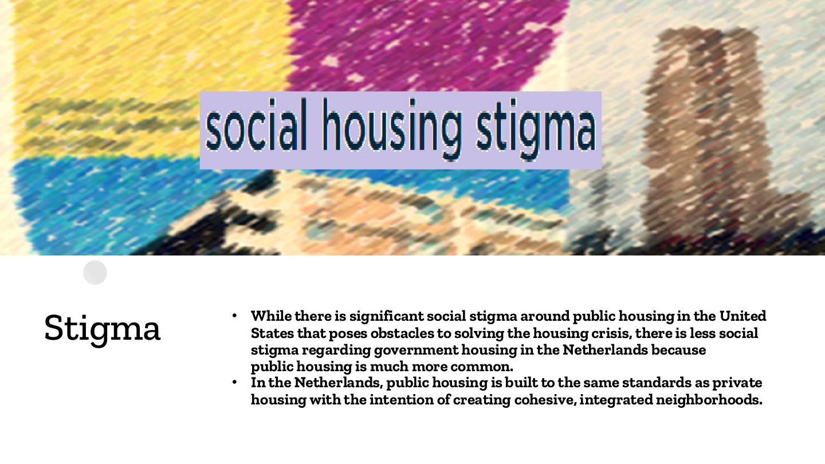
原PPT第41页 / Original slide 41 · 理解 / Understand

PPT中英翻译 / PPT translation
PPT English / 英文原文与图示 | 中文翻译 / Chinese translation
While there is significant social stigma around public housing in the United States that poses obstacles to solving the housing crisis, there is less social stigma regarding government housing in the Netherlands because public housing is much more common. | 美国公共住房的明显污名妨碍住房问题的解决；荷兰因公共支持住房更常见，相关污名相对较低。
In the Netherlands, public housing is built to the same standards as private housing with the intention of creating cohesive, integrated neighborhoods. | 荷兰社会住房采用与私人住房相同的建设标准，旨在形成有凝聚力、融合的社区。

本页核心 / Key takeaway
课件以较普遍的供给和接近私人住房的品质解释较低污名，而不只诉诸公众态度。
The lecture links lower stigma to more widespread provision and standards comparable with private housing, beyond differences in public attitudes.

精要解析 / Essential explanation

1. 为什么常态化有作用 / Why normalisation matters
当社会住房是较广泛群体的正常居住方式，建筑又不刻意标示较低身份，就较不容易把住户视为特殊、失败的群体。供给规模与设计标准共同塑造社会评价。
When social housing is a normal option and buildings do not deliberately signal inferior status, residents are less readily marked as a separate failed group. Scale and standards jointly shape social perceptions.

2. 保留时间变化 / Allow for change over time
较低污名不等于永远没有污名。下一页展示改革、话语和低收入集中怎样改变社会评价，因此要把本页理解为比较性特征，而不是固定不变的国家性格。
Lower stigma does not mean stigma is permanently absent. The next slide shows how reforms, discourse and concentration of lower-income groups can change perceptions; this is a comparative feature, not a timeless national trait.

42｜新自由主义转向 / The neoliberal turn
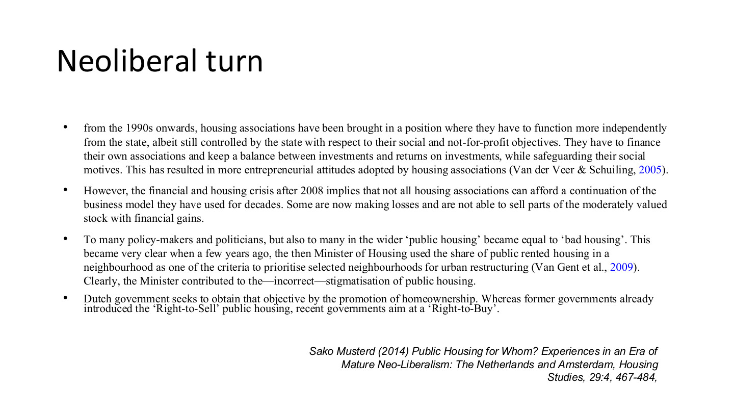
原PPT第42页 / Original slide 42 · 重点 / Focus

PPT中英翻译 / PPT translation
PPT English / 英文原文与图示 | 中文翻译 / Chinese translation
From the 1990s onwards, housing associations have been brought in a position where they have to function more independently from the state, albeit still controlled by the state with respect to their social and not-for-profit objectives. They have to finance their own associations and keep a balance between investments and returns on investments, while safeguarding their social motives. This has resulted in more entrepreneurial attitudes adopted by housing associations (Van der Veer & Schuiling, 2005). | 自20世纪90年代起，住房协会需更独立于国家经营，但社会和非营利目标仍受国家约束。它们需自行融资、平衡投资与回报，同时保留社会使命，因而更具企业经营取向。
However, the financial and housing crisis after 2008 implies that not all housing associations can afford a continuation of the business model they have used for decades. Some are now making losses and are not able to sell parts of the moderately valued stock with financial gains. | 2008年后的金融与住房危机使部分协会难以维持原有商业模式，出现亏损，也无法通过出售部分中等价值住房实现预期收益。
To many policy-makers and politicians, but also to many in the wider public, “public housing” became equal to “bad housing”. This became very clear when a few years ago, the then Minister of Housing used the share of public rented housing in a neighbourhood as one of the criteria to prioritise selected neighbourhoods for urban restructuring (Van Gent et al., 2009). Clearly, the Minister contributed to the—incorrect—stigmatisation of public housing. | 一些政策制定者、政治人物及公众把“公共住房”等同于“差住房”。当时住房部长曾把社区公租比例用作优先更新标准之一；原文批评这助长了对公共住房的不当污名。
Dutch government seeks to obtain that objective by the promotion of homeownership. Whereas former governments already introduced the “Right-to-Sell” public housing, recent governments aim at a “Right-to-Buy”. | 原文描述当时政府促进住房自有化：早期已引入出售公共住房的政策，后来的政府进一步倡议租户购买。
Sako Musterd (2014), Public Housing for Whom? Experiences in an Era of Mature Neo-Liberalism: The Netherlands and Amsterdam, Housing Studies, 29:4, 467–484. | 来源：Musterd（2014）关于成熟新自由主义时期荷兰及阿姆斯特丹公共住房的研究。

本页核心 / Key takeaway
转向的机制是更独立融资与企业化经营，同时保留社会任务；市场风险、资产出售和污名可能改变保障结构。
The turn combines greater financial independence and entrepreneurship with continuing social obligations, exposing provision to market risk, asset sales and changing stigma.

精要解析 / Essential explanation

1. 社会目标与回报怎样冲突 / Social goals and returns
协会需要维持经营收入，可能用商业活动或住房出售支持社会任务。交叉补贴把社会供给与市场表现连接起来，不是市场收入始终足以保障公益的保证。
Associations may support social activities through commercial income or sales. Cross-subsidy links social provision to market performance, rather than guaranteeing that market revenues will always fund the mission.

2. 危机为什么会传导 / How crisis affects provision
如果模式依赖资产出售和投资收益，市场低迷会削弱收入与融资空间。由此可见，法律上非营利并不能消除经营风险，也不自动确保社会住房持续扩张。
A model reliant on asset sales or investment returns becomes vulnerable when markets weaken. Nonprofit status does not remove financial risks or automatically ensure continuing growth in social housing.

3. 污名怎样被政策生产 / How policy can produce stigma
把公租比例当作“问题社区”的标记，会把制度类别与负面评价连接。与前页相比，污名不仅取决于建筑品质，也受政府话语和更新标准影响。
Using a public-rental share as a marker of a problem neighbourhood links tenure to negative judgements. Stigma therefore reflects policy discourse and redevelopment criteria as well as building quality.

4. 判断转向看什么 / Identifying the turn
综合看谁融资、谁承担风险、资产是否出售及哪些人仍能进入，而不是只看有无补贴。原文的Right-to-Buy是当时政策方向的表述，不能当成所有荷兰租客现有的无条件购买权。
Assess financing, risk-bearing, sales and continuing access rather than subsidies alone. The text’s Right-to-Buy describes a policy direction at that time, not an unconditional current purchase right for every Dutch tenant.

43｜社会住房越来越为谁服务？ / For whom is public housing?
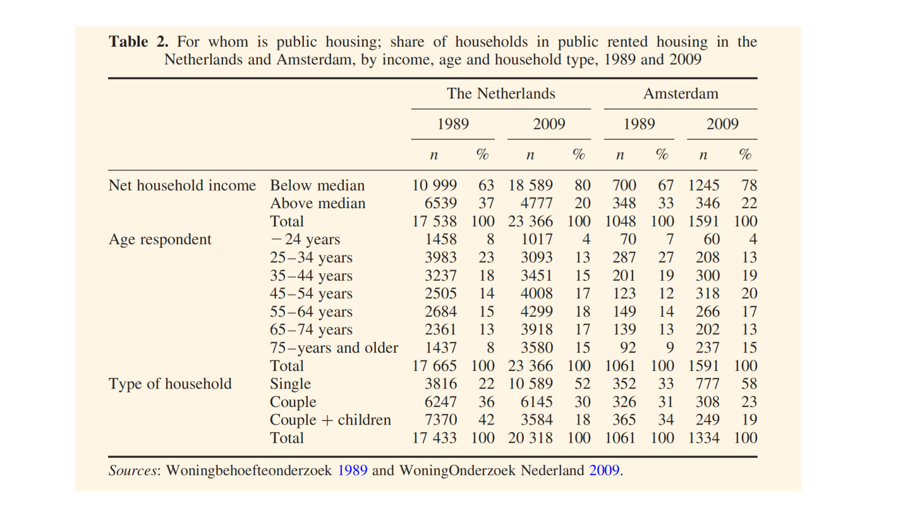
原PPT第43页 / Original slide 43 · 重点 / Focus

PPT中英翻译 / PPT translation
PPT English / 英文原文与图示 | 中文翻译 / Chinese translation
Table 2. For whom is public housing; share of households in public rented housing in the Netherlands and Amsterdam, by income, age and household type, 1989 and 2009. | 表2：公共住房为谁服务？按收入、年龄与家庭类型划分的荷兰全国及阿姆斯特丹公共租赁住户构成，1989与2009年。
The Netherlands; Amsterdam. 1989; 2009. n; %. Net household income; Age respondent; Type of household. | 列：荷兰全国、阿姆斯特丹；1989、2009年；n为原表观察数，%为组别构成比例。行：家庭净收入、受访者年龄、家庭类型。
Sources: Woningbehoefteonderzoek 1989 and WoningOnderzoek Nederland 2009. | 来源：1989年及2009年荷兰住房调查。完整数字见下表，n与百分比合并在一格。
The original n totals vary across income, age and household-type groups; all figures are retained as printed. | 原表不同分组的n总数不一，所有数字照原表保留，不自行重算。

原表数字完整转写：n (%) / Full transcription: n (%)
组别 / Category | 荷兰 NL 1989 | 荷兰 NL 2009 | 阿姆斯特丹 AMS 1989 | 阿姆斯特丹 AMS 2009
净收入低于中位数 / Income below median | 10,999 (63%) | 18,589 (80%) | 700 (67%) | 1,245 (78%)
净收入高于中位数 / Income above median | 6,539 (37%) | 4,777 (20%) | 348 (33%) | 346 (22%)
收入组总数 / Income total | 17,538 (100%) | 23,366 (100%) | 1,048 (100%) | 1,591 (100%)
受访者≤24岁 / Respondent up to 24 | 1,458 (8%) | 1,017 (4%) | 70 (7%) | 60 (4%)
25–34岁 / Years | 3,983 (23%) | 3,093 (13%) | 287 (27%) | 208 (13%)
35–44岁 / Years | 3,237 (18%) | 3,451 (15%) | 201 (19%) | 300 (19%)
45–54岁 / Years | 2,505 (14%) | 4,008 (17%) | 123 (12%) | 318 (20%)
55–64岁 / Years | 2,684 (15%) | 4,299 (18%) | 149 (14%) | 266 (17%)
65–74岁 / Years | 2,361 (13%) | 3,918 (17%) | 130 (13%) | 202 (13%)
75岁及以上 / Years and older | 1,437 (8%) | 3,580 (15%) | 92 (9%) | 237 (15%)
年龄组总数 / Age total | 17,665 (100%) | 23,366 (100%) | 1,061 (100%) | 1,591 (100%)
单人户 / Single | 3,816 (22%) | 10,589 (52%) | 352 (33%) | 777 (58%)
伴侣户 / Couple | 6,247 (36%) | 6,145 (30%) | 326 (31%) | 308 (23%)
伴侣与子女 / Couple + children | 7,370 (42%) | 3,584 (18%) | 365 (34%) | 249 (19%)
家庭类型总数 / Household-type total | 17,433 (100%) | 20,318 (100%) | 1,061 (100%) | 1,334 (100%)

本页核心 / Key takeaway
表中社会租赁住户更集中于低收入者和单人户，显示受益者结构变化，而不只是房屋数量变化。
The table shows greater concentration of lower-income and single-person households within social renting, revealing changes in beneficiaries rather than stock alone.

精要解析 / Essential explanation

1. 收入变化怎样读 / Read the income shift
荷兰全国低于中位收入者占比从63%升至80%，阿姆斯特丹从67%升至78%。分母是公租住户，不能倒过来说“80%的低收入家庭都住公屋”。
Below-median households rise from 63% to 80% nationally and from 67% to 78% in Amsterdam. The denominator is public-rental households, not all low-income households; the table does not show that 80% of low-income households live there.

2. 家庭构成变化 / Changing household composition
单人户占比全国从22%升至52%，阿姆斯特丹从33%升至58%；部分年轻和有子女家庭的份额下降。复习时抓住构成变化，不必逐个记年龄段。
Single-person shares rise from 22% to 52% nationally and from 33% to 58% in Amsterdam, while some younger and family groups decline. Focus on composition rather than memorising every age category.

3. 怎样连接剩余化 / Connecting to residualisation
较低收入者在公租内部更集中，可用于讨论社会住房是否趋于剩余化。表格显示关联和构成变化，不能单独证明具体改革造成了哪一户迁离；各组n也不是全国房源总量。
Concentration of lower incomes supports discussion of residualisation. The table documents composition, not proof that a specific reform displaced particular households; its n values are not national dwelling totals.

44｜收入与住房权属 / Income and tenure
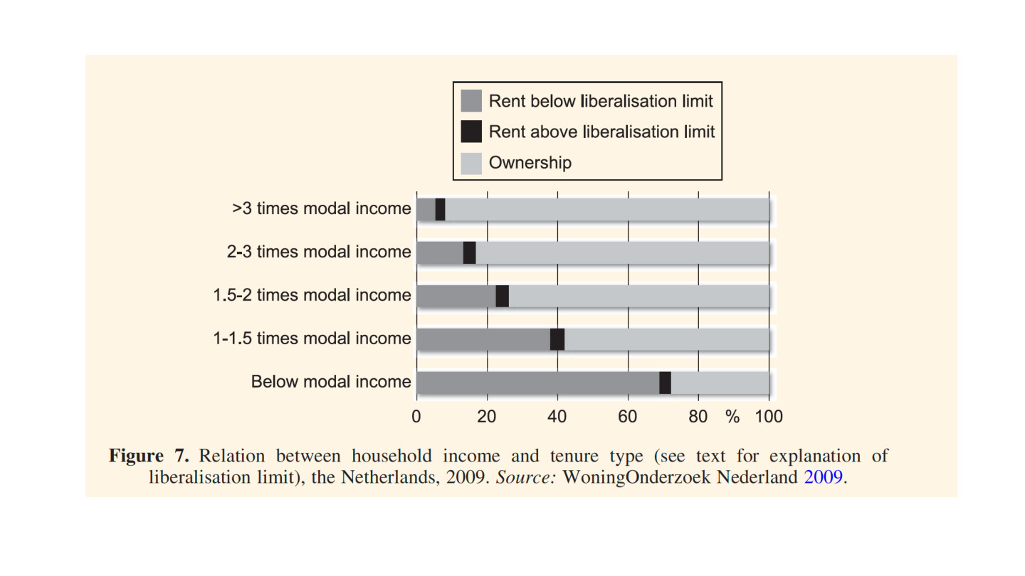
原PPT第44页 / Original slide 44 · 理解 / Understand

PPT中英翻译 / PPT translation
PPT English / 英文原文与图示 | 中文翻译 / Chinese translation
Figure 7. Relation between household income and tenure type, the Netherlands, 2009. Source: WoningOnderzoek Nederland 2009. | 图7：2009年荷兰家庭收入与住房占有／使用类型的关系。来源：2009年荷兰住房调查。
Rent below liberalisation limit; Rent above liberalisation limit; Ownership. | 图例：租金低于自由化界限的租赁；租金高于界限的租赁；自有住房。
>3 times modal income; 2–3 times modal income; 1.5–2 times modal income; 1–1.5 times modal income; Below modal income. | 收入组：超过标准收入3倍；2—3倍；1.5—2倍；1—1.5倍；低于标准收入。此处modal income保留为标准／典型收入，不直接等同前页收入中位数。
Horizontal axis: 0, 20, 40, 60, 80, 100 (%). | 横轴：各收入组内部住房类型的百分比（0%—100%）。

本页核心 / Key takeaway
图中收入越高，自有住房份额总体越大；较低收入群体更依赖低于自由化界限的租赁。
Higher-income groups generally have larger owner-occupied shares, while lower-income groups rely more on renting below the liberalisation threshold.

精要解析 / Essential explanation

1. 与前页的分母不同 / A different denominator from slide 43
第43页问公租住户由哪些人组成，本页问某收入组住哪类房。本页每条柱子的分母是该收入组，不能把两页百分比直接当作同一指标比较。
Slide 43 asks who lives in public renting; this asks which tenures an income group uses. Each bar’s denominator is its income group, so percentages across the two pages are not the same measure.

2. 租金监管不等于房东身份 / Rent status is not ownership type
低于租金自由化界限描述的是监管范围，不直接说明房东是政府、协会还是私人。图无逐段精确数值，读总体方向即可，不把目测比例当成准确统计。
Rent below the threshold describes a regulatory category, not necessarily government, association or private ownership. Read the overall pattern without inventing precise segment values from an unlabelled chart.

45｜美荷比较总结 / US–Netherlands comparison
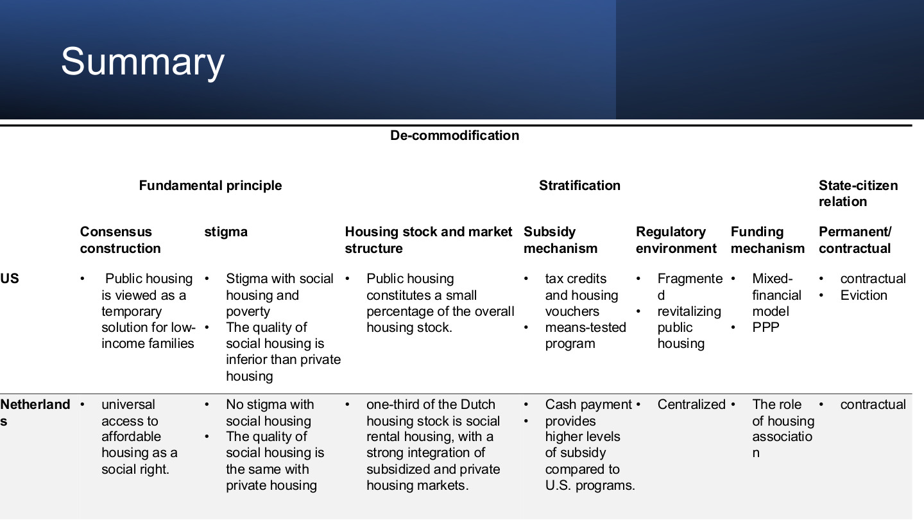
原PPT第45页 / Original slide 45 · 重点 / Focus

PPT中英翻译 / PPT translation
PPT English / 英文原文与图示 | 中文翻译 / Chinese translation
De-commodification. Fundamental principle; Stratification; State-citizen relation. | 总主题：去商品化。上位维度：基本原则、社会分层、国家与公民关系。
Consensus construction — US: Public housing is viewed as a temporary solution for low-income families. Netherlands: universal access to affordable housing as a social right. | 共识建构——美国：公共住房被视为低收入家庭的临时解决方案。荷兰：普遍获得可负担住房被视为社会权利。
Stigma — US: Stigma with social housing and poverty; the quality of social housing is inferior than private housing. Netherlands: No stigma with social housing; the quality of social housing is the same with private housing. | 污名——美国：社会住房与贫困污名相关，品质较私人住房低。荷兰：原表概括为“无污名”，品质与私人住房相同。【“无污名”应结合第42页理解为相对较低，并非始终完全不存在。】
Housing stock and market structure — US: Public housing constitutes a small percentage of the overall housing stock. Netherlands: one-third of the Dutch housing stock is social rental housing, with a strong integration of subsidized and private housing markets. | 住房存量与市场结构——美国：公屋只占总存量很小部分。荷兰：社会租赁约占三分之一，补贴住房与私人市场联系较强。
Subsidy mechanism — US: tax credits and housing vouchers; means-tested program. Netherlands: Cash payment; provides higher levels of subsidy compared to U.S. programs. | 补贴机制——美国：税收抵免和住房券，采用经济状况审查。荷兰：向住户支付现金津贴；按课件比较，补贴力度较高。
Regulatory environment — US: Fragmented; revitalizing public housing. Netherlands: Centralized. | 监管环境——美国：较碎片化，进行公屋更新。荷兰：较集中。
Funding mechanism — US: Mixed-financial model; PPP. Netherlands: The role of housing association. | 融资机制——美国：混合融资与公私合作。荷兰：住房协会发挥核心作用。
Permanent/contractual — US: contractual; eviction. Netherlands: contractual. | 永久／契约关系——美国：契约型，存在驱逐风险。荷兰：同样为契约型。

本页核心 / Key takeaway
比较按原则→供给与资金→资格和监管→社会后果展开，最终判断实际居住保障和市场依赖。
Compare principles, provision and finance, eligibility and regulation, then social outcomes, to assess housing security and market dependence.

精要解析 / Essential explanation

1. 用共同问题比较 / Ask the same questions
结合听课宝和Word的框架，对两国都问：政策对象是谁、目标是什么、资源怎样投放、结果怎样。不要美国只谈住房券、荷兰只谈协会，而缺少同一维度的比较。
Using the listening summary and Word framework, ask both cases about beneficiaries, purposes, resources and outcomes. Compare the same dimensions rather than discussing only US vouchers and only Dutch associations.

2. 最核心的制度对照 / The central institutional contrast
美国历史上以市场和自有住房为主、公共援助偏安全网；荷兰以社会权利理念和较大协会存量支撑供给。两者都有国家、市场和合同，差异在组合方式与责任范围。
Historically, the US emphasises markets, homeownership and a public safety net; the Dutch case combines social-rights principles with substantial association stock. Both involve state, markets and contracts; their combinations and responsibilities differ.

3. 工具不能混为一谈 / Keep instruments distinct
HCV支持租户支付，LIHTC支持项目投资，协会持有和运营房源。现金、税收和实物存量可能共同存在；公共资金流向私人主体，也不能单凭这一点完成体制分类。
HCV supports rental payments, LIHTC supports project investment, and associations hold and manage housing. Cash, tax instruments and stock can coexist; public money reaching private actors alone cannot classify an entire regime.

4. 答题怎样落到后果 / Explain consequences in an answer
先说明制度定位，再选两三个机制，最后讨论可负担性、居住稳定、污名与隔离。HOPE VI和荷兰改革说明：建筑变好或财务独立，都需进一步检验原住户实际受益。
Define the policy orientation, explain two or three mechanisms, then assess affordability, security, stigma and segregation. HOPE VI and Dutch reforms show why better buildings or financial independence require further evaluation of residents’ actual gains.

46｜结束页 / Questions?

原PPT第46页 / Original slide 46 · 简读 / Brief

PPT中英翻译 / PPT translation
PPT English / 英文原文与图示 | 中文翻译 / Chinese translation
Questions? | 有什么问题吗？
June Wang; June.wang@cityu.edu.hk | June Wang；联系邮箱：June.wang@cityu.edu.hk。

本页核心 / Key takeaway
结束页，无新增理论。
Closing slide; no new theory.

