第01页 / Slide 01｜Three worlds of welfare capitalism｜福利资本主义的三个世界
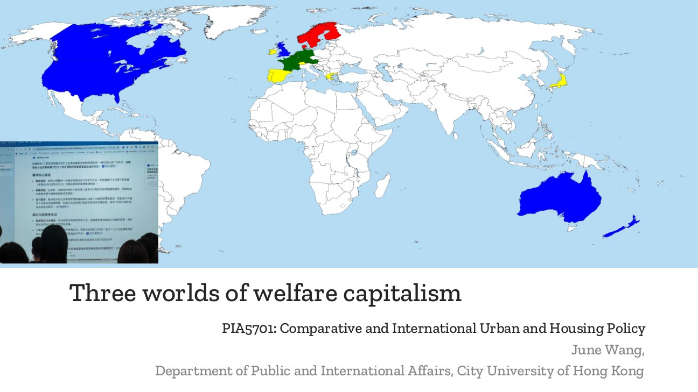
原PPT第1页截图 / Original screenshot, slide 1.
阅读标记：重要定义、关键区别和核心结论适量标红；次重点加粗；普通解释黑色。原PPT五角星在第9、12页，本版重点展开。所有复习内容均有英文。
Reading key: red marks selected definitions, distinctions and conclusions; bold marks secondary emphasis, and explanations stay black. Original stars are on slides 9 and 12, which receive extra attention. All review content is bilingual.

PPT中英翻译 / PPT translation
PPT English / 英文 | 中文翻译 / Chinese
Three worlds of welfare capitalism | 福利资本主义的三个世界
PIA5701: Comparative and International Urban and Housing Policy; June Wang; Department of Public and International Affairs, City University of Hong Kong. | PIA5701：比较与国际城市及住房政策；June Wang；香港城市大学公共及国际事务学系。

PPT知识点复习与分析 / Review and analysis
以下结合Word与听课宝讲解，属于复习补充。 / The following combines the Word notes and class summary as supplementary explanation.

知识点详解 / Detailed study notes

1. 本讲主线 / Main argument
本讲用政治经济学解释福利制度：保障依靠国家、市场还是家庭，资格按需要、缴费还是成员身份分配，这些安排怎样影响市场依赖与社会差异。不是只把国家分成三组。
This lecture explains welfare through political economy: how the state, market and family organise support, how entitlement is allocated, and how institutions shape market dependence and social differences.

2. 与住房课的联系 / Link to housing
同一框架可以用于住房：谁供给、谁付费、谁有资格、失业后能否继续稳定居住。先理解制度逻辑，再分析具体工具和结果。
Apply the framework to housing: provision, payment, eligibility and security after income loss. Understand institutional logic before assessing instruments and outcomes.

3. 历史语境 / Historical context
听课宝提醒经典框架主要解释现代资本主义福利制度，许多证据来自20世纪后半叶。现实政策会变化，国家名称只是比较起点，不是永久标签。
The class summary stresses modern capitalist welfare institutions, with much evidence from the later twentieth century. Policies change; country labels are starting points, not permanent classifications.

第02页 / Slide 02｜Agenda｜课程议程
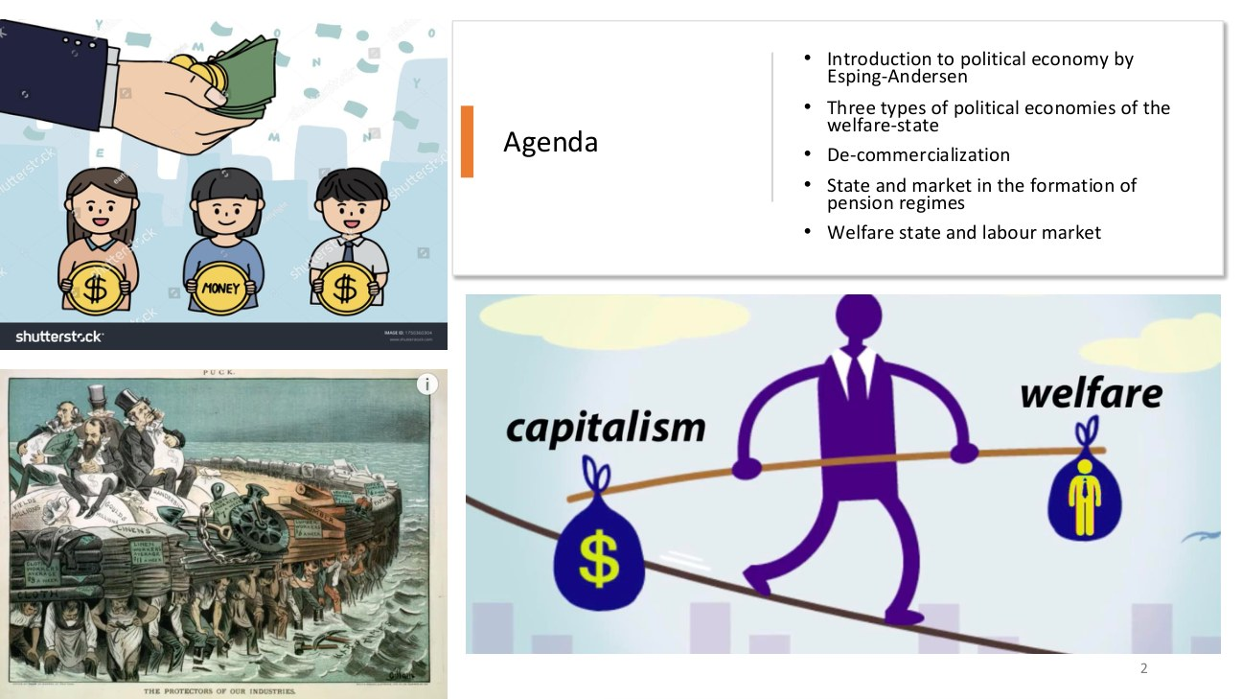
原PPT第2页截图 / Original screenshot, slide 2.

PPT中英翻译 / PPT translation
PPT English / 英文 | 中文翻译 / Chinese
Introduction to political economy by Esping-Andersen | 介绍Esping-Andersen的政治经济学分析。
Three types of political economies of the welfare-state | 福利国家政治经济的三种类型。
De-commercialization | 原文用词：去商业化；本讲实际讨论的核心术语是de-commodification（去商品化）。
State and market in the formation of pension regimes | 国家与市场在养老金体制形成中的作用。
Welfare state and labour market | 福利国家与劳动力市场。

PPT知识点复习与分析 / Review and analysis
以下结合Word与听课宝讲解，属于复习补充。 / The following combines the Word notes and class summary as supplementary explanation.

知识点详解 / Detailed study notes

1. 议程怎样串起来 / Connecting the agenda
先界定福利国家，再比较三类制度，接着用去商品化衡量保障，最后看养老金和就业如何体现不同制度安排。教育是后面的应用领域。
The sequence moves from definition and classification to decommodification, then pensions, employment and educational applications.

2. 政治经济学的提问 / Political-economic questions
政策不是纯技术安排。它涉及资源由谁控制、责任怎样分配，以及不同阶层和群体取得什么权利。分析需解释政策背后的制度与利益关系。
Policy involves control of resources, allocation of responsibility and group entitlements. A political-economic explanation examines institutions and interests behind policy design.

3. 术语区别 / Terminology
Commercialization强调商业经营；commodification强调把满足需要、服务或劳动力纳入商品交换。两词相关但不等同，本讲以去商品化而非泛泛的非营利化为核心。
Commercialisation concerns commercial operation; commodification concerns treating needs, services or labour as commodities. The lecture focuses on decommodification, not simply non-profit provision.

易错辨析 / Pitfalls and distinctions

去商业化与去商品化 / Commercialisation versus commodification
不要把议程中的De-commercialization当成本讲规范概念。商业经营与商品交换有关，但本讲讨论生活对市场的依赖，应使用decommodification。
Do not use the agenda’s wording as the core technical term. The lecture concerns dependence on commodity exchange and markets: decommodification.

第03页 / Slide 03｜Three types of welfare capitalism｜福利资本主义的三种类型

原PPT第3页截图 / Original screenshot, slide 3.

PPT中英翻译 / PPT translation
PPT English / 英文 | 中文翻译 / Chinese
Three types of welfare capitalism; Esping-Andersen | 福利资本主义的三种类型；Esping-Andersen。

PPT知识点复习与分析 / Review and analysis
以下结合Word与听课宝讲解，属于复习补充。 / The following combines the Word notes and class summary as supplementary explanation.

本页核心 / Key takeaway
三类先记责任中心：自由型重市场，保守型重家庭与身份，社会民主型重共同社会权利。
Start with responsibilities: liberal regimes stress markets, conservative regimes family and status, and social democracy shared social rights.

知识点详解 / Detailed study notes

1. 三类关键词 / Three sets of keywords
自由主义：市场、自力更生、补缺救助；保守—法团主义：职业身份、社会保险、家庭责任；社会民主主义：普遍权利、较高去商品化与国家保障。
Liberal: markets, self-reliance and residual assistance. Conservative-corporatist: occupational status, social insurance and family responsibility. Social-democratic: universal rights, stronger decommodification and public protection.

2. 理想类型 / Ideal types
这些是帮助比较的理想类型。一个国家的不同政策领域可能具有不同特征；不能看到一种福利工具，就判断整个国家属于某一类型。
These are ideal types for comparison. Policy domains within a country can differ; one instrument cannot identify an entire regime.

3. 与上一课的区别 / Difference from the introduction
本讲集中讲经典三个世界。上一份导论课件另加入发展型国家，不能因此写成Esping-Andersen本来提出四种经典类型。
This lecture concentrates on the classic three worlds. The introductory course also compared developmental states; that does not make them an original fourth category in the classic typology.

易错辨析 / Pitfalls and distinctions

类型不是国名清单 / Types are not country lists
不能用“它是德国”代替“资格如何按职业与缴费组织”。制度机制是证据，国家名称只是提示。
The country name is not the evidence. Explain entitlement, occupation and contributions rather than relying on a label.

第04页 / Slide 04｜Welfare state: definition｜福利国家的定义
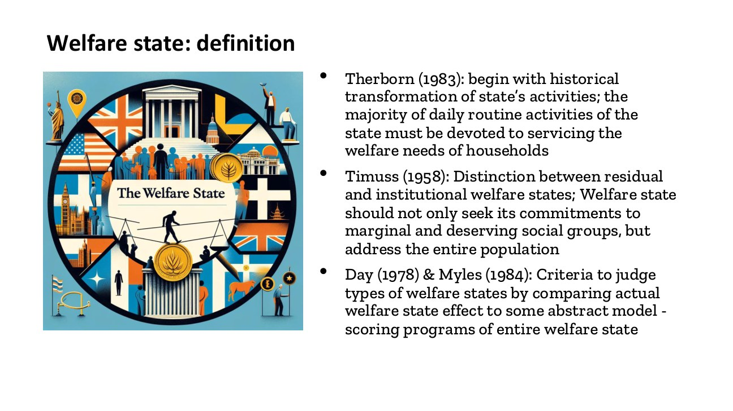
原PPT第4页截图 / Original screenshot, slide 4.

PPT中英翻译 / PPT translation
PPT English / 英文 | 中文翻译 / Chinese
Therborn (1983): begin with historical transformation of state’s activities; the majority of daily routine activities of the state must be devoted to servicing the welfare needs of households. | Therborn（1983）：从国家活动的历史转型出发；国家多数日常活动应服务于家庭的福利需要。
Timuss (1958): distinction between residual and institutional welfare states; commitments should address the entire population, not only marginal and deserving social groups. | 原文Timuss（规范拼写Titmuss，1958）：区分残余型与制度型福利国家；福利承诺应面向全体人口，而不只面向边缘及被认为“值得帮助”的群体。
Day (1978) & Myles (1984): compare actual welfare-state effects with an abstract model and score programmes of the entire welfare state. | Day（1978）与Myles（1984）：把实际福利效果与抽象模型比较，并对福利项目进行评分，以判断福利国家类型。

PPT知识点复习与分析 / Review and analysis
以下结合Word与听课宝讲解，属于复习补充。 / The following combines the Word notes and class summary as supplementary explanation.

本页核心 / Key takeaway
残余型把福利当作不足时的补缺；制度型把福利需要视为正常社会生活的一部分。
Residual welfare fills gaps; institutional welfare treats need as a normal part of social life.

知识点详解 / Detailed study notes

1. 三个定义角度 / Three approaches
Therborn看国家主要做什么；Titmuss看福利是补缺还是社会常规制度；Day与Myles强调与模型比较和评价实际效果。它们不是同一句定义的不同翻译。
Therborn examines state activities; Titmuss contrasts residual and institutional provision; Day and Myles emphasise models and effects. These are distinct analytical approaches.

2. 残余型与制度型 / Residual and institutional
残余型把福利看作市场或家庭失灵后的补救；制度型把福利需要看作正常社会生活的一部分，由稳定制度回应。“制度型”不只是指项目有规章。
Residual welfare intervenes after market or family failure. Institutional welfare treats needs as normal and addresses them through established institutions; institutional does not merely mean having rules.

3. Deserving的含义 / Meaning of deserving
Deserving指被政策或社会认为“值得救助”的群体，带有资格与道德判断。区分需要与是否值得帮助，能解释救助中的筛选和污名。
Deserving refers to people judged worthy of assistance. It introduces moral and eligibility distinctions that help explain selection and stigma.

4. 复习应用 / Application
判断福利国家不能只数项目或支出，还应检查覆盖对象、制度地位与结果。两地投入相近，也可能因资格不同产生不同保障。
Examine coverage, institutional status and outcomes, not only programme counts or expenditure. Similar spending can produce different protection through different rules.

易错辨析 / Pitfalls and distinctions

残余不是不存在 / Residual does not mean absent
残余型仍有公共福利，只是定位为补缺；制度型也仍有资格规则。不要把二者分别写成“零福利”和“人人无条件”。
Residual provision exists as gap-filling; institutional provision still has rules. Neither zero welfare nor completely unconditional provision captures the distinction.

第05页 / Slide 05｜Social citizenship｜社会公民权
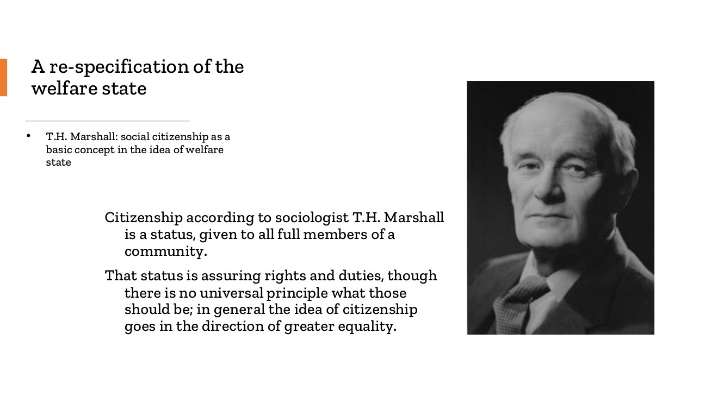
原PPT第5页截图 / Original screenshot, slide 5.

PPT中英翻译 / PPT translation
PPT English / 英文 | 中文翻译 / Chinese
T.H. Marshall: social citizenship as a basic concept in the idea of the welfare state. | T.H. Marshall：社会公民权是福利国家理念的基本概念。
Citizenship is a status given to all full members of a community. It assures rights and duties; there is no universal principle fixing their content, but citizenship generally moves towards greater equality. | 公民身份是共同体全部正式成员具有的一种地位，带来权利与义务；权利义务内容没有适用于所有社会的固定原则，但公民身份总体指向更大程度的平等。

PPT知识点复习与分析 / Review and analysis
以下结合Word与听课宝讲解，属于复习补充。 / The following combines the Word notes and class summary as supplementary explanation.

本页核心 / Key takeaway
社会公民权把基本保障理解为成员权利，而不只是慈善恩惠。
Social citizenship frames basic protection as a membership right, not merely charity.

知识点详解 / Detailed study notes

1. 权利而非恩惠 / Rights rather than favours
社会公民权把基本保障放在社会成员权利的框架中，而不是只依赖慈善或个人怜悯。重点是制度性资格与可主张的保障。
Social citizenship frames protection as a membership-based entitlement rather than charity or personal generosity. Institutional and claimable rights are central.

2. 权利与义务 / Rights and duties
公民身份包含权利，也包含共同体中的责任。不能把“有社会权利”理解为一切福利都无条件、免费或没有制度边界。
Citizenship includes duties as well as rights. Social rights do not imply that every benefit is unconditional, costless or without institutional boundaries.

3. 形式平等与实际平等 / Formal and substantive equality
人人名义上有权申请，不代表人人实际能取得。行政手续、费用、身份条件与信息差距可能造成不同机会，需要比较制度落实后的效果。
Formal eligibility does not ensure effective access. Procedures, costs, status rules and information barriers can create unequal opportunities.

4. 与下页连接 / Link to the next slide
接下来既要问社会权利有多强，也要问权利在群体之间怎样分配。这就把社会公民权联系到去商品化与社会分层。
The next questions concern both the strength of protection and its distribution across groups, linking citizenship to decommodification and stratification.

易错辨析 / Pitfalls and distinctions

名义权利与有效取得 / Formal versus effective rights
有申请权不等于一定领取或实际用得上。回答应区分制度承诺、资格、障碍与实际效果。
A right to apply does not establish receipt or effective use. Distinguish commitments, rules, barriers and outcomes.

第06页 / Slide 06｜Welfare-state regimes｜福利国家体制
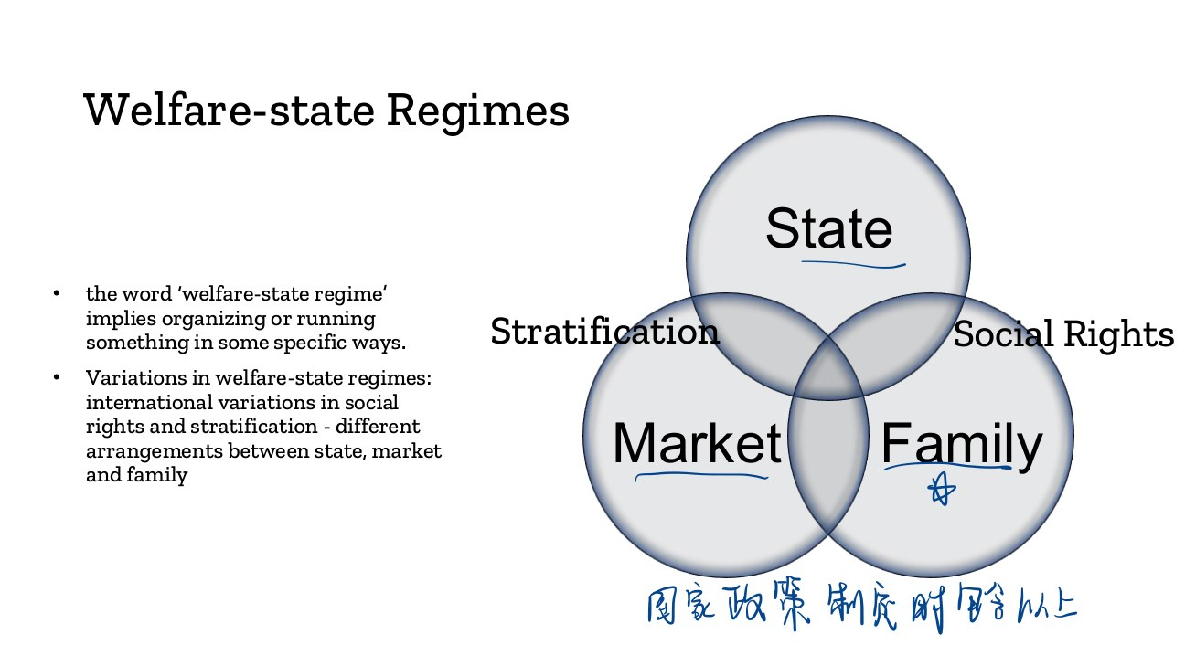
原PPT第6页截图 / Original screenshot, slide 6.

PPT中英翻译 / PPT translation
PPT English / 英文 | 中文翻译 / Chinese
A welfare-state regime implies organising or running something in specific ways. | 福利国家体制指以特定方式组织和运作福利。
International variations in social rights and stratification arise from different arrangements between state, market and family. | 国家、市场与家庭之间的安排不同，带来社会权利与社会分层的国际差异。
Diagram: State / Market / Family; Stratification / Social Rights. | 图示：国家／市场／家庭；社会分层／社会权利。

PPT知识点复习与分析 / Review and analysis
以下结合Word与听课宝讲解，属于复习补充。 / The following combines the Word notes and class summary as supplementary explanation.

本页核心 / Key takeaway
福利体制分析国家—市场—家庭怎样共同组织保障，不能与单个福利项目混同。
A welfare regime concerns the state–market–family organisation of protection, not a single programme.

知识点详解 / Detailed study notes

1. Regime不是单个项目 / Regime versus programme
体制是一套相互关联的组织方式，涉及资格、融资、供给和责任；失业保险或养老金是其中的项目，不能与整个体制互换。
A regime is an interconnected arrangement of eligibility, finance, provision and responsibility. Individual pension or unemployment programmes are components, not the whole regime.

2. 三方责任 / Three institutional roles
市场通过收入与购买配置资源；家庭通过照顾、转移和代际支持回应需要；国家通过公共服务、保险、救助和监管发挥作用。三者可以同时存在。
Markets allocate through income and purchasing; families provide care and transfers; states supply services, insurance, assistance and regulation. These roles coexist.

3. 社会分层 / Stratification
制度可能缩小差异，也可能按职业、性别或家庭位置维持差异。应问谁被纳入、谁被排除，而不只看受益者平均拿到多少钱。
Institutions may reduce or reproduce divisions by occupation, gender or family position. Examine inclusion and exclusion, not only average benefit amounts.

4. 比较步骤 / Comparison steps
先说明三方怎样分工，再比较资格与保障，最后评价社会差异。图中“中心”表示相对责任，不意味着其他主体完全消失。
Identify institutional responsibilities, compare entitlements and protection, then assess divisions. A central role does not mean the other institutions disappear.

易错辨析 / Pitfalls and distinctions

家庭重要不等于国家无力 / Family importance is not a weak state
国家可以通过强制社会保险和家庭规则维护家庭中心。不能只按公共支出多少推断体制。
A state may actively sustain family-centred arrangements through insurance and law. Spending alone cannot identify the regime.

第07页 / Slide 07｜De-commodification｜去商品化
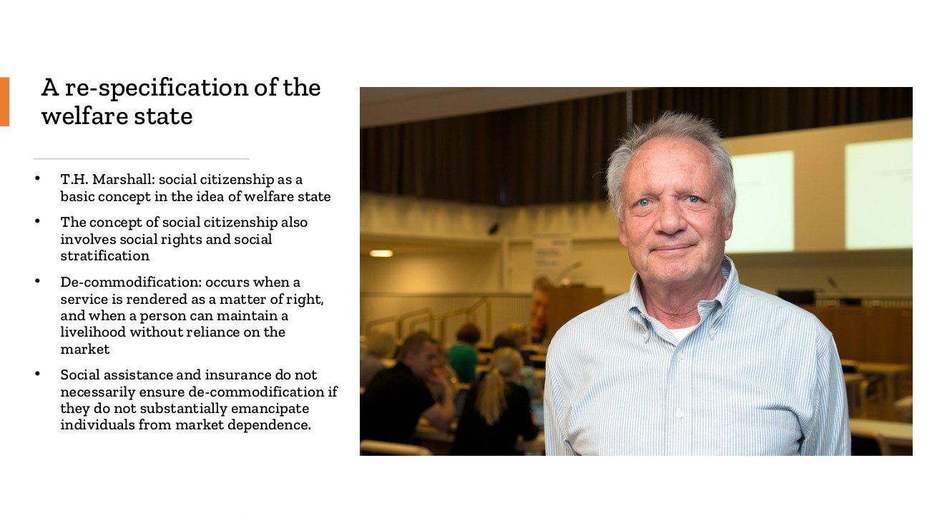
原PPT第7页截图 / Original screenshot, slide 7.

PPT中英翻译 / PPT translation
PPT English / 英文 | 中文翻译 / Chinese
Social citizenship involves social rights and social stratification. | 社会公民权涉及社会权利与社会分层。
De-commodification occurs when a service is rendered as a matter of right, and a person can maintain a livelihood without reliance on the market. | 当服务作为权利提供，个人不依赖市场也能维持生活时，就发生去商品化。
Social assistance and insurance do not necessarily ensure de-commodification if they do not substantially emancipate individuals from market dependence. | 若社会救助与社会保险没有实质降低个人对市场的依赖，它们就不一定确保去商品化。

PPT知识点复习与分析 / Review and analysis
以下结合Word与听课宝讲解，属于复习补充。 / The following combines the Word notes and class summary as supplementary explanation.

本页核心 / Key takeaway
去商品化看“不完全依赖市场也能维持社会可接受生活”的程度。
Decommodification measures the extent of socially acceptable living without complete market dependence.

知识点详解 / Detailed study notes

1. 核心定义 / Core definition
去商品化关注不完全依赖市场参与而维持社会可接受生活的程度。失业、患病或年老时，保障能否持续与充分，是判断的关键。
Decommodification concerns the degree to which people maintain socially acceptable lives without complete dependence on market participation, including during unemployment, illness and old age.

2. 有制度不等于保障充分 / Existence versus protection
一个项目即使叫社会保险，若给付过低、期限过短或资格极严，仍可能迫使人立即返回市场。因此需看给付水平、期限、覆盖和资格的组合。
An insurance programme may provide weak protection if benefits are low, short or difficult to obtain. Examine amounts, duration, coverage and eligibility together.

3. 程度而非全有全无 / A matter of degree
Word总结中“只有完全解放才算”的语气过强。本课指数本身按程度评分，部分减少市场依赖也可以具有去商品化作用，不要求现实中彻底取消市场。
The notes’ all-or-nothing wording is too strong. The index measures degrees: partial protection can decommodify without abolishing markets.

4. 辅助例子 / Illustration
两位病人都有病假制度，但一人可得到足以生活的带薪病假，另一人只能得到极少且短期的支持，两者去商品化程度可能不同。
Two workers may both have sickness protection, yet adequate paid leave can offer stronger decommodification than minimal, brief support.

易错辨析 / Pitfalls and distinctions

项目存在不等于高度去商品化 / A programme is not enough
判断需要看资格、额度、期限和保障对象。给付少且短，即使名字叫社会保险，仍可能高度依赖市场。
Assess eligibility, amount, duration and coverage. Brief, small benefits can leave strong market dependence despite an insurance label.

案例应用 / Worked application
给定一种疾病津贴，依次检查谁有资格、收入能替代多少、可领多久、谁被排除，再判断它如何降低市场压力。项目叫保险不是分析终点。
For sickness benefit, check eligibility, replacement, duration and exclusions before explaining reduced market pressure. The insurance label is only the start.

第08页 / Slide 08｜The three worlds｜三个世界的名称
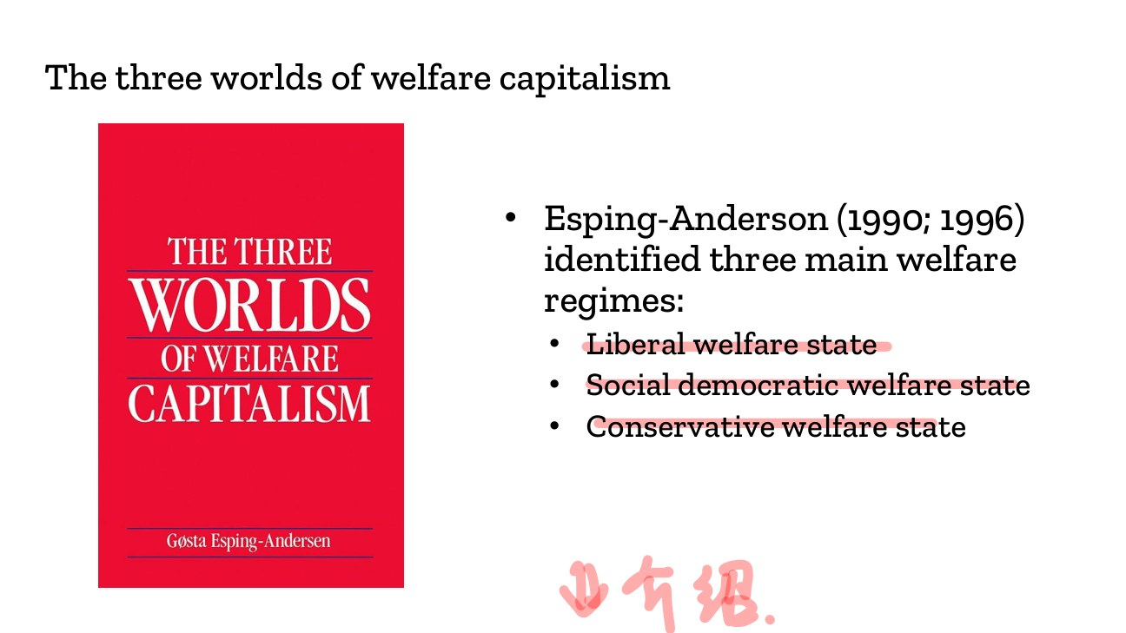
原PPT第8页截图 / Original screenshot, slide 8.

PPT中英翻译 / PPT translation
PPT English / 英文 | 中文翻译 / Chinese
Esping-Anderson (1990; 1996) identified three main welfare regimes. | 课件原文Esping-Anderson（规范拼写Esping-Andersen，1990、1996）提出三种主要福利体制。
Liberal welfare state / Social democratic welfare state / Conservative welfare state | 自由主义福利国家／社会民主主义福利国家／保守主义福利国家。

PPT知识点复习与分析 / Review and analysis
以下结合Word与听课宝讲解，属于复习补充。 / The following combines the Word notes and class summary as supplementary explanation.

知识点详解 / Detailed study notes

1. 名称与机制 / Labels and mechanisms
记名称后，要能说出福利通过什么渠道提供、凭什么取得，以及怎样影响市场依赖与阶层差异。只背美国、德国、瑞典不足以完成分析。
After learning the labels, explain provision, entitlement, market dependence and stratification. Country-name recall alone is insufficient.

2. 国家案例的地位 / Country examples
典型国家展示某些制度特征，并不保证每项政策都符合类型。分析应注明领域和时期，例如养老金分类可能与教育领域分类不完全一致。
Typical countries illustrate features rather than exact uniformity. Specify domain and period; pension and education classifications need not coincide.

3. 答题组织 / Answer structure
先给出类型的核心逻辑，再用政策资格和供给方式举证，最后指出局限。不要先贴标签，再把所有事实硬塞进标签。
State the logic, demonstrate it with policy mechanisms, then note limits. Avoid forcing every fact into a prior label.

易错辨析 / Pitfalls and distinctions

经典三类与现实混合 / Ideal types and mixed cases
不要假定每个国家在养老金、教育和住房都处于同一组；领域和时期可能改变判断。
Countries need not fit the same group across pensions, education and housing. Domain and period matter.

第09页 / Slide 09｜Three-regime comparison table｜三类体制比较表
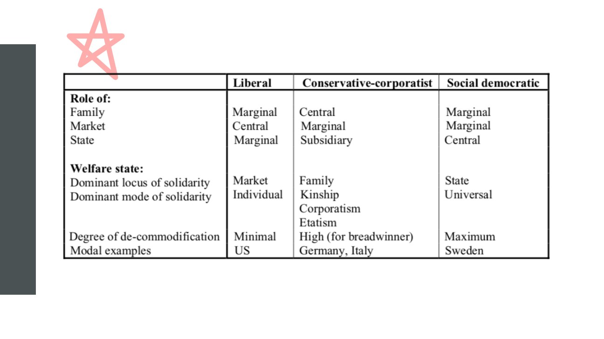
原PPT第9页截图 / Original screenshot, slide 9.

PPT中英翻译 / PPT translation
PPT English / 英文 | 中文翻译 / Chinese
Liberal: family marginal; market central; state marginal. | 自由型：家庭相对边缘；市场中心；国家相对边缘。
Conservative-corporatist: family central; market marginal; state subsidiary. | 保守—法团型：家庭中心；市场相对边缘；国家辅助。
Social democratic: family marginal; market marginal; state central. | 社会民主型：家庭和市场相对边缘；国家中心。
Dominant locus / mode of solidarity: liberal—market / individual; conservative—family / kinship, corporatism, etatism; social democratic—state / universal. | 团结的主要依托／方式：自由型为市场／个人；保守型为家庭／亲属、法团主义、国家主义；社会民主型为国家／普遍性。
Degree of de-commodification: minimal / high (for breadwinner) / maximum. Modal examples: US / Germany and Italy / Sweden. | 去商品化：最低／对家庭主要收入者较高／最高。典型例：美国／德国和意大利／瑞典。

PPT知识点复习与分析 / Review and analysis
以下结合Word与听课宝讲解，属于复习补充。 / The following combines the Word notes and class summary as supplementary explanation.
★ 原PPT五角星重点 / Starred on the original PPT

本页核心 / Key takeaway
三类责任中心依次是市场、家庭、国家；还要比较权利依据、团结方式与分层。
The three ideal types centre responsibility on market, family and state; also compare entitlement, solidarity and stratification.

知识点详解 / Detailed study notes

1. 角色是相对的 / Relative roles
市场或家庭在表中边缘化，不表示这些机构不存在；国家辅助也不等于国家无力。保守型国家可以用强制度维护职业与家庭安排。
Marginal roles do not mean absence. A subsidiary state can use strong institutions to sustain occupational and family arrangements.

2. Breadwinner / 家庭主要收入者
表中保守型对breadwinner保障较高，提醒我们保护可能偏向稳定就业的主要收入者。不能把这一群体的较高保障推成所有成员都平等获得保障。
High protection for breadwinners may favour stable earners; it does not establish equal protection for every member.

3. 与Word表格的不同 / Difference from the Word table
Word把保守型去商品化概括为“中等”，课件则特意限定“对主要收入者较高”。考试说明对象和条件，比机械排出高中低更准确。
The Word table says moderate, while the slide specifies high protection for breadwinners. State the protected group and conditions rather than relying on a simple ranking.

4. 跨阶层与地位维持 / Equality versus status preservation
普遍保障可强调跨群体共同权利；职业分割的保险可能维持身份差异。要同时比较保障水平和分配结构。
Universal provision can stress common rights, while occupational insurance may preserve status divisions. Compare both protection levels and distribution.

星标内容重点展开 / In-depth starred focus

星标重点①：按同一顺序读表 / Star focus 1: read in a fixed order
先看家庭、市场、国家谁居中心，再看团结依托，最后看去商品化对象和典型案例。例如保守型家庭居中心、国家辅助，但社会保险可能很强，不能用“政府弱”概括。
Read central roles first, then solidarity, protected groups and examples. Family centrality and state subsidiarity can coexist with strong statutory insurance; they do not simply mean a weak government.

星标重点②：两个问题不能合并 / Star focus 2: two separate questions
去商品化问：保障能在多大程度上减少市场依赖？社会分层问：保障在不同职业、家庭和性别位置间怎样分配？一个制度可较好保护主要收入者，同时保留身份差异。
Decommodification asks how far protection reduces market dependence; stratification asks how protection is distributed across occupations and household or gender positions. Strong earner protection can preserve status differences.

星标重点③：用同一个需要作比较 / Star focus 3: compare the same need
假设都讨论退休后的收入：自由型提问聚焦市场与补缺，保守型聚焦职业缴费与家庭，社会民主型聚焦广泛共同权利。它们是分析方向，不代表每个国家项目只有一种工具。
For retirement income, ask about markets and residual support, occupational contributions and family, or broad common rights. These are comparative questions, not claims that each country uses only one instrument.

英文组织示例 / Model explanation
三种理想类型在市场、家庭和国家之间分配责任的方式不同。保守型可以高度保护主要收入者，同时维持身份差异，因此保障与平等需要分别评价。
The three ideal types allocate responsibility differently among market, family and state. Conservative protection can be high for breadwinners while preserving status differences, so protection and equality must be assessed separately.
复习维度 / Dimension | 自由型 / Liberal | 保守型 / Conservative | 社会民主型 / Social-democratic
责任中心 / Responsibility | 市场 / Market | 家庭与身份 / Family and status | 国家保障 / State protection
资格提问 / Entitlement question | 怎样审查需要？ / How is need assessed? | 怎样联系职业缴费？ / How is status linked to contributions? | 怎样覆盖共同成员？ / How broad is membership-based coverage?
分层关注 / Stratification | 安全网与市场二元 / Assistance–market dualism | 身份差异 / Status divisions | 共同权利与标准 / Shared rights and standards

易错辨析 / Pitfalls and distinctions

中心、保障与平等 / Centrality, protection and equality
国家辅助不等于国家没有作用；主要收入者保障高不等于人人保障高；去商品化高也不能单独证明阶层平等。
Subsidiarity is not absence; strong breadwinner protection is not universal protection; high decommodification alone does not prove equality.

第10页 / Slide 10｜De-commodification｜去商品化主题页

原PPT第10页截图 / Original screenshot, slide 10.

PPT中英翻译 / PPT translation
PPT English / 英文 | 中文翻译 / Chinese
De-commodification | 去商品化。

PPT知识点复习与分析 / Review and analysis
以下结合Word与听课宝讲解，属于复习补充。 / The following combines the Word notes and class summary as supplementary explanation.

知识点详解 / Detailed study notes

1. 本节要回答的问题 / Section question
为什么资本主义中需要保障人在市场之外的生活？后续页面先解释劳动力商品化，再对比自由主义、社会主义与现实资格制度的回应。
Why protect life outside the market under capitalism? The following slides explain labour commodification and compare ideological and institutional responses.

2. 先区分两个方向 / Two directions
商品化使生活资源更依赖购买与工资；去商品化提供一定保障，使人不必在所有情况下立即出售劳动力。两者可在同一社会并存。
Commodification increases reliance on purchases and wages; decommodification protects people from an immediate need to sell labour in every circumstance. Both can coexist.

3. 图片的使用边界 / Limits of the image
图片是批判性示意，不是就业或收入数据。用它理解问题意识，不从图中推导具体国家的评分或政策成效。
The image is illustrative rather than empirical evidence. It cannot establish country scores or policy effects.

第11页 / Slide 11｜Capitalism and commodification｜资本主义与商品化
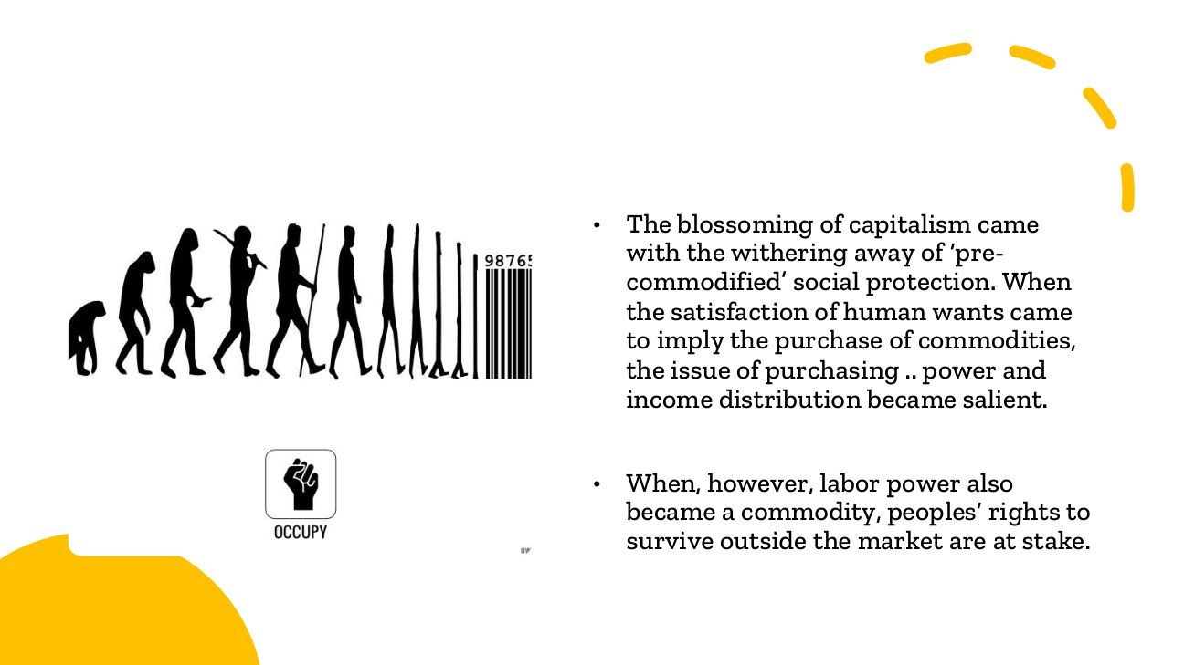
原PPT第11页截图 / Original screenshot, slide 11.

PPT中英翻译 / PPT translation
PPT English / 英文 | 中文翻译 / Chinese
Capitalism blossomed as “pre-commodified” social protection withered. When satisfying human wants required purchasing commodities, purchasing power and income distribution became salient. | 资本主义发展伴随“商品化以前”的社会保护衰退；当满足需要要靠购买商品时，购买力和收入分配就变得重要。
When labour power also became a commodity, people’s rights to survive outside the market were at stake. | 当劳动力也成为商品，人们在市场之外生存的权利就面临问题。

PPT知识点复习与分析 / Review and analysis
以下结合Word与听课宝讲解，属于复习补充。 / The following combines the Word notes and class summary as supplementary explanation.

本页核心 / Key takeaway
当生活依靠购买、劳动力依靠出售时，能否在市场之外生存就成为福利问题。
When necessities are purchased and labour is sold, survival outside the market becomes a welfare question.

知识点详解 / Detailed study notes

1. 为什么购买力变重要？ / Why purchasing power matters
若食物、居住和照顾主要通过购买取得，没有收入的人便难以满足需要。市场分配与生活机会因此相连，而不只是消费偏好的差异。
When necessities are purchased, lack of income threatens access. Market allocation then shapes basic life chances, not merely consumer preferences.

2. 劳动力商品化 / Labour commodification
劳动者通过出售劳动能力获得工资；失业、疾病或年老可能使出售能力受限。福利问题是在不能出售或暂时不出售时如何维持生活。
Workers earn by selling labour power. Unemployment, illness and age can interrupt this capacity, raising the question of income and support outside employment.

3. 避免美化过去 / Avoid romanticising the past
旧有家庭、地方和身份保障未必公平或充分。课件说明保护方式转型，不意味着市场出现以前人人都享有良好福利。
Earlier family, local or status-based protection was not necessarily adequate or equal. The slide describes institutional change, not universal security in the past.

4. 与分层的联系 / Link to stratification
购买力不同，会影响取得资源的能力；公共权利与家庭支持也可能改变这种关系。因此要把工资、转移和服务一起看。
Different purchasing power creates unequal access, while public entitlements and family resources can modify it. Examine wages, transfers and services together.

易错辨析 / Pitfalls and distinctions

工资收入不是去商品化 / Wages are not decommodification
工资高可提高购买力，但仍以出售劳动为条件；要问收入中断时是否有独立保障，不能把高薪本身当去商品化。
High wages increase purchasing power but depend on selling labour. Examine protection when earnings stop, not wages alone.

第12页 / Slide 12｜Labour’s commodity form｜劳动力的商品形式
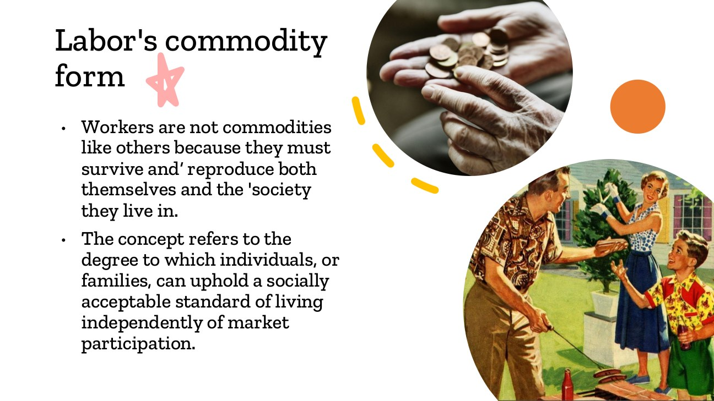
原PPT第12页截图 / Original screenshot, slide 12.

PPT中英翻译 / PPT translation
PPT English / 英文 | 中文翻译 / Chinese
Workers are not commodities like others: they must survive and reproduce themselves and the society they live in. | 劳动者不同于一般商品：他们必须生存，并维系自身与社会的再生产。
The concept refers to the degree to which individuals or families can uphold a socially acceptable standard of living independently of market participation. | 这一概念指个人或家庭能够在多大程度上不依赖市场参与，仍维持社会可接受的生活水平。

PPT知识点复习与分析 / Review and analysis
以下结合Word与听课宝讲解，属于复习补充。 / The following combines the Word notes and class summary as supplementary explanation.
★ 原PPT五角星重点 / Starred on the original PPT

本页核心 / Key takeaway
劳动者必须生存并维系社会；去商品化衡量不依靠市场参与也能维持生活的程度。
Workers must survive and sustain society; decommodification measures protection of living standards outside market participation.

知识点详解 / Detailed study notes

1. 特殊性在哪里？ / What makes labour special?
普通物品可以停止使用，但劳动者仍有食物、居住、健康和照顾需要。劳动能力的维持还依赖家庭照顾与公共服务，不能把人完全当作可任意调节的库存。
Unlike unused objects, workers continue to need food, shelter, health and care. Maintaining labour capacity depends on care and services, not merely market exchange.

2. 社会再生产 / Social reproduction
这里包括照顾、教育和维系新一代与社会生活，不只指生育。理解这点，才能看见家庭和国家怎样支持看似独立的劳动市场。
Social reproduction includes care, education and sustaining generations and social life, not only childbirth. Families and public services support the labour market.

3. 生活标准而非只求生存 / Living standard beyond survival
定义是社会可接受的生活，不是只要不饿死。福利额度很低，即使形式上有项目，也可能不足以实质降低市场依赖。
The standard is socially acceptable living, not bare survival. A nominal benefit may be too small to reduce market dependence substantially.

4. 个人与家庭都要看 / Individuals and families
家庭总收入可能掩盖成员之间的依赖。例如一个人靠配偶收入生活，并不等于获得独立的社会权利；保障与家庭内部关系需要一起分析。
Household income can conceal dependence within families. Reliance on a spouse is not necessarily an independent social entitlement.

星标内容重点展开 / In-depth starred focus

星标重点①：为何劳动不是普通商品？ / Star focus 1: why is labour special?
普通商品暂时卖不出去可以搁置，但人仍需食物、居所、健康和照顾。劳动者还参与养育和维系社会，市场需求降低并不会使这些需要消失。这是社会保护问题的起点。
Unsold goods can be stored, but people still need food, shelter, health and care. Workers also sustain families and society; lower market demand does not erase these needs. This motivates social protection.

星标重点②：定义的三个组成 / Star focus 2: three parts of the definition
判断去商品化要说清保障对象是个人或家庭，判断标准是社会可接受的生活，核心关系是对市场参与的依赖程度。不能省略“程度”，把现实制度分成完全有或完全没有。
Specify the individual or family, a socially acceptable standard, and the degree of dependence on market participation. The degree matters: real protection is not simply all-or-nothing.

星标重点③：假设对照例子 / Star focus 3: a hypothetical comparison
甲生病后工资中断且没有替代保障，被迫立即找收入；乙有足以维持生活的法定疾病津贴。乙可能有更强去商品化。若丙只靠配偶收入，也要另外看家庭依赖，不能直接当作独立社会权利。
A loses pay during illness without replacement support; B has adequate statutory sickness benefit. B may be better protected from market dependence. If C relies only on a spouse, family dependence must also be examined.

星标重点④：与后面指数相连 / Star focus 4: link to the index
第19页用养老金、疾病和失业保障操作化这一概念。例子的比较逻辑应落到资格、给付、期限和覆盖，而不是只说哪国更好或有没有福利名称。
Slide 19 operationalises the concept through pensions, sickness and unemployment. Compare entitlement, amounts, duration and coverage rather than country reputation or programme names alone.

英文组织示例 / Model explanation
劳动者不是普通商品，因为他们的生存与社会再生产必须持续。去商品化衡量人们能在多大程度上不依赖市场维持可接受的生活；制度必须通过实际保障来评价。
Workers are not ordinary commodities because their subsistence and social reproduction must continue. Decommodification measures how far people can maintain acceptable lives without market dependence; institutions must be evaluated through actual protection.
假设情形 / Hypothetical situation | 应怎样判断？ / Interpretation
有较高工资，但收入完全随就业中断 / High wages, but all income stops with work | 工资高不自动等于去商品化高 / High wages alone do not establish decommodification
本人不就业，完全依靠配偶 / No employment; entirely supported by a spouse | 须另看家庭依赖与独立权利 / Examine family dependence and independent rights
患病时有足以生活的法定津贴 / Adequate statutory income during illness | 可降低市场压力；仍看资格和期限 / Can reduce market pressure; eligibility and duration still matter

易错辨析 / Pitfalls and distinctions

不工作、家庭支持与社会权利 / Non-work, family help and rights
没有就业不自动等于高去商品化；靠配偶生活不自动等于独立社会权利；去商品化也不是取消就业或所有市场。
Non-employment does not automatically mean decommodification, spousal support is not an independent social right, and decommodification does not abolish employment or markets.

第13页 / Slide 13｜Classical political economy｜古典政治经济学的不同回应
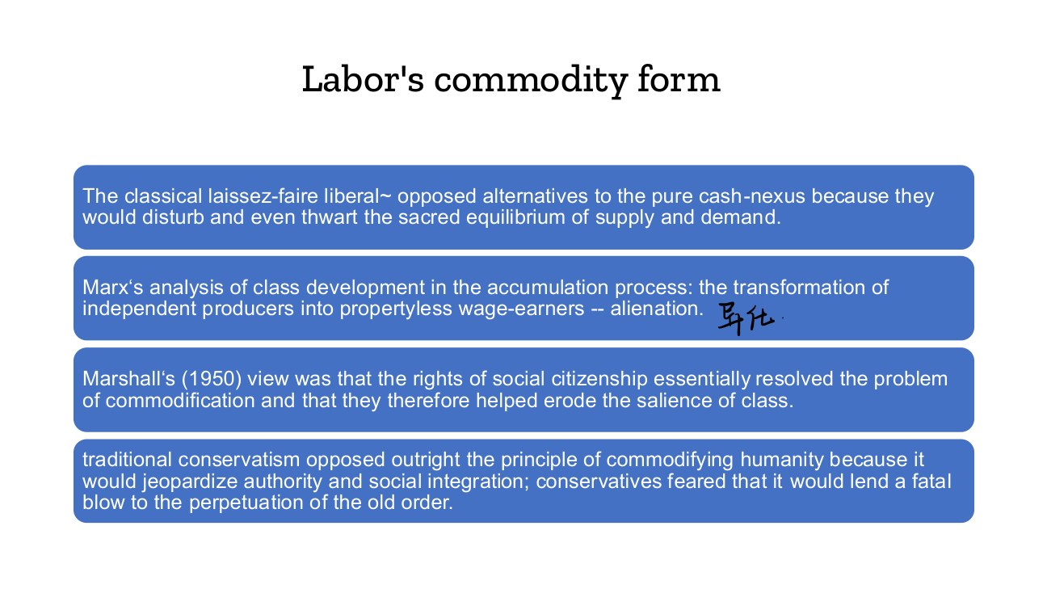
原PPT第13页截图 / Original screenshot, slide 13.

PPT中英翻译 / PPT translation
PPT English / 英文 | 中文翻译 / Chinese
Classical laissez-faire liberals opposed alternatives to the pure cash nexus because these would disturb the equilibrium of supply and demand. | 古典自由放任主义反对纯粹金钱交换关系之外的安排，认为这会扰乱供求均衡。
Marx: accumulation transforms independent producers into propertyless wage-earners—alienation. | 马克思：积累过程把独立生产者转变为无产的工资劳动者，并产生异化。
Marshall (1950): social citizenship rights resolved commodification and helped erode the salience of class. | Marshall（1950）的观点：社会公民权回应商品化问题，并帮助削弱阶级的重要性。
Traditional conservatism opposed commodifying humanity because it jeopardised authority, social integration and the old order. | 传统保守主义反对把人商品化，因为它会危及权威、社会整合及旧有秩序。

PPT知识点复习与分析 / Review and analysis
以下结合Word与听课宝讲解，属于复习补充。 / The following combines the Word notes and class summary as supplementary explanation.

本页核心 / Key takeaway
本页传统保守主义反对的是把人商品化，不是反对去商品化；理由可与维护权威有关。
Here traditional conservatism opposes commodifying humanity, not decommodification; its reasons may concern authority.

知识点详解 / Detailed study notes

1. Cash nexus与异化 / Cash nexus and alienation
Cash nexus指人际关系主要经金钱交易联结；异化在本页联系独立生产者失去生产资料、依靠工资生活。不要只把两个词译成“现金”和“陌生”。
Cash nexus refers to relations mediated by money. Alienation here connects loss of independent production with wage dependence; these are analytical concepts, not literal everyday labels.

2. 共同问题，不同理由 / Different reasons
不同思想都回应商品化，但理由不一样：自由放任重市场秩序，马克思重阶级与资本积累，Marshall重权利与平等，保守主义重权威和传统整合。
The responses differ: market order, class and accumulation, rights and equality, or authority and traditional integration.

3. 必须纠正的方向 / Essential correction
听课宝将保守主义写成反对“去商品化”，与本页原文方向不符。本页明确说传统保守主义反对把人商品化；反市场商品化的理由也不必是追求平等。
The summary reverses the term. This slide says traditional conservatism opposed commodifying humanity, not decommodification. Opposition to commodification need not be egalitarian.

4. 别混同历史思想与完整体制 / Ideas versus regimes
这里比较思想传统，后文才讨论现代福利制度。不能把一条思想论证直接当成今天所有保守型国家政策的事实。
This slide compares intellectual traditions. Do not convert a historical argument into a factual claim about every contemporary conservative-regime policy.

易错辨析 / Pitfalls and distinctions

不要把方向写反 / Do not reverse the concept
本页原文是传统保守主义反对商品化，理由是权威与社会整合；不要沿用总结里反对“去商品化”的误写。
The slide concerns opposition to commodification for reasons of authority and integration. Do not repeat the summary’s reversed terminology.

第14页 / Slide 14｜The liberal response｜自由主义对商品化困境的回应
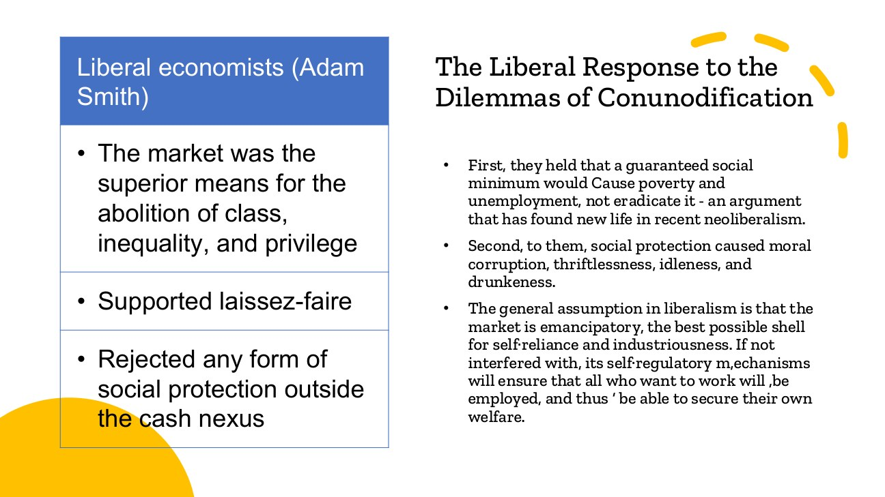
原PPT第14页截图 / Original screenshot, slide 14.

PPT中英翻译 / PPT translation
PPT English / 英文 | 中文翻译 / Chinese
Liberal economists (Adam Smith): the market was the superior means to abolish class, inequality and privilege; supported laissez-faire; rejected social protection outside the cash nexus. | 课件所述自由主义论证：市场是消除阶级、不平等和特权的更优方式；支持自由放任；拒绝金钱交换关系之外的社会保护。
A guaranteed social minimum would cause poverty and unemployment, not eradicate them; this argument reappears in neoliberalism. | 这一立场认为，保证社会最低生活水平反而会导致贫困与失业；课件指出类似论证在新自由主义中再出现。
Social protection was said to cause moral corruption, thriftlessness, idleness and drunkenness. | 这种论证把社会保护与道德败坏、不节俭、懒惰和酗酒联系起来。
The market is seen as emancipatory and supportive of self-reliance and industriousness; undisturbed self-regulation is expected to employ all who wish to work. | 市场被视为促进解放、自立和勤奋；这种理论假定不受干预的自我调节可使愿意工作的人获得就业并自给。

PPT知识点复习与分析 / Review and analysis
以下结合Word与听课宝讲解，属于复习补充。 / The following combines the Word notes and class summary as supplementary explanation.

本页核心 / Key takeaway
“福利降低工作激励”是课件介绍的论证立场，不是已经证明的普遍事实。
The work-disincentive argument is a position presented on the slide, not a proven universal fact.

知识点详解 / Detailed study notes

1. 工作激励的逻辑 / Work incentives
课件呈现一种担忧：非市场收入可能降低接受工作的动力，因此福利应受限制。这是在解释一种理论立场，不是证明福利必然使人懒惰。
The argument worries that non-market income weakens incentives to work. This explains a position; it does not prove that benefits inevitably create idleness.

2. 规范主张与事实分开 / Claims versus evidence
“市场会让所有愿意工作的人就业”是所述理论假定，现实中还要检查岗位、技能、照顾负担及经济波动。翻译不能把思想主张变成已经证实的事实。
Full employment through self-regulation is an assumption here. Actual outcomes depend on jobs, skills, care responsibilities and economic conditions.

3. 历史标签的边界 / Historical labels
此页把复杂思想概括为理想化立场。不要据此断言Adam Smith的所有思想或全部现代自由主义政策都完全相同。
The slide simplifies a complex tradition. It should not establish that all of Adam Smith’s views or all modern liberal policies are identical.

易错辨析 / Pitfalls and distinctions

解释理论不等于支持理论 / Explaining is not endorsing
用“该理论认为……”引入激励论证，再检验证据；不要直接写福利必然导致懒惰或市场必然充分就业。
Attribute the argument to the theory and then assess evidence; do not assert inevitable idleness or automatic full employment.

第15页 / Slide 15｜Means-testing and residualism｜家计审查与补缺主义
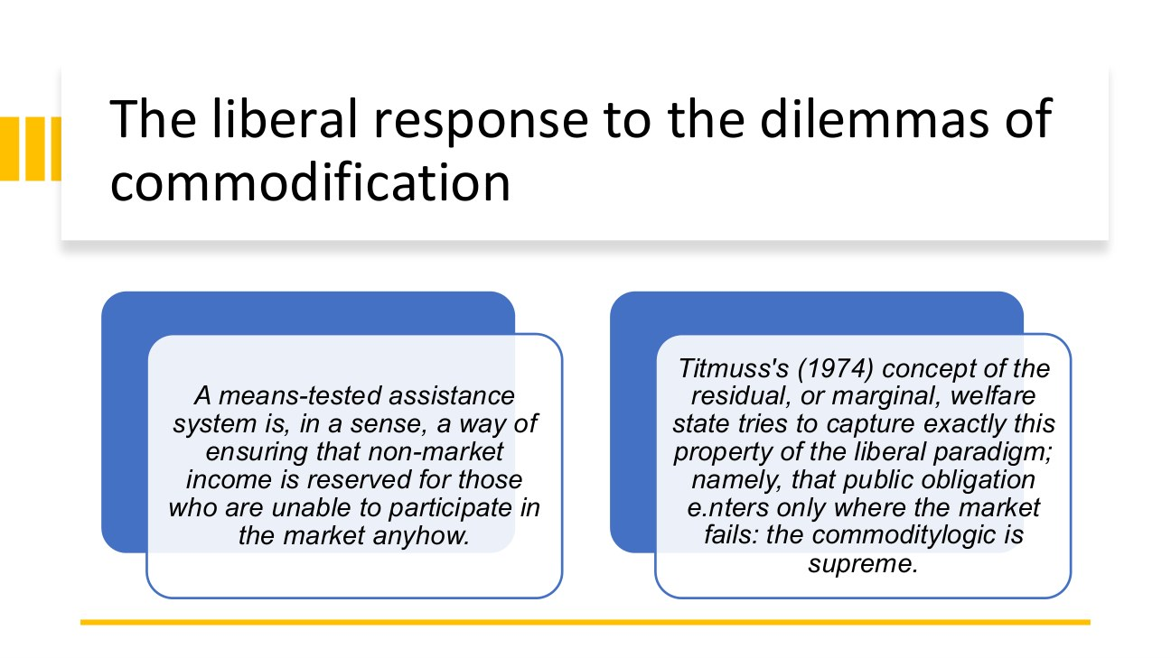
原PPT第15页截图 / Original screenshot, slide 15.

PPT中英翻译 / PPT translation
PPT English / 英文 | 中文翻译 / Chinese
Means-tested assistance reserves non-market income for those unable to participate in the market. | 家计审查式救助把非市场收入保留给无法参与市场的人。
Titmuss (1974): residual or marginal welfare means public obligation enters only where the market fails; commodity logic remains supreme. | Titmuss（1974）：残余型或边缘型福利指公共责任只在市场失灵时进入，商品逻辑仍占主导。

PPT知识点复习与分析 / Review and analysis
以下结合Word与听课宝讲解，属于复习补充。 / The following combines the Word notes and class summary as supplementary explanation.

本页核心 / Key takeaway
Means-testing审查收入与资产等经济状况；残余主义把公共保障定位为补缺安全网。
Means-testing assesses income and assets; residualism positions public protection as a gap-filling safety net.

知识点详解 / Detailed study notes

1. Means-tested的准确含义 / Meaning of means-tested
指审查收入、财产等经济状况以判断资格，不是“反复测试个人是否努力”。它可把资源集中于经济困难者，但也可能增加手续和资格边界。
Means-testing assesses income or assets, not repeated tests of personal effort. It targets economic need but can create administrative and eligibility barriers.

2. 补缺怎样体现市场中心？ / Residualism and markets
多数人被预期通过市场取得资源，公共支持在不足时补上缺口。救助存在并不推翻市场中心，关键看公共责任是常规权利还是例外安全网。
Public help fills gaps while most people are expected to rely on markets. Assistance can coexist with market centrality.

3. 污名与未领取 / Stigma and non-take-up
如果资格要求证明贫困，申请者可能面对被标签化的压力；手续也可能使有资格者没有领取。不能仅看法律覆盖，还应关心实际取得机会。
Proving poverty can create stigma, while procedures may deter eligible claimants. Legal coverage and effective receipt are different.

4. 与普遍主义比较 / Comparison with universalism
普遍权利通常不以贫困证明作为基本资格，可能有更广覆盖；两者仍可能有居住、年龄等条件。不要把普遍主义简单等同无条件。
Universal entitlement does not normally require proof of poverty as its basic criterion, but can still include residence or age rules.

易错辨析 / Pitfalls and distinctions

Means不是努力测验 / Means-testing is not an effort test
Means指经济资源，不是反复考验一个人愿不愿工作。资格审查、工作条件与道德判断需要分别分析。
Means refers to financial resources. Resource tests, work conditions and moral judgements should be analysed separately.

第16页 / Slide 16｜Voluntarism and contributions｜自愿原则与贡献—回报
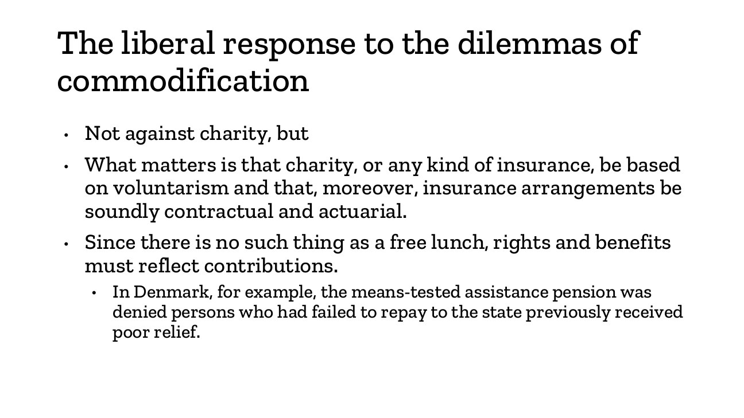
原PPT第16页截图 / Original screenshot, slide 16.

PPT中英翻译 / PPT translation
PPT English / 英文 | 中文翻译 / Chinese
Not against charity, but charity and insurance should rest on voluntarism; insurance should be contractual and actuarial. | 并非反对慈善，而是要求慈善和保险建立在自愿基础；保险应具有契约性并遵循精算原则。
There is no free lunch: rights and benefits must reflect contributions. | 所谓“没有免费午餐”：权利与福利应反映缴费或贡献。
Historical Danish example: a means-tested assistance pension was denied to people who had not repaid previously received poor relief. | 历史丹麦例子：未向国家偿还先前贫困救济的人，曾被拒绝领取家计审查式救助养老金。

PPT知识点复习与分析 / Review and analysis
以下结合Word与听课宝讲解，属于复习补充。 / The following combines the Word notes and class summary as supplementary explanation.

本页核心 / Key takeaway
自愿、契约和精算是不同原则；贡献型保险也不等于所有福利都按交钱返还。
Voluntary, contractual and actuarial principles differ; contributory insurance does not describe every form of welfare.

知识点详解 / Detailed study notes

1. 三个词怎样区分？ / Three terms
Voluntarism强调自愿参与；contractual强调约定权利义务；actuarial强调按风险、缴费等计算。它们不等于人人取得相同给付。
Voluntarism concerns voluntary participation, contractuality concerns agreed rights and duties, and actuarialism links calculations to risk and contributions.

2. 保险与救助不同 / Insurance and assistance
贡献型保险按缴费记录等确定待遇；经济审查式救助按经济需要确定资格。现实制度可以并存，不能把所有福利都当作交钱后返还。
Contributory insurance relates benefits to contribution records; means-tested assistance assesses need. Systems can combine both.

3. 历史例子不代表今天 / Historical scope
丹麦例子用于说明资格的道德和契约约束，不能直接写成今天丹麦养老金的现行规则。比较必须标明时期和具体制度。
The Danish example illustrates historical restrictions, not a statement of current pension law. Specify the period and programme.

易错辨析 / Pitfalls and distinctions

贡献与保险不是全部福利 / Contributions do not define all welfare
社会救助、普遍服务和缴费保险的资格基础不同；不能将所有权利都理解为等额退回自己的缴费。
Assistance, universal services and insurance rest on different rules; not all rights are a return of one’s payments.

第17页 / Slide 17｜Socialist politics and decommodification｜社会主义政治与去商品化
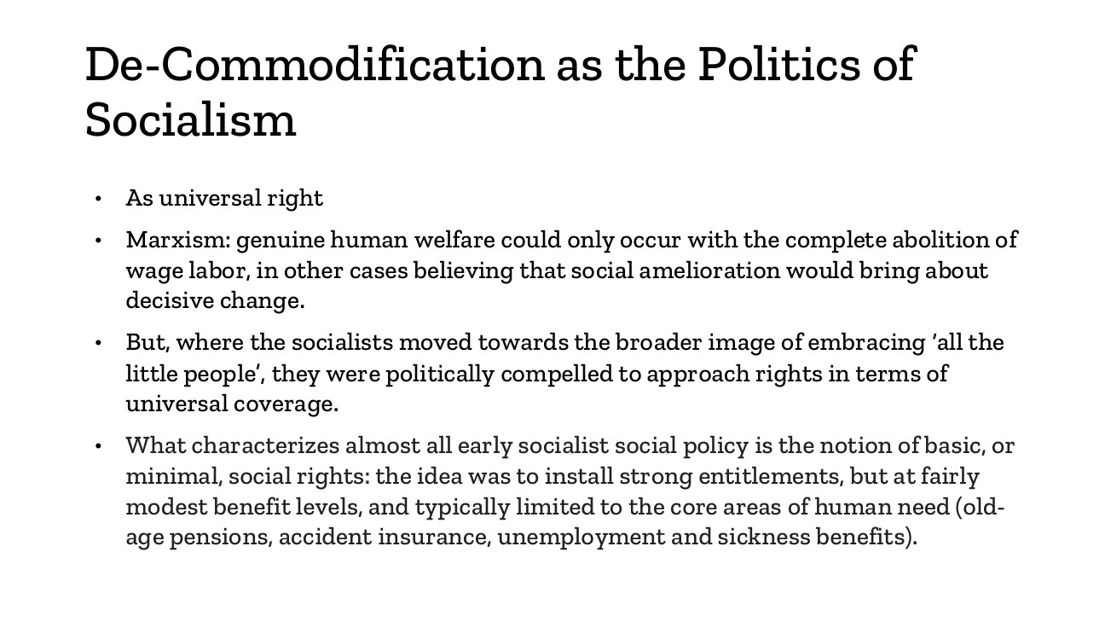
原PPT第17页截图 / Original screenshot, slide 17.

PPT中英翻译 / PPT translation
PPT English / 英文 | 中文翻译 / Chinese
As a universal right. | 作为普遍权利。
Some Marxist arguments locate genuine welfare in abolishing wage labour; other positions expect social improvements to bring decisive change. | 部分马克思主义论证把真正福利联系到废除工资劳动；另一些立场则认为社会改良可带来决定性变化。
Embracing “all the little people” pushed socialists towards universal coverage. | 为争取更广泛普通群体，社会主义政治逐渐走向普遍覆盖。
Early socialist policy: strong basic entitlements, modest benefits, concentrated on pensions, accident insurance, unemployment and sickness. | 早期政策特点：基本权利较强，给付水平较有限，集中于养老、工伤、失业和疾病。

PPT知识点复习与分析 / Review and analysis
以下结合Word与听课宝讲解，属于复习补充。 / The following combines the Word notes and class summary as supplementary explanation.

本页核心 / Key takeaway
早期社会主义政策可同时具有较强权利与较有限给付，权利强弱和金额高低要分开。
Early socialist policy could combine strong entitlement with modest benefits; rights and payment levels are separate dimensions.

知识点详解 / Detailed study notes

1. 权利强不等于金额高 / Rights versus benefit levels
权利是否稳定可主张，与金额多少是不同维度。一个制度可有较广而明确的权利，但给付仍有限；因此不能只按金额判断普遍主义。
Stable, broad entitlement and benefit generosity are distinct. A programme can establish strong rights while paying modest benefits.

2. 从特定阶级到广泛联盟 / Broadening political support
要覆盖更广群体，政策可能从狭窄身份支持走向共同权利。普遍主义也有政治联盟基础，而不是单纯行政设计。
Reaching wider groups can shift policy towards shared rights. Universalism can rest on broad political coalitions as well as administrative design.

3. 与自由型的对照 / Contrast with residual provision
自由型例外救助重在证明需要；普遍主义把基本保障放在共同成员资格上。两者区别既在对象，也在福利被理解为权利还是补缺。
Residual assistance centres on demonstrated need; universalism centres on shared membership. The contrast concerns both coverage and the status of welfare.

4. 不要把社会主义与无市场等同 / Avoid a false equivalence
后文社会民主主义是在资本主义内建立广泛保障，不等于已经废除所有工资劳动或市场。应区分激进理论目标与现实福利体制。
Social democracy builds protection within capitalism; it does not imply abolition of all wage labour or markets. Distinguish theoretical aims from actual institutions.

易错辨析 / Pitfalls and distinctions

普遍覆盖与高额给付 / Coverage versus generosity
覆盖广、权利稳不必金额高；给付慷慨也不必覆盖广。至少分开资格、水平、期限三个问题。
Wide coverage and stable rights need not mean high amounts; generosity need not mean inclusion. Distinguish eligibility, level and duration.

第18页 / Slide 18｜Entitlement conditions｜现实中的福利资格
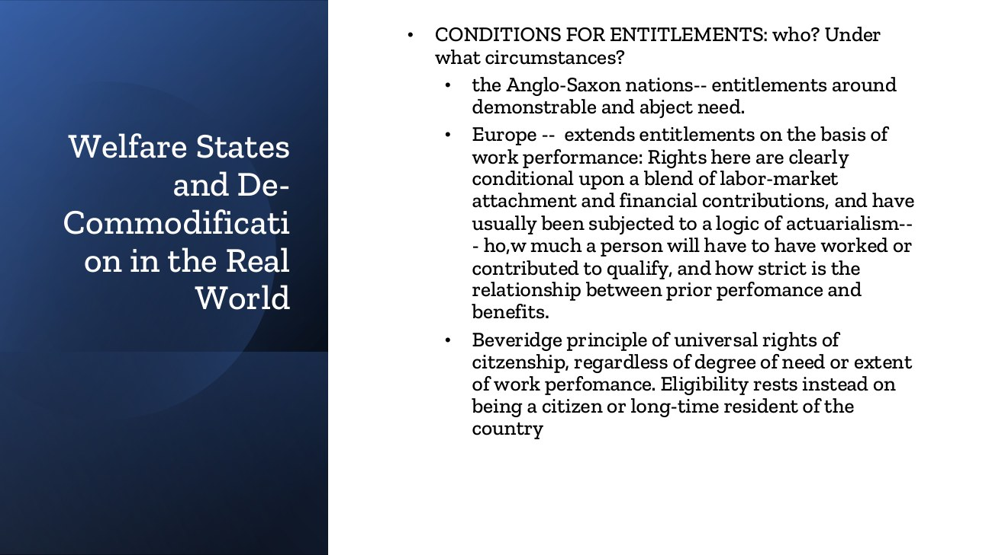
原PPT第18页截图 / Original screenshot, slide 18.

PPT中英翻译 / PPT translation
PPT English / 英文 | 中文翻译 / Chinese
Conditions for entitlements: who, and under what circumstances? | 福利资格：谁，在什么条件下取得？
Anglo-Saxon cases: demonstrable and abject need. | 课件中的盎格鲁—撒克逊案例：以可证明的严重困难为资格基础。
European contributory cases: work performance, labour-market attachment and financial contributions; actuarial links between records and benefits. | 课件中的欧洲缴费型案例：依据工作表现、劳动力市场联系和缴费；记录与待遇之间存在精算关联。
Beveridge: universal rights of citizenship, regardless of need or work performance; eligibility rests on citizenship or long-term residence. | 贝弗里奇原则：公民普遍权利不以贫困程度或劳动贡献为基本标准，而以公民或长期居民身份为资格基础。

PPT知识点复习与分析 / Review and analysis
以下结合Word与听课宝讲解，属于复习补充。 / The following combines the Word notes and class summary as supplementary explanation.

本页核心 / Key takeaway
资格逻辑分三类：按需要、按贡献、按成员身份；普遍资格不等于零条件或无需筹资。
Entitlement may rest on need, contribution or membership; universalism does not remove all conditions or financing.

知识点详解 / Detailed study notes

1. 三种资格逻辑 / Three entitlement logics
需要审查问“是否经济困难”；贡献逻辑问“是否工作或缴费达到要求”；成员资格问“是否属于覆盖共同体”。它们在现实中可以组合。
Need-testing asks about hardship; contribution rules ask about work or payment records; membership rules ask whether a person belongs to the covered community. Systems can combine them.

2. 需要比较哪些细节？ / Relevant details
同样称为社会保险，也可因最低缴费期、待遇计算、等待期和给付期限不同而提供不同保护。资格严格程度是去商品化分析的一部分。
Minimum contribution periods, calculation rules, waiting and duration can change protection even within insurance. Eligibility stringency matters for decommodification.

3. 普遍主义不是零条件 / Universalism is not condition-free
不以贫困或先前就业为基本资格，不等于没有年龄、身份或居住要求；也不表示整个制度完全不需要税收或缴费。
Removing poverty or work tests does not remove age, status or residence conditions, nor all tax or contribution financing.

4. 地理概括的边界 / Geographic simplification
欧洲内部也有多种制度，盎格鲁国家也并非每项福利都按家计审查。把此页看作资格逻辑的类型化比较，而不是所有国家政策的逐条事实。
European and Anglo-Saxon countries contain mixed arrangements. Read the slide as a typology of entitlement logics, not an exhaustive geographical rule.

易错辨析 / Pitfalls and distinctions

资格与筹资 / Entitlement versus finance
按公民身份取得资格，不表示制度无需税收、社会缴费或居住条件。不要把领取资格与筹资来源混为一谈。
Citizenship-based entitlement does not remove taxes, contributions or all residence rules. Separate entitlement from finance.

三种资格对照 / Entitlement comparison
同样是养老收入，甲先证明贫困，乙满足工作缴费记录，丙凭规定的成员资格领取。比较的是资格依据；三者都还可能有年龄和居住条件。
For retirement support, A proves need, B meets work and contribution records, and C qualifies through membership. All three can still have age or residence conditions.

第19页 / Slide 19｜Index of decommodification｜去商品化指数
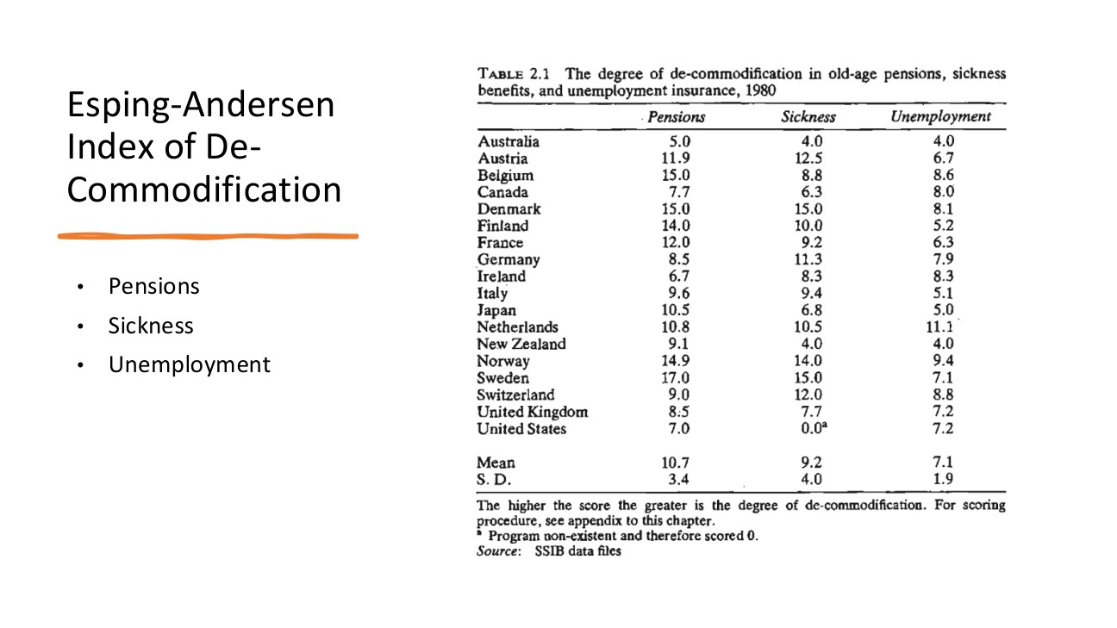
原PPT第19页截图 / Original screenshot, slide 19.

PPT中英翻译 / PPT translation
PPT English / 英文 | 中文翻译 / Chinese
The degree of de-commodification in old-age pensions, sickness benefits and unemployment insurance, 1980. | 1980年养老金、疾病津贴与失业保险的去商品化程度。
Pensions / Sickness / Unemployment; the higher the score, the greater the degree of de-commodification. | 养老金／疾病津贴／失业保险；分数越高，去商品化程度越高。
Mean / S.D.; source: SSIB data files. Footnote: a programme that did not exist was scored zero. | 均值／标准差；来源：SSIB资料。脚注：当时不存在的相关项目记为0分。

Table 2.1｜1980年各项目去商品化分数
Country 国家 | Pensions 养老金 | Sickness 疾病 | Unemployment 失业
Australia 澳大利亚 | 5.0 | 4.0 | 4.0
Austria 奥地利 | 11.9 | 12.5 | 6.7
Belgium 比利时 | 15.0 | 8.8 | 8.6
Canada 加拿大 | 7.7 | 6.3 | 8.0
Denmark 丹麦 | 15.0 | 15.0 | 8.1
Finland 芬兰 | 14.0 | 10.0 | 5.2
France 法国 | 12.0 | 9.2 | 6.3
Germany 德国 | 8.5 | 11.3 | 7.9
Ireland 爱尔兰 | 6.7 | 8.3 | 8.3
Italy 意大利 | 9.6 | 9.4 | 5.1
Japan 日本 | 10.5 | 6.8 | 5.0
Netherlands 荷兰 | 10.8 | 10.5 | 11.1
New Zealand 新西兰 | 9.1 | 4.0 | 4.0
Norway 挪威 | 14.9 | 14.0 | 9.4
Sweden 瑞典 | 17.0 | 15.0 | 7.1
Switzerland 瑞士 | 9.0 | 12.0 | 8.8
United Kingdom 英国 | 8.5 | 7.7 | 7.2
United States 美国 | 7.0 | 0.0* | 7.2
Mean 均值 | 10.7 | 9.2 | 7.1
S.D. 标准差 | 3.4 | 4.0 | 1.9

* 美国疾病项目0分的脚注意为该历史编码中相应项目不存在。
* The US sickness zero refers to absence of the relevant programme in that historical coding.

PPT知识点复习与分析 / Review and analysis
以下结合Word与听课宝讲解，属于复习补充。 / The following combines the Word notes and class summary as supplementary explanation.

本页核心 / Key takeaway
去商品化指数比较养老金、疾病与失业保障；分数不是百分比，也不是完整福利总评分。
The index compares pensions, sickness and unemployment protection; its scores are not percentages or a complete welfare rating.

知识点详解 / Detailed study notes

1. 指数衡量什么？ / What is measured?
指数通过具体保障项目把去商品化变成可比较的分数。它衡量选定项目中的保护，不是整个社会幸福、全部公共服务或住房制度的总评分。
The index operationalises protection in selected programmes. It is not a complete score for happiness, all public services or housing.

2. 跨项目差异 / Differences across programmes
同一国家的养老金、疾病和失业保障分数可以不同。不要只看一种保障，就推断所有政策领域都同样强或弱。
A country can score differently in pensions, sickness and unemployment. One programme does not establish uniform protection across domains.

3. 0分的解释边界 / Interpreting zero
美国疾病栏0.0带有“当时相关项目不存在”的脚注，不能扩大成美国所有人从来没有任何病假或健康保障。需保留项目范围和1980年背景。
The US sickness zero refers to the programme and historical coding. It does not mean that nobody ever had paid leave or health protection.

4. 统计量 / Statistics
均值是样本平均，标准差表示分布离散。不要把分数当百分比或把0—15等分值读成参保率。评分规则需查原文附录。
The mean is an average and the standard deviation describes dispersion. Scores are not percentages or enrolment rates; coding rules require the original appendix.

易错辨析 / Pitfalls and distinctions

指数0分与全部现实 / Zero in an index is not all reality
美国疾病0分对应历史编码中的相关项目，不能说美国从来没有任何疾病支持。分数也不能读成覆盖率。
The US sickness zero belongs to historical programme coding, not every form of sickness support. Scores are not coverage rates.

读图顺序 / Reading sequence
先确认1980年和三种项目，再比较同国不同列，最后看脚注与分数局限。不要把项目分数当参保百分比。
Identify 1980 and the three programmes, compare columns within a country, then check footnotes and limits. Scores are not coverage percentages.

原文核对 / Source check
本页三项可见数值与下一页综合表个别项目不完全吻合，例如美国；两表按原图分别抄录，不自行改数或假定可无条件简单相加。
Some visible component values do not exactly match the next slide’s combined scores, including the US. Values are transcribed separately rather than silently altered or assumed to add unconditionally.

第20页 / Slide 20｜Combined decommodification ranking｜综合去商品化排名
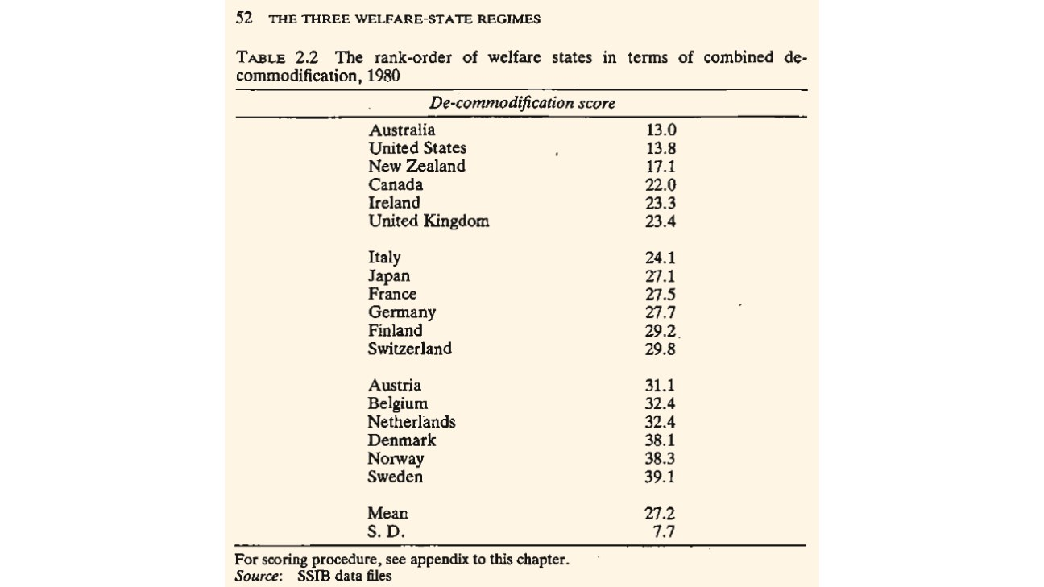
原PPT第20页截图 / Original screenshot, slide 20.

PPT中英翻译 / PPT translation
PPT English / 英文 | 中文翻译 / Chinese
Rank-order of welfare states in combined de-commodification, 1980. | 1980年福利国家综合去商品化程度排序。
De-commodification score; Mean 27.2; S.D. 7.7; source: SSIB data files. | 去商品化分数；均值27.2；标准差7.7；来源：SSIB资料。

Table 2.2｜1980年综合去商品化分数
Country 国家 | Score 分数
Australia 澳大利亚 | 13.0
United States 美国 | 13.8
New Zealand 新西兰 | 17.1
Canada 加拿大 | 22.0
Ireland 爱尔兰 | 23.3
United Kingdom 英国 | 23.4
Italy 意大利 | 24.1
Japan 日本 | 27.1
France 法国 | 27.5
Germany 德国 | 27.7
Finland 芬兰 | 29.2
Switzerland 瑞士 | 29.8
Austria 奥地利 | 31.1
Belgium 比利时 | 32.4
Netherlands 荷兰 | 32.4
Denmark 丹麦 | 38.1
Norway 挪威 | 38.3
Sweden 瑞典 | 39.1
Mean 均值 | 27.2
S.D. 标准差 | 7.7

PPT知识点复习与分析 / Review and analysis
以下结合Word与听课宝讲解，属于复习补充。 / The following combines the Word notes and class summary as supplementary explanation.

本页核心 / Key takeaway
这是1980年的综合分数排序；指数排名与福利体制分类不是同一件事。
This is a 1980 ranking; index ranking and welfare-regime classification are not identical.

知识点详解 / Detailed study notes

1. 怎样读排序？ / Reading the ranking
图中澳大利亚和美国分数较低，丹麦、挪威和瑞典较高。它支持比较制度保护差异，但不是今天各国的实时福利排名。
Australia and the US score low while Denmark, Norway and Sweden score high in this historical table. This is not a current live ranking.

2. 排名与类型不等同 / Ranking versus regime type
奥地利、比利时和荷兰也在较高分数组，说明按指数分高低与按制度关系分类不是完全相同的操作。要结合资格、分层和国家—市场关系。
Austria, Belgium and the Netherlands also score relatively high. Index ranking and regime classification are not identical; entitlement, stratification and institutional relations also matter.

3. 正确的比较表达 / Appropriate claim
可说“在此1980年样本和评分中，瑞典报告分数高于美国”；不能直接说“因此瑞典所有人都比美国所有人生活好”。
Say that Sweden reports a higher score than the US in this 1980 measure, not that every Swede necessarily lives better than every American.

易错辨析 / Pitfalls and distinctions

高分不等于类型完全相同 / High scores do not imply identical regimes
奥地利和北欧都可能分数高，但保护对象与分层方式未必相同。指数与类型要一起解释。
High scores in Austria and Nordic cases do not establish identical entitlement or stratification. Interpret scores alongside institutions.

读图顺序 / Reading sequence
先说历史年份，再描述低分与高分组，最后指出指数与制度类型不完全重合，不能推成当下生活质量排名。
State the year, describe lower and higher scores, then distinguish index ranking from regime type and current quality of life.

第21页 / Slide 21｜Basic principles｜三类基本原则
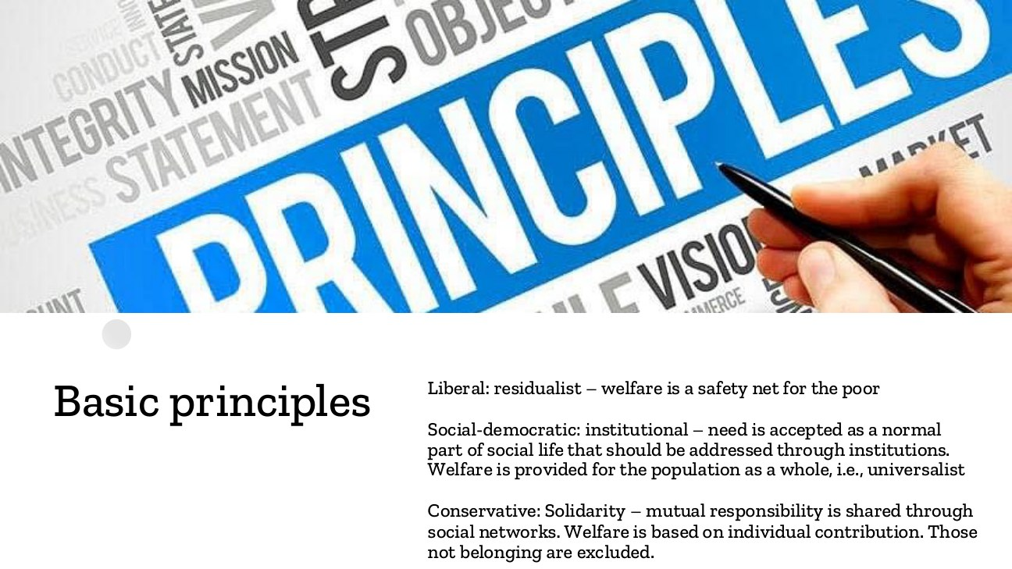
原PPT第21页截图 / Original screenshot, slide 21.

PPT中英翻译 / PPT translation
PPT English / 英文 | 中文翻译 / Chinese
Liberal: residualist—welfare is a safety net for the poor. | 自由型：补缺主义——福利是穷人的安全网。
Social-democratic: institutional—need is a normal part of social life, addressed through institutions; welfare is universalist. | 社会民主型：制度主义——需要是社会生活的正常组成部分，应通过制度回应；福利面向广泛人口。
Conservative: solidarity—mutual responsibility through social networks; welfare is contribution-based and outsiders are excluded. | 保守型：团结互助——通过社会网络分担责任；保障基于贡献，不属于相关体系者被排除。

PPT知识点复习与分析 / Review and analysis
以下结合Word与听课宝讲解，属于复习补充。 / The following combines the Word notes and class summary as supplementary explanation.

本页核心 / Key takeaway
补缺安全网、常规普遍保障、群体内贡献互助，分别体现不同公共责任与团结边界。
Residual safety nets, institutional universalism and contribution-based solidarity imply different responsibilities and boundaries.

知识点详解 / Detailed study notes

1. 安全网与常规制度 / Safety net and institution
安全网强调其他渠道不足时救助；制度型强调保障是社会生活正常组成部分。它们不仅对象多少不同，也体现公共责任的不同理解。
A safety net intervenes when other channels fail; institutional welfare treats protection as a normal responsibility. The contrast goes beyond beneficiary numbers.

2. 保守型的团结范围 / Boundaries of solidarity
团结可以是职业、缴费或家庭群体内部的互助，不必是对所有社会成员同等覆盖。被某项保险排除，也不自动等于完全没有其他援助。
Solidarity can operate within occupational, contribution or family groups. Exclusion from one scheme does not prove absence of every other assistance channel.

3. 三问快速识别 / Three quick questions
问保障为谁提供、凭什么取得、谁承担主要责任，再联系去商品化和分层。不能仅以“政府有发钱”判断社会民主主义。
Ask who receives support, on what basis, and through whose responsibility; then assess decommodification and stratification. A public cash payment alone does not identify social democracy.

易错辨析 / Pitfalls and distinctions

群体互助不等于普遍保障 / Group solidarity is not universalism
某职业保险内部很团结，仍可能排除其他职业或未就业者。应说明团结的边界。
Solidarity within an occupational scheme can coexist with exclusion of other groups. Identify its boundaries.

第22页 / Slide 22｜State and market in pension regimes｜养老金体制中的国家与市场

原PPT第22页截图 / Original screenshot, slide 22.

PPT中英翻译 / PPT translation
PPT English / 英文 | 中文翻译 / Chinese
State and market in the formation of pension regimes | 国家与市场在养老金体制形成中的作用。

PPT知识点复习与分析 / Review and analysis
以下结合Word与听课宝讲解，属于复习补充。 / The following combines the Word notes and class summary as supplementary explanation.

知识点详解 / Detailed study notes

1. 从抽象体制到具体制度 / From regime to institution
养老金能展示人们退出就业后依靠什么生活：公共转移、职业养老金、个人积蓄、财产收入或继续劳动。比较不能只问养老金高不高。
Pensions reveal resources after employment: public transfers, occupational pensions, savings, assets or continued work. Compare institutional composition as well as amounts.

2. 国家与市场不是简单替代 / Beyond substitution
国家可以建立规则、提供税收支持或保障来发展私人养老金市场；市场的不足又可能推动公共供给。需要分析两者如何共同形成制度。
States can create rules and support for private pensions, while market limitations can prompt public provision. Examine interaction rather than assuming simple substitution.

3. 与去商品化的联系 / Link to decommodification
领取养老金可能减少继续工作的压力，但若待遇不足、市场投资风险很大，或资格排除许多人，保护仍可能有限。
Pensions can reduce pressure to keep working, yet low benefits, investment risks or exclusion may weaken protection.

第23页 / Slide 23｜Interaction in pension provision｜养老金供给中的相互塑造
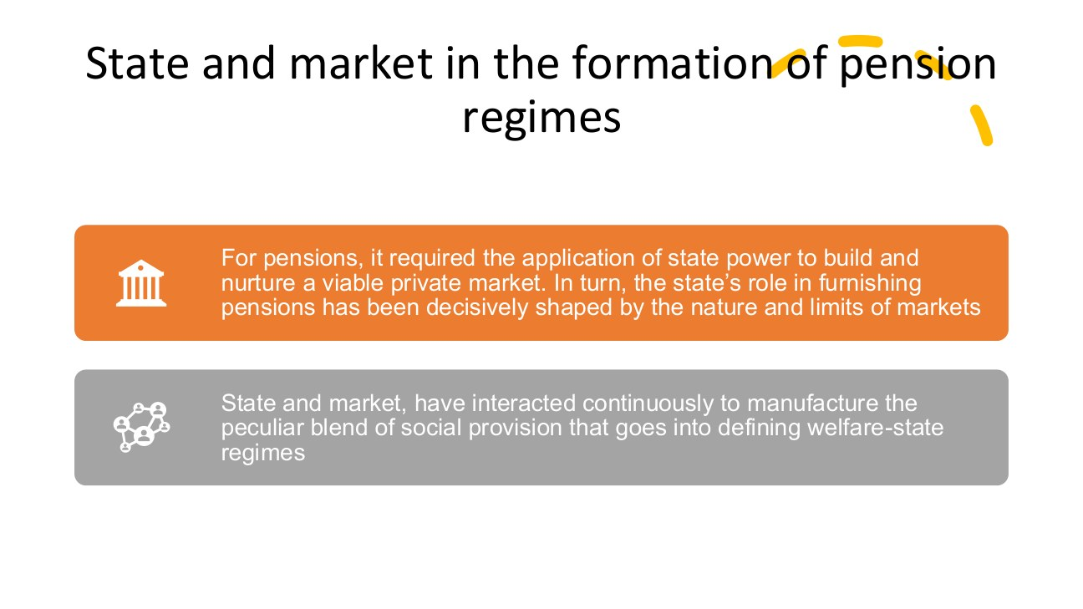
原PPT第23页截图 / Original screenshot, slide 23.

PPT中英翻译 / PPT translation
PPT English / 英文 | 中文翻译 / Chinese
State power was required to build and nurture a viable private pension market; the state’s own provision was shaped by the nature and limits of markets. | 私人养老金市场的建立和培育需要国家权力；国家自身的养老金供给，又受到市场性质与局限的塑造。
State and market have interacted continuously to manufacture the particular blend of social provision defining welfare-state regimes. | 国家与市场持续互动，形成界定福利体制的特定社会供给组合。

PPT知识点复习与分析 / Review and analysis
以下结合Word与听课宝讲解，属于复习补充。 / The following combines the Word notes and class summary as supplementary explanation.

本页核心 / Key takeaway
私人养老金市场也可由国家培育；国家与市场是相互塑造，而不只是此消彼长。
The state can nurture private pensions; state and market shape each other rather than simply displace one another.

知识点详解 / Detailed study notes

1. 为什么私人市场也需要国家？ / Why markets need the state
合同、监管、税收安排和制度承认会影响私人养老金是否可行。看到私人机构供给，不等于国家缺席；国家也可通过非直接支付的方式发挥作用。
Contracts, regulation, taxation and institutional recognition shape private pension markets. Private provision does not mean an absent state.

2. 市场怎样反过来影响国家？ / How markets shape public policy
若私人方案覆盖有限或风险较大，公共部门可能填补缺口；既有私人市场又会影响改革对象和支持联盟。此处讲相互塑造，不是单向决定。
Limited coverage or risk can encourage public action; existing private arrangements also shape reform constituencies. The relationship is reciprocal.

3. 供给、融资与责任分开 / Provision, finance and responsibility
私人管理的基金可能享受公共支持；公共制度也可能与缴费和市场收入紧密相连。比较时要拆开谁管理、谁出钱、谁承担风险。
Private funds may receive public support, while public schemes can depend on contributions and earnings. Distinguish management, financing and risk-bearing.

4. 可用于英文答题 / Useful answer
先描述国家—市场组合，再解释它如何影响退休后的生活保障。不要直接以机构名称判断去商品化高低。
Pension regimes are shaped by continuous state–market interaction; the resulting mix influences coverage, entitlement and protection after retirement.

易错辨析 / Pitfalls and distinctions

私人供给不等于零国家 / Private provision is not no state
国家可能提供规则、税收支持和监管；比较需区分谁管理、谁筹资、谁承担风险。
Rules, tax support and regulation can sustain private provision. Separate management, finance and risk-bearing.

机制应用 / Mechanism application
若私人养老金受税收优惠和监管支持，应同时记录私人管理、公共制度支持与风险承担，不能直接把它写成国家退场。
For tax-supported, regulated private pensions, identify private management, public institutional support and risk-bearing rather than assuming state withdrawal.

第24页 / Slide 24｜Income sources in older households｜老年家庭的收入来源
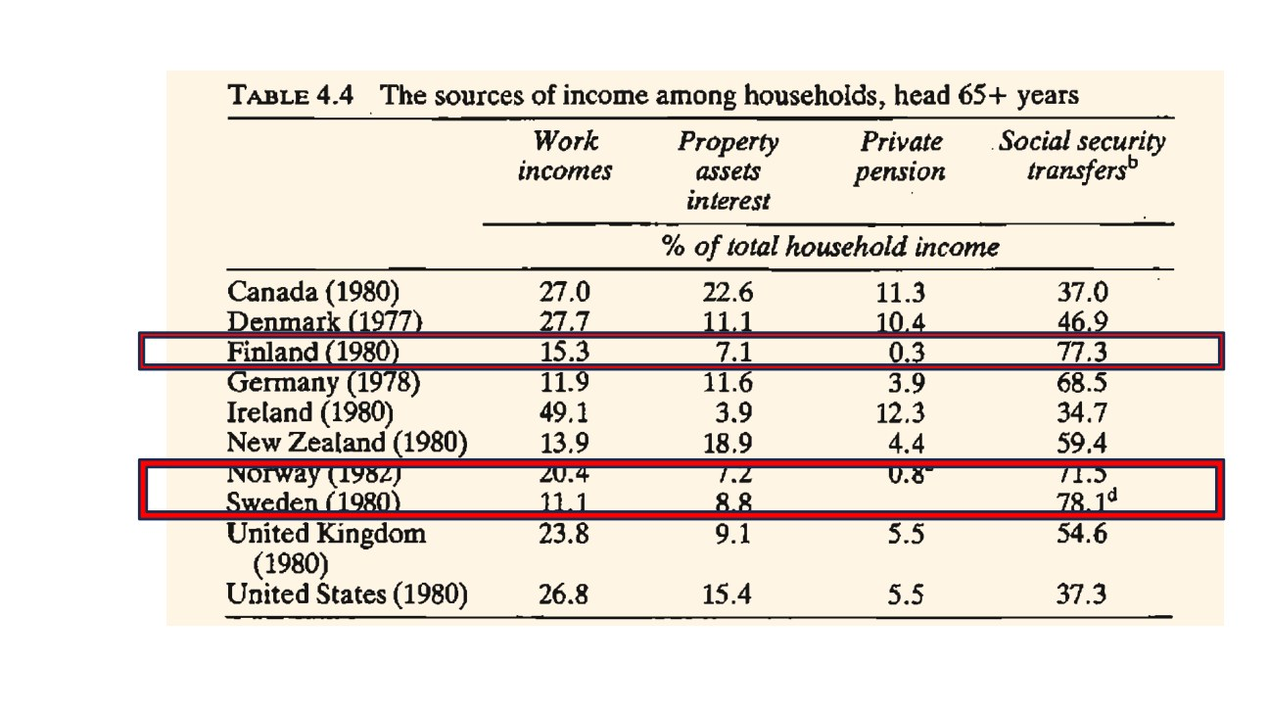
原PPT第24页截图 / Original screenshot, slide 24.

PPT中英翻译 / PPT translation
PPT English / 英文 | 中文翻译 / Chinese
Sources of income among households whose head is aged 65+, as a percentage of total household income. | 户主65岁及以上家庭的收入来源，占家庭总收入百分比。
Work incomes / Property assets interest / Private pension / Social security transfers | 劳动收入／财产资产利息收入／私人养老金／社会保障转移收入。

Table 4.4｜户主65岁及以上家庭收入构成（%）
Country/year 国家/年 | Work 劳动 | Property 财产 | Private pension 私人养老 | Transfers 社保转移
Canada 加拿大 1980 | 27.0 | 22.6 | 11.3 | 37.0
Denmark 丹麦 1977 | 27.7 | 11.1 | 10.4 | 46.9
Finland 芬兰 1980 | 15.3 | 7.1 | 0.3 | 77.3
Germany 德国 1978 | 11.9 | 11.6 | 3.9 | 68.5
Ireland 爱尔兰 1980 | 49.1 | 3.9 | 12.3 | 34.7
New Zealand 新西兰 1980 | 13.9 | 18.9 | 4.4 | 59.4
Norway 挪威 1982 | 20.4 | 7.2 | 0.8* | 71.5
Sweden 瑞典 1980 | 11.1 | 8.8 | — | 78.1*
United Kingdom 英国 1980 | 23.8 | 9.1 | 5.5 | 54.6
United States 美国 1980 | 26.8 | 15.4 | 5.5 | 37.3

—表示原图未列清数值；*表示原图存在未完整呈现的上标脚注，不自行补出内容。
A dash preserves an unreported visible entry. An asterisk marks a superscript footnote not fully reproduced in the slide; its content is not invented.

PPT知识点复习与分析 / Review and analysis
以下结合Word与听课宝讲解，属于复习补充。 / The following combines the Word notes and class summary as supplementary explanation.

本页核心 / Key takeaway
本表分母是老年户主家庭的总收入，不是个人福利金额或政府预算。
The denominator is income of older-headed households, not individual benefits or the government budget.

知识点详解 / Detailed study notes

1. 先确认对象与分母 / Unit and denominator
本表看的是户主65岁以上家庭的收入构成，不是所有老年个体的收入，也不是养老金占政府预算的比例。每列的分母是家庭总收入。
The unit is households headed by someone aged 65+, not every older individual. Columns show shares of household income, not government spending shares.

2. 怎样作制度比较？ / Institutional comparison
例如芬兰社会保障转移占77.3%，美国为37.3%；可说明该历史样本中收入来源组合不同，不能直接据此计算生活水平或福利总额。
For example, transfers account for 77.3% in Finland and 37.3% in the US in the table. Composition differs, but these shares do not directly establish income levels.

3. 劳动收入高不一定代表成功 / Work income is ambiguous
较高劳动收入可能反映选择继续工作，也可能反映退休保障不足。需要额外了解年龄结构、工作条件和收入水平，不能把收入份额直接当幸福指标。
Higher work-income shares may reflect choice or inadequate retirement protection. Additional evidence is needed on ages, conditions and income levels.

4. 年代与缺失值 / Dates and missing values
各国年份从1977到1982不等；瑞典私人养老金栏原图未列清数值，脚注也未完整呈现。空缺不应自动改成0，跨年比较要谨慎。
Countries use different years between 1977 and 1982. Sweden’s private-pension entry is not visibly supplied; missing information is not automatically zero.

易错辨析 / Pitfalls and distinctions

份额与金额 / Shares versus levels
社会转移占比高，不必总收入或待遇更高；分母不同和年代差异会影响比较。
A higher transfer share need not mean a higher income or benefit level. Denominators and periods matter.

读表顺序 / Reading sequence
对象是户主65岁以上家庭；分母是总家庭收入；再比较劳动、财产、私人养老金和转移的组合，保留不同年份与空缺。
Identify older-headed households and total household income, then compare the four sources while retaining differing years and missing entries.

第25页 / Slide 25｜Pension regimes｜养老金体制的三种模式
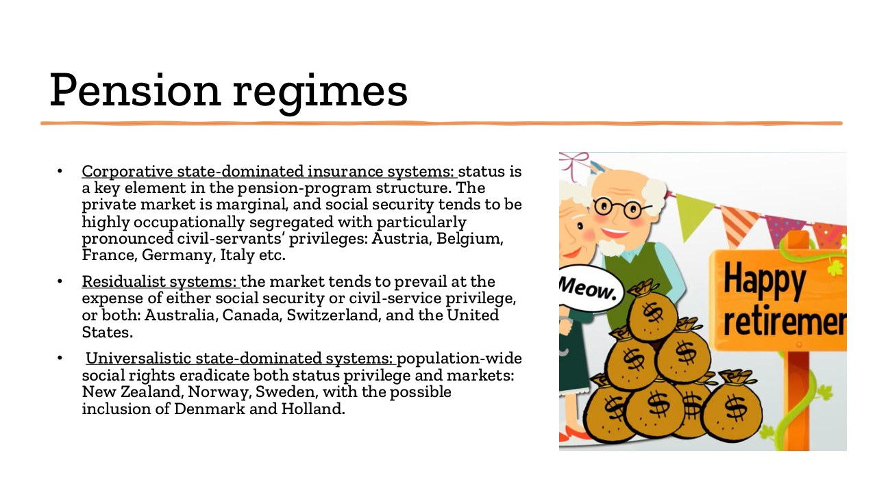
原PPT第25页截图 / Original screenshot, slide 25.

PPT中英翻译 / PPT translation
PPT English / 英文 | 中文翻译 / Chinese
Corporative state-dominated insurance: status is central; private markets marginal; social security occupationally segregated with civil-servant privileges. Examples: Austria, Belgium, France, Germany, Italy. | 法团主义、国家主导的保险：身份地位居核心；私人市场相对边缘；社会保障按职业分割，公务员特权突出。例：奥地利、比利时、法国、德国、意大利。
Residualist systems: market provision prevails relative to social security and/or civil-service privilege. Examples: Australia, Canada, Switzerland, United States. | 残余型制度：相对社会保障及／或公务员特殊保障，市场更占优势。例：澳大利亚、加拿大、瑞士、美国。
Universalistic state-dominated systems: population-wide rights displace status privilege and markets. Examples: New Zealand, Norway, Sweden, with possible inclusion of Denmark and Holland. | 普遍主义、国家主导制度：全民社会权利取代身份特权并压缩市场作用。课件例：新西兰、挪威、瑞典；可能包括丹麦和荷兰。

PPT知识点复习与分析 / Review and analysis
以下结合Word与听课宝讲解，属于复习补充。 / The following combines the Word notes and class summary as supplementary explanation.

本页核心 / Key takeaway
养老金模式要比较身份分割、市场依赖和共同社会权利；不能仅背国家列表。
Compare pension status divisions, market reliance and common social rights rather than only country lists.

知识点详解 / Detailed study notes

1. 三类比较的对象 / What is classified?
这里是养老金模式，不是把每个国家的全部制度重新贴标签。新西兰或瑞士在养老金中的位置，应结合本页领域和历史时期理解。
This classifies pension arrangements, not every institution in a country. Read New Zealand’s or Switzerland’s placement in that domain and period.

2. 地位保障与再分配 / Status and redistribution
按职业分割的保险可保护既有收入或身份差异，不等于完全不保障劳动者。要区分对市场冲击的保护和跨群体再分配。
Occupational insurance can protect workers while preserving status differences. Protection against market risks and redistribution across groups are distinct.

3. 普遍保障的含义 / Universal protection
覆盖广泛、权利共同化可降低职业特权的重要性；但课件“消除市场”属于类型化概括，不应写成这些国家现实中不存在任何私人养老金。
Broad, shared rights can reduce occupational privilege. The slide’s strong wording should not imply that no private pension exists in those countries.

4. 比较时的四问 / Four comparison questions
谁覆盖、给付按什么计算、谁提供与管理、风险由谁承担？这比只背国家列表更能解释制度差异。
Ask who is covered, how benefits are calculated, who provides and manages them, and who bears risk.

易错辨析 / Pitfalls and distinctions

养老金分类与国家总分类 / Pension versus overall classification
本页在比较特定养老金安排；不要由新西兰在本页的位置推成所有领域都社会民主。
The classification concerns pensions; one placement does not determine every policy domain.

第26页 / Slide 26｜Welfare state and labour market｜福利国家与劳动力市场

原PPT第26页截图 / Original screenshot, slide 26.

PPT中英翻译 / PPT translation
PPT English / 英文 | 中文翻译 / Chinese
Welfare-State and Labor-Market Regimes | 福利国家与劳动力市场体制。

PPT知识点复习与分析 / Review and analysis
以下结合Word与听课宝讲解，属于复习补充。 / The following combines the Word notes and class summary as supplementary explanation.

知识点详解 / Detailed study notes

1. 为什么放在一起？ / Why analyse them together?
福利影响人在何时工作、何时休假和何时退休；就业也提供缴费与税收，并影响福利资格。两者相互依赖，不是独立领域。
Welfare shapes employment, leave and retirement, while employment generates revenue and entitlement records. The relationship is interdependent.

2. 不只看失业率 / Beyond unemployment rates
劳动参与、带薪离岗、提前退休和公共就业同样重要。劳动力市场外的人不一定是失业者，可能已经退休或不属于就业统计中的劳动力。
Participation, leave, retirement and public jobs also matter. People outside the labour force are not necessarily counted as unemployed.

3. 与家庭和性别联系 / Family and gender
照顾服务与育儿假会影响谁能够工作，也影响家庭内照顾责任。分析女性就业不能只归因于个人偏好，还要看制度条件。
Care services and leave shape access to employment and household responsibilities. Gendered employment outcomes cannot be reduced to personal preferences.

第27页 / Slide 27｜Exit, paid absence and entry｜退出、带薪离岗与进入
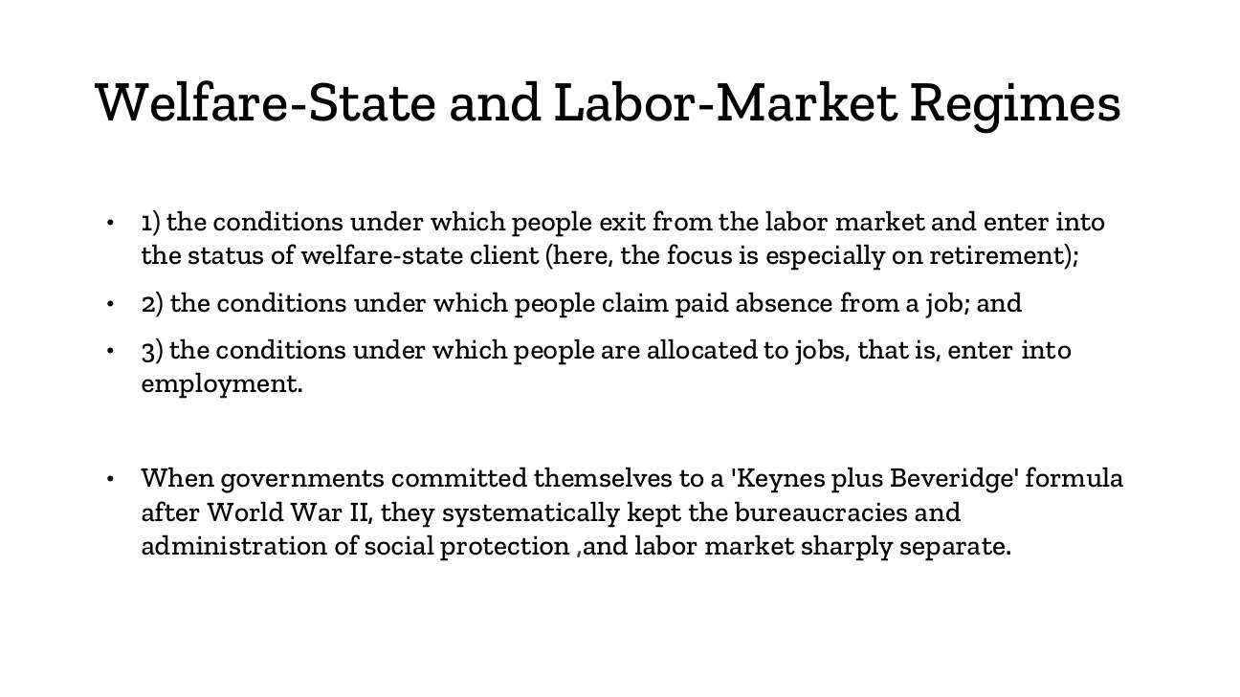
原PPT第27页截图 / Original screenshot, slide 27.

PPT中英翻译 / PPT translation
PPT English / 英文 | 中文翻译 / Chinese
1) Conditions for exit from the labour market into welfare-client status, especially retirement. | 1）人们退出劳动力市场、成为福利领取者的条件，尤其是退休。
2) Conditions for claiming paid absence from a job. | 2）劳动者申请带薪离岗的条件。
3) Conditions under which people are allocated to jobs and enter employment. | 3）人们被分配到岗位、进入就业的条件。
After World War II, a “Keynes plus Beveridge” formula kept social-protection and labour-market bureaucracies sharply separate. | 二战后“凯恩斯＋贝弗里奇”模式下，社会保护与劳动力市场的行政管理被明显分开。

PPT知识点复习与分析 / Review and analysis
以下结合Word与听课宝讲解，属于复习补充。 / The following combines the Word notes and class summary as supplementary explanation.

本页核心 / Key takeaway
三种关系分别是退出就业、带薪暂离和进入就业；福利与就业可以互相支持。
The framework distinguishes exit, paid absence and entry; welfare and employment can support each other.

知识点详解 / Detailed study notes

1. 三种状态 / Three states
退休是退出，病假或育儿假是暂时离岗，就业进入是获得岗位。它们的资格和后果不同，不能都概括为“领取福利所以不工作”。
Retirement is exit, leave is a temporary absence, and entry concerns obtaining work. Their conditions and consequences differ.

2. 凯恩斯与贝弗里奇 / Keynes and Beveridge
作为理解线索，凯恩斯联系需求管理与就业，贝弗里奇联系社会保障。行政分开不代表实际运行没有联系：工作记录和财政收入仍把两者连起来。
As a guide, Keynes relates to employment and demand management, Beveridge to social protection. Separate administration does not remove economic interdependence.

3. 带薪离岗也能支持就业 / Leave can support employment
如果生病或照顾孩子必须永久辞职，劳动市场联系会更弱；适当带薪离岗可帮助维持岗位关系。因此福利不一定与就业相反。
Without leave, illness or care may force permanent exit. Paid absence can maintain attachment to a job, so welfare need not oppose employment.

4. 应用顺序 / Applying the framework
遇到政策案例，先识别它影响进入、暂离还是退出，再讨论资格、收入保障、财政与家庭分工。
First identify entry, leave or exit, then examine entitlement, income protection, finance and household responsibilities.

易错辨析 / Pitfalls and distinctions

休假与永久退出 / Leave versus permanent exit
带薪病假可维持岗位联系，退休是退出；两者不能都当作失业或福利使人不工作。
Paid sick leave can maintain employment attachment; retirement is exit. Neither is simply unemployment.

状态应用 / Applying the states
同一位劳动者取得岗位是进入；生病获带薪离岗可维持岗位；正式退休是退出。先分清状态，再分析资格、收入和制度责任。
For one worker, obtaining a job is entry, paid sick leave can maintain attachment, and retirement is exit. Identify the state before analysing rights and responsibilities.

第28页 / Slide 28｜The three creeping revolutions｜三场渐进式变革
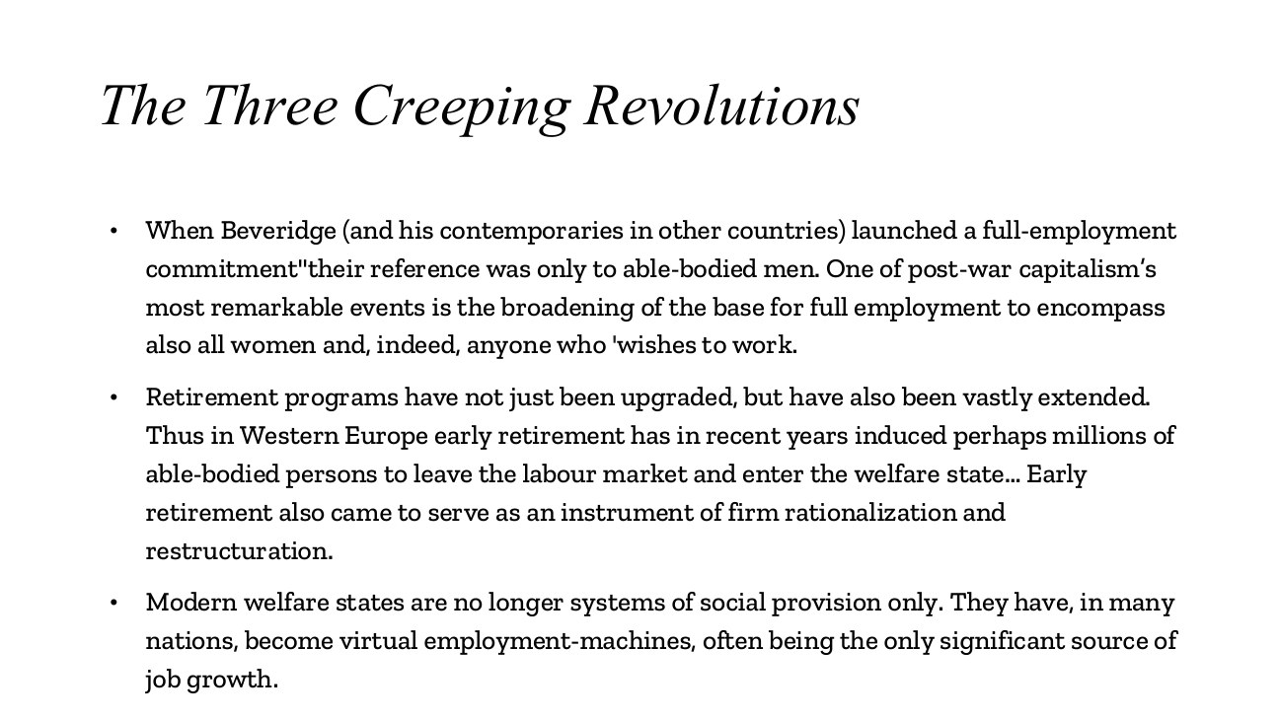
原PPT第28页截图 / Original screenshot, slide 28.

PPT中英翻译 / PPT translation
PPT English / 英文 | 中文翻译 / Chinese
Full-employment commitments broadened from able-bodied men to women and everyone wishing to work. | 充分就业承诺从有劳动能力的男性，扩展到女性及所有希望工作的人。
Retirement programmes expanded; early retirement moved many able-bodied people out of employment and became an instrument of firm restructuring. | 退休制度扩展；提前退休使许多有劳动能力者退出就业，也成为企业调整重组的工具。
Welfare states became employment-machines and, in many countries, a major source of job growth. | 福利国家不只提供保障，也成为就业机器，在许多国家是岗位增长的重要来源。

PPT知识点复习与分析 / Review and analysis
以下结合Word与听课宝讲解，属于复习补充。 / The following combines the Word notes and class summary as supplementary explanation.

本页核心 / Key takeaway
三场渐进变化：扩大充分就业对象、扩展退休与提前退出、福利供给创造岗位。
Three gradual changes broaden employment aims, expand retirement and early exit, and create jobs through welfare provision.

知识点详解 / Detailed study notes

1. 渐进而非瞬间 / Gradual change
Creeping指逐步发展的变化，不是一天内发生的革命。人口覆盖、退休安排和公共服务就业的扩展，共同改变福利与劳动的关系。
Creeping describes gradual institutional change. Broader participation, retirement arrangements and public-service jobs transform welfare–labour relations.

2. 提前退休的双重作用 / Two roles of early retirement
它可提供收入和退出机会，也可帮助企业缩减人员。因此有保障的退出未必意味着所有人都自愿选择，应比较谁获益和谁承担成本。
Early retirement can protect income and facilitate workforce reduction. Protected exit need not always be fully voluntary; assess benefits and costs.

3. 福利也创造岗位 / Welfare creates jobs
教育、医疗和照顾服务需要雇员，国家供给服务可以同时回应需要并扩大就业。不能只把福利看成从就业者转钱给不就业者。
Education, health and care services employ workers. Welfare can meet needs and create jobs, rather than only transfer income from workers to non-workers.

4. 性别关系 / Gender relations
公共托育可能使更多照顾者进入就业，但也应看照顾工作由谁承担、工资与工作条件如何。就业数量增长不自动消除性别差异。
Public care may enable employment, but also examine who performs care and under what conditions. More jobs do not automatically remove gender divisions.

易错辨析 / Pitfalls and distinctions

表中变化不等于单一因果 / Change is not a single cause
提前退休可以服务保障和重组，女性就业也受照顾服务与经济条件影响；不能只归因于福利金额。
Early retirement serves protection and restructuring; women’s employment depends on care and economic conditions as well as benefits.

第29页 / Slide 29｜Exit and labour supply｜退出与劳动供给
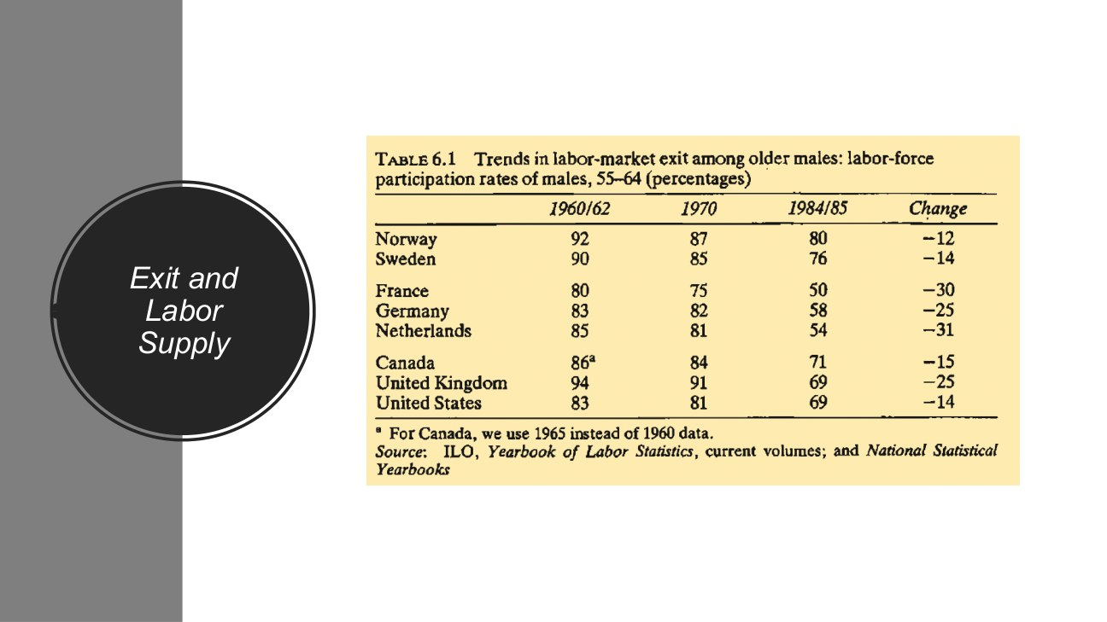
原PPT第29页截图 / Original screenshot, slide 29.

PPT中英翻译 / PPT translation
PPT English / 英文 | 中文翻译 / Chinese
Trends in labour-market exit among older males: labour-force participation rates of males aged 55–64 (%). | 较年长男性退出劳动力市场趋势：55—64岁男性的劳动参与率（%）。
1960/62 / 1970 / 1984/85 / Change | 1960/62年／1970年／1984/85年／变化。
For Canada, 1965 is used instead of 1960. Source: ILO and national statistical yearbooks. | 加拿大第一期采用1965年而非1960年。来源：国际劳工组织及各国统计年鉴。

Table 6.1｜55—64岁男性劳动参与率（%）
Country 国家 | 1960/62 | 1970 | 1984/85 | Change 变化（百分点 pp）
Norway 挪威 | 92 | 87 | 80 | -12
Sweden 瑞典 | 90 | 85 | 76 | -14
France 法国 | 80 | 75 | 50 | -30
Germany 德国 | 83 | 82 | 58 | -25
Netherlands 荷兰 | 85 | 81 | 54 | -31
Canada 加拿大 | 86* | 84 | 71 | -15
United Kingdom 英国 | 94 | 91 | 69 | -25
United States 美国 | 83 | 81 | 69 | -14

* 加拿大起点为1965年；变化单位为百分点。
* Canada’s starting observation is 1965; changes are in percentage points.

PPT知识点复习与分析 / Review and analysis
以下结合Word与听课宝讲解，属于复习补充。 / The following combines the Word notes and class summary as supplementary explanation.

本页核心 / Key takeaway
80%降至50%是下降30个百分点；劳动参与率也不同于就业率。
A fall from 80% to 50% is 30 percentage points; participation is not the employment rate.

知识点详解 / Detailed study notes

1. 劳动参与率不是就业率 / Participation is not employment
参与率衡量人口中进入劳动力队伍的比例，通常包含就业者及符合统计定义的失业者。不能把所有退出劳动力队伍者都说成失业。
Participation concerns labour-force membership, including employed and qualifying unemployed people. Leaving the labour force is not the same as becoming unemployed.

2. 变化的单位 / Units of change
法国80降至50，变化为负30个百分点，不是下降30%。若计算相对降幅需要另除以初值，不能混用百分比与百分点。
France falls from 80 to 50: a 30-percentage-point change, not a 30% relative decline. Relative change requires division by the starting value.

3. 与提前退休联系 / Link to retirement
下降与本节讨论的退休扩展一致，但表格本身不证明全部下降都由提前退休政策造成。还需考虑其他制度和经济因素。
The decline is consistent with the discussion of retirement expansion, but the table alone does not identify the cause of every change.

4. 样本边界 / Scope
数据只包括55—64岁男性，不能推广为所有年龄与女性的劳动参与。年份不同、加拿大的替代起点也应保留。
The table covers men aged 55–64, not every age or gender. Preserve its period and Canada’s alternative starting year.

易错辨析 / Pitfalls and distinctions

百分点与百分比 / Percentage points versus percent
80到50是减少30个百分点；相对降幅为30÷80＝37.5%。两种说法计算不同，不能混写。
From 80 to 50 is 30 percentage points; the relative decline is 30/80 = 37.5%. These are different measures.

读表顺序 / Reading sequence
先确定55—64岁男性与三期年份，再读劳动参与率，最后用百分点描述变化，并记录加拿大起点不同。
Identify men aged 55–64 and the periods, read participation, then express changes in percentage points and retain Canada’s different baseline.

第30页 / Slide 30｜The welfare state as employer｜福利国家作为雇主
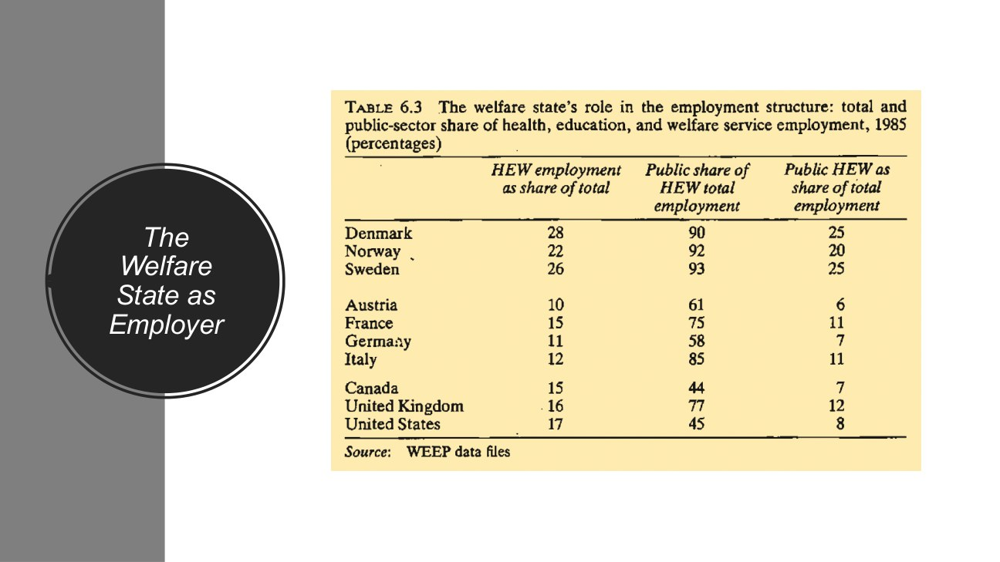
原PPT第30页截图 / Original screenshot, slide 30.

PPT中英翻译 / PPT translation
PPT English / 英文 | 中文翻译 / Chinese
Employment structure: total and public-sector shares of health, education and welfare (HEW) service employment, 1985 (%). | 1985年卫生、教育与福利服务（HEW）的总体及公共部门就业份额（%）。
HEW employment as share of total / Public share of HEW employment / Public HEW as share of total employment | HEW就业占总就业／公共部门占HEW就业／公共HEW就业占总就业。
Source: WEEP data files. | 来源：WEEP资料。

Table 6.3｜1985年卫生、教育与福利服务就业（%）
Country 国家 | HEW / total HEW占总就业 | Public / HEW 公共占HEW | Public HEW / total 公共HEW占总就业
Denmark 丹麦 | 28 | 90 | 25
Norway 挪威 | 22 | 92 | 20
Sweden 瑞典 | 26 | 93 | 25
Austria 奥地利 | 10 | 61 | 6
France 法国 | 15 | 75 | 11
Germany 德国 | 11 | 58 | 7
Italy 意大利 | 12 | 85 | 11
Canada 加拿大 | 15 | 44 | 7
United Kingdom 英国 | 16 | 77 | 12
United States 美国 | 17 | 45 | 8

PPT知识点复习与分析 / Review and analysis
以下结合Word与听课宝讲解，属于复习补充。 / The following combines the Word notes and class summary as supplementary explanation.

本页核心 / Key takeaway
三列的分母不同：总就业、HEW就业、总就业；90%不能读成全民九成为国家工作。
The denominators are total employment, HEW employment and total employment; 90% is not the whole workforce.

知识点详解 / Detailed study notes

1. 三列分母不同 / Different denominators
第一列分母为总就业；第二列为HEW就业；第三列又为总就业。因此丹麦第二列90不能读成全国90%的人为国家工作。
The first and third columns use total employment; the second uses HEW employment. Denmark’s 90 does not mean 90% of all workers work for the state.

2. 怎样连接三列？ / Connecting columns
丹麦HEW占28%，其中公共部门约90%，两者相乘约25.2%，与第三列约25%相近。原表为取整数据，不要求每个结果完全精确。
For Denmark, 28% × 90% is approximately 25.2%, close to the reported 25%. Rounded figures need not reproduce every entry exactly.

3. 对福利体制的含义 / Institutional meaning
北欧例子显示较大的公共服务就业，可与国家直接供给、照顾服务和女性就业联系。但表本身不评价服务质量、工资或性别平等。
Nordic examples show substantial public-service employment. This relates to direct provision and care, but the table does not measure quality, wages or gender equality.

4. 就业机器的边界 / Limits of the claim
福利成为雇主，不等于全部岗位都由政府提供；私人或非营利机构也可能供给服务。要区分领域规模与公共比例。
Welfare employment can include private and non-profit providers. Distinguish the size of the service sector from its public share.

易错辨析 / Pitfalls and distinctions

90%的分母 / The denominator of 90%
丹麦90%是公共部门占HEW就业，不是公共HEW占总就业；后者约25%。
Denmark’s 90% is the public share within HEW, not public HEW’s share of total employment, which is around 25%.

读表顺序 / Reading sequence
逐列写出分母，再核对HEW总体份额与公共比例，最后判断公共服务就业规模；不要只看最大的90或93。
Write each denominator, relate the HEW share to its public share, then assess employment structure rather than focusing only on 90 or 93.

第31页 / Slide 31｜Examples｜应用案例引入

原PPT第31页截图 / Original screenshot, slide 31.

PPT中英翻译 / PPT translation
PPT English / 英文 | 中文翻译 / Chinese
Examples | 例子／应用案例。

PPT知识点复习与分析 / Review and analysis
以下结合Word与听课宝讲解，属于复习补充。 / The following combines the Word notes and class summary as supplementary explanation.

知识点详解 / Detailed study notes

1. 转入教育领域 / Moving to education
本页是标题页，接下来用教育制度检验同一比较框架：谁融资、谁供给、学生凭什么进入、家庭要付多少。不要为此页添加不存在的具体数据。
This title introduces education: financing, provision, access and family costs. No additional case data are printed on this slide.

2. 同一框架，不同指标 / Same framework, different measures
教育的标准化、分流与职业教育特定性，与养老金给付不同。理论问题可相通，操作指标却需要按领域重新界定。
Educational standardisation, tracking and vocational specificity differ from pension benefits. Shared theoretical questions require domain-specific measures.

3. 听课宝中的现实案例 / Cases mentioned in the summary
听课宝另提香港贫困线与内地低收入救助，但这张PPT没有给具体规则。可用作分析练习，不能把未提供的细节写成课件事实。
The class summary also mentions Hong Kong poverty-line and mainland assistance discussions, but this slide supplies no detailed rules for those cases.

第32页 / Slide 32｜Educational systems across regimes｜不同体制下的教育体系
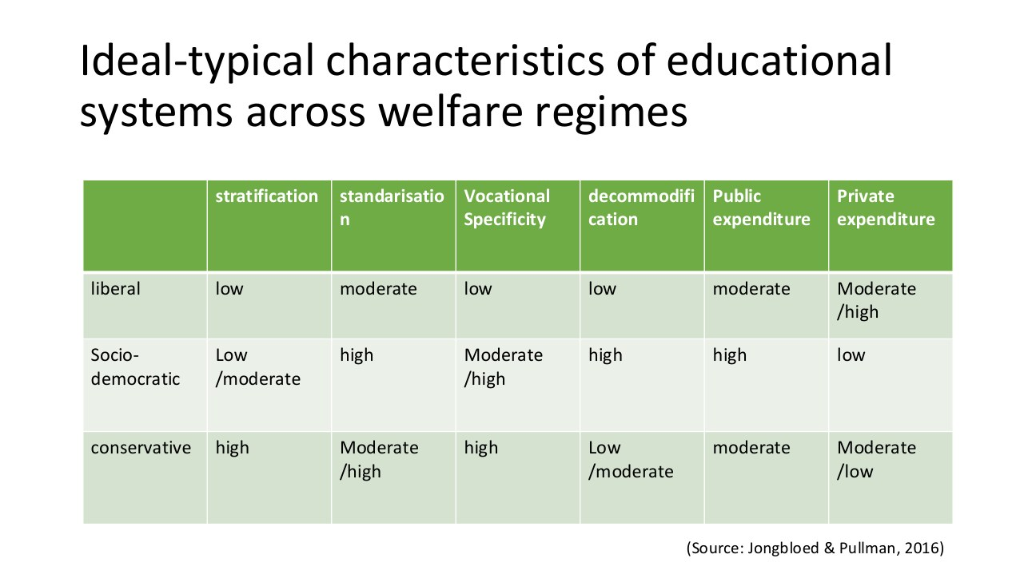
原PPT第32页截图 / Original screenshot, slide 32.

PPT中英翻译 / PPT translation
PPT English / 英文 | 中文翻译 / Chinese
Ideal-typical characteristics of educational systems across welfare regimes. | 不同福利体制下教育体系的理想类型特征。
Stratification / Standardisation / Vocational specificity / Decommodification / Public expenditure / Private expenditure | 教育分层／标准化／职业技能特定性／去商品化／公共支出／私人支出。
Source: Jongbloed & Pullman, 2016. | 来源：Jongbloed与Pullman，2016。

教育理想类型逐项对照 / Educational ideal-type comparison
Dimension 维度 | Liberal 自由型 | Social democratic 社会民主型 | Conservative 保守型
Stratification 分层 | Low 低 | Low/moderate 低/中 | High 高
Standardisation 标准化 | Moderate 中 | High 高 | Moderate/high 中/高
Vocational specificity 职业技能特定性 | Low 低 | Moderate/high 中/高 | High 高
Decommodification 去商品化 | Low 低 | High 高 | Low/moderate 低/中
Public expenditure 公共支出 | Moderate 中 | High 高 | Moderate 中
Private expenditure 私人支出 | Moderate/high 中/高 | Low 低 | Moderate/low 中/低

PPT知识点复习与分析 / Review and analysis
以下结合Word与听课宝讲解，属于复习补充。 / The following combines the Word notes and class summary as supplementary explanation.

本页核心 / Key takeaway
教育制度分轨、社会机会差距和职业技能特定性，是不同概念，不能互相替代。
Educational tracking, inequality of opportunity and vocational specificity are different concepts.

知识点详解 / Detailed study notes

1. 教育分层的含义 / Educational stratification
这里较多指制度内的分轨、层级或通向不同路径的结构，不应直接等同社会整体收入不平等。自由型本表“低分层”与后页描述机会不平等并非必然矛盾。
Here stratification concerns structured educational tracks or levels, not simply total income inequality. Low formal stratification can coexist with unequal opportunities.

2. 标准化 / Standardisation
指课程、目标、评价或制度安排在多大程度上统一；不是“所有学生成绩都一样”。统一标准也不自动保证资源和结果完全均等。
Standardisation concerns common curricula, goals or arrangements, not identical student results. Common standards do not guarantee equal resources or outcomes.

3. 职业技能特定性 / Vocational specificity
指教育与特定职业技能、岗位或资格的联系程度。高并不简单表示所有人都读职业学校，也不是学校名气更特殊。
Vocational specificity concerns links to particular occupational skills and qualifications; it does not mean that everyone attends vocational school.

4. 去商品化与支出 / Protection and expenditure
公共资助和较低私人负担可能减轻对家庭购买力的依赖，但教育领域的指标不等同第19页养老金等指数。需说明具体领域与测量方法。
Public funding and lower private costs may reduce dependence on purchasing power, but educational measures are not identical to the pension-based index.

5. 读理想类型表 / Reading ideal types
用表提出比较问题，不把高中低当作每所学校、每个时期的事实。还需考察准入、资助和制度变化。
Use the table to frame questions rather than treat every rating as an exact fact about every school and period.

易错辨析 / Pitfalls and distinctions

标准化不是同分 / Standardisation is not identical attainment
标准化看课程和制度统一；分层看路径结构；机会不平等看社会背景的影响。三者可以不同方向变化。
Standardisation concerns common arrangements, stratification concerns paths, and unequal opportunity concerns background effects. They can vary separately.

概念应用 / Applying the concepts
一个体系可以较少正式分轨，但因家庭费用不同仍有明显机会差距。回答要分别陈述制度结构与实际机会，避免把两个不同层次的结论当矛盾。
A system can have limited formal tracking yet unequal opportunities through family costs. Distinguish structural arrangements from effective opportunity.

第33页 / Slide 33｜Classification of higher education｜高等教育体系分类图
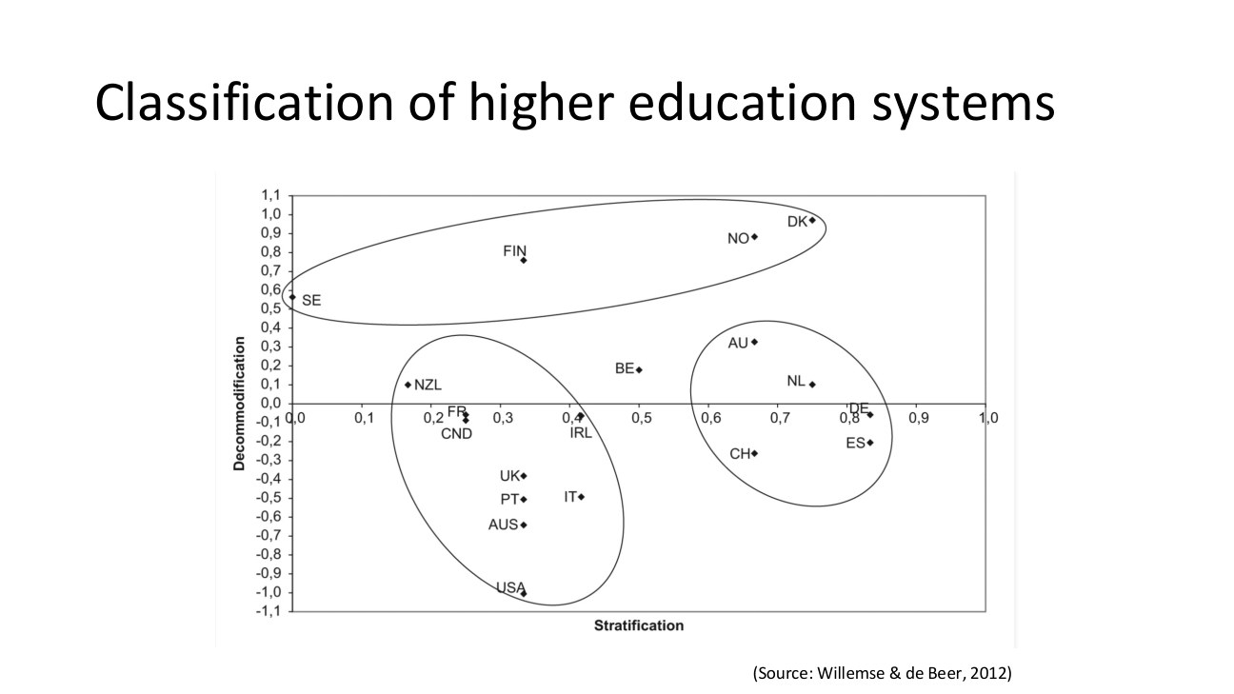
原PPT第33页截图 / Original screenshot, slide 33.

PPT中英翻译 / PPT translation
PPT English / 英文 | 中文翻译 / Chinese
Classification of higher education systems. | 高等教育体系的分类。
X-axis: Stratification. Y-axis: Decommodification. | 横轴：分层；纵轴：去商品化。
Source: Willemse & de Beer, 2012. | 来源：Willemse与de Beer，2012。

PPT知识点复习与分析 / Review and analysis
以下结合Word与听课宝讲解，属于复习补充。 / The following combines the Word notes and class summary as supplementary explanation.

本页核心 / Key takeaway
横轴是分层，纵轴是去商品化；位置与负值都应按该研究尺度理解，不是百分比。
Read stratification horizontally and decommodification vertically; the index positions and negative values are not percentages.

知识点详解 / Detailed study notes

1. 先看两条轴 / Read the axes
位置越靠右表示横轴分层指标更高，越向上表示纵轴去商品化指标更高。两维可独立变化，不能把右上角简单当成“全部最优”。
Rightward positions indicate higher stratification values; upward positions indicate higher decommodification. The dimensions vary separately; upper-right is not automatically best.

2. 负值不是负福利 / Negative values
图的纵轴包含负数，这是所用指标的尺度，不是领取负数福利或“少于0%的去商品化”。截图没有完整说明标准化程序，不补造公式。
Negative values belong to the index scale, not negative benefits or a negative percentage. The slide does not supply the full scaling formula.

3. 国家缩写 / Country abbreviations
DK丹麦、NO挪威、SE瑞典、FIN芬兰；USA美国、UK英国、AUS澳大利亚、AU奥地利；NL荷兰、CH瑞士、DE德国、ES西班牙。AU与AUS不能混淆。
DK, NO, SE and FIN are Denmark, Norway, Sweden and Finland; AU is Austria while AUS is Australia; NL, CH, DE and ES are the Netherlands, Switzerland, Germany and Spain.

4. 领域特定的分类 / Domain-specific grouping
图中椭圆说明高等教育的聚类，未必逐国复制总体福利类型。解释国家位置要看研究指标，不能只依传统国家标签判断图片画错。
The ellipses group higher-education systems and need not reproduce general welfare classifications country for country. Interpret positions through the study’s measures.

易错辨析 / Pitfalls and distinctions

负值不是负福利 / Negative values are not negative benefits
纵轴是研究尺度，出现负值不能译成少于0%的福利。图的组别也不必等同总体福利类型。
Negative values belong to the study’s scale, not a negative welfare percentage; education clusters need not reproduce overall regimes.

读图顺序 / Reading sequence
先读横纵轴，再定位国家，最后比较两维与椭圆分组；没有指标说明时不把坐标当百分比或因果效果。
Read axes, locate countries, then compare dimensions and clusters; do not assume percentage or causal meanings without the measurement rules.

第34页 / Slide 34｜Education in the USA｜美国教育

原PPT第34页截图 / Original screenshot, slide 34.

PPT中英翻译 / PPT translation
PPT English / 英文 | 中文翻译 / Chinese
Market-driven approach: a significant private role; families may pay for quality, generating socioeconomic disparities. | 市场驱动：私人机构发挥重要作用；家庭可能为优质教育付费，并产生社会经济差异。
Means-tested financial aid, such as Pell Grants, targets low-income families in higher education. | 如Pell Grants等经济状况审查式高教资助面向低收入家庭。
Private schooling can create a dual system in which wealthier families can buy better schooling. | 私立教育可能形成双轨，较富裕家庭有更强的购买能力。
Limited state involvement: the slide says the federal government provides basic services without guaranteeing equal access or quality. | 国家介入有限：课件称联邦政府提供基本教育服务，但不保证所有学生取得相同机会与质量。
High out-of-pocket costs can deter access to higher education. | 较高个人自付费用可能阻碍高等教育准入。

PPT知识点复习与分析 / Review and analysis
以下结合Word与听课宝讲解，属于复习补充。 / The following combines the Word notes and class summary as supplementary explanation.

本页核心 / Key takeaway
分析教育机会时要看付费、资助与家庭资源；美国联邦、州和地方责任不能混同。
Assess fees, aid and family resources, and distinguish US federal, state and local responsibilities.

知识点详解 / Detailed study notes

1. 课件的分析方向 / Analytical emphasis
本页把美国作为市场与私人负担较突出的例子。分析应把家庭支付能力、资助与进入机会联系起来，不能说美国不存在庞大公立教育。
The slide highlights markets and private costs. Examine purchasing power, aid and access without implying that the US lacks a large public education system.

2. 经济审查式资助 / Means-tested aid
面向低收入学生的资助可降低门槛，但不等于每位低收入者都得到足额支持，也不表示所有资助都只有一种资格。需查看具体项目规则。
Need-based aid may reduce barriers without fully covering costs or describing every aid programme. Entitlement depends on specific rules.

3. 联邦与地方要分开 / Federal versus local roles
美国官方说明教育主要是州和地方责任，联邦提供补充支持。因此课件“联邦提供基本服务”的概括需加限定，不能把三级政府混为一谈。
US official guidance places primary responsibility with states and localities, with a supplementary federal role. Distinguish these levels of government.

4. 机会与结果 / Access and outcomes
家庭收入、学费与学校资源可能影响机会，但单一体制标签不能解释每所学校质量。评价需具体数据，不把“私人”直接等同“优质”。
Costs and resources can shape opportunities, but neither regime labels nor private status determine every school’s quality. Evidence is needed.

易错辨析 / Pitfalls and distinctions

市场化不是没有公立学校 / Markets do not imply no public schools
有私人付费与资助差异，不等于美国主要由联邦直接提供所有教育，或所有私立学校都更优质。
Private costs and aid do not imply federal delivery of all education or automatic superiority of private schools.

第35页 / Slide 35｜Tuition fees｜学费与大学融资

原PPT第35页截图 / Original screenshot, slide 35.

PPT中英翻译 / PPT translation
PPT English / 英文 | 中文翻译 / Chinese
Public universities are partly financed by their states (45%). | 公立大学部分由所在州资助；课件列出45%。
Private universities are financially independent and rely on tuition and donations from businesses and alumni. | 课件称私立大学财政独立，依靠学费及企业、校友捐赠。
Students pay fees in both public and private universities. | 公立与私立大学的学生都要支付学费。

PPT知识点复习与分析 / Review and analysis
以下结合Word与听课宝讲解，属于复习补充。 / The following combines the Word notes and class summary as supplementary explanation.

本页核心 / Key takeaway
公立不等于免费，私立不等于零公共资金；45%缺少年份与口径，不能当现行统一比例。
Public does not mean free, private does not mean no public funding, and the undated 45% is not a universal current figure.

知识点详解 / Detailed study notes

1. 公立不等于个人不付费 / Public does not mean free
机构所有权、融资来源与学生费用是不同问题。公立大学可以同时获得公共拨款并收学费；私人大学也可能存在公共支持渠道。
Ownership, funding and student charges differ. Public institutions may receive appropriations and charge fees; private institutions may also receive public support.

2. 45%的证据边界 / The 45% claim
此页没有说明年份、样本和分母，不能当作2026年美国所有公立大学的统一比例。若写论文或作现实比较，需要原统计来源。
The slide supplies no year, sample or denominator for 45%. Do not use it as a universal 2026 figure; seek the original statistics.

3. “完全独立”不要绝对化 / Avoid an absolute claim
私立大学不等于没有任何公共资金：联邦科研资助或学生援助可使公共资源进入。知识点应区分私人治理与所有收入均来自私人。
Private governance does not mean exclusively private revenue; research grants and student aid can introduce public resources.

4. 真正要比较的负担 / Relevant burdens
学费标价之外还看奖助、贷款、生活费与家庭支付能力。相同标价对不同家庭造成的负担可能不同。
Consider aid, loans, living costs and family resources alongside advertised fees. Identical fees can impose unequal burdens.

易错辨析 / Pitfalls and distinctions

单一比例的证据 / Evidence for one percentage
没有年份、分母和样本的45%不能当2026年统一事实；收费与融资渠道也需分开。
Without year, denominator and sample, 45% is not a uniform current fact; fees and finance are separate issues.

第36页 / Slide 36｜Education policy in Sweden｜瑞典教育政策的两种取向比较
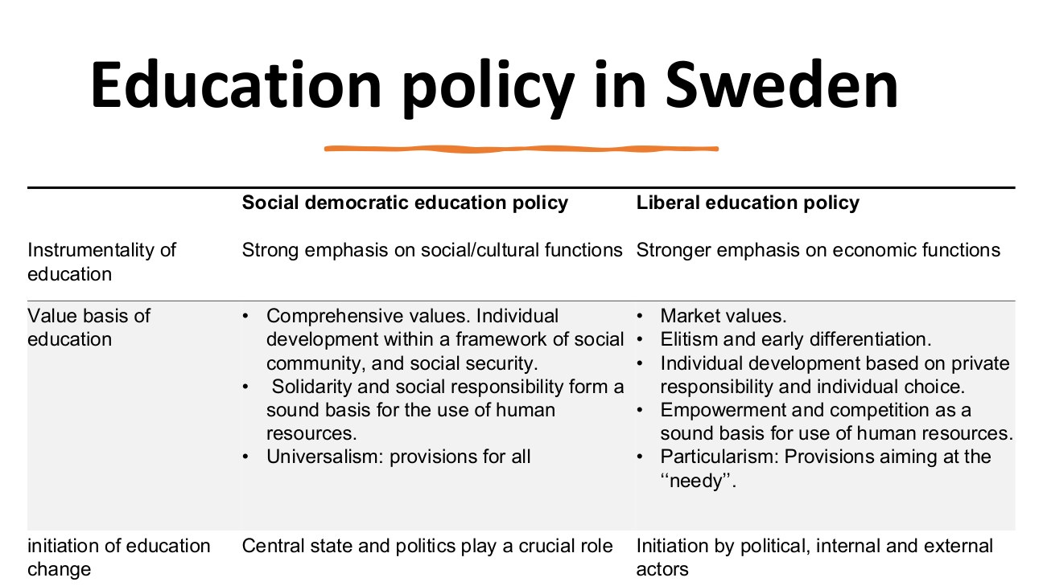
原PPT第36页截图 / Original screenshot, slide 36.

PPT中英翻译 / PPT translation
PPT English / 英文 | 中文翻译 / Chinese
Instrumentality: social democratic—social/cultural functions; liberal—economic functions. | 教育的工具性目标：社会民主取向重社会文化功能；自由取向更重经济功能。
Social-democratic values: comprehensive education, development within community and social security, solidarity, social responsibility and universal provision. | 社会民主价值：综合性教育、在共同体与社会保障框架内发展个人、团结、社会责任和普遍供给。
Liberal values: markets, elitism and early differentiation, private responsibility, individual choice, empowerment, competition and targeted provision for the needy. | 自由取向价值：市场、精英主义与早期分化、私人责任、个人选择、赋能、竞争及面向困难者的针对性供给。
Educational change: social-democratic—central state and politics; liberal—political, internal and external actors. | 教育变革的发起：社会民主取向强调中央国家与政治；自由取向强调政治、内部与外部行动者。

PPT知识点复习与分析 / Review and analysis
以下结合Word与听课宝讲解，属于复习补充。 / The following combines the Word notes and class summary as supplementary explanation.

本页核心 / Key takeaway
表内比较社会民主与自由主义两种教育取向，不是直接比较两个国家。
The table compares social-democratic and liberal educational orientations, not directly two countries.

知识点详解 / Detailed study notes

1. 比较的是政策取向 / What is compared?
标题写瑞典，但表内比较两种政策方向，不是瑞典与美国的逐项实测。它也提示同一国家内可能出现取向转变。
The table contrasts orientations rather than a direct measured Sweden–US comparison. It also allows change within a country.

2. Universalism与particularism / 普遍主义与特定群体取向
前者强调广泛供给；后者将供给集中于被认定需要者。不能把后者机械译成“特殊主义所以不讲理”，应解释资格范围。
Universalism stresses broad provision; particularism targets specified groups. Explain scope and eligibility rather than attaching a moral label.

3. 标准与选择的张力 / Standards and choice
统一保障可能支持共同机会，竞争和选择可能提供多样性，但要看家庭资源是否影响实际选择。表格是价值与机制比较，不直接证明哪类政策在所有指标上最好。
Common provision and choice offer different mechanisms. Assess effective choice and resources; the table does not establish universal superiority on every outcome.

4. 与福利体制联系 / Link to regimes
可比较教育的权利基础、国家角色与私人责任，再看分层和准入结果。不能只用“瑞典”这个名字代替制度分析。
Compare rights, state roles and private responsibility, then examine access and stratification rather than relying on the country label.

易错辨析 / Pitfalls and distinctions

取向与国家不是同一单位 / Orientation is not country
标题提瑞典，但列比较政策价值和机制，不能把两列直接改写成瑞典与美国的测量结果。
Although Sweden is named, the columns compare orientations, not a measured Sweden–US pair.

第37页 / Slide 37｜Education in Sweden｜瑞典教育的三项特点

原PPT第37页截图 / Original screenshot, slide 37.

PPT中英翻译 / PPT translation
PPT English / 英文 | 中文翻译 / Chinese
Universal access: education as a right, with comprehensive high-quality provision regardless of socioeconomic background. | 普遍准入：教育被视为权利，不论社会经济背景，都应取得全面、高质量的教育。
Strong public funding maintains standards across schools. | 较强公共财政投入支持各校维持教育标准。
Focus on equity: free higher education and support for disadvantaged groups aim to reduce inequality. | 强调公平：免学费的高等教育及弱势群体支持，旨在减少不平等。

PPT知识点复习与分析 / Review and analysis
以下结合Word与听课宝讲解，属于复习补充。 / The following combines the Word notes and class summary as supplementary explanation.

本页核心 / Key takeaway
免学费不等于生活零成本；形式准入也不等于有效参与和公平结果。
Tuition-free does not mean cost-free living; formal access is not effective participation or equal outcomes.

知识点详解 / Detailed study notes

1. Equity与equality / 公平与平等
同样的形式待遇未必回应不同需要；为残障或资源不足学生提供额外支持，可以帮助实现更实质的机会公平。
Identical treatment may not address different needs. Additional support can improve substantive equality of opportunity.

2. 公共投入怎样作用？ / How funding matters
资金可以支持师资、资源与服务，但投入高不自动等于每个学生结果相同。需检查资源分配、准入和结果。
Funding can support staff, resources and services, but high spending does not establish identical outcomes. Examine distribution and access.

3. 免费要说明范围 / Specify what is free
高等教育免学费不等于没有生活费、交通费或其他支出，也不一定覆盖所有国际学生。下一页要进一步界定资格。
Tuition-free higher education does not remove living or other costs, and does not necessarily cover every international student.

4. 去商品化的教育应用 / Educational decommodification
若取得教育较少依赖家庭当期购买力，可体现一定去商品化；但仍要考察生活支持和实际进入，而不只看学费是否为零。
Reduced dependence on family purchasing power can decommodify access, but living support and effective entry matter alongside tuition.

易错辨析 / Pitfalls and distinctions

形式免费与实际公平 / Formal free access and equity
学费为零仍可能有生活费和机会成本；额外支持可帮助不同需要者有效参与。
Zero tuition can coexist with living and opportunity costs; additional support can enable participation.

第38页 / Slide 38｜Access, curriculum and support｜准入、课程与支持
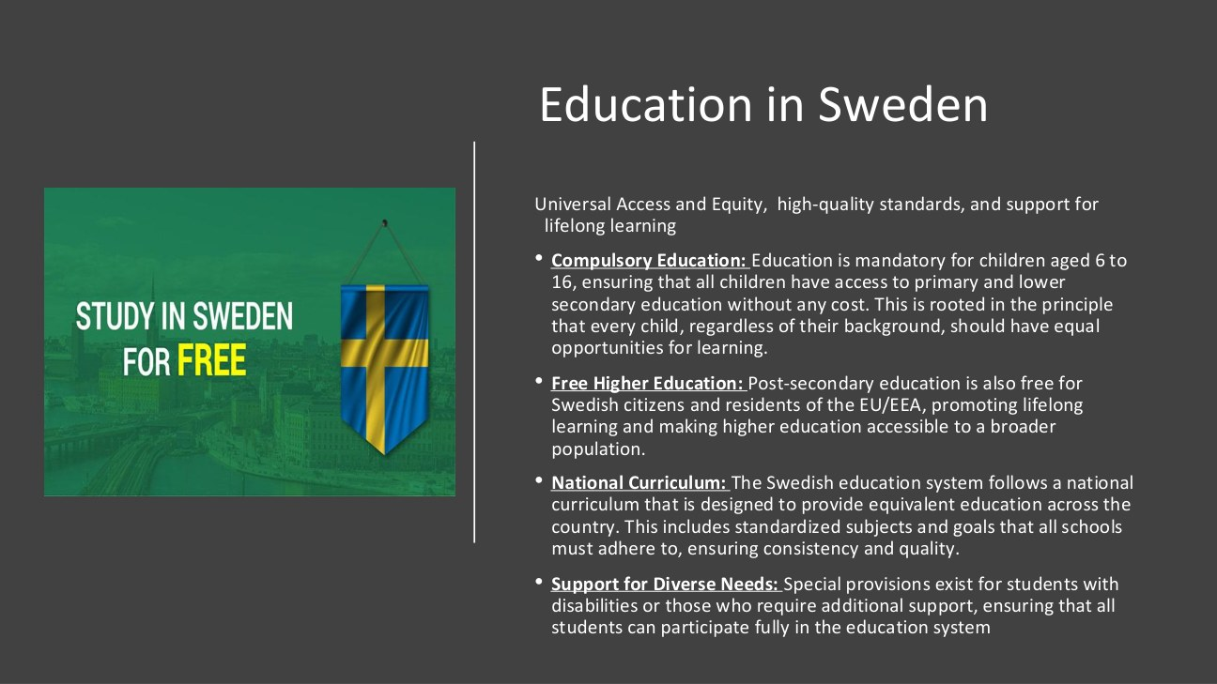
原PPT第38页截图 / Original screenshot, slide 38.

PPT中英翻译 / PPT translation
PPT English / 英文 | 中文翻译 / Chinese
Universal access and equity, high-quality standards, lifelong learning. | 普遍准入与公平、高质量标准、终身学习。
Compulsory education: ages 6–16, free primary and lower-secondary education with equal learning opportunities. | 义务教育：课件写6—16岁，免费取得小学与初中教育，并追求平等学习机会。
Free higher education: Swedish citizens and residents of the EU/EEA. | 原文称瑞典公民及欧盟／欧洲经济区居民可免高等教育学费；资格准确范围见下方说明。
National curriculum: standard subjects and goals for equivalent education across the country. | 国家课程：通过共同学科和目标，追求全国等值教育。
Support for diverse needs: specific provisions for disabilities and additional support. | 多样需要支持：为残障及需要额外帮助者设置特别安排。

PPT知识点复习与分析 / Review and analysis
以下结合Word与听课宝讲解，属于复习补充。 / The following combines the Word notes and class summary as supplementary explanation.

本页核心 / Key takeaway
瑞典学费豁免需看国籍及特定居留资格；不能把“在欧盟居住”直接等同免学费。
Swedish fee exemptions depend on citizenship and specified residence status, not simply living somewhere in the EU.

知识点详解 / Detailed study notes

1. 资格纠正 / Eligibility clarification
瑞典招生官方按国籍及特定居留资格判断免学费：欧盟／EEA／瑞士公民等通常豁免，某些其他居留资格也可豁免。仅在其他欧盟国家居住并不自动等同免学费。
Official guidance uses citizenship and specified residence categories. EU/EEA/Swiss citizens are generally exempt, with other exceptions; residence somewhere in the EU alone is not equivalent.

2. 国家课程的作用与局限 / Curriculum
共同目标可增强制度一致性；是否实现等值教育，还需看学校资源、实施和学生支持。统一课程不是所有人成绩一致。
Common goals can improve consistency, while equivalent education also depends on resources, implementation and support—not identical grades.

3. 支持差异需要 / Supporting different needs
若只宣布所有人都可入学，却没有无障碍和辅助服务，部分人仍难以学习。形式开放与有效参与应同时看。
Open admission alone may not enable participation without accessible facilities and support. Examine formal access and effective inclusion.

4. 年份与政策层次 / Date and policy level
截图是课程材料中的概括；现实资格与政策改革需看现行规则。复习概念可以用此例，不能把未标日期的每句话当作对所有人的现行承诺。
The slide is a teaching summary. Current eligibility and reforms require current rules; undated statements are not universal promises.

易错辨析 / Pitfalls and distinctions

居民身份不是一句话 / Residence needs specification
EU/EEA/瑞士国籍及部分居留类别可获豁免，不能只写“住在欧洲所以都免费”。
Fee rules depend on citizenship and specified residence categories, not merely living in Europe.

第39页 / Slide 39｜Summary｜总结引入

原PPT第39页截图 / Original screenshot, slide 39.

PPT中英翻译 / PPT translation
PPT English / 英文 | 中文翻译 / Chinese
Summary | 总结。

PPT知识点复习与分析 / Review and analysis
以下结合Word与听课宝讲解，属于复习补充。 / The following combines the Word notes and class summary as supplementary explanation.

知识点详解 / Detailed study notes

1. 把三个维度重新连上 / Reconnect the dimensions
资格依据说明谁能取得；国家—市场—家庭说明通过谁取得；去商品化和分层说明保障有多强、怎样分配。三者配合才形成完整解释。
Entitlement identifies who qualifies, institutional relations identify provision, and decommodification and stratification assess strength and distribution.

2. 实证领域的作用 / Role of empirical domains
养老金、就业与教育提供可检验的制度证据。分类不能只看一个指标，也不必在不同领域完全一致。
Pensions, labour and education provide institutional evidence. Classification should not rely on one measure or assume uniformity across domains.

3. 复习到应用 / From revision to application
接下来的三页是类型化总结。回答案例时仍需限定时期、政策和群体，不能直接抄总结当作所有现实事实。
The next slides summarise ideal types. Case answers still require boundaries of period, policy and population.

第40页 / Slide 40｜Liberal welfare state｜自由主义福利国家总结
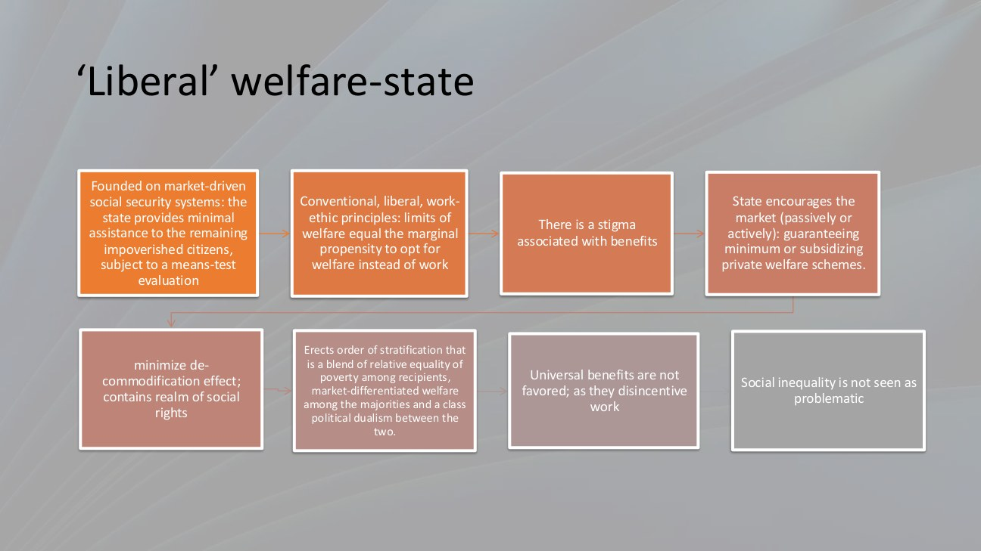
原PPT第40页截图 / Original screenshot, slide 40.

PPT中英翻译 / PPT translation
PPT English / 英文 | 中文翻译 / Chinese
Market-driven security; minimal assistance to impoverished citizens subject to means-testing. | 市场驱动的保障；向经济困难且通过家计审查者提供有限援助。
Work-ethic principles limit welfare where people might choose benefits instead of employment. | 以工作伦理为基础，担心人们选择福利而不就业，因此限制福利。
Stigma is associated with benefits. | 领取福利可能伴随污名。
State encourages markets, passively or actively, through minimum guarantees or subsidies to private schemes. | 国家消极或积极地支持市场，例如最低保障或补贴私人福利方案。
Minimises decommodification and restricts social rights. | 限制去商品化作用与社会权利范围。
Stratification combines relative equality of poverty among recipients with market-differentiated welfare among the majority, creating dualism. | 分层表现为受助者相对共同贫困与多数人按市场地位差异取得福利，并形成两者间的二元分化。
Universal benefits are not favoured because of work-disincentive concerns; inequality is not treated as inherently problematic in this model. | 该模型因工作激励担忧而不偏好普遍福利，也不把不平等本身当作必然需消除的问题。

PPT知识点复习与分析 / Review and analysis
以下结合Word与听课宝讲解，属于复习补充。 / The following combines the Word notes and class summary as supplementary explanation.

本页核心 / Key takeaway
自由型国家也会支持私人市场；它不是“完全没有国家或福利”。
Liberal states can support private provision; the model is not an absence of state action or welfare.

知识点详解 / Detailed study notes

1. 不是没有国家 / Not an absent state
本页明确国家会支持私人市场。应把“直接普遍供给较少”与“完全不干预”分开；扶持私人保险也是政策选择。
The state supports private markets. Less universal direct provision is not the absence of intervention.

2. Dualism怎样形成？ / How dualism develops
多数人依市场能力取得不同保障，困难者依公共救助；两个渠道的资格、质量与社会评价不同，可形成制度性分隔。
Market-based protection for the majority and assistance for the poor can create distinct entitlements, quality and social standing.

3. 主张不等于事实 / Position versus evidence
工作激励担忧与不平等观是模型中的政治理念，不是本资料赞成的价值判断，也不是福利必然降低就业的实证结论。
These are ideological premises in the model, not endorsed value judgements or proof that benefits necessarily reduce employment.

4. 案例答题线索 / Case evidence
寻找经济审查、补缺定位、私人方案支持与市场依赖的证据，同时记录例外。一个政策向低收入者发钱，尚不足以判定整个国家。
Look for means-testing, residual targeting, support for private provision and market dependence, while noting exceptions.

易错辨析 / Pitfalls and distinctions

自由型仍有积极政策 / Liberal regimes still make policy
支持市场、补贴私人福利本身也是国家行动；有限直接供给不能写成国家不管。
Supporting markets and private provision is state action; limited direct provision is not complete non-intervention.

第41页 / Slide 41｜Social-democratic welfare state｜社会民主主义福利国家总结
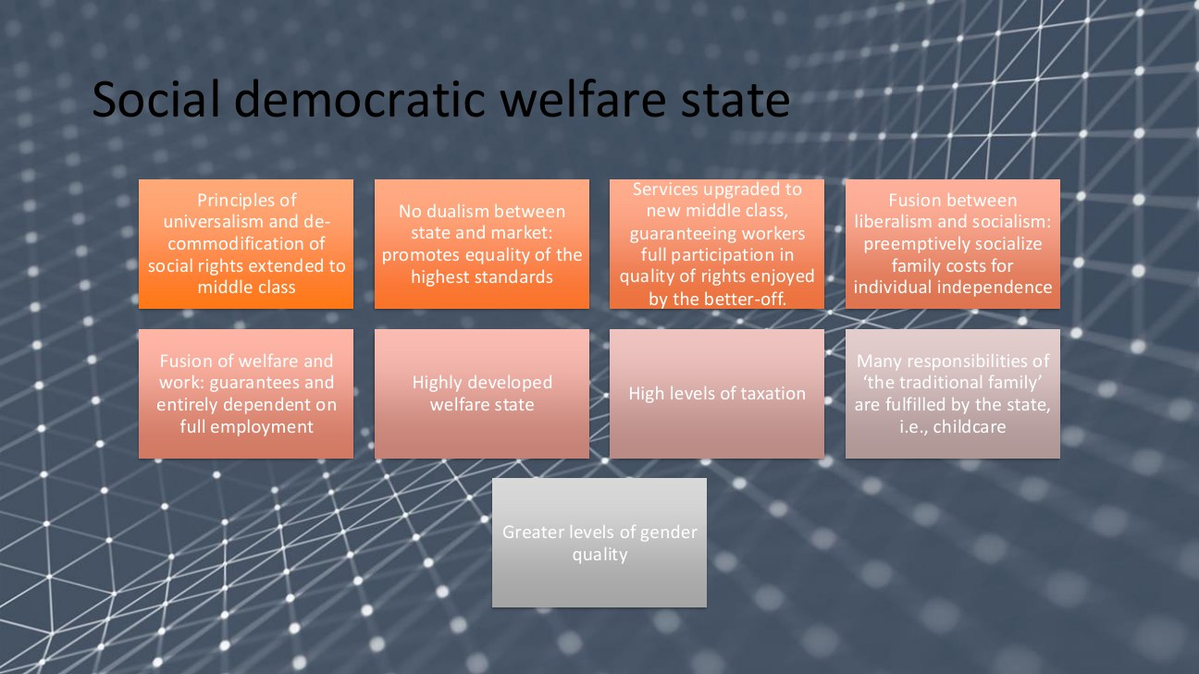
原PPT第41页截图 / Original screenshot, slide 41.

PPT中英翻译 / PPT translation
PPT English / 英文 | 中文翻译 / Chinese
Universalism and decommodification extend social rights to the middle class. | 普遍主义与去商品化把社会权利扩展至中产阶级。
No dualism between state and market; equality at high standards. | 避免国家与市场之间的二元分割，追求较高标准上的平等。
Services meet new middle-class standards, giving workers access to rights enjoyed by the better-off. | 服务提升至新中产标准，让劳动者也能享有较富裕群体的高质量权利。
Socialising family costs supports individual independence. | 把家庭成本社会化分担，以支持个人独立。
Welfare and work are fused; protection depends on full employment. | 福利与劳动结合；保障的维持依赖充分就业。
Developed welfare state; high taxation; state fulfils responsibilities such as childcare; greater gender equality. | 较发达福利制度、高税收，国家承担托育等传统家庭责任，并促进更高性别平等。

PPT知识点复习与分析 / Review and analysis
以下结合Word与听课宝讲解，属于复习补充。 / The following combines the Word notes and class summary as supplementary explanation.

本页核心 / Key takeaway
社会民主型联系普遍权利、较高标准、公共照顾与充分就业，不是只给穷人最低救助。
Social democracy links universal rights, high standards, public care and full employment, not merely minimum poor relief.

知识点详解 / Detailed study notes

1. 为何包括中产阶级？ / Why include the middle class?
如果公共福利只对少数困难者提供低标准，较富裕者可能退出公共体系。较高质量、广泛覆盖可支持更广联盟，减少穷人救助与私人高质量服务之间的二元分化。
Broad, high-quality services can retain middle-class support and reduce division between poor relief and superior private provision.

2. 家庭成本社会化 / Socialising family costs
托育等服务把部分照顾成本从单个家庭转为共同承担，有助于个人不完全依赖家庭成员。它不表示家庭消失或国家处理一切私人生活。
Public childcare shares care costs and can reduce dependence within families. It does not abolish families or all private responsibility.

3. 就业与财政联系 / Employment and finance
广泛就业支持税收与制度筹资，同时服务供给也创造就业。因此高福利不能只理解为“不工作也拿钱”，还要看工作、照顾和财政的结合。
Employment supports revenue and financing, while services create jobs. The model links protection, care, employment and finance.

4. 性别平等不是自动实现 / Gender equality is not automatic
公共照顾可支持女性就业，但仍需看工资差异、职业分隔和家庭分工。课件末行gender quality按语境应为gender equality。
Care services can support women’s employment, but pay, occupational segregation and household responsibilities still matter. Gender quality is a slide typo for gender equality.

易错辨析 / Pitfalls and distinctions

社会民主不是无市场 / Social democracy is not no market
广泛权利与公共服务可在资本主义和就业基础上运作；不能写成废除工资劳动或所有家庭责任。
Broad rights and services can operate with capitalist markets and employment; neither wage labour nor all family responsibility is abolished.

第42页 / Slide 42｜Conservative welfare state｜保守主义福利国家总结
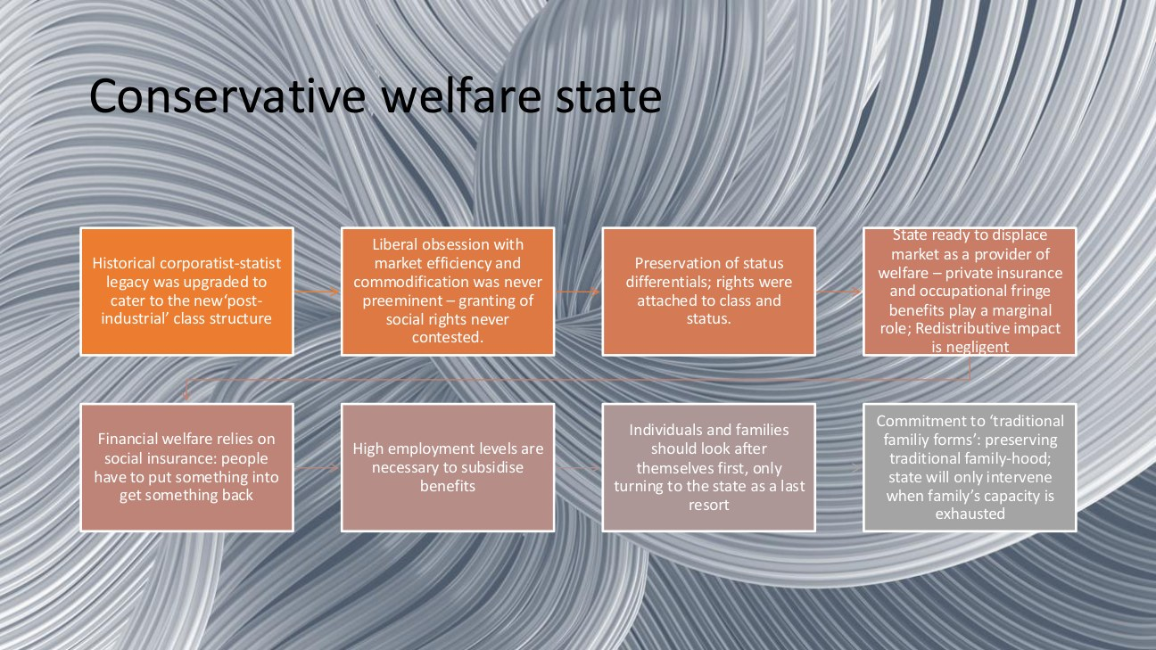
原PPT第42页截图 / Original screenshot, slide 42.

PPT中英翻译 / PPT translation
PPT English / 英文 | 中文翻译 / Chinese
A corporatist-statist legacy adapts to new post-industrial class structures. | 法团—国家主义传统被调整以适应后工业社会阶级结构。
Market efficiency and commodification were not pre-eminent; granting social rights was not itself contested. | 市场效率与商品化并非首要目标；给予社会权利本身不受根本质疑。
Status differentials are preserved; rights attach to class and status. | 保存身份差异；权利与阶级和地位相连。
State displaces market provision; private insurance and occupational fringe benefits are marginal; redistributive effect is small. | 国家可取代市场供给；私人保险与职业附加福利相对边缘；再分配作用较小。
Social insurance links input and return; high employment finances benefits. | 社会保险把投入与回报相连；较高就业支撑福利筹资。
Individuals and families act first; state intervenes when family capacity is exhausted, preserving traditional family forms. | 个人与家庭先承担责任，家庭能力耗尽后国家才介入，并维护传统家庭形态。

PPT知识点复习与分析 / Review and analysis
以下结合Word与听课宝讲解，属于复习补充。 / The following combines the Word notes and class summary as supplementary explanation.

本页核心 / Key takeaway
保守型可有强保障，却维护身份差异；保护较强不等于跨群体更平等。
Conservative regimes can provide strong protection while preserving status; strong protection is not necessarily greater equality.

知识点详解 / Detailed study notes

1. 强国家与家庭优先可并存 / Strong state and family priority
国家可以积极组织社会保险，却仍要求家庭先承担照顾。国家辅助不是国家无力，而是公共责任按特定家庭和身份逻辑组织。
An active insurance state can coexist with family-first care. Subsidiarity concerns the organisation of responsibility, not simply state weakness.

2. 有保护但维持差异 / Protection with status preservation
缴费者可获得较强保障，但不同职业与家庭位置的待遇仍可能不同。去商品化与平等不能直接画等号。
Contributors can receive strong protection while benefits differ by occupation and family position. Decommodification is not identical to equality.

3. 不同“职业福利”要区分 / Occupational categories differ
职业分割的法定社会保险，不等同于雇主自愿提供的私人附加福利。因此说职业身份重要与私人附加福利边缘，并不必然矛盾。
Statutory insurance segmented by occupation differs from voluntary private employer benefits. Occupational status can matter while private fringe benefits remain marginal.

4. 原文措辞 / Wording
课件写redistributive impact is negligent，按语境意为negligible（很小），不是“再分配影响疏忽”。这仍是理想类型概括，并非逐项实测的全称判断。
Negligent appears to mean negligible here. The claim remains a stylised summary rather than a measured universal statement about every programme.

易错辨析 / Pitfalls and distinctions

职业保险与私人附加福利 / Occupational insurance versus private benefits
按职业分割的法定保险与雇主自愿附加福利不同，因此职业身份重要和私人附加福利边缘可同时成立。
Statutory occupation-based insurance differs from voluntary employer benefits; the two statements are compatible.

第43页 / Slide 43｜Questions?｜提问与自测

原PPT第43页截图 / Original screenshot, slide 43.

PPT中英翻译 / PPT translation
PPT English / 英文 | 中文翻译 / Chinese
Questions? June Wang; June.wang@cityu.edu.hk | 有问题吗？June Wang；June.wang@cityu.edu.hk。

PPT知识点复习与分析 / Review and analysis
以下结合Word与听课宝讲解，属于复习补充。 / The following combines the Word notes and class summary as supplementary explanation.

知识点详解 / Detailed study notes

1. 概念自测 / Concept check
能否解释社会公民权、去商品化与社会分层，并区分社会救助、社会保险和普遍权利？回答需要定义与例子，不只译词。
Can you explain citizenship, decommodification and stratification, and distinguish assistance, insurance and universal rights with examples?

2. 图表自测 / Chart check
第19—20页是1980年指数，不是当前排名；第24页看家庭收入份额；第29页变化用百分点；第30页三列分母不同。能否逐项说清？
Distinguish historical scores, household-income shares, percentage-point changes and different employment denominators.

3. 案例答题 / Case answer
按“背景与目标→国家市场家庭→资格与供给→去商品化与分层→证据与局限”展开。类型判断放在机制证据之后，不凭直觉下结论。
Use background and aims → institutions → entitlement and provision → protection and stratification → evidence and limits. Let mechanisms support classification.

附录A｜原Word知识点逐条对照 / Source Word notes in Chinese and English
本附录保留上传Word的知识点，逐条配英文；原资料概括过强或与PPT不同之处，另见附录C。说明性尾句和重复格式提示不作为知识点。
This appendix retains the uploaded Word’s study content with English counterparts. Overgeneralisations and discrepancies are qualified in Appendix C. Closing boilerplate and formatting prompts are not study content.
PIA5701 第1‑2周 艾斯平‑安德森：福利资本主义的三个世界 知识点整理
PIA5701 Weeks 1–2: Esping-Andersen’s Three Worlds of Welfare Capitalism—study notes.
一、福利国家基础概念
I. Basic concepts of the welfare state
1. 不同学者对福利国家的定义
1. Definitions offered by different scholars
Therborn（1983）：从国家职能历史转型出发；国家大部分日常活动用来满足家庭福利需求。
Therborn (1983): begin with the historical transformation of state functions; most routine activities serve household welfare needs.
Titmuss（1958）：区分 残余型（residual）与制度型（institutional） 福利国家。福利不应该只面向少数边缘弱势群体，应当面向全部人口。
Titmuss (1958): distinguish residual and institutional welfare states. Welfare should address the whole population, not only small marginal or disadvantaged groups.
Day & Myles：将现实福利国家效果和抽象模型对比打分，以此判断福利国家类型。
Day and Myles: compare actual welfare-state effects with an abstract model and score them to identify types.
2. T.H. 马歇尔：社会公民权（Social Citizenship）⭐
2. T.H. Marshall: social citizenship—key concept
公民身份是共同体全部正式成员拥有的地位；该地位带来权利与义务，整体导向更大程度的社会平等。
Citizenship is the status held by full members of a community. It brings rights and duties and generally points towards greater equality.
社会公民权包含两大核心维度：社会权利（social rights）、社会分层 / 阶层化（stratification）。
Social citizenship involves two central dimensions: social rights and social stratification.
福利体制（welfare‑state regime）：指一套特定的社会运行组织方式，核心看国家、市场、家庭三者之间的制度安排差异，带来各国社会权利与社会分层的国际差异。
A welfare-state regime is a particular organisation of social provision. Arrangements between state, market and family create international differences in social rights and stratification.
3. 去商品化 De‑commodification【全书核心概念】
3. Decommodification—the central concept
定义：当福利服务作为公民权利被提供，个人不需要依赖劳动力市场也可以维持社会可接受的生活水平，就发生了去商品化。
Definition: decommodification occurs when welfare is provided as a right and people can maintain a socially acceptable living standard without dependence on the labour market.
仅仅社会救助、社会保险不等于实现去商品化；只有制度可以真正把人从市场依附关系中解放出来，才算实现去商品化。
Assistance and insurance alone do not establish decommodification; the notes stress that institutions must actually release people from market dependence. See the qualification in the correction appendix concerning degrees rather than complete release.
劳动力本身是特殊商品：劳动者需要生存、繁衍自身与社会，不能像普通商品一样被随意处置。
Labour power is a special commodity: workers must survive and reproduce themselves and society rather than be treated like ordinary objects.
艾斯平‑安德森构建去商品化指数，从养老金、疾病津贴、失业保险三个维度打分；分数越高，去商品化程度越强。北欧（瑞典、挪威、丹麦）得分最高；盎格鲁‑撒克逊自由主义国家得分低。
Esping-Andersen’s index scores pensions, sickness benefits and unemployment insurance. Higher scores indicate stronger decommodification. Nordic cases score high and Anglo-Saxon liberal cases low in the historical comparison.
二、三大福利体制：福利资本主义三个世界（Esping‑Andersen）
II. The three welfare regimes: Esping-Andersen’s three worlds of welfare capitalism
判断体制核心：看国家、市场、家庭三者谁是福利供给中心，谁是补充，谁被边缘化。
To identify a regime, examine which institution—state, market or family—is central, supplementary or marginal in provision.

自由主义 Liberal / Liberal
维度 / Field | 原文 / Chinese source | English / 英文
福利体制 / Regime | 自由主义 Liberal | Liberal
核心原则 / Core principle | 残余主义 Residualism；福利是穷人安全网 | Residualism: welfare as a safety net for the poor
福利资格逻辑 / Entitlement | 家计 / 需求审查 means‑tested，证明贫困才可以获得福利；福利带有污名 | Means-tested need; proving poverty can carry stigma
去商品化程度 / Decommodification | 低 | Low
国家角色 / State role | 最小限度干预；鼓励私人福利市场 | Minimal intervention and encouragement of private welfare markets, in the source’s wording
市场角色 / Market role | 福利供给主导 | Dominant in provision
家庭角色 / Family role | 边缘化 | Marginal in the ideal type
典型国家 / Examples | 美国、加拿大、澳大利亚、英国 | US, Canada, Australia, UK

保守主义 / 社团主义 Conservative‑Corporatist / Conservative-corporatist
维度 / Field | 原文 / Chinese source | English / 英文
福利体制 / Regime | 保守主义 / 社团主义 Conservative‑Corporatist | Conservative-corporatist
核心原则 / Core principle | 团结互助；贡献‑回报；维护既有社会地位分层 | Solidarity, contribution–return links and preservation of status
福利资格逻辑 / Entitlement | 基于工作贡献、劳动市场依附、缴费记录；福利和职业身份挂钩 | Employment attachment, contribution records and occupational identity
去商品化程度 / Decommodification | 中等 | Moderate in the notes; see the breadwinner qualification on slide 9
国家角色 / State role | 维持社会秩序与原有阶层；家庭优先 | Maintains order and status arrangements; family-first logic
市场角色 / Market role | 与国家并存，次要 | Secondary alongside state arrangements
家庭角色 / Family role | 福利供给核心，强调家庭责任 | Central, with strong family obligations
典型国家 / Examples | 德国、法国、奥地利、意大利 | Germany, France, Austria, Italy

社会民主主义 Social‑Democratic / Social-democratic
维度 / Field | 原文 / Chinese source | English / 英文
福利体制 / Regime | 社会民主主义 Social‑Democratic | Social-democratic
核心原则 / Core principle | 普遍主义 Institutional；福利面向全体国民 | Universal/institutional provision for the population
福利资格逻辑 / Entitlement | 公民身份 / 长期居留权，不需要贫困证明、不需要强制缴费贡献 | Citizenship or long-term residence; no poverty proof and, in the notes’ wording, no compulsory contributions. The financing qualification is discussed separately
去商品化程度 / Decommodification | 高 | High
国家角色 / State role | 强国家直接提供普惠福利 | Broad public provision
市场角色 / Market role | 被明显弱化 | Reduced as the basis of basic protection
家庭角色 / Family role | 国家替代部分家庭功能 | Some care responsibilities are publicly shared
典型国家 / Examples | 瑞典、挪威、丹麦、芬兰 | Sweden, Norway, Denmark, Finland

这张原资料表是高度概括：普遍资格不能推成不需要融资，保守型保障需限定群体；请结合附录C核对。
This source table is highly simplified: universal entitlement does not remove financing, and conservative protection depends on the group. See Appendix C.
1. 自由主义福利体制要点
1. Main features of liberal welfare regimes
信奉自由市场，认为市场可以解决贫困与不平等；国家只在市场失灵的时候介入。
The notes describe faith in markets as a way to address poverty and inequality, with state intervention when markets fail.
公共救助带有道德污名；普遍福利不受欢迎，担心降低工作激励。
Public assistance may carry moral stigma. Universal provision is resisted out of concern about work incentives.
国家会补贴、扶持私人保险与私人福利方案；社会不平等本身不被视作政策问题。
The state subsidises or supports private insurance and welfare arrangements; inequality itself is not treated as a policy problem in this stylised account.
福利对象主要是被市场淘汰的贫困群体，多数普通人依靠市场获得福利。
Public welfare primarily targets economically excluded poor groups, while most people obtain provision through markets.
2. 保守（社团主义）福利体制要点
2. Main features of conservative-corporatist regimes
继承法团‑国家主义传统，重点保护原有社会地位差异；福利权利和阶级、职业身份绑定。
The corporatist-statist legacy preserves status differences, linking rights to class and occupational identity.
福利逻辑：先投入缴费，才有资格领取；社会保险为主要工具，再分配效果微弱。
Social insurance links entitlement to contributions. The notes characterise redistribution as limited.
家庭是首要责任主体，国家只有家庭能力耗尽之后才介入；重视维护传统家庭形态。
Families bear primary responsibility; the state intervenes after family capacity is exhausted and preserves traditional family arrangements.
私人保险、职业福利处于次要位置；高就业率是维持社保体系运转的基础。
Private insurance and private occupational benefits have a secondary role. High employment supports social-insurance finance.
3. 社会民主主义福利体制要点
3. Main features of social-democratic regimes
普遍权利 Universal Right：福利是公民权利，不是施舍恩惠。面向全部国民，不分贫富。
Universal rights treat welfare as citizenship rather than charity, addressing the population across income groups.
高水平去商品化；国家承担很多传统家庭职能（例如普惠托育），推进性别平等。
Strong decommodification and public provision of some traditional family functions, such as childcare, can advance gender equality.
福利与充分就业绑定，依靠高税收支撑高福利；目标是让中产阶级也享受高质量公共福利。
Welfare connects to full employment and taxation, aiming to include the middle class in high-quality public services.
早期社会主义政策特征：强权利、中等给付水平；重点覆盖养老、工伤、失业、疾病等人类基础需要。
The notes describe early socialist policy as strong rights with moderate benefits, concentrating on pensions, accidents, unemployment and sickness. The slide itself says fairly modest benefit levels.
三、三大关键实证领域：养老金、劳动力市场、教育
III. Three empirical domains: pensions, labour markets and education
1. 养老金制度的三种模式
1. Three pension-regime models
社团主义国家主导保险模式：职业身份地位是核心；私人市场边缘化；社保高度按职业分割，公务员特权突出。代表：德、法、奥、比、意。
Corporatist state-dominated insurance puts occupational status at the centre, marginalises private markets and segments provision by occupation, with civil-servant privileges. Examples: Germany, France, Austria, Belgium and Italy.
残余主义模式：市场占主导，国家社保作用弱。代表：美国、加拿大、澳大利亚、瑞士。
Residualist pensions give markets a dominant role relative to public social security. Examples: the US, Canada, Australia and Switzerland.
普遍主义国家主导模式：全民社会权利，消除身份特权，压缩市场作用。代表：瑞典、挪威、新西兰，丹麦、荷兰。
Universalistic state-dominated pensions extend common social rights and reduce status privilege and market roles. Slide examples include Sweden, Norway, New Zealand and possibly Denmark and the Netherlands.
养老金体现国家‑市场‑家庭博弈：国家权力会培育私人养老金市场；反过来市场的局限也塑造国家养老金政策。
Pensions reflect state–market–family relations: state power cultivates private pension markets while market limits also shape public pension policy.
2. 福利国家与劳动力市场
2. Welfare states and labour markets
研究三个关键问题：
Three key questions:
人们什么条件下退出劳动力市场（尤其退休、提前退休）；西欧大量劳动者通过提前退休离开劳动市场，成为企业重组的工具。
Under what conditions do people leave the labour market, especially through retirement and early retirement? Early retirement in Western Europe also served company restructuring.
在什么条件下劳动者可以带薪离岗（病假、育儿假等）。
Under what conditions can workers take paid absence, such as sickness or parental leave?
劳动者进入就业岗位的分配条件。
Under what conditions are people allocated to jobs and enter employment?
战后 “凯恩斯 + 贝弗里奇” 模式：把社会保障行政和劳动力市场管理分开；后期发生三重变革：
①充分就业目标从仅限男性拓展到全体女性与所有希望工作的人；
②退休制度大规模扩张，提前退休被大量使用；
③福利国家本身成为重要就业机器，成为很多国家新增岗位主要来源。
The post-war Keynes-plus-Beveridge arrangement separated social-protection and labour-market administration. Three later changes widened employment aims to women and others wishing to work, expanded retirement and early exit, and made welfare provision an important source of jobs.
3. 不同福利体制下的教育体系对比
3. Educational systems across regimes
维度 / Dimension | 自由型 / Liberal | 社会民主型 / Social-democratic | 保守型 / Conservative
阶层分化 stratification  Stratification | 低  Low | 低‑中等  Low–moderate | 高  High
标准化 standardisation  Standardisation | 中等  Moderate | 高  High | 中‑高  Moderate–high
职业教育特殊性  Vocational specificity | 低  Low | 中‑高  Moderate–high | 高  High
去商品化  Decommodification | 低  Low | 高  High | 低‑中等  Low–moderate
公共支出  Public expenditure | 中等  Moderate | 高  High | 中等  Moderate
私人支出  Private expenditure | 中‑高  Moderate–high | 低  Low | 中‑低  Moderate–low

案例 1：美国（自由主义）教育
Case 1: education in the liberal US setting
市场驱动，私立机构占重要地位；家庭付费决定教育质量，带来巨大阶层差距。
The notes describe market-driven education and important private institutions; they state that families’ payments determine educational quality and create substantial class gaps. This is the source’s broad claim, qualified in the review.
资助只针对低收入群体（家计审查）；公私双轨，富裕家庭享受优质私立教育。
They state that assistance only targets low-income groups through means-testing, and describe a public/private divide in which wealthier families obtain better private schooling. These generalisations require the qualifications in the review.
个人承担高额学费，联邦政府不保障全民平等教育机会。
They stress high personal tuition costs and state that the federal government does not guarantee equal educational opportunities for everyone. State and local roles must be distinguished from federal roles.
案例 2：瑞典（社会民主主义）教育
Case 2: education in the social-democratic Swedish setting
教育是公民权利，国家大规模公共财政投入；追求平等，缩小社会经济背景带来的差距。
Education is framed as a right, with substantial public funding and a goal of reducing socioeconomic gaps.
6‑16 岁义务教育完全免费；本国及欧盟居民高等教育免费。
The notes describe free compulsory education at ages 6–16 and tuition-free higher education for domestic and EU residents. Exact fee-exemption categories are clarified separately.
全国统一国家课程，保障全国教育质量均衡；为残障、弱势学生提供专项支持。
A national curriculum seeks equivalent education, with additional support for disabled and disadvantaged students.
四、考试 / 作业分析框架（答题模板）
IV. Framework for exam or policy analysis
分析一项社会政策，需要完整回答：
A social-policy analysis should answer:
政策背景、政策目标；
What are the policy background and objectives?
体现出怎样国家‑市场‑家庭三者关系；
What relationship between the state, market and family does it express?
是否体现去商品化，程度如何；
Does it decommodify, and to what extent?
福利对象是谁，资格条件是什么；
Who receives welfare, and under what eligibility rules?
判断属于哪一类福利体制，提供证据，不要仅凭直觉下结论；
Which welfare logic does it reflect? Supply evidence rather than an intuitive label.
对政策设计与执行做出评价。
How should its design and implementation be evaluated?
⚠答题易错提醒
Exam pitfalls and reminders
概念不是死记硬背，重点要会用概念分析现实政策。
Concepts should be used to analyse policy rather than only memorised.
论证立足于课程理论概念，不能只靠个人感受。
Arguments should rest on course concepts, not personal impressions alone.
时间范围聚焦现代资本主义时期，不要使用过久远历史材料。
Choose historical material appropriate to modern capitalism rather than unrelated remote periods.
五、核心总结
V. Core summary
艾斯平‑安德森 “福利三大世界” 的两大分析主轴：去商品化（de‑commodification）、社会分层（stratification）；分析视角就是看国家‑市场‑家庭的组合关系。
Two central analytical axes are decommodification and stratification; the institutional perspective concerns the state–market–family mix.
自由主义：市场优先，家计审查，低去商品化；保守主义：家庭与职业身份优先，贡献换取福利；社会民主主义：公民普遍权利，高去商品化，强国家。
Liberal: market priority, means-testing and low decommodification. Conservative: family and occupational status, contributions for protection. Social-democratic: broad citizenship rights, strong decommodification and public provision.
养老金、劳动力市场制度、教育制度是识别福利体制的三大实证领域，不同体制会在这些领域呈现系统性差异。
Pensions, labour-market institutions and education are empirical domains in which systematic institutional differences can be examined.

附录B｜听课宝要点与分析步骤 / Class-summary points and analysis

理论与历史 / Theory and history
听课宝要求把理论放回现代资本主义与20世纪福利国家发展的语境，同时考虑当代新自由主义改革。不能把经典类型当作永不变化的国家标签。
The summary locates the theory in modern capitalism and twentieth-century welfare development, while noting later neoliberal reforms. Classic types are not permanent labels.

分析三方关系 / Institutional relations
先问国家、市场与家庭谁居中心、谁补充，再看权利、资格和分层。中心与边缘是相对概括，不表示其他主体不存在。
Ask which institution is central or supplementary, then examine rights, entitlement and stratification. Relative marginality is not absence.

商品化与去商品化 / Commodification and decommodification
商品化强调生活与劳动被市场交换组织；去商品化看在不参与市场时仍能维持生活的程度。收入审查救助不一定提供充分保护。
Commodification organises needs and labour through exchange; decommodification measures protection outside market participation. Assistance may still be inadequate.

三类比较 / Comparing regimes
自由型看市场、个人责任与审查；保守型看家庭、职业和贡献；社会民主型看普遍权利与公共保障。不要只背国名。
Compare market responsibility and tests, family/status/contributions, and universal public protection rather than memorising countries alone.

香港与内地案例 / Hong Kong and mainland cases
总结提到香港贫困线争议与内地低收入家庭救助，但文件未给完整政策条文。可比较贫困界定、资格、责任和执行，不编造数值或现行门槛。
The notes mention poverty-line and assistance discussions without full rules. Compare definitions, eligibility, responsibility and implementation without inventing thresholds.

答题路径 / Answer sequence
定义概念→识别政策机制→用证据作类型判断→评价后果与局限。理论分析不等于只表达赞成或反对。
Define → identify mechanisms → classify with evidence → assess consequences and limits. Analysis goes beyond personal approval or disapproval.

概括需限定 / Qualifying generalisations
“当代国家越来越相似”应作待检验问题；家庭重要不能推出国家弱；有救助不能推出高去商品化。保守主义商品化一词的方向错误见纠错表。
Convergence is a question for evidence; strong families do not prove weak states, and assistance does not prove strong decommodification. The terminology reversal is corrected below.

附录C｜术语、概括与证据核对 / Terminology and evidence checks

商品化方向 / Direction of commodification
听课宝称保守主义反对过度去商品化；PPT第13页实际说传统保守主义反对把人商品化。应按原文区分。
The summary reverses the term: slide 13 says traditional conservatism opposed commodifying humanity, not decommodification.

去商品化是程度 / Degrees of protection
Word“只有真正解放才算”不应读成全有全无。第19—20页本身就是程度指数；比较资格、额度与期限。
Do not read the notes as all-or-nothing. Slides 19–20 measure degrees through entitlement and protection.

普遍资格与融资 / Entitlement and finance
普遍权利可不以贫困或工作贡献作为基本资格，但不能推成所有福利都无需税收、缴费或身份条件。
Universal entitlement need not be based on poverty or employment, but this does not remove taxation, contributions or all status conditions.

保守型保障 / Conservative protection
Word写去商品化中等；PPT第9页明确对breadwinner较高。群体与领域会影响判断。
The notes say moderate, while slide 9 specifies high protection for breadwinners; population and domain matter.

教育分层 / Educational stratification
第32页的制度分流指标，不等于社会经济机会差异。低制度分层与机会不平等可并存。
Educational tracking and socioeconomic inequality are not identical. Low structural stratification can coexist with unequal opportunity.

美国政府层级 / US government levels
美国教育主要由州和地方负责；联邦提供补充支持。课件第34页应按此限定。[V1]
US education is primarily a state and local responsibility, with federal support. Qualify slide 34 accordingly. [V1]

美国大学融资 / US university finance
第35页45%没有日期或统计口径，不能当现行普遍比例；私人治理也不等于不接收任何公共资源。
The 45% lacks date and denominator and is not a universal current figure; private governance does not exclude all public resources.

瑞典学费资格 / Swedish fee eligibility
通常看EU/EEA/瑞士国籍及特定居留类别；在欧盟某国居住不自动等于免学费。免学费不免生活费。[V2]
Fee exemptions generally follow EU/EEA/Swiss citizenship and specified residence categories, not mere residence somewhere in the EU. Tuition-free is not cost-free living. [V2]

原文笔误 / Slide typos
De-commercialization在本讲应联系de-commodification；Timuss与Esping-Anderson规范为Titmuss与Esping-Andersen；gender quality按语境为gender equality；negligent应理解为negligible。
Interpret the agenda in terms of decommodification; standardise author names to Titmuss and Esping-Andersen; gender quality means gender equality and negligent appears to mean negligible.

历史数据 / Historical data
第19—20页为1980年指数；第24页各国年份不同；第29页是百分点；第30页三列分母不同。源图脚注不可见时不补造。
Preserve historical dates, differing country years, percentage points and different denominators. Do not invent footnotes missing from the image.

核对来源 / Verification sources
以下官方资料仅用于核对现实教育职责与学费资格，不能替代课程原文；历史图表按截图所列时期理解。
The official sources below verify educational responsibilities and fee eligibility. They do not replace course readings; historical tables retain their original periods.
[V1] U.S. Department of Education: Federal Role in Education / 美国教育部：联邦在教育中的角色
https://www.ed.gov/about/ed-overview/federal-role-in-education
[V2] University Admissions Sweden: Who is required to pay fees? / 瑞典大学招生官方：谁须缴费？
https://www.universityadmissions.se/en/fees-scholarships-residence-permit/who-is-required-to-pay-fees/

