01｜私人住房与住房所有权 / Private housing and ownership
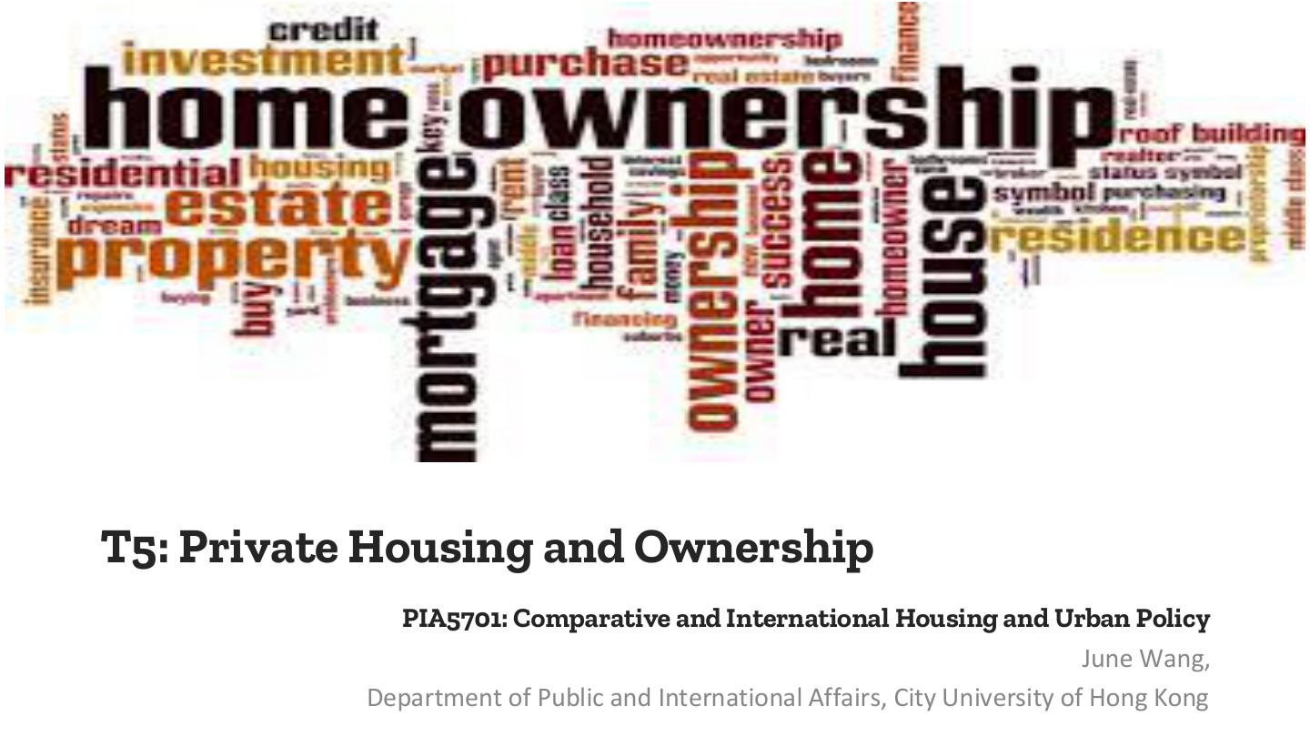
原PPT第1页 / Original slide 1 · 简读 / Brief

PPT中英翻译 / PPT translation
PPT English / 英文原文与图示 | 中文翻译 / Chinese translation
T5: Private Housing and Ownership | 第五讲：私人住房与住房所有权。
PIA5701: Comparative and International Housing and Urban Policy | PIA5701：比较与国际住房及城市政策。
June Wang, Department of Public and International Affairs, City University of Hong Kong | June Wang，香港城市大学公共及国际事务系。
Word cloud: homeownership; mortgage; property; housing; residence; ownership; estate; investment; credit; purchase; building. | 词云主要术语：住房自有、按揭、财产、住房、住所、所有权、地产、投资、信贷、购买、建造。

本页核心 / Key takeaway
本课分析住房自有如何连接福利、家庭资产、市场风险和国家政策。
This lesson connects homeownership with welfare, household assets, market risks and public policy.

阅读说明 / Reading guide
核心理论和辨析标红，次重点加粗；非重点与重复页浓缩。全篇中英对照，无附录。
Red marks core theory and distinctions; bold marks secondary points. Brief or repetitive pages retain essentials. All review content is bilingual; no appendix.
听课宝偏重美荷公共住房回顾，用于相关对照；本讲新增内容以本课PPT结合Word整理。
The listening summary reviews public housing. Relevant comparisons are integrated; new ownership, affordability and crisis content follows this PPT and the Word notes.

02｜本课路线 / Agenda
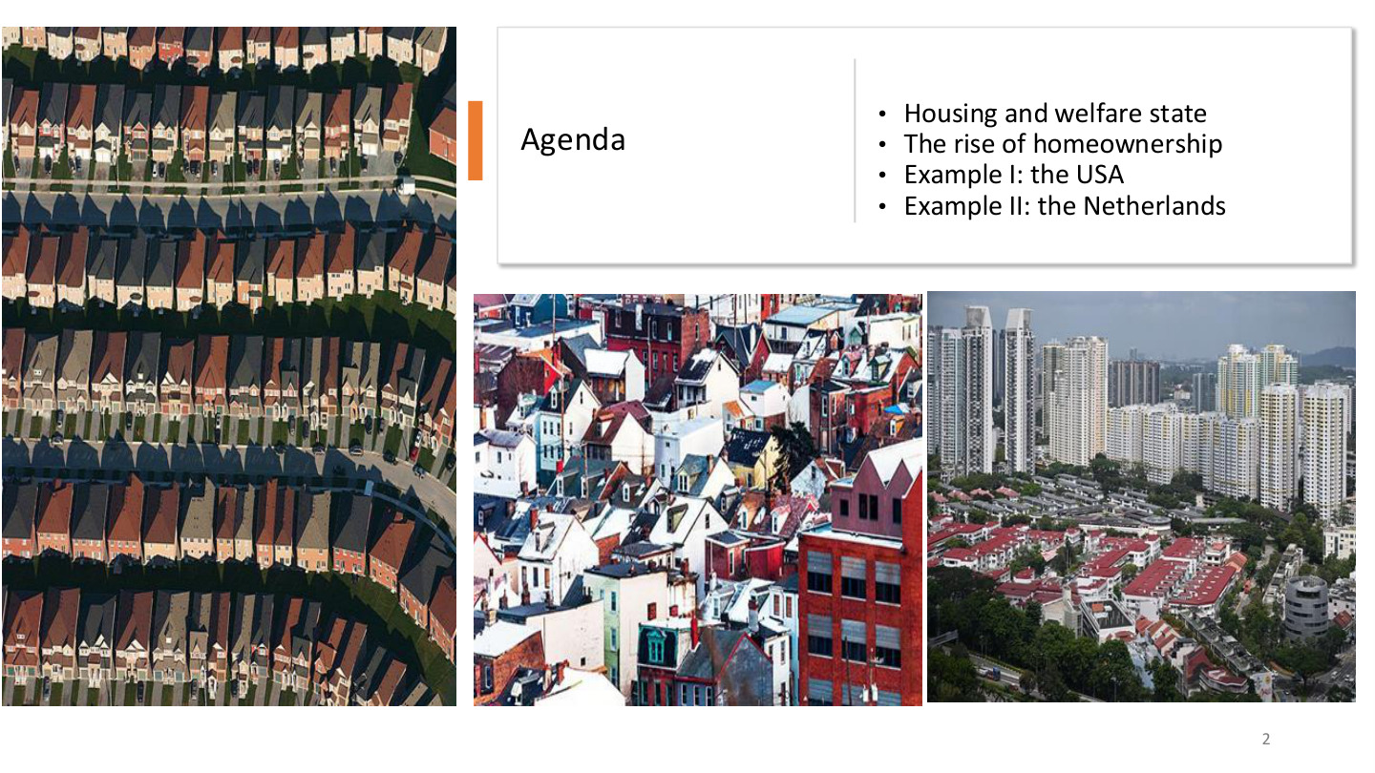
原PPT第2页 / Original slide 2 · 简读 / Brief

PPT中英翻译 / PPT translation
PPT English / 英文原文与图示 | 中文翻译 / Chinese translation
Housing and welfare state; The rise of homeownership; Example I: the USA; Example II: the Netherlands. | 住房与福利国家；住房自有的兴起；案例一：美国；案例二：荷兰。

本页核心 / Key takeaway
按“理论→自有住房与可负担性→美国→荷兰”的顺序复习。
Study theory, homeownership and affordability, then the US and Dutch cases.

03｜住房与福利国家 / Housing and the welfare state

原PPT第3页 / Original slide 3 · 简读 / Brief

PPT中英翻译 / PPT translation
PPT English / 英文原文与图示 | 中文翻译 / Chinese translation
I. Housing and welfare state | 第一部分：住房与福利国家。

本页核心 / Key takeaway
先问：住房保障主要依靠国家制度，还是家庭资产与市场？
Start by asking whether housing security relies mainly on public institutions or on household assets and markets.

04｜住房与去商品化 / Housing and decommodification
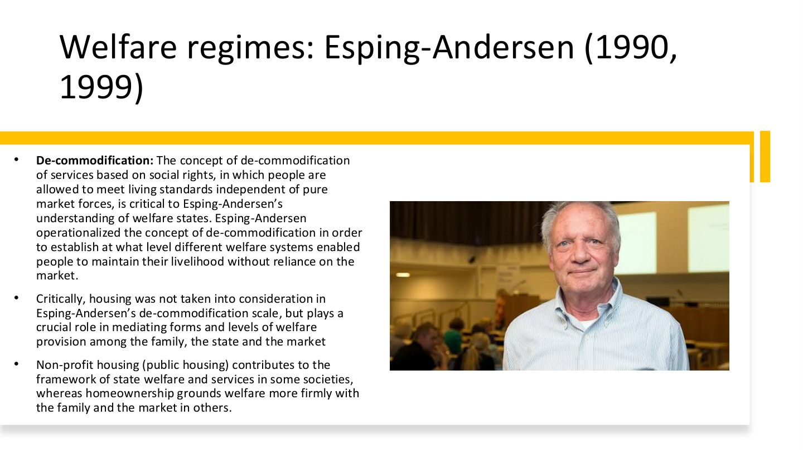
原PPT第4页 / Original slide 4 · 重点 / Focus

PPT中英翻译 / PPT translation
PPT English / 英文原文与图示 | 中文翻译 / Chinese translation
Welfare regimes: Esping-Andersen (1990, 1999) | 福利体制：Esping-Andersen（1990、1999）。
De-commodification: The concept of de-commodification of services based on social rights, in which people are allowed to meet living standards independent of pure market forces, is critical to Esping-Andersen’s understanding of welfare states. Esping-Andersen operationalized the concept of de-commodification in order to establish at what level different welfare systems enabled people to maintain their livelihood without reliance on the market. | 去商品化以社会权利为基础，使人们不完全依靠纯粹市场力量维持生活水平，是Esping-Andersen理解福利国家的关键。他将概念操作化，以比较不同福利制度在多大程度上使个人能够不依赖市场维持生计。
Critically, housing was not taken into consideration in Esping-Andersen’s de-commodification scale, but plays a crucial role in mediating forms and levels of welfare provision among the family, the state and the market. | 关键是，住房未被纳入其去商品化量表，却在家庭、国家和市场之间调节福利供给的形式与程度。
Non-profit housing (public housing) contributes to the framework of state welfare and services in some societies, whereas homeownership grounds welfare more firmly with the family and the market in others. | 一些社会的非营利住房（课件括注公共住房）构成国家福利服务的一部分；另一些社会的住房自有，则把福利更紧密地建立在家庭与市场上。

本页核心 / Key takeaway
原始去商品化量表没有纳入住房，但住房仍决定国家、市场和家庭怎样分担保障。
Housing was omitted from the original decommodification scale, yet it shapes how state, market and family share welfare responsibilities.

精要解析 / Essential explanation

1. 概念与指标分开 / Concept versus measure
去商品化是减少生计对市场依赖的概念；量表是具体测量工具。未纳入量表不等于住房与福利无关，这正是本课引入住房研究的理由。
Decommodification is a concept; a scale is its measurement instrument. Omission from the scale does not make housing irrelevant to welfare, motivating the housing perspective developed in this lesson.

2. 公屋与自有住房的渠道 / Different channels of security
非营利租赁可以通过公共规则提供保障，自有住房则可能以家庭持有资产支持生活。资产保障与社会权利保障的机制不同，而有按揭的房主仍须持续付款。
Nonprofit renting can provide security through public rules; ownership can support households through assets. Asset-based and rights-based security work differently, and mortgaged owners still face continuing payments.

3. 承接听课宝 / Link to the listening summary
听课宝回顾住房券、住房协会和资金流向。本课进一步问：支持租赁与支持买房，分别把哪些责任、资产和风险交给国家、机构及家庭？
The listening summary reviews vouchers, associations and funding flows. This lesson extends the comparison by asking how rental and purchase support allocate responsibilities, assets and risks among public institutions and households.

易错辨析 / Key distinction
非营利住房与政府直接持有住房不完全等同；住房所有权本身也不能证明已经充分去商品化。
Nonprofit housing is not identical to direct government ownership, and owning a home alone does not establish high decommodification.

05｜Kemeny：住房连接福利与社会结构 / Housing, welfare and social structure
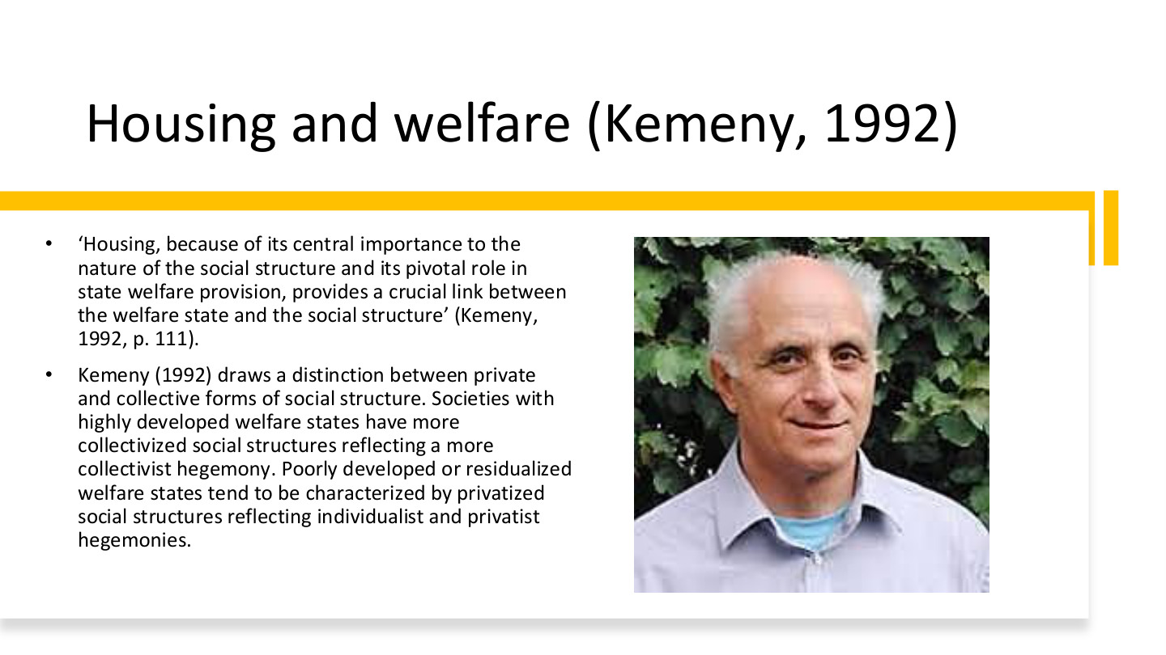
原PPT第5页 / Original slide 5 · 重点 / Focus

PPT中英翻译 / PPT translation
PPT English / 英文原文与图示 | 中文翻译 / Chinese translation
“Housing, because of its central importance to the nature of the social structure and its pivotal role in state welfare provision, provides a crucial link between the welfare state and the social structure” (Kemeny, 1992, p.111). | Kemeny认为，住房因其对社会结构的重要性及在国家福利供给中的关键作用，成为福利国家与社会结构之间的重要连接（1992，第111页）。
Kemeny (1992) draws a distinction between private and collective forms of social structure. Societies with highly developed welfare states have more collectivized social structures reflecting a more collectivist hegemony. Poorly developed or residualized welfare states tend to be characterized by privatized social structures reflecting individualist and privatist hegemonies. | Kemeny区分私人化与集体化社会结构：高度发展的福利国家倾向较集体化的结构及集体主义主导；较弱或剩余化福利国家倾向私人化结构，以及个人主义、私有主义主导。

本页核心 / Key takeaway
Kemeny的核心命题是住房把福利制度与社会结构连接起来，而不只是提供居住空间。
Kemeny’s central thesis is that housing links welfare institutions to social structure, beyond supplying shelter.

精要解析 / Essential explanation

1. 集体主义 / Collectivism
collectivism强调共同承担与集体安排，住房上更容易支持社会租赁等制度。这里描述一种社会和政策取向，不是说所有财产都必须国有。
Collectivism stresses shared responsibility and collective arrangements, supporting options such as social renting. It describes an institutional orientation rather than requiring national ownership of all property.

2. 私有主义 / Privatism
privatism强调私人家庭、产权和自我保障。家庭通过购房积累资产，并把住房安全更多联系到收入、贷款和市场表现；它不等于政府完全没有住房政策。
Privatism emphasises private households, property and self-provision. Security becomes connected to earnings, credit and asset markets, without implying that government housing policy disappears.

3. 与Esping-Andersen的关系 / Relation to Esping-Andersen
前者提供福利体制和去商品化视角，Kemeny突出住房及其社会结构作用。比较时要说明各自解释什么，而不是把两位学者的概念合并为同一个量表。
Esping-Andersen supplies welfare-regime and decommodification perspectives; Kemeny emphasises housing and social structure. Identify their different contributions rather than merging them into one measurement scale.

06｜意识形态、住房形式与反馈 / Ideology, tenure and feedback
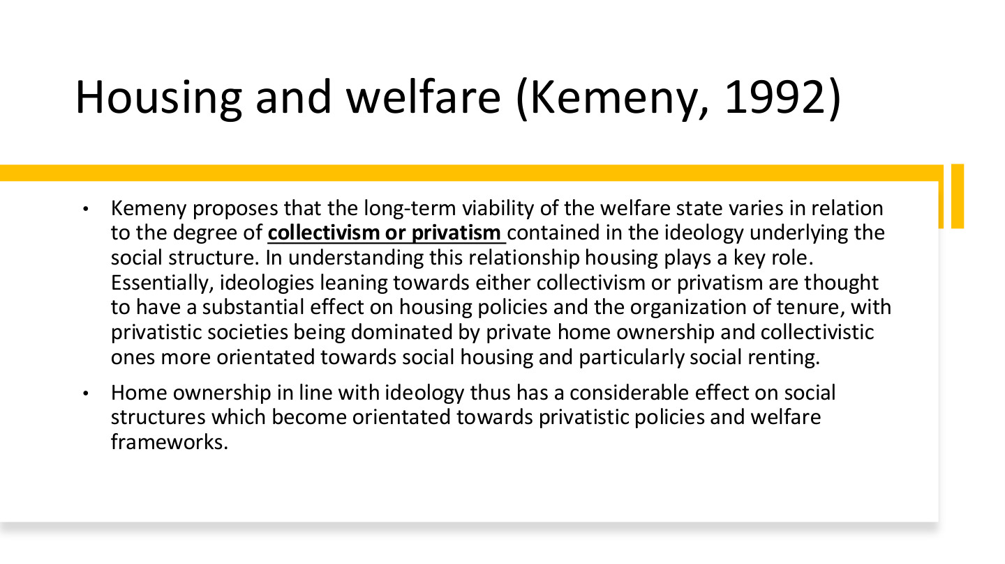
原PPT第6页 / Original slide 6 · 重点 / Focus

PPT中英翻译 / PPT translation
PPT English / 英文原文与图示 | 中文翻译 / Chinese translation
Kemeny proposes that the long-term viability of the welfare state varies in relation to the degree of collectivism or privatism contained in the ideology underlying the social structure. In understanding this relationship housing plays a key role. Essentially, ideologies leaning towards either collectivism or privatism are thought to have a substantial effect on housing policies and the organization of tenure, with privatistic societies being dominated by private home ownership and collectivistic ones more orientated towards social housing and particularly social renting. | Kemeny提出，福利国家的长期持续性与社会结构背后的集体主义或私有主义程度有关。住房政策与占有形式受到意识形态影响：私有主义社会更偏私人自住，集体主义社会更偏社会住房，尤其是社会租赁。
Home ownership in line with ideology thus has a considerable effect on social structures which become orientated towards privatistic policies and welfare frameworks. | 与意识形态相联系的住房自有，也会反过来影响社会结构，使其更偏向私人化政策与福利框架。

本页核心 / Key takeaway
掌握双向关系：意识形态塑造住房制度，住房制度又反馈到社会结构与福利偏好。
Understand the feedback: ideology shapes housing institutions, which in turn shape social structure and welfare preferences.

精要解析 / Essential explanation

1. 先有制度选择 / Institutional choices
社会如何理解责任，会影响国家优先支持买房、非营利租赁还是其他供给。tenure指住房占有和使用形式，包括自住、私人租赁与社会租赁。
Ideas about responsibility influence support for ownership, nonprofit renting and other provision. Tenure means arrangements for occupying and using housing, including ownership, private renting and social renting.

2. 再看制度的反馈 / Institutional feedback
不同住房位置形成不同利益与保障需求：依靠资产者更关心价格和贷款，依靠租赁保障者更关心租金和供给。制度可能因此改变集体政策的支持基础。
Different housing positions create different interests and security needs: asset holders may focus on prices and credit, tenants on rents and provision. Institutions can thereby alter the support base for collective policies.

3. 理论命题的限度 / Limits of the thesis
这是解释制度联系的理论，不是“买房的人一定反对福利”的个人行为定律。国家历史、政策设计和阶层差异仍会影响实际结果。
This is a theory of institutional relationships, not a law that every owner opposes welfare. Historical conditions, policy design and class differences still shape actual outcomes.

07｜二元与整合租赁体系 / Dualist and integrated rental systems
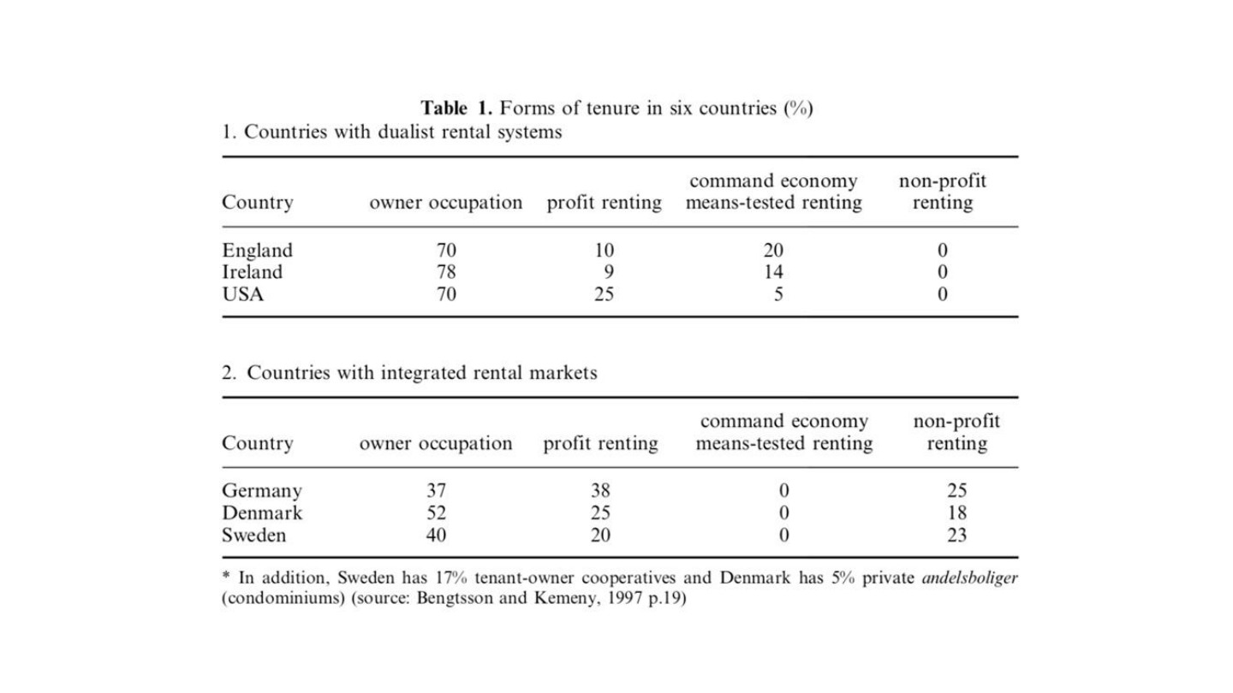
原PPT第7页 / Original slide 7 · 理解 / Understand

PPT中英翻译 / PPT translation
PPT English / 英文原文与图示 | 中文翻译 / Chinese translation
Table 1. Forms of tenure in six countries (%). 1. Countries with dualist rental systems. 2. Countries with integrated rental markets. | 表1：六国住房占有形式（%）。第一组：二元租赁体系；第二组：整合型租赁市场。
Country; owner occupation; profit renting; command economy means-tested renting; non-profit renting. | 列：国家、自住、营利租赁、行政分配／经济状况审查型租赁（原表术语）、非营利租赁。
In addition, Sweden has 17% tenant-owner cooperatives and Denmark has 5% private andelsboliger (condominiums). Source: Bengtsson and Kemeny, 1997, p.19. | 此外，瑞典有17%的租户所有合作住房，丹麦有5%的andelsboliger合作／共管式住房（按原表括注）。来源：Bengtsson与Kemeny，1997，第19页。

原表转写 / Original table transcribed
国家／组别 / Country/system | 自住 / Owner occupation | 营利租赁 / Profit renting | 经审查租赁 / Means-tested renting | 非营利租赁 / Nonprofit renting
England 英格兰｜二元 Dualist | 70 | 10 | 20 | 0
Ireland 爱尔兰｜二元 Dualist | 78 | 9 | 14 | 0
USA 美国｜二元 Dualist | 70 | 25 | 5 | 0
Germany 德国｜整合 Integrated | 37 | 38 | 0 | 25
Denmark 丹麦｜整合 Integrated | 52 | 25 | 0 | 18
Sweden 瑞典｜整合 Integrated | 40 | 20 | 0 | 23

本页核心 / Key takeaway
看市场租赁与非营利／受助租赁是否分隔，而不只比较自有率高低。
Examine separation between market renting and nonprofit or assisted renting, rather than ownership rates alone.

精要解析 / Essential explanation

1. 二元体系与整合体系 / The two arrangements
二元体系中，经审查的公共支持较独立于一般租赁市场；整合体系中，非营利租赁可面向更广市场发挥作用。两者差别在租赁部门怎样组织，不是一个只有两类房屋。
In dualist systems, means-tested assistance is separated from general renting; in integrated systems, nonprofit renting can operate more broadly. The distinction concerns rental-sector organisation, not merely the number of tenure categories.

2. 怎样读数字 / Reading the figures
瑞典、丹麦须连同脚注的合作住房理解；部分合计受四舍五入影响。原表年代较早，德国37%与第10页42%不能当作同年同口径数据直接比较。
Include the cooperative categories in the Swedish and Danish footnote and allow for rounding. This historical table’s German 37% and slide 10’s 42% are not presented as one same-year dataset.

08｜自由主义与私人住房自有 / Liberal regimes and ownership
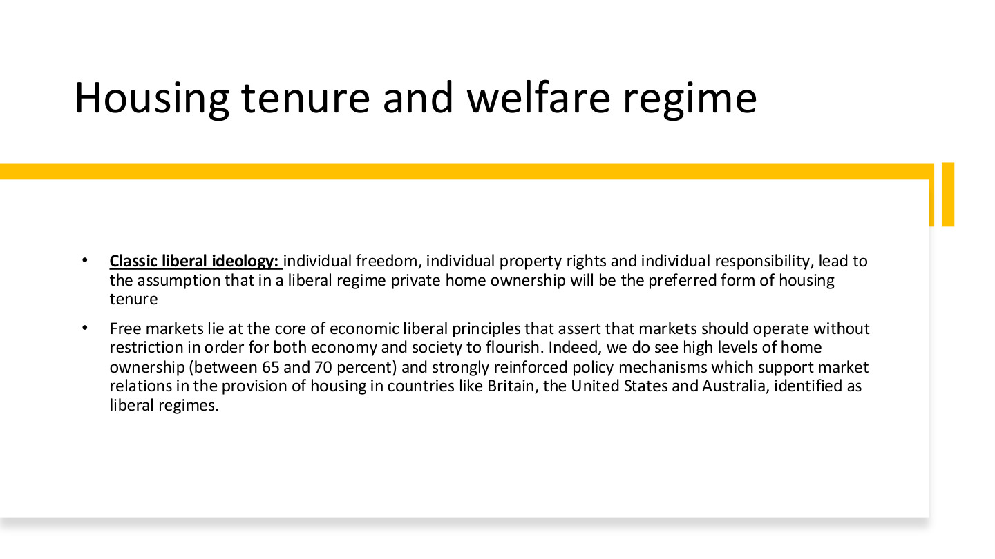
原PPT第8页 / Original slide 8 · 重点 / Focus

PPT中英翻译 / PPT translation
PPT English / 英文原文与图示 | 中文翻译 / Chinese translation
Classic liberal ideology: individual freedom, individual property rights and individual responsibility, lead to the assumption that in a liberal regime private home ownership will be the preferred form of housing tenure. | 古典自由主义强调个人自由、私人产权和个人责任，因此理论上预期自由主义体制偏好私人住房自有。
Free markets lie at the core of economic liberal principles that assert that markets should operate without restriction in order for both economy and society to flourish. Indeed, we do see high levels of home ownership (between 65 and 70 percent) and strongly reinforced policy mechanisms which support market relations in the provision of housing in countries like Britain, the United States and Australia, identified as liberal regimes. | 自由市场是经济自由主义的核心，认为市场应较少受限以促进经济和社会发展。课件以英国、美国、澳大利亚为例，列出约65%—70%的住房自有率，以及支持住房市场关系的政策机制。

本页核心 / Key takeaway
自由主义的解释链是个人自由、产权与责任→偏好私人自有→政策支持市场关系。
The liberal logic links individual liberty, property and responsibility to ownership preferences and market-supporting policies.

精要解析 / Essential explanation

1. 国家怎样支持市场 / How the state supports markets
偏好市场不等于国家不作为。政府可通过贷款制度、税收和购房支持促进私人自有；后面的美国历史正好说明市场住房如何被公共政策塑造。
Preference for markets does not imply state inactivity. Lending institutions, taxation and purchase assistance can promote ownership, as the later US history demonstrates.

2. 65%—70%怎样使用 / Using the percentage
这是课件的历史性案例概括，不是判定自由主义的统一门槛。其他体制也可能有高自有率，必须同时看制度和责任如何安排。
This is a historical illustration, not a classification threshold. Other regimes can also have high ownership; examine institutions and responsibilities alongside the rate.

3. 住房产权与风险 / Ownership and risk
自住家庭可积累资产，但按揭、维护和收入中断风险仍由具体制度决定。评价私人自有时，要把获得住房和持续保有住房分开。
Ownership can accumulate assets, while mortgage, maintenance and income-loss risks depend on institutions. Distinguish gaining access to ownership from being able to retain the home.

09｜社会民主主义：去商品化不只一种产权 / Social democracy and tenure
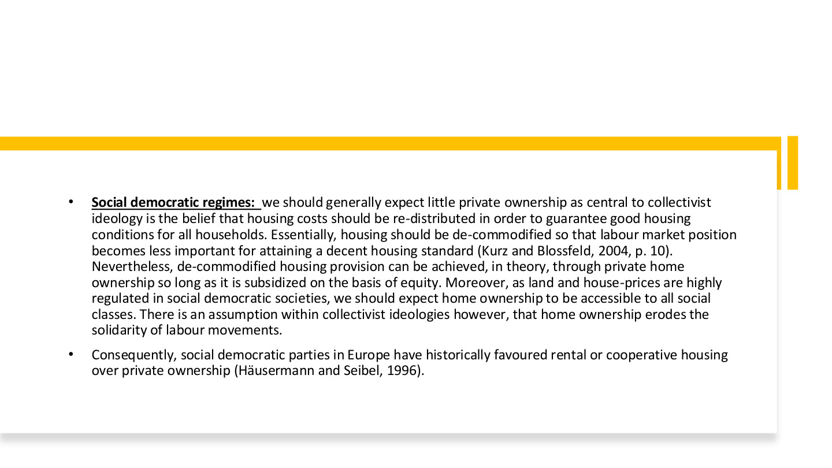
原PPT第9页 / Original slide 9 · 重点 / Focus

PPT中英翻译 / PPT translation
PPT English / 英文原文与图示 | 中文翻译 / Chinese translation
Social democratic regimes: we should generally expect little private ownership as central to collectivist ideology is the belief that housing costs should be re-distributed in order to guarantee good housing conditions for all households. Essentially, housing should be de-commodified so that labour market position becomes less important for attaining a decent housing standard (Kurz and Blossfeld, 2004, p.10). | 社会民主体制重视集体分担和重新分配住房成本，以保证所有家庭有良好居住条件，因此一般预期较少依赖私人自有。住房应去商品化，使劳动市场地位较少决定能否获得体面住所。
Nevertheless, de-commodified housing provision can be achieved, in theory, through private home ownership so long as it is subsidized on the basis of equity. Moreover, as land and house-prices are highly regulated in social democratic societies, we should expect home ownership to be accessible to all social classes. | 但理论上，只要依公平原则提供补贴，私人自有也可能实现去商品化。土地与房价受到较强监管时，各阶层也可能更容易进入自有住房。
There is an assumption within collectivist ideologies however, that home ownership erodes the solidarity of labour movements. Consequently, social democratic parties in Europe have historically favoured rental or cooperative housing over private ownership (Häusermann and Seibel, 1996). | 集体主义理论中也有一种观点，认为住房自有可能削弱劳工运动的团结，因此欧洲社会民主党历史上通常较偏好租赁或合作住房。

本页核心 / Key takeaway
去商品化不等于必须由国家持有产权；关键是住房取得与持续居住是否较少受市场位置支配。
Decommodification does not require state ownership of every home; the issue is how far access and security depend on market position.

精要解析 / Essential explanation

1. 重分配的目标 / The aim of redistribution
住房成本若被共同分担，低收入或就业不稳定者也可能获得良好住房。政策目标是减弱劳动市场地位对居住标准的影响，不是仅追求某一种产权比例。
Shared housing costs can support households with low or unstable earnings. The aim is to weaken the effect of labour-market position on housing standards, rather than achieve one tenure percentage.

2. equity的两种含义 / Two meanings of equity
本页on the basis of equity中的equity指公平，不是住房净值。第28页home equity才指房产价值扣除未还按揭；同一个英文词需按语境判断。
Here equity means fairness, not housing wealth. Home equity on slide 28 means property value minus outstanding mortgage debt; interpret the word in context.

3. 理论预期与经验区分 / Theory and experience
课件一方面讨论集体主义对租赁的偏好，另一方面承认公平补贴的私人自有也可能提供保障。答题应同时保留这两层，避免把社会民主简化为禁止买房。
The slide discusses a preference for renting but also allows ownership supported on equitable terms. Retain both points rather than reducing social democracy to a prohibition on home purchase.

10｜法团主义体制的多样性 / Variation in corporatist regimes
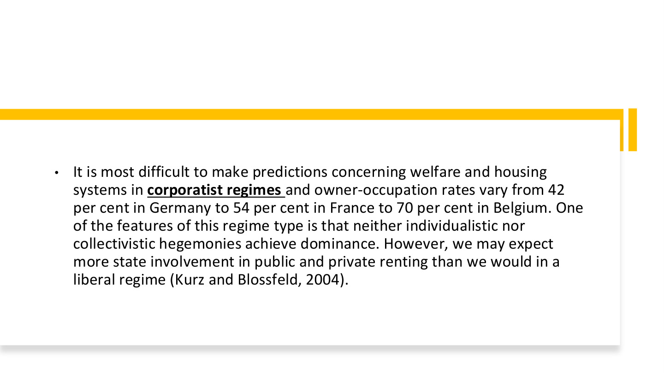
原PPT第10页 / Original slide 10 · 理解 / Understand

PPT中英翻译 / PPT translation
PPT English / 英文原文与图示 | 中文翻译 / Chinese translation
It is most difficult to make predictions concerning welfare and housing systems in corporatist regimes and owner-occupation rates vary from 42 per cent in Germany to 54 per cent in France to 70 per cent in Belgium. One of the features of this regime type is that neither individualistic nor collectivistic hegemonies achieve dominance. However, we may expect more state involvement in public and private renting than we would in a liberal regime (Kurz and Blossfeld, 2004). | 法团主义体制的福利与住房较难一概预测；课件举例德国自有率42%、法国54%、比利时70%。个人主义与集体主义都未完全占主导；相较自由主义，预期国家对公共和私人租赁的介入更多。

本页核心 / Key takeaway
法团主义内部差异说明：福利类型不能机械推出一个固定住房自有率。
Variation within corporatism shows that a welfare-regime label cannot mechanically predict one ownership rate.

精要解析 / Essential explanation

1. 为什么预测较难 / Why prediction is difficult
两种取向都没有绝对支配地位，住房制度可能出现不同组合。分析时应补充国家历史和租赁监管，不能只根据一个体制名称猜比例。
Neither orientation fully dominates, allowing different institutional combinations. Add historical context and rental regulation rather than guessing a percentage from the regime label alone.

2. 数字的用途 / What the figures illustrate
42%、54%、70%用于展示差异，不是今天的即时数据。核心比较仍是国家如何介入公共与私人租赁，以及家庭通过什么渠道获得保障。
The 42%, 54% and 70% figures illustrate variation, not current estimates. The substantive comparison concerns state involvement in renting and households’ routes to housing security.

11｜住房自有的兴起 / The rise of homeownership

原PPT第11页 / Original slide 11 · 简读 / Brief

PPT中英翻译 / PPT translation
PPT English / 英文原文与图示 | 中文翻译 / Chinese translation
II. The rise of homeownership | 第二部分：住房自有的兴起。

本页核心 / Key takeaway
接下来把自有住房连接到市场化福利、家庭资产及住房可负担性。
Next connect ownership with market-oriented welfare, household assets and affordability.

12｜欧洲住房占有形式 / European tenure patterns
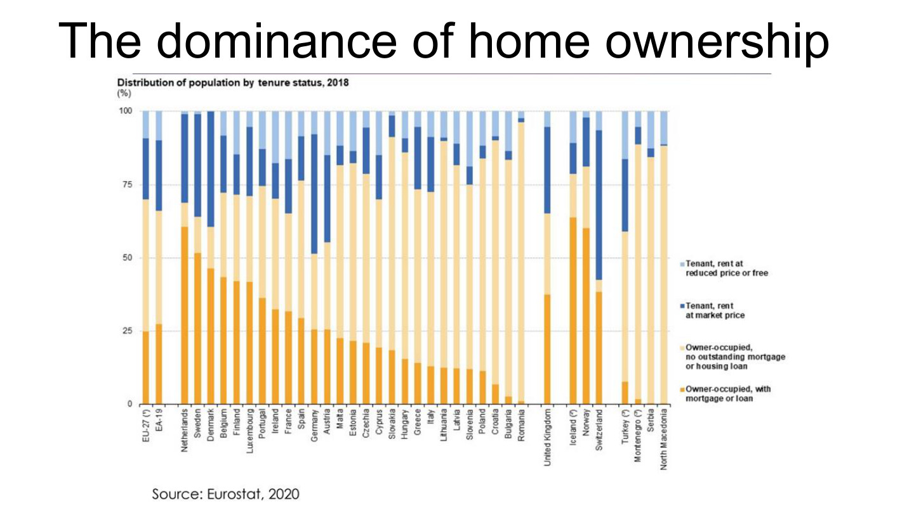
原PPT第12页 / Original slide 12 · 简读 / Brief

PPT中英翻译 / PPT translation
PPT English / 英文原文与图示 | 中文翻译 / Chinese translation
The dominance of home ownership. Distribution of population by tenure status, 2018 (%). Source: Eurostat, 2020. | 住房自有的主导地位。图：2018年按住房占有形式划分的人口构成（%）。来源：Eurostat，2020。
Tenant, rent at reduced price or free; Tenant, rent at market price; Owner-occupied, no outstanding mortgage or housing loan; Owner-occupied, with mortgage or loan. | 图例：低租金或免租租客；市场租金租客；无未偿按揭或住房贷款的自住；仍有按揭或贷款的自住。
EU-27; EA-19; Netherlands; Sweden; Denmark; Belgium; Finland; Luxembourg; Portugal; Ireland; France; Spain; Germany; Austria. | 欧盟27国、欧元区19国、荷兰、瑞典、丹麦、比利时、芬兰、卢森堡、葡萄牙、爱尔兰、法国、西班牙、德国、奥地利。
Malta; Estonia; Czechia; Cyprus; Slovakia; Hungary; Greece; Italy; Lithuania; Latvia; Slovenia; Poland; Croatia; Bulgaria; Romania. | 马耳他、爱沙尼亚、捷克、塞浦路斯、斯洛伐克、匈牙利、希腊、意大利、立陶宛、拉脱维亚、斯洛文尼亚、波兰、克罗地亚、保加利亚、罗马尼亚。
United Kingdom; Iceland; Norway; Switzerland; Turkey; Montenegro; Serbia; North Macedonia. | 英国、冰岛、挪威、瑞士、土耳其、黑山、塞尔维亚、北马其顿。原图个别名称带脚注符号，未展示其说明。

本页核心 / Key takeaway
只抓住自住仍须分有债与无债；本图统计居住人口，不等于每个人都在法律上持有房产。
Remember ownership includes both mortgaged and debt-free occupation; the chart describes residents, not individual legal ownership of property.

精要解析 / Essential explanation

1. 读图精华 / Essential reading
不同国家的自住总份额和债务结构差异很大。较高自有率不自动意味着住房负担轻，也不够单独判断福利体制；不必逐根柱子背数值。
Countries differ in both ownership shares and debt structures. High ownership does not automatically mean low burdens or identify a welfare regime; detailed bar values are secondary.

13｜住房自有与福利新自由主义化 / Neoliberalisation of welfare
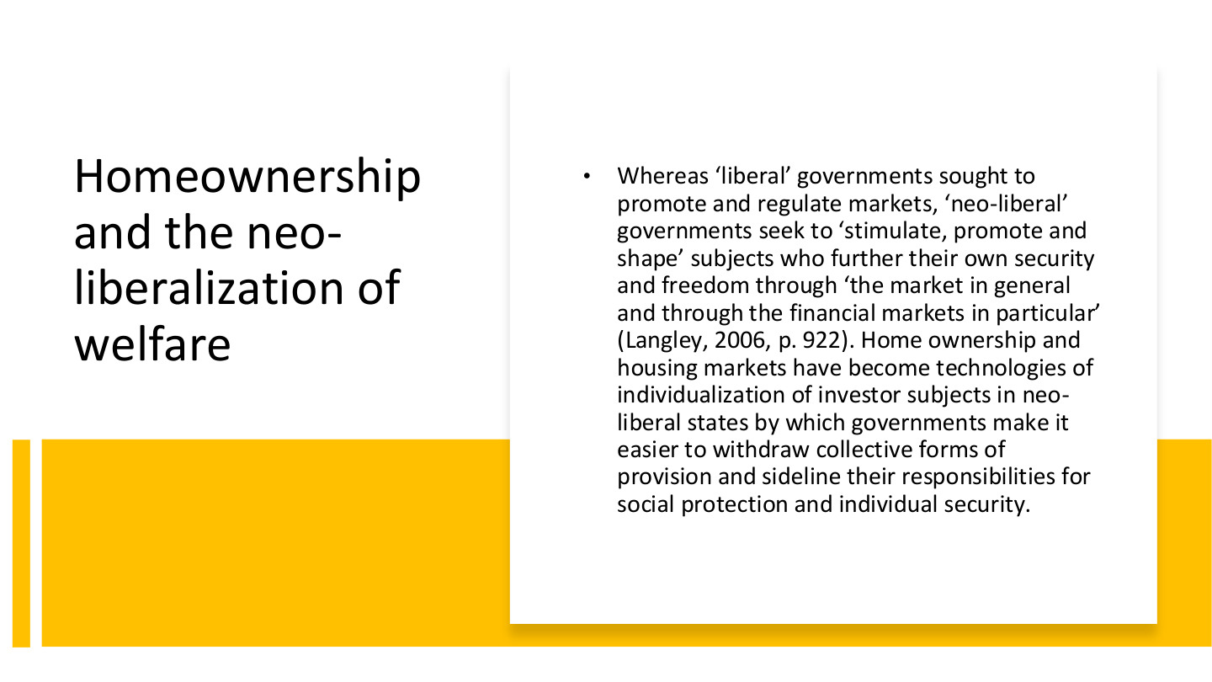
原PPT第13页 / Original slide 13 · 重点 / Focus

PPT中英翻译 / PPT translation
PPT English / 英文原文与图示 | 中文翻译 / Chinese translation
Whereas “liberal” governments sought to promote and regulate markets, “neo-liberal” governments seek to “stimulate, promote and shape” subjects who further their own security and freedom through “the market in general and through the financial markets in particular” (Langley, 2006, p.922). | 自由主义政府试图促进和监管市场；新自由主义政府进一步“激发、推动和塑造”通过市场、尤其金融市场追求自身安全与自由的主体（Langley，2006，第922页）。
Home ownership and housing markets have become technologies of individualization of investor subjects in neo-liberal states by which governments make it easier to withdraw collective forms of provision and sideline their responsibilities for social protection and individual security. | 住房自有和住房市场成为塑造个体化投资者主体的治理工具，使政府更容易缩减集体供给，并把社会保护和个人安全责任推向个人。

本页核心 / Key takeaway
新自由主义化不仅涉及市场交易，还涉及把个人塑造成通过住房和金融市场自我保障的投资者。
Neoliberalisation also involves shaping individuals as investors who seek security through housing and financial markets.

精要解析 / Essential explanation

1. 主体怎样被塑造 / How subjects are shaped
个人被鼓励把买房、借贷、资产升值看作安全来源。住房由生活需要进一步成为投资与自我保障工具，政策因此也改变人们怎样理解责任。
People are encouraged to see purchase, borrowing and appreciation as sources of security. Housing becomes an investment and self-provision instrument as well as a need, changing understandings of responsibility.

2. 责任与风险怎样转移 / How responsibilities and risks shift
当保障更依赖家庭资产，收入下降、还贷和房价波动会直接影响家庭生活。国家并非一定消失，而可能由集体供给转向建立市场、引导投资和管理风险。
Asset-dependent security exposes households to income loss, repayments and price changes. The state need not disappear; its role can shift from collective provision towards market-making, investment promotion and risk management.

3. 怎样连接案例 / Applying it to cases
美国的住房梦想、宣传与住房金融，可用于观察投资者主体怎样形成。解释时写出“政策工具→个人行为与责任→保障后果”，不要只用市场化作为标签。
The US dream, campaigns and housing finance illustrate investor-subject formation. Explain instruments, behavioural or responsibility changes, and welfare consequences rather than using marketisation only as a label.

14｜再商品化与公民身份 / Recommodification and citizenship
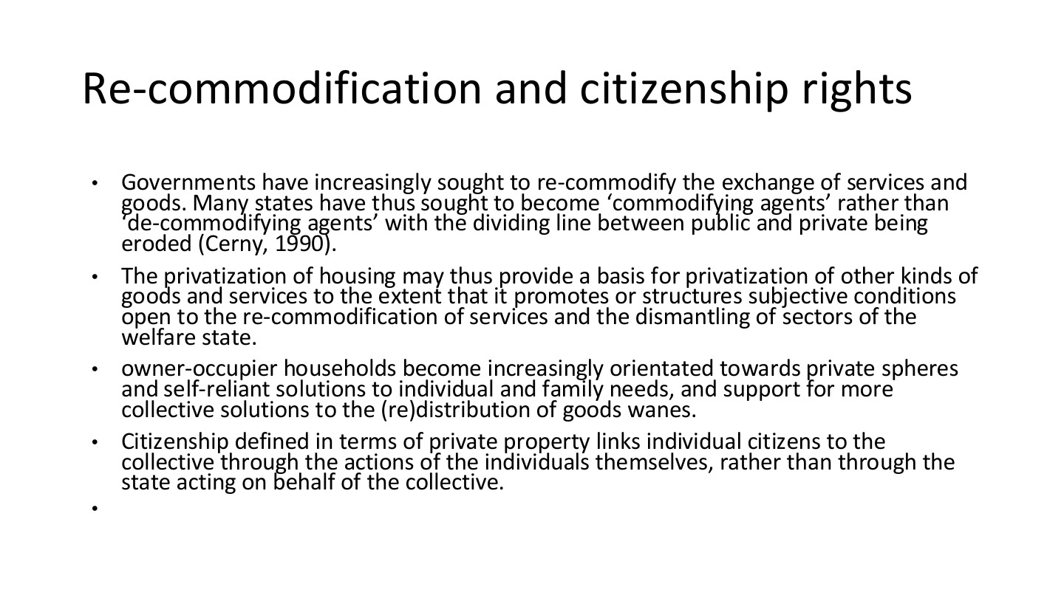
原PPT第14页 / Original slide 14 · 重点 / Focus

PPT中英翻译 / PPT translation
PPT English / 英文原文与图示 | 中文翻译 / Chinese translation
Governments have increasingly sought to re-commodify the exchange of services and goods. Many states have thus sought to become “commodifying agents” rather than “de-commodifying agents”, with the dividing line between public and private being eroded (Cerny, 1990). | 政府越来越多地推动服务和商品再商品化，由“去商品化行动者”转向“商品化推动者”，公私边界随之变化。
The privatization of housing may thus provide a basis for privatization of other kinds of goods and services to the extent that it promotes or structures subjective conditions open to the re-commodification of services and the dismantling of sectors of the welfare state. | 住房私有化若改变人们对私人解决方案的接受程度，也可能为其他商品和服务私有化、服务再商品化及福利部门收缩提供基础。
Owner-occupier households become increasingly orientated towards private spheres and self-reliant solutions to individual and family needs, and support for more collective solutions to the (re)distribution of goods wanes. | 自住家庭可能更倾向私人领域和家庭自助方案，而对集体分配与再分配的支持减弱。
Citizenship defined in terms of private property links individual citizens to the collective through the actions of the individuals themselves, rather than through the state acting on behalf of the collective. | 以私人财产界定公民形象时，个人与集体的联系更多通过个人自身行动实现，而不是由国家代表集体提供保障。

本页核心 / Key takeaway
再商品化是把保障重新更多地系于市场交换和家庭自助；国家也可能主动推动这一过程。
Recommodification reconnects security to market exchange and household self-provision, and can be actively promoted by the state.

精要解析 / Essential explanation

1. 与去商品化相对照 / Contrast with decommodification
去商品化减少维持生活所需的市场依赖；再商品化则把更多需要交由购买、贷款和资产收益解决。区别在保障机制，不只在产权名称。
Decommodification reduces market dependence; recommodification channels needs through purchasing, credit and asset returns. The distinction concerns protection mechanisms, not property labels alone.

2. 为何影响集体支持 / Why collective support may change
若家庭更依靠自有资产解决需要，可能更支持有利于资产收益的政策。这是课件讨论的制度反馈机制，不意味着每位房主都持同一政治立场。
When assets become a household’s solution to need, policies supporting asset returns may gain support. This is an institutional feedback argument, not a claim that every owner shares identical political views.

3. citizenship应怎样理解 / Interpreting citizenship
此处分析政策话语中的公民形象：有产权、负责任、能自助的人。它不是在宣称无房者在法律上不具公民身份；政治理念与法定资格要分开。
The passage analyses an image of the property-owning, responsible, self-reliant citizen. It does not claim that nonowners legally lack citizenship; distinguish political ideals from legal status.

