15｜住房阶层 / Housing class
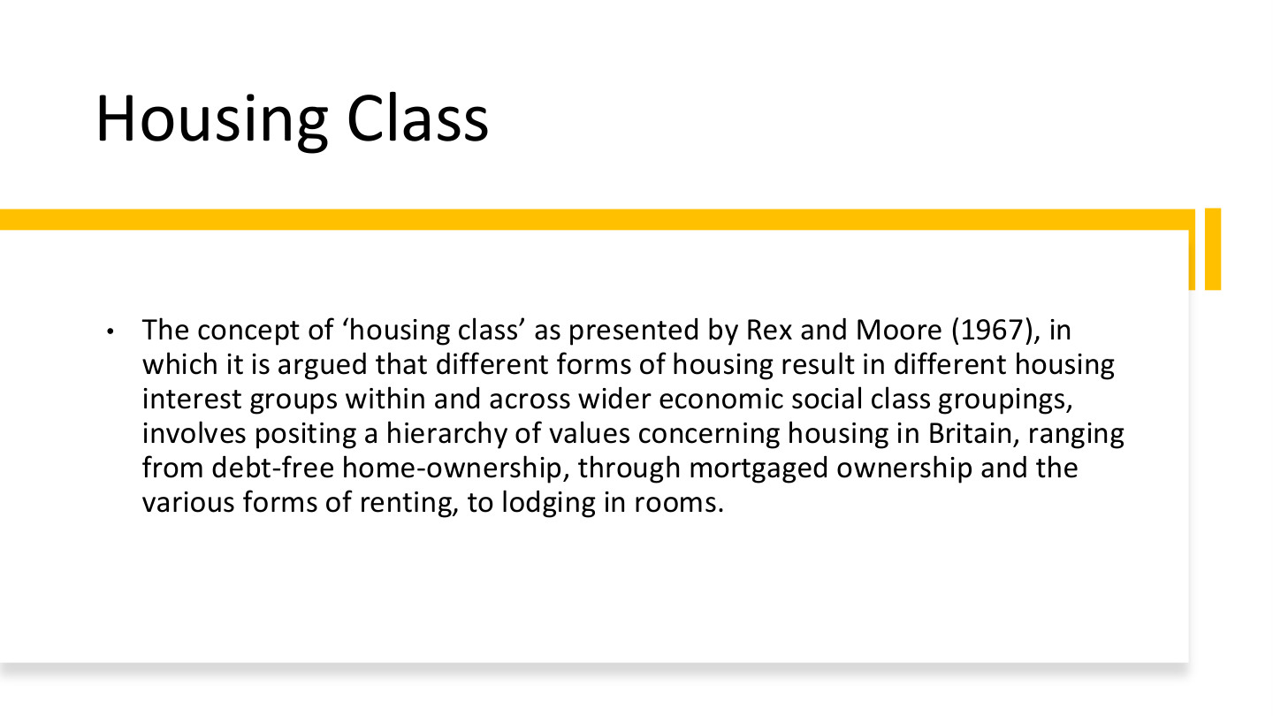
原PPT第15页 / Original slide 15 · 重点 / Focus

PPT中英翻译 / PPT translation
PPT English / 英文原文与图示 | 中文翻译 / Chinese translation
The concept of “housing class” as presented by Rex and Moore (1967), in which it is argued that different forms of housing result in different housing interest groups within and across wider economic social class groupings, involves positing a hierarchy of values concerning housing in Britain, ranging from debt-free home-ownership, through mortgaged ownership and the various forms of renting, to lodging in rooms. | Rex与Moore（1967）的“住房阶层”概念认为，不同住房形式会在更广泛的经济社会阶层内部及其之间形成住房利益群体。英国住房的价值等级被排列为：无债自住、按揭自住、各种租赁形式，再到租住单间。

本页核心 / Key takeaway
住房阶层强调不同住房位置带来不同利益、成本和保障，不能把所有房主或租客视为完全相同。
Housing class concerns different interests, costs and security attached to housing positions, rather than treating all owners or tenants as identical.

精要解析 / Essential explanation

1. 无债与按揭为何不同 / Debt-free versus mortgaged ownership
两者都有产权，但按揭住户仍有持续还款责任和收入风险。名义产权相同不等于负担与安全相同，这也连接到后面的住房金融危机。
Both hold property, but mortgaged households face repayments and income risks. The same ownership label does not imply equal burdens or security, linking housing class to the later financial crisis.

2. 与经济阶层怎样交叉 / Interaction with economic class
收入相似的家庭，可能因是否有房、负债或租赁条件而处境不同。住房阶层因此补充而非直接取代一般阶层分析，帮助识别住房制度中的利益分化。
Households with similar incomes can occupy different positions because of assets, debt and rental conditions. Housing class supplements broader class analysis by identifying interests created through housing institutions.

3. 等级应怎样理解 / Interpreting the hierarchy
课件列的是特定英国背景下的住房价值和利益层级，不是所有国家、所有时期都固定适用的优劣榜。比较时应进一步看实际居住质量与制度保障。
The hierarchy refers to housing values and interests in a particular British context, not a universal ranking for every society. Compare actual housing conditions and institutional security.

16｜住房历程与人生事件 / Housing careers and life events
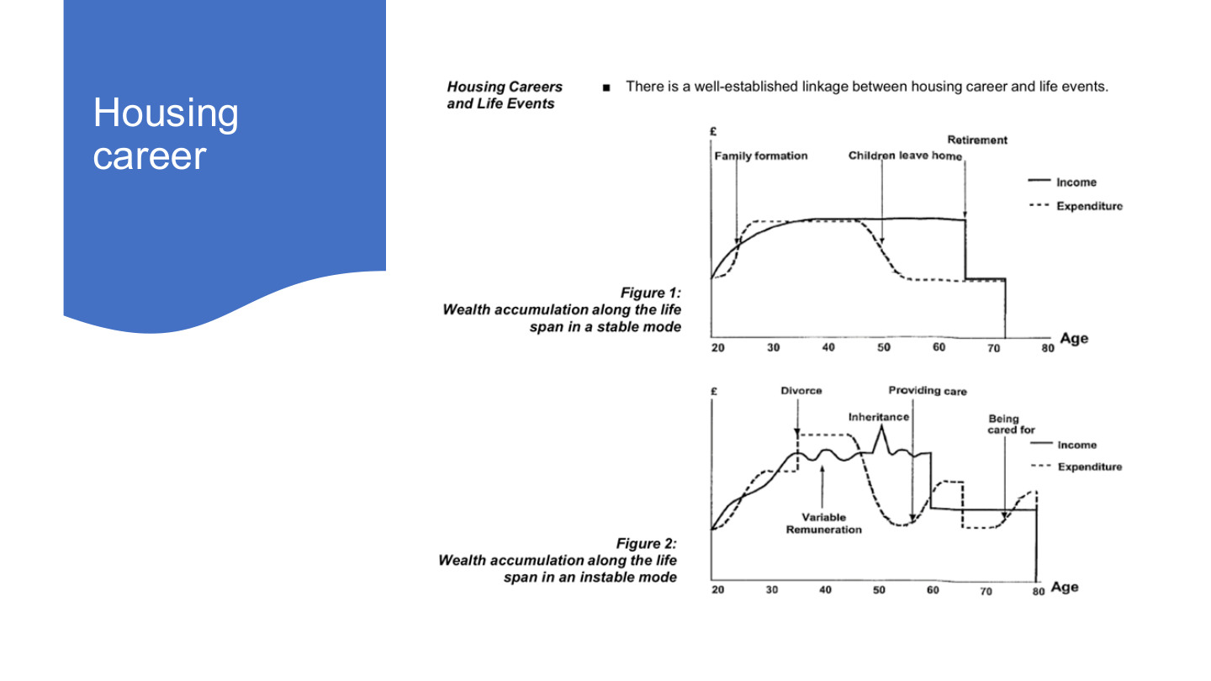
原PPT第16页 / Original slide 16 · 理解 / Understand

PPT中英翻译 / PPT translation
PPT English / 英文原文与图示 | 中文翻译 / Chinese translation
Housing career. Housing Careers and Life Events. There is a well-established linkage between housing career and life events. | 住房历程。住房历程与人生事件之间存在明确联系；career在此不是“职业”。
Figure 1: Wealth accumulation along the life span in a stable mode. Family formation; Children leave home; Retirement. | 图1：稳定模式下的终身财富积累。事件：家庭形成、子女离家、退休。
Figure 2: Wealth accumulation along the life span in an instable mode. Divorce; Variable Remuneration; Inheritance; Providing care; Being cared for. | 图2：不稳定模式下的终身财富积累。事件：离婚、收入报酬波动、继承遗产、提供照护、接受照护。
Axes and legend: £; Age (20–80); Income (solid); Expenditure (dashed). | 坐标与图例：英镑、年龄（20—80岁）；实线为收入，虚线为支出。

本页核心 / Key takeaway
住房历程随人生事件改变；实际收入与支出未必沿平稳生命周期变化。
Housing careers change with life events; actual income and expenditure need not follow a smooth life-cycle path.

精要解析 / Essential explanation

1. 先读清坐标 / Identify the plotted quantities
虽然图题讨论财富积累，实际两条线分别是收入和支出，并非房价或住房净值。收支差影响可积累资源，不能把收入曲线的高度直接当作资产总额。
Although the figures discuss accumulation, their lines plot income and expenditure, not prices or home equity. The income–expenditure gap affects resources available to accumulate, so line height is not total wealth.

2. 为什么影响住房选择 / Effects on housing choices
离婚、照护或收入波动会改变家庭资源及空间需要，可能影响借贷、搬家和保有住房。模型用于解释可能的联系，不要求每个人都结婚、生育或按相同路径生活。
Divorce, care and variable earnings change resources and space needs, affecting borrowing, moving and retention. The model explains possible relationships rather than prescribing marriage, children or one identical life path.

17｜什么是住房可负担性？ / Housing affordability
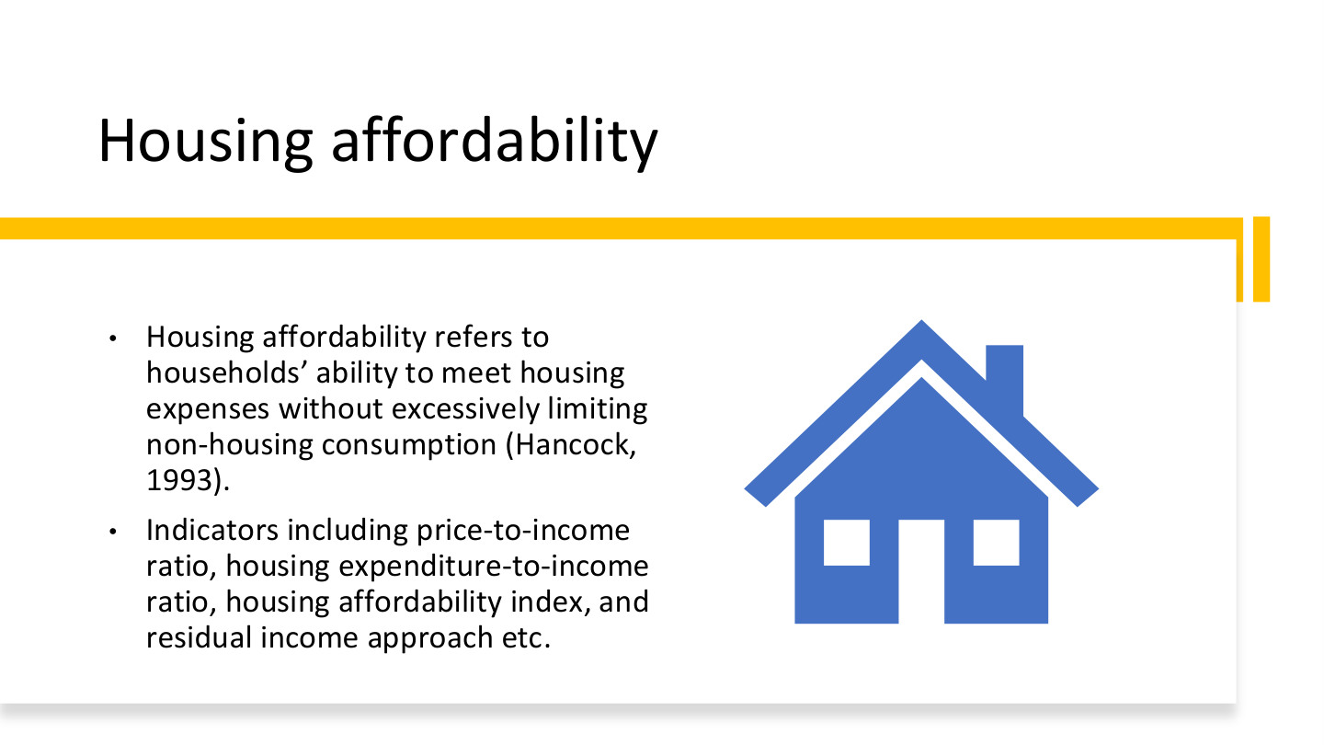
原PPT第17页 / Original slide 17 · 重点 / Focus

PPT中英翻译 / PPT translation
PPT English / 英文原文与图示 | 中文翻译 / Chinese translation
Housing affordability refers to households’ ability to meet housing expenses without excessively limiting non-housing consumption (Hancock, 1993). | 住房可负担性指家庭能够支付住房费用，同时不至于过度压缩非住房消费（Hancock，1993）。
Indicators including price-to-income ratio, housing expenditure-to-income ratio, housing affordability index, and residual income approach etc. | 指标包括房价收入比、住房支出收入比、住房可负担性指数和剩余收入法等。

本页核心 / Key takeaway
付得出住房费还不够，还要能维持必要的非住房生活，这是可负担性的核心。
Paying for housing is insufficient if essential non-housing consumption is squeezed; affordability concerns both.

精要解析 / Essential explanation

1. 住房费用之外还有什么 / Beyond housing expenditure
食品、交通、医疗和照护等必要支出不能被忽略。相同住房支出比例的家庭，剩余生活能力可能不同，因此不能把单一比例当作完整答案。
Food, transport, health and care costs still matter. Households with the same housing-cost ratio can have different remaining living resources, so one percentage cannot fully assess affordability.

2. 价格与持续支付 / Price versus continuing payments
房价收入比观察购买价格相对收入；月供或租金收入比观察持续现金流。购房门槛、还款压力和租赁负担相关，但并不是同一个问题。
Price-to-income compares the purchase price with income; payment or rent ratios assess continuing cash flow. Entry barriers, repayment pressure and rental burdens are related but distinct.

3. 先选问题再选指标 / Match measures to questions
比较城市入市难度、家庭月度负担或基本生活是否受挤压，需要不同信息。第18页的重点是知道各指标测什么、遗漏什么，而不只背英文名称。
Comparing purchase barriers, monthly burdens or pressure on necessities requires different information. Slide 18 asks what each measure captures and omits, beyond remembering its English name.

18｜四种可负担性指标 / Four affordability measures
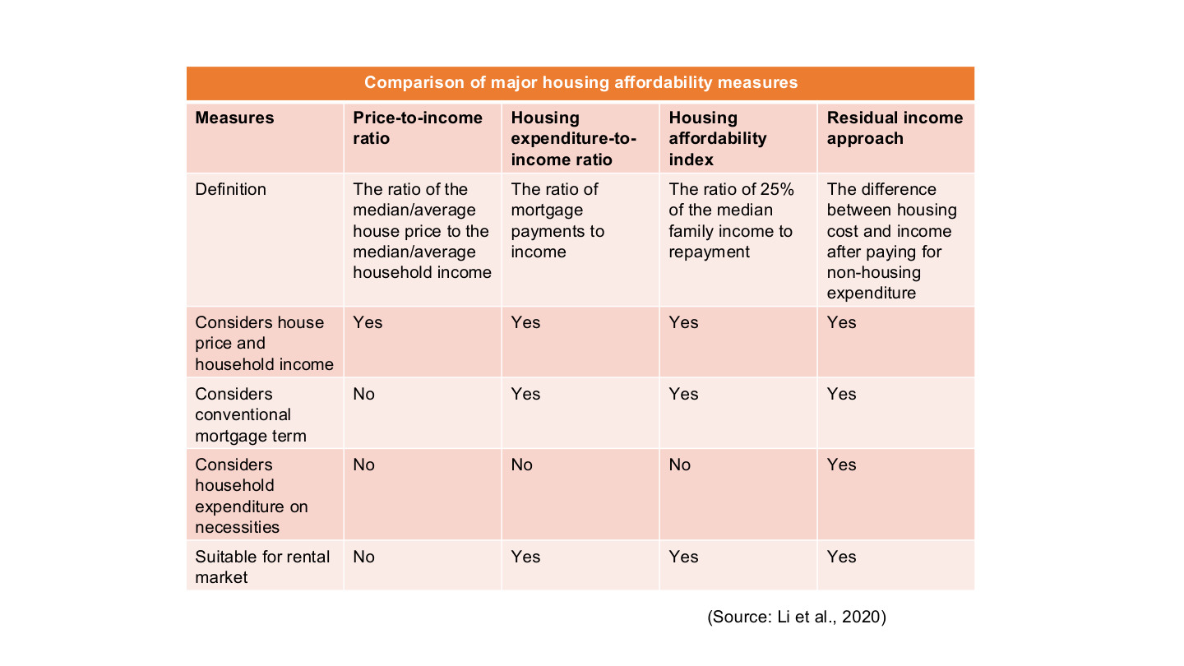
原PPT第18页 / Original slide 18 · 重点 / Focus

PPT中英翻译 / PPT translation
PPT English / 英文原文与图示 | 中文翻译 / Chinese translation
Comparison of major housing affordability measures. Source: Li et al., 2020. | 主要住房可负担性指标比较。来源：Li等，2020。
Price-to-income ratio: The ratio of the median/average house price to the median/average household income. | 房价收入比：住房价格中位数／平均数，与家庭收入中位数／平均数之比。
Housing expenditure-to-income ratio: The ratio of mortgage payments to income. | 住房支出收入比：按揭还款与收入之比。用于租赁时需把支出项改为租金等住房支出。
Housing affordability index: The ratio of 25% of the median family income to repayment. | 住房可负担性指数：家庭收入中位数的25%，与还款额之比。
Residual income approach: The difference between housing cost and income after paying for non-housing expenditure. | 剩余收入法：比较住房成本与扣除非住房支出后的可用收入。原表未明确差额方向，理解时以支付基本生活后的收支是否足够为准。
Comparison criteria: considers house price and household income; considers conventional mortgage term; considers household expenditure on necessities; suitable for rental market. | 比较维度：是否考虑房价及家庭收入；常规按揭条件；家庭必要支出；是否适用于租赁。原表Yes／No完整转写见下表。

原表Yes／No转写 / Original yes/no comparison
维度 / Criterion | 房价收入比 / Price-to-income | 支出收入比 / Cost-to-income | 可负担性指数 / HAI | 剩余收入法 / Residual
房价与家庭收入 / Price and income | Yes 是 | Yes 是 | Yes 是 | Yes 是
常规按揭条件 / Mortgage terms | No 否 | Yes 是 | Yes 是 | Yes 是
必要消费支出 / Necessities | No 否 | No 否 | No 否 | Yes 是
适用于租赁 / Suitable for renting | No 否 | Yes 是 | Yes 是 | Yes 是

本页核心 / Key takeaway
四类指标分别看购买价格、持续支付、标准还款能力、必要消费后的余量；它们的方向和单位不同。
The measures concern purchase prices, continuing payments, benchmark repayment capacity, and resources after necessities; their directions and units differ.

精要解析 / Essential explanation

1. 1. 房价收入比 / Price-to-income
房价÷家庭年收入：假设房价300,000，家庭年收入60,000，则比值为5。它不计日常消费、利率和具体还款安排，不能理解成不吃不喝之外也保证“五年买到房”。
P/annual Y: a price of 300,000 and annual income of 60,000 give 5. It excludes living costs and financing terms, so it does not establish that a household can actually buy the dwelling in five years.

2. 2. 住房支出收入比 / Housing-cost ratio
住房支出÷同一时期收入：月住房支出1,500、月收入5,000，比值为30%。分子是月供或租金等支出，不是整套房价；30%也不是对所有家庭都适用的充分保障标准。
H/Y for the same period: monthly housing costs of 1,500 and income of 5,000 give 30%. Use payments or rent, not the full price; 30% is not a sufficient universal test for every household.

3. 3. 可负担性指数 / Affordability index
本页公式为0.25×收入中位数÷还款。设月家庭收入中位数5,000、月供1,500演示，结果约0.833，或指数化为83.3；比值低于1（或指数低于100），表示未达到这项25%基准，数值越高通常越可负担。
The slide uses 0.25 × median income / repayment. With monthly median income 5,000 and repayment 1,500, this is about 0.833, or 83.3 when scaled by 100. Below 1 in ratio form (or 100 on the index scale) means the 25% benchmark is not met; higher generally indicates greater affordability.

4. 4. 剩余收入法 / Residual-income approach
判断Y−H−N是否≥0，N为必要非住房开支。同一家庭若N=2,800，余额为5,000−1,500−2,800=700。它把基本生活需要纳入评估，说明比例相同的家庭仍可能有不同处境。
Check whether Y − H − N is nonnegative, with N representing necessary non-housing costs. If N is 2,800, the example leaves 700. This incorporates basic needs and distinguishes households with otherwise identical housing-cost ratios.

易错辨析 / Key distinction
HAI本页公式通常越高越好，房价收入比或住房支出比通常越高负担越重；表中“可用于租赁”需要相应调整支付项，不能照搬按揭定义。
The slide’s HAI generally improves as it rises; higher price or cost ratios generally indicate heavier burdens. Applying payment-based measures to renting requires adapting their payment term.

19｜住房生命周期 / Housing life cycle
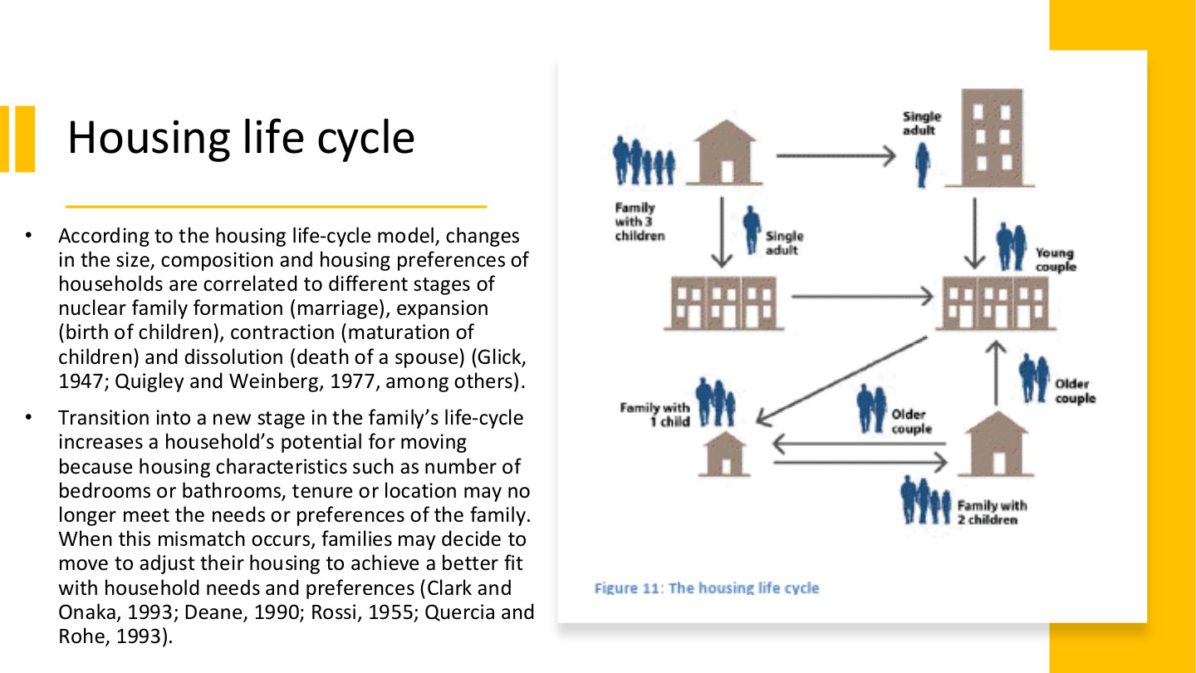
原PPT第19页 / Original slide 19 · 重点 / Focus

PPT中英翻译 / PPT translation
PPT English / 英文原文与图示 | 中文翻译 / Chinese translation
According to the housing life-cycle model, changes in the size, composition and housing preferences of households are correlated to different stages of nuclear family formation (marriage), expansion (birth of children), contraction (maturation of children) and dissolution (death of a spouse) (Glick, 1947; Quigley and Weinberg, 1977, among others). | 住房生命周期模型将家庭规模、结构与偏好变化，联系到核心家庭的形成（结婚）、扩张（子女出生）、收缩（子女成长）及解体（配偶死亡）等阶段。
Transition into a new stage in the family’s life-cycle increases a household’s potential for moving because housing characteristics such as number of bedrooms or bathrooms, tenure or location may no longer meet the needs or preferences of the family. When this mismatch occurs, families may decide to move to adjust their housing to achieve a better fit with household needs and preferences (Clark and Onaka, 1993; Deane, 1990; Rossi, 1955; Quercia and Rohe, 1993). | 进入新阶段后，卧室、卫生间数量、住房占有形式或区位可能不再符合需要，从而提高搬迁的可能性；家庭可通过搬家使住房与需要重新匹配。
Figure 11: The housing life cycle. Single adult; Young couple; Family with 1 child; Family with 2 children; Family with 3 children; Older couple. | 图11：住房生命周期。标签：单身成人、年轻伴侣、一个孩子的家庭、两个孩子的家庭、三个孩子的家庭、年长伴侣。箭头表示家庭与居住安排的变化。

本页核心 / Key takeaway
核心机制是家庭需要变化→现有住房不匹配→搬迁或调整住房，不是年龄本身自动决定买房。
The mechanism is changing household needs, a housing mismatch, then moving or adjustment, rather than age automatically determining purchase.

精要解析 / Essential explanation

1. 四阶段怎样记 / Remembering the stages
形成、扩张、收缩、解体描述家庭结构变化；例如孩子出生增加空间需要，子女长大后需要可能再次改变。把阶段和具体住房需求连起来，而非只背年龄。
Formation, expansion, contraction and dissolution describe household changes. A birth can increase space needs; later changes can alter them again. Connect stages with housing requirements rather than fixed ages.

2. 搬迁的直接原因 / The proximate reason to move
不匹配可来自面积、设施、tenure或区位，不只来自房屋太小。通勤、照护或支付能力改变，也会影响家庭如何选择适合的住所。
Mismatch can concern space, amenities, tenure or location, beyond an undersized dwelling. Commuting, care and affordability also shape appropriate choices.

3. 潜在需要与实际行动 / Need versus action
原文说搬迁可能性增加，并非一定能搬。收入、贷款、房源和交易成本会约束行动；模型也不要求每个家庭经历完全相同的生命周期。
The slide predicts greater moving potential, not guaranteed mobility. Income, credit, supply and transaction costs constrain action, and not every household follows the same life course.

20｜美国案例 / The United States

原PPT第20页 / Original slide 20 · 简读 / Brief

PPT中英翻译 / PPT translation
PPT English / 英文原文与图示 | 中文翻译 / Chinese translation
III. The United States | 第三部分：美国。

本页核心 / Key takeaway
美国案例把住房梦想、国家推动和住房金融风险连接起来。
The US case links the ownership dream, state promotion and financial risks.

21｜美国住房自有梦想 / The American ownership dream
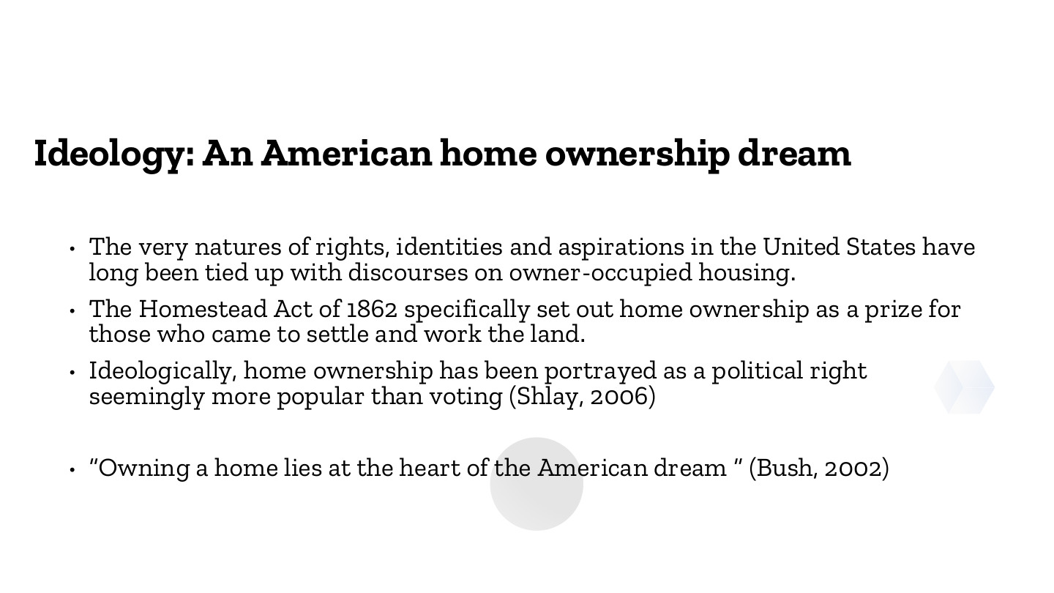
原PPT第21页 / Original slide 21 · 重点 / Focus

PPT中英翻译 / PPT translation
PPT English / 英文原文与图示 | 中文翻译 / Chinese translation
The very natures of rights, identities and aspirations in the United States have long been tied up with discourses on owner-occupied housing. | 美国关于权利、身份和愿望的理解，长期与自住住房的话语联系在一起。
The Homestead Act of 1862 specifically set out home ownership as a prize for those who came to settle and work the land. | 1862年《宅地法》把土地／住房所有权设为对定居并耕作土地者的奖励。
Ideologically, home ownership has been portrayed as a political right seemingly more popular than voting (Shlay, 2006). | 在意识形态中，住房自有被描绘为一种政治权利，甚至似乎比投票更受欢迎（Shlay，2006）。
“Owning a home lies at the heart of the American dream” (Bush, 2002). | “拥有住房处于美国梦的核心”（布什，2002）。

本页核心 / Key takeaway
住房自有不仅是消费选择，还被建构为权利、身份、自立和成功的象征。
Homeownership is framed as a symbol of rights, identity, self-reliance and success, beyond a consumer choice.

精要解析 / Essential explanation

1. 意识形态有什么作用 / What ideology does
把拥有住房视为理想生活，有助于为购房支持政策争取认同。偏好可以被历史制度和公共话语塑造，不必把高自有率当作自然、不变的个人选择。
Presenting ownership as the ideal life helps legitimise purchase-support policies. Preferences can be shaped by institutions and public discourse, rather than being timeless or purely individual choices.

2. 历史政策与价值相连 / Connecting policy and values
宅地法例子说明国家会把财产权与定居、劳动等行为联系起来。后面的宣传和贷款制度则提供不同工具，将“理想”转化成政策方向。
The Homestead example links property with settlement and work. Later campaigns and lending institutions provide other instruments that translate ideals into policy priorities.

3. 权利话语与实际可及性 / Rhetoric and access
把住房自有称为政治权利，并不自动保证每个人买得起或保得住房。分析要继续看信贷、收入、价格与排除条件，不能把宣传用语当作实际结果。
Calling ownership a political right does not guarantee affordability or retention. Examine credit, income, prices and exclusion rather than treating rhetoric as an achieved outcome.

22｜美国梦的官方表述 / An official ownership proclamation
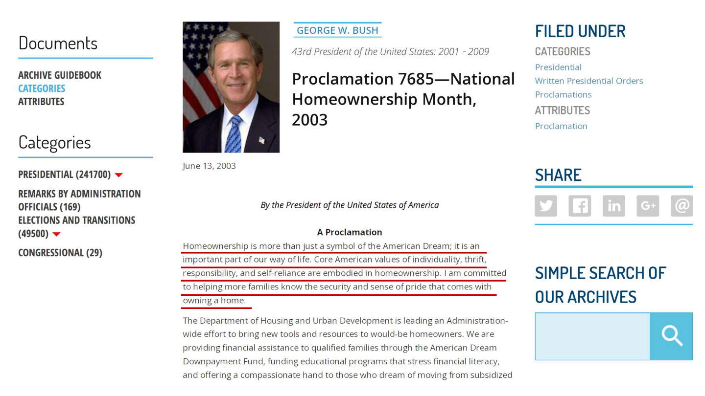
原PPT第22页 / Original slide 22 · 简读 / Brief

PPT中英翻译 / PPT translation
PPT English / 英文原文与图示 | 中文翻译 / Chinese translation
George W. Bush, 43rd President of the United States: 2001–2009. Proclamation 7685—National Homeownership Month, 2003. June 13, 2003. | 乔治·W.布什，美国第43任总统（2001—2009）。第7685号公告——2003年全国家庭住房自有月，日期为2003年6月13日。
By the President of the United States of America. A Proclamation. | 美利坚合众国总统公告。
Homeownership is more than just a symbol of the American Dream; it is an important part of our way of life. Core American values of individuality, thrift, responsibility, and self-reliance are embodied in homeownership. I am committed to helping more families know the security and sense of pride that comes with owning a home. | 住房自有不仅是美国梦的象征，也是生活方式的重要组成部分；个人性、节俭、责任和自立等价值体现在其中。总统承诺帮助更多家庭体验拥有住房所带来的安全感与自豪感。
The Department of Housing and Urban Development is leading an Administration-wide effort to bring new tools and resources to would-be homeowners. We are providing financial assistance to qualified families through the American Dream Downpayment Fund, funding educational programs that stress financial literacy, and offering a compassionate hand to those who dream of moving from subsidized… [image cuts off]. | HUD牵头向潜在购房者提供工具和资源，包括通过美国梦首付基金向合资格家庭提供资助、支持金融素养教育，以及帮助希望从补贴住房迁出的家庭……【截图下文截断，不补写。】
Site navigation: Documents; Archive Guidebook; Categories; Attributes; Presidential; Remarks by Administration Officials; Elections and Transitions; Congressional; Filed Under; Share; Simple Search of Our Archives. | 网页导航：文件、档案指南、类别、属性、总统文件、政府官员讲话、选举与过渡、国会文件、归档、分享、档案检索。

本页核心 / Key takeaway
红线引文把住房自有与节俭、责任、自立和安全感联系起来，是第21页的具体话语例证。
The underlined passage links ownership with thrift, responsibility, self-reliance and security, illustrating slide 21’s discourse.

精要解析 / Essential explanation

1. 只抓这项用途 / Focus on its purpose
本页证明政府怎样公开宣传住房自有，不直接证明这些政策已经使所有家庭更安全。公告原文、价值主张和实际政策效果是不同层次，无需背网页导航。
The document illustrates official promotion, not proof of improved security for every family. Distinguish the proclamation, its values and programme outcomes; navigation labels are not study priorities.

23｜住房自有的历史政治背景 / Historical political context
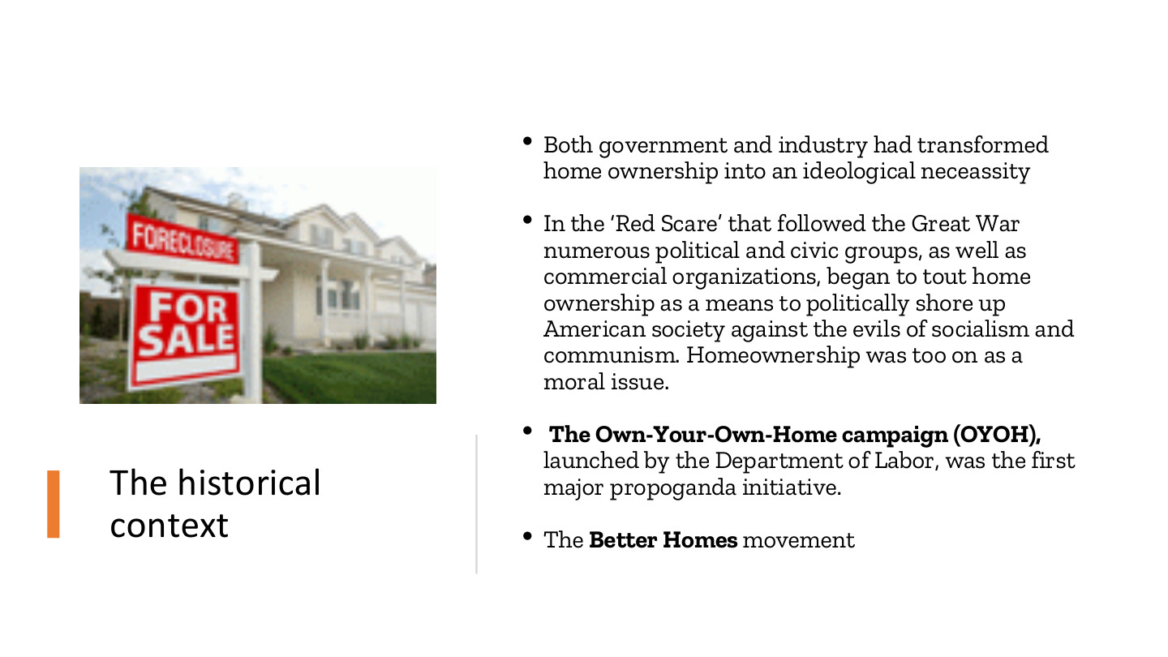
原PPT第23页 / Original slide 23 · 理解 / Understand

PPT中英翻译 / PPT translation
PPT English / 英文原文与图示 | 中文翻译 / Chinese translation
Both government and industry had transformed home ownership into an ideological neceassity. | 政府与行业共同把住房自有塑造成意识形态上的必要追求（原文neceassity为拼写错误）。
In the “Red Scare” that followed the Great War numerous political and civic groups, as well as commercial organizations, began to tout home ownership as a means to politically shore up American society against the evils of socialism and communism. Homeownership was too on as a moral issue. | 一战后的“红色恐慌”时期，政治、公民和商业组织把住房自有宣传为抵御社会主义与共产主义、巩固美国社会的方式，并将其道德化。【末句原文有排印问题，按语境翻译。】
The Own-Your-Own-Home campaign (OYOH), launched by the Department of Labor, was the first major propoganda initiative. The Better Homes movement. | 劳工部推动“拥有自己的家”（OYOH）大型宣传活动；另有“更美好住宅”运动。

本页核心 / Key takeaway
本页说明住房自有也通过政治宣传和道德叙事被推动，不能只用市场偏好解释。
Ownership was also promoted through political campaigns and moral narratives, beyond market preferences.

精要解析 / Essential explanation

1. 政府与行业怎样协作 / Government–industry cooperation
房地产行业有推动交易和建设的利益，政府把产权与社会稳定联系起来。双方可以使用不同理由支持同一方向，这说明住房政策同时具有政治与经济基础。
Property interests can favour transactions and construction while government links ownership with stability. Different motivations can support the same policy direction, giving housing promotion political as well as economic foundations.

2. 与前页如何衔接 / Connection to preceding pages
第21—22页呈现价值主张，本页补充其历史动员背景；后两页再看具体宣传。话语能塑造愿望，但不等于直接提供购房资金。
Slides 21–22 present values, while this page adds historical mobilisation. The next pages show campaigns. Discourse can shape aspirations without directly financing purchase.

24｜OYOH宣传运动 / Own-Your-Own-Home
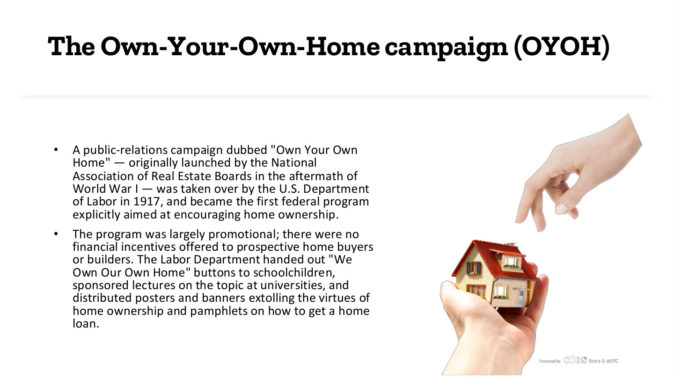
原PPT第24页 / Original slide 24 · 理解 / Understand

PPT中英翻译 / PPT translation
PPT English / 英文原文与图示 | 中文翻译 / Chinese translation
A public-relations campaign dubbed “Own Your Own Home” — originally launched by the National Association of Real Estate Boards in the aftermath of World War I — was taken over by the U.S. Department of Labor in 1917, and became the first federal program explicitly aimed at encouraging home ownership. | 原文称，“拥有自己的家”公关运动由全国房地产委员会协会在一战后发起，1917年由美国劳工部接手，成为第一个明确鼓励住房自有的联邦项目。【两项时序有张力，见辨析。】
The program was largely promotional; there were no financial incentives offered to prospective home buyers or builders. The Labor Department handed out “We Own Our Own Home” buttons to schoolchildren, sponsored lectures on the topic at universities, and distributed posters and banners extolling the virtues of home ownership and pamphlets on how to get a home loan. | 项目主要用于宣传，没有向潜在买家或建造者提供直接财政激励。劳工部向学生发放“我们拥有自己的家”徽章，资助大学讲座，分发赞扬住房自有的海报、横幅及介绍如何获得房贷的手册。

本页核心 / Key takeaway
OYOH主要是宣传与认知动员，并非直接购房补贴。
OYOH principally involved promotion and mobilisation rather than direct purchase subsidies.

精要解析 / Essential explanation

1. 用了什么工具 / Its instruments
徽章、讲座和宣传材料把住房自有变成值得追求的生活方式；贷款信息则连接愿望与金融渠道。这些都属于政策工具，不一定表现为现金转移。
Badges, lectures and publicity normalise ownership, while loan information connects aspiration with finance. These are policy instruments even without cash transfers.

2. 怎样判断效果 / Assessing effects
激励愿望与改善支付能力必须分开。没有直接财政补贴意味着项目不直接解决首付或月供问题；不能只因宣传广泛就推断所有潜在买家更负担得起。
Encouraging aspirations differs from improving ability to pay. Without direct financial aid the campaign does not directly resolve deposits or repayments; widespread publicity alone cannot establish improved affordability.

易错辨析 / Key distinction
原文同时写“一战后发起”和“1917年接手”，时序不一致；保留原文供对照，核心记宣传机制，不把这条起始年当作已核实定论。
The slide combines a post-war launch with a 1917 takeover, an inconsistent sequence. Retain it for comparison and focus on the promotional mechanism rather than treating the start date as settled.

25｜Better Homes与家庭角色 / Better Homes and household roles
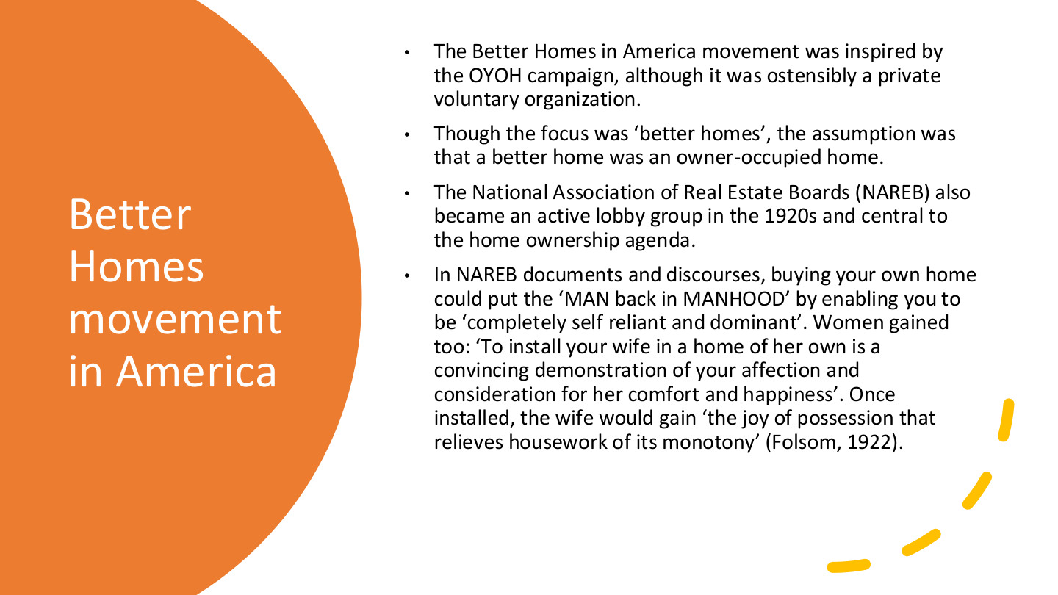
原PPT第25页 / Original slide 25 · 理解 / Understand

PPT中英翻译 / PPT translation
PPT English / 英文原文与图示 | 中文翻译 / Chinese translation
The Better Homes in America movement was inspired by the OYOH campaign, although it was ostensibly a private voluntary organization. | 美国“更美好住宅”运动受OYOH启发，形式上是民间志愿组织。
Though the focus was “better homes”, the assumption was that a better home was an owner-occupied home. | 虽然强调“更好的住宅”，其预设却是更好的家就是自有住房。
The National Association of Real Estate Boards (NAREB) also became an active lobby group in the 1920s and central to the home ownership agenda. | 全国房地产委员会协会（NAREB）在20世纪20年代成为活跃游说组织，在住房自有议程中居于重要位置。
In NAREB documents and discourses, buying your own home could put the “MAN back in MANHOOD” by enabling you to be “completely self reliant and dominant”. Women gained too: “To install your wife in a home of her own is a convincing demonstration of your affection and consideration for her comfort and happiness”. Once installed, the wife would gain “the joy of possession that relieves housework of its monotony” (Folsom, 1922). | NAREB历史宣传把买房描述为恢复男子气概、实现“完全自立与主导”的方式；又称给妻子一个自己的家能表达关爱，并让“拥有的喜悦缓解家务单调”（Folsom，1922）。这段引语呈现当时男性供养者与家庭主妇的角色想象。

本页核心 / Key takeaway
本页抓住“更好的家＝自有住房”的价值预设，以及财产如何被连接到家庭和性别角色。
Focus on the assumption that a better home means an owner-occupied home and its links to household and gender roles.

精要解析 / Essential explanation

1. 不是中性的品质比较 / Beyond a neutral quality comparison
“更好”被赋予产权含义，租赁即使质量良好也可能不被视为理想。价值评价先于住房实际品质，帮助解释为什么所有权能获得较强政治吸引力。
“Better” is given a tenure meaning, potentially excluding good-quality rentals from the ideal. The value judgement precedes actual dwelling quality, helping explain ownership’s political appeal.

2. 家庭形象怎样服务政策 / How household images support policy
宣传把男性自立、妻子幸福和家庭安定与产权捆绑，使购房不只是经济决定。分析时识别这些角色怎样动员支持，并把它与第13页“主体塑造”联系起来。
Publicity links male self-reliance, a wife’s happiness and household stability with property. Identify how these roles mobilise support and connect them to subject formation on slide 13.

26｜美国住房自有政策时间线 / US policy timeline
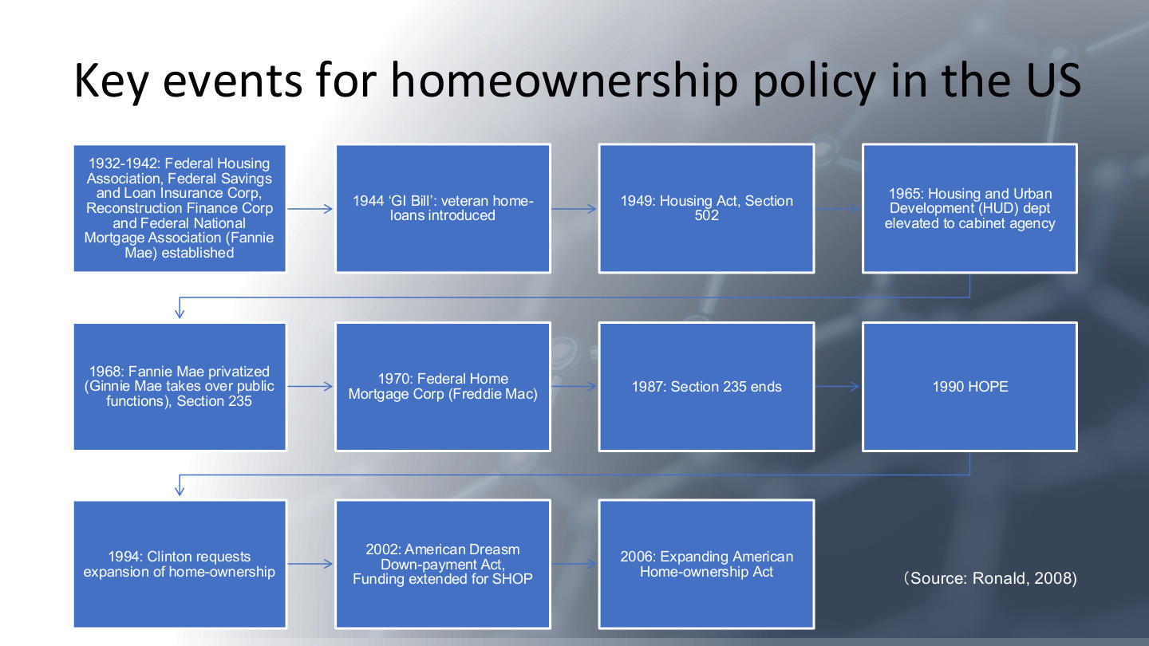
原PPT第26页 / Original slide 26 · 理解 / Understand

PPT中英翻译 / PPT translation
PPT English / 英文原文与图示 | 中文翻译 / Chinese translation
1932–1942: Federal Housing Association, Federal Savings and Loan Insurance Corp, Reconstruction Finance Corp and Federal National Mortgage Association (Fannie Mae) established. | 1932—1942年：原表列联邦住房机构、联邦储蓄贷款保险公司、复兴金融公司及房利美（Fannie Mae）等机构设立；FHA名称辨析见下方。
1944 “GI Bill”: veteran home-loans introduced. 1949: Housing Act, Section 502. | 1944年《退伍军人权利法案》引入退伍军人住房贷款；1949年《住房法》第502条。
1965: Housing and Urban Development (HUD) dept elevated to cabinet agency. | 1965年：住房与城市发展部（HUD）升为内阁级机构。
1968: Fannie Mae privatized (Ginnie Mae takes over public functions), Section 235. | 1968年：房利美私有化，吉利美（Ginnie Mae）接手公共职能；列入第235条。
1970: Federal Home Mortgage Corp (Freddie Mac). 1987: Section 235 ends. | 1970年：设立房地美（Freddie Mac；规范名称为Federal Home Loan Mortgage Corporation）；1987年第235条项目结束。
1990 HOPE. 1994: Clinton requests expansion of home-ownership. | 1990年HOPE；1994年克林顿提出扩大住房自有。
2002: American Dreasm Down-payment Act, Funding extended for SHOP. 2006: Expanding American Home-ownership Act. | 原表2002年列《美国梦首付法案》及SHOP资金延续；2006年列《扩大美国住房自有法案》。【保留原表年份，不将提案与生效状态混同。】
Source: Ronald, 2008. | 来源：Ronald，2008。

本页核心 / Key takeaway
不必逐年扩写；主线是国家从宣传延伸到住房金融机构、贷款和购房支持。
Focus on state promotion extending into financial institutions, lending and purchase support, rather than expanding every date.

精要解析 / Essential explanation

1. 国家与市场的关系 / State and market
机构建设、保险及贷款渠道说明私人自有并非只靠自由市场自发形成。国家可以通过金融制度推动私人产权，与本课“再商品化行动者”的视角相连。
Institutions, insurance and lending show that ownership is not simply a spontaneous market outcome. The state can promote private property through financial institutions, linking this history to recommodification.

2. 怎样使用这条时间线 / How to use the timeline
按“宣传—金融支持—扩大进入”整理政策路径，选择少数工具解释机制即可。1990年HOPE不能直接等同前课1993年启动的HOPE VI更新计划。
Organise the trajectory as promotion, financial support and expanded access, explaining selected instruments. The 1990 HOPE entry is not identical to the HOPE VI redevelopment programme launched in 1993 in the previous lecture.

易错辨析 / Key distinction
原表Federal Housing Association通常应为Federal Housing Administration；个别年份还混有倡议／立法状态，勿把整表当成逐项已核实的生效年表。
Federal Housing Association should normally read Federal Housing Administration. Some entries also require distinguishing proposals from enacted measures; the table is not a fully verified enactment chronology.

27｜美国自有率的长期上升 / Long-run US ownership growth
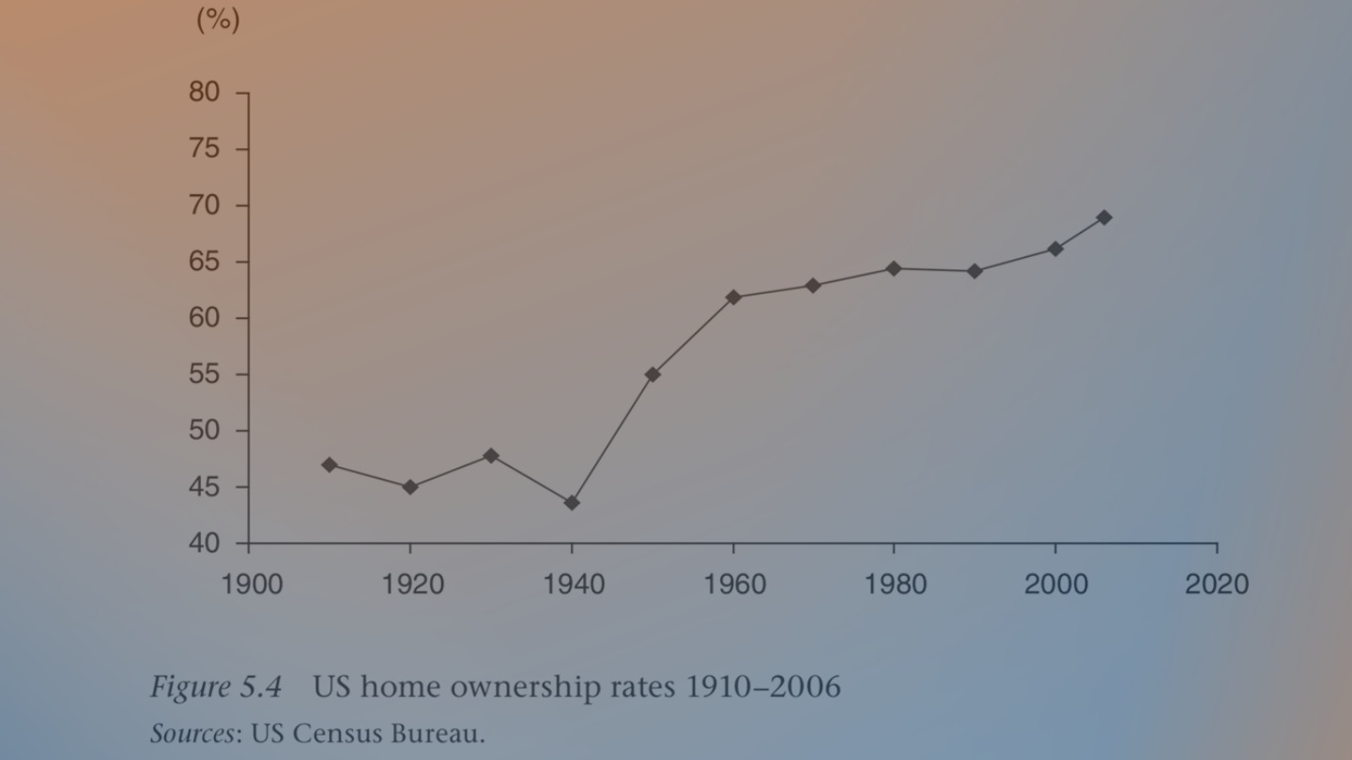
原PPT第27页 / Original slide 27 · 简读 / Brief

PPT中英翻译 / PPT translation
PPT English / 英文原文与图示 | 中文翻译 / Chinese translation
Figure 5.4. US home ownership rates 1910–2006. Sources: US Census Bureau. | 图5.4：1910—2006年美国住房自有率。来源：美国人口普查局。
Vertical axis: % (40–80); horizontal axis: year (ticks from 1900 to 2020). | 纵轴：百分比（40%—80%）；横轴：年份，刻度从1900到2020。刻度范围不同于数据覆盖期。

本页核心 / Key takeaway
只记趋势：早期有起伏，二战后自有率明显上升，并非从起点持续直线上升。
Remember early fluctuations followed by marked post-war growth, rather than an uninterrupted straight rise.

精要解析 / Essential explanation

1. 本页的作用 / Purpose of the figure
它为前页的制度史提供结果背景；单条趋势不能证明某项法律单独造成了上升。具体转折和小数无需逐点记忆，后面还会看到危机后的逆转。
The trend supplies context for the institutional history but cannot isolate one law’s effect. Detailed points are secondary; later slides show the post-crisis reversal.

