28｜2008年危机的根源 / Roots of the 2008 crisis
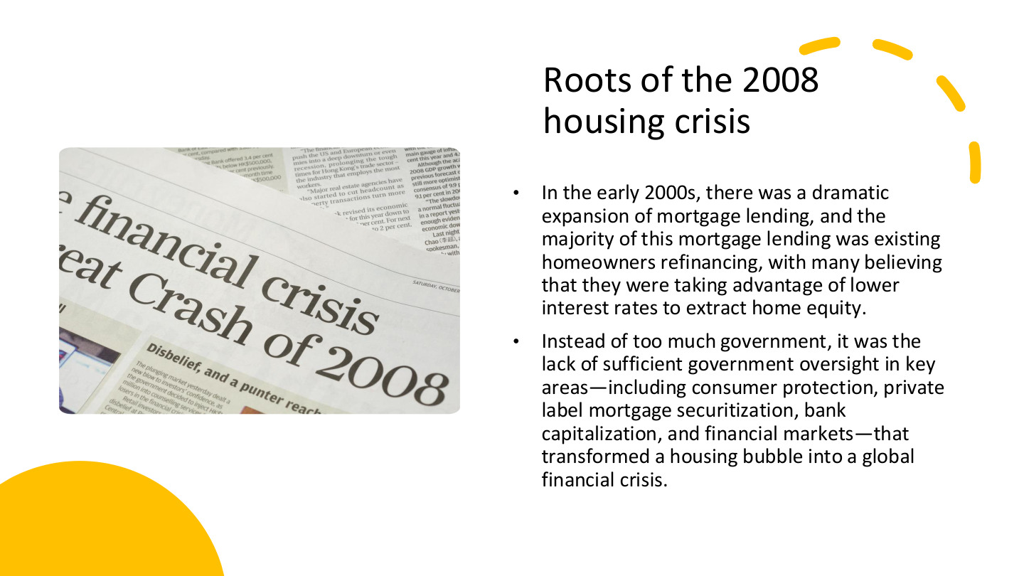
原PPT第28页 / Original slide 28 · 重点 / Focus

PPT中英翻译 / PPT translation
PPT English / 英文原文与图示 | 中文翻译 / Chinese translation
In the early 2000s, there was a dramatic expansion of mortgage lending, and the majority of this mortgage lending was existing homeowners refinancing, with many believing that they were taking advantage of lower interest rates to extract home equity. | 2000年代初按揭贷款大幅扩张，其中大量、按课件说法占多数的活动是现有房主再融资；许多人认为可利用低利率提取住房净值。
Instead of too much government, it was the lack of sufficient government oversight in key areas—including consumer protection, private label mortgage securitization, bank capitalization, and financial markets—that transformed a housing bubble into a global financial crisis. | 本页认为，问题不在于笼统的“政府太多”，而在消费者保护、私人标签按揭证券化、银行资本及金融市场等关键领域监管不足，使住房泡沫演变为全球金融危机。

本页核心 / Key takeaway
把再融资、住房净值提取、风险传递与监管不足串起来，不能把危机只归结为更多人买房。
Connect refinancing, equity extraction, risk transmission and insufficient oversight, rather than explaining the crisis merely as more people buying homes.

精要解析 / Essential explanation

1. home equity怎样算 / Defining home equity
住房净值＝房屋市场价值−未还按揭。例如价值300,000、贷款余额200,000，净值为100,000；这是资产负债差额，不是家庭每月收入。
Home equity equals market value minus outstanding mortgage debt. A home worth 300,000 with debt of 200,000 has equity of 100,000; this is a balance-sheet amount, not monthly income.

2. 再融资为什么能提取现金 / Cash-out refinancing
再融资是以新贷款替换旧贷款；若增加借款，可把部分住房净值转成现金。提取现金本身不创造净财富，还款义务仍在，房价下跌或收入下降可能放大压力。
Refinancing replaces an existing loan; a larger new loan can convert equity into cash. Cash extraction does not itself create net wealth; repayment remains and falling prices or earnings can intensify pressure.

3. 风险怎样向外扩散 / Risk transmission
私人标签证券化把按揭现金流打包为金融产品，使住房风险进入更广金融网络。银行资本是抵御损失的缓冲；若风险识别、消费者保护与资本约束不足，冲击可能相互放大。
Private-label securitisation packages mortgage cash flows into financial products, connecting housing risks to broader finance. Bank capital buffers losses; weak risk assessment, consumer protection and capital constraints can amplify shocks.

4. 国家角色要具体分析 / Specify the state’s role
本页提出的是关键监管缺口，不是任何政府干预都有效。分析时写清哪个环节缺保护、风险由谁承担，再与前文家庭资产化保障联系起来。
The slide identifies regulatory gaps, not a claim that every intervention works. Specify the unprotected stage and risk-bearer, then connect this to the earlier shift towards asset-dependent household security.

29｜金融危机与住房自有逆转 / Crisis and ownership reversal
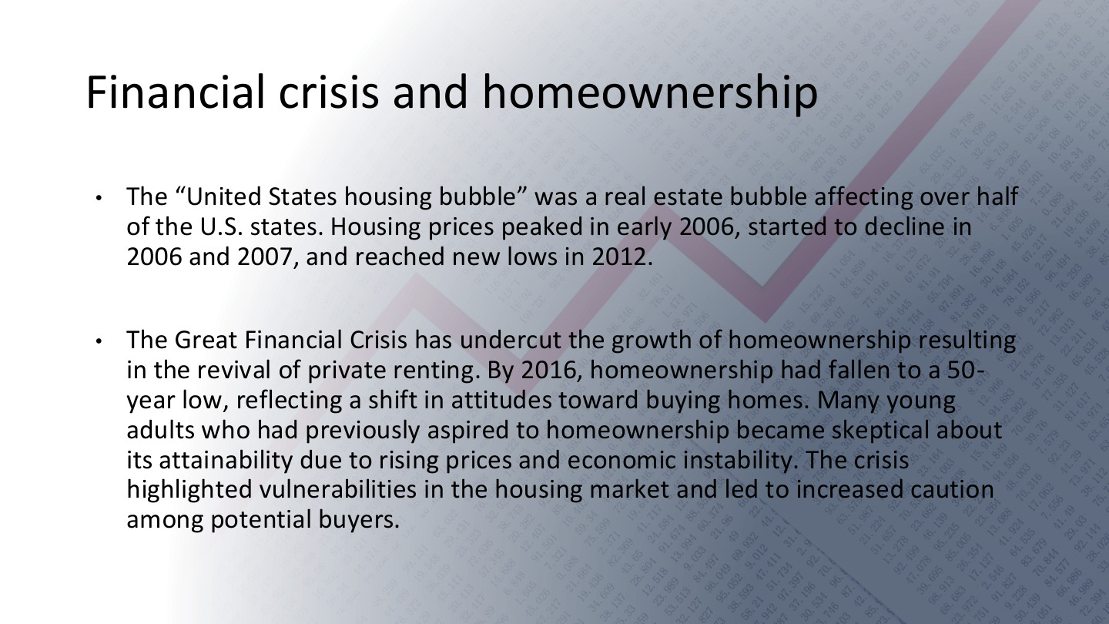
原PPT第29页 / Original slide 29 · 重点 / Focus

PPT中英翻译 / PPT translation
PPT English / 英文原文与图示 | 中文翻译 / Chinese translation
The “United States housing bubble” was a real estate bubble affecting over half of the U.S. states. Housing prices peaked in early 2006, started to decline in 2006 and 2007, and reached new lows in 2012. | 美国住房泡沫影响超过一半的州；课件称房价在2006年初达到高点，2006—2007年开始下降，2012年降至新低。
The Great Financial Crisis has undercut the growth of homeownership resulting in the revival of private renting. By 2016, homeownership had fallen to a 50-year low, reflecting a shift in attitudes toward buying homes. Many young adults who had previously aspired to homeownership became skeptical about its attainability due to rising prices and economic instability. The crisis highlighted vulnerabilities in the housing market and led to increased caution among potential buyers. | 全球金融危机削弱住房自有扩张，并伴随私人租赁复兴。课件称2016年自有率降至约50年低点；房价与经济不稳定使部分年轻人怀疑购房目标能否实现，潜在买家也更谨慎。

本页核心 / Key takeaway
危机显示住房自有扩张可以逆转，家庭也可能重新依靠租赁；资产化保障并非单向增长。
The crisis shows that ownership expansion can reverse and households can return to renting; asset-based security does not grow in one direction indefinitely.

精要解析 / Essential explanation

1. 房价与自有率不同 / Prices and ownership rates differ
房价反映资产价格，自有率反映住户的占有形式。价格下降不自动保证更多家庭能买房，因为收入、信贷可得性和风险预期也会同时变化。
Prices measure asset values; ownership rates measure household tenure. Lower prices do not automatically enable more households to buy, because incomes, credit access and expectations also change.

2. 私人租赁为何重要 / Why private renting matters
当进入或保有自住更困难，租赁成为替代渠道。评价危机后的保障，需要同时观察租金、租赁稳定性和支持制度，而不是只看房价从高点下降多少。
Renting becomes an alternative when entering or retaining ownership is harder. Assess post-crisis protection through rents, tenancy security and support as well as falling purchase prices.

3. 把机制与时间线结合 / Combine mechanisms and chronology
用第28页的借贷与监管机制解释脆弱性，用本页记录价格、自有率和住房选择的变化；不要把所有变化都压成“2008年同一天发生”。
Use slide 28 to explain financial vulnerability and this page to trace prices, ownership and choices. These changes occur over different periods rather than at one moment in 2008.

30｜美国自有率：红圈拐点 / The circled ownership turning point
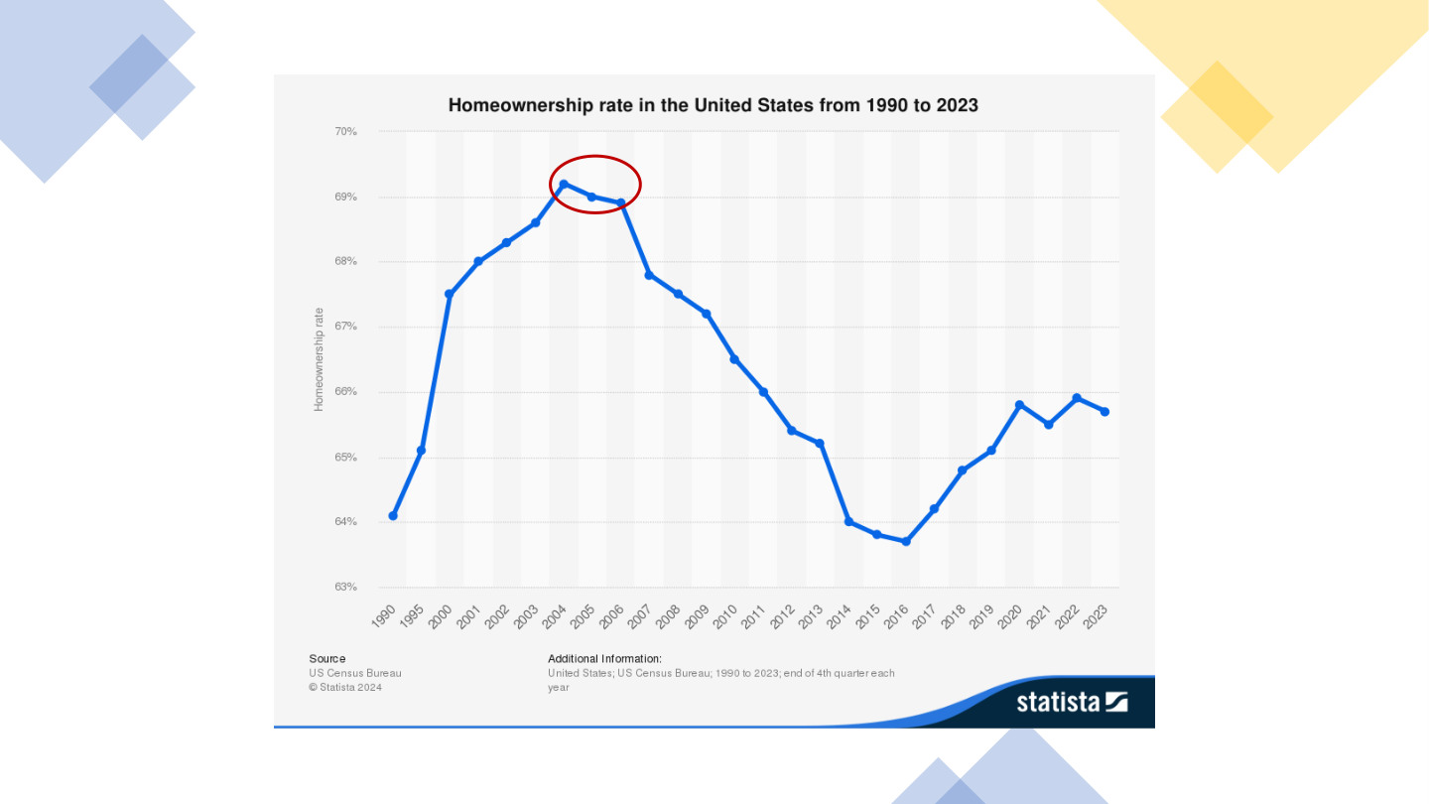
原PPT第30页 / Original slide 30 · 理解 / Understand

PPT中英翻译 / PPT translation
PPT English / 英文原文与图示 | 中文翻译 / Chinese translation
Homeownership rate in the United States from 1990 to 2023. | 1990—2023年美国住房自有率。
Vertical axis: Homeownership rate (63%–70%). Source: US Census Bureau; Statista 2024. Additional information: end of 4th quarter each year. | 纵轴：住房自有率（约63%—70%）。来源：美国人口普查局、Statista 2024。附注：各年第四季度末。
The original red ellipse highlights the high point around 2004–2006. | 原图红圈突出2004—2006年前后的高位与转折。

本页核心 / Key takeaway
重点读2004年前后高位→长期下滑→2016年前后低位→部分回升，而不是逐年背小数。
Read the high around 2004, prolonged decline, a low around 2016 and partial recovery, rather than memorising each decimal.

精要解析 / Essential explanation

1. 别把两个高点混同 / Distinguish the two peaks
本图自有率高点不等于第29页房价高点。前者约在2004年前后，后者课件记为2006年初；两个指标的转折可以不同。
The ownership-rate peak is not the price peak on slide 29. This chart peaks around 2004, while the text dates prices to early 2006; the two series can turn at different times.

2. 回升说明到哪一步 / Interpreting recovery
后期有所回升，但截至原图2023年仍未回到早期高位；它不直接说明家庭债务或可负担性已经恢复。引用时保留截止年份。
The later recovery remains below the early high through 2023. It does not establish that debt burdens or affordability recovered; retain the chart’s end date when discussing the trend.

31｜美国住户与住房援助 / US households and assistance
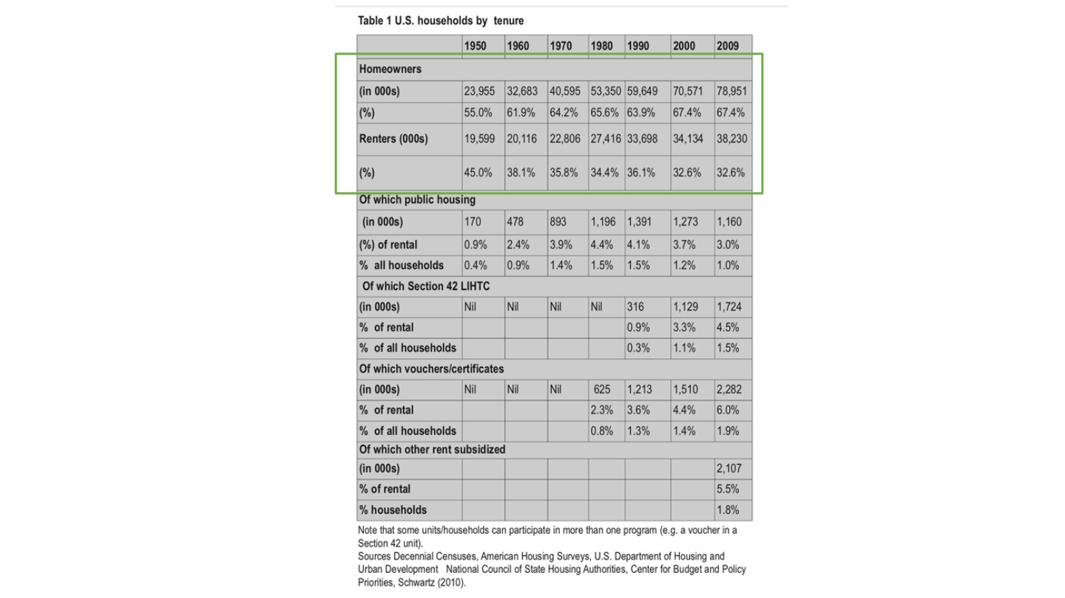
原PPT第31页 / Original slide 31 · 理解 / Understand

PPT中英翻译 / PPT translation
PPT English / 英文原文与图示 | 中文翻译 / Chinese translation
Table 1. U.S. households by tenure. Years: 1950, 1960, 1970, 1980, 1990, 2000, 2009. | 表1：美国按住房占有形式划分的住户，年份为1950—2009所列年份。绿色框突出自住与租赁的总体构成。
Homeowners; Renters; Of which public housing; Section 42 LIHTC; vouchers/certificates; other rent subsidized. Counts in 000s; % of rental; % of all households. | 项目：自住户、租户；租户中公屋、第42条LIHTC、住房券／证书及其他租金补贴。数量为千户；百分比分别以租户或全部住户为分母。
Some units/households can participate in more than one program (e.g. a voucher in a Section 42 unit). | 部分住房／家庭可同时参与多项计划，例如在LIHTC住房中使用住房券。
Sources: Decennial Censuses; American Housing Surveys; HUD; National Council of State Housing Authorities; Center for Budget and Policy Priorities; Schwartz (2010). | 来源：十年人口普查、美国住房调查、HUD、州住房机构全国委员会、CBPP及Schwartz（2010）。
In the transcribed assistance table, each cell reads: count in 000s / % of rental / % of all households. Nil means none as printed; — preserves an original blank. | 下方援助表每格依次为：千户／占租户比例／占全部住户比例。Nil保留原表“无”，—表示原空白，不擅自填成零。

总体住户：数量为千户 / Overall households: thousands
年份 / Year | 自住户 / Owners | 自有率 / Owner % | 租户 / Renters | 租户比例 / Renter %
1950 | 23,955 | 55.0% | 19,599 | 45.0%
1960 | 32,683 | 61.9% | 20,116 | 38.1%
1970 | 40,595 | 64.2% | 22,806 | 35.8%
1980 | 53,350 | 65.6% | 27,416 | 34.4%
1990 | 59,649 | 63.9% | 33,698 | 36.1%
2000 | 70,571 | 67.4% | 34,134 | 32.6%
2009 | 78,951 | 67.4% | 38,230 | 32.6%

援助项目：千户／租户%／全部住户% / Assistance: thousands / renter % / all-household %
年份 / Year | 公屋 / Public housing | LIHTC Section 42 | 券／证书 / Vouchers | 其他补贴 / Other
1950 | 170 / 0.9% / 0.4% | Nil / — / — | Nil / — / — | — / — / —
1960 | 478 / 2.4% / 0.9% | Nil / — / — | Nil / — / — | — / — / —
1970 | 893 / 3.9% / 1.4% | Nil / — / — | Nil / — / — | — / — / —
1980 | 1,196 / 4.4% / 1.5% | Nil / — / — | 625 / 2.3% / 0.8% | — / — / —
1990 | 1,391 / 4.1% / 1.5% | 316 / 0.9% / 0.3% | 1,213 / 3.6% / 1.3% | — / — / —
2000 | 1,273 / 3.7% / 1.2% | 1,129 / 3.3% / 1.1% | 1,510 / 4.4% / 1.4% | — / — / —
2009 | 1,160 / 3.0% / 1.0% | 1,724 / 4.5% / 1.5% | 2,282 / 6.0% / 1.9% | 2,107 / 5.5% / 1.8%

本页核心 / Key takeaway
看清自有率、占租户比例与占全部住户比例三个分母；援助类别还可能重叠。
Distinguish ownership rates, shares of renters and shares of all households; assistance categories may also overlap.

精要解析 / Essential explanation

1. 分母怎样改变结论 / How denominators change interpretation
2009年公屋为租户的3.0%，却为全部住户的1.0%。同一数量可以对应不同百分比；不能把这两个数字当成互相矛盾，也不能与其他年份的0.8%直接混用。
In 2009 public housing accounts for 3.0% of renters but 1.0% of all households. One count can produce different percentages; these are not contradictory, nor interchangeable with a 0.8% figure from another year.

2. 为什么不能直接相加 / Why categories cannot simply be added
原表明确同一家庭可同时使用券和LIHTC房源。项目覆盖不一定互斥，将援助行相加可能重复计数；自有与租赁总体构成才是上方绿色框的主要信息。
The source explicitly permits vouchers in LIHTC units. Programme coverage is not necessarily exclusive, so summing assistance rows can double-count households; the green box focuses on the overall owner–renter split.

32｜美国住房成本负担 / US housing cost burdens
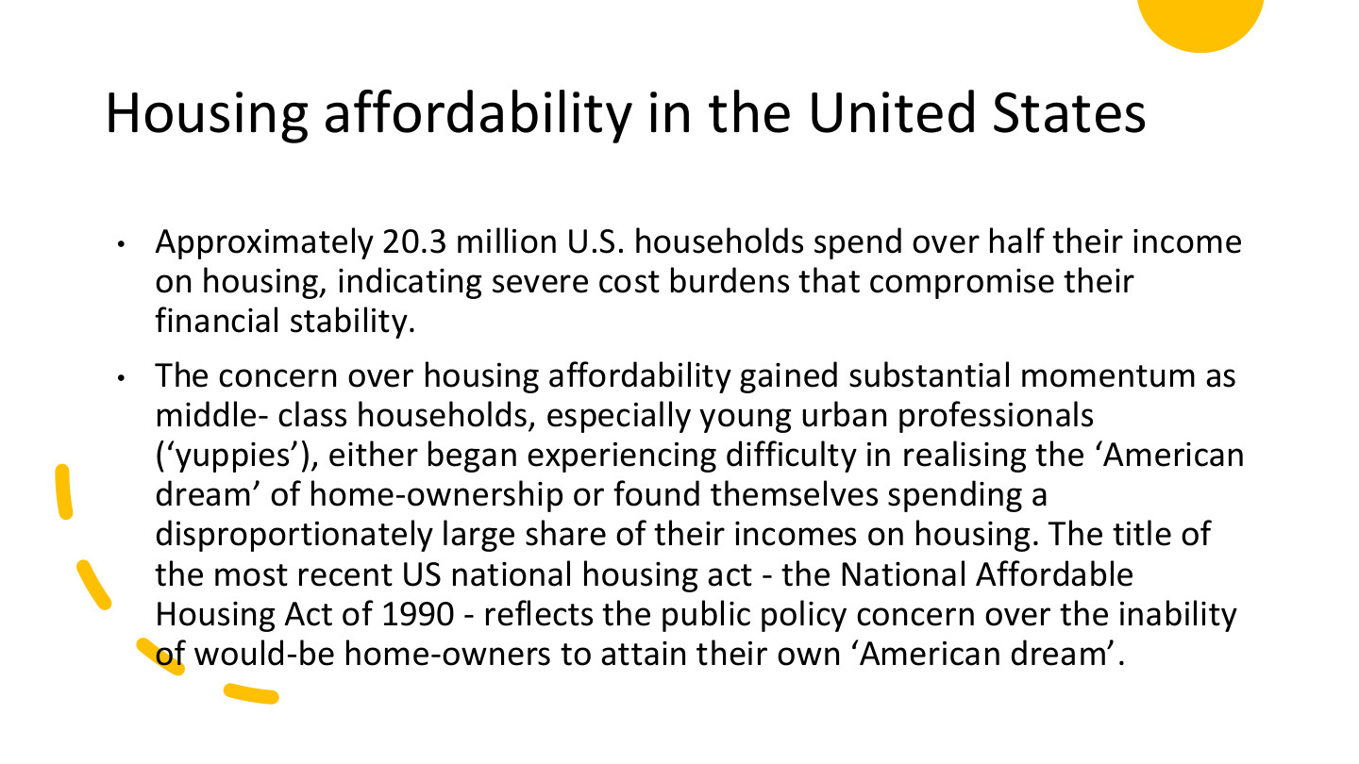
原PPT第32页 / Original slide 32 · 重点 / Focus

PPT中英翻译 / PPT translation
PPT English / 英文原文与图示 | 中文翻译 / Chinese translation
Approximately 20.3 million U.S. households spend over half their income on housing, indicating severe cost burdens that compromise their financial stability. | 课件称，约2,030万美国家庭把超过一半收入用于住房，面临影响财务稳定的严重成本负担。
The concern over housing affordability gained substantial momentum as middle-class households, especially young urban professionals (“yuppies”), either began experiencing difficulty in realising the “American dream” of home-ownership or found themselves spending a disproportionately large share of their incomes on housing. | 当中产家庭、尤其年轻城市专业人士（yuppies）难以实现购房梦想，或把过多收入用于住房时，可负担性问题受到更广泛关注。
The title of the most recent US national housing act—the National Affordable Housing Act of 1990—reflects the public policy concern over the inability of would-be home-owners to attain their own “American dream”. | 原文以1990年《国家可负担住房法》的名称，说明政策对潜在购房者无法实现美国梦的关注。“most recent”为原文历史表述，不作为当前最新法律的判断。

本页核心 / Key takeaway
购房梦想与实际住房负担之间存在落差；本页用支出超过收入一半描述严重成本负担。
The ownership dream can diverge from actual affordability; this slide uses housing costs above half of income to describe severe burdens.

精要解析 / Essential explanation

1. 50%是什么指标 / What the 50% figure measures
这里是住房支出÷收入超过50%，不是房价收入比，也不是一套房值年收入的一半。2,030万的单位是家庭／住户，不是人口。
This concerns housing expenditure exceeding 50% of income, not the house-price ratio or a dwelling worth half of annual income. The 20.3 million figure counts households, not people.

2. 为什么不仅是贫困议题 / Beyond poverty alone
中等收入者也可能因房价、租金或还款而承受压力。可负担性取决于成本与资源的关系，不能只按收入阶层推断；同时也不能忽视低收入家庭的必要消费受挤压。
Middle-income households can face pressure from prices, rents or repayments. Affordability depends on costs relative to resources, not class labels alone; necessary consumption among lower-income households also matters.

3. 怎样连接前面的指标 / Link to earlier measures
用第17—18页的方法检查比例、支付条件与剩余生活资源。原页未注明2,030万的统计年份，作为课程历史材料使用，不把它当作今天的即时总数。
Apply slides 17–18 to payment ratios, terms and resources left for necessities. The slide does not date the 20.3 million statistic; treat it as historical course evidence, not a current estimate.

33｜房价收入比图怎样读？ / Reading the price–income chart
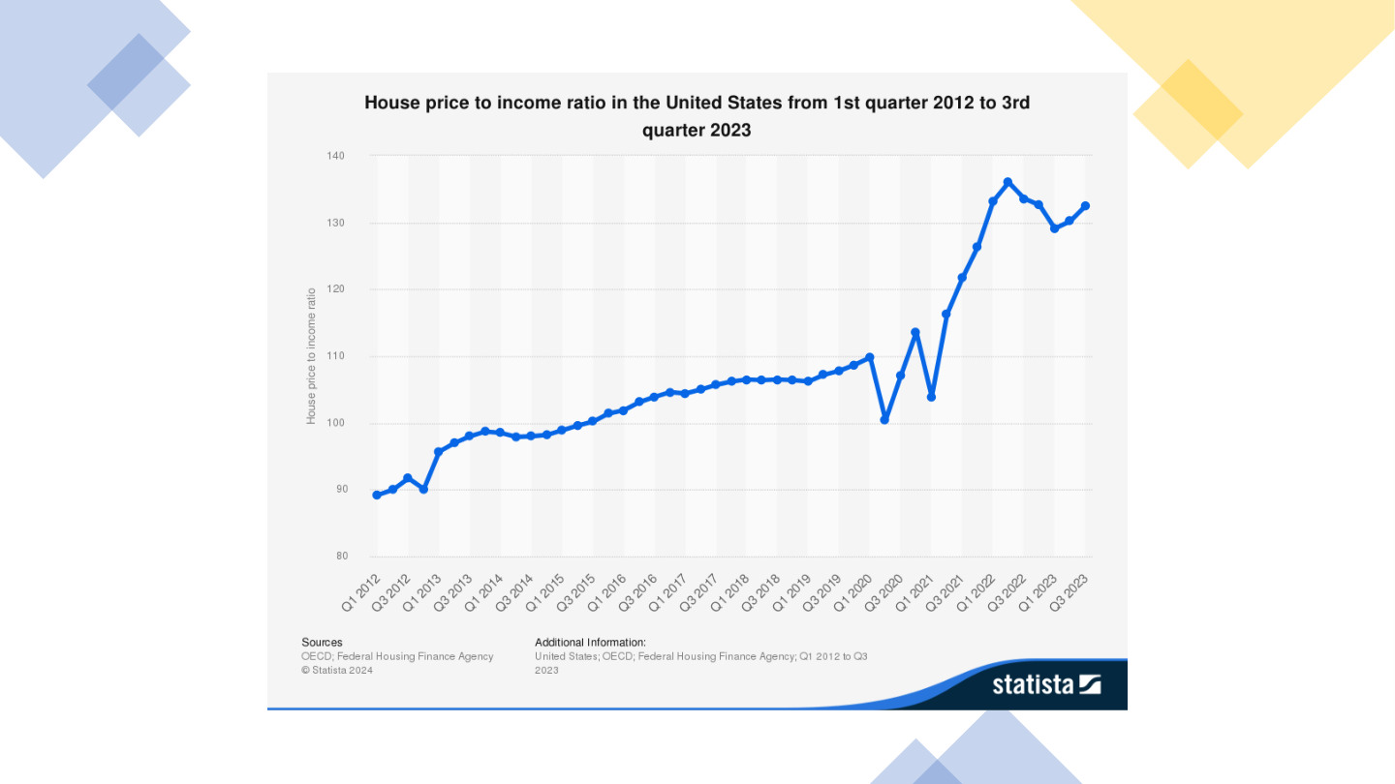
原PPT第33页 / Original slide 33 · 理解 / Understand

PPT中英翻译 / PPT translation
PPT English / 英文原文与图示 | 中文翻译 / Chinese translation
House price to income ratio in the United States from 1st quarter 2012 to 3rd quarter 2023. | 美国2012年第一季度至2023年第三季度的房价收入比序列。
Vertical axis: House price to income ratio, approximately 80–140; horizontal axis: quarters from Q1 2012 to Q3 2023. | 纵轴约80—140，标为房价收入比；横轴为2012Q1—2023Q3的季度。数值应按指数化序列理解，截图未明确基期。
Sources: OECD; Federal Housing Finance Agency. © Statista 2024. | 来源：OECD、美国联邦住房金融局；Statista 2024。

本页核心 / Key takeaway
图中房价相对收入总体上升，后期有明显波动；指数值不能直接读成年收入倍数。
The chart shows an overall rise in prices relative to incomes, with later fluctuations; indexed values are not literal multiples of annual income.

精要解析 / Essential explanation

1. 指数与原始比值不同 / Index versus level
图上130不等于房价为年收入130倍。指数用于比较相对变化；原截图未明确基期，不自行补出基年，也不把它与第18页例子的比值5直接比较。
A chart value of 130 does not mean a price of 130 times annual income. An index compares relative change; the base year is not stated in the screenshot, so do not invent it or compare directly with the ratio of 5 on slide 18.

2. 本页只需记趋势 / Retain the main trend
后段快速上升后有所回落、再波动，并非始终直线上涨。该图不包含利率和必要生活支出，不能独自给出每个家庭实际可负担性的结论。
The later sharp increase is followed by a pullback and further fluctuation, not a continuous straight rise. The chart omits financing costs and necessities, so it cannot establish affordability for each household.

34｜荷兰案例 / The Netherlands

原PPT第34页 / Original slide 34 · 简读 / Brief

PPT中英翻译 / PPT translation
PPT English / 英文原文与图示 | 中文翻译 / Chinese translation
IV. The Netherlands | 第四部分：荷兰。

本页核心 / Key takeaway
观察社会租赁传统下，国家怎样支持住房自有，以及住房结构和成本如何变化。
Examine ownership promotion, changing tenure and costs within a society with a strong social-rental tradition.

35｜荷兰红框：自有不等于无债 / The highlighted Dutch debt structure
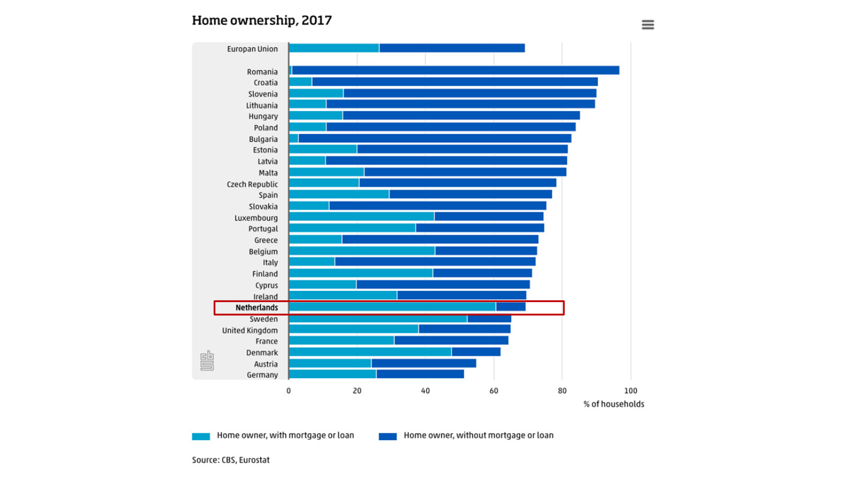
原PPT第35页 / Original slide 35 · 理解 / Understand

PPT中英翻译 / PPT translation
PPT English / 英文原文与图示 | 中文翻译 / Chinese translation
Home ownership, 2017. Horizontal axis: % of households. Source: CBS, Eurostat. | 2017年住房自有。横轴为住户百分比；来源：CBS、Eurostat。
Home owner, with mortgage or loan; Home owner, without mortgage or loan. | 图例：有按揭／贷款的房主；无按揭／贷款的房主。原图红框标出荷兰。
European Union; Romania; Croatia; Slovenia; Lithuania; Hungary; Poland; Bulgaria; Estonia; Latvia; Malta; Czech Republic; Spain; Slovakia; Luxembourg. | 欧盟、罗马尼亚、克罗地亚、斯洛文尼亚、立陶宛、匈牙利、波兰、保加利亚、爱沙尼亚、拉脱维亚、马耳他、捷克、西班牙、斯洛伐克、卢森堡。
Portugal; Greece; Belgium; Italy; Finland; Cyprus; Ireland; Netherlands; Sweden; United Kingdom; France; Denmark; Austria; Germany. | 葡萄牙、希腊、比利时、意大利、芬兰、塞浦路斯、爱尔兰、荷兰、瑞典、英国、法国、丹麦、奥地利、德国。

本页核心 / Key takeaway
荷兰红框强调相当一部分自住家庭仍有按揭，不能把较高自有率理解为已经没有住房支付压力。
The highlighted Dutch bar shows substantial mortgage-backed ownership, so ownership does not mean an absence of payment pressure.

精要解析 / Essential explanation

1. 先看总长，再看内部 / Total share and internal composition
总长表示自有住房住户比例，两种颜色再区分有债与无债。相同自有率可能对应很不同的债务结构；原图无逐段数值，不编造精确比例。
Bar length gives ownership’s share; colours distinguish mortgaged and debt-free positions. Equal ownership rates can conceal different debt structures; do not invent precise segment values absent from the chart.

2. 与后面荷兰数据连接 / Connect to subsequent Dutch evidence
本图是2017年住户口径，第38页是1981—2010年住房存量结构。年份和分母不同，适合相互补充，不宜直接把差值解释成同一指标的变化。
This is a 2017 household measure; slide 38 presents housing stock in 1981–2010. Different dates and denominators make them complementary, not one directly comparable series.

36｜荷兰购房支持 / Dutch homeownership schemes

原PPT第36页 / Original slide 36 · 重点 / Focus

PPT中英翻译 / PPT translation
PPT English / 英文原文与图示 | 中文翻译 / Chinese translation
Homeownership schemes in the 1990s offered low-income families home-purchase subsidies. These initiatives were eventually incorporated in the “Promotion of Homeownership Act” (BEW, 2000) synthesizing two related bills: “Stimulating Homeownership”, 1998, and “Individual Purchase Contribution”, 1999. | 20世纪90年代的计划向低收入家庭提供购房补贴，后整合进2000年《促进住房所有权法》（BEW）；课件列出1998年“促进住房自有”和1999年“个人购房补助”两项相关法案。

本页核心 / Key takeaway
荷兰案例说明公共支持也可以用来促进私人住房自有，并不只表现为社会租赁供给。
The Dutch case shows that public support can promote private homeownership, alongside social-rental provision.

精要解析 / Essential explanation

1. 补贴改变什么 / What purchase support changes
购房补贴主要帮助家庭跨越购买门槛，不等于政府长期替代全部还款和维护责任。进入自有住房与持续负担得起是两个问题。
Purchase subsidies help households cross entry barriers; they do not necessarily replace continuing repayments and upkeep. Access to ownership and sustainable affordability are distinct questions.

2. 与听课宝怎样对照 / Comparison with the listening summary
听课宝强调住房协会、租金补贴与资金流向；本页把视角转向购买端。比较要问支持的是租赁支付、非营利供给，还是家庭取得私人资产，而不只看有无补贴。
The listening summary emphasises associations, rent support and funding flows. This page turns to purchases: distinguish support for rent, nonprofit supply and acquisition of household assets rather than subsidies alone.

3. 政策目标与结果分开 / Goals and outcomes
促进自有是政策方向，但成本还受供给、信贷和价格影响。补助可能提高购买能力，却不能单凭设立计划就证明所有目标家庭更可负担；第37页继续看成本。
Ownership promotion is an objective; supply, credit and prices still shape costs. Assistance can increase buying power without proving affordability for every target household; slide 37 examines costs.

37｜荷兰住房成本与价格 / Dutch costs and prices
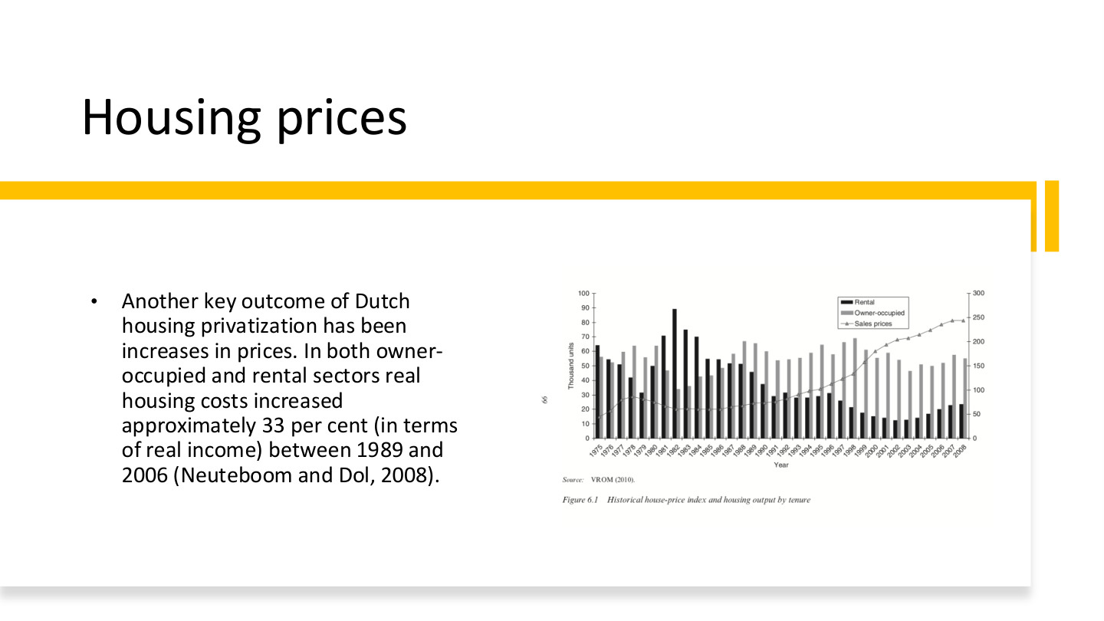
原PPT第37页 / Original slide 37 · 重点 / Focus

PPT中英翻译 / PPT translation
PPT English / 英文原文与图示 | 中文翻译 / Chinese translation
Another key outcome of Dutch housing privatization has been increases in prices. In both owner-occupied and rental sectors real housing costs increased approximately 33 per cent (in terms of real income) between 1989 and 2006 (Neuteboom and Dol, 2008). | 课件把价格上升列为荷兰住房私有化的重要结果，并称1989—2006年自住和租赁部门实际住房成本约增加33%（原文以实际收入表述；Neuteboom与Dol，2008）。
Figure 6.1. Historical house-price index and housing output by tenure. Rental; Owner-occupied; Sales prices. | 图6.1：历史房价指数与按占有形式划分的住房产出。图例：租赁、业主自住、出售价格。
Left axis: Thousand units. Right axis: price-index scale. Horizontal axis: Year, 1975–2008. Source: VROM (2010). | 左轴：千套；右轴：价格指数刻度；横轴：1975—2008年。来源：VROM，2010。

本页核心 / Key takeaway
自有住房扩张不自动等于成本下降；课件同时报告租赁与自住的实际住房成本上升。
Expansion of ownership does not automatically reduce costs; the lecture reports rising real costs in both rented and owner-occupied sectors.

精要解析 / Essential explanation

1. 33%是什么变化 / What increased by 33%?
实际住房成本上升约33%，不是负担率增加33个百分点，也不能直接改写成所有住宅售价上涨33%。成本、房价、收入比例是不同量。
A 33% rise in real housing costs is not a 33-percentage-point increase in a burden ratio, nor a claim about every sale price. Costs, prices and income shares are different quantities.

2. 双轴图怎样读 / Reading the two axes
柱子表示不同住房产出、单位为千套，线条表示销售价格指数。两类量不能直接按同一纵轴比较；建设量变化与价格变化需分别读。
Bars measure housing output in thousands; the line is a sale-price index. They must not be read against one shared vertical scale; interpret quantities and prices separately.

3. 怎样评价私有化 / Evaluating privatisation
把政策方向与成本结果联系起来，同时保留供给、信贷和收入等可能影响。图表的共同变化并不单独证明私有化是唯一原因，也不能只依据房主人数评价福利改善。
Connect policy direction with costs while considering supply, credit and income. Co-movement alone does not establish privatisation as the sole cause, and owner counts alone do not establish welfare gains.

38｜荷兰住房结构：1981—2010 / Dutch tenure structure, 1981–2010
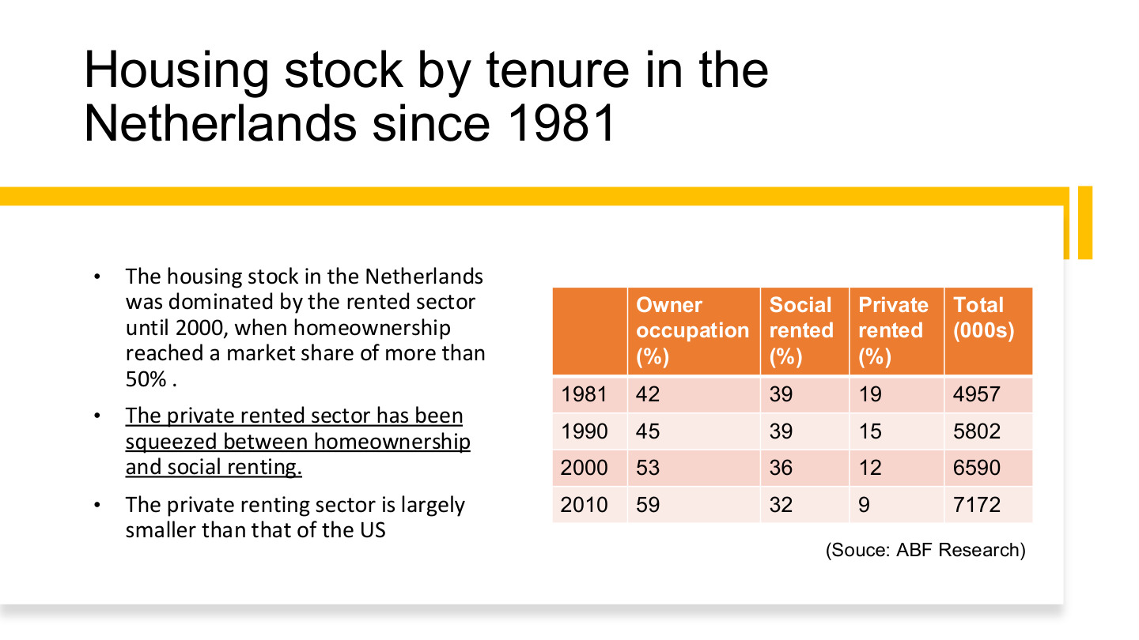
原PPT第38页 / Original slide 38 · 重点 / Focus

PPT中英翻译 / PPT translation
PPT English / 英文原文与图示 | 中文翻译 / Chinese translation
The housing stock in the Netherlands was dominated by the rented sector until 2000, when homeownership reached a market share of more than 50%. | 荷兰住房存量原以租赁为主，到2000年前后自有住房份额超过50%。
The private rented sector has been squeezed between homeownership and social renting. The private renting sector is largely smaller than that of the US. | 私人租赁部门在自有住房与社会租赁之间受到挤压，其相对规模明显小于美国。
Owner occupation (%); Social rented (%); Private rented (%); Total (000s). Source: ABF Research. | 表列自住、社会租赁和私人租赁的百分比，总存量以千套计。来源：ABF Research。

原表完整转写 / Full transcription
年份 / Year | 自住 / Owner % | 社会租赁 / Social % | 私人租赁 / Private % | 总存量：千套 / Total: 000s
1981 | 42 | 39 | 19 | 4,957
1990 | 45 | 39 | 15 | 5,802
2000 | 53 | 36 | 12 | 6,590
2010 | 59 | 32 | 9 | 7,172

本页核心 / Key takeaway
记住自住42%→59%，社会租赁39%→32%，私人租赁19%→9%的结构变化，年份为1981—2010。
From 1981 to 2010, ownership rises from 42% to 59%, social renting falls from 39% to 32%, and private renting from 19% to 9%.

精要解析 / Essential explanation

1. 不是整个租赁部门都消失 / Renting remains important
私人租赁下降不等于社会租赁同步消失；2010年后者仍占32%。要把私人租赁与社会租赁分开，才能解释荷兰与美国的差别。
Declining private renting does not mean social renting disappears; the latter still accounts for 32% in 2010. Separate private from social renting when explaining differences from the US.

2. 比例与数量分开 / Shares versus quantities
总存量从4,957千套增至7,172千套。份额下降不必等于绝对套数下降，因为分母也增长；表内少数年份合计99%或101%，按原表保留四舍五入。
Total stock rises from 4,957 to 7,172 thousand. A falling share need not mean fewer dwellings, because the denominator grows. Preserve the original 99% or 101% totals caused by rounding.

3. 放回整课理解 / Place the evidence in the lesson
荷兰的购房支持和自有率增长，与社会租赁传统同时存在。比较福利体制时，应解释两种机制怎样重新组合，而不是因为自有超过一半就宣布整个国家成为自由主义体制。
Ownership promotion and growth coexist with a social-rental tradition. Explain the changing combination rather than reclassifying the entire welfare regime merely because ownership exceeds half of stock.

39｜荷兰长期结构图 / Long-run Dutch tenure chart
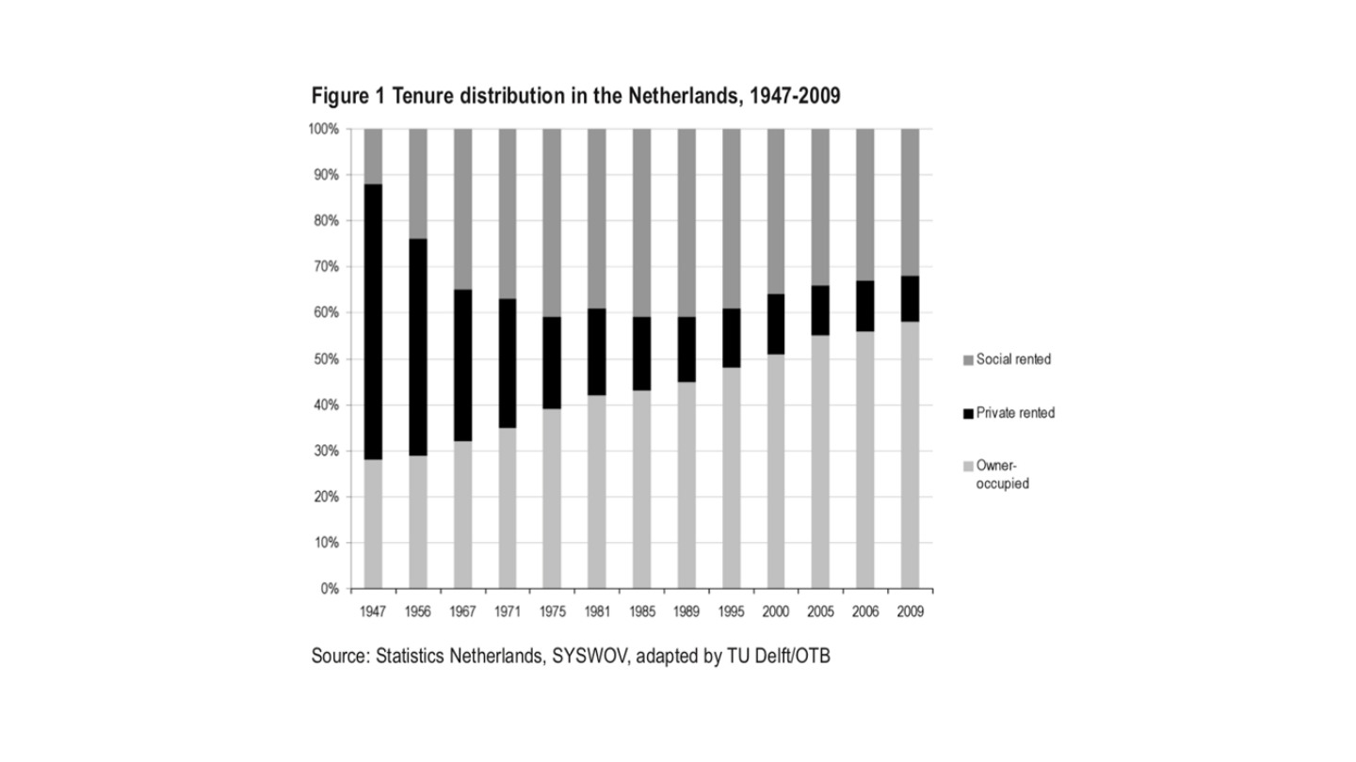
原PPT第39页 / Original slide 39 · 简读 / Brief

PPT中英翻译 / PPT translation
PPT English / 英文原文与图示 | 中文翻译 / Chinese translation
Figure 1. Tenure distribution in the Netherlands, 1947–2009. | 图1：1947—2009年荷兰住房占有形式分布。
Social rented; Private rented; Owner-occupied. Vertical axis: 0–100%. Years: 1947, 1956, 1967, 1971, 1975, 1981, 1985, 1989, 1995, 2000, 2005, 2006, 2009. | 图例：社会租赁、私人租赁、业主自住。纵轴0%—100%；横轴为1947—2009所列年份。
Source: Statistics Netherlands, SYSWOV, adapted by TU Delft/OTB. | 来源：荷兰统计局、SYSWOV，由代尔夫特理工大学／OTB改编。

本页核心 / Key takeaway
本页是第38页的长期图示补充：自住扩张、私人租赁收缩，社会租赁经历先扩张后回落。
This extends slide 38 historically: ownership expands, private renting contracts, and social renting first grows then declines.

精要解析 / Essential explanation

1. 精华即可 / Keep the essential reading
按三种色块看结构变化，不需逐根柱子估算精确比例。它补充历史过程；核心数值已在第38页表格中整理，避免重复背两套数据。
Read the three segments as structural change without inventing exact bar values. This adds historical context; the key figures are already organised on slide 38, so avoid memorising a second dataset.

40｜结束页 / Questions?

原PPT第40页 / Original slide 40 · 简读 / Brief

PPT中英翻译 / PPT translation
PPT English / 英文原文与图示 | 中文翻译 / Chinese translation
Questions? June Wang; June.wang@cityu.edu.hk | 有什么问题吗？June Wang；联系邮箱：June.wang@cityu.edu.hk。

本页核心 / Key takeaway
结束页，无新增理论。
Closing slide; no new theory.

